20.12.12

Preparation of the draft budget of the Union for 2014-2015

- Status at 20 December 2012
This document presents the status of the submissions received from all Sectors and Departments at 20 December 2012 in the preparation of the draft Budget of the Union for 2014-2015.
The draft Budget for 2014-2015 amounts to CHF 342.6 million against CHF 323.8 million in 2012-2013 as shown in Table 1 below, an increase of CHF 18.8 million on the expense side. Taking into account the increase of CHF 3.4 million in the revenue forecast, revenue less expenses shows a shortfall of CHF 15.3 million before any withdrawal from the Reserve Account.
Table 1
* The 7.2% variance in the General Secretariat includes CHF 5.7 million increases for ITU-wide common expenses such as Social responsibility for after service health insurance, ITU external communications, PP-14 as well as additional documentation costs.
- Revenue
Annex 1 contains the revenue forecast for 2014-2015, which amounts to CHF 327.3 million.
There is a revenue increase of CHF 10 million compared with the 2012-2013 budget before any withdrawal from the Reserve Account. The increase includes the choice of a higher class of contribution from Azerbaijan, from ¼ unit to 10 units, and additional cost recovery income from Satellite network filing and Sales of publications .

- Expenses
Annex 2 contains the detailed status of the 2014-2015 submissions by Sectors and Departments. Comparison is provided with budgets and actual expenditure for 2010-2011 and 2012-2013. The original version of the first round of submissions relating to the preparation of the 2010-2011 budget has also been provided. Annex also provides, for information, preliminary estimates for the period 2016-2017.

Annex 4 contains a more in-depth view of the Bureaux and General Secretariat Departments by category of expenses. Annex 5 shows the detail of intersectoral outputs. Annex 6 provides the list of retirees between 2013 and 2015.

- Analysis
It is important to note that three major conferences will be held on the same biennium in 2014-2015: PP-14, WTDC-14 and WRC-15.

The detailed breakdown of the CHF 18.8 million increase on the expense side compared with 2012-2013 is provided in Annex 3. The variance can be analyzed as follows:

- Most of the difference, CHF 15.2 million, comes from the Bureaux and Departments.
It includes:
- Increases in the staff cost calculation (CHF 8.6 million). This increase is applicable to all Bureaux and Departments. A 5 % ITU-wide staff cost cut has been applied in the draft budget for 2014-2015. The increase in health insurance costs which is currently under negotiation with the ILO has also been included. The increase of the contribution rate from 3.3% to 3.91%, is equivalent to CHF 1.5 million for active staff and CHF 2 million for retirees.

- 10 additional posts compared to the 2013 budget, the breakdown of which is provided by Sector and Department in Table 2 below (CHF 2.8 million).

Table 2

- Documentation volume has increased variable costs by CHF 2.6 million. There is increased workload of translation by 19.1 % due to programme variations. As shown in Annex 7, total documentation cost is CHF 31.7 million in 2014-2015 and total language cost including interpretation is CHF 39 million. Increases in volume are shown in Table 3 below.
Table 3

Compared with the documentation workload requests received at 22 November, the current status shows a decrease of CHF 2.5 million corresponding to a decrease in volume of 14% (119,269 pages of translation instead of 138,948 pages) for CHF 2.3 million and a shift in the allocation of the variable costs appropriations between short term recruitments and external contracts for CHF 0.2 million. The ratio short term contracts versus external contracts has changed from 50/50 to 25/75 leaving more opportunities to place external contracts (additional CHF 0.8 million) and benefit from market conditions to obtain more pages of translation.

Annex 8 provides the documentation detail such as translation and typing comparison from 2010 to 2015 and documentation workload detail for the draft Budget 2014-2015.

- Increases in non-staff costs, categories 3 to 9 without documentation costs (CHF 1.1 million).

- Program variations explain another CHF 3.5 million increase due to new requests such as improved external communications, PP-14, WTDC-14 and WRC-15.
Table 4 below provides the breakdown of the external communications budget amounting to CHF 0.9 million.

Table 4

Annex 9 provides the detail of the CHF 22.7 million reductions and CHF 9.2 million revenue increases made during the budgetary preparation process compared with the 1st November version which showed a shortfall of CHF 41.5 million.

Annex 1

Annex 2
Annex 3
Annex 4
Departments and Bureaux by categories of expenses

Annex 5
Intersectoral Outputs

Annex 6
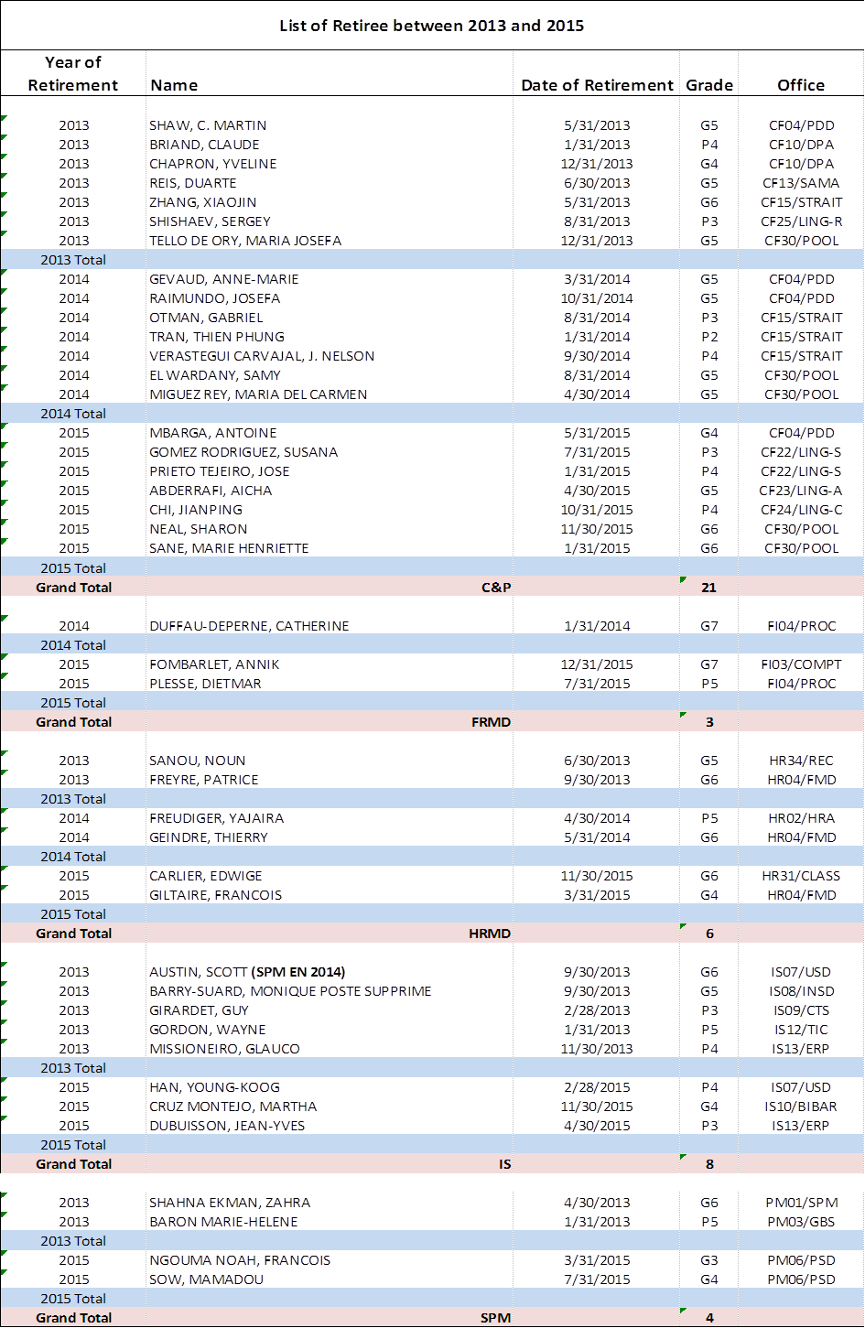

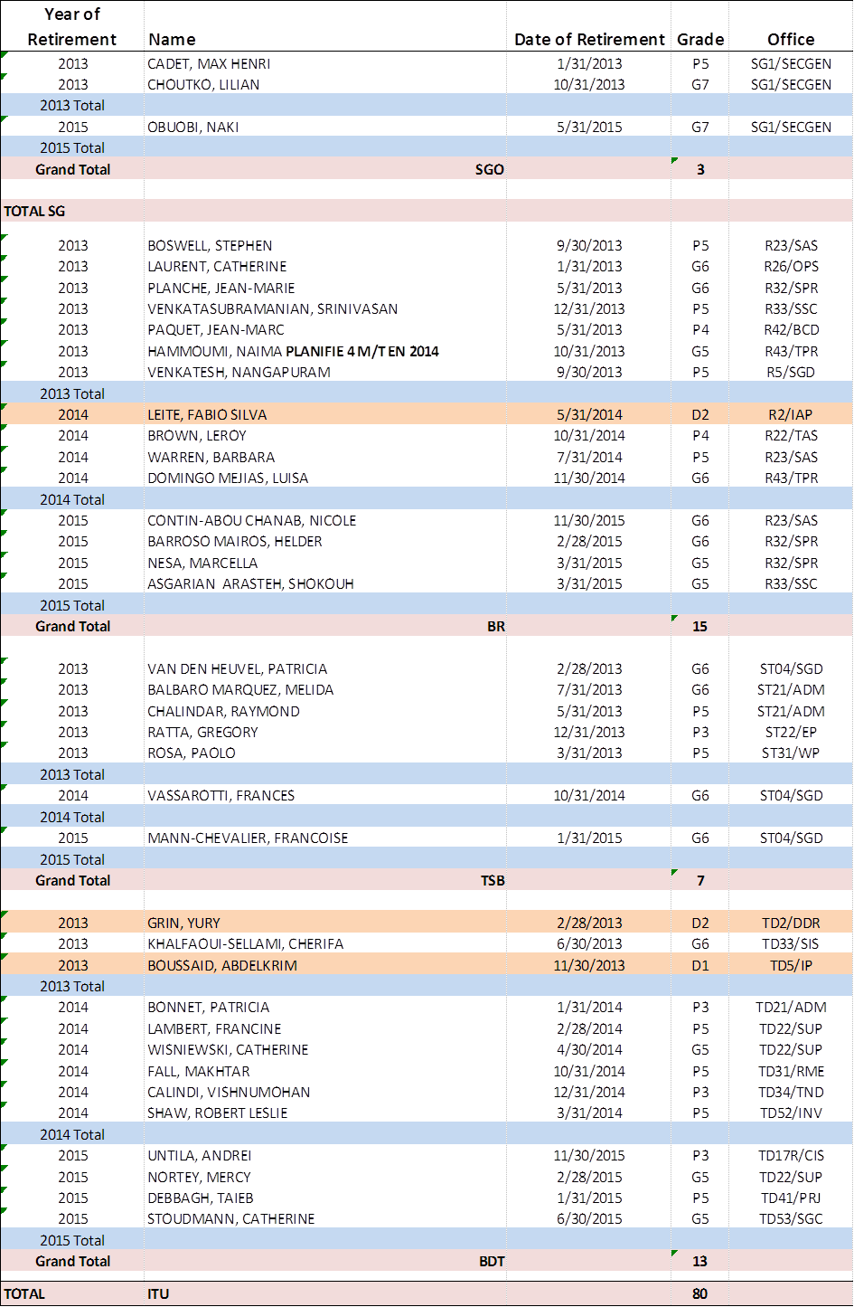

Annex 7

Annex 8

Annex 9

