 |  | Doc. CPG15(14)017 Annex IV-04
CPG15-4
Riga, Latvia 25th – 28th March 2014
Date issued: | 28th March 2014
Source: | CPG15-4
Subject: | Draft CEPT Brief on WRC-15 Agenda Item 1.4
Summary:
Proposal:

DRAFT CEPT BRIEF ON AGENDA ITEM 1.4
1.4 to consider possible new allocation to the amateur service on a secondary basis within the band 5 250-5 450 kHz in accordance with Resolution 649 (WRC-12).

ISSUE
Resolution 649 (WRC-12) invites WRC-15 to consider, based on the results of the ITU-R studies, the possibility of making an allocation of an appropriate amount of spectrum, not necessarily contiguous, to the amateur service on a secondary basis within the band 5 250-5 450 kHz.
CEPT has identified the following elements, relevant for this agenda item:
- to study spectrum requirements for a secondary allocation to the amateur service within the band 5 250-5 450 kHz;
- to conduct sharing studies on the impact to other services currently allocated in the band referred to in invites ITU R 1 and in the adjacent bands;

Preliminary CEPT position
CEPT is of the view that the existing allocations in the frequency band 5250-5450 kHz need to be protected. CEPT recognizes that the allocation of the frequency band 5 250 - 5 450 kHz or any part thereof to the amateur service on a secondary basis will be extremely complicated as shown in supporting compatibility studies

Background
WRC-12 adopted Agenda item 1.4 for WRC-15, to consider the possibility of making an allocation of an appropriate amount of spectrum, not necessarily contiguous, to the amateur service on a secondary basis within the band 5 250-5 450 kHz.
This part of the spectrum is interesting to radio amateurs because it bridges the propagation gap between 3.8 and 7.0 MHz. Particularly at higher latitudes, there are many times when the maximum usable frequency (MUF) is below 7.0 MHz, but is too far above the next lowest amateur frequency band 3.5 – 3.8 MHz for communication to be supported in that band, using typical amateur antennas and power levels. As amateur communication increasingly uses digital rather than analogue modes of emission, intersymbol distortion caused by multipath propagation becomes a more important factor, requiring an operating frequency as near as possible to the MUF.
In accordance with Radio Regulations Table of Frequency Allocations the frequency band 5250-5450 kHz is allocated to fixed and mobile (except aeronautical mobile) services on global primary basis.
The analysis of International Frequency Master Register showed that currently 17143 frequency assignments are notified in this frequency band. The location of these frequency assignments taken from TerRaQ software is shown in Fig.1.The notified frequency assignments operate mainly in the fixed, land mobile and maritime mobile services. They provide data transmission in telephone and telegraphy modes and can be used for different services including providing governmental communication, safety of navigation and communication in sparsely populated areas and in difficult to access areas.
Figure 1: Location of stations operating in the frequency band 5250-5450 kHz
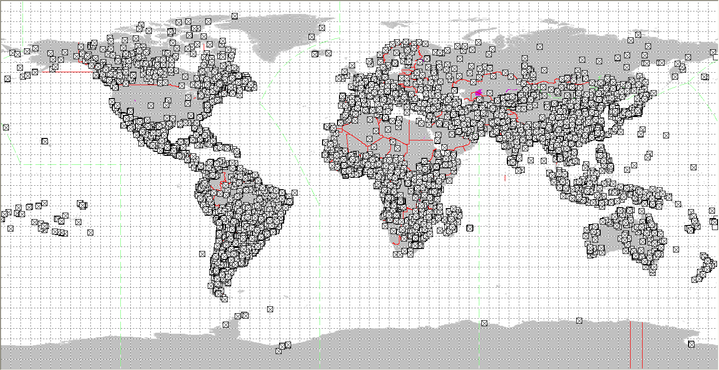
Propagation characteristics of this frequency band.
It is recognised that sky-wave propagation of as much as 10,000 km is possible on these frequencies, as per Recommendation ITU-R F.1795. Practical considerations of operating a link over such ranges depend on atmospheric noise and interference caused by stations that may be deployed several thousand kilometres from the given radio communication link.
Editor’s Note: one CEPT administration provided preliminary results of compatibility studies between proposed amateur stations and systems in the fixed service stating that compatibility between the amateur stations and fixed links appear to be quite complicated.
Sharing scenario
The compatibility studies of the stations in the amateur service with the systems in the fixed service showed that:
- for the considered transmitter power of the amateur station the protection distance required to ensure interference-free operation of the fixed link exceeds 6200 km;
- interference caused by the amateur station transmitters can result in operation failure of the fixed station link and degradation of wanted signal receiving conditions. The duration of operation failure of the fixed service link is defined by the distance between the transmitter of the amateur station and the receiver of the fixed service and their mutual location and used antenna types. At the rest of the time the interference impact from the amateur stations can lead to significant degradation of receiving conditions of the fixed service signal which result in decrease of the number of available operation modes;
- the interference impact on the fixed link operation can be partially reduced by application of directional antennae in the fixed links. However application of antennae with gain of 13.4 dB in the fixed receivers and transmitters can lead only to partial reduction of interference which is unacceptable for the fixed links at the significant time percentage.
It allows to conclude that compatibility between the amateur stations and fixed links appears to be quite complicated which is not subject to the fading conditions.
It should be noted that while considering possible methods to satisfy WRC-15 Agenda item 1.4, ITU-RWP 5A recognized that the compatibility of the stations in the amateur service with the oceanographic radars in the frequency band 5250-5275 kHz will be quite complicated therefore proposed not to consider the allocation of the frequency band 5250-5275 kHz to the amateur service.
Monitoring results.
FM PT22 monitoring results show that less than 20% of the band 5 250 – 5 450 kHz is used by stations in the fixed and mobile service, indicating that a secondary amateur allocation in this band is feasible. The monitoring results currently do not show amateur traffic.
Regulatory and procedural considerations.
For reference, the applicable portion of the Table of Frequency Allocations, including the modifications made at WRC-12, is provided below.
5 060-5 680 kHz
Allocation to services
Region 1 | Region 2 | Region 3
5 060-5 250
FIXED
Mobile except aeronautical mobile
5.133
5 250-5 275  FIXED  MOBILE except aeronautical mobile  Radiolocation 5.132A  5.133A | 5 250-5 275  FIXED  MOBILE except aeronautical mobile  RADIOLOCATION 5.132A | 5 250-5 275  FIXED  MOBILE except aeronautical mobile  Radiolocation 5.132A
5 275-5 450
FIXED
MOBILE except aeronautical mobile
5 450-5 480  FIXED  AERONAUTICAL MOBILE (OR)  LAND MOBILE | 5 450-5 480  AERONAUTICAL MOBILE (R) | 5 450-5 480  FIXED  AERONAUTICAL MOBILE (OR)  LAND MOBILE
5 480-5 680
AERONAUTICAL MOBILE (R)
5.111 5.115

5.111 The carrier frequencies 2 182 kHz, 3 023 kHz, 5 680 kHz, 8 364 kHz and the frequencies 121.5 MHz, 156.525 MHz, 156.8 MHz and 243 MHz may also be used, in accordance with the procedures in force for terrestrial radiocommunication services, for search and rescue operations concerning manned space vehicles. The conditions for the use of the frequencies are prescribed in Article 31.
The same applies to the frequencies 10 003 kHz, 14 993 kHz and 19 993 kHz, but in each of these cases emissions must be confined in a band of ± 3 kHz about the frequency. (WRC-07)
5.115 The carrier (reference) frequencies 3 023 kHz and 5 680 kHz may also be used, in accordance with Article 31, by stations of the maritime mobile service engaged in coordinated search and rescue operations. (WRC 07)
5.132A Stations in the radiolocation service shall not cause harmful interference to, or claim protection from, stations operating in the fixed or mobile services. Applications of the radiolocation service are limited to oceanographic radars operating in accordance with Resolution 612 (Rev.WRC-12). (WRC-12)
5.133 Different category of service: in Armenia, Azerbaijan, Belarus, the Russian Federation, Georgia, Kazakhstan, Latvia, Lithuania, Moldova, Uzbekistan, Kyrgyzstan, Tajikistan, Turkmenistan and Ukraine, the allocation of the band 5 130-5 250 kHz to the mobile, except aeronautical mobile, service is on a primary basis (see No. 5.33). (WRC-12)
5.133A Alternative allocation: in Armenia, Austria, Belarus, Moldova, Uzbekistan and Kyrgyzstan, the frequency bands 5 250-5 275 kHz and 26 200-26 350 kHz are allocated to the fixed and mobile, except aeronautical mobile, services on a primary basis. (WRC-12)

List of relevant documents
ITU-Recommendations:
Recommendation ITU-R F.162-3 Use of directional transmitting antennas in the fixed service operating in bands below 30 MHz;
Recommendation ITU-R F.240-7 Signal-to-interference protection ratios for various classes of emission in the fixed service below about 30 MHz;
Recommendation ITU-R F.339-7 Bandwidths, signal-to-noise ratios and fading allowances in complete systems;
Recommendation ITU-R SM.1541-4 Unwanted emissions in the out-of-band domain;
Recommendation ITU-R M.1732-1 Characteristics of systems operating in the amateur and amateur-satellite services for use in sharing studies;
Recommendation ITU-R F.1761 Characteristics of HF fixed radiocommunication systems;
Recommendation ITU-R F.1762 Characteristics of enhanced applications for high frequency (HF) radiocommunication systems;
Recommendation ITU-R F.1821 Characteristics of improved digital high frequency (HF) radiocommunication systems ;
Recommendation ITU-R M.1795 Technical and operational characteristics of SF/HF land mobile systems;
Recommendation ITU-R P.533-11 Methodology for prediction of HF-links operational characteristics;
ITU-Reports:
Working Document towards Preliminary Draft New Report ITU-R M.[5 MHZ CHAR], “Characteristics of amateur radio stations in the range 5 250-5 450 kHz for sharing studies”.
Working Document towards Preliminary Draft New Report ITU-R М.[AMATEUR]
Working Document towards Preliminary Draft New Report ITU-R M.[HF-SPECTRAL OCCUPANCY]
Working Document towards the Draft CPM text for WRC-15 Agenda item 1.4
Other ITU documents:
Updated information/documentation on the ITU-R Preparatory Studies for WRC-15 are available at http://www.itu.int/ITU-R/go/rcpm-wrc-15-studies.
Amateur and amateur-satellite services Handbook
Work plan for WRC-15 Agenda item 1.4
Resolution 649 (WRC-12)
CEPT and/or ECC Documentation (Decisions, Recommendations, Reports):
EU Documentation (Directives, Decisions, Recommendations, other), if applicable:

Actions to be taken
- Develop spectrum requirements for the amateur service;
- Conduct compatibility studies based on characteristics, protection criteria and interference scenario’s;
- Develop the CEPT position for this Agenda Item
- Provide additional information on regulatory and operational aspects of amateur stations and licenses
- Assess the final results of the FM-22 to perform monitoring campaign in the band 5 250 – 5 450 kHz.

Relevant information from outside CEPT

European Union (date of proposal)

Regional telecommunication organisations:
APT Preliminary view (28 November 2013)
APT Members support relevant ITU-R studies on this issue.
APT Members are of the view that the protection of the services to which the band is currently allocated and their future development should be ensured, through appropriate technical, operational and regulatory measures, where required. No constraints should also be imposed upon existing services and their future development in the frequency band 5 250-5 450 kHz

ATU (January 2014)
To support the ongoing studies, and take a view after considering the results of the studies and to take into account the protection of existing services in the band

ASMG Position (1 December 2013)
The band 5250-5450 MHz is heavily used in the Arab countries.
Follow up the current studies within activities of WP 5A and wait for studies results

CITEL Preliminary views (4 December 2013)
Canada
The amateur service requires access to spectrum in the vicinity of 5 300 kHz to carry out reliable emergency and disaster-relief communications;
An allocation to the amateur service, on a secondary basis for one or more segments of contiguous spectrum in the range 5 250 kHz to 5 450 kHz, taking into account the results of ITU-R studies, could satisfy this requirement;
Supports the work of WP 5A on sharing, compatibility and other studies conducted under this agenda item.

Brazil
Recognizes the value of ongoing experiments with Amateur Service on the 5 250 to 5 450 kHz frequency range (promoted by national administrations under the provisions of section II, Article 4.4 of the Radio Regulations);
Supports ongoing and future ITU-R sharing studies to determine appropriate compatibility criteria.

RCC Preliminary position (1 November 2013)
The RCC Administrations do not support the allocation of the frequency band 5250 – 5450 kHz or part of this band to the amateur service on the secondary basis, due to its intense use by fixed / land mobile services and oceanographic radars, as well as unacceptable interference from amateur stations to the existing systems that is confirmed by the studies.
The RCC Administrations consider that during studies of possible additional allocations to the amateur service in the frequency band 5250-5450 kHz it is necessary to take into account the need for protection of the FS and MS systems in the frequency band 5250 – 5450 kHz, oceanographic radars in the frequency band 5250-5275 kHz and for protection of systems, which operate in adjacent frequency bands.

International organisations
IARU (29 March 2013)
The addition of a new allocation within the band 5250 – 5450 kHz is a high priority for the amateur service.
IARU (29 January 2014)
Sharing practice
A number of administrations allow amateur communication in the band 5 250 – 5 450 kHz under article 4.4.
- Several administrations allow amateur operations in the full band 5 250 – 5 450 kHz
- Other administrations allow amateur traffic in that part of the band not used by primary users.
- Other administrations allow amateur traffic on dedicated channels
Amateur use of the band 5 250 – 5 450 kHz under the provision of article 4.4 has not led to reports of harmful interference
Civil/Military sharing
IARU is of the opinion that Co-primary services AMATEUR and FIXED and MOBILE (eam) successfully share the band 3 500 – 3 800 kHz and in the band 10100 - 10150 kHz where the amateur service has a secondary status.
Sharing scenario
Should CEPT decide for an amateur allocation in the band 5 250 – 5 450 kHz national administrations would have optimal flexibility by a secondary allocation for the amateur service in the full band 5 250 – 5 450 kHz.

IATA

ICAO (28 November 2012)
Preliminary Position
To ensure that any allocation made to the amateur service shall not cause harmful interference to the operation of aeronautical systems operating under the allocation to the aeronautical mobile (R) service in the adjacent frequency band 5 450 – 5 480 kHz in Region 2.

IMO
NATO Preliminary position (27 January 2014)
NATO does not support a worldwide secondary allocation to the Amateur service within the 5 250-5 450 kHz band, which are currently exclusive allocations to the FIXED and MOBILE, except aeronautical mobile service
SFCG

WMO and EUMETNET

Regional organisations

ESA (date of proposal)

Eurocontrol (date of proposal)

OTHER INTERNATIONAL AND REGIONAL ORGANISATIONS
EBU (date of proposal)

GSMA (date of proposal)

