|  |  |  |
| --- | --- | --- |
|  | | Doc. CPG(17)011 Annex IV-04 |
| CPG19-3 | | |
| Vienna, Austria, 14th - 17th March 2017 | | |
|  | |  |
| Date issued: | 17th March 2017 | |
| Source: | CPG19-3 minutes | |
| Subject: | Draft CEPT Brief on WRC-19 Agenda Item 1.4 | |
|  | | |
| Summary: | | |
|  | | |
| Proposal: | | |

DRAFT CEPT BRIEF ON AGENDA ITEM 1.4

1.4 to consider the results of studies in accordance with Resolution 557 (WRC-15), and review, and revise if necessary, the limitations mentioned in Annex 7 to Appendix 30 (Rev.WRC‑12), while ensuring the protection of, and without imposing additional constraints on, assignments in the Plan and the List and the future development of the broadcasting-satellite service within the Plan, and existing and planned fixed-satellite service networks;

# ISSUE

Resolution 557 (WRC-15) “Consideration of possible revision of Annex 7 to Appendix 30 of the Radio Regulations” invites:

to conduct studies on, review, and identify possible revisions to, if necessary, the limitations mentioned in Annex 7 to Appendix 30 (Rev.WRC-12), while ensuring the protection of, and without imposing additional constraints on, assignments in the Plan and in the List and the future of BSS networks mentioned in recognizing c) and existing and planned FSS networks mentioned in recognizing d).

# Preliminary CEPT position

CEPT reaffirms, inter alia considering that 74 Administrations are having frequency assignments within the allowable portions of Table 1 of Annex 7 to Appendix 30 (Rev.WRC‑12), that it is necessary to ensure the protection of, and not impose additional constraints on, assignments in the Plan and the List and the future development of the broadcasting-satellite service within the Plan, and existing and planned fixed-satellite service networks. In order to fulfil the requirements above, inter alia consideration of compatibility studies between BSS assignments subject to Appendix 30 (Rev.WRC-12) within Regions 1 and 3 is required for the specific cases mentioned in noting c) and recognising b) of Resolution 557 (WRC-15).

CEPT supports the deletions of the limitations:

* Limitation A1 (part a) (No assignments in the Region 1 List further west than 37.2°W)
* Limitation A2a (No modification in the Region 2 Plan further east than 54°W)
* Limitation A2b (No modification in the Region 2 Plan further east than 44°W)

CEPT considers the possible deletions of the limitations:

* Limitation A1 (part b) (No assignments in the Region 1 List further east than 146°E)Limitation A2c (No modification in the Region 2 Plan further west than 175.2°W)

CEPT will continue to study the possible deletion of other limitations:

# Background

The Annex 7 to Appendix 30 (Rev. WRC-12) contains several orbital position limitations applicable to the 3 Regions applicable to specific sub-band of the band 11.7-12.7 GHz. To simplify the readiness of this CEPT Brief the same nomenclature as agreed by WP4A was retained as shown in Table 1 bellow.

Table 1: Annex 7 to Appendix 30 (Rev. WRC-12) limitations

|  |  |  |  |  |  |
| --- | --- | --- | --- | --- | --- |
| Annex 7 Limitation | Region and Service of interfering assignments | Region and Service of impacted assignments | Frequency band, GHz | Limitation description | Associated regulatory text |
| A1  (part a) | Region 1  BSS | Region 2  FSS (Atlantic) | 11.7-12.2 | No assignments in the Region 1 List further west than 37.2°W | Section A 1) |
| A1  (part b) | Region 2  FSS (Pacific) | No assignments in the Region 1 List further east than 146°E |
| Region 3  BSS subject to Appendix 30 |
| A2a | Region 2  BSS | Region 1  FSS (Atlantic) | 12.5-12.7 | No modification in the Region 2 Plan further east than 54°W | Section A 2) a) |
| A2b | Region 1  BSS subject to Appendix 30 | 12.2-12.5 | No modification in the Region 2 Plan further east than 44°W | Section A 2) b) |
| A2c | Region 3  FSS | 12.2-12.7 | No modification in the Region 2 Plan further west than 175.2°W | Section A 2) c) |
| Region 1  BSS | 12.2-12.5 |
| Region 1  FSS (Pacific) | 12.5-12.7 |
| A3  (part a) | Region 1  BSS | Region 2  FSS | 11.7-12.2 | No assignments in the Regions 1 & 3 List outside specific allowable portions of the orbital arc between 37.2°W and 10°E (see Table 2) | Section A 3) |
| A3  (part b) | Max. e.i.r.p. of 56 dBW for assignments in the Regions 1 & 3 List at specific allowable portions of the orbital arc between 37.2°W and 10°E (see Table 3) |
| A3  (part c) | Max. power flux density of -138 dB(W/(m2·27 MHz)) at any point in Region 2 by assignments in the Regions 1 & 3 List located at 4°W and 9°E |
| B | Region 2  BSS | Region 2  BSS | 12.2-12.7 | Required agreement of administrations having to space stations in the same cluster when an administration may locate a satellite within this cluster | Section B |

Table 2: Allowable portions of the orbital arc between 37.2° W and 10°E for assignments in the Regions 1 & 3 Plan and List

|  |  |  |  |  |  |  |  |  |  |  |
| --- | --- | --- | --- | --- | --- | --- | --- | --- | --- | --- |
| Allowable orbital position | | | | | | | | | | |
| 37.2°W  to  36°W | 33.5°W  to  32.5°W | 30°W  to  29°W | 26°W  to  24°W | 20°W  to  18°W | 14°W  to  12°W | 8°W  to  6°W | 4°W | 2°W  to  0°E | 4°E  to  6°E | 9°E |

Table 3: Portions of the orbital arc between 37.2° W and 10°E for assignments in the Regions 1 & 3 List with Max. e.i.r.p. of 56 dBW

|  |
| --- |
| Orbital position with Max. e.i.r.p. of 56 dBW limitation |
| ] 36.8°W ; 36°W ] |
| ] 33.5°W ; 32.5°W ] |
| ] 30°W ; 29°W ] |
| [ 26°W ; 25.2°W [ |
| ] 24.8°W ; 24°W ] |
| [ 20°W ; 19.2°W [ |
| ] 18.8°W ; 18°W ] |
| [ 14°W ; 13.2°W [ |
| ] 12.8°W ; 12°W ] |
| [ 8°W ; 7.2°W [ |
| ] 6.8°W ; 6°W ] |
| [ 2°W ; 1.2°W [ |
| ] 0.8°W ; 0°E ] |
| [ 4°E ; 4.8°E [ |
| ] 5.2°E ; 6°E ] |

Before make the decision about any action (deletion/revision) of the current limitation mentioned above, the detailed study should be done. To carry out these investigations must be identified:

* technical characteristics of FSS systems, which may operate in the 11.7-12.2 GHz frequency bands in Region 2, in the 12.2-12.5 GHz frequency bands in Region 3 and in the 12.5-12.7 GHz frequency bands in Regions 1 & 3.
* technical characteristics of BSS systems, which may operate in the 11.7-12.2 GHz frequency bands in Regions 1 & 3, in the 12.2-12.5 GHz frequency bands in Regions 1 & 2 and in the 12.5-12.7 GHz frequency bands in Region 2, with a particular attention to BSS systems within the orbital arc 37.2°W – 9°E.

Working Party 4A (WP 4A) is the responsible group for the studies on agenda item 1.4. During its latest meeting (28 September – 6 October 2016, Geneva) WP 4A updated the skeleton of Working Document towards a Preliminary Draft New Report (PDNR) ITU-R BO.[AP30.ANNEX7] to provide an assessment for possible revisions of the limitations given in Table 1. It was also agreed that BSS not subject to RR Appendix 30 (12.5-12.7 GHz), in Region 3, is not the subject of consideration in accordance with Resolution 557 (WRC-15). The main discussion held about whether a review of the compatibility between BSS assignments subject to Appendix 30 RR within Regions 1 and 3 is inside or outside the scope of Resolution 557 (WRC-15), when considering a possible review of limitation A3 (part a).

Limitations A1, A2a, A2b and A2c were developed long time ago to facilitate sharing between Regions taken into account the state of the Art at this date. Since the adoption of such limitations, technologies were really improved and it’s more and more convenient to find the same satellite operating full or part of the 11.7-12.7 GHz band simultaneously on different Regions. In addition, regulatory sharing criteria to protect all services in the frequency band 11.7-12.7 GHz in all Regions are in place and are fully applicable if WRC-19 will decide to delete Limitations A1, A2a, A2b and A2c. Furthermore, in cases A1 (part a), A2a and A2b simultaneously operations on same frequency band are benefit from the geographical separation that exists between the Regions where these limitations apply. In cases A1 (part b) and A2c further analysis is required to confirm the deletion.

In conclusion, CEPT has decided to support the deletion of Limitations A1 (part A), A2a, A2b and is considering the possible deletion of Limitations A1 (part B) and A2c, taking into account that they will permit a better utilisation of the orbit spectrum resource without creating undue constraints to all services in the band 11.7-12.7 GHz in all Regions.

Section 3 of Annex 7 defines orbital position, e.i.r.p and PFD limitations in the orbital arc 37.2°W – 10°E in the band 11.7-12.2 GHz, identified as Limitations A3 in Table 1. These limitations were developed to preserve access to the geostationary-satellite orbit by the Region 2 fixed-satellite service in the band 11.7-12.2 GHz, and has resulted in a stable regulatory regime with implications on assignments in the Plan and the List. The limitations state that the orbital position associated with any proposed new or modified assignment in the Regions 1 and 3 List of additional uses shall lie within one of the portions of the orbital arc listed in Table 2.

CEPT recognises that in considering the modification or deletion of Limitations A3, satellite networks implementing antenna sizes smaller than 60cm in orbital positions listed in Table 2 must be protected. However, additional studies are required to decide the protection method to be applied: PFD mask, keep the Limitations A3, etc. Such studies should take into account the existing level of protection of those satellite networks. Furthermore impact on FSS Region 2 needs to be assessed if any modification or deletion is made to Limitation A3. Also, additional studies are necessary to decide which satellite networks, with antenna sizes smaller than 60cm, must be protected: e.g. only the satellite networks implemented before last day of WRC19. Understanding by “implemented” in this case, those satellite networks that have submitted a part B and have been brought into use.

## Possible operations with current Table 1 of Annex 7 for specific Cases

As can be seen above, Table 2 contains orbital intervals in which proposed new or modified assignments in the List are allowed. Taking into account the orbital limitations referred to above, and considering an example where a pair of assignments are having a geocentric separation according to Table 2, it could be possible under the current regulatory framework to implement smaller antenna sizes than the standard 0.60 m antenna size for some specific cases. For such specific cases, additional studies should be conducted to possibly identify, if such specific protection level is required. In Figure 1 below, the off-axis antenna gains (following Recommendation ITU-R BO.1213 reference pattern) of antenna sizes 0.60 m, 0.55 m, 0.50 m, 0.45 m and 0.40 m are plotted vs geocentric orbital separation (frequency 11.7 GHz and efficiency of 65%).

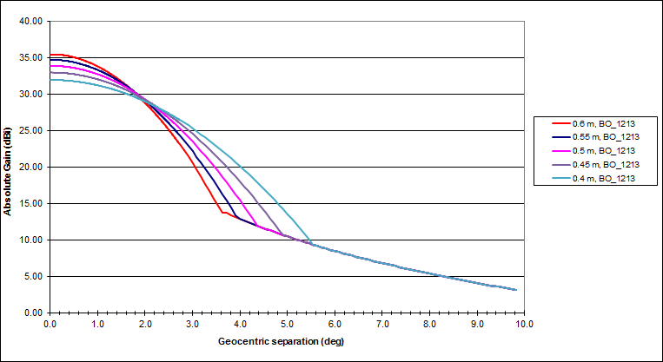

Figure 1: Off-axis antenna gain of antenna dimensions from 0.60 m to 0.40 m vs geocentric orbital separation

As can be seen in Figure 1 above, the off-axis antenna gain for antennas with diameter below 0.60 m are the same as for a 0.60 m antenna for orbital separation greater than 4.1˚ for 0.55 m antenna up to 5.5° for 0.40 m antenna.

WP 4A (28 September – 06 October 2016, Geneva) didn’t come to compromise whether compatibility studies between BSS assignments subject to Appendix 30 within Regions 1 and 3 are inside or outside of the scope of studies under Resolution 557 (WRC-15). Two views including relevant justifications were included in the Working Document towards PDNR ITU-R BO.[AP30.ANNEX7].

## Potential impact to assignments in the List within the allowable portions of Table 1 to Annex 7 of RR Appendix 30

The second WP 4A meeting of 2016 received a contribution (document 4A/145) that examined the potential impact to assignments in the List within the allowable portions of Table 1 to Annex 7 of Appendix 30 with earth stations having antenna size of 0.40 m for the scenario when Table 1 to Annex 7 would be removed.

Table 5 below contains a summary of document 4A/145 of the potential additional interference from two adjacent satellites that an incumbent is forced to accept, for each possible slots in Table 1 of Annex 7 of RR Appendix 30 for a network operating with earth stations with antenna size 40 cm, if current orbit limitations in Annex 7 are removed without additional specific measures.

Table 5: Summary of analysis of potential impact to assignments in the List within the allowable portions of Table 1 to Annex 7 of RR Appendix 30 for earth stations   
with antenna size 40 cm

|  |  |  |  |  |  |  |  |  |  |  |  |
| --- | --- | --- | --- | --- | --- | --- | --- | --- | --- | --- | --- |
| Orbital arc | 37.2°W to 36°W | 33.5°W to 32.5°W | 30°W to 29°W | 26°W to 24°W | 20°W to 18°W | 14°W to 12°W | 8°W to 6°W | 4°W | 2°W to 0°E | 4°E to 6°E | 9°E |
| Additional interference towards Sat. A (dB) | Up to 4.14 dB | Up to 0.79 dB | Up to 1.1 dB | Up to 2.4 dB | Up to 5.35 dB | Up to 5.35 dB | Up to 7.85 dB | 0 dB | Up to 7.85 dB | Up to 5.67 dB | 0 dB |

The analysis demonstrates an increase, by up to 7.85 dB, of the interference level received by an earth station with antenna size 40 cm that an incumbent is forced to accept in case WRC-19 would decide to remove the Annex 7 limitation A3a (section A3 of Annex 7 of RR Appendix 30) if no additional specific measures would be considered. This result was obtained considering only 2 interfering satellites, and it is recognised that the interference will be higher if more than 2 interfering satellites are to be considered.

As the additional interference levels considered in this study would be the maximum levels allowable according to PFD mask of section 1 of Annex 1 of RR Appendix 30, administrations would have to accept these interferences and their wanted networks would need to be designed to accept these levels of interference.

Therefore, there is a risk that an existing satellite network implementing earth stations with antenna size 40 cm under the current regulatory regime defined by current orbit limitations in Annex 7, will not be able to continue its operation due to the additional level of interference that an incumbent is forced to accept, unless no additional specific measures are considered. Such situation would be in contradiction to recognizing b) of Resolution 557 (WRC-15), stating: “BSS networks implemented in accordance with the current provisions of Annex 7 to Appendix 30 shall continue to be protected”.

In conclusion, additional specific measures are needed in order not to impose additional constraints on implemented BSS networks if Annex 7 limitation A3a is revised by WRC-19.

## satellite networks of Region 1&3 BSS AP30 located within the allowable portions of Table 1 of Annex 7 of RR Appendix 30 for which has implemented or planning to implement assignments with antenna sizes smaller than 0.60 m

As of SPS database of BR IFIC 2836, there are 6 satellite network filings submitted with antenna sizes smaller than 0.6m, in 3 different orbital locations. As of February 2017 one of them is implemented.

# List of relevant documents

ITU-Documentation:

* Recommendation ITU-R BO.1697, “Power flux-density values in the band 11.7‑12.7 GHz and associated calculation methodology which may be used for bilateral coordination when the power flux-density values in § 3 of Annex 1 to Appendix 30 or Annex 4 to Appendix 30 of the Radio Regulations are exceeded“, adopted in 2005.

1. This Recommendation further expands upon the information in Annex 6 to Appendix 30, and generally breaks down the pfd levels in Annexes 1 and 4 for inter-regional sharing by wanted earth station size.

* Report ITU-R BO.809, “Inter-regional sharing of the 11.7 to 12.75 GHz frequency band between the broadcasting-satellite service and the fixed-satellite service“, adopted in 1990.
* Doc. 4A/196, Annex 05 Working document towards a Preliminary Draft Report ITU-R BO.[AP30.ANNEX7] “Assessment on limitations mentioned in Annex 7 to RR Appendix 30 (Rev.WRC-12) in the 11.7-12.7 GHz band for the GSO broadcasting-satellite service in all Regions“
* Doc. 4A/196, Annex 26 Work plan for WRC-19 Agenda item 1.4
* Doc. 4A/145, Proposed revisions to the working document on WRC-19 agenda item 1.4 ITU-R BO.[AP30.ANNEX7] - Potential impact to assignments in the Plan and list within the allowable portions of Table 1 to Annex 7 of Appendix 30

CEPT and/or ECC Documentation:

* ERC Decision ERC/DEC/(00)08 of 19 October 2000 on the use of the band 10.7 - 12.5 GHz by the fixed service and Earth stations of the broadcasting-satellite and fixed-satellite Service (space-to-Earth)

EU Documentation (Directives, Decisions, Recommendations, other), if applicable

# Actions to be taken

To identify technical characteristics of FSS & BSS systems affected

To prepare proposals to preliminary draft new Report ITU-R BO.[AP30.ANNEX7], if necessary

To prepare proposals to revision of Recommendation ITU-R BO.1697, if necessary

To prepare proposals to the draft CPM Report

To prepare proposals to ECP

To asses impact on FSS Region 2 if any modification or deletion to Limitation A3 is made.

To further study

Limitation A3 (part a) (No assignments in the Regions 1 & 3 List outside specific allowable portions of the orbital arc between 37.2°W and 10°E)

Limitation A3 (part b) (Max. e.i.r.p. of 56 dBW for assignments in the Regions 1 & 3 List at specific allowable portions of the orbital arc between 37.2°W and 10°E)

Limitation A3 (part c) (Max. power flux density of -138 dB(W/(m2·27 MHz)) at any point in Region 2 by assignments in the Regions 1 & 3 List located at 4°W and 9°E)

Limitation B (Required agreement of administrations having space stations in the same cluster when an administration may locate a satellite within this cluster)

# Relevant information from outside CEPT (examples of these are below)

## European Union (date of proposal)

## Regional telecommunication organisations

APT (date of proposal)

ATU (date of proposal)

Arab Group (date of proposal)

CITEL (December 2016)

Preliminary Views

USA:

With respect to Agenda Item 1.4, the United States supports the studies in accordance with Resolution 557 (WRC-15).  Based upon successful conclusion of these activities, the United States supports the review and revision, as necessary, of the limitations of Annex 7 to Appendix 30 (Rev.WRC‑12), while ensuring the protection of existing assignments in the Plan and the List and the future development of BSS service within the Plan, and existing and planned fixed-satellite service networks.

RCC (16 September, 2016)

The RCC Administrations support studies on possible revisions to the limitations in Annex 7 to Appendix 30 (Rev. WRC-12), while ensuring the protection of, and without imposing additional constraints on, assignments in the Plan and in the List of BSS and FSS networks.

The RCC Administrations consider that the proposed revisions of criteria and provisions of Appendix 30 (Rev. WRC-12), differing from Appendix 7, are beyond the scope of the studies in accordance with Resolution 557 (WRC-15).

## International organisations

IATA (date of proposal)

ICAO (date of proposal)

IMO (date of proposal)

SFCG (date of proposal)

WMO and EUMETNET (date of proposal)

## Regional organisations

ESA (date of proposal)

Eurocontrol (date of proposal)

## OTHER INTERNATIONAL AND REGIONAL ORGANISATIONS

EBU (date of proposal)

GSMA (date of proposal)

CRAF (December 2016)

The frequency bands under consideration are sufficiently far away from RAS allocations and the revision of Annex 7 to Appendix 30 will not concern CRAF.

1. methodology to develop PFD mask
   1. methodology used to develop the PFD limits of Annex 1 to Appendix 30

A summary of the parameters and typical e.i.r.p. levels extracted from Annex 6 to Appendix 30 and used to develop Annex 1 to Appendix 30 are presented in Table 5 below.

Table 5: Summary of technical parameters for establishing pfd limits to Section 1 of Annex 1 to Appendix 30

|  |  |  |  |  |  |
| --- | --- | --- | --- | --- | --- |
| Diameter | 0.6 | 0.8 | 1.2 | 2.4 | m |
| Frequency | 11700.0 | 11700.0 | 11700.0 | 11700.0 | MHz |
| Speed of light | 299792458.0 | 299792458.0 | 299792458.0 | 299792458.0 | m/s |
| Efficiency | 0.65 | 0.65 | 0.65 | 0.65 | - |
| Gain, G_max | 35.5 | 38.0 | 41.5 | 47.5 | dBi |
| Receiving earth station noise temperature | 110.0 | 125.0 | 150.0 | 150.0 | K |
| Total link noise temperature | 174.0 | 198.0 | 238.0 | 238.0 | K |
| DeltaT/T criteria | 0.06 | 0.06 | 0.06 | 0.06 | - |
| I/N criteria | -12.2 | -12.2 | -12.2 | -12.2 | dB |
| Distance | 35786.0 | 35786.0 | 35786.0 | 35786.0 | km |
| Free-space loss | 204.9 | 204.9 | 204.9 | 204.9 | dB |
| Bandwidth | 27.0 | 27.0 | 27.0 | 27.0 | MHz |
| e.i.r.p. (edge of coverage) | 51.0 | 48.5 | 45.0 | 39.0 | dBW |
| C/N | 13.5 | 12.9 | 12.1 | 12.1 | dB |
| C/I_protection | 25.7 | 25.1 | 24.3 | 24.3 | dB |
| Spreading loss | 162.1 | 162.1 | 162.1 | 162.1 | dB/m2 |
| pfd (edge of coverage) | -111.1 | -113.6 | -117.1 | -123.1 | dBW/m2*27MHz |
| Allowed pfd at 0° | -136.7 | -138.7 | -141.4 | -147.4 | dBW/m2*27MHz |

The allowed pfd at a specific orbital separation can be derived as follows:

$C/I={PFD}_{wanted}+G_{max}-\left({PFD}_{unwanted}+G_{φ}\right)$ (1)

or equivalently,

${PFD}_{unwanted}={PFD}_{wanted}-C/I+\left(G_{max}-G_{φ}\right)$ (2)

Substituting C/I with C/I_protection, the allowed pfd is:

${PFD}_{allowed}={PFD}_{wanted}-{C/I}_{protection}+\left(G_{max}-G_{φ}\right)$ (3),

where G_φ is the receiver off-axis antenna gain at a given topocentric angle φ.

The allowed pfd, calculated using formula (3) based on the parameters listed in Table 5, as a function of geocentric orbital separation θ (by using average topocentric geocentric conversion φ = 1.1*θ), can be found in Figure 2. The current pfd limit in Section 1 of Annex 1 to Appendix 30 is plotted for verification (dashed line in green colour).

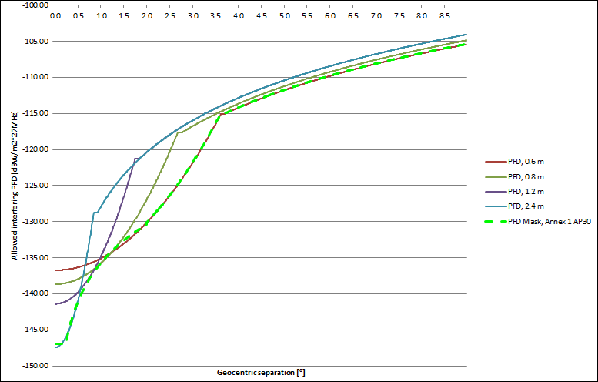

Figure 2: Pfd mask considering antenna sizes from 0.60 m and larger

* 1. example of PFD mask considering antenna size smaller than 60 cm, using the methodology of section A1.1

Following the same principle as Table 5 above, Table 6 lists parameters and typical e.i.r.p. levels for a system considering, for example, an antenna size of 0.40 m.

Table 6: Summary of technical parameters for establishing pfd limits for antenna size of 0.40 m

|  |  |  |
| --- | --- | --- |
| Diameter | 0.4 | m |
| Frequency | 11700.0 | MHz |
| Speed of light | 299792458.0 | m/s |
| Efficiency | 0.65 | - |
| Gain, G_max | 31.9 | dBi |
| Receiving earth station noise temperature | 110.0 | K |
| Total link noise temperature | 174.0 | K |
| DeltaT/T criteria | 0.06 | - |
| I/N criteria | -12.2 | dB |
| Distance | 35786.0 | km |
| Free-space loss | 204.9 | dB |
| Bandwidth | 27.0 | MHz |
| e.i.r.p. (edge of coverage) | 54.5 | dBW |
| C/N | 13.5 | dB |
| C/I_protection | 25.7 | dB |
| Spreading loss | 162.1 | dB/m2 |
| pfd (edge of coverage) | -107.5 | dBW/m2*27MHz |
| Allowed pfd at 0° | -133.2 | dBW/m2*27MHz |

Similarly as in Section A1.1, the resulting allowed pfd limit (calculated using formula (3), and based on the parameters listed in Table 6 at a specific geocentric orbital separation is shown in Figure 3:

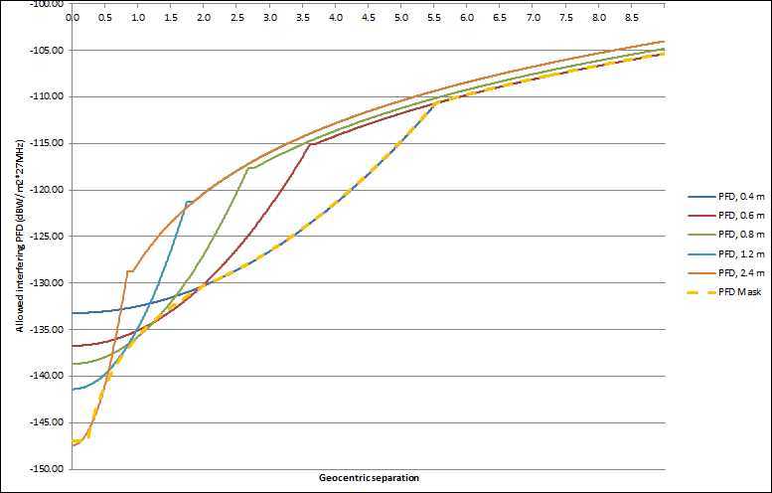

Figure 3: Pfd mask considering antenna sizes from 0.40 m and larger, using methodology of section A1.1

The dashed yellow line in Figure 3 could be expressed as:

–147 dB(W/(m^2 · 27 MHz)) for 0° ≤ θ < 0.23°

–135.7 + 17.74 log θ dB(W/(m^2 · 27 MHz)) for 0.23° ≤ θ < 1.96°

–133.2 + 0.74 θ^2 dB(W/(m^2 · 27 MHz)) for 1.96° ≤ θ < 5.53°

–129.2 + 25 log θ dB(W/(m^2 · 27 MHz)) for 5.53° ≤ θ < 9°