European Telecommunications Standards Institute | European Conference of Post and Telecommunications, Electronic Communications Committee
CEPT ECC/ETSI Officials meeting #16  Brussels, Belgium, 08-09 October 2012 | ECC-ETSI-16(12)04

Source: | ECO
Date: | 02 October 2012
Title: | Update of ECC-ETSI process depiction

European process of standardisation and regulation for radiocommunications devices and systems – cooperation between CEPT and ETSI

This paper on the European process of standardisation and regulation for radiocommunications devices and systems has the objective to describe the current processes. It has been developed jointly by the CEPT Electronic Communications Committee (ECC) and ETSI.
In case of discrepancy at some point in time between the procedures described here and those in the internal ECC or ETSI working procedures (e.g. the ECC Rules of Procedure, the ETSI Directives), the internal working procedures shall prevail.
A MoU has been agreed between ETSI and the ECC for co-operation in the development of their interrelated respective deliverables.
- One purpose of the MoU is to make sure that ECC and ETSI deliverables do not contradict each other: ETSI produces System Reference documents (SRdoc)
- ECC carries out sharing studies
- The results of these sharing studies should be mutually acceptable
- The results should be implemented consistently by both parties in ECC deliverables and ETSI Harmonized Standards
The details of these processes are described in steps (1 to 18), as illustrated in the attached Annex (flow diagram). The boxes above and below the dotted line across the page in the annex show ETSI and CEPT activities respectively:
1. The process is normally started in an ETSI technical group in response to an industry demand. A work item is created and considered for adoption in accordance with clause 1.6 of the ETSI Technical Working Procedures which are part of the ETSI Directives. The ETSI work programme is updated accordingly (http://webapp.etsi.org/workprogram/SimpleSearch/QueryForm.asp);
1'. Although a proposal for new or revised radiocommunications devices/systems is normally initiated through ETSI as shown in box 1 , sometimes it could also happen that such a proposal is first presented within the ECC family, typically within the ECC Working Group Frequency Management (WG FM). In such cases, WG FM informs ETSI TC ERM about the proposed new work item and advises the promoter of new system to initiate development of a European standard through the ETSI mechanisms;
2. If the new proposal does not involve a demand for a new spectrum allocation and when no sharing or compatibility issues exist, e.g. if there is already a frequency allocation for the application in question or the revision of the standard does not lead to changes in the sharing parameters, then steps 3 & 4 are not relevant, and the process continues at step 5;
3. If there is a sharing or compatibility problem or when a new spectrum allocation is required, then the originating ETSI technical group generates a SRdoc describing the RF characteristics and any RF compatibility issues as detailed in ETSI EG 201 788. In addition, if the proposal of revision to a standard or of an existing SRdoc leads to changes in the sharing parameters, the proposal is sent to ETSI TC ERM;
4. The information for CEPT (i.e. SRdoc, proposal, Liaison Statement) is coordinated within ETSI by ETSI TC ERM, which is responsible for interfacing with CEPT. TC ERM sends the resulting SRdoc to CEPT for consideration. Occasionally, TC ERM may delegate responsibility to other groups to send documentation to CEPT.
5. The ETSI technical group develops the standard and handles the deliverable in accordance with the ETSI Technical Working Procedures (clause 2.2.1 is applicable for an EN and clause 2.2.2 for an EN (telecommunications series) qualified as a Harmonized Standard). Inputs from results of related compatibility studies and ECC regulations in CEPT are duly taken into account in this drafting process in order to avoid contradictions. These inputs may come from Working Group Spectrum Engineering (WG SE) (step 16), from draft regulation (usually WG FM step 10) or ECC in case of final regulation (step 12).
6. In case of Harmonized Standards, ETSI sends the EN to the European Commission (EC) which considers to list it in the Official Journal of the EU (OJEU);
7. When the ECC involvement is requested, see step 4, WG FM analyses the SRdoc and decides if the ETSI SRdoc should lead to a new work item. The ECC Work Programme is modified accordingly (http://apps.ero.dk/ecc_workprogram/Application/WorkProgram/WorkItemList/ );
8. If sharing or compatibility issues are identified, WG FM sends a request to WG SE to perform the necessary sharing/compatibility studies.
9. Within WG FM, the new ETSI request is usually given to a particular Project Team (PT) for detailed consideration of frequency management issues and, eventually, for development of a proposal on the necessary spectrum designation for the proposed application Note: In special cases, when several involved issues (frequency management, spectrum engineering, regulatory) are closely interlinked, or when the considered new system is of very wide (global) importance, then a Joint PT between several WGs or even an ECC PT or a Task Group (TG) may be established to consider those wide inter-disciplinary issues and develop draft ECC regulation;
10. The responsible PT develops the draft ECC deliverables establishing a regulatory framework including spectrum designation, which takes form of either an ECC Decision or an ECC Recommendation. Liaison statements are expected to be sent to ETSI to inform them of the draft regulation asking comments and feedback;
11. WG FM (or several groups in case of Joint PT) approves the draft ECC regulation or amend an existing ECC regulation and send it to public consultation (PC). In cases were an ECC Decision was developed, the ECC is responsible for its final approval. Comments by ETSI are duly taken into account in this process;
12. The PC of draft ECC deliverables is carried out by the European Communications Office (ECO). The results of the PC are summarised by the ECO and considered by WG FM or the ECC for an ECC Decision. If many detailed comments are received, then the responsible PT will be asked to review the comments and propose a revision of the draft regulation. WG FM may itself decide on final adoption of draft ECC Recommendations. For an ECC Decision, the ECC decides on the final adoption of the ECC Decision. The final regulatory deliverable may be sent to ETSI;
13. After final approval by WG FM or ECC, as appropriate, the final ECC Recommendation or ECC Decision is published on the ECO Document Database (http://www.erodocdb.dk);
14. If a sharing/compatibility study was requested from WG SE (see step 8), then WG SE considers such a request and normally assigns it to one of its PTs to carry out the necessary studies;
15. The responsible WG SE PT carries out the necessary sharing and compatibility studies. At the end of studies, the WG SE PT formalises their results in the form of draft ECC Report on sharing/compatibility of considered applications;
16. WG SE reviews the developed draft ECC Report and decides on sending it to PC. At the same time liaison statements are expected to be sent to ETSI to advise them on the tentative results of the studies and asking comments and feedback;
17. The PC of draft ECC reports is carried out by the ECO. The results of the PC are summarised by the ECO and considered by WG SE. If many detailed comments are received, then the responsible PT will be asked to review the comments and propose a revision of the draft Report. WG SE finally adopts the ECC Report. WGSE informs ETSI TC ERM of the published deliverables.
18. The approved ECC Report is published on the ECO Document Database (http://www.erodocdb.dk).
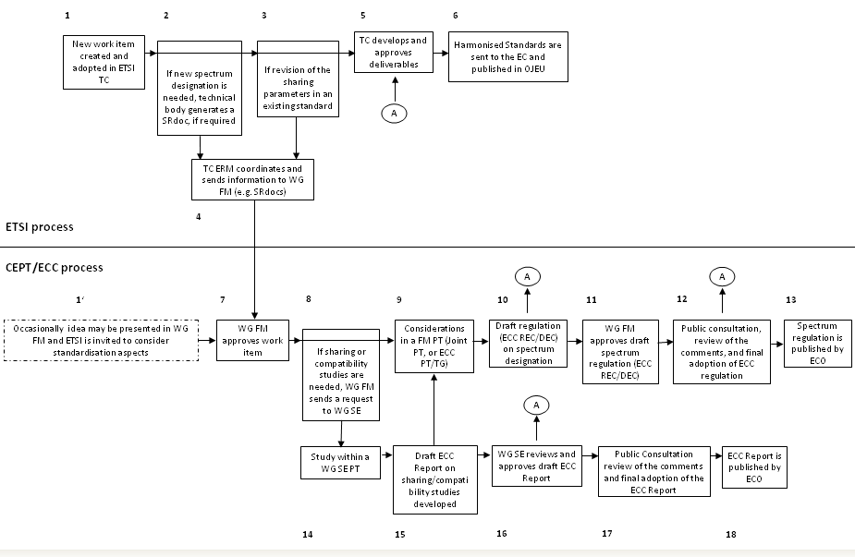
Annex: Flow Diagram

CEPT (from French acronym) – European Conference of Postal and Telecommunications administrations, where members are administrations from 48 countries of the European continent
ETSI – European Telecommunications Standards Institute, with broad membership from industry and administrations.
ECC – CEPT’s Electronic Communications Committee (the other CEPT committee deals with postal matters). The ECC area is further divided between several Working Groups and Project Teams
Link to the ECC Rules of Procedure: http://www.cept.org//files/1051/ECC/Framework/ECC%20Rules%20of%20Procedure/Edition%2012%20of%20the%20RoP_%20December%202011.pdf
Link to the ETSI Directive: http://portal.etsi.org/Directives/home.asp
“Sharing” is a term usually used to describe co-existence with an incumbent radiocommunications application(-s) within the same frequency band as proposed for new application(s)
“Compatibility” is a term used to describe co-existence with an incumbent radiocommunications applications(-s) in adjacent band(-s) to those proposed for new application(s)
According to the Working Procedures for ETSI, a 'System Reference Document' (SRdoc) should be produced for any new system, service or application requiring a change of the present frequency designation / utilisation within CEPT or a change in the present regulatory framework for the proposed band(s) regarding either intended or unwanted emissions
ECC Decisions are measures on significant harmonization matters. It is understood that all CEPT administrations should implement measures specified in ECC Decisions, except specially requested derogation cases
For an ECC Decision, if the schedule of meetings allows, the responsible ECC PT which has developed the draft ECC Decision shall consider the results of the PC and shall present proposals to the ECC Plenary on how to incorporate any adopted new element resulting from it into the draft ECC Decision. If the schedule of meetings does not allow this procedure the Chairman of the responsible PT shall present the results of the PC directly to the ECC Plenary

