Interim Report

Interim Report from CEPT to the European Commission in response to the Mandate “to develop harmonised technical conditions for the 694-790 MHz ('700 MHz') frequency band in the EU for the provision of wireless broadband and other uses in support of EU spectrum policy objectives”
XX Month 2014

Executive summary
This Interim report has been developed within European Conference of Postal and Telecommunications Administrations (CEPT) in the framework of the EC Mandate on the 700 MHz (see Annex 1).
CEPT was mandated to undertake the following tasks:
- Develop a preferred technical (including channelling) arrangement and identify common and minimal (least restrictive) technical conditions for wireless broadband use in the 694-790 MHz frequency band for the provision of electronic communications services, subject later to a precise definition of the lower band edge under task (3), as well as PPDR services that can make use of such technical conditions. These conditions should be sufficient:
- to avoid interference between wireless broadband use and other services in the 694³-790 MHz band and in adjacent bands, and in particular to ensure the appropriate protection of broadcasting and PMSE services below the lower band edge, as well as compliance with EU harmonised conditions for the 790-862 MHz band;
- to facilitate cross-border coordination, including at the EU external borders;
- In performing (1), study the possibility of identifying suitable spectrum to accommodate incumbent uses in the 694³-790 MHz band such as PMSE (in particular wireless microphones), and develop common technical conditions for the coexistence of such uses with wireless broadband use in the band, taking into account spectrum sharing requirements and efficient spectrum use;
- In addition to and based on (1) and taking utmost account of the possibility of international harmonisation, assess the need to refine the conditions developed under (1), in particular the common and minimal (least restrictive) technical conditions, in order to ensure that they are sufficiently precise for the development of EU-wide equipment. The overall aim of a coordinated European approach should be considered, as implemented through detailed national decisions on frequency rearrangements in line with international frequency coordination obligations;
The status of the CEPT work in response to the tasks of the Mandate is presented in the relevant sections of this report.
CEPT ECC confirmed that currently the work is progressing according the time schedule of the mandate.

TABLE OF CONTENTS

0 Executive summary 2
1 introduction 5
2 Preferred technical channeling arrangement in 694 -790 MHz 6
3 Common least restrictive technical conditions (BEM) 7
4 Compatibility with harmonized conditions of wireless broadband at 790 -862 MHz 8
5 Coexistence between wireless broadband and Broadcasting at 694 MHz 9
6 PMSE Issues 10
ANNEX 1: EC Mandate on 700 MHz 11

LIST OF ABBREVIATIONS

Abbreviation | Explanation
BEM  CEPT | Block Edge Mask  European Conference of Postal and Telecommunications Administrations
EC  ECC  FDD  IMT  LRTC  PMSE  PPDR  UE  WRC-15 | European Commission  Electronic Communications Committee  Frequency Duplex Division  International Mobile Telecommunications  Least Restrictive Technical Conditions  Programme Making and Special Events  Public Protection and Disaster Relief  User Equipment  World Radiocommunications Conference 2015

introduction
ECC considered the various tasks (1, 2 & 3) as described in the EC Mandate on 700 MHz and identified relevant actions to be launched in order to respond to the mandate according to the time schedule of the mandate.
This interim report is providing an overview of the current on-going ECC activities on:
- preferred technical channelling arrangement in 694-790 MHz,
- relevant LRTC (BEM) for wireless Broadband as well for PPDR,
- compatibility with harmonized conditions of wireless broadband at 790-862 MHz,
- coexistence between wireless broadband and Broadcasting at 694 MHz,
- PMSE.

Preferred technical channeling arrangement in 694 -790 MHz
CEPT ECC confirmed the lower edge at 694 MHz as the only option to be studied in the WRC 15 preparation and discussed possible channeling arrangements on that basis.
CEPT ECC is studying channelling arrangements in this band suitable for wireless broadband as well for Public Protection and Disaster Relief (PPDR).
CEPT ECC started to reduce the number of options under consideration for the 700 MHz band plan. The following options for channelling arrangements (see Figure 1 below) are currently under consideration by CEPT:

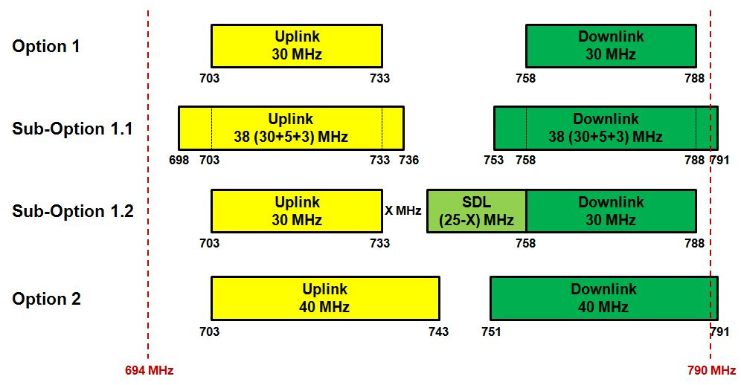
Figure 1: Options for channelling arrangements under consideration in CEPT
CEPT is considering the band plan based on the lower duplexer of the APT 700 MHz (2x30 MHz) band plan, providing high degree of harmonization, as one option (1) with additional sub options to address in particular PPDR (2x5 MHz) (option 1.1) and SDL (1.2). Another option 2 (2x40MHz) is also under consideration.
CEPT will continue its work with a view to reducing the number of options to conclude on a preferred channelling arrangement for the 694-790 MHz band.

Moreover CEPT ECC noted that LTE technology is expected to be the future technology to meet broadband PPDR needs, the work is in progress with standardization to define functionality enhancements for PPDR operators. CEPT ECC is considering the options for accommodating 2x10 MHz for PPDR LTE equipment within the frequency range 694 to 790 MHz, subject to national decision at a later stage. At the same time CEPT ECC is also considering the 410-430 MHz and 450-470 MHz sub-bands for PPDR LTE. CEPT also assumes that any decision on the allocation of either dedicated or shared with commercial LTE operators spectrum to PPDR users will be taken at a national level.

Common least restrictive technical conditions (BEM)
Regarding the work on Task 1.b identified by ECC in response to the 700 MHz EC Mandate:
- ECC intends to develop common technical conditions (BEMs), suitable for commercial mobile broadband and also for PPDR networks, as LTE technology is assumed to be the future technology to meet the PPDR user needs. To this aim ECC is currently considering requirements for mission critical operations in its technical work, to assess if any additional protection is necessary. Furthermore PPDR networks may have different design and deployment parameters (e.g. density of base stations and user terminals) than those of commercial LTE networks. In consequence, additional studies may be necessary.

- ECC has assessed the applicability to the 700 MHz band of the harmonised conditions of wireless broadband at 790-862 MHz. To this aim, CEPT Report 30 has been taken into account in the work on 700 MHz BEMs. In view of the current work on channeling arrangement for the 700 MHz band, definition of the terminal station BEM is given special attention.

- ECC has developed a preliminary definition of BEMs for the 700 MHz band. Technical conditions for FDD base stations are derived from CEPT Report 030, with the additional consideration of the expected channeling arrangement for 700 MHz. Technical conditions for FDD terminal stations may be derived from current coexistence studies between IMT and broadcasting service.

Compatibility with harmonized conditions of wireless broadband at 790 -862 MHz
CEPT ECC preliminary assessed the compatibility with harmonized conditions of wireless broadband at 790-862 MHz. All of the options for 694-790 MHz channeling arrangements under consideration in CEPT use a conventional duplex arrangement (uplink in the lower part of the band and downlink in the upper part of the band). The 790-862 MHz band uses a reversed duplex arrangement (downlink in the lower part of the band and uplink in the upper part of the band), starting at 791 MHz. As a consequence, the 700 MHz base station transmit band would be adjacent to the 800 MHz base station transmit band. This avoids adjacency between base stations and terminal stations and therefore provides compatibility between the existing 790-862 MHz channeling arrangement and the options for 694-790 MHz channeling arrangements.

Coexistence between wireless broadband and Broadcasting at 694 MHz
The issue of coexistence between wireless broadband and broadcasting at 694 MHz is ongoing at this stage to identify :
- the out-of-band (OOB) emission limit of the mobile (IMT) User Equipment (UE) and
- the required guard band between 694 MHz and the mobile (IMT) uplink
- due diligence assessment of any strong signal blocking of TV from the mobile (IMT) base station (BS) and UE
in order to protect the broadcasting transmission in TV channel 48 and below from interference from the mobile service (IMT) in the band 694-790 MHz.

It is expected that the terminal out-of-band emission requirements would need to be included in the relevant European harmonised standard (EN 301 908).

In addition, CEPT ECC is assessing particular scenarios of deployment for PPDR that may imply additional studies on coexistence between PPDR and broadcasting at 694 MHz.

PMSE Issues
CEPT ECC noted that the 694-790 MHz band is currently available on a sharing basis with the broadcasting service for PMSE equipment and is used on a daily basis.
CEPT ECC has also sought the views on whether there is any interest in the possible use of the guard band or centre gap of 700 MHz band plans for Programme Making and Special Events (PMSE) applications. CEPT ECC identifies interest to retain some spectrum to accommodate PMSE in the 694-790 MHz band.
In consequence, CEPT ECC will launch relevant studies to develop Least Restrictive Technical Conditions (LRTC) BEM according to the opportunities offered by the relevant 700 MHz band plans under investigation as described above.

- EC Mandate on 700 MHz

Provisional lower band edge subject to precise definition within the scope of this Mandate
Such as the definition of appropriate BEMs (Block Edge Masks)
This provisional lower band edge is subject to a precise definition within the scope of this Mandate. It is identical with the provisional lower limit stipulated in WRC-12 Resolution 232 which is subject to additional refinement at the WRC-15
Subject to Commission Decision 2010/267/EU
For example in unused parts of the band such as a center gap of a potential FDD arrangement
Such as resolutions at the ITU WRC-15

