ECC Report 21 6

Practical guidance for TDD networks synchronisation

**Month YYYY (Arial 9pt bold)**

# Executive summary

When more than one TDD network operates in the same geographic area and in the same band, severe interference may impair network performance if the networks are uncoordinated, i.e. if some equipment is transmitting while other equipment is receiving in the same time-slots. In that case, guard band and/or additional filtering and/or other techniques often can be used in order to reduce interference.

However in the case of TDD-TDD coexistence, another way to avoid all BS-BS and UE-UE interferences without using guard band and specific filtering is to synchronise base stations so that they roughly transmit and receive in the same time. More precisely, **synchronised operation means that no simultaneous uplink and downlink occur between any pairs of cells which may interfere with each other** **in the same band**. The word “synchronisation” is often used in several other contexts (e.g. frequency synchronisation for FDD networks, BS-UE synchronisation, etc.), and this report will focus on phase/time synchronisation for interference-mitigation purposes, which involves different techniques.

In order to achieve synchronised operation, the following needs to be implemented on all base stations that may interfere with each other (both within the operator and between other operators in the same frequency band):

* **Having a common reference phase clock** (e.g. for the start of frame). Unlike FDD technology that only requires a frequency reference, TDD needs a common phase reference. The desired accuracy depends on the technology, but the order of magnitude for currently considered IMT technologies is about 1 to 3µs of clock drift between base stations. In practical deployments UTC is mostly used as a common time reference.
* **Configuring compatible frame structures** (e.g. length of frame, TDD ratio, etc.) in order to align uplink/downlink switching points. This is straightforward in the case of the same technology, but it needs careful analysis in the case of cross-technology synchronisation. In the case of WiMAX/LTE-TDD synchronisation, it is straightforward in most cases, even though some specific cases need more work.

The following techniques are currently available for transmitting a reference phase/time clock:

* **GNSS**: GPS is the main technique used today in TDD macrocells to provide phase/time with the proper accuracy. This is a mature technology, however it requires sky visibility, and may experience outages (intentional or unintentional). It is therefore usually not applicable for indoor small cells scenarios as well as for some particular outdoor small cells scenarios.
* **Packet based networks**: packet methods such as PTPv2 are seriously considered to transmit a time clock over packet networks. They require careful network engineering. Several telecom “profiles” have been defined or are currently discussed at ITU-T SG15/Q13, both for frequency and phase/time clock transport. At the time of writing, the nearly-finalised (expected in 2014) phase/time profile assumes full on-path timing support i.e. assumes that all transport equipment between the master and the final slave clock have dedicated hardware and software support to compensate for the time error introduced by various effects, such as other traffic load variation. However full on-path timing support is not always practical in some situations (e.g. because of cost constraints, or because the backhaul belongs to a 3rd party operator). Work and tests are still ongoing on other deployment scenarios where only partial on-path timing support is available i.e. when not all transport equipment supports PTPv2 functions.
* **Over-the-air synchronisation**: 3GPP has defined a mechanism that allows a slave cell to get the phase clock from a master cell. This mechanism is currently specified for LTE TDD HeNB up to 4 hops, and has been tested in the lab with 1 hop. Work is ongoing to extend it to more scenarios. This is likely to enable indoor small cells to get a reference phase clock in a cost effective way. However a surrounding macrocell network in the same band with a proper UTC reference is required in order to obtain UTC traceability.
* **LORAN**: in contrast to several existing terrestrial synchronisation technologies, LORAN accuracy is on par with GNSS while having different characteristics (e.g. not affected by GNSS jamming). Infrastructure is already deployed in some regions of the world such as Europe, APAC and Russia (towers/transmitters based on Loran-C or eLoran depending on countries). Its low frequency theoretically enables it to indoor and submarine coverage, even though additional studies are necessary to assess whether the antennas could be properly miniaturised while still ensuring proper signal reception in most indoor scenarios. It is currently used for marine and military positioning, and has not been specified at ITU for telecom contexts at the time of this writing.

The above 4 techniques are the main ones that allow UTC traceability with accuracy performance that is suited for IMT deployments at the time of writing. This does not exclude the applicability of potential other / new techniques for phase synchronisation, although this has not been fully evaluated yet.

In order to deploy synchronised TDD mobile networks in a multi-operator context (without guard bands), agreement needs to be reached on

* A common phase clock reference (e.g. UTC) and accuracy/performance constraints (e.g. +/- 1.5µs), either using their own equipment to provide the clock, or sharing the same phase/time clock infrastructure;
* A compatible frame structure (including TDD UL/DL ratio) in order to avoid uplink/downlink overlapping;
* A commitment not to interfere with each other as any synchronisation issue of one operator may impact the network of the others (e.g. reliability of the reference clock and protection mechanism have to be ensured and/or procedure when losing this reference clock has to be defined);
* The terms & conditions where cross-operator synchronisation must apply and/or may not be required (e.g. geographical zones / isolated eNB, HeNB-only deployments…);
* How to update those parameters.

When multiple operators deploy TDD networks on adjacent bands inter-network synchronisation conditions can be discussed and agreed at the national level and implemented nationwide or limited to a given area (regional) as appropriate.

**TABLE OF CONTENTS**

[0 Executive summary 2](#_Toc382917596)

[1 Introduction: synchronisation of TDD networks 6](#_Toc382917597)

[1.1 Context 6](#_Toc382917598)

[1.2 New deployment scenarios 6](#_Toc382917599)

[2 TDD network synchronisation techniques 8](#_Toc382917600)

[2.1 Definition for synchronised TDD networks 8](#_Toc382917601)

[2.2 Phase Synchronisation of the reference phase/time clock 9](#_Toc382917602)

[2.2.1 Accuracy requirements 9](#_Toc382917603)

[2.2.2 Synchronisation by GNSS 10](#_Toc382917604)

[2.2.3 Synchronisation over packet networks 11](#_Toc382917605)

[2.2.4 Over-the-air synchronisation for LTE-TDD HeNB by network listening 14](#_Toc382917606)

[2.2.5 Terrestrial synchronisation networks 15](#_Toc382917607)

[2.2.6 Holdover and resilience 17](#_Toc382917608)

[2.3 Frame structure coordination 19](#_Toc382917609)

[2.3.1 Overview 19](#_Toc382917610)

[2.3.2 Cross-technology network synchronisation 19](#_Toc382917611)

[3 Practical guidance for inter-operator deployments 21](#_Toc382917612)

[3.1 Clock synchronisation 21](#_Toc382917613)

[3.2 Inter-operator synchronisation pre-requisites 22](#_Toc382917614)

[3.3 General considerations on Inter-operator agreements 22](#_Toc382917615)

[4 Conclusion 23](#_Toc382917616)

[ANNEX 1: WiMAX and LTE-TDD frame structures 24](#_Toc382917617)

[4.1 3GPP LTE 24](#_Toc382917618)

[4.2 WiMAX 802.16e 25](#_Toc382917619)

[4.3 WiMAX/LTE-TDD compatibility matrix 26](#_Toc382917620)

[ANNEX 2: ITU-T SG15/Q13 standards and workplan 28](#_Toc382917621)

[ANNEX 3: Existing examples of cross-operator TDD synchronisation 29](#_Toc382917622)

[ANNEX 4: List of references 30](#_Toc382917623)

**LIST OF ABBREVIATIONS**

|  |  |
| --- | --- |
| **Abbreviation** | **Explanation** |
| **ACIR** | Adjacent Channel Interference Rejection |
| **APTS** | Assisted Partial Timing Support |
| **BEM** | Block Edge Mask |
| **BS** | Base station |
| **BWA** | Broadband Wireless Access |
| **CEPT** | European Conference of Postal and Telecommunications Administrations |
| **CoMP** | Cooperative Point to MultiPoint |
| **DwPTS** | Downlink Pilot Time Slot |
| **ECC** | Electronic Communications Committee |
| **EC** | European Commission |
| **ECO** | European Communications Office |
| **eNB** | eNodeB (LTE BS) |
| **EU** | European Union |
| **E-UTRA** | Evolved Universal Terrestrial Radio Access |
| **FDD** | Frequency Division Duplex |
| **FFS** | For Further Study |
| **GNSS** | Global Navigation Satellite System (GPS, Galileo, Glonass, BeiDou, etc…) |
| **GPS** | Global Positioning System |
| **HeNB** | Home eNodeB (LTE femtocell) |
| **IMT** | International Mobile Telecommunications |
| **LORAN** | LOng RAnge Navigation system |
| **LOS** | Line Of Sight |
| **MBSFN** | Multicast Broadcast Single Frequency Network |
| **MFCN** | Mobile/Fixed Communications Networks |
| **MFW** | Multipoint Fixed Wireless |
| **MTIE** | Maximum Time Interval Error |
| **OCXO** | Oven Controlled Crystal Oscillator |
| **OTA** | Over-the-air |
| **PDV** | Packet Delay Variation |
| **PMP** | Point to Multipoint |
| **PNT** | Positioning, Navigation and Timing |
| **PTP** | Precision Time Protocol (IEEE-1588) |
| **PTS** | Partial Timing Support |
| **PRTC** | Primary Reference Time Clock |
| **SDO** | Standard developing organization |
| **TCXO** | Temperature Controlled Crystal Oscillator |
| **TDD** | Time Division Duplex |
| **TS, SS** | Terminal Station, Subscriber Station |
| **UE** | User Equipment (LTE TS) |
| **UL/DL** | Uplink/Downlink |
| **UTC** | Universal Coordinated Time |

# Introduction: synchronisation of TDD networks

## Context

When more than one TDD network operates in the same geographic area, severe interference may happen if the networks are uncoordinated, i.e. if some equipment is transmitting while other equipment is receiving in the same time-slots and in the same band (on the same channel or on adjacent channels) while having a poor isolation (e.g. because of geographical proximity like in co-sited deployments in a multi-operator context, or because of line of sight situations). Indeed, in this situation, both out-of-band and spurious emission on the transmitter side and imperfect adjacent channel selectivity on the receiver side can desensitise or block the neighbour receiver, preventing it from properly listening to desired signals.



Figure 1: Adjacent network interference scenarios for unsynchronised TDD (from [1])

BS-UE interferences (yellow arrows) happen in all cases and are handled as part of the standards

UE-UE and BS-BS interferences (orange arrows) happen in the case of unsynchronised TDD networks

Without inter-operator synchronisation, coexistence may require operator-specific filters at the eNB side both at the transmitter and receiver to avoid interference. This may prevent economies of scale. Furthermore, additional filtering at the UE side is usually not feasible.

In the case of TDD-TDD coexistence, one way to avoid all BS-BS and UE-UE interference without using guard band and specific filtering is to synchronise base stations so that they align their downlink and uplink switching points, as described in further sections.

Since synchronised operation reduces UE-UE and eNB-eNB interferences compared to unsynchronised operation, different regulatory constraints (such as block edge masks) may apply to those two different situations. ECC report 203 [19] gives an example of different block edge masks for synchronised TDD and unsynchronised TDD operations.

## New deployment scenarios

Most often (except in the case of isolated BS deployments), all TDD equipment from the same operator is phase/time synchronised in order to avoid self-interference. At the time of writing most TDD networks have been deployed with outdoor macrocells where BS antenna is installed above the roof-top or on a mast. In this context, phase/time synchronisation is mostly not a technical issue thanks to GNSS. Besides, they have mostly been deployed in single-technology and single-operator per region context, avoiding issues for cross-operator or cross-technology common frame structure configuration.

In the near future other deployment scenarios are expected as several frequency bands are available for TDD networks (e.g.: 1900-1920 MHz, 2010-2025 MHz, 2300-2400 MHz, 2570-2620 MHz, 3400-3600 MHz, 3600-3800 MHz.

N.B. this report is not limited to a specific band and applies generically to any TDD deployment). More precisely, this report will consider the following new orthogonal cases that may require different synchronisation techniques:

* networks deployments using indoor and/or outdoor cells of any kind (macrocell, microcell, picocell, HeNB, HetNets…) and using various types of backhaul links[[1]](#footnote-2) (e.g. Ethernet, Microwave, xDSL, xPON, etc.);
* networks using different technologies (e.g. WiMAX/LTE-TDD);
* networks from different operators on adjacent channels;
* or a combination of those cases.

# TDD network synchronisation techniques

## Definition for synchronised TDD networks

The word “synchronisation” is used in many different contexts with different meanings. For example, BS-UE synchronisation within the same network, frequency and phase synchronisation at the carrier level for demodulation purposes, frequency synchronisation for FDD networks like GSM, etc. This report will only focus on synchronisation at the frame level between TDD networks for interference mitigation purposes.

Frequency synchronisation, phase synchronisation and time synchronisation can be distinguished, as illustrated in the following figure:

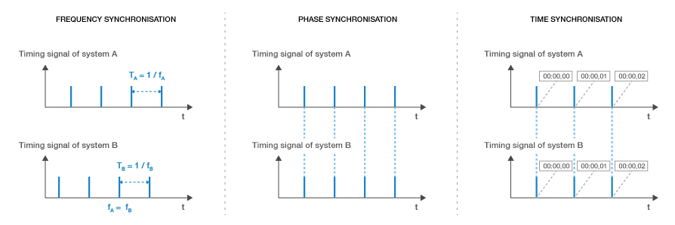

Figure 2: frequency, phase and time synchronisation

**Frequency synchronisation** (also called "*syntonisation*") means equipment A and B get a common reference signal and evolve at the same rate within a given accuracy and stability but significant instants of the signal are not aligned in time.

**Phase synchronisation** means equipment A and B get a common reference signal and significant instants are aligned in time within a given accuracy and stability but are not necessary traceable to a reference time clock (e.g. UTC).

**Time synchronisation** means equipment A and B are phase-synchronised with a known traceable reference clock (e.g. UTC, same reference for leap seconds, etc.).

Both FDD and TDD mobile networks usually require frequency synchronisation in order to implement seamless handovers. In addition to that, TDD networks require aligning UL/DL switching points between cells in overlapping coverage areas in order to avoid interference. In the context of this report, **synchronised operation means that no simultaneous uplink and downlink occurs between any pairs of cells which may interfere with each other** **in the same band** (e.g. because of geographical proximity or line-of-sight). This implies:

* Having a common phase reference
* Configuring compatible frame structures[[2]](#footnote-3), i.e. setting the length of the frame, the TDD uplink/downlink ratio and guard period in order to align UL/DL switching points, so that the last transmitter stops before the first receiver starts, taking into account the propagation delay (e.g. in LOS non co-sited cases). Frame structures do not need to be exactly identical provided this condition is met.

This definition is valid both within a single operator network (in order to avoid self-interference between equipment from the same operator), and between operators in the same band (e.g. on adjacent-channels). It has to be noted:

* In order to avoid interference, only cells in the vicinity of each other that may interfere together need to be synchronised in phase. Therefore isolated cells may not require to be synchronised with other cells in the same band if they cannot interfere.
* Only phase synchronisation is required for interference-mitigation, but time synchronisation is generally implemented practically in order to have a traceable time reference (e.g. UTC).

The following picture illustrates interference when the start of frame is not aligned (2nd scenario) or when TDD UL/DL ratio is not aligned (3rd scenario).

|  |  |  |  |  |  |  |  |  |  |  |  |  |  |  |  |  |  |  |  |  |  |  |  |  |  |  |  |  |  |  |  |  |  |  |  |
| --- | --- | --- | --- | --- | --- | --- | --- | --- | --- | --- | --- | --- | --- | --- | --- | --- | --- | --- | --- | --- | --- | --- | --- | --- | --- | --- | --- | --- | --- | --- | --- | --- | --- | --- | --- |
| Examples of synchronised operations (no TX/RX overlap and no interference, despite slightly different frames) | | | | | | | | | | | | | | | | | | | | | | | | | | | | | | | | | | | |
| Operator A |  |  |  |  |  |  |  |  |  |  |  |  |  |  |  |  |  |  |  |  |  |  |  |  |  |  |  |  |  |  |  |  |  |  | OK |
| Operator B |  |  |  |  |  |  |  |  |  |  |  |  |  |  |  |  |  |  |  |  |  |  |  |  |  |  |  |  |  |  |  |  |  |  |
| Operator C |  |  |  |  |  |  |  |  |  |  |  |  |  |  |  |  |  |  |  |  |  |  |  |  |  |  |  |  |  |  |  |  |  |  |
| Operator D |  |  |  |  |  |  |  |  |  |  |  |  |  |  |  |  |  |  |  |  |  |  |  |  |  |  |  |  |  |  |  |  |  |  |
|  |  |  |  |  |  |  |  |  |  |  |  |  |  |  |  |  |  |  |  |  |  |  |  |  |  |  |  |  |  |  |  |  |  |  |  |
| Same frame structure, but not same start of frame | | | | | | | | | | | | |  |  |  |  |  |  |  |  |  |  |  |  |  |  |  |  |  |  |  |  |  |  |  |
| Operator A |  |  |  |  |  |  |  |  |  |  |  |  |  |  |  |  |  |  |  |  |  |  |  |  |  |  |  |  |  |  |  |  |  |  | NOK |
| Operator B |  |  |  |  |  |  |  |  |  |  |  |  |  |  |  |  |  |  |  |  |  |  |  |  |  |  |  |  |  |  |  |  |  |  |
| Interference periods |  |  |  |  |  |  |  |  |  |  |  |  |  |  |  |  |  |  |  |  |  |  |  |  |  |  |  |  |  |  |  |  |  |  |
|  |  |  |  |  |  |  |  |  |  |  |  |  |  |  |  |  |  |  |  |  |  |  |  |  |  |  |  |  |  |  |  |  |  |  |  |
| Same start of frame, but not same frame structure | | | | | | | | | | | | |  |  |  |  |  |  |  |  |  |  |  |  |  |  |  |  |  |  |  |  |  |  |  |
| Operator A |  |  |  |  |  |  |  |  |  |  |  |  |  |  |  |  |  |  |  |  |  |  |  |  |  |  |  |  |  |  |  |  |  |  | NOK |
| Operator B |  |  |  |  |  |  |  |  |  |  |  |  |  |  |  |  |  |  |  |  |  |  |  |  |  |  |  |  |  |  |  |  |  |  |
| Interference periods |  |  |  |  |  |  |  |  |  |  |  |  |  |  |  |  |  |  |  |  |  |  |  |  |  |  |  |  |  |  |  |  |  |  |
|  |  |  |  |  |  |  |  |  |  |  |  |  |  |  |  |  |  |  |  |  |  |  |  |  |  |  |  |  |  |  |  |  |  |  |  |
|  |  |  | Downlink | | | | | |  |  |  |  |  |  |  |  | Uplink | | | |  |  |  |  |  |  |  |  |  |  |  |  |  |  |  |

Figure 3: Interference scenarios for TDD/TDD systems

“Interference period” as illustrated on the third scenario of figure 3 may embrace both eNB-eNB (downlink-to-uplink) and UE-UE (uplink-to-downlink) interference types leading to mutual interferences between operators. However when only one type of interference is dominant, the interferences may no longer be mutual: if eNB-eNB interferences are dominant, the operator who has more downlink is an interferer and the operators who have less downlink are interfered. Conversely, if UE-UE interferences are dominant, the operator who has more uplink is interferer and the other operators are interfered.

N.B.: some advanced features in both FDD and TDD networks, such as CoMP and MBSFN also require phase synchronisation in order to be effective. The exact values are still under discussion and could be more stringent than the requirements for TDD. This report focuses on phase/time synchronisation in TDD network for interference-mitigation purposes.

## Phase Synchronisation of the reference phase/time clock

This section discusses the main techniques, available at the time of writing, to bring a reference phase/time clock to the TDD base stations with a proper accuracy for the considered IMT technologies and with UTC traceability. Other synchronisation techniques may also be considered in the future (e.g. restricted to phase synchronisation without UTC traceability).

### Accuracy requirements

At the time of writing, most IMT technologies have a typical requirement of 50ppb in frequency accuracy for wide area base stations. When phase synchronisation is required, it is often on the order of 1µs, as illustrated in the following table:

Table 1: phase/time accuracy requirements for various technologies

| **Technology** | **Phase/time accuracy requirements[[3]](#footnote-4)** |
| --- | --- |
| CDMA2000 FDD (C.S0010-B, C.S0002-C) | +/- 3 µs with respect to UTC (during normal conditions. +/- 10 µs of UTC (when the time sync reference is disconnected) |
| WCDMA TDD (TS 25.402) | 2.5 µs |
| TD-SCDMA (TS 25.836) | 3µs |
| LTE TDD (TS 36.133 [2]) | 3µs (normal cell radius), 10µs (large cells), 1.33µs+Tprop (HeNB > 500m radius) |
| WiMAX 802.16e TDD (IEEE 802.16) | 1µs |

The calculations that lead to the 3µs value between LTE eNB can be found in 3GPP contribution R4-082105 [3].

### Synchronisation by GNSS

**Description**:

GNSS systems such as GPS, Galileo, GLONASS or BeiDou allow a receiver to get time synchronisation with an accuracy of 100 ns. Standard G.8272 defines those Primary Reference Time Clocks (PRTC) characteristics.

**Maturity and current deployment**:

Synchronisation by GNSS is suitable for base stations that have an outdoor antenna (with good sky visibility) and therefore can receive a GNSS signal. Macro-cell outdoor BS should then be able to be synchronised by this method, which is already widely used for most existing outdoor TDD systems like WiMAX and TD-SCDMA networks, as well as CDMA2000 FDD networks. It has to be mentioned that at the time of writing some GNSS system are not yet fully available (e.g. Galileo) or are not worldwide available (e.g. BeiDou).

**Implementability**:

Currently this method requires sky visibility, which makes it difficult to implement in some situations (e.g. for indoor cells or in urban canyons). Some progress in chipset sensitivity may make GNSS available indoor in some situations, but this remains a case-by-case applicability that cannot be generalised.

Using directly a GNSS solution implies some costs (e.g. antenna, lightning arrester, possible amplifier, cable to the base station that may not be located immediately near). This cost may be small for macro/microcell compared to the cost of the site and equipment, but may be non-negligible for small cells, depending on advances on chipsets designed specifically for these cases.

The threat from GPS jamming by commercially available jammers has been extensively researched in the UK by two UK Government supported projects GAARDIAN and SENTINEL. This threat should not be ignored. Since the signal from space to earth is extremely low (equivalent to a 20W light bulb at a distance of 20,000 km), it is very easy to jam with a relatively low power jammer, and practical interference events have already been observed. Besides, more powerful criminal jammers with a far bigger impact radius must also not be ignored. Other interference effects such as space weather and multipath may also affect GPS reception. As a consequence, GPS should not be considered 100% reliable and may experience temporary outages.

As an illustration of regular GPS jamming, Figure 4 below shows a histogram of jamming events over 5 seconds duration at a sensor from the SENTINEL project located in the city of London during the period Feb-Dec 2013. Most months show in excess of 100 events.

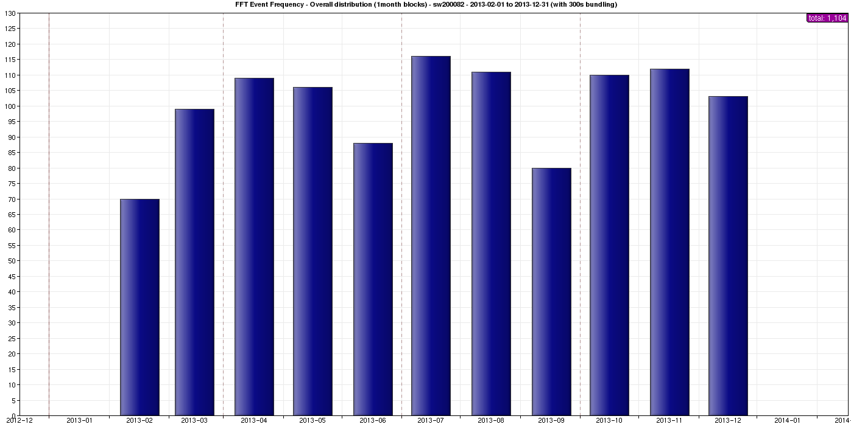

Figure 4: GPS Jamming Events per Month in the center of London, and pdf of jamming duration

From this data-set, the following statistics could be computed about jamming events (duration is in seconds):

|  |  |
| --- | --- |
| Number of events | 1755 |
| Mean duration | 44,68 |
| Standard deviation of duration | 66,85 |
| Max duration | 605 |
| Total sum of durations | 1755 |

This example shows that most jamming events have a duration of about a few seconds or minutes. More generally GPS regular jamming events are expected to remain mostly localised in time and space. However longer durations (10 minutes in this example) cannot be excluded even though those events may be rare. Other type of events (such as military conflicts, terrorist or organised crime activity, antenna outage, space weather conditions, spoofing, etc.) may also lead to wider or longer GPS outages. It has to be noted that the jamming duration is not the only parameter to take into account in order to estimate GPS outage, since the event may be of sufficient power to totally deny GPS reception for a period which then causes the GPS receiver to have to reacquire signal. The time holdover capability of the base station should therefore also take this reacquisition time into account. GPS receiver designs should also ensure that they don’t suffer catastrophic failures (e.g. manual reset) after such events.

### Synchronisation over packet networks

**Introduction:**

Several techniques have been designed in the past in order to ensure clock transport over packet networks:

* NTP [4] is one of the oldest protocols and is widely deployed for non-critical applications with an accuracy of around 1ms, but in general it is not designed with hardware support in mind and therefore is not suited for accuracies around 1µs even though some proprietary non-standard implementations with proper hardware support may achieve this kind of accuracy.
* Synchronous Ethernet (SyncE) [5] has been specified by ITU-T SG15/Q13, reusing many concepts from SDH (which inherently provides frequency synchronisation). It is only designed for frequency synchronisation and does not support phase/time synchronisation. It may be used complementary to a phase/time synchronisation technique in order to improve reliability (time holdover) in case of time reference failure.
* IEEE-1588v2 (Precision Time Protocol or PTP) [5][6][7] is the main considered technique in order to transport phase/time by the network with the desired accuracy for IMT purposes. It may be used for frequency synchronisation and/or for phase/time synchronisation.

It has to be noted that all those methods are only clock transport mechanisms and need to be driven by a proper clock source that is defined by a global standard. It may be a GNSS receiver (as described in G.8275) or any other system.

Considering the accuracy requirements previously defined for IMT deployments, this section will focus on IEEE-1588v2 (PTPv2) for phase/time synchronisation, possibly assisted with SyncE.

**IEEE-1588v2/PTPv2: presentation**

Precision Time Protocol (PTP) version 1, also known as IEEE1588, is a standardised protocol defined by the IEEE in 2002, coming initially from the automation world. The initial objective of this protocol is to deliver time synchronisation with a very high accuracy (sub-microsecond) in a LAN environment. Therefore, IEEE 1588 is not a technology dedicated only to telecom. A second version of the standard has been approved by the IEEE in 2008. It provides new features that enable it to be used in telecom applications. However, it is a standard with a large scope and many options defined for different contexts and not restricted to telecoms, therefore there is a need to define a subset of the options in order to avoid unnecessary complexity and ensure interoperability in telecom environments. Additional specifications are also needed in order to define user requirements (e.g. performance, architecture, reference model, security, management, etc.). These are part of the so-called "telecom profiles" defined by the ITU-T SG15/Q13 standard group.

Several telecom recommendation series (including profiles) have been or are being specified by ITU-T:

* **G.826x**: in 2010, ITU-T Q13/SG15 has defined a PTP telecom profile for “end-to-end” **frequency** distribution in the Recommendation G.8265.1. “End-to-end” means that the nodes in the synchronisation path (the path the PTP packets follow from the grandmaster to the slave) do not embed PTPv2 functions such as TC or BC since their use is prohibited in this profile.
* **G.827x:** ITU-T Q13/SG15 is currently working on new profiles to address the **phase and time** distribution by the network. Different profiles address the situations where either all the nodes embed PTPv2 functions in the synchronisation path (called full on path timing support) or where only some nodes implement this (called partial on-path timing support).

Annex 2 summarises the relevant ITU-T standards at the time of writing.

**IEEE-1588v2/PTPv2: technical description**

The following figure illustrates the basic PTP dialog between master and slave when PTP is used as a two-way protocol for phase/time recovery (i.e. delay request-response mechanism is used in order to calculate and compensate the delay that the packets spent through the network):

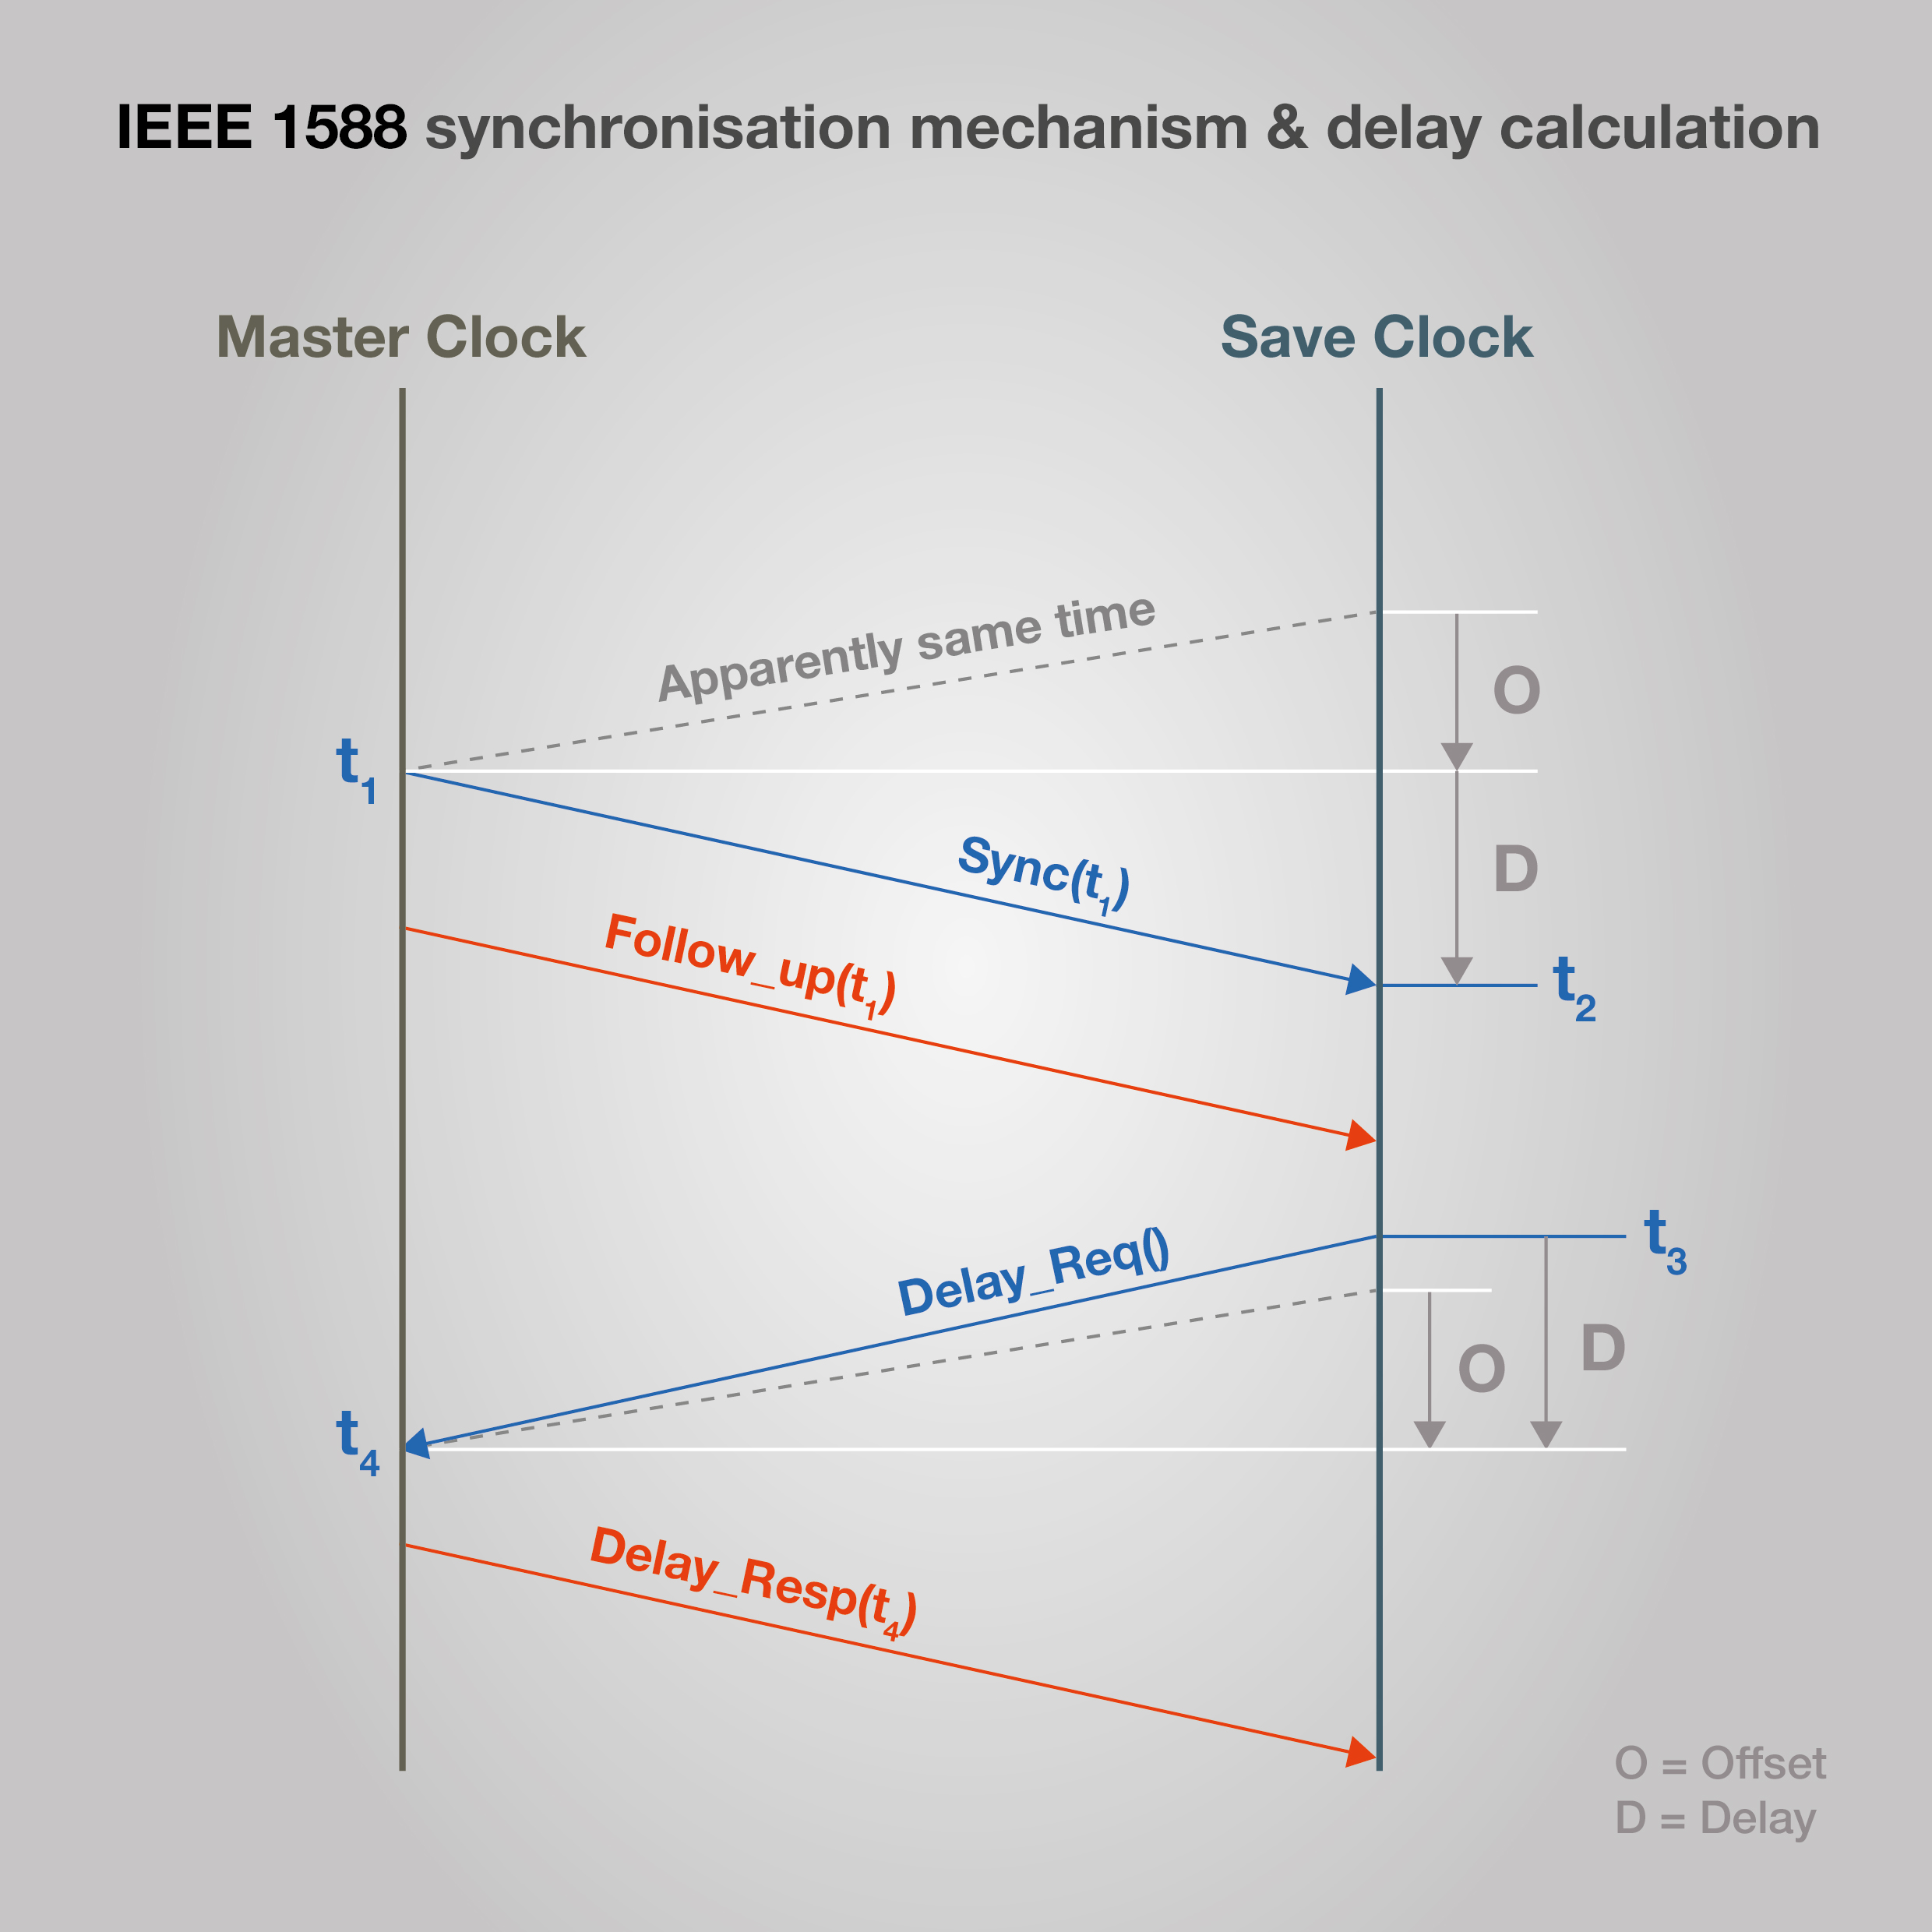

Figure 5: Principle for PTP algorithm

Master and slave have their own internal reference clock, and the purpose is to align slave internal clock on master reference clock. Thanks to the dialog depicted in the figure above, the slave knows the four timestamps t1, t2, t3, and t4, and will use them to calculate the offset its internal clock experiences compared to master reference clock, using the following formula:

$$T_{Offset}=\frac{{(t}_{2}-t_{1})-{(t}_{4}-t_{3})}{2}$$

This calculation assumes that the delays in both directions (delay from Master to Slave and delay from Slave to Master) are symmetric, or at worst that the asymmetry is fixed and known (otherwise, it is not possible to determine and compensate the slave internal clock offset).

As we can see, PTP is normally a two-way protocol since messages are exchanged between master and slave in both directions. It is possible to use PTP as a one-way protocol, using only the "Sync" messages, in order to deliver only frequency. In this case, the calculation differs from the previous formula and is based in general on “adaptive clock recovery” principles, which consists in recovering frequency synchronisation via packets. For phase/time synchronisation, two-way communication is always needed. When PTP is used with the two-way mode (for phase and time delivery), the slave initiates the path delay calculation, e.g. by issuing "Delay\_Req" messages to the master, which answers by "Delay\_Resp" messages, in order to calculate and compensate the delay that the packets spend through the network

Packet Delay Variation (PDV also called packet jitter) is the main factor impairing PTP solutions when there is no hardware support from the intermediate nodes. In order to be able to reach the requirements for phase/time, two mechanisms are defined in the protocol, based on hardware and software PTPv2 functions embedded in nodes:

* **Telecom Boundary Clock (T-BC):** it acts like a slave on the ingress port (connected to a master) and as a master on the egress port (connected to slave(s)). This allows compensating the internal latencies and jitter of the node.
* **Telecom Transparent Clock (T-TC):** it measures the time of residence of the PTP packet in the node by timestamping its arrival time on the ingress port and its departure time on the egress port. The difference is inserted on the fly in the PTP packet in the correction field. The end application slave will use this correction field to compensate PDV and calculate its offset.

Those mechanisms, as part of the PTP protocol, will not help to fight against the asymmetry of physical links. In case of link asymmetry, the protocol is not capable of determining and compensating this asymmetry and there will be a time error in the calculation of the slave internal clock offset if there is no prior calibration. For instance over fibre links, it is generally agreed that a meter of length difference between the two ways will generate roughly 2.5 ns of time error. Potentially this error may accumulate over the links of the synchronisation path.

Asymmetry can be made of:

* **Constant time error**: if the link asymmetry is static (e.g. when Tx and Rx fibers have different length), it can be calibrated during the deployment (e.g. using a GPS receiver as a reference clock) and set as a parameter in order to compensate the asymmetry in T-BCs/T-TCs and slave equipment.
* **Dynamic time error**: since PTP packets are multiplexed with data packets of different length, and for many other reasons such as temperature effects on oscillators, PDV (packet jitter) is introduced by the equipment (even when PTP traffic is prioritised). This is precisely where hardware assistance in BC and TC helps improve the accuracy.

**Maturity and current deployment**:

As mentioned previously ITU-T Q13/SG15 is currently defining several telecom profiles for phase and time delivery:

* **G.8275.1** is the phase/time profile assuming full on-path timing support (i.e. assuming that all transport equipment between the master clock and the slave clock support PTP functions). This recommendation has been formally consented in April 2014 and the approval process of this recommendation has been initiated. The currently defined mapping occurs at OSI layer 2 (i.e. PTP mapped over Ethernet). This recommendation is expected to be approved in March 2014 and can be considered as nearly finished. The currently defined mapping occurs at OSI layer 2 (e.g. Ethernet). Deployments are already happening in China using this draft profile. It should be noted that interworking with technologies other than Ethernet (e.g. xPON, xDSL, microwaves, etc.) has to be assessed on a case by case basis.
* **G.8275.2** is the phase/time profile assuming Assisted Partial on-path Timing Support (APTS). This is the current Q13 work item that refers to the case where a GNSS receiver is deployed at the base station for frequency and time synchronisation, and protected with PTP Partial on-path Timing Support (PTS) i.e. allowing legacy non PTP-aware equipment between the master and the slave clock. This is therefore rather a protection scenario than a real phase/time distribution solution that simplifies the problem of partial timing support, because the asymmetry of the network can be estimated when the GNSS is working properly. With a proper asymmetry compensation, PTPv2 with partial on-path timing support is expected to be able to provide timing synchronisation that allows respecting the +/- 1.5 µs requirement during a GNSS failure that could last several hours. In this case it is expected that the profile will be based on PTP mapped over IP.
* **G.8275.x** stands for future profile that is not yet studied but is likely to describe the case of Partial on-path Timing Support (PTS). The performance of such solution is therefore hard to predict or guarantee. Indeed, despite static/fixed asymmetry can be corrected by proper calibration, dynamic asymmetry and other effects such as packed delay variation are much more challenging to handle, even though clock noise filtering might be able to attenuate some of those effects. Therefore at the time of writing, it is premature to conclude on the performance or applicability of PTS to deliver phase and time with the proper quality, and it may also depend on the deployment scenario. Also in this case this profile may be based on PTP mapped over IP as well as over Ethernet.

**Implementability:**

Some equipment is already available at the time of writing for phase/time synchronisation, but is not yet compliant with G8275.1 so interoperability is not fully guaranteed until this equipment is upgraded (it is expected that software upgrade will be sufficient). These deployments scenarios mostly assume that IEEE-1588v2 is used over the backhaul, with a full on-path timing support between the master and slave equipment. What is feasible on various technologies (such as xDSL, xPON, microwaves) is a case-by-case analysis. Some of those have been assessed in [8].

Other studies are ongoing in some countries (e.g. US and China) to assess other deployment scenarios with a master clock (e.g. GNSS receiver + PTP grandmaster) closer to the slave equipment, and a limited number of hops on a non-PTP-enabled network (e.g. 2-3 hops on a gigabit Ethernet LAN). Those scenarios are considered for TDD small cells deployments, but they are for further studies within ITU-T Q13 standards therefore it is premature to give conclusions or to guarantee performances at the time of writing.

### Over-the-air synchronisation for LTE-TDD HeNB by network listening

**Description**:

Network listening is presented in 3GPP technical report TR 36.922 §6.4.2 [9], and the corresponding signalling messages are specified in technical standards TS 36.413 §9.2.3.34 and TS 32.592 §6.1.1.8.1 [10]. Using this technique, a HeNB[[4]](#footnote-5) derives its timing from another synchronised eNB or HeNB.

The cell used as a clock reference is not required to be a macrocell connected to GNSS since the scheme allows for multi-hop HeNB-to-HeNB. First lab tests have given promising results, suggesting that this technique has real potential (e.g. 200ns for one hop in some tests). 3GPP has currently defined 4 levels of precedence, which allow up to 3 hops (in TS-36.413 §9.2.3.34 [10]). More hops may be allowed in the future – especially considering that HeNB several hops away might be far enough not to interfere with each other.

Two mechanisms are described in the TR 36.922, one that relies on MBSFN subframe, and one that relies on dwPTS subframe. They both have different merits, as discussed in [11].

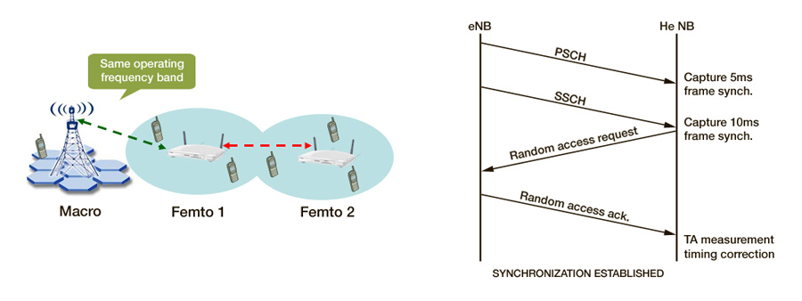

Figure 6: Illustration of over-the-air "network listening" mechanism for LTE-TDD

**Maturity and current deployment**:

At the time of this writing, the network-listening approach has been successfully implemented and tested in the lab for single-operator LTE HeNB synchronisation [11]. Those reference implementations use the two approaches described in TR 36.922 §6.4.2.1.3 [9].

A new work-item “small cell enhancements for E-UTRA and E-UTRAN Physical layer aspects” was set up in 3GPP RAN#62 for Rel-12 (RP-132073). It will focus on single-operator or multi-operator deployments[[5]](#footnote-6), may allow for more hops according to scenarios and may enable the technology to other types of nodes than HeNB.

**Implementability**:

This solution is restricted to LTE HeNB. The stratum 0 eNB needs to be connected to a proper UTC reference (e.g. GNSS) in order to get UTC traceability. It currently requires less than 4 hops between the master and the slave cell. Following current 3GPP work in Release 12, other deployment scenarios may be possible in a near future.

### Terrestrial synchronisation networks

**Description**:

The LOng RAnge Navigation system (Loran) is a narrowband terrestrial timing and positioning system, employing pulsed radio signals at 100 kHz, a frequency at which signal propagation is very time-stable. Its enhancement called eLoran, is replacing the earlier Loran-C which was deployed for civil and military maritime and aviation navigation. According to International Loran Association [12], "Enhanced Loran (or eLoran) is a Loran system that incorporates the latest receiver, antenna, and transmission system technology to enable Loran to serve as a backup and complement to global navigation satellite systems (GNSS) for navigation and timing. This new technology provides substantially enhanced performance beyond what was possible with Loran-C. For example, it is now possible to obtain absolute accuracies of 8-20 meters using eLoran for harbour entrance and approach. Similarly, eLoran can function as an independent, highly accurate source of universal coordinated time (UTC)”. For timing, eLoran transmissions are synchronised to an accurate source of UTC. Also, a UTC time message is broadcast to users over an eLoran Data Channel.

According to [13] [14], eLoran has the following benefits (contrary to several other terrestrial systems such as DCF77):

* UTC traceability, accuracy and stability on a par with GPS and other GNSS (fig. 7) shows accuracies which degrade to 500ns in the red zone at a 1500 km radius of the transmitter, but the use of differential corrections could improve accuracy to 50ns.
* Not impacted by GPS jamming, (and therefore can be a possible mitigation solution when GNSS fails).
* Better indoor penetration than GNSS with current eLoran antennas in the coverage zone.

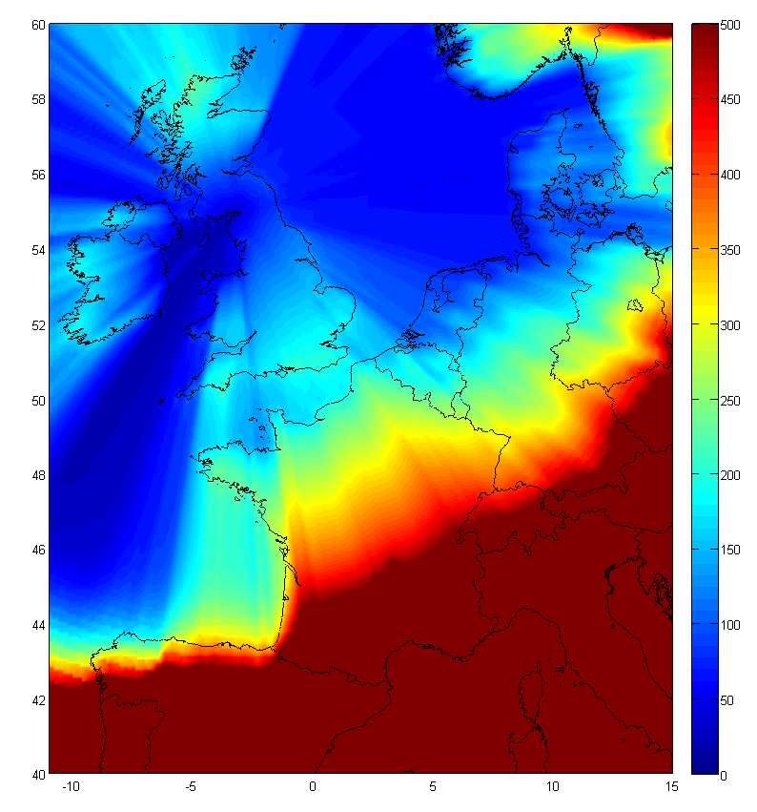 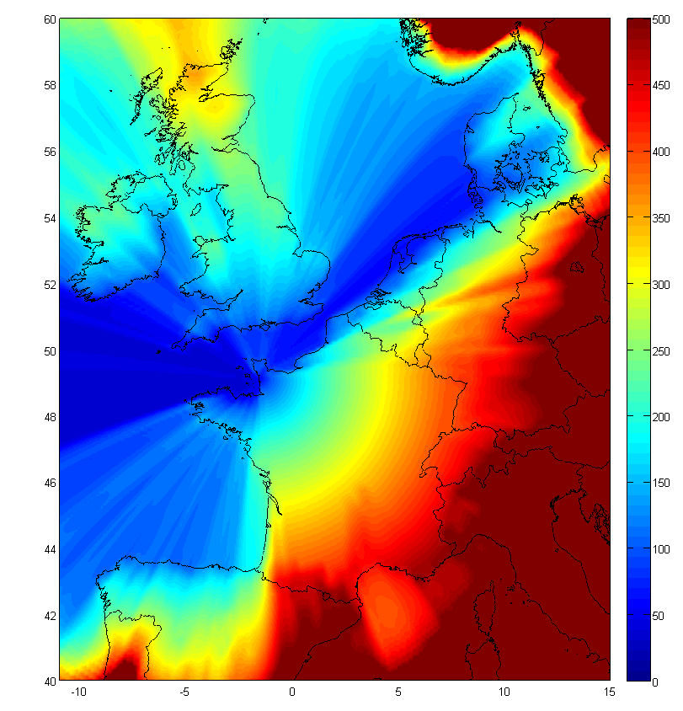 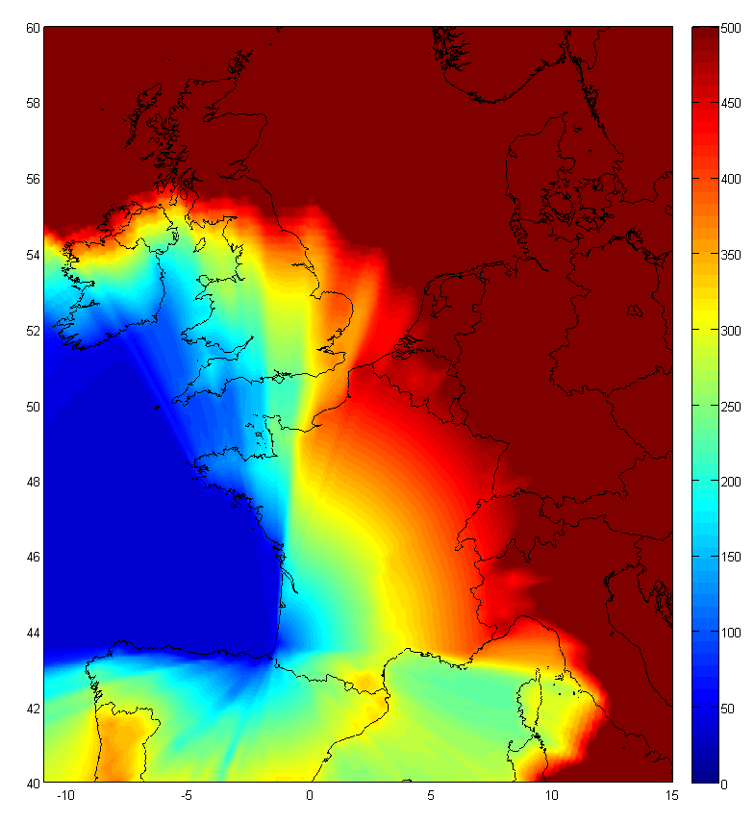

Figure 7: Best (Blue) to 500ns (Red) eLoran Coverage for Anthorn, Lessay and Soustons

An indication of the relative accuracy of GPS and eLoran timing references is shown in the following figures (data provided by Chronos UK). It can be seen that eLoranUTC tracks GPSUTC (USNOUTC) with a good accuracy.

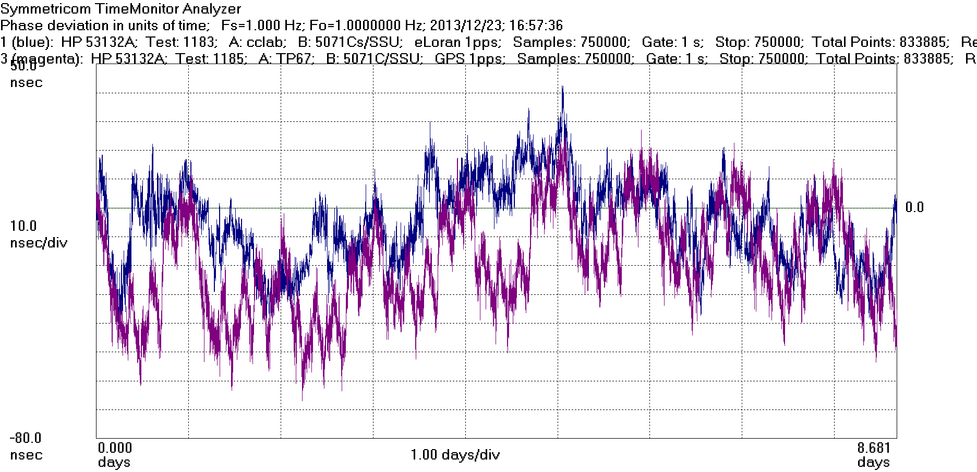

Figure 8: TIE graph of eLoran (Blue) and GPS (Magenta) 1pps timing signals over 9 days

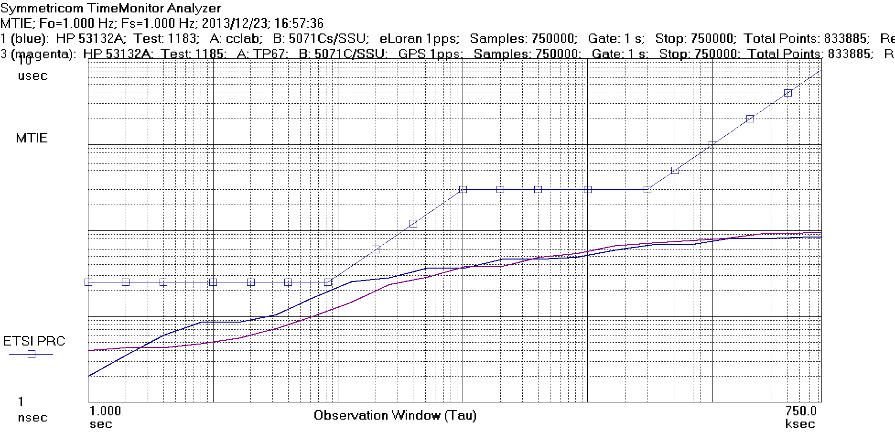

Figure 9: MTIE graph of eLoran (Blue) and GPS (Magenta) 1pps timing signals over 9 days

Drawbacks of eLoran currently are:

* Coverage is regional rather than international, even though several regions in the world have similar systems (e.g. APAC, Europe, Russia…). It is challenging to deploy new high-power stations in Europe considering the practical requirements and logistics however low-power stations could be deployed to enhance land coverage. More generally, eLoran is targeted at maritime PNT users, resulting in uneven coverage that favours sea areas.
* Loran-C future and maintenance is unclear in some countries, pending arbitrations based on budget considerations vs Loran’s technical merits as a complementary, independent and dissimilar backup to GNSS (e.g. in case of jamming or signal unavailability). Potential applicability for civil uses such as telecoms might also favourably influence those arbitrations.
* The cost, volume and footprint of current receivers may be acceptable for macrocells but not yet for low-cost small cells; however, developing a dedicated low-cost receiver ASIC is not foreseen to be difficult technically or commercially given sufficient volume.
* Antenna enhancements are needed in order to lower their footprint for small cell applications. Indoor coverage with such low-footprint antennas is still to be assessed.
* It has not been formally specified for telecom applications by standards organization such as ITU-T, therefore its practical applicability needs further studies.

**Maturity and current deployment**:

In the UK, prototype eLoran has operated for over 3 years and Initial Operational Capability (IOC) has recently been implemented for maritime positioning, navigation and timing (PNT). The service provides precise timing for land users across the UK, Ireland and parts of the Continent. These UK eLoran transmissions are backward-compatible with Loran-C, which remains operational in northwest Europe with transmitters in France, Denmark (Faroe Islands), Germany and Norway. All Loran-C stations can be modernised to provide eLoran navigation and timing. Global evolution towards eLoran is anticipated, with integrated eLoran/GNSS receivers aimed at multiple applications. This technology is also deployed in Russia and APAC. Equipment/towers are also deployed in the US even though the US government has stopped operating it at the time of this writing (but it is technically feasible to restart operations).

### Holdover and resilience

All oscillators drift over time when they are not disciplined by a reference clock. More expensive oscillators such as OCXOs drift more slowly than cheaper ones like TCXOs (which are more frequently used in UEs and small cells), even though new TCXO generations have an increasing quality that may allow them to be used in situations where an OCXO used to be required. The following tables (from [20]) give indications on the typical holdover time for various clocks defined by ITU-T (it does not exclude better performances by available hardware from the industry):

Table 2: Time to Produce a Particular Error for Various Oscillator Types



Table 3: Error Produced in a Particular Time for Various Oscillator Types



When base stations lose the reference clock, they can still continue to operate with their local oscillator in a mode called "holdover". Frequency synchronisation and phase/time synchronisation have different requirements and therefore maximum holdover duration before respectively frequency or time error exceeds the drift tolerance — i.e. the maximum acceptable frequency or time error for the considered technology — differs between them. Considering current accuracy limits for IMT technologies, time holdover is typically shorter than frequency holdover meaning that some protection mechanism need to be found in order to maintain the proper accuracy and avoid radio interferences. Some protection mechanism may be used in order to increase the time holdover duration (e.g. the local base station oscillator can get a proper frequency reference clock in order to drift more slowly).

Some base station vendors allow to configure a default holdover parameter (e.g. 2 hours for some WiMAX macro base stations [15], and supposedly significantly better for newer LTE-TDD eNB with more recent oscillators), and take appropriate measure when they lose the time reference for a duration that exceeds this configured holdover (e.g. shutdown the radio signal as described in [15]). It should however be noted that the clock drift does not only depend on oscillator quality, but also on several parameters such as temperature gradient, so the configured holdover time has to take into account the worst-case drift.

Synchronisation methods described in this report are not exclusive and may be complementary and/or used as a backup.

For example:

* In case of a localised GNSS jamming, an alternate IEEE-1588v2 path may allow to transport a remote backup clock if properly engineered that way. Some protection scenarios are described in ITU-T G.8275.
* Despite being focused on frequency synchronisation, SyncE may help to discipline the local oscillator so that it drifts more slowly in case the reference time clock is lost (this is taken into account in G.8271).
* G.8275.1 defines resiliency features (e.g. to reselect a new master clock in case the primary master clock fails).

## Frame structure coordination

### Overview

Having a common reference phase/time clock is not enough to avoid interference between networks. Since TDD allows flexibility in the frame length and uplink/downlink ratio, it is necessary to properly align UL/DL switching points so that the last transmitter stops before the first receiver starts, taking into account the propagation delay (frame structure do not need to be exactly identical provided this condition is met). In TDD networks, the frame configuration (i.e. frame length and uplink/downlink ratio) can be set as software parameters. Therefore cross-operator synchronisation implies agreeing on proper common parameters.

It should be noted that agreement on a common frame structure decreases the flexibility of TDD (e.g. with respect to the choice of the ratio), maybe leading to some suboptimal parameters at the individual level for each operator. However synchronised operation also allows saving some spectrum that would otherwise have to be used in restricted blocks or guard bands, and also makes it unnecessary to implement additional filtering. Therefore the benefits and drawbacks of synchronised operation have to be balanced taking into account the waste of spectrum and extra filtering costs in the case of unsynchronised networks. Also, the common TDD ratio is not restricted to 50:50 but may be a compromise between the needs of the various involved operators, which may be updated later in time.

### Cross-technology network synchronisation

Configuring compatible frame structures is technically straightforward when the base stations use the same technology. When they use a different technology, the feasibility of synchronisation requires a case-by-case analysis. This section will assess WiMAX/TD-LTE cross-technology synchronisation as these two technologies are the two main candidates for MFCN within several TDD bands and there is therefore a possibility that they are deployed in adjacent channels in the same band.

Based on the current state of the specification exposed in Annex 1, it can be shown that most WiMAX 802.16e configurations have at least one equivalent TD-LTE set of parameters, giving options for synchronising two networks implementing different technologies.

Some limitations exist however: current WiMAX Forum profiles only support 5ms frame length and TDD ratios above 50% for downlink. This study focuses on currently available technologies, therefore only LTE up-down configurations #1 and #2 are applicable for coexistence with WiMAX. The following table summarises which LTE frame type and "S" subframe configurations correspond to each WiMAX configurations (details and calculations are in Annex 1):

Table 4: LTE-TDD equivalent parameters for existing WiMAX frame configurations

| **WiMAX configuration** | **LTE frame configuration** | **LTE "S" possible configurations** |
| --- | --- | --- |
| 10MHz 35:12 | 2 | 0,1,5,6 |
| 10MHz 34:13 | 2 | 0,5 |
| 10MHz 33:14 | 2 | 0,5 |
| 10MHz 32:15 | 2 | 0,5 |
| 10MHz 31:16 | 2 | 0,5 |
| 10MHz 30:17 | - | No exact equivalent |
| 10MHz 29:18 | - | No exact equivalent |
| 10MHz 28:19 | 1 | 0-4 |
| 10MHz 27:20 | 1 | 0-8 |
| 10MHz 26:21 | 1 | 0-2,5-7 |
| 7MHz 24:9 | 2 | 0,5 |
| 7MHz 23:10 | 2 | 0,5 |
| 7MHz 22:11 | 2 | 0,5 |
| 7MHz 21:12 | - | No exact equivalent |
| 7MHz 20:13 | 1 | 0-4 |
| 7MHz 19:14 | 1 | 0-8 |
| 7MHz 18:15 | 1 | 0-2,5-7 |
| 8.75MHz 30:12 | 2 | 0,5 |
| 8.75MHz 29:13 | 2 | 0,5 |
| 8.75MHz 28:14 | 2 | 0,5 |
| 8.75MHz 27:15 | - | No exact equivalent |
| 8.75MHz 26:16 | - | No exact equivalent |
| 8.75MHz 25:17 | 1 | 0-5 |
| 8.75MHz 24:18 | 1 | 0-3,5-8 |

In a few cases (e.g. WiMAX DL/UL ratio 29:18), no direct TD-LTE equivalent parameters exist. However, even in those cases, only minimal overlap happens, and several technical solutions are applicable in order to solve this. Taking the example of 29:18 WiMAX DL/UL ratio, the following approaches may be used:

* Blank-out the two last OFDM symbols in the WiMAX frame (making DL/UL ratio effectively 27:18), at the expense of an 8% capacity loss on the WiMAX side. This can be done in several ways.
* Blank-out a part of the UpPTS field in the LTE “S” subframe. As this carries no payload and the system can use other slots for RACH and SRS, there is nearly no loss of capacity, however it leads to a relatively narrow “inter-technology guard period”. The picture below shows an example of such configuration:

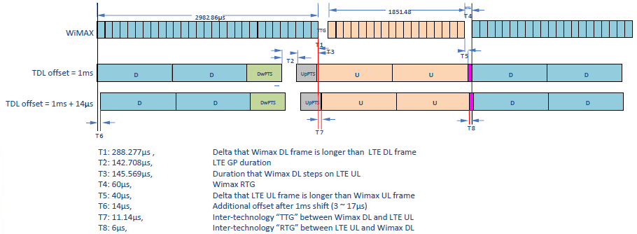

Figure 10: Frame alignment mechanism between WiMAX with 29:18 DL/UL ratio and LTE-TDD

This solution has been successfully implemented by Clearwire US as part of their WiMAX to LTE-TDD transition.

# Practical guidance for inter-operator deployments

## Clock synchronisation

The following table summarizes and compares the assessed techniques for phase/time synchronisation:

Table 5: Summary of assessed techniques for various scenarios

|  | **GNSS** | **Packet networks** | **LTE OTA** | **eLoran** |
| --- | --- | --- | --- | --- |
| **Status** | Mature. Implemented in existing TDD networks. May experience some outages | G.8275.1 assumes full on-path timing support (i.e. all equipment between GM and slave must have dedicated hardware and software support for IEEE-1588v2). Expected in 2014.  G.8275.2 will address assisted partial on-path timing support case (PTPv2 used to backup GNSS failure). Under specification.  G.8275.x: partial on-path timing support. Not yet defined | Available for HeNB. Under study for other type of cells and scenarios | Essentially used in maritime navigation and military contexts, but not yet used for IMT |
| **Cross-technology (e.g. WiMAX-LTE)** | Yes | Yes | No, LTE-only | Yes |
| **Works indoors** | Generally not, although some improvements in chipset performance may make this applicable on a case-by-case basis | N/A (not based on RF technologies. Applicability depends on network characteristics). Work and tests are still ongoing on indoor small cells scenarios | Yes, up to 3 HeNB-to-HeNB hops.  Work-item ongoing for more hops and for more deployment scenarios | FFS. The signal is expected to have good indoor penetration. However this has not yet been tested with low-cost low-footprint chipsets and antennas (which also require further studies) |

## Inter-operator synchronisation pre-requisites

In order to deploy synchronised TDD mobile networks in a multi-operator context (without guard bands), agreement needs to be reached on:

* a common phase clock reference (e.g. UTC) and accuracy/performance constraints (e.g. +/- 1.5 µs), either using their own equipment to provide the clock, or sharing the same phase/time clock infrastructure;
* a compatible frame structure (including TDD UL/DL ratio) in order to avoid uplink/downlink overlapping[[6]](#footnote-7);
* a commitment not to interfere with each other as any synchronisation issue of one operator may impact the network of the others (e.g. reliability of the reference clock and protection mechanism have to be ensured and/or procedure when losing this reference clock has to be defined);
* the terms & conditions where cross-operator synchronisation must apply and/or may not be required (e.g. geographical zones / isolated eNB. HeNB-only deployments…);
* how to update those parameters.

## General considerations on Inter-operator agreements

For different unpaired frequency bands, the least restrictive technical conditions (BEM, guard bands, etc.) have been defined in different ECC reports, for example, the least restrictive technical conditions for the frequency bands 3400-3600 MHz and 3600-3800 MHz are described in ECC Report 203 [19]. TDD network in a given unpaired frequency band can be deployed following the least restrictive technical conditions described in the corresponding ECC report.

Inter-operator TDD network synchronisation as described in this report allows deployment without guard bands and to implement a relaxed BEM (Block Edge Mask) between synchronised equipment. However, it may also introduce new operational constraints and additional costs. For instance, inter-operator synchronisation may lead to a less flexible UL/DL ratio selection, resulting in suboptimal spectrum utilisation for an individual operator.

As described above, for different network deployment scenarios (Macrocell, microcell, picocell, femtocell), some network synchronisation methods could be more appropriate than others. Therefore, technical and operational aspects described in §3.2 need to be taken into account by concerned operators aiming to reach a common bilateral/multilateral agreement.

It should be anticipated that inter-operator agreement may not be straightforward in some situations, for example:

* **Lack of mutual incentive**: when eNB-eNB interference is dominant compared to UE-UE interference, the operator who has more downlink may be interferer and the operator(s) who has less downlink are interfered if no additional filtering is implemented to prevent blocking even if the interferer complies with its block edge mask. The same issue happens with the operator that configures more uplink if UE-UE interference is dominant. Unlike when interference is mutual, the interferer has little incentive to compromise on parameters such as UL/DL ratio in those situations, and the negotiations to find an agreement on a common UL/DL ratio may be biased.
* **Unanimity required**: operator-specific filters may be required to comply with unsynchronised operation both on the transmitter and receiver. Avoiding such operator-specific filters may be desirable in order to get economies of scale. However, this may require unanimity on synchronised operation as defined in section §3.2.
* **Sustainability of the synchronised arrangement**: when operators deploy synchronised networks (e.g. avoiding operator-specific filters), challenging situations may occur if the synchronised operation is disrupted at a later point in time (e.g. if a new operator deploys without agreeing on synchronised operation) as the already deployed equipments from the former operator(s) may not be compliant with unsynchronised operation (BEM and blocking requirements and regulation).

Inter-network synchronisation conditions can be discussed and agreed at the national level and implemented nationwide or limited to a given area (regional) as appropriate.

Some inter-operator TDD network synchronisations have been implemented in various countries; examples are given in Annex 3.

# Conclusion

In this report synchronisation for TDD networks has been assessed as a solution to avoid UE-UE and BS-BS interferences between networks in the same geographic area and represents a possible alternative solution to the use of guard bands or extra filtering. Synchronised operation has been defined as a mode where no simultaneous uplink and downlink occurs between any pairs of cells which may interfere with each other in the same band. Two orthogonal topics have been discussed:

* reference phase clock (order of magnitude of 1µs)
* compatible frame configuration.

For the first topic, the usual GNSS-based phase/time synchronisation solution is generally used in existing TDD deployments, which are mostly outdoor macrocells with one single operator per geographic zones. This report addresses new scenarios where GNSS cannot always be used. Therefore other techniques have also been assessed: IEEE-1588v2 on packet networks, over-the-air synchronisation and terrestrial networks (eLoran). The following deployment scenarios can be addressed by existing or under development synchronisation techniques:

* **Outdoor cells**: can be synchronised by all considered techniques, both for intra-network and cross-operator network synchronisation. GNSS is generally the most used and mature solution for this scenario. IEEE-1588v2 is considered as an alternative when GNSS is not usable or in order to avoid implementing a GNSS receiver at each site. eLoran may be assessed as a complementary or backup solution. Over-the-air synchronisation is not yet fully specified for non-HeNB scenarios but may be used in a near future.
* **Indoor micro/picocells**: GNSS requires sky visibility and is mostly not usable in that context. IEEE-1588v2 can be considered if full on-path support is available. It may be also usable when only partial on path support is available, although studies and standardization are still ongoing, so performance cannot yet be guaranteed. eLoran may be assessed as a complementary or backup solution. Over-the-air synchronisation is not yet fully specified for this scenario but may be used in a near future.
* **Indoor HeNB**: Over-the-air "network listening" has been specified and evaluated in labs environment for intra-network 1-hop HeNB synchronisation. The specifications allow HeNB-HeNB synchronisation up to 3 hops. Additional work is currently ongoing at 3GPP to extend this technique.

Nevertheless, further studies are still needed regarding:

* over-the-air synchronisation in a multi-operator context and/or with other types of cells than HeNB and/or in HeNB-only scenarios;
* eLoran in a telecom context, especially for indoor uses with low-footprint antennas;
* partial on-path support for IEEE-1588v2, e.g. for small cell deployments with a GNSS receiver a few hops away on an Ethernet LAN;
* potential use of other RF signals as a phase reference;
* behaviour and resilience of TDD technologies when imperfect synchronisation is implemented (e.g. due to synchronisation error, or slightly different start of frame or frame structure), leading to a limited interference zone in the frame.

Regarding frame structure configuration, it has been shown that most WiMAX configurations have at least an equivalent LTE-TDD one (however the opposite is not true since LTE also allows for more uplink than downlink, contrary to WiMAX except in some non-standard vendor-specific cases). Specific fine-tuning at the frame level may be required in some cases (e.g. to align the 29:18 WiMAX configuration to the closest corresponding LTE-TDD configuration).

When multiple operators deploy TDD networks on adjacent bands, inter-network synchronisation conditions can be discussed and agreed at the national level and implemented nationwide or limited to a given area (regional) as appropriate.

1. WiMAX and LTE-TDD frame structures

This annex details the supported parameters in LTE and WiMAX specifications at the time of this writing.

## 3GPP LTE

TS 36.211 (§4.2) [16] defines the following frame structure for TDD-LTE (frame type 2).



Figure 11: LTE-TDD frame structure

Each subframe has a 1ms length, and can be used in the 3 following modes: "D" (downlink), "U" (uplink) and "S" (switching point). The LTE superframe supports the following configurations:

Table 6: LTE TDD uplink-downlink configurations

| **Uplink-downlink**  **configuration** | **Downlink-to-Uplink**  **Switch-point periodicity** | **Subframe number** | | | | | | | | | | **%DL (min-max)** |
| --- | --- | --- | --- | --- | --- | --- | --- | --- | --- | --- | --- | --- |
|  |  | **0** | **1** | **2** | **3** | **4** | **5** | **6** | **7** | **8** | **9** |  |
| #0 | 5 ms | D | S | U | U | U | D | S | U | U | U | 24% - 37% |
| #1 | 5 ms | D | S | U | U | D | D | S | U | U | D | 44% - 57% |
| #2 | 5 ms | D | S | U | D | D | D | S | U | D | D | 64% - 77% |
| #3 | 10 ms | D | S | U | U | U | D | D | D | D | D | 62% - 69% |
| #4 | 10 ms | D | S | U | U | D | D | D | D | D | D | 72% - 79% |
| #5 | 10 ms | D | S | U | D | D | D | D | D | D | D | 82% - 89% |
| #6 | 5 ms | D | S | U | U | U | D | S | U | U | D | 34% - 47% |

The "S" subframe itself is made of 3 parts: DwPTS (downlink pilot and data timeslot), GP (guard period) and UpPTS (uplink pilot timeslot). The following configurations are defined for this "S" subframe (where Ts = 32.55 ns):

Table 7: LTE-TDD "S" subframe configurations (values are in number of Ts)

|  |  |  |  |  |  |  |
| --- | --- | --- | --- | --- | --- | --- |
| Special subframe configuration | Normal cyclic prefix in downlink | | | Extended cyclic prefix in downlink | | |
| DwPTS | UpPTS | | DwPTS | UpPTS | |
| Normal cyclic prefix in uplink | Extended cyclic prefix in uplink | Normal cyclic prefix in uplink | Extended cyclic prefix in uplink |
| #0 | 6592 | 2192 | 2560 | 7680 | 2192 | 2560 |
| #1 | 19760 | 20480 |
| #2 | 21952 | 23040 |
| #3 | 24144 | 25600 |
| #4 | 26336 | 7680 | 4384 | 5120 |
| #5 | 6592 | 4384 | 5120 | 20480 |
| #6 | 19760 | 23040 |
| #7 | 21952 | - | - | - |
| #8 | 24144 | - | - | - |

## WiMAX 802.16e

In WiMAX 802.16e (as defined in the WiMAX Forum System Profiles [4, 5], based on [17]), the frame length is always 5ms. The TTG/RTG must be above 5µs, but the current WiMAX Forum profiles define a fixed value of 60µs for the RTG (or 74.4µs for the 8.75 MHz channel size). The TTG is taking the remaining part of the frame (which allows a cell radius of ~8km for the 5 MHz and 10 MHz channel size, and ~16km for the 3.5 MHz and   
7 MHz channel size. If it is required, it is still possible to blank some OFDM symbols in order to increase the TTG to allow a greater cell radius).

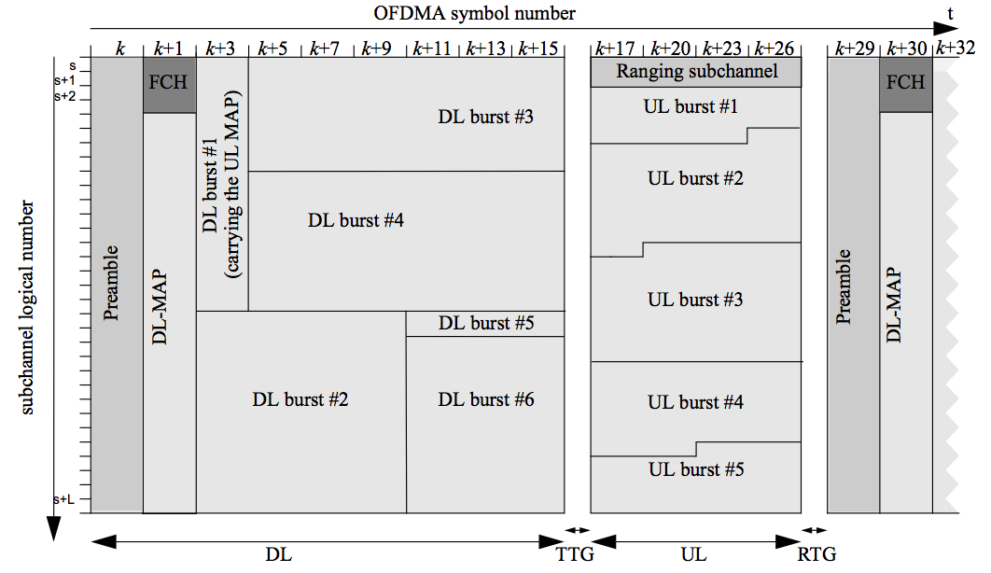

Figure 12: IEEE-802.16e (WiMAX) frame structure (figure 8-46 in [[1](" \l "IEE)])

Table 8: WiMAX 802.16e parameters

| **BW** | **10 MHz** | **7 MHz** | **5 MHz** | **3.5 MHz** | **8.75 MHz** |
| --- | --- | --- | --- | --- | --- |
| Min TDD ratio (DL:UL) | 35:12 | 24:09 | 35:12 | 24:09 | 30:12 |
| Max TDD ratio (DL:UL) | 26:21 | 18:15 | 26:21 | 18:15 | 24:18 |
| Sampling factor | 1.12 | 1.142857143 | 1.12 | 1.142857143 | 1.142857143 |
| FFT size | 1024 | 1024 | 512 | 512 | 1024 |
| Fs (sampling frequency) | 11200000 | 8000000 | 5600000 | 4000000 | 10000000 |
| Carrier spacing (Hz) | 10937.5 | 7812.5 | 10937.5 | 7812.5 | 9765.625 |
| Useful OFDM symbol length (µs) | 91.4 | 128 | 91.4 | 128 | 102.4 |
| Cyclic prefix length (µs) | 11.4 | 16 | 11.4 | 16 | 12.8 |
| Total OFDM symbol length (µs) | 102.8 | 144 | 102.8 | 144 | 115.2 |
| Useful OFDM symbols / frame | 47 | 33 | 47 | 33 | 42 |
| RTG | 60µs | 60µs | 60µs | 60µs | 74.4µs |
| TTG | 105.7µs | 188µs | 105.7µs | 188µs | 87.2µs |

## WiMAX/LTE-TDD compatibility matrix

The next table shows the gap/overlap between the WiMAX and the LTE-TDD frame. "Ratio" shows how much downlink there is in % of the total 5ms frame. "DL\_length", "UL\_length" and "UL\_start" are in µs, as well as the other values, which are computed with the following formula:

Overlap == min( (wimax\_ul\_start-lte\_dl\_length), (lte\_ul\_start-wimax\_dl\_length) )

When this computation is positive (green values), it means there is no overlap, and the extra time is similar to a guard period. On the other hand, scenarios where only negative values (red values) appear in the corresponding line (or column) means that the standards do not allow straightforward cross-technology synchronisation as there is no exact compatible frame structure between the two technologies without using some specific technical measures (like offsetting start of frame, or blanking out some OFDM symbols, as described in section §2.3).

In order to be compatible, the amount of time in the gap should not only be positive, but also leave enough time for TX ramp-up/ramp-down (17µs in the case of LTE-TDD. Yellow values in the table are positive values which are below this 17µs duration).

*N.B. in order to practically implement WiMAX-LTE cross-technology synchronisation and considering the frame structures of the two technologies, it is necessary to specify an offset (e.g. if the WiMAX frame is aligned on multiple of 1s+k\*5ms boundaries, then the neighbour TD-LTE network has to align its frame on 1s+1ms+k\*5ms boundaries when using type 1 configuration or 1s+2ms+k\*5ms boundaries when using configuration type 2).*

*N.B. WiMAX 5 MHz uses the same timing as 10 MHz, and WiMAX 3.5 MHz uses the same timings as 7 MHz.*

Table 7: 802.16e/LTE-TDD coexistence

|  |  |  |  |  |  |  |  |  |  |  |  |  |  |  |  |  |  |  |  |  |  |  |  |
| --- | --- | --- | --- | --- | --- | --- | --- | --- | --- | --- | --- | --- | --- | --- | --- | --- | --- | --- | --- | --- | --- | --- | --- |
|  |  |  |  | **LTE U-D conf** | | **1** | | | | | | | | | **2** | | | | | | | | |
|  |  |  |  |  | **"S" frame** | **0** | **1** | **2** | **3** | **4** | **5** | **6** | **7** | **8** | **0** | **1** | **2** | **3** | **4** | **5** | **6** | **7** | **8** |
|  | **Ratio** |  |  |  |  | 44,3% | 52,9% | 54,3% | 55,7% | 57,1% | 44,3% | 52,9% | 54,3% | 55,7% | 64,3% | 72,9% | 74,3% | 75,7% | 77,1% | 64,3% | 72,9% | 74,3% | 75,7% |
|  |  | **DL length** |  |  |  | 2215 | 2643 | 2715 | 2786 | 2857 | 2215 | 2643 | 2715 | 2786 | 3215 | 3643 | 3715 | 3786 | 3857 | 3215 | 3643 | 3715 | 3786 |
|  |  |  | **TTG / GP** |  |  | 714 | 285 | 214 | 143 | 71 | 643 | 214 | 143 | 71 | 714 | 285 | 214 | 143 | 71 | 643 | 214 | 143 | 71 |
|  |  |  |  | **UL length** |  | 2071 | 2071 | 2071 | 2071 | 2071 | 2143 | 2143 | 2143 | 2143 | 1071 | 1071 | 1071 | 1071 | 1071 | 1143 | 1143 | 1143 | 1143 |
|  |  |  |  |  | **UL start** | 2929 | 2929 | 2929 | 2929 | 2929 | 2857 | 2857 | 2857 | 2857 | 3929 | 3929 | 3929 | 3929 | 3929 | 3857 | 3857 | 3857 | 3857 |
| **Conf WiMAX** |  |  |  |  |  |  |  |  |  |  |  |  |  |  |  |  |  |  |  |  |  |  |  |
| 10MHz 35:12 | 74,5% | 3600 | 106 | 1234 | 3706 | -671 | -671 | -671 | -671 | -671 | -743 | -743 | -743 | -743 | 329 | 62 | -9 | -80 | -152 | 257 | 62 | -9 | -80 |
| 10MHz 34:13 | 72,3% | 3497 | 106 | 1337 | 3603 | -568 | -568 | -568 | -568 | -568 | -640 | -640 | -640 | -640 | 388 | -40 | -112 | -183 | -254 | 360 | -40 | -112 | -183 |
| 10MHz 33:14 | 70,2% | 3394 | 106 | 1440 | 3500 | -466 | -466 | -466 | -466 | -466 | -537 | -537 | -537 | -537 | 285 | -143 | -215 | -286 | -357 | 285 | -143 | -215 | -286 |
| 10MHz 32:15 | 68,1% | 3291 | 106 | 1543 | 3397 | -363 | -363 | -363 | -363 | -363 | -434 | -434 | -434 | -434 | 183 | -246 | -317 | -389 | -460 | 183 | -246 | -317 | -389 |
| 10MHz 31:16 | 66,0% | 3189 | 106 | 1646 | 3294 | -260 | -260 | -260 | -260 | -260 | -331 | -331 | -331 | -331 | 80 | -349 | -420 | -492 | -563 | 80 | -349 | -420 | -492 |
| 10MHz 30:17 | 63,8% | 3086 | 106 | 1749 | 3191 | -157 | -157 | -157 | -157 | -157 | -228 | -228 | -228 | -228 | -23 | -452 | -523 | -595 | -666 | -23 | -452 | -523 | -595 |
| 10MHz 29:18 | 61,7% | 2983 | 106 | 1851 | 3089 | -54 | -54 | -54 | -54 | -54 | -126 | -126 | -126 | -126 | -126 | -555 | -626 | -697 | -769 | -126 | -555 | -626 | -697 |
| 10MHz 28:19 | 59,6% | 2880 | 106 | 1954 | 2986 | 49 | 49 | 49 | 49 | 49 | -23 | -23 | -23 | -23 | -229 | -658 | -729 | -800 | -872 | -229 | -658 | -729 | -800 |
| 10MHz 27:20 | 57,4% | 2777 | 106 | 2057 | 2883 | 152 | 152 | 152 | 97 | 26 | 80 | 80 | 80 | 80 | -332 | -760 | -832 | -903 | -974 | -332 | -760 | -832 | -903 |
| 10MHz 26:21 | 55,3% | 2674 | 106 | 2160 | 2780 | 254 | 137 | 65 | -6 | -77 | 183 | 137 | 65 | -6 | -435 | -863 | -935 | -1006 | -1077 | -435 | -863 | -935 | -1006 |
| 8,75MHz 30:12 | 71,4% | 3456 | 87 | 1382 | 3543 | -527 | -527 | -527 | -527 | -527 | -599 | -599 | -599 | -599 | 329 | -100 | -171 | -243 | -314 | 329 | -100 | -171 | -243 |
| 8,75MHz 29:13 | 69,0% | 3341 | 87 | 1498 | 3428 | -412 | -412 | -412 | -412 | -412 | -484 | -484 | -484 | -484 | 213 | -215 | -287 | -358 | -429 | 213 | -215 | -287 | -358 |
| 8,75MHz 28:14 | 66,7% | 3226 | 87 | 1613 | 3313 | -297 | -297 | -297 | -297 | -297 | -368 | -368 | -368 | -368 | 98 | -330 | -402 | -473 | -544 | 98 | -330 | -402 | -473 |
| 8,75MHz 27:15 | 64,3% | 3110 | 87 | 1728 | 3198 | -182 | -182 | -182 | -182 | -182 | -253 | -253 | -253 | -253 | -17 | -446 | -517 | -588 | -660 | -17 | -446 | -517 | -588 |
| 8,75MHz 26:16 | 61,9% | 2995 | 87 | 1843 | 3082 | -67 | -67 | -67 | -67 | -67 | -138 | -138 | -138 | -138 | -132 | -561 | -632 | -704 | -775 | -132 | -561 | -632 | -704 |
| 8,75MHz 25:17 | 59,5% | 2880 | 87 | 1958 | 2967 | 49 | 49 | 49 | 49 | 49 | -23 | -23 | -23 | -23 | -247 | -676 | -747 | -819 | -890 | -247 | -676 | -747 | -819 |
| 8,75MHz 24:18 | 57,1% | 2765 | 87 | 2074 | 2852 | 164 | 164 | 137 | 66 | -5 | 92 | 92 | 92 | 66 | -363 | -791 | -863 | -934 | -1005 | -363 | -791 | -863 | -934 |
| 7MHz 24:9 | 72,7% | 3456 | 188 | 1296 | 3644 | -527 | -527 | -527 | -527 | -527 | -599 | -599 | -599 | -599 | 429 | 1 | -71 | -142 | -213 | 401 | 1 | -71 | -142 |
| 7MHz 23:10 | 69,7% | 3312 | 188 | 1440 | 3500 | -383 | -383 | -383 | -383 | -383 | -455 | -455 | -455 | -455 | 285 | -143 | -215 | -286 | -357 | 285 | -143 | -215 | -286 |
| 7MHz 22:11 | 66,7% | 3168 | 188 | 1584 | 3356 | -239 | -239 | -239 | -239 | -239 | -311 | -311 | -311 | -311 | 141 | -287 | -359 | -430 | -501 | 141 | -287 | -359 | -430 |
| 7MHz 21:12 | 63,6% | 3024 | 188 | 1728 | 3212 | -95 | -95 | -95 | -95 | -95 | -167 | -167 | -167 | -167 | -3 | -431 | -503 | -574 | -645 | -3 | -431 | -503 | -574 |
| 7MHz 20:13 | 60,6% | 2880 | 188 | 1872 | 3068 | 49 | 49 | 49 | 49 | 49 | -23 | -23 | -23 | -23 | -147 | -575 | -647 | -718 | -789 | -147 | -575 | -647 | -718 |
| 7MHz 19:14 | 57,6% | 2736 | 188 | 2016 | 2924 | 193 | 193 | 193 | 138 | 67 | 121 | 121 | 121 | 121 | -291 | -719 | -791 | -862 | -933 | -291 | -719 | -791 | -862 |
| 7MHz 18:15 | 54,5% | 2592 | 188 | 2160 | 2780 | 337 | 137 | 65 | -6 | -77 | 265 | 137 | 65 | -6 | -435 | -863 | -935 | -1006 | -1077 | -435 | -863 | -935 | -1006 |

1. ITU-T SG15/Q13 standards and workplan

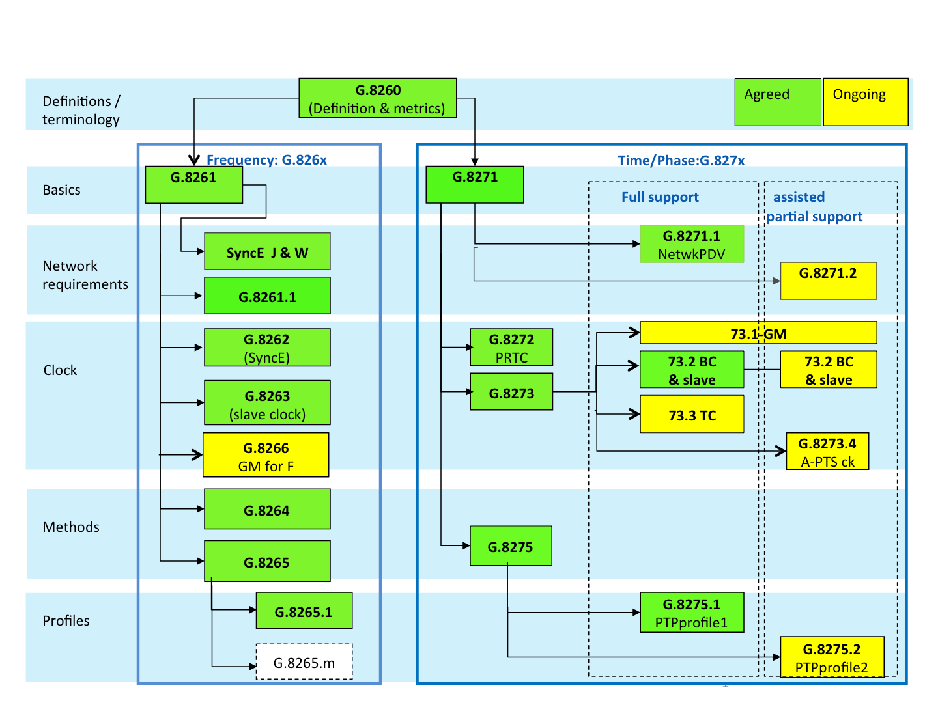

Figure 13: Frequency, phase and time synchronisation profiles from ITU-T SG15/Q13

N.B: this figure is only given for information and is only valid at the time of writing. It is likely to evolve to reflect ITU-T on-going work.

1. Existing examples of cross-operator TDD synchronisation

Successful inter-operator synchronisation deployments have already been implemented. As an example:

* In China, both 2.6GHz (3GPP band 41) and 2.3GHz band have been allocated for multiple operators in December 2013, e.g. 2.6GHz band for China Mobile (CMCC), China Unicom(CU) and China Telecom(CT), and 2.3GHz band for CMCC and CU with adjacent channels. Full Synchronisation is mandatory between multiple operators within the same band and no guard band is reserved. It is agreed under the RRB (Radio Regulatory Bureau) coordination that the exact synchronisation configurations should be applied among operators, including coordination on frame starting time, UL/DL configuration and special sub frame configuration. Moreover, it also set a rule to coordinate the unsynchronised interference caused by out of sync.
* In Italy (From [15]), “In both Linkem and Aria network each single Base Station is synchronised by GPS that, according to WiMAX Forum specification, receives 1pps (one pulse per second) with precision of 2ppm. The Base Station’s GPS board generates 1µs clock to synchronise the frames. Both the networks use 32:15 downlink/uplink ratio that reflects the current traffic profile of broadband internet access services. This ratio will allow full compatibility with LTE TDD 10 ms frame configuration type 2 ensuring no loss of capacity. The plan is to set GAP at 63.05 µs which can provide 19 km safe distance. It means that 2 Base Stations at 19 km, potentially mutually interfered, will be still synchronised. This best practice is in place since middle 2011 without evidence of interferences or service degradation”
* From ECC PT1(11)103: “In the Asia Pacific region Malaysian operators in the 2300MHz band operate synchronised TDD systems (frame timing and DL/UL transmission) in unpaired blocks through a voluntarily agreed cooperation agreement. The agreed DL/UL ratio is 29:18 but there is a possibility to agree alternative ratios. Internationally, the 29:18 DL/UL ratio is a very common and popular ratio for the uplink and downlink sub-frames in TDD mode.”
* In Japan, according to the operator Softbank: PHS is using 3GPP band #39 (1880-1920). Three operators (DDI-P, NTT-P, ASTEL) share the frequency. So, there are no guard bands between operators. PHS requires one dedicated Control Carrier for each operator, but share all the traffic CH. among operators and also unlicensed PHS devices. PHS has a fixed 1:1 uplink-downlink ratio, so there was no discussion regarding this area.
* The KT/SKT synchronisation on their TDD WiBRO 802.16e network is another example of inter-operator agreement on all aspects discussed in this report – including UL/DL ratio. According to Korea Telecom: “*For the decision of TDD ratio, Operators made a task force including KCC (Korea Communications Commission, government organization). Through the result of operators harmonization, government made a regulation for the TDD ratio*”.

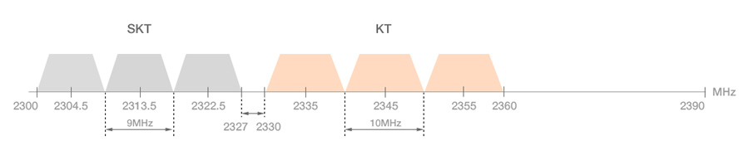

Figure 14: band plan for WiBRO in Korea

1. List of references
2. WiMAX Forum. FDD-TDD Coexistence.pdf. [Online]. http://resources.wimaxforum.org/sites/wimaxforum.org/files/document\_library/Service Recommentations to Support Technology Neutral Allocations - FDDTDD Coexistence.pdf
3. 3GPP. 36.133. [Online]. [http://www.3gpp.org/ftp/specs/archive/36\_series/36.133/36133-c20.zip §7.4](http://www.3gpp.org/ftp/specs/archive/36_series/36.133/36133-c20.zip%20§7.4)
4. 3GPP. R4-082105. [Online]. <http://www.3gpp.org/ftp/tsg_ran/wg4_radio/TSGR4_48/Documents/R4-082105.zip>
5. David Mills. [Online]. <http://www.ntp.org/>
6. Mike Gilson, Sebastien Jobert, Michael Mayer, Laurent Montini, Michel Ouellette, Silvana Rodrigues, Stefano Ruffini Jean-Loup Ferrant, *Synchronous Ethernet and IEEE 1588 in Telecoms: Next Generation Synchronisation Networks*.: [Online]. <http://eu.wiley.com/WileyCDA/WileyTitle/productCd-184821443X.html>
7. Kishan Shenoi, *Synchronisation and Timing in Telecommunications*., <http://www.amazon.com/Synchronisation-Timing-Telecommunications-Kishan-Shenoi/dp/1439226326>
8. John C. Eidson, *Measurement, Control, and Communication Using IEEE 1588*.: Springer, <http://www.springer.com/engineering/control/book/978-1-84628-250-8>
9. Small cells Forum. [Online]. <http://scf.io/en/documents/075_-_Synchronisation_for_LTE_small_cells.php>
10. 3GPP. 36.922. [Online]. [http://www.3gpp.org/ftp/Specs/archive/36\_series/36.922/36922-910.zip §6.4](http://www.3gpp.org/ftp/Specs/archive/36_series/36.922/36922-910.zip%20§6.4)
11. 3GPP. 36.413. [Online]. [http://www.3gpp.org/ftp/Specs/archive/36\_series/36.413/36413-b00.zip §9.2.3.34](http://www.3gpp.org/ftp/Specs/archive/36_series/36.413/36413-b00.zip%20§9.2.3.34)
12. Global TD-LTE Initiative. [Online]. [http://www.lte-tdd.org/Resources/rep/2013-11-11/1409.html](http://www.lte-tdd.org/Resources/rep/2013-11-11/1409.html" \t "_blank)
13. Loran Association. Loran.org. [Online]. <http://loran.org/>
14. Chronos Technology Ltd. Long Term Time & Timing Trials with eLoran. [Online]. <http://www.chronos.co.uk/files/pdfs/itsf/2011/Day2/1215_Chronos_Charles_Curry.pdf>
15. Loran Association. [Online]. [http://www.loran.org/news/eLoran Definition Document 0 1 Released.pdf](http://www.loran.org/news/eLoran%20Definition%20Document%200%201%20Released.pdf)
16. Linkem. [Online]. [http://cept.org/Documents/ecc-pt1/10417/Annex-replies\_Annex-replies , "Linkem and Aria.doc"](http://cept.org/Documents/ecc-pt1/10417/Annex-replies_Annex-replies%20,%20%20)
17. 3GPP. 36.211. [Online]. <http://www.3gpp.org/ftp/specs/archive/36_series/36.211/36211-910.zip>
18. IEEE. 802.16. [Online]. <http://standards.ieee.org/getieee802/download/802.16-2009.pdf>
19. Small cells Forum. scf.io. [Online]. <http://scf.io/en/documents/all_documents.php>
20. ECC Report 203 Least Restrictive Technical Conditions suitable for Mobile/Fixed Communication Networks (MFCN), including IMT, in the frequency bands 3400-3600 MHz and 3600-3800 MHz
21. Symmetricom — WD 45 “Time Holdover for Unassisted Oscillators”

1. N.B. those scenarios have also been assessed by white-papers from the Small Cells Forum [18]. [↑](#footnote-ref-2)
2. N.B. for certain scenarios it may not be necessary to align frame structures as other interference mitigation schemes may be sufficient (e.g. Cell clustering interference mitigation, studied in 3GPP). [↑](#footnote-ref-3)
3. Those values are peak-to-peak time error between base stations according to the relevant standards for the air interfaces. One practical way to implement those is to refer to a reference like UTC (e.g. in the case of LTE-TDD, consider +/- 1.5 µs from UTC) [↑](#footnote-ref-4)
4. Assuming HeNB synchronisation is still desired, which may not always the case be considering the low power and high wall penetration loss and ACIR in case of adjacent channels. [↑](#footnote-ref-5)
5. If eNBs of different operators are to be co-located (e.g. in indoor scenarios), then one eNB has to switch to the other eNB’s carrier and listen to it. This can lead to the received power far exceeding the dynamic range requirements, resulting in inoperability or at the very least unpredictable behavior. Hence, additional isolation between the eNBs may be required either via locating the two eNBs further apart or by some other mitigation technique. [↑](#footnote-ref-6)
6. If UE-UE interference can be considered negligible compared to eNB-eNB interferences and the start of frame is properly synchronised, then the operator that has the smallest amount of downlink will not interfere with the other operator(s), and may therefore be considered as having a “compatible” frame structure with those others operators. The same rationale applies to the operator that has the highest amount of downlink if UE-UE interferences are dominant compared to eNB-eNB interferences. [↑](#footnote-ref-7)