ANNEX 1

ECC Plenary MEETING
TOULOUSE, FRANCE
18 – 21 JUNE 2013

GENERAL INFORMATION

Meeting Venue

Pullman Toulouse Centre
Address: 84, allées Jean Jaurès, 31000 TOULOUSE, FRANCE
GPS: N 43° 36' 31.37'' E 1° 27' 12.83''
Tel : (+33)5/61102310
Phone : (+33)5/61102351
Fax : (+33)5/61102320
E-mail : H1091@accor.com
Airport: TOULOUSE BLAGNAC INTERNATIONAL
Railway Station: GARE MATABIAU
Underground station: Line A/B, Station JEAN- JAURES

Location and access to Pullman Toulouse Centre
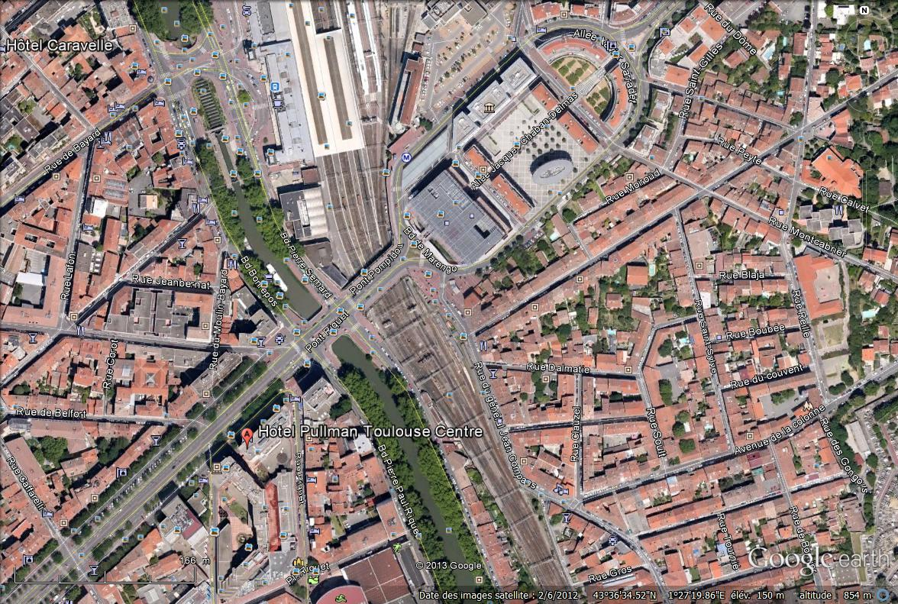
Click on that file to access to Google earth information:

Contact person

Mr Christian Rissone
ECC Technical secretary
ANFR
265 rue Pierre Rivoalon - CS 13829 - 29238 Brest Cedex 3 - France
Telephone: +33 2 98 34 12 42
Mobile: +33 6 32 64 42 15
Fax: +33 2 98 34 12 20
E-mail: rissone@anfr.fr

Hotel accommodation

A certain number of rooms have been reserved in the hotel of the venue until the 15th May 2013.
Please, use the attached form to make your reservation in due time. There are many other hotels in Toulouse that can be reaches from the meeting venue quite easily.
Some of them are:

3 STAR HOTEL

Hotel Kyriad Toulouse Centre * * *
Address : 5-7 Boulevard de la Gare - 31500 TOULOUSE
Phone : + 00 33 5 61 34 11 71 / Fax : + 00 33 5 61 34 12 21
Web : www.kyriad.fr

Hôtel Saint Sernin * * *
Address : 2 Rue Saint Bernard - 31000 TOULOUSE
Phone : + 33 5 61 21 73 08 / Fax : + 33 5 61 22 49 61
Web : www.hotelstsernin.com

Hôtel des Beaux Arts * * *
Address : 1 Place du Pont Neuf / 31000 TOULOUSE
Tél : + 33 5 34 45 42 42 / Fax : + 33 5 34 45 42 43
Web : www.hoteldesbeauxarts.com

2 STAR HOTEL

Hôtel Victor Hugo * *
Adresse : 26 Boulevard de Strasbourg - 31000 TOULOUSE
Tél : + 33 5 61 63 40 41 / Fax : + 33 5 61 62 66 31
Web : www.victorhugo-hotel.com

Hôtel la Castellane * *
Address : 17 Rue Castellane - 31000 TOULOUSE
Tél : + 33 5 61 62 18 82 / Fax : + 33 5 61 62 58 04
Web : www.castellanehotel.com

Hôtel le Président * *
Address : 43-45 Rue Raymond IV - 31000 TOULOUSE
Tél : + 33 5 61 63 46 46 / Fax : 05 61 62 83 60
Web : www.hotel-president.com

1 STAR HOTEL

Hôtel Anatole France *
Address : 46 Place Anatole France - 31000 TOULOUSE
Tél : + 33 5 61 23 19 96 / Fax : + 33 5 61 21 47 66
Web :www.hotel-anatolefrance.com

There is no special rate negotiate with these hotels, you are request to book yourself you accommodation.

Internet
There will be a WLAN network available within the conference rooms.

Access to Toulouse
Toulouse-Blagnac international airport is 8 km west of Toulouse. The city centre is easily reached by the airport shuttle service or by taxi (taxi rank outside the arrivals hall). You can also hire a car from one of the many vehicle hire companies represented at the airport.
Toulouse-Blagnac international airport
www.toulouse.aeroport.fr
Tel +33 8 25 38 00 00 (0,15 €/min)
Bus connections Airport shuttle/city centre
Outdoor counter, airport, arrivals area, hall B, gate C
Airport > Toulouse:
– first departure every day at 5.30 a.m.
– last departure every day at 12.15 a.m.
One departure every 20 minutes.
Toulouse > Airport:
– first departure from bus station: every day at 5 a.m.
– last departure from bus station: every day at 9.20 p.m.
One departure every 20 minutes.
Journey time: from 20 to 45 minutes, depending on traffic conditions.
City centre stops: Congress Centre Compans-Caffarelli, Jeanne-d’Arc Square, Jean-Jaurès, bus terminal.
Price: 5 €
www.tisseo.fr
Tel +33 5 61 41 70 70
Taxis
Taxis are parked outside the arrivals hall on the ground floor of the airport.
Tourism information
Further tourism information could be found on these website :
http://www.so-toulouse.com/index.php?id=132&L=2
http://www.toulouse-visit.com/
Matabiau Railway Station
Matabiau SNCF railway station is in the city centre. As you arrive in Toulouse, you can admire the Canal du Midi, which is just opposite. UNESCO has now classified the Canal du Midi as one of the World Heritage Sites. Canal du Midi as one of the World Heritage Sites.
Public transport in Toulouse

The public transport system is very dense and provides connections to all parts of the city.
For more information: http://www.tisseo.fr/en/home (all information available: maps, ticket price, schedule)

Electrical Appliances

The electric current in France is 230 V, 50 Hz.

