CEPT Report 49

Report from CEPT to the European Commission in response to the Mandate
“Technical conditions regarding spectrum harmonisation for terrestrial wireless systems in the 3400-3800MHz frequency band”
Report approved on DD Month YYYY by the ECC(Arial 9pt bold)

Executive summary
TASK 1 (Block Edge Mask)
The base station requirements are defined for base stations with different power levels, enabling network deployment with both macro cells and small cells.
The base station Block Edge Mask (BEM) requirements as described below may be relaxed whenever there are bilateral agreements between operators. The BEM has not been developed to protect other services or applications in the band, and only applies in blocks that have been licensed to MFCN according to the new harmonised frequency arrangement. In the figures below it is assumed for simplicity that all blocks have been licensed to MFCN.
Table 1 contains the different elements of the BEM in the 3400 – 3600 MHz and 3600 – 3800 MHz bands, together with the frequency regions where they apply. The guard bands apply in case of an FDD allocation in 3400 – 3600 MHz. It should be noted that whenever guard bands are mentioned in this report, it is understood that those apply only for an FDD allocation.
Tables 2 to 5 contain the power limits that apply for the different BEM elements. P_{Max} is the maximum carrier power for the base station in question, measured as e.i.r.p.
To obtain a BEM for a specific block, these elements are combined as follows:
- For each 5 MHz interval in the 3400 – 3600 MHz and 3600 – 3800 MHz bands, used by MFCN according to the harmonised frequency arrangements, the BEM elements that apply have to be determined (there may be several).
- The most relaxed requirement of those defined in the interval in question has to be chosen.
In the following paragraphs the different BEM elements are described further.
- BEM elements
BEM element | Region of applicability
In-block | Block for which the BEM is derived
Baseline | Spectrum assigned for TDD and FDD UL and DL
Transitional region | For FDD DL blocks, the transitional region applies 0 to 10 MHz below and above the block assigned to the operator.  For TDD blocks, the transitional region applies 0 to 10 MHz below and above the block assigned to the operator, in spectrum that is not assigned to another operator, including the guard band 3590 – 3600 MHz, or in case of synchronized blocks with the same UL/DL configuration.
Guard bands | 3400 – 3410, 3490 – 3510 and 3590 – 3600 MHz (for an FDD allocation)

- Baseline and guard band power limits
BEM element | Frequency range | Power limit
Baseline | FDD DL (3510 – 3590 MHz).  Synchronized TDD blocks with the same UL/DL configuration (3400–3800 or 3600–3800 MHz). | Min(P_{Max} – 43, 13) dBm/5 MHz  e.i.r.p. per antenna
Baseline | FDD UL (3410 – 3490 MHz).  TDD (3400–3800 or 3600–3800 MHz) (unless synchronized). | -34 dBm/5 MHz e.i.r.p. per cell⁽¹⁾
Guard band | 3400–3410 MHz | -34 dBm/5 MHz e.i.r.p. per cell
Guard band | 3490–3500 MHz | -23 dBm/5 MHz e.i.r.p. per antenna
Guard band | 3500–3510 MHz | Min(P_{Max} – 43, 13) dBm/5 MHz  e.i.r.p. per antenna
Guard band | 3590–3600 MHz | Min(P_{Max} – 43, 13) dBm/5 MHz  e.i.r.p. per antenna
(1) In case of multiple antennas with different polarization, the power limit should be relaxed to -31 dBm/5 MHz e.i.r.p. per cell.

Additional baseline requirements for country specific cases
- Additional base station baseline requirements for country specific cases
Case |  | BEM element | Frequcy range | Power limit
A | CEPT countries with military radiolocation systems below 3400 MHz | Additional Baseline | Below 3400 MHz for both TDD and FDD allocation⁽¹⁾ | -59 dBm/MHz e.i.r.p.⁽²⁾
B | CEPT countries with military radiolocation systems below 3400 MHz | Additional Baseline | Below 3400 MHz for both TDD and FDD allocation⁽¹⁾ | -50 dBm/MHz e.i.r.p. ⁽²⁾
C | CEPT countries without adjacent band usage or with usage that does not need extra protection | Additional Baseline | Below 3400 MHz for both TDD and FDD allocation | Not necessary  (spurious levels from the standards apply)
(1) Administrations may choose to have a guard band below 3400 MHz. In that case the power limit may apply below the guard band only.
(2) Administrations may select the limit from case A or B depending on the level of protection required for the radar in the region in question.
Cases A; B and C can be applied per region or country so that the adjacent band may have different levels of protection in different geographical areas, depending on the deployment of the adjacent band systems.
- In-block power limit
BEM element | Frequency range | Power limit
In-block | Block assigned to the operator | Not obligatory.  In case an upper bound is desired by an administration, a value of 68 dBm/5 MHz per antenna may be applied.

For femto base stations, power control should be applied to minimize interference to adjacent channels.
- Transitional region power limits
BEM element | Frequency range | Power limit
Transitional | -5 to 0 MHz offset from lower block edge  0 to 5 MHz offset from upper block edge | Min(P_{Max} – 40, 21) dBm/5 MHz  e.i.r.p. per antenna
Transitional | -10 to 5 MHz offset from lower block edge 5 to 10 MHz offset from upper block edge | Min(P_{Max} – 43, 15) dBm/5 MHz  e.i.r.p. per antenna
Note: For TDD blocks the transitional region applies in case of synchronized adjacent blocks, and in-between adjacent TDD blocks that are separated by 5 or 10 MHz. The transition region does not extend below 3400 MHz or above 3800 MHz

Baseline limits
There are two different types of baseline levels. The first is defined for FDD downlink spectrum. This requirement is expressed as attenuation relative to the maximum carrier power, combined with a fixed upper limit. The stricter of the two requirements applies. The fixed level prevents interference from increasing in the region where the limit derived from the relative requirement is less stringent. The values are derived from BS – UE interference analysis, and are expressed as e.i.r.p. limits per antenna.
When two TDD blocks are synchronized and have the same UL/DL configuration, there will be no BS – BS interference. In this case, the same baseline as for the FDD DL region is used.
The second type of baseline is defined for FDD UL and TDD spectrum, and is expressed as a fixed limit only, calculated based on BS – BS interference. The e.i.r.p. limit is given per cell. When multiple antennas are used, 3 dB should be subtracted from the e.i.r.p. value due to the different polarizations of the antennas. An exception for this type of baseline can be negotiated between adjacent operators for femto base stations in the case where macro base stations are not used in its proximity. In that case -25 dBm/5MHz e.i.r.p. per cell may be used.
In Figure 1 the baseline levels are presented for a TDD-only allocation and in Figure 2 and for an allocation with both FDD (3400 – 3600 MHz) and TDD (3600 – 3800 MHz). The baseline in the TDD allocations corresponds to a scenario where all operators are synchronized and use the same UL/DL configuration.
Figure 3 describes how the relative level and the fixed level are combined.
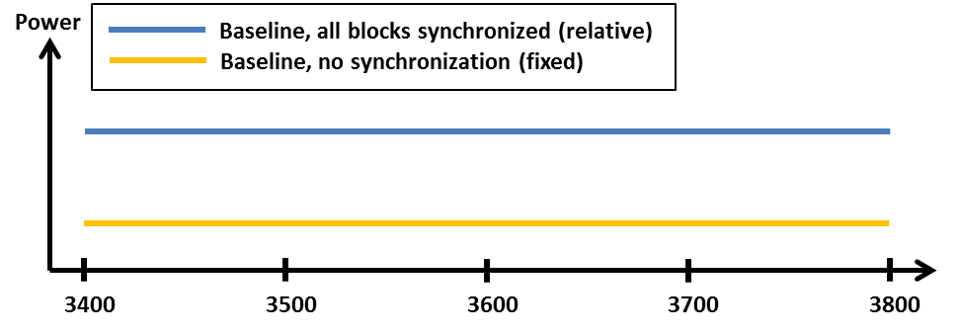
- Schematic description of baseline and guard band power levels for a TDD-only allocation. In the case of synchronized TDD, it is assumed that all blocks are synchronized.
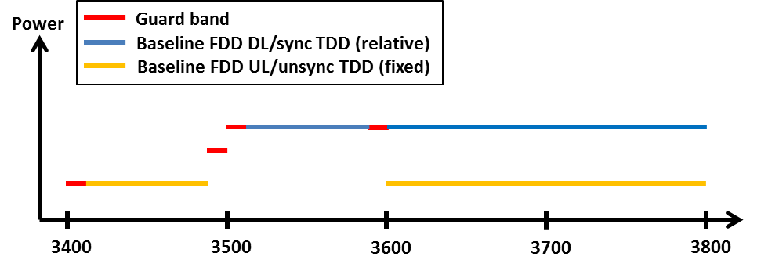
- Schematic description of baseline and guard band power levels for a mixed FDD and TDD allocation. In the case of synchronized TDD, it is assumed that all blocks are synchronized.
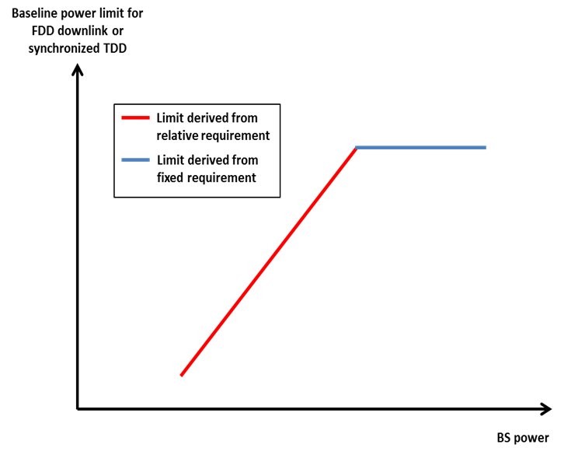
- Combining the relative and the fixed limit for the baseline applying to FDD DL spectrum
Guard band limits
In the case of an FDD allocation there will be guard bands below the FDD UL, above the FDD DL, and in-between the FDD UL and DL, see Figure 2 above. For the guard band 3400 – 3410 MHz, the power limit is chosen to be the same as the baseline in the adjacent FDD UL spectrum, 3410 – 3490 MHz. Similarly, the baseline that applies in 3510 – 3590 MHz is also used in the guard band regions 3500 – 3510 MHz and 3590 – 3600 MHz. Finally, spurious requirements converted to 5 MHz bandwidth apply in the 3490 – 3500 MHz.
In-block limits
The in-block power limit, as defined in Table 4 above, is not obligatory. The requirement on power control for femto base stations is because of the need to reduce interference from equipment that may be deployed by consumers and thus the exact location may not be known to the operators.
Different licensing approaches might be chosen by administrations to licence TDD spectrum. Examples for those are a regulatory approach with no frequency separation between the block edges of two adjacent unsynchronised TDD networks, a regulatory approach with unlicensed separation between the block edges of the two adjacent operators or the definition of restricted blocks.
Transitional region limits
The transitional region is defined to enable the reduction of power from the in-block level to the baseline or guard band levels, and is defined as in Table 5 above. The general shape of the transitional region is presented in Figure 4 below.
The requirements are defined for 5 MHz bandwidth, 0 – 5 MHz and 5 – 10 MHz offset from the upper and lower edges of an operator’s block. They are expressed as attenuation relative to the maximum carrier power, combined with a fixed upper limit, as for the baseline requirement in the FDD DL. The stricter of the two requirements applies.
Combination of BEM elements
The BEM elements as described above are combined to provide a BEM for a particular block by choosing the most relaxed requirement of those that are defined for a frequency interval. Figure 4 provides an example of such a combination of BEM elements for an FDD block in the lower part of the FDD DL spectrum.
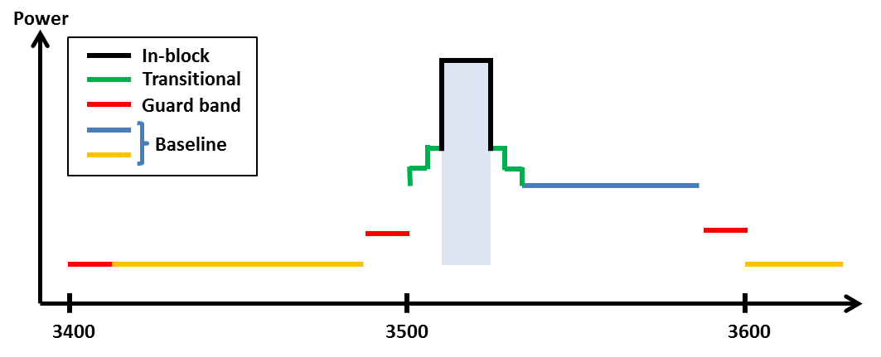

- Combined BEM elements for an FDD block starting at 3510 MHz

UE In-block requirement
This report provides a recommended upper limit of 25dBm e.i.r.p. for the in-block power of the terminals.
Coexistence with other services than MFCN
Co-existence studies for other services than MFCN have been carried out for both in-band and out-of-band scenarios. The in-band services considered are FSS, FS and BWA and the out-of-band services are civil and military Radiolocation.
No single separation distance, guard band or signal strength limit can be provided for FSS and FS to ensure co-existence with MFCN.
It is assumed that BWA systems are similar to MFCN systems and that BWA can co-exist under the new BEM licensing regime.
In some CEPT countries military radiolocation systems that are deployed below 3400 MHz need a fixed limit for protection from base station interference (cases A and B in Table 3). For the MFCN base stations -59dBm/MHz is defined in Table 3. Other mitigation measures like geographical separation, coordination on a case by case basis or an additional guard band may be necessary for a TDD allocation.
For UEs other mitigation measures will be necessary such as e.g. geographical separation or an additional guard band for both FDD or TDD allocation.

TASK2 (Channelling Arrangements)
In this report CEPT has assessed and justified the need to introduce channeling arrangements in the 3400-3800 MHz band to develop a harmonised solution that is sufficiently precise for the development of EU-wide equipment.

For the 3400-3600 MHz band two channeling arrangements have been introduced: one comprising of a 200 MHz TDD plan, the other one comprising of the 2x80 MHz FDD plan (see Figures 6 and 7 below respectively and Section 3.1.4.4 of this report for details).

- Option A: CEPT has identified the frequency arrangement for the 3400-3600 MHz band based on TDD as described in Annex 1 of ECC/DEC/(11)06 as the preferred frequency arrangement. A frequency arrangement based on FDD as described in Annex 2 of ECC/DEC/(11)06 is provided as an alternative.

- Option C: CEPT has decided to maintain both frequency arrangements without indicating any preference. ECC/DEC/(11)06 to be revised to remove Decides 3.

For the 3600-3800 MHz band one channeling arrangement has been introduced comprising of a 200 MHz TDD plan (see Figure 5 below and Section 3.1.4.3 of this report for details).

- Harmonised frequency arrangement for the 3600 – 3800 MHz band based on TDD

- Frequency arrangement for the 3400 – 3600 MHz band based on TDD

- Frequency arrangement for the 3400 – 3600 MHz band based on FDD

TABLE OF CONTENTS

0 Executive summary 2
1 Introduction 11
2 task 1 of the mandate (Block edge mask) 12
2.1 Justification for the need to revise the existing BEM 12
2.2 Development of the new BEM 12
3 task 2 of the mandate (channelling arrangements) 20
3.1 Channelling arrangements in the 3400 – 3600 MHz and 3600 – 3800 MHz 20
3.1.1 Background information 20
3.1.2 EC context 21
3.1.3 General justification for harmonised frequency arrangements 21
3.1.4 Justification of channeling arrangements in ECC/DEC/(11)06 21
3.1.4.1 Block size 21
3.1.4.2 Sub-bands 3400-3600 MHz and 3600-3800 MHz are treated separately 21
3.1.4.3 Channeling arrangement for the sub-band 3600-3800 MHz 21
3.1.4.4 Channeling arrangements for the sub-band 3400 – 3600 MHz 22
3.2 Key principles related to the coordination of MFCN and FSS 23
3.2.1 Key principles for coordination between FSS and MFCN 23
4 Conclusions 24
4.1 Task 1 (Block Edge Mask) 24
4.2 Task 2 (Channelling arrangements) 30
ANNEX 1: Technical analysis for the justification of new BEM 32
ANNEX 2: Comparison of the 3400–3800 MHz ECC deliverables 39
ANNEX 3: EC mandate on 3400-3800 MHz 41
ANNEX 4: List of reference 42

LIST OF ABBREVIATIONS

Abbreviation | Explanation
BEM | Block Edge Mask
BS | Base stations
BWA | Broadband Wireless Access systems
CEPT | European Conference of Postal and Telecommunications Administrations
ECC | Electronic Communications Committee
EC | European Commission
ECO | European Communications Office
ENG | Electronic News Gathering
ERO | European Radiocommunication Office
ETSI | European Telecommunications Standards Institute
EU | European Union
E-UTRA | Evolved Universal Terrestrial Radio Access
FDD | Frequency Division Duplex
FSS | Fixed Satellite Service
FWS | Fixed Wireless Systems
IMT | International Mobile Telecommunications
LRTC | Least Restrictive Technical Conditions
MFCN | Mobile/Fixed Communications Networks
MFW | Multipoint Fixed Wireless
MCL | Minimum Coupling Loss
OB | Outside Broadcasting
PMP | Point-to-Multipoint
PP FS | Point-to-Point (fixed service)
TDD | Time Division Duplex
UE | User Equipment
UL/DL | Uplink/Downlink
WAPECS | Wireless Access Policy for Electronic Communications Services

Introduction
The European Commission has issued a Mandate to CEPT on technical conditions regarding spectrum harmonisation for terrestrial wireless systems in the 3400 – 3800 MHz frequency band (see Annex 3) to review and amend the technical conditions for the harmonised use of the 3400 – 3800 MHz frequency band in order to adapt them to the latest developments in technology by preserving flexibility of use in line with the WAPECS approach, including the updating of the Block Edge Mask (BEM) and introducing harmonised frequency arrangements.
CEPT is mandated to undertake the following tasks:
- “Assess and justify any need to revise the common minimal (least restrictive) technical conditions, including BEM, which underlie the harmonised use of in the 3400 – 3800 MHz frequency band in the EU and, if necessary, identify modified conditions in view of accommodating developments in wireless broadband access technology in particular larger bandwidths. These conditions should be sufficient to avoid interference, facilitate cross-border coordination, and ensure co-existence with other existing systems and services in the same band and adjacent bands.”
- “Assess and justify any need to introduce channelling arrangements in addition to (1) and, if necessary, develop a harmonised solution that is sufficiently precise for the development of EU-wide equipment.”
CEPT has developed a roadmap to structure the work in response to this Mandate to address the following issues:
- assess and justify any need to revise the common minimal (least restrictive) technical conditions including BEM
- identify modified conditions in view of accommodating developments in wireless broadband access technology in particular larger bandwidths
- assess and justify any need to introduce channeling arrangements in addition to the LRTC (BEM)
- if necessary, develop a harmonised solution that is sufficiently precise for the development of EU-wide equipment.

task 1 of the mandate (Block edge mask)

Justification for the need to revise the existing BEM
Regarding the work on issue (a) (see Introduction), ECC agreed on the justification for the need to revise the common minimal (least restrictive) technical conditions including BEM. The justification being the following:
In 2004 ECC adopted ECC/REC/ (04)05 [2] on “Guidelines for accommodation and assignment of Multipoint Fixed Wireless systems in frequency bands 3.4 – 3.6 GHz and 3.6 – 3.8 GHz” and in 2007 ECC/DEC/(07)02 [1] on “Availability of frequency bands between 3400 – 3800 MHz for the harmonised implementation of Broadband Wireless Access systems (BWA)”. In 2008 the BEM contained in ECC/REC/(04)05 [2] were included in the Commission Decision 2008/411/EC [3] on the harmonisation of the 3400 – 3800 MHz frequency band for terrestrial systems capable of providing electronic communications services in the Community.
WRC-07 identified the band 3400 – 3600 MHz for IMT, so ECC developed band plans for MFCN systems including IMT (see ECC/DEC/(11)06 [4]).
ECC analyzed the existing BEM contained in ECC/REC/(04)05 [2], which were developed for PMP FWS systems in 2004 and concluded that it is not suitable for the introduction of MFCN systems including IMT in the 3400 – 3600 MHz band, due to the following reasons:
- The BEM available have been designed to ensure co-existence between PMP FWS applications only.
- The BEM were derived with the assumption of an internal guard band (half a channel width).
- The effect of blocking was not considered for establishing the BEM (which may lead to more stringent masks).
- The BEM may not even be suitable when PMP FWS are based on adjacent TDD blocks.
- The BEM is developed under the assumption that a high gain antenna leads to a lower probability of interference than a low gain antenna. While that might be appropriate for Fixed Wireless Systems, it is certainly inappropriate for other types of MFCN systems.
- The ETSI SEM (for 3GPP band class 7/38) do not allow an operation to fit to the BEM. It is anticipated that the SEMs of IMT-Advanced systems would not allow an operation to fit the BEM of the ECC/REC/(04)05 [2] as well (due to their large bandwidths).
- The existing 3.5 GHz BEM is justified in cases, where there is no commonly agreed band plan and maximum flexibility is needed (like the case of BWA deployments). When band plans are available and adopted, there is no need for the unnecessarily tight BEM but it should be adjusted to the more harmonised conditions in order to facilitate affordable equipment, maximise the spectrum efficiency (e.g. by reduced guard bands) and thus maximize the available amount of spectrum.
The technical analysis is provided in Annex 1 of this report.

Development of the new BEM
In this report the BEM was derived from a minimum coupling loss (MCL) analysis and simulations.
For the purposes of this report the term “BWA” (Broadband Wireless Access) refers to legacy BWA systems licenced under the existing 3400 – 3600 MHz licencing regimes as described in ECC/DEC/(07)02 or 2008/411/EC. The term “MFCN” (Mobile/fixed communications networks) includes IMT and other communications networks in the mobile and fixed services and for the purposes of this report refers to radio communication systems which should comply with the BEM defined in this report.
The base station BEM requirements as described below may be relaxed whenever there are bilateral agreements between operators. The BEM has not been developed to protect other services or applications in the band, and only applies in blocks that have been licensed to MFCN according to the new harmonised frequency arrangement. In the figures below it is assumed for simplicity that all blocks have been licensed to MFCN.
Figure 8 describes a general BEM. Table 6 contains the different elements of the BEM in the 3400 – 3600 MHz and 3600 – 3800 MHz bands, together with the frequency regions where they apply. The guard bands apply in case of an FDD allocation in 3400 – 3600 MHz. It should be noted that whenever guard bands are mentioned in this report, it is understood that those apply only for an FDD allocation.
Tables 7 to 10 contain the power limits that apply for the different BEM elements. P_{Max} is the maximum carrier power for the base station in question, measured as e.i.r.p.
To obtain a BEM for a specific block, these elements are combined as follows:
- For each 5 MHz interval in the 3400 – 3600 MHz and 3600 – 3800 MHz bands, used by MFCN according to the harmonised frequency arrangements, the BEM elements that apply have to be determined (there may be several).
- The most relaxed requirement of those defined in the interval in question has to be chosen.
In the following paragraphs the different BEM elements are described further.

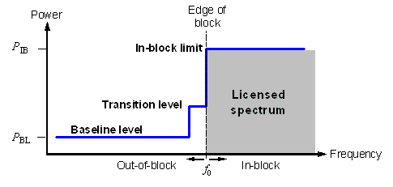
- Illustration of a general block-edge mask
- BEM elements
BEM element | Region of applicability
In-block | Block for which the BEM is derived
Baseline | Spectrum assigned for TDD and FDD UL and DL
Transitional region | For FDD DL blocks, the transitional region applies 0 to 10 MHz below and above the block assigned to the operator.  For TDD blocks, the transitional region applies 0 to 10 MHz below and above the block assigned to the operator, in spectrum that is not assigned to another operator, including the guard band 3590 – 3600 MHz, or in case of synchronized blocks with the same UL/DL configuration.
Guard bands | 3400 – 3410, 3490 – 3510 and 3590 – 3600 MHz (for an FDD allocation)

- Baseline and guard band power limits
BEM element | Frequency range | Power limit
Baseline | FDD DL (3510 – 3590 MHz).  Synchronized TDD blocks with the same UL/DL configuration (3400–3800 or 3600–3800 MHz). | Min(P_{Max} – 43, 13) dBm/5 MHz  e.i.r.p. per antenna
Baseline | FDD UL (3410 – 3490 MHz).  TDD (3400–3800 or 3600–3800 MHz) (unless synchronized). | -34 dBm/5 MHz e.i.r.p. per cell⁽¹⁾
Guard band | 3400–3410 MHz | -34 dBm/5 MHz e.i.r.p. per cell
Guard band | 3490–3500 MHz | -23 dBm/5 MHz e.i.r.p. per antenna
Guard band | 3500–3510 MHz | Min(P_{Max} – 43, 13) dBm/5 MHz  e.i.r.p. per antenna
Guard band | 3590–3600 MHz | Min(P_{Max} – 43, 13) dBm/5 MHz  e.i.r.p. per antenna
(1) In case of multiple antennas with different polarization, the power limit should be relaxed to -31 dBm/5 MHz e.i.r.p. per cell.

Additional baseline requirements for country specific cases
- Additional base station baseline requirements for country specific cases
Case |  | BEM element | Frequcy range | Power limit
A | CEPT countries with military radiolocation systems below 3400 MHz | Additional Baseline | Below 3400 MHz for both TDD and FDD allocation⁽¹⁾ | -59 dBm/MHz e.i.r.p.⁽²⁾
B | CEPT countries with military radiolocation systems below 3400 MHz | Additional Baseline | Below 3400 MHz for both TDD and FDD allocation⁽¹⁾ | -50 dBm/MHz e.i.r.p. ⁽²⁾
C | CEPT countries without adjacent band usage or with usage that does not need extra protection | Additional Baseline | Below 3400 MHz for both TDD and FDD allocation | Not necessary  (spurious levels from the standards apply)
(1) Administrations may choose to have a guard band below 3400 MHz. In that case the power limit may apply below the guard band only.
(2) Administrations may select the limit from case A or B depending on the level of protection required for the radar in the region in question.
Cases A; B and C can be applied per region or country so that the adjacent band may have different levels of protection in different geographical areas, depending on the deployment of the adjacent band systems.
- In-block power limit
BEM element | Frequency range | Power limit
In-block | Block assigned to the operator | Not obligatory.  In case an upper bound is desired by an administration, a value of 68 dBm/5 MHz per antenna may be applied.

For femto base stations, power control should be applied to minimize interference to adjacent channels.
- Transitional region power limits
BEM element | Frequency range | Power limit
Transitional | -5 to 0 MHz offset from lower block edge  0 to 5 MHz offset from upper block edge | Min(P_{Max} – 40, 21) dBm/5 MHz  e.i.r.p. per antenna
Transitional | -10 to 5 MHz offset from lower block edge 5 to 10 MHz offset from upper block edge | Min(P_{Max} – 43, 15) dBm/5 MHz  e.i.r.p. per antenna
Note: For TDD blocks the transitional region applies in case of synchronized adjacent blocks, and in-between adjacent TDD blocks that are separated by 5 or 10 MHz. The transition region does not extend below 3400 MHz or above 3800 MHz.

Baseline limits
There are two different types of baseline levels. The first is defined for FDD downlink spectrum. This requirement is expressed as attenuation relative to the maximum carrier power, combined with a fixed upper limit. The stricter of the two requirements applies. The fixed level prevents interference from increasing in the region where the limit derived from the relative requirement is less stringent. The values are derived from BS – UE interference analysis, and are expressed as e.i.r.p. limits per antenna.
When two TDD blocks are synchronized and have the same UL/DL configuration, there will be no BS – BS interference. In this case, the same baseline as for the FDD DL region is used.
The second type of baseline is defined for FDD UL and TDD spectrum, and is expressed as a fixed limit only, calculated based on BS – BS interference. The e.i.r.p. limit is given per cell. When multiple antennas are used, 3 dB should be subtracted from the e.i.r.p. value due to the different polarizations of the antennas. An exception for this type of baseline can be negotiated between adjacent operators for femto base stations in the case where macro base stations are not used in its proximity. In that case -25 dBm/5MHz e.i.r.p. per cell may be used.
In Figure 9 the baseline levels are presented for a TDD-only allocation and in Figure 10 and for an allocation with both FDD (3400 – 3600 MHz) and TDD (3600 – 3800 MHz). The baseline in the TDD allocations corresponds to a scenario where all operators are synchronized and use the same UL/DL configuration.
Figure 11 describes how the relative level and the fixed level are combined.
- Schematic description of baseline and guard band power levels for a TDD-only allocation. In the case of synchronized TDD, it is assumed that all blocks are synchronized.
- Schematic description of baseline and guard band power levels for a mixed FDD and TDD allocation. In the case of synchronized TDD, it is assumed that all blocks are synchronized.
- Combining the relative and the fixed limit for the baseline applying to FDD DL spectrum
Guard band limits
In the case of an FDD allocation there will be guard bands below the FDD UL, above the FDD DL, and in-between the FDD UL and DL, see Figure 10 above. For the guard band 3400 – 3410 MHz, the power limit is chosen to be the same as the baseline in the adjacent FDD UL spectrum, 3410 – 3490 MHz. Similarly, the baseline that applies in 3510 – 3590 MHz is also used in the guard band regions 3500 – 3510 MHz and 3590 – 3600 MHz. Finally, spurious requirements converted to 5 MHz bandwidth apply in the 3490 – 3500 MHz.
In-block limits
The in-block power limit, as defined in Table 9 above, is not obligatory. The requirement on power control for femto base stations is because of the need to reduce interference from equipment that may be deployed by consumers and thus the exact location may not be known to the operators.
Different licensing methodologies might be chosen by administrations to licence TDD spectrum. Examples for those are a regulation methodology with no frequency separation between the block edges of two adjacent unsynchronised TDD networks, a regulation methodology with unlicensed separation between the block edges of the two adjacent operators or the definition of restricted blocks.
Transitional region limits
The transitional region is defined to enable the reduction of power from the in-block level to the baseline or guard band levels, and is defined as in Table 10 above. The general shape of the transitional region is presented below in Figure 12.
The requirements are defined for 5 MHz bandwidth, 0 – 5 MHz and 5 – 10 MHz offset from the upper and lower edges of an operator’s block. They are expressed as attenuation relative to the maximum carrier power, combined with a fixed upper limit, as for the baseline requirement in the FDD DL. The stricter of the two requirements applies.
Combination of BEM elements
The BEM elements as described above are combined to provide a BEM for a particular block by choosing the most relaxed requirement of those that are defined for a frequency interval. Figure 12 provides an example of such a combination of BEM elements for an FDD block in the lower part of the FDD DL spectrum.

- Combined BEM elements for an FDD block starting at 3510 MHz
UE In-block requirement
This report provides a recommended upper limit of 25dBm e.i.r.p. for the in-block power of the terminals.
Coexistence with other services than MFCN
Coexistence studies for other services than MFCN have been carried out for both in-band and out-of-band scenarios. The in-band services considered are FSS, FS and BWA and the out-of-band services are civil and military Radiolocation.
The conclusions are as follows:
BWA
For the purpose of coexistence, it is assumed that BWA systems as defined above are similar to MFCN systems. Therefore no studies were carried out for MFCN – BWA coexistence.
Fixed Service
MFCN applies to all Mobile and Fixed communication networks including point-to-point Fixed links.
Due to the varying characteristics of different types of FS systems and their deployment, no single separation distance, guard band or signal strength limit can be provided to ensure co-existence with mobile systems. Co-existence can be achieved through co-ordination on a case-by-case basis. Based on the results of analysis of both directions of interference (mobile service interfering into P-P and vice-versa) some general observations can be made. Overlapping-channel sharing meaning any opverlap between spectrum of interfering and interfered signals) between the mobile service and P-P links is not feasible in the same geographical area. Consequently if spectrum is used ubiquitously by the FS it cannot be used by the mobile service in the same region. With larger frequency separation and distances coordination is needed, depending on the characteristics of the mobile and the P-P services.
The studies that were carried out in ECC Report XXX on 3.5 MHz [12] take into account a single interferer. In the case of multiple interferers the co-existence could be more difficult to achieve.
Also interference from FS systems to mobile systems may exceed the acceptable interference level.
The similarities between Mobile Systems and P-MP Fixed Systems indicate that the results for mobile – mobile adjacent channel co-existence largely apply to the mobile – P-MP scenario as well. In case of BS – BS interference additional measures may thus be necessary, such as frequency separation and/or additional filters, whereas otherwise co-existence is expected to be possible without such measures.
Fixed Satellite Service
Due to the varying characteristics of different types of FSS earth stations and their deployment, no single separation distance, guard band or signal strength limit can be provided to ensure co-existence with MFCN. Co-existence should be achieved through co-ordination on a case-by-case basis, assuming FSS earth stations locations are known. However, some general observations can be made. Separation distances for co-existence vary considerably depending on type of equipment and deployment (e.g. tilt and clutter), but can be large. User equipment impact earth stations less than base stations, so separation that prevents interference from base stations will also protect earth stations from UE interference. There are several mitigation techniques that can be applied, in particular site shielding of earth stations. Interference from FSS satellites to MFCN may exceed the acceptable interference level, but in most cases only by a small margin.
Radiolocation
Due to the varying characteristics of different types of radar stations and their deployment, no single separation distance, guard band or signal strength limit can be provided to ensure co-existence with MFCN, but some representative examples are provided. Co-existence should be achieved through co-ordination on a case-by-case basis. However, some general observations can be made for non-overlapping adjacent channels. For airborne radars the required separation distance is approximately 0 km, depending on the radar type and antenna type. For land-based/ship-borne radars the required separation distance is less than 1 km, depending on the radar type and antenna type. A frequency separation analyses concludes that for a 5 km separation, and considering wideband IMT-Advanced interference to wideband radars, the required frequency separation varies between 14 and 65 MHz, depending on radar type and scenario.
There are mitigation techniques which can reduce the separation distance or frequency separation required. In particular, for adjacent channel/adjacent band interference, improved receiver performance and decreased unwanted emissions can be efficient.
Regarding interference from radars to MFCN networks, installation of systems closer than approximately 5 km from the radar should be coordinated. It is necessary to establish a protection distance of approximately 11 km in some areas. Considering blocking effects, the radar may impact MFCN systems up to a distance of 30 km.
The analysis did not take into account the fact that radar antennas rotate and therefore only affect a particular MFCN base station or UE intermittently.
Adjacent band limit in the case of adjacent band usage by military systems
In some CEPT countries military radiolocation systems that are deployed below 3400 MHz need a fixed limit for protection from base station interference (cases A and B in Table 8). Other mitigation measures like geographical separation, coordination on a case by case basis or an additional guard band may be necessary for a TDD allocation.
For UEs other mitigation measures will be necessary such as e.g. geographical separation or an additional guard band for both FDD or TDD allocation.

task 2 of the mandate (channelling arrangements)

Channelling arrangements in the 3400 – 3600 MHz and 3600 – 3800 MHz
The aim of this section is to assess and justify the need to introduce channelling arrangements in addition to the BEM developed as task 1 of the mandate. The channelling arrangements should be sufficiently precise to enable the development of EU-wide equipment.
In the year 2011 CEPT approved ECC/DEC/(11)06 [4] that precisely provides channelling arrangements in the 3400-3600 MHz and 3600-3800 MHz frequency bands. The reasoning and justification that led to the improvement of the regulatory framework in terms of channelling arrangements is used as basis for this section.
In the year 2013 the frequency arrangement in the 3400-3600 MHz was subject to a review with the aim to identify a preferred frequency arrangement as set out in Decides 3 of ECC/DEC/(11)06.
Option A: CEPT has identified the frequency arrangement for the 3400-3600 MHz band based on TDD as described in Annex 1 of ECC/DEC/(11)06 as the preferred frequency arrangement. A frequency arrangement band based on FDD as described in Annex 2 of ECC/DEC/(11)06 is provided as an alternative.
Option C: CEPT has decided to maintain both frequency arrangements without indicating any preference. ECC/DEC/(11)06 to be revised to remove Decides 3.

Background information
Any harmonised frequency arrangements for the 3400 – 3800 MHz band should facilitate high data rate mobile/fixed communications networks (MFCN) including International Mobile Telecommunications (IMT) services supported by larger channel bandwidths as an evolution to the existing framework without the consequential requirement for a replacement of systems based on the existing regulatory framework. It aims at providing the basis to the mobile industry and administrations to respond to the growth of mobile broadband and technological developments for wider channel bandwidths and increased data rates.
At WRC-07, the 3400-3600 MHz band was allocated on a primary basis to the mobile, except aeronautical mobile, service and identified for IMT in almost all CEPT member countries.
The term IMT covers IMT-2000 and IMT-Advanced systems. A wide range of systems are defined under this term: 6 IMT-2000 radio interfaces and 2 IMT-Advanced radio interfaces ensure a competitive environment.
Recommendation ITU-R M.1036 [5] on frequency arrangements for implementation of the terrestrial component of IMT has been revised in 2012 to include, among others, the arrangements for the 3400-3600 MHz band.
At the beginning of 2012, ITU-R agreed on the IMT-Advanced technologies in cooperation with standardisation organisations paving the way for future mobile broadband usage going beyond IMT-2000.
The ECO (formerly ERO) carried out a survey in 2008 [8] which found diverse implementations of BWA/FWA within 3400-3800 MHz in CEPT countries, including some IMT systems. This is reflected in various licensing coverage (national, regional) and various frequency blocks choices (different portions of the 3400-3800 MHz band). Moreover, this survey showed that paired blocks are used or planned to be used in TDD mode in some countries.
As far as practicable, the frequency arrangements in ECC/DEC/(11)06 [4] are intended to be technology neutral and capable of facilitating competitive provision of services using a range of technologies and modes (fixed, nomadic and mobile) with sufficient flexibility to accommodate current wireless broadband services deployed in the band.

When developing these channelling arrangements, ECC considered the following CEPT regulatory framework that is in force for broadband and fixed wireless access systems (BWA/FWA) in the 3400-3800 MHz band:
- ECC/REC/(04)05 [2] that offers guidelines for accommodation and assignment of multipoint fixed wireless systems in the frequency bands 3400-3600 MHz and 3600-3800 MHz;
- ECC/DEC/(07)02 [1] on availability of frequency bands between 3400-3800 MHz for the harmonised implementation of Broadband Wireless Access systems (BWA). This Decision refers to ECC/REC/(04)05 [2] for frequency arrangements.
Annex 2 of this CEPT report provides a comparison of the variouos ECC Deliverables for the 3400-3800 MHz band.

EC context
The existing Commission Decision 2008/411/EC [3] on the harmonisation of the 3400-3800 MHz frequency band for terrestrial systems capable of providing electronic communications services in the Community is based on the results of studies in response to EC mandates that are documented in CEPT Reports 15 and 19 (which defines least restrictive technical conditions for the 3400-3800 MHz band).
Under the scope of this EC mandate (Task 1) CEPT is conducting additional analysis to determine whether the existing least restrictive technical conditions (BEM) are suitable also for the high data rate IMT services supporting larger channel bandwidths.

General justification for harmonised frequency arrangements
It was recognised by the ECC that implementation of MFCN including IMT systems providing high data rate applications in the band 3400-3800 MHz based on a harmonised frequency arrangement will maximise the opportunities and benefits for end users and society, reduce development and implementation costs of equipment and will secure future long term investments by providing economies of scale. Harmonised frequency arrangements facilitate economies of scale resulting in the availability of affordable equipment. A harmonised frequency arrangement will also reduce complexity in cross border coordination. Global roaming is facilitated by common frequency arrangements and measures for free circulation for IMT terminals. The opportunity to utilize larger channel bandwidths will support the provision of high data rates for IMT (especially with IMT-Advanced).

Justification of channeling arrangements in ECC/DEC/(11)06

Block size
ECC/DEC/(11)06 [4] chose to use block sizes of 5 MHz. It was considered that spectrum licensed for MFCN is generally assigned in multiples of 5 MHz, except where this is not possible, e.g. due to the presence of existing users. This block size enables (by combination of adjacent blocks) to utilize larger channel bandwidths creating the possibility to provide high data rates for IMT (especially with IMT-Advanced). Channel bandwidths such as 10, 20 and 40 MHz or more that could be accommodated in the bands 3400 – 3600 MHz and 3600 – 3800 MHz will enable higher data rates.

Sub-bands 3400-3600 MHz and 3600-3800 MHz are treated separately
The two sub-bands are treated as separate bands considering that they are treated differently in the Radio Regulations context and that the incumbent use of spectrum for each sub-band varies. For instance use of these two sub-bands for Fixed Satellite Service (FSS) is not the same (the band 3600 – 3800 MHz is used for FSS more intensively than the band 3400 – 3600 MHz).

Channeling arrangement for the sub-band 3600-3800 MHz
A TDD band plan has been chosen for this sub-band. It was considered that TDD may allow more flexible accommodation of current use of the frequency bands by other services. There is more flexibility to create “holes” in the band to protect incumbent users, as these holes are not replicated in the UL/DL band as is the case for FDD. For example TDD allows more efficient spectrum use when taking into account existing fixed satellite usage in case of geographical sharing. This is especially relevant to the 3600-3800 MHz band since this band is more intensively used for FSS than the band 3400-3600 MHz.
The TDD arrangement is based on a block size of 5 MHz starting at the lower edge of 3600 MHz (see Figure 13 below). If blocks need to be offset to accommodate other uses, the raster should be 100 kHz. Narrower blocks can be defined adjacent to other users, to allow full use of spectrum. It has to be noted that TDD in one extreme case also covers downlink only operation.
- Harmonised frequency arrangement for the 3600 – 3800 MHz band based on TDD

Channeling arrangements for the sub-band 3400 – 3600 MHz
The ECC Decision contains two band plans (FDD and TDD) for the 3400-3600 MHz band.

Option A: CEPT has identified the frequency arrangement for the 3400-3600 MHz band based on TDD as described in Annex 1 of ECC/DEC/(11)06 as the preferred frequency arrangement. A frequency arrangement band based on FDD as described in Annex 2 of ECC/DEC/(11)06 is provided as an alternative.

Option C: CEPT has decided to maintain both frequency arrangements without indicating any preference. ECC/DEC/(11)06 to be revised to remove Decides 3.

It is also noted in ECC/DEC/(11)06 [4] that although there are licensed paired frequency arrangements in many CEPT countries, TDD systems are currently used in a number of those countries in the band 3400-3600 MHz due to the better availability of TDD systems.
Figure 14 below is the frequency arrangement based on TDD duplex mode. The block size is 5 MHz starting at the lower edge of 3400 MHz. If blocks need to be offset to accommodate other users, the raster should be 100 kHz. Narrower blocks can be defined adjacent to other users, to allow full use of spectrum. It has to be noted that TDD in one extreme case also covers downlink only operation.

- Frequency arrangement for the 3400 – 3600 MHz band based on TDD
Figure 15 below is the frequency arrangement based on FDD. The block size is 5 MHz starting at the lower edge of 3410 MHz. The sub-band 3410-3490 MHz is used for the uplink, the sub-band 3510-3590 MHz is used for the downlink. The resulting duplex gap is 20 MHz (3490-3510 MHz). If blocks need to be offset to accommodate other uses, the raster should be 100 kHz. Narrower blocks can be defined adjacent to other users, to allow full use of spectrum.
- Frequency arrangement for the 3400 – 3600 MHz band based on FDD

Key principles related to the coordination of MFCN and FSS
There are currently 170 fixed satellite earth stations authorized within the EU Member States (deployed on 78 sites). As such, they are protected by Member States against harmful interference.
For MFCN and FSS coordination, similar principles can be used as for BWA and FSS coordination. Indeed in the case of BWA, the “central stations” are coordinated with the FSS earth stations. This implies that all the (fixed) terminal stations, operating under the control of central stations are consequently coordinated under the umbrella of the central stations (this typically requires to slightly extend the coordination distances). The same idea can be applied to MFCN where the BWA terminal stations are now replaced with mobile terminal stations that also operate under the control of the base stations (which need to be coordinated with the FSS stations).

Key principles for coordination between FSS and MFCN
The following key principles related to the coordination between Mobile/Fixed Communication Network stations and Fixed-Satellite Service (FSS) Earth stations should be implemented at national level in order to ensure coordination between these systems:
- Frequency coordination is primarily concerned with local implementation, local propagation conditions and local licensed use of the shared band. This is best dealt with by national administrations;
- Some administrations have effective co-ordination arrangements in place. The implementation of these guidelines is at the discretion of the national administrations to the extent this may help them;
- The key objectives of co-ordination processes are maximising efficient use of the available spectrum for the benefit of the EU whilst protecting existing licensed uses of the band;
- Coordination processes and associated protection should only apply to registered/licensed spectrum users;
- Data exchange and coordination processes are mutual and reciprocal to all band users;
- Data on registered use of the band should be available to all users under relevant legal protections and confidentiality obligations;
- The coordination process must be both accurate and fast to enable all operators to efficiently plan spectrum utilisation and network deployments;
- Operators should have access to registered band usage to maximise the successful coordination of spectrum through propagation modelling without physical measurement at the planning stage;
- All parties are responsible for the efficient use of spectrum. In deploying new MFCN stations and new FSS Earth stations, operators should be cognisant of the need to minimise constraints on the other service;
- These guidelines primarily relate to co-ordination within national boundaries. For the situation where MFCN and FSS stations are within the territories of different administrations, the use of these guidelines within bilateral agreements may help to expedite cross border co-ordination;
- All parties should undertake reasonable efforts to successfully complete the coordination exercise as quickly as possible;
- Either party has the inherent right to refer the co-ordination to the relevant NRA(s) if agreement cannot be reached.

Conclusions
With this report CEPT replies to the Mandate from the European Commission “Technical Conditions regarding spectrum harmnosiation for terrestrial wireless systems in the 3400-380 MHz frequency band” (provided in Annex 3).

Task 1 (Block Edge Mask)
The justification for the development of new BEM is included in Section 2.1 of this report.
The resulting new BEM is outlined in Section 2.2 of this report.
In this report the BEM was derived from a minimum coupling loss (MCL) analysis and simulations.
For the purposes of this report the term “BWA” (Broadband Wireless Access) refers to legacy BWA systems licenced under the existing 3400 – 3600 MHz licencing regimes as described in ECC/DEC/(07)02 [1] or 2008/411/EC [3]. The term “MFCN” (Mobile/fixed communications networks) includes IMT and other communications networks in the mobile and fixed services and for the purposes of this report refers to radio communication systems which should comply with the BEM defined in this report.
The base station BEM requirements as described below may be relaxed whenever there are bilateral agreements between operators. The BEM has not been developed to protect other services or applications in the band, and only applies in blocks that have been licensed to MFCN according to the new harmonised frequency arrangement. In the figures below it is assumed for simplicity that all blocks have been licensed to MFCN.
Figure 16 describes a general BEM.
- Illustration of a general block-edge mask
Table 11 contains the different elements of the BEM in the 3400 – 3600 MHz and 3600 – 3800 MHz bands, together with the frequency regions where they apply. The guard bands apply in case of an FDD allocation in 3400 – 3600 MHz. It should be noted that whenever guard bands are mentioned in this report, it is understood that those apply only for an FDD allocation.
Tables 12 to 15 contain the power limits that apply for the different BEM elements. P_{Max} is the maximum carrier power for the base station in question, measured as e.i.r.p.
To obtain a BEM for a specific block, these elements are combined as follows:
- For each 5 MHz interval in the 3400 – 3600 MHz and 3600 – 3800 MHz bands, used by MFCN according to the harmonised frequency arrangements, the BEM elements that apply have to be determined (there may be several).
- The most relaxed requirement of those defined in the interval in question has to be chosen.
In the following paragraphs the different BEM elements are described further.
- BEM elements
BEM element | Region of applicability
In-block | Block for which the BEM is derived
Baseline | Spectrum assigned for TDD and FDD UL and DL
Transitional region | For FDD DL blocks, the transitional region applies 0 to 10 MHz below and above the block assigned to the operator.  For TDD blocks, the transitional region applies 0 to 10 MHz below and above the block assigned to the operator, in spectrum that is not assigned to another operator, including the guard band 3590 – 3600 MHz, or in case of synchronized blocks with the same UL/DL configuration.
Guard bands | 3400 – 3410, 3490 – 3510 and 3590 – 3600 MHz (for an FDD allocation)

- Baseline and guard band power limits
BEM element | Frequency range | Power limit
Baseline | FDD DL (3510 – 3590 MHz).  Synchronized TDD blocks with the same UL/DL configuration (3400–3800 or 3600–3800 MHz). | Min(P_{Max} – 43, 13) dBm/5 MHz  e.i.r.p. per antenna
Baseline | FDD UL (3410 – 3490 MHz).  TDD (3400–3800 or 3600–3800 MHz) (unless synchronized). | -34 dBm/5 MHz e.i.r.p. per cell⁽¹⁾
Guard band | 3400–3410 MHz | -34 dBm/5 MHz e.i.r.p. per cell
Guard band | 3490–3500 MHz | -23 dBm/5 MHz e.i.r.p. per antenna
Guard band | 3500–3510 MHz | Min(P_{Max} – 43, 13) dBm/5 MHz  e.i.r.p. per antenna
Guard band | 3590–3600 MHz | Min(P_{Max} – 43, 13) dBm/5 MHz  e.i.r.p. per antenna
(1) In case of multiple antennas with different polarization, the power limit should be relaxed to -31 dBm/5 MHz e.i.r.p. per cell.

Additional baseline requirements for country specific cases
- Additional base station baseline requirements for country specific cases
Case |  | BEM element | Frequcy range | Power limit
A | CEPT countries with military radiolocation systems below 3400 MHz | Additional Baseline | Below 3400 MHz for both TDD and FDD allocation⁽¹⁾ | -59 dBm/MHz e.i.r.p.⁽²⁾
B | CEPT countries with military radiolocation systems below 3400 MHz | Additional Baseline | Below 3400 MHz for both TDD and FDD allocation⁽¹⁾ | -50 dBm/MHz e.i.r.p. ⁽²⁾
C | CEPT countries without adjacent band usage or with usage that does not need extra protection | Additional Baseline | Below 3400 MHz for both TDD and FDD allocation | Not necessary  (spurious levels from the standards apply)
(1) Administrations may choose to have a guard band below 3400 MHz. In that case the power limit may apply below the guard band only.
(2) Administrations may select the limit from case A or B depending on the level of protection required for the radar in the region in question.

Cases A; B and C can be applied per region or country so that the adjacent band may have different levels of protection in different geographical areas, depending on the deployment of the adjacent band systems.
- In-block power limit
BEM element | Frequency range | Power limit
In-block | Block assigned to the operator | Not obligatory.  In case an upper bound is desired by an administration, a value of 68 dBm/5 MHz per antenna may be applied.

For femto base stations, power control should be applied to minimize interference to adjacent channels.
- Transitional region power limits
BEM element | Frequency range | Power limit
Transitional | -5 to 0 MHz offset from lower block edge  0 to 5 MHz offset from upper block edge | Min(P_{Max} – 40, 21) dBm/5 MHz  e.i.r.p. per antenna
Transitional | -10 to 5 MHz offset from lower block edge 5 to 10 MHz offset from upper block edge | Min(P_{Max} – 43, 15) dBm/5 MHz  e.i.r.p. per antenna
Note: For TDD blocks the transitional region applies in case of synchronized adjacent blocks, and in-between adjacent TDD blocks that are separated by 5 or 10 MHz. The transition region does not extend below 3400 MHz or above 3800 MHz.

Baseline limits
There are two different types of baseline levels. The first is defined for FDD downlink spectrum. This requirement is expressed as attenuation relative to the maximum carrier power, combined with a fixed upper limit. The stricter of the two requirements applies. The fixed level prevents interference from increasing in the region where the limit derived from the relative requirement is less stringent. The values are derived from BS – UE interference analysis, and are expressed as e.i.r.p. limits per antenna.
When two TDD blocks are synchronized and have the same UL/DL configuration, there will be no BS – BS interference. In this case, the same baseline as for the FDD DL region is used.
The second type of baseline is defined for FDD UL and TDD spectrum, and is expressed as a fixed limit only, calculated based on BS – BS interference. The e.i.r.p. limit is given per cell. When multiple antennas are used, 3 dB should be subtracted from the e.i.r.p. value due to the different polarizations of the antennas. An exception for this type of baseline can be negotiated between adjacent operators for femto base stations in the case where macro base stations are not used in its proximity. In that case -25 dBm/5MHz e.i.r.p. per cell may be used.
In Figure 17 the baseline levels are presented for a TDD-only allocation and in Figure 18 and for an allocation with both FDD (3400 – 3600 MHz) and TDD (3600 – 3800 MHz). The baseline in the TDD allocations corresponds to a scenario where all operators are synchronized and use the same UL/DL configuration.
Figure 19 describes how the relative level and the fixed level are combined.
- Schematic description of baseline and guard band power levels for a TDD-only allocation. In the case of synchronized TDD, it is assumed that all blocks are synchronized.
- Schematic description of baseline and guard band power levels for a mixed FDD and TDD allocation. In the case of synchronized TDD, it is assumed that all blocks are synchronized.
- Combining the relative and the fixed limit for the baseline applying to FDD DL spectrum
Guard band limits
In the case of an FDD allocation there will be guard bands below the FDD UL, above the FDD DL, and in-between the FDD UL and DL, see Figure 18 above. For the guard band 3400 – 3410 MHz, the power limit is chosen to be the same as the baseline in the adjacent FDD UL spectrum, 3410 – 3490 MHz. Similarly, the baseline that applies in 3510 – 3590 MHz is also used in the guard band regions 3500 – 3510 MHz and 3590 – 3600 MHz. Finally, spurious requirements converted to 5 MHz bandwidth apply in the 3490 – 3500 MHz.
In-block limits
The in-block power limit, as defined in Table 14 above, is not obligatory. The requirement on power control for femto base stations is because of the need to reduce interference from equipment that may be deployed by consumers and thus the exact location may not be known to the operators.
Different licensing methodologies might be chosen by administrations to licence TDD spectrum. Examples for those are a regulation methodology with no frequency separation between the block edges of two adjacent unsynchronised TDD networks, a regulation methodology with unlicensed separation between the block edges of the two adjacent operators or the definition of restricted blocks.
Transitional region limits
The transitional region is defined to enable the reduction of power from the in-block level to the baseline or guard band levels, and is defined as in Table 15 above. The general shape of the transitional region is presented in Figure 20 below.
The requirements are defined for 5 MHz bandwidth, 0 – 5 MHz and 5 – 10 MHz offset from the upper and lower edges of an operator’s block. They are expressed as attenuation relative to the maximum carrier power, combined with a fixed upper limit, as for the baseline requirement in the FDD DL. The stricter of the two requirements applies.
Combination of BEM elements
The BEM elements as described above are combined to provide a BEM for a particular block by choosing the most relaxed requirement of those that are defined for a frequency interval. Figure 20 provides an example of such a combination of BEM elements for an FDD block in the lower part of the FDD DL spectrum.

- Combined BEM elements for an FDD block starting at 3510 MHz

UE In-block requirement
This report provides a recommended upper limit of 25dBm e.i.r.p. for the in-block power of the terminals.
Coexistence with other services than MFCN
Coexistence studies for other services than MFCN have been carried out for both in-band and out-of-band scenarios. The in-band services considered are FSS, FS and BWA and the out-of-band services are civil and military Radiolocation.
The conclusions are as follows:
BWA
For the purpose of coexistence, it is assumed that BWA systems as defined above are similar to MFCN systems. Therefore no studies were carried out for MFCN – BWA coexistence.
Fixed Service
MFCN applies to all Mobile and Fixed communication networks including point-to-point Fixed links.
Due to the varying characteristics of different types of FS systems and their deployment, no single separation distance, guard band or signal strength limit can be provided to ensure co-existence with mobile systems. Co-existence can be achieved through co-ordination on a case-by-case basis. Based on the results of analysis of both directions of interference (mobile service interfering into P-P and vice-versa) some general observations can be made. Overlapping-channel sharing meaning any overlap between spectrum of interfering and interfered signals) between the mobile service and P-P links is not feasible in the same geographical area. Consequently if spectrum is used ubiquitously by the FS it cannot be used by the mobile service in the same region. With larger frequency separation and distances coordination is needed, depending on the characteristics of the mobile and the P-P services.
The studies that were carried out in ECC Report on 3.5 GHz BEM [12] take into account a single interferer. In the case of multiple interferers the co-existence could be more difficult to achieve.
Also interference from FS systems to mobile systems may exceed the acceptable interference level.
The similarities between Mobile Systems and P-MP Fixed Systems indicate that the results for mobile – mobile adjacent channel co-existence largely apply to the mobile – P-MP scenario as well. In case of BS – BS interference additional measures may thus be necessary, such as frequency separation and/or additional filters, whereas otherwise co-existence is expected to be possible without such measures.
Fixed Satellite Service
Due to the varying characteristics of different types of FSS earth stations and their deployment, no single separation distance, guard band or signal strength limit can be provided to ensure co-existence with MFCN. Co-existence should be achieved through co-ordination on a case-by-case basis, assuming FSS earth stations locations are known. However, some general observations can be made. Separation distances for co-existence vary considerably depending on type of equipment and deployment (e.g. tilt and clutter), but can be large. User equipment impact earth stations less than base stations, so separation that prevents interference from base stations will also protect earth stations from UE interference. There are several mitigation techniques that can be applied, in particular site shielding of earth stations. Interference from FSS satellites to MFCN may exceed the acceptable interference level, but in most cases only by a small margin.
Radiolocation
Due to the varying characteristics of different types of radar stations and their deployment, no single separation distance, guard band or signal strength limit can be provided to ensure co-existence with MFCN, but some representative examples are provided. Co-existence should be achieved through co-ordination on a case-by-case basis. However, some general observations can be made for non-overlapping adjacent channels. For airborne radars the required separation distance is approximately 0 km, depending on the radar type and antenna type. For land-based/shipborne radars the required separation distance is less than 1 km, depending on the radar type and antenna type. A frequency separation analyses concludes that for a 5 km separation, and considering wideband IMT-Advanced interference to wideband radars, the required frequency separation varies between 14 and 65 MHz, depending on radar type and scenario.
There are mitigation techniques which can reduce the separation distance or frequency separation required. In particular, for adjacent channel/adjacent band interference, improved receiver performance and decreased unwanted emissions can be efficient.
Regarding interference from radars to MFCN networks, installation of systems closer than approximately 5 km from the radar should be coordinated. It is necessary to establish a protection distance of approximately 11 km in some areas. Considering blocking effects, the radar may impact MFCN systems up to a distance of 30 km.
The analysis did not take into account the fact that radar antennas rotate and therefore only affect a particular MFCN base station or UE intermittently.
Adjacent band limit in the case of adjacent band usage by military systems
In some CEPT countries military radiolocation systems that are deployed below 3400 MHz need a fixed limit for protection from base station interference (cases A and B in Table 13). Other mitigation measures like geographical separation, coordination on a case by case basis or an additional guard band may be necessary for a TDD allocation.
For UEs other mitigation measures will be necessary such as e.g. geographical separation or an additional guard band for both FDD or TDD allocation.
Cross-border coordination
Cross-border coordination in the band 3400-3800 MHz will be subject to an ECC Recommendation and national agreements as for cross-border coordination in other bands.

Task 2 (Channelling arrangements)
In this report CEPT has assessed and justified the need to introduce channelling arrangements in the 3400-3800 MHz band to develop a harmonised solution that is sufficiently precise for the development of EU-wide equipment.
For the 3400-3600 MHz band two channelling arrangements have been introduced: one comprising of a 200 MHz TDD plan, the other one comprising of the 2x80 MHz FDD plan (see Figures 22 and 24 below respectively and Section 3.1.4.4 of this report for details).
Option A: CEPT has identified the frequency arrangement for the 3400-3600 MHz band based on TDD as described in Annex 1 of ECC/DEC/(11)06 as the preferred frequency arrangement. A frequency arrangement band based on FDD as described in Annex 2 of ECC/DEC/(11)06 is provided as an alternative.

Option C: CEPT has decided to maintain both frequency arrangements without indicating any preference. ECC/DEC/(11)06 to be revised to remove Decides 3.

For the 3600-3800 MHz band one channelling arrangement has been introduced comprising of a 200 MHz TDD plan (see Figure 21 below and Section 3.1.4.3 of this report for details).
- Harmonised frequency arrangement for the 3600 – 3800 MHz band based on TDD

- Frequency arrangement for the 3400 – 3600 MHz band based on TDD

- Frequency arrangement for the 3400 – 3600 MHz band based on FDD

- Technical analysis for the justification of new BEM
  - Technical conditions for PMP FWS base stations
The technical conditions provided in this section are extracted from ECC/REC/(04)05 [2], Annexes 2 and 3.
  - Maximum e.i.r.p., defined in Annex 2 of ECC/REC/(04)05
The following texts have been extracted form Annex 2:
“Maximum e.i.r.p. density limits are set by administrations in their national licensing conditions in order to define pfd levels for co-ordination distances between different geographical areas or for cross-border agreements or sharing with other services. Transmit output power and e.i.r.p. levels for Multipoint FWS systems are more driven by trade-offs between the required service coverage and other operational considerations. e.i.r.p. density depends also on the system bandwidth that in modern PMP FWS might be flexibly changed.”
Maximum e.i.r.p. within a block:
Station Type | Max EIRP spectral density  (dBW/MHz)
 | (Including tolerances and ATPC range, Note 1)
Central Station (CS)  (and Repeater Station(RS) down-links) | +23  Note 2
Note 2: CS EIRP density value given in the table is considered suitable for conventional 90 deg sectorial antennas. Administrations may consider to adjust this value if other type of antennas are used (e.g. decrease the limit for omni-directional antennas, or increase when narrow-sector or adaptive antennas are used)

“For further enhancing the efficiency, administrations may allow operators to apply mutual co-ordination at the block edge and at the service border edge for potential further relaxation of the above e.i.r.p. limits, depending on requirements for protecting other services or systems, such as PP FS. This could be reached, for instance, by taking advantage of mitigation techniques such as the shielding effect, limiting the height of Central Stations, or for stations that are located far from the service area boundary.”
  - Reference Block Edge Mask, defined in Annex 3 of ECC/REC/(04)05
The following texts have been extracted form Annex 3:
“The block edge mask given in this annex was developed to ensure co-existence between PMP FWS applications only; different considerations would be required where the adjacent system is not a PMP FWS system, but for example ENG/OB or other.”
“The floor level in the mask provided in this annex has been based on co-existence studies reported in ECC Report 33 [7][7]; where the PMP FWS co-existence studies were mostly made with statistical tools and assumptions of typical radio systems, their deployment and service performance objectives. The reference points of the transition slope were chosen based on consideration of practical filters and various modulation envelopes. These studies and considerations may be subject to refinement as operational experience and system characteristics evolve. Therefore the block edge mask based upon these studies may also be subject to refinement.”
“Emissions from one operator’s frequency block into another operator’s frequency-adjacent block will need to be controlled. This was done in few other frequency bands by establishing fixed guard bands between the assignments. However, taking due account of the possible variety of broadband systems considered in this recommendation, different network and service requirements, and considering the expected broadening of the required bandwidth, it would be impossible to uniquely and efficiently set such guard bands and it is recommended that coordination and interference mitigation techniques be implemented between operators.”
“Also adjacent block receiver rejection concurs to a reduced interference scenario, however the study in Report 33 did not consider the effect of receiver selectivity since the technology neutrality assumption did not allow deciding on its typical parameters. Therefore it is not in the scope of this recommendation to set limits for it; nevertheless it is expected that ETSI standards will adequately cover the issue.”
“It should be also noted that when TDD or mixed FDD/TDD systems are placed in immediately adjacent blocks, the probability of occurrence of worst cases of interference between CSs is quite higher than in situations where only FDD are deployed. Therefore, even if the mask proposed in this annex would offer a suitably low probability of interference for such cases, when TDD systems are concerned additional mitigation techniques (geographic separation of stations, natural/physical shielding, etc.) and/or additional co-ordination (including networks synchronisation) between operators should be implemented as far as possible.”
Definition of the block edge mask:
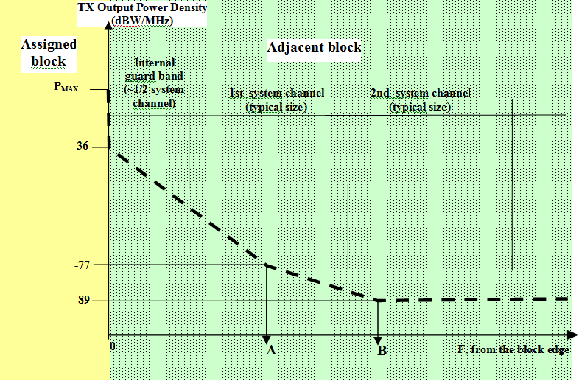

- Frequency offset break points for the CS mask | Definition  (% of the size of the assigned block, Note )
A | 20%
B | 35%
Note: X% of the smaller of adjacent blocks, if blocks are of unequal size
- Central Station Block Edge Spectral Density Mask

- Tabular description of Central Station Block Edge Spectral Density Mask
Frequency offset | CS Transmitter Output Power Density Limits(dBW/MHz)
In-band (within assigned block) | See Annex 2
ΔF=0 | -36
0<ΔF<A | -36 - 41·(ΔF/A)
A | -77
A<ΔF<B | -77 - 12·((ΔF-A)/(B-A))
ΔF≥B | -89

  - ETSI requirements for LTE
The relevant document to consider is ETSI EN 301 908-14 V5.2.1 (2011-05) [6]: Evolved Universal Terrestrial Radio Access (E-UTRA) Base Stations (BS).
It should be noted that the bands 3400-3600 MHz and 3600-3800 MHz are not yet part of the E-UTRA Base Station operating bands ; see Table 1-1 in [6], copied below as Table 17.
- E-UTRA Base Station operating bands
E-UTRA band | Direction of transmission | E-UTRA Base Station operating bands
1 | Transmit | 2 110 MHz to 2 170 MHz
1 | Receive | 1 920 MHz to 1 980 MHz
3 | Transmit | 1 805 MHz to 1 880 MHz
3 | Receive | 1 710 MHz to 1 785 MHz
7 | Transmit | 2 620 MHz to 2 690 MHz
7 | Receive | 2 500 MHz to 2 570 MHz
8 | Transmit | 925 MHz to 960 MHz
8 | Receive | 880 MHz to 915 MHz
20 | Transmit | 791 MHz to 821 MHz
20 | Receive | 832 MHz to 862 MHz
33 | Transmit and Receive | 1 900 MHz to 1 920 MHz
34 | Transmit and Receive | 2 010 MHz to 2 025 MHz
38 | Transmit and Receive | 2 570 MHz to 2 620 MHz

The closest E-UTRA band from the 3.5 GHz band is band 7 (and 38). Therefore the comparison between the ETSI mask and the CEPT BEM has been made on that basis although this represents a tightening of the SEM.
- e.i.r.p. defined by ETSI in band 7 and 38
ETSI currently defines no in-band e.i.r.p. limit, nor output power values.
- Spectrum Emission Mask for band 7 and 38
The following tables are extracted from document ETSI EN 301 908-14 [6]. Three different types of base stations have been defined: wide area, local area and home.

- Wide Area BS operating band unwanted emission limits for 5 MHz, 10 MHz, 15 MHz and 20 MHz channel bandwidth (E-UTRA bands 7 and 38)
Frequency offset of measurement filter -3 dB point, Δf | Frequency offset of measurement filter centre frequency, f_offset | Test requirement | Measurement bandwidth
0 MHz ≤ Δf < 5 MHz | 0,05 MHz ≤ f_offset < 5,05 MHz |  | 100 kHz
5 MHz ≤ Δf <  min(10 MHz, Δfmax) | 5,05 MHz ≤ f_offset < min(10,05 MHz, f_offsetmax) | -12,5 dBm | 100 kHz
10 MHz ≤ Δf ≤ Δfmax | 10,5 MHz ≤ f_offset < f_offsetmax | -15 dBm (see note) | 1 MHz
NOTE: The requirement is not applicable when Δfmax < 10 MHz.

- Local Area BS operating band unwanted emission limits for 5 MHz, 10 MHz, 15 MHz and 20 MHz channel bandwidth
Frequency offset of measurement filter -3 dB point, Δf | Frequency offset of measurement filter centre frequency, f_offset | Minimum requirement | Measurement bandwidth
0 MHz ≤ Δf < 5 MHz | 0,05 MHz ≤ f_offset < 5,05 MHz |  | 100 kHz
5 MHz ≤ Δf <  min(10 MHz, Δfmax) | 5,05 MHz ≤ f_offset <  min(10,05 MHz, f_offsetmax) | -35,5 dBm | 100 kHz
10 MHz ≤ Δf ≤ Δfmax | 10,05 MHz ≤ f_offset < f_offsetmax | -37 dBm (see note) | 100 kHz
NOTE: The requirement is not applicable when Δfmax < 10 MHz.

- Home BS operating band unwanted emission limits for 5 MHz, 10 MHz, 15 MHz and 20 MHz channel bandwidth
Frequency offset of measurement filter -3 dB point, Δf | Frequency offset of measurement filter centre frequency, f_offset | Minimum requirement | Measurement bandwidth
0 MHz ≤ Δf < 5 MHz | 0,05 MHz ≤ f_offset < 5,05 MHz |  | 100 kHz
5 MHz ≤ Δf < 10 MHz | 5,05 MHz ≤ f_offset < 10,05 MHz | -40,5 dBm | 100 kHz
10 MHz ≤ Δf ≤ Δfmax | 10,5 MHz ≤ f_offset < f_offsetmax | P – 52 dB, 2 dBm ≤ P ≤ 20 dBm  -50 dBm, P < 2 dBm  (see note) | 1 MHz
NOTE: For Home BS, the parameter P is defined as the aggregated maximum power of all transmit antenna ports of Home BS
Note: for home BS, with frequency offset ≥ 10 MHz, an output power of 20 dBm has been chosen for the purpose of this contribution ; the corresponding minimum requirement is therefore -32 dBm/MHz.

  - Analysis of these technical conditions
- Maximum e.i.r.p.
As there is no value specified in the ETSI harmonised standard, the comparison with the value mentioned in the CEPT Recommendation is not possible. However, a short analysis is provided below:
The e.i.r.p. value as provided in ECC/REC/(04)05 [2] = 23 dBW/MHz=30 dBW/ 5 MHz=60 dBm/5 MHz
This value is similar to what would be expected for a macro base station (also in the order of 60 dBm/5 MHz).
Conclusion: the maximum e.i.r.p. (in-band value) set up in ECC/REC/(04)05 [2] is compatible with typical in-band e.i.r.p. mobile deployments.
- BEM vs. SEM
- The three following figures show the comparisons of BEM and SEM for BEM based on a 5 MHz block assignment, as well as 10 MHz and 20 MHz.
5 MHz | 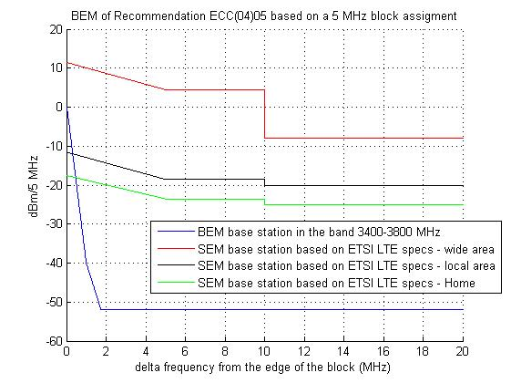
- BEM of ECC/REC/(04)05 based on 5 MHz block assignment

10 MHz | 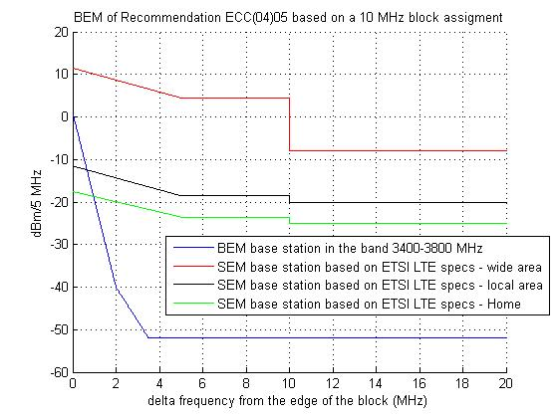

- BEM of ECC/REC/(04)05 based on 10 MHz block assignment

20 MHz | 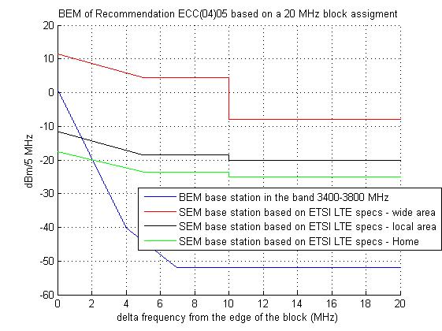

- BEM of ECC/REC/(04)05 based on 20 MHz block assignment
It can be seen from the above figures that the SEM exceed the BEM for any value of block assignment.

  - ETSI requirements for BWA
The relevant document to consider is ETSI EN 302 774 V1.1.1 (2011-05) “Broadband Wireless Access Systems (BWA) in the 3 400 MHz to 3 800 MHz frequency band (Base Stations)” [9].
Taking the same approach to compare the SEM of BWA and the current given BEM for the 3.4-3.6 GHz band, the conclusions are the same as described in Section 2.2 of this report.

- Comparison of the 3400–3800 MHz ECC deliverables
This annex provides an overview of the current ECC framework for the band 3400 – 3800 MHz including a comparison of ECC/DEC/(07)02, ECC/REC/(04)05 and ECC/DEC/(11)06 that confirms the consistency of ECC framework according to evolution of market needs and the need to maintain this consistency in the future.

At this stage, there are three relevant deliverables for the band 3400 – 3800 MHz:
- ECC/DEC/(07)02 “Availability of frequency bands between 3400 – 3800 MHz for the harmonised implementation of Broadband Wireless Access systems (BWA)”
- ECC/REC/(04)05 “Guidelines for accommodations and assignments of multipoint fixed wireless systems 3.4-3.6 GHz and 3.6-3.8 GHz”
- ECC/DEC/(11)06 : “Harmonised frequency arrangements for mobile/fixed communications networks (MFCN) (including IMT) operating in the bands 3400 - 3600 MHz and 3600- 3800 MHz”
  - scope of deliverables
ECC/REC/(04)05 covers Point multipoint fixed wireless systems (Point-to-Multipoint Fixed Wireless Systems (PMP FWS). It has a more narrow scope than the other two ECC deliverables.

ECC/DEC/(07)02 on Broadband Wireless Access systems (BWA) covers Fixed, Nomadic and, also, Mobile Wireless Access (MWA). It provides in its Annex considerations for an implementation of a flexible usage mode for BWA in 3400 – 3600 MHz and/or in 3600 – 3800 MHz on the basis initially of a fixed and nomadic usage. In particular, these considerations refers to ECC/REC/(04)05 and state that the technical conditions in ECC/DEC/(04)05 may be used for implementation of flexible usage mode. Moreover ECC/DEC/(07)02 mentions that the introduction of MWA usage mode will be subject to additional requirements for deployment of mobile TS Mobile Wireless Access (annex 1 §3 of the Decision).

ECC/DEC/(11)06, focusing primarily on a mobile usage includes a forward looking approach. The harmonised frequency arrangements for the 3400 – 3600 MHz and 3600 – 3800 MHz bands are intended to facilitate high data rate International Mobile Telecommunications (IMT) services supported by larger channel bandwidths as an evolution to the existing framework without the consequential requirement for a replacement of systems based on the existing regulatory framework.
  - coexistence with incumbent users
For ECC/DEC/(07)02, the designation of spectrum within 3400 – 3800 MHz for BWA should take due consideration of incumbent users (see decides 1 and 3).

Although the wording is different, ECC/DEC/(11)06 also designates spectrum for MFCN on a non-exclusive basis (“without prejudice to the protection and continued operation of other existing users in these bands”). It is assumed that transition from legacy terrestrial systems to future terrestrial systems will be managed at national level.
  - Band plan and duplex mode
ECC/DEC/(07)02 does not provided a definite duplex mode or any band plan.

ECC/DEC/(11)06 provides two possible band plans for the band 3400 – 3600 MHz, one TDD and one FDD. The band plan for 3600 – 3800 MHz is TDD.

ECC/REC/(04)05 lets the possibility to have a mix of FDD and TDD blocks (i.e. recommends paired blocks that can be used either for FDD or for TDD). The guidelines for these flexible arrangements are:
- the bands 3400 – 3600 MHz and 3600 – 3800 MHz are treated as separate bands;
- 100 MHz duplex separation for paired blocks;
- in the case of paired FDD blocks the lower block of the two paired FDD blocks is used for uplink;
- that 3400 MHz to 3410 MHz is not included in the band plan.
  - block size
ECC/REC/(04)05 The blocks are designed to fit 3.5 MHz and 7 MHz channels (4 of them per block). The preferred size for blocks are multiple of these channels and may include internal guard bands. The resulting sizes for paired spectrum are (2x17.5 MHz, 2x21 MHz, 2x35 MHz, 2x42 MHz) and for unpaired spectrum (35 MHz, 42 MHz, 70 MHz and 84 MHz).
In case of external guard bands the sizes of the blocks may be reduced.

ECC/DEC/(11)06: the block sizes are multiples of 5 MHz.
  - emission requirements
ECC/DEC/(07)02 refers to ECC/REC/(04)05 for emission levels. But since it covers also MWA which is not covered by ECC/REC/(04)05 additional requirements are provided for mobile terminal stations (in block emission level and spacing of the carrier from the block edge to protect adjacent networks).
- For the technical requirements it refers in its annex to ECC/REC/(04)05: “As a starting point, the guidance given in ECC/REC/(04)05 on technical conditions for implementation of flexible usage mode, to be set in the technology neutral BWA licence process, shall be considered”.
- For mobile terminals, the annex of ECC/DEC/(07)02 provides additional requirements

In the case of adjacent band TDD/FDD systems additional mitigation techniques should be considered (geographical separation of stations, natural/physical shielding, and/or additional co-ordination including networks synchronisation)

ECC/REC/(04)05 provides emission requirements in the form of Block Edge Masks (BEM).
- For the Central Station (CS) BEM are provided with an “in block” limit (annex 2) and “out of block” limits (annex 3).
- For the terminal stations (NB: which are fixed in the context of ECC Recommendation (04)05) only an “in block” limit is provided (annex 2). The equipment requirements in the relevant harmonised standards are considered to provide sufficient protection for adjacent networks, so that “out of block” BEM limits for terminals are not needed.

ECC/DEC/(11)06 There is no emission technical requirement.
Least restrictive technical conditions suitable for IMT systems with larger channel bandwidth are developed separetly.
  - Harmonisation
ECC/DEC/(07)02 does not contain a harmonised band plan, since it refers to ECC/REC/(04)05 for detailed frequency arrangements, which itself allows for flexibility and a mix of duplex modes.

ECC/DEC/(11)06 provides one harmonised band plan for the band 3600 – 3800 MHz (TDD) and two harmonised band plans for the band 3400 – 3600 MHz (FDD and TDD). ECC decided that the band plans for the band 3400 – 3600 MHz should be subject to review no later than end 2013 with the aim to identify a preferred band plan.

- EC mandate on 3400-3800 MHz
EC Mandate to the CEPT “Technical conditions regarding spectrum harmnosiation for terrestrial wireless systems in the 3400-380 MHz frequency band”

- List of reference
- ECC Decision (07)02 on availability of frequency bands between 3400-3800 MHz for the harmonised implementation of Broadband Wireless Access systems (BWA)
- ECC Recommendation (04)05 onGuidelines for accommodations and assignments of multipoint fixed wireless systems 3.4-3.6 GHz and 3.6-3.8 GHz
- Commission Decision 2008/411/EC on the harmonisation of the 3400-3800 MHz frequency band for terrestrial systems capable of providing electronic communications services in the Community).
- ECC Decision (11)06 on Harmonised frequency arrangements for mobile/fixed communications networks (MFCN) (including IMT) operating in the bands 3400-3600 MHz and 3600-3800 MHz
- Recommendation ITU-R M.1036 “Frequency arrangements for implementation of the terrestrial component of International Mobile Telecommunications (IMT) in the bands identified for IMT in the Radio Regulations (RR)”
- ETSI EN 301 908-14 V5.2.1 (2011-05) “Harmonised EN for IMT-2000, Evolved Universal Terrestrial Radio Access (E-UTRA) (BS) covering the essential requirements of article 3.2 of the R&TTE Directive”
- ECC Report 33 on the analysis of the coexistence of Point-to-Multipoint FWS cells in the 3.4-3.8 GHz band
- ECC PT1(09)109R1 Annex 16: “ERO Information Document on the use of the bands 3400-3600 MHz and 3600-3800 MHz in CEPT”, Final Minutes of the 32nd ECC PT1 meeting (27-29 April 2009)
- ETSI EN 302 774 V1.1.1 (2011-05) “Broadband Wireless Access Systems (BWA) in the 3 400 MHz to 3 800 MHz frequency band (Base Stations)”
- CEPT Report 15 Report from CEPT to the European Commission in response to the Mandate to identify the conditions relating to the provision of harmonised radio frequency bands in the European Union for Broadband Wireless Access applications
- CEPT Report 19 Report from CEPT to the European Commission in response to EC Mandate to develop least restrictive technical conditions for frequency bands addressed in the context of WAPECS
- ECC Report XXX “Least Restrictive Technical Conditions suitable for Mobile/Fixed Communication Networks (MFCN), including IMT, in the frequency bands 3400-3600 MHz and 3600-3800 MHz” (update the reference after the final approval of the draft ECC Report)

For cross-border coordination with non-EU administrations not listed in the 5.430A footnote of RR the provisions of this footnote should be taken into account.

