Practical information
- Visa
If you need an entry visa for Estonia, you are advised to check information on webpage of Estonian Ministry of Foreign Affairs http://www.vm.ee/?q=en/node/53 or ask the Estonian Embassy or Consulate in your own country to inquire about specific visa requirements. Information about Estonian representations which are handling visa applications can be found on webpage of Estonian Ministry of Foreign Affairs http://www.vm.ee/?q=en/node/13884
If you need an invitation for applying visa, please contact ASAP to Mrs Maia Ivask by sending an e-mail to maia.ivask@tja.ee
- Currency
The currency unit in Estonia is Euro.
Automatic cash dispensers are available twenty-four hours a day.
The major credit cards are accepted by most shops in Estonia, as well as electronic debit cards.
- Climate
The average daytime temperature in Tallinn in May is 10 – 15º C.
- Electrical Appliances
Electricity is 220V/50Hz. Plugs are the normal round continental type.
- Time
Local time in Tallinn is GMT+3.
- Hotel
Hotel is located harbour area just 500 m from the The Great Coastal Gate of the Medieval Old City. There is Aqua Spa in the hotel and WiFi in every room.
- Venue
Meeting will take place in Galaxy hall on the second floor of the hotel.
- Transport to the hotel
Hotel is located ca 5 km from the airport.
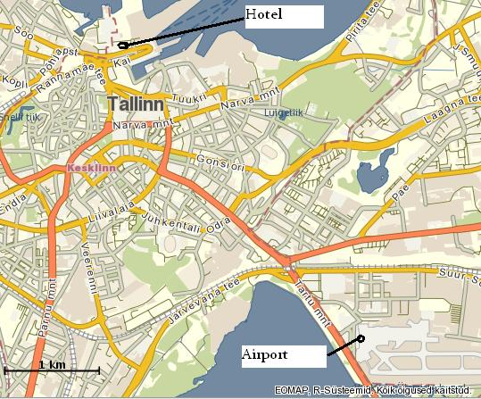
The hotel can be reached by bus or by taxi.
Bus
Bus stop is located near the exit of the airport on your right, ticket can be purchased from driver (~1.6 €). Take bus No 2 destination “Reisisadam” (Port). Buses depart every 20 min from 6 to 23 and it takes ca 20 min. Get off at final stop “Reisisadam” (Port Terminal A), the hotel is 200 m towards the city.
Taxi
Taxi stand is located at the exit of the airport and trip to the hotel costs about 7.7 €. Most taxis accept credit cards. Receipt must be printed (not hand-written). Be aware that there is a free market on taxi transport, so the fares can differ substantially. Check the pricelist (on backseat window). ~1 € per km and starting fee 3.2 € is normal price but also 4 € per km and starting fee 13 € may occur, especially at night in tourist areas. You can choose any taxi in the row and you can refuse to pay if the meter or receipt printer is not working.
- Tourist information
www.tourism.tallinn.ee/fpage/explore
www.tallinn.info/flash/
www.ttw.ee

