To
Dr. Gabrielle Owen
Chairman ETSI TC ERM
Email: gabrielle.owen@agentschaptelecom.nl

Cc
Mr Esa Barck
Chairman ETSI TC MSG
Email: esa.barck@nsn.com

Mr Robert Sarfati
Union Internationale des Chemins de Fer
Email : rsarfati@systra.com

Date | Enclosures
11th March 2013 | amended ECC/DEC/(02)05
Our reference | Your reference
L13-ECC-001
Subject
Amended ECC Decision (02)05, 876-880 MHz / 921-925 MHz
Dear Gabrielle,
ECC at its meeting in Bratislava, 5 - 8 March 2013, finally approved the amended ECC Decision (02)05 on “the designation and availability of frequency bands for railway purposes in the 876-880 MHz and 921-925 MHz bands” based on the results of the public consultation.
The amended ECC Decision (02)05 is herewith provided, it may also be helpful for you for future revisions of ETSI deliverables, e.g. of ETSI TS 145 005.

Best regards,
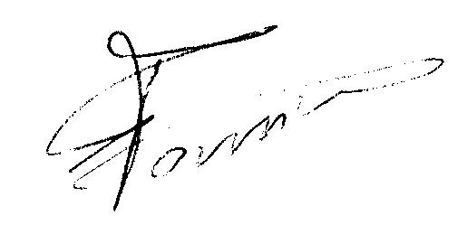
Eric Fournier
Chairman CEPT Electronic Communications Committee

