To
Mr O’Donohue
European Commission
Information Society and Media Directorate-General
BU-33 07/55
Avenue de Beaulieu/Beaulieulaan 33
1160 BRUSSELS
Belgium

Date | Enclosures
11th March 2013 | CEPT Report 50
Our reference | Your reference
L13-ECC-004 | -
Subject
Final Approval of CEPT Report 50

Dear Mr O’Donohue,
I am pleased to inform you that ECC, during its 33rd meeting in Bratislava (Slovak Republic), adopted the final CEPT Report 50 in response to the first part (Report A) of the mandate “On technical conditions regarding spectrum harmonisation options for wireless radio microphones and cordless video-cameras (PMSE equipment)”.
ECC would also like to inform that in order to determine the usability of the 1785-1805 MHz band for PMSE a supplemental report to the CEPT Report 50 will be developed in June 2013, subject to the Public Consultation.
Yours sincerely,
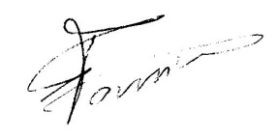
Eric Fournier
Chairman CEPT Electronic Communications Committee

