Doc. SE21(13)25

82nd meeting of PT SE 21

ECO, Copenhagen, Denmark, 13-14 June2013

Date issued: 04 01 2013

Source: Bundesnetzagantur (Germany)

Status: For consideration

Subject: Measurements on the impact of LTE800-User Equipment on wireless microphones, hearing aids and tourguide systems in the frequency range 863 – 865 MHz
Password protected: yes |  | No | x

Summary:
The impact of of different types of LTE UE at 857 MHz on wireless microphones, heraing aids and tourguide systems in the band 863-865 MHz were investigated on a total batch of 17 receivers provided by several manufacturers. Measurements were conducted in the BNetzA measurement laboratories of the monitoring station in Munich, Germany during April and July 2012.

Proposal:
For consideration

Background:
WI SE21_17

Measurements on the impact of LTE800-User Equipment (Interferer) on Wireless microphones, Listening Aids and Tourguides (Victim) in the frequency range 863 – 865 MHz

Introduction
The assignment of the frequency range from 790 to 862 MHz (former TV-Channel 60 – 69) to mobile and fixed communication networks (MFCN) raises the question about the consequences for wireless microphones and other short range devices in the band 863-870 MHz. The focus of this investigation is on wireless audio applications used in the band 863-865 MHz as this frequency range is the closest neighbour to LTE-Terminals, and thus basically a potential candidate for intereferences by the aforementioned devices.
The protection ratios required for the interefence-free operation of
- wireless microphones,
- hearing aids,
- and tourguide systems
were investigated on a total batch of 17 receivers provided by several manufacturers in the measurement laboratories of the monitoring station in Munich, Germany in April and July 2012.
Parameters and interference criteria for wireless audio applications were derived from ETSI TS 102 192-1:2004-08: Electromagnetic compatibility and Radio spectrum Matters (ERM); International Technical Characteristics and Test Methods; Part 1: Wireless/Radio Microphones in the 25 MHz to 3 GHz Frequency Range.

Investigated receivers
A total of 17 receivers from 9 manufacturers were available during the measurement period.
The available wireless audio systems were split into two categories:
- Professional / upper class amateur microphones
- Listening aids and tourguides
Throughout this report, all receivers are numerated as ‚Rx1-xx’ ir ‚Rx2-xx’, where the index ‚1’ or ‚2’ marks the category, the ‚-xx’ the running number.
A further distinction inside ofcategory ‘2’ between listening aid and tourguide is not always clear, since those systems are partially marketed for both applications. For the sake of result comparison and because of the fact that listening aids also exist for professional applications (p.e. in school classes), receiver of category ‘2’ were always rated as professional devices – just like all devices belonging to category ‘1’, for example in terms of the interference criteria and signal levels. Nonetheless, since the application scenario for both categories differs: the main use for Rx-Cat.1 is the transmission of high quality music, while Rx-Cat. 2 usually serves most times for speech signals or the audio signal from a movie.

Following Tab. 1 gives a quick overview of the available wireless audio systems, their primary application and the transmission type.

Rx-Name | Analogue | Digital | Microphone | Tourguide | Listening Aid
1-1 | X |  | X
1-2 | X |  | X
1-3 | X |  | X
1-4 | X |  | X
1-5 | X |  | X
1-6 | X |  | X
1-7 | X |  | X
1-8 | X |  | X
1-9 | X |  | X
2-1 | X |  |  |  | X
2-2 |  | X |  | X
2-3 | X |  |  | X
2-4 | X |  |  |  | X
2-5 | X |  |  | X
2-6 | X |  |  | X
2-7 |  | X |  |  | X
2-8 |  | X |  |  | X
Tab. 1: Wireless audio types, primary application and transmission type – overview

Interference criterion
ETSI TS 102 192-1 considers a professional microphone transmission as interference-free, if the unweighted AF-SINAD is at least 30 dB. This interference criterion (SINAD is reduced to 30 dB in the presence of an interferer) is applied in the measurements at hand, since all receivers are classified as intended for professional use.

A SINAD-measurement (‚Signal in Noise and Distortion’) rates the signal-to-noise-ratio including distortion at the audio output (AF output) of a receiver using two consecutive RMS-voltage measurements: the useful transmitter is always modulated with a single tone at 1 kHz. The first measurement thus gives the result for the signal with noise and distortion part. A second measurement loops in a narrow notch, suppressing the 1 kHz tone. This leaves only the noise and distortion part, which is measured. Finally, 20 times the logarithm of the voltages quotient results in the final SINAD-reading.
Note: In a noise-free environment, the inverse SINAD gives the THD value (Total harmonic distortion).
Some of the devices measured can give up to 49 dB SINAD with ease, especially in category ‘Rx1-xx’. Listening tests revealed that an interefered SINAD of 30 dB often leads to crackling and rattling sounds that are partially quite easy to hear. Nonetheless, below that point a massive drop in audio quality occurs. Thus, the limit of 30 dB seems to be a suitable choice.
Typically, analogue systems employ audio compression and decrompression techniques. A consequence beyond the dynamic enhancement is that a small change in the HF-interference situation can lead to a drastic change in the received audio. This also means that the selection of the absolute limit isn’t that crucial after all: for such high-sophisticated devices, the point between first perceptible interfering sounds and the SINAD-reduction down to 30 dB often is in the range of 1…2 dB
Furthermore, the 30 dB-Limit has shown to be a good choice for digital systems, too. Beyond the practical reason that no easy method exists to measure the bit error rate for those systems, the following effects apply in the presence of interference (at the 30 dB limit):
- The SINAD starts to drop rapidly which – vice versa – means that the bit error rate climbs up in a steep ascent.
- The audio signal starts to sound chopped; the amplitude starts to fluctuate.
- The audio signal starts to crackle and rattle.

Interference effects
This measurement campaign deals with interferences caused by the operation of LTE-Terminals.
As previously noted, the frequency range of 832 – 862 MHz is assigned to LTE terminals, while the neighboured frequency range of 863 – 865 MHz is assigned to the interfered devices. Although LTE base stations (Downlink) transmit with higher power than the terminals, they are usually operated at a larger distance from the victim and the radio path loss is partially increased by shadowing obstacles like, e.g. buildings. This means, that the signal received from the terminal usually dominates compared to the signal received from the base station.
Basically, two interference effects were investigated:
- Interference by spurious emissions / Out-of-Band emissions: in this case, reception is interfered by out-of-band RF-energy radiated by the interferer at the victim’s frequency. Thus, the victim’s Signal-to-Noise ratio is decreased if the receiver is in a linear state. This effect dominats on small frequency separations between the LTE-Channel and the victim’s channel. This kind of interference is mainly dominated by the spectral shape of the interfering signal.
- Interference by blocking: The receiver’s input stage respectively it’s active antenna is employed with so much energy that it starts to get into a non-linear operating state – it is overdriven / overloaded. As a consequence, the useful signal is attenuated and distorted, rendering the previously quasi-error-free reception impossible. This effect decreases only slowly with an increasing frequency offset and usually affects many reception channels. It is independent of the interefering’s signal spectrum mask.

Wanted signals
ETSI TS 102 192-1 contains signal levels for protection ratio measurements that are 60 dB above the receiver’s sensitivity. The sensitivity was measured for all receivers under test, using the same quality measure as used to the protection ratio measurements, see section 3.
This so called ‚normative level’ is already that high that the margin until an overload occurs is quite narrow. Nonetheless, this input level could be regarded as a realistic situation, when one considers that transmitter and receiver are not that far away from each other. In reality, especially microphone receivers must be able to cope with quite high useable and interfering field strengths.
A different, but still realistic situation is given if the wanted signal’s level is just barely above the sensitivity limit. This takes account for signal drops due to shadowing and / or longer distance transmissions, per example during city tours or sport events, partially with more than only one receiver involved. To cover this aspect, measurements were taken with a wanted signal level that is 10 dB above the receiver’s sensitivity limit. Those values are labelled ‘low level’ in the result graphs. This minimum distance from the sensitivity limit is needed to be far enough away from the noise floor, ensuring that the interference is really caused by the interfering signal only.
Due to the measurement’s setup, for the “normative level”, It wasn’t possible to deliver that much field strength to the receiver (60 dB above sensitivity) while creating so much interfering field strength that the interference occurred. This is why, the typical measurement situation is the ‘10 dB above sensitivity’ case. Occasionally, the wanted signal level was raised by up to 30 dB above this, but not all measurement points could be taken in that case. Those measurements are marked ‘increased level’ in the result graphs.
For the measurements, all receivers were tuned to the lowest possible channel in that frequency range. Regarding the total of the receiver’s tests, the lowest tunable channel was 863.025 MHz; the highest 863.5 MHz. Most devices were operated in the range of 863.1 MHz. Considering the high bandwidth of the interferer (up to 10 MHz), this variation of the wanted frequency is neglible, what has been confirmed by taking a few samples.
This means, that the interfered devices were operated as close as possible to the LTE800’s Uplink-band.
All measured / stated signal levels are RMS-values over the whole signal bandwidth. For the pulsed LTE-signals, the pulse with the highest level was selected, using the symbol time of approx 71 µs as RMS-integration interval.

Analogue systems
The wanted signal was frequency modulated with a 1 kHz continous sine. The peak deviation was set to each individual receiver to get a maximum SINAD while avoiding any signs of clipping at the transmitter / receiver’s clipping indicator. For the Rx1-category, the peak deviation was usually in a range of 40 kHz. For the Rx2-category, the peak deviation was in the range from 20 to 40 kHz, depending on the receiver’s application (speech / music).
The wanted RF-signal was generated using an R&S CMS 48 Tx/Rx-Tester. An R&S SMGU was used to generate and inject a pilot tone, if the receiver needed one for operation. The resulting spectrum is shown in Fig. 1.
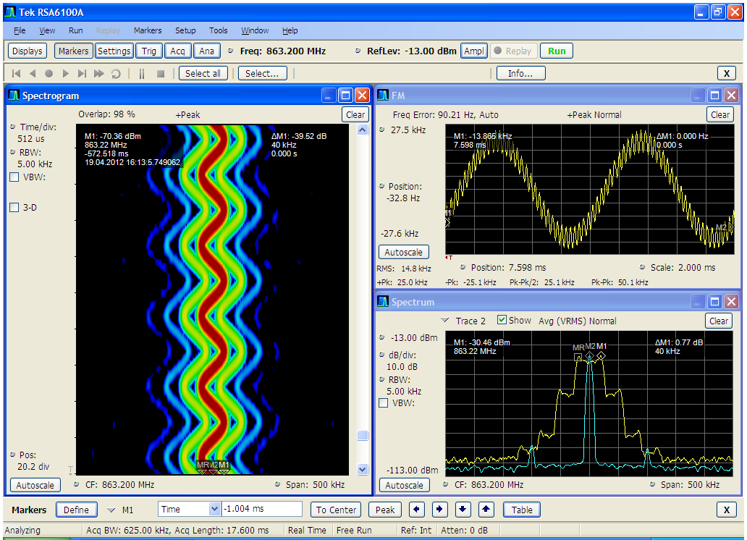
Fig. 1: spectrogram, deviation over time and spectrum for the wanted analogue signal (yellow: modulation with 1 kHz sine and pilot; cyan: modulation with pilot tone & carrier reference level)

Digital Systems
For the case of digital systems, the wanted signal was created in the following way:
The AF-signal was created using the CMS and fed to the digital transmitter. After the input voltage was optimized for maximum SINAD, the transmitter was built up inside of a TEM-Cell and fed with the test tone. The cell’s output was connected to a realtime-analyzer (Tektronix RSA 6114A), which sampled the downconverted complex-valued baseband signal for up to two minutes using an oversampling factor of at least two. Finally, the baseband stream was replayed by an arbitrary signal generator (R&S SMU200A) in a continous loop.
The systems under test usually employed (G)MSK of 2-FSK-variants for transmission with up to 128 kSym/s. An example of several parameters for one system is given in Fig. 2 below.
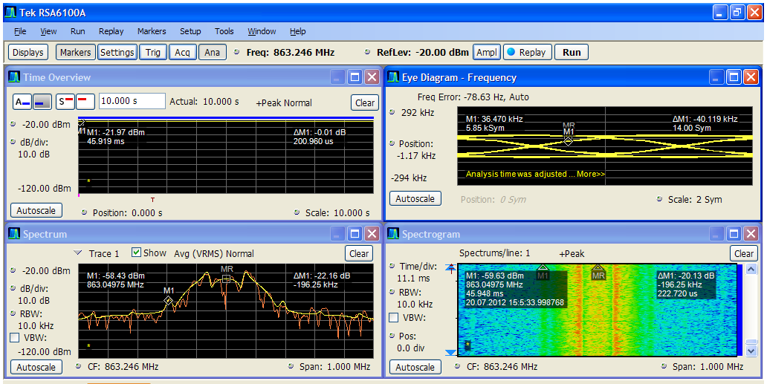
Fig. 2: Power over Time (upper left), Spectrum (lower left), Eye Diagram (upper right) and Spectrogram for System TRx-2-8.

Wanted signal strengths

Receiver Cat. 1
Fig. 3 shows the wanted signal’s fieldstrength at the antenna for receivers for category 1. Fig. 4 shows the resulting SINAD-values for this situation. Additionally, the maximum SINAD is shown for information.
Fig. 3: wanted signal's field strength for receiver categoy Rx1 at the receiver’s antenna
Fig. 4: SINAD for receiver category 1 at the fieldstrength shown in Fig. 3.

Receiver Cat. 2
The wanted signal’s fieldstrength at the receivers’ antenna used for the measurements is depicted below, cf. Fig. 5. The resulting SINAD-values for these fieldstrengths are shown in Fig. 6, along with the maximum achievable SINAD.
Fig. 5: wanted signal fieldstrength for receiver category 2 at the receiver’s antenna

Fig. 6: SINAD values for receivers of category 2 at the fieldstrength shown in Fig. 5

Interfering signals
For this measurement campaign, only the LTE-Uplink signal part was examined. Since LTE-signals offer a high degree of flexibility in terms of time, power and bandwidth, five different signals were investigated.
Following Tab. 2 gives a short description for the different signals involved. The subsequent sections will deal with the signals in more detail. Since only the FDD-Mode is of interest in this frequency range, TDD-Operation has not been investigated.
The Block Edge Mask (BEM) compliance was measured manually. In the following spectrum plots, the BEM is shown in light green. As indicated, it has been assumed that those limits can be extended beyond 862 MHz, which is not quite correct. The correct OoB-limits to apply were found after the measurements took place. Those are indicated in pink on the plots.
Since the limits given in ECC/DEC(09)03 are to be interpreted as a channel power, one has to take care when downscaling the values using a simple bandwidth correction, so the limit lines can be a bit misleading. This is especially true for signal UE3, where only 180 kHz are occupied by the LTE-signal. All spectrum plots were scaled in level so that the LTE-Uplink’s channel power meets the maximum allowed 23 dBm/10 MHz.

Name | Description
UE1 | Replay of a real-life upload with full speed
UE2 | Replay of a real-life upload with limited throughput (2,54 MBits/s)
UE3 | Simulated, static signal. Only the uppermost resource block is allocated for 100% of time. Artifical emissions such that BEM-compliance is just met.
UE4 | Simulated, static signal. Only the uppermost 25 resource blocks are allocated for 100% of time. Artifical emissions such that BEM-compliance is just met.
UE5 | Simulated, static signal. All resource blocks are allocated for 100% of time. Artifical emissions such that BEM-compliance is just met.
Tab. 2: overview of interfering signal parameters

Interfering signal UE1
This LTE-Uplink signal was recorded and played back from an arbitrary signal generator. The recording situation was as follows: the terminal was operated using one antenna path only. A fixed attenuator was placed in the antenna path to force the terminal’s power control to the maximum output power – which also maximises the out of band emissions. The signal’s content is a file upload using the maximum speed and hence bandwidth. It was ensured that the terminal was the only one associated with the serving base station at that moment.
Following Fig. 7 shows the RMS-spectrum for signal UE1 using an RBW of 100 kHz.
Fig. 7: spectrum for UE1-signal (upper sideband only)

Interfering signal UE2
This signal was created in a similar fashion like UE1. The key difference is that the terminal was from a different manufacturer and that the upload speed was limited to approx. 2.54 MBits/s. Because of this, a very dynamic resource block allocation occurs along the time- and frequency axis.
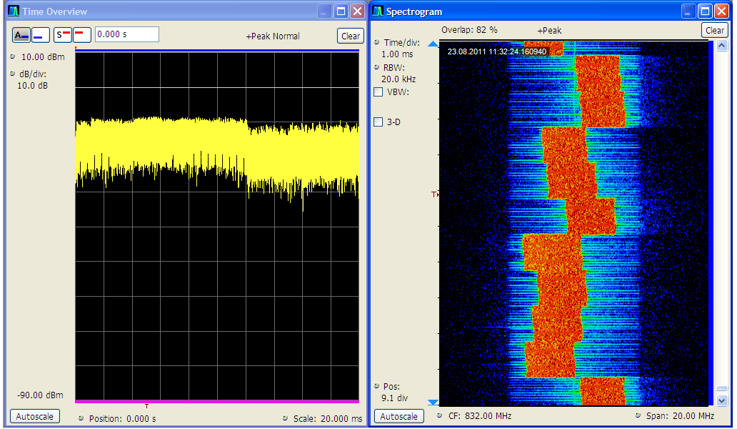
Fig. 8: Power versus time and spectogram for signal UE2

Fig. 9: spectrum for UE2-signal, upper sideband only

Interfering signals UE3 – UE5
These signals were generated in the style of „Investigation on the receiver characteristics of SRD equiqment in the 863-870 MHz band; ERA Technology report 2011-0299 (Issue 2)“ using the LTE-Option from the generator R&S SMU200A.
Those signals employ a fixed resource block allocation at every instant of time. For 10 MHz-LTE, 50 resource block with 180 kHz bandwidth each are available.
Signal UE3 only occupies the single uppermost of them; signal UE4 occupies all resource blocks from the center frequency to the upper block’s edge and signal UE5 occupies all 50 resource blocks.
Next, all signals were altered to employ the maximum of allowed out ouf band power in the following way: the signals were sampled with the Tektronix RSA 6114A with an oversampling factor of approx. 5 for the duration of one radio frame. The recording started synchronized to the radio frames start. Afterwards, the RMS-power for each symbol was calculated and a white, gaussian noise was added with a power relative to the symbol’s power. This so created noise floor was chosen such that the first step of the BEM from ECC/DEC(09)03 has reached the limit of out of band emissions, cf. section 6.5. This signal was replayed from the generator R&S SMU200A. Using the AWGN-Option of that generator, the second step of the BEM was driven to the limit by adding another source with the appropinate limit values.
This way simulates the case that all those three signals employ the maximum allowed out of band power for 100% of time. Furthermore, the allocated bandwidth is getting occupied in steps up to the maximum of 50 resource blocks (from UE3 to UE5). In reality, the situation is that the resource blocks are active all of the time usually never occurs – rather a combination of all those cases. For example, a terminal sends the PUCCH from time to time according to the setup given by the base station (the uppermost resource block, the lowermost resource block, or alternating between those), telling the network about it’s presence and to request resources – but only in short bursts. Nonetheless, the signals are suited to give an impression about the worst-case scenarios and to serve as a reference when it comes to a comparison with the impact of real-life situations to the victim receiver.
Fig. 10: spectrum of UE3 (upper sideband only)

The following Fig.11 (UE4) illustrates the steps of the noise floor, which is inherent to all those three signals. The spectrogram shows the occupied resource blocks in red and the nominal usable bandwidth of 10 MHz in yellow. The first noise step is marked green-yellow and the final step is marked blue. A spectrum plot incl. the transmitter maskes is shown in Figures 12 and 13.
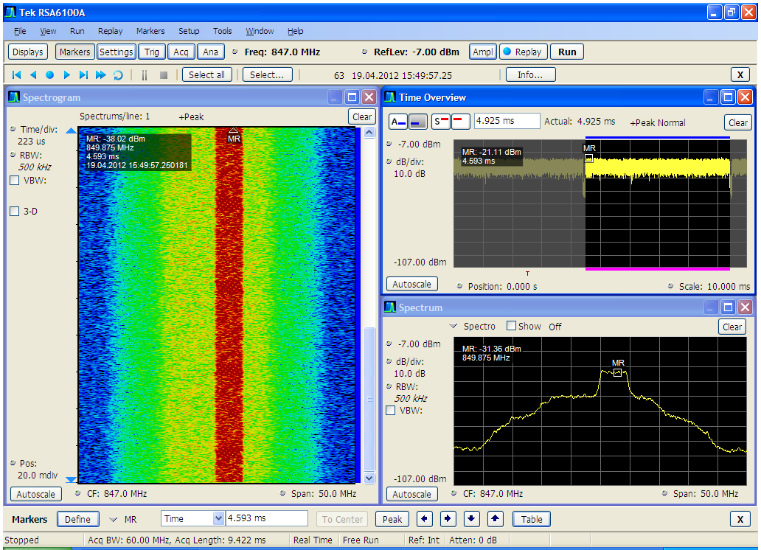
Fig. 11: spectrogram, power vs. time and spectrum for signal UE4
Fig. 12: spectrum for signal UE4 (upper sideband only)
Fig. 13: spectrum of UE5 (upper sideband only)

Discussion of Out-of-Band-Emissions
The Signals UE3 – UE5 simulate the out-of-band-emission by an additive, permanent noise with a defined, controllabe level relative to the useful emission. In reality, those emissions arise e.g. due to signal discontinuities (like insertion of the cyclic prefix or symbol changes) and device parameters, like the final amplifier’s characteristics and I/Q inbalances.
In practice, those OOB emissions are usually not emitted at 100% of time, in contrast to the simulation. This means, that UE3 – UE5 depict are more pessimistic views compared to UE1 and UE2.
Following Fig. 14 shows an example of the OoB-emissions from a real device. The observation bandwidth is 40 MHz, the acquisition time is 100 ms (10 radio frames). The yellow spectrum shows the peak-hold spectrum over that time, while the orange spectrum shows the momentary spectrum at the time instant marked with a line in the spectrogram. The resolution bandwidth was set to match one resource block (180 kHz). The spectrogram clearly shows the correlation between the allocations in the useful signal’s part and the OoB-emissions especially when the small blocks are observed: blocks that are occupied show up with a similar pattern below the nominal 10 MHz bandwidth. Above the nominal 10 MHz bandwidth, the allocated blocks show up mirrored. The shoulder distance of approx. 40 dB seen in the spectrum is a quite typical value for unfiltered OFDM-systems.
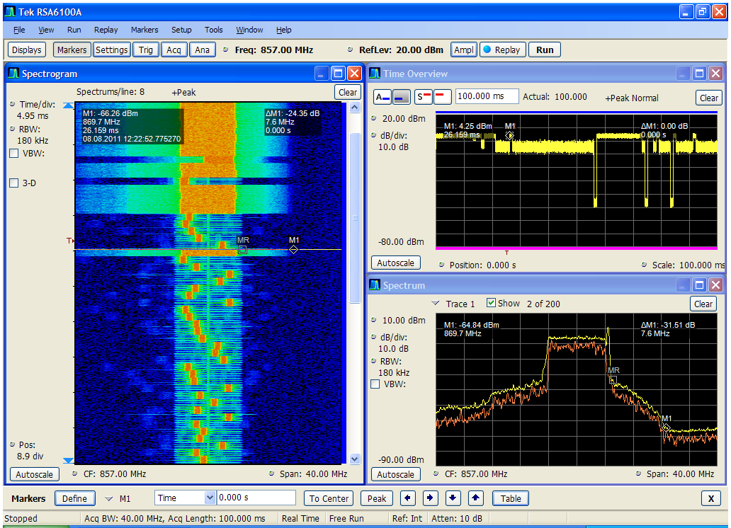
Fig. 14: Example of out-of-Band emissions of a real LTE terminal . Spectrogram (left), power vs. time (upper right) and spectrum (yellow: whole acquisition time; orange: time instant marked with a line in the spectrogram)
Fig. 15 shows the spectral properties of a second real-life LTE-terminal. The correlation between the wanted emission and the OOB emission is well visible during the times when the Demodulation reference symbol is on Air (marked with yellow arrows). Furthermore it can be seen that the main energy content for the OOB emissions lies within the actual used LTE-channel (10 MHz). The spectrum plot shows that the dynamics is in the range of 40…50 dB, which – once again – is above the dynamics given by the simulated signals.

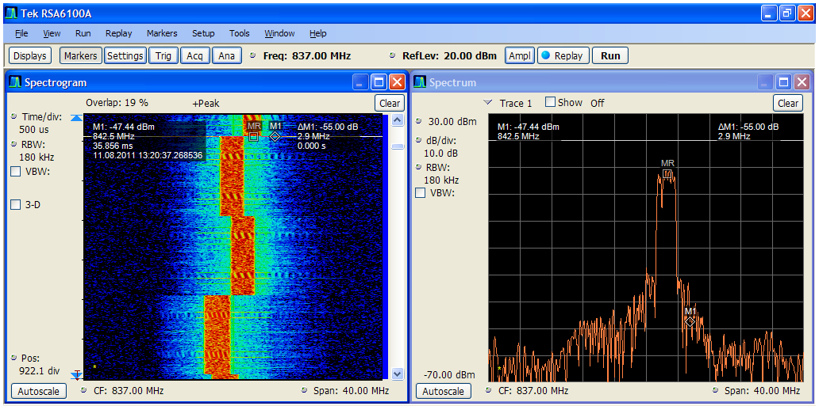
Fig. 15: Example of out-of-Band-emissions of another real LTE terminal; Spectrogram (left); instantenous spectrum (right) at time instant marked with a white line in the spectrogram
The following Fig. 16 shows the operation of the device shown in Fig. 14 with a high time resolution. Again, both from the spectrogram and the spectrum it can be seen that there’s a high degree of correlation between the actual content of the useful signal part and the OOB part: the vertical light blue line (marker M1) matches to the vertical red line’s shape and timing. Considering the same behaviour for a terminal that hops along all possible resource blocks, a swept analyzer in Max-Hold-Mode will show a very broad OOB component, neglecting the time relationship between the useful signal and OOB component.
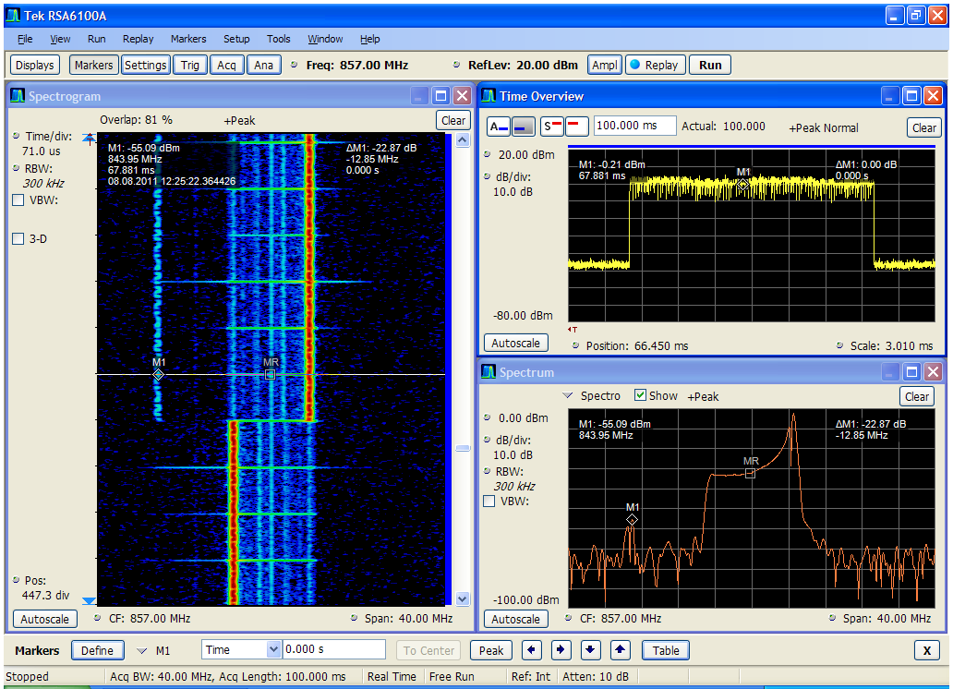
Fig. 16: Spectrum, power versus time and momentary spectrum at the time marked with a line in the spectrogram of a real UE, high time resolution
The examples in this section indicate the dependence between the number, position and time dependency of allocated resource blocks and their associated OOB emissions. This is the main reason for the conclusion of some other measurements that remarked the dependency between the number of allocated resource blocks and the interference potential. From the BEM’s point of view, the number of resource blocks is not of interest – as long as the BEM’s limits are not exceeded. Due to the BEM’s intention, planning and sharing criteria are to be based upon these given limits, whatever technology is operated in the frequency range 791 – 821 MHz and 832 – 862 MHz with a 5 MHz channellization – independent of resource blocks.

OOB Limits of LTE-Terminal stations in the 800 MHz frequency range
The OOB- limits of LTE-Terminals stations in the frequency range of 800 MHz are published in ECC/DEC(09)03. In addition the harmonised standard ETSI EN 301 908-13 (V5.2.1 2011-05) contains OOB limits for Evolved Universal Terrestrial Radio Access (E-UTRA) User Equipment (UE).

As stated above, the signals UE3-UE5 are made such, that the limits from ECC/DEC(09)03 are just met. Thus, the worst case from the victim’s service point of view is created. In practice, the current real UE’s employ a better OoB-supression, as shown by the signals UE1 and UE2.

Measurement setup
The measurement setup for the protection ratio measurement is shown in Fig. 17.

The interfering signals were generated by the SMU200A (top left). This was always operated at a constant output power to keep the sideband emissions at a defined level and constant distribution. The interferer’s power was always adjusted by the means of external attenuators.
The directional coupler has got an insertion loss of 20 dB at the injection point and 0 dB at its throughput port. The decoupling from the interfering signal path at the coupler towards the useful signal path is approx. 50 dB.
The power amplifier and the TEM-Cell were placed outside the room to prevent more potential coupling paths. Inside of the cell, the microphone receivers always were operated with their full number of antennas, if they were designed as diversity receivers.
The useful signal source was either the CMS (analogue devices) or the SMU on the right path (digital devices). If a pilot tone was needed, then it was injected into the CMS by the means of the SMGU.
The CMS has got an integrated measurement device for AF-signals, which was used to rate the signal at the receivers output.
Output power level and center frequency of the SMU and CMS are freely adjustable.
Prior to the measurement, the antenna factor of the TEM-Cell was determined, so that the wanted and unwanted signal’s fieldstrength could be specified.
The microphone receivers usually employ a λ/4-dipole. Thus, an antenna conversion factor of $k_{\text{Rx}}=\text{34}{\text{dB}}/m$ applies. This has been verified by a measurement in the TEM-cell and a ruler.
Thus, the receiver input voltage is given by:
$${U_{\text{Rx}}}/{\text{dBµV}}={{E_{\text{Rx}}}/{\text{dBµV}}}/m−\text{34}{\text{dB}}/m$$

Please note that the absolute fieldstrengths are usually not shown in this report, as it relies on the evaluation of protection ratios.

-20 dB
Wireless audio Tx
analogue
TRx Meas. Device
CMS48
LTE UE
Signalgen.
SMU200A
30 dB
1W
DuT
TEM-Cell
Signalgen.
SMGU
0..59 dB
1 dB Steps
6..60 dB
Stepless
Pilot tone
Ext. Mod Input
AF Input
Realtime Analyzer
RSA 6114A
Wireless audio Tx
digital
Signalgen.
SMU200A
XX
Fig. 17: Schematic of the measurement setup. Blue wires mark RF-connections; black wires mark AF-connections. Dashed lines represent temporary wirings
Exception: Rx2-1 was delivered as a testing device, where the integrated antenna was replaced by a line. For this measurement, the device was connected right after the directional coupler. For result evaluation, $k_{\text{Rx}}$ was assumed to convert the applied voltages into fieldstrength values.

Protection ratio measurements
The protection ratios were measured as follows: the wanted level of the useful signal (‘low level’ resp. ‘increased level’) was applied to the receiver.
Afterwards, the interfering signal was fed into the measurement chain. It’s level was increased by the manual attenuators until the interference criterion was barely not exceeded, e.g. the SINAD didn’t drop below 30 dB. The difference of the wanted and interfering signal level was noted as the protection ratio (C/I, Carrier-to-Interferer-Ratio). This was done from the co-channel case on towards lower center frequencies of the interfering signal. Thus, an increasing frequency offset in the result graphs mean that the interferer’s center frequency has decreased.
A positive protection ratio means that the interferer’s power level has to be at least that amount lower than the wanted signal to ensure interference free reception. Vice versa: a negative protection ratio means that the interferer’s power level can be up to that degree higher than the wanted signal level without interference.

Results
The figures in this section give the summary of the results, grouped by the wireless audio categories. The protection ratio lines mark the median of the protection ratios of all individual receivers, unless stated otherwise. Additionally, errorbars are provided to indicate the highest and lowest protection ratio of all measured receivers of a category.

Receiver category Rx1 (PMSE)
The following section deals with the measurements performed on wireless audio devices from category 1.

Overview
Following Fig. 18 shows the median of the protection ratios for receivers of category 1 for all interfering signal types at low wanted level. The errorbars depict the highest -/ lowest protection ratio that occurred along all receivers (of that single category).
Please note that the signal ‘UE3’ only occupies the highest resource block, so that the signal power is concentrated on this single 180 kHz block. Because of this the lower protection ratio in the co-channel case only seems to be off the others.
Fig. 18: comparison of median protection ratios for all interfering signals at low level, Rx cat. 1
The static signals UE3 – UE5 show that the median value of the required protection ratio is almost the same for all three signals and is thus independent of the allocation of resource blocks. This is not surprising, since the sideband emissions are set to the same degree of suppression relative to the channel power across the whole LTE channel.The required protection ratios for the more realistic signals UE1 and UE2 are significantly lower in all cases.

Since the uppermost resource-block is not always occupied on UE1 and UE2, the protection ratio is less than in the case of a continous allocation as in UE3. This means, that the required protection for ‘live’ signals in contrast to a static allocation of a resource block is less. Exemplary review of a single case
The spread of single values is large as illustrated by the error bars (which show the min. /max. protection ratio of all receivers inside that category). Inspecting the single values in detail relaxes this spreading range a bit. In this paragraph, the single results of the receivers are inspected with more detail for the exemplary case ‘UE1, Offset = 5 MHz’.
The figure below (cf. Fig. 19) shows the distribution of the protection ratios of all receivers. While the median is at -39 dB, the minimum is at -44 dB; the maximum at -30 dB, resulting in a spreading range of 14 dB. Within a confidence interval of 95%, the protection ratio is within the interval of (-42 dB, -35 dB), if a student-t-distribution is assumed.
Fig. 19: distribution of protection ratios for interfering signal UE1, Offset 5 MHz, Rx category 1

Example of one interference situation
Fig. 20 show the signal constellation at the point of interference for Rx1-4 (low level) when subjected to interference signal UE2 at an offset of 8 MHz. The left picture shows the power over time across the whole analyed bandwidth (20 MHz). The spectrogram and spectrum (at the marked line in the spectrogram) is shown on the picture’s right side with a resolution bandwidth of 180 kHz. The microphone’s wanted signal can be seen as a thin, light blue line in the spectrogram and is furthermore indicated by the ‘MR’-Marker in the spectrum view.
The protection ratio in this situation is -42 dB, which means that the wanted signal power is 42 dB lower than the interfering signal’s power. The picture shows how the noise on the microphone’s channel drastically increases as the LTE-channel gets fully occupied.
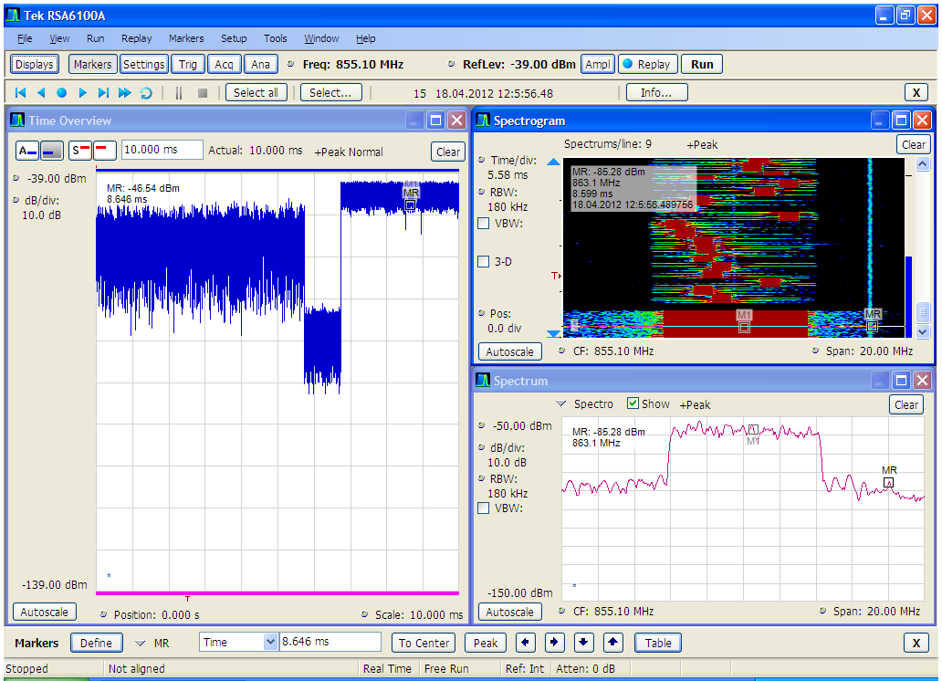
Fig. 20: Signal analysis for Rx1-4, low level, interfering signal UE2, Offset 8 MHz

Behaviour at high wanted levels
Following Fig. 21 shows the results for two receivers that were operated with an increased wanted signal level. One can see that especially for large offsets, the interference is caused by the onset of non-linear effects for UE1 and UE2.
For the other interfering signals, the measurement line decreases, so that the interference cause is mainly due OoB-Emissions. Furthermore, for UE1 and UE2, offset range 5…10 MHz shows that already a partial overload situation seems to occur, cf. Fig. 18 – the protection ratios start to rise.
Fig. 21: Median of proection ratios at high level for two receivers (Rx-Cat. 1)

Receiver category Rx2 (Hearing aids and tourguide systems)
The following section deals with the measurements performed on devices from category 2.

Overview
Fig. 22 shows the median of the protection ratios for receivers of category 2 for all interfering signal types at low wanted level.
Please note that the signal ‘UE3’ only occupies the highest resource block, so that the signal power is concentrated on this single 180 kHz block. Because of this the lower protection ratio in the co-channel case is lower than for the other signals.
The static signals UE3 – UE5 show that the median value of the required protection ratio is almost the same for all three signals and is thus independent of the allocation of resource blocks. This is not surprising, since the sideband emissions are set to the same degree of suppression relative to the channel power across the whole LTE channel.The required protection ratios for the more realistic signals UE1 and UE2 are significantly lower in all cases.

Since the uppermost resource-block is not always occupied on UE1 and UE2, the protection ratio is less than the case of a continous allocation as in UE3. This means, that the required protection for ‘live’ signals in contrast to a static allocation of a resource block is less.
Fig. 22: Rx2-xx: Comparison of protection ratios (median values) for all interfering signals, low level.

Exemplary review of a single case
The spread of single values is large as illustrated by the error bars (which show the min. /max. protection ratio of all receivers inside that category). Inspecting the single values in detail relaxes this spreading range a bit. In this paragraph, the case ‚UE1, Offset 5 MHz’ is taken as an example for that. Fig. 23 shows the relative distribution of occurence of protection ratios for that special situation. The median is -35.5 dB, the minimum -44 dB and the maximum is -15 dB, so the min/max-spread is 29 dB. The median tells us that half of the devices tested don’t need more protection than -35.5 dB. On a average scale, a protection of -31 dB is required. By cumulating the distribution, one can see that two third of all devices tested don’t need more than -34 dB protection. Vice versa: only one third of all devices need a protection of more than -34 dB (but not more than -15 dB). Assuming a student-t-distribution, the protection ratio lies within the interval of (-41 dB…-22 dB) for a 95%-level of confidence.
A comparison with the distribution shown in Fig. 19 supports the impression that the typical spread within this device category is much higher than for receiver of category 1.

Fig. 23: distribution of protection ratios for interfering signal UE1, Offset 5 MHz, Rx category 2
To stick with the example of UE1, Fig. 24 show the single results for all receivers in cat. Rx2 for that signal. For more distinction, analogue receivers are indicated by solid lines, while digital receivers are indicated by dashed lines. Please note that the distinction analogue / digital refers to the transmission scheme and not to receiver’s internal design.
It can be observed that most receivers have quiet similiar behaviour, with an exception of Rx2-3 and Rx2-4. Neglecting the results for Rx2-3 and Rx2-4, the digital systems are inside the spreading range of typical analogue receivers. From previous signal analysis it is known that Rx2-2 yields the lowest data rate of the digital systems (approx. 96 kSym/s, GMSK), while Rx2-7 and Rx2-8 are operated at 128 kSym/s (FSK). Furthermore, one can see that the slower the transmission the higher the immunity, what is not surprising. On the other hand, the digital receivers tend to be more susceptible to blocking effects, when the frequency offset is high (see later section for blocking issues).
Fig. 24: singular results for all receivers of category Rx2, interfering signal UE1

Comparison of interfering spectra and protection ratios
The dependence between shape and relative level of the interfering signal to the shape of the protection ratios are shown in the following figure. The level of the interfering signal was normalized to match the protection ratio for the co-channel case. One can observe a high similiarity between both shapes.
Fig. 25: Spectrum- and protection ratio comparison for UE5
Some interesting observations about transients can be drawn from the results with the recorded real UE1 using Fig. 26 and Fig. 27.
Fig. 26: Spectrum- and protection ratio comparison for UE1
Fig. 27: Spectrum- and protection ratio comparison for UE1, Rx-Cat.2 in detail
- In the offset range 5-8 MHz (which is 862-865 MHz for LTE UE center frequency of 857 MHz) Rx 2-3 and Rx2-4 showing a sensitivity against properties of the LTE-Signal different than the OOB spectrum (transients); the others are roughly following the OOB spectrum. Both receivers were listening aids intended for mainly non-professional use and showed to be susceptible to all signals tested. This statement does not hold for other listening aids, which outperformed both devices.
- For offset frequencies above 15 MHz one can see that there are some receivers who suffer from interference by the OOB-emissions (Rx2-7 and Rx2-8 roughly follow the spectrum’s shape). Many more are not affected by this effect, they rather get into a blocking state.

Investigation of blocking-immunity
Following test was made to distinguish between the interference cause by blocking and sideband emissions: a tunable notch was inserted at the point marked ‘XX’ in the schematic shown in Fig. 26. That notch filter was tuned such that the sideband emissions of the LTE signal into the wireless audio wanted frequency were suppressed, while the LTE main carrier wasn’t. Then, two situations were investigated:
Interference situation 1: Rx1-4, low level, Offset 8 MHz, Interference signal UE4.
The filter has the frequency transfer function as shown in Fig. 26. The insertion loss of the LTE-signal is 2 dB. The suppression of the LTE-sideband on the wireless audio receiver’s working frequency was 32 dB.
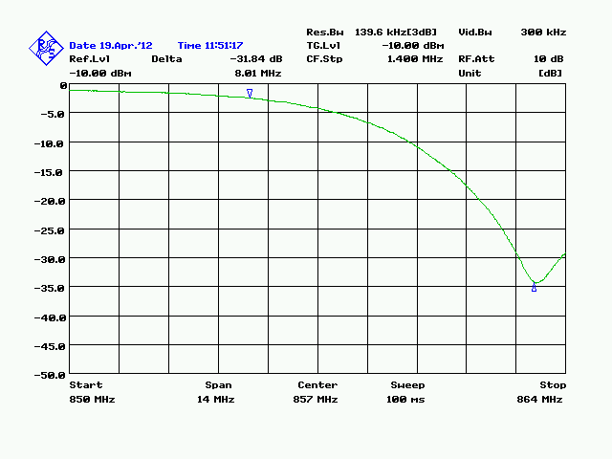
Fig. 28: frequency transfer function of the notch used for interference situation 1
The protection ratio measured without the filter is -24 dB. With the filter, the protection ratio was measured to be -57 dB, which is 32 dB less than before. This value corresponds to the sideband suppression of the notch filter. This means, that the interference cause is the sideband emission on the wanted channel.
Interference situation 2: Rx1-8,increased level, Offset 28 MHz, interference signal UE5.
The notch was tuned to the frequency transfer function shown in Fig. 29. The insertion loss of the LTE signal is approx. 1 dB. It’s sideband emissions are lowered by 36 dB.
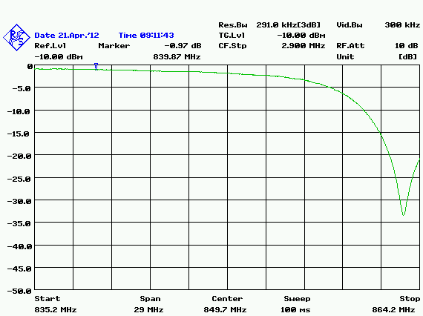
Fig. 29: frequency transfer function of the notch used for interference situation 2
Without the filter the protection ratio was measured to be -56 dB. With the filter, the protection ratio stayed the same. This means, that a reduction of the sideband emissions does not clear the interference. This further means that the receiver has reached a blocking state due to the high-power imissions at its antenna.
The evaluation of the involved fieldstrengths for the offset range of 18…28 MHz for many receivers (esp. thos from category 1) showed that the normative limit for interference immunity at the DuT’s chassis resp. signal ports of 130 dBµV/m (for an AM-carrier with 1 kHz modulation and a modulation degree of 80%) was at least reached. For this, the differentiation between ‘interference by blocking’ and ‘interference due too much power flux density at the device’ get ambiguous.

Separation distances

Separation distances for the best LTE signal (UE1) and the worst signal (UE3) are provided for different propagation conditions in Fig. 30 (Free space loss) and Fig. 31 (propagation exponent 3.5, PL=32.5dB+ 20log(f/GHz)+35log(r/m)). UE1 is a recorded signal with OOB emissions much lower as allowed in ECC/DEC(09)03 and UE3 is a simulated LTE signal emitting constantly the max. allowed limits of ECC/DEC(09)03.

Fig. 30: Separation distances. Free space loss, LTE UE at 857 MHz

Fig. 31: Separation distances. Path loss exponent 3.5, LTE UE at 857 MHz

Summary
- The recorded real LTE emissions (UE1, UE2) are far below (20-30 dB) the limits specified in ECC/DEC(09)03; three different test signals where generated (UE3-UE5) to simulate devices exploiting the allowed limits of ECC/DEC(09)03.
- The figure below (Fig. 30) compares the median protection ratios for both wireless audio receiver categories (Rx Cat. 1 → PMSE; Rx Cat. 2 → hearing aids & Tourguide systems), using the most uncritical and most critical signal (UE1 / UE3). It can be observed that receivers of cat. Rx2 tend to be more susceptible to interference.
Fig. 30: Comparison of median-protection ratios between receiver categories for interfering signal UE1 and UE3

- The high negative protection ratios for spectrally pure signals show that most wireless audio receivers have got a good selection and a good strong signal immunity. The protection ratios are dominated by the spectral shape of the out-of-band emissions. This is also confirmed by the comparision of this measurement results with the blocking requirement for cordless audio devices from EN 301357-1 (see Fig. 29)
Fig. 29:

- Some wireless audio devices seems to be sensitive against transient effects of the recorded real LTE signals (e.g. UE1) while most devices seem to be able to cope with these effects. However, for all receivers the worst performance is observed if the LTE signals fully exploite the OoB emission limits (independent of a consideration of transient effects).
- A blocking situation occurs quite seldom at low wanted field strengths in combination with high frequency offsets. With increasing wanted field strengths, the protection ratio rises slightly. A non-linear behaviour starts to set in, but the field strengths needed to create interference are above 120 dBµV/m.
- Except the special case of ‚UE3’ in the co-channel situation, all LTE-UE signals employ an interference potential independent of the actual allocation of the resource blocks. Please note that the interference levels are given as RMS-levels over the whole signal bandwidth.
- Inbetween the receiver categories, no substantial difference in the behaviour to interferences from LTE-terminals can be seen with the exception of a higher spread inside of cat. 2 relative to cat. 1.
- Required separation distances under worst case conditions (e.g. LTE used at 857 MHz, max LTE UE power) to fulfil the tested SINAD criterion (about 30 dB) of wireless audio devices at 864 MHz are for real LTE equipment (e.g. UE1) between about 5 m (propagation exponent 3.5) and 20 m (Free space loss); For LTE devices exploiting the allowed spectrum mask the separation distances are between about 20 m and 200 m.

