Evaluation of receiver parameters and the future role of receiver performance in spectrum management and coexistence studies

approved DD Month YYYY (Arial 9)

ECC Report <No>

[last updated: DD Month YYYY] (Arial 9)

# Executive summary

TABLE OF CONTENTS

0 Executive summary 2

0.1 Scope of the draft ECC Report on receiver parameters 7

1 Introduction 8

2 Definitions (optional section) 9

3 GENERAL PRINCIPLES OF RECEIVERS 11

3.1 The receiving chain 11

3.2 Sensitivity 11

3.2.1 Noise figure 11

3.3 [receiver selectivity (ADJACENT channel rejection)] 11

3.3.1 Adjacent channel selectivity 12

3.4 receiver blocking (blocking rejection) 12

3.5 receiver desensitisation 14

3.6 dynamic range 15

3.7 intermodulation rejection 16

3.8 external spurious responses 16

3.9 internal spurious responses 16

3.10 co-channel rejection 17

4 Receiver parameters 18

4.1 Receiver Parameters used in ECC documents 18

4.1.1 ECC/REC/(02)01 -Specification of Reference Receiver Performance Parameters [5] 18

4.1.2 Receiver parameters used in SEAMCAT 19

4.2 Parameters USED in ETSI documents 20

4.2.1 ETSI RED Guide EG 203 336 V1.1.1 (2015-08)[4] 20

4.2.2 ETSI TR 103 265 - Definition of radio parameters [6] 20

5 Receiver architectures 22

5.1 Super heterodyne 22

5.1.1 IF filter 23

5.1.2 Image filter 24

5.1.3 Image reject mixers 24

5.1.3.1 Hartley 24

5.1.3.2 Weaver 25

5.2 Zero IF Receiver 26

5.3 Low IF receiver 28

5.4 Architecture comparison 31

5.5 Formula for IF selectivity of a Super heterodyne receiver 33

6 LINKAGE between Technical description of receivers and terminology used by different communities 34

6.1 Selection of relevant receiver parameters 34

6.2 Comparison between ECC rECOMMENDATION(02)01 and ETSI EG 203 336 37

6.2.1.1 Examples of scenarios where reference receiver performance parameters are fundamental for frequency management 43

6.2.2 Receiver parameters in SEAMCAT 44

7 Agreed RECEIVER parameters to be used for different services/applications 52

7.1 decsription 52

7.2 critical PARAMETERS for ACHIEVING better compatibility 52

8 examples of reciever testing 53

8.1 Receiver testing of 2.4 GHz Wi-Fi equipment 53

8.1.1 Theoretical analysis 53

8.1.2 Results for three tested devices 56

9 Measurements of receiver performance of common digital systems 59

10 on results 62

10.1 MODELLING OF INTERFERENCE SCENARIOUS 62

10.2 improved compatibility results 62

11 Conclusions 63

ANNEX 1: Heading (style: ECC Annex - Heading1) 64

ANNEX 2: Heading (style: ECC Annex - Heading1) 65

ANNEX 3: List of Reference 66

LIST OF ABBREVIATIONS

|  |  |
| --- | --- |
| Abbreviation | Explanation |
| ACIR | Adjacent channel interference ratio |
| ACLR | Adjacent channel leakage ratio |
| ACS | Adjacent channel selectivity |
| ADC | Analogue to Digital Converter |
| AFA | Adaptive Frequency Agility |
| CDMA | Code Division Multiple Access |
| CEPT | European Conference of Postal and Telecommunications Administrations |
| DDC | Digital Down Conversion |
| DFS | Dynamic Frequency Selection |
| DTT | Digital Terrestrial Television |
| ECC | Electronic Communications Committee |
| EN | European Standard |
| e.i.r.p. | Equivalent Isotropically Radiated Power |
| ETSI | European Telecommunication Standards Institude |
| E-UTRA | Evolved Universal Terrestrial Radio Access |
| FDD | Frequency Division Duplex |
| FM | Frequency Modulation |
| FSK | Frequency Shift Keying |
| GMSK | Gaussian Minimum Shift Keying |
| GSM | Global System for Mobile Communications |
| GSM-R | Global System for Mobile Communications - Railway |
| IEEE | Institute of Electrical and Electronic Engineers |
| IF | Intermediate Frequency |
| IMT | International Mobile Telecommunications |
| ITU | International Telecommunication Union |
| ITU-R | International Telecommunication Union - Radiocommunication Sector |
| LBT | Listen Before Talk |
| LO | Local Oscillator |
| LTE | Long Term Evolution |
|  |  |
| MFCN | Mobile/Fixed Communications Networks |
| MSR | Multi Standard Radio |
| NFD | Net filter discrimination |
| NZIF | Non-Zero Intermediate-Frequency |
| OFDM | Orthogonal Frequency Division Multiplexing |
| OFDMA | Orthogonal Frequency Division Multiple Access |
| OoB | Out-of-Band |
| PAPR | Peak-to-Average Power Ratio |
| PEP | Peak Envelope Power |
| PSD | Power Spectral Density |
| RED | Radio Equipment Directive |
| RF | Radio Frequency |
| RLAN | Radio Local Area Network |
| RMS | Root Mean Square |
| RR | Radio Regulations |
| RSPG | European Commission Radio Spectrum Policy Group |
| R&TTE | Radio and Telecommunications Terminal Equipment Directive |
| SE | Spectrum Engineering |
| SEAMCAT | Spectrum Engineering Advanced Monte Catrlo Analysis Tool |
| SEM | Spectrum Emission Mask |
| SINR | Signal to Interference plus Noise Ratio |
| SIR | Signal to Interference Ratio |
| SNR | Signal to Noise Ratio |
| SRD | Short Range Devices |
| SSB | Single Sideband Modulation |
| TDD | Time Division Duplex |
| TDMA | Time Division Multiple Access |
| TETRA | Terrestrial Trunked Radio |
| UMTS | Universal Mobile Telecommunications System |
| TPC | Transmit Power Control |
| TRP | Total Radiated Power |
| WAS | Wireless Access System |
|  |  |
| WLAN | Wireless Local Area Network |
| WRC | World Radio Conference |

## Scope of the draft ECC Report on receiver parameters

The scope of this ECC Report is to define and evaluate relevant receiver parameters to be used for sharing and compatibility studies. The purpose of the report is to:

1. Define linkages between terminology and definitions used by different communities
2. To identify the relevant receiver parameters on studies involving different services/applications -
3. To evaluate their impact on study results by e.g. providing mathematical description (formulas)
4. To ensure their usability in inter system studies, especially with respect to adjacent channels operation
5. To develop a methodology for dealing with unlike bandwidth and different technologies. For example, selectivity of the adjacent channel refers to same system opposed to systems having different bandwidths and signal types.

Background material for the deliverable has been taken from, among others:

* ECC/REC/(02)01 [5] Appendix A,
* Receiver parameters in ETSI 201 399 and ETSI EG 203 336 [4]
* Definitions of receiver parameters in ETSI TR 103 265 [6]
* ECC Report 252 - SEAMCAT User Manual [7]

1. ..Above text is from the WGSE guidance for drafting this report, so may not be necessary in the final version

The goal of this report is to define realistic parameters which will be used in the future in sharing and compatibility studies in order not to overestimate or underestimate possible harmful interference as was the case in some past examples of ECC reports e.g. ECC Report 127, GSM-R, DTT receivers at 700 MHz, ECC Report 191 (MFCN).

Based on the results of this report a possible recommendation could be built on the definition linked to filter selectivity (common definition in CEPT) and described clearly in the previous section. One way to define blocking parameter in a recommendation could be made considering only receivers under RED. Categorization may be based on the one of recommendation 74-01, on the radiocommunication services, on frequency ranges, etc

1. To redraft above paragraph.
2. Need to make specific reference to which receiver parameters are important (problematic in the past and possibly in the future) and focus on those which would make a difference

# Introduction

A new European Radio Equipment Directive (RED), 2014/53/EU [1] was published in the Official Journal of the European Commission on May 22nd 2014 which repealed the Radio and Telecommunications Terminal Equipment Directive (R&TTE) 1999/5/EC [2] on June 12th 2016. The RED brings with it significant changes, including a scope wider than that of the R&TTE Directive, and a new definition of 'radio equipment'. The ‘essential requirements’ of the RED relating to spectrum use have also been clarified to promote more efficient use of the radio spectrum, particularly by receivers.

With regard to Article 3.2 of the RED, the development of European Harmonised Standards is the responsibility of ETSI. ETSI has revised the ETSI Guide EG 201 399 [3] and developed ETSI Guide EG 203 336 [4] which aims to further assist ETSI technical bodies with this work. The receiver parameters, contained in previous EG 201 399 (optional only) are now reflected in the revised/new EG 203 336 (as mandatory) with significant update to the definitions and descriptions of the parameters. This is currently manageable as ETSI technical bodies have been given some freedom for justified variations from the requirements of the Guide.

1. To update to be specific for this report

# Definitions (optional section)

1. To decide if this section is necessary in final version, as definitions are covered throughout the report

|  |  |  |  |
| --- | --- | --- | --- |
| Term1 | Definition | | |
|  | 1. To consider whether we need those definition and move them to relevant sections afterwards | | |
|  |  | | |
| Adjacent channel inter-ference (ACI) | | | | Interference caused by extraneous power from a signal on an adjacent channel |
| Blocking rejection (RSPG Report on Furthering Interference Management, Annex 2 [16]) | | | | Ability to reject strong interfering signals |
| Co-channel rejection (RSPG Report, Annex 2 [16]) | | | | A measure of the capability of the receiver to receive a wanted modulated signal without exceeding a given degradation due to the presence of an unwanted modulated signal, both signals being at the nominal frequency of the receiver. It is worth stating if the interfering signal is of the same or a different modulation type – as this can have a major effect. Where digital signals using the same modulation type are concerned, the time correlation between wanted and unwanted signals also comes into play, so this definition is a little simplistic. |
| Inter-modulation rejection (RSPG Report, Annex 2 [16]) | | | Rejection of unwanted interference caused by the mixing of interfering signals |
| Inter-modulation response rejection (RSPG Report, Annex 2 [16]) | | | | Measure of the capability of the receiver to receive a wanted signal, without exceeding a given degradation due to the presence of two or more unwanted signals with a specific frequency relationship to the wanted signal frequency |
|  | | | |  |
| Noise (radio noise) (ITU-R P.372) | | | | A time-varying electromagnetic phenomenon having components in the radio-frequency range, apparently not conveying information and which may be superimposed on, or combined with, a wanted signal |
| Permissible interference (RR 1.167) | | | | Observed or predicted interference which complies with quantitative interference and sharing criteria contained in these Regulations or in ITU-R Recommendations or in special agreements as provided for in these Regulations |
| Protection ratio (RF) (RR 1.170) | | | | The minimum value of the wanted-to-unwanted signal ratio, usually expressed in decibels, at the receiver input, determined under specified conditions such that a specified reception quality of the wanted signal is achieved at the receiver output. |
| Receiver sensitivity (RSPG Report, Annex 2 [16]) | | | | The level which in-band signals (within the designated operating band) must reach before they can be detected |
| Receiver selectivity (RSPG Report, Annex 2 [16]) | | | | A measure of how well the receiver can discriminate between in-band signals and out-of-band signals i.e. how well adjacent channel signals are rejected. If the neighbours in adjacent channels are relatively quiet there is no need for the out-of-band signals to be strongly suppressed, but the arrival of a new “loud” neighbour can cause reception problems. Some applications have historically required reception of out-of-band signals for good operational performance e.g. GPS relying on auxiliary out-of-band signals for high-resolution operation. |
| Receiver blocking (RSPG Report, Annex 2 [16]) | | | | Measure of the receiver's ability to receive a wanted signal at its assigned channel frequency in the presence of an unwanted interferer on frequencies other than those of the adjacent channels. It is caused by gain compression due to overloading from a very strong signal in the receiver front end. |
| Receiver desensitisation (RSPG Report, Annex 2 [16]) | | | | Occurs when a strong off-channel signal reaches a receiver front end and mixes with the local oscillator side bands (noise), producing a signal in the IF (which includes base-band indirect conversion) and thus reduces the sensitivity to weaker on-channel signals. This effect is caused by reciprocal mixing, due to phase noise. |
| Signal-to-Interference Ratio (SIR) | | | | Quotient between the average received modulated carrier power S and the average received co-channel interference power I |
| Signal-to-Noise Ratio (SNR) | | | | Ratio of the power of a signal (meaningful information) and the power of background noise (unwanted signal) |
| Receiving Stations (RR 3.12) | | | | Receiving stations should use equipment with technical characteristics appropriate for the class of emission concerned; in particular, selectivity should be appropriate having regard to No. 3.9[1] on the bandwidths of emissions |
| Performance characteristics of receivers (RR 3.13) | | | | The performance characteristics of receivers should be adequate to ensure that they do not suffer from interference due to transmitters situated at a reasonable distance and which operate in accordance with these Regulations |
| 1 Numbers in brackets preceded by 'RR' refer to paragraph numbers in the ITU Radio Regulations [10] | | | |

# GENERAL PRINCIPLES OF RECEIVERS

## The receiving chain

The following figure depicts a typical receiving chain in a simplified manner.



Figure 1: Simplified receiving chain

## Sensitivity

The main parameter of a receiver is its sensitivity which is defined as the required input power (typically specified in dBm) in order to enable it to process the incoming signal correctly in terms of a defined limit of errors (e.g. a bit error rate of 10-4).

This sensitivity defines by itself another characteristic parameter of the receiver: the minimum signal to noise ratio S/N,

where S = received signal level

N = noise = thermal noise + NF

thermal noise = 10.log10(kB.T.BW)

NF = noise figure in dB

BW = necessary bandwidth in MHz

kB = Boltzmann’s constant

T = 290 K (reference temperature)

Note that, in the absence of any interferer (I), S/N is equal to C/(N+I) where C is the received power from the wanted signal.

It is obvious that decreasing this ratio impacts the ability of the receiver to process the signal correctly. Consequently this ratio gets its main rule as protection criterion called Protection Ratio.

### Noise figure

1. Assumed noise figure as it is not going to be defined in ETSI but a crucial parameter for compatibility studies.
2. Add relevant description and equation

## [receiver selectivity (ADJACENT channel rejection)]

1. Thibault: to choose the definition for selectivity

An example of the definition from ….. TR 102914: The adjacent channel selectivity is a measure of the capability of the receiver to receive a wanted modulated signal without exceeding a given degradation due to the presence of an unwanted signal which differs in frequency from the wanted signal by an amount equal to the adjacent channel separation for which the equipment is intended.

If the intended power of the interferer is radiated completely outside the operational bandwidth of the receiver, unlike the unwanted power emitted into its bandwidth, the receiver can apply measures in terms of filtering to reduce the impact of the unwanted emissions.

Note that for the filtering of the unwanted power the term “Net Filter Discrimination (NFD)” is also used.

There are four parameters defining the behaviour of the receiver where the impacting mechanism behind these parameters depends on the number of interfering transmitters and their frequency offsets relative to the centre frequency of the receiver:

* adjacent channel selectivity
* blocking intermodulation
* overloading

### Adjacent channel selectivity

As the wording suggests, this parameter defines the requirement in case one single interfering transmitter is set at the centre frequency of the first adjacent channel. Sometimes also the values for the second and third adjacent channel are defined by a standard. However, the standards implicitly define the interfering signal as of the same system type as the victim, i.e. using the same bandwidth as well as (mostly) the same or at least a similar modulation scheme.

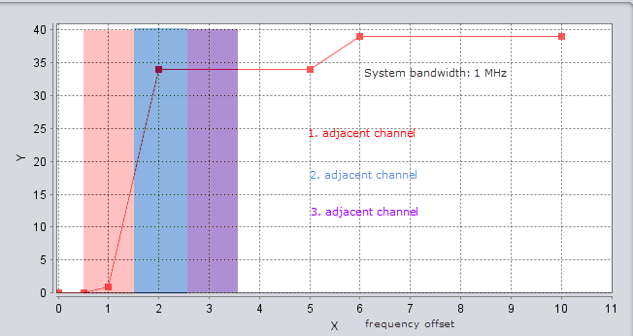

Figure 2: Adjacent channel(s) selectivity

The parameter adjacent channel selectivity takes account of the shape of the selectivity mask.

### Formula for IF selectivity of a Super heterodyne receiver

The following provides a mathematical model to represent the Intermediate Frequency (IF) selectivity of a super heterodyne receiver. This is a basic model and could be used for an approximation or receiver performance in the absence of more accurate information or measured data. The formula was Sourced from: ‘William G. Duff Electromagnetic Compatibility in Telecommunications Volume 7, Section 4.3.1.2’ (published 1988). While this is a dated reference, it is worth discussion for inclusion or looking for a more to date more information



Where:

 Slope of selectivity curve for applicable region

 Frequency offset outside the bandwidth of the applicable region (eg IF bandwidth + Offset

 Related to bandwidth of applicable region – (eg IF bandwidth)

 Shape Factor (ratio of the bandwidths of the pass band to the stop band)

For the publication of William G. Duff the spectrum signature data of ~100 different receiver nomenclatures were analysed. Of receivers analysed it found the following applied for Shape Factor:

90% of receivers the SF is greater than 2

50% of receivers the SF is greater than 4

20% of receivers the SF is greater than 8

1. For sensitivity as well power of interfering system and blocking has to taken into account

## receiver blocking (blocking rejection)

An example of the definition from ….. TR 102914: Blocking is a measure of the capability of the receiver to receive a modulated wanted input signal in the presence of an unwanted un-modulated input signal on frequencies other than those of the spurious responses or the adjacent channels, without this unwanted input signal causing a degradation of the performance of the receiver beyond a specified limit.

Blocking (or desensitisation) defines the behaviour of the receiver in the presence of one single interfering signal with a frequency offset, compared to the system bandwidth of the receiver, large enough to ensure a constant value of the selectivity mask over the complete operational bandwidth[2] of the interfering signal. Most of the standards define therefore the interfering signal as continuous wave (CW) with the total power of the interfering system.

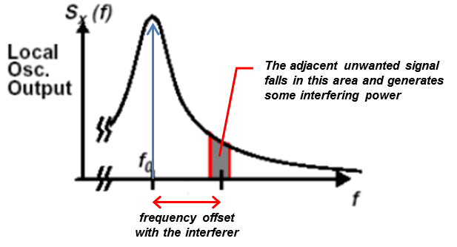

Figure 3: Blocking phenomenon

Blocking is due to the local oscillator that is not a pure frequency. Thus the local oscillator may generate some interfering power in the receiving chain from an adjacent unwanted signal.

For a given received power from the wanted signal, the blocking level is defined as the maximum emission level that can be accepted by the receiver from an off-channel unwanted signal without preventing the processing of this wanted signal.



Figure 4: Illustration of the blocking level

When describing the receiver performance, the Adjacent Channel Selectivity (ACS) is often used. It is defined as follows.

ACS = IOOB - IIB

where IOOB is the blocking level

IIB is the equivalent co-channel interfering power

IIB = N + 10 log10(10D/10 - 1)

D is the desensitisation for which the blocking level is defined

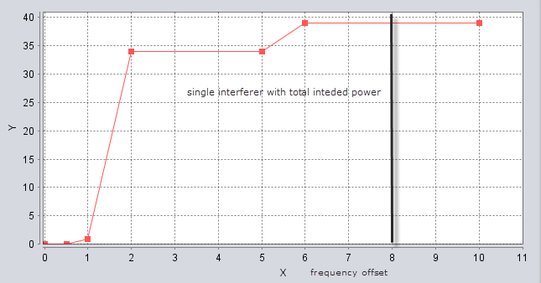

Figure 5: Blocking illustration in SEAMCAT

Some specifications, e.g. 3GPP 36.xxx, distinguish between “in-band” and “out-of-band” as well as “narrow band” blocking, but then the specifications also define the modulation of the interfering signal in case not CW is to be used[3].

## receiver desensitisation

To ensure proper operation of the receiver, a margin D is selected which allows to tolerate a certain level of interference in the listened channel. This margin is the planned desensitisation (also called interference degradation margin) and is defined in dB as a function of the maximum acceptable level of interference IIBmax.

D = 10.log10[(iIBmax + N)/N]

When planning the radio network or a radio link, the objective is to maintain the signal to interference and noise ratio SINR equal to the sensitivity to noise ratio.

C / (IIBmax + N) = S / N

⇔ (IIBmax + N) / N = C / S

This is illustrated by the following figure.



Figure 6: Planned desensitisation

The desensitisation is often translated into interference to noise ratio INR, which is given by the following formula.

INR = 10 log10(10D/10 - 1)

noting that IIB / N = [(IIB + N) / N] - 1 = 10D/10 - 1

C/I may vary typically between 9 dB (e.g. for QPSK) to 26 dB or higher (e.g. for 64QAM…). Introducing man made noise on top of the noise floor (also called thermal noise) (I/N), then C/I is desensitised by (N+I)/N resulting in C/(N+I). Note that the desensitisation is exactly the factor: (N+I)/N (also = 1+I/N).

Considering that :

 and 

and assuming a C/I of 19 dB, the following examples may be considered:

I/N = 0 dB, results in (N+I)/N = 3 dB and considering C/I = 19 dB, then C/(N+I) = C/I - 3 dB = 16 dB

I/N = -6 dB, results in (N+I)/N ≈ 1 dB and considering C/I = 19 dB, then C/(N+I) = C/I - 7 dB = 12 dB

I/N = -10 dB, results in (N+I)/N ≈ 0.4 dB and considering C/I = 19 dB, then C/(N+I) = C/I - 10 dB = 9 dB

I/N = -20 dB, results in (N+I)/N = 0.04 ≈ 0.1 dB and considering C/I = 19 dB, then C/(N+I) = C/I - 20 dB = -1 dB

Note, in case C/(I+N) is chosen as the protection criterion, the impact of the interferer is negligible compared to the noise floor (i.e. C/(I+N) ≈ C/N), if I/N ≤ -20 dB;

if I/N > 10...20 dB, then C/(I+N) ≈ C/I (i.e. the interferer is more dominant than the noise floor)

Note that the mathematical relations between these 4 interference criteria and also the algorithms of the consistency check are provided in Annex 2 of SEAMCAT Manual.

While in operation, the network will provide the planned coverage and capacity as long as the experienced desensitisation remains below the planned desensitization.

## dynamic range

According to Annex 2 of the RSPG Report on Furthering Interference Management [16], dynamic range is defined as: "The signal range over which the receiver is considered to operate properly; the upper side of a receiver’s dynamic range determines how strong a received signal can be before failure due to overloading occurs. Automatic RF gain control allows a receiver to adjust the level of a received signal as it appears at the unit’s signal processing and demodulation sections. It can also be used to improve a unit’s dynamic range and provide protection against overload. Shielding can consist of metal boxes, foil or other materials that isolate sections of a receiver from undesired RF energy."

Dynamic range – is a term conventionally used to define “spurious free dynamic range” i.e. 2/3 of the difference between third order intermodulation intercept point and the receiver noise floor.

There is also a “phase noise limited dynamic range”. This is the range of OFF-TUNE signal strength to raise the noise floor by 3 dB.

## intermodulation rejection

Intermodulation phenomenon comes from non-linearity of the amplifier in the receiving chain. The output signal of the amplifier is of this kind: a.x + b.x² + c.x³ + … Since c.x³ is the dominant component after a.x (which is the desired output), one talks of order 3 intermodulation.

Intermodulation is the only parameter requiring two interfering signals.

When considering two signals of frequencies f1 and f2, the amplifier will generate:

c.[A1.cos(w1.t) + A2.cos(w2.t)]³ = c.¾.A1².A2.cos(2.w1.t - w2.t) + c.¾.A2².A1.cos(2.w2.t - w1.t) + […]

It means that two signals of frequencies 2.f1 - f2 and 2.f2 - f1 appear in the receiver: these are intermodulation products.

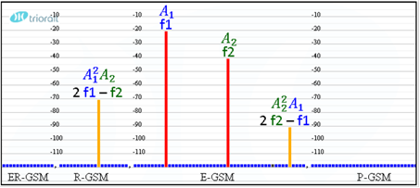

Figure 7: Generation of intermodulation products

The receiver, listening to a channel whose frequency is f0, is interfered by intermodulation products when the following conditions are met:

f0 = 2.f1 - f2 or f0 = 2.f2 - f1

the strength of the signals f1 and f2 is above a given threshold

Note that some standards/specifications define one of the interfering signals (mostly the signal close to the receiver) with a system specific modulation whereas the second one remains unmodulated.

## external spurious responses

According to Annex 2 of the RSPG Report on Furthering Interference Management [16], external spurious responses are defined as: "Signals propagated at frequencies outside of the tuned principal response frequency to which the receiver responds with measurable output power. They reveal frequencies where the receiver is most susceptible to undesired signals".

## internal spurious responses

According to Annex 2 of the RSPG Report on Furthering Interference Management [16] , internal spurious responses are : "caused by harmonics and/or mixing products of internal oscillators, which can lead to a sensitivity reduction on certain frequencies."

## co-channel rejection

1. Definition needed

Receiver co-channel rejection is a measure of the capability of a receiver to receive a wanted signal, without exceeding a given degradation, due to the presence of an unwanted signal, both signals being at the nominal frequency of the receiver [4].

# Receiver parameters

1. Added this new heading. After reorganising the document this seemed to be needed to break this content from '3 General Principals of Receivers'

## Receiver Parameters used in ECC documents

1. This have been moved from below the ETSI section to above it (ECC should come first as the baseline)

### ECC/REC/(02)01 -Specification of Reference Receiver Performance Parameters [5]

1. Added description / overview paraphrased from the recommendation

ECC REC (02)01 was published February 2002 encouraging administrations to use it as a basis for spectrum planning criteria and methods of investigation and resolving interference where reference receiver performance parameters are not included in a given harmonised standard or in any CEPT deliverable. ECC REC (02)01 provided the following recommendations

1. that the reference receiver performance parameters given in Annex 1 to this recommendation should be used by CEPT administrations as the basis for planning the radio spectrum and for radio compatibility and sharing analysis;
2. that CEPT administrations make reference to the reference receiver performance parameters given in Annex 1 to this recommendation for the purpose of making decisions on investigating and resolving interference complaints;
3. that, for the purposes of recommends 2) above, CEPT administrations should recognise receiving equipment as either:

radio equipment which complies with reference receiver performance parameters as defined in the relevant recognised standards; or

other radio equipment for which interference complaints would , in principle, not be investigated.

Annex 1 of the Recommendation provides a list of reference receiver performance parameters to be considered for spectrum planning and investigation of interference for on site paging and commercially available amateur radio equipment. It was noted that the intention was that the list would be updated to include other equipment for which receiver parameter are not included in harmonised standards or in any ECC deliverable. However there was no update.

1. Paremeter to be inserted



### Receiver parameters used in SEAMCAT

SEAMCAT (Spectrum Engineering Advanced Monte Carlo Analysis) is software tool used in CEPT for sharing and compatibility studies. In the SEAMCAT User Manual (ECC Report 252 [7]) receiver parameters are described in Chapters 1.2, 1.4.5 - 1.4.8 The report also describes methodology associated to the interference criterion (C/I, C/(I+N), (N+I)/N, I/N) and its calculations:

C/I : Carrier to interference ratio

C/(I+N) : Carrier to interference plus noise ratio (receiver protection ratio)

(N+I)/N : Desensitisation

I/N : Interference to noise ratio

Interference criteria relationship:

C/I may vary typically between 9 dB (e.g. for QPSK) to 26 dB or higher (e.g. for 64QAM…). Introducing a man made noise iRSS on top of the noise floor (I/N), then C/I is desensitised by (N+I)/N resulting in C/(N+I). Note that the desensitisationis exactly the factor (N+I)/N (also = 1+I/N).

Further details of the relationship are given in Annex 3 of ECC Report 252. [7]

Considering that

and  (Eq. 1)

And assuming a C/I of 19 dB, the following examples may be considered:

I/N = 0 dB, results in (N+I)/N = 3 dB and considering C/I = 19 dB, then C/(N+I) = C/I - 3 dB = 16 dB

I/N = -6 dB, results in (N+I)/N ≈ 1 dB and considering C/I = 19 dB, then C/(N+I) = C/I - 7 dB = 12 dB

I/N = -10 dB, results in (N+I)/N ≈ 0.4 dB and considering C/I = 19 dB, then C/(N+I) = C/I - 10 dB = 9 dB

I/N = -20 dB, results in (N+I)/N = 0.04 ≈ 0.1 dB and C/I = 19 dB, then C/(N+I) = C/I - 20 dB = -1 dB

## Parameters USED in ETSI documents

### ETSI RED Guide EG 203 336 V1.1.1 (2015-08)[4]

1. Added a background information on the puropose and scope of the guidebelow

ETSI EG 203 336 'Guide for the selection of technical parameters for the production of Harmonised Standards covering article 3.1(b) and article 3.2 of Directive 2014/53/EU' provides guidance to Technical Bodies / Committees within ETSI. Economic operators placing equipment on the European Market can use a Harmonised Standard written by ETSI as one way to conform with the Essential Requirements of the RED (presumption of conformity). Essential requirements are high level objectives described in European Directives. The purpose the Harmonised Standards is to translate those high level objectives into detailed technical specifications. The guide outlines a number of receiver parameters that should be considered for inclusion in Harmonised Standards.

We can structure these parameters with regards to what they are related or depend upon and how many signals are involved, which is used for measurements

1. Moved this table to before 'Receiver parameters from ETSI Guide ETSI EG 203 336 V1.1.1[4]' as it provides a concise summary

Table 1: Structured receiver parameters from ETSI Guide ETSI EG 203 336 V1.1.1

|  |  |  |
| --- | --- | --- |
| RecieverReceiver parameter | Relates to or depend upon | Signals involved for the purpose of its measurement |
| Sensitivity | Antennas, amplification chain, etc. | One signal (the wanted signal) |
| Co-channel rejection | Modulation and demodulation process | Two signals (one wanted, one unwanted) |
| Sensitivity  (Adjanced channel) | Filtering (close to the sought channel) | Two signals (one wanted, one unwanted) |
| Blocking | The saturation of receiver | Two signals (one wanted, one unwanted) |
| Spurious response rejection | The choice of intermediate frequencies (if any) and frequency conversion (if any) | Two signals (one wanted, one unwanted) |
| Intermodulation | The (non-) linearity of the receiver | Three signals (one wanted, two unwanted) |

### ETSI TR 103 265 - Definition of radio parameters [6]

ETSI TR 103 265 [6] is an ETSI Technical report presenting all definitions found in most ETSI standards and information on how all these definitions were gathered. Other ETSI documents

* ETSI TR 102 914 V1.1.1 (2009-01) – Technical report on aspects and implications of the inclusion of receiver parameters within ETSI standards, Annex A: Definitions of receiver parameters currently found in ETSI Harmonized Standards under article 3.2 of the R&TTE Directive [12]
* ETSI TR 102 137 V1.2.1 (2008-10) Use of radio frequency spectrum by equipment meeting ETSI standards [13]. Anexcel table is provided with search function for searching standards for equipment operating in a specified frequency band [SE21(16)05_An1_tr_102137v010201po.xls]
* ETSI EG 202 150 V1.1.1 (2003-02) - ETSI Guide on "Common Text" for Application Forms/Short Equipment Description Forms [14], AP-1_v104: Common text for EQUIPMENT DESCRIPTION FORM FOR TESTING and ETSI TR 100 0TT-1 V1.0.4 (2002-12) Test Report Form for "in-house testing" to <EN …>.

1. have to be known

# LINKAGE between Technical description of receivers and terminology used by different communities

1. To move all ETSI definitions from section 3 here
2. Define linkages between terminology and definitions used by different communities (include references to the ECC Report 252 on SEAMCAT User Manual)
3. To check this text from draft ECO Report, if there was any update in ECC Report 252
4. To check consistency with ETSI definitions
5. This table is a conclusion of 3.1.1 - shall we rather have it here or there

## Selection of relevant receiver parameters

Comparing the ETSI and ECC documentation is the proposal to take as a basis ETSI Guide ETSI EG 203 336, as ECC REC(02)01 recommendation was developed in 2002 and only limited samples of equipment was taken into account. But ETSI Guide was developed in 2015 taking into account all existing equipment and is basic document for ETSI to develop harmonised standards in accordance with RED Directive and specifies the meaning and the measurement guidelines to ETSI technical bodies.

For the needs of ECC some additional parameters were considered …

1. It should be checked, if some of receiver parameters from ECC Report 252 and/or ECC REC(02)01 which are not included in ETSI Guide needs to be taken into account

Table 3: Receiver parameters from ETSI Guide ETSI EG 203 336 V1.1.1[4]

|  |  |
| --- | --- |
| Receiver parameter | Description |
| Receiver sensitivity | Receiver sensitivity is the ability to receive a wanted signal at low input signal levels while providing a pre-determined  level of performance. |
| Receiver co-channel rejection | Receiver co-channel rejection is a measure of the capability of a receiver to receive a wanted signal, without exceeding a given degradation, due to the presence of an unwanted signal, both signals being at the nominal frequency of the receiver.1 |
| Receiver single signal selectivity | |
| Receiver adjacent signal selectivity (adjacent channel selectivity) | It depends on usage scenario of the receiver, for example in channelized use the requirements for selectivity differ from scenarios without channelization. Also mixed bandwidth scenarios require different selectivity measures.  The choice on how to specify receiver selectivity as a technical parameter is left to the individual ETSI Technical Body  . |
| Receiver spurious response rejection | The spurious response rejection is a measure of the capability of the receiver to receive a wanted signal without exceeding a given degradation due to the presence of an unwanted signal at any frequency at which a response is obtained. The frequencies of the adjacent signals (channels) are excluded. 2 |
| Receiver multiple signal selectivity | |
| Receiver blocking | Receiver blocking is as a measure of the capability of the receiver to receive a wanted signal without exceeding a given degradation due to the presence of an unwanted input signal at any frequency other than those of the spurious responses or of the adjacent channels. 3 |
| Receiver radio-frequency intermodulation | The receiver radio-frequency intermodulation response rejection is a measure of the capability of the receiver to receive a wanted signal, without exceeding a given degradation due to the presence of at least two unwanted signals at frequencies F1 and F2 with a specific frequency relationship to the wanted signal frequency (minimum second order intermodulation and third order intermodulation performance). |
| Receiver adjacent signal selectivity (adjacent channel selectivity) | Receiver adjacent signal selectivity (adjacent channel selectivity) can be part of multiple signal selectivity because attenuation of the interfering signal will require linear signal processing in the receiver even if the specified interferer is a constant envelope signal.4 |
| Other receiver effects | |
| Receiver dynamic range | Receiver "dynamic range" is a generic term broadly defined as the range of input signal levels over which a receiver functions at a specified performance level. |
| Reciprocal mixing | Reciprocal mixing is an important degrading effect in all receivers. Noise sidebands of the Local Oscillator (LO) mix with unwanted signals producing unwanted noise at the frequency of the receiver which may result in degraded receiver sensitivity. In direct Digital Down Conversion receivers (DDC) a similar effect occurs caused by the phase jitter of the clock associated with the ADC.  NOTE: The term "jitter" is often used in digital systems whereas the term "phase noise" is used in traditional radio systems however the two terms refer to the variation in phase of a signal and are therefore essentially the same phenomenon.  In many receivers degradation due to reciprocal mixing may occur before degradation due to non-linearity. As a result reciprocal mixing may be the dominant effect in a receiver's performance. |
| Desensitisation | Desensitisation is a degradation of receiver sensitivity caused by the presence of a large unwanted signal. The term is most commonly applied when an unwanted signal is present in the receiver which is above a receiver's linear "dynamic range" resulting in desensitization for example by the process of gain compression. It should be noted that gain compression can occur in any stage of the receiver. |
| Receiver unwanted emissions in the spurious domain | As a default, the limit for unwanted emissions in the spurious domain referenced at the antenna port should respect those in ERC/REC 74-01 [11] |
|  | |
| Transmitter Power Control (TPC) | Regulatory spectrum management measures may assume a defined range of Transmitter Power Control (TPC). |
| Listen Before Talk (LBT) | Listen Before Talk (LBT) is a common spectrum sharing protocol, which is often combined with Active Frequency  Agility (AFA). In its simplest form the equipment selects a channel, listens for a pre-determined time and if no signal  above a pre-defined level is received during that time, then the channel is deemed clear for use and transmission can  begin. If the selected channel is busy then the equipment may select another channel and start the process again after a pre-defined amount of time.  Listen time (before the decision to start transmission is  taken), receive signal level that defines a clear channel, algorithm for selecting next channel to listen, time for which a channel should not be re-used should be considered.  Dynamic Frequency Selection (DFS) is an enhanced version of this protocol is where the equipment is listening for specific signal types or patterns. This is used where regulatory spectrum management measures require the protection of particular applications, e.g. when Wireless Access Systems (WAS)/Radio Local Area Network (RLAN) equipment are required to avoid radars in the 5GHz band.  In this example, in addition to the parameters above, details of the specific signals to be avoided should also be defined. |
| Equipment operating under the control of a network | Some radio equipment, e.g. cellular handsets and WAS/RLAN client devices, may only transmit after receiving instructions from a central controller. Others may be required to shut down transmissions when instructed by the network controller.  In these cases the receiver performance of the terminal equipment should be of sufficient quality to enable correct  operation of this function so as to avoid unauthorized transmission.  Requirements to ensure the equipment's ability to receive and react correctly to an authorization signal or an absence thereof should be specified. |
| Antennas | For cases where mobile terminals use an integral antenna, this requirements should be specified on the product including its antenna. For other equipment that contains an integral antenna or is supplied with a dedicated antenna, should be considered whether radiated and/or conducted requirements are appropriate.  Where the antenna is supplied separately from the radio equipment antenna should not be included in the characteristics.+.5 |

1When specifying tests for receiver co-channel rejection the unwanted signal has to be specified which may be similar to the wanted signal or an unwanted interfering signal defined in ECC sharing or compatibility studies. For allowable frequency offsets test a co-channel interfering signal with frequency offset from the wanted signal has to be specified.

2 Technical Bodies should specify the frequency range over which this requirement should be evaluated. Technical Bodies may specify a frequency search method to identify the specific frequencies at which spurious responses occur. Technical Bodies may consider specifically identifying image-rejection and intermediate-frequency rejection. In the case of direct conversion receivers that do not have an image response, then the Frx / 2 and Frx / 3 may be considered.

3 Furthermore Technical Bodies should consider practical measurement methods as testing at "any frequency" is clearly an unbounded requirement. Where spurious response rejection and blocking are both specified, receiver blocking should usually be specified at a

more stringent level than that specified for spurious response rejection (clause 5.3.4.2.2) at frequencies relatively far

removed from the operating frequency, but still within the operating frequency range ( e.g. for narrowband systems, a typical practical blocking test may evaluate performance with unwanted signals at Frx ± 1 MHz, ± 2 MHz, ± 5 MHz and ± 10 MHz., Technical bodies may also limit the acceptable number of spurious response frequencies.)

4For receivers using Near-Zero Intermediate-Frequency technology (NZIF), i.e. were the first intermediate frequency is similar or less than the receiver channel spacing (or receiver bandwidth), Technical Bodies should consider specifying adjacent channel selectivity tests with unwanted signals simultaneously applied on upper and lower adjacent channels . This should be considered because the adjacent channel rejection of NZIF receivers maybe asymmetric. Technical Bodies may consider to test the adjacent channel selectivity both sides of the receive frequency simultaneously also in cases where adjacent channel interference level is expected to be significantly higher than the wanted signal.

1. Further discussion needed on how protocol related parameters (highlighted in yellow above) should be addressed - i.e. whether to include them above, remove them or address in a separate section. No agreement reached at SE21#92 on this issue.

## Comparison between ECC rECOMMENDATION(02)01 and ETSI EG 203 336

1. Added new header to make this a new section. The table 4 duplicates parts of Table 3: Receiver parameters from ETSI Guide ETSI EG 203 336 V1.1.1[4]. Combine? Delete Table 3?

Appendix A of ECC Recommendation (02)01 provides a list of reference receiver performance parameters to be considered and their impact on spectrum efficiency in the case of poor receiver performance.

shows this list in comparison to ETSI Guide ETSI EG 203 336 [4]. The ETSI Guide is used as a basis.

Table 4: List of reference receiver performance parameters to be considered and their impact on spectrum efficiency in the case of poor receiver performance from Appendix A of ECC ECC/REC/(02)01 [5] with definitions from ETSI Guide ETSI EG 203 336 [4]

|  |  |  |  |  |
| --- | --- | --- | --- | --- |
| Receiver parameter | Impact on spectrum utilisation and efficiency of radio equipment with poor receiver performance parameters - ECC/REC/(02)01 [5] | Description from  ETSI EG 203 336 [4] | ECC/REC/(02) 01 | ETSI EG 203 336 |
| Receiver sensitivity | * increase in the number of transmitters (base stations) * increase in transmitter power * increased spectrum demand if number of transmitters and transmitter power cannot be changed * increased difficulty to define channel plans   which leads to:   * more interference to other services * system capacity loss and therefore an inefficient spectrum use | Receiver sensitivity is the ability to receive a wanted signal at low input signal levels while providing a pre-determined level of performance. | X | X |
| Receiver co-channel rejection | * decrease in the number of transmitters of the interfering service and * decrease in transmitter power of the interfering service   which leads to:   * system capacity loss for the interfering service and consequently more spectrum for the other service * increase in the interference probability of interference to the wanted radio service | Receiver co-channel rejection is a measure of the capability of a receiver to receive a wanted signal, without exceeding a given degradation, due to the presence of an unwanted signal, both signals being at the nominal frequency of the receiver. | X | X |
| Receiver single signal selectivity | | | | |
| Receiver adjacent signal selectivity (adjacent channel selectivity in ETSI, adjacent band rejection in REC) | * decrease in the number of transmitters of the interfering service and * decrease in transmitter power of the interfering service   which leads to:   * system capacity loss for the interfering service and consequently more spectrum for the other service   increase in the interference probability to the wanted radio service | It depends on usage scenario of the receiver, for example in channelised use the requirements for selectivity differ from scenarios without channelisation. Also mixed bandwidth scenarios require different selectivity measures.  The choice on how to specify receiver selectivity as a technical parameter is left to the individual ETSI Technical Body  . | X  Adjacent band rejection | X  Adja-cent cha-nnel selec-tivity |
| Receiver spurious response rejection | * decrease in the number of transmitters of the interfering service and * decrease in transmitter power of the interfering service   which leads to:   * system capacity loss for the interfering service and consequently more spectrum for the other service * increase in the interference probability of interference to the wanted radio service | The spurious response rejection is a measure of the capability of the receiver to receive a wanted signal without  exceeding a given degradation due to the presence of an unwanted signal at any frequency at which a response is  obtained. The frequencies of the adjacent signals (channels) are excluded. | X | X |
| Receiver multiple signal selectivity | | | | |
| Receiver blocking | * decrease in the number of transmitters of the interfering service and * decrease in transmitter power of the interfering service   which leads to:   * system capacity loss for the interfering service and consequently more spectrum for the other service   increase in the interference probability of interference to the wanted radio service | Receiver blocking is as a measure of the capability of the receiver to receive a wanted signal without exceeding a given degradation due to the presence of an unwanted input signal at any frequency other than those of the spurious responses or of the adjacent channels. | X | X |
| Receiver radio-frequency intermodulation | More spectrum is required to allow channel planning to avoid intermodulation products | The receiver radio-frequency intermodulation response rejection is a measure of the capability of the receiver to receive a wanted signal, without exceeding a given degradation due to the presence of at least two unwanted signals at frequencies F1 and F2 with a specific frequency relationship to the wanted signal frequency (minimum second order intermodulation and third order  intermodulation performance). | X | X |
| Cross-modulation rejection | Applies to systems with an AM component only: requires increased received signal so impacts on transmit power | Not included | X |  |
| Receiver adjacent signal selectivity (adjacent channel selectivity) | * decrease in the number of transmitters of the interfering service and * decrease in transmitter power of the interfering service   which leads to:   * system capacity loss for the interfering service and consequently more spectrum for the other service * increase in the interference probability of interference to the wanted radio service | Receiver adjacent signal selectivity (adjacent channel selectivity) can be part of multiple signal selectivity because  attenuation of the interfering signal will require linear signal processing in the receiver even if the specified interferer is  a constant envelope signal | X | X |
| Other receiver effects | | | | |
| Receiver dynamic range | Not included | Receiver "dynamic range" is a generic term broadly defined as the range of input signal levels over which a receiver  functions at a specified performance level. |  | X |
| Reciprocal mixing | Not included | Reciprocal mixing is an important degrading effect in all receivers. Noise sidebands of the Local Oscillator (LO) mix  with unwanted signals producing unwanted noise at the frequency of the receiver which may result in degraded receiver sensitivity. In direct Digital Down Conversion receivers (DDC) a similar effect occurs caused by the phase jitter of the clock associated with the ADC.  NOTE: The term "jitter" is often used in digital systems whereas the term "phase noise" is used in traditional  radio systems however the two terms refer to the variation in phase of a signal and are therefore essentially the same phenomenon.  In many receivers degradation due to reciprocal mixing may occur before degradation due to non-linearity. As a result reciprocal mixing may be the dominant effect in a receiver's performance. |  | X |
| Desensitisation | * decrease in the number of transmitters of the interfering service and * decrease in transmitter power of the interfering service   which leads to:   * system capacity loss for the interfering service and consequently more spectrum for the other service * increase in the interference probability of interference to the wanted radio service | Desensitisation is a degradation of receiver sensitivity caused by the presence of a large unwanted signal. The term is most commonly applied when an unwanted signal is present in the receiver which is above a receiver's linear "dynamic range" resulting in desensitization for example by the process of gain compression. It should be noted that gain compression can occur in any stage of the receiver. | X | X |
| Receiver unwanted emissions in the spurious |  | As a default, the limit for unwanted emissions in the spurious domain referenced at the antenna port should respect those in ERC/REC 74-01 [11] |  | X |
| Protocol elements, interference mitigation techniques and  type of modulation | | | | |
| Transmitter Power Control (TPC) | Not included | Regulatory spectrum management measures may assume a defined range of Transmitter Power Control (TPC). |  | X |
| Listen Before Talk (LBT) | Not included | Listen Before Talk (LBT) is a common spectrum sharing protocol, which is often combined with Active Frequency  Agility (AFA). In its simplest form the equipment selects a channel, listens for a pre-determined time and if no signal  above a pre-defined level is received during that time, then the channel is deemed clear for use and transmission can begin. If the selected channel is busy then the equipment may select another channel and start the process again after a pre-defined amount of time.  Dynamic Frequency Selection (DFS) is an enhanced version of this protocol is where the equipment is listening for specific signal types or patterns. This is used where regulatory spectrum management measures require the protection of particular applications. |  | X |
| Equipment operating under the control of a network | Not included | Some radio equipment may only transmit after receiving instructions from a central controller. Others may be required to shut down transmissions when instructed by the network controller.  In these cases the receiver performance should be of sufficient quality to enable correct operation of this function so as to avoid unauthorized transmission.  Requirements to ensure the equipment's ability to receive and react correctly to an authorization signal or an absence of it. |  | X |
| Protection ratio | * decrease in the number of transmitters of the interfering service and * decrease in transmitter power of the interfering service   which leads to:   * system capacity loss for the interfering service and consequently more spectrum for the other service   increase of the interference probability of interference to the wanted radio service | Not included | X |  |
| Receiving mask | * decrease in the number of transmitters of the interfering service and * decrease in transmitter power of the interfering service   which leads to:   * system capacity loss for the interfering service and consequently more spectrum for the other service * increase in the interference probability of interference to the wanted radio service | Not included | x |  |
| Antennas | Not included | For cases where mobile terminals use an integral antenna, this requirements should be specified on the product including its antenna. For other equipment that contains an integral antenna or is supplied with a dedicated antenna, should be considered whether radiated and/or conducted requirements are appropriate.  Where the antenna is supplied separately from the radio equipment antenna should not be included in the characteristics. |  | X |

1. To replace ETSI Guide definitions with reference to relevant section if they are included in the ETSI Guide, and maybe add comments if there are differences
2. To handle protocol elements according to whether they are included in previous tables (see Table 3 and related Editor's Note 23:)

As this recommendation was developed in 2002 and only a limited range of equipment was taken into account, some of receiver parameters differ from the ETSI Guide, which was developed in 2015 taking into account all relevant existing equipment

1. It should be checked, if some of receiver parameters from ECC REC(02)01 which are not included in ETSI Guide needs to be taken into account

#### Examples of scenarios where reference receiver performance parameters are fundamental for frequency management

Appendix B of ECC/REC/(02)01 [5] provides examples of scenarios where reference receiver performance parameters are fundamental for frequency management:

1. Inter-system scenarios :

Compatibility study on adequate guard bands to implement between systems operating in adjacent bands: these studies are based on MCL (Minimum Coupling Loss) or statistical (Monte Carlo) methods, both of which require knowledge of input parameters such as receiver sensitivity, selectivity (C/I) and blocking, as defined by the available standards. If these parameters are not controlled, there is a risk that some radio receivers may be subject to harmful interference, although appropriate measures can be assumed to be required to avoid this interference. For future systems, if receiver parameters are not known, pessimistic assumptions will be necessary that will increase the calculated guard bands and consequently lower the spectrum efficiency. In addition, it should be noted that not only are guard bands affected, but also geographical separation distances, particularly in the case where the band is shared between two systems.

Studies to produce channel plans for the fixed and mobile services in order to ease standardisation and circulation of equipment: these channel plans cannot be produced efficiently if the receiver selectivity is not well known.

CEPT has produced a recommendation on limits of spurious emissions from radio equipment (ERC/REC 74-01 [11]), which applies constraints on the transmitter in order to increase the effectiveness of use of the spectrum. Additionally, ITU-R has also produced Recommendation ITU-R SM.329[15]. These recommendations are based on the assumption that the receiver should be sufficiently selective to be more affected by unwanted emissions than by blocking phenomena. This needs to be ensured in order for all users to benefit from increased spectrum efficiency.

1. Intra-system scenarios :

Studies to produce channel plans for the fixed and mobile services in order to facilitate frequency co-ordination, standardisation and circulation of equipment: these channel plans cannot be produced effectively if the receiver performance is not well known.

Some systems related to the safety of life applications require receiver parameters to be used as a basis to ensure correct operation.

For radio systems using a "Listen Before Talk" protocol of any kind, the receiver performance is inextricably tied to a transmitter response. Where the system capacity is linked to a specific response e.g. power control in a CDMA type system a "rogue" receiver can act in a "predatory" manner, leading to a significant reduction in system capacity, and thus spectrum utilisation.

1. Examples of scenarios where receiver parameters are required for enforcement activities

When an interference case needs to be resolved it is important to be able to prove that the problem is caused by a rogue transmitter. This would be extremely difficult in a regime where there is no defined acceptable receiver performance parameters to use as reference criteria.

### Receiver parameters in SEAMCAT

1. To add general description here on how receiver parameters are handled in SEAMCAT (blocking mask and equations), then refer to this text from the table (see yellow highlighted cells)

SEAMCAT has different calculation modules for "generic" systems and cellular (CDMA and OFDMA) systems. Relevant receiver parameters are defined differently in different modules. Table 3 is a summary of all receiver parameters used in SEAMCAT in comparison with ETSI Guide ETSI EG 203 336 [4] and ECC/REC/(02)01 [5].

Table 5: List of receiver parametrs used in SEAMCAT in comparison with ETSI Guide ETSI EG 203 336 and ECC/REC/(02)01

|  |  |  |  |  |  |  |  |  |
| --- | --- | --- | --- | --- | --- | --- | --- | --- |
| Receiver parameter | ECC Report 252 [7] description | Generic | CDMA | OFDM | Library | Description from  ETSI RED Guide EG 203 336 [4] | REC 02-01 | EG 203 336 |
| Noise floor | The noise floor (N) in dBm is the level of noise introduced by the receiver system, below which the signal that’s being captured cannot be isolated from the noise and is defined in dBm as.  N (dBm) = N0 (dBm) + NF (dB) or in linear scale  N (Watts) = 10^((-173.977 + 10*log10(systemBandwidth (Hz)) + NF)/10) | X | X | X | X |  |  |  |
| Receiver sensitivity | * Sensitivity = Noise Floor + C/(N+I) | X | X | X | X | Receiver sensitivity is the ability to receive a wanted signal at low input signal levels while providing a pre-determined level of performance. | X | X |
| Receiver co-channel rejection - In ECC Report 252 - Receiver filter + Reception bandwidth: Operating bandwidth | * Filtering of the receiver (if any). The filtering of the receiver is by default 0 dB (similarly to the default blocking filtering value). It is used in connection with the overloading calculation. * Freq. (MHz), Attenuation (dB) * Bandwidth of the receiver(kHz) | X | X | X | X | Receiver co-channel rejection is a measure of the capability of a receiver to receive a wanted signal, without exceeding a given degradation, due to the presence of an unwanted signal, both signals being at the nominal frequency of the  receiver.* | X | X |
| Receiver single signal selectivity |  |  |  |  |  |  |  |  |
| Receiver adjacent signal selectivity (adjacent channel selectivity in ETSI, adjacent band rejection + receiving mask in REC)  In ECC Report 252 - Receiver filter + Reception bandwidth: Operating bandwidth | * Filtering of the receiver (if any). The filtering of the receiver is by default 0 dB (similarly to the default blocking filtering value). It is used in connection with the overloading calculation. * Freq. (MHz), Attenuarion (dB) * Bandwidth of the receiver(kHz) | X | X | X | X | It depends on usage scenario of the receiver, for example in channelized use the requirements for selectivity differ from scenarios without channelization. Also mixed bandwidth scenarios require different selectivity measures.  The choice on how to specify receiver selectivity as a technical parameter is left to the individual ETSI Technical Body | X | X |
| Receiver spurious response rejection  In ECC Report 252 - Receiver filter | * Filtering of the receiver (if any). The filtering of the receiver is by default 0 dB (similarly to the default blocking filtering value). It is used in connection with the overloading calculation. * Freq. (MHz), Attenuarion (dB) | X | X | X | X | The spurious response rejection is a measure of the capability of the receiver to receive a wanted signal without  exceeding a given degradation due to the presence of an unwanted signal at any frequency at which a response is  obtained. The frequencies of the adjacent signals (channels) are excluded. ** | X | X |
| Receiver multiple signal selectivity |  |  |  |  |  |  |  |  |
| Receiver blocking  ECC Report 252 -  Blocking response: Receiver frequency response (receiver blocking performance) | Blocking mode and associated blocking mask – is a receiver mask attenuation versus frequency, Freq. (MHz), Attenuarion (dB) or (dBm)  Protection ratio case, SEAMCAT takes the positive values of the blocking mask and considers the underlying measurement procedure by this calculation: $$a_{VLR}\left(∆f\right)={block}_{protection_{ratio}}\left(∆f\right)+$$ $\frac{C}{N+I}+\frac{N+I}{N}-I/N$  In selectivity case it takes negative values: $$a_{VLR}\left(∆f\right)={block}_{sensitivity}\left(∆f\right)$$ $$-{sensitivity}_{VLR}+\frac{C}{N+I}-I/N$$ | X | X | X | X | Receiver blocking is as a measure of the capability of the receiver to receive a wanted signal without exceeding a given degradation due to the presence of an unwanted input signal at any frequency other than those of the spurious responses or of the adjacent channels. *** | X | X |
| Intermodulation rejection: Intermodulation response (intermodulation interference)  ECC Report 252 -  Receiver radio-frequency intermodulation | Intermodulation response (intermodulation interference) - Receiver mask at the intermodulation frequency:  Freq. (MHz), Attenuarion (dB)  For the intermodulation products of the 3rd order are $f_{VLR}-\frac{b}{2}≤f_{0}≤f_{VLR}+\frac{b}{2}$     b : is the bandwidth of the VLR,  : the trialed frequency of the victim system  : the trialed frequencies of pairs of interfering systems in case more than two systems are to be taken into account | X | X | X | X | The receiver radio-frequency intermodulation response rejection is a measure of the capability of the receiver to receive a wanted signal, without exceeding a given degradation due to the presence of at least two unwanted signals at frequencies F1 and F2 with a specific frequency relationship to the wanted signal frequency (minimum second order intermodulation and third order  intermodulation performance). | X | X |
| Receiver adjacent signal selectivity (adjacent channel selectivity in ETSI, adjacent band rejection + receiving mask in REC)  In ECC Report 252 - Receiver filter + Reception bandwidth: Operating bandwidth | * Filtering of the receiver (if any). The filtering of the receiver is by default 0 dB (similarly to the default blocking filtering value). It is used in connection with the overloading calculation. * Freq. (MHz), Attenuarion (dB) * Bandwidth of the receiver(kHz) | X | X | X | X | It depends on usage scenario of the receiver, for example in channelized use the requirements for selectivity differ from scenarios without channelization. Also mixed bandwidth scenarios require different selectivity measures.  The choise how to specify receiver selectivity as a technical parameter is left to the individual ETSI Technical Body  . | X | X |
| Other receiver effects |  |  |  |  |  |  |  |  |
| Receive power dynamic range | In dB. Used in the calculation of the dRSS. It is the maximum range of the received power that the VLR can accept, in terms of the maximum receive power over the VLR’s sensitivity threshold. | X | X | X | X | Receiver "dynamic range" is a generic term broadly defined as the range of input signal levels over which a receiver  functions at a specified performance level. |  | X |
| Reciprocal mixing |  |  |  |  |  | Reciprocal mixing is an important degrading effect in all receivers. Noise sidebands of the Local Oscillator (LO) mix with unwanted signals producing unwanted noise at the frequency of the receiver which may result in degraded receiver sensitivity. In direct Digital Down Conversion receivers (DDC) a similar effect occurs caused by the phase jitter of the clock associated with the ADC.  “Jitter" and "phase noise” refer to the variation in phase of a signal and are essentially the same phenomenon. |  | X |
| Desensitisation – in ECC Report 252 overloading, overloading threshold | Overloading threshold is the maximum interfering signal level, where close to that level the receiver loses its ability to discriminate against interfering signals at frequencies differing from that of the wanted signal. ECC Report 252 Annex A5.4  Overloading - single source of interference $${iRSS}_{overloading}=P_{ILT}^{output}+ g_{ILT}^{PC}-Rx_filter+max\left({PL}_{ILT→VLR}-G_{ILT→VLR}+G_{VLR→ILT},MCL\right)$$ multiple source of interference  2.1 If the interferers are operating at the same frequency, iRSSoverloading is sum of each of the iRSSoverloading calculated for each of the source of interference.  2.2 If the interferers are operating at different frequencies, an iRSSoverloading should be calculated considering all of the sources of interference for each frequency (i.e. the sum of the iRSS overloading is performed at the specific frequency). Each of the calculated iRSSoverloading should be compared with the different overloading threshold extracted from the overloading mask depending on the considered frequency offset. | X | X | X | X | Desensitisation is a degradation of receiver sensitivity caused by the presence of a large unwanted signal. The term is most commonly applied when an unwanted signal is present in the receiver which is above a receiver's linear "dynamic range" resulting in desensitisation for example by the process of gain compression. It should be noted that gain compression can occur in any stage of the receiver. | X | X |
| Receiver unwanted emissions in the spurious |  |  |  |  |  | As a default, the limit for unwanted emissions in the spurious domain referenced at the antenna port should respect those in ERC/REC 74-01 |  | X |
| Protocol elements, interference mitigation techniques and type of modulation |  |  |  |  |  |  |  |  |
| Transmitter Power Control (TPC) | ECC Report – Chapter 4.9 Power control and Annex14:  The power control, in the victim link, is a simplified power control mechanism which ensures only that a certain dRSS is not exceeded in the victim link receiver.  The “receive power dynamic range” input parameter (denoted Pcmax) is the maximum range of the receive power that a victim link receiver can accept, in terms of the maximum receive power over the VLR’s sensitivity threshold.  For CDMA see Chapter 8.7.1 of ECC Report  For OFDMA UL power control see Chapter 9.10 of ECC Report | X | X | X | X | Regulatory spectrum management measures may assume a defined range of Transmitter Power Control (TPC). |  | X |
| Listen Before Talk (LBT) |  |  |  |  |  | Listen Before Talk (LBT) is a common spectrum sharing protocol, which is often combined with Active FrequencyAgility (AFA). In its simplest form the equipment selects a channel, listens for a pre-determined time and if no signalabove a pre-defined level is received during that time, then the channel is deemed clear for use and transmission can begin. If the selected channel is busy then the equipment may select another channel and start the process again after a pre-defined amount of time.  Dynamic Frequency Selection (DFS) is an enhanced version of this protocol is where the equipment is listening for specific signal types or patterns. This is used where regulatory spectrum management measures require the protection of particular applications. |  | X |
| Equipment operating under the control of a network |  |  |  |  |  | Some radio equipment may only transmit after receiving instructions from a central controller. Others may be required to shut down transmissions when instructed by the network controller.  In these cases the receiver performance should be of sufficient quality to enable correct operation of this function so as to avoid unauthorized transmission.  Requirements to ensure the equipment's ability to receive and react correctly to an authorization signal or an absence of it. |  | X |
| Antennas | ECC Report 252: chapters:  5.2.2 Antenna pointing  5.2.3 Antenna patterns identification | X | X | X | X | For cases where mobile terminals use an integral antenna, this requirements should be specified on the product including its antenna. For other equipment that contains an integral antenna or is supplied with a dedicated antenna, should be considered whether radiated and/or conducted requirements are appropriate.  Where the antenna is supplied separately from the radio equipment antenna should not be included in the characteristics. |  | X |

# Agreed RECEIVER parameters to be used for different services/applications

## desCription

## critical PARAMETERS for ACHIEVING better compatibility

# Measurements of receiver performance of common digital systems

The receiver measurements should be realized according to the declaration of ETSI standards as far as possible. But for some radio services / applications standards are still missing at the present time.

Different receiver parameters and features are given in the various radio services / applications. This needs a widely individual assessment of the operational states and the criterions for the judgement of a receiving distortion.

Criterions could be:

* - The hard transition in the two states - a proper receiving or no receiving
* - A soft transition from the proper receiving to the complete failure

o reduction of the transmission rate

o increase of the bit error rate (BER) or the frame error rate (FER)

o partial failure of feature

Measurements could be enforced via air interface or via conductor between transmitter and receiver.

ETSI Standards in which receiver measurement methods

|  |  |  |  |  |  |  |  |  |
| --- | --- | --- | --- | --- | --- | --- | --- | --- |
|  |  |  |  | R&TTE Standards | | RED Work Program | | |
| Prioritization | Technology | Technology | Technology | Existing standard | Title | Harmonised Standard | Stage | Note |
| H | LAND MOBILE | Cordless Telephones | DECT BS | ETSI EN 301 406 V1.5.1 (2003-07) | “DECT“ | [EN 301 406 Ver. 2.2.1](https://portal.etsi.org/webapp/WorkProgram/Report_WorkItem.asp?WKI_ID=39306&curItemNr=155&totalNrItems=197&optDisplay=100000&qSORT=HIGHVERSION&qETSI_ALL=&SearchPage=TRUE&qDIRECTIVE=2014%2F53%2FEU&qINCLUDE_SUB_TB=True&qINCLUDE_MOVED_ON=&qSTOP_FLG=N&qKEYWORD_BOOLEAN=OR&qCLUSTER_BOOLEAN=OR&qFREQUENCIES_BOOLEAN=OR&qSTOPPING_OUTDATED=&butExpertSearch=Search&includeNonActiveTB=FALSE&includeSubProjectCode=FALSE&qREPORT_TYPE=) | Published |  |
| H | LAND MOBILE | Cordless Telephones | DECT UE | ETSI EN 301 406 V1.5.1 (2003-07) | “DECT“ |  |  |  |
| H | LAND MOBILE | Terminals and Base Stations | Land mobile | Draft ETSI EN 300 086-1 V1.3.1 (2007-12) | “Land Mobile Service; analogue“ | [EN 300 086 Ver. 2.1.1](https://portal.etsi.org/webapp/WorkProgram/Report_WorkItem.asp?WKI_ID=47173&curItemNr=196&totalNrItems=197&optDisplay=100000&qSORT=HIGHVERSION&qETSI_ALL=&SearchPage=TRUE&qDIRECTIVE=2014%2F53%2FEU&qINCLUDE_SUB_TB=True&qINCLUDE_MOVED_ON=&qSTOP_FLG=N&qKEYWORD_BOOLEAN=OR&qCLUSTER_BOOLEAN=OR&qFREQUENCIES_BOOLEAN=OR&qSTOPPING_OUTDATED=&butExpertSearch=Search&includeNonActiveTB=FALSE&includeSubProjectCode=FALSE&qREPORT_TYPE=) | Approval stage |  |
| H | LAND MOBILE | Terminals and Base Stations | Land mobile | ETSI EN 300 113 | “Land Mobile Service“ |  |  |  |
| H | LAND MOBILE | Terminals and Base Stations | Land mobile | ETSI EN 300 390-1 V1.2.1 (2000-09) | “Land Mobile Service“ | [EN 300 390 Ver. 2.1.1](https://portal.etsi.org/webapp/WorkProgram/Report_WorkItem.asp?WKI_ID=47178&curItemNr=183&totalNrItems=197&optDisplay=100000&qSORT=HIGHVERSION&qETSI_ALL=&SearchPage=TRUE&qDIRECTIVE=2014%2F53%2FEU&qINCLUDE_SUB_TB=True&qINCLUDE_MOVED_ON=&qSTOP_FLG=N&qKEYWORD_BOOLEAN=OR&qCLUSTER_BOOLEAN=OR&qFREQUENCIES_BOOLEAN=OR&qSTOPPING_OUTDATED=&butExpertSearch=Search&includeNonActiveTB=FALSE&includeSubProjectCode=FALSE&qREPORT_TYPE=) | Published |  |
| H | LAND MOBILE | ? | RTTT | ETSI EN 300 674-1 V1.2.1 (2004-08) | “RTTT; DSRC; 5.8 GHz-ISM-band“ | [EN 300 674-2-2 Ver. 2.0.5](https://portal.etsi.org/webapp/WorkProgram/Report_WorkItem.asp?WKI_ID=46543&curItemNr=170&totalNrItems=197&optDisplay=100000&qSORT=HIGHVERSION&qETSI_ALL=&SearchPage=TRUE&qDIRECTIVE=2014%2F53%2FEU&qINCLUDE_SUB_TB=True&qINCLUDE_MOVED_ON=&qSTOP_FLG=N&qKEYWORD_BOOLEAN=OR&qCLUSTER_BOOLEAN=OR&qFREQUENCIES_BOOLEAN=OR&qSTOPPING_OUTDATED=&butExpertSearch=Search&includeNonActiveTB=FALSE&includeSubProjectCode=FALSE&qREPORT_TYPE=) | Approval stage | Multi part - 2 parts |
| H | LAND MOBILE |  | SRD 800/900 MHZ | Final draft ETSI EN 300 220-1 V2.4.1 (2012-01) | “SRD“ | [EN 300 220-2 Ver. 3.1.0](https://portal.etsi.org/webapp/WorkProgram/Report_WorkItem.asp?WKI_ID=47883&curItemNr=191&totalNrItems=197&optDisplay=100000&qSORT=HIGHVERSION&qETSI_ALL=&SearchPage=TRUE&qDIRECTIVE=2014%2F53%2FEU&qINCLUDE_SUB_TB=True&qINCLUDE_MOVED_ON=&qSTOP_FLG=N&qKEYWORD_BOOLEAN=OR&qCLUSTER_BOOLEAN=OR&qFREQUENCIES_BOOLEAN=OR&qSTOPPING_OUTDATED=&butExpertSearch=Search&includeNonActiveTB=FALSE&includeSubProjectCode=FALSE&qREPORT_TYPE=) | Approval stage | Multi part - 5 parts |
| H |  |  | GNSS |  | GNSS |  |  |  |
| H |  |  | Radiodetermination 2,7 GHz |  | Radiodetermination |  |  |  |
| H |  |  | Radiodetermination 76 GHz |  | Radiodetermination |  |  |  |
| H |  |  | Radiodetermination 24 GHz |  | Radiodetermination |  |  |  |
| H | LAND MOBILE | ? | ITS |  |  |  |  |  |
| H | Fixed | BWA systems operating between 1 GHz and 6 GHz | FBWA |  |  |  |  |  |
| H |  |  | DAB+ |  |  |  |  |  |
| H |  |  | DVB-T |  |  |  |  |  |
| H |  |  | LTE 800 BS |  |  |  |  |  |
| H |  |  | LTE 800 UE |  |  |  |  |  |
| H |  |  | LTE 2300 BS |  |  |  |  |  |
| H |  |  | LTE 2300 UE |  |  |  |  |  |
| H |  |  | GSM 900 BS |  |  |  |  |  |
| H |  |  | GSM 900 UE |  |  |  |  |  |
| H |  |  | UMTS 2100 BS |  |  |  |  |  |
| H |  |  | UMTS 2100 UE |  |  |  |  |  |
| H |  |  | RLAN 2400 AP |  |  |  |  |  |
| H |  |  | RLAN 2400 UE |  |  |  |  |  |
| H |  |  | RLAN 5G AP |  |  |  |  |  |
| H |  |  | RLAN 5G UE |  |  |  |  |  |
| H |  |  | LTE 3500 BS |  |  |  |  |  |
| H |  |  | LTE 3500 UE |  |  |  |  |  |
| H |  | new equipment > 2010 | P-P, 26 GHz |  |  |  |  |  |
| H |  | trunk equipmenet | P-P 4 GHz |  |  |  |  |  |
| L | LAND MOBILE | CB | Land mobile | ETSI EN 300 433-1 V1.1.3 (2000-12) | “Land Mobile Service; AM-CB“ | [EN 300 433 Ver. 2.1.1](https://portal.etsi.org/webapp/WorkProgram/Report_WorkItem.asp?WKI_ID=47179&curItemNr=176&totalNrItems=197&optDisplay=100000&qSORT=HIGHVERSION&qETSI_ALL=&SearchPage=TRUE&qDIRECTIVE=2014%2F53%2FEU&qINCLUDE_SUB_TB=True&qINCLUDE_MOVED_ON=&qSTOP_FLG=N&qKEYWORD_BOOLEAN=OR&qCLUSTER_BOOLEAN=OR&qFREQUENCIES_BOOLEAN=OR&qSTOPPING_OUTDATED=&butExpertSearch=Search&includeNonActiveTB=FALSE&includeSubProjectCode=FALSE&qREPORT_TYPE=) | Published |  |
| L | LAND MOBILE | Terminals and Base Stations | Land mobile | ETSI EN 300 219-1 V1.2.1 (2001-03) | “Land Mobile Service“ | [EN 300 219 Ver. 2.1.0](https://portal.etsi.org/webapp/WorkProgram/Report_WorkItem.asp?WKI_ID=47175&curItemNr=193&totalNrItems=197&optDisplay=100000&qSORT=HIGHVERSION&qETSI_ALL=&SearchPage=TRUE&qDIRECTIVE=2014%2F53%2FEU&qINCLUDE_SUB_TB=True&qINCLUDE_MOVED_ON=&qSTOP_FLG=N&qKEYWORD_BOOLEAN=OR&qCLUSTER_BOOLEAN=OR&qFREQUENCIES_BOOLEAN=OR&qSTOPPING_OUTDATED=&butExpertSearch=Search&includeNonActiveTB=FALSE&includeSubProjectCode=FALSE&qREPORT_TYPE=) | Approval stage |  |
| L | LAND MOBILE |  |  | ETSI EN 300 761-1 V1.2.1 (2001-06) | “SRD; 2.45 GHz“ | Not on work program | EN 300 440, EN 300 328? |  |
| L |  |  | Aeronautical Mobile Service | ETSI EN 302 617-1 V1.1.1 (2009-01) | “UHF Aeronautical Mobile Service; AM“ | [EN 302 617-2 Ver. 2.1.1](https://portal.etsi.org/webapp/WorkProgram/Report_WorkItem.asp?WKI_ID=46580&curItemNr=52&totalNrItems=197&optDisplay=100000&qSORT=HIGHVERSION&qETSI_ALL=&SearchPage=TRUE&qDIRECTIVE=2014%2F53%2FEU&qINCLUDE_SUB_TB=True&qINCLUDE_MOVED_ON=&qSTOP_FLG=N&qKEYWORD_BOOLEAN=OR&qCLUSTER_BOOLEAN=OR&qFREQUENCIES_BOOLEAN=OR&qSTOPPING_OUTDATED=&butExpertSearch=Search&includeNonActiveTB=FALSE&includeSubProjectCode=FALSE&qREPORT_TYPE=) | Published |  |
| L |  |  | Maritime Mobile Service | ETSI EN 300 698-1 V1.4.1 (2009-12) | “VHF Maritime Mobile Service“ | [EN 300 698 Ver. 2.1.0](https://portal.etsi.org/webapp/WorkProgram/Report_WorkItem.asp?WKI_ID=46517&curItemNr=168&totalNrItems=197&optDisplay=100000&qSORT=HIGHVERSION&qETSI_ALL=&SearchPage=TRUE&qDIRECTIVE=2014%2F53%2FEU&qINCLUDE_SUB_TB=True&qINCLUDE_MOVED_ON=&qSTOP_FLG=N&qKEYWORD_BOOLEAN=OR&qCLUSTER_BOOLEAN=OR&qFREQUENCIES_BOOLEAN=OR&qSTOPPING_OUTDATED=&butExpertSearch=Search&includeNonActiveTB=FALSE&includeSubProjectCode=FALSE&qREPORT_TYPE=) | Approval stage |  |
| L |  |  | Maritime Mobile Service | Draft ETSI EN 301 178 V2.1.0 (2015-09) | “VHF Maritime Mobile Service“ | [EN 301 178 Ver. 2.1.1](https://portal.etsi.org/webapp/WorkProgram/Report_WorkItem.asp?WKI_ID=46520&curItemNr=158&totalNrItems=197&optDisplay=100000&qSORT=HIGHVERSION&qETSI_ALL=&SearchPage=TRUE&qDIRECTIVE=2014%2F53%2FEU&qINCLUDE_SUB_TB=True&qINCLUDE_MOVED_ON=&qSTOP_FLG=N&qKEYWORD_BOOLEAN=OR&qCLUSTER_BOOLEAN=OR&qFREQUENCIES_BOOLEAN=OR&qSTOPPING_OUTDATED=&butExpertSearch=Search&includeNonActiveTB=FALSE&includeSubProjectCode=FALSE&qREPORT_TYPE=) | Published |  |
| L |  |  | Aeronautical Mobile Service | ETSI EN 300 676-1 V1.4.1 (2007-04) | ”VHF Aeronautical Mobile Service; AM“ | [EN 300 676-2 Ver. 2.1.1](https://portal.etsi.org/webapp/WorkProgram/Report_WorkItem.asp?WKI_ID=46579&curItemNr=169&totalNrItems=197&optDisplay=100000&qSORT=HIGHVERSION&qETSI_ALL=&SearchPage=TRUE&qDIRECTIVE=2014%2F53%2FEU&qINCLUDE_SUB_TB=True&qINCLUDE_MOVED_ON=&qSTOP_FLG=N&qKEYWORD_BOOLEAN=OR&qCLUSTER_BOOLEAN=OR&qFREQUENCIES_BOOLEAN=OR&qSTOPPING_OUTDATED=&butExpertSearch=Search&includeNonActiveTB=FALSE&includeSubProjectCode=FALSE&qREPORT_TYPE=) | Published |  |
| M | LAND MOBILE | Terminals and Base Stations | Land mobile | Draft ETSI EN 301 166 V2.1.0 (2015-12) | “Land Mobile Service; analogue / digital“ | [EN 301 166 Ver. 0.0.3](https://portal.etsi.org/webapp/WorkProgram/Report_WorkItem.asp?WKI_ID=47181&curItemNr=159&totalNrItems=197&optDisplay=100000&qSORT=HIGHVERSION&qETSI_ALL=&SearchPage=TRUE&qDIRECTIVE=2014%2F53%2FEU&qINCLUDE_SUB_TB=True&qINCLUDE_MOVED_ON=&qSTOP_FLG=N&qKEYWORD_BOOLEAN=OR&qCLUSTER_BOOLEAN=OR&qFREQUENCIES_BOOLEAN=OR&qSTOPPING_OUTDATED=&butExpertSearch=Search&includeNonActiveTB=FALSE&includeSubProjectCode=FALSE&qREPORT_TYPE=) | Approval stage |  |
| M | LAND MOBILE | Terminals and Base Stations | Land mobile | Draft ETSI EN 300 296-1 V1.4.1 (2012-07) | “Land Mobile Service; analogue“ | [EN 300 296 Ver. 2.1.1](https://portal.etsi.org/webapp/WorkProgram/Report_WorkItem.asp?WKI_ID=47176&curItemNr=187&totalNrItems=197&optDisplay=100000&qSORT=HIGHVERSION&qETSI_ALL=&SearchPage=TRUE&qDIRECTIVE=2014%2F53%2FEU&qINCLUDE_SUB_TB=True&qINCLUDE_MOVED_ON=&qSTOP_FLG=N&qKEYWORD_BOOLEAN=OR&qCLUSTER_BOOLEAN=OR&qFREQUENCIES_BOOLEAN=OR&qSTOPPING_OUTDATED=&butExpertSearch=Search&includeNonActiveTB=FALSE&includeSubProjectCode=FALSE&qREPORT_TYPE=) | Published |  |
| M | LAND MOBILE |  | “SRD;below 6 GHz“ | ETSI EN 300 440-1 V1.5.1 (2009-03) | “SRD; 1 - 40 GHz“ | [EN 300 440 Ver. 2.1.0](https://portal.etsi.org/webapp/WorkProgram/Report_WorkItem.asp?WKI_ID=46724&curItemNr=175&totalNrItems=197&optDisplay=100000&qSORT=HIGHVERSION&qETSI_ALL=&SearchPage=TRUE&qDIRECTIVE=2014%2F53%2FEU&qINCLUDE_SUB_TB=True&qINCLUDE_MOVED_ON=&qSTOP_FLG=N&qKEYWORD_BOOLEAN=OR&qCLUSTER_BOOLEAN=OR&qFREQUENCIES_BOOLEAN=OR&qSTOPPING_OUTDATED=&butExpertSearch=Search&includeNonActiveTB=FALSE&includeSubProjectCode=FALSE&qREPORT_TYPE=) | Published |  |
| M |  | Ecc REC (02)01 | On-site Paging Service | ETSI EN 300 224-1 V1.3.1 (2001-01) | ”On-site Paging Service“ | Not on the work program |  |  |

## Receiver testing of 2.4 GHz Wi-Fi equipment

Analysis was conducted on the impact of LTE-TDD at 2.3 GHz (2350 – 2390 MHz only) to a range of different Wi-Fi devices. 21 devices were tested including routers/access points, smartphones, tablets and laptops. The tests were performed in an anechoic chamber using a simulated LTE-TDD source.

The results showed that interference is a possibility in the presence of high LTE signals, resulting in a drop in Wi-Fi throughput. Interference was found to be dominated by receiver blocking rather than out-of-band emissions i.e. it is largely due to the lack of a band-pass filter on the Wi-Fi front end.

The blocking levels for each device have been derived at the point at which throughput starts to drop, the point at which it drops to 50% of the maximum level, and the point at which it drops below 1 Mbps. These levels can vary significantly between different devices. In the worst cases blocking can occur at levels of -47 dBm, equal to the minimum requirement from the relevant IEEE 802.11 standard[4]. Other devices perform significantly better, with blocking occurring at −11 dBm for the best case device.

The blocking level based on the onset of degradation for the median device is used as the main metric for further analysis but we also present results for best and worst to show sensitivity. These are summarised in the following table:

Table 6: Blocking levels found in measurements

|  |  |  |  |
| --- | --- | --- | --- |
| Device type | Blocking level (dBm) | | |
| Worst case | Median | Best case |
| Routers/access points | -44 | -39 | -34 |
| Client devices | -47 | -35 | -11 |

### Theoretical analysis

The blocking levels derived from measurements above are used in a minimum coupling loss analysis to derive minimum separation distances from typical LTE devices, and in a detailed model to determine the impact of downlink interference on different categories of Wi-Fi usage across the UK.

The results from the MCL analysis are presented below:

Table A7.7: Minimum separation distances for different LTE deployments

| LTE Interferer | Wi-Fi Victim | EIRP (dBm) | MCL (dB) | Required separation distance* (m) |
| --- | --- | --- | --- | --- |
| Macro cell 20 m | Access point | 67 | 106 | 220 |
| Client | 102 | 160 |
| Small cell 5 m | Access point | 45 | 84 | 55 |
| Client | 80 | 45 |
| Femto cell (max. power) | Access point | 20 | 59 | 9 |
| Client | 55 | 5 |
| Femto cell (typical power) | Access point | 10 | 49 | 3 |
| Client | 45 | 2 |
| Mobile device (max. power) | Access point | 23 | 62 | 13 |
| Client | 58 | 8 |
| Mobile device (typical power) | Access point | 3 | 42 | 1 |
| Client | 38 | 1 |

* Based on Suburban Hata propagation for macro and small cells, free space loss assumed in other cases

Blocking signals were wideband pulsed LTE signals (with differing duty cycles as per the LTE frame structure requirements)

Additional Tests for ETSI ERM TG 11 drafting of EN 300 328

Three devices (two laptops and tablet PC) were tested using Carrier Wave as the blocking source and wanted Wi-Fi at 6, 12 and 20dB above Minimum Usable Signal strength. These Tests were conducted as part of analysis in ETSI ERM TG11 for drafting the RED Harmonised Standard EN 300 328 ‘Wideband transmission systems; Data transmission equipment operating in the 2,4 GHz ISM band and using wide band modulation techniques’. These additional tests were done to help understand the differences in measurement approaches compared by industry testing

The methodology used is as described above. These measurements were undertaken using a wideband LTE signal at a wanted signal level of 20dB above the minimum usable sensitivity (MUS).

Figure 19: Example Device Under Test and test criteria

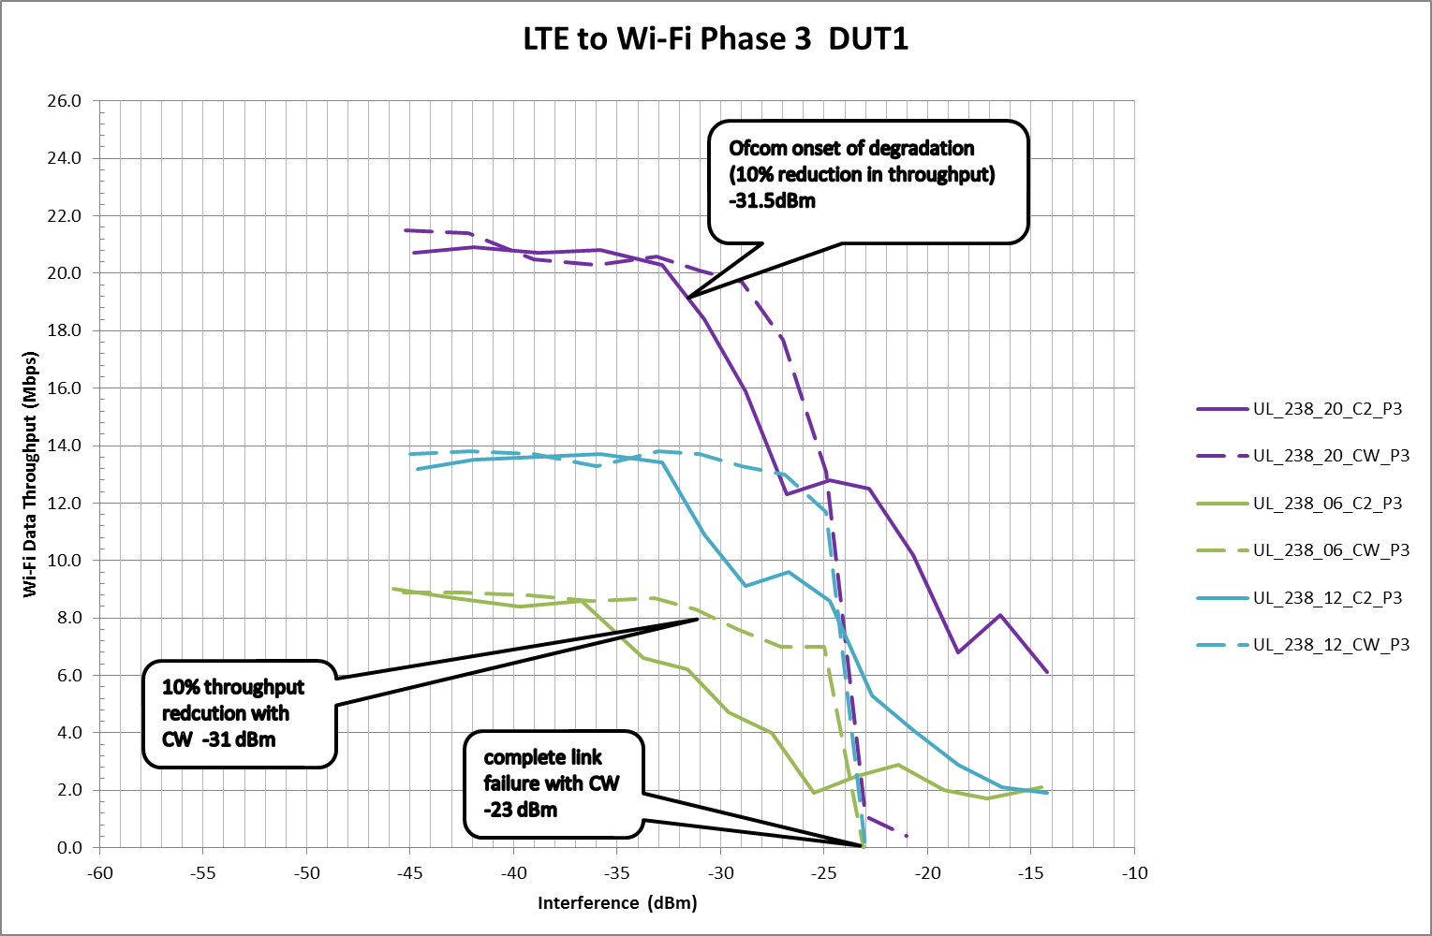

Figure 1 shows the level of blocking signal of LTE uplink using TD-LTE frame configuration 2 (solid lines) and carrier wave (CW) (dashed lines) signals for three different wanted signals (6, 12 and 20 dB above minimum sensitivity (MUS)). Results for three tested devices are shown below.

The analysis above was based on the onset of degradation (10% reduction in throughput) for a signal that was 20dB above MUS (solid purple line). However, testing with the proposed CW signal at 6dB above MUS (green dashed line) in this example shows that the two test points are equivalent. This is not the case for the other devices presented as shown in Annex 1 and summarised in Figure 2.

Figure 20: minimum performance criteria variations

|  |  |  |  |
| --- | --- | --- | --- |
| Device | Ofcom onset of degradation - as measured (dBm) | CW @ MUS + 6dB with 10% reduction criteria (dBm) | CW @ MUS + 6dB with link failure criteria (dBm) |
| DUT1 | -31.5 | -31 | -23 |
| DUT 3 | -29 | -38 | -24 |
| DUT 5 | -32 | -42 | -33 |
| DUT 5 – 802.11b | N/A | -42 | -33 |

From such a small sample it is not possible to draw a firm conclusion but it is clear that the relationship between measured levels based on wideband blocking signals and CW signals at only 6dB above MUS as proposed in the standard is variable (0dB ,9dB and 10dB delta in Figure 2).

It is also clear that the minimum performance level defined by a manufacturer can have a significant effect on the ability of a device to comply with the standard.

### Results for three tested devices

The legend describes the following information for the blocking signal

LTE direction – Uplink (UL) signal in all cases

Frequency – 238 = 2380 MHz

Offset – from minimum sensitivity 6, 12 or 20 dB

Blocking signal type – carrier wave (CW) or LTE Frame configuration 2 (C2)

Group of measurements – all measurements were conducted as part of group “P3”

Results follow for:

DUT 1 – WiFi 802.11g

DUT 3 – WiFi 802.11g

DUT 5 – WiFi 802.11g

DUT 5 – set to operate in 802.11b mode only

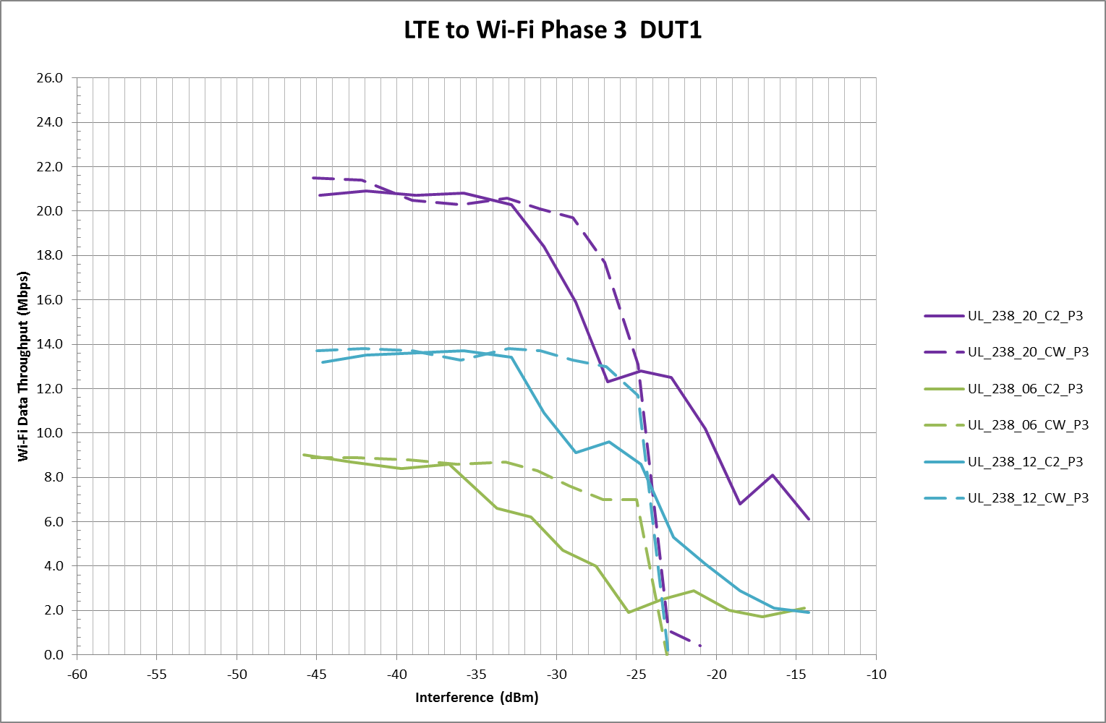

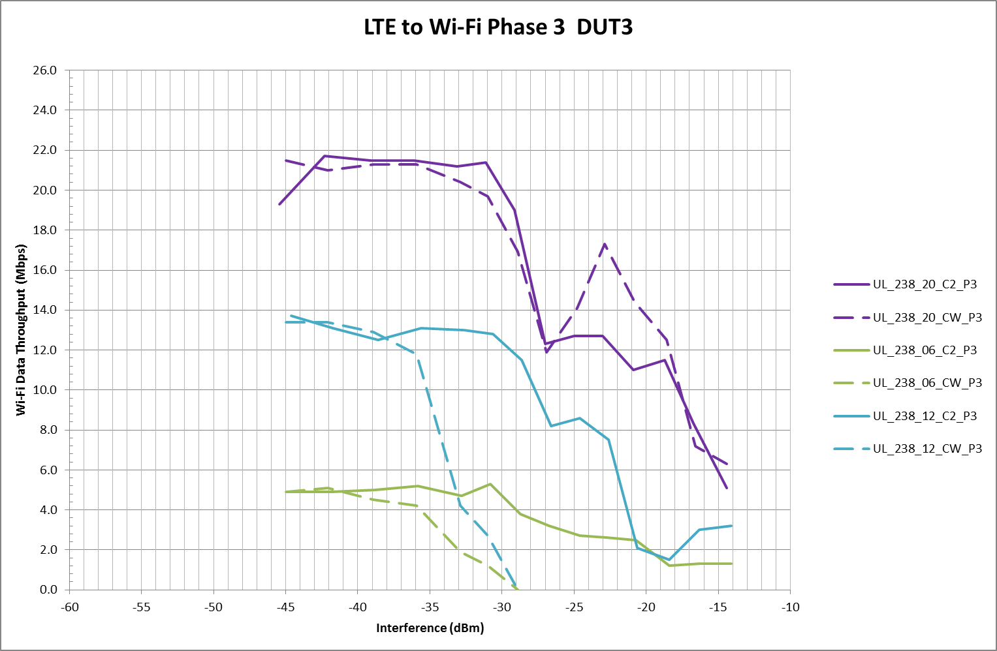

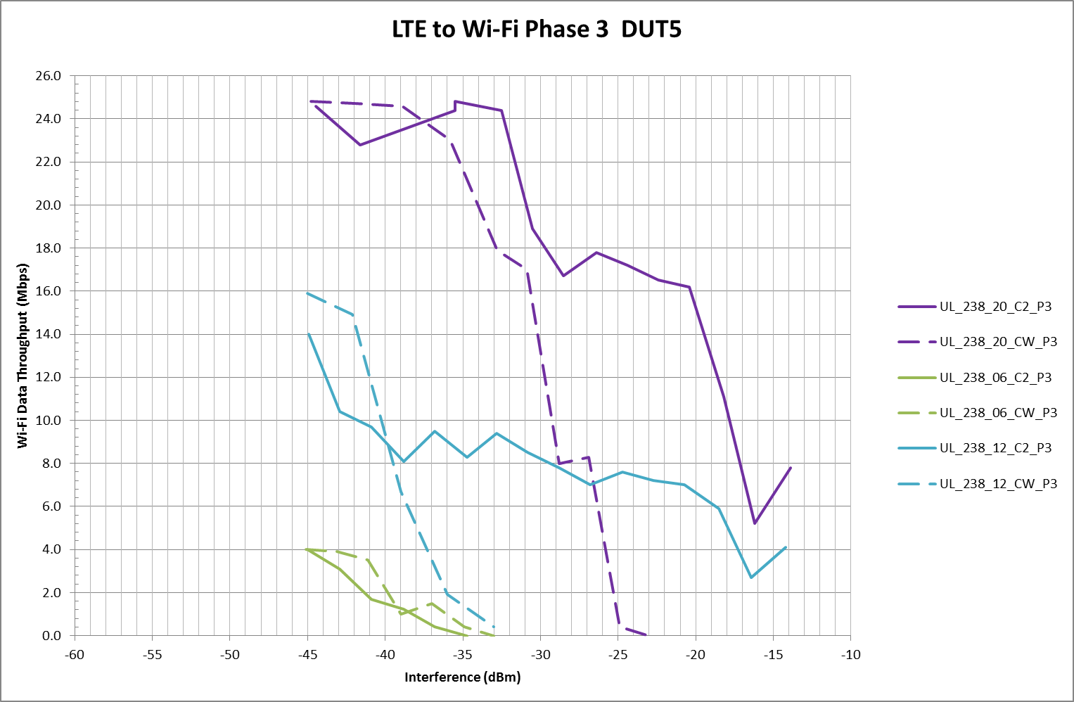

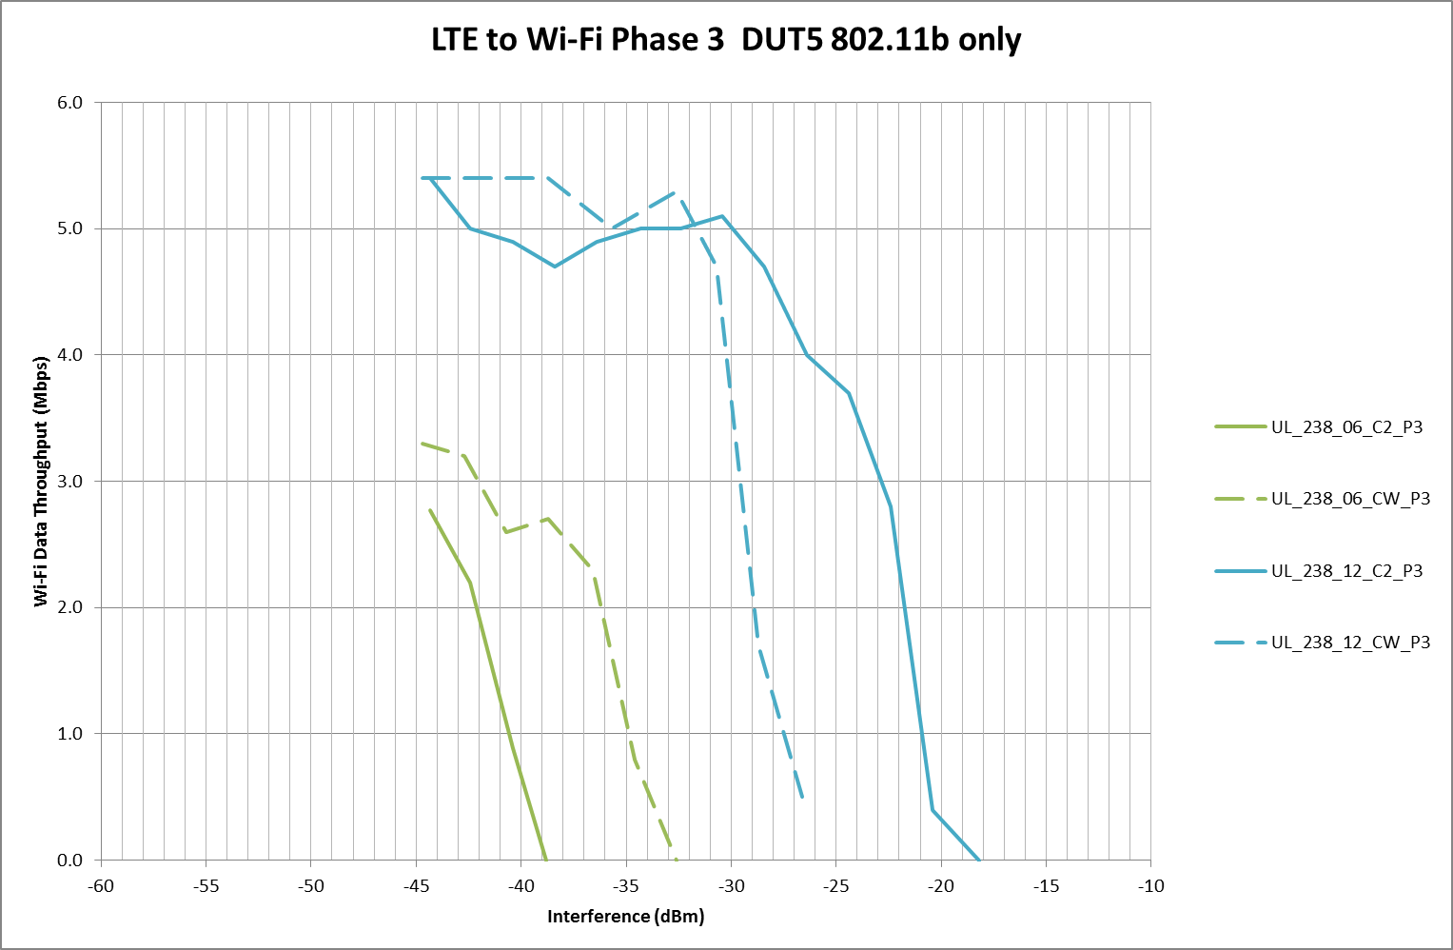

# on results

## MODELLING OF INTERFERENCE SCENARIOUS

## improved compatibility results

1. To evaluate their impact on study results by e.g. providing mathematical description (formulas)
2. To ensure their usability in inter system studies, especially with respect to adjacent channels operation

# Conclusions

Body text (style: ECC Paragraph)

(advice: a conclusion may review the main points of the ECC Report. A conclusion might elaborate on the results of the ECC Report and suggest extensions.)

1. Receiver architectures

This chapter looks at typical receiver architectures currently used, beginning with super heterodyne receivers, capable of very good performance but needing a large number of discrete elements such as filters, before moving to architectures which lend themselves to more integrated approaches with fewer external components. These more integrated approaches allow almost the entire receiver to be fabricated in silicon, so that when manufactured in large volumes the unit cost is very low, and performance, after calibration, between one receiver and another is very consistent. The low cost is due to very low material costs, and rapid, highly automated, assembly and test.

This highly integrated approach lends itself very well to high volume applications such as cellular or broadcast where total world, per annum, volumes are greater than one billion[5]. However the very high development costs; especially when using the smallest feature size, where the IC mask cost alone can be a few million dollars[6], prohibit this approach for smaller volume applications, such as PMSE.

## Super heterodyne

Superhet receivers were used in the majority of receivers from when Armstrong first popularised the approach in 1917 up until around the year 2000. At this point alternative receiver architectures more suitable for complete integration into an IC, such as direct conversion, became increasingly popular.

A single stage superhet is shown in Figure 8.. The mixer mixes the received RF signal with a local oscillator (LO) signal converting the received RF signal to an intermediate or “IF” frequency. The LO signal can be higher than the RF signal (high side LO) or alternatively lower than the RF signal (low side LO).

-RF + LO = IF high side LO

RF - LO = IF low side LO

The image filter is required to stop the receiver from responding to the signals at the image frequency. Receiver selectivity is gained by the IF filter bandpass filtering the wanted signal suppressing power in the channels adjacent to the wanted signal. Following the IF filter the signal can then be sampled using a sub-sampling approach as discussed in section 2.2.1.i. With this approach the IF filter acts as the ADC’s anti alias filter. Alternatively it can be converted by a second mixer to baseband for digital sampling or analogue signal detection.

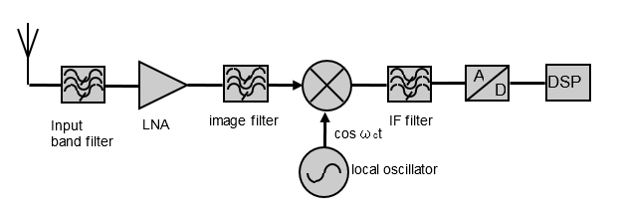

Figure 8: Superhet architecture

In most receivers the IF is at a fixed frequency. To allow the receiver to be tuned to a range of receive frequencies the local oscillator is varied.

### IF filter

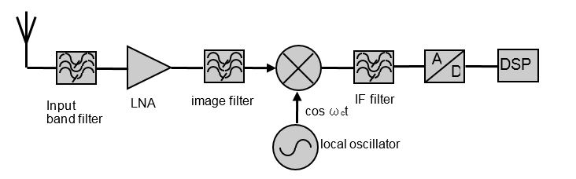

Figure 9: IF filter

The IF filter is generally at a lower fixed frequency than the received RF signal allowing a high Q filter to be implemented to provide the required selectivity. The ideal IF filter, shown in Figure 10, should have a flat pass band and good group delay to pass the wanted frequency channel without distortion; with very steep skirts on both sides of the pass band in order to be able to reject the adjacent channels well.

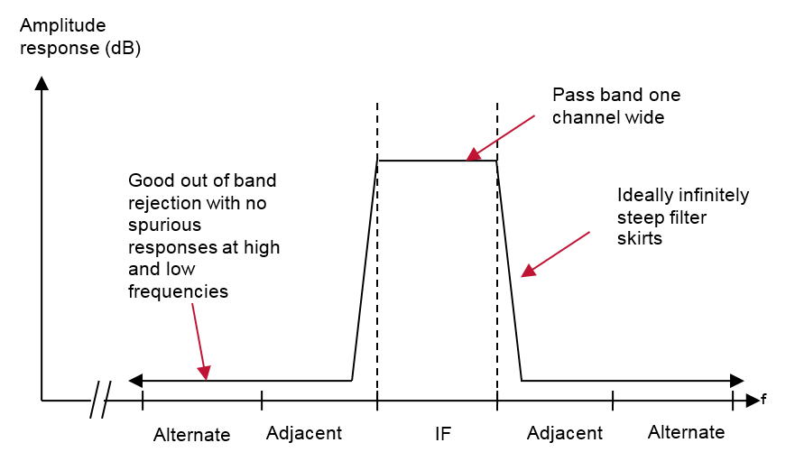

Figure 10: Ideal filter response

A number of typically passive technologies are used to realise IF filters including crystals, ceramic, and SAW filters. These filters tend to be available for a range of system standard IF frequencies including 455KHz - AM, 10.7MHz – FM broadcast and 36MHz – TV. Due to the high Q and stability at high frequencies required, the IF filter is rarely integrated into an IC.

### Image filter

Assuming a low side local oscillator is used, where the local oscillator is at a lower frequency than the wanted receive frequency, i.e. the wanted frequency is at ωc+ωif; then the input band filter and image filter together must reject the receiver’s image response at ωc-ωif. For a high side local oscillator the opposite is true, the wanted frequency is at ωc-ωif and the receiver’s image response is at ωc+ωif.

These filters need to operate directly at the RF frequency and as they have limited Q don’t provide any real channel filtering. Any filter placed directly at the input of receiver will directly affect, and may dominate, the receiver’s noise figure and therefore the receiver’s sensitivity to receive weak signals; therefore it must have low insertion loss. The insertion loss of the filter following the LNA (low noise amplifier) is less critical. However, in this case, the LNA must have adequate linearity to not distort any signals passed by the input band filter. A significant positive side effect of an image filter is that it does attenuate other potential ‘far-off’ interferers apart from the image frequency before the signals reach the mixer. This reduces the effects of reciprocal mixing and limited channel filtering dynamic range on the receiver’s far selectivity.

The image filter may have a fixed pass band, wide enough to pass all the channels within the tuning range of the receiver. These types of filters, depending on the frequency of operation and the pass bandwidth required, can be made from various different materials. At lower frequencies wire wound inductors and ceramic capacitors are often used whilst for cellular physically small SAW filters etched on a variety of substrates are commonly used.

As the tuning range of the receiver increases, the lowest received frequency and the highest image frequency get closer together making it more difficult to get adequate rejection until eventually the lowest wanted frequency and highest image overlap. At this point it becomes impossible to realise the image filter using this approach.

Another approach is to use a much narrower filter which has a tuneable pass-band. It is generally more complicated to build a tuneable filter. However assuming the filter can “track” the receive frequency it does allow a receiver with a wide tuning range to be developed. Tracking filters are often realised by using varactor tuned diodes to act as variable capacitors in an inductor capacitor tuned circuit. These allow the filter’s pass band frequency to be adjusted with a DC voltage.

### Image reject mixers

The superhet receiver discussed so far uses the amplitude response of filters to reject the image frequency. Another approach is to use mixers operating in quadrature to cancel out the image signal. Two architectures are often used to realise this approach, Hartley and Weaver. For both the Weaver and Hartley image reject mixers, it is necessary to generate signals in quadrature to each other. For perfect image rejection these quadrature signals need to be phase and gain matched across the frequency band of interest.

#### Hartley

The Hartley image rejection architecture is shown in Figure 11. The RF signal is down converted by quadrature LO signals. The resulting IF signals are then low pass filtered and after one is phase shifted by 90° the IF signals are combined. This result is that, depending on which channel is subjected to the 90° phase shift, either the image or wanted channel being rejected.

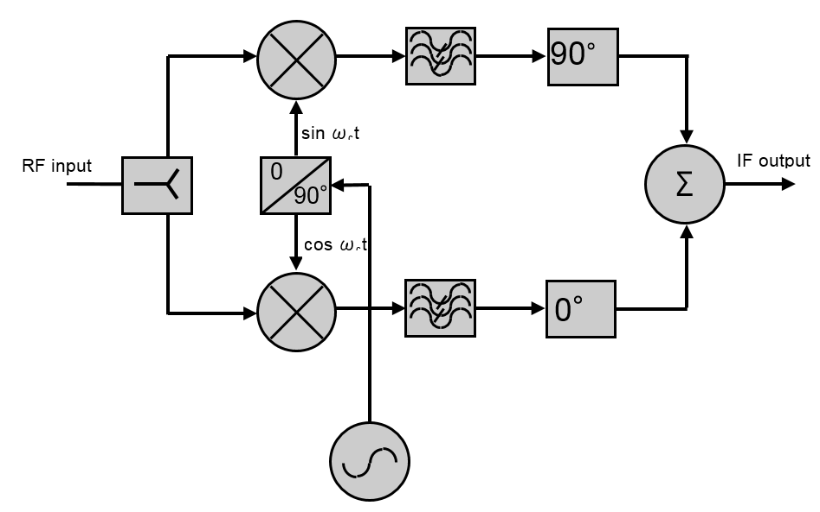

Figure 11: Hartley image reject architecture

The image rejection obtainable is dependent on how close to 90°the phase shift of the local oscillator is, how similar are the amplitude responses of the two arms of the mixer and how close to 90° is the final phase shift. It can be shown that an amplitude mismatch of 0.1dB and a phase mismatch of 1° yields around 41dB of IRR. To realise this degree of IRR requires careful design and possibly some form of calibration to minimise any imbalances.

#### Weaver

The Weaver approach overcomes the amplitude mismatch issues caused by needing to add a 90°phase shift to one arm of the quadrature mixer by adding a second pair of mixers to realise the phase shift. This second mix does create another set of image frequencies which need to be addressed. One approach is to use a second IF centred on DC (0Hz) with the sampling of the signal being done in quadrature as shown in Figure 12.

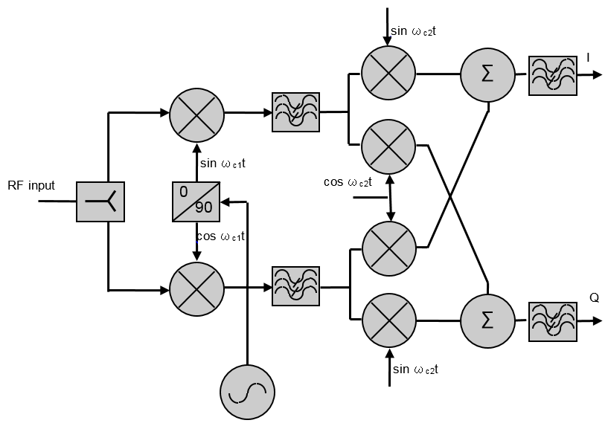

Figure 12: Quadrature Weaver architecture

## Zero IF Receiver

The zero IF receiver overcomes the superhet IF image response issue by directly converting the signal to baseband centred on 0Hz using two mixers operating in quadrature. Its architecture is shown in Figure 13.

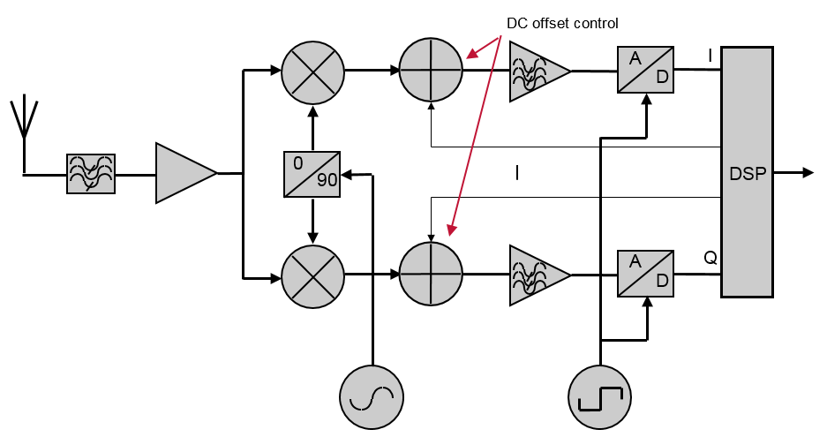

Figure 13: Zero IF receiver

In the zero IF receiver the LO is at the same frequency as the received RF frequency. This causes the down converted image signal to fall directly on the wanted signal so that both the wanted and image signals are mirror images of each other, with each reflected around the frequency axis.

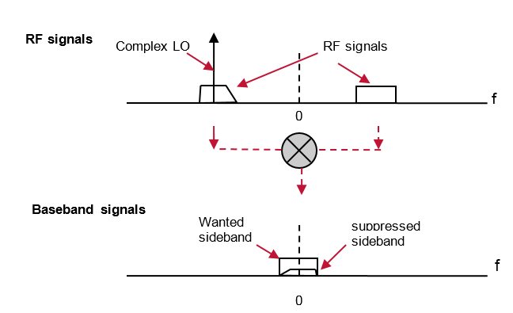

Figure 14: Zero IF image down conversion with image suppression

Whilst the zero IF approach deals with the image response, the receiver still has significant spurious responses at odd LO harmonics, i.e. 3fLO, 5fLO, 7fLO…. This is commonly due to the use of a square wave LO signal. In a zero IF receiver, as the local oscillator is at the RF frequency, any received signals at these frequencies will cause interference. In narrow band receivers, where frequencies at 3fRF etc do not need to be received, fixed frequency input filters can be used. In very wide band receivers, such as cable TV receivers needing to cover 48 to 860MHz, this can be a significant problem.

The analogue low pass filters following the mixer help provide the receiver’s selectivity and act as anti-alias filters to the ADC. If all the selectivity is provided by these filters, they must have a cut off frequency at half the channel bandwidth and must reject the adjacent channel and other channels further from the wanted frequency by the selectivity required.

Usually some of the receiver’s selectivity requirement is realised with digital filters following the ADC. Digital filters don’t suffer from many of the limitations of analogue filters such as their performance being affected by component and silicon process tolerances, cross talk and noise. This allows their performance to be closely defined and very repeatable. In addition they can be implemented in low cost digital CMOS making use of either DSP processors or custom digital circuitry. With this approach the ADC must have enough bits of resolution to sample any high level adjacent and other channels without clipping, whilst not degrading the low level wanted signal with quantisation noise.

Whilst the zero IF approach minimises the image issue, the architecture does introduce other issues. These issues are mainly centred on needing a lot of amplifier gain to amplify signals near or at DC. These include:

Second order receiver nonlinearity causing spurious products at DC

Local oscillator leakage causing varying levels of DC offsets

Amplifier DC offsets

Flicker noise reducing sensitivity

These limitations detract from the simplicity of the zero-IF approach requiring a receiver with good IP2 performance and extensive calibration to overcome the DC offset issues.

## Low IF receiver

A low IF receiver attempts to overcome the DC offset and 1/f noise issues associated with zero IF receivers whilst still using an approach that lends itself to a high degree of integration. Many radio standards require less selectivity for interfering signals occurring in adjacent channels than they do for interfering signals in other channels. Low IF receivers often make use of this by choosing an IF frequency which causes the image frequency to fall into an adjacent channel.

Using a low IF frequency allows the IF channel filter to be integrated into silicon or implemented digitally Figure 15shows where the adjacent, alternate channels and image response are down converted to when a low side local oscillator is used positioned on the edge of the wanted frequency channel. After down conversion, signals in one of the channels adjacent to the wanted receive channel fall into the wanted channel and signals in one of the alternate channels fall into the receiver’s adjacent channel. As the wanted signal is just above DC, DC offset and 1/f noise issues are not such a concern as they are in zero IF receivers.

It can be seen that the receiver must achieve sufficient image rejection to meet the required adjacent channel specification. In addition, it can be seen that the lower alternate channel, after down conversion, lies next to the wanted frequency. Any adjacent channel leakage power (ACPL) from the lower alternate channel originally transmitted on the high side of the transmission, after down-conversion will fall into the wanted channel. This energy cannot be suppressed by filtering after down conversion and therefore the receiver must have sufficient image rejection to adequately suppress the signal. It is found in systems such as GSM with poor ACPL performance, that ACPL sets the image rejection requirements in a low IF receiver.

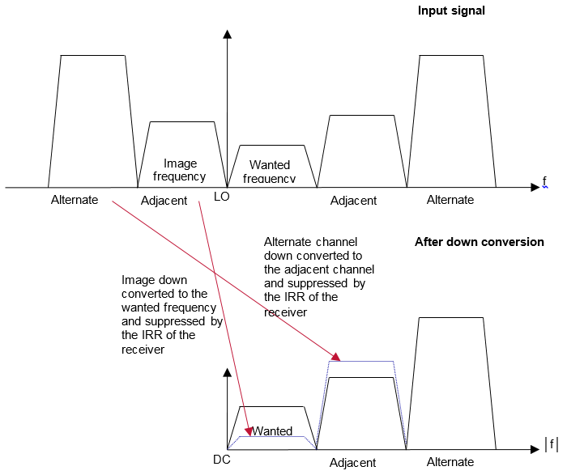

Figure 15: Low IF down-conversion

As the image is so close to the wanted frequency, an image filter at the receiver input can’t be used, however image reject techniques can be used. One approach is by using the dual quadrature mixer Weaver architecture as shown in Figure 16. The second set of mixers is implemented digitally, and the second digital LO is set so that the output is centred around DC.

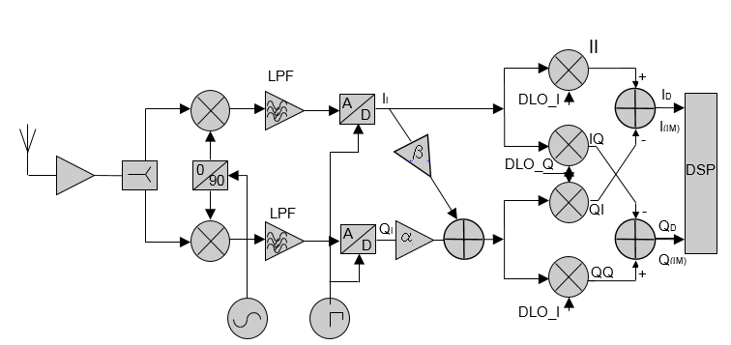

Figure 16: Digital low IF Weaver architecture

The signals are down converted to a low IF frequency by the first set of mixers. The I and Q signals are low pass (anti alias) filtered and sampled. As discussed in section 3.1.3, due to phase and gain errors between each arm of an analogue image reject mixer, it is very difficult to achieve greater than 25 to 35dB of image rejection without calibration. Overcoming the imbalances of the first analogue mixer can be achieved using the amplifiers just after the ADCs with gains α and β to modify the I and Q signals slightly allowing image rejection figures of typically up to 40dB. The values of α and β needs to be determined by a calibration process. The accuracy of the calibration process and final image rejection obtainable is at least in part due to the resolution of the ADCs used.

A polyphase band pass filter can be used instead of digital down conversion to obtain reasonable image rejection. The key attribute of a polyphase filter is that it provides a different filter response for positive and negative frequencies unlike most filters which just respond to the absolute frequency of the signal and not the sign of the signal. Using this approach an ‘image reject’ filter can be built.

1/RC



response to positive frequency

response to negative frequency

Figure 17: Ideal response of a single stage polyphase image reject filter

Figure 17 shows an image reject polyphase filter integrated with a quadrature mixer to implement a low IF receiver. Whilst this approach shows the polyphase filter which rejects the image frequency it does not show the channel filter. The channel filter may be implemented in the analogue domain prior to the ADC. Alternatively it may be implemented digitally. In either case there needs to be sufficient filtering prior to the ADC to avoid aliasing issues.

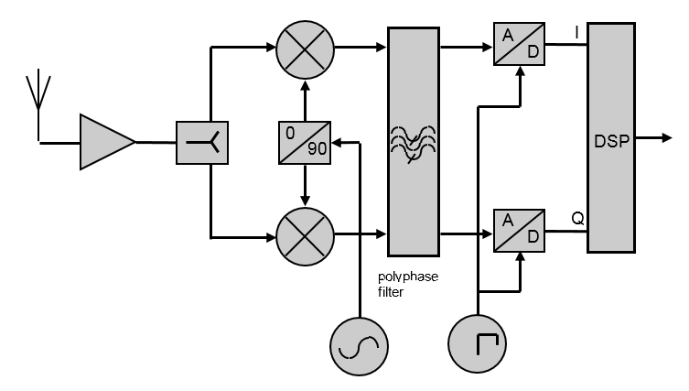

Figure 18: Low IF receiver with polyphase filter

Phase and amplitude variations in the quadrature mixer and imbalances in the polyphase filter all contribute to limiting the receiver’s image rejection.

## Architecture comparison

Table 3 summarises the selectivity limitations of the various receiver architectures discussed.

|  |  |  |  |
| --- | --- | --- | --- |
|  | Superhet | Low IF | Zero IF |
| Sensitivity | LNA, flicker noise not important | LNA, flicker noise may be important | LNA, flicker noise more important |
| Image rejection | Image filter and image reject mixer rejection.    Enough image rejection needed for adequate selectivity at the image frequency, typical tens of MHz away from the wanted | Phase and amplitude matching of mixers plus:  Digital approach -enough ADC dynamic range and bandwidth for digital dual down convertor  Analogue approach - polyphase filter rejection  Enough image rejection needed for adequate C/N and selectivity at frequencies close to the wanted  ACPL from the alternate channel mixes into the wanted signal and may dictate the image rejection required | Not a selectivity issue  Enough image rejection needed for adequate C/N for signal decoding |
| Spurious response rejection | Limited by:  Input filter rejection  Mixer mFRF±nFLO response  Mixer RF to IF and LO to IF isolation  It is likely that all the spurious frequencies will be in frequency channels well away from the wanted channel and therefore may be subject to interfering signals at frequencies much higher than the wanted signal | Limited by:  Input filter rejection  Mixer mFRF±nFLO response  Mixer RF to IF and LO to IF isolation  A number of the most significant spurious frequencies due to factors such as the mixers ½ IF response will be in the wanted or adjacent frequency channels and therefore not subject to interfering signals higher than the adjacent channel signal | Limited by:  Input filter rejection  Mixer mFRF±nFLO response  Mixer RF to IF and LO to IF isolation  A number of the most significant spurious frequencies due to factors such as the mixers ½ IF response will be in the wanted frequency channel and therefore not subject to interfering signals at frequencies higher than the wanted signal |
| Channel filtering | Limited by:  Discrete filter + ADC dynamic range  LO phase noise  External high Q filters needed | Digital approach limited by:  ADC dynamic range  mixer image rejection  LO phase noise  Analogue approach limited by:  Integrated analogue filter  mixer image rejection  polyphase filter rejection  LO phase noise  Medium Q filters needed, either integrated analogue filters or digital | Limited by:  integrated analogue filter  ADC dynamic range  LO phase noise  Lowest Q filters needed, either integrated analogue filters or digital |
| Linearity | IP3 important, IP2 not so important | IP3 and IP2 important | IP2 critical |

Table 3: Receiver architecture selectivity limitations

Key points from this table are:

The superhet’s image filter can be eliminated in the zero IF and low IF architectures. However in a superhet, an image filter, whilst also acting as an input RF filter, can provide very significant spurious response rejection, channel filtering and enhanced linearity for interfering signals several channels away from the wanted frequency.

A superhet’s adjacent channel filtering is provided by a discrete fixed frequency IF filter with potentially very high Q, and post ADC digital filtering. The IF filter’s high Q can relax the receiver’s ADC dynamic range requirement compared to a zero or low IF receiver.

A Low IF receiver’s adjacent and alternate channel selectivity is provided by a combination of the receiver’s image rejection and channel filtering. Selectivity of one of the adjacent channels is provided solely by the receiver’s image rejection. For interfering signals several channels away from the wanted, minimal input filtering will limit receiver selectivity and linearity.

In zero IF receivers, adjacent channel selectivity is provided by the receiver’s integrated analogue and digital filtering. Zero IF receiver’s performance can be limited by even order nonlinearity. Minimal input filtering will limit receiver selectivity and linearity for interfering signals several channels away from the wanted.

1. Heading (style: ECC Annex - Heading1)

Body text (style: ECC Paragraph)

* 1. heading 2 (style: ECC annex heading2)

1. Heading (style: ECC Annex - Heading1)
   * 1. Heading 3 (style: ECC Annex heading3)
        1. Heading 4 (style: ECC Annex heading4)
2. List of Reference
3. Directive 2014/53/EU of the European Parliament and of the Council of 16 April 2014 on the harmonisation of the laws of the Member States relating to the making available on the market of radio equipment and repealing Directive 1999/5/EC]
4. Directive 1999/5/EC of the European Parliament and of the Council of 9 March 1999 on radio equipment and telecommunications terminal equipment and the mutual recognition of their conformity
5. ETSI EG 201 399 v3.1.1: A guide to the production of Harmonized Standards for application under the Radio & Telecommunication Terminal Equipment Directive 1999/5/EC (R&TTE) and a first guide on the impact of the Radio Equipment Directive 2014/53/EU (RED) on Harmonized Standards.
6. ETSI EG 203 336 V1.1.1: Guide for the selection of technical parameters for the production of Harmonised Standards covering article 3.1(b) and article 3.2 of Directive 2014/53/EU
7. ECC Recommendation (02)01: Specification Of Reference Receiver Performance Parameters
8. ETSI TR 103 265 V1.1.1: Definition of radio parameters
9. [Draft] ECC Report 252: SEAMCAT User Manual
10. ECC Report 127: The impact of receiver standards on spectrum management
11. ECC Report 191: Adjacent band compatibility between MFCN and PMSE audio applications in the 1785-1805 MHz frequency range.
12. ITU Radio Regulations Edition of 2012
13. ERC Recommendation 74-01: Unwanted emissions in the spurious domain
14. ETSI TR 102 914 V1.1.1 (2009-01) – Technical report on aspects and implications of the inclusion of receiver parameters within ETSI standards
15. ETSI TR 102 137 V1.2.1 (2008-10) Use of radio frequency spectrum by equipment meeting ETSI standards
16. ETSI EG 202 150 V1.1.1 (2003-02) - ETSI Guide on "Common Text" for Application Forms/Short Equipment Description Forms
17. Recommendation ITU-R SM.329-12: Unwanted emissions in the spurious domain
18. Radio Spectrum Policy Group Report on Furthering Interference Management through exchange of regulatory best practices concerning regulation and/or standardisation (https://www.google.co.uk/url?url=https://circabc.europa.eu/d/a/workspace/SpacesStore/247df229-c887-4064-83f6-7d013df00d52/RSPG13-527rev1%2520final-Report_Interference_Management.pdf&rct=j&frm=1&q=&esrc=s&sa=U&ved=0ahUKEwiN47v8z8jNAhXDrxoKHcXWA88QFggZMAA&sig2=Wn6IbNA7z6Lyltw5ELY82w&usg=AFQjCNGBRDaVNtCxCmQIx0P4nb8E6QDoig )

1. RR 3.9: The bandwidths of emissions also shall be such as to ensure the most efficient utilization of the spectrum; in general this requires that bandwidths be kept at the lowest values which the state of the technique and the nature of the service permit. Appendix 1 is provided as a guide for the determination of the necessary bandwidth.
2. The wording „operational bandwidth“ shall avoid the misleading use of either „occupied“ or „necessary“ bandwidth, due to these terms are explicitly defined by the Radio Regulations and the ECC REC (02)05, respectively. In the context of this report, it means basically the system bandwidth of the ILT.
3. For several measurement procedures a single resource block is defined as modulation of the interfering signal.
4. Derived from nonadjacent channel rejection specification in IEEE Std 802.11-2012, Table 18-15: <http://standards.ieee.org/getieee802/download/802.11-2012.pdf>
5. [IDC Worldwide Quarterly Mobile Phone Tracker,](http://www.idc.com/getdoc.jsp?containerId=IDC_P8397) February 4, 2009
6. 20th July 2009. “Cheaper options for chip designs” IET, <http://kn.theiet.org/magazine/issues/0913/cheaper-chip-designs-0913.cfm> [accessed 24th July 2009]