|  |  |  |
| --- | --- | --- |
|  | | **SE43(12)15** |
| 13th meeting of SE43  **Paris, 20 – 22 March 2012** | |  |
| Date issued: | 14 of March 2012 | |
| Source: | Nokia, Tekes Wise-project | |
| Subject: | **PMSE sensitivity degradation measurements** | |

|  |  |
| --- | --- |
| Summary: | Several analogue PMSE-receivers were tested. Using 1% THD at the audio output as impairment criterion, the sensitivities were found to be typically between -90 and -95 dBm (200 kHz). Two of the PMSE-receivers were tested more thoroughly with co-channel interference. It was found out that co-channel interference at levels of -113 dBm (200kHz) and -116 dBm (200 kHz) were not causing any degradation of sensitivity when measured using the impairment criterion of 1% THD at audio output. |
| Proposal: | See section **.** |
| Background: | Draft complementary report A1 “Further definition of technical and operational requirements for the operation of white space devices in the band 470-790 MHz**”** and ECC Report 159. |

|  |  |
| --- | --- |
| Password protection required? (Y/N) | **N** |

# Introduction

The draft complementary report A2 section 5.2.1 is discussing the methodology to protect the PMSE. The suggested approach is limiting the interference so that the sensitivity of the PMSE receiver is not degraded more than an acceptable amount. To achieve this, the interference form the WSD weighted by the receiver ACS is suggested to be set below the noise floor (including noise figure). The loss of sensitivity is illustrated in figure 5 of section 5.2.1 in A2 and is reproduced here as .



Figure 1 Degradation of the receiver sensitivity as a function of I/N

As can be seen a 0 dB I/N would lead to a 3 dB degradation, 1 dB degradation is achieved with -6 dB I/N and 0.5 dB degradation roughly at -10 dB I/N.

If we assume that the PMSE receiver noise figure is for example 8 dB, the resulting noise floor is at -113 dBm (200 kHz) and correspondingly the 3 dB, 1 dB and 0. 5 dB degradation interference levels would be -113 dBm, -119 dBm and -123 dBm (200 kHz) or -97 dBm, -103 dBm and -107 dBm (8MHz).

In Report 159, section 5.13,the PMSE receiver protection requirement is set to -115dB (200 kHz).

The purpose of this contribution is to study the sensitivity of some analogue PMSE-devices and measure what WSD-interference levels are causing different sensitivity degradations in the practical PMSE-receiver. Different criteria and measurement methods for sensitivity are briefly studied as well as the effect of a time variant multipath channel produced by a channel simulator.

# Measurements

## PMSE-devices

Altogether 6 different PMSE-devices were available for testing and they were labelled from A to F. One of the receivers (device D) did not have an antenna connector and with this device it was impossible to get a reliable connection even in a TEM-cell. Therefore this device was not tested. There characteristics of different devices are described in sections where the basic sensitivity measurement of each device is explained.

## Basic Set-up

The measurement set-up is shown in .

The PMSE-receivers were tested using either their own transmitters (microphones) or FM-signal generator as signal source. The microphones were placed inside a TEM-cell (see ) together with a small MP-3 player which was feeding the microphone audio input. In some cases Body Worn (BW) microphones had antenna connectors which were used to connect the devices directly with the test system. The output of the TEM-cell was connected via a step attenuator to one input of the PMSE-receiver. The other input of the PMSE-receiver was terminated with 50 Ω load. All power level measurements for the microphone signals were done with R&S FSP spectrum analyser by moving the cable from the PMSE-receiver antenna input to the spectrum analyser.

Interference simulating the WSD-signal was generated by R&S SFU and the used signal was a continuous 8k DVB-T OFDM-signal with 7.6 MHz bandwidth. The microphone signal and the interference were combined with a 3 dB power splitter. The level of the WSD-signal was checked with R&S ETL from the PMSE antenna input. Continuous OFDM-signal was used as it has been seen in various measurements that with PMSE-receivers the effect of the TDM-parameters of the WSD-signal is not as obvious as with DVB-receivers. With continuous signal the measurement of the total harmonic distortion (THD) is much more reliable and easier.

The audio quality assessment was based on measuring the total harmonic distortion (THD) from the PMSE-receiver output with a Neutrik audio analyser A2. In some cases audio was also monitored with a speaker.



Figure 2 Measurement set-up

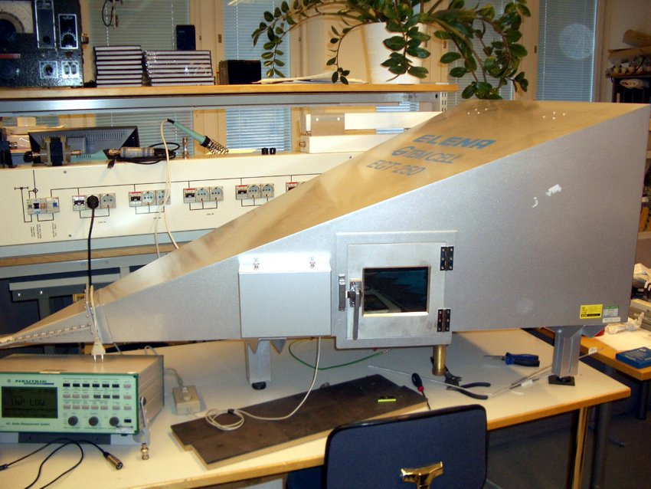

Figure 3 TEM-cell and the audio analyser

## Basic sensitivity measurements

### PMSE A

PMSE A was a midrange device used typically in auditoriums or schools. The body worn transmitter was connected to a small MP3-player containing 1 kHz sound loop. The level of the audio signal was adjusted so that a low THD was obtained with a good signal level to the receiver. With no extra attenuation the signal level from the TEM-cell was -49.5 dBm and resulting THD 0.21%. Next the attenuation was increased so that THD 1% was reached. The signal level for this was -89.5 dBm. Next the attenuation was increased until the receiver went to mute at -96.5 dBm and with 2.2% THD.

Next the microphone transmitter was replaced by a signal generator. FM-signal with 1 kHz audio at 15 kHz deviation was fed to the receiver. The receiver muted at -96 dBm and at -95 dBm the THD was 0.76%. Finally it was tested briefly that at -50 dBm level the maximum deviation for 1% THD was 30 kHz.

### PMSE B

PMSE B was rather similar midrange device as A but from a different manufacturer. The measurement procedure was similar to PMSE A. The receiver muted at -91.4 dBm with 0.6 % THD. Next the receiver output was monitored with headphones with and without the 1kHz audio. It was found out that acceptable quality was reached 2 dB before the muting at -89.4 dBm.

It was not possible to test PMSE B with FM-signal generator as additional pilot signals would have been needed to unmute the receiver. It was not possible to turn of this feature in the receiver.

### PMSE C

PMSE C was a low end microphone intended to be used with a video camera. A problem with this device was that the receiver was not equipped with an antenna connector and it was impossible to feed the signal directly to the receiver. Instead the receiver was placed inside another small TEM-cell. First the connection from the cell to the receiver was calibrated using similar antenna as the receiver had. It was found to be about -40 dB. It should be understood that the accuracy of this kind of method is not very good. The sensitivity corresponding 1% THD was found to be -91 dBm. When the receiver was connected to the FM-signal generator it was found that this method gave the same -91 dBm sensitivity.

### PMSE D

PMSE D was similar low end microphone as PMSE C, but it was not possible to establish a repeatable and reliable connection between transmitter and the test system. Therefore the PMSE D was not measured.

### PMSE E

The PMSE E was a high quality studio level analogue device from a rather recent model series. With this device a more comprehensive set of tests were performed.

The body worn microphone was again connected to the MP3-player and placed in the TEM-cell. Next the THD from the receiver audio was measured as a function of the receiver input level. 1% THD was reached at -91.9 dBm and the receiver muted at -94.9 dBm with 1.3% THD. In addition to these more points were measured and the result is show in .



Figure 4 THD vs level in device E

Next the receiver was connected to the FM-signal generator with 15 kHz deviation and the levels for 1% THD and mute were searched. It was found that the 1% THD criterion was reached at -83 dBm and mute happened at -92 dBm with 2.7% THD. It seems that with device E the 15 kHz deviation is clearly too low and interestingly it is leading to worse THD and sensitivity figures. Therefore the effect of the deviation was studied more in detail using the -83 dBm signal level, which was producing 1% THD with 15 kHz deviation. The results are shown in .



Figure 5 Device E THD with different deviations and signal levels

As can be seen a similar sensitivity of -92 dBm as with the own transmitter (microphone) is achieved with 40 kHz deviation. At least with device E the use of fixed 15 kHz deviation would not be suitable for sensitivity measurement. It is also interesting to note that lower deviation is increasing the THD, not lowering as one would expect.



Figure 6 Device E THD vs C/N

The next measurement was testing the C/N-performance of the device. This was done at rather high signal level of -50 dBm and by using the body worn transmitter. Gaussian noise was added using an Elektrobit PromSim channel simulator. First 30 dB C/N was applied and the THD was measured. Then the C/N was reduced in 1 dB steps and THD was recorded in every step. 1% THD was reached at 13 dB C/N and mute at 11 dB C/N. The result is shown in .

Finally the microphone and the receiver were briefly tested with a time variant multipath channel using the Elektrobit PropSim channel simulator (see ). As there was not too much experience or information of the channel models associated with PMSE-equipment this measurement should be considered as experimental. A modified Portable Indoor (PI) channel model was selected. The basic PI-model has originally been developed for DVB indoor reception and it has 12 taps in two groups. One group has short delays up to 1.6 µs and the other group has delays between 8 and 9 µs. The model has 1.5 Hz Doppler applied to all taps, the first dominant tap having a direct shift and the others Gaussian Doppler spectrum. When tested with full PI channel it was found that the PMSE-system did not work too well at all. Therefore the longer taps (8-9 µs) were dropped. This would be logical as the original model is developed for outdoor to indoor case, where the transmitter is kilometres away and the longer delays are presenting the reflexions happening outside on large scale and the shorter ones are presenting the more close by or indoor reflexions.

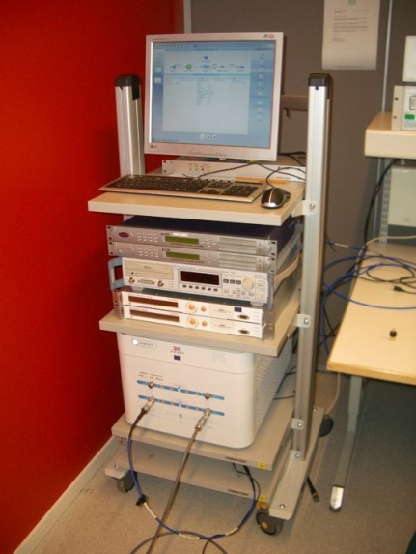

Figure 7 PropSim channel simulator (lowest device) and modified PI-channel envelope.

No noise was applied and the receiver sensitivity was tested with the own body worn transmitter trying to use the 1% THD criteria. This was found to be very difficult as the THD reading is not stable close to the sensitivity level and audio monitoring was used in addition. The sensitivity was now found to be -66 dBm, which is 26 dB less than in Gaussian channel. Although there is no direct evidence that modified PI-channel model would be representative of the PMSE use case, it is interesting to see that using this kind of multipath low Doppler model gives very similar results than field measurements, which were showing 30 dB differences between line of sight static case and microphone attached and moving. When the envelope of the applied signal was measured with spectrum analyser set to zero-span, it was found that the notches in the envelope are about 25 dB down. This is shown in on the left.

### PMSE F

Device F was also a studio quality device, but an older model and from different manufacturer than device E. The used device had also been in hard use for some years, but was still in good working order. The set included only hand microphones so it was not possible to use the same MP3-player to feed the 1 kHz audio. Instead the hand microphone was installed to a microphone calibrator unit, which gives a calibrated audio pressure to the microphone. For this device only simple sensitivity measurements were done and it was found that 1% THD criteria was reached at -92 dBm level in both cases using either the microphone or the FM-signal generator with 15 kHz deviation. The receiver muted just after this at -93 dBm.

### Summary of the sensitivity measurements

summarises the basic sensitivity measurements. As can be seen the best measured sensitivity was -95 dBm and this was reached with the FM generator as source, the same PMSE-receiver giving worse result with the microphone. All other results are very similar around -92 dBm when using the 1% THD limit as a criterion. It should be noted that 1 dB steps were used in the attenuator and the fractions of dBs in the results are coming from method rather than trying to measure with 0.1 dB accuracy. In some later measurements the PMSE-signal level has been adjusted so that results are round dBs

Table 1 Summary of the basic sensitivity measurements



When the PMSE receiver audio was monitored with a loudspeaker or headphones, it was observed that in some cases the audio was still somewhat noisy even if the THD was at 1% and for a better quality audio a higher signal level would have been required.

## Protection ratio with PMSE E

Basic protection ratio measurement was performed to the PMSE E receiver using the body worn transmitter. The interfering signal was DVB-T as explained in section 2.2. For the frequency offsets similar raster was used as in the draft complementary report A1. The PR was measured at 4 different PMSE signal levels at -30 dBm, -50 dBm, -65 dBm and at -80 dBm.



Figure 8 PMSE E protection ratio at various PMSE signal levels

Full measurement with positive and negative offsets was done only at the lowest level. The results are shown in Figure 8. Note that due to the interfering signal power limitations some of the points at the higher levels were not reaching the 1% THD and the true PR is somewhat higher. These points are marked with red circles in Figure 8. Reduction of the protection ration at higher PMSE signal levels is natural as the interfering signal level at the PMSE receiver input starts to overload the receiver. Overall the results are very similar than in the draft complementary report A1 and what other measurements have shown.

## Degradation of sensitivity of PMSE due to WSD-interference

### Measurements

This purpose of this measurement was to study how the practical PMSE-receiver sensitivity is degrading in the presence of co-channel WSD-interference. The theoretical background is discussed in the introduction section. Two devices PMSE E and PMSE A were used one representing a high quality device and the other one a cheaper mid class device. There was also a difference in the sensitivities of the devices. With PMSE E the body worn transmitter was used as signal source and with PMSE A FM-signal generator was used as signal source as this was giving a better sensitivity. The overall set-up was according . PMSE and interfering signals were set to the same frequency and the interfering signal was set to a wanted interference level. Then the PMSE signal level was swept down from -30 dBm until the receiver muted and at each step the THD% -value was recorded and a curve presenting the THD at different signal levels was obtained. Next the interference level was changed to another value and another THD-curve was produced.



Figure 9 PMSE E loss of sensitivity due to the interference

For PMSE E 11 different interference levels were measured from -120 dBm to -85 dBm. The results are shown in and more in detail in . Roughly 0.5 dB loss of sensitivity is reached at -94 dBm interference level, 1 dB loss at -91 dBm and 3 dB loss at -87 dBm.

For PMSE A 7 different interference levels were measured from -120 dBm to -85 dBm. The results are shown in . 0.5 dB loss was now reached at -97 dBm interference level, 1 dB at -96 dBm and 3 dB loss at -94 dBm.

Note that all interference power levels are measured in 8 MHz channel.



Figure 10 PMSE E loss of sensitivity due to the interference (zoomed)



Figure 11 PMSE A loss of sensitivity due to the interference

With PMSE E the measurement was repeated by adding the modified PI-channel to the PMSE-signal path with the channel simulator. With the time variant channel the THD % becomes very unstable close to the sensitivity level. Therefore a slightly lower and stable value for THD % was used as a criterion and the audio quality was also checked. Results are shown in Figure 12. Note that for graphical purposes the limit is still shown here with 1% value. As can be seen degradation starts at -94 dBm interference level. This is similar to the Gaussian channel case where also the first interference level, which caused loss of sensitivity, was -94 dBm. Thus it seems that loss of sensitivity due to extra interference is similar even in a case where severe multipath channel is applied.



Figure 12 PMSE E loss of sensitivity due to the interference with modified PI-channel

### Analysis

For the PMSE E, which had a lower sensitivity of -92 dBm (200 kHz), the first interference level, which caused any degradation of sensitivity was -94 dBm (8MHz).The next measured interference level of -97 dB (8MH) did not cause any degradation of sensitivity.

For the PMSE A, which had a better sensitivity of -95 dBm (200 kHz), the first interference level, which caused any degradation of sensitivity was -97 dBm (8MHz), the loss in this case still being rather low 0.5 dB. The next measured interference level of -100 dB (8MHz) did not cause any degradation of sensitivity.

If these interference levels, which did not cause any degradation of sensitivity are converted to 200 kHz bandwidth, values of -113 dBm (200kHz) and -116 dBm (200kHz) are obtained. These match quite well with the protection requirement of -115 dBm in section 5.13 of the Report 159.

## Conclusions

Several analogue PMSE-receivers were tested. Using 1% THD at the audio output as impairment criterion, the sensitivities were found to be typically between -90 and -95 dBm (200 kHz). This is in line with the previous studies like SE43(11)92. Two of the PMSE-receivers were tested more thoroughly with co-channel interference. It was found out that co-channel interference at levels of -113 dBm (200kHz) and -116 dBm (200 kHz) were not causing any degradation of sensitivity when measured using the impairment criterion of 1% THD at audio output. This seems to indicate that the protection criterion of -115 dBm in section 5.13 of the Report 159 is usable when no degradation is allowed in the PMSE-receiver. It was also shown that when a time variant multipath channel is applied between the microphone and the PMSE-receiver, use of similar interference limit would not cause any additional degradation in the receiver performance.

## Proposal

It is proposed that the conclusions (section 2.6) of this contribution are added to the section 4.3 of Complementary Report A1. Further it is proposed to add figures 10 and 11 of this contribution to section 4.3 of A1 as examples of loss of PMSE-receiver sensitivity in case of co-channel interference.