|  |  |  |
| --- | --- | --- |
|  | | **Doc. STG(13)22** |
| **WGSE STG** | |  |
| **34th Meeting of SE STG**  **Copenhagen, Denmark, 17 – 18 April 2013** | |  |
|  | |  |
| **Date issued:** | 17 April 2013 | |
| **Source:** | Bundesnetzagentur | |
| **Subject:** | Default values used by creating a new SEAMCAT workspace | |

|  |  |
| --- | --- |
| Password protection required? (Y/N) | **N** |

# Introduction

The actual default values in SEAMCAT are useful to run the workspace without any warning messages. If the ticket [#995](http://tractool.seamcat.org/ticket/995) is applied, the consistency check is disabled. If the user causes one of the offered options the calculated values have to have in line with the consistency check.

# Proposal

The calculations of the values are:

$${\left.\frac{C}{N+I}\right|}_{I=0dB}=\frac{C}{N}=Sensitivity - Noise Floor$$

The actual default value for the noise floor (N) is: -110 dBm

The actual default value for the sensitivity (C) is: -103 dBm

$$\frac{C}{I}=\frac{C}{N}+\left|\frac{I}{N}\right|$$

$$\frac{N+I}{N} =10∙log⁡\left({10}^{\frac{\left(\frac{I}{N}\right)}{10}}+1\right)$$

The noise floor (N) can be derived with:

$$N=10∙\log_{10}\left(k∙T∙B\right)+30$$

Per default B is 200 kHz, this leads to a noise floor of: -**121 dBm**

The values in the interference criteria panel should be not changed:

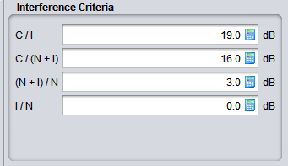

With the calculated noise floor of 121 dBm and the default value for C/(N+I) we get the following values:

$Sensitivity= Noise Floor+{\left.\frac{C}{N+I}\right|}_{I=0dB}=-121 dBm+16 dB=-105 dBm$

Therefore it is proposed to change the default values for the noise floor and sensitivity.

Noise floor = **-121dBm**

Sensitivity = **-105dBm**