STG(13)23 Annex 1
SEAMCAT activities report of the first period for 2013
1. Time plan
3 periods of work (peak style)
Tasks | Period | Status
Milestone title Time estimate (days) Week  Bug 5 1  Batch 5 1  xls 5 1  Library 7.5 1.5  Improvement 1 5 1 | February/March: week 6, 7, 8, 9 and 10 | complete
Milestone title Time estimate (days) Week  Improvement 2 5 1  Post Processing Plugin 7.5 1.5  Consistency check 7.5 1.5  New tasks: task 1 5 1 | May-June: week 21, 22, 23, 24 and 25
Milestone title Time estimate (days) Week  New tasks: task 2 5 1  New tasks: task 3 5 1  On-line update interface 10 2  Maintenance 10 2 | October: week 40, 41, 42, 43 and 44

The remaining tasks are for ECO to do or distribute during 2013
Milestone title | Time estimate (days) | Week | Period
ECO Bug | - |  | 1st phase
Populate the SEAMCAT Library | - |  | Distribute over 2013
Specification development | - |  | Distribute 1st half 2013

2. Details of tasks
Ticket | Task Status | Title | STG32
 |  | Bug
#101xx |  | Java Web Start (jnlp) in combination with plugins | plugin
#1018 |  | consideration of the emission mask and BEM | General Seamcat
#1016 |  | error in displaying propagation on same graph/compare | General Seamcat
#1015 |  | allow edition of the legend in the propagation model compare feature | General Seamcat
#1012 |  | in the spectrum mask make a check that the offset | General Seamcat
#1011 |  | a warning is needed when "restore default library" is selected | General Seamcat
#1010 |  | consistency check (manual/automatically) | General Seamcat
#1008 |  | Change of the default propagation model to Free Space | Propagation plugins
#1006 |  | change of the default value of the Rx characteristic panel | General Seamcat
#1005 |  | impact of general environment not considered for suburban and rural in HataSRD | Propagation Models
#1002 |  | constant value not displayed properly in the simulation outline | GUI
#1000 |  | UI and UI-models that are light weight and fast to construct | GUI
#999 |  | add users to SEAMCAT/STG reflector when downloading the tool | General Seamcat
#925 | STG34 agrees with proposal | saving issue in Temp | To be done in 2013
#969 | Not solved. Need a UI model and a simulation model. | closing ofdma workspace very slow, even stalling SEAMCAT | STG34 pushed this item to the next period.
#981 | Cannot reproduce | repetition of antenna name
#692 | Not treated | Enable click to "insert point" not working properly | Not important, nice to have if budget allows (can be done late 2013)
 |  | ECO Bug
#952 |  | OFDMA UL: blocking per link should be blocking for the system | To be done in 2013.
#929 |  | ECC PT1: interference calculations | To be done in 2013.
#938 |  | CDMA DL - improve the optimisation per event? | To be done in 2013.
 |  | Batch
#947 | Not treated | batch: overview of the results | To be done in 2013 under the condition that contribution defines the requirements.
#1020 |  | load batch with results
#1014 |  | batch does not load propagation model plugins
 |  | xls
#802 | Not treated | generated report to be saved in xlsx format | To be done in 2013
 |  | Library
#1019 |  | import blocking mask -> wrong name
 |  | Improvement
#991 |  | include the bug button to the menu bar | New to STG
#992 | Closed | implement MCL in generic system. | STG33
#993 |  | update Extended hata and Extended hata SRD | STG33
#994 |  | modify the download page text | STG33
#995 |  | review of the "interference criteria" panel | STG33
#989 |  | should propagation model input consider the BS ID for cellular scenario | To be discussed
#968 |  | optimise the user defined stair computation | when the user set 1500 frequencies using the attached file for both the victim and interfering link, the computation time is reduced.  There is a need to investigate how to optimise the computation.
#959 |  | Protection distance | STG considered the proposal of doc STG(12)23 and decided to move the protection distance to the “Relative positioning panel”, to introduce the protection distance into the “None” mode equation. The new implementation is to be tested so that save/load parameter is working.
#960 |  | Disable the 1000 event limit in the cdf/pdf computation | See KK’s proposal of fix for it. Only 100 events to be displayed.
#961 | Closed | Removing the legend | STG welcomed the proposal of STG(12)20 and suggested that the legend be removed.
#962 | Closed | Hiding the cdf/pdf panel from front display | The panel for CDF and PDF to be hidden.
#963 | Closed | Selection of the vectors from front panel. | The “choose links” to be kept (to be changed by “generated signals”) and that the selection of one vector or multiple selection be possible. Find a solution to remove the flickering effect of the panel. Karl and Stefan to provide modified source code by the end of October.
#957 | Closed | setting a spectrum mask manually - line jumping | clear, add, then 1.5, 0, 3000 press add.  The task is to review how it is made to avoid the jumping of the line to 0 every time.
#958 |  | user defined stair rounding value | When using the user defined stair to have an activity factor, it seems necessary to slightly modify the display too. For SRDs, activity factors might be well below 1%. Up to now, the display is limited to 3 digits after the comma. So when setting e.g. 0.25%, which means in the file e.g. (99.9975 -100; 1.0 30), the display will show a probability of 0,998. This could lead to some confusion. I assume this is only a display problem, when I'm right the calculation was fine.
#967 | Closed | display multiple vector - legend to be editable | To be done in 2013
#927 | Closed | CDMA/OFDMA results should be displayable with the new multi-vector display | To be done in 2013
#708 | reverted | optimise the LLD calculation time using binary search CDMA | To discuss with developer if time is being improved. Check whether the OFDMA look up table can be improved too. In the 2013 budget.
#843 |  | output information on the Rsimu need improvement | To be fixed in the 2013 budget  Use the term “Not applicable”
#836 |  | icon of children dialog window to be harmonise with parent dialog window | Only nice to have and to be done when time/budget allows
#685 | the removing of the x/y tab is a bigger job. not worth spending the money on. Ticket is closed. | harmonize the distribution dialog box (user defined and stair distribution) | To be done in 2013.
#863 | closed | allow the user to open the log file directly from SEAMCAT | To be done in 2013.  Text of the information dialog box to be moved in the status bar with a link to the file.  If the status bar is hidden, then it should be appearing again. When the user click on the link then the status bar is hidden again.
#875 |  | last snaphot: get a horizontal split | To be done in 2013.
#942 |  | histogram (pdf): to add a bin size input? | To be done in 2013.
#955 | closed | CDMA UL: Target cell noise rise | The default value should be set to 0.1 dB.
#896 |  | possibility to hide the ACLR on the display | To be done in 2013.
#923 |  | help button url to be updated | To be done in 2013.
#854 | Closed since duplicate with #978 | update construct in CDMA general settings | To be done in 2013.
#970 |  | coverage radius - provide statistic on the generated input.
#972 |  | get the java console into seamcat for msi version?
#973 |  | introduce capacity vector in the CDMA DL module results
#978 | Closed | CDMA/OFDMA constructor
#979 | Closed | folder browse - history needed
#980 |  | open/save browse need refresh
 |  | Post Processing Plugin
#1009 |  | when PPP fail, user should be informed. | Postprocessing Plugins
#618 | Not done | bug(?) in the index of the postprocessing in EGE | To be further assessed. STG 34 decided that it should be addressed in the PPP period.  Indexing of the interfering links and the transmitter within the link is not consistent. Example:  Link1 with Tx 1 = L1.1  Link1 with Tx 2 = L1.2  Link1 with Tx 3 = L1.3 etc….  Link2 with Tx 1 = L2.2  Link2 with Tx 2 = L2.3 etc…
#707 |  | restriction?: cdma/ofdma and post processing | In 2013, developer to look on how to make the post processing access all the parameters of the workspace provided and generated in SEAMCAT in a generic solution (ex: the frequency is only available after the first snapshot).  The call of the postprocessing is made within the EGE. Cannot use the postprocessing if CDMA/OFDMA is victim. Is there a solution to call the postprocessing for a victim network (CDMA/OFDMA).  New definition of an interface. To be made easier. More generic interface. (to make the main method public) which method to make public?
#635 |  | consider iteration of interfer on list based and not index based | To be done in 2013 under condition that assessment is made with developer. This may solve the indexing issue with PPP.
#846 |  | Integrate the location probability post processing plugin into SEAMCAT | STG decided that it is not useful to hard code the existing post-processing plugin into SEAMCAT (redundancy in the work) but acknowledge the need to improve the portability of the post-processing plugin.  - a PPP should be added to a workspace  - A PPP is to be embedded in a workspace for sharing workspaces  - The PPP tab should accept has many PPP possible. Therefore the use of 2 lists:  - Activated PPP: allow the configuration of the PPP  - Inactivated PPP: does not allow configuration of PPP  - Allow moving PPP from active list to inactive list functionality (i.e. Add >>, <<remove)  - In the active list, sequential execution of the PPP (allow move up and down button to switch the order of execution)  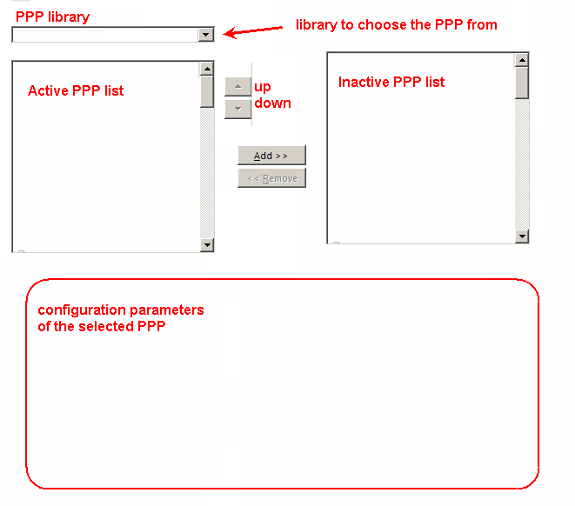  - Move current configuration to the PPP tab  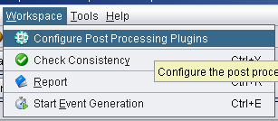  - Consider “Built-in” library from STG (i.e. collection of .jar PP received by STG and approved)  See Ticket xx for the new interface (developer side) of PPP
 |  | Consistency check
#615 |  | Consistency check need to be improved | Major action to potentially split in several steps Strategy 2013:  1) harmonise how the exception are handled.  2) improve the message of the exception handling  3) “red marked input cell”  3.1) consider the possibility with the developer the cost of having “red marked input cell” to check that input are within ranges.  3.2) STG to identify the input ranges  3.3) link the “red marked input cell” to the consistency check.
#139 |  | P1546 - propagation model consistency check | See Ticket #615
 |  | New tasks
#956 | See #1000 | To get the opening of a workspace faster | To be done in 2013 as part of the bug internal clean up to speed up the load of a workspace.
#85 |  | new GUI with victim in the center and interferers around | STG decided that the scenario outline display should contain the option of selected the VLR or VLT as centre point (requires the points coordinate to be kept in memory)  It is only a display matter, and the actual coordinate calculation should not be changed (i.e. not dependent on the setting).  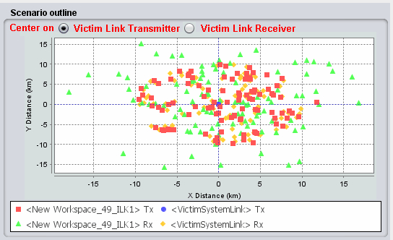
#847 |  | ICE configurations results should be saved into the workspace | STG32 considered that saving the results of the ICE panel is not needed and that saving the configuration of the ICE panel was confusing for the user. Therefore STG 32 decided that the ICE configuration panel should not be saved in the workspace.  However, the configuration and the results have to be saveable for the report generation only.  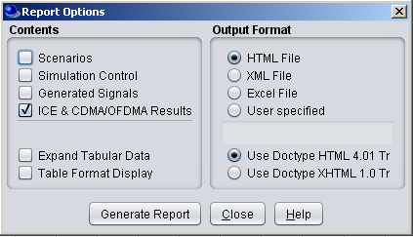  Note that there is a bug in the “signals used in calculation” and the order of “next”
#310 |  | WiMAX | Implementation was stopped in the middle due to lack of resources in 2010. No further request to restart and finalise the task was received since. Report that there are some specifications back from 2010 that could be reused.  The real difference between the LTE and WiMAX is the allocation of the resource blocks. The proposal is to only give the user the choice of either block allocation (i.e. LTE) or random allocation (i.e. WiMAX) in the Transmitter settings.  STG to ask guidance from WGSE on how to further progress with the implementation.
#504 |  | SEAMCAT to support of parallel processing | Parallel processing may be problematic with plugins in general. Therefore, parallel processing is no further investigated.  To speed up, CDMA simulation, another solution is to use “Cloud computing” since they should provide faster processor.  ECO with guidance from developer to assess the feasibility of using SEAMCAT with cloud computing.
#951 |  | plugin: JTG5-6 + longley Rice to be reviewed | Karl Koch to provide test comparison for both model  When validated the propagation plugin should be made available on the on-line manual.  Deadline: 20 October 2012
 |  | On-line update interface
#965 |  | news/event update + possibility to have library updated on line | ECO to have an improved interface for the news/event update + possibility to have library updated on line.  Is it possible to get a counter on the usage of the news (i.e. do people visit the links?)
 |  | Maintenance
#966 |  | Automatised the simulation_test for each commit | To be done in 2013.
#921 |  | need clarification on InspectSystemDetailsPanel.java | To be done in 2013.
#666 |  | Update Junit testing with new benchmark workspaces | Part of the maintenance  Allocate budget for 2013
#872 |  | generating Junit for propagation model | JTG5-6 and Longley Rice results from KK to be added.
#609 |  | dead code to clean | Regular maintenance for 2013. Ask developers if Eclipse (or compiler) can automatically identify dead code (i.e. unused method etc..)
#611 |  | javadoc | Regular maintenance for 2013
#702 |  | revision number with Hudson lost | To be done in 2013
 |  | Populate the SEAMCAT Library
#862 |  | populate the database of SEAMCAT | Restore button are you sure you want to delete your own library.  Add the ITU-R F1336 antenna pattern to the SEAMCAT library (STG(12)21)- check the frequency range validity.  STG would like to propose WGSE to request PT’s chairpersons (and ECC PT1 SWG-C) to add in their Agenda a “SEAMCAT library” item where the PT would provide the technical characteristic that they use in their report when parameters are agreed.  STG/ECO to provide a template to fill in by the PT for each library (list of libraries to be provided).
 |  | Specification development
#932 |  | ECC PT1: generic cellular module | See LS from ECC PT1 (STG(12)21)
#934 |  | Implementation with multicarrier (or wideband) IM | Some activity on the IM may arise in the 2013 CEPT activity in general.  Some days should be allocated in the budget in the eventuality of further development.
 |  | Video
#245 |  | create tutorial videos | ECO to embed the video from  http://tractool.seamcat.org/wiki/Manual/video  into the site instead of the download option.  ECO to investigate how much would cost to get professional videos made or any other educational media.  To be proposed for the budget 2013.

