**STG(13)38**

|  |  |  |  |
| --- | --- | --- | --- |
|  | | |  |
| **STG #36**  **WGSE - SEAMCAT Technical Group**  **BNetzA, Mainz**  **5 – 6 December 2013** | | |  |
| **Date Issued:** 30 October 2013  **Source :** Karl Koch  **Subject:**  correction of the tilt angle with azimuth angle | | | |
| **Document:** for discussion | | | |
| Password protection required? (Y/N) | N |

#### Current Situation

As described in the [manual](http://tractool.seamcat.org/wiki/Manual/Algorithms/Basics/AzimuthsAndElevationBetweenLinks) on Calculation of antenna azimuths and elevations (ILT - VLR path), SEAMCAT corrects the tilt angle by applying this calculation:

,

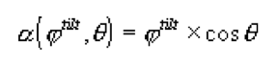

where θ is in this section of the manual the azimuth angle to the VLR seen from the ILT.

This calculation (calculateElevationWithCorrectionFactorFromAzimuth) is made for all elevation angles of the system links, i.e. the victim system link as well as the interfering system link:



The resulting “corrected” elevation angle is then used for the calculation of the antenna gains.

*Note: This correction becomes zero degree in case the antenna is pointing at least in the azimuth to its link component.*

With the slight difference that not the system link is referenced, but therefore the positions and antenna heights of the components between which the angles are to be calculated, the correction method is called by the following methods:

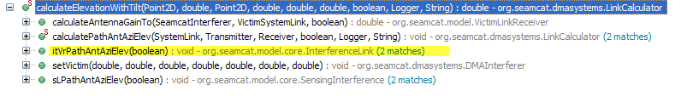

One may see that also the path ILT – VLR (and VLR - ILT) is “affected”.

#### Discussion

STG #17 in March 2009 and STG #18 in April 2009 discussed how to solve a bug described in [ticket #29](http://tractool.seamcat.org/ticket/29), unfortunately spotted by myself. STG found that the implementation in SEAMCAT’s class InterfernceLink was correct (tilt correction for vertical pattern!), but that a correction factor is needed to avoid values outside the range of ±90 degree. This had been solved accordingly.

*Note:*

*STG also concluded to modify the calculation of the total gain in case of combined horizontal and vertical pattern by taking account of a “threshold delta”*



*This modification is implemented as follows with the threshold set to 3 dB:*

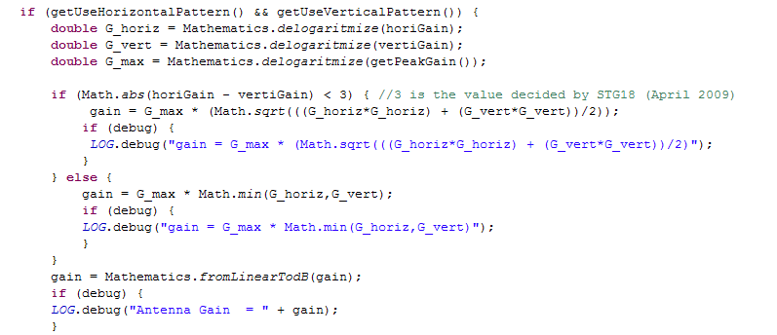

*But in the summary of the STG#18 meeting it also pointed out:  
It has to be kept in mind that for the main lobe it is a good approximation but the user should be aware that for outside the main beam special care in analysing the results should be considered.*

*STG members are invited to contribute to future STG meeting with a more accurate approximation is necessary (i.e. elliptical interpolation, etc…).*

Meanwhile the calculation methods on the class InterfernceLink have been changed in terms of defining the angles to be used to determine the resulting antenna gains, and it seems that for certain cases the above azimuth correction leads to wrong results in case the antenna uses spherical pattern.

###### Example 1 – system links, antennas not pointing:

The method “calculateGain” of the class Antenna is called by all links (that means not only the system links) for the calculation of the resulting path loss. In case spherical pattern are used, this method takes account of the angles which have been referenced by the calling method:

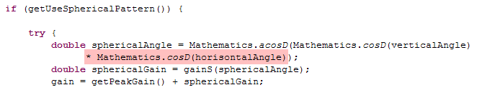

But because the referenced vertical angle (including the tilt angle) has been corrected before applying the same azimuth angle as referenced, this azimuth angle is now considered a second time.

###### Example 2 - path VLR – ILT:

Independent of whether the antenna of the VLR is pointing to its VLT (?!)[1], the elevation angle between VLR and VLT is taken as “tilt” (taking into account the value of a “real” tilt as parameter, if any) and is then corrected by the azimuth angle to the ILT. Nevertheless, the calculation of the resulting antenna gain (see Example 1) is considering this azimuth angle again.

#### Proposal

STG is invited to discuss this issue, also whether it is correct to consider the elevation angles between the components of a system link as tilt, even the antennas are not pointing to the corresponding component in the elevation plane.

My personal view is

* To remove the elevation correction in case spherical pattern are used.
* To consider the elevation angles between the components of a system link as tilt **only** in case the elevation pointing of the corresponding antenna is selected.

1. It should be checked whether it is correct that if pointing is not selected, the elevation VLR – VLT is also taken as tilt.