**STG(13)39**

|  |  |  |  |
| --- | --- | --- | --- |
|  | | |  |
| **STG #36**  **WGSE - SEAMCAT Technical Group**  **BNetzA, Mainz**  **5 – 6 December 2013** | | |  |
| **Date Issued:** 4 November 2013  **Source :** ECO  **Subject:**  Proposed play/replay feature (ticket [#1097](http://tractool.seamcat.org/ticket/1097)) | | | |
| **Document:** for discussion | | | |
| Password protection required? (Y/N) | N |

#### Proposal

It is proposed to allow a play/replay of a simulation for the "simulation outline" and the "cellular structure" tab. The purpose is to have a more interactive tool, a "enhanced mode" to see more data when debugging may be selectable as for instance the enhanced mode would not be useful in batch.

**Assessment:**

The memory consumptions need to be assessed

* allow a "enhanced mode" (to see more data when debugging):
  + save more data
  + play/replay mode
  + allow display of the antenna pattern (?)
  + allow to see for one event the respective iRSS/dRSS
* Save the ***state*** of the simulation instead of the “actual” results. This would allow to reproduce virtually any simulation irrespective of their length. This need to be investigated by the ECO and the developer on the feasibility of this concept into SEAMCAT.

#### GUI Example

The below figures illustrates the concept of play/replay. The user would be able to scroll left/right a cursor to “replay” the simulation. At the same time information of antenna pattern, antenna height frequency, dRSS, iRSS etc… would be displayed, i.e. a sort of “on-line” debug, for the generic and also for the CDMA/OFDMA. Note that when saved the play/replay could be distributed.

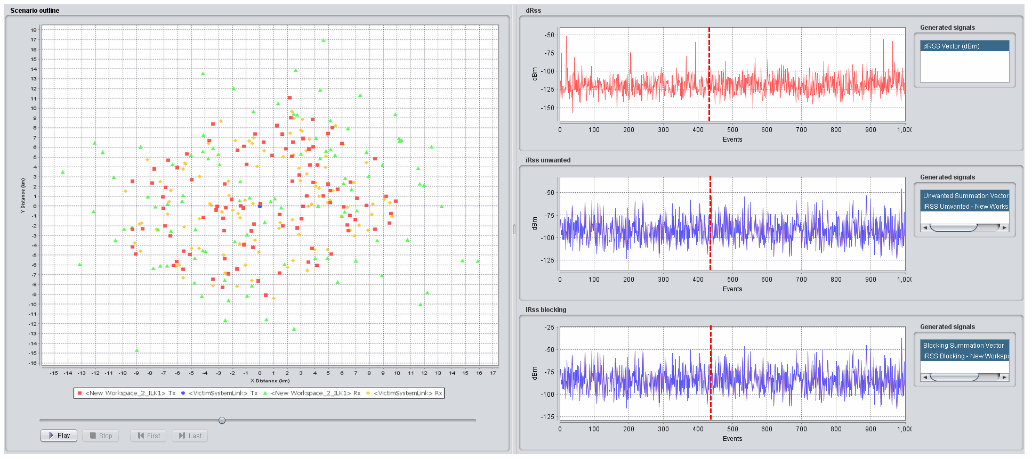

**Example for the Generic model**

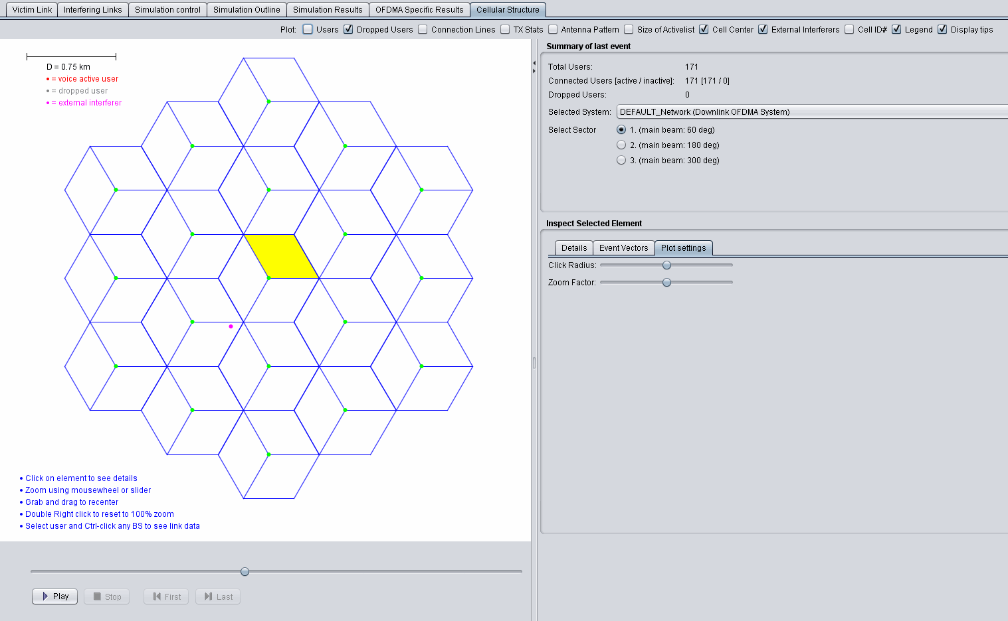

**Example for the Cellular model**