|  |  |  |
| --- | --- | --- |
|  | | **Doc. ECC/STG(13)42** |
| **Working Group SE** | |  |
| **63th Meeting of STG**  **Mainz, Germany, 5 – 6 December 2013** | |  |
|  | |  |
| **Date issued:** | 20 November 2013 | |
| **Source:** | Bundesnetzagentur | |
| **Subject:** | Allow hexagonal shape distribution for generic module, Ticket #1102 | |

|  |  |
| --- | --- |
| Password protection required? (Y/N) | N |

|  |  |
| --- | --- |
| **Summary:** | This document gives some background and shows some expected side effects to be taken into account before implementing a new functionality, as described in ticket #1102. |
| **Proposal:** | For consideration |
| **Background:** | Ticket #1102  The STG Chairman introduced the possibility to extend the functionality, in the sense that the user has the freedom, to choose any shape that he likes. |

# Structure

Firstly, we will give an overview how SEAMCAT calculates the position (distance and angle) of a system based on two distributions and then we will introduce our understanding of the proposed changes, given in Ticket #1102. This is related to the additions made by the STG chairman, proposed to STG by the mail sent at Wednesday, 6 November 2013, 16:37. Finally, the differences will be discussed based on the given examples.

# How SEAMCAT calculates a position based on the chosen distribution

For the distribution *Uniform*, in this case the *Path azimuth,* one can calculate the probability of a specific angle as given in the SEAMCAT online manual:

|  |  |
| --- | --- |
| $$U\left(u_{min},u_{max}\right)=\left\{\begin{aligned}1, &u_{min}≤x≤u_{max} \\ 0, &otherwise\end{aligned}\right.$$ | (1) |

umin and umax can be chosen in the figure below.

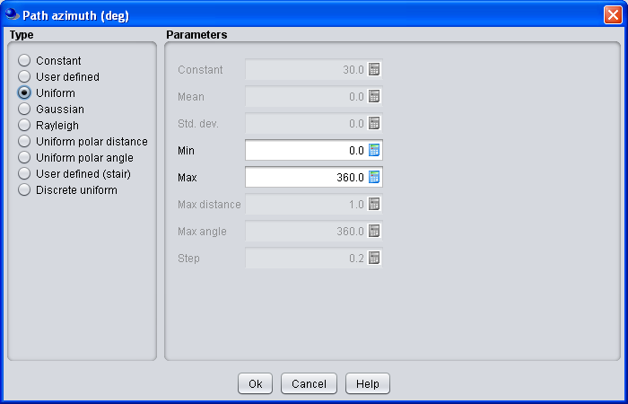

Figure 1: Distribution window of SEAMCAT

For the values in Figure 1 the probability for any angle  between 0° and 360° is given as $p(α)=1/{360}$  
.

Now, the user has to specify the distribution of the distance from the VLT or ILT. We will use in this example the *Path distance factor* with *Uniform polar distance*. The distance is calculated with the formula:

|  |  |
| --- | --- |
| $$T\left(D\left(R\right)\right)=R∙\sqrt{T\left(U\left(0,u_{max}\right)\right)}$$ | (2) |

With T(x) as trial of x, R as *simulation radius* and $u_{max}$ as *max distance* (between 0 and 1).

## Example 1

If both inputs for (1) are set to 0 and for (2), $R=1$ km and $u_{max}=1$. The result will be a distribution of all systems at one line with more and more systems if the distance is increasing (see Figure 2).

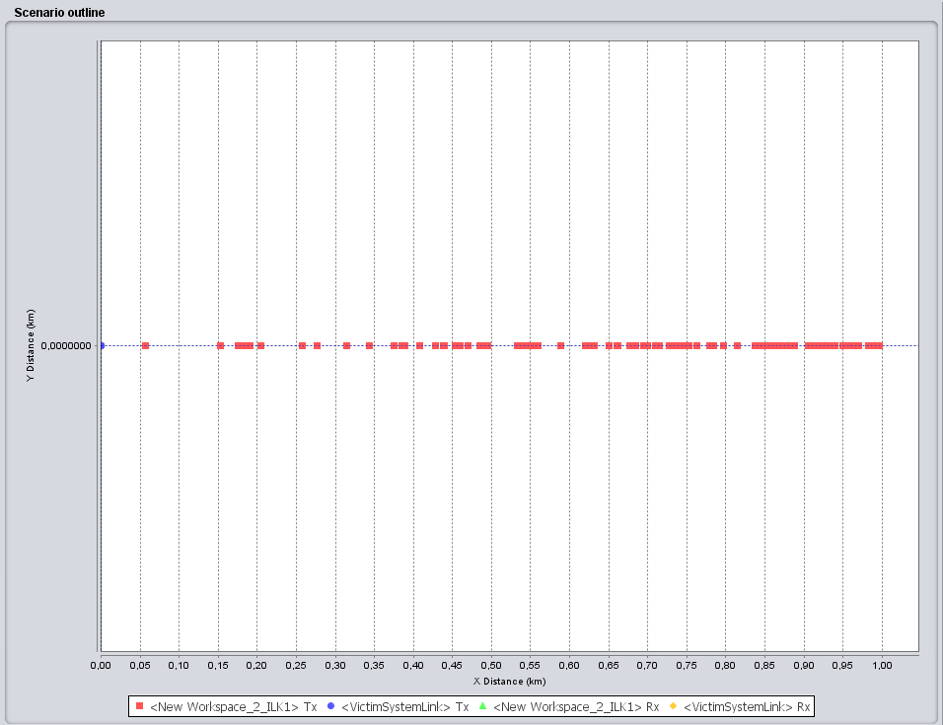

Figure 2: Extract from SEAMCAT; R = 1km,  = 0° and distribution = *Uniform polar distance* with umax = 1

If one expand this example and distribute the angle  as uniform from 0° to 360° the result is a circle. The result is, that at any place of the area a constant density is adjusted itself, e.g. 10 devices/km², seen from the centre of the circle.

## Example 2

Different from the above example, one can also use for the *Path distance factor* the distribution *Uniform*. If one uses the same values from Figure 2, this would also result in a line and at any position, the same amount of systems will be placed.

For the expansion to a circle the density of systems is not anymore constant, in the centre of the circle the density is higher than near by the border.

# Proposed introduction of other shapes than a circle

The proposed introduction of other shapes as a circle is illustrated in Figure 3. Our understanding of the proposal is, if in the blue area a device (black dot) is dropped, it will be replaced inside the square (which is fitting in the blue circle), after calculation of the trial. The trial will be repeated until the device is inside the square. It is noted that the error will decrease with the decrease of the blue area.

R = 10 km

r=root(2)*R/2

Figure 3: Illustration of the geometric relations

For other shapes like a hexagon the algorithm is the same as described above. The error of inhomogeneous deployment ($e_{x}$) of the station can be roughly estimated with the ratio of the differences in the areas.

|  |  |
| --- | --- |
| $$e_{x}=\left(1-\frac{A_{x}}{A_{circle}}\right)∙100$$ | (3) |

The resulting areas are calculated as follows, two examples are used, a square and a hexagon with R= 10 km.

|  |  |
| --- | --- |
| $$A_{circle}=π∙R^{2}=314.16 km²$$ |  |
| $$A_{square}=2∙R^{2}=200.00 km²$$ |  |
| $$A_{hexagon}=\frac{3∙\sqrt{3}}{2}∙R^{2}=259.81 km²$$ |  |

With formula (3), one gets the result of:

|  |  |
| --- | --- |
| $$e_{square}=35.34\%$$ |  |
| $$e_{hexagon}=17.30\%$$ |  |

# Differences between the original system and the proposed changes (Example 1)

With the replacement of an actual calculated and dropped device, the density of devices would change. In example 1, the *Path distance factor* with *Uniform polar distance* was used and the wanted shape (for the simulation) was set to a square. In Figure 4 an orange circle is drawn for better illustration of the differences. Within this orange circle the density of the devises is higher than in the white corners of the square and also higher than in the initial blue circle. The reason for this is that the calculated position falling in the white corners is not changed and based on the density calculated by (2) and the proposed algorithm will not change this position. If a device is newly placed it will be falling in the orange circle (or in one of the corners). The probability is higher, that a device will be dropped down in the area of the orang circle than in the full area of the square.

R=10 km

r=root(2)*r/2

Figure 4: Illustration of the geometric relations

As a simple calculation the radius of the orange circle is:

|  |  |
| --- | --- |
| $$r=\frac{\sqrt{2}∙R}{2}$$ | (4) |
| $$r=\frac{\sqrt{2}∙10 km}{2}=7,07 km$$ |  |

One can now expect that the density is increasing until 7 km and drops then down, if the distance is be increased further the corners of the square. Based on an extract of in SEAMCAT produced datas (source: ECO), a histogram in MatLab was created, see Figure 5. Circle 1 and 2 are the results from two runs of one scenario, to see differences between. Then the hexagon or square was used in the same scenario and the simulation was redone. Both, the hexagon and square lie within the circle with a radius of 10 km.

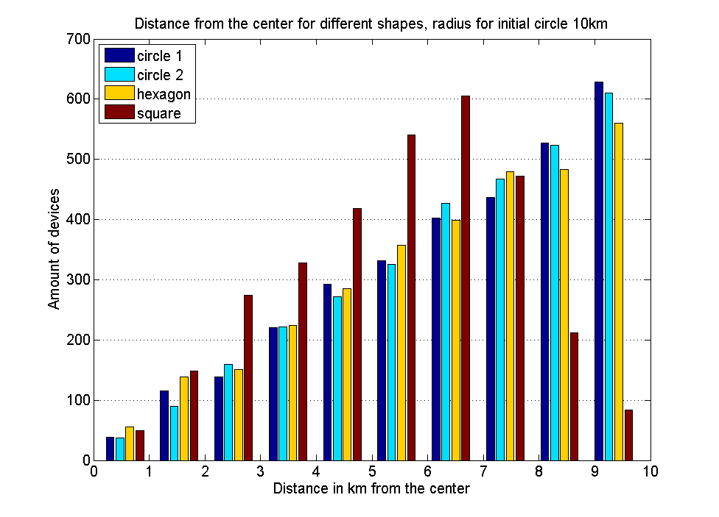

Figure 5: Histogram with different shapes

# Influence to *dRSS* and *iRSS*

The explanation above is very general, but the ticket #1102 explains that the change will be only to the *Victim Link* or *Interfering Link*. Therefor the influence of a change of the density should be taken into account. It has been shown that the density is increasing, if a shape, different form a circle, would be used.

## Victim Link

In the *Victim Link* the *Victim Link Transmitter* (VLT) is only used for the calculation of *dRSS* on the Position of the *Victim Link Receiver* (VLR). If the VLT is located outside the blue circle of Figure 4 and the VLR would be distributed inside this circle. SEAMCAT calculates for each snapshot a *dRSS* value, based on the distance between and the used propagation model. If the user changes the shape to a square, the VLR would be placed manly in the orange circle. Therefore the distance between the VLT and VLR is higher, seen over all snapshots.

The resulting mean of the *dRSS* vector would become different from the *dRSS* for a shape like the blue circle, probably it would decrease. The other way around is that the VLT is located in the centre of the square then the distances would be lower than for the situation for the blue circle. The mean of the *dRSS* vector increases accordingly.

## Interfering Link

The behaviour is the same like the description in 5.1 except the fact that the *iRSS* vectors are influenced in case, that *power control* would be used. Then one would get an additional unknown influence on the transmit power of the ILT.

# Discussion of the results

If one calculates for the full area, enclosed by the circle, the density of devices, one could also recalculate the needed radius R of the circle, to get the same result for the density in a square or hexagon. But not on each position the density is then equal. The corners of the square have a different density than the orange circle in Figure 4. The miss match is smaller if the user increase the amount of corners, e.g. to a hexagon, Figure 5 shows also the results for such a shape.

## Impact to the results in terms of *Interference probability*

After the calculation of the placement for each device, a lot of other calculations are driven by SEAMCAT, but all the results in terms of *Interference probability* are based on the users input for the geometries of a scenario. With the proposed change, there are some uncertainties in the results, maybe covered by other distributions or inputs are taken into account by the user.

Different from the generic part of SEAMCAT, which was addressed by the ticket, are the network modules (CDMA or OFDM), in the modules is a hexagon the basis for the geometrics, but the results are not based on that. The results are based on the connection of a device to the base station, of course, the initial placement are calculated on a hexagon, but on top SEAMCAT calculates the load of the network and change the first calculated density, e.g. throws some devices away or connect them to another base station. The result is also not an *Interference probability,* it is a change in the throughput of the network, not based on an area density of the devices in the network.

# Conclusion

The proposed new functionality to shape the placement of the VLR or ILR different from a circle, gives results, not anymore based on the calculations, given for a density in a circle as implemented in SEAMCAT. The change of the geometries implies also a change of the calculations, but this could be more complex. The vectors *dRSS* and *iRSS* are influenced, if the shape is changing, the user needs such in information at least on the *Simulation outline* panel. This could be a similar indication like the one for a used PPP, see the Figure 6 below.

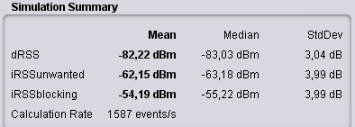

**#**

**#**

**#**

Figure 6: Proposed indication (red label) of a changed shape influencing the result vectors

How big the influence is, needs maybe analysed in more detail, but at this stage one can say that the minimum allowed number of corners is 4, a triangle would be impacting the results too much. Such an implementation for the ILT to VLR path should be avoided, regarding the unexpected influences to the results and the connection between the geometries and the area density.