**STG(13)44**

|  |  |  |  |
| --- | --- | --- | --- |
|  | | |  |
| **STG #36**  **WGSE - SEAMCAT Technical Group**  **BNetzA, Mainz**  **5 – 6 December 2013** | | |  |
| **Date Issued:** 30 November 2013  **Source :** Karl Koch  **Subject:**  calculation of blocking | | | |
| **Document:** for discussion | | | |
| Password protection required? (Y/N) | N |

#### Background

SEAMCAT considers the total (supplied) power of the ILT for the calculation of the impact due to blocking in taking account of the frequency offset of the centre frequencies of the VLR and ILT.

This implicitly requires that

* The values of the blocking mask have to be constant over the entire (system) bandwidth of the ILT.
* The system bandwidths of the VLR and the ILT must not overlap.

Both requirements were quite easily to meet using only systems with comparatively small system bandwidths and, compared to these, quite large frequency offsets.

As soon as one of these preconditions is not given, the calculated result becomes at least inaccurate as shown in the below example for a not constant value of the mask:

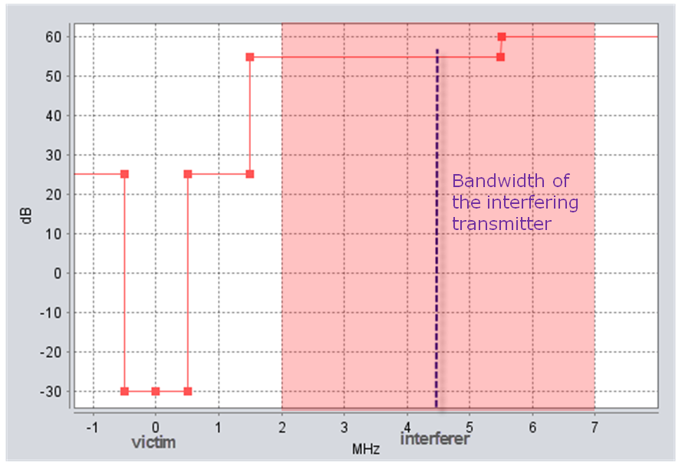

Figure 1: blocking mask not constant over the bandwidth of the ILT

Simulating randomly distributed frequencies, either of the VLR or of the ILT or of both, could result to frequency offsets being within the bandwidth of the VLR. It is obvious that then the calculated result becomes in terms of “blocking” wrong, but the calculated value is even tough considered as iRSSblock.

Additionally there is another issue connected to the blocking calculation:   
intermodulation products caused by the modulation bandwidth of the ILT falling into the VLR bandwidth.

Measurements recently carried out inter alia by the BNetzA (see [CG on GSM-R](http://www.cept.org/ecc/groups/ecc/wg-fm/client/meeting-documents) of the WG FM) show that the adjacent channels selectivity of an – in this case narrow band – receiver is “covered up” by intermodulation products generated by the modulation spectra of the interferer (UMTS and LTE). This phenomenon is not yet considered by any of SEAMCAT’s implemented algorithms.

#### Proposal

STG is invited to think about

* To modify the algorithm of the blocking calculation by taking account of a “blocking mask integrated over the interfering bandwidth” in order to cover the non constant issue. This might be for a transitional period offered as EPP.
* To modify the algorithm of the blocking calculation in avoiding that any “co-channel” situation is considered as blocking. This might be for a transitional period offered as EPP, too, or by an advice to define the blocking mask accordingly, i.e. to set the blocking attenuation for the “wanted part” of the mask to e.g. 1000 dB (respectively e.g. 1000 dBm).
* To modify the algorithm of the blocking calculation by taking account of the phenomenon “intermodulation” either as a generic implementation or as option selectable by the user. In particular the latter one could be offered as EPP.

In any case, such modifications would have to be approved by WG SE, maybe except EPPs.