**STG(14)12**

|  |  |  |  |
| --- | --- | --- | --- |
|  | | |  |
| **STG #37**  **WGSE - SEAMCAT Technical Group**  **Biel-Bienne, OFCOM Switzerland**  **11-12 March 2014** | | |  |
| **Date Issued:** 05.03.2014  **Source :** BNetzA, Germany  **Subject:**  discrete uniform distribution | | | |
| **Document:** **for discussion**~~/for information/for action~~ | | | |
| Password protection required? (Y/N) | N |

|  |
| --- |
| Summary:  Basically, the user is not (always) aware of the specific behaviour of the implemented and well documented method of the discrete uniform distribution which starts with an offset of half the step width after the start value and stops with the same offset before the stop value of the defined range. |
| Proposal:  None, only for discussion |
| Background:  ./. |

#### Assumed history

Reading the step width of the discrete uniform distribution as bandwidth of an equipment, one could comprehend this method in terms of radio channels where the generated value represents the centre frequency of the simulated system.

#### Experienced reality

Not having always in mind the specific definition of the implemented method and defining a distribution e.g. as shown in the figure below

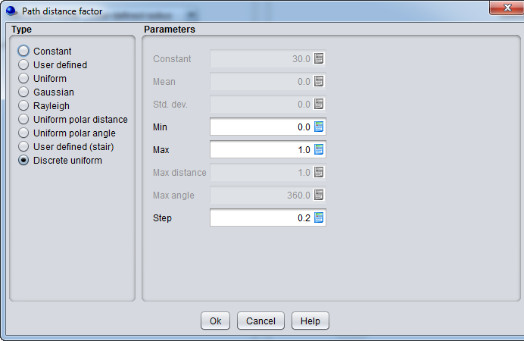

one intuitionally expects simulated values of 0, 0.2 ... 1.0, each with the same probability of 16.67%, but the simulated result is different:

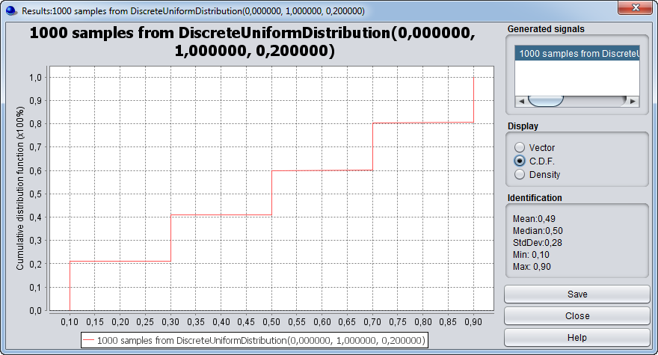

If one wants to get the intended values of 0, 0.2 ... 1.0, one would have to define the wanted distribution like this

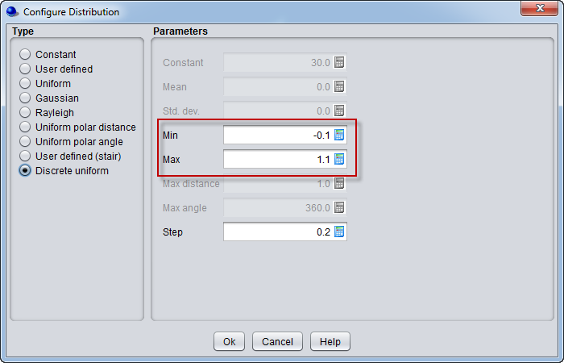

At least all non-SEAMCAT people will never understand the need for that trick and even experienced SEAMCAT users might not be aware of the necessity of it in order to get the wanted result.

#### Desired future

As STG is revisiting SEAMCAT 4.1.0 in the course of developing the new version 5, it should be thought about:

* to change the implemented method accordingly, amending of course the manual
* perhaps, the currently implemented method could be kept for the distribution of frequencies;  
  in this case the word "Step" could be replaced by "System bandwidth"