**STG(14)14**

|  |  |  |  |
| --- | --- | --- | --- |
|  | | |  |
| **STG #37**  **WGSE - SEAMCAT Technical Group**  **Biel-Bienne, OFCOM Switzerland**  **11-12 March 2014** | | |  |
| **Date Issued:** 9 March 2014  **Source :** France  **Subject:**  Proposal of new plugin for Seamcat Tool | | | |
| **Document:** for discussion and for action if appropriate | | | |
| Password protection required? (Y/N) | N |

|  |
| --- |
| Summary: this document presents how Winner propagation model and Manhattan Grid could be suitable in Seamcat Tool. |
| Proposal: discuss on how Manhattan Gird as well as Winner Propagation Model should be included in Seamcat (using Event Processing Plugin) or directly linked to the Seamcat software and elaborate further actions when implementing these two functions. |
| **Background:** It is proposed to relaunch[1] work on Winner Models for inclusion in Seamcat Tool. Since the Seamcat Tool structure recently changed with the possibility to build PPP – EPP (trunk) plugins, there is a need to decide whether in a PPP-EPP or in any other form the Winner Model could be included within Seamcat Tool.  The stake is that the Winner models is a collection of propagation models (more than 10) that are used in dense urban area, accounting various information such as indoor/outdoor location of the transmitter/receiver, its mobility (low, pedestrian…), its height (floor in a building) in order to select the most suitable pathloss model for a given location of both transmitter and receiver (the path being split into Line Of Sight (LOS) components). The topology of the area is the key requirement to compute the appropriate pathloss. In other words, the usage of a Manhattan grid[2] featuring a portion of a dense environment (urban, suburban): size of the buildings, width of the street would cover Winner Model requirements.  For the time being, such a grid is not available in Seamcat. The only view on equipment location is generic and does not list any information related to the topology of the terrain. This leads to raise the following question: how could the Manhattan grid could be reflected on Seamcat? |

1. **Manhattan Grid manages the Winner model and more**

If Winner II models enable the usage of various propagation models with Manhattan Grid information, a Manhattan Grid plugin needs to be built. In addition, the Manhattan grid could be used for other propagation models that address any link budget/interference assessment of other services (mobile broadband non IMT: PMSE, RLANs, fixed service: backhaul equipment…) operating in any dense urban environment. This means that this plugin could be further called by other future plugins which deal with anything about dense urban area. Thus, the functionalities of the Manhattan grid need to be further described.

1. **How to start with Manhattan Grid view**

As a first step and in order to launch the discussion on this topic, a simple and intuitive interface as shown in Figure 1[3] could depict Manhattan grid if it is used:

* to manually select the location of both transmitter or receiver before any link budget calculation,
* to view the randomly generated location of a or some transmitter/receiver devices.

This window consists of different parts:

* a menubar on the top in order to include some common menus to load or save files and to close the application.
* on the left, the Manhattan Grid will be shown, once it has been (randomly) built by setting the parameters on the right panel.
* the latter contains the parameters for building the Manhattan Grid and also the positioning of the transmitters/receivers.
* Finally, the first version of the plugin will show on the same panel the results computed from the propagation models implemented.

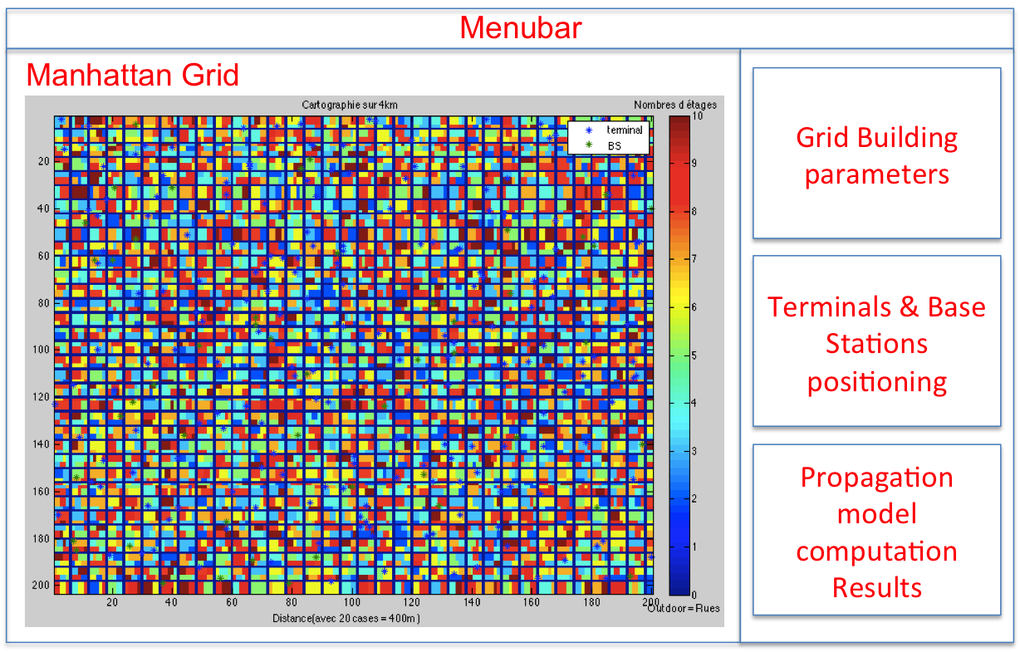

Figure 1 : Manhattan Grid Plugin

This Manhattan grid also consists of a data Matrix giving for each square unit (for instance 20mx20m) all needed information (outdoor, indoor- which floor -) related to the location as well as the user velocity (mobile/nomad/static) or the device position (antenna direction).

Consequently, when the location of all devices is randomly generated over this Manhattan grid, the data matrix is then updated and called (as a set of parameters) by the Winner Model to compute the right pathloss.

1. **Possible characteristics of the Manhattan grid**

Provided that any Manhattan grid can be randomly or fixed generated, buildings and streets would require the following parameters to be created:

* size (width) of the streets (outdoor)
* number of horizontal and vertical streets within a district
* size of the building (mean, standard deviation)
* number of floors of a building (max, mean, standard deviation).

Aside from these features, transmitter and receiver parameters could be extracted from the Interferer/Victim transmitter/receiver panel:

* the number of equipment (e.g. base stations, terminals)
* the positions of equipment (relative to possible other device)

#### How could the Winner plugin fit within Seamcat Tool?

Like any other propagation model, it could be suitable for a category of link:

* Victim Tx -> Victim Rx
* Interferer Tx -> Interferer Rx
* Interferer Tx -> Victim Rx since it accounts both transmitter/receiver device characteristics within the Manhattan grid.

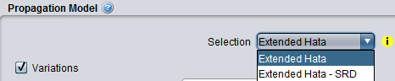In order to set the parameters for the Winner model when selecting this propagation model, the user can access the Manhattan grid interface

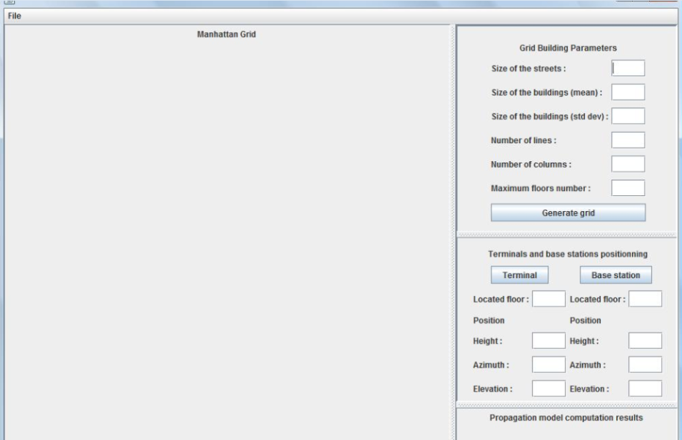If no specific location of the device is left, some basic information such as: indoor/outdoor, number of devices… information can be filled out as existing with other propagation models (Extended Hata, Spherical Diffraction):

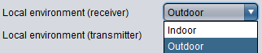

#### as well as the specific information from the Manhattan grid. Additional information fields can improve the Manhattan grid interface settings.

#### Additional questions on the further implementation

For Monte-Carlo simulations with numerous devices located within a Manhattan grid, the calculation of single or aggregated interference is derived with single calculation of each link (given the location of the transmitter/receiver within the Manhattan Grid) in each event. In such case:

* is this necessary to display the Manhattan grid for more than 1 event simulation running since the location of the receiver/transmitter interferer/victim may subject to change from one event to another one? or possibly adopt the same approach like in cellular network (see Figure 2) with UE locations by depicting the view for the last snapshot (in this case, the Manhattan grid cannot be displayed in the propagation model interface depicted just above as this window is used **before** the simulations are run.
* propose the user to display or not the distribution of the device within the Manhattan grid?

Since Winner Propagation Model calls Manhattan Grid but could not be the only one which could require to map the location of devices, would it be better to have

* + Winner propagation Model in the Propagation Model panel
  + **and** have
    - Manhattan Grid interface (all Manhattan plugin with Grid view+Parameters set)
    - OR just the Manhattan Grid view

as an Event Processing Plugin (EPP)?

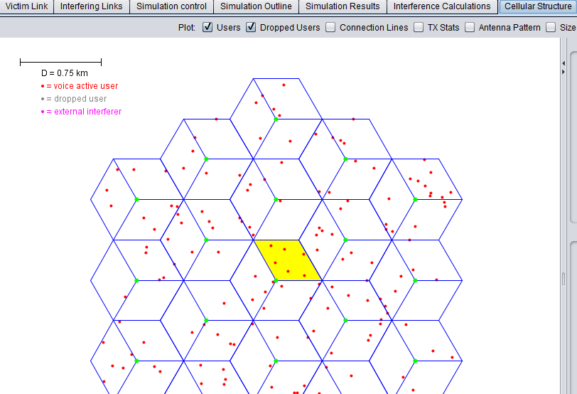

1. <http://tractool.seamcat.org/wiki/Manual/PropagationModels/winner>
2. 3GPP TR 25.942
3. Extracted from a view of a city district randomly generated on Matlab file