STG(14)21
SEAMCAT activities for 2014
1. Time plan
About 14 weeks of work
- December 2013: Finalisation of the generic model migration and implementation of EPP interface. Release of an alpha version and testing.
- February 2014: following items have the priority
  - Implementation of the CDMA/OFDMA migration work for the EPP
  - Consider the improvement on the EPP from STG#36 (see Annex 1)
  - Update the PM plugin with new interface
  - Update the OFDMA UL PC + mixed scenario (high priority)
  - Implement the “system approach”
  - Update the download functionality from the server
  - Implement an automatic version “check”
  - Get the 100 event limitation done
  - Update propagation model (P.1546-5, P.542-15)
  - If budget allows implement the play/replay feature.
  - Remaining point on the wish list
2. Details of tasks
Ticket | Task Status | Title | STG35 | STG36
 |  | Bug
 |  | Feedback from alpha 5
#1151 |  | problem with the multi generation
#1150 |  | Allow mixed indoor/outdoor propagation model in one simulation
#1149 |  | modify the LTE power control
#1148 |  | Problem with the compare propagation model feature in 5.0.0
#1147 |  | add unit to the path distance field
#1146 |  | Consider integrating antenna pattern equation like ITU-R F.699, F.1245, then plugin to library
#1145 |  | For heavy simulation (more than 100000 points) consider switching off the GUI to save processing power
#1144 |  | Give the user the possibility to import/export any of the libraries from the EPP
#1143 |  | Hudson configuration
#1142 |  | list of generic system parameters to be made available to the user
#1141 |  | Crash of EPP with following workspace
#1140 |  | EPP Function2D - bug2 - exception after modifying a workspace
#1139 |  | EPP Function2D - bug1 - panel display not in line
#1138 |  | Link information
#1134 |  | Bug in the antenna for IL - check also duplicate
#1117 |  | Try to get the X,Y (lower tab) from the “user defined” removed or define a new class
#1116 |  | EPP Demo 1: unit in dBm in the vector display
#1109 |  | typo in consistency check m/km
#1108 |  | Bug; Tool: Test propagation models; Data export, Save function
#1087 |  | wrong antenna gain calculation (ILT-VLR) in case elevation pointing is selected
#981 |  | repetition of antenna name
#969 |  | closing ofdma workspace very slow, even stalling SEAMCAT
#1002 |  | constant value not displayed properly in the simulation outline
#1076 |  | displaying multi-vector CDF fail when one of the external vector is constant
#1110 |  | allow to import in the compare vectors feature xls/xlsx files | Bug. It works for .txt but not for xls/xlsx data
#1108 |  | Tool: Test propagation models; Data export, Save function | Bug
#1107 |  | update of the name of the interferer not done | Bug
#1104 |  | refresh issue with “noise limited coverage radius” | Bug in the refresh STG decided to remove it (check that the refresh still works for the input parameters
#1103 |  | Antenna pattern in polar coordinates | Bug in the polar representation
#1089 |  | exception when cdma/ofdma is launch when running more than 100 samples | Annoying bug that is not reproducible all the time
#1067 | Partially fixed | issue with "missing permission" and "code base" due to java SE7U25 | Bug
#1073 | See #1067 | online update of SEAMCAT does not work with JRE 7 Update 25 | Bug
#990 | No fedora available | installation issue with Fedora 17 when not connected on the net | bug
#692 | Not treated | Enable click to "insert point" not working properly | Not important, nice to have if budget allows (can be done late 2013)
 |  | ECO Bug
#929 |  | ECC PT1: interference calculations | To be done in 2013.
#938 |  | CDMA DL - improve the optimisation per event? | To be done in 2013.
 |  | CDMA-OFDMA
#1058 |  | cell/sector preview with antenna pattern | Enhancement
#969 | Not solved. Need a UI model and a simulation model. | closing ofdma workspace very slow, even stalling SEAMCAT | STG34 pushed this item to the next period.
#1044 |  | in single cell (CDMA or OFDMA), there is a drastic time computation whether tri-sector or single sector is selected | ??
#708 | reverted | optimise the LLD calculation time using binary search CDMA | To discuss with developer if time is being improved. Check whether the OFDMA look up table can be improved too. In the 2013 budget.
#896 |  | possibility to hide the ACLR on the display | To be done in 2013.
#875 |  | last snaphot: get a horizontal split | To be done in 2013.
 |  | Batch
#1080 |  | To allow copy/paste of the batch results into a text/xls format | Enhancement  STG36 agrees
#1056 |  | Integrate the batch panel into the workspace tabs. | Enhancement  STG36 asked ECO to check that the new interface considers the batch
#1055 |  | Results of the .sws should be saved incrementally and automatically | Enhancement
 |  | xls
#802 | Not treated | generated report to be saved in xlsx format | To be done in 2013
 |  | Library
 |  | For STG consideration and resolution
#1102 | Demo on branche 4.1.0 | allow hexagonal shape distribution for generic module | For STG – done
#1040 |  | default library input needed for SEM, Antenna and Blocking receiver | For STG – on going
#1018 |  | consideration of the emission mask and BEM | For STG
 |  | Improvement
#1144 |  | Give the user the possibility to import/export any of the libraries from the EPP
#1143 |  | Hudson configuration
#1137 |  | Bandwidth ILT
#1136 |  | Home location of SEAMCAT
#1135 |  | Java console and jar distribution
#1133 |  | create sublink to the interferer
#1130 |  | A new SEAMCAT installation should not overwrite the library.
#1129 |  | Allow the user to modify the system frequency from the workspace panel.
#1128 |  | Give the possibility to extend the built-in model with mesh network, ppdr
#1127 |  | Help button needed for the EPP
#1126 |  | Description on how to compile
#1125 |  | Duplication of the workspace should automatically save the EPP
#1124 |  | Modify the EPP-> save it -> export to the library with new input (last parameters)
#1123 |  | Duplicate workspace should also duplicate the EPP
#1122 |  | Update the name of the EPP when changed in the configure EPP
#1121 |  | Remove ACLR from EPP
#1120 |  | New type of output graphic for the EPP
#1119 |  | Can the EPP access the display panel
#1118 |  | Consider dipslaing the CDF “inverse”
#1114 |  | make the cdf as default display instead of vector
#1106 |  | allow preview in the plugin loading
#1100 |  | Proposed towards a system based GUI
#1097 |  | allow play/replay of the simulation
#1085 |  | security issue with loading jar file to be adressed by STG
#1079 |  | update the ITU-RP.452-14 into ITU-RP.452-15
#85 |  | new GUI with victim in the center and interferers around | STG decided that the scenario outline display should contain the option of selected the VLR or VLT as centre point (requires the points coordinate to be kept in memory)  It is only a display matter, and the actual coordinate calculation should not be changed (i.e. not dependent on the setting).  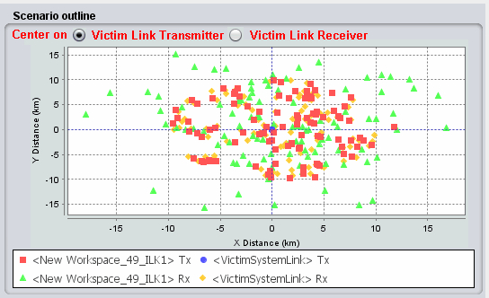  STG 36 would recommend to have that implemented when the play/replay ticket is treated. Otherwise the EPP is another solution.
#847 |  | ICE configurations results should be saved into the workspace | STG32 considered that saving the results of the ICE panel is not needed and that saving the configuration of the ICE panel was confusing for the user. Therefore STG 32 decided that the ICE configuration panel should not be saved in the workspace.  However, the configuration and the results have to be saveable for the report generation only.  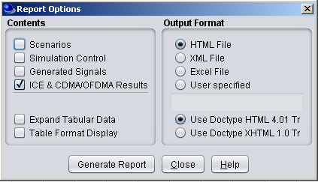  Note that there is a bug in the “signals used in calculation” and the order of “next”  STG36: Check that the “Report” is still valid with the “results” file approach.
#310 |  | WiMAX | Implementation was stopped in the middle due to lack of resources in 2010. No further request to restart and finalise the task was received since. Report that there are some specifications back from 2010 that could be reused.  The real difference between the LTE and WiMAX is the allocation of the resource blocks. The proposal is to only give the user the choice of either block allocation (i.e. LTE) or random allocation (i.e. WiMAX) in the Transmitter settings.  STG to ask guidance from WGSE on how to further progress with the implementation.  STG36 prepared a LS to ECC PT1. | It was noted that in some countries (Croatia, Finland and Lithuania) WiMAX is used in the 3.5 GHz range. WG SE suggests that STG should liaise to PT1 on that issue.
#504 |  | SEAMCAT to support of parallel processing | Parallel processing may be problematic with plugins in general. Therefore, parallel processing is no further investigated.  To speed up, CDMA simulation, another solution is to use “Cloud computing” since they should provide faster processor.  ECO with guidance from developer to assess the feasibility of using SEAMCAT with cloud computing.  STG36 noted that with the new SEAMCAT structure, it may be possible to implement “parallel processing” in an easy way. | It may now be possible to have parallel processing due to the new model restructuration.
#1000 |  | UI and UI-models that are light weight and fast to construct - To get the opening of a workspace faster | GUI
#999 |  | add users to SEAMCAT/STG reflector when downloading the tool | Add a tick box if you want to be added to the SEAMCAT email reflector.  STG36 approved this approach. By default the box is False.
#1057 |  | Archive capability with web-start | New  STG 36 noted the oral presentation of the ECO. The ECO will proceed forward with the developer on a working solution. “.msi” and “webstart” will disappear.  ECO to provide a description for the minutes.
#995 |  | review of the "interference criteria" panel | STG33  STG36, see STG(13)22 for some equations.
#968 |  | optimise the user defined stair computation | when the user set 1500 frequencies using the attached file for both the victim and interfering link, the computation time is reduced.  There is a need to investigate how to optimise the computation.  STG36: to be investigated if resources allows.
#960 |  | Disable the 1000 event limit in the cdf/pdf computation | See KK’s proposal of fix for it. Only 100 events to be displayed.  STG36 approved. To be done for the version 5.0.0
#958 |  | user defined stair rounding value | When using the user defined stair to have an activity factor, it seems necessary to slightly modify the display too. For SRDs, activity factors might be well below 1%. Up to now, the display is limited to 3 digits after the comma. So when setting e.g. 0.25%, which means in the file e.g. (99.9975 -100; 1.0 30), the display will show a probability of 0,998. This could lead to some confusion. I assume this is only a display problem, when I'm right the calculation was fine.  STG36: to be investigated if resources allows. May the new generic display may provide an easy solution.
#843 |  | output information on the Rsimu need improvement | To be fixed in the 2013 budget  Use the term “Not applicable”  STG36: to be done for version 5.0.0
#942 |  | histogram (pdf): to add a bin size input? | To be done in 2013.  STG36: to be done for version 5.0.0
#970 |  | coverage radius - provide statistic on the generated input. | EPP
#959 | Fixed but to put on hold for further feedback | Protection distance | STG considered the proposal of doc STG(12)23 and decided to move the protection distance to the “Relative positioning panel”, to introduce the protection distance into the “None” mode equation. The new implementation is to be tested so that save/load parameter is working. | Feedback from Karl Koch (BNetzA)(02.09.2013)  As reported last week, the implementation itself works as expected with the probably minor disadvantage that existing workspaces have still as default a protection distance of 0.1 km (instead of 0 km given for new workspaces created with beta 6).  After discussing possible side effects of the modification, Stefan and I came to the opinion that something should additionally be taken into account in considering the following:  1.The formula implemented now as “general” is in our view only applicable for a uniform density distribution.  2.Unlike the modes “Uniform density” and “Closest interferer” the mode “None” does not deactivate the “Path distance factor”.  This might cause some inconsistencies, in particular if e.g. “Constant” would be selected.  We therefore would like to propose, to discuss in STG before approving this modification first:  •For which of the distance factors a protection distance is applicable in general (for instance would “User defined” not make that sense). Btw, concerning “Uniform polar angle” a hint on the manual could help to explain that such a distribution is not for distances. * For which of these the “area” formula as implemented now applies (in our view only for “Uniform polar distance”).  •How to handle Min-Max distributions in case Min differs from zero.  •How to avoid an accidently wrong usage of the protection distance (for instance by deactivating this input field).
 |  | Post Processing Plugin
#1009 |  | when PPP fail, user should be informed. | Postprocessing Plugins
#618 | Not done | bug(?) in the index of the postprocessing in EGE | To be further assessed. STG 34 decided that it should be addressed in the PPP period.  Indexing of the interfering links and the transmitter within the link is not consistent. Example:  Link1 with Tx 1 = L1.1  Link1 with Tx 2 = L1.2  Link1 with Tx 3 = L1.3 etc….  Link2 with Tx 1 = L2.2  Link2 with Tx 2 = L2.3 etc…
#707 |  | restriction?: cdma/ofdma and post processing | In 2013, developer to look on how to make the post processing access all the parameters of the workspace provided and generated in SEAMCAT in a generic solution (ex: the frequency is only available after the first snapshot).  The call of the postprocessing is made within the EGE. Cannot use the postprocessing if CDMA/OFDMA is victim. Is there a solution to call the postprocessing for a victim network (CDMA/OFDMA).  New definition of an interface. To be made easier. More generic interface. (to make the main method public) which method to make public?
#635 |  | consider iteration of interfer on list based and not index based | To be done in 2013 under condition that assessment is made with developer. This may solve the indexing issue with PPP.
#846 |  | Integrate the location probability post processing plugin into SEAMCAT | STG decided that it is not useful to hard code the existing post-processing plugin into SEAMCAT (redundancy in the work) but acknowledge the need to improve the portability of the post-processing plugin.  - a PPP should be added to a workspace  - A PPP is to be embedded in a workspace for sharing workspaces  - The PPP tab should accept has many PPP possible. Therefore the use of 2 lists:  - Activated PPP: allow the configuration of the PPP  - Inactivated PPP: does not allow configuration of PPP  - Allow moving PPP from active list to inactive list functionality (i.e. Add >>, <<remove)  - In the active list, sequential execution of the PPP (allow move up and down button to switch the order of execution)  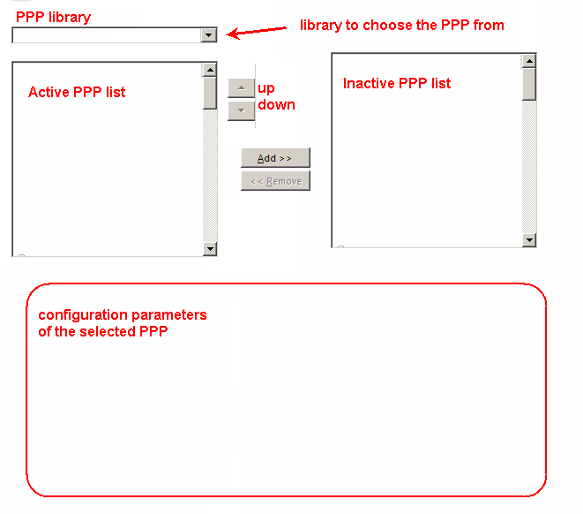  - Move current configuration to the PPP tab  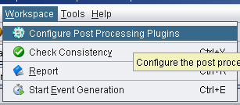  - Consider “Built-in” library from STG (i.e. collection of .jar PP received by STG and approved)  See Ticket xx for the new interface (developer side) of PPP
 |  | Consistency check
#1010 |  | consistency check (manual/automatically) | General Seamcat
#615 |  | Consistency check need to be improved | Major action to potentially split in several steps Strategy 2013:  1) harmonise how the exception are handled.  2) improve the message of the exception handling  3) “red marked input cell”  3.1) consider the possibility with the developer the cost of having “red marked input cell” to check that input are within ranges.  3.2) STG to identify the input ranges  3.3) link the “red marked input cell” to the consistency check. | To be implemented for the EPP too
#139 |  | P1546 - propagation model consistency check | See Ticket #615
 |  | New tasks
 |  | On-line update interface
#965 |  | news/event update + possibility to have library updated on line | ECO to have an improved interface for the news/event update + possibility to have library updated on line.  Is it possible to get a counter on the usage of the news (i.e. do people visit the links?)
 |  | Maintenance
#966 |  | Automatised the simulation_test for each commit | To be done in 2013. | Time reduced to 1h21min on developer machine
#921 |  | need clarification on InspectSystemDetailsPanel.java | To be done in 2013.
#666 |  | Update Junit testing with new benchmark workspaces | Part of the maintenance  Allocate budget for 2013 | Last done for coverage and simulation radius and decrease number of snapshot for some and re-arrange by increasing speed
#872 | Fixed | generating Junit for propagation model | JTG5-6 and Longley Rice results from KK to be added. | Fixed see #951
#609 |  | dead code to clean | Regular maintenance for 2013. Ask developers if Eclipse (or compiler) can automatically identify dead code (i.e. unused method etc..)
#611 |  | javadoc | Regular maintenance for 2013
#702 |  | revision number with Hudson lost | To be done in 2013
 |  | Populate the SEAMCAT Library
#862 |  | populate the database of SEAMCAT | Restore button are you sure you want to delete your own library.  Add the ITU-R F1336 antenna pattern to the SEAMCAT library (STG(12)21)- check the frequency range validity.  STG would like to propose WGSE to request PT’s chairpersons (and ECC PT1 SWG-C) to add in their Agenda a “SEAMCAT library” item where the PT would provide the technical characteristic that they use in their report when parameters are agreed.  STG/ECO to provide a template to fill in by the PT for each library (list of libraries to be provided).  Postponed to STG37, since the interface will change and include the “system approach”.
 |  | Specification development
#932 |  | ECC PT1: generic cellular module | See LS from ECC PT1 (STG(12)21)  STG36: consider Mesh network, PPDR etc…
#934 |  | Implementation with multicarrier (or wideband) IM | Some activity on the IM may arise in the 2013 CEPT activity in general.  Some days should be allocated in the budget in the eventuality of further development.  STG36 decided that the current implementation of the IM in SEAMCAT will be moved to an EPP format and removed from the built-in. This will allow the user to copy/paste it and to create their own modified versions. The STG EPP library cannot be modified.  The on-line manual should be updated.
 |  | Video
#245 |  | create tutorial videos | ECO to embed the video from  http://tractool.seamcat.org/wiki/Manual/video  into the site instead of the download option.  ECO to investigate how much would cost to get professional videos made or any other educational media.  To be proposed for the budget 2013.  STG37expect to get some input from members on topics to be addressed in a video.

