

Installation manual on the SEAMCAT source code
(14/03/2014)




About the CEPT and ECO
The European Conference of Postal and Telecommunications Administrations (CEPT) is an organisation where policy makers and regulators from 48 countries across Europe collaborate to harmonise telecommunication, radio spectrum and postal regulations.

The European Communications Office (ECO) is the Secretariat of the CEPT. It provides advice and support to CEPT to help it to develop and deliver its policies and decisions in an effective and transparent way. Its core duties are to provide a European centre of expertise in electronic communications, to contribute to the work of the three CEPT committees and to manage CEPT’s day-to-day activities.

ECO further supports CEPT member countries and other stakeholders providing a forum to debate and advance European communications policy for the benefit of all Europe’s citizens.

Acknowledgment
ECO would like to thank many participating companies and organisations to the SEAMCAT MoU, who made the creation of SEAMCAT tool possible. Special thanks go to the active members of CEPT Working Group Spectrum Engineering (WG SE), SEAMCAT Management Committee (SMC) (1997-2002), and SEAMCAT Technical Group (STG) (since 2003), whose many contributions formed the main basis of the work in the SEAMCAT project.
Contents

About the CEPT and ECO 2
Section 1 Introduction 4
Section 2 Installing JAVA 5
Section 3 Installing a compiler: Example with ANT 7
Section 4 Setting the System Path 10
Section 5 Installing the source code package 12
Section 6 Editing SEAMCAT: an example with ECLIPSE 14
Section 7 Adding a library to SEAMCAT 17
Section 8 Packages needed for plugins 18
8.1 Option 1 (recommended): 18
8.2 Option 2: 19
8.3 Option 3: 19
Section 9 Updating JAVA in ECLIPSE 21
Section 10 Compiling and running SEAMCAT 23
10.1 Using Ant 23
10.2 Using Eclipse 24
10.2.1 Method 1 24
10.2.2 Method 2 27
10.2.3 Run application memory settings 28
Section 11 SEAMCAT in ECLIPSE debug mode 29
Section 12 Maven in ECLIPSE – SEAMCAT 5.0.0 32
12.1 Install maven in Eclipse 32
12.2 Import an existing project 33
12.3 Run maven project in Eclipse 35
12.4 Problem with the dependencies in Eclipse 36
Section 13 SEAMCAT in IntelliJ Idea 39
13.1 Install JDK and IntelliJIdea 39
13.2 Map JDK and IntelliJIdea 40
13.3 Install SEAMCAT 41
13.4 Create a run configuration to launch SEAMCAT 44
13.5 Tips on the editor 46
Section 14 How to create a project in IntelliJ Idea 51
14.1 Create a project 51
14.2 Create a package and a class file 55
14.3 Your first step in creating an EPP 55

- Introduction
ECO (European Communications Office) is responsible for the software software tool, named SEAMCAT (Spectrum Engineering Advanced Monte Carlo Analysis Tool), which is based on the Monte-Carlo simulation method, to enable statistical modelling of different radio interference situations. It has been developed to deal with a complex range of spectrum engineering and radio compatibility problems.

The ECO provides the SEAMCAT source code (product version). The source code for SEAMCAT-3 is made available for scrutiny.

The only condition for obtaining a copy of the source code is to sign a special Source Code User Licence Agreement and deliver it to ECO (either by fax, email or mail post).

http://tractool.seamcat.org/wiki/Manual/SourceCode

In this manual you will learn how to:
- How to install JAVA
- Install a compiler on your machine: example with Ant
- Set the System Path on your machine
- Install the SEAMCAT source code package
- Compile SEAMCAT using ANT
- Edit SEAMCAT source code: an example with ECLIPSE
- Get the right JAVA version and update running in ECLIPSE

Requirement: you need to have administrator right to your machine to download software and to set up your path and you need to have JAVA installed.

- Installing JAVA
Go to google (www.google.com) and search for the JDK 6 developer kit, “download java development kit”. You will get to download a .zip file.

Note that the JDK (Java development kit) includes the JRE (Java Runtime Environment).

Extract the JAVA.zip into the C:\Program Files\JAVA. In the Environment Variables, 2 changes needed:

- create a new variable called JAVA_HOME and set the value to the path where Java is installed → C:\Program Files\Java\jdk1.6.0_13

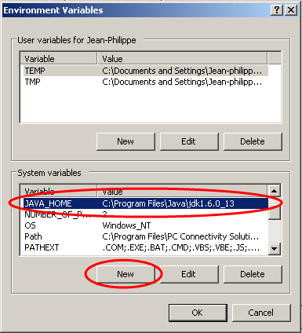

- Set the path: %JAVA_HOME%\bin or write down the actual java folder you have.

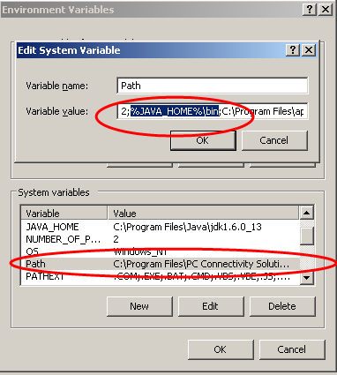

- Installing a compiler: Example with ANT
Go to google (www.google.com) and search for “Ant download”
Select the Binary distribution as shown below

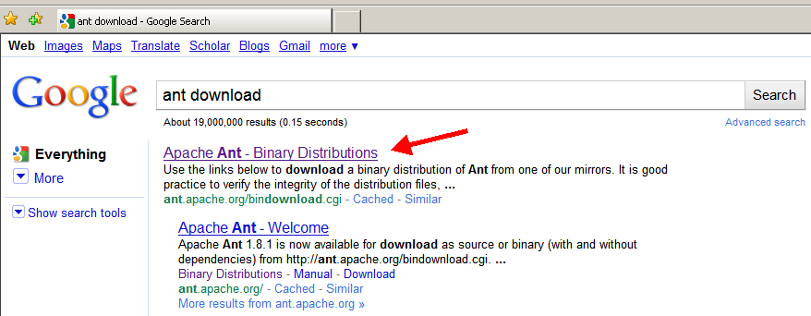

You will reach he following page
- Select the mirror of your choice to speed-up the download (#1)
- Then select the .zip archive (#2)

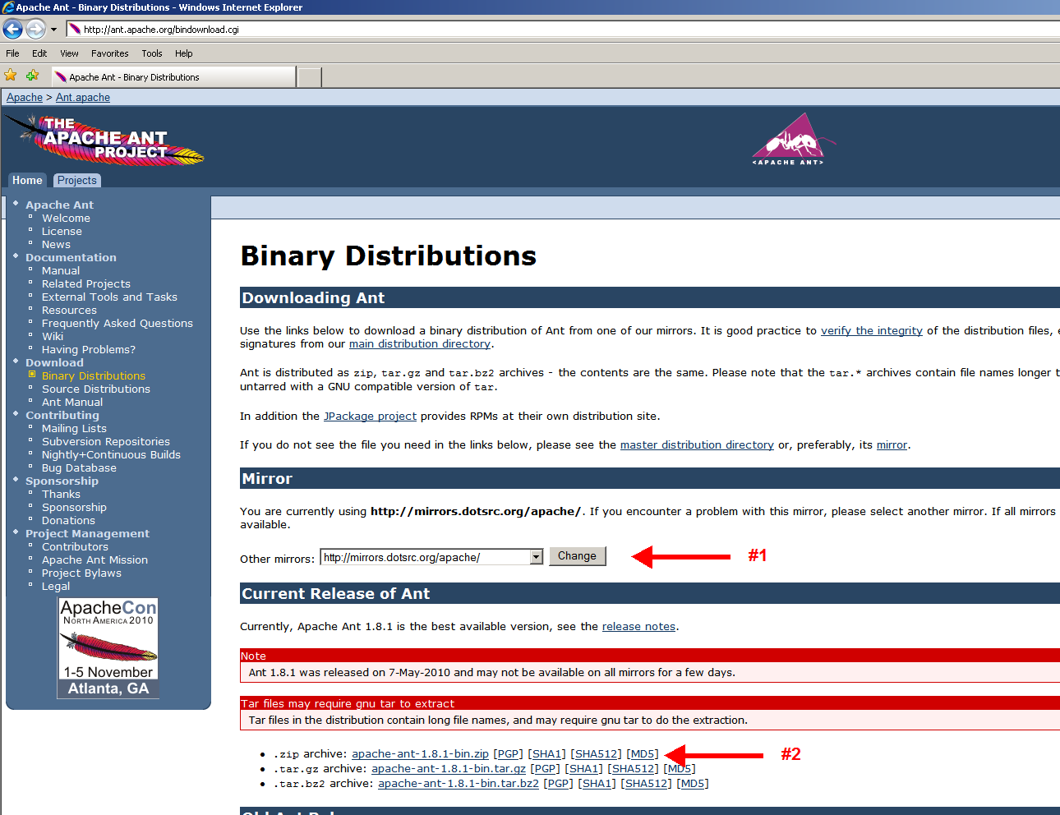

Save the binary zip file (#1) in any folder of your choice (in my example it is a Temp folder) (#2), make sure you have selected the right zip file (#3) and finally save it (#4).
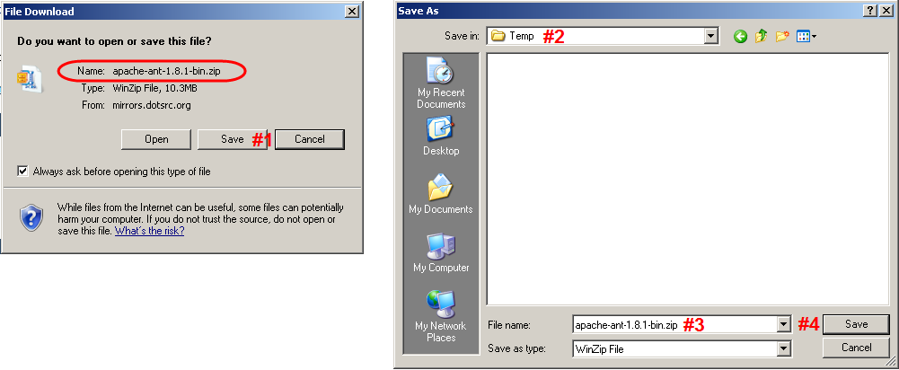

Meanwhile, you have opened a new window on your computer:
- Go to start (#1)
- Select run (#2)
- Write c: (#3)
- Press enter (#4)

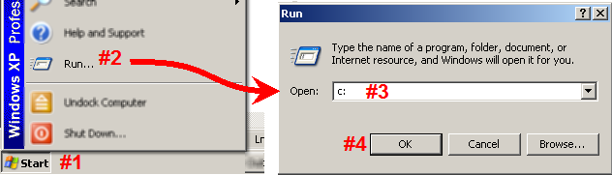

You need now to extract the .zip file into the c:/program
- Right click on the zip file
- Select Open with WinZip (#1)
- and select the content of the zip wich has been save as a folder.

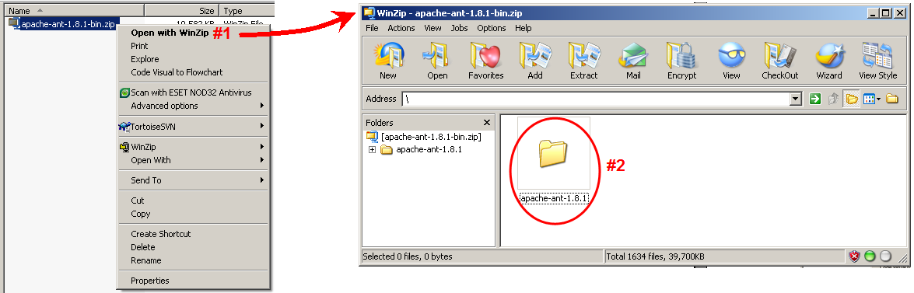

- drag and drop the folder into the c:/program (#3)
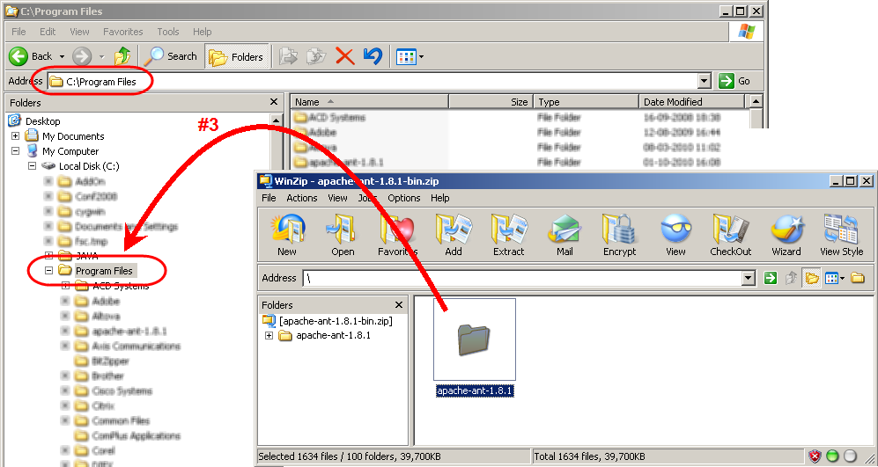

You can now see that a new folder is in your program files and now you have Ant installed on your machine

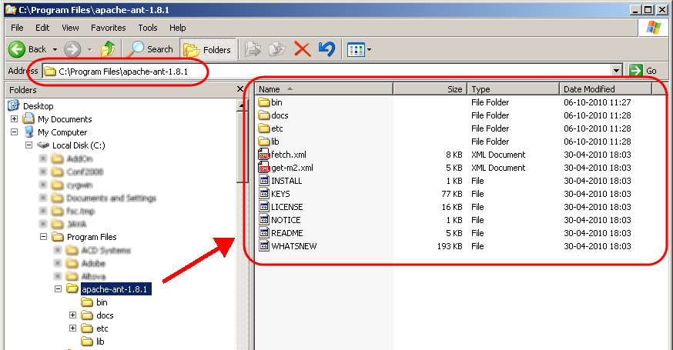

When compiling SEAMCAT, you need to be able to call Ant from anywhere in your tree-folder. Therefore you need to set the binary file of the Ant (i.e. the “bin” folder) (next section).

- Setting the System Path
Double click on the bin folder (so that you can copy paste: C:\Program Files\apache-ant-1.8.1\bin)
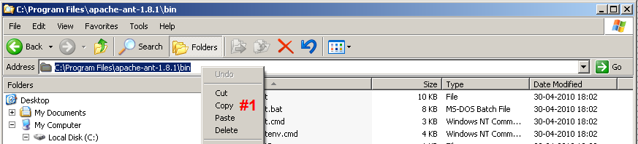

To change the System Path:
- Go to start (#1)
- Settings (#2)
- Control panel (#3)
- Select System (#4)

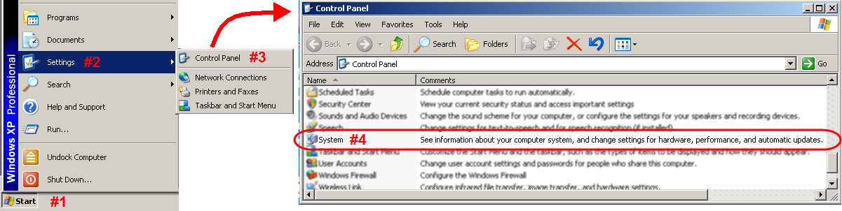

In the “System Properties”, select the “advanced” panel (#1) and the “Environment Variables” (#2).

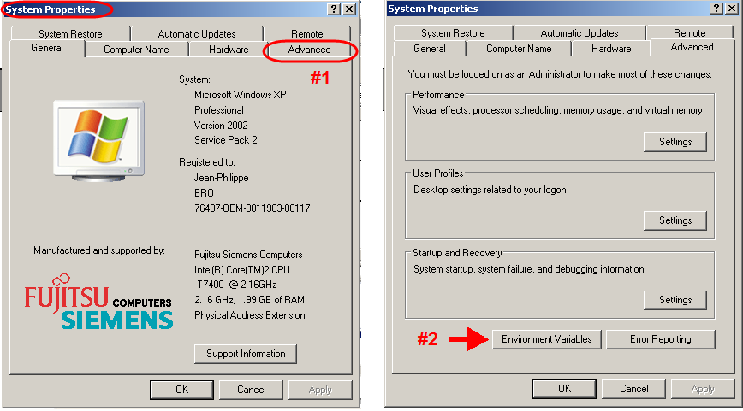
In the “Environment Variables”:
- Select the Path
- click on edit
- In the “Variabe Value” (#3)
- add a semi-column (;) at the end of the existing path (#4) and paste the path of the Ant-binary folder that you have copied earlier (C:\Program Files\apache-ant-1.8.1\bin).

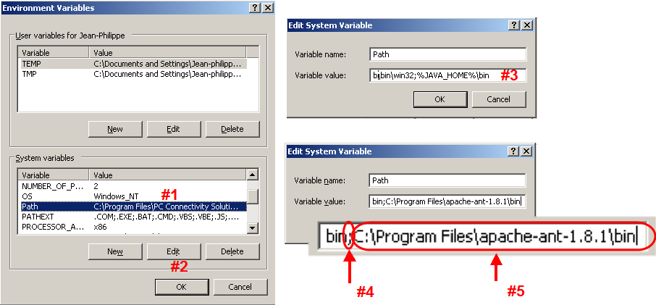

- Installing the source code package
- Upon receipt of the SEAMCAT zip package, save the zip file wherever you want (in this example, it is in a Temp folder) (#1)
- right click on the .zip file and select “Extract to the folder” (#2)

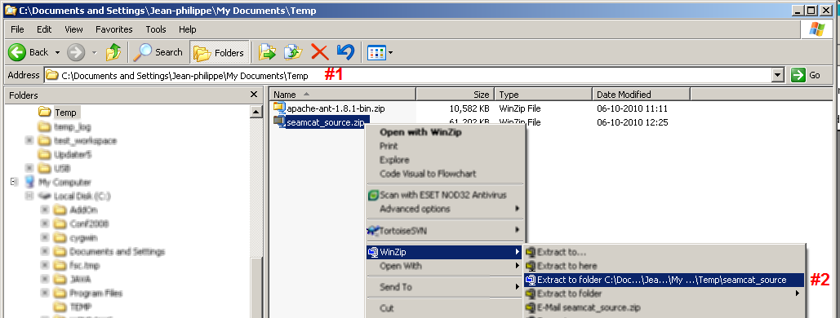

- Press enter and will see the file being extracted (#3)

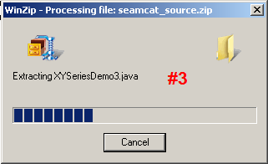

- It will create a new folder (#4)

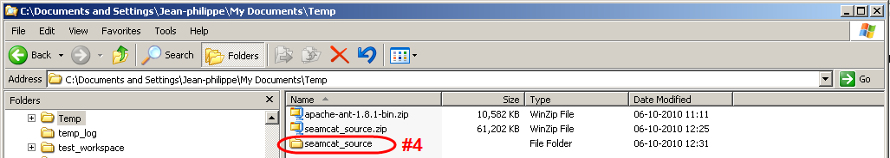

- Move the newly created folder wherever you want to have SEAMCAT runing. In this example, it is set directly under C: (c:\seamcat_source)

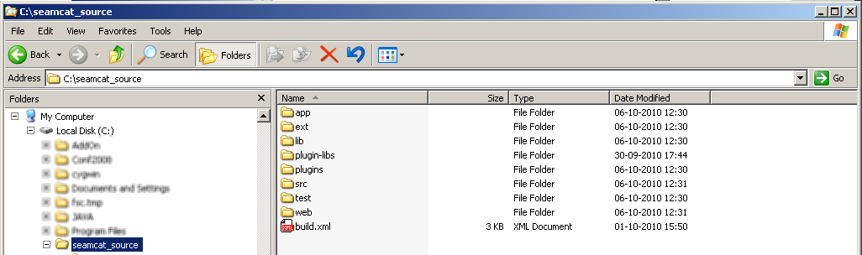
- Editing SEAMCAT: an example with ECLIPSE
Download Eclipse on your machine (go to google, and search for “eclipse download”), you will find the page http://www.eclipse.org/downloads/

- Select either the 32 or 64 Bit depending on your Operating System.
- Select the mirror site of your choice when asked.
- Uncompressed the downloaded file
- In the newly created folder, find the application “eclipse”, double click so that Eclipse can be installed on the machine. Under Eclipse top folder, you will see the run application “eclipse”, double click on it to run ECLIPSE.

Open Eclipse:

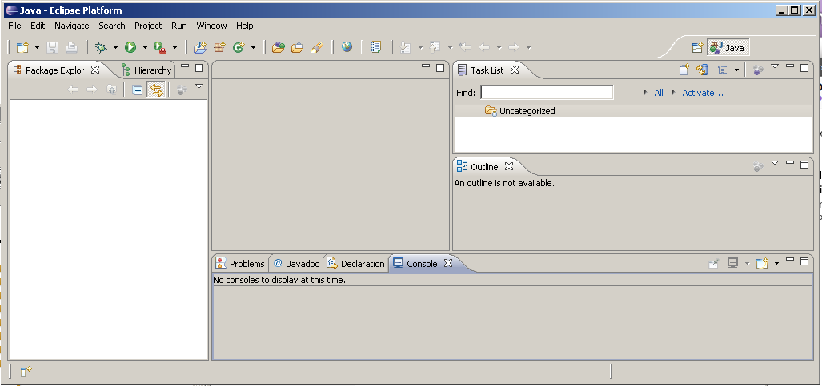

In the file menu:
- Select New (#1)
- Select Project (#2)

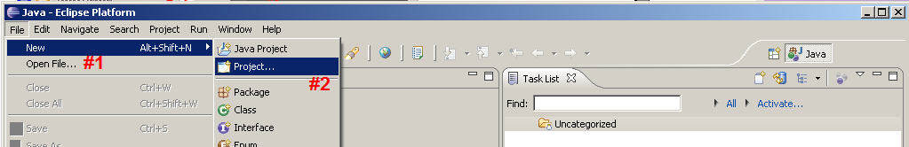

In the Wizard window:
- Select “Java” (#1)
- Select “Java Project from Existing Ant Buildfile” (#2)
- Press Next (#3)

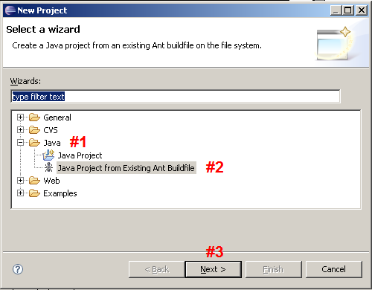

- Type the name you want to designat the project you are working with (i.e. you may different version of SEAMCAT in Eclipse (#1)
- Select Browse to find the build.xml file (#2)
- Find the correct folder where the build.xml file iss located (#3)
- Select the build.xml file (#4)
- Press open (#5)

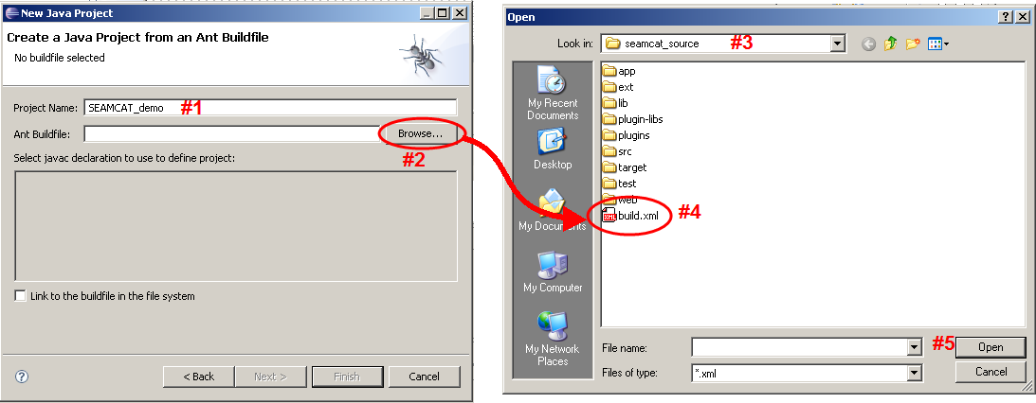

Select the first line (#1)
Press “finish” (#2)

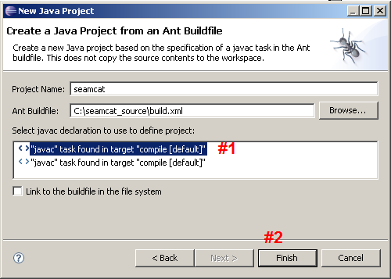

Eclipse is now building the workspace

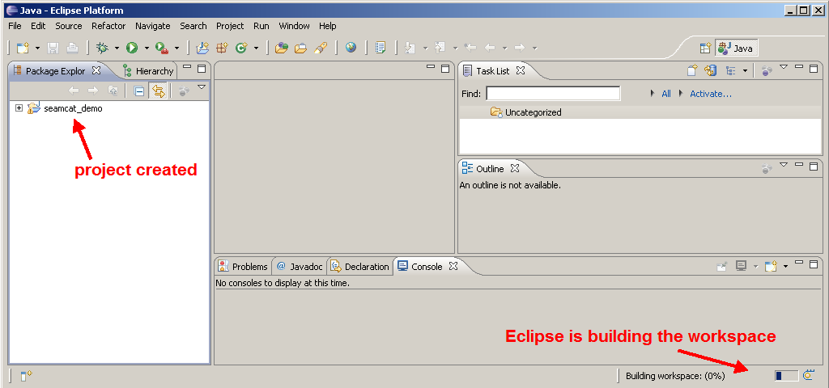

You have now access to all the source code of SEAMCAT. This will allow you to further develop the tool.

Contact the seamcat@ero.dk when you have developed new codes for STG to test.

- Adding a library to SEAMCAT
This instruction details how to add a new library for the project. It is exemplified with a library called jfreec.jar. All file references in this example are relative to the root folder of the project.

To add a new library to the Eclipse project

- After downloading the .jar file copy it to the folder app/lib/.
- In Eclipse in the package explorer right-click on the SEAMCAT project and select "Properties"
- On the left select the "Java Build Path" (#1) and in the Java Build Path window select the tab "Libraries" (#2).
- Click "Add JARs..." (#3)
- In the file dialog popup select the newly added file in the app/lib/ folder.
- The new library is added to the list (#4)

If it is not present in the list, try a refresh on the lib folder in the project.

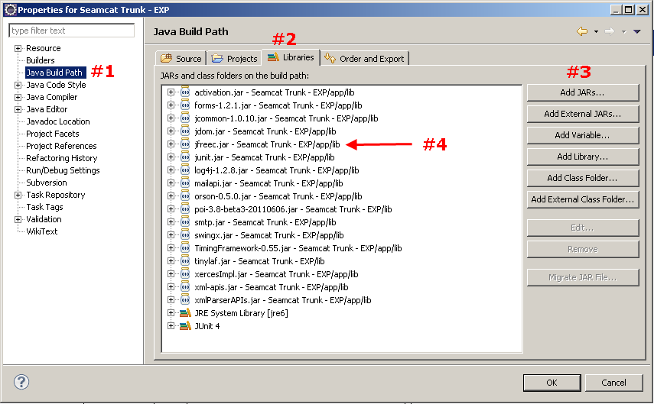

- Packages needed for plugins
All packages needed to run workspaces considering plugins are provided by the seamcat_neded_for_plugin.jar file.
This file is automatically generated running an official version of SEAMCAT and saved onto the default SEAMCAT plugin folder and then afterwards used by SEAMCAT during the simulation.

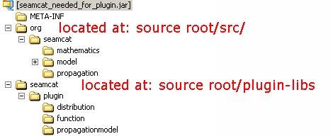
Figure 8.1 Packages needed for plugins

The same packages are needed for writing the valid code for plugins. Due to fact that the jar file on the default plugin folder is replaced by an empty file when running SEAMCAT from the source code you have to ensure that the packages are unchanged and available within your development environment.

You have three options: Either you include in your “java build path” the plugin libs or you copy the origin jar file onto e.g. your source folder or you generate your own (i.e. local) “seamcat_needed_for_plugin.jar”, respectively.
  - Option 1 (recommended):
You can add in the “Java Build Path” (#1), specifically in the source (#2), the plugin-libs (#3). This library package contains the necessary information that is additionally to the ‘org’ packages required (see Figure 8.1 above).
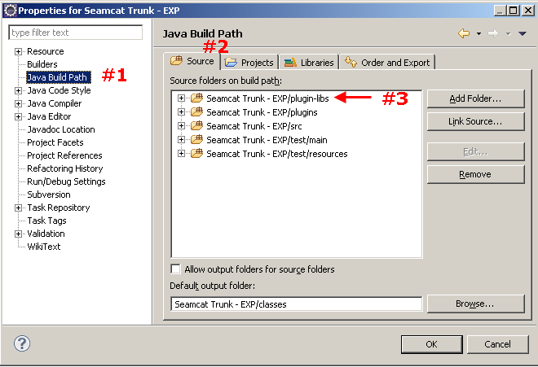
Figure 8.2 Java Build Path

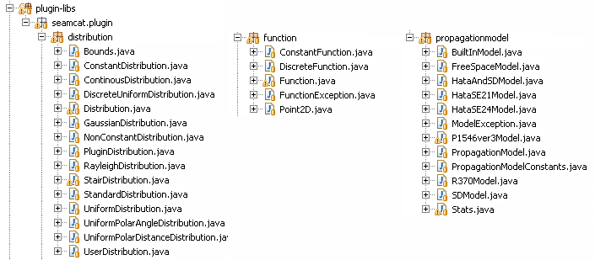
Figure 8.3 Content of the plugin-libs
  - Option 2:
After running an official version of SEAMCAT at least once and before opening your SEAMCAT project, copy the so automatically generated original of seamcat_needed_for_plugin.jar onto e.g. the root folder of your SEAMCAT project. Then you have to add it as library as described in Section 7 above.

  - Option 3:
Alternatively you can generate your own (i.e. local) “seamcat_needed_for_plugin.jar”, run the ant target from the command line.

This is done by opening a command line and going to the root folder of the SEAMCAT project (i.e. where the build.xml is located).

Run the command: ant pluginjar.

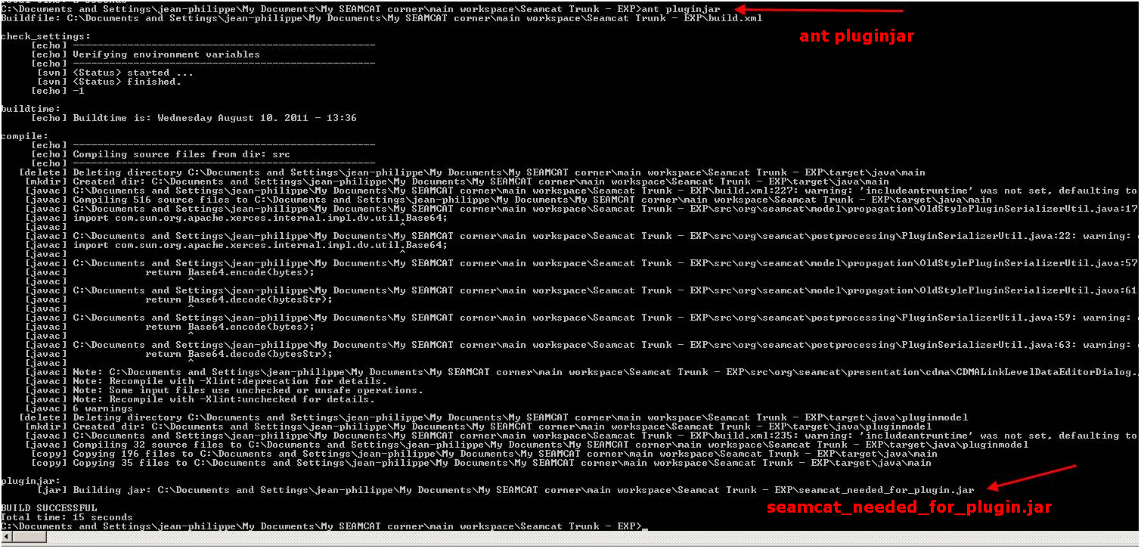
Figure 8.3: Creating a local copy of seamcat_needed_for_plugin.jar

The generated file is saved onto the root folder of your SEAMCAT project. You have to add it as library as described in Section 7 above.

- Updating JAVA in ECLIPSE
If you update the JAVA version on your machine and you have Eclipse already installed you will need to update the installed JRE from Eclipse. The following is an example with JDK 6 update 13 (development kit)

- Open Eclipse
- Select “window” #1
- Select “Preferences” (#2)

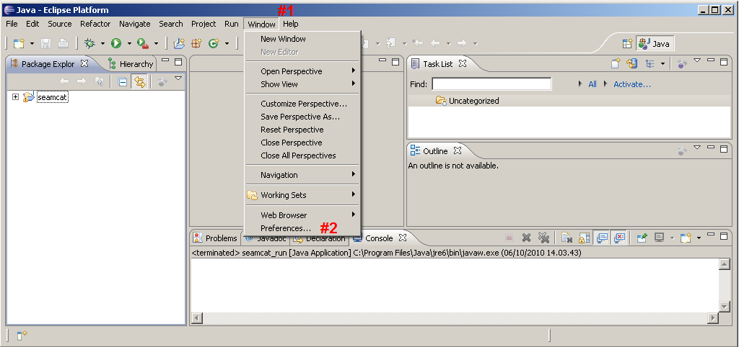

- In the filter (#3)

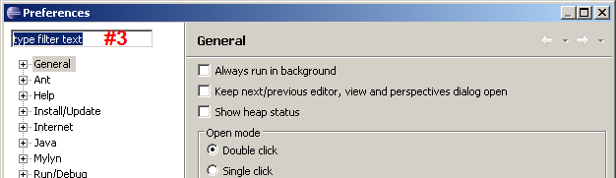

- Type JRE ()#4
- select the “installed JREs” (#5)
- if the JAVA version you want is not in the list then click “add” (#6)
- Add JRE window open and click on “browse…”(#7)
- Select the C: drive (#8), program files (#9) and java/ jdk1.6.0_13 (#10)
- Click ok (#11)
- Close the JRE window (#12)
- Select/deselect the java you want/do not want (#13)

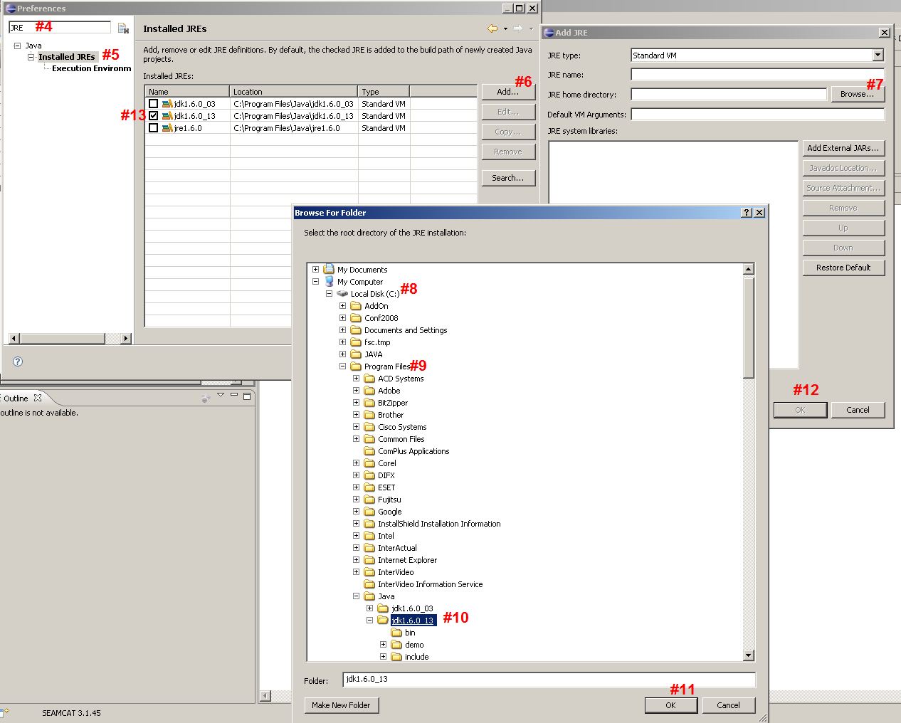

- Compiling and running SEAMCAT
You can compile SEAMCAT using two ways, either using Ant from the command line or directly from Eclipse.
  - Using Ant
In this example we will use ANT to compile SEAMCAT. The procedure is as follow:
- Go to “Start” (#1)
- select “run” (#2)
- type: cmd (#3)
- press “ok” (#4)
- this will prompt the DOS command line (#5)

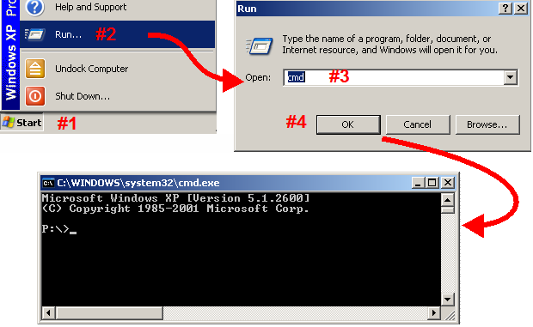

- you may need to change the disk where you are being prompted. Go to C: (#1)
- find the folder where SEAMCAT has been installed (here it is c:\seamcat_source) (#2)
- to built SEAMCAT, type: ant (#3)

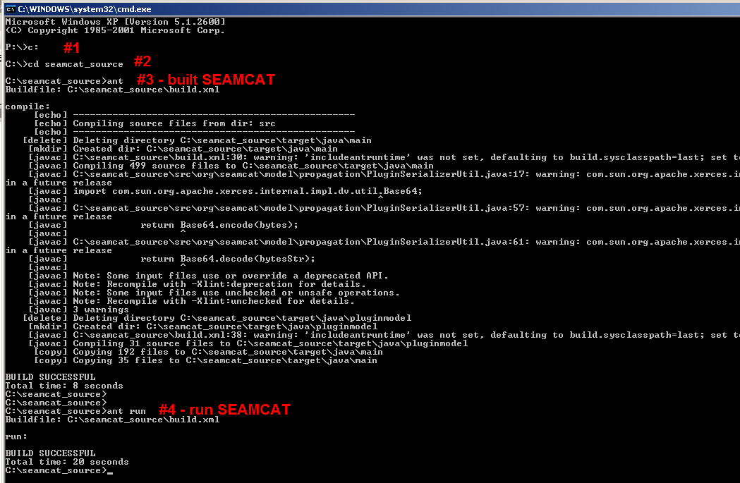

- to run SEAMCAT, type: ant run (#4)

  - Using Eclipse
Provided the steps of Section 2, Section 4 and Section 5have been done accordingly and Eclipse has been installed, follow these steps:
    - Method 1

- Start Eclipse and select as workspace that folder you extracted the source code onto.

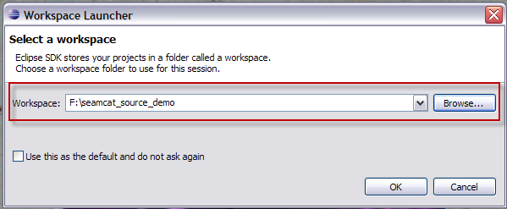

- On the Welcome window go to Workbench (you can also close the Welcome to eclipse window)

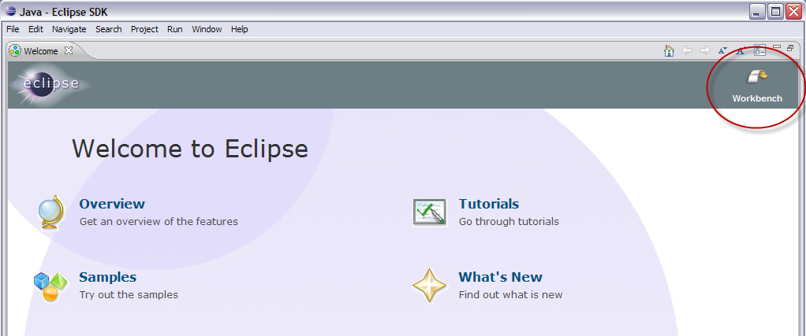

- Select ‘New -> Project’

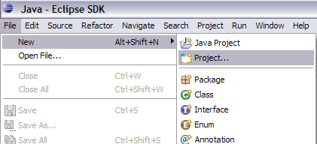
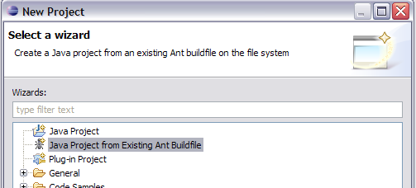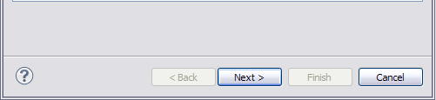

- Press ‘Next’ and browse on your source code folder ‘build.xml’

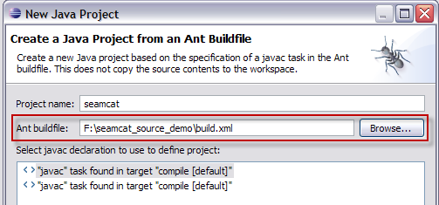


Pressing ‘Finish’ Eclipse starts to build the workspace
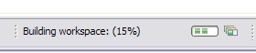

- Open the file ‘seamcat.java’

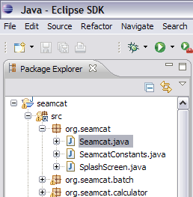

and run as “Java Application”

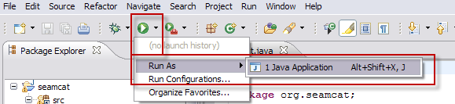

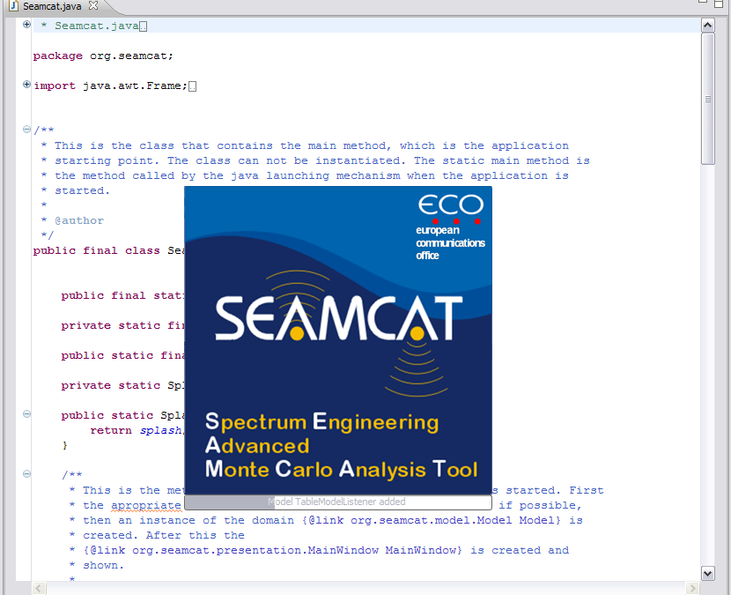

    - Method 2

Another method to run SEAMCAT is to access the “Open Run Dialog”

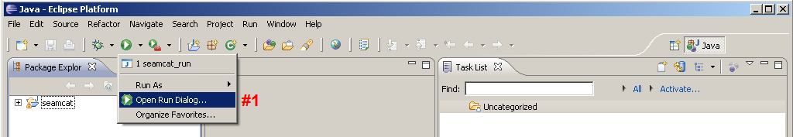
or
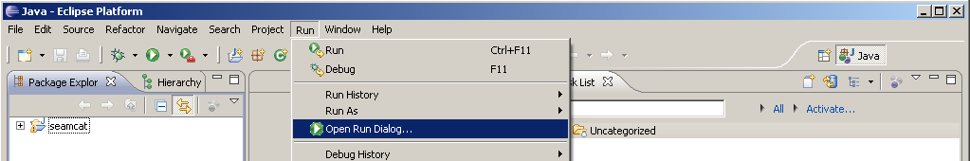

When opened, you will be prompted witht the following:
In the Main window:
- To create a new configuration (#1)
- Select the configuration (#2)
- Set a name (#3)
- Select the “Main” dialog box (#4)
- Select the Project name (#5)
- Find the “Main class” using the Search button, or type it (org.seamcat.Seamcat). (#6)

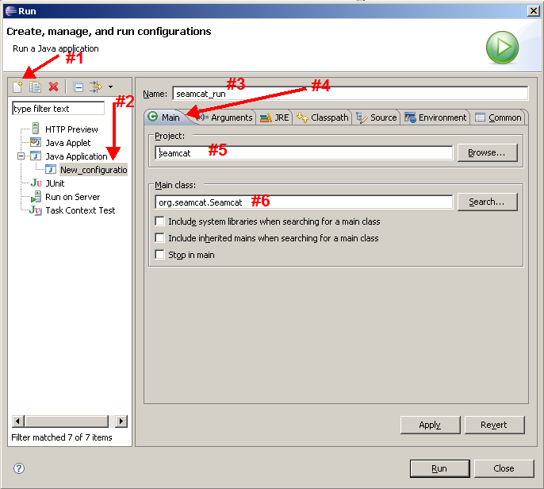

    - Run application memory settings

Note: In both methods described above, do not forget to set the memory of the run application.

In the Arguments window (#1), add the –Xmx512m or –Xm1024m to determine how much memory SEAMCAT has (#2), apply (#3).

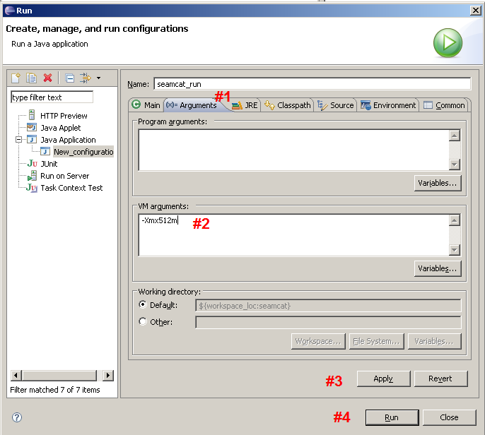

When clicking on #4, this should launch SEAMCAT from Eclipse
- SEAMCAT in ECLIPSE debug mode
Since you have installed the source code on your machine using ECLIPSE, you can now run SEAMCAT in debug mode where you can check each line code using step-by-step.

A good tutorial is available here
http://www.ibm.com/developerworks/library/os-ecbug/

Also another source of learning ECLIPSE from the open community, is to go on www.youtube.com and search for “Eclipse tutorial” (or similar kind of search).

The following description is a very brief and concise guidance you on how to use SEAMCAT in a debug mode.

- First, you need to set some breakpoint in the source code you want to investigate (there is no restriction in the number of break point you want.). For this, put your cursor on the left hand side of the editor, in the line number area, and right click at the line you want to check.

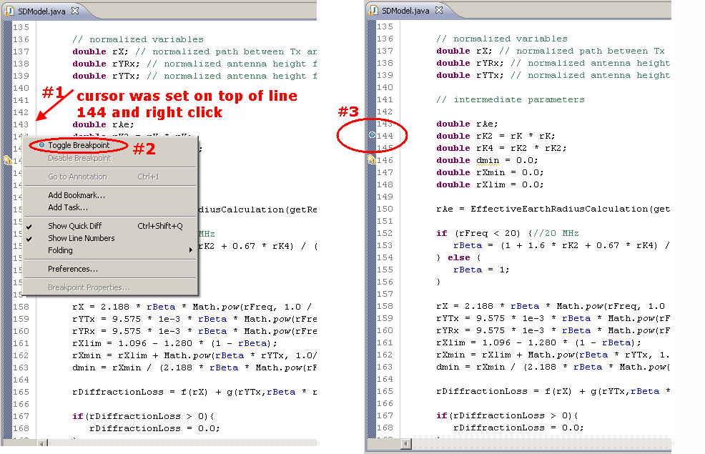
- Now you can run SEAMCAT in debug mode
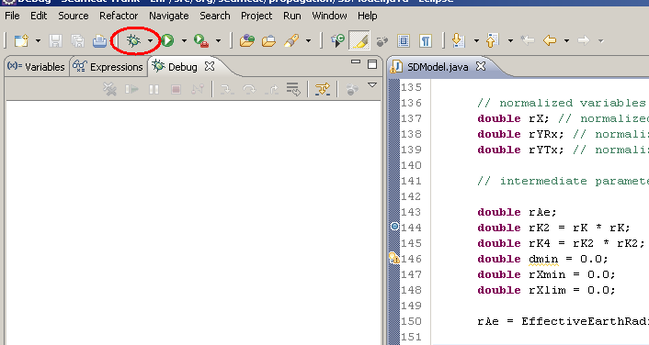
- when SEAMCAT is running you will see the following
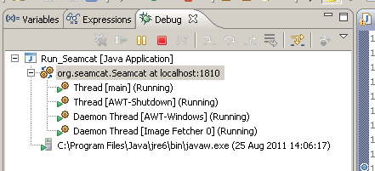
If you want to kill the process (if it is hanging for instance) then click on the red square. It will terminate your SEAMCAT session.
- Either during the loading of SEAMCAT or running a workspace, Eclipse will give you the following opportunity to step into the code when the code line that you have selected is reached. The line code being processed in highlighted in green.
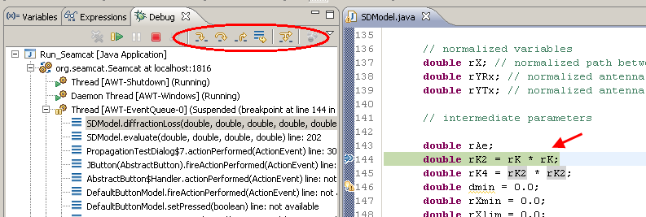

The basic commands are as follow:
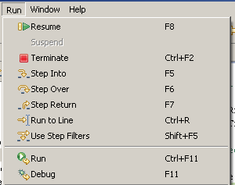

- Maven in ECLIPSE – SEAMCAT 5.0.0
  - Install maven in Eclipse
To install maven in eclipse (http://www.eclipse.org/m2e/) go to help and select “install new software”.

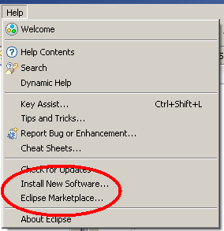

A good link at http://www.himainc.com/files/m2e.pdf

Then when you have maven, you need to import the project that you have downloaded from the ECO server

  - Import an existing project
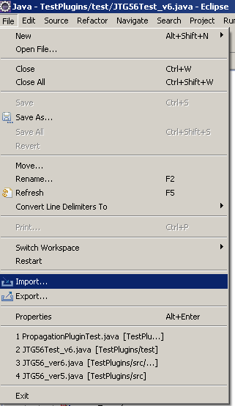

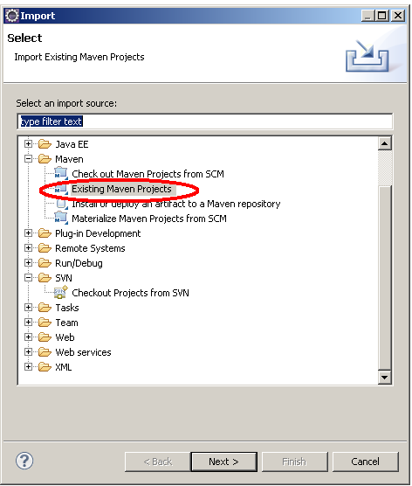

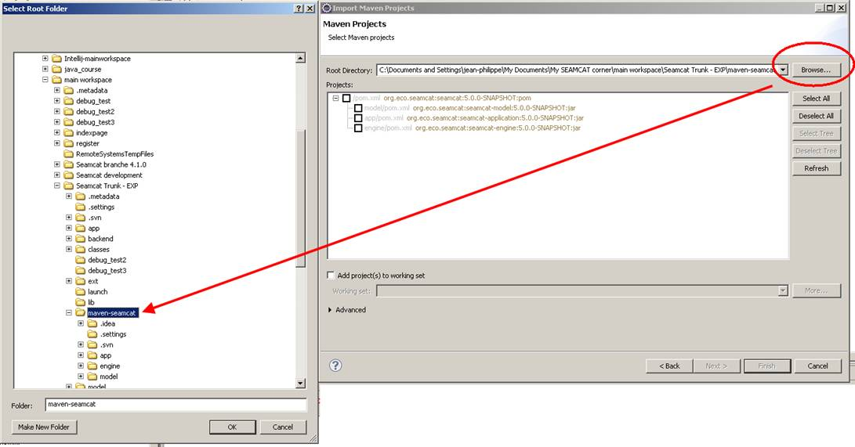

You end up with

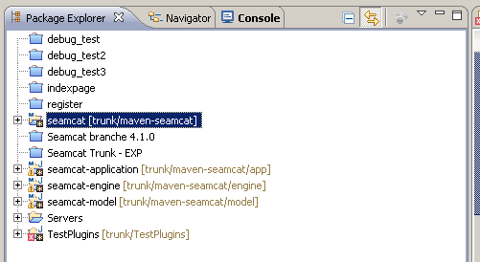

Check also the builder
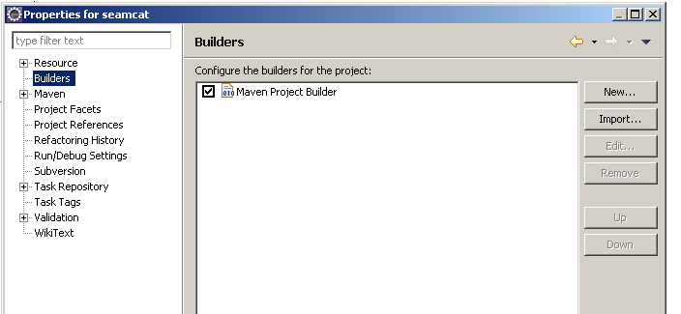

  - Run maven project in Eclipse
To run it

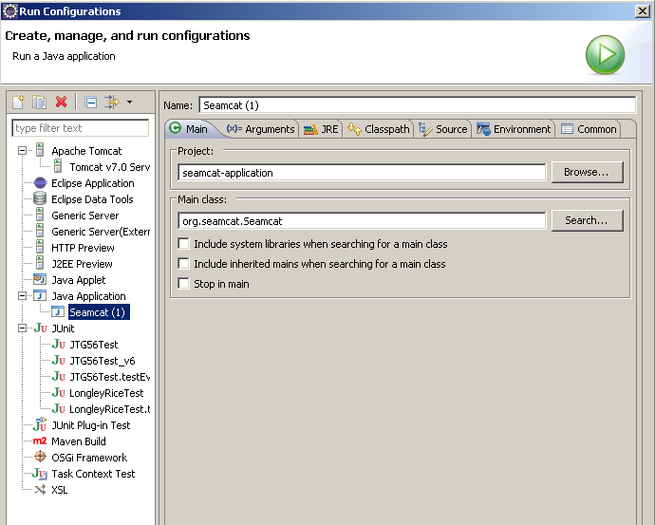

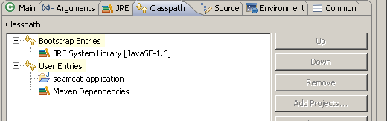

  - Problem with the dependencies in Eclipse
It may happen that Eclipse complains with the following
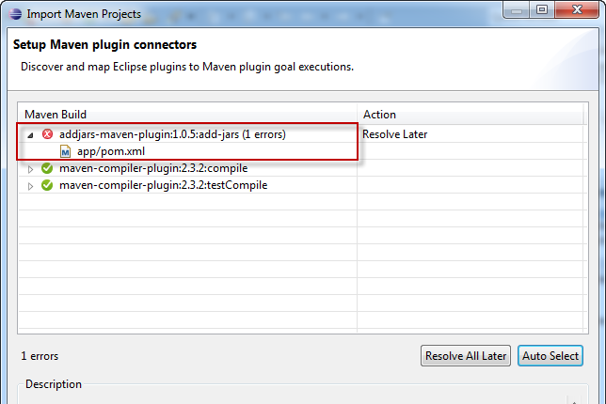

Edit the app/pom.xml (the problematic one) and comment out the below lines.
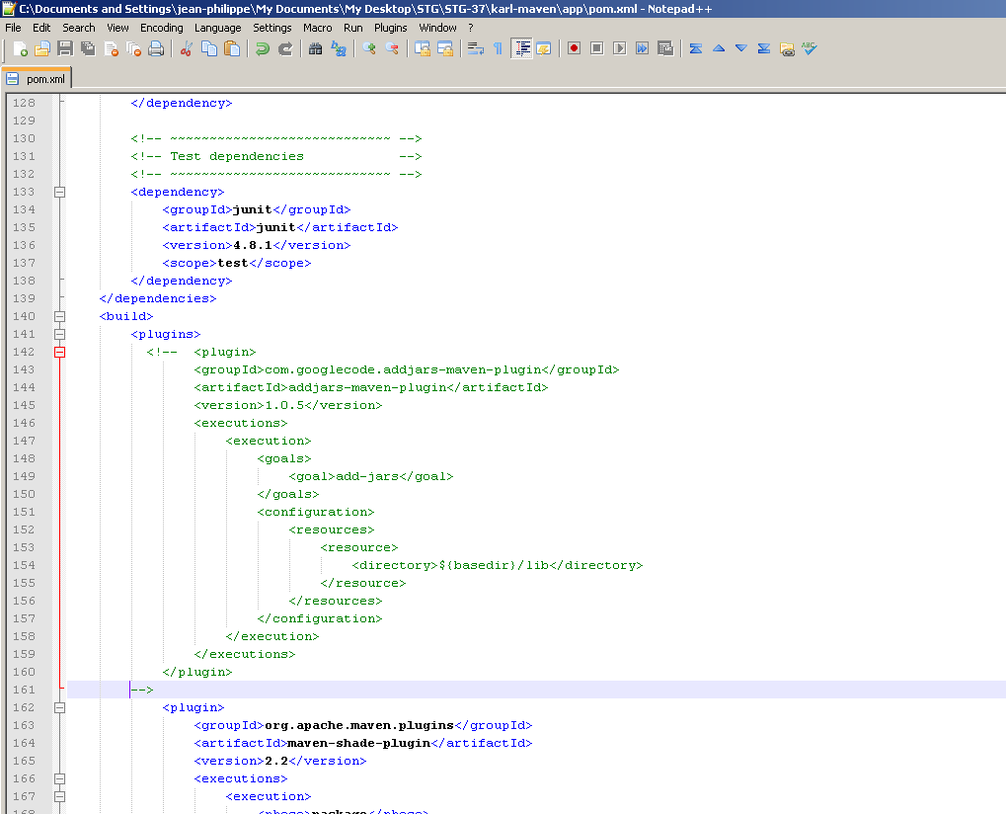

- SEAMCAT in IntelliJ Idea
  - Install JDK and IntelliJIdea
Prior to installing IntelliJIdea, you need to have a Java Development Kit (JDK) installed on your machine.

Step 1: Java Development Kit (JDK):
http://www.oracle.com/technetwork/java/javase/downloads/jdk8-downloads-2133151.html

Select the JDK adapted to your operating system.
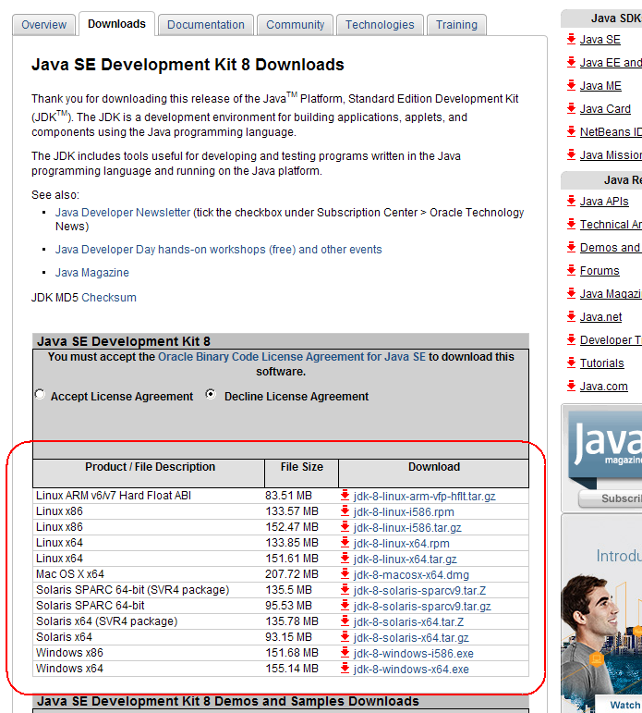

Step 2: IntelliJIdea:
http://www.jetbrains.com/idea/download/

Select the free version ☺ (screen shot taken in April 2014)

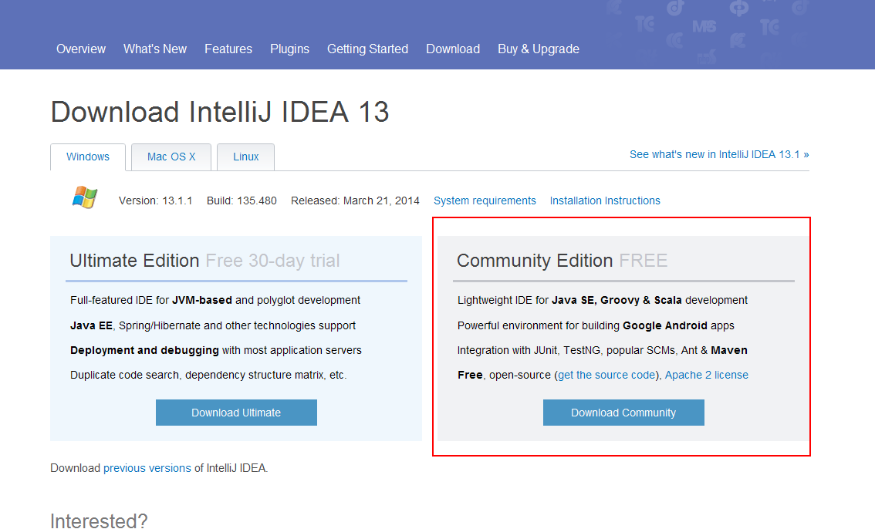

  - Map JDK and IntelliJIdea
When both softwares are installed on your machine, you need to map inbtelliJIdea to your JDJ.
For this go to the project structure
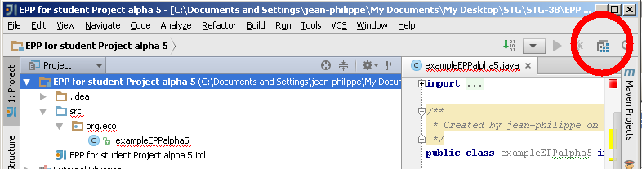

In this example the jdk 1.7 is shown because the maping has been done.
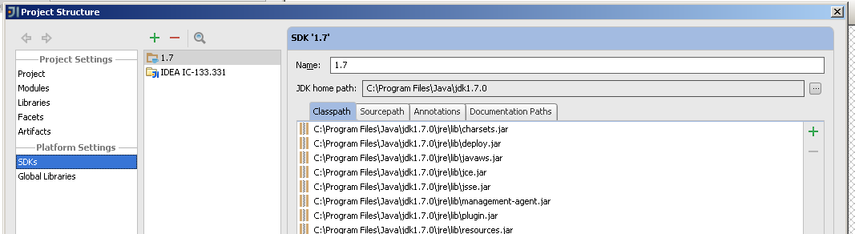

If it is the first time you will need to add it
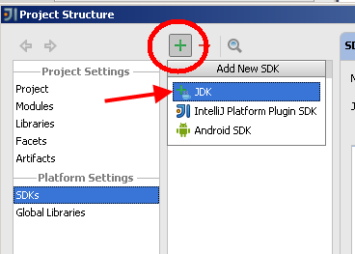

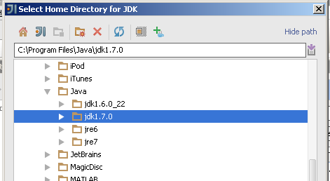
  - Install SEAMCAT

Click “File” and “open”

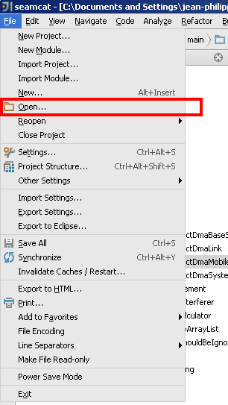

Select the project file “pom.xml” file
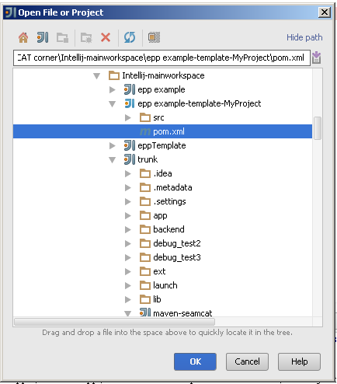

Click yes
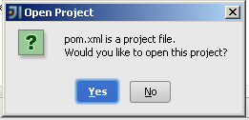

And select a new window

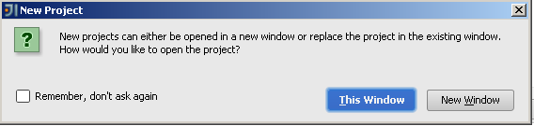

You get the following
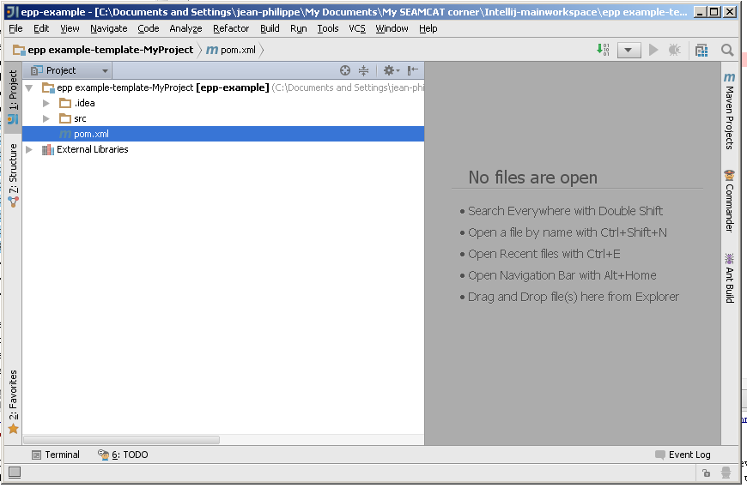

You are ready now to launch SEAMCAT (see next section)
  - Create a run configuration to launch SEAMCAT
To run SEAMCAT in intelliJ, open the seamcat.java (CTRL+N “seamcat”) and then right click on the class name “seamcat”

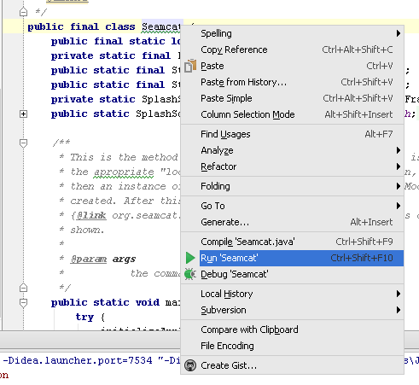

Or directly on the folder structure as shown below
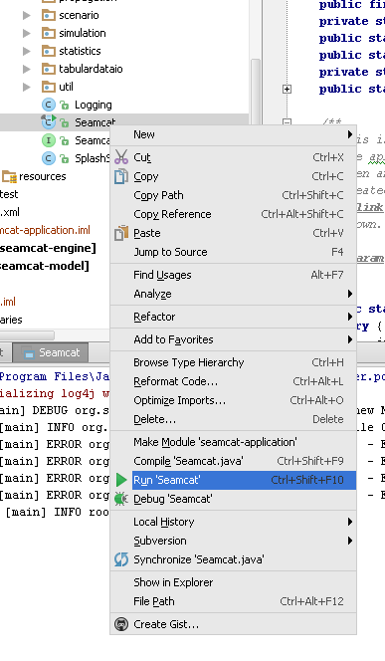

  - Tips on the editor
Find classes: Ctrl + N
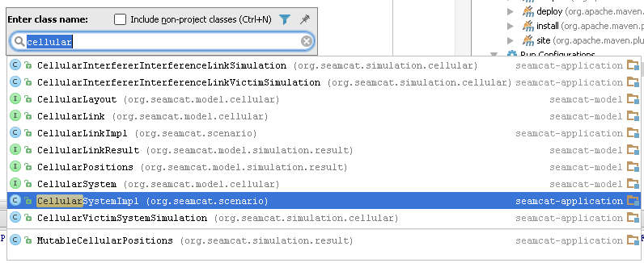

Find usage

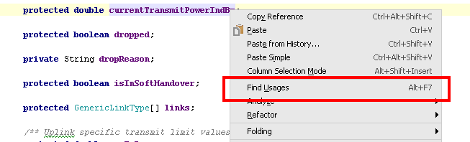

To find the .java file in the overall project

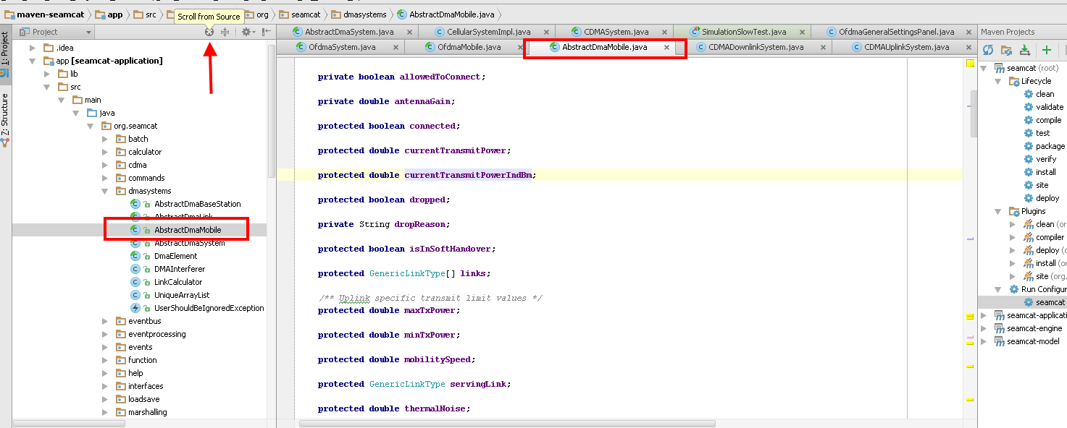

Debug mode

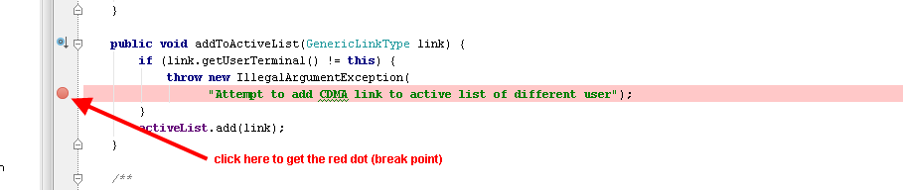

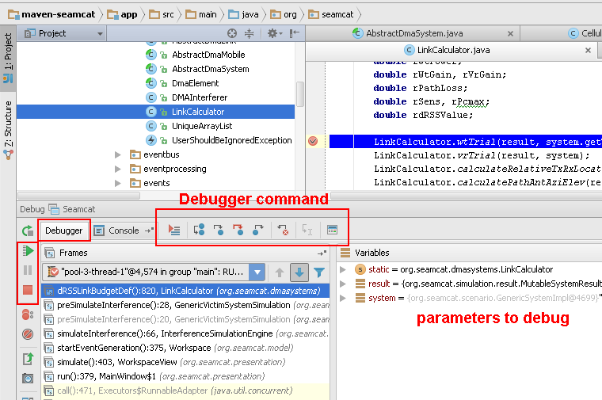

Expression evaluation

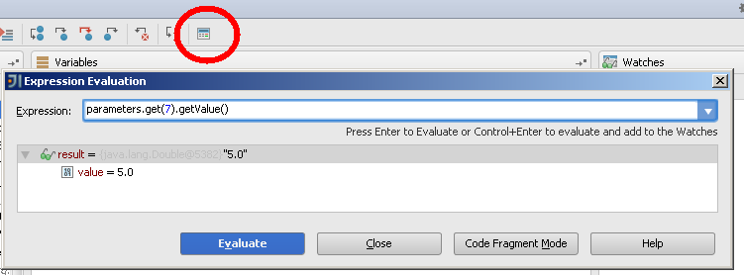

Search for string in the project

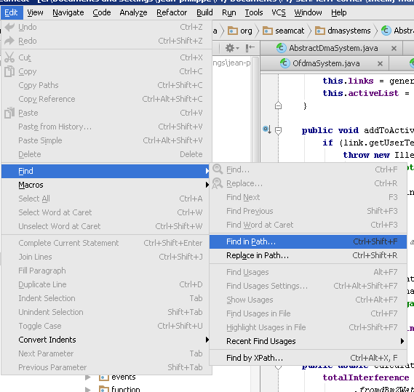

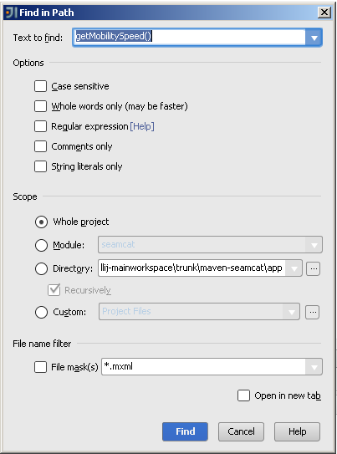

- How to create a project in IntelliJ Idea
  - Create a project
Create a new project
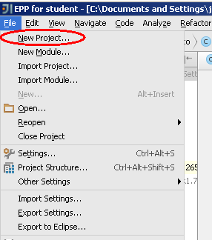

Set a project name and project location
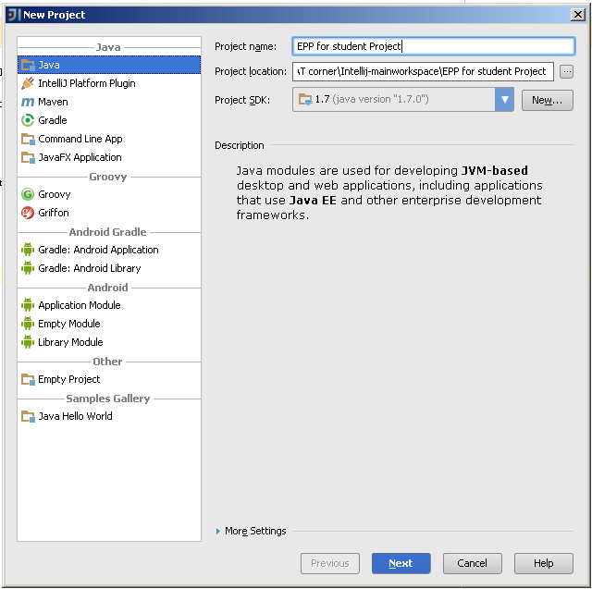

Click next. Don’t select Groovy. Click finish
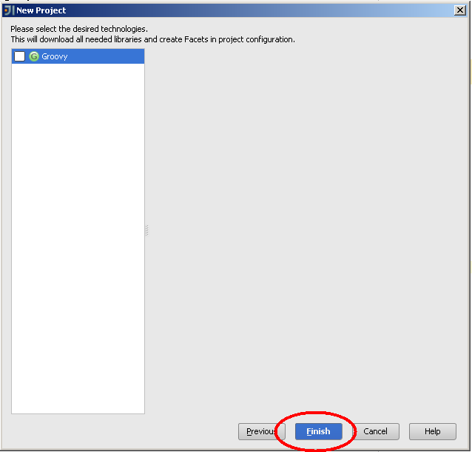

Select the project in a new window
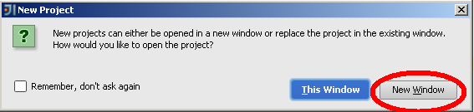

Now you need to insert the library seamcat-plugin-5.0.0 xxx. This file is needed if you want to be able to see the SEAMCAT model interface.

Go to “Open Module Settings”

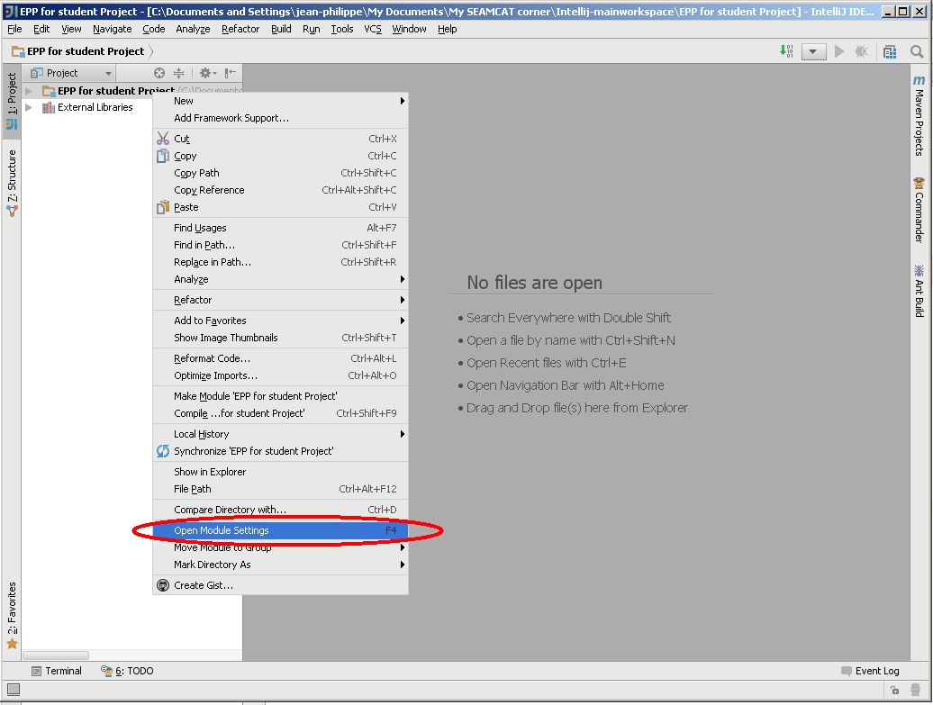

Click the green cross on the right handside and select “Jar or directories”
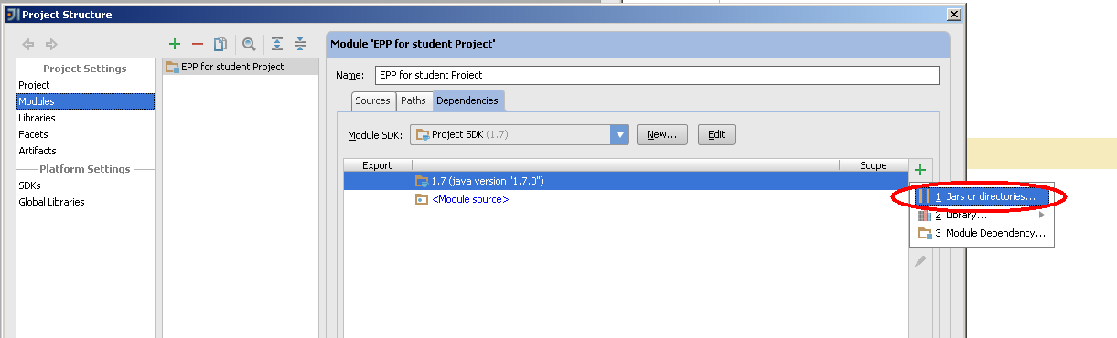

Go and fetch the .jar file from your file system (you need to download it from the official SEAMCAT web page to get the latest version)
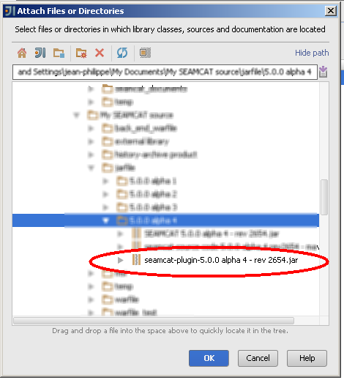

It is displayed as below under dependencies
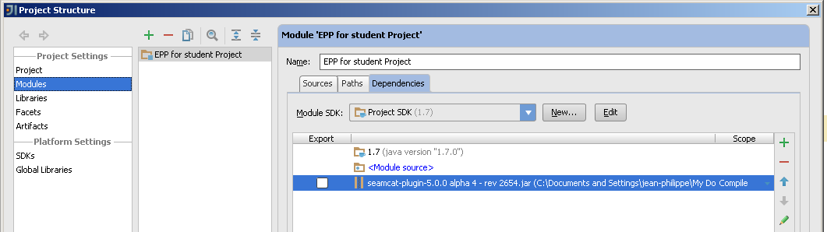

You can also see it under the “External Libraries”, just below your project
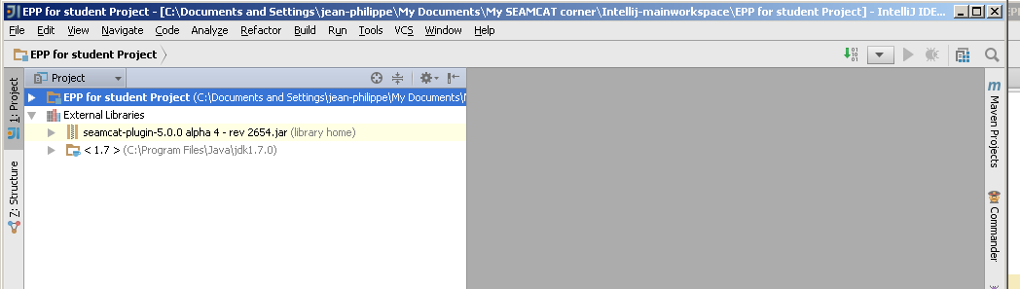

  - Create a package and a class file
Go under src and right click
Select Package.
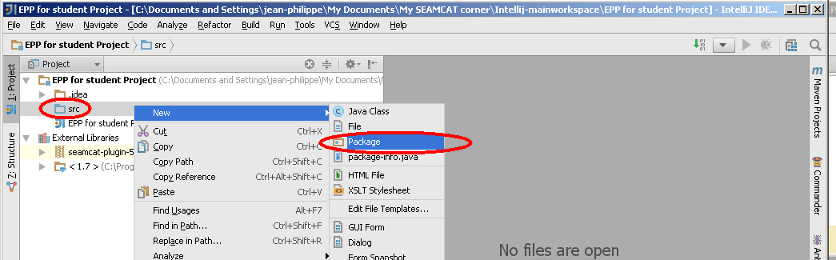

As an example it is called org.eco, but you can choose whatever name you want.
Remember that when you include your plugin into SEAMCAT, it will need to follow the naming of the package (see the last graphic to embed your class file into a jar file manually)
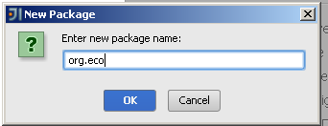

Under the package that you have just created, you can now create your java class.
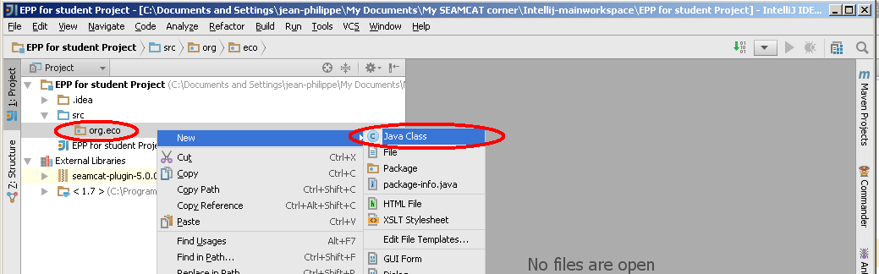

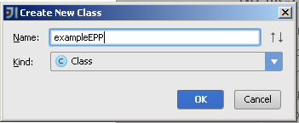

  - Your first step in creating an EPP
When you have created your java class, IntellJ Idea will generate a template as shown below
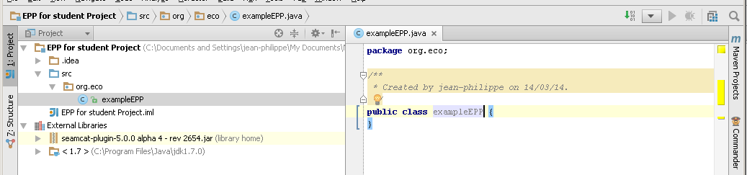

You need to implement the EventProcessingPlugin (EPP)

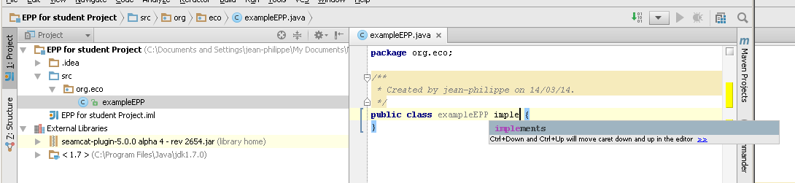

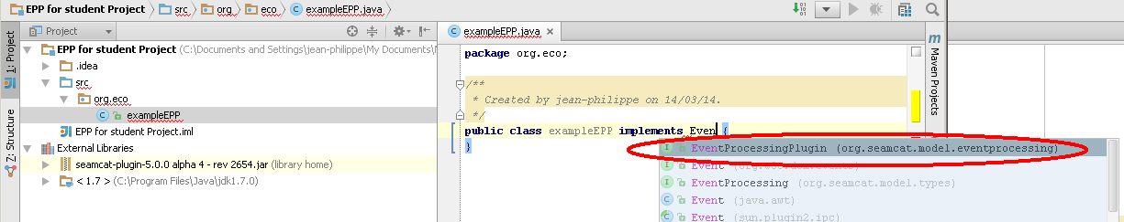
SO far there is an error because you need to implement the method.
- Press Alt + enter to see the option to fix the problem
- Select “Implement Methods”
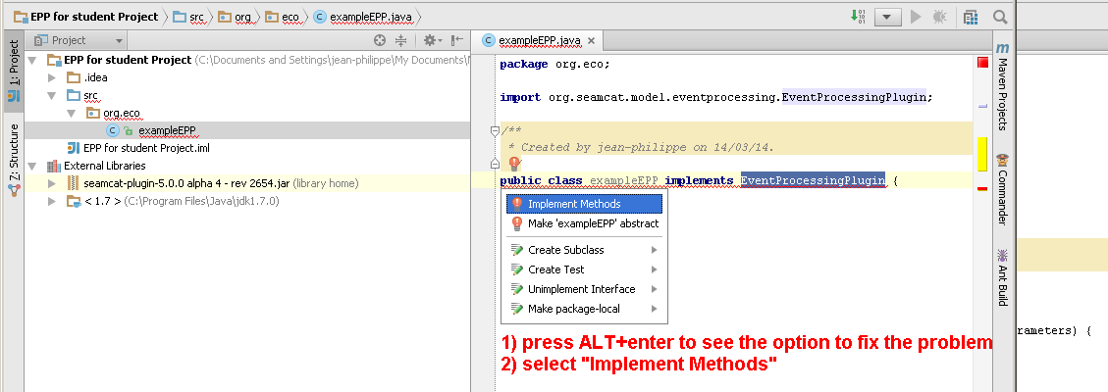

Select all the method and click ok
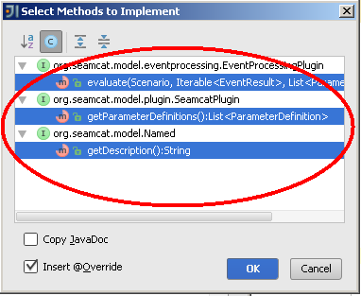

You are now ready to write your EPP.
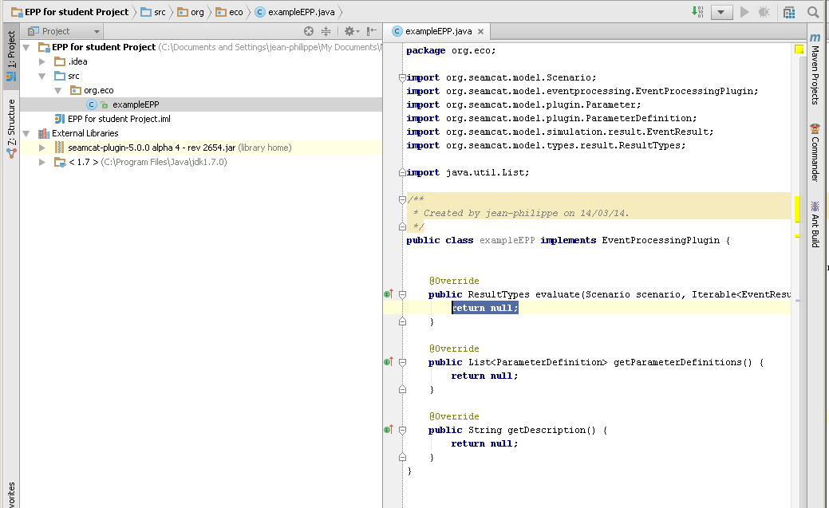

When you are done, you need to compile your code.
Right click the name of your java class and select compile.
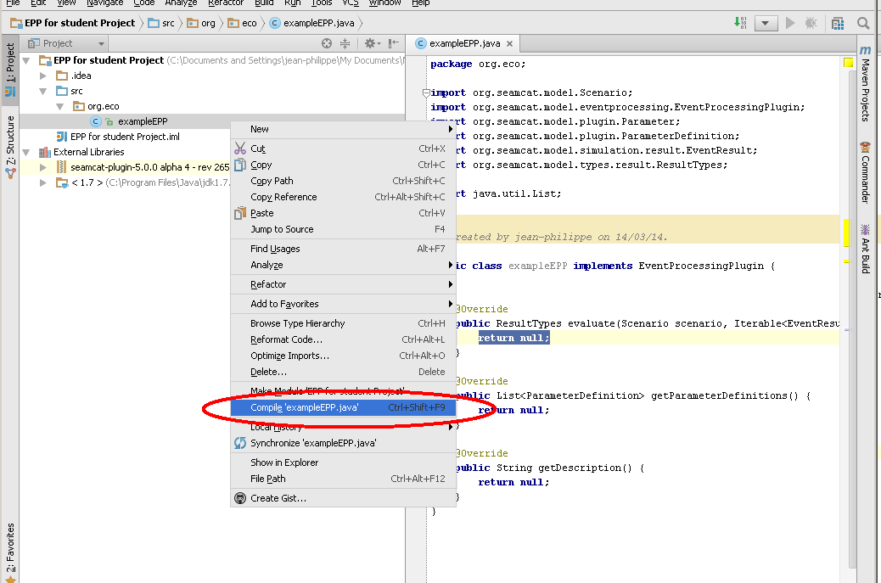

You will find your class file under the “Out” folder that is automatically generated.
Remember that you need to include the .class file into a .jar file.
To make the .jar file un-corrupted (or legal) you need to respect the package convention. So in this case you need, in your file system, to zip the folder “org”.
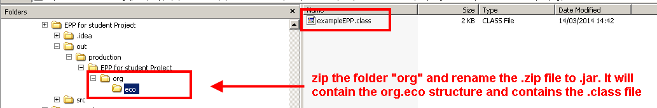
Then change the extension of the file from .zip to .jar.

That is it, you are now ready to include your EPP in SEAMCAT!!!

