**STG(14)35**

|  |  |  |  |
| --- | --- | --- | --- |
|  | | |  |
| **STG #39**  **WGSE - SEAMCAT Technical Group**  **Copenhagen, ECO**  **10-11 June 2014** | | |  |
| **Date Issued: 17 April 2014**  **Source : Karl Koch**  **Subject:**  blocking in case co-channel is simulated | | | |
| **Document:** ~~for discussion/for information~~/for action | | | |
| Password protection required? (Y/N) | N |

|  |
| --- |
| Summary:  In case co-channel is (e.g. randomly) simulated the current implementation calculates also the iRSSblocking taking the values defined by the blocking mask. Depending on the values of the blocking mask this causes wrong results. |
| Proposal:   * STG is invited to consider the necessary changes of the implemented blocking calculation by excluding the overlapping frequency ranges of the VLR bandwidth and the ILT bandwidth[1]. * At least the [User Manual](http://tractool.seamcat.org/wiki/Manual/Algorithms/Basics/BlockingAttenuation) shall modified accordingly. |
| Background:  See below |

.

###### Background

Without thinking about the possible co-channel situation, which might occur if for instance the frequencies are randomly distributed, usually one defines for the wanted frequency range of the bandwidth of the VLR a blocking attenuation of 0 dB. This is e.g. also done for the default blocking mask for PMSE below:

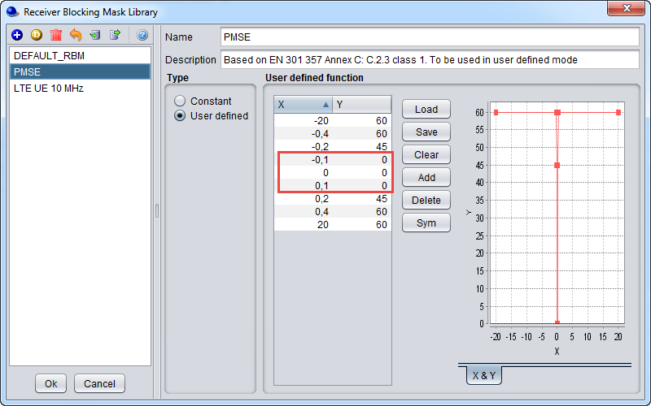

Figure 1: default blocking mask PMSE

SEAMCAT calculates the resulting iRSSblocking as follows:

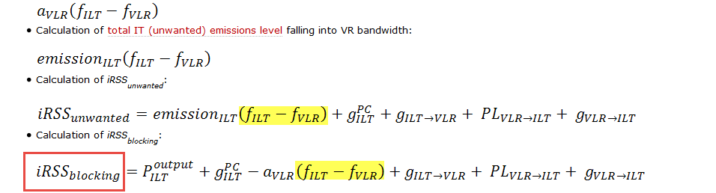

It is obvious that in case is within the range -0.1 ... 0.1the total power of the ILT is used for the calculation of the impact due to blocking.

As a workaround for the current implementation one could define the blocking values accordingly, for instance as shown below:

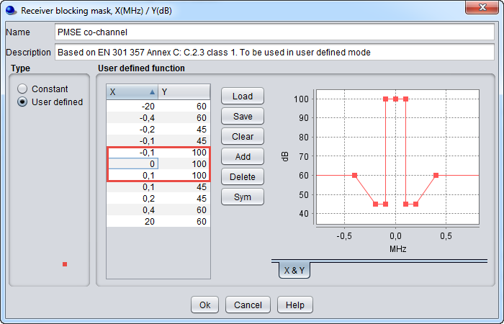

Figure 2: modified blocking mask PMSE

###### Remark

The proposed algorithm for the calculation of an integrated blocking value which takes account of the bandwidth of the ILT and the shape of the blocking mask (*action point from the last STG meeting, not yet approved by STG; cross-check with ANFR is pending*) goes a step further. It additionally considers the overlapping ranges of both bandwidths, of the VLR as well as the ILT. The result in terms of user defined blocking response is shown below for one example:

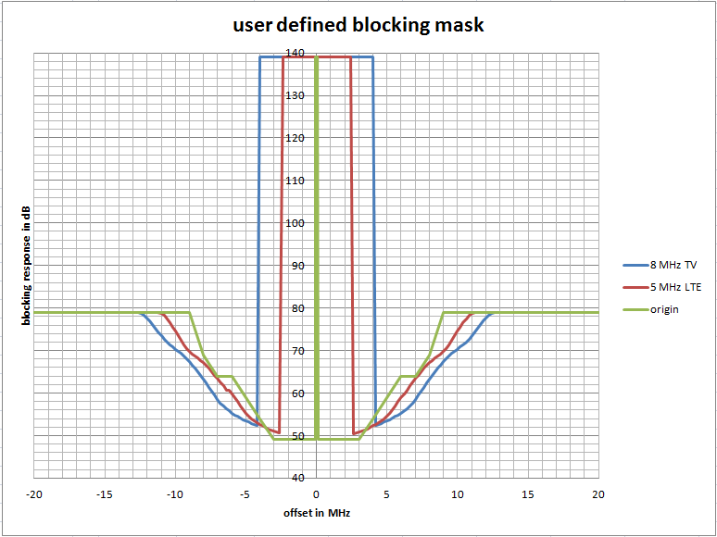

Figure 3: example of integrated blocking values

The algorithm takes for the range "to be protected" the value of the origin blocking mask at an offset of 0 MHz, but uses at least 100 dB.

Similar to this method, the current implementation of the blocking calculation could be modified. For this, the bandwidth of the ILT is required, in case asymmetrical emission masks additionally the lower and upper frequency ranges of the ILT bandwidth.

The EPP providing the proposed algorithm generates the latter values with the proposal for the calculation of the ILT bandwidth (see below).

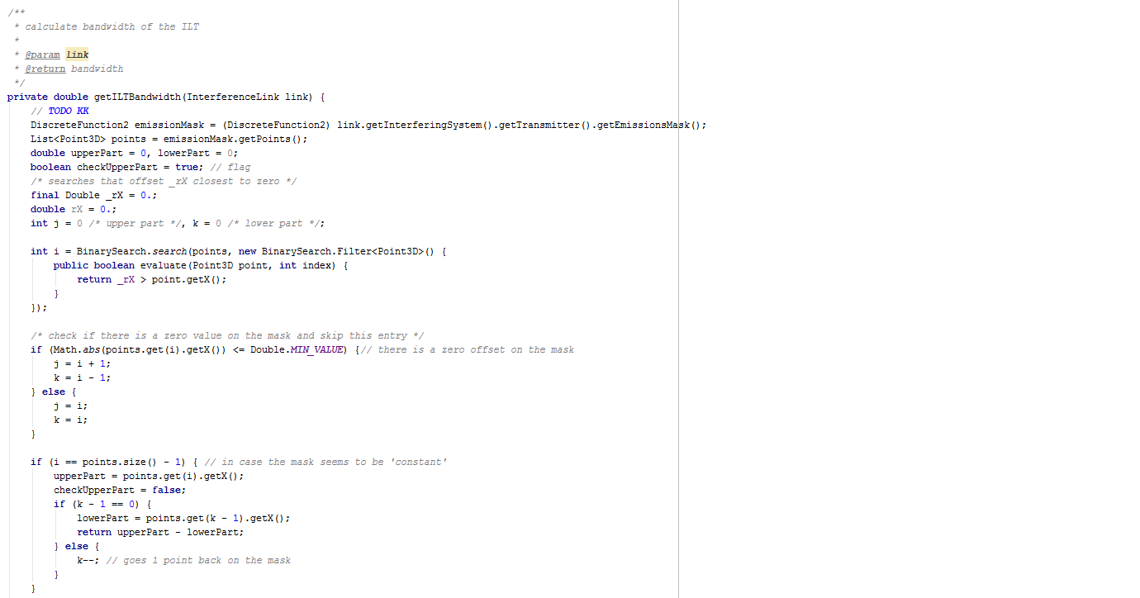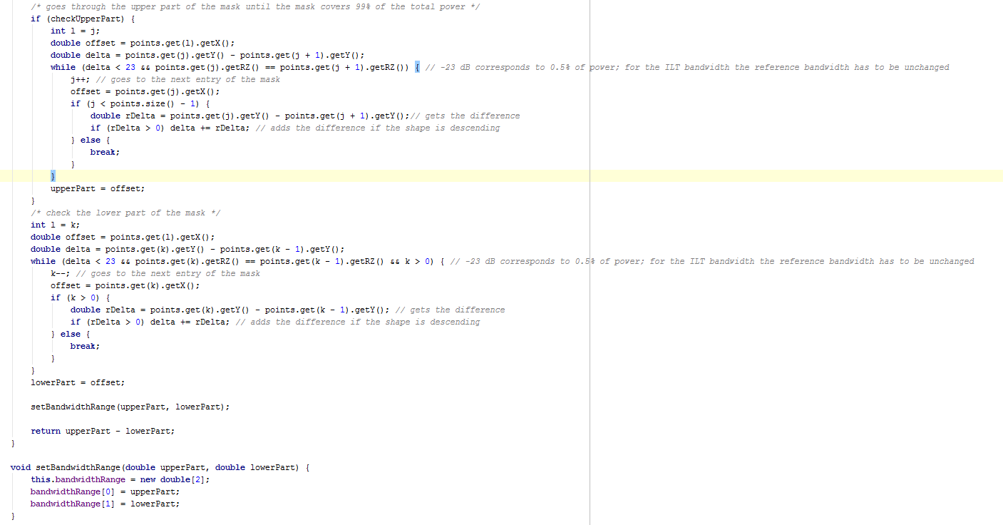

1. The separately proposed algorithm for the calculation of an integrated blocking value takes account of this.