Doc. SE44(12)xxx

PT SE44 Meeting

ECO, Copenhagen, 28-29 March 2012

Date issued: 28 February 2012

Source: ECO

Subject: Information on a new SEAMCAT feature for the antenna pointing direction.

N
Password protection required? (Y/N)

Summary
This contribution presents a generic feature for the pointing/de-pointing of the antenna settings. This solution can be useful for the current BDA2GC simulation.

This new implementation from ECO is available in a beta form at :
http://www.seamcat.org/betaversion/

Proposal
SE44 is invited to consider this new solution when using SEAMCAT for their simulation.

Background
At the 2nd SE44 meeting, the ECO presented the capability of SEAMCAT for BDA2GC simulation. The antenna pointing/de-pointing feature of the version 3.2.5 was limited in view to the need of SE44. In version 3.2.5, the antenna are pointing at each other in the azimuth domain but not in the elevation angle.

The ECO has developed a new generic solution which allows SE44 to simulate the antenna pointing/de-pointing as needed.

This solution was also reported to STG (ticket #781)

1 - Overview
The new solution (http://www.seamcat.org/betaversion/) gives the possibility to have the same antenna pointing convention between the horizontal and vertical antenna as illustrated in the figure below

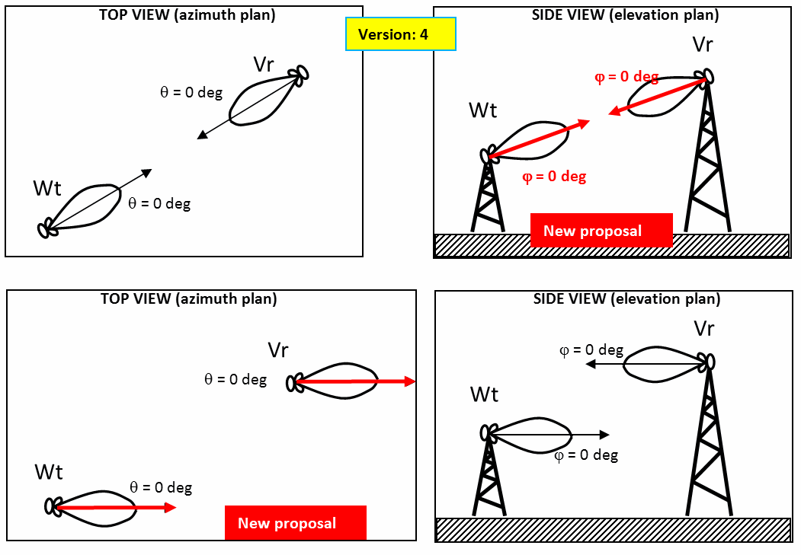
Figure 1: new generic solution in pointing/de-pointing of the antenna

2 - New Interface

Note: this new interface, since in a beta version, is subject to change from feedback of SEAMCAT users.

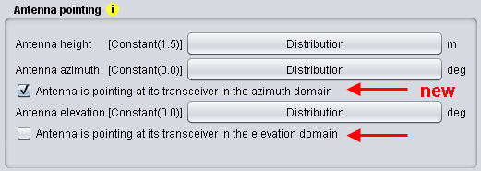
Figure 2: new interface for the antenna pointing

Two configurations are now possible for an antenna in the elevation and Azimuth domain

- Checked: Antenna is pointing at its transceiver in the azimuth/elevation domain
This means that the 0 deg reference is in the direction of the opposite transceiver. This is illustrated below for the azimuth domain.
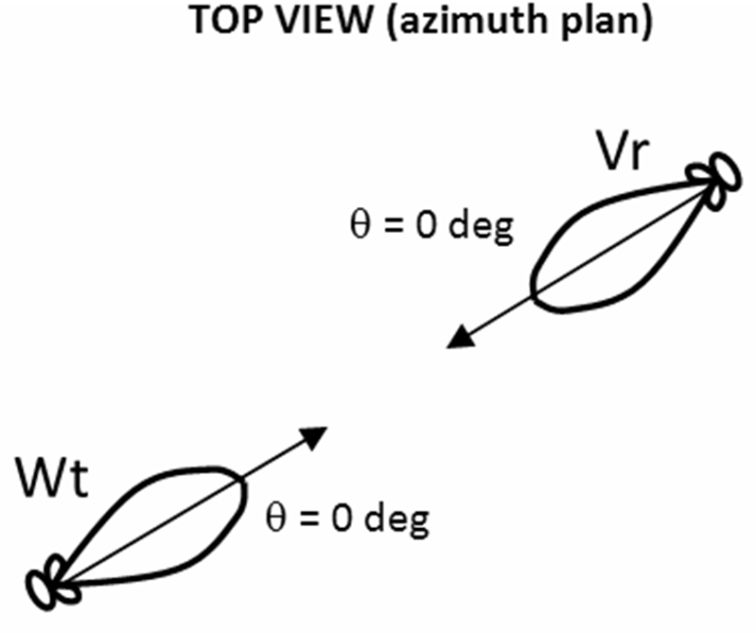
Figure 3: 0 deg reference is in the direction of the opposite transceiver.

- Unchecked: Antenna is pointing at its transceiver in the azimuth/elevation domain
This means that the 0 deg reference is fixed to the EAST direction for the azimuth and horizontal plane for the elevation. This is illustrated below for the azimuth domain.

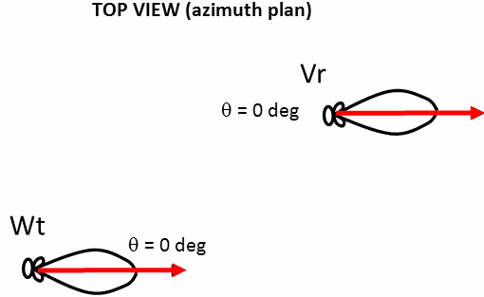
Figure 4: 0 deg reference in azimuth domain for de-pointing solution = EAST.

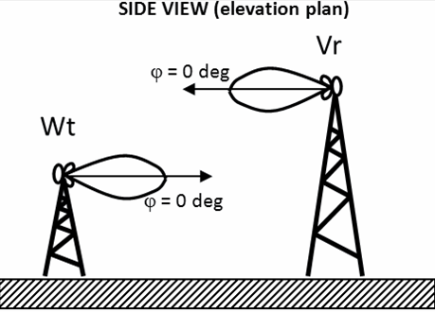
Figure 5: 0 deg reference in elevation domain for de-pointing solution = horizontal plane.

Additionally to option 1) and 2), the user can now steer the antenna to the direction he wants by setting the azimuth/elevation parameter with the angle convention in section 3.

3 - Convention

Antenna pattern angle definition: positive counter-clockwise to the 0 deg reference
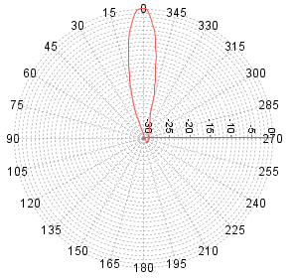

Azimuth angle: positive clockwise to the 0 deg reference
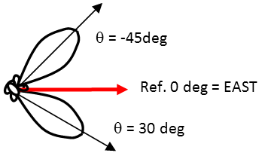
Elevation angle: positive clockwise to the 0 deg reference

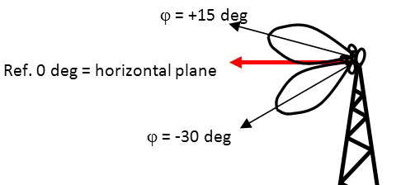

4 - Applicability
With respect to SE44 activities, it is now possible to simulate an aircraft constantly pointing at a BS (i.e. for all the random position of the aircraft).

It is also possible to evaluate any misalignment error by setting a random distribution of a few degrees in the elevation or azimuth.

This solution should be generic enough to simulate more configurations.

5 - Conclusion
The new solution proposes to point or not to point (i.e. de-point) to the opposite transceiver. It is available for both the Victim Link and Interfering Links.

These options are available for both azimuth and elevation domain.

For a single link there are the following combinations:

