|  |  |  |  |  |  |
| --- | --- | --- | --- | --- | --- |
| WGSE/STG | | | | | **Doc. STG(13)xx** |
| **Date issued:** 5 February 2013  **Source:**  STG  **Status:** For information  **Subject:** Liaison Statement to SE24 on the path loss in SEAMCAT at low distances | | | | | |
| **Password protected: yes** |  | **No** | **x** |

Dear Ralf,

STG in its 33rd meeting reviewed your LS on the path loss in SEAMCAT at low distances.

STG decided:

1. to implement MCL option when generic system is selected as interferer. This implementation may take some time which may not be appropriate to SE24 time schedule. As a temporary solution, BNetzA proposed to generate a propagation plugin that would provide the MCL functionality. That propagation plugin will only be for both Hata models (to be selectable on the plugin).
2. to implement option 3 from the BnetzA (i.e. to implement “L(d) + T(G(σ)) ≥ LFree(d) + T(G(3.5dB))”) in contribution (STG(13)10) see Annex 1. The Extended Hata and Extended Hata SRD will be modified accordingly. This modification can be implemented in a Beta version fairly soon for testing.

Best regards

Jean-Philippe Kermoal

STG chairman

Email: [Jean-Philippe.kermoal@eco.cept.org](mailto:Jean-Philippe.kermoal@eco.cept.org)

**Annex 1**

**Option 3 from STG(13)10**

**Proposal:** Stick to the Free Space path loss with a normal distribution of standard deviation 3.5dB as minimum path loss for the Extended Hata model, in all environments and scenarios. This sigma is used in the first 40m of the model (Free Space part).

L(d) + T(G(σ)) ≥ LFree(d) + T(G(3.5dB))

Illustration in Figure 1 shows that the blue line is the minimum of the calculated path loss.

Red curve = L(d) + T(G(σ))

Blue curve = LFree(d) + T(G(3.5dB)

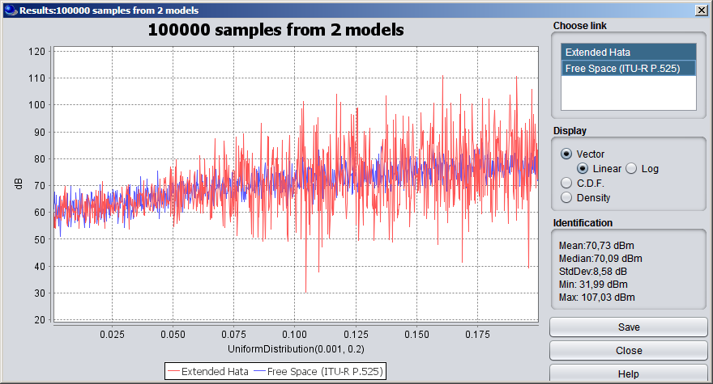

Figure 1: Results of path loss (Extended Hata (red) and Free Space (blue)), between 1 to 200 m.