ECC Report <No>

Compatibility/sharing studies related to Broadband Direct-Air-to-Ground Communications (DA2GC) in the frequency bands 1900 – 1920 MHz / 2010 – 2025 MHz
Editor’s note:
This working document has to be considered as a preliminary draft ECC Report which is still under development. All parts of it are still subject to further discussions and considerations.

Month YYYY (Arial 9pt bold)
(last updated: Month YYYY) (Arial 9pt)

Executive summary (style: heading 1)
Body text (style: ECC Paragraph)
(advice: the Executive Summary should provide a short and concise explanation on the purpose of the respective ECC Report and should clearly indicate the covered subjects to which it applies. In addition, it should clearly explain the application of the document.)

TABLE OF CONTENTS

0 Executive summary (style: heading 1) 2
1 Introduction 7
2 Definitions (optional section) 7
3 Frequency usage 7
3.1 Frequency usage in the band 1900 – 1920 MHz 8
3.2 Frequency usage in the band 2010 – 2025 MHz 8
4 broadband DA2GC System characteristics 10
4.1 DA2GC system according to ETSI TR 103 054 10
4.1.1 Ground station parameters 10
4.1.1.1 Antenna characteristics 11
4.1.1.2 Unwanted emissions 12
4.1.2 Aircraft station parameters 13
4.2 DA2GC system according to ETSI TR 101 599 14
4.2.1 Overall system architecture 14
4.2.2 Ground station equipment 15
4.2.3 Transmitter parameters 16
4.2.3.1 Transmitter Output Power / Radiated Power 16
4.2.3.2 Example radiation patterns 17
4.2.3.3 Operating Frequency 19
4.2.3.4 Bandwidth 19
4.2.3.5 Unwanted emissions 19
4.2.4 Receiver parameters 20
4.2.6 Channel access parameters 20
4.3 DA2GC SYSTEM ACCORDING TO ETSI TR 103 108 20
4.3.1 Technical Description 21
4.3.1.1 Transmitter 21
4.3.1.2 Receiver 21
4.3.1.3 Ground Antennas Characteristics 21
4.3.1.4 Aircraft Antenna Characteristics 22
4.3.1.5 Ground Station Elevation E.I.R.P Mask 23
4.3.1.6 Aircraft Station Elevation Eirp Masks 23
4.3.1.7 Spectrum Emission Mask 24
4.3.1.8 Unwanted emissions 25
4.3.1.9 Aircraft Station Mitigation Attenuation 25
5 Compatibility studies in the unpaired 2 GHz bands 26
5.1 Introduction 26
5.2 Compatibility and sharing scenarios in the band 1900 – 1920 MHz 26
5.3 Technical characteristics of UMTS 27
5.4 Technical characteristics of DECT systems 28
5.5 DA2GC Reverse Link in the band 1900 – 1920 MHz 30
5.5.1 Compatibility studies on DA2GC according to ETSI TR 103 054 31
5.5.1.1 Impact of DA2GC AS on UMTS BS 31
5.5.1.2 Results 31
5.5.1.3 Impact of UMTS UE on DA2GC GS 35
5.5.1.4 Results 35
5.5.1.5 Impact of DA2GC AS on DECT station/terminal 37
5.5.1.6 Results 37
5.5.1.7 Impact of DECT station on DA2GC GS 40
5.5.1.8 Results 40
5.5.1.9 Conclusions on compatibility between DA2GC RL and UMTS/DECT systems 42
5.5.2 Compatibility studies on DA2GC according to ETSI TR 101 599 42
5.5.2.1 Impact of DA2GC AS on UMTS BS 43
5.5.2.2 Results 44
5.5.2.3 Impact of UMTS UE on DA2GC GS 45
5.5.2.4 Results 45
5.5.2.5 Impact of DA2GC AS on DECT station/terminal 46
5.5.2.6 Results 46
5.5.2.7 Impact of DECT station on DA2GC GS 47
5.5.2.8 Results 47
5.6 DA2GC Foreward Link in the Band 1900 – 1920 MHz 48
5.6.1 Compatibility studies on DA2GC according to ETS TR 103 054 50
5.6.1.1 Impact of DA2GC GS on UMTS BS 50
5.6.1.2 Results 50
5.6.2 Impact of UMTS UE on DA2GC AS 52
5.6.2.1 Results 52
5.6.3 Impact of DA2GC GS on DECT station/terminal 56
5.6.3.1 Results 56
5.6.4 Impact of DECT station on DA2GC AS 59
5.6.4.1 Results 59
5.6.5 Conclusions on compatibility between DA2GC FL and UMTS/DECT systems 61
5.6.5.1 Compatibility between DA2GC FL and UMTS 61
5.6.5.2 Compatibility between DA2GC FL and DECT 61
5.6.6 Compatibility studies on DA2GC according to ETSI TR 101 599 62
5.6.6.1 Impact of DA2GC GS on UMTS BS 62
5.6.6.2 Results 62
5.6.6.3 Impact of UMTS UE on DA2GC AS 63
5.6.6.4 Results 63
5.6.6.5 Impact of DA2GC GS on DECT station/terminal 64
5.6.6.6 Results 64
5.6.6.7 Impact of DECT station on DA2GC AS 65
5.6.6.8 Results 65
5.7 Compatibility and sharing scenarios for the band 2010 – 2025 MHz 65
5.8 Technical characteristics of Space service receivers in the band 2025 – 2110 MHz 65
5.9 Technical characteristics of Satellite Earth Stations 66
5.10 Technical characteristics of MSS components in the band 1990-2010 MHz 67
5.10.1 MSS complementary ground component base station (CGC BS) 67
5.10.2 MSS User Terminal (UT) 69
5.11 Technical characteristics of MSS (satellite receiver parameter) 73
5.12 Technical characteristics of the Fixed service (FS) System 73
5.13 TRR (no data available so far) 75
5.14 DA2GC Reverse Link in the band 2010 – 2025 MHz 76
5.14.1 Compatibility studies on DA2GC according to ETSI TR 103 054 76
5.14.1.1 Impact of DA2GC AS on Satellite receivers 76
5.14.1.2 Methodology 76
5.14.1.3 Results 76
5.14.2 Impact of Satellite Earth station on DA2GC GS 82
5.14.3 Conclusions on compatibility between DA2GC RL (TR 103 054) and space services 82
5.14.3.1 Impact of DA2GC AS on MSS CGC BS 82
5.14.3.2 Methodology 83
5.14.3.3 Results 83
5.14.3.4 Impact of MSS UT on DA2GC GS 87
5.14.3.5 Methodology 87
5.14.3.6 Results 87
5.14.4 Conclusions on compatibility between DA2GC (TR103 054) and MSS CGC 94
5.14.5 Impact of DA2GC AS on MSS satellite 95
5.14.6 Methodology 95
5.14.7 Results 95
5.14.8 Conclusions 96
5.14.9 Impact of DA2GC AS on FS 96
5.14.10 Methodology 96
5.14.11 Results 97
5.14.12 Impact of FS on DA2GC GS 98
5.14.13 Results 99
5.14.14 Conclusions 100
5.14.15 Compatibility studies on DA2GC according to ETSI TR 101 599 101
5.14.15.1 Impact of DA2GC AS on satellite receivers 101
5.14.15.2 Impact of Satellite Earth Stations on DA2GC GS 101
5.14.15.3 Results 101
5.15 DA2GC Forward link in the band 2010 – 2025 MHz 103
5.15.1 Compatibility studies on DA2GC according to ETSI TR 103 054 103
5.15.1.1 Impact of DA2GC GS on Satellite receivers 103
5.15.1.2 Methodology 103
5.15.1.3 Results 104
5.15.1.4 Conclusions on Impact of DA2GC GS on Satellite receivers 110
5.15.1.5 Impact of Satellite Earth Stations on DA2GC Aircraft Stations 110
5.15.1.6 Methodology 111
5.15.1.7 Results 111
5.15.1.8 Conclusions on Impact of Satellite Earth Stations on DA2GC Aircraft Stations 122
5.15.1.9 Impact of DA2GC GS on MSS CGC BS 122
5.15.1.10 Results 123
5.15.1.11 Impact of MSS UT on DA2GC AS 125
5.15.1.12 Results 125
5.15.2 Conclusions 132
5.15.3 Impact of DA2GC GS on MSS satellite 133
5.15.4 Methodology 133
5.15.5 Results 135
5.15.6 Conclusions 136
5.15.7 Impact of DA2GC GS on FS 136
5.15.8 Results 136
5.15.9 Impact of FS on DA2GC AS 138
5.15.10 Results 138
5.15.11 Conclusions 140
5.15.12 Compatibility studies on DA2GC according to ETSI TR 101 599 140
5.15.12.1 Impact of DA2GC GS on satellite receivers 140
5.15.12.2 Results 140
5.15.12.3 Conclusions on Impact of DA2GC GS on satellite receivers 141
5.15.13 Impact of Satellite Earth stations on DA2GC Aircraft Stations 141
6 conclusions 141
ANNEX 1: LIST OF STATIONS USED BY ESA OR COOPERATING SPACE AGENCIES in Europe 142
Location 142
ANNEX 2: Proposed mitigation techniques for the DA2GC system descriebd in ETSI TR101 599 143
0 Introduction 143
1 Damage 143
2 Unwanted emissions 144
3 Saturation/blocking 144
ANNEX 3: List of reference 148

LIST OF ABBREVIATIONS

Abbreviation | Explanation (style: Arial 10pt bold red (colour values RGB: 210, 35, 42)
<abbr> | <explanation – edit the table as necessary>
3GPP | 3rd Generation Partnership Project
ACLR | Adjacent channel leakage power ratio
ACS  AS | Adjacent channel selectivity  Aircraft station
CEPT | European Conference of Postal and Telecommunications Administrations
DA2GC | Direct air-to-ground communication
ECC | Electronic Communications Committee
FDD | Frequency division duplex
FSS  GS | Fixed-satellite service  Ground station
IMT | International mobile telecommunications
IMT-A | IMT-Advanced (4G)
I/N | Interference-to-noise ratio
ITU | International Telecommunication Union
LOS | Line-of-sight
LTE | Long term evolution
OBU | Onboard Unit
OFDMA | Orthogonal Frequency-Division Multiple Access
SEM | Spectrum emission mask
S/I | Signal-to-interference ratio
TDD | Time division duplex
UE | User equipment
UL | Uplink

Introduction
Body text (style: ECC Paragraph)
(advice: this document gives a template for preparing an ECC Report. All existing contents including the annexes are given for information purposes, only, and they shall be replaced by the relevant contents of the new ECC Report.)

Definitions (optional section)
Term | Definition (style: Arial 10pt bold red (colour values RGB: 210, 35, 42)
<Term 1> | <Definition 1>
<Term 2> | <Definition 2>

Frequency usage
Services/systems currently operating in the bands and in adjacent bands (Source: European Common Allocation Table)

Frequency usage in the band 1900 – 1920 MHz
Table 1: Utilisations in the 1.9 GHz band
European Common Allocation | Frequency range  MHz | Utilisation
MOBILE  Fixed | 1 835 – 1 900 | DECT
MOBILE  Fixed | 1 900 – 1 930 | IMT  Fixed services on a national basis
MOBILE  Fixed | 1 930 – 1 970 | IMT  Fixed services on a national basis
Table 2: Footnotes in the band 1900-1920 MHz
EU29
The frequency bands 890-915 / 935-960 MHz, 880-890 / 925-935 MHz, 1710-1785 / 1805-1880 MHz, 1900-1980 MHz, 2010-2025 MHz and 2010-2170 MHz are reserved for public cellular mobile use only. Other services such as the fixed service should only be allowed in the above bands where coexistence with public mobile systems is possible i.e. in sparsely populated or rural areas where the frequency band is not needed for mobile cellular systems.
EU33
The band 1880-1900 MHz is generally expected to be used by IMT/DECT.
5.388
The bands 1885 - 2025 MHz and 2110 - 2200 MHz are intended for use, on a worldwide basis, by administrations wishing to implement International Mobile Telecommunications-2000 (IMT-2000). Such use does not preclude the use of these bands by other services to which they are allocated. The bands should be made available for IMT-2000 in accordance with Resolution 212 (Rev.WRC-97). (See also Resolution 223 (WRC-2000)).
5.388A
In Regions 1 and 3, the bands 1885 - 1980 MHz, 2010 - 2025 MHz and 2110 - 2170 MHz and, in Region 2, the bands 1885 - 1980 MHz and 2110 - 2160 MHz may be used by high altitude platform stations as base stations to provide International Mobile Telecommunications 2000 (IMT-2000), in accordance with Resolution 221 (Rev.WRC-03). Their use by IMT-2000 applications using high altitude platform stations as base stations does not preclude the use of these bands by any station in the services to which they are allocated and does not establish priority in the Radio Regulations. (WRC-03)

Frequency usage in the band 2010 – 2025 MHz

Table 3: Utilisations in the 2 GHz band
European Common Allocation | Frequency range  MHz | Utilisation
MOBILE  MOBILE-SATELLITE (E/S)  Fixed | 1 980 – 2 010 | IMT  Mobile Satellite applications including CGC  Fixed services on a national basis
MOBILE  Fixed | 2 010 - 2025 | IMT  Fixed services on a national basis
EARTH EXPLORATION-SATELLITE (E/S) (S/S)  FIXED  MOBILE  SPACE OPERATION (E/S) (S/S)  SPACE RESEARCH (E/S) (S/S) | 2 025 – 2 110 | Space Research / EESS  Tactical radio relay (2025 – 2070 MHz)  SAP/SAB on a tuning range  Fixed links
Table 4: Footnotes in the band 2010-2025 MHz
EU2
Civil-military sharing.
EU15
In the frequency band 1350-2690 MHz tactical radio relay systems should be capable of tuning over the full range of this band. Requirements for tactical radio relay should be met from the following sub-bands: 1350-1400 MHz; 1427-1452 MHz; 1492-1525 MHz; 1660-1670 MHz; 1675-1710 MHz; 1785-1800 MHz; 2025-2110 MHz; 2200-2290 MHz; 2520-2575 MHz; 2615-2670 MHz. Tactical radio relay systems may operate in the bands 2520-2575 MHz and 2615-2670 MHz provided that they shall not cause harmful interference to terrestrial IMT and do not claim protection from them. The common requirement of 2 x 45 MHz for tactical radio relay for cross/near border operations and exercises should be met from 2025-2110 MHz and 2200-2290 MHz and in particular the bands 2025-2070 / 2200-2245 MHz.
EU16A
Use of the band by the mobile service is limited to tactical radio relay and SAP/SAB applications.
EU27
A frequency band that is in general military use in Europe and identified for major military utilisation in the ECA. Such a frequency band forms a basis for military use and planning. The band can be shared between civil and military users according to national requirements and legislation.
EU29
The frequency bands 890-915 / 935-960 MHz, 880-890 / 925-935 MHz, 1710-1785 / 1805-1880 MHz, 1900-1980 MHz, 2010-2025 MHz and 2010-2170 MHz are reserved for public cellular mobile use only. Other services such as the fixed service should only be allowed in the above bands where coexistence with public mobile systems is possible i.e. in sparsely populated or rural areas where the frequency band is not needed for mobile cellular systems.
5.351A
For the use of the bands 1518-1544 MHz, 1545-1559 MHz, 1610-1626.5 MHz, 1626.5-1645.5 MHz, 1646.5-1660.5 MHz, 1668-1675 MHz, 1980-2010 MHz, 2170-2200 MHz, 2483.5-2500 MHz, 2500-2520 MHz and 2670- 2690 MHz by the mobile-satellite service, see Resolutions 212 (Rev.WRC-07) and 225 (Rev.WRC-07). (WRC-07)
5.388
The bands 1885 - 2025 MHz and 2110 - 2200 MHz are intended for use, on a worldwide basis, by administrations wishing to implement International Mobile Telecommunications-2000 (IMT-2000). Such use does not preclude the use of these bands by other services to which they are allocated. The bands should be made available for IMT-2000 in accordance with Resolution 212 (Rev.WRC-97). (See also Resolution 223 (WRC-2000)).
5.388A
In Regions 1 and 3, the bands 1885 - 1980 MHz, 2010 - 2025 MHz and 2110 - 2170 MHz and, in Region 2, the bands 1885 - 1980 MHz and 2110 - 2160 MHz may be used by high altitude platform stations as base stations to provide International Mobile Telecommunications 2000 (IMT-2000), in accordance with Resolution 221 (Rev.WRC-03). Their use by IMT-2000 applications using high altitude platform stations as base stations does not preclude the use of these bands by any station in the services to which they are allocated and does not establish priority in the Radio Regulations. (WRC-03)
5.389A
The use of the bands 1980-2010 MHz and 2170-2200 MHz by the mobile-satellite service is subject to coordination under No. 9.11A and to the provisions of Resolution 716 (Rev.WRC-2000). (WRC-07)
5.391
In making assignments to the mobile service in the bands 2025 - 2110 MHz and 2200 - 2290 MHz, administrations shall not introduce high-density mobile systems, as described in Recommendation ITU-R SA.1154, and shall take that Recommendation into account for the introduction of any other type of mobile system. (WRC-97)
5.392
Administrations are urged to take all practicable measures to ensure that space-to-space transmissions between two or more non-geostationary satellites, in the space research, space operations and Earth exploration-satellite services in the bands 2025 - 2110 MHz and 2200 - 2290 MHz, shall not impose any constraints on Earth-to-space, space-to-Earth and other space-to-space transmissions of those services and in those bands between geostationary and non-geostationary satellites.

broadband DA2GC System characteristics

DA2GC system according to ETSI TR 103 054
The system parameters used for evaluation of interference impact are chosen according to information given by 3GPP on LTE transmitter and receiver characteristics for UE [1] and BS [2]. The DA2GC systems parameter are modified according to the need for the aeronautical use case (mainly related to antenna characteristics as well as Tx power of the AS).The following Table 5 and Table Table 7 give an overview of the main characteristics used for the ground station and aircraft station according to the ETSI system reference document TR 103 054 of the DA2GC. Paired spectrum of 2 x 10 MHz for FDD operation is considered necessary to cope with short- to medium-term demand. Unpaired spectrum for TDD operation (20 MHz) would also be an option, but it might be more complicated to identify a contiguous block of 20 MHz for TDD operation. The DA2GC system is applied only as transport medium to transfer data from user terminals onboard aircraft to the internet or vice versa. The relevant radio link is between the aircraft station and the ground stations of the ground network. Onboard aircraft passengers have access to internet services via separate radio technologies like GSM and WiFi. These onboard networks were already considered in other CEPT activities (e.g. see [8]). As they have no relevance for the DA2GC system implementation in the 2 GHz band, they are not considered in this document.

Ground station parameters
As it is assumed that DA2GC base stations will be mainly implemented in rural environments due to better line-of-sight (LOS) conditions to aircraft compared to sites in urban areas, only macro cell stations of the terrestrial LTE network are considered for the evaluations. Due to the propagation conditions at about 3500 MHz and different GS antenna adjustment, sufficient decoupling should be achieved between the DA2GC ground stations and possible micro or pico cell stations of the terrestrial LTE network in neighboring urban areas.
Table 5 gives an overview of the main parameters used for the ground stations.
Table 5: Main parameters used for ETSI DA2GC ground stations (TR 103 054)
Parameter | DA2GC ground station
 | FDD |  | TDD
Base station type |  | Macro | Macro
Environment |  | Rural | Rural
Cell radius (max.) |  | Up to 100 km | Up to 100 km
Tx power |  | 46 dBm | 46 dBm
Antenna type |  | 3 x 120° sector antennas  (90° half power beam width) | 3 x 120° sector antennas  (90° half power beam width)
Antenna gain |  | Up to 20 dBi | Up to 20 dBi
Antenna height |  | 50 m | 50 m
Antenna tilt |  | 10°(up-tilt)  (Note 1) | 10°(up-tilt)  (Note 1)
Channel bandwidth |  | 2 x 10 MHz (FDD) | 15 or 20 MHz (TDD)
Frequency re-use factor |  | 1 | 1
Signal bandwidth  (related to number of occupied resource blocks with bandwidth of 180 kHz) |  | 9 MHz (FDD) | 13.5 or 18 MHz (TDD)
Rx thermal noise |  | -104.5 dBm (FDD) | -102.7 or -101.5 dBm (TDD)
Rx noise figure |  | 5 dB
Rx noise floor |  | -99.5 dBm (FDD) | -97.7 or -96.5 dBm (TDD)
Rx reference sensitivity level |  | -101.5 dBm (FDD)  (Note 2) | -99.7 or -98.5 dBm (TDD)  (Note 2)
Interference protection ratio I/N |  | -6 dB | -6 dB
Interference protection level |  | -105.5 dBm (FDD)  (Note 2) | -103.7 or -102.5 dBm (TDD)  (Note 2)
Tx spectrum emission mask (SEM) / Spurious emissions |  | According to [2] | According to [2]
Adjacent channel leakage ratio (ACLR) limit |  | 45 dB  (Note 3) | 45 dB  (Note 3)
Rx in-band / out-of-band blocking |  | According to [2] | According to [2]
Rx adjacent channel selectivity (ACS) |  | 43.5 dB  (according to [2]) | 43.5 dB  (according to [2])
Estimated number of GS across Europe |  | 377
Note 1: The antenna up-tilt is dependent on the final characteristic of the antenna and the cell radius to be covered. The value used here is suitable for large cells; for cells with smaller radius the main lobe should have higher up-tilt.
Note 2: In [17] the sensitivity level of -101.5 dBm is also applied for signal bandwidths above 10 MHz, as only up to 25 resource blocks (RB) are assigned to a single UE link, even if more RBs are feasible.
Note 3: In general the ACLR limit given in the table or the absolute limit of -15 dBm/MHz is valid, whichever is less stringent (macro BS according category B) [2]

Antenna characteristics
For the DA2GC GS antennas with 3 sectors per site are assumed. The horizontal and vertical antenna patterns used in the evaluations are shown in Figure 1 and Figure 2, respectively, as screen shots of SEAMCAT.
The horizontal antenna pattern is based on the characteristics defined in 3GPP TR 36.814 [18]. The pattern is very similar to the antenna characteristics given in ITU-R Rec. F.1336 [6] which were applied for compatibility studies in the ITU-R Report M.2109.
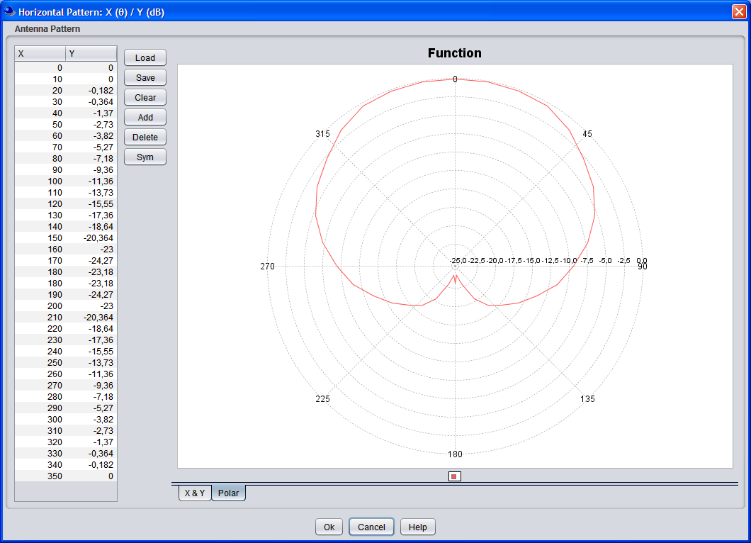
Figure 1: Horizontal sector antenna pattern of the base stations
The vertical diagram of the DA2GC GS has been adapted to a cosecant-squared characteristic which is better suited for air coverage compared to usual sector antennas for terrestrial mobile radio systems as the Rx power is nearly constant with increasing distance between GS and aircraft [7].
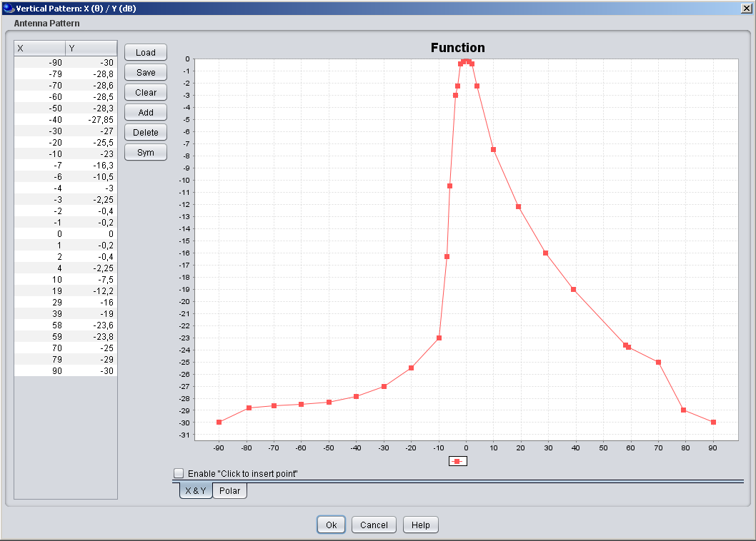
Figure 2: Vertical sector antenna pattern (cosecant-squared) characteristic of the DA2GC BS (screen shot of SEAMCAT GUI; up-tilt not considered in the diagram)

Unwanted emissions
The spectrum emission limits for DA2GC and terrestrial LTE BSs are assumed to be the same. The corresponding values are defined by 3GPP and can be found in Table 6.
Table 6: Unwanted emission limits for DA2GC ground stations adapted to LTE base stations for channel bandwidth of 10 MHz according to [2]
Frequency offset of measurement filter -3dB point, Δf | Frequency offset of measurement filter centre frequency, f_offset | Minimum requirement | Measurement bandwidth
0 MHz ≤ Δf < 5 MHz | 0.05 MHz ≤ f_offset < 5.05 MHz |  | 100 kHz
5 MHz ≤ Δf < 10 MHz | 5.05 MHz ≤ f_offset < 10.05 MHz | -14 dBm | 100 kHz
10 MHz ≤ Δf < 25 MHz | 10.5 MHz ≤ f_offset < 24.5 MHz | -15 dBm | 1MHz
25 MHz ≤ Δf | 25.5 MHz ≤ f_offset | -30 dBm (Note 1) | 1MHz
Note 1: Spurious emissions valid for frequency offset larger than 250% of necessary bandwidth [21]

Aircraft station parameters
Table 7 provides the main parameters of the aircraft station.
Table 7: Main parameters used for ETSI DA2GC aircraft stations (TR 103 054)
Parameter | DA2GC aircraft station
 | FDD |  | TDD
Tx power (max./min.)  (Note 1) |  | 40 dBm / -23 dBm | 40 dBm / -23 dBm
Antenna type |  | Azimuth: Omni-directional  Elevation: See Figure 3 | Azimuth: Omni-directional  Elevation: See Figure 3
Antenna gain |  | 6.54 dBi  (Note 2) | 6.54 dBi  (Note 2)
Antenna height |  | 3000 - 13000 m  (Note 3) | 3000 - 13000 m  (Note 3)
Channel bandwidth |  | 2 x 10 MHz | 15 or 20 MHz
Signal bandwidth  (related to number of occupied resource blocks with bandwidth of 180 kHz) |  | 9 MHz | 13.5 or 18 MHz
Rx thermal noise |  | -104.5 dBm | -102.7 or -101.5 dBm
Rx noise figure |  | 9 dB | 9 dB
Rx noise floor |  | -95.5 dBm | -93.7 or -92.5 dBm
Rx reference sensitivity level |  | -97.5 dBm | -95.7 or -94.5 dBm
Interference protection ratio I/N |  | -6 dB | -6 dB
Interference protection level |  | -101.5 dBm | -99.7 or -98.5 dBm
Tx spectrum emission mask (SEM) / Spurious emissions |  | According to [1] | According to [1]
Adjacent channel leakage ratio (ACLR) limit |  | 37 dB  (Note 4) | 37 dB  (Note 4)
Rx in-band / out-of-band blocking |  | According to [1] | According to [1]
Rx adjacent channel selectivity (ACS) |  | 33 / 30 / 27 dB for channel bandwidths of 10 / 15 / 20 MHz  (according to [1] | 33 / 30 / 27 dB for channel bandwidths of 10 / 15 / 20 MHz  (according to [1])
Note 1: The Tx power of the mobile station is dependent on the power control implementation applied by the equipment provider.
Note 2: For former evaluation a simple omni-directional characteristic with 0 dBi gain was assumed. The final diagram incl. the gain will be dependent on further antenna optimization steps as well as on limits set by the regulation. In the range just below the horizontal aircraft plane the antenna gain will normally be higher (up to about 6 dBi) to allow access of the OBU to the BS at the cell edge.
Note 3: The current assumption for a DA2GC OBU is that it will not transmit for altitudes below 3000 m as the GSM/WiFi onboard wireless access networks for the passengers have to be switched off below that threshold. In case the airlines are interested to use the DA2GC also for their operational services (non-safety relevant), it has to be clarified with the regulatory authorities under which conditions DA2GC radio links can kept until the aircraft reaches the airport ground (only wired access in the aircraft below the altitude threshold allowed).
Note 4: A higher ACLR value is required to keep the maximum allowed out-of-band emission level given in [1] in case of higher maximum Tx power of up to 40 dBm for the DA2GC OBU.

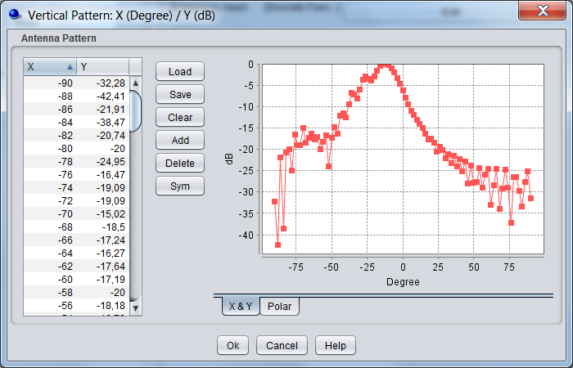 | 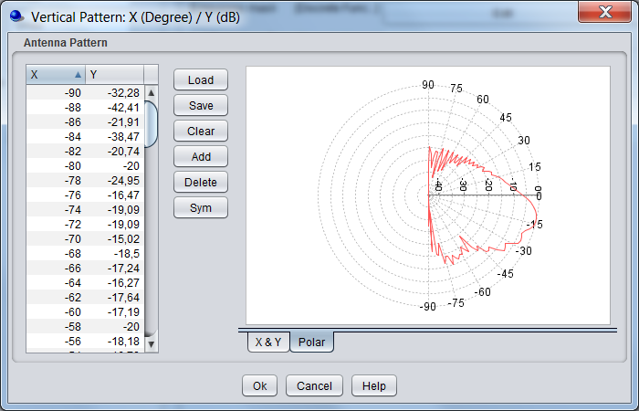
Figure 3: Vertical antenna pattern (monopol) for the DA2GC AS (gain of 6.54 dBi; direction to earth at 0°, to the horizon at ±90°)

DA2GC system according to ETSI TR 101 599

Overall system architecture
The broadband DA2G system using beamforming antennas is designed to provide bi-directional ground-to-aircraft connectivity as part of an overall broadband communications system which will offer a variety of IP-based applications for the use of passengers as well as operational (non-safety) data for airline use.
Figure 4 gives a high-level overview of how the DA2G system fits within the end-to-end system architecture. The elements which constitute the DA2G link are those elements which provide connectivity between the Air Network and the Ground Network, including the Air Station and Wireless Base Station shown in the top left hand corner of the figure
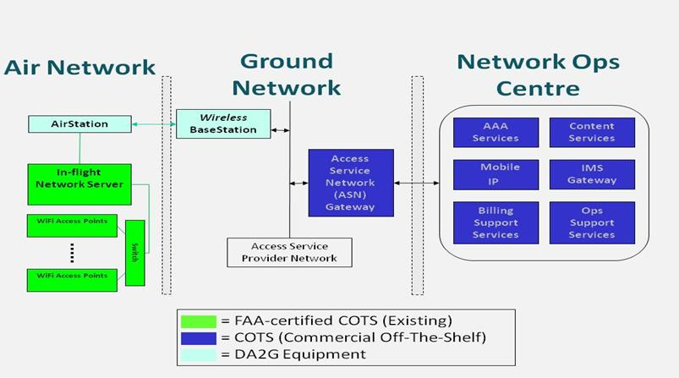
Figure 4: DA2G system, as part of overall end-to-end architecture

Ground station equipment
A unique feature of this DA2GC system is the simultaneous use of four separate integrated radio transceivers/phased array antenna assemblies at the ground station. Such an arrangement enables each ground station to cover the entire visible air space, from horizon to horizon, at all azimuths. Each integrated 8-element antenna array is capable of simultaneously producing multiple co-frequency shaped beams which need to maintain sufficient spatial separation to avoid self-interference such that three simultanous beams per sector (or quadrant), or twelve beams per ground station can be assumed operationally. This is shown diagrammatically in Figure 5.
.
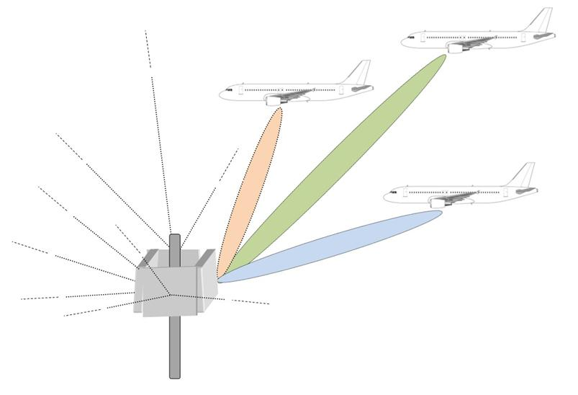
Figure 5: Typical Ground Station antenna arrangement showing three beams per quadrant
The use of TDMA and FDMA could further increase the number of individual data paths established (and hence number of aircraft served) to much higher numbers, but that would be at the cost of reduced data rate per aircraft since the total power (and hence total capacity) per beam would remain the same. Potential problems of cross-talk between the transmit and receive paths of the various aircraft links at a given ground station antenna are eliminated due to the use of TDD, together with synchronisation of signals such that all paths from that ground station are in transmit or receive mode at the same time when each beamforming array is generating multiple beams.

Transmitter parameters

Transmitter Output Power / Radiated Power
Table 8: DA2GC Transmitter characteristics
Parameter | Tx output | e.i.r.p.
Maximum ground station TX output power (dBm) | 22 | 45
Maximum aircraft TX output power (dBm)1 | 28 | 45
ATPC used? | Yes
Maximum operational ATPC range (dB) | 30
Max e.i.r.p. GS | 32 dBm/MHz
Max e.i.r.p. AS | 32 dBm/MHz
Maximum number of antenna arrays per Ground Station | 4
Number of operationally simultaneous beams per Ground Station antenna array | 3
Estimated number of GS across Europe | 130

NOTE: The e.i.r.p. levels in Table 8 represent the maximum operational levels at all times for a single beam, including link acquisition, since the periodic beacon signal transmitted from the ground station radiates lower transmit powers than the signals used to carry data once the aircraft links are established. Antenna Characteristics
Table 9: DA2GC Antenna characteristics
Parameter | Value
Ground station peak gain (8 antenna array) (dBi) | 23
Aircraft peak gain (dBi) (multi elementantenna array) | 17
NOTE: The Ground Station peak gains given above are for each antenna array.

Use of phased array antennas and beamforming results in beam shapes which can be optimised for the intended operational frequency bands and co-existence scenarios. The beamforming algorithms used at the ground station and on the aircraft station permit highly accurate beam pointing, i.e. with an accuracy of 0.1 degrees, and the pointing is refreshed at a rate of at least 200 times per second implying a 5 ms minimum refresh period. This enables accurate control to be maintained during all phases of a flight, including the ability to maintain pointing direction to within 0.5 degrees or less even during periods of flight turbulence or extreme manoeuvres.

Example radiation patterns
Example elevation and azimuth radiation patterns are shown in Figure 6 and Figure 7respectively, for the ground station antennas, when operating in the 2 GHz band. These are based on the latest generation products using 8-element antenna arrays at the ground station. Figure 8 and Figure 9 show the elevation and azimuth patterns respectively for the multi element antenna arrays on the aircraft.

The Ground Station antenna array has a fixed pattern in the vertical plane, but is designed to use beamforming in azimuth so that one or more aircraft can be tracked during flight(up to 3 aircrafts per sector). Although, in practise, the radiation pattern will vary as the beam is scanned, the pattern given in Figure 6 can be assumed to be the worst case for all azimuths. i.e. the gain at any azimuth pointing direction will be less than or equal to the values shown, for any given elevation angle.

The beam produced by the aircraft antenna array is steered in both azimuth and elevation so that the main lobe tracks the ground station as the aircraft traverses its flight path. The off-axis radiation pattern shown in Figure 9 can be assumed to be the worst case for all main lobe pointing directions.
-
30
-
20
-
10
0
10
20
30
-
90
-
80
-
70
-
60
-
50
-
40
-
30
-
20
-
10
0
10
20
30
40
50
60
70
80
90
Gain (dBi)
Elevation angle (deg)
Figure 6: Ground Station Antenna Elevation Pattern (8-antenna array)
-
40
-
35
-
30
-
25
-
20
-
15
-
10
-
5
0
-
90
-
80
-
70
-
60
-
50
-
40
-
30
-
20
-
10
0
10
20
30
40
50
60
70
80
90
Gain, relative to peak boresight gain (dB)
Azimuth Angle, relative to pointing direction (deg)
Figure 7: Ground Station Antenna Azimuth Pattern (8-antenna array)
Note that, for three dimensional computations, the resulting ground station antenna gain in any given pointing direction is the sum of the relevant elevation and azimuth gains shown in Figure 8 and Figure 9 respectively.
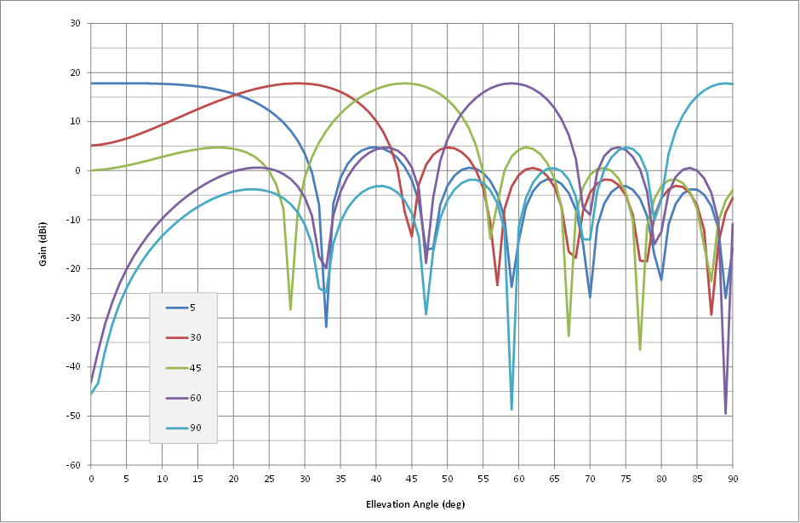
Figure 8: Aircraft Station Antenna Elevation Patterns (16-antenna array)

Note that, in the above sample plots, an elevation angle of 0 degrees represents the horizon pointing direction and 90 degrees is straight down.
-
50
-
40
-
30
-
20
-
10
0
0
10
20
30
40
50
60
70
80
90
100
110
120
130
140
150
160
170
180
Gain, relative to peak boresight gain (dB)
Azimuth Angle, relative to pointing direction (deg)
Figure 9: Aircraft Station Antenna Azimuth Pattern (16-antenna array)
Note that, for three dimensional computations, the resulting aircraft station antenna gain for any given pointing direction is the sum of the relevant elevation and azimuth gains shown in Figure 8 and Figure 9 respectively. [Add text to explain Figure 8]

Operating Frequency
The scope of the ETSI System Reference Document is restricted to operation within the 2 400 MHz to 2 483,5 MHz band and/or the 5 855 MHz to 5 875 MHz band. However, the technology is capable of operating in any frequency band within the range from 790 MHz to 6 GHz including the unpaired 2 GHz bands.

Bandwidth
The necessary bandwidth (as defined by Articles 1.152 and 1.153 of the ITU Radio Regulations) can be chosen to be any value between 5 and 20 MHz for operation in either the 1900 – 1920 MHz and/or 2010 - 2025 MHz bands and the occupied bandwidth falls within the emission mask specified in Figure 13.

Unwanted emissions
The out-of-band ground station and aircraft station emissions when operating in the 1900 -1920 MHz/ 20120 – 2025 MHz band fall within the limits given in Figure 10 when operating under highest output power conditions.
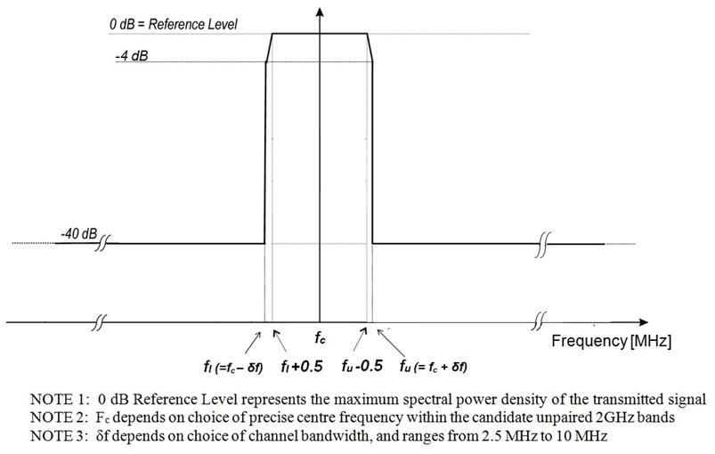
Figure 10: Out-of-band Emission mask

NOTE: The maximum spectral power density referred to in Note 1 of Figure 11 is equivalent to +9dBm/MHz into the Ground Station antenna and +15 dBm/MHz into the aircraft antenna in the case of a 20 MHz channel.
In addition the spurious emissions for both aircraft and ground stations will not exceed a fixed level of -42dBm/MHz. The quoted spurious level relates to the total conducted power due to spurious emissions delivered to all antennas and antenna elements of a single ground or aircraft station antenna array.

Receiver parameters
The sensitivity is better than or equal to -87 dBm in a 20MHz bandwidth on both the ground station and aircraft station receivers. Adjacent channel selectivity is 43.5 dB for the ground station and the aircraft station, as specified in 3GPP TS 36.104. Other receiver parameters comply with, or exceed, the requirements within this 3GPP specification.

4.2.6 Channel access parameters
The operational channel access parameters such as frame duration, resource grouping and allocation in time and frequency, random access procedures, are fully configurable. Typically, the system employs 5 ms frames with 80 % forward/20 % return link (4 ms ground to air, 1ms air to ground). The frequencies are broken into 12 to 24 channels, depending on the scheduler. The access is fully scheduled using MAC messaging inside the 5 ms frame.

DA2GC SYSTEM ACCORDING TO ETSI TR 103 108

Technical Description
The system is essentially based on 3G UMTS TDD standards. The unpaired bands (1900 MHz to 1920 MHz and 2010 MHz to 2025 MHz) are currently allocated for IMT and has been used for 3G UMTS TDD services. It uses multi-sector antennas to optimise the ground infrastructure performance by providing coverage when and where required while reducing interference. Essentially the signal in space is compliant with 3GPP standards. Doppler shift and range compensation is introduced by the air station such that the base station considers the mobile to be near stationary with a fixed range. Both vertical and horizontal polarisations may be used.

Transmitter

It is important to note that for any given cell, at any given instant, the system restricts the total number of active transmitters to one. This can be either the GS or one AS. Hence the actual number of aircraft physically within the cell coverage does not impact the aggregate interference from that cell.
The maximum values of the transmitter parameters are listed below:

Table 10: DA2GC Transmitter characteristics
Parameter | Unit | Value
Bandwidth | MHz | 5 or 10
Transmitter Mean Output Power (GS) | dBm | 38
Transmitter Mean Output Power (AS) | dBm | 36
Transmitter feeder loss (GS) | dB | 2
Transmitter feeder loss (AS) | dB | 4
Transmitter Mean EIRP (GS) | dBm | 51
GS antenna height | m
Estimated number of GS across Europe | ?

The EIRP figures given in Table 10 are independent of whether a 5 MHz or 10 MHz bandwidth is used.

Receiver
Range and Doppler shift compensations are achieved within the avionics receiver. The receiver modem characteristics are compliant with 3GPP release 7 at the physical layer.
The receiver characteristics are listed below:

Table 11: Receiver characteristics
Parameter | Unit | Value
Bandwidth | MHz | 5 or 10
Receiver sensitivity | dBm | -106 (5 MHz Bandwidth)  -103 (10 MHz Bandwidth)
Receiver feeder loss | dB | 1
Receiver interference threshold | dBm/MHz | -113,9

Ground Antennas Characteristics

Figure 11: Sector Antenna Pattern - Elevation

Figure 12: Sector Antenna Pattern - Azimuth

Aircraft Antenna Characteristics

Figure 13: Aircraft Antenna Pattern - Elevation

Figure 14: Aircraft Antenna Pattern - Azimuth

Ground Station Elevation E.I.R.P Mask

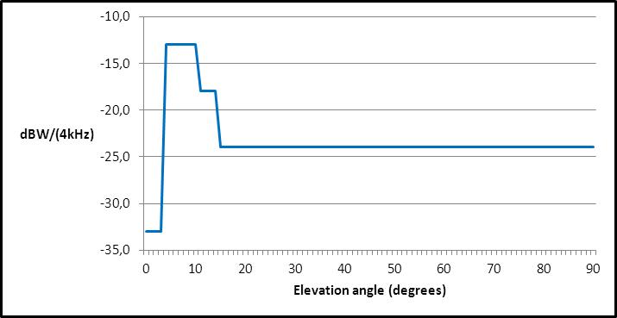

This mask is assumed for all azimuth angles.

Aircraft Station Elevation Eirp Masks

The following elevation masks for the aircraft station is taken from ETSI TR 103 108. The depression angle denotes angles below the fuselage where 0 degrees is the horizontal. Elevation angle denotes angles above the fuselage where 0 degrees is the horizontal.

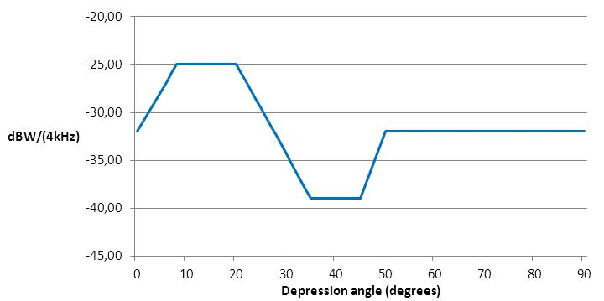

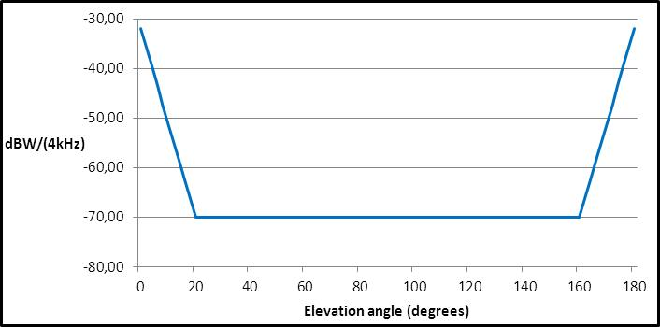

Spectrum Emission Mask

The spectrum emission mask taken from ETSI TR 103 108 is given below:

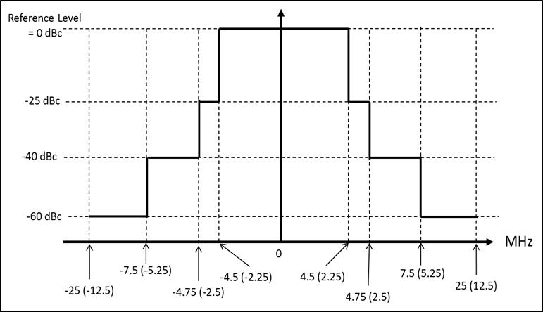

Figure 15: Spectral Emission Mask for both GS and AS
Note 1: 0 dBc Reference Level is the spectral density relative to the maximum spectral power density of the transmitted signal. For example:
i) for a Ground Station with a directional antenna, using a 10 MHz bandwidth, the Reference level (0 dBc) would be 60 dBm/(10 MHz) = 50 dBm/MHz
ii) for an Aircraft Station using a 5 MHz bandwidth, the Reference level (0 dBc) would be 39dBm/(5 MHz) = 32 dBm/MHz
Note 2: On the Frequency Offset axis, the figures apply to a 10 MHz bandwidth system, whereas the figures in parentheses apply to a 5 MHz bandwidth system.

Unwanted emissions
The spurious emissions from the antenna connector during transmit mode are defined as unwanted power in the bands from 30 MHz up to Fc -2.5*BW and from Fc +2.5*BW up to 5*Fc, where Fc is the carrier frequency and BW is the signal bandwidth (5 MHz or 10 MHz). This frequency band covers both in-band and out-of-band emissions.
The maximum level of spurious emission is: -36 dBm/(100 kHz), for 9 kHz ≤ f ≤ 1 GHz
-30 dBm/MHz , for 1 GHz < f ≤ 26 GHz

Aircraft Station Mitigation Attenuation

The AS introduces additional transmitter attenuation according to its altitude as follows:
Altitude | Attn (dB)
0 | 20
1 | 15
2 | 10
3 | 8
4 | 8
5 | 6
6 | 4
7 | 0
8 | 0
9 | 0
10 | 0
11 | 0
12 | 0

Table 12: Additional attenuation according to the aircraft altitude

Compatibility studies in the unpaired 2 GHz bands

Introduction

Compatibility and sharing scenarios in the band 1900 – 1920 MHz
Compatibility and sharing studies for DA2GC might be necessary versus the following services and systems
- Adjacent channel compatibility:
  - IMT (UMTS FDD UL),
  - DECT (indoor + outdoor),
  - Non-specific SRDs (indoor + outdoor),
  - PMSE (indoor + outdoor),
  - FS (secondary).
- Co-channel compatibility:
  - Non-specific SRDs (indoor + outdoor),
  - PMSE (indoor + outdoor),
  - FS (secondary).

According to the information given in 3.1 two systems already commercially deployed within Europe are in the focus of first compatibility evaluations for DA2GC:
- DECT (TDD) in the adjacent band below 1900 MHz.
- UMTS FDD (UL) in the adjacent band above 1920 MHz.
UMTS TDD services within the band 1900-1920 MHz will be not considered as there are no relevant commercial deployments within European area.

Technical characteristics of UMTS
The UMTS system parameters are based on 3GPP specifications for transmitter and receiver characteristics for BS [11] and UE [12].

Table 13: Main parameters for the UMTS system
Parameter | UMTS BS | UMTS UE
 | FDD | FDD
Type | Macro / Wide area | Power class 3
Tx power | 43 dBm | 24 dBm
Antenna type | 3 x 120° sector antennas  (according to ITU-R F.1336) | Omni
Antenna gain | 17 dBi | 0 dBi
Antenna height | 30 m | 1.5 m
Antenna tilt | -2.5°(down-tilt) | 0°
Channel bandwidth | 5 MHz | 5 MHz
Frequency re-use factor | 1 | 1
Signal bandwidth | 3.84 MHz | 3.84 MHz
Rx thermal noise | -108 dBm | -108 dBm
Rx noise figure | 5 dB | 9 dB
Rx noise floor | -103 dBm | -99 dBm
Rx reference sensitivity level | -121 dBm | -117 dBm
Interference protection ratio I/N | -6 dB | -6 dB
Interference protection level | -109 dBm | -105 dBm
Tx spectrum emission mask (SEM) / Spurious emissions | According to [11] | According to [12]
Adjacent channel leakage ratio (ACLR) limit (related to UMTS) | 45 dB / 50 dB (1st/2nd channel) | 33 dB / 43 dB (1st/2nd channel)
Rx in-band / out-of-band blocking | According to [11] | According to [12]
Rx adjacent channel selectivity (ACS) | 46 dB | 33 dB

Figure 14: Vertical sector antenna pattern characteristic of the UMTS BS (according to ITU-R F.1336 with k = 0.2 [6]; down-tilt not considered in the diagram)

Technical characteristics of DECT systems
The DECT system parameters used in the study are based on ETSI EN 300 175-2 [13] and on additional information provided by the DECT Forum (e.g.[14]).
DECT technology has been deployed worldwide since many years with applications for residential cordless telephones, enterprise (multi-cell) local mobility systems, public wireless local loop (WLL) systems and public pedestrian mobility systems. According to information of the DECT Forum the dominating applications are residential cordless phones followed by enterprise systems. Public DECT systems exist in a few places in Eastern Europe, and the market is very small.
Table 14: Main parameters for DECT stations/terminals
Parameter | DECT station/terminal
 | TDD
Tx power (max./min.) | 24 dBm
Antenna type | Directional / Omni-directional
Antenna gain | Up to 12 dBi / Up to 3 dBi  (Note 1)
Antenna height | 5 m  (Note 2)
Channel separation | 1.728 MHz
Signal bandwidth | 1.152 MHz
Rx thermal noise | -114 dBm
Rx noise figure | 11 dB
Rx noise floor | -103 dBm
Rx reference sensitivity level | -93 dBm  (Note 3)
Interference protection ratio I/N | 0 dB
Interference protection level | -103 dBm  (Note 4)
Tx spectrum emission mask (SEM) / Spurious emissions | According to [13]
Adjacent channel leakage ratio (ACLR) limit | See Table 12
Rx in-band / out-of-band blocking | According to [13]
Rx adjacent channel selectivity (ACS) | See Table 13

Note 1: Typically DECT equipment uses omni-directional antennas with 0 dBi (due to asymmetries in the diagram peak gains up to 3 dBi may occur). About 5 % of the enterprise base stations have external antennas with 6-12 dBi. This corresponds to 0,026% of all DECT base stations, and 0,01 % of all DECT transmitters. The 12 dBi value has been considered as worst case assumption for the interference computation in the present study.
Note 2: Similar to the antenna gain a height of 5 m has been assumed corresponding to an outdoor enterprise or WLL station.
Note 3: The reference sensitivity level given in ETSI EN 300 175-2 [13] is only -83 dBm, but DECT manufacturers very early succeeded to make cost efficient DECT phones with -93 dBm sensitivity, which is the industry standard since then.
Note 4: Interfering signal level to allow a 3dB desensitization of the DECT receiver.

Ten RF carriers are defined for DECT in the frequency band 1880-1900 MHz with center frequencies Fc given by:
Fc = F0 - c x 1.728 MHz where F0 = 1897.344 MHz and c = 0, 1, ..., 9.
Figure 15: Position of DECT carriers and adjacent channels extended outside the DECT band (related to UMTS TDD channelization)

Table 15: Adjacent channel leakage ratio for DECT channelization (bandwidth of about 1 MHz)
Adjacent channel # | Maximum power level | ACLR
1st adj. channel | -8 dBm | 32 dB
2nd adj. channel | -30 dBm | 54 dB
3rd adj. channel | -41 dBm | 65 dB
4th & higher adj. channel | -44 dBm | 68 dB

Table 16: Adjacent channel selectivity for DECT-like interferer
Adjacent channel # | ACS
1st adj. channel | 24 dB
2nd adj. channel | 45 dB
3rd adj. channel | 51 dB
4th adj. channel | 55 dB
5th & higher adj. channel | 58 dB

DA2GC Reverse Link in the band 1900 – 1920 MHz
Following interference scenarios are evaluated based on the assumption that the DA2GC reverse link (RL) is applied in the band 1900-1920 MHz:
- UMTS:
  - The reception at the UMTS base station (UMTS UL) is interfered with by the DA2GC RL from the onboard unit (OBU) of the aircraft station (AS).
  - The reception at the DA2GC ground station (GS), i.e. the DA2GC RL, is interfered with by the UMTS UL (UE).
- DECT:
  - The reception at a DECT station is interfered with by the DA2GC RL.
  - The reception at the DA2GC GS (DA2GC RL) is interfered with by the signal transmission of a DECT station.
The evaluation results described later are based on worst case single link scenarios between the interferer and the victim system to get an overview about scenarios which might perhaps require a more deep analysis based on statistical evaluations e.g. by use of the SEAMCAT Monte Carlo simulation functionality.

Figure 16: Interference scenarios for BDA2GC Reverse Link in the frequency band 1900 – 1920 MHz

Compatibility studies on DA2GC according to ETSI TR 103 054

Impact of DA2GC AS on UMTS BS

Results
The following diagrams always show
- path loss with and without consideration of the vertical antenna characteristic at the DA2GC AS and UMTS BS (antenna gain not included),
- received interference power at the UMTS BS (related to the signal bandwidth of 3.84 MHz),
- resulting interference-to-noise ratio (I/N) compared to the threshold of victim system
along the great circle distance from 0 km to 100 km considering different aircraft altitudes of 3 km and 10 km, respectively.
With respect to interference the worst case assumption is to have line-of-sight propagation between interferer and victim. Therefore, only free space loss was applied [30]. In real scenarios there may be a strong shadowing of the interfering signal resulting in drastically improved system performance compared to the results given in the present document.
The carrier frequency of the interfering DA2GC RL is placed at 1915 MHz, the UMTS UL carrier is at 1922.5 MHz, i.e. there is no frequency guard band in between the 2 channels.
For the I/N computation the resulting adjacent channel interference ratio (ACIR) was considered which is based on following relationship of the Tx and Rx characteristics of interferer and victim equipment:
The ACLR value of the DA2GC AS for the frequency separation given before corresponds to 42.5 dB, which can be increased to 47.2 and 59.2 dB by shifting the carrier frequency in direction of the lower edge of the band 1900-1920 MHz (i.e. to 1910 MHz and 1905 MHz, respectively).
Figure 17: Path loss with and without consideration of the vertical antenna characteristic (antenna gain not included) at the DA2GC AS and UMTS BS (aircraft altitude of 3 km)
Figure 18: Interference signal power at UMTS BS w/ & w/o consideration of ACIR (aircraft altitude of 3 km)

Figure 19: Resulting I/N at UMTS BS w/ & w/o consideration of ACIR (aircraft altitude of 3 km)
Figure 20: Path loss with and without consideration of the vertical antenna characteristic (antenna gain not included) at the DA2GC AS and UMTS BS (aircraft altitude of 10 km)
Figure 21: Interference signal power at UMTS BS w/ & w/o consideration of ACIR (aircraft altitude of 10 km)
Figure 22: Resulting I/N at UMTS BS w/ & w/o consideration of ACIR (aircraft altitude of 10 km)
It can be seen that the resulting interference margin is in the range of about 10 dB in the considered worst case scenario occurring at an aircraft altitude of 3 km. The margin increases to about 20 dB for an altitude of 10 km.

Impact of UMTS UE on DA2GC GS

Results
The following diagrams always show – similar to the case of scenario 5.5.1.1 but now there is no need to consider any aircraft altitude – the interference impact of a UMTS UE on the DA2GC GS. In principle this scenario is the identical to the one if LTE and UMTS carriers, both for terrestrial mobile radio coverage, are deployed on adjacent channels. Therefore it is not only related to the DA2GC case.
Figure 23: Path loss with and without consideration of the vertical antenna characteristic (antenna gain not included) at the DA2GC GS and UMTS UE
Figure 24: Interference signal power at DA2GC GS w/ & w/o consideration of ACIR
Figure 25: Resulting I/N at DA2GC GS w/ & w/o consideration of ACIR
In the hypothetical case considered here the I/N threshold is exceeded for a UE placement near the site of the DA2GC GS, requiring an unobstructed line-of-sight path between the antennas. In case of co-located BSs for UMTS and DA2GC the UMTS power control would reduce the UE Tx power level of 24 dBm which was assumed here. The maximum interference impact may occur if there is no site sharing and the UMTS UE is near the cell edge which is also near by a DA2GC site. As rural areas are favored for deployment of DA2GC sites, the occurrence of such an interference situation is strongly limited.

Impact of DA2GC AS on DECT station/terminal

Results
The interference impact of a DA2GC AS on a DECT station is shown in the following diagrams. For the examinations a worst case scenario is created with DECT outdoor reception (transmission in case of Scenario (5.5.1.3) at rooftop level (i.e. line-of-sight between both antennas) and applying a directional high gain antenna towards the aircraft (or to the DA2GC GS, respectively).
As reference the DECT channel F0 is applied as victim carrier frequency and the DA2GC signal was placed near the DECT band in the adjacent channel with a carrier frequency of 1905 MHz.
The ACLR values of the AS transmitter were adapted to the DECT signal bandwidth and the spacing between the carrier frequencies resulting in a value of 50 dB for the example considered here (carrier spacing of about 7.66 MHz). Shifting the DA2GC signal to the upper edge of the 1900-1920 sub-band (i.e. carrier frequency of 1915 MHz as already considered in Scenario (1a/b)) the ACLR increases to about 65 dB.
For the computation of ACIR also modified values for the DECT Rx ACS are needed as the ones given in Table 13 are only for DECT carrier frequency spacing and signal bandwidth. A similar approach as proposed by the DECT Forum in [14] was applied to get ACS values for other frequency separations and bandwidths. The resulting values are 56 dB for the considered carrier spacing as well as 58 dB for additional increase of carrier frequency distance by more than 5 MHz. The corresponding ACIR values are 49 dB and 55.5 dB, respectively.
Figure 26: Path loss with and without consideration of the vertical antenna characteristic (antenna gain not included) at the BDA2GC AS and DECT station (aircraft altitude of 3 km)
Figure 27: Interference signal power at DECT station w/ & w/o consideration of ACIR (aircraft altitude of 3 km)
Figure 28: Resulting I/N at DECT station w/ & w/o consideration of ACIR (aircraft altitude of 3 km)
Figure 29: Path loss with and without consideration of the vertical antenna characteristic (antenna gain not included) at the BDA2GC AS and DECT station (aircraft altitude of 10 km)
Figure 30: Interference signal power at DECT station w/ & w/o consideration of ACIR (aircraft altitude of 10 km)
Figure 31: Resulting I/N at DECT station & w/o consideration of ACIR (aircraft altitude of 10 km)
There is no noticeable impact of the DA2GC AS on the reception at the DECT station even in the examined worst case scenario with outdoor reception using the high gain antenna. One reason for that is the achieved ACIR based on relatively high ACLR of the DA2GC AS and ACS of the DECT station.

Impact of DECT station on DA2GC GS

Results

The interference impact of a DECT station on a DA2GC GS is presented in the following diagrams.

Figure 32: Path loss with and without consideration of the vertical antenna characteristic (antenna gain not included) at the BDA2GC GS and DECT station
Figure 33: Interference signal power at DA2GGC GS w/ & w/o consideration of ACIR
Figure 34: Resulting I/N at DA2GC BS w/ & w/o consideration of ACIR
Similar to the case with a UMTS UE as interferer (same Tx power of 24 dBm) the I/N threshold is exceeded for a placement of a DECT station near the DA2GC GS (up to a distance of about 0.4 km). Further frequency separation between the DECT and the DA2GC carrier will not significantly improve the results (only by 0.5 dB) as the ACIR is dominated by the ACS of the DA2GC BS (43.5 dB), even if the DECT ACLR is increased from 51 to 58.5 dB.
Nevertheless, the final interference impact of DECT stations on the DA2GC RL reception is rated as rather small due to very low number of deployed outdoor stations with high gain antennas in Europe in combination with the low number of DA2GC GS (about 400) required for pan-European coverage. As a simple mitigation measure sufficient link distances between DECT stations and DA2GC GS should be considered during network deployment.

Conclusions on compatibility between DA2GC RL and UMTS/DECT systems
The worst case link evaluations presented in the present document have shown that there will be no negative impact on DECT and UMTS FDD UL, if the DA2GC RL is implemented in the band 1900-1920 MHz independent of the positioning of the carrier frequency in the range between 1905 and 1915 MHz.
On the other hand DECT stations as well as UMTS UEs may disturb the DA2GC RL reception at the GS, if they are placed near the GS with unobstructed line-of-sight path to the GS antenna and, in addition, if they are required to transmit with their maximum power (e.g. a UE at cell edge). But as such a situation will only seldom occur for UMTS UEs and as DECT outdoor stations are only rarely deployed there is only a very low risk for any performance degradation of the DA2GC RL transmission.
Possible mitigation measures are sufficient separation distances between DECT outdoor stations and DA2GC GS as well as an improvement of the ACS of the GS receiver.

Compatibility studies on DA2GC according to ETSI TR 101 599

For most of these situations a straightforward analysis is presented in the following sections based on ground path interference or air-to-ground interference. In the case of ground path interference, a graph of interference level as a function of distance is presented with the interference criterion indicating the separation distances necessary to ensure satisfactory operation. In the case of air-to-ground interference a graph of interference level as a function of elevation angle at the victim is presented. In all cases, the key parameters on which the interference graphs are based are shown at the beginning of each section.

Impact of DA2GC AS on UMTS BS

In the case of worst case victim locations relating to interference from DA2GC Aircraft Stations into UMTS and DECT systems in adjacent bands these have been determined by modelling a range of victim distance offsets from the DA2GC Ground Station. An example surface plot is shown in Figure 35 below for a victim UMTS Base Station.
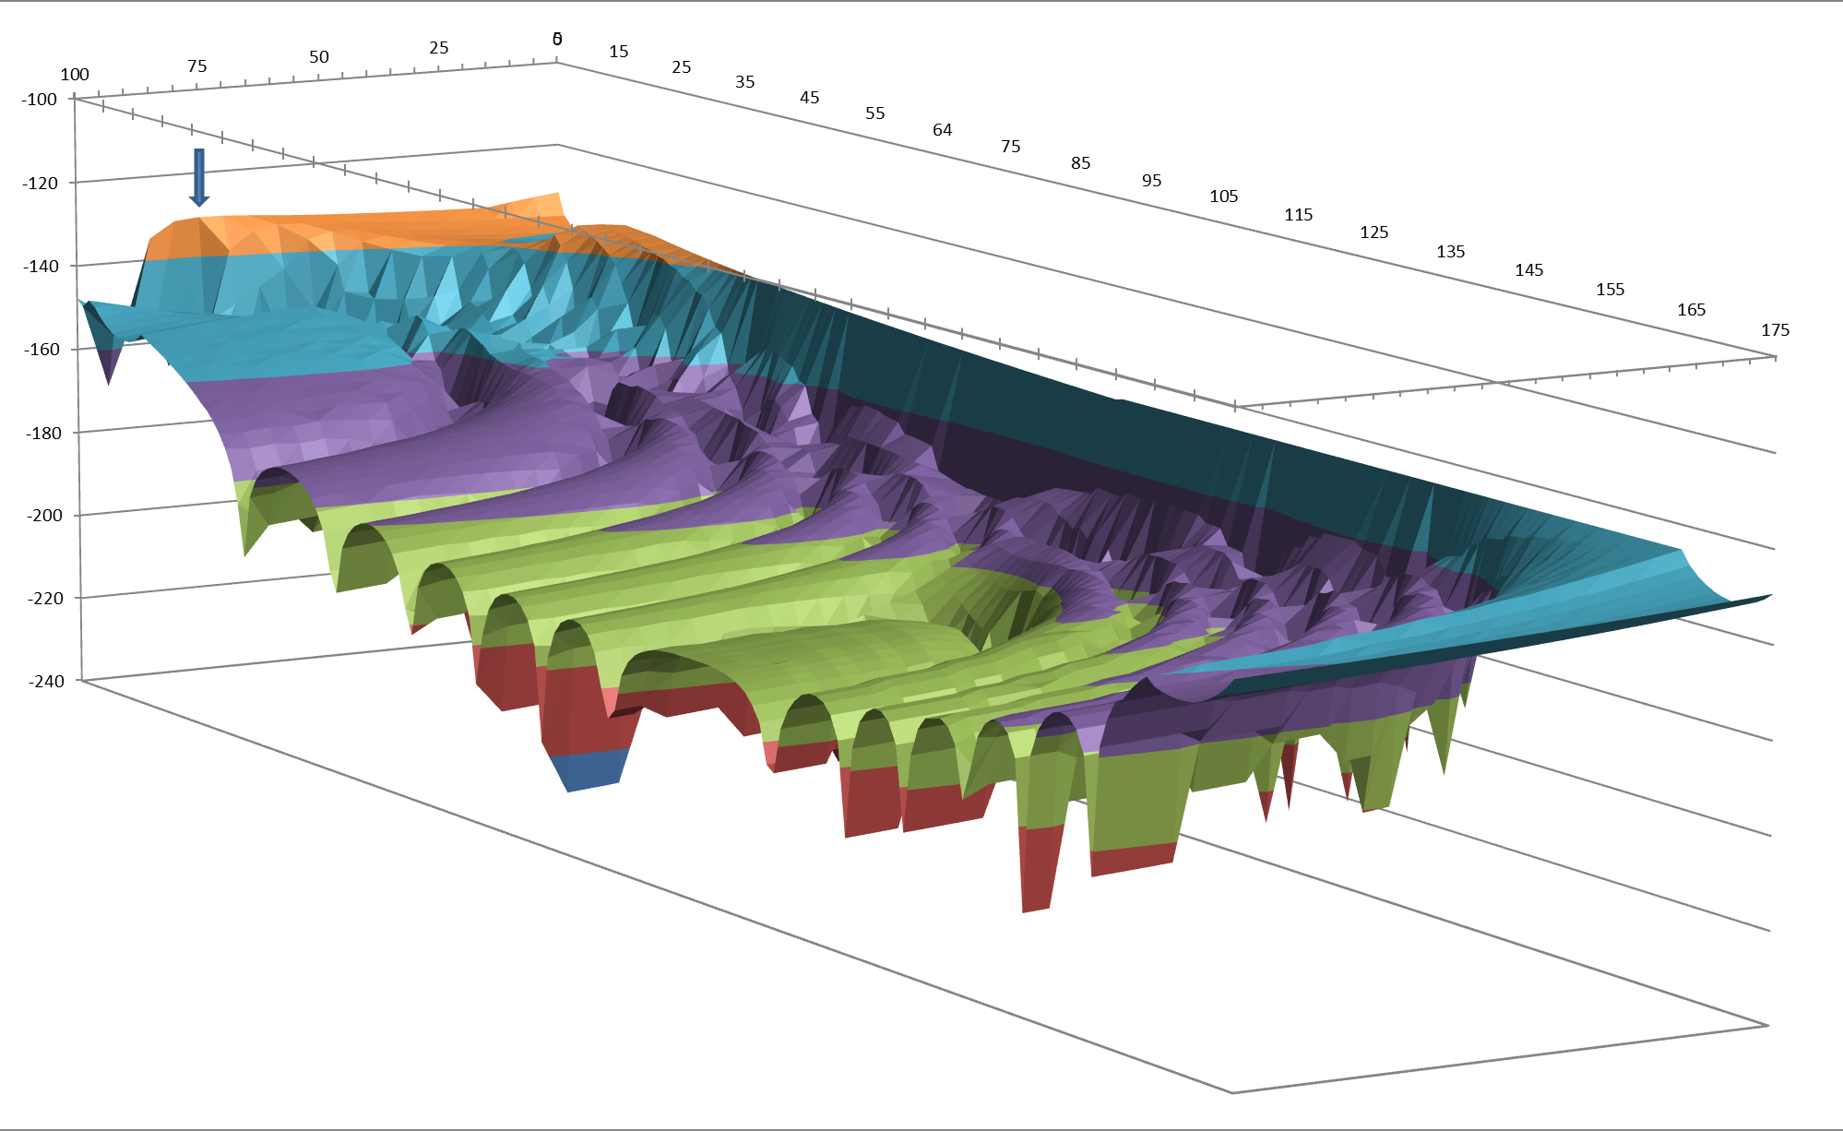
Figure 35: Variation in interference levels with UMTS Base Station location
The three axes in the above plot represent:
• the interference level received by the UMTS Base Station in the range -100 to 240 dBm
• the distance of the UMTS Base Station from the DA2GC Ground Station. The distance is in the direction towards the aircraft as it comes over the horizon and is in the range 0 to 100 km
• the elevation of the aircraft relative to the DA2GC Ground Station in the range 5 to 175 degrees as the aircraft does not operate below 5 degrees elevation

It can be seen from Figure 35 that the worst case location (i.e. that which gives rise to the highest received level of interference) for the UMTS Base Station is 74 km from the DA2GC Ground Station.

Results
Table 17: Key parameter values
Parameter | Value | Unit | Comment
Noise (Victim) | -103 | dBm | in 3.84 MHz (5 MHz channel)
ACS (Victim) | 46 | dB | Assume same for second adjacent channel (but likely to be better [greater value] than this)
ACLR (Interferer) | 46 | dB | Bandwidth correction (6 dB) applied
I/N Criterion (Victim) | -6 | dB
Rx Gain (Victim) | 17 | dBi | ITU-R F.1336 k=0.2
Tx EIRP (Interferer) | 32.76 (for C/N=10)  42.8 (for C/N=20) | dBm | ATPC. UMTS BS located in worst case location (74 km offset from DA2GC Ground Station).

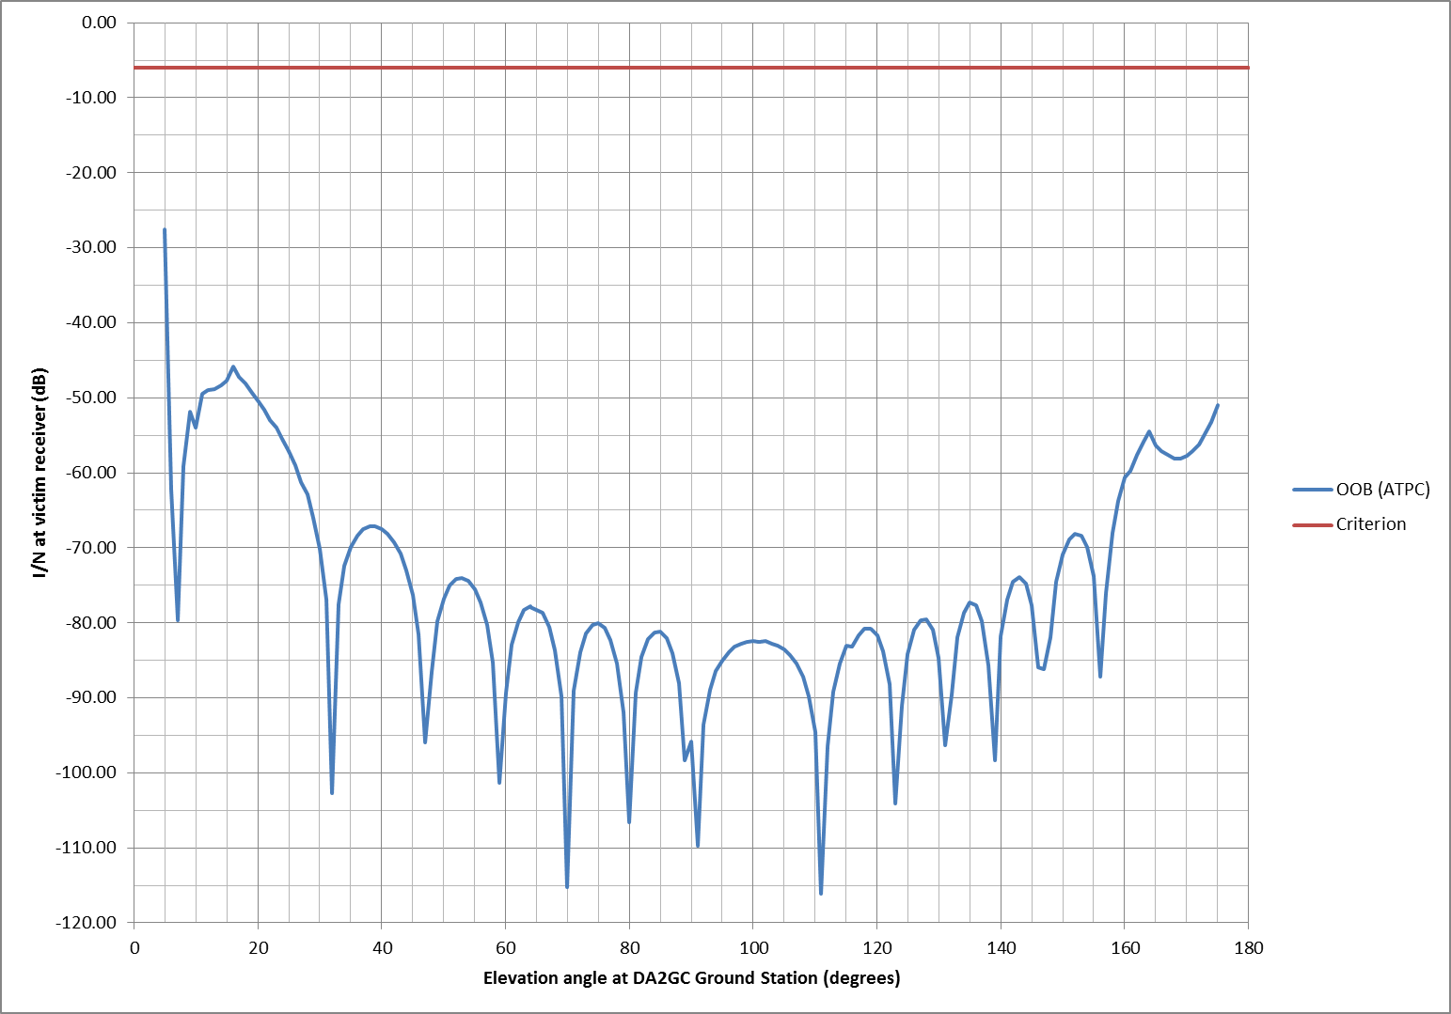
Figure 36: Interference at the victim UMTS Base Station in a worst case location (74 km offset from DA2GC Ground Station) as a function of elevation at the DA2GC GS.
The result in Figure 36 above is based on a DA2GC EIRP of 42.8 dBm which supports a C/N of 23 dB. It can be seen that the margin available here is 21.6 dB, noting that there is little or no difference between 3 km and 10 km altitude because the DA2GC ATPC affects OOB emissions as well as the main carrier level.

Impact of UMTS UE on DA2GC GS

Results
Table 18: Key parameter values
Parameter | Value | Unit | Comment
Noise (Victim) | -100 | dBm | in 10 MHz channel
ACS (Victim) | 39 | dB | From DA2GC system design authority
ACLR (Interferer) | 35.6 | dB | 1st and 2nd adjacent channel combination
I/N Criterion (Victim) | -10 | dB
Rx Gain (Victim) |  | dBi | -10 to 0 dBi depending on where in null
Tx EIRP (Interferer) | 24 | dBm | in 3.84 MHz (5 MHz channel)

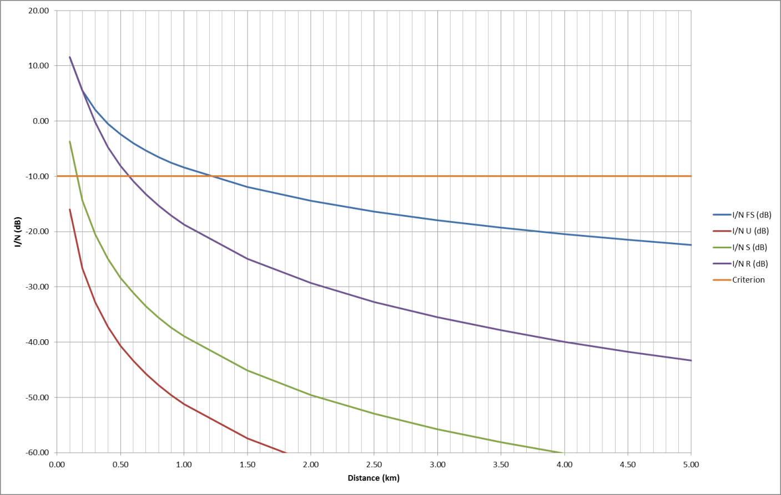
Figure 37: Interference as a function of distance
The result in Figure 37 above is based on the Extended Hata propagation model. It has been assumed that the UMTS UE has a height of 1.5 m and that the height of the DA2GC Ground Station is 20 m. The DA2GC GS receive gain at or near 0° elevation has been assumed to be 0 dBi (which is a worst case i.e. null not taken into account). The separation distance required ranges from less than 600 m (rural) to less than 100 m (urban).

Impact of DA2GC AS on DECT station/terminal

A similar process as described in section 5.5.2.1 was used to identify the worst-case location for a DECT terminal, which resulted in a figure of 80km from the DA2GC Ground Station.

Results

Table 19: Key parameter values
Parameter | Value | Unit | Comment
Noise (Victim) | -103 | dBm | in 1.152 MHz (1.728 MHz channel)
ACS (Victim) | 53.2 | dB | DECT ACS values averaged across interferer bandwidth
ACLR (Interferer) | 50.6 | dB | Bandwidth correction (10.6 dB) applied
I/N Criterion (Victim) | 0 | dB
Rx Gain (Victim) | 0 | dBi | As indicated by SE7 DECT guidance. 12 dBi implication noted below.
Tx EIRP (Interferer) | 32.8 (for C/N=10)  42.8 (for C/N=23) | dBm | DECT terminal located in worst case location (80 km offset from DA2GC Ground Station).

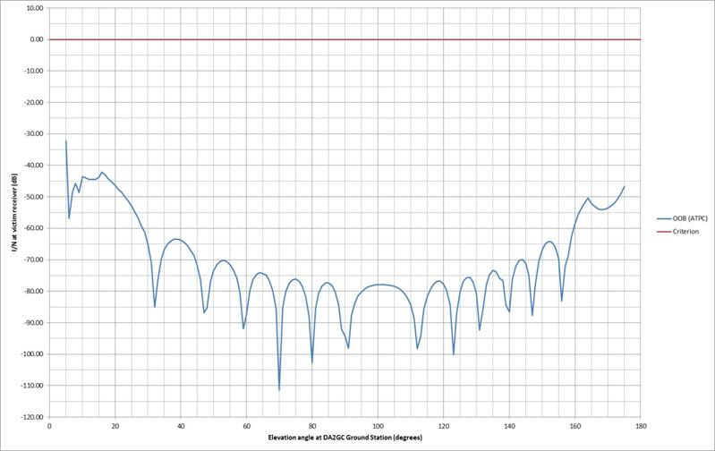
Figure 38: Interference at the victim UMTS Base Station in a worst case location (74 km offset from DA2GC Ground Station) as a function of elevation at the DA2GC GS
The result in Figure 38 above is based on a DA2GC EIRP of 42.76 dBm which supports a C/N of 20 dB. It can be seen that the margin available here is 23.3 dB, noting that there is little or no difference between 3 km and 10 km altitude because the DA2GC ATPC affects OOB emissions as well as the main carrier level.
The margin available is reduced to 18.5 dB if directional (12 dBi) DECT terminals are considered to be pointing directly at the aircraft with a 22 degree elevation.

This result indicates that no guard bands are required and the full 20 MHz can be used by the DA2GC system without exceeding the UMTS base station protection criterion.

Impact of DECT station on DA2GC GS

Results
Table 20: Key parameter values
Parameter | Value | Unit | Comment
Noise (Victim) | -97 | dBm | in 20 MHz channel
ACS (Victim) | 39 | dB | Modified to reflect reduced selectivity closer to victim pass band
ACLR (Interferer) | 52.3 | dB | DECT ACLR values aggregated across victim bandwidth
I/N Criterion (Victim) | -10 | dB
Rx Gain (Victim) |  | dBi | -10 to 0 dBi depending on where in null
Tx EIRP (Interferer) | 24 | dBm | in 1.152 MHz (1.728 MHz channel). G = 12 dBi implication noted below.

[
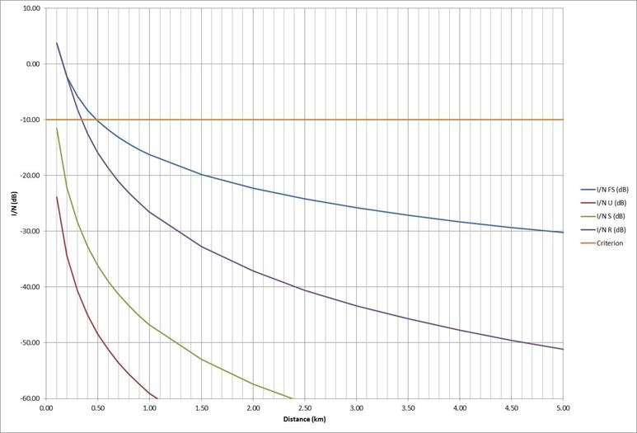
Figure 39: Interference as a function of distance

The result in Figure 39 above is based on the Extended Hata propagation model. It has been assumed that the DECT terminal has a height of 1.5 m and that the height of the DA2GC Ground Station is 20 m. The DA2GC GS receive gain at or near 0° elevation has been assumed to be 0 dBi (which is a worst case i.e. null not taken into account). The separation distance required ranges from 350 m (rural) to less than 100 m (urban).
For the case where the DECT transmitter has an additional gain of 12 dBi and is located at a height of 5 m this separation distance would increase to approximately 600 m (rural) taking account of the discrimination in the DA2GC Ground Station null (-10 dBi) which comes into play for greater distances(i.e closer to zero degrees in the elevation plane).
This result indicates that no guard bands are required and the full 20 MHz can be used by the DA2GC system

DA2GC Foreward Link in the Band 1900 – 1920 MHz
Compatibility and sharing studies for DA2GC might be necessary versus the following services and systems (see Figure 40):
• Adjacent channel compatibility:
o IMT (UMTS FDD UL),
o DECT (indoor + outdoor),
o Non-specific SRDs (indoor + outdoor),
o PMSE (indoor + outdoor),
o FS (secondary).
• Co-channel compatibility:
o Non-specific SRDs (indoor + outdoor),
o PMSE (indoor + outdoor),
o FS (secondary).

Figure 40: Scenarios for DA2GC forward link in the frequency band 1900-1920 MHz
Two systems already commercially deployed within Europe are in the focus of this compatibility evaluation for DA2GC:
- DECT (TDD) in the adjacent band below 1900 MHz.
- UMTS FDD (UL) in the adjacent band above 1920 MHz.
UMTS TDD services within the band 1900-1920 MHz will be not considered as there are no relevant commercial deployments within European area.
Following interference scenarios are evaluated based on the assumption that the DA2GC forward link (FL) is applied in the band 1900-1920 MHz:
UMTS:
- DA2GC ground station (GS) into UMTS base station.
- UMTS UE into DA2GC aircraft station (AS).

DECT:
- DA2GC ground station (GS) into a DECT station.
- DECT station into a DA2GC aircraft station (AS).

Compatibility studies on DA2GC according to ETS TR 103 054
The evaluation results described later are based on worst case single link scenarios between the interferer and the victim system to get an overview about scenarios which might perhaps require a more deep analysis based on statistical evaluations e.g. by use of the SEAMCAT Monte Carlo simulation functionality.

Impact of DA2GC GS on UMTS BS

Results
This scenario represents the most critical case for integration of the DA2GC FL in the lower 2 GHz unpaired band, as the transmission is in the opposite direction compared to UMTS and therefore corresponds to a similar case as applying UMTS (and/or LTE) TDD and FDD/TDD systems in adjacent channels. Results of such evaluations considering also the case of interference between 2 base (ground) stations are given e.g. in CEPT Reports 39 and 41.
In Figure 41 the path loss between a DA2GC GS and a UMTS BS for free space propagation is shown based on the parameter sets given in Subsection 3.2.1 and 3.2.2. For increasing distances it is always assumed that the main lobes of the horizontal antenna diagrams (typically sector antennas) are pointed directly to each other (worst case). At a distance near zero it is assumed that the antennas are placed at the same mast, but with different heights (50 m for the DA2GC antenna, 30 m for the UMTS antenna). In a real environment the resulting minimal coupling loss will be strongly dependent on the antenna characteristic (mainly the side lobes) and the kind of installation at the mast (including the impact of the mast type). Results of achievable antenna isolations are summarized e.g. in Report ITU-R M.2244.
Figure 41: Path loss with and without consideration of the vertical antenna characteristic (antenna gain not included) at the UMTS BS and DA2GC GS (free space)

Figure 42shows the received interference power at the UMTS BS (related to the signal bandwidth of 3.84 MHz at a carrier frequency of 1922.5 MHz) and Figure 43 the resulting I/N compared to the threshold of victim system. For interference power and I/N 3 different curves are given for inclusion of final ACIR dependent on the position of the DA2GC signal carrier frequency. For a carrier frequency of 1915 MHz the ACIR is equal to 36.8 dB (with ACS of UMTS BS equal to 46 dB and ACLR of DA2GC GS equal to 37.4 dB), resulting in a necessary separation distance between a DA2GC GS and a UMTS BS in the range of about 18 km. With a higher frequency separation) the ACIR increases to 39.9 dB (ACLR equal to 41.2 dB at 1910 MHz) and 45 dB (ACLR equal 52.2 dB at 1905 MHz), resulting in decreased separation distances in the range of about 13 km and 7 km, respectively.
Figure 42: Interference signal power at UMTS BS w/ & w/o consideration of ACIR
(free space; ACIR for DA2GC carrier frequencies at 1905/1910/1915 MHz)
Figure 43: Resulting I/N at UMTS BS w/ & w/o consideration of ACIR
(free space; ACIR for DA2GC carrier frequencies at 1905/1910/1915 MHz)

Figure 44 demonstrates the impact of the environment around the stations applying the more realistic Extended Hata Model instead of free space propagation (here for the lower band edge). For rural (open) and suburban areas the impact on separation distances compared to free space propagation is only low because of the assumed high antenna heights, for urban area the separation distance reduces to less than 2 km.
Figure 44: Resulting I/N at UMTS BS w/ & w/o consideration of ACIR
for DA2GC carrier frequency at 1905 MHz
(Ext. Hata Model for Rural (here equal to free space), Suburban and Urban Area)

Based on the results, a very careful radio network planning would be required for placement of DA2GC GS (incl. coordination with UMTS network operators) even if the lowest possible carrier frequency of 1905 MHz in the band 1900-1920 MHz is applied. Alternative means to ease compatibility would be on the one hand side to increase the ACLR of the DA2GC GS - a rather expensive task due to development of steep RF filters - or on the other hand to reduce the Tx power of the DA2GC GS. The latter mitigation method would have a strong economic impact as the number of GS required to cover Europe would drastically increase resulting in a negative business case for DA2GC deployment.

Impact of UMTS UE on DA2GC AS

Results
The interference impact of a UMTS UE on a DA2GC AS for aircraft altitudes of 3 and 10 km is shown in Figure 46 - Figure 50. Only free space propagation has been considered which may be realistic for short (ground) distances between UE and AS in flat rural (open) areas. In case of higher distances there will be typically stronger shadowing of the transmission link because of the low antenna height of the UE (1.5 m). In the evaluations the impact of the power control algorithm implemented in the UMTS system is not considered, i.e. a Tx power of the UE was always set to 24 dBm.
The carrier frequency of the UMTS UL signal was assumed to be at 1922.5 MHz and for DA2GC at 1915 MHz, i.e. this scenario represents the worst case. The final ACIR is equal to 27.3 dB (ACS of DA2GC AS equal to 33 dB and ACLR of UMTS UE equal to 28.7 dB). Even in this worst case situation there is a large margin of about 14 dB between the resulting I/N and the given threshold for an aircraft altitude of 3 km. At 10 km aircraft altitudes the margin is in the range of about 24 dB.
A shift of the DA2GC carrier frequency to 1905 MHz will increase the ACIR to 32.1 dB due to higher ACLR of the UMTS UE (39.5 dB), i.e. there is a further increase of the margin of about 4.8 dB (not shown in the diagrams).
Figure 45: Path loss with and without consideration of the vertical antenna characteristic (antenna gain not included) at UMTS UE and DA2GC AS (aircraft altitude of 3 km)
Figure 46: Interference signal power at DA2GC AS w/ & w/o consideration of ACIR (aircraft altitude of 3 km)
Figure 47: Resulting I/N at DA2GC AS w/ & w/o consideration of ACIR (aircraft altitude of 3 km)
Figure 48: Path loss with and without consideration of the vertical antenna characteristic (antenna gain not included) at UMTS UE and DA2GC AS (aircraft altitude of 10 km)
Figure 49: Interference signal power at DA2GC AS w/ & w/o consideration of ACIR (aircraft altitude of 10 km)
Figure 50: Resulting I/N at DA2GC AS w/ & w/o consideration of ACIR (aircraft altitude of 10 km)

Impact of DA2GC GS on DECT station/terminal

Results
The interference impact of a DA2GC GS on a DECT station is shown in Figure 51 - Figure 53. For the examinations again a worst case scenario is created with DECT outdoor reception (transmission in case of Scenario (2b)) at rooftop level (height of 5 m, i.e. line-of-sight between both antennas) and applying a directional high gain antenna of 12 dBi towards the DA2GC GS. As reference the DECT channel F0 is applied as victim carrier frequency and the DA2GC signal carrier frequency was placed at 1905 MHz, 1910 MHz and 1915 MHz.
The ACLR values of the DA2GC GS transmitter were adapted to the DECT signal bandwidth and the spacing between the carrier frequencies resulting in a value of 43.7 dB for a carrier frequency of 1905 MHz. For the carrier frequencies of 1910 MHz and 1915 MHz the ACLR is equal to 47 and 58 dB, respectively.
For the computation of the ACIR also modified values for the DECT Rx ACS are needed as the ones given in Table 13are only for DECT carrier frequency spacing and signal bandwidth. A similar approach as proposed by the DECT Forum in [14] was applied to get ACS values for other frequency separations and bandwidths. The resulting values are 56 dB for the considered frequency separation to 1905 MHz as well as 58 dB for additional increase of the DA2GC carrier frequency distance by more than 5 MHz. The resulting ACIR values are 43.5 dB for 1905 MHz, 46.7 dB for 1910 MHz, and 55 dB for 1915 MHz. The path loss between the DA2GC GS and the DECT station is shown in Figure 51, the interference power at the DECT station and the resulting I/N for the different positioning of the DA2GC carrier frequency are shown in Figure 52 and Figure 53. For a DA2GC carrier frequency of 1905 MHz a separation distance of about 3 km is required between the stations which can be reduced to less than 1 km in the case of using the upper band edge.
Similar to Scenario (1a) Figure 54 demonstrates the impact of the environment around the stations applying the more realistic Extended Hata Model instead of free space propagation (here for the DA2GC carrier frequency of 1905 MHz only). For rural (open) areas the impact is only low because of the assumed high antenna heights, but for suburban and urban areas the separation distance is reduced to less than 0.7 and 0.3 km, respectively.
Due to the rather small number of DA2GC GS required to cover Europe (about 400 sites), the low number of existing outdoor DECT stations and the instant Dynamic Channel Selection (iDCS) feature of the DECT system (selection of transmission channels with lowest degradation by interference from adjacent bands) the impact of a DA2GC deployment the band 1900-1920 MHz on DECT is seen as negligible, even with a DA2GC carrier frequency of 1905 MHz.
Figure 51: Path loss with and without consideration of the vertical antenna characteristic (antenna gain not included) at the DECT station and DA2GC GS
Figure 52: Interference signal power at DECT station w/ & w/o consideration of ACIR
for DA2GC carrier frequencies at 1905/1910/1915 MHz
Figure 53: Resulting I/N at DECT station w/ & w/o consideration of ACIR
for DA2GC carrier frequencies at 1905/1910/1915 MHz
Figure 54: Resulting I/N at DECT station w/ & w/o consideration of ACIR for DA2GC carrier frequency at 1905 MHz (Ext. Hata Model for Rural (Open), Suburban and Urban Area)

Impact of DECT station on DA2GC AS

Results
This scenario is similar to Scenario (1b). Differences are only in the antenna height of the DECT station compared to the UMTS UE (5 m instead of 1.5 m) and the gain of the omni-directional antenna (12 dBi instead of 0 dBi which is not very realistic for areas above the DECT station). Therefore the path loss is nearly identical to that given in Scenario (1b) and is not shown here.
However the resulting ACIR is different due to other system characteristics of the DECT station compared to the UMTS UE. Assuming the transmission channel F0 for DECT and a carrier frequency of 1905 MHz for the DA2GC FL the ACIR value is equal to 32.9 dB (DA2GC AS ACS equal to 33 dB and DECT station ACLR equal to 51 dB). Shifting the DA2GC FL carrier frequency to 1910 MHz or 1915 MHz has no impact. The DECT station ACLR increases to 58.5 dB, but the resulting ACIR is unchanged due to lower ACS value of the DA2GC AS (improvements are possible if required).
Figure 55 - Figure 58 show that the resulting I/N in the considered seldom worst case situation stays below the required threshold. At an aircraft altitude of 3 km the remaining margin is in the range of 8 dB, at 10 km at about 18 dB. Therefore the impact of DECT on a DA2GC FL deployment in band 1900-1920 MHz seems to be uncritical, even with a DA2GC GS carrier frequency of 1905 MHz.

Figure 55: Interference signal power at DA2GGC AS w/ & w/o consideration of ACIR (aircraft altitude of 3 km)
Figure 56: Resulting I/N at DA2GC AS w/ & w/o consideration of ACIR (aircraft altitude of 3 km)
Figure 57: Interference signal power at DA2GGC AS w/ & w/o consideration of ACIR (aircraft altitude of 10 km)
Figure 58: Resulting I/N at DA2GC AS w/ & w/o consideration of ACIR (aircraft altitude of 10 km)

Conclusions on compatibility between DA2GC FL and UMTS/DECT systems

Compatibility between DA2GC FL and UMTS
Interference at a UMTS BS may occur when a DA2GC GS is co-located at the same site or both stations are placed at another site near each other. To keep the impact low, the DA2GC FL carrier frequency should be at 1905 MHz, i.e. at the lower edge of the band 1900-1920 MHz. But even in that case the separation distance would be about 7 km, and thus a careful radio network planning for DA2GC in combination with site coordination with UMTS operators is required.
The interference impact of UMTS UEs on the DA2GC FL reception at the AS is rated as uncritical due to high ACIR and sufficient path loss between both stations, in particular if a DA2GC FL carrier frequency of 1905 MHz is chosen.

Compatibility between DA2GC FL and DECT
The implementation of a DA2GC FL in the band 1900-1920 MHz would have no negative impact on DECT operations in the adjacent band below. Only in the very seldom cases that DECT outdoor stations may be deployed near a DA2GC station a small separation distance is required which is strongly dependent on the link conditions between both stations (even in the worst case less than 3 km, typically distinctly lower).
The interference impact of DECT stations on DA2GC FL reception at the AS is rated as uncritical due to high ACIR and sufficient path loss between both stations which would be increased in more realistic scenarios by typical usage of DECT in indoor environments and lower DECT station antenna gain (maximum 3-4 dBi instead of 12 dBi).

Compatibility studies on DA2GC according to ETSI TR 101 599

Impact of DA2GC GS on UMTS BS

Results
Table 21: Key parameter values
Parameter | Value | Unit | Comment
Noise (Victim) | -103 | dBm | in 3.84 MHz (5 MHz channel)
ACS (Victim) | 46 | dB | Includes worst case assumption that 2nd, 3rd and 4th adjacent channel values are the same as the 1st adjacent channel
ACLR (Interferer) | 46 | dB | Bandwidth correction (6 dB) applied
I/N Criterion (Victim) | -6 | dB
Rx Gain (Victim) | 17 | dBi | ITU-R F.1336 k=0.2
Tx EIRP (Interferer) | 15 | dBm | Based on a DA2GC C/N performance objective of 20 dB and a DA2GC Ground Station antenna gain of -10 dBi (i.e. in the null which is applicable for geometries involving separation distances greater than several hundred metres).
[
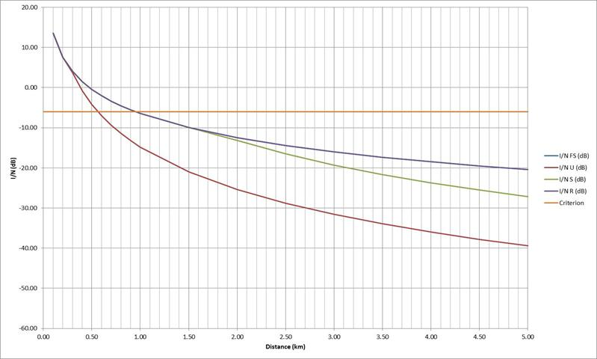
Figure 59: Interference as a function of distance

The result in Figure 59 above is based on the Extended Hata propagation model. It has been assumed that the DA2GC Ground Station has a height of 20 m and that the height of the UMTS Base Station is 30 m. The separation distance required ranges from 950 m (rural) to 550 m (urban). These distances are based on a DA2GC transmitter power level of 25 dBm into a transmit gain of -10 dBi (i.e. in the DA2GC Ground Station antenna null) giving an EIRP of 15dBm which supports a C/N of 20 dB.
The distances are also based on the main beam gain (17 dBi) of the UMTS Base Station.

Impact of UMTS UE on DA2GC AS

Results
The calculation is largely aircraft altitude independent as the path loss and the area on the ground within the aircraft main beam are both proportional to altitude squared. For the calculation below the altitude has been assumed to be 10 km. The interference received at an aircraft can therefore be calculated as follows:
Table 22: Aggregate interference into DA2GC Aircraft Station
Parameter | Value | Unit | Comment
Average EIRP of UMTS UE | -2.5 | dBm | For urban areas (Value from [27])
Density of simultaneous UMTS users | 30.2 | Users/sq km | For urban areas (Value derived from [27]
Aircraft receive antenna half power beamwidth | 8 | Degrees | Wider aircraft beamwidth at lower elevation angles increases area by a factor 33.4 which would increase the interference / reduce the margin available by 15.2 dB.
Area on ground within HPBW for 10 km altitude | 1.5 | Sq km | Larger areas subtended by lower elevation slant path largely compensated for by increased path loss.
Aircraft receive antenna gain | 17.8 | dBi
Free Space Path Loss (10 km at 2 GHz) | 118.5 | dB
ACIR | 31.6 | dB | ACLR = 31.9 dB, ACS = 43.5 dB
Received interference | -118.2 | dBm

The received interference calculated in Table 19 above can be compared to an acceptable level at the DA2GC airborne receiver of -107 dBm (based on I/N = -10 dB). A margin of 11.2 dB is therefore available. Although this margin appears to be not quite adequate to accommodate the wider aircraft beamwidth at lower elevation angles, it would be expected that local clutter would attenuate many of the interference contributions at low elevation angles. Furthermore, a worst case assumption has been made in aggregating the UMTS ACLR values across the DA2GC channel bandwidth. Taking account of both of these factors, the situation can be judged to be satisfactory..

Impact of DA2GC GS on DECT station/terminal

Results
Table 23: Key parameter values
Parameter | Value | Unit | Comment
Noise (Victim) | -103 | dBm
ACS (Victim) | 53.2 | dB | DECT ACS values averaged across interferer bandwidth
ACLR (Interferer) | 50.6 | dB | Bandwidth correction (10.6 dB) applied
I/N Criterion (Victim) | 0 | dB
Rx Gain (Victim) | 0 | dBi | As indicated by [14]. 12 dBi implication noted below.
Tx EIRP (Interferer) | 25 | dBm | Based on a DA2GC C/N performance objective of 20 dB and a DA2GC Ground Station antenna gain of 0 dBi (i.e. not the null as this does not apply to geometries involving separation distances less than a few hundred metres).

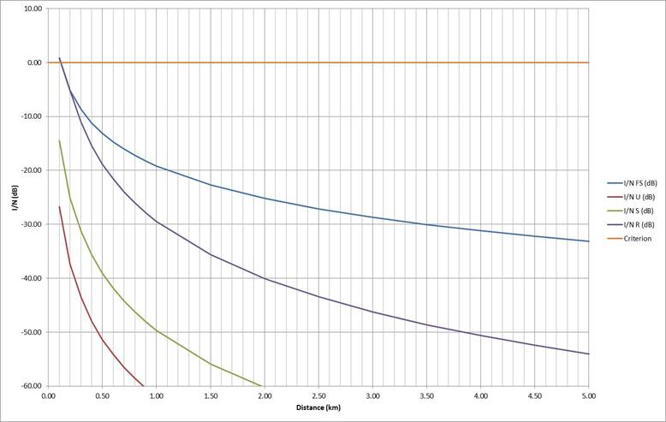
Figure 57: Interference as a function of distance

The result in Figure 57 above is based on the Extended Hata propagation model as before. It has been assumed that the DA2GC Ground Station has a height of 20 m and that the height of the DECT terminal is 1.5 m. The separation distance required for all environments is less than 110 m. This distance is based on a DA2GC transmitter power level of 25 dBm (which supports a C/N of 20 dB) into a transmit gain of 0 dBi (i.e. not in the DA2GC Ground Station antenna null) giving an EIRP of 25 dBm. Furthermore, the figures just quoted are all based on the main beam gain (17 dBi) of the UMTS Base Station.
The above figures are based on a DECT gain of 0 dBi. A DECT gain of 12 dBi (at a height of 5 m) would increase these distances from <110 m to 450 m (rural) / less than 100 m (urban).

Impact of DECT station on DA2GC AS

Results
This scenario will be similar to the situation above (5.6.6.3 - UMTS User Equipment into DA2GC Aircraft Station). Results would be expected to be reasonably similar although density of DECT use is a lot lower and devices are generally used indoors thereby providing greater margins. Little or no impact would be expected from 12 dBi DECT terminals as they are very small in number and in aggregate they will average to 0 dBi.

Compatibility and sharing scenarios for the band 2010 – 2025 MHz
Compatibility and sharing studies for DA2GC might be necessary versus the following services and systems
- Adjacent channel compatibility:
  - MSS UL (including CGC),
  - Non-specific SRDs (indoor + outdoor),
  - PMSE (indoor + outdoor),
  - FS (secondary),
  - Tactical radar,
  - Space research/earth exploration satellite services (E-S).
- Co-channel compatibility:
  - Non-specific SRDs (indoor + outdoor),
  - PMSE (indoor + outdoor),
  - FS (secondary).

Technical characteristics of Space service receivers in the band 2025 – 2110 MHz
The band 2025-2110 MHz is used by a great multiplicity of satellite systems ranging from LEO polar satellites to distant SRS satellites at the Lagrangian point, from geostationary telecom satellites in LEOP/emergency phase to the International Space Station (including all the vessels that are used for ferrying people and material to/from the ISS), from the Galileo RNSS satellites to HEO SRS satellites. In total, several hundred filings can be found in the ITU database for this band.
The protection criterion for this band is -177 dBW/kHz at the satellite receiver input for 0.1% of the time as identified in ITU-R Rec. SA.609-2 [19]. Although the recommendation refers only to SRS systems, this protection criterion is normally used for sharing studies also for the other satellite services in this band. It is to be noted that this value presents the maximum aggregate interference from all the interference sources and from all the different services. This means:

1. that the total number of interfering systems in visibility of the spacecraft receiver has to be taken into account and
2. that an apportionment of the allowed interference level has to be made among the various terrestrial services sharing the band (or emitting unwanted emissions from adjacent bands)

For point 2, in the case of the studies made in the past for sharing with mobile systems the "interference budget" was divided 50/50 between FS and MS, resulting in a threshold of
-180 dBW/kHz (see ITU-R Rec. SA.1154 [28]). ESA suggested to start the studies by applying the same value as used for the studies with mobile systems and to further discuss this point at a later stage. Unfortunately there is wide variety of satellite systems in this band, therefore it is not possible to define a single technical parameter set for all of them.
One common element is the fact that all these systems use a hemispherical quasi-omnidirectional antenna for the satellite receiver. Figure 61 shows an example from an ESA EESS satellite (Sentinel-1) that could be considered as representative of these antennae and therefore be used in the present studies.

Figure 61: Exemplary vertical satellite receive antenna pattern for S-Band uplink: co-polar (red lines) and cross-polar (blue lines)
Another relevant parameter is the satellite orbit. As said above, the orbits vary extremely depending on the type of satellite. The most critical case for compatibility with DA2GC GS transmissions is the case of the International Space Station (ISS) and all the related vessels, since the other satellite systems fly at higher orbital altitudes. The ISS itself flies at a height between 330 and 410 km and therefore a satellite altitude of 330 km is used for the worst case analysis.

Technical characteristics of Satellite Earth Stations
There are currently more than 112 missions and 126 uplinks only for Earth Exploration Satellite Service (EESS) and many planned for the near future. Under the Space Operations Service a high numbers of uplinks are used for connections to the International Space Station (ISS), its payloads and all related vehicles. Some low orbiting SRS systems use these bands. Also the European Radionavigation system Galileo uses these bands for TT&C, as well as the Ariane launchers. The number of military links in these bands is not known, but expected to be high. Several hundreds of GSO and NGSO telecom satellite links are filed in these bands. These bands are also beginning to be used by microsatellite systems (see WRC AI 9.1.8).
In addition, only for ESA usage, there are about 25 Earth stations in Europe (see ANNEX 1:) and a number of other Earth stations are deployed by various satellites operators. The following technical parameters of Satellite Earth Stations were provided by ESA:

- G, Antenna gain (3 to 15 m diameter) : 34 to 48 dBi (56 and 62 dBi in Robledo)
- Antenna pattern : F.1245 (average side lobes)
- P, Power : 50 to 70 dBm (56 dBm for ESA stations)
- B, Bandwidth : 0.1 to 3 MHz

It is also necessary to consider the unwanted emissions specifications of the Earth Stations. Considering their quite small bandwidth, one can assume that, in the DA2GC band, they would more likely relate to the “spurious” domain, as given in RR Appendix 3 as (for Space service (earth stations)):

43 + 10 log (P), or 60 dBc, whichever is less stringent

This has to be taken together with note 10 stating “Spurious domain emission limits for all space services are stated in a 4 kHz reference bandwidth”.

With a mean power of 50 dBm (20 dBW - 100 W):
– Attenuation relative to total mean power = 43-10*log (100) = 63 dBc.
– The 63 dBc value is more stringent than the 60 dBc limit, so the 60 dBc value is used.
– Therefore: Spurious domain emissions must not exceed 60 dBc in a 4 kHz reference bandwidth, or converting to an absolute level, they must not exceed 20 dBW – 60 dBc = −40 dBW in a 4 kHz reference bandwidth (similarly -20 dBW/4 kHz for a 40 dBW power station)

This leads to the following maximum unwanted emissions power in the DA2GC receiver:
Table 24: Space services unwanted emissions
P (dBm) | Punw (dBm/ 4 kHz) | Punw (dBm/ 10 MHz)
50 | -40 | 24
56 | -34 | 30
70 | -20 | 44

Technical characteristics of MSS components in the band 1990-2010 MHz

MSS complementary ground component base station (CGC BS)
The main parameters describing the radio frequency characteristic of a CGC BS are given in the ETSI Standard EN 302 574-1[22]. As there is no transmission from a CGC BS in the band 1980-2010 MHz only the receiver characteristics have to be considered. The following tables related to blocking and adjacent channel selectivity (ACS) are an extract taken from the ETSI standard. Both for blocking and ACS the bit error rate (BER) at the CGC BS receiver shall not exceed 0.001 for the parameters specified in Table 22 to Table 24 depending on the declared CGC type.
Table 25: Blocking characteristics for a wideband CGC BS
CGC type | Centre frequency of interfering signal | Interfering  signal mean  power | Wanted signal  mean power | Minimum offset of interfering signal | Type of  interfering signal
Wide  coverage CGC | 1980 - 2010 MHz | -40 dBm | -115 dBm | 10 MHz | WCDMA
Wide  coverage CGC | 1900 - 1980 MHz | -40 dBm | -115 dBm | 10 MHz | WCDMA
Medium coverage CGC | 1980 - 2010 MHz | -35 dBm | -105 dBm | 10 MHz | WCDMA
Medium coverage CGC | 1900 - 1980 MHz | -35 dBm | -105 dBm | 10 MHz | WCDMA
Local coverage CGC | 1980 - 2010 MHz | -30 dBm | -101 dBm | 10 MHz | WCDMA
Local coverage CGC | 1900 - 1980 MHz | -30 dBm | -101 dBm | 10 MHz | WCDMA
NOTE: The characteristics of the WCDMA interference signal are specified in TS 125 141, annex I.

For Table 23 and Table 24 the interference signal is offset from the wanted signal by the frequency offset F_{uw} which is determined by both the assigned channel bandwidth CBw_{assigned} and the adjacent channel bandwidth CBw_{adjacent}. In Table 23 it is assumed that the assigned and the adjacent multiplex signal have the same bandwidth (CBw_{assigned} = CBw_{adjacent} =CBw).
Table 26: Adjacent channel selectivity for CGC BS for the same channel characteristic [22]
Parameter | Level for CGC coverage type |  |  | Unit
 | Wide | Medium | Local
Reference measurement channel data rate | 4.75 |  |  | kbit/s
Wanted signal mean power | -115 | -105 | -101 | dBm
Interfering signal mean power | -52 | -42 | -38 | dBm
F_{uw} offset (modulated) | ±CBw |  |  | MHz

Table 27: Adjacent channel selectivity for CGC BS for different channel characteristic [22]
Parameter | Level for CGC coverage type |  |  | Unit
 | Wide | Medium | Local
Reference measurement channel data rate | 4.75 |  |  | kbit/s
Wanted signal mean power | -115 | -105 | -101 | dBm
Interfering signal mean power | -52 | -42 | -38 | dBm
F_{uw} offset (modulated) | ± |  |  | MHz
NOTE: If necessary a guard band may be introduced.

Based on the parameters given in the tables an ACS value of 63 dB can be assumed for the compatibility studies.
As no further details are available about the final structure of the MSS signal a WCDMA-based approach similar to UMTS for the Rx parameters was applied for the study using a typical MSS channel bandwidth of 5 MHz. This is also in agreement with Draft ECC Report 197 [25].
Following parameters for the CGC BS are additionally used:
    - Interference criterion to be kept: I/N = -6 dB (with Rx noise floor of -103 dBm).
    - •CGC BS antenna (only wide coverage CGC BS assumed for worst case evaluation):
        - Height of CGC BS antenna: 30 m.
        - Tri-sector antenna type according to ITU-R Rec. F1336-2 [26] with gain of 17 dBi and downtilt of 2.5°.

MSS User Terminal (UT)
In general, two types of MSS UT are identified: wideband (operating with carrier bandwidths of 1 MHz or greater) and narrowband (operating with carrier bandwidths of less than 1 MHz). Each of them is referring to the ETSI standard EN 302 574-2 [23] and EN 302 574-3 [24], respectively. The UT may be handset, handheld, portable, vehicle-mounted, host connected, semi-fixed or fixed equipment, or may be an element in a multi-mode terminal. It may consist of a number of modules with associated connections and user interface, or may be a self-contained single unit. The UT has both transmit and receive capabilities and operates within an hybrid satellite/terrestrial network, i.e. it is connected to a satellite and/or a CGC network with the satellite component based on GSO.
For the compatibility studies related to DA2GC in the upper unpaired 2 GHz band only the UT Tx characteristics are relevant because of the MSS UL in the band 1980-2010 MHz. The Draft ECC Report 197 [25] which is an extension of the work described in ERC Report 65 [27] includes results of compatibility studies between MSS UTs and UMTS in the lower adjacent band. Due to the availability of that reference document [25] the same MSS UT parameters were applied in present study.
For each of the wideband or narrowband type, a given MSS UT can be a “High” or “Low” gain terminal. The first type refers to UTs equipped with a directional antenna, while the antenna of the second type of terminals can be assumed isotropic. Table 25 resumes the relevant parameters and assumptions. In Table Table 26 the different power classes for a wideband UT are summarized.

Table 28: MSS UT parameters [25]
Parameter | Wideband  High Gain | Narrowband  High Gain | Wideband  Low Gain | Narrowband  Low Gain
Maximum antenna gain (dBi) | 15 | 15 | 0 | 0
Antenna gain pattern | As per rec. 4.1 of ITU-R Rec. F.1336-2 | As per rec. 4.1 of ITU-R Rec. F.1336-2 | Isotropic | Isotropic
Maximum output power at antenna connector (dBm) | 33  (Class 1bis) | 30 | 39  (Class 1) | 39
Minimum antenna elevation (deg) | 5 | 5 | - | -
Typical antenna elevation (deg) | 20 | 20 | - | -
Carrier bandwidth | 5 MHz | 200 kHz | 5 MHz | 200 kHz
Antenna height (m) | 1 | 1 | 1.5 | 1.5

Table 29: Power classes for wideband MSS UT [23]
Power Class 1 |  | Power Class 1bis |  | Power Class 2 |  | Power Class 3
Power  (dBm) | Tolerance  (dB) | Power  (dBm) | Tolerance  (dB) | Power  (dBm) | Tolerlance  (dB) | Power  (dBm) | Tolerance  (dB)
+39 | +2.7/-2.7 | +33 | +1/-3 | +27 | +1/-3 | +24 | +1.7/-3.7

In [25] the characteristics of the adjacent channel leakage ratio (ACLR) applicable to wideband UTs has been derived based on information in EN 302 574-2 [23]. These values (42 dB for the 1st and 52 dB for the 2nd adjacent channel) are valid for an adjacent channel bandwidth of 5 MHz (corresponding to UMTS). For the DA2GC signal with a channel bandwidth of 10 MHz (FDD) the ACLR of the wideband UT was computed based on the spectrum emission mask provided in [25]. In Figure 62 the corresponding spectrum emission mask is shown including the ACLR of the 1st adjacent channel with 10 MHz bandwidth. For frequency values greater than 12.5 MHz away from the UT center carrier frequency the spurious emission limit of -30 dBm measured within 1 MHz is assumed [23].
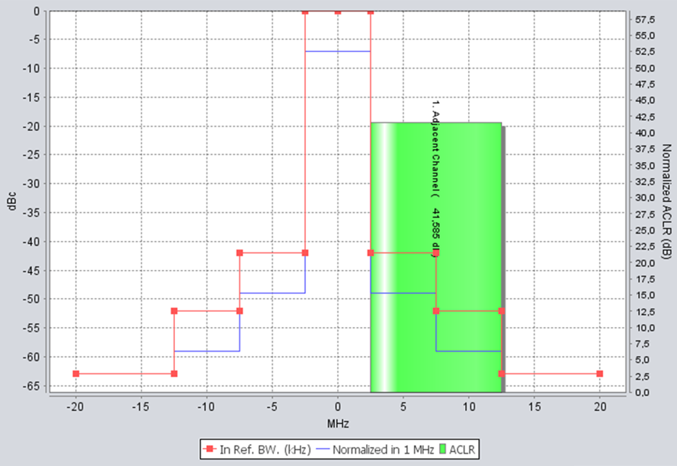
Figure 62: Screenshot of SEAMCAT with spectrum emission mask applied for wideband UT
In Table 27 the resulting ACLR values are given dependent on an additional guard band between the channel edges. Assuming that the MSS UT transmits at the upper edge of the band 1980-2010 MHz the 3 values represent the cases that the DA2GC signal is positioned at the lower edge of the band 2010-2025 MHz (carrier frequency of 2015 MHz), in the middle (2017.5 MHz) as well as at the upper edge (2020 MHz).
Table 30: ACLR values for MSS wideband UT related to adjacent channel bandwidth of 10 MHz
Guard band between MSS channel (5 MHz) and adjacent channel (10 MHz) | ACLR value for adajacent channel
0 MHz | 41.6 dB
2.5 MHz | 44.1 dB
5 MHz | 50.6 dB

In contrast to wideband UTs there is no explicit spectrum mask given for narrowband UTs in ETSI EN 302 574-3, but out-of-band emissions in the adjacent channel 2010-2025 MHz are dependent on Tx EIRP spectral densities. The same method as proposed in [25] to derive the ACLR from maximum EIRP values was also used in the present study, only the reference bandwidth of the adjacent channel is changed to 10 MHz according to the DA2GC signal characteristic.
In Figure 60 and Figure 61 the corresponding masks are shown for narrowband high and low gain UTs including the ACLR of the 1st and 2nd adjacent channel with 10 MHz bandwidth. These values are valid, if the narrowband MSS signal with 200 kHz bandwidth is placed at the upper edge of the MSS UL band with a carrier frequency of 2009.9 MHz (worst case assumption for interference to DA2GC).
Table 28 provides the resulting ACLR values dependent on an additional guard band between the channel edges. Without guard band the DA2GC signal is positioned at the lower edge of the band 2010-2025 MHz (carrier frequency of 2015 MHz), with guard band of 10 MHz at the upper edge (2020 MHz). Figure 60 shows the values in a diagram. It can be seen that by a very small guard band of more than about 0.3 MHz the ACLR values achieve satisfying values even for that worst case situation.
Figure 60: Spectrum emission mask applied for narrowband high gain UT

Figure 61: spectrum emission mask applied for narrowband low gain UT

Table 31: ACLR values for MSS narrowband UT related to adjacent channel bandwidth of 10 MHz for DA2GC
Guard band between MSS channel and DA2GC channel in MHz | Carrier frequency of DA2GC signal in MHz | ACLR value for high gain UT in dB | ACLR value for for low gain UT in dB
0.00 | 2015.00 | 13.2 | 11.7
0.10 | 2015.10 | 22.8 | 20.0
0.20 | 2015.20 | 26.5 | 20.6
0.30 | 2015.30 | 37.6 | 31.8
0.40 | 2015.40 | 39.9 | 34.1
0.50 | 2015.50 | 41.5 | 35.6
0.75 | 2015.75 | 45.7 | 39.9
1.00 | 2016.00 | 48.9 | 43.1
1.50 | 2016.50 | 51.6 | 45.8
2.00 | 2017.00 | 52.6 | 46.8
2.50 | 2017.50 | 53.9 | 48.1
3.00 | 2018.00 | 54.4 | 48.6
3.50 | 2018.50 | 55.0 | 49.2
4.00 | 2019.00 | 55.6 | 49.8
4.50 | 2019.50 | 56.3 | 50.5
5.00 | 2020.00 | 57.2 | 51.4

Figure 60: ACLR values for narrowband high and low gain UTs (related to the band 2010-2025 MHz)

Technical characteristics of MSS (satellite receiver parameter)
The satellite component adjacent to the band 2010-2025 MHz is operated on the Eutelsat satellite 10A which is located in geostationary orbit at 10°E. The main system parameters are provided in [34]. The system characteristics for the MSS uplink (return link of the S-DMB system) used for the present study are summarised below. The satellite is assumed to have implemented a spot beam pattern as shown in Figure 61, with a FDM (Frequency Division Multiplexing) re-use of 1-3 with in the frequency range 1995-2010 MHz.
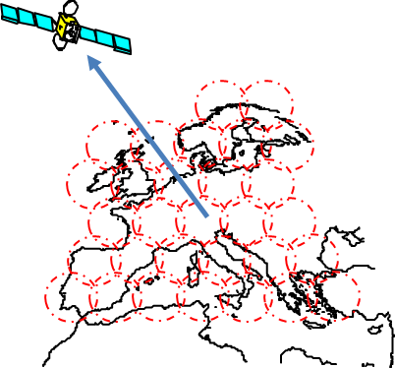
Figure 61: S-DMB return link with 30 beams

Table 32: S-DMB return link characteristics
Parameter | Value
Orbital height | 35786 km
Longitude | 10°E
Uplink frequency range | 1995-2010 MHz
Number of FDMs | 1 per beam
Useful bandwidth per FDM | 4.68 MHz (3.84 Mbit/s, 1.22 roll-off factor)
Number of beams | 30
Antenna pattern | Omni-directional (worst case assumption)
Antenna gain | 39 dBi (same gain as for transmission antenna assumed)
Antenna C/I | 13 dB (same gain as for transmission antenna assumed)
System noise temperature | 550 K

Technical characteristics of the Fixed service (FS) System
The frequency band 2025 - 2110 MHz is paired with 2200 - 2290 MHz for the FS. The preferred channel arrangements according to [35] are shown in Figure 62.
Figure 62: FS channel plans for the band 2025 - 2110 MHz paired with 2200 - 2290 MHz
The FS system parameters are primarily based on Table 13 of [36] and Annex A of [38]. The following tables provide an overview of the FS system parameters.

Table 33: Fixed Service link parameters
Parameter | Value | Comment
Modulation | 256-QAM | Taken from [36]
Carrier frequency | 2028 MHz / 2038.5 MHz | Derived from [35]
Channel spacing and receiver noise bandwidth (MHz) | 1.75 MHz /  14 MHz | Most sensitive for adjacent band interference due to smallest guard band / Highest potential for adjacent band interference due to large signal bandwidth
Antenna gain | 35 dBi  (Parabolic Dish) | Taken from Table 13 of [36] (33…38 dBi), pattern from [37]
Maximum Tx e.i.r.p. | 66 dBm | Taken from [36](32…40 dBW)
Maximum Tx output power | 31 dBm | Derived from [36](66 dBm – 35 dBi)
Spurious emission limit | -50 dBm/MHz [to be revised] | According to [42]
Antenna Height | 48 m | Taken from [41]
Receiver noise figure | 4 dB | Taken from [36]
Receiver noise floor | -107.54 dBm (1.75 MHz CS)  -98.52 dBm (14 MHz CS) | Calculated with k*T₀*b
Interference to Noise Ratio (I/N) | -6 dB | Taken from [36] (30 MHz to 3 GHz)
Adjacent Channel Selectivity (ACS) | ACS1 = 30 dB  ACS2 = 55 dB  ACS3 = 70 dB | Derived from Table A.7 of [38]  Derived from Table A.7 of [38]  Taken from [39]
Receiver Signal Level (RSL) | -87 dBm | Taken from Table A.6 of [38]  (RSL for BER ≤ 10⁻⁶ for class 4L equipment)
Hop length for FS | 50 km | Taken from [41]

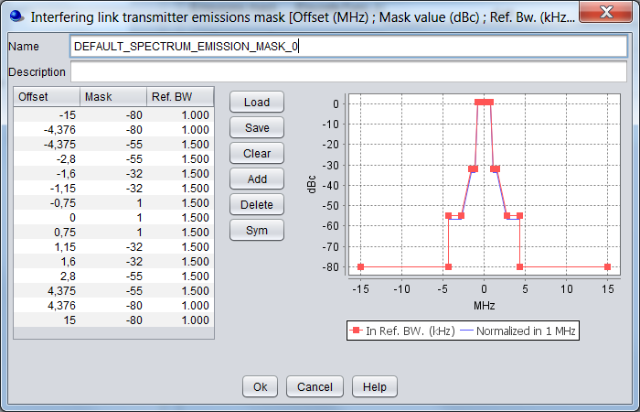 | 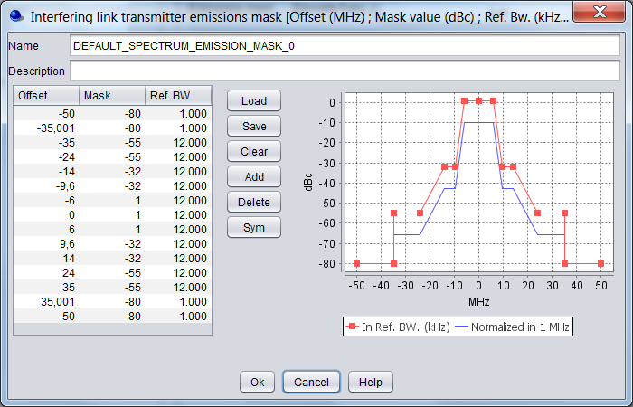
Figure 65: FS station spectrum emission masks for 1.75 MHz and 14 MHz channel spacing according to [38]

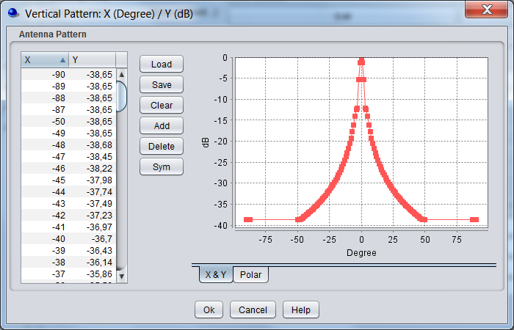 | 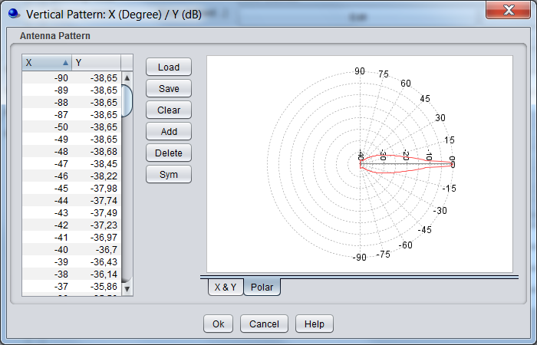
Figure 66: FS vertical antenna pattern (Parabolic Dish) taken from [37]

TRR (no data available so far)

DA2GC Reverse Link in the band 2010 – 2025 MHz

Figure 64: Compatibility/sharing scenarios for DA2GC RL in the frequency band 2010-2025 MHz

Compatibility studies on DA2GC according to ETSI TR 103 054

Impact of DA2GC AS on Satellite receivers

Methodology
Due to the great multiplicity of satellite systems implemented in the band 2025-2110 MHz a worst case scenario has been considered for the space station orbit, which corresponds to an altitude of 330 km. This altitude is relevant for the International Space Station (ISS) and all the related vessels. Other satellite systems fly at higher orbital altitudes. As protection criterion for that band a value of -180 dBW/kHz (equal to -180 dBm/Hz) for the aggregated interference level at the satellite receiver input was identified.

Results
Figure 65 shows the interference power density level in dBm/Hz in the co-channel case between a single DA2GC AS flying at an altitude of 10 km and the satellite/space station at an altitude of 330 km versus the distance (great circle distance, i.e. distance mapped on the earth surface, as well as signal path distance). A carrier frequency of 2 GHz has been taken into account without loss of generality as it is seen worse with respect to the upper adjacent band compared to carrier frequencies of 2015 to 2020 MHz. For the computation of the path loss line-of-sight propagation until the radio horizon is assumed. After the radio horizon a simplified approach according to [20] was applied resulting in an additional attenuation of 1.15 dB/km for the selected carrier frequency.
For the interference power density shown in Figure 65 the diagrams of the DA2GC AS as well as the co-polar satellite Rx antenna were considered. No polarization discrimination has been taken into account.
Figure 65: Co-channel interference power density caused by a single DA2GC AS flying at an altitude of 10 km at a space station with altitude of 330 km vs. distance (AS as well as satellite antenna diagrams considered)
In Figure 66 the appropriate interference power density for a single DA2GC AS flying above European center area is given. As seen in both figures the maximum interference value is equal to -189.8 dBm/Hz.
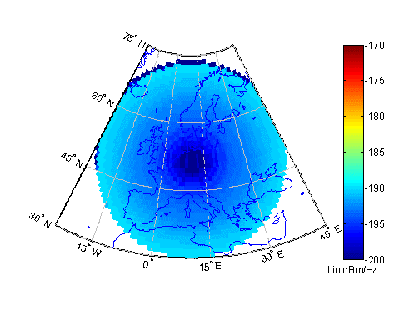
Figure 66: Co-channel interference power density at a space station with altitude of 330 km caused by a single DA2GC AS flying at an altitude of 10 km
The next figures show the impact of larger sets of aircraft on the satellite reception, again for co-channel transmission. In the 1st case a single aircraft with altitude of 10 km was allocated to each of the GS sites across Europe, in the 2nd case 12 aircraft/GS site are transmitting simultaneously, i.e. 4 per sector, which can be seen as a typical for the LTE-based scheduling implementation on the available time-frequency resources.
In Figure 67 the aggregated co-channel interference power density level at a satellite/space station with an altitude of 330 km for the 2 cases mentioned before is shown. Figure 68 provides a 3D view of these power densities.
The peak interference level in the 1st case corresponds to -166.7 dBm/Hz. In the 2nd case the peak level of the total set of aircraft (worst case) is increased to -155.9 dBm/Hz, i.e. the interference level has to be reduced by at least 24.1 dB to keep the threshold.
The DA2GC system is planned to be used in the band 2010-2025 MHz just below the band 2025-2110 MHz. Thus the interference level noted above is mainly caused by out-of-band emissions and spurious emissions, respectively, dependent on the frequency separation between the DA2GC signal and satellite/space station link signal. For the DA2GC AS the same unwanted emission limits as defined by 3GPP for LTE UEs are assumed (see Table 29). Due to the higher maximum Tx power of a AS compared to a UE, a stronger attenuation of the RF filters is required.

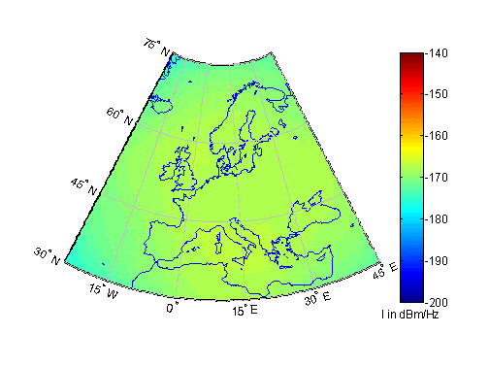
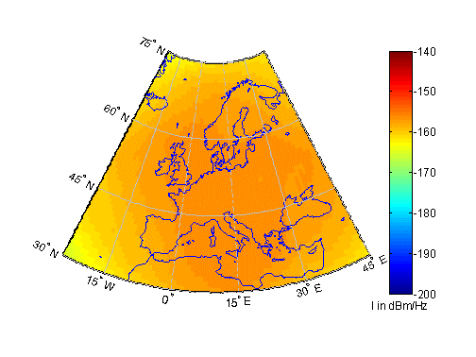
Figure 67: Aggregated co-channel interference power density at a space station with an altitude of 330 km caused by all DA2GC AS (1st case with 1 AS/GS site in upper figure, 2nd case with 12 AS/GS site in lower figure)
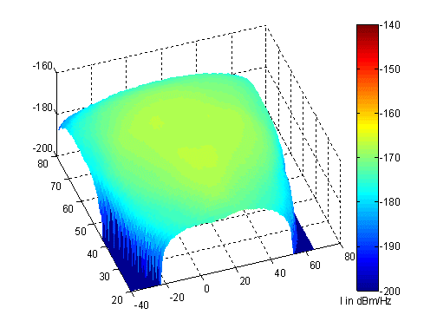
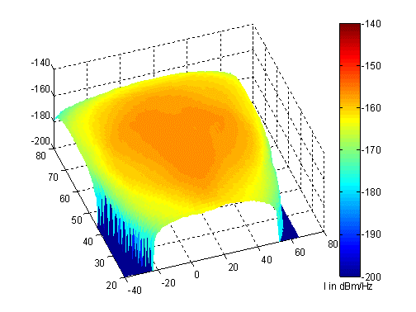
Figure 68: 3D view of aggregated co-channel interference power density at a space station with an altitude of 330 km caused by all DA2GC AS (1st case with 1 AS/GS site in upper figure, 2nd case with 12 AS/GS site in lower figure)

Table 34: Unwanted emission limits for DA2GC aircraft stations adapted to LTE UEs for channel bandwidth of 10 MHz according to [1]
Frequency offset of measurement filter -3dB point, Δf | Minimum requirement | Measurement bandwidth
0 MHz ≤ Δf < 1 MHz | -18 dBm | 30 kHz
1 MHz ≤ Δf < 5 MHz | -10 dBm | 1 MHz
5 MHz ≤ Δf < 10 MHz | -13 dBm | 1 MHz
10 MHz ≤ Δf < 15 MHz | -25 dBm | 1 MHz
15 MHz ≤ Δf | -30 dBm (Note 1) | 1 MHz
Note 1: Spurious emissions valid for frequency offset larger than 250% of necessary bandwidth [21]

The DA2GC RL signal with 10 MHz channel bandwidth could be placed within the band 2010-2025 MHz on a carrier frequency in the range between 2015 and 2020 MHz. The possible reduction of the interference power level based on the values given in Table 29 and the resulting peak interference level at a space station with an altitude of 330 km caused by all active DA2GC AS according to the 2nd case are calculated for DA2GC signal carrier frequencies at 2015 MHz, 2017.5 MHz and 2020 MHz, i.e. the DA2GC signal is placed at the band edges as well as in the middle of the band. The corresponding results are given in Table 30 Table 31, and Table 32, respectively. Figure 69 includes a graphical presentation of the results.
Table 35: Resulting adjacent peak interference power density level at a space station with an altitude of 330 km caused by all DA2GC AS (2nd case with 12 AS/GS site at an altitude of 10 km) with a carrier frequency of 2015 MHz at
Frequency range in MHz | Max. power density level in dBm/Hz | Attenuation vs.  Tx power level in dB | Peak interference level in dBm/Hz
2025 ≤ f < 2030 | -73 | 43.5 | -199.4
2030 ≤ f < 2035 | -85 | 55.5 | -211.4
2035 ≤ f ≤ 2110 | -90 | 66.5 | -216.4

Table 36: Resulting adjacent peak interference power density level at a space station with an altitude of 330 km caused by all DA2GC AS (2nd case with 12 AS/GS site at an altitude of 10 km) with a carrier frequency of 2017.5 MHz
Frequency range in MHz | Max. power density level in dBm/Hz | Attenuation vs.  Tx power level in dB | Peak interference level in dBm/Hz
2025 ≤ f < 2027.5 | -70 | 40.5 | -196.4
2027.5 ≤ f < 2032.5 | -73 | 43.5 | -199.4
2032.5 ≤ f < 2037.5 | -85 | 55.5 | -211.4
2037.5 ≤ f ≤ 2110 | -90 | 66.5 | -216.4

Table 37: Resulting adjacent peak interference power density level at a space station with an altitude of 330 km caused by all DA2GC AS (2nd case with 12 AS/GS site at an altitude of 10 km) with a carrier frequency of 2020 MHz
Frequency range in MHz | Max. power density level in dBm/Hz | Attenuation vs.  Tx power level in dB | Peak interference level in dBm/Hz
2025 ≤ f < 2026 | -62.8 | 33.3 | -189.2
2026 ≤ f < 2030 | -70 | 40.5 | -196.4
2030 ≤ f < 2035 | -73 | 43.5 | -199.4
2035 ≤ f < 2040 | -85 | 55.5 | -211.4
2040 ≤ f ≤ 2110 | -90 | 66.5 | -216.4

Figure 69: Resulting adjacent peak interference power density level at a space station with an altitude of 330 km caused by all DA2GC AS ( 2nd case with 12 AS/GS site at an altitude of 10 km) for carrier frequencies of 2015 MHz, 2017.5 MHz and 2020 MHz

Impact of Satellite Earth station on DA2GC GS
[The impact of satellite feeder link stations on the reception of the DA2GC RL (TR103 054) at the GS is still to be evaluated. Due to high transmission power of the satellite feeder link stations a certain separation distance between such stations dependent on applied antenna diagrams and the corresponding tilts of the main beams is expected to be required as a mitigation method.]

Conclusions on compatibility between DA2GC RL (TR 103 054) and space services
The evaluations demonstrate that a deployment of the DA2GC RL in the band 2010-2025 MHz would cause no harmful interference into space station receivers of the Space Research Services operating in the adjacent band above 2025 MHz,- even in a worst case situation - if the appropriate Tx filtering of the DA2GC AS is implemented. This applies even for the highest possible DA2GC carrier frequency of 2020 MHz, where a safety margin of about 9 dB remains.
[see 5.14.2]

Impact of DA2GC AS on MSS CGC BS
The diagrams with evaluation results in following subsections show
• the path loss with and without consideration of the vertical antenna characteristics of the involved system components, i.e. the DA2GC GS and AS as well as the MVL Tx and Rx, but without inclusion of antenna gains,
• the received interference power at the victim station (always related to the signal bandwidth of the victim system; in present study the bandwidth of both systems is equal to 10 MHz),
• the resulting interference-to-noise ratio (I/N) compared to the threshold of victim system
along the ground-based distance (great circle distance) between the involved stations. In case of involvement of a DA2GC AS results are given for aircraft altitudes of 3 km and 10 km, respectively.
With respect to interference the worst case assumption is to have line-of-sight propagation between interferer and victim. Therefore, in all cases with involvement of the DA2GC AS free space loss was applied [30] Only in the cases where both victim and interferer are placed on the ground the Extended Hata Model for open rural area was applied for the computation of the path loss (see e.g. [10] for information about the model).
For the I/N computation the resulting adjacent channel interference ratio (ACIR) was considered which is based on following relationship of the Tx and Rx characteristics of interferer and victim equipment:
The ACLR and ACS values of the involved systems may vary dependent on the frequency separation which is related to the positioning of the DA2GC signal and the MSS UT signal as mentioned before.

Methodology
For this scenario the DA2GC RL is positioned at the lower edge of the band 2010-2025 MHz, i.e. the carrier frequency is selected to 2015 MHz. The MSS UL is assumed to transmit at the upper edge of the band 1980-2010 MHz with a bandwidth of 5 MHz, i.e. at a carrier frequency of 2007.5 MHz. Based on the given ACLR and ACS values of the interfering and the victim system (40.3 dB and 63 dB, respectively) a final ACIR value of 40.3 dB is computed (i.e. the ACIR is dominated by the ACLR of the AS).

Results
In Figure 70 the path loss between the DA2GC AS and the CGC BS for free space propagation is shown based on the technical parameters given in section 3 and assuming an aircraft altitude of 3 km. Only the vertical antenna diagram characteristics are considered, i.e. it is always assumed that the main lobes of the horizontal antenna diagrams (typically sector antennas for CGC BS as well as an omnidirectional antenna at the DA2GC AS) are pointed directly to each other (worst case).
Figure 71 and Figure 72 show the resulting interference power and I/N at the CGC BS. Under consideration of the ACIR value the I/N is distinctly below the threshold. Shifting the DA2GC carrier frequency to the middle or to the upper edge of the band 2010-2025 MHz increases the ACIR to 44.1 and 45.9 dB, respectively, due to improved ACLR of the AS (44.2 as well as 46 dB). This results in an increase of the margin to the I/N threshold by 3.8 and 5.6 dB.
Figure 73 to Figure 75 show the corresponding results for an aircraft altitude of 10 km. Due to higher path loss the margin to the I/N threshold is further increased.
It has to be noted that the power control feature of the DA2GC AS was not applied, i.e. the signal is always transmitted with full power of 40 dBm. In a realistic scenario the transmission with maximum power will only happen at cell edge, therefore the interference probability is strongly reduced.
Figure 70: Path loss w & w/o consideration of vertical antenna characteristics (antenna gain not included) at DA2GC AS (Station 1) and MSS CGC BS (Station 2) for aircraft altitude of 3 km (free space)

Figure 71: Interference signal power at MSS CGC BS (Station 2) for aircraft altitude of 3 km w/ & w/o consideration of ACIR (free space)

Figure 72: Resulting I/N at MSS CGC BS (Station 2) for aircraft altitude of 3 km w/ & w/o consideration of ACIR (free space)

Figure 73: Path loss w & w/o consideration of vertical antenna characteristics (antenna gain not included) at DA2GC AS (Station 1) and MSS CGC BS (Station 2) for aircraft altitude of 10 km (free space)

Figure 74: Interference signal power at MSS CGC BS (Station 2) for aircraft altitude of 10 km w/ & w/o consideration of ACIR (free space)

Figure 75: Resulting I/N at MSS CGC BS (Station 2) for aircraft altitude of 10 km w/ & w/o consideration of ACIR (free space)

Impact of MSS UT on DA2GC GS
This scenario has the same basic parameters as used in 5.14.3.2, but now the interference of a MSS UT into a DA2GC GS is evaluated.

Methodology
The path loss computation between both stations is based on the Extended Hata Model for rural (open) area, which is more realistic than free space propagation In the case of a wideband UT the resulting ACIR corresponds to 39.4 dB assuming a DA2GC GS ACS of 43.5 dB and a MSS UT ACLR of 41.6 dB if both signals are at adjacent channel edges. Shifting the DA2GC carrier to higher frequencies inside the band 2010-2025 MHz the ACIR changes according to the MSS UT ACLR values given in Table 6 to 40.8 dB for 2.5 MHz and 42.7 dB for 5 MHz.

Results
- MSS wideband terminals
In Figure 11 to Figure 13 the results are given using a MSS wideband low gain UT. It can be seen that the DA2GC RL reception at the GS is disturbed if the MSS UT is in a range of about 1 km around the site. This is mainly caused by the high Tx power of 39 dBm. In an environment with more clutter or vegetation the interference signal may be stronger attenuated as in present case, so the interference probability will be further reduced. As there is only a relative low number of DA2GC GS to be deployed across Europe it is not expected that there will be a continuous disturbance by MSS UT users.
For a wideband high gain MSS UT the final I/N results are given in Figure 14 for a DA2GC carrier frequency of 2015 MHz. In contrast to former diagrams here the elevation angle of the MSS UT was varied between 5° and 30°. With increasing angle the separation distance is reduced by more than 3 km, but due to direction of the antenna boresight to the DA2GC GS site the interference level at places near the DA2GC GS is increased. In a real environment with less deployed DA2GC sites and MSS UT antenna orientation to a GEO satellite, the true interference probability is not very high. Further reduction of interference by about 3.5 dB is possible by shifting the DA2GC carrier to higher frequencies within the band 2010-2025 MHz as noted already for the low gain MSS UT.

Figure 76: Path loss w & w/o consideration of vertical antenna characteristics (antenna gain not included) at MSS wideband low gain UT (Station 1) and DA2GC GS (Station 2) (Ext. Hata Model for open rural area)

Figure 77: Interference signal power at DA2GC GS (Station 2) w/ & w/o consideration of ACIR for DA2GC carrier frequencies 2015, 2017.5 and 2020 MHz (Ext. Hata Model for open rural area)

Figure 78: Resulting I/N at DA2GC GS (Station 2) w/ & w/o consideration of ACIR for DA2GC carrier frequencies 2015, 2017.5 and 2020 MHz (Ext. Hata Model for open rural area)

Figure 79: Resulting I/N at DA2GC GS with carrier frequency of 2015 MHz (Station 2) w/ & w/o consideration of ACIR for interference caused by a MSS wideband high gain UT with different antenna elevation angles of 5° (curve on top), 10°, 20°, and 30° (Ext. Hata Model for open rural area)

- MSS narrowband terminals

Assuming an ACS value of 43.5 dB for the DA2GC GS the resulting ACIR value to be considered in further evaluation can be computed. The corresponding values are listed in Table 3.

Table 38: Resulting ACIR values for MSS narrowband UT disturbance in adjacent channel bandwidth of 10 MHz for DA2GC GS
Guard band between MSS channel and DA2GC channel in MHz | Carrier frequency of DA2GC signal in MHz | ACIR value for high gain UT in dB | ACIR value for for low gain UT in dB
0.00 | 2015.00 | 13.20 | 11.70
0.10 | 2015.10 | 22.76 | 19.98
0.20 | 2015.20 | 26.41 | 20.58
0.30 | 2015.30 | 36.61 | 31.52
0.40 | 2015.40 | 38.33 | 33.63
0.50 | 2015.50 | 39.38 | 34.95
0.75 | 2015.75 | 41.45 | 38.33
1.00 | 2016.00 | 42.40 | 40.29
1.50 | 2016.50 | 42.87 | 41.49
2.00 | 2017.00 | 43.00 | 41.83
2.50 | 2017.50 | 43.12 | 42.21
3.00 | 2018.00 | 43.16 | 42.33
3.50 | 2018.50 | 43.20 | 42.46
4.00 | 2019.00 | 43.24 | 42.59
4.50 | 2019.50 | 43.28 | 42.71
5.00 | 2020.00 | 43.32 | 42.85

In Figure 81 to Figure 83 the results are given using a MSS narrowband low gain UT. The DA2GC RL reception at the GS at the lowest carrier frequency of 2015 MHz is disturbed, if the MSS UT is in a range of about 5 km around the site. With an additional guard band of only 0.3 MHz the interference range is already reduced to 1.2 km, for guard bands above 1 MHz to about 0.6 km. The interference is mainly caused by the high Tx power of 39 dBm. In an environment with more clutter or vegetation the interference signal may be stronger attenuated as in present case, so the interference probability will be further reduced. As there is only a relative low number of DA2GC GS to be deployed across Europe it is not expected that there will be a continuous disturbance by MSS UT users.
For a narrowband high gain MSS UT the final I/N results are given in Figure 84 to Figure 86 for DA2GC carrier frequencies of 2015, 2015.3, and 2017.5 MHz. The results for 2020 MHz are comparable to those for 2017.5 MHz. In contrast to former diagrams here the elevation angle of the MSS UT was varied between 5° and 30°. Generally the separation distance to avoid interference is reduced by increasing angle, but due to direction of the antenna boresight to the DA2GC GS site the interference level at places near the DA2GC GS is increased. In a real environment with less deployed DA2GC sites and MSS UT antenna orientation to a GEO satellite, the true interference probability is not very high. The worst case is at the elevation of 5°. For a carrier frequency of 2015 MHz the separation distance is about 6 km, with guard band of 0.3 MHz at 1.2 and with 2.5 MHz at 0.7 km. For the highest angle of 30° the separation distance is 2.7 km at 2015 MHz, 0.6 km at 2015.3 MHz, and 0.4 km at 2017.5 MHz.

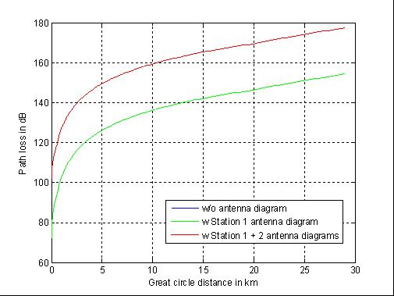
Figure 81: Path loss w & w/o consideration of vertical antenna characteristics (antenna gain not included) at MSS narrowband low gain UT (Station 1) and DA2GC GS (Station 2) (Ext. Hata Model for open rural area)

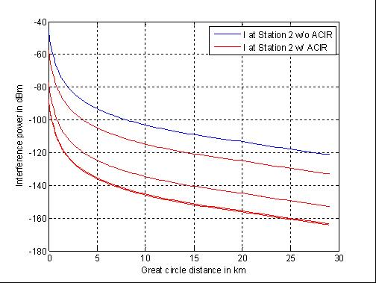
Figure 82: Interference signal power at DA2GC GS (Station 2) w/ & w/o consideration of ACIR for DA2GC carrier frequencies 2015, 2015.3, 2017.5 and 2020 MHz (Ext. Hata Model for open rural area)

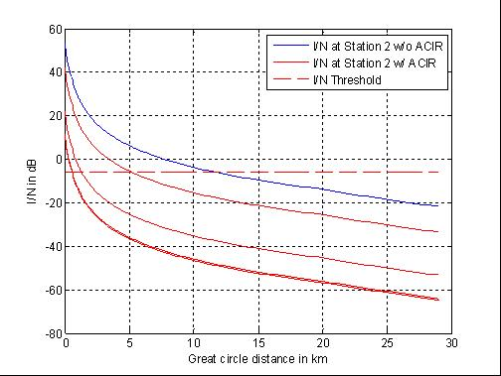
Figure 83: Resulting I/N at DA2GC GS (Station 2) w/ & w/o consideration of ACIR for DA2GC carrier frequencies 2015, 2015.3, 2017.5 and 2020 MHz (Ext. Hata Model for open rural area)

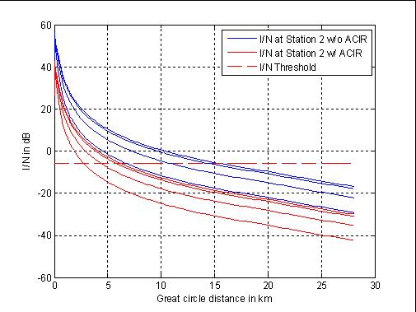
Figure 84: Resulting I/N at DA2GC GS with carrier frequency of 2015 MHz (Station 2) w/ & w/o consideration of ACIR for interference caused by a MSS wideband high gain UT with different antenna elevation angles of 5° (curve on top), 10°, 20°, and 30° (Ext. Hata Model for open rural area)

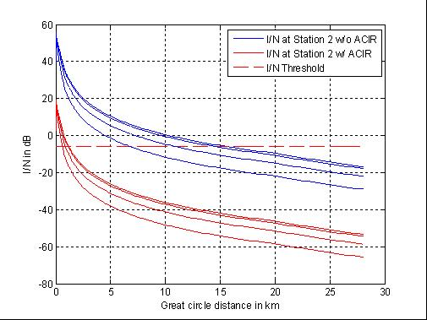
Figure 85: Resulting I/N at DA2GC GS with carrier frequency of 2015.3 MHz (Station 2) w/ & w/o consideration of ACIR for interference caused by a MSS wideband high gain UT with different antenna elevation angles of 5° (curve on top), 10°, 20°, and 30° (Ext. Hata Model for open rural area)

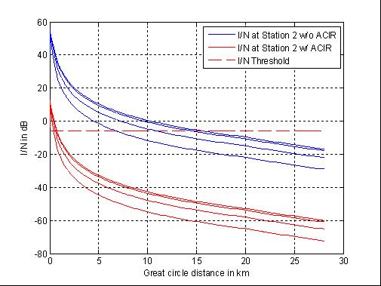
Figure 86: Resulting I/N at DA2GC GS with carrier frequency of 2017.5 MHz (Station 2) w/ & w/o consideration of ACIR for interference caused by a MSS wideband high gain UT with different antenna elevation angles of 5° (curve on top), 10°, 20°, and 30° (Ext. Hata Model for open rural area)

Conclusions on compatibility between DA2GC (TR103 054) and MSS CGC

Victim | Interferer | DA2GC carrier at 2015 MHz | DA2GC carrier at 2017.5 MHz | DA2GC carrier at 2020 MHz
MSS CGC BS Rx | DA2GC AS Tx | No interference.
DA2GC GS Rx | MSS wideband UT Tx | In the worst case interference may occur in a rage of about 1 km around the DA2GC GS.

Victim | Interferer | DA2GC carrier between 2015 MHz and 2017.5 MHz
DA2GC GS Rx | MSS narrowband UT Tx | For both MSS high and low gain UT transmissions a guard band of at least 0.5 MHz (carrier at 2015.5 MHz) is required to keep the interference range around the DA2GC GS below 1 km.
Table 39: Summary of compatibility study results

Impact of DA2GC AS on MSS satellite

Methodology
Europe is covered by 30 S-DMB return beams as shown in Figure 4. Assuming that 10 of these beams are covering area not covered by DA2GC (e.g. north Scandinavia, Mediterranean see, etc.), the numbers of DA2GC GS per S-DMB return beam can be calculated as:
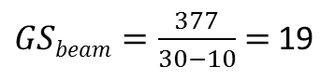
The following Figure shows the 19 GS locations taken into account for the evaluation of the interference impact for a single beam.
Figure 81: DA2GC GS locations used to evaluate the interference impact on a single S-DMB return beam

For the evaluation of the spectrum demand for DA2GC, up to 7 aircraft per cell sector were taken into account. With 3 sectors per GS, the following number of aircraft per S-DMB return beam can be calculated:

Results
Applying the method described in 5.14.1.1 the aggregated interference power level of the 399 DA2GC AS (all flying at altitude of 10 km) at the GEO satellite position (including satellite antenna gain of 39 dBi) corresponds to
-170.2 dBm/Hz,
assuming co-channel transmission in the MSS UL band (1980-2010 MHz).
The DA2GC RL signal with 10 MHz channel bandwidth is intended to be placed within the band 2010-2025 MHz on a carrier frequency in the range between 2015 and 2020 MHz, i.e. only the out-of-band emissions have to be considered. The final maximum interference power level in the MSS band can be computed by taking into account the spectrum emission mask of the DA2GC AS. The resulting interference power level is given in Table 36 dependent on the frequency offset to the edge of the DA2GC channel. The table also includes the resulting increase in the satellite noise temperature in K as well as the percentage value of the noise temperature increase.
Table 40: Resulting maximum interference power levels at the MSS satellite dependent on the frequency offset to the DA2GC RL channel edge as well as increase in satellite system noise temperature
Frequency offset to DA2GC channel edge in MHz | Minimum interference  reduction  in dB | Maximum interference  level  in dBm/Hz | Increase in  satellite system noise temperature in K | Increase in  satellite system noise  temperature in %
0 ≤ Δf < 1 | 33.3 | -203.5 | 1.3e-5 | ≅ 0
1 ≤ Δf < 5 | 40.5 | -210.7 | 8e-13 | ≅ 0
5 ≤ Δf < 10 | 43.5 | -213.7 | <1e-15 | ≅ 0
10 ≤ Δf < 15 | 55.5 | -225.7 | <1e-15 | ≅ 0
15 ≤ Δf | 66.5 | -236.7 | <1e-15 | ≅ 0

From the values in Table 36 it can be concluded that even in the worst case when the DA2GC channel is directly positioned without guard band at the upper edge of the MSS band (DA2GC carrier frequency equal to 2015 MHz), the increase of the noise temperature within the MSS band is negligible. In the spectrum part with highest inference level (frequency offset less than 1 MHz) the margin to the threshold is about 5.6 dB (6.4 dB) for 1% (5%) noise temperature increase.
It has to be noted that the average interference level will be much smaller compared to the worst case evaluated here as the impact of the Tx power control at the DA2GC AS was not considered. In a real environment there will be a homogeneous distribution of the aircraft, i.e. only a part of the aircraft are at a cell edge where they require the full Tx power of 40 dBm.

Conclusions
Worst case link evaluations concerning the DA2GC in the band 2010-2025 MHz and MSS UL operation below 2010 MHz have been conducted for the implementation of a DA2GC FDD system in the unpaired 2 GHz bands. The impact of the DA2GC RL transmission on the reception at a geostationary MSS satellite has been evaluated:
- The DA2GC RL can be implemented in the upper 2GHz TDD band without any degradation on the MSS satellite reception (independent on the positioning of the DA2GC carrier frequency between 2015 and 2020 MHz).

Impact of DA2GC AS on FS

Methodology
The evaluation results are based on worst case single link scenarios between the interferer and the victim system to get an overview about scenarios which might perhaps require a more deep analysis based on statistical evaluations e.g. by use of the SEAMCAT Monte Carlo simulation functionality.
The figures show the interference power received at the victim receiver and the resulting I/N. In case the aircraft station is involved, an aircraft altitude of 3000 m is assumed. Calculations are made first for a DA2GC carrier frequency of 2020 MHz. When interference is identified, calculations are also made for a DA2GC carrier frequency of 2015 MHz.

Results

Figure 90: Interference power and resulting I/N at FS Rx (1.75 MHz channel spacing) for DA2GC carrier frequency of 2020 MHz and aircraft altitude of 3 km

Figure 91: Interference power and resulting I/N at FS Rx (1.75 MHz channel spacing) for DA2GC carrier frequency of 2015 MHz and aircraft altitude of 3 km

Figure 92: Interference power and resulting I/N at FS Rx (14 MHz channel spacing) for DA2GC carrier frequency of 2020 MHz and aircraft altitude of 3 km

Figure 93: Interference power and resulting I/N at FS Rx (14 MHz channel spacing) for DA2GC carrier frequency of 2015 MHz and aircraft altitude of 3 km

Impact of FS on DA2GC GS
[Figures to be revised with respect to the spurious levels for FS according to ERC REC 74-01]

Results
Figure 94: Interference power and resulting I/N at DA2GC GS Rx for DA2GC AS carrier frequency of 2020 MHz from FS Tx (1.75 MHz channel spacing)

Figure 95: Interference power and resulting I/N at DA2GC GS Rx for DA2GC AS carrier frequency of 2015 MHz from FS Tx (1.75 MHz channel spacing)

Figure 96: Interference power and resulting I/N at DA2GC GS Rx for DA2GC AS carrier frequency of 2020 MHz from FS Tx (14 MHz channel spacing)

Figure 97: Interference power and resulting I/N at DA2GC GS Rx for DA2GC AS carrier frequency of 2015 MHz from FS Tx (14 MHz channel spacing)

Conclusions
Worst case link evaluations concerning the compatibility between DA2GC in the band 2010-2025 MHz and FS operation above 2025 MHz have been conducted for the implementation of a DA2GC FDD system in the unpaired 2 GHz bands. For the DA2GC RL in the band 2010-2025 MHz the following conclusions can be drawn:
Table 41: Summary of compatibility study results (FS carrier spacing of 1.75 MHz)
Victim | Interferer | DA2GC carrier at 2015 MHz | DA2GC carrier at 2020 MHz
FS Rx (1.75 MHz CS) | DA2GC AS Tx | For aircraft altitude of 3 km the interference threshold is kept. | For aircraft altitude of 3 km the interference threshold is slightly exceeded for ground distances of about 10 km to 40 km.
DA2GC GS Rx | FS Tx (1.75 MHz CS) | The interference threshold is exceeded up to a distance of about 12 km. | The interference threshold is exceeded up to a distance of about 16 km.

Table 42: Summary of compatibility study results (FS carrier spacing of 14 MHz)
Victim | Interferer | DA2GC carrier at 2015 MHz | DA2GC carrier at 2020 MHz
FS Rx (14 MHz CS) | DA2GC AS Tx | For aircraft altitude of 3 km the interference threshold is kept. | For aircraft altitude of 3 km the interference threshold is exceeded for ground distances starting from about 3 km.
DA2GC GS Rx | FS Tx (14 MHz CS) | The interference threshold is exceeded up to a distance of about 16 km. | The interference threshold is exceeded up to a distance of about 30 km.

Compatibility studies on DA2GC according to ETSI TR 101 599

Impact of DA2GC AS on satellite receivers
This will not be problematic as DA2GC Ground Stations (addressed in Section 5.15.1.1) have not been identified as an interference issue. There will be the same number of Aircraft Stations as the number of beams associated with all the Ground Stations and therefore the situation will not be any worse than that for the Ground Stations and that is judged satisfactory in Section 5.15.1.1. However, unlike the Ground Stations, the majority of Aircraft Stations will be shielded from a victim SS satellite by the aircraft fuselage and therefore the situation will be considerably better than that with respect to the Ground Stations.

Impact of Satellite Earth Stations on DA2GC GS
This section relates to the potential impact of satellite Earth stations unwanted emissions on DA2GC Ground stations in a view to determine the necessary geographical separation between these stations. A long-term calculation has been considered using the parameters as in Table 34 below :

Results
Table 43: Key parameter values
Parameter | Value | Unit | Comment
Noise (Victim) | -100 | dBm | In DA2GC 10 MHz channel
ACS (Victim) | 39 | dB | From DA2GC system design authority
ACLR (Interferer) | 26 | dB | Derived from space services spurious level
I/N Criterion (Victim) | -10 | dB | [ESA : an I/N -6 dB seems more appropriate for Mobile type applications].
Rx Gain (Victim) | -10 | dBi | -10 to 0 dBi depending on where in null
Rx height | 20 | m
Tx height | 20 | m | Center of the Earth Station antenna
Tx EIRP (Interferer)  in the 2025-2110 MHz band | 72.6 | dBm | Max EIRP through 15 degree sidelobe
Tx spurious EIRP (Interferer) in the 2010-2025 MHz band | 46.6 | dBm/10 MHz | See Note

On this basis, when considering an satellite Earth station pointing in the direction of a DA2GC ground station, an attenuation of 146.6 dB (for 70 dBm power Earth stations) is required between the 2 stations. In such a case, the corresponding results in Figure 80 below are based on the median pathloss of the Extended Hata propagation model (Urban, Suburban and Rural).
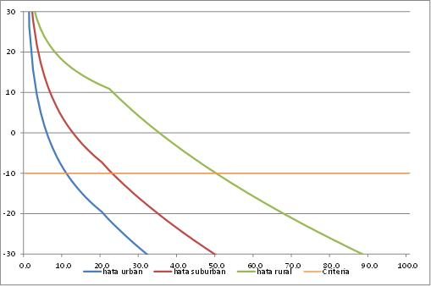
Figure 80: Interference as a function of distance
For a 70 dBm power earth station, this figure shows that a maximum separation distance of 49 km (43 km if I/N = -6 dB) might be required in rural areas. For a 50 dBm power earth station, this distance would drop down to about 22 km (16 km if I/N = -6 dB).
It should be considered that taking into account real situations and in particular Earth Station surrounding and real terrain model as well as the satellite Earth station azimuth would allow to limit at minimum the necessary separation distances between those stations.
Taking into account the quite low number of Earth station and DA2GC ground stations it is therefore not expected difficulty in finding relevant locations for DA2GC GS receivers in the 2010-2025 MHz band.

DA2GC Forward link in the band 2010 – 2025 MHz

Figure 81: Interference scenarios for BDA2GC in the frequency band 2010 – 2025 MHz

Compatibility studies on DA2GC according to ETSI TR 103 054

Impact of DA2GC GS on Satellite receivers

Methodology
For the compatibility evaluations a DA2GC set-up of 377 sites across Europe, covering the main flight corridors for continental aircraft traffic, has been assumed. The exemplary site positions arranged in a regular hexagonal grid are shown in Figure 82.
DA2GC GS sites are typically deployed with 3 sector antennas each, which are assumed here to result in a near omnidirectional coverage. In order to simplify the model and reduce the calculation time, omnidirectional antennas are applied for the DA2GC GS sites in the present evaluation, i.e. only the vertical GS antenna diagram is correctly modelled. This represents a worst case interference situation caused by the DA2GC system.

Figure 82: Regular hexagonal grid with possible site positions for a DA2GC system across Europe

Results

Figure 83 and Figure 84 show the interference power density level in dBm/Hz in the co-channel case between a single DA2GC GS and the satellite/space station at an altitude of 330 km versus the distance (great circle distance, i.e. distance mapped on the earth surface, as well as signal path distance). For the computation of the path loss line-of-sight propagation [20]. until the radio horizon is assumed. A carrier frequency of 2 GHz has been taken into account without loss of generality as it is seen worse with respect to the upper adjacent band compared to carrier frequencies of 2015 to 2020 MHz.
For the interference power density shown in Figure 83 only the GS antenna diagram is considered, i.e. the satellite Rx antenna is assumed to be omnidirectional with gain of 0 dBi. Figure 84 shows the final interference power density if the co-polar vertical satellite receive antenna pattern according to Figure 61 is included in the computation (gain of 3.2 dBi). No polarization discrimination has been taken into account.
In Figure 85 the interference power density above Europe is given considering GS as well as satellite antennas, the corresponding 3D view of the power density is shown in Figure 86. Values behind the radio horizon are not considered in the evaluation due to strongly increased signal attenuation. Figure 87 and Figure 88 show the corresponding results for the aggregated co-channel interference caused by all active DA2GC GS sites.

Figure 83: Co-channel interference power density of a single DA2GC GS at a space station with altitude of 330 km vs. distance (only main lobe of GS antenna diagram considered)

Figure 84: Co-channel interference power density of a single DA2GC GS at a space station with altitude of 330 km vs. distance (GS as well as satellite antenna diagram considered)

Figure 85: Co-channel interference power density of a single DA2GC GS at a space station with altitude of 330 km
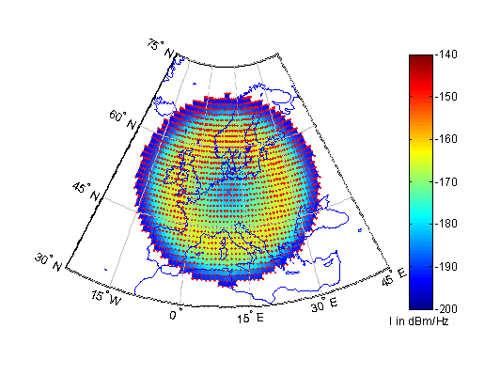
Figure 86: 3D view of the co-channel interference power density of a single DA2GC GS at a space station with altitude of 330 km
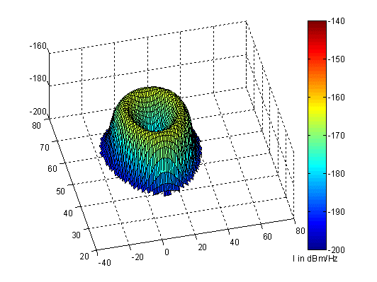

Figure 87: Aggregate co-channel interference power density of all DA2GC GS sites at a space station with altitude of 330 km
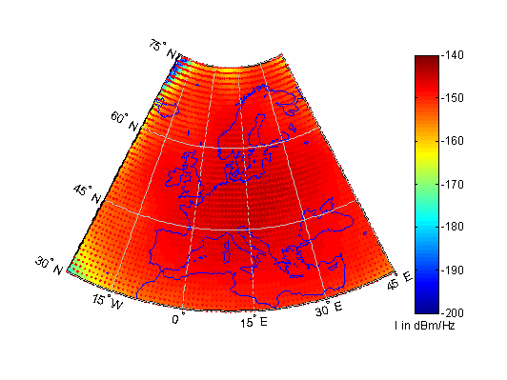
Figure 88: 3D view of aggregate co-channel interference power density of all DA2GC GS sites at a space station with altitude of 330 km
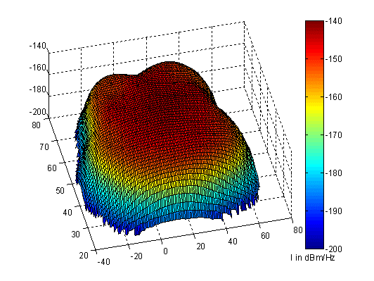

Already one single DA2GC GS running with full DL data load would cause a peak interference level of -165.6 dBm/Hz (-168.5 dBm/Hz in case of an omnidirectional antenna with 0 dBi) which is 13.4 dB (11.5 dB) above the threshold of -180 dBm/Hz (equal to -180 dBW/kHz). The peak level of the total ground network (worst case) corresponds to -143.7 dBm/Hz (-146.5 dBm/Hz), i.e. the interference level has to be reduced by at least 36.3 dB (33.5 dB) to keep the threshold.
As the DA2GC system is planned to be used in the band 2025-2110 MHz just below the band 2025-2110 MHz. Thus the interference level noted above is mainly caused by out-of-band emissions and spurious emissions, respectively, dependent on the frequency separation between the DA2GC signal and space station link signal. For the DA2GC GS the same unwanted emission limits as defined by 3GPP for LTE base stations are assumed (see Table 6).

The DA2GC DL signal with 10 MHz channel bandwidth could be placed within the band 2010-2025 MHz on a carrier frequency in the range between 2015 and 2020 MHz. The possible reduction of the interference power level based on the values given in Table 6 and the resulting peak interference level from the DA2GC network (all active GS) at a space station with an altitude of 330 km are calculated given for DA2GC signal carrier frequencies at 2015 MHz, 2017.5 MHz and 2020 MHz, i.e. the DA2GC signal is placed at the band edges as well as in the middle of the band. The corresponding results are given in Table 35, Table 36 and Table 37, respectively. The values in parentheses in the last column are valid if the omnidirectional satellite Rx antenna is applied. Figure 89 includes a graphical presentation of the results.

Table 44: Resulting adjacent peak interference power density level of all DA2GC GS sites with carrier frequency of 2015 MHz at a space station with altitude of 330 km
Frequency range in MHz | Max. power density level in dBm/Hz | Attenuation vs.  Tx power level in dB | Peak interference level in dBm/Hz
2025 ≤ f < 2030 | -64 | 40.5 | -184.2 (-187)
2030 ≤ f < 2045 | -75 | 51.5 | -195.2 (-198)
2045 ≤ f ≤ 2110 | -90 | 66.5 | -210.2 (-213)

Table 45: Resulting adjacent peak interference power density level of all DA2GC GS sites with carrier frequency of 2017.5 MHz at a space station with altitude of 330 km
Frequency range in MHz | Max. power density level in dBm/Hz | Attenuation vs.  Tx power level in dB | Peak interference level in dBm/Hz
2025 ≤ f < 2027.5 |  |  | ()
2027.5 ≤ f < 2032.5 | -64 | 40.5 | -184.2 (-187)
2032.5 ≤ f < 2047.5 | -75 | 51.5 | -195.2 (-198)
2047.5 ≤ f ≤ 2110 | -90 | 66.5 | -210.2 (-213)

Table 46: Resulting adjacent peak interference power density level of all DA2GC GS sites with carrier frequency of 2020 MHz at a space station with altitude of 330 km
Frequency range in MHz | Max. power density level in dBm/Hz | Attenuation vs.  Tx power level in dB | Peak interference level in dBm/Hz
2025 ≤ f < 2030 |  |  | ()
2030 ≤ f < 2035 | -64 | 40.5 | -184.2 (-187)
2035 ≤ f < 2050 | -75 | 51.5 | -195.2 (-198)
2050 ≤ f ≤ 2110 | -90 | 66.5 | -210.2 (-213)

Figure 89: Resulting adjacent peak interference power density level of all DA2GC GS sites for different carrier frequencies at a space station with altitude of 330 km

Conclusions on Impact of DA2GC GS on Satellite receivers
With the DA2GC GS carrier frequency at 2015 MHz, the peak interference level in the band part directly above 2025 GHz band is at least about 4 dB below the threshold. For the parts of the band above 2030 MHz the safety margin is higher than 15 dB. Also by shifting the DA2GC GS carrier frequency to 2017.5 MHz, the protection criterion for the SRS UL is still met with present assumptions for the OOB emissions. Only if a DA2GC GS carrier frequency of 2020 MHz is chosen the SRS UL protection threshold is exceeded within a range of about 2 MHz.
Thus it can be concluded that a DA2GC forward link implementation with 10 MHz signal bandwidth within the band 2010-2025 MHz would not cause harmful interference to SRS UL operations in the band 2025-2110 MHz, if DA2GC GS carrier frequencies between 2015 MHz and 2018 MHz are chosen.
Further mitigation, if necessary, could be achieved by adaptation of the DA2GC GS TX spectrum mask, e.g. enhanced TX filtering leading to lower adjacent channel leakage ratio. Moreover, the actual degree of possible interference from DA2GC into SRS depends on the signal bandwidth of the SRS transmission, e.g. the impact on a broadband signal at the band edge would be less than on a narrowband signal.

Impact of Satellite Earth Stations on DA2GC Aircraft Stations
By nature, EESS, SO and SRS Earth Stations in the 2025-2110 MHz band operates at very high e.i.r.p. levels up to 85/90 dBW (and even 99 to 105 in the case of the NASA station in Robledo (Spain)).
At present, no situation exists where possible receivers of others services in closely adjacent bands are able to operate within the Earth Stations main beam.

Methodology

2 scenarios are considered:

- SCENARIO-1 : In-band emissions of Space service Earth Station in the sensitivity filter of the DA2GC receiver, that could lead DA2GC receivers LNA into blocking/saturation
- SCENARIO-2 : Unwanted emissions of the Space service Earth Station in the band of the DA2GC receiver.

The Earth station parameters are given in Section 5.9. The Space service unwanted emission levels can be found in Table 21.

For the evaluations the following DA2GC receiver parameters were assumed:

- Go, Antenna gain: 0 dBi (omnidirectional is assumed)
- Bo, Bandwidth = 10 MHz
- Operation altitude : from 3000 to 10000 m
- Speed : 900 km/h
- Protection criteria : -105 dBm/10MHz
- Saturation/blocking level : -43 dBm

Results

Main beam coupling

Based on parameters above, and considering an Earth station pointing at 90°, the following Table 38 provides relevant levels of potential interference for SCENARIO-1. In all cases, the assumed “blocking level“ of -43 dBm is exceeded, in a range 8 to 53 dB.

Table 38: Scenario 1
P (dBm) | G (dBi) | 3000 m altitude | 10000 m altitude
50 | 34 | -24.0 dBm | -34.5 dBm
50 | 48 | -10.0 dBm | -20.5 dBm
56 | 48 | -4.0 dBm | -14.5 dBm
70 | 34 | -4.0 dBm | -14.5 dBm
70 | 48 | 10.0 dBm | -0.5 dBm

Similarly, the following Table 39 provides relevant levels of potential interference for SCENARIO-2. Here also, in all cases, the protection criteria (-105 dBm/10 MHz) is exceeded, in a range 44 to 89 dB.

Table 39: Scenario 2
P (dBm) | G (dBi) | 3000 m altitude | 10000 m altitude
50 | 34 | -50 | -60.5
50 | 48 | -36 | -46.5
56 | 48 | -30 | -40.5
70 | 34 | -30 | -40.5
70 | 48 | -16 | -26.5
Note : interference levels in dBm/10 MHz

These calculations are indeed worst case and only representative of the situation of a plane passing right in the Earth Station main beam. This would more than likely relate to low probability of occurrence but, some of these levels are very high and could be quite disruptive to DA2GC receiver or even, under SCENARIO-1, destructive (levels of 10 dBm).

Exclusion and duration of disruption

Taking into account the Earth stations antenna pattern (F.1245) and the above calculation allow to determine a potential “exclusion volume” around each Earth Stations in which the DA2GC will still be interfered or blocked.
The situation of an Earth Station pointing at 90° has been considered at this stage (see Figure 90 below).

Figure 90: Scenario

On this basis, the following figures provide, at 3000m and 10000 altitude, the angles of discrimination from the main beam within which the interference will remain above the relevant criteria (for various combination of parameters).

For SCENARIO 1

Figure 91: Blocking level Earth Station 1

Figure 92: Blocking level Earth Station 2

Figure 93: Blocking level Earth Station 3

For SCENARIO-1, results from Figure 91, Figure 92 and Figure 93 can be summarized and interpreted as in Table 40 below, showing that the potential blocking situation of DA2GC receivers can last over 2 to 12 s for one single earth Station (assuming a plane speed of 900 km/h).

P (dBm) | G (dBi) |  | 3000 m altitude | 10000 m altitude
50  Figure 91 | 34 | Discrimination (°) | 4.5 | 2.5
50  Figure 91 | 34 | exclusion radius (m) | 235 | 435
50  Figure 91 | 34 | duration at 900 km/h | 2 | 4
56  Figure 92 | 48 | Discrimination (°) | 6 | 2
56  Figure 92 | 48 | exclusion radius (m) | 315 | 350
56  Figure 92 | 48 | duration at 900 km/h | 3 | 3
70  Figure 93 | 48 | Discrimination (°) | 24.5 | 8.5
70  Figure 93 | 48 | exclusion radius (m) | 1245 | 1480
70  Figure 93 | 48 | duration at 900 km/h | 10 | 12

Table 40: Summary of the results for scenario 1

For SCENARIO 2

Figure 94

Figure 95

Figure 96
Figure 97

Figure 98

For SCENARIO-2, results from Figure 94 to Figure 98 can be summarised and interpreted as in Table 41 below, showing that the potential interference situation of DA2GC receivers can last from 52s to about 14 minutes for one single earth Station (assuming a plane speed of 900 km/h, which may not be typical at 3000 m altitude) and represent interference areas radius from 6.5 km to more than 103 km.

P (dBm) | G (dBi) |  | 3000 m altitude | 10000 m altitude
50  (Figure 94) | 34 | Discrimination (°) | 74 | 41.5
50  (Figure 94) | 34 | exclusion radius (m) | 10460 | 8850
50  (Figure 94) | 34 | duration at 900 km/h | 84 | 71
56  (Figure 95) | 48 | Discrimination (°) | 66.5 | 33
56  (Figure 95) | 48 | exclusion radius (m) | 6900 | 6500
56  (Figure 95) | 48 | duration at 900 km/h | 55 | 52
56  (Figure 96) | 48 | Discrimination (°) | 78 | 53.5
56  (Figure 96) | 48 | exclusion radius (m) | 14110 | 13510
56  (Figure 96) | 48 | duration at 900 km/h | 113 | 108
70  (Figure 97) | 34 | Discrimination (°) | 88 | 84.5
70  (Figure 97) | 34 | exclusion radius (m) | 85910 | 103850
70  (Figure 97) | 34 | duration at 900 km/h | 687 | 831
70  (Figure 98) | 48 | Discrimination (°) | 87.5 | 82
70  (Figure 98) | 48 | exclusion radius (m) | 68710 | 71150
70  (Figure 98) | 48 | duration at 900 km/h | 550 | 569
Table 41

Impact with Earth stations at typical low elevations

Unlike previous calculations that are only considering Earth stations pointing at zenith, the calculations below take into account their typical pointing characteristics to assess the impact of their unwanted emissions on DA2GC AS Receivers.
The following parameters are considered :

Earth stations elevations: 5, 15 and 35 ° (range 15 to 35° for GSO satellites, 5° minimum for NGSO). It should be noted that the minimum elevation for space operation service is 3° but was not considered in the calculation.
Earth stations unwanted emissions level : 30 dBm/10 MHz (corresponding to stations with 26 dBW power) (the other figures given in Table 21 (24 and 44 dBm/10 MHz) are not used in the calculations below)
Earth station antenna gain: 34 and 48 dBi (antenna pattern F.1245)

Calculation scenario:
The scenario used for the calculation is described on the Figure 96 below. It considers the roundness of the Earth and hence the maximum visibility distance from the Earth station to a potential airplane.
For an Earth station at 20 m high, this visibility distance is of 211 km for a plane at 3000m height and 371 km at 10000 m.

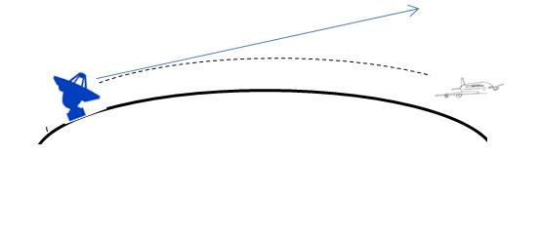
Figure 96: Description of the scenario between the ES and airplane

For the different Earth Station assumptions, 2 different calculations are made:
1) SCENARIO 1 : the interference level at the plane is calculated at fixed plane height up to the visibility distance in the pointing direction of the Earth Station
2) SCENARIO 2 : the maximum distance up to which the interference is above the protection criteria (-105 dBm) for all azimuths from the pointing direction of the Earth station (up to 48°, corresponding to the minimum gain for the F.1245 pattern)

Results for SCENARIO 1:

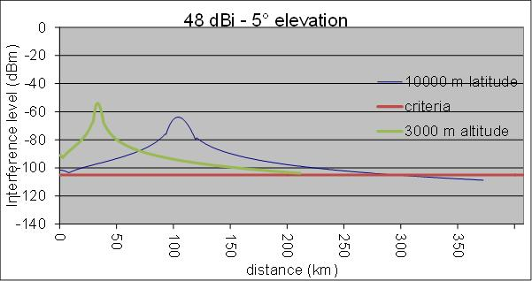
Figure 97: Interference from a 48 dBi ES at 5° elevation

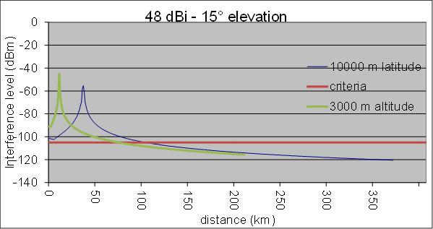
Figure 98: Interference from a 48 dBi ES at 15° elevation

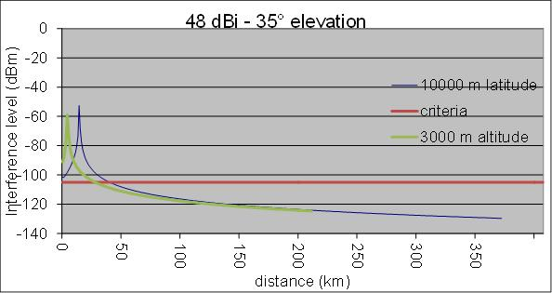
Figure 99: Interference from a 48 dBi ES at 35° elevation

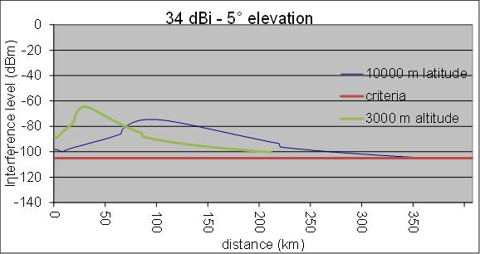
Figure 100: Interference from a 34 dBi ES at 5° elevation

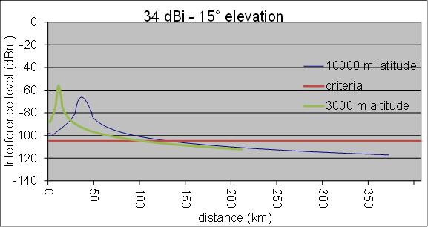
Figure 101: Interference from a 34 dBi ES at 15° elevation

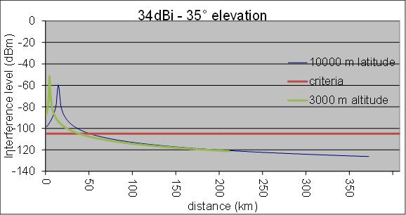
Figure 102: Interference from a 34 dBi ES at 35° elevation

These calculations with scenario 1 shows that using typical operational elevations of satellite earth stations (5° to 35°), the DA2GC receivers on airplane will be interfered from 40 km up to 371 km (visibility distance) and with interference up to more than 50 dB above the DA2GC protection criteria.

Results for SCENARIO 2:

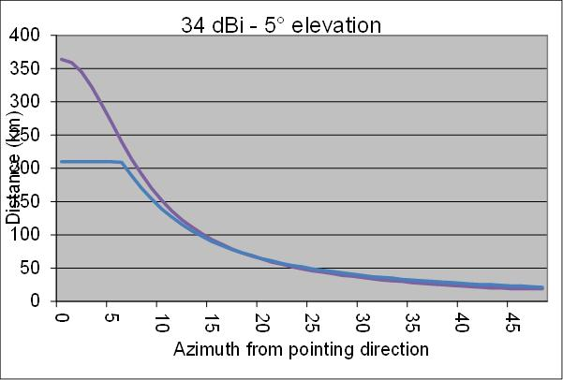
Figure 103: Interference from a 34 dBi ES at 5° elevation

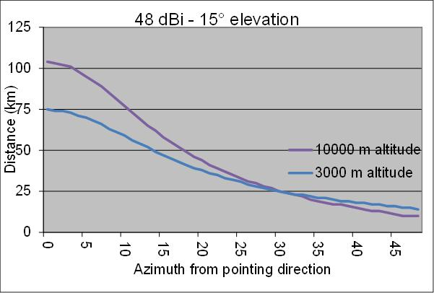
Figure 104: Interference from a 48 dBi ES at 15° elevation

These calculations with scenario 2 shows that using typical operational elevations of satellite earth stations (5° to 35°), the DA2GC receivers on airplane will remain interfered over large distances and large azimuths, representing huge areas where number of airplanes stations will not be able to operate .

Conclusions on Impact of Satellite Earth Stations on DA2GC Aircraft Stations
Calculations provide a rough demonstration that DA2GC on-board receivers will experience quite high levels of blocking or interference from Earth stations emissions:
- The blocking threshold (-43 dBm) can be exceeded by up to 53 dB during periods from 2 to 12s. One could expect that the maximum level at 10 dBm could be destructive to DA2GC receivers.
- The interference threshold (-105 dBm/10 MHz) can be exceeded by up to 44 – 89 dB during periods from 52s to about 14 minutes.
- calculations using typical operational elevations of satellite earth stations (5° to 35°) shows that the DA2GC receivers on airplane will be interfered from 40 km up to 371 km (visibility distance) and with interference up to more than 50 dB above the DA2GC protection criteria. DA2GC AS stations will remain interfered over large distances and azimuths, representing huge areas where airplanes stations will not be able to operate.

One should note that these calculations are not worst case since maximum DA2GC antenna gain were not used. Also, it should be taken into account that several antennas are co-localised at Earth Stations places and operate simultaneously in various directions.
These calculations demonstrate that DA2GC FL operated in the 2010-2025 MHz band will experience significant interference from Space services uplink in the 2025-2110 MHz band and will not be able to operate a service with high performance objectives. By applying mitigation techniques (see ANNEX 2:) to DA2GC systems the impact of these interference events could be reduced although not totally eliminated.

Impact of DA2GC GS on MSS CGC BS
This scenario represents a critical case for implementation of 2 BS in adjacent channels, but with different transmission directions (i.e. a well-known interference case at the border of FDD and TDD or within TDD systems). The results are similar to those presented in section 5.6.1.1 for UMTS and DA2GC in adjacent channels.

Results
In Figure 99 the path loss between a DA2GC GS and a CGC BS based on the Extended Hata Model for rural (open) area is shown, which is more realistic than simple free space propagation. Nevertheless, for the assumed antenna heights the differences are rather small. For increasing distances it is always assumed that the main lobes of the horizontal antenna diagrams (typically sector antennas) are pointed directly to each other (worst case). At a distance near zero it is assumed that the antennas are placed at the same mast, but with different heights (50 m for the DA2GC antenna, 30 m for the CGC BS antenna). In a real environment the resulting minimal coupling loss will be strongly dependent on the antenna characteristic (mainly the side lobes) and the kind of installation at the mast (including the impact of the mast type).
In Figure 100 and Figure 101 different curves under consideration of the resulting ACIR are given. The variation is related to a shift of the DA2GC carrier frequency in direction to the upper edge of the band 2010-2025 MHz (i.e. from 2015 to 2017.5 and 2020 MHz). Due to increasing ACLR of the DA2GC BS from 36 to 39 and 40 dB, respectively, the finally required separation distance between the two stations can be reduced from about 20 to about 12 km. Again the ACLR of the DA2GC BS is the dominating factor, so further improvements are possible by more complex filters in the RF part.

Figure 99: Path loss w & w/o consideration of vertical antenna characteristics (antenna gain not included) at DA2GC GS (Station 1) and MSS CGC BS (Station 2) (Ext. Hata Model for open rural area)

Figure 100: Interference signal power at MSS CGC BS (Station 2) w/ & w/o consideration of ACIR for DA2GC carrier frequencies 2015, 2017.5 and 2020 MHz (Ext. Hata Model for open rural area)

Figure 101: Resulting I/N at MSS CGC BS (Station 2) w/ & w/o consideration of ACIR for DA2GC carrier frequencies 2015, 2017.5 and 2020 MHz (Ext. Hata Model for open rural area)

Impact of MSS UT on DA2GC AS
Again the evaluation here was based on a worst case approach, therefore the probability that a MSS UT will cause interference at a DA2GC AS is still given, but it will be lowered if real antenna boresight directions to GEO satellites are considered in real-world evaluation with flight data. In addition further improvements are possible by increasing the DA2GC AS Rx ACS, because the ACLR of the MSS UT is distinctly higher.

Results
- MSS wideband terminal
Figure 18 to Figure 23 show the path loss between a MSS wideband low gain UT and a DA2GC AS for 2 altitudes of 3 and 10 km as well as the resulting interference powers and I/N values at the AS. The signals are placed as in the other scenarios at the neighbouring band edges. Here the ACS of the DA2GC AS (33 dB) is the dominant factor for the determination of the ACIR value which corresponds to 32.5 dB. The carrier frequency shift for the DA2GC signal within the band 2010-2025 MHz leads only to an ACIR improvement of 0.5 dB due to higher ACLR of the MSS UT. Therefore no additional curves are given.
In Figure 24 and Figure 25 the results (only final I/N) for the 2 aircraft altitudes are shown in case of interference by a MSS wideband high gain UT. As in scenario (1c) the elevation angle of the MSS UT was varied between 5° and 30°. For all angles the I/N threshold is exceeded for ground distances between DA2GC AS and MSS UT in the range between about 5 and 15 km. For higher altitudes the interfering link is stronger attenuated, so the threshold is kept.

- MSS narrowband terminal
Table 4 shows the resulting ACIR value to be considered in further evaluations assuming an ACS value of 33 dB for the DA2GC AS. That value is the dominant factor for ACIR computation. The maximum value is already achieved for guard bands between the MSS channel edge and the lower edge of the DA2GC channel of about more than 0.5 MHz.
Table 46: Resulting ACIR values for MSS narrowband UT disturbance in adjacent channel bandwidth of 10 MHz for DA2GC AS
Guard band between MSS channel and DA2GC channel in MHz | Carrier frequency of DA2GC signal in MHz | ACIR value for high gain UT in dB | ACIR value for for low gain UT in dB
0.00 | 2015.00 | 13.15 | 11.67
0.10 | 2015.10 | 22.40 | 19.79
0.20 | 2015.20 | 25.62 | 20.36
0.30 | 2015.30 | 31.71 | 29.35
0.40 | 2015.40 | 32.19 | 30.50
0.50 | 2015.50 | 32.43 | 31.10
0.75 | 2015.75 | 32.77 | 32.19
1.00 | 2016.00 | 32.89 | 32.60
1.50 | 2016.50 | 32.94 | 32.78
2.00 | 2017.00 | 32.95 | 32.82
2.50 | 2017.50 | 32.96 | 32.87
3.00 | 2018.00 | 32.97 | 32.88
3.50 | 2018.50 | 32.97 | 32.90
4.00 | 2019.00 | 32.98 | 32.91
4.50 | 2019.50 | 32.98 | 32.92
5.00 | 2020.00 | 32.98 | 32.94

Figure Figure 119 to Figure 124 show the path loss between a MSS narrowband low gain UT and a DA2GC AS for 2 altitudes of 3 and 10 km as well as the resulting interference powers and I/N values at the AS for carrier frequency of 2015, 2015.3 and 2017.5 MHz. A guard band of 0.3 MHz is sufficient to keep the I/N threshold for the altitude of 3 km.
In Figure 125 Figure 130 the results (only final I/N) for the 2 aircraft altitudes are shown in case of interference by a MSS narrowband high gain UT. As in scenario (1c) the elevation angle of the MSS UT was varied between 5° and 30°. For altitude of 3 km the I/N threshold is slightly exceeded for ground distances between DA2GC AS and MSS UT in the range between 5 and 12 km even with a guard band of 2.5 MHz (same result also for 1 MHz). For higher altitudes the interfering link is stronger attenuated, so the threshold is kept.
Again the evaluation here was based on a worst case approach, therefore the probability that a MSS UT will cause interference at a DA2GC AS is still given, but it will be lowered if real antenna boresight directions to GEO satellites are considered in real-world evaluation with flight data. In addition further improvements are possible by increasing the DA2GC AS Rx ACS, because the ACLR of the MSS UT is distinctly higher.

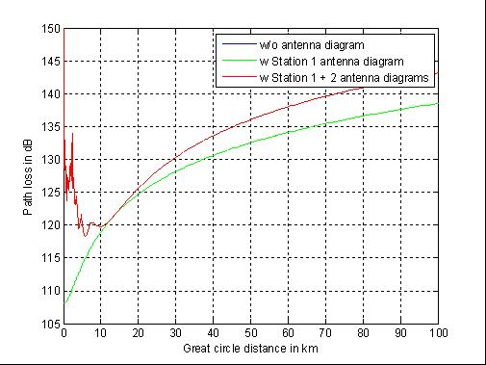
Figure 119: Path loss w & w/o consideration of vertical antenna characteristics (antenna gain not included) at MSS narrowband low gain UT (Station 1) and DA2GC AS (Station 2) for aircraft altitude of 3 km (free space)

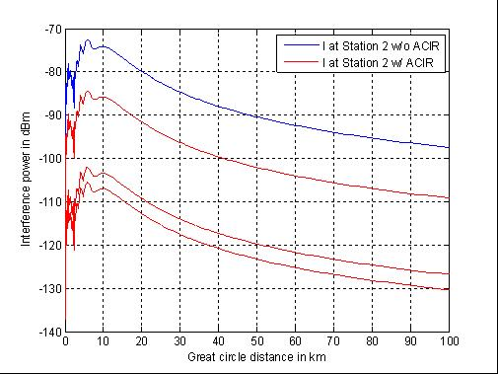
Figure 120: Interference signal power at DA2GC AS (Station 2) for aircraft altitude of 3 km w/ & w/o consideration of ACIR for DA2GC carrier frequencies 2015, 2015.3 and 2017.5 MHz (free space)

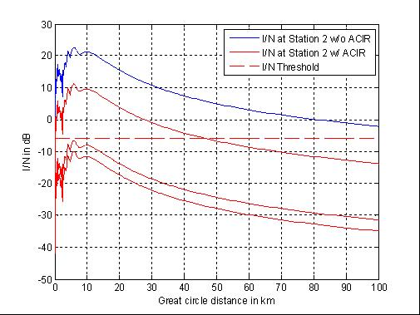
Figure 121: Resulting I/N at DA2GC AS (Station 2) for aircraft altitude of 3 km w/ & w/o consideration of ACIR for DA2GC carrier frequencies 2015, 2015.3 and 2017.5 MHz (free space)

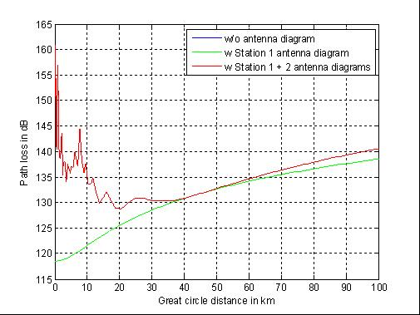
Figure 122: Path loss w & w/o consideration of vertical antenna characteristics (antenna gain not included) at MSS narrowband low gain UT (Station 1) and DA2GC AS (Station 2) for aircraft altitude of 10 km (free space)

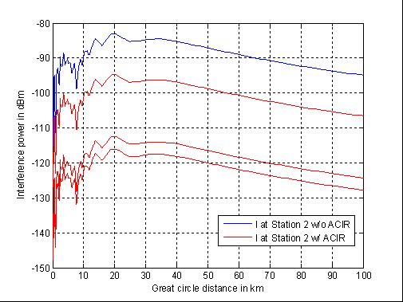
Figure 123: Interference signal power at DA2GC AS (Station 2) for aircraft altitude of 10 km w/ & w/o consideration of ACIR for DA2GC carrier frequencies 2015, 2015.3 and 2017.5 MHz (free space)

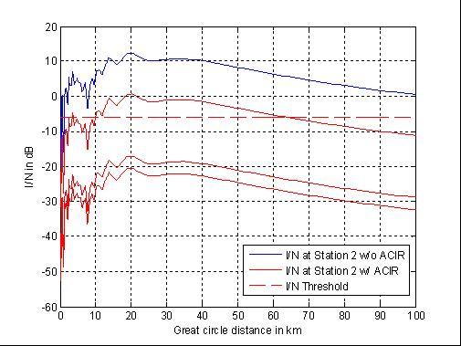
Figure 124: Resulting I/N at DA2GC AS (Station 2) for aircraft altitude of 10 km w/ & w/o consideration of ACIR for DA2GC carrier frequencies 2015, 2015.3 and 2017.5 MHz (free space)

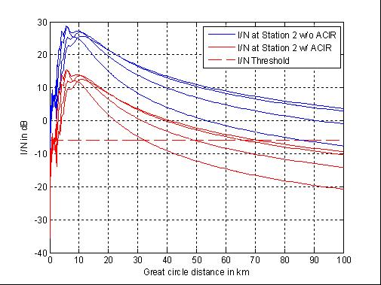
Figure 125: Resulting I/N at DA2GC AS (Station 2) with carrier frequency of 2015 MHz for aircraft altitude of 3 km w/ & w/o consideration of ACIR for interference caused by a MSS narrowband high gain UT with different antenna elevation angles of 5° (curve on top), 10°, 20°, and 30° (free space)

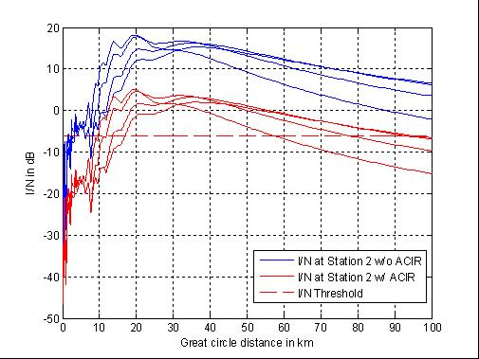
Figure 126: Resulting I/N at DA2GC AS (Station 2) with carrier frequency of 2015 MHz for aircraft altitude of 10 km w/ & w/o consideration of ACIR for interference caused by a MSS narrowband high gain UT with different antenna elevation angles of 5° (curve on top), 10°, 20°, and 30° (free space)

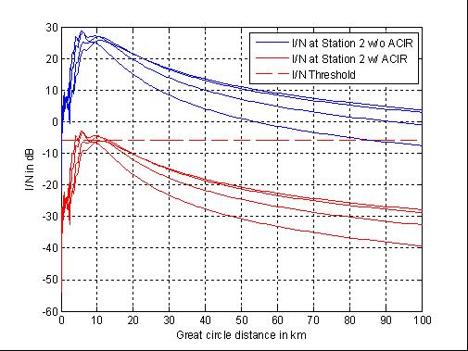
Figure 127: Resulting I/N at DA2GC AS (Station 2) with carrier frequency of 2015.3 MHz for aircraft altitude of 3 km w/ & w/o consideration of ACIR for interference caused by a MSS narrowband high gain UT with different antenna elevation angles of 5° (curve on top), 10°, 20°, and 30° (free space)

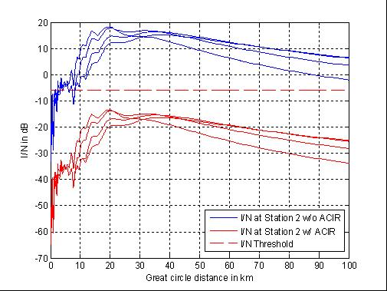
Figure 128: Resulting I/N at DA2GC AS (Station 2) with carrier frequency of 2015.3 MHz for aircraft altitude of 10 km w/ & w/o consideration of ACIR for interference caused by a MSS narrowband high gain UT with different antenna elevation angles of 5° (curve on top), 10°, 20°, and 30° (free space)

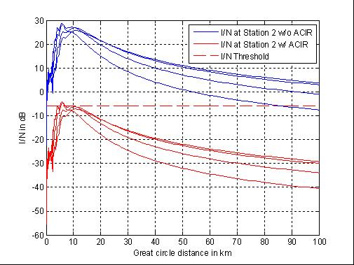
Figure 129: Resulting I/N at DA2GC AS (Station 2) with carrier frequency of 2017.5 MHz for aircraft altitude of 3 km w/ & w/o consideration of ACIR for interference caused by a MSS narrowband high gain UT with different antenna elevation angles of 5° (curve on top), 10°, 20°, and 30° (free space)

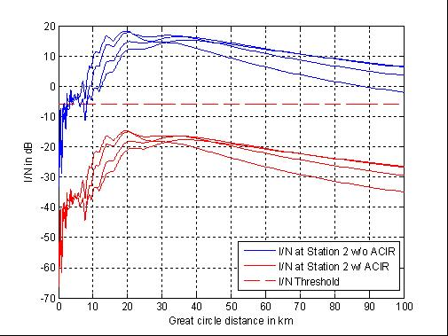
Figure 130: Resulting I/N at DA2GC AS (Station 2) with carrier frequency of 2017.5 MHz for aircraft altitude of 10 km w/ & w/o consideration of ACIR for interference caused by a MSS narrowband high gain UT with different antenna elevation angles of 5° (curve on top), 10°, 20°, and 30° (free space)

Conclusions

Victim | Interferer | DA2GC carrier at 2015 MHz | DA2GC carrier at 2017.5 MHz | DA2GC carrier at 2020 MHz
MSS CGC BS Rx | DA2GC GS Tx | Separation distance of about 20 km is required for the worst case. | Separation distance of about 14 km is required for the worst case. | Separation distance of about 12 km is required for the worst case.
DA2GC AS Rx | MSS wideband UT Tx | Interference may occur from MSS wideband high gain UT transmissions at aircraft altitudes of 3 km and somewhat above, but not up to 10 km. No interference is identified from MSS low gain UT transmissions.

Victim | Interferer | DA2GC carrier between 2015 MHz and 2017.5 MHz
DA2GC AS Rx | MSS narrowband UT Tx | Interference may occur from MSS narrowband high gain UT transmissions at aircraft altitudes around 3 km for ground distances between UT and AS of about 5 to 12 km. No interference is identified from MSS low gain UT transmissions, if the DA2GC carrier frequency is shifted at least to 2015.3 MHz.
Table 42: Summary of compatibility study results

Impact of DA2GC GS on MSS satellite

Methodology
For the compatibility evaluations a DA2GC set-up of 377 sites across Europe, covering the main flight corridors for continental aircraft traffic, has been assumed. The exemplary site positions arranged in a regular hexagonal grid are shown in section 5.15.1.2.
The ΔT/T approach described in Appendix 8 of the ITU Radio Regulations is used in the study in order to assess the impact of interference from a large number of DA2GC aircraft/ground stations in the field-of-view of a satellite antenna beam. Although not directly suitable for use in the case of inter-service sharing, it does provide a very simple method of analysing the impact without much knowledge of the characteristics of the carriers used on the satellite network requiring protection. In this technique, the interference from the DA2GC aircraft/ground stations into the satellite receivers is treated as an increase in thermal noise in the wanted MSS network and hence is converted to a noise temperature (by considering the interference power per Hz) and compared with tolerable percentage increases in noise temperature. This approach has the advantage that very few satellite parameters are required to be known and a detailed link budget for every type of carrier (especially those most sensitive to interference) is not required for the satellite network requiring protection.
Recommendation ITU-R M.1183 indicates the permissible levels of interference to a mobile-satellite service (MSS) network from other MSS and fixed-satellite service (FSS) networks. The recommended single entry and aggregate interference levels are expressed by the ratios of interference power level to total noise power level. According to this recommendation the maximum level of interference power should not exceed for more than (100 – X)% of any month 6% of the total noise power at the input to the demodulator which would give rise to the desired performance objectives. Consequently, the limitation of increase of equivalent noise temperature is expressed by the following relationship:
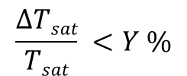 (1)
where,
ΔT_{sat} : is the apparent increase in the receiving system noise temperature at the satellite in K, due to an interfering emission;
T_{sat} : is the receiving system noise temperature at the satellite in K referred to the output of the receiving antenna of the satellite;
Y : is the noise increase allowed (e.g. 1%, 6%, etc.).
In the case under consideration here, ΔT_{sat} is the contribution of aggregate emissions from DA2GC aircraft/ground stations at the input of a satellite receiver.
Assuming that the interference from DA2GC can be treated similarly to thermal noise, the link noise temperature contribution from a single DA2GC radio node (GS or AS) can be expressed as follows:

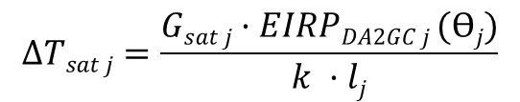 K (2)

where:
G_{sat} : is the gain of receiving antenna of the satellite in the direction of the DA2GC radio node (GS or AS) (linear ratio, relative to isotropic);
EIRP_{DA2GC j} (θ_{j} ) : is the EIRP spectral density in W/Hz of a single DA2GC radio node transmitting antenna in the satellite beam and in the direction of the satellite;
θ_{j} : is the off-axis angle of the DA2GC radio node antenna towards the satellite in the elevation plane (degrees);
k : is the Boltzmann’s constant (1.38·10⁻²³ J·K⁻¹);
l_{j} : is the uplink free space path loss (linear power ratio) [11]. Note that this could also include gaseous attenuation due to absorption by water vapour and oxygen molecules.
Then the aggregate effect can be calculated as:
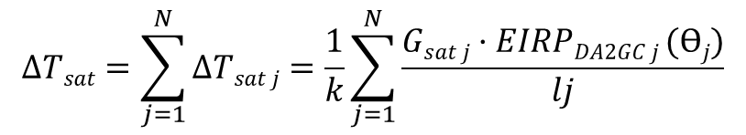 K (3)

where:
N: is the total number of DA2GC radio nodes within the satellite beam.
Here, the EIRP for each DA2GC radio node must be calculated in the direction of the satellite. Note that G_{sat j} and l_{j} will not be constant, but will vary with the position of the DA2GC radio node within the satellite beam and its distance to the satellite. As the satellite antenna diagram is not precisely known, the maximum gain is always applied resulting in a worst case estimation for the interference impact.
Applying the values for the S-DMB return link in Table 30 the increase of the noise temperature by the interfering signals from the DA2GC radio nodes at the satellite receiver has to be less than 5.5 K (33 K) to keep a percentage value of 1% (6%) which corresponds to a maximum aggregated interference power level of -197.9 dBm/Hz (-197.1 dBm/Hz).
Europe is covered by 30 S-DMB return beams as shown in Figure 61. Assuming that 10 of these beams are covering area not covered by DA2GC (e.g. north Scandinavia, Mediterranean see, etc.), the numbers of DA2GC GS per S-DMB return beam can be calculated as:
The following Figure 112 shows the 19 GS locations taken into account for the evaluation of the interference impact for a single beam.

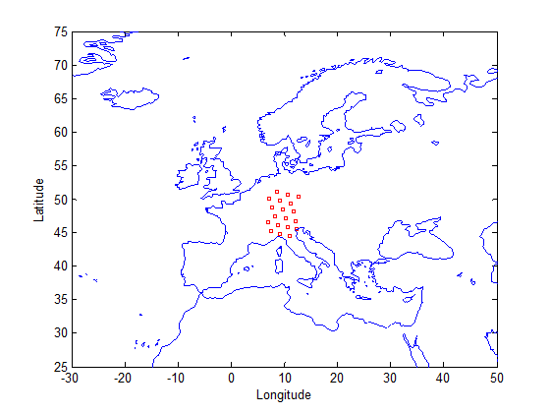
Figure 112: DA2GC GS locations used to evaluate the interference impact on a single S-DMB return beam

Results
Applying the method described in 5.15.1.1 the aggregated interference power level of the 19 DA2GC GS at the GEO satellite position (including satellite antenna gain of 39 dBi) corresponds to
-161 dBm/Hz,
assuming co-channel transmission in the MSS UL band (1980-2010 MHz). Except of the higher Tx power the higher interference level compared to DA2GC AS is mainly caused by the uptilt of the GS antenna diagram.
Again the out-of-band emissions of the involved DA2GC radio components have to be considered for final evaluation of the interference impact. Table 45 provides the resulting maximum interference power level in the MSS band and the noise temperature increase at the satellite receiver dependent on the frequency offset to the edge of the DA2GC channel taking into account the spectrum emission mask of the DA2GC GS.
Table 45: Resulting maximum interference power levels at the MSS satellite dependent on the frequency offset to the DA2GC FL channel edge as well as increase in satellite system noise temperature
Frequency offset to DA2GC channel edge in MHz | Minimum interference  reduction  in dB | Maximum interference  level  in dBm/Hz | Increase in  satellite system noise temperature in K | Increase in  satellite system noise  temperature in %
0 ≤ Δf < 5 |  |  | 1.3e+4 … 1.3e-3 | 2285 … 0
5 ≤ Δf < 10 | 40.5 | -201.5 | 1.3e-3 | ≅ 0
10 ≤ Δf < 25 | 51.5 | -212.5 | 1e-14 | ≅ 0
25 ≤ Δf | 66.5 | -227.5 | <1e-15 | ≅ 0

According to the values in Table 45 the interference threshold is exceeded in the case that the DA2GC FL channel is directly positioned at the upper edge of the MSS band. To keep the threshold for 1% (6%) noise temperature increase a guard band of at least 2.4 MHz (1.9 MHz) is required, i.e. the carrier frequency of the DA2GC RL signal has to be higher than 2017.4 MHz (2016.9 MHz), if there are no further modifications of the RF filters at the GS.

Conclusions
Worst case link evaluations concerning the DA2GC in the band 2010-2025 MHz and MSS UL operation below 2010 MHz have been conducted for the implementation of a DA2GC FDD system in the unpaired 2 GHz bands. For the DA2GC system the two different alternatives for the realization of RL and FL in the band 2010-2025 MHz were taken into account.The impact of the DA2GC FL transmission on the reception at a geostationary MSS satellite has been evaluated:
- In case of the DA2GC FL a frequency guard interval between the DA2GC channel edge and the upper edge of the MSS UL band is required. In the case of allowance of 1% increase of the system noise temperature the guard band has to be at least 2.4 MHz.

Impact of DA2GC GS on FS

Results

Figure 142: Interference power and resulting I/N at FS Rx (1.75 MHz channel spacing) for DA2GC GS carrier frequency of 2020 MHz

Figure 143: Interference power and resulting I/N at FS Rx (1.75 MHz channel spacing) for DA2GC GS carrier frequency of 2015 MHz

Figure 144: Interference power and resulting I/N at FS Rx (14 MHz channel spacing) for DA2GC GS carrier frequency of 2020 MHz

Figure 145: Interference power and resulting I/N at FS Rx (14 MHz channel spacing) for DA2GC GS carrier frequency of 2015 MHz

Impact of FS on DA2GC AS

Results
[Figures to be revised with respect to spurious levels]
Figure 146: Interference power and resulting I/N at FS Rx (1.75 MHz channel spacing) for DA2GC GS carrier frequency of 2020 MHz

Figure 147: Interference power and resulting I/N at FS Rx (1.75 MHz channel spacing) for DA2GC GS carrier frequency of 2015 MHz

Figure 148: Interference power and resulting I/N at FS Rx (14 MHz channel spacing) for DA2GC GS carrier frequency of 2020 MHz

Figure 149: Interference power and resulting I/N at FS Rx (14 MHz channel spacing) for DA2GC GS carrier frequency of 2015 MHz

Conclusions
Worst case link evaluations concerning the compatibility between DA2GC in the band 2010-2025 MHz and FS operation above 2025 MHz have been conducted for the implementation of a DA2GC FDD system in the unpaired 2 GHz bands. For the DA2GC FL in the band 2010-2025 MHz the following conclusions can be drawn:

Table 49: Summary of compatibility study results (FS carrier spacing of 1.75 MHz)
Victim | Interferer | DA2GC carrier at 2015 MHz | DA2GC carrier at 2020 MHz
FS Rx (1.75 MHz CS) | DA2GC GS Tx | The interference threshold is exceeded up to a distance of about 68 km. | The interference threshold is exceeded up to a distance of about 72 km.
DA2GC AS Rx | FS Tx (1.75 MHz CS) | Interference threshold is kept already with DA2GC carrier at 2020 MHz. | For aircraft altitude of 3 km the interference threshold is kept.

Table 50: Summary of compatibility study results (FS carrier spacing of 14 MHz)
Victim | Interferer | DA2GC carrier at 2015 MHz | DA2GC carrier at 2020 MHz
FS Rx (14 MHz CS) | DA2GC GS Tx | The interference threshold is exceeded up to a distance of about 39 km. | The interference threshold is exceeded up to a distance of about 82 km.
DA2GC AS Rx | FS Tx (14 MHz CS) | Interference threshold is kept already with DA2GC carrier at 2020 MHz. | For aircraft altitude of 3 km the interference threshold is kept.

Compatibility studies on DA2GC according to ETSI TR 101 599

Impact of DA2GC GS on satellite receivers
This situation concerns the aggregation of DA2GC Ground Station emissions, where each DA2GC Ground Station is transmitting a number of beams, into a Space Science satellite receiver at 300 km altitude (worst case). The DA2GC emissions will either be spurious (at a fixed level into the antenna) or out-of-band which will vary with ATPC. The spacecraft criterion = -180 dBm/Hz (SE44(12)048) and the margin calculated below relative to this is to allow for the aggregate from all Ground stations and their transmit beams.

Results
- Spurious emissions (fixed level)

The static single entry spurious interference from a DA2GC Ground Station into an SS satellite receiver can be calculated through the following steps:

-30 dBm/MHz into antenna = -90 dBm/Hz

Peak DA2GC GS spurious EIRP = -67 dBm/Hz at 10° elevation (but -75 dBm/Hz more representative at 90° elevation)

Power received at spacecraft (90°) = -75-148.8+0= -223.8 dBm/Hz (Margin = 43.8 dB)
Power received at spacecraft (10°) = -67-160.4+3= -224.4 dBm/Hz (Margin = 44.4 dB)

- Out-of-band emissions (subject to ATPC)

The static single entry out-of-band interference from a DA2GC Ground Station into an SS satellite receiver can be calculated through the following steps:

DA2GC GS EIRP (based on max P at 5° elevation) -22 (10°) to -30 (90°) dBm/Hz

DA2GC GS OOB EIRP therefore -62 (10°) to -70 (90°) dBm/Hz

Power received at spacecraft (90°) = -70-148.8+0= -218.8 dBm/Hz (Margin = 38.8 dB)
Power received at spacecraft (10°) = -62-160.4+3= -219.4 dBm/Hz (Margin = 39.4 dB)

Conclusions on Impact of DA2GC GS on satellite receivers
Whether dealing with spurious or OOB emissions it can be seen from the above calculations that the margin approximates to 40 dB.
Assuming a very worst case of equal contributions from 150 Ground Stations (21.8 dB) and 12 beams at each Ground Station (10.8 dB) with no azimuth discrimination taken into account, a margin of 32.6 dB would be required which is well within the margin available. In practice azimuth discrimination available at the Ground Station would make the situation significantly better.

Impact of Satellite Earth stations on DA2GC Aircraft Stations
Technical calculations and conclusions are provided in section 5.15.1.5

conclusions

- LIST OF STATIONS USED BY ESA OR COOPERATING SPACE AGENCIES in Europe
Location | Latitude | Longitude | Country | Operator | P (dBW) | Antenna diameter (gain) | Max EIRP  (dBW)
Kiruna/Salamijärvi | 67° 51' 26" N | 20° 57' 57" E | Sweden | ESA/SSC | 26 | 15 m (48 dBi)  13 m (46 dBi) | 74  72
Kiruna/Esrange | 67° 53′ N | 21° 4′ E | Sweden | SSC/CNES | 28  23 | 6.1 m (41 dBi)  13 m (47 dBi) | 69  70
Svalbard | 78° 13' 18" N | 15° 24' 03" E | Norway | KSAT |  | (47 dBi)
Svalbard | 78° 13' 49" N | 15° 23' 34" E | Norway | KSAT  for Metop (EUMETSAT) | 14 | 10m (45 dBi) | 59
Tromso | 69 36‘ 44“ N |  | Norway | KSAT
  18 56‘ 30“ E
Surrey Guildford | TBD | TBD | UK | SSTL
Villafranca | 40° 26' 33" N | 03° 57' 06" W | Spain | ESA | 26 | 15 m (48 dBi) | 74
Robledo | 40° 25' 43" N | 04° 14' 57" W | Spain | NASA | 43 | 70 m (62 dBi)  34 m (56 dBi) | 105  99
Maspalomas | 27° 45' 46" N | 15° 38' 02" W | Spain (Canary Islands) | ESA/INTA | 26 | 15 m (49 dBi) | 75
Maspalomas | 27° 45' 45" N | 15° 38' 00" W | Spain (Canary Islands) | INTA  for Meteosat (EUMETSAT) | 20 | 9.2 m (43.5 dBi) | 63.5
Redu | 50° 00' 07" N | 05° 08' 43" E | Belgium | ESA | 26 | 15 m (49 dBi) | 75
Aussaguel | 43° 25' 26" N | 01° 30' 22" E | France | CNES | 26 | 11 m (45 dBi) | 71
Neustrelitz | 53° 19' 47" N | 13° 04' 12" E | Germany | DLR | 20 | 7.3 m (40 dBi)  4 m (36 dBi) | 60  56
Weilheim | 47° 52' 55" N | 11° 04' 54" E | Germany | DLR | 33 (>10 meters),  20 (<10 meters), | 15 m (46,4 dBi)  15 m (47,2 dBi),  9 m (43,1 dBi),  4,5 m (38 dBi),  30 m (52,3 dBi) | 79.4  80.2  63.1  58  85.3
Usingen | 50° 20' 02" N | 08° 29' 04" E | Germany | Media Broadcast for Meteosat (EUMETSAT) | 21 | 13 m (47 dBi) | 68
Usingen | 50° 19' 45" N | 08° 28' 15" E | Germany | Media Broadcast for Jason (EUMETSAT) | 20 | 3.1m (34.7 dBi) | 54.7
Brandenburg | 52° 24' 37'' N | 12° 33' 51'' E | Germany | Rapid Eye
Gelsdorf | 50° 34' 09'' N | 07° 02' 09'' E | Germany | Government
Fucino | 41° 59' 00" N | 13° 36' 00" E | Italy | Telespazio  for Meteosat (EUMETSAT) | 20 | 13 m (47 dBi) | 67
Torrejon de Ardoz | 40° 27' 32" N | 03° 28' 18" W | Spain | INTA/
Cheia | 45° 27' 27" N | 25° 56' 20" E | Romania | Telespazio  for Meteosat (EUMETSAT) | 28 | 9.2 m (43.5 dBi) | 71.5
Wessling | 48° 05' 06" N | 11° 12' 00" E | Germany | DLR | 14 | 5,4 m (39,1 dBi) | 53.1

- Proposed mitigation techniques for the DA2GC system descriebd in ETSI TR101 599

Introduction
This contribution provides further information with regard to:
- Potential for damage to the DA2GC Aircraft Station front end
- Likely durations of DA2GC service outages due to SS unwanted emissions falling within the DA2GC channel pass band
- Similar considerations for outages due to saturation/blocking arising from the high power SS signal falling outside the DA2GC channel pass band
- Revised separation distances between SS earth station and DA2GC ground station sites

Damage
In certain circumstances a maximum received power level of +10 dBm at the DA2GC aircraft LNA could be generated if an aircraft were to fly through the beam of a Space Services uplink. An extract from an example Avago Technologies LNA datasheet is shown in Table 1 below where it can be seen that the maximum level which the device can tolerate is +20 dBm. Such levels are therefore well within the rating of the LNA and would not cause any damage to the device.

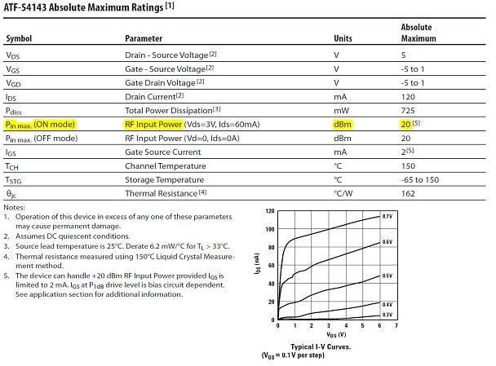
Table 1 – Extract from LNA Datasheet showing maximum power ratings
It is recognised that the Robledo station may produce higher received signal levels but that this is a unique situation in Europe with Robledo having a maximum EIRP which is some 20dB dB higher than the maximum produced by any other European SS uplink stations. Nevertheless, if it proves necessary to protect the DA2GC receiver against even this unusual scenario, this can be achieved by fitting a limiter or RF switch in front of the LNA as part of the system design. Such devices are readily obtainable with a typical insertion loss of around 0.1dB, which would have no real impact on the system performance.
For these reasons, the beamforming system described in TR 101 599 could operate in the band 2010-2025 MHz without any risk of damage to the airborne equipment from Space Service transmissions in the adjacent band.

Unwanted emissions
Digital processing techniques within the DA2GC channel enable interfering signals that fall within that channel to be rejected (through a combination of nulling and cancellation). References show that rejection levels of up to 80 dB have been attained through simulation. In practice, careful optimisation of the DSP algorithms employed in the currently considered beamforming system allows interfering signals at levels up to at least 50 dB above the wanted signal to be rejected. (See Annex for example plots) Given that the assumed DA2GC wanted signal level is -77 dBm (as in previous LHS contributions on 2GHz bands) this means that levels up to -27 dBm can be rejected.
On this basis the outages described in of Scenario-2 of the ESA contribution (Annex 1 to doc SE44(13)040) are almost completely avoided since the criterion shown in Figures 5 to 9 of the ESA contribution effectively moves up from -105 dBm to -27 dBm a change of 78 dB. The potential for outages is therefore only associated with Space Service Earth Stations using a transmitter power of 70 dBm and Gain of 48 dBi as represented in Figure 9 of the ESA document. Examination of Figure 9 with respect to the -27 dBm criterion shows a discrimination angle of 1 or 2 degrees, which would amount to potential outages in this worst case amount of no more than a second or so at 10,000m and even less at 3km altitude.

Saturation/blocking
Although damage due to the very high power SS signals is not anticipated, as noted in Section 2 above, it is still the case that DA2GC service outages could occur due to front end saturation on the one hand and blocking (interference experienced by the DA2GC receiver) on the other.
4.1 Saturation
Front end saturation levels for the same example LNA, considered with respect to damage (Section 2 above), are as shown in the further datasheet extract in Table 2 below:
Table 2 – Extract from LNA Datasheet showing saturation levels

From the highlighted figures it can be seen that the input saturation level is +3.8 dBm. This is significantly higher than the -43 dBm quoted in SE44(13)040 (although it is not entirely clear from that contribution when it is described as “saturation / blocking level” which of these two effects it applies to).
From a saturation point of view, the results of SE44(13)040 Scenario-1 (Figures 2 to 4 in that document) indicate that outages would not occur in most cases and only be a matter of a second or two in the worst case (Space Service Earth Stations using a transmitter power of 70 dBm and Gain of 48 dBi as represented in Figure 4 of the ESA document) with a similar amount of time required for resynchronisation.

4.2 Blocking
Insofar as interference due to blocking is concerned, the rejection of this interference will be managed through the use of the digital processing (nulling/cancellation) mentioned in Section 3 and prior to that by a combination of analogue and digital filters.
Immediately adjacent to the main DA2GC channel it is the digital filtering that provides the greatest rejection through the use of a wider sampling “pseudo-channel”, which extends beyond the main DA2GC channel. An example of the levels of rejection that can be achieved is shown in Figure 1 below (extract from AD9961/3 datasheet from Analog Devices) where it can be seen that many 10s of dB rejection can be achieved very close to the channel edge.
Figure 1 – Digital filter response

Outside the digital filtering “pseudo-channel” it will be the analogue filter that provides the necessary rejection. If it is assumed that the DA2GC channel is 15 MHz wide (the whole of the upper 2 GHz band), and that the sampled “pseudo channel” is twice that, then beyond 15 MHz from the centre frequency it will be the function of the analogue filter to reject interference. A typical analogue (SAW) filter response is shown in Figure 2 below (ADRF6516 from Analog Devices):
Figure 2 – Analogue filter response

The relevant trace for a 15 MHz channel is the 8th from the left coloured maroon where the knee is just turning over at 7.5 MHz. At 15 MHz on relevant trace above, and where the “pseudo channel” stops, the analogue filter provides a rejection of 30 – 5 = 25 dB.
In the worst case therefore the filtering only provides 25 dB of rejection (as determined by the analogue filter) but the signal is then aliased into the processing channel where the 50 dB of digital processing gain (nulling/cancellation) mentioned in Section 3 is applied. This means that interfering signals of up to -77 dBm +25 dB + 50 dB = -2 dBm can be rejected.
Once again it will only be the worst case situation of Space Service Earth Stations using a transmitter power of 70 dBm and Gain of 48 dBi (as represented in Figure 4 of the ESA document) that cause any outages at all. Reference to Figure 4 of the ESA document indicates that if the criterion is moved up from -43 dBm to -2 dBm then the duration of such outages will only be a matter of a second or two.

- List of reference
- 3GPP TS 36.101: User equipment (UE) radio transmission and reception; V10.3.0, June 2011.
- 3GPP TS 36.104: Base station (BS) radio transmission and reception
- 3GPP TS 36.300: Evolved Universal Terrestrial Radio Access (E-UTRA) and Evolved Universal Terrestrial Radio Access Network (E-UTRAN); Overall description; Stage 2; V10.4.0, June 2011.
- Holma, H.; Toskala, A.: LTE for UMTS – OFDMA and SC-FDMA Based Radio Access; John Wiley & Sons, 2009.
- ETSI TR 103 054: Electromagnetic compatibility and Radio spectrum Matters (ERM); System Reference Document; Broadband Direct-Air-to-Ground Communications operating in part of the frequency range from 790 MHz to 5 150 MHz; V1.1.1, July 2010.
- ITU-R Rec. F.1336-2: Reference radiation patterns of omnidirectional, sectoral and other antennas in point-to-multipoint systems for use in sharing studies in the frequency range from 1 GHz to about 70 GHz; 2007.
- CEPT FM(11)008: Qualcomm / Information about the impact of antenna selection on the design, practical implementation and performance of a DA2GC system; March 2011
- ECC Report 93: Compatibility between GSM equipment on board aircraft and terrestrial networks; May 2008.
- ETSI EN 300 328 V1.8.1 (2012-06): Electromagnetic compatibility and Radio spectrum Matters (ERM);Wideband transmission systems;Data transmission equipment operatingin the 2,4 GHz ISM band andusing wide band modulation techniques;Harmonized EN covering the essential requirementsof article 3.2 of the R&TTE Directive
- European Communications Office (ECO): SEAMCAT handbook; January 2010.
- 3GPP TS 25.104: Base station (BS) radio transmission and reception (FDD).
- 3GPP TS 25.101: User equipment (UE) radio transmission and reception (FDD).
- ETSI EN 300 175-2 “Digital Enhanced Cordless Telecommunications (DECT); Common Interface (CI); Part 2: Physical Layer”.
- CEPT SE7(12)020: Reference information from DECT Forum to the Guidance paper on DECT antenna gain.
- ITU-R Report M.2109: Sharing studies between IMT-Advanced systems and geostationary satellite networks in the fixed-satellite service in the 3400-4200 and 4500-4800 MHz frequency bands; 2007.
- ITU-R Report M.2111: Sharing studies between IMT-Advanced and the radiolocation service in the 3400 – 3700 MHz bands; 2007.
- ITU-R Report M.2039: Characteristics of terrestrial IMT-2000 systems for frequency sharing/ interference analyses; November 2010.
- 3GPP TS 36.814: Technical Specification Group Radio Access Network; Evolved Universal Terrestrial Radio Access (E-UTRA); Further advancements for E-UTRA physical layer aspects; V9.0.0, March 2010.
- [6] ITU-R Rec. SA.609-2: Protection criteria for radiocommunication links for manned and unmanned near-Earth research satellites; 2006.
- ITU-R Rec. P.528-3: Propagation curves for aeronautical mobile and radionavigation services using the VHF, UHF and SHF bands; February 2012.
- CEPT ERC/Recommendation 74-01: Unwanted emissions in the spurious domain; January 2011
- ETSI EN 302 574-1: Satellite Earth Stations and Systems (SES); Harmonized Standard for satellite earth stations for MSS operating in the 1 980 MHz to 2 010 MHz (earth-to-space) and 2 170 MHz to 2 200 MHz (space to-earth) frequency bands; Part 1: Complementary Ground Component (CGC) for wideband systems: Harmonized EN covering the essential requirements of article 3.2 of the R&TTE Directive; V1.1.1, August 2010.
- ETSI EN 302 574-2: Satellite Earth Stations and Systems (SES); Harmonized Standard for satellite earth stations for MSS operating in the 1 980 MHz to 2 010 MHz (earth-to-space) and 2 170 MHz to 2 200 MHz (space to-earth) frequency bands; Part 1: User Equipment (UE) for wideband systems: Harmonized EN covering the essential requirements of article 3.2 of the R&TTE Directive; V1.1.1, August 2010.
- ETSI EN 302 574-3: Satellite Earth Stations and Systems (SES); Harmonized Standard for satellite earth stations for MSS operating in the 1 980 MHz to 2 010 MHz (earth-to-space) and 2 170 MHz to 2 200 MHz (space to-earth) frequency bands; Part 3: User Equipment (UE) for narrowband systems: Harmonized EN covering the essential requirements of article 3.2 of the R&TTE Directive; V1.1.1, August 2010.
- (Draft) ECC Report 197: Compatibility studies - MSS terminals transmitting to a satellite in the band 1980-2010 MHz and adjacent channel UMTS services; January 2013.
- ITU Radio Regulations (Edition of 2008).
- ERC Report 65: Adjacent band compatibility between UMTS and other services in the 2 GHz band; November 1999.
- ITU-R Rec. SA.1154: Provisions to protect the space research (SR), space operations (SO) and Earth exploration-satellite services (EES) and to facilitate sharing with the mobile service in the 2 025-2 110 MHz and 2 200-2 290 MHz bands; 1995.
- Ng, M.H.; Lin, S.; Li, J.; Tatesh, S.: Coexistence studies for 3GPP LTE with other mobile systems; IEEE Communications Magazine, April 2009.
- ITU-R Rec. P.525-2: Calculation of free-space attenuation; August 1994.
- ITU-R Rec. P.452-14: Prediction procedure for the evaluation of interference between stations on the surface of the Earth at frequencies above about 0.1 GHz; October 2009
- CEPT FM(11)008: Qualcomm / Information about the impact of antenna selection on the design, practical implementation and performance of a DA2GC system; March 2011
- ITU-R Rec. S.465-6: Reference radiation pattern of earth station antennas in the fixed-satellite service for use in coordination and interference assessment in the frequency range from 2 to 31 GHz (01/2010)
- CEPT ECC document JPTMSS2GHz(04)08: S-DMB Link Budgets.
- Recommendation T/R 13-01 E (Montreux 1993, Revised Rottach-Egern, February 2010): Preferred channel arrangements for Fixed Service systems operating in the frequency range 1 - 2.3 GHz.
- Recommendation ITU-R F.758-5 (03/2012): System parameters and considerations in the development of criteria for sharing or compatibility between digital fixed wireless systems in the fixed service and systems in other services and other sources of interference
- Recommendation ITU-R F.699-7: Reference radiation patterns for fixed wireless system antennas for use in coordination studies and interference assessment in the frequency range from 100 MHz to about 70 GHz.
- ETSI EN 302 217-2-2 V2.0.0 (2012-09): Fixed Radio Systems; Characteristics and requirements for point to point equipment and antennas; Part 2 2: Digital systems operating in frequency bands where frequency co-ordination is applied; Harmonized EN covering the essential requirements of article 3.2 of the R&TTE Directive.
- ETSI TR 101 854 V1.3.1 (2005-01), Fixed Radio Systems; Point-to-point equipment; Derivation of receiver interference parameters useful for planning fixed service point-to-point systems operating different equipment classes and/or capacities.
- ERC Report 64: Frequency sharing between UMTS and existing Fixed Services (Menton, May 1999).
- Recommendation ITU-R F.1247-1: Technical and operational characteristics of systems in the fixed service to facilitate sharing with the space research, space operation and Earth exploration-satellite services operating in the bands 2 025-2 110 MHz and 2 200-2 290 MHz
- CEPT/ERC/RECOMMENDATION 74-01E (Siófok 98, Nice 99, Sesimbra 02, Hradec Kralove 05, Cardiff 11), UNWANTED EMISSIONS IN THE SPURIOUS DOMAIN

The quoted TX output power level is the total transmit power delivered to all antennas and antenna elements of a single ground station or aircraft station antenna array when the transmitter is operating at its maximum power level
The LoS propagation model is valid for 50% of the time. An adequate adaptation to 0.1% of time is for further discussion, e.g. for 1% of the time the propagation loss is about 5 dB less than for 50% of the time according to ITU-R Rec. P.528-3..
This is a worst case level and is based on a 70 dBm transmitter power in association with a 2.6 dBi sidelobe level which comes from the RR Appendix 8 Earth Station antenna pattern at an off-axis angle of 15 degrees stated as the minimum operating angle for GSO systems. The sidelobe level for non-GSO systems operating at 5 degrees elevation would be 14.5 dBi, some 11.9 dB more, but is not related to a long-term approach. In case of a short-term approach, the DA2GC short-term protection criteria would be more than likely higher than -10 dB (or -6 dB).
taking into account various types of Earth stations (and their different spurious maximum emission levels (see Table 21), the spurious EIRP level would range 26.6 (for 50 dBm stations) to 46.6 dBm/10 MHz (for 70 dBm stations)
The LoS propagation model is valid for 50% of the time. An adequate adaptation to 0.1% of time is for further discussion, e.g. for 1% of the time the propagation loss is about 5 dB less than for 50% of the time according to ITU-R Rec. P.528-3 [20].
Yan Wang, Shangce Gao, Hang Yu and Zheng Tang: Synthesis of Antenna Array by Complex-valued Genetic Algorithm. IJCSNS International Journal of Computer Science and Network Security, Vol.11 No.1, January 2011. SU Chengxiao, WANG Jiegui and LIU Kai: Study of Adaptive Nulling Methods under Different Constraints. Proceedings of the 2nd International Conference on Computer Science and Electronics Engineering (ICCSEE 2013).

