ECC Report <No>

Compatibility/sharing studies related to Broadband Direct-Air-to-Ground Communications (DA2GC) in the frequency bands 2400-2483.5 MHz, 3400 – 3600 MHz and 5855-5875 MHz.
Editor’s note:
This working document has to be considered as a preliminary draft ECC Report which is still under development. All parts of it are still subject to further discussions and considerations.

Month YYYY (Arial 9pt bold)
(last updated: Month YYYY) (Arial 9pt)

Executive summary (style: heading 1)
Body text (style: ECC Paragraph)
(advice: the Executive Summary should provide a short and concise explanation on the purpose of the respective ECC Report and should clearly indicate the covered subjects to which it applies. In addition, it should clearly explain the application of the document.)

TABLE OF CONTENTS

0 Executive summary (style: heading 1) 2
1 Introduction 7
2 Definitions (optional section) 8
3 Frequency usage 9
3.1 Frequency usage in the band 5855 – 5875 MHz 9
3.2 Frequency usage in the band 2400 – 2483.5 MHz 9
3.3 Frequency usage in the band 3400 – 3600 MHz 10
4 broadband DA2GC System characteristics 11
4.1 DA2GC system according to ETSI TR 103 054 11
4.1.1 Ground station parameters 11
4.1.1.1 Antenna characteristics 12
4.1.1.2 Unwanted emissions 13
4.1.2 Aircraft station parameters 13
4.2 DA2GC system according to ETSI TR 101 599 15
4.2.1 Overall system architecture 15
4.2.2 Ground station equipment 16
4.2.3 Transmitter parameters 18
4.2.3.1 Transmitter Output Power / Radiated Power 18
4.2.3.2 Example radiation patterns 19
4.2.3.3 Operating Frequency 22
4.2.3.4 Bandwidth 22
4.2.3.5 Unwanted emissions 22
4.2.4 Receiver parameters 23
4.2.6 Channel access parameters 23
4.3 DA2GC system according to ETSI TR 103 108 V0.0.7 24
4.3.1 Technical Description 24
4.3.1.1 Transmitter 24
4.3.1.2 Receiver 24
4.3.1.3 Antenna parameters 25
4.3.1.4 Ground Station Elevation E.I.R.P Mask 28
4.3.1.5 Aircraft Station Elevation Eirp Masks 28
4.3.1.6 Spectrum Emission Mask 29
4.3.1.7 Unwanted Emissions 30
4.3.1.8 Aircraft Station Mitigation Attenuation 30
5 Compatibility and sharing scenarios for the band 5855 – 5875 MHz 32
5.1 Compatibility between DA2GC and BFWA at 5.8 GHz 33
5.1.1 Technical characteristics of BFWA systems 33
5.1.2 Compatibility between DA2GC AS (ETSI TR 103 054) and BFWA 35
5.1.2.1 Methodology 35
5.1.2.2 Results 36
5.1.3 Compatibility between DA2GC GS (ETSI TR 103 054) and BFWA 39
5.1.3.1 Methodology 40
5.1.3.2 Results 40
5.1.3.3 Conclusions on the compatibility between DA2GC (ETSI TR 103 054) and BFWA 40
5.1.4 Compatibility between DA2GC AS (ETSI TR 101 599) and BFWA 41
5.1.4.1 Methodology 41
5.1.4.2 Results 41
5.1.5 Compatibility between DA2GC GS (ETSI TR 101 599) and BFWA 47
5.1.6 Compatibility between DA2GC AS (ETSI TR 103 108) and BFWA 47
5.1.6.1 Methodology 47
5.1.6.2 Results 47
5.1.7 Compatibility between DA2GC GS (ETSI TR 103 108) and BFWA 49
5.1.7.1 Methodology 49
5.1.7.2 Results 49
5.1.7.3 Conclusions on the compatibility between DA2GC (ETSI TR 103 108) and BFWA 50
5.2 Compatibility between DA2GC and FSS 51
5.2.1 Technical characteristics of GSO satellite systems 51
5.2.2 Technical characteristics of FSS Earth stations 52
5.2.3 Compatibility between DA2GC AS (TR 101 599) and FSS 52
5.2.3.1 Methodology 52
5.2.3.2 Conclusions on compatibility between DA2GC AS (TR 101 599) and FSS 54
5.2.4 Compatibility between DA2GC GS (TR 101 599) and FSS 54
5.2.4.1 Conclusions 60
5.2.5 Compatibility between DA2GC AS (TR 103 108) and FSS 61
5.2.5.1 Methodology 61
5.2.6 Compatibility between DA2GC GS (TR 103 108) and FSS 61
5.2.6.1 Methodology 61
5.2.6.2 Results 62
5.2.6.3 Conclusions on the compatibility between DA2GC (ETSI TR 103 108) and FSS 64
5.3 Compatibility between DA2GC and SRD 64
5.3.1 Technical characteristics of SRDs 64
5.3.2 Compatibility between DA2GC AS (TR 101 599) and SRD 65
5.3.3 Compatibility between DA2GC GS (TR 101 599) and SRD 65
5.3.4 Compatibility between DA2GC AS (TR 103 108) and SRD 65
5.3.4.1 Methodology 65
5.3.4.2 Results 66
5.3.5 Compatibility between DA2GC GS (TR 103 108) and SRD 67
5.3.5.1 Methodology 67
5.3.5.2 Results 68
5.3.5.3 Conclusions on the compatibility between DA2GC (ETSI TR 103 108) and SRD 69
5.4 Compatibility between DA2GC and ITS 69
5.4.1 Technical characteristics of ITS 69
5.4.2 Compatibility between DA2GC AS (TR 101 599) and ITS 72
5.4.2.1 Methodology 72
5.4.2.2 Criteria 73
5.4.2.3 Results based on static interference alignments 73
5.4.2.4 Results from statistical analysis 74
5.4.2.5 Conclusions on compatibility between DA2GC AS (TR 101 599) and ITS 76
5.4.3 Compatibility between DA2GC GS (TR 101 599) and ITS 76
5.4.3.1 Methodology 76
5.4.4 Compatibility between DA2GC AS (TR 103 108) and ITS 77
5.4.5 Compatibility between DA2GC GS (TR 103 108) and ITS 77
5.5 Compatibility between DA2GC and RTTT systems 77
5.5.1 Technical characteristics of RTTT systems 77
5.5.2 Compatibility between DA2GC AS (TR 101 599) and RTTT systems 78
5.5.3 Compatibility between DA2GC GS (TR 101 599) and RTTT systems 78
5.6 Compatibility between DA2GC and Radiolocation systems 78
5.6.1 Technical characteristics of Radiolocation systems 78
5.6.2 Compatibility between DA2GC AS (TR 101 599) and Radiolocation systems 80
5.6.3 Compatibility between DA2GC GS (TR 101 599) and Radiolocation systems 80
5.6.4 Compatibility between DA2GC AS (TR103 108) and Radiolocation systems 80
5.6.5 Compatibility between DA2GC GS (TR 103 108) and Radiolocation systems 80
6 conclusions 82
ANNEX 1: COMPATIBILITY AND SHARING SCENARIOS FOR THE BAND 2400 – 2483.5 MHZ 83
ANNEX 2: COMPATIBILITY AND SHARING SCENARIOS FOR THE BAND 3400 – 3600 MHZ 94
ANNEX 3: Capacity estimations for BroAdband DA2GC based on lte 133
ANNEX 4: List of reference 142

LIST OF ABBREVIATIONS

Abbreviation | Explanation (style: Arial 10pt bold red (colour values RGB: 210, 35, 42)
<abbr> | <explanation – edit the table as necessary>
3GPP | 3rd Generation Partnership Project
ACLR | Adjacent channel leakage power ratio
ACS  AS | Adjacent channel selectivity  Aircraft station
CEPT | European Conference of Postal and Telecommunications Administrations
DA2GC | Direct air-to-ground communication
ECC | Electronic Communications Committee
FDD | Frequency division duplex
FSS  GS | Fixed-satellite service  Ground station
IMT | International mobile telecommunications
IMT-A | IMT-Advanced (4G)
I/N | Interference-to-noise ratio
ITU | International Telecommunication Union
LOS | Line-of-sight
LTE | Long term evolution
OBU | Onboard Unit
OFDMA | Orthogonal Frequency-Division Multiple Access
SEM | Spectrum emission mask
S/I | Signal-to-interference ratio
TDD | Time division duplex
UE | User equipment
UL | Uplink

Introduction
Body text (style: ECC Paragraph)
(advice: this document gives a template for preparing an ECC Report. All existing contents including the annexes are given for information purposes, only, and they shall be replaced by the relevant contents of the new ECC Report.)

Definitions (optional section)
Term | Definition (style: Arial 10pt bold red (colour values RGB: 210, 35, 42)
<Term 1> | <Definition 1>
<Term 2> | <Definition 2>

Frequency usage
Services/systems currently operating in the bands and in adjacent bands (Source: European Common Allocation Table)

Frequency usage in the band 5855 – 5875 MHz
Table 1: Utilizations in the 5.8 GHz band
European Common Allocation | Frequency range  MHz | Utilisation
FIXED  FIXED-SATELLITE (E-s)  MOBILE | 5 850 – 5 925 | BFWA  FSS  ISM  ITS  Non-Specific SRDs Radiodetermination applications

Frequency usage in the band 2400 – 2483.5 MHz
Table 2: Utilizations in the 2.4 GHz band
European Common Allocation | Frequency range  MHz | Utilisation
FIXED  MOBILE  Amateur  Radiolocation | 2 300 – 2 400 | Aeronautical Telemetry  Amateur  Mobile applications  SAP/SAB
FIXED  MOBILE  Amateur-satellite  Radiolocation | 2 400 – 2 450 | Amateur  Amateur Satellite  ISM  Non-Specific SRDs  Radiodetermination applications  Railway applications  RFID  Wideband Data Transmission
FIXED  MOBILE | 2 450 – 2 483.5 | ISM  Non-Specific SRDs Radiodetermination applications  Railway applications  RFID  Wideband Data Transmission
FIXED  MOBILE  MOBILE-SATELLITE (S/E)  5.371: Radiodetermination-satellite (S/E) | 2 483.5 – 2 500 | IMT Satellite component  ISM  Mobile applications  Mobile satellite applications  SAP/SAB

Frequency usage in the band 3400 – 3600 MHz
Table 3: Utilizations in the 3.5 GHz band
European Common Allocation | Frequency range  MHz | Utilisation
RADIOLOCATION | 3 300 – 3 400 | Defence systems  Radars (Upper limit for airborne radars 3410  MHz)
FIXED  FIXED-SATELLITE (S/E)  MOBILE 5.430A  Amateur  Radiolocation | 3 400 – 3 500 | Amateur  BWA  FSS  IMT (planned for future applications)  Mobile applications (SAB/SAP)  Radars
FIXED  FIXED-SATELLITE (S/E)  MOBILE | 3 500 – 3 600 | BWA  FSS  IMT (planned for future applications)  Mobile applications (SAB/SAP)
FIXED  FIXED-SATELLITE (S/E)  MOBILE | 3 600 – 3 800 | BWA  FSS  Medium/high capacity fixed links

broadband DA2GC System characteristics

DA2GC system according to ETSI TR 103 054
The system parameters used for evaluation of interference impact are chosen according to information given by 3GPP on LTE transmitter and receiver characteristics for UE [6] and BS [7]. The DA2GC systems parameter are modified according to the need for the aeronautical use case (mainly related to antenna characteristics as well as Tx power of the AS).The following Table 4 and Table Table 6 give an overview of the main characteristics used for the ground station and aircraft station according to the ETSI system reference document TR 103 054 of the DA2GC. Paired spectrum of 2 x 10 MHz for FDD operation is considered necessary to cope with short- to medium-term demand. Unpaired spectrum for TDD operation (20 MHz) would also be an option, but it might be more complicated to identify a contiguous block of 20 MHz for TDD operation. The DA2GC system is applied only as transport medium to transfer data from user terminals onboard aircraft to the internet or vice versa. The relevant radio link is between the aircraft station and the ground stations of the ground network. Onboard aircraft passengers have access to internet services via separate radio technologies like GSM and WiFi. These onboard networks were already considered in other CEPT activities (e.g. see [4]). As they have no relevance for the DA2GC system implementation in the 3400-3600 MHz band, they are not considered in this document.

Ground station parameters
As it is assumed that DA2GC base stations will be mainly implemented in rural environments due to better line-of-sight (LOS) conditions to aircraft compared to sites in urban areas, only macro cell stations of the terrestrial LTE network are considered for the evaluations. Due to the propagation conditions at about 3500 MHz and different GS antenna adjustment, sufficient decoupling should be achieved between the DA2GC ground stations and possible micro or pico cell stations of the terrestrial LTE network in neighboring urban areas.
Table 4 gives an overview of the main parameters used for the ground stations.
Table 4: Main parameters used for ETSI DA2GC ground stations (TR 103 054)
Parameter | DA2GC ground station
 | FDD |  | TDD
Base station type |  | Macro | Macro
Environment |  | Rural | Rural
Cell radius (max.) |  | Up to 100 km | Up to 100 km
Tx power |  | 46 dBm | 46 dBm
Antenna type |  | 3 x 120° sector antennas  (90° half power beam width) | 3 x 120° sector antennas  (90° half power beam width)
Antenna gain |  | Up to 20 dBi | Up to 20 dBi
Antenna height |  | 50 m | 50 m
Antenna tilt |  | 10°(up-tilt)  (Note 1) | 10°(up-tilt)  (Note 1)
Channel bandwidth |  | 2 x 10 MHz (FDD) | 15 or 20 MHz (TDD)
Frequency re-use factor |  | 1 | 1
Signal bandwidth  (related to number of occupied resource blocks with bandwidth of 180 kHz) |  | 9 MHz (FDD) | 13.5 or 18 MHz (TDD)
Rx thermal noise |  | -104.5 dBm (FDD) | -102.7 or -101.5 dBm (TDD)
Rx noise figure |  | 5 dB
Rx noise floor |  | -99.5 dBm (FDD) | -97.7 or -96.5 dBm (TDD)
Rx reference sensitivity level |  | -101.5 dBm (FDD)  (Note 2) | -99.7 or -98.5 dBm (TDD)  (Note 2)
Interference protection ratio I/N |  | -6 dB | -6 dB
Interference protection level |  | -105.5 dBm (FDD)  (Note 2) | -103.7 or -102.5 dBm (TDD)  (Note 2)
Tx spectrum emission mask (SEM) / Spurious emissions |  | According to [7] | According to [7]
Adjacent channel leakage ratio (ACLR) limit |  | 45 dB  (Note 3) | 45 dB  (Note 3)
Rx in-band / out-of-band blocking |  | According to [7] | According to [7]
Rx adjacent channel selectivity (ACS) |  | 43.5 dB  (according to [7]) | 43.5 dB  (according to [7])
Note 1: The antenna up-tilt is dependent on the final characteristic of the antenna and the cell radius to be covered. The value used here is suitable for large cells; for cells with smaller radius the main lobe should have higher up-tilt.
Note 2: In [14] the sensitivity level of -101.5 dBm is also applied for signal bandwidths above 10 MHz, as only up to 25 resource blocks (RB) are assigned to a single UE link, even if more RBs are feasible.
Note 3: In general the ACLR limit given in the table or the absolute limit of -15 dBm/MHz is valid, whichever is less stringent (macro BS according category B) [7]

Antenna characteristics
For the DA2GC GS antennas with 3 sectors per site are assumed. The horizontal and vertical antenna patterns used in the evaluations are shown in Figure 1 and Figure 2, respectively, as screen shots of SEAMCAT.
The horizontal antenna pattern is based on the characteristics defined in 3GPP TR 36.814 [15]. The pattern is very similar to the antenna characteristics given in ITU-R Rec. F.1336 [20] which were applied for compatibility studies in the ITU-R Report M.2109.
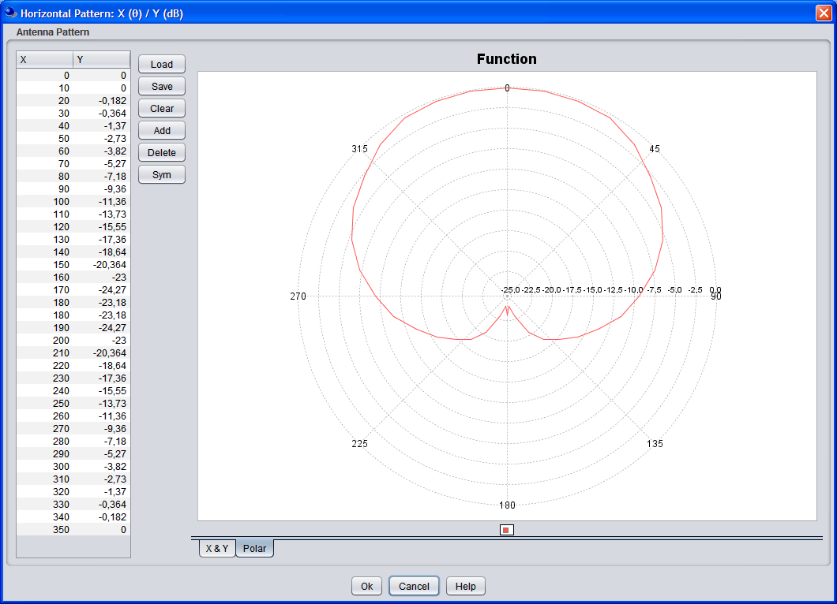
Figure 1: Horizontal sector antenna pattern of the base stations
The vertical diagram of the DA2GC GS has been adapted to a cosecant-squared characteristic which is better suited for air coverage compared to usual sector antennas for terrestrial mobile radio systems as the Rx power is nearly constant with increasing distance between GS and aircraft [23].
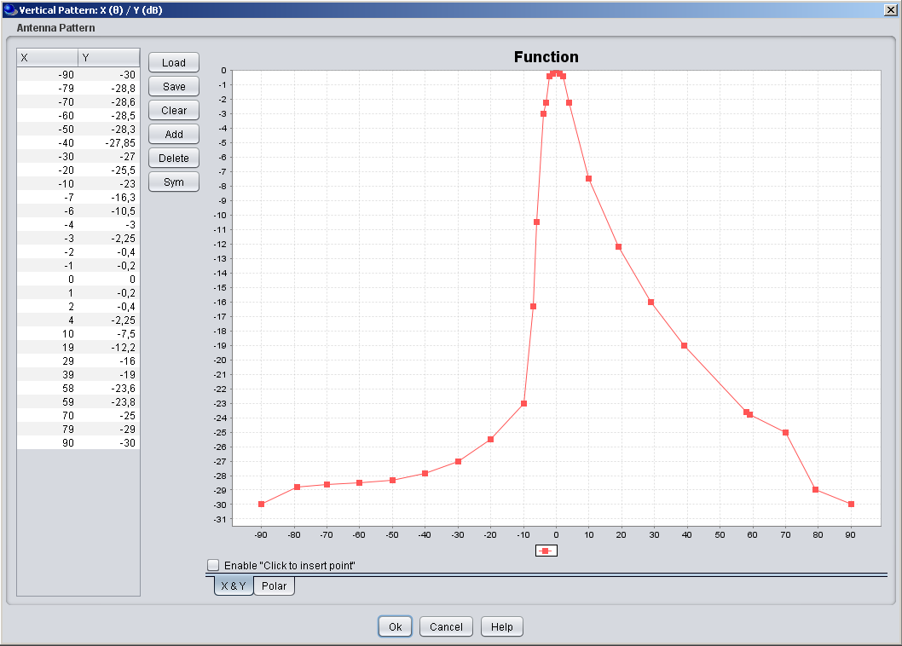
Figure 2: Vertical sector antenna pattern (cosecant-squared) characteristic of the DA2GC BS (screen shot of SEAMCAT GUI; up-tilt not considered in the diagram)

Unwanted emissions
The spectrum emission limits for DA2GC and terrestrial LTE BSs are assumed to be the same. The corresponding values are defined by 3GPP and can be found in Table 5.
Table 5: Unwanted emission limits for DA2GC ground stations adapted to LTE base stations for channel bandwidth of 10 MHz according to [7]
Frequency offset of measurement filter -3dB point, Δf | Frequency offset of measurement filter centre frequency, f_offset | Minimum requirement | Measurement bandwidth
0 MHz ≤ Δf < 5 MHz | 0.05 MHz ≤ f_offset < 5.05 MHz |  | 100 kHz
5 MHz ≤ Δf < 10 MHz | 5.05 MHz ≤ f_offset < 10.05 MHz | -14 dBm | 100 kHz
10 MHz ≤ Δf < 25 MHz | 10.5 MHz ≤ f_offset < 24.5 MHz | -15 dBm | 1MHz
25 MHz ≤ Δf | 25.5 MHz ≤ f_offset | -30 dBm (Note 1) | 1MHz
Note 1: Spurious emissions valid for frequency offset larger than 250% of necessary bandwidth [17]Fehler! Verweisquelle konnte nicht gefunden werden..

Aircraft station parameters
Table 6 provides the main parameters of the aircraft station.
Table 6: Main parameters used for ETSI DA2GC aircraft stations (TR 103 054)
Parameter | DA2GC aircraft station
 | FDD |  | TDD
Tx power (max./min.)  (Note 1) |  | 40 dBm / -23 dBm | 40 dBm / -23 dBm
Antenna type |  | Azimuth: Omni-directional  Elevation: See Figure 3 | Azimuth: Omni-directional  Elevation: See Figure 3
Antenna gain |  | 6.54 dBi  (Note 2) | 6.54 dBi  (Note 2)
Antenna height |  | 3000 - 13000 m  (Note 3) | 3000 - 13000 m  (Note 3)
Channel bandwidth |  | 2 x 10 MHz | 15 or 20 MHz
Signal bandwidth  (related to number of occupied resource blocks with bandwidth of 180 kHz) |  | 9 MHz | 13.5 or 18 MHz
Rx thermal noise |  | -104.5 dBm | -102.7 or -101.5 dBm
Rx noise figure |  | 9 dB | 9 dB
Rx noise floor |  | -95.5 dBm | -93.7 or -92.5 dBm
Rx reference sensitivity level |  | -97.5 dBm | -95.7 or -94.5 dBm
Interference protection ratio I/N |  | -6 dB | -6 dB
Interference protection level |  | -101.5 dBm | -99.7 or -98.5 dBm
Tx spectrum emission mask (SEM) / Spurious emissions |  | According to [6] | According to [6]
Adjacent channel leakage ratio (ACLR) limit |  | 37 dB  (Note 4) | 37 dB  (Note 4)
Rx in-band / out-of-band blocking |  | According to [6] | According to [6]
Rx adjacent channel selectivity (ACS) |  | 33 / 30 / 27 dB for channel bandwidths of 10 / 15 / 20 MHz  (according to [6]) | 33 / 30 / 27 dB for channel bandwidths of 10 / 15 / 20 MHz  (according to [6])
Note 1: The Tx power of the mobile station is dependent on the power control implementation applied by the equipment provider.
Note 2: For former evaluation a simple omni-directional characteristic with 0 dBi gain was assumed. The final diagram incl. the gain will be dependent on further antenna optimization steps as well as on limits set by the regulation. In the range just below the horizontal aircraft plane the antenna gain will normally be higher (up to about 6 dBi) to allow access of the OBU to the BS at the cell edge.
Note 3: The current assumption for a DA2GC OBU is that it will not transmit for altitudes below 3000 m as the GSM/WiFi onboard wireless access networks for the passengers have to be switched off below that threshold. In case the airlines are interested to use the DA2GC also for their operational services (non-safety relevant), it has to be clarified with the regulatory authorities under which conditions DA2GC radio links can kept until the aircraft reaches the airport ground (only wired access in the aircraft below the altitude threshold allowed).
Note 4: A higher ACLR value is required to keep the maximum allowed out-of-band emission level given in [6] in case of higher maximum Tx power of up to 40 dBm for the DA2GC OBU.

Figure 3: Vertical antenna pattern (monopol) for the DA2GC AS (gain of 6.54 dBi; direction to earth at 0°, to the horizon at ±90°)

DA2GC system according to ETSI TR 101 599

Overall system architecture
The broadband DA2G system using beamforming antennas is designed to provide bi-directional ground-to-aircraft connectivity as part of an overall broadband communications system which will offer a variety of IP-based applications for the use of passengers as well as operational (non-safety) data for airline use.
Figure 4 gives a high-level overview of how the DA2G system fits within the end-to-end system architecture. The elements which constitute the DA2G link are those elements which provide connectivity between the Air Network and the Ground Network, including the Air Station and Wireless Base Station shown in the top left hand corner of the figure
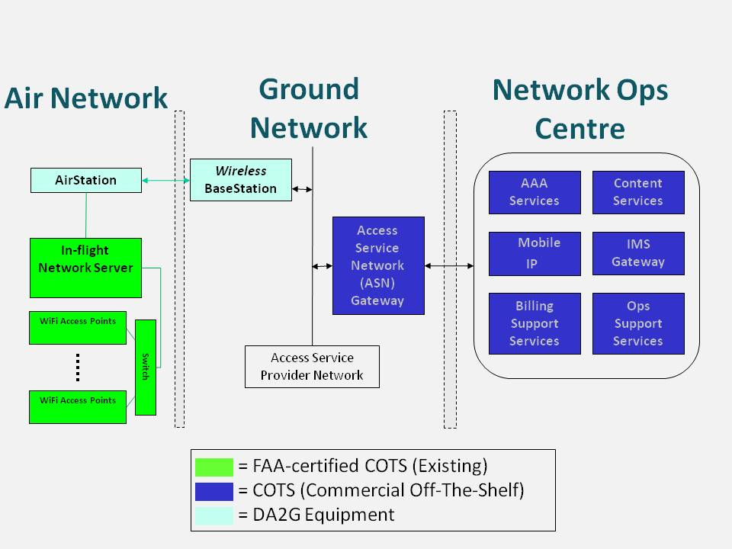
Figure 4: DA2G system, as part of overall end-to-end architecture

Ground station equipment
An unique feature of this DA2GC system is the simultaneous use of four separate integrated radio transceivers/phased array antenna assemblies at the ground station. Such an arrangement enables each ground station to cover the entire visible air space, from horizon to horizon, at all azimuths. Each integrated 8-element antenna array is capable of simultaneously producing at least two multiple co-frequency shaped beams which are need to maintain sufficient spatially separatedion to avoid self-interference such that, thereby allowing for a minimum of two three simultaneous beams per sector (or quadrant), or eight twelve beams per ground station can be assumed operationally. This is shown diagrammatically in Figure 5..
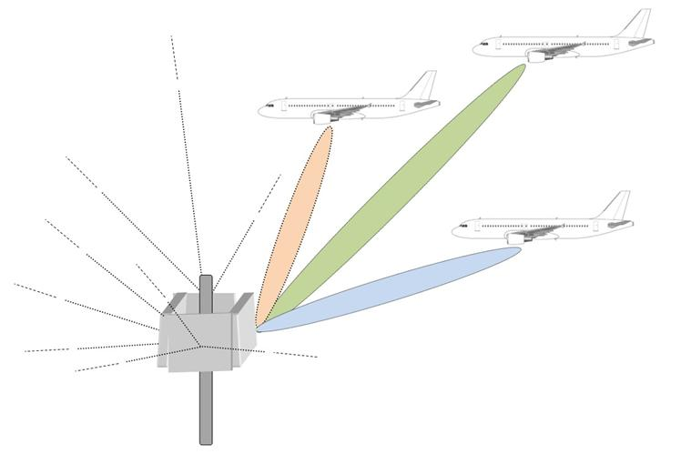
Figure 5: Typical Ground Station antenna arrangement showing three beams per quadrant

The use of TDMA and FDMA could further increase the number of individual data paths established (and hence number of aircraft served) to much higher numbers, but that would be at the cost of reduced data rate per aircraft, since the total power (and hence total capacity) per beam would remain the same.. Potential problems of cross-talk between the transmit and receive paths of the various aircraft links at a given ground station antenna are eliminated due to the use of TDD, together with synchronisation of signals such that all paths from that ground station are in transmit or receive mode at the same time when each beamforming array is generating multiple beams.
Figure 6 contains a block diagram of the main components within the wireless access point showing the basic connectivity within the radio equipment and outputs to the antenna array.
Figure 7 is a simplified depiction of the antenna array itself. Together, these two diagrams represent one of the four separate integrated radio transceiver/phased array assemblies at the ground station referred to in the earlier paragraph of simplicity, both Figure 6 and Figure 7 show only four transmission chains and four antenna elements respectively. However, in reality, the equipment intended for use in the 5.8 GHz band comprises eight separate transmission chains and eight phased array antenna elements with identical connectivity to that depicted in the diagrams.
[One aspect of concern which was raised during SE44 discussions was the nature of the spurious emissions which would be generated within the radio. In particular, it was questioned whether these would be subject to TPC and hence vary in level, or would be at a constant level. Further clarity was also sought on the degree to which such spurious elements would be correlated and hence nulled out through the use of beamforming.]
By referring to Figure 6, it can be deduced that several potential sources of spurious emissions exist, which are spread around the system such that some of them are affected by power control but some are not. For example, any spurious generated within the stages up to and including the RF transceiver will vary in level with TPC, whereas those generated after this point (e.g. in the final power amplifiers) will be at a constant level.

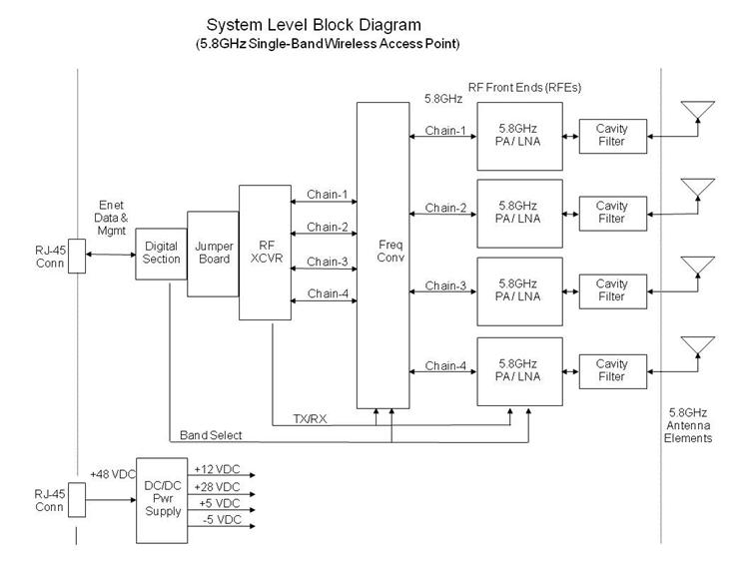
Figure 6: Radio transceiver unit basic connectivity (only 4 chains shown)
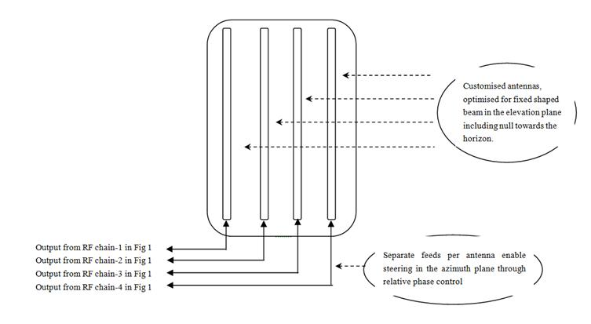
Figure 7: Antenna array assembly (only 4 elements shown)
Also, because of the varying causes of these spurious signals, they cannot be regarded as being correlated, in general. For these reasons, the studies reported in Section 5.6.2 and 5.6.3, in which the effect of spurious signals has been examined, assumed no benefits from correlation of these spurious signals and no variation in the level of any of these components due to power control.
Given the specifics of the technology described here, these can be regarded as worst-case assumptions.

Transmitter parameters

Transmitter Output Power / Radiated Power
Table 7: DA2GC Transmitter characteristics
Parameter | Tx output | e.i.r.p.
Maximum ground station TX output power (dBm) | 22 | 45
Maximum aircraft TX output power (dBm) 1 | 28 | 45
ATPC used? | Yes
Maximum operational ATPC range (dB) | 30
Max e.i.r.p. GS | 32 dBm/MHz
Max e.i.r.p. AS | 32 dBm/MHz
Maximum number of antenna arrays per Ground Station | 4
Number of operationally simultaneous beams per Ground Station antenna array | 3

NOTE: The e.i.r.p. levels in Table 7 represent the maximum operational levels at all times for a single beam, including link acquisition, since the periodic beacon signal transmitted from the ground station radiates lower transmit powers than the signals used to carry data once the aircraft links are established. Antenna Characteristics
Table 8: DA2GC Antenna characteristics
Parameter | Value
Ground station peak gain using 8 antenna array (dBi) | 23
Aircraft peak gain (dBi) using >4 antenna array | 17
NOTE: The Ground Station peak gains given above are for a single antenna array.

Use of phased array antennas and beamforming results in beam shapes which can be optimised for the intended operational frequency bands and co-existence scenarios. The beamforming algorithms used at the ground station and on the aircraft station permit highly accurate beam pointing, i.e. with an accuracy of 0.1 degrees, and the pointing is refreshed at a rate of at least 200 times per second implying a 5 ms minimum refresh period. This enables accurate control to be maintained during all phases of a flight, including the ability to maintain pointing direction to within 0.5 degrees or less even during periods of flight turbulence or extreme manoeuvres.

Example radiation patterns
Example elevation and azimuth radiation patterns are shown in Figure 9 respectively, for the ground station antennas, when operating in the 5.8 GHz bands. These are based on measurement performed at 5.8GHz on the latest generation products using 8-element antenna arrays at the ground station. Figures 8 and 9 show the elevation and azimuth patterns respectively for the multi-element antenna arrays on the aircraft
The Ground Station antenna array has a fixed pattern in the vertical plane, but is designed to use beamforming in azimuth so that one or more aircraft can be tracked during flight. Although, in practise, the radiation pattern will vary as the beam is scanned, the pattern given in Figure 9 can be assumed to be the worst case for all azimuths. i.e. the gain at any azimuth pointing direction will be less than or equal to the values shown, for any given elevation angle.The beam produced by the aircraft antenna array is steered in both azimuth and elevation so that the main lobe tracks the ground station as the aircraft traverses its flight path. The off-axis radiation pattern shown in Figure 6 can be assumed to be the worst case for all main lobe pointing directions.

-
30
-
20
-
10
0
10
20
30
-
90
-
80
-
70
-
60
-
50
-
40
-
30
-
20
-
10
0
10
20
30
40
50
60
70
80
90
Gain (dBi)
Elevation angle (deg)
Figure 8: Ground Station Antenna Elevation Pattern (8-antenna array)
-
40
-
35
-
30
-
25
-
20
-
15
-
10
-
5
0
-
90
-
80
-
70
-
60
-
50
-
40
-
30
-
20
-
10
0
10
20
30
40
50
60
70
80
90
Gain, relative to peak boresight gain (dB)
Azimuth Angle, relative to pointing direction (deg)
Figure 9: Ground Station Antenna Azimuth Pattern (8-antenna array)
Note that, for three dimensional computations, the resulting ground station antenna gain in any given pointing direction is the sum of the relevant elevation and azimuth gains shown in Figure 8 and Figure 9 respectively.
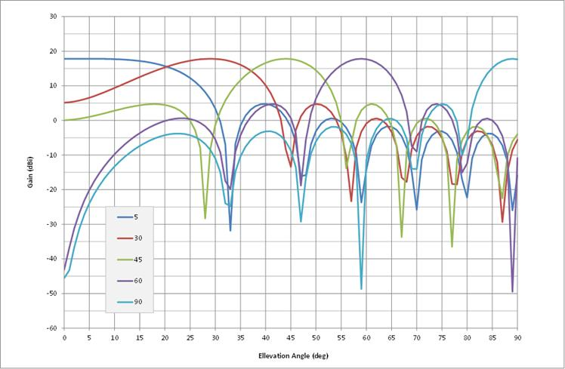
Figure 10: Aircraft Station Antenna Elevation Patterns (16-antenna array)
Note that, in the above sample plots, an elevation angle of 0 degrees represents the horizon pointing direction and 90 degrees is straight down.
-
50
-
40
-
30
-
20
-
10
0
0
10
20
30
40
50
60
70
80
90
100
110
120
130
140
150
160
170
180
Gain, relative to peak boresight gain (dB)
Azimuth Angle, relative to pointing direction (deg)
Figure 11: Aircraft Station Antenna Azimuth Pattern (16-antenna array)
Note that, for three dimensional computations, the resulting aircraft station antenna gain for any given pointing direction is the sum of the relevant elevation and azimuth gains shown in Figure 10 and Figure 11 respectively.

Operating Frequency
The scope of the System Reference Document is restricted to operation within the 2 400 MHz to 2 483,5 MHz band and/or the 5 855 MHz to 5 875 MHz band. However, the technology is capable of operating in any frequency band within the range from 790 MHz to 6 GHz.

Bandwidth
The necessary bandwidth (as defined by Articles 1.152 and 1.153 of the ITU Radio Regulations) is 20 MHz and the occupied bandwidth complies with Clause 4.3.2.6 of ETSI EN 300 328 V1.8.1 [28] for operation in the 2400 MHz to 2483.5 MHz band and falls within the emission mask specified in for operation in the 5855 MHz to 5875 MHz band.

Unwanted emissions
- Out-of-Band emissions

The out-of-band ground station and aircraft station emissions when operating in the 5 855 MHz to 5 875 MHz band fall within the limits given in when operating under highest output power conditions.

The unwanted emissions, including spurious emissions and out-of-band emissions (as defined by Article 1.146 of the ITU Radio Regulations [27] fall within the limits specified in Clauses 4.3.2.7 and 4.3.2.8 of EN 300 328 V1.8.1 [28] for operation in the 2 400 MHz to 2 483,5 MHz band. The out-of-band ground station and aircraft station emissions when operating in the 5 855 MHz to 5 875 MHz band fall within the limits given in when operating under highest output power conditions.

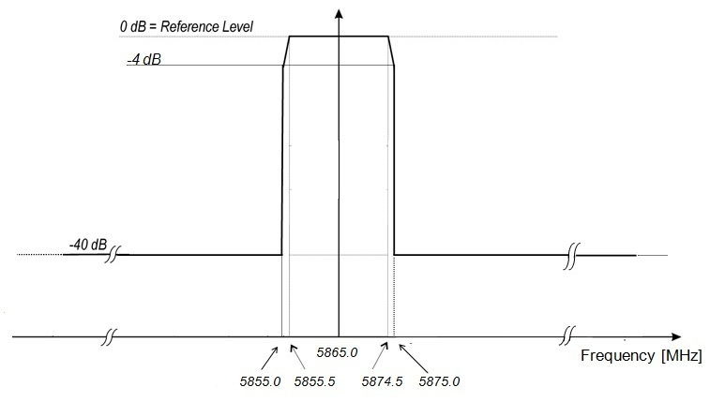
Figure 12: Out-of Band Emission mask

NOTE: 0 dB Reference Level represents the maximum spectral power density of the transmitted signal, which is +9dBm/MHz into the Ground Station antenna and +15 dBm/MHz into the aircraft antenna.

- Spurious emissions

The spurious emissions for both aircraft and ground stations will not exceed a fixed level of -42dBm/MHz. The quoted spurious level relates to the total conducted power due to spurious emissions delivered to all antennas and antenna elements of a single ground or aircraft station antenna array.

- Unwanted emissions below 5 850 MHz

In addition to the above specifications which apply in-band and up to the transmit channel edges, both the Out-of-Band and Spurious emissions will be reduced to significantly lower levels at frequencies below 5850 MHz through the use of digital pre-distortion and filtering techniques. (See Annex 4). Levels as low as -70dB relative to full carrier power can readily be achieved.

Receiver parameters
The sensitivity is better than or equal to -87 dBm in a 20MHz bandwidth on both the ground station and aircraft station receivers. Adjacent channel selectivity is 43.5 dB for the ground station and for the aircraft station, as specified in 3GPP TS 36.104. Other receiver parameters comply with, or exceed, the requirements within this 3GPP specification.

4.2.6 Channel access parameters
The operational channel access parameters such as frame duration, resource grouping and allocation in time and frequency, random access procedures, are fully configurable. Typically, the system employs 5 ms frames with 80 % forward/20 % return link (4 ms ground to air, 1ms air to ground). The frequencies are broken into 12 to 24 channels, depending on the scheduler. The access is fully scheduled using MAC messaging inside the 5 ms frame.

DA2GC system according to ETSI TR 103 108 V0.0.7

Technical Description
The system is essentially based on 3G UMTS TDD standards that have been adapted for operation in the 5,8 GHz band. It uses multi-sector antennas to optimise the ground infrastructure performance by providing coverage when and where required while reducing interference. Essentially the signal in space is compliant with 3GPP standards apart from the operating frequency. Doppler shift and range compensation is introduced by the air station such that the base station considers the mobile to be near stationary with a fixed range. Both vertical and horizontal polarisations may be used.

Transmitter
The transmission modulation technology is CDMA. It is important to note that for any given cell at any given instant the resource scheduler dedicates all the available capacity to one aircraft thereby effectively restricting the total number of aircraft transmitters to one. The maximum values of the transmitter parameters are listed below:

Table 9: DA2GC Transmitter characteristics
Parameter | Unit | Value
Bandwidth | MHz | 5 or 10
Transmitter Mean Output Power (GS) | dBm | 38
Transmitter Mean Output Power (AS) | dBm | 36
Transmitter feeder loss (GS) | dB | 2
Transmitter feeder loss (AS) | dB | 4
Transmitter Mean EIRP (GS) | dBm | 60 (for directional antenna)  51 (for sector antenna)  43 (for omnidirectional antenna)
Transmitter Mean EIRP (AS) | dBm | 39
Transmitter Duty Cycle Factor | dB | 3
Minimum Transmit Power Control (GS) Range | dB | 3
Minimum Transmit Power Control (AS) Range | dB | 50

The EIRP figures given in Table 9 are independent of whether a 5 MHz or 10 MHz bandwidth is used. The system normally uses a 10 MHz bandwidth but 5 MHz may be used for long range coverage (e.g. across a sea).

Receiver
Frequency conversion to/from 5.8 GHz as well as range and Doppler shift compensations are achieved within the avionics receiver. The receiver modem characteristics are compliant with 3GPP release 7 at the physical layer.
The receiver characteristics are listed below:
Table 10: Receiver characteristics
Parameter | Unit | Value
Bandwidth | MHz | 5 or 10
Receiver sensitivity | dBm | -106 (5 MHz Bandwidth)  -103 (10 MHz Bandwidth)
Receiver feeder loss | dB | 1
Receiver interference threshold | dBm/MHz | -113,9

Antenna parameters

Parameter | Unit | Value
Max antenna gain (AS) | dBi | 7
Max antenna gain (GS Omni) | dBi | 7
GS omni antenna up-tilt | degrees | 15
Max antenna gain (GS Sector) | dBi | 15
GS sector antenna up-tilt | degrees | 6
Max antenna gain (GS Directional) | dBi | 24
GS directional antenna up-tilt | degrees | 3
Table 11: DA2GC Antenna Parameters
The planned network is based on the use of sector GS antennas and every ground station is so equipped. Hence the ground station Eirp mask, as described in ETSI TR 103 108, has been derived using this type of antenna.
During flight testing the omni-directional GS antenna was also used. It would be convenient to use this type of antenna for some flight testing/validation of aircraft installations while respecting the Eirp mask. However such use would be very limited and intermittent.
In the event that a directional GS antenna is used, the interference level at elevation angles below about 8 degrees would be up to 9 dB higher. However, since such directional antennas are only intended to be operated at coastal locations to provide additional range out to sea, there is not considered to be any additional risk of interference into BFWA, ITS, RTTT or SRD systems. Maritime radars (Radar Q) operate in the band 5450-5825 MHz and the additional frequency separation would ensure that any unwanted emission interference would respect the limit specified in ETSI TR 103 108. Finally, the azimuthal bearing angle would be such as to not align with FSS satellites.

Figure 13: Omni Antenna Pattern - Elevation

Figure 14: Omni Antenna Pattern - Azimuth

Figure 15: Sector Antenna Pattern - Elevation

Figure 16: Sector Antenna Pattern - Azimuth

The elevation pattern of the aircraft antenna used for analysis is illustrated below:

Figure 17: Aircraft Antenna Pattern - Elevation

Figure 18: Aircraft Antenna Pattern - Azimuth

Some measured patterns are presented below for information purposes:

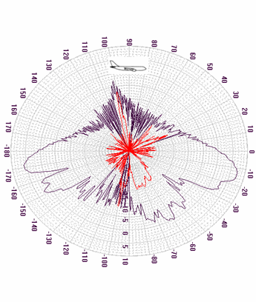
Figure 19: A/C Antenna Pattern – Elevation (Measured)
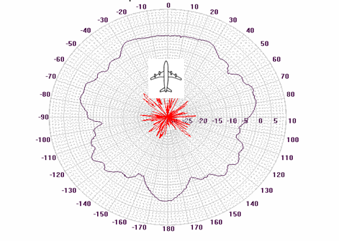
Figure 20: A/C Antenna - Azimuth (Measured)

Ground Station Elevation E.I.R.P Mask

Figure 21: Ground Station Elevation Eirp Mask

This mask is assumed for all azimuth angles.

Aircraft Station Elevation Eirp Masks
The following elevation masks for the aircraft station is taken from ETSI TR 103 108. The depression angle denotes angles below the fuselage where 0 degrees is the horizontal. Elevation angle denotes angles above the fuselage where 0 degrees is the horizontal.

Figure 22: Aircraft Station Elevation Eirp Mask (Below fuselage)

Figure 23: Aircraft Station Elevation Eirp Mask (Above fuselage)

Spectrum Emission Mask
The spectrum emission mask taken from ETSI TR 103 108 is given below:

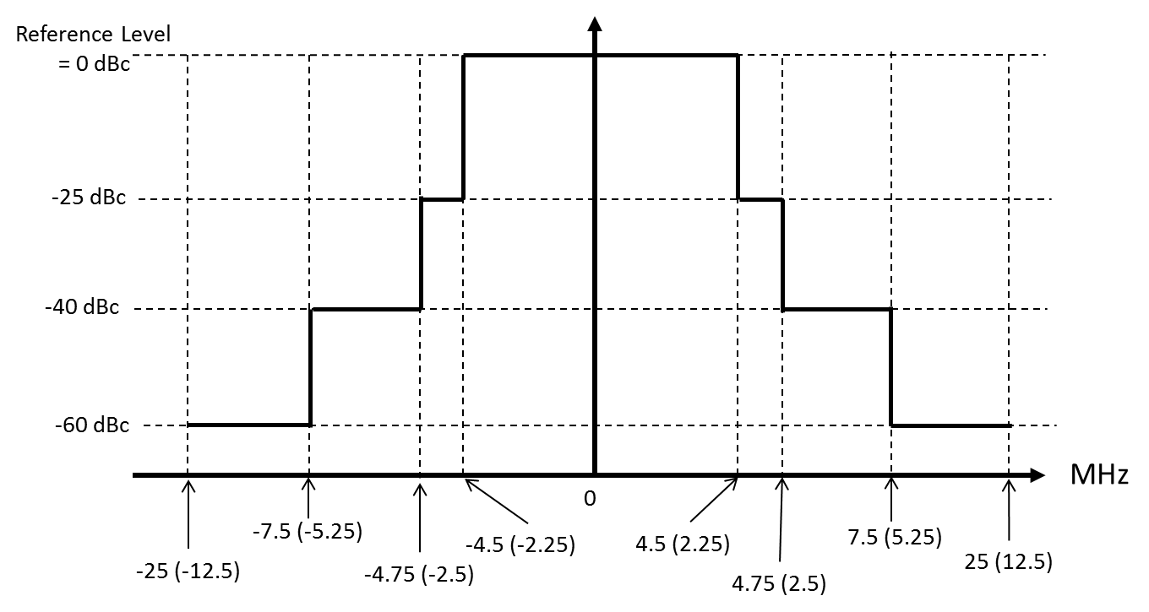
Figure 24: Spectral Emission Mask for both GS and AS
Note 1: 0 dBc Reference Level is the spectral density relative to the maximum spectral power density of the transmitted signal. For example:
i) for a Ground Station with a directional antenna, using a 10 MHz bandwidth, the Reference level (0 dBc) would be 60 dBm/(10 MHz) = 50 dBm/MHz
ii) for an Aircraft Station using a 5 MHz bandwidth, the Reference level (0 dBc) would be 39dBm/(5 MHz) = 32 dBm/MHz
Note 2 to Figure 24: On the Frequency Offset axis, the figures apply to a 10 MHz bandwidth system, whereas the figures in parentheses apply to a 5 MHz bandwidth system.

Unwanted Emissions
The spurious emissions from the antenna connector during transmit mode are defined as unwanted power in the bands from 30 MHz up to Fc -2.5*BW and from Fc +2.5*BW up to 5*Fc, where Fc is the carrier frequency and BW is the signal bandwidth (5 MHz or 10 MHz). This frequency band covers both in-band and out-of-band emissions.
The maximum level of spurious emission is: -36 dBm/(100 kHz), for 9 kHz ≤ f ≤ 1 GHz
-30 dBm/MHz , for 1 GHz < f ≤ 26 GHz
The maximum level of unwanted emission is: -50 dBm/MHz, for 5,250 GHz < f ≤ 5,850 GHz

Aircraft Station Mitigation Attenuation
The AS introduces additional transmitter attenuation according to its altitude as follows:
Altitude | Attn (dB)
0 | 20
1 | 15
2 | 10
3 | 8
4 | 8
5 | 6
6 | 4
7 | 0
8 | 0
9 | 0
10 | 0
11 | 0
12 | 0

Compatibility and sharing scenarios for the band 5855 – 5875 MHz

Table 12 contains the services and systems deployed in the frequency band 5.8 GHz. Figure 25 shows the sharing scenarios in both interference directions when assuming TDD mode of the DA2GC system.
Table 12: Incumbent services/systems deployed in the 5.8 GHz band
System | Frequency range/MHz | Compatibility issues
BFWA | 5 725 – 5 875 | ECC/REC (06)04 Technical characteristics ETSI TR 102 079 EN 302 502, Fixed Systems according to ITU-R F.758.
FSS (E-s) | 5 725 – 5 875 | ECC Report 68 contains sample of GSO satellite data taken from the ITU filings for the band 5 725 – 5 875 MHz. Annex 3 of ECC REC (06)04 contains e.i.r.p. spectral density limits in the elevation plane to protect GSO satellite receivers in the FSS.
SRDs | 5 725 – 5 875 | Non-Specific SRDs according ERC/REC 70-03 Annex 1, Technical parameters EN 300 440, 25 mW e.i.r.p.  ECC Report 68 contains compatibility studies between BFWA and SRD.
ITS | 5 875 – 5 925  5 855 – 5 875 | Safety related ITS applications  Non-safety related ITS applications  ECC Report 101 details spectrum sharing studies between ITS systems (Roadside and onboard unit) within the frequency band 5855-5925 MHz and the other services and applications in this frequency range and identifies conditions for ITS applications that facilitate spectrum sharing. ECC Reports 109 and 110 supplement these studies. Technical parameters can also be found in EN 302 571
Radiolocation | 5 725 – 5 850 | Recommendation ITU-R M.1638 provides characteristics of radars operating under the Radiolocation services in the frequency range 5250-5850 MHz

Figure 25: Interference scenarios for BDA2GC in the frequency band 5855 -5875 MHz

Compatibility between DA2GC and BFWA at 5.8 GHz

Technical characteristics of BFWA systems
For BFWA, the system parameters as provided in ECC Report 68 and in ETSI TR 102 079 (System Reference Document for BFWA (HIPERMAN) in the 5.8 GHz band) have been used. The following Table 7-2 contains the technical parameters of a BFWA P-MP system. Annex D of ETSI TR 102 079 provides various radio parameters, especially table D.7 shows the parameters for different modulation schemes. Figure 28 shows a typical deployment scenario for a BFWA P-MP network.
Table 13: BFWA system parameter
Parameter | P-MP
Topology | Sectored Central Station (CS) Terminal Stations (TS).
Channel bandwidth | 20 MHz
Duplex/  Access scheme | TDD/TDMA
Max e.i.r.p. | 36 dBm
Power density spectral (dBm/MHz) e.i.r.p. | 23 dBm/MHz
Antenna gain | 17 dBi
Antenna pattern CS | See Figure 1
Antenna pattern TS | See Figure 2
Receiver sensitivity (16-QAM) | -74 dBm (in 20 MHz BW)
Interference protection ratio C/I (16 QAM) | 20 dB
Interference protection ratio C/I (64-QAM) | 30 dB
Receiver sensitivity(64-QAM) | -68 dBm (in 20 MHz BW)
Interference protection level (16-QAM system) | -107 dBm /MHz
Interference protection level (64-QAM system) | -111 dBm/MHz

Figure 26: Typical P-MP Central station antenna pattern (see Annex 1 of ECC Report 68)
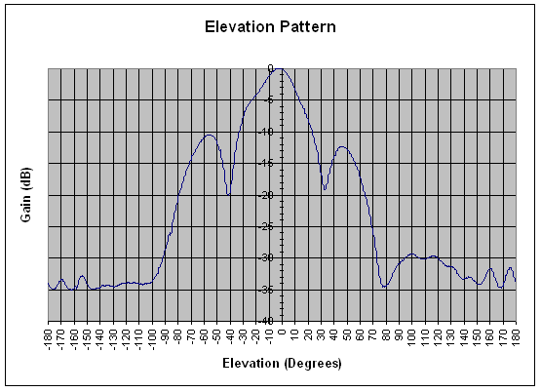
Figure 27: BFWA Terminal Station Elevation pattern (20 degree beam width)

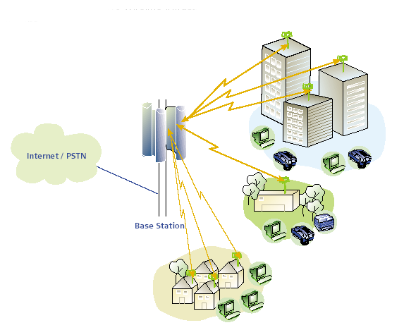
Figure 28: Typical P-MP deployment scenario

Compatibility between DA2GC AS (ETSI TR 103 054) and BFWA

Methodology
It is considered that the DA2GC aircraft station is approaching the BFWA CS at a given altitude (3000m and 10000m). The interference level arriving at the victim receiver was calculated taking into account the transmit power density of the interfering system, the great circle distance, the aircraft elevation (up to 90 degrees), the resulting free space loss, the antenna characteristics of the interfering and the victim system and the interference protection level of the victim system. The following Figure 4 illustrates the scenario between a BFWA BS and a DA2GC AS. In this analysis the 16-QAM system was used as a reference. A protection criterion (C/I) of 20 dB was assumed in the calculations. It should be noted that systems operating with high data rates may need a C/I of up 30 dB for their operation. For both station types (CS and TS) a maximum power spectral density of 23 dBm/MHz was considered in this study.

Figure 29: Interference scenario

Results
Figure 30 to Figure 37 show the

- received power spectral density (PSD) in dBm/MHz at the BFWA stations and the DA2GC AS and also
- resulting interference-to-noise ratio (I/N) compared to the different thresholds of both systems

along the great circle distance from 0 km to 100 km.
Line-of-sight propagation was assumed between BFWA CS/TS and DA2GC AS. Therefore, free space loss was considered. Only co-channel transmission was evaluated.
Interference scenarios between BFWA CS and DA2GC AS as well as between BFWA TS and DA2GC AS are considered for aircraft altitudes of 3 km and 10 km, respectively.

Figure 30: Received PSD (aircraft altitude 3000 m) | Figure 31: Resulting I/N ratio (aircraft altitude 3000 m)
Figure 32: Received PSD (aircraft altitude 10.000 m) | Figure 33: Resulting I/N ratio (aircraft altitude 10.000 m)
Figure 34: Received PSD (aircraft altitude 3000 m) | Figure 35: Resulting I/N ratio (aircraft altitude 3000 m)
Figure 36: Received PSD (aircraft altitude 10000 m) | Figure 37: Resulting I/N ratio (aircraft altitude 10000 m)

Figure 38 to Figure 41 show the resulting PSD at the BFWA (CS and TS) receiver input in dependence of the aircraft elevation. Considering an aircraft approaching at an altitude of 3000 meters, it can be observed (Figure 38 and Figure 39), that the protection criterion of the BFWA will be exceeded by a wide margin. Figure 40 and Figure 41 shows the situation, when the aircraft is approaching at an altitude of 10000 meters. It can be observed that an additional free space loss of 10.5 dB is achieved independently of the aircraft elevation. In case of the BFWA CS for aircraft heights above 8000 meters, the protection level is continuously met. Interference at the TS can still be observed up to 10.000 meters (see Figure 41).
Figure 38: Resulting interference at the BFWA CS antenna input caused by a DA2GC AS (altitude 3000m) | Figure 39: Resulting interference at the BFWA TS antenna input caused by a DA2GC AS (altitude 3000m)
Figure 40: Resulting interference at the BFWA CS antenna input caused by a DA2GC AS (altitude 10.000 m) | Figure 41: Resulting interference at the BFWA TS antenna input caused by a DA2GC AS (altitude 10.000m)
Figure 42: Resulting interference at the DA2GC AS antenna input caused by a BFWA CS (aircraft altitude 3000m) | Figure 43: Resulting interference at the DA2GC AS antenna input caused by a BFWA TS (aircraft altitude 3000m)

Figure 42 and Figure 43 showing an approach of an aircraft at an altitude of 3000m.It can be noted that the protection criterion is continuously met in case of the CS. In case of the BFWA TS as the interfering system interference of 2.3 dB can still be observed. Above an aircraft altitude of about 3900 meters compatibility is achieved.

Compatibility between DA2GC GS (ETSI TR 103 054) and BFWA
Table 14 shows the technical parameters of the DA2GC Ground Station. According to the system description of the DA2GC Ground station an antenna up-tilt of 10 degree was assumed, leading to a maximum horizontal gain of 8 dBi, which was used in the calculation.
Table 14: Technical parameters of the DA2GC GS (TR 103 054)
DA2GC GS Parameter | Value | Unit
DA2GC Tx power | 46,0 | dBm
Antenna gain (mainlobe) | 20,0 | dBi
e.i.r.p. max | 66,0 | dBm
Power spectral density | 53,4 | dBm/MHz
GS Antenna tilt | 10,0 | degree
Antenna gain(horizontal) | 8,0 | dBi
DA2GC GS antenna height | 50,0 | m
Signal bandwidth | 18,0 | MHz
Rx thermal noise | -101,4 | dBm
Rx noise figure | 5,0 | dB
Rx noise floor | -96,4 | dBm
Rx sensitivity level | -98,5 | dBm
Interference protection ratio I/N | -6,0 | dB
Interference protection level | -102,5 | dBm
Interference protection level | -115,1 | dBm/MHz

Methodology

[Text]

Results
The following Table 15 and Table 16 show the calculated separation distances between a DA2GC Ground station and a BFWA Central station by using the free space loss model and the ITU-R P.452 model.
Table 15: Required separation distances (DA2GC victim)
BFWA to DA2GC GS (SRDoc) | Required  attenuation | Unit | FSL | ITU-R P.452 | Unit
BFWA ML - DA2GC | 146,0 | dB | 82,2 | 51,4 | km
BFWA 1st SL (0 dBi) - DA2GC | 129,0 | dB | 11,6 | 11,6 | km
BFWA 2nd SL (-20 dBi) - DA2GC | 109,0 | dB | 1,2 | 1,2 | km
Table 16: Required separation distances (BFWA victim)
DA2GC GS (SRDoc) to BFWA | Required  attenuation | Unit | FSL | ITU-R P.452 | Unit
DA2GC - BFWA ML | 165,5 | dB | 768,6 | 58,9 | km
DA2GC - BFWA 1st SL (0 dBi) | 148,5 | dB | 108,6 | 52,0 | km
DA2GC - BFWA 2nd SL (-20 dBi) | 128,5 | dB | 10,9 | 10,8 | km

Conclusions on the compatibility between DA2GC (ETSI TR 103 054) and BFWA
- Impact on BFWA
For aircraft altitudes of about 3 km the I/N threshold will be generally exceeded at the BFWA TS, and also in a large range at the CS. The results are strongly dependent on the antenna characteristic applied for BFWA installation, especially the impact of the side lobes is recognizable in the I/N curves.
The I/N threshold at the TS is exceeded even at an aircraft altitude of 10 km. For the CS single critical peaks occur only near its location, but for medium altitudes the threshold can no more be kept in that area.
Thus, it is concluded that co-channel operation of DA2GC reverse link (air-to-ground) and BFWA systems in the band 5855-5875 is not feasible.
- Impact on DA2GC AS
At higher altitudes the impact of BFWA transmitters on the receiving DA2GC AS is negligible. Only in distances below 10 km from a BFWA TS the receiving DA2GC AS at altitudes of 3 km and below can be slightly affected by interference.
Thus it is concluded that single BFWA CS and TS should be uncritical for the DA2GC forward link (ground-to-air), but a larger deployment of BFWA CS and TS in an area may create noticeable performance degradation due to the aggregation of interference signals at the receiving DA2GC AS.
- Interference between BFWA CS and BDA2GC GS
Compatibility studies between BFWA CS (Central Station) and BDA2GC GS (Ground Stations according to ETSI TR 103 054 have been carried out. The separation distances for all possible cases have been calculated. However, there is no need to consider the suitability of the separation distances more in detail because the compatibility studies between BFWA and DA2GC AS (ETSI TR 103 054) have shown that co-channel sharing is not feasible.

Compatibility between DA2GC AS (ETSI TR 101 599) and BFWA

Methodology
For the deterministic case the same methodology as described in section 5.1.3.1 was used. The aircraft antenna beam was assumed to be steered so that the main lobe tracks the ground station as the aircraft traverses its flight path

Results
- Deterministic approach DA2GC AS on BFWA

Figure 44 and Figure 45 show the results in case of the second generation of the DA2GC system (17 dBi AS antenna, 23 dBi GS antenna). It can be observed that in case the elevation angle of the aircraft in relation to its ground station is below seven degree, no interference is observed at the BFWA CS receiver. The green dotted lines in the graphs show the great-circle-distance and the solid green line the distance on the ground (values on the right hand vertical coordinate). It can be seen that the lower the elevation angles of the aircraft, the higher the interference level at the BFWA receiver. This can be explained by the higher transmit power required on the aircraft station to get the link with the ground station and the corresponding ATPC range at higher elevations. Table 17 shows an example calculation for BFWA that is in 10 km distance (ground distance) to an aircraft (aircraft altitude 10 km). The corresponding distance between aircraft and the DA2GC GS is about 27.5 km
Figure 44: Interference level at BFWA CS (DA2GC 2nd generation)

Figure 45: Interference level at BFWA TS (DA2GC 2nd generation)
Table 17: Interfering Link budget
Link budget at 10 km height | value
Required Rx level at GS receiver (dBm) | -87
Elevation Angle (degree) | 20
Antenna gain AS (dBi) | 17
FSL (dB) | 136,9
Antenna gain GS (dBi) | 15
Required Tx level at AS (dBm) | 18,3
Resulting e.i.r.p. (dBm) | 35,3
BFWA TS at 10 km distance (on the ground)
BFWA gain towards DA2GC AS (dBi) | 4,5
DA2GC AS gain towards BFWA (dBi) | 14,1
FSL (dB) | 130,7
I max (dBm) | -98
I calculated (dBm) | -93,8
Limit exceedance (dB) | 4,2

- Deterministic approach BFWA on DA2GC

According to the system description the sensitivity of the aircraft station receiver is better than or equal to
-87 dBm in a 20MHz bandwidth. Considering a C/N = 10 dB, the noise floor of the aircraft station receiver is at -97 dBm. Figure 46 shows the required separation distances in case a BFWA CS or TS is in the same azimuth as the DA2GC AS. It can be noted that in case the aircraft flies at an altitude of 10000 m the AS receiver will be interfered nearly constantly by the BFWA TS. In case of the BFWA CS, the interference criterion is met at an altitude of 10000 metres.

Figure 46: Required separation distances as a function of the elevation angle (DA2GC 2nd generation)

- Statistical approach DA2GC AS on BFWA

[SE44(12)026, SE44(12)032rev1, SE44(12)060]

[Editor’s Note: 2 studies are available with diverging results. No text was agreed during SE44]

- Statistical approach BFWA on DA2GC AS

For this calculation a density of 0.0056 BFWA CS stations/ km2 and 0.112 TS stations/ km2 was assumed which is in accordance with the actual deployment data of BFWA systems in Germany. The simulation radius was set to 100 km, leading to a number of 176 CS on the simulated area. In the simulation ¼ of the TS are set to be active uniform distributed over the frequency range 5765 – 5865 MHz. The emission mask of BFWA systems at 5.8 GHz is given in ETSI EN 302 502 and was used in the simulation A SEAMCAT screenshot of the emission mask is given in Figure 47. The mean e.i.r.p. of the BFWA system was set to 30 dBm. Table 18 and Table 19 show the main characteristics used in the simulation.

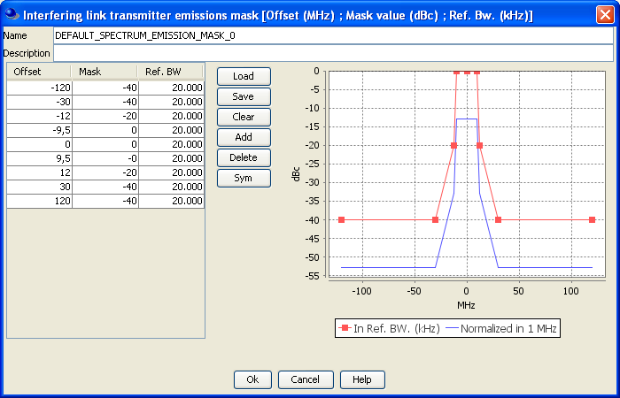
Figure 47: BFWA emission mask

Table 18: Main BFWA characteristics used in the simulation
Interfering link transmitter | BFWA CS | BFWA TS
TX power | 13 dBm (+/- 6 dB) | 13 dBm +- 6 dB
Antenna gain (max.) | 17 dBi | 17 dBi
Antenna pattern | Figure 1 | Figure 48Figure 49 Figure 50
Antenna height | 30 m | 10 m
Emission mask | Figure 15 | Figure 15
Operating frequency | 5765 – 5865 MHz (uniform distributed) | 5765 – 5865 MHz (uniform distributed)
Transmitter to receiver path | 5 km coverage radius,  ITU-R P. 526 | 5 km coverage radius,  ITU-R P. 526

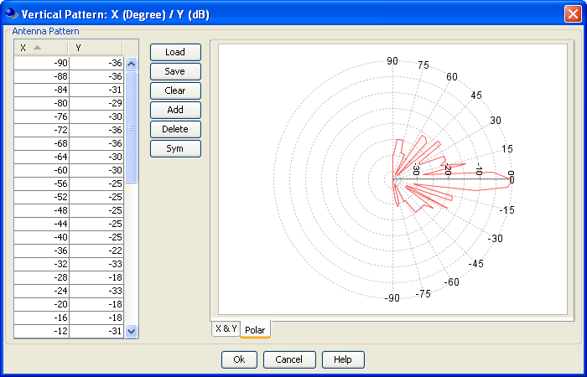
Figure 48: Typical P-MP Central station antenna pattern

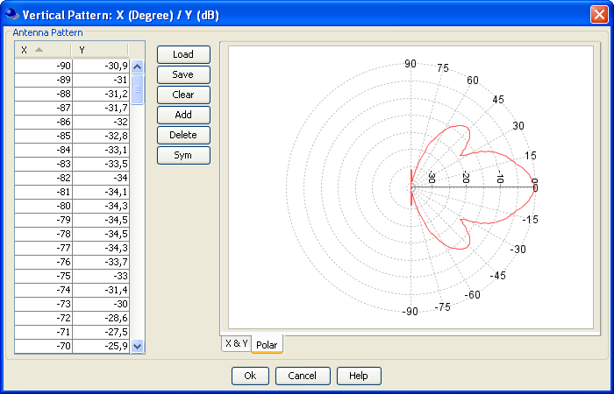
Figure 49: Typical BFWA Terminal Station Elevation pattern (20 degree beam width)

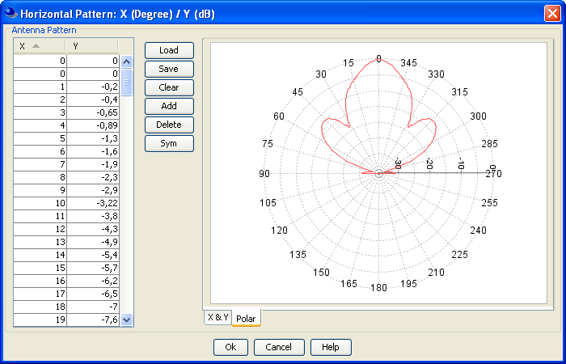
Figure 50: BFWA Terminal station horizontal pattern

Table 19: Main DA2GC characteristics used in the simulation
Victim Link Receiver | DA2GC AS
dRSS (desired received signal strength) | -84 dBm
Antenna peak gain | 17 dBi
Antenna pattern | Figure 10 andFigure 11
Antenna height | 3000 – 10000 m (uniform distributed)
Antenna pointing | In azimuth and elevation to the Tx
Reception bandwidth | 20 MHz
Frequency | Constant at 5865 MHz
Noise floor | -97 dBm
Sensitivity | -87 dBm
Interference criterion I/N | 0 dB
Transmitter to receiver path | 100 km coverage radius, Free space
Density of interferers | 0.112 TS/km² / 0.0056 CS/km²

Figure 51 and Figure 52 show the C.D.F. of the unwanted level produced by the BFWA TS and the BFWA CS on the DA2GC AS. It can be noted that an interference probability of 15 % for an interfering BFWA TS and 5% for the BFWA CS is calculated.

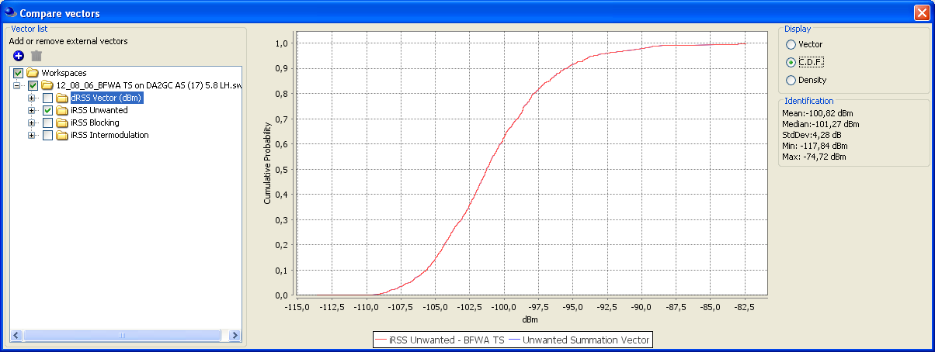
Figure 51: iRSS Unwanted BFWA TS

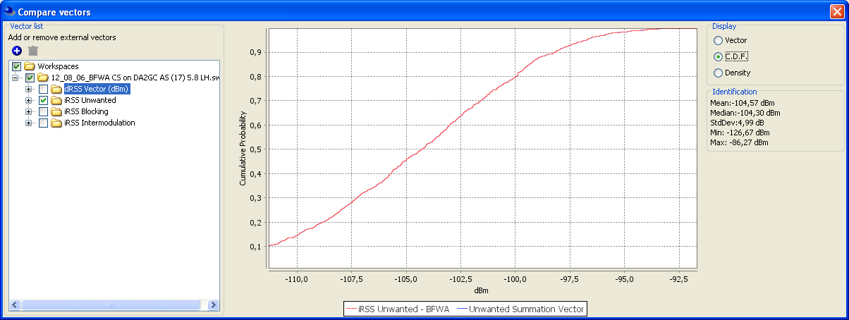
Figure 52: iRSS unwanted BFWA CS

Compatibility between DA2GC GS (ETSI TR 101 599) and BFWA

[SE44(12)026, SE44(12)032rev1]

Editor’s Note: 2 studies are available with diverging results. No text was agreed during SE44]

Compatibility between DA2GC AS (ETSI TR 103 108) and BFWA

Methodology

The AS elevation Eirp mask (below fuselage) defined in 4.3.1 has been used. The aircraft source is assumed to fly at a constant altitude (10 kms or 3 kms) from a ground range from the BFWA victim station of between 0 kms and the maximum shown in the associated graph. The worst case scenario was always assumed wherein the BFWA antenna was always pointing at the aircraft.
For air/ground propagation Free Space Loss, as defined below, has been used:

$$FSL=32.44+20\log_{10}\left({Freq}_{MHz}\right)+20\log_{10}({Distance}_{Km})$$

Results
[Editor’s Note: Clarification needed whether an additional ATPC was used in the calculations]
The results of the analysis are presented below:
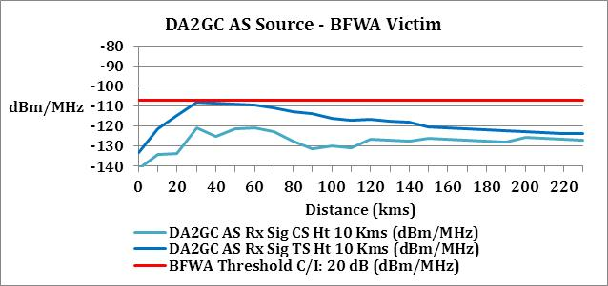
Figure 53: DA2GC AS Source (10 km) / BFWA Victim
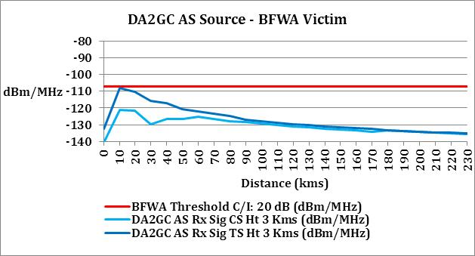
Figure 54: DA2GC AS Source (3 km) / BFWA Victim
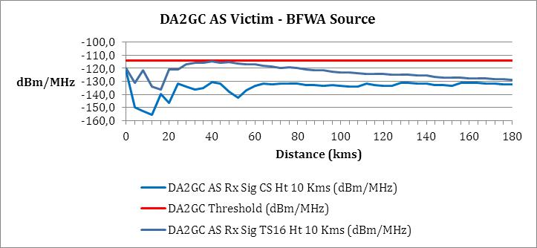
Figure 55: DA2GC AS Victim (10 km) / BFWA Source
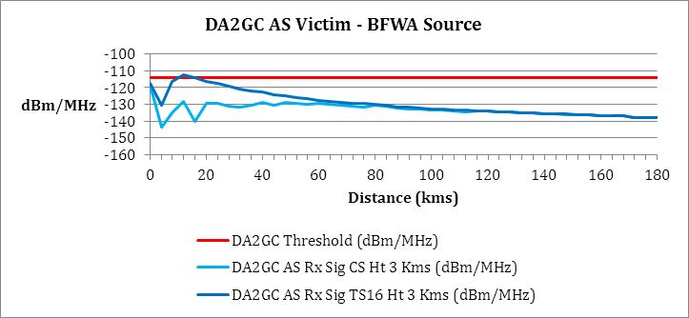
Figure 56: DA2GC AS Victim (3 km) / BFWA Source

Compatibility between DA2GC GS (ETSI TR 103 108) and BFWA

Methodology
The GS elevation Eirp mask defined in Section 4.3.1 has been used.. The GS source is assumed to be at given ranges from the BFWA victim station of between 0 km and the maximum shown in the associated graph. The worst case scenario was always assumed wherein the BFWA antenna was always pointing at the GS.
[Editor’s Note: The propagation models used in the studies differ thus leading to different results. It is seen meaningful to use a common model. One could describe the propagation models used in a separate section]
For terrestrial propagation path loss the methodology adopted by ECC Reports 68 and 101 has been used, namely:
$Pathloss=20\log_{10}(\frac{λ}{4πd}$) d ≤ d₀
$Pathloss=20\log_{10}\left(\frac{λ}{{4ᴫd}_{0}}\right)-10n_{0 }\log_{10}(\frac{d}{d_{0}})$ d₀ ˂ d ≤ d₁
$Pathloss=20\log_{10}\left(\frac{λ}{{4ᴫd}_{0}}\right)-10n_{0 }\log_{10}(\frac{d_{1}}{d_{0}})-10n_{1 }\log_{10}(\frac{d}{d_{1}})$ d ˃ d₁

 | _{Urban} | _{Rural}
Breakpoint distance d0 (m) | 64 | 256
Pathloss factor n0 beyond the first break point | 3.8 | 2.8
Breakpoint distance d1 (m) | 128 | 1024
Pathloss factor n1 beyond the second breakpoint | 4.3 | 3.3
Table 20: Propagation Parameters
All ground stations are planned to be sited in an urban environment to benefit from the existing points of presence offered by the telecommunications infrastructure. However, in addition, a rural scenario has also been analysed for comparison purposes.

Results
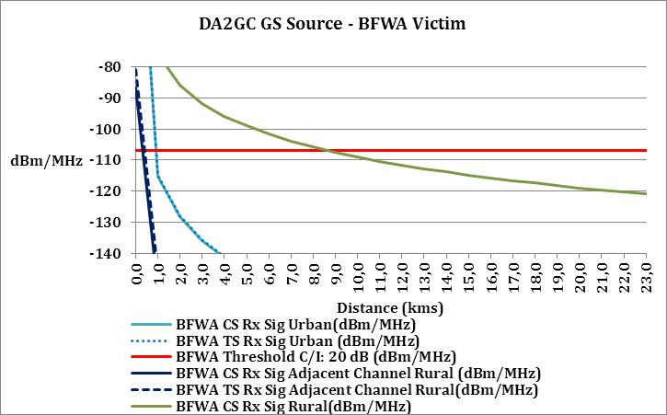
Figure 57: DA2GC GS Source / BFWA Victim
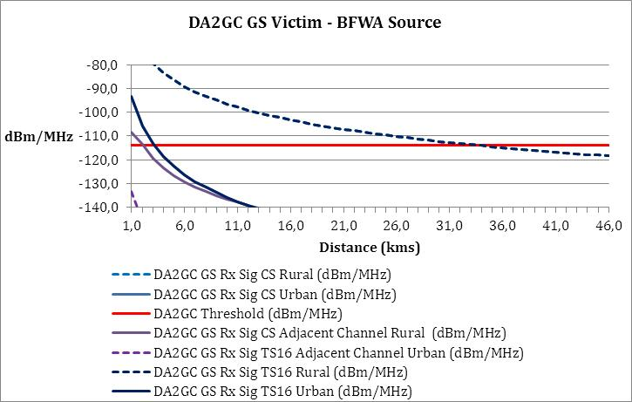
Figure 58: DA2GC GS Victim / BFWA Source

Conclusions on the compatibility between DA2GC (ETSI TR 103 108) and BFWA

[Aircraft Station
It is concluded that compatibility is achieved for all cases.]
Ground Station
DA2GC Source: For the urban scenario, co-channel compatibility is achieved with a separation distance of 1 km while, for the rural scenario, co-channel compatibility is achieved with a separation distance of 9 km. Given the flexibility in siting DA2GC ground stations it is concluded that the separation distances can be assured through site planning. Adjacent channel compatibility is achieved for a separation distance less than 100 m. It is noted that the horizontal DA2GC GS Eirp is less than that of a BFWA station.
DA2GC Victim: For the urban scenario, co-channel compatibility is achieved with a separation distance of 3 km while, for the rural scenario, co-channel compatibility is achieved with a separation distance of 30 km. Given that the ground stations will normally be sited in an urban environment, these separation distances are operationally acceptable. Adjacent channel compatibility is achieved for a separation distance less than 1 km.
Summary
Co-channel compatibility between DA2GC and BFWA is considered to be achieved as seperation distances can be respected through site planning.

Compatibility between DA2GC and FSS

Technical characteristics of GSO satellite systems
Satellite | Satellite orbital position | Receiver Gain, G_{Sat} | Satellite Receiving system | Aggregate e.i.r.p. dB(W Hz⁻¹) | Satellite Name | Administration | Beam
A | 5º West | 34 | 773 | -54.1 | TELECOM-2B | Fr | MET
B | 14º West | 26.5 | 1200 | -44.7 | EXPRESS-2 | RUS | ZER
C | 31.5º West | 32.8 | 700 | -53.3 | INTELSAT8 | USA | 9Z3
D | 3º East | 34 | 773 | -54.1 | TELECOM-2C | Fr | MET
E | 18º West | 32.8 | 700 | -53.3 | INTELSAT8 | USA | 9Z3
F | 53º East | 26.5 | 1200 | -44.7 | EXPRESS-5 | RUS | ZER
G | 59.5º East | 34 | 1200 | -52.2 | No longer existing
H | 66º East | 34.7 | 700 | -55.2 | INTELSAT9 | USA | 9Z1
I | 359º East | 32.8 | 700 | -53.3 | INTELSAT8 | USA | 9Z3
Table 21: Derivation of acceptable aggregate e.i.r.p. from interferers in the satellite beam (see ECC Report 101)

Technical characteristics of FSS Earth stations

Earth Station | ST1 | ST2 | ST3 | ST4
Elevation (deg) | 10 | 10 | 33 | 33
Antenna Diameter (m) | 4.6 | 32.5 | 4.6 | 32.5
Power (dBW/MHz) | 21.3 | 2.0 | 21.3 | 2.0
Max antenna gain (dBi) | 47.8 | 63 | 47.8 | 63
Height (m) | 4.3 | 18.25 | 4.3 | 18.25
Antenna pattern | ITU-R Rec. S.465 [26]
Table 22: Assumed FSS parameters (see ECC Report 101)

Compatibility between DA2GC AS (TR 101 599) and FSS
In practice since we are dealing with a TDD DA2GC system the aggregate interference into the satellite receiver will be a mix of interference from aircraft transmitters and DA2GC ground terminal transmitters. These have been treated separately in the following sub-sections. It can be noted however that these two contributions should not be added to obtain the aggregate interference at the satellite since TDD does not allow for simultaneous transmission by both ends of the same link.

Methodology
A similar situation has been analysed previously in ECC Report 68 with respect to the potential for Fixed Wireless Access systems to interfere with geostationary satellites receiving in the band 5725 – 5875 MHz. The situation here is similar, but with aircraft transmitters substituting for BFWA transmitters.
The analysis in ECC Report 68 identified Satellite H at 66°E as the most sensitive to interference due to the high G/T associated with its European coverage. See Figure 51 below for the geographic nature of Satellite H’s coverage.

Figure 59: Beam Contours for FSS Satellite H at 66° East (from ECC Report 68)

Satellite H is therefore used here to ensure that a worst-case scenario is considered and the parameter values for assessing the potential for interference from DA2GC are contained in Table 23 below
Table 23: DA2GC and FSS parameter values
Parameter | Value | Unit | Comment
Frequency | 5865 | MHz | Centre of 20 MHz channel of interest.
Slant path loss (free space) | 198.9 – 200.2 | dB | 90° to 0° elevation at the ground. (Note 1)
Atmospheric loss | 0.5 | dB | As used in ECC Report 68
Satellite H receive gain (max) | 34.7 | dBi | From ECC Report 68
Satellite H receive system noise temperature (T) | 700 | K | From ECC Report 68
Satellite ΔT/T criterion | 6 | % | Co-Primary Services
Power to aircraft antenna (max) | 24.7 | dBm
Aircraft antenna gain (max) | 17.8 | dBi
Aircraft emission density | -60.5 | dBW/Hz | Power in 20 MHz channel
Power to ground terminal antenna | 24.7 | dBm | At 5° elevation
Ground terminal antenna gain | 20.7 | dBi | At 5° elevation
Ground terminal emission density | -57.6 | dBW/Hz | Power in 20 MHz channel
Note 1 – The higher path loss is applicable to limb of earth geometry being considered below
The power density received by a satellite due to one aircraft =
Aircraft emission - Losses + Satellite Gain
= -60.5 dBW/Hz - 200.2 dB - 0.5 dB + 34.7 dBi = -226.5 dBW/Hz

This is equivalent to an increase in satellite receive system noise temperature which =
Power density received by satellite - Boltzmann’s constant
= -226.5 dBW/Hz - -228.6 dBW/K/Hz = 2.1 dBK = 1.6 K

This would allow for 26 aircraft for the 6% ΔT/T criterion (42 K increase allowable).

At this point it should be noted that the geometry giving rise to the increase in satellite noise temperature identified above will in itself be a rare occurrence as it depends on the exact alignment of aircraft, DAG2C base station and satellite as the aircraft comes over the horizon (with respect to the DAG2C base station) and starts operating at 5° elevation. The likelihood of more than one aircraft achieving the same geometrical alignment at the same time is even smaller.

In the more general case the interference entry from the aircraft will emanate from the aircraft sidelobes or be almost entirely obscured by the fuselage. Furthermore, because of the power control employed on the DAG2C link the impact on the satellite receiver is further reduced. For example, if we assume that the aircraft antenna gain is some 13 dB down on the main lobe and the power into the antenna is 7 dB down on its maximum then the following figures would apply.

The power density received by a satellite due to one aircraft =
Aircraft emission - Losses + Satellite Gain
= -80.5 dBW/Hz - 200.2 dB - 0.5 dB + 34.7 dBi = -246.5 dBW/Hz

This is equivalent to an increase in satellite receive system noise temperature which =
Power density received by satellite - Boltzmann’s constant
= -246.5 dBW/Hz - -228.6 dBW/K/Hz = -17.9 dBK = 0.016 K

This would allow for 2625 aircraft for the 6% ΔT/T criterion (42 K increase allowable). Note that in this case there is no special alignment involved. However, it is still the case that this situation would only apply where the aircraft are operating at the limb of the earth (with respect to the satellite) so that emissions from the underside of the aircraft are barely obstructed by the fuselage. It can be expected that aircraft away from the limb of the earth and operating more towards the sub-satellite point will have their emissions towards the satellite almost totally obscured. There is a ground plane above the antenna so the antenna gain in any direction above the aircraft horizon (0° / 180° elevation) and towards the satellite will be at least 40 – 50 dB below the aircraft horizon (0° / 180° elevation) gain. These interference entries can therefore be safely ignored.

Conclusions on compatibility between DA2GC AS (TR 101 599) and FSS
In the general case, and noting that it is only aircraft operating at the limb of the earth that generate interference, it can be considered that the tolerable numbers of aircraft indicated by the analysis above are sufficient to accommodate the DA2GC system.

Compatibility between DA2GC GS (TR 101 599) and FSS
[SE44(13)008, SE44(13)015]
Initial analysis
Due to the reciprocal nature of the TDD link between aircraft and associated ground terminals, and similar antenna gains at both ends of the link, a comparable but not simultaneous level of potential interference from DA2GC ground terminals into the FSS satellite receiver can be expected. The worst case, which will occur for very short periods of time, relies on a ground terminal, aircraft, satellite alignment that gives the minimum 5 degrees of elevation at the DA2GC ground terminal
For this alignment the power density received by a satellite due to one DA2GC ground terminal =
Ground terminal emission - Losses + Satellite Gain
= -57.6 dBW/Hz - 200.2 dB - 0.5 dB + 34.7 dBi = -223.6 dBW/Hz

This is equivalent to an increase in satellite receive system noise temperature which =
Power density received by satellite - Boltzmann’s constant
= -223.6 dBW/Hz - -228.6 dBW/K/Hz = 5 dBK = 3.2 K

This would allow for 13 ground terminals for the 6% ΔT/T criterion (42 K increase allowable).

As already noted, and similar to the aircraft interference case, the geometry giving rise to the increase in satellite noise temperature identified above will in itself be a rare occurrence and the likelihood of more than one DA2GC ground terminal achieving the same geometrical alignment at the same time is even smaller.

In the more general case the interference entry from the aircraft DA2GC ground terminal will be at a much lower level because of the power control employed on the link. For example, if we assume that the power into the antenna is 7 dB down on its maximum and the DA2GC ground terminal antenna gain is at 15 dBi (for all elevations between 16 and 90 degrees) then the following figures would apply.

The power density received by a satellite due to one DA2GC ground terminal =
Ground terminal emission - Losses + Satellite Gain
= -70.3 dBW/Hz - 200.2 dB - 0.5 dB + 34.7 dBi = -236.3 dBW/Hz

This is equivalent to an increase in satellite receive system noise temperature which =
Power density received by satellite - Boltzmann’s constant
= -236.3 dBW/Hz - -228.6 dBW/K/Hz = -7.7 dBK = 0.17 K

This would allow for 247 DA2GC ground terminals for the 6% ΔT/T criterion (42 K increase allowable).

On the basis that the DA2GC cell radius is approximately 100 km, and taking account of the relevant water / land mass ratio, it is estimated that 150 hexagonal cells would fall within Satellite H’s European coverage. The tolerable number of ground terminals indicated by the analysis above shows that the DA2GC system can be accommodated without causing undue interference.

Further Analysis using revised FSS protection criterion agreed within SE44
DA2GC Ground Stations
An FSS satellite receiver will be subject to an aggregation of interference from all visible DA2GC Ground Stations. Figure 60 gives an example layout of DA2GC Ground Stations across Europe. In the absence of real deployment data, and for the sake of simplicity, the assumed grid of Ground Stations is a regular pattern across Europe. As such, it has not been optimised for any particular route coverage. However, the precise placement of individual ground stations has little impact on the aggregate interference experienced at the geostationary orbit and this simplified distribution forms an acceptable basis for the statistics presented later in this document.

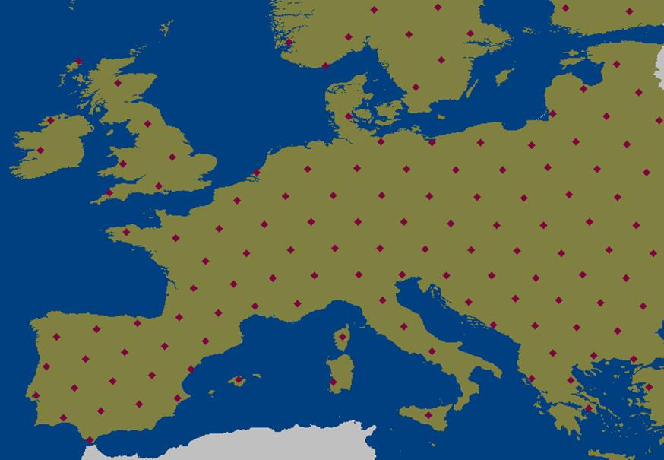
Figure 60: Example distribution of DA2GC Ground Stations (not optimised for coverage)

EIRP statistics for a single DA2GC Ground Station
Each DA2GC Ground Station has the same EIRP statistics if it is assumed that each one is simultaneously transmitting towards 12 aircraft using beam-forming techniques. If the 12 aircraft are randomly distributed across the Ground Station’s coverage area then the statistics will be the same in all directions of azimuth. The statistic of interest with respect to a FSS victim satellite receiver is therefore the EIRP as a function of elevation. This is shown in Figure 61 below.

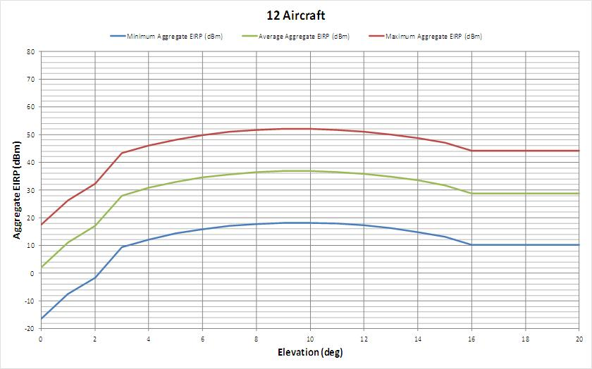
Figure 61: Min / Av / Max aggregate EIRP from a single DA2GC Ground Station supporting 12 aircraft simultaneously (Max. average at 10 degrees = 36.8 dBm / 20 MHz, ≥ 16 degrees = 28.8 dBm / 20 MHz)

Because an FSS victim satellite experiences an aggregation of interference from multiple DA2GC Ground Stations, and the variations in power levels emitted from each individual Ground Station in the direction of the satellite are not correlated in any way, it is the average EIRP per Ground Station that should be used.

Figure 61 simply shows the EIRP statistics in terms of minimum, average and maximum levels. It should be noted that the maximum levels occur with very small probability (e.g. 0.00001%). This can be seen from the full EIRP distributions shown in Figure 62, below. Each of the curves in Figure 62 represents a vertical slice through the curves of Figure 61 at the respective elevation angle.

Starting at the left hand side of Figure 61 above, i.e. at zero degrees elevation, the aggregate EIRP cumulative distribution at this elevation is represented by the solid purple line at the left of Figure 3, below
.
Moving from left to right in Figure 61 above through elevations between zero degrees to the “peak” at 10 degrees, the aggregate EIRP cumulative distributions at the intervening elevations are represented by the dashed purple lines moving from left to right in Figure 3 below, culminating in the “peak” at 10 degrees represented by the solid red line.

Continuing to move from left to right in Figure 61 above (beyond the “peak” at 10 degrees), the aggregate EIRP cumulative distributions fall back i.e. move from right to left as represented by the dotted red lines until they reach a constant distribution for elevation angles of 16 degrees up to 90 degrees as represented by the solid orange line.

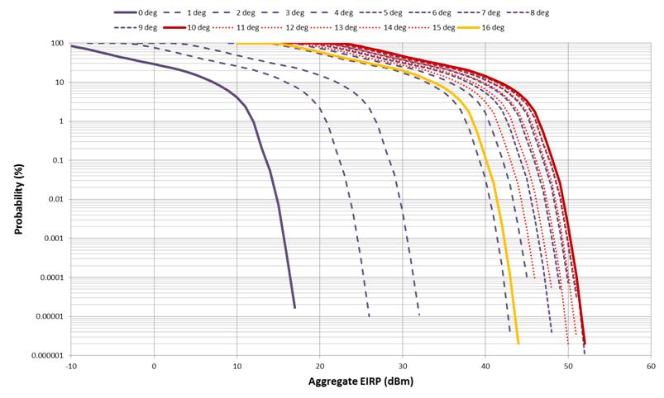
Figure 62: Cumulative distributions of aggregate EIRP from a singleDA2GC Ground Station supporting 12 aircraft simultaneously

DA2GC ground station elevation statistics
In order to assess the total interference from all DA2GC Ground Stations (as shown in Figure 60) into a victim FSS receiver it is necessary to know the elevation statistics from all the Ground Stations to a given orbital position. These statistics are shown in Figure 4.
It can be seen from these curves that the DA2GC Ground Stations subtend elevations in the range 20 to 45 degrees towards a FSS satellite above Europe (e.g. at 15 degrees East) and 5 to 30 degrees towards an easterly inter-continental satellite (e.g. at 60 degrees East).

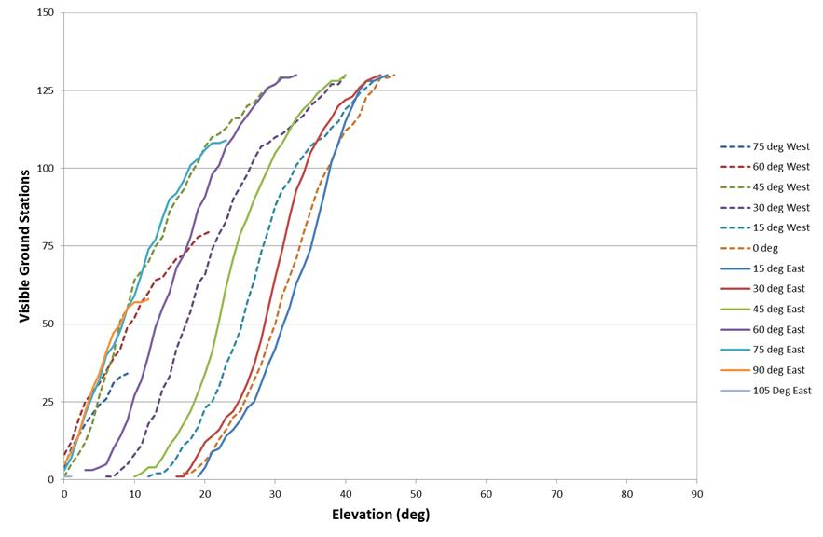
Figure 63: Cumulative distribution of DA2GC Ground Station elevations towards a range of orbital locations

Interference received by FSS satellite
The initial analysis indicated that Satellite H at 66 degrees East is the most susceptible to interference so in order to ensure that the worst-case has been considered the current assessment is also based on this satellite.
From the 60 degree East orbital location curve (closest to 66 degrees East of Satellite H) shown in Figure 4 it can be seen that 60 DA2GC Ground Stations subtend an elevation angle in the range 5 to 15 degrees and 70 DA2GC Ground Stations subtend an elevation angle 16 degrees or greater.
The numeric average EIRP between 5 and 15 degrees elevation is 35.3 dBm and is 28.8 dBm for elevation angles 16 degrees or greater as seen in Figure 1. The aggregate EIRP from 130 DA2GC Ground Stations towards a satellite at 60 degrees East is therefore 51.1 dBm on average. This figure is obtained by weighting the EIRP values by the relevant numbers of Ground Stations. It should further be noted that only half the Ground Stations are transmitting at any instant because of TDD synchronisation across the network (a fact not taken into account in the earlier analyses.
The aggregate interference received by Satellite H is then given by:
I = 51.1 dBm – 30 (to dBW) – 73 dBHz – 200.2 dB (FSPL) – 0.5 dB (atmospheric) + 34.7 dBi
I = –217.9 dBW/Hz
T = –217.9 dBW/Hz – –228.6 dBW/K/Hz = 10.7 dBK = 11.75 K
ΔT/T = 11.75 K / 700 K (Satellite H system noise temperature) = 1.7%
It can be seen from the above calculation that the aggregate EIRP from multiple DA2GC Ground Stations gives rise to an increase in satellite noise temperature for Satellite H of 11.75 K, a rise of 1.7 % in the system noise temperature (2.5 dB less than the revised ΔT/T criterion of 3% agreed by SE44 as the basis for studies).
The above further analyses have indicated that that a mask as shown in Figure 5, when applied to an individual DA2GC Ground Station employing beamforming antennas would be appropriate to ensure protection of FSS satellites. As considered in earlier contributions, the proposed mask would also provide regulatory equivalence with BFWA at the lower elevation angles.
The above further analyses have indicated that that a mask as shown in Figure 64, when applied to an individual DA2GC Ground Station employing beamforming antennas would be appropriate to ensure protection of FSS satellites. As considered in earlier contributions, the proposed mask would also provide regulatory equivalence with BFWA at the lower elevation angles.

The proposed mask is based on three levels:
Angle range | Basis | Proposed level (dBW / 4 kHz)
< 2.5° | BFWA equivalence | -31
2.5° to 16° | 36.8 dBm / 20 MHz + 2.5 dB | -27.7
>16° | 28.8 dBm / 20 MHz + 2.5 dB | -35.7

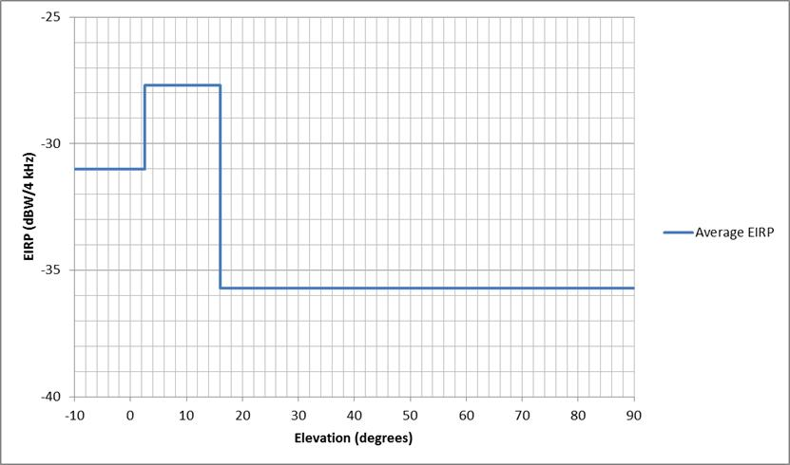
Figure 64: Proposed average EIRP mask

Real v. mask
As noted during SE44 meetings there will always be some inconsistency between the interference results obtained from actual EIRP behaviour and a generic mask that is designed to be technology neutral.
The table below compares two cases where the first reflects the result obtained with the actual EIRP lobe of Figure 65. The other result is based on a “squared-off” mask as shown in Figure 64. A real implementation fitting within this mask would be expected to give a ΔT/T of 3% whereas the theoretical ΔT/T based on the “squared-off” mask would be 3.9% as indicated in the table below.
Basis of calculation | 5° to 15° EIRP contribution | >15° EIRP contribution | Aggregate EIRP (TDD) | Resulting ΔT/T
Actual (Figure 1) | 60 x 35.3 dBm | 70 x 28.8 dBm | 51.1 dBm | 1.7%
Mask (Figure 2) | 60 x 39.3 dBm | 70 x 31.3 dBm | 54.8 dBm | 3.9%

A visual comparison of the actual EIRP produced by the beamforming system described in ETSI TR 101 599 and the proposed average EIRP mask is provided in Figure 65 below.

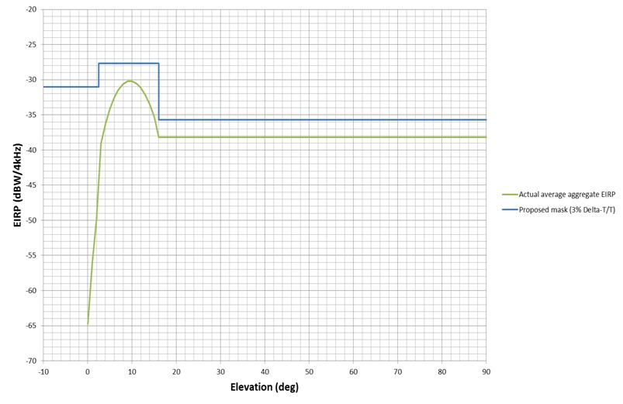
Figure 65: EIRP comparison

[Edtor’s Note: Study from the Russian Federation based on the proposed EIRP mask comes to the result, that the protection level can be exceeded by 5.5 to 8.5 dB depending on the number of Ground stations and coverage territory for a ΔT/T criterion of =3%- Clarification is needed from the Russian Federation regarding the general assumption in the study that one GS antenna is directed to the satellite in the horizontal plane]

Conclusions
[Indicate tolerable number of GS]
[Analyses have shown that the tolerable number of DA2GC base stations to protect the FSS satellite receiver is greater than the numbers operationally required by the proposed DA2GC system so it can be concluded that sharing is feasible.
The agreed FSS protection criterion can be used to construct an average EIRP mask to be applied to DA2GC Ground Stations in the 5.8 GHz band order to provide appropriate levels of protection to FSS services operating on a co-frequency basis.
A suitable mask has been derived, based on an agreed FSS protection criterion of 3% ΔT/T within which the DA2GC beamforming Ground Station comfortably operates.

It is further noted that although the theoretical use of a “squared-off” mask suggests a small exceedance (3.9%) a real implementation will, in fact, fall within the 3% criterion.]

Compatibility between DA2GC AS (TR 103 108) and FSS

[SE44(13)017], SE44(13)036

Methodology

Compatibility between DA2GC GS (TR 103 108) and FSS

[SE44(13)017, SE44(13)015], SE44(13)036

Methodology

Earth-space propagation losses have already been accounted for in the table above when calculating the maximum allowable aggregate interference.

The satellite interference threshold is given by:
$H=10\log_{10}\left(kTBC\right)$ dBW
Where:
k = Boltzmann’s constant = 1.38 * 10⁻²³ (joules/K)
T = noise temperature of the receiver (degrees K)
C = Δt/t (%)

The aggregate signal received at the satellite is derived as follows.
For a single DA2GC aircraft station, the source signal is given by:

$${Sig}_{Rx}={Eirp}_{DA2GC}-Satellite Antenna Factor-Polarisation Factor$$
Where:
Satellite Antenna Factor accounts for any reduction in power due to the position of the DA2GC AS within the satellite antenna beam.
Polarisation Factor = 3 dB
Eirp_{DA2GC} is derived from the associated masks in ETSI TR 103 108

The aggregate signal becomes:
${Sig}_{Aggregate}=10\log_{10}(\sum_{1}^{Max GS}{{10}^{\frac{{Sig}_{Rx}}{10}}}$)
It is noted from ETSI TR 103 108 that is a given cell only one transmission is active (i.e. ground station or one aircraft station).

No ATPC has been used.

Results

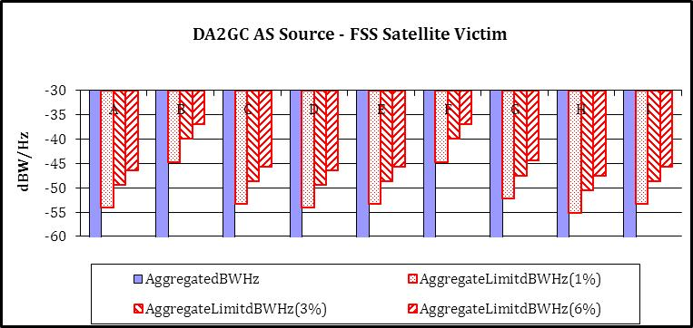
Figure 66: DA2GC AS Source / FSS Satellite Victim

The satellite interference threshold is given by:
$H=10\log_{10}\left(kTBC\right)$ dBW
Where:
k = Boltzmann’s constant = 1.38 * 10⁻²³ (joules/K)
T = noise temperature of the receiver (degrees K)
C = Δt/t (%)

The aggregate signal received at the satellite is derived as follows.
For a single DA2GC ground station the source signal is given by:
$${Sig}_{Rx}={Eirp}_{DA2GC}-Satellite Antenna Factor-Polarisation Factor$$
Where:
Satellite Antenna Factor accounts for any reduction in power due to the position of the DA2GC GS within the satellite antenna beam.
Polarisation Factor = 3 dB
Eirp_{DA2GC} is derived from the associated masks in ETSI TR 103 108

The aggregate signal becomes:
${Sig}_{Aggregate}=10\log_{10}(\sum_{1}^{Max GS}{{10}^{\frac{{Sig}_{Rx}}{10}}}$)
It is noted from ETSI TR 103 108 that is a given cell only one transmission is active (i.e. ground station or one aircraft station).

No ATPC has been used.

The ground station transmissions are dominant given the aircraft airframe shadowing. Hence the ground station interference is the worst case.The ground station only services one aircraft at a given instant and one antenna sector is used for this purpose. The other sectors do not transmit. To achieve the necessary cell range at 5.8 GHz it is necessary to have at least 6 sectors of which one is for overhead coverage. Assuming a uniform distribution of aircraft, the probability of a particular sector radiating is given by:

$${Probability}_{Overhead}= {Coverage Area}_{Overhead}/{Coverage Area}_{Cell}$$
$${Probability}_{Sector}=\frac{\left(1-{Probability}_{Overhead}\right)}{Number of Remaining Sectors}$$

Where:
Coverage Area_{Cell} = 64,274 sq km
Coverage Area_{Overhead} = 2,372 sq km
Number of Remaining Sectors = 4

The ground station azimuthal pattern provides a null for the 90 degree radial. This null is better than -15dB.. Knowing the fixed positions of both satellite and GS, this null can be aligned with one chosen satellite. Satellite H is the most vulnerable satellite so the antenna assembly is fixed with the null pointing towards this satellite for ground stations in western and central Europe. For eastern Europe ground stations Satellite C becomes the most vulnerable and the null is aligned towards this satellite.

The positioning of DA2GC ground stations is that used for the initial planned deployment. 200 GS were simulated and these are mainly sited to the West of Longitude 20E.
However, to take into account deployment to the East of Longitude 20E, the number of GS was increased to a total of 400 by reproducing the original 200 but with their respective longitudes given a 20 degree offset (i.e. an additional 20 degrees East).

It was assumed that two 10 MHz radio channels were available so one channel would support up to 200 GS.

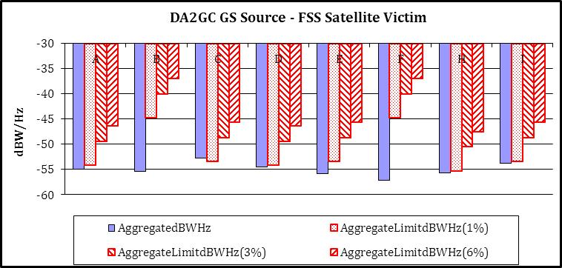
Figure 67: DA2GC GS Source / FSS Satellite Victim

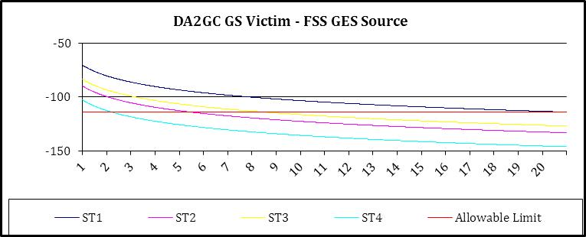
Figure 68: DA2GC GS Victim / FSS GES Source

Conclusions on the compatibility between DA2GC (ETSI TR 103 108) and FSS
Aircraft Station
Compatibility is achieved for the case where the FSS satellite is the victim. The FSS Earth-space transmissions will interfere with the aircraft station causing an effective loss of signal. However, given the narrow beamwidth and the aircraft speed, this interference will only exist for a short period and is operationally acceptable to the DA2GC.AS.
Ground Station
Given that the number of GS operating on the same 10 MHz channel is limited to 200, and, taking into account the fixed null in the azimuth pattern, the interference caused to FSS satellites is less than 1% Δt/t in all cases. Any FSS GES interference to the DA2GC GS is compatible with a separation distance of 20 km. This is easily achievable through the site planning for DA2GC GS.
Summary
Co-channel compatibility between DA2GC GS and FSS is considered to be achieved.

Compatibility between DA2GC and SRD

Technical characteristics of SRDs
- General (Non-Specific) Short Range Devices characteristics
As specified in Annex 1 of ERC Recommendation 70-03, the frequency band 5725-5875 MHz is used by non-specific SRD. This use should comply with the technical characteristics as shown below.

Frequency Band | Power | Antenna | Channel Spacing | Duty Cycle
5725-5875 MHz | 25 mW e.i.r.p. | Integral (no external antenna socket)  or dedicated | No channel spacing - the whole stated frequency band may be used | No duty cycle restriction
Table 24: Technical characteristics of SRD

In addition to these regulatory technical characteristics, assumptions on some parameters had to be made in order to carry out compatibility studies. Three kinds of SRD are considered for the interference assessment (see the following table).

Parameter | SRD I | SRD II | SRD III | Comments
Typical bandwidth BW (MHz) | 0.25 MHz | 20 MHz | 8MHz | Note 1, Note 2.
TX Power, dBm e.i.r.p. | +14 | +14 | +14
Ant. Gain, dBi | 2 to 20 | 2 to 24 | 2
Ant. Polarization | Circular | Circular | Vertical
Receiver sensitivity, dBm | -110 | -91 | -84
Receiver noise dBm/MHz | -114 | N/A | N/A
Protection criterion, dB | I/N=0dB | C/I=8dB | C/I=20dB
SRD Noise figure F | 9.00 dB | N/A | N/A
FkTB | -105 dBm/MHz | N/A | N/A
Max OoB RX interference, dBm | -35 | -35 | -35 | E.g. limit for Rx blocking
Duty cycle : % | Up to 100% | Up to 100% | 100%
RX wake-up time (if applicable) | 1 sec | 1 sec | N/A | For battery operated equipment
Note 1: The given bandwidths are for non-spread spectrum modulation.
Note 2: For spread spectrum modulation (FHSS, DSSS and other types) the bandwidth can be up to 100 MHz
Table 25: Assumed SRD parameters

Compatibility between DA2GC AS (TR 101 599) and SRD

Compatibility between DA2GC GS (TR 101 599) and SRD

Compatibility between DA2GC AS (TR 103 108) and SRD

Methodology
The unwanted interference has been calculated according to the following equation:

$$Interfering Signal={Eirp}_{Source}-{AS}_{Mitigation}[-ATPC]-{Loss}_{Prop}+{Antenna Gain}_{Rx}$$

For DA2GC, both ${Eirp}_{Source}$ and ${Antenna Gain}_{Rx}$ are defined in section x.x.x [ETSI TR 103 108].

Results
The results of the analysis are presented below:
[Updated Results provided by Aero3G after 9th SE44 meeting]

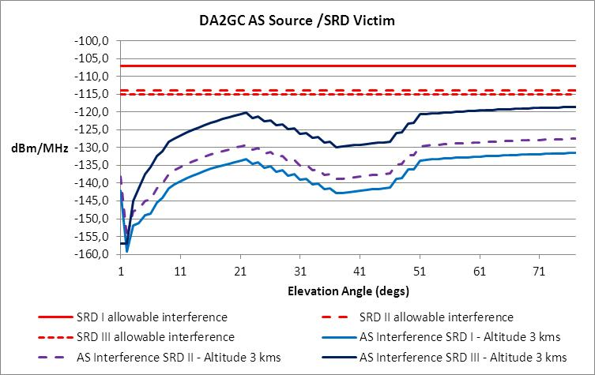
Figure 69: DA2GC AS Source (3 kms) / SRD Victim

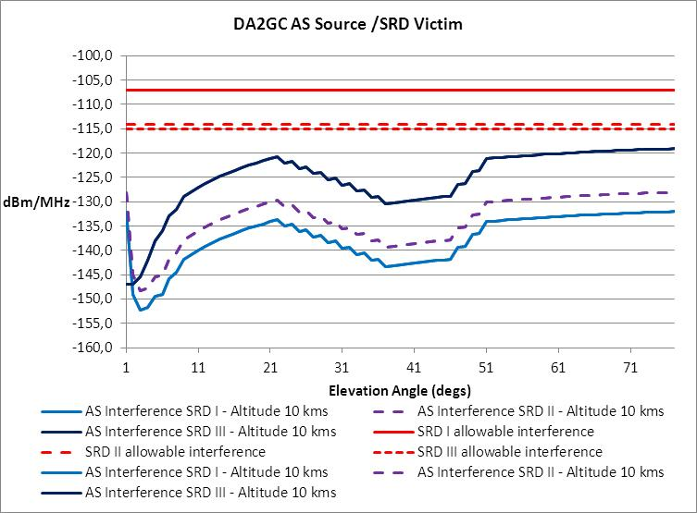
Figure 70: DA2GC AS Source (10 kms) / SRD Victim

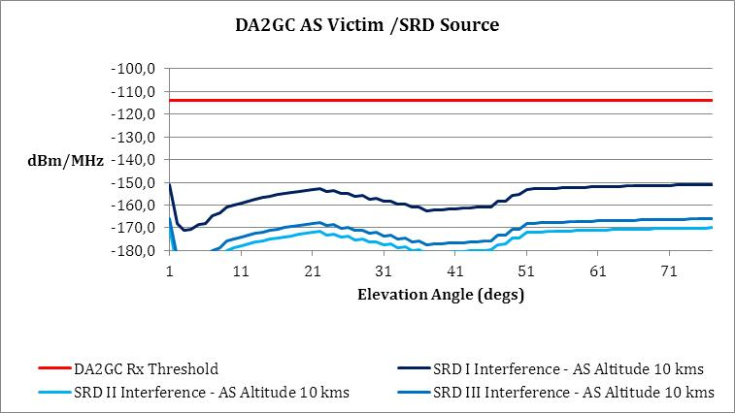
Figure 71: DA2GC AS Victim (10 kms) / SRD Source

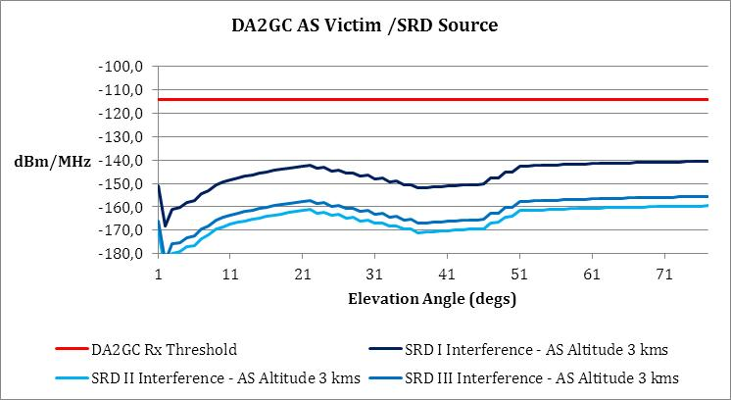
Figure 72: DA2GC AS Victim (3 kms) / SRD Source

Compatibility between DA2GC GS (TR 103 108) and SRD

Methodology
All ground stations are planned to be sited in an urban environment to benefit from the existing points of presence offered by the telecommunicatioins infrastructure

No ATPC has been used for terrestrial scenarios.

The unwanted interference has been calculated according to the following equation:

$$Interfering Signal={Eirp}_{Source}-{Loss}_{Prop}+{Antenna Gain}_{Rx}$$

For DA2GC, both ${Eirp}_{Source}$ and ${Antenna Gain}_{Rx}$ are defined in section x.x.x [ETSI TR 103 108].

Results

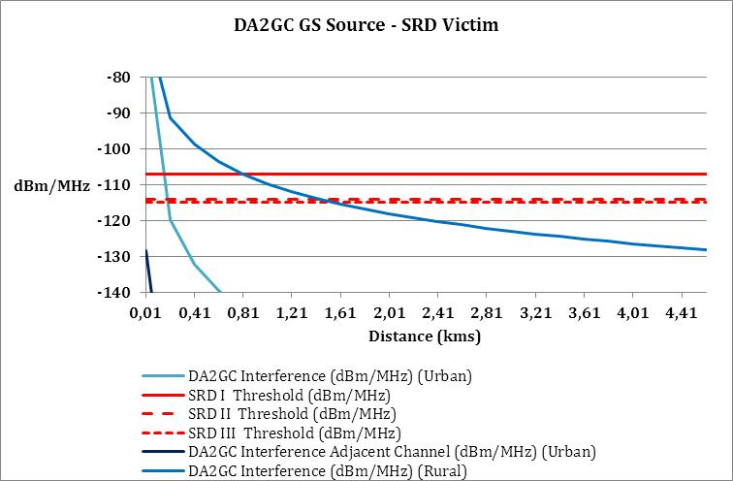
Figure 73: DA2GC GS Source / SRD Victim

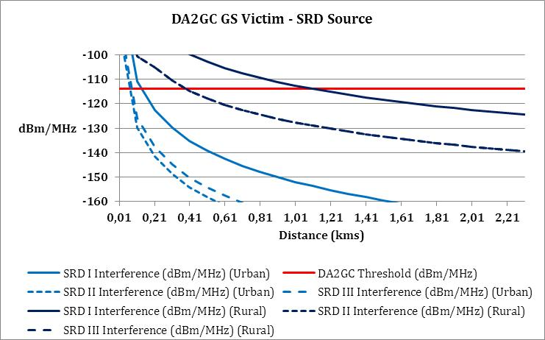
Figure 74: DA2GC GS Victim / SRD Source

Conclusions on the compatibility between DA2GC (ETSI TR 103 108) and SRD

Aircraft Station
Compatibility is achieved for all cases.
Ground Station
Co-channel compatibility is achieved with a separation distance of 1.5 km assuming rural propagation. For the urban case the separation distance is reduced to about 200 metres.
Summary
Co-channel compatibility between DA2GC GS and SRD is considered to be achieved.

Compatibility between DA2GC and ITS

Technical characteristics of ITS

Parameter | Value | Comments
Frequency stability | 10 ppm | According to ETSI EN 302 571 V1.2.2 (2011-10)
Maximum radiated power (e.i.r.p.) | Channel 5860, 5910 and 5920 MHz:  0 dBm, -10 dBm/MHz  Channel 5870 and 5890 MHz:  23 dBm, 13 dBm/MHz  Channel 5880 and 5900 MHz:  33 dBm, 23 dBm/MHz | According to ETSI EN 302 571 V1.2.2 (2011-10) and ETSI EN 302 663 V1.3.1 (2012-06)  There are no equipment classes anymore. There are different power limits for different channels with highest allowed power for the most critical channels.  See figure 1.
Antenna beam shape/gain | For RSU and OBU use antenna model ITU-R F.1336-3 with parameters G0 5 dB, k 1.2, max gain in +10 deg elevation | See Figure 76 and Equation 1. In ECC Report 101 there were 2 possible antennas, one very directional and one omnidirectional ITU-R F.1336-1. However ITS systems development shows that the omnidirectional will be the dominant type and therefore only this should be used in these compatibility studies. There is a new version of model ITU-R F.1336-3 which should be used. Both versions 1 and 3 results in exactly the same antenna performance with these parameter settings.
Polarization | Vertical linear | The antenna performance is not described in ETSI ITS however the vertical linear polarization is dominant.
Modulation scheme | BPSK QPSK 16QAM 64QAM | According to ETSI EN 302 571 V1.2.2 (2011-10) and ETSI EN 302 663 V1.3.1 (2012-06)
Data rates | 3/4.5 /6/9/12/18 /24/27 Mbit/s  Mandatory: 3/6/12 Mbit/s | According to ETSI EN 302 571 V1.2.2 (2011-10) and ETSI EN 302 663 V1.3.1 (2012-06)
Channel Bandwidth | 10 MHz | According to ETSI EN 302 571 V1.2.2 (2011-10) and ETSI EN 302 663 V1.3.1 (2012-06)
Communication mode | Half-duplex, broadcast | Half-duplex and broadcast are believed to be adequate for the applications considered to date.
Receiver sensitivity | See Table 28 | ETSI EN 302 571 V1.2.2 (2011-10) specifies minimum required sensitivity..
Protection criterion | Channel 5880, 5890 and 5900 MHz:  C/I=12dB  Other channels:  C/I=6dB | The three ITS-G5A channels are decided by the European Commission to be used for road safety communication and therefore a higher C/I value of 12 dB should be used for these channels.
Table 26: System parameter of ITS (not exhaustive)
Communication channels will be open for the applications within the respective usage category (either road safety related or not, i.e. used for traffic management).
The required power levels (e.i.r.p.) range from 3 dBm to 33 dBm to achieve communication distances of up to 1000 m.
To avoid collisions of radio messages in areas with a lot of vehicles, a mechanism DCC (dynamic congestion control) in ITS radios will when necessary reduce the output power and the available time to transmit.
There is a mechanism in ITS radios which will reduce the output power or available time to transmit when the radios are close to 5.8 GHz RTTT road tolling stations.

Unwanted emission levels are given by to ETSI EN 302 571 V1.2.2 (2011-10) for the out of band domain and SM.329 and ERC Recommendation 74-01 for the spurious domain.

Power spectral density at the carrier center fc (dBm/MHz) | ±4,5 MHz  Offset  (dBm/MHz) | ±5,0 MHz  Offset  (dBm/MHz) | ±5,5 MHz  Offset  (dBm/MHz) | ±10 MHz  Offset  (dBm/MHz) | ±15 MHz  Offset  (dBm/MHz)
23 | 23 | -3 | -9 | -17 | -27
The limits are reduced by 10 dB for the 5870 and 5890 channels and by 33 dB for 5860, 5910 and 5920 channels.
Table 27: Transmitter unwanted emission limits inside the 5 GHz ITS bands (e.i.r.p.)

Figure 75: Maximum limit of mean spectral power density for each channel type in ITS-G5A, ITS-G5B, and ITS-G5D

Figure 76: OBU and RSU antenna pattern

Modulation | Coding rate | Minimum sensitivity (dBm)
BPSK | 1/2 | –85
BPSK | 3/4 | –84
QPSK | 1/2 | –82
QPSK | 3/4 | –80
16-QAM | 1/2 | –77
16-QAM | 3/4 | –73
64-QAM | 2/3 | –69
64-QAM | 3/4 | –68
Table 28: Minimum required receiver sensitivity; receivers will have up to 10 dB better sensitivity.

(1a)

with:

(1b)

(1c)

where:
G(θ) : gain relative to an isotropic antenna (dBi)
G0 : the maximum gain in the azimuth plane (dBi)
θ : elevation angle relative to the angle of the maximum gain (degrees) θ
θ3 : the 3 dB beamwidth in the elevation plane (degrees)
k: parameter which accounts for increased side-lobe levels above what would be expected for an antenna with improved side-lobe performance

Equation 1: Antenna model ITU-R F.1336-3; use G0 5 dB, k 1.2, max gain in +10 deg elevation

Editor’s Note: This section only deals with ITS, RTTT is covered in a separate section, transfer text covering RTTT]
[ITS/RTTT systems]

These traffic systems support communication between vehicles using on-board units (OBU) and fixed road-side units (RSU). The most well know application is road tolling but there are many other applications some having a safety aspect and others that are less critical. The earlier generation system, RTTT, supported solely RSU-OBU communication whereas the newer system, ITS, also supports communication between vehicles.
The RTTT system has similarities with passive RFID systems in that the RSU activates and powers the OBU. The ITS system is more conventional in that active transceivers exist at both ends of the link.
Regarding coexistence studies where these systems are potentially victims of interference from other systems, representative receivers have been used as follows:
• In the case of ITS the RSU is considered to point towards the ground from an elevated position whereas the OBU uses an aerial that is omnidirectional in the horizontal plane and has some directivity in the vertical plane. The most susceptible of these is the vehicular unit which is used as the victim in the remainder of this document.
• In the case of RTTT the OBU is passive and requires a significant received power level in order to be activated / powered. In general this means that this part of the system can be ignored as such levels of interference are very unlikely to occur. The RSU is therefore considered to be the most susceptible unit although since it is pointing towards the ground from an elevated position (as in the case of the ITS example above) its susceptibility will be limited.]

Compatibility between DA2GC AS (TR 101 599) and ITS
Editor’s Note: This section only deals with ITS, RTTT is covered in a separate section, transfer results covering RTTT aspects

Methodology
The methodology employed with respect to potential aircraft air-to-ground signals interfering into ITS / RTTT systems is exactly the same as that employed for radars as described in Section 5.6.2. However, instead of a victim radar two victims representing the ITS and RTTT systems were used, as follows:
• A vehicle that uses an aerial which is omnidirectional in the horizontal plane and has some directivity (up to 8 dBi) in the vertical plane (ITS)
• A road side unit that uses a directional aerial which points downwards towards the road (RTTT). It will be assumed that it has uniform rear lobes above the horizontal plane (i.e. towards the sky). A 0 dBi reference level is used for the modelling and the results can be interpreted as appropriate.

Criteria
With reference to the two representative victims identified above, the interference criteria from previous studies are shown in Table 6, noting that the values included here are specified at the input to the receiver (i.e. after the antenna).

Victim | Rx sensitivity (dBm) | Rx bandwidth (MHz) | C/I criterion (dB) | I criterion in Rx bandwidth (dBm) | I criterion (dBm / MHz)
ITS vehicle | -82 | 10 | 6 | -88 | -98
RTTT road side unit | -104 | 0.5 | 6 | -110 | -107
Table 29: ITS / RTTT interference criteria

Results based on static interference alignments
In order to scope the statistical results presented in the following section it is instructive to know the interference signal level received by the ITS / RTTT receivers in certain static situations. Three cases are presented; where the interfering aircraft is on the horizon and transmitting at its maximum EIRP towards the victim, where the aircraft is at 16 degrees elevation which represents a nominal worst case combination of EIRP, path loss and antenna gain, and where the interfering aircraft is directly overhead (minimum EIRP and minimum path loss).
Table 30: Received interference levels (Static configurations)
Configuration | Aircraft transmitter power (dBm) | Aircraft antenna gain (dBi) | OOB suppression (dB) | Path loss (dB) | Victim antenna gain (dBi) | Bandwidth correction (dB) | Interference in receive bandwidth (dBm)
ITS vehicle – Horizon | 24.3 | 17.8 | Co-frequency | -158.9 | 8 | -3 | -111.8
ITS vehicle – 16° el | 19.1 | 17.8 | Co-frequency | -138.9 | 6 | -3 | -99.0
ITS vehicle – Zenith | 8.0 | 17.8 | Co-frequency | -127.8 | -5 | -3 | -110.0
ITS vehicle – Horizon | 24.3 | 17.8 | -40 | -158.9 | 8 | -3 | -151.8
ITS vehicle – 16° el | 19.1 | 17.8 | -40 | -138.9 | 6 | -3 | -139.0
ITS vehicle – Zenith | 8.0 | 17.8 | -40 | -127.8 | -5 | -3 | -150.0
RTTT RSU – Horizon | 24.3 | 17.8 | -40 | -158.9 | 0 | -16 | -172.8
RTTT RSU – 16° el | 19.1 | 17.8 | -40 | -138.9 | 0 | -16 | -158.0
RTTT RSU – Zenith | 8.0 | 17.8 | -40 | -127.8 | 0 | -16 | -158.0
Note – Based on aircraft at 10 km altitude

Comparing the interference criteria of Table 29 with the levels of received interference shown in Table 30 it can be seen that very significant margins exist for the adjacent channel cases (50 dB and more) and significant margin exists for the co-frequency ITS case (11 dB).

Results from statistical analysis
The methodology for calculating the statistical interference into ITS and RTTT ground based receivers is the same as that used in relation to radars (see Section 5.6.2). The three results that follow are (in order of presentation):
• Co-frequency interference from 1 and 100 aircraft at 10 km altitude into ITS ground based vehicular receivers having an antenna gain of 5 dBi and 8 dBi.
• Out-of-band interference from 1 and 100 aircraft at 10 km altitude into ITS ground based vehicular receivers having an antenna gain of 5 dBi and 8 dBi.
• Out-of-band interference from 1 and 100 aircraft at 10 km altitude into RTTT ground based fixed road side receiver having a residual antenna gain of 0 dBi.

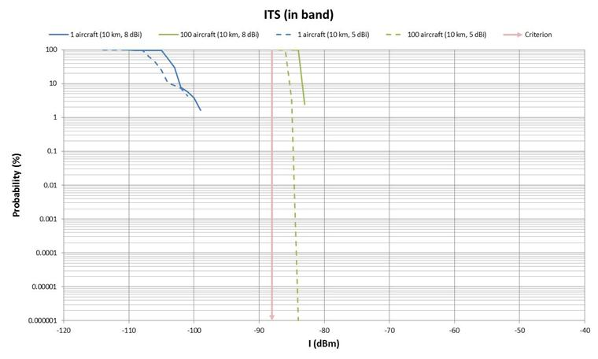
Figure 77: Interference into ITS receiver (co-frequency)

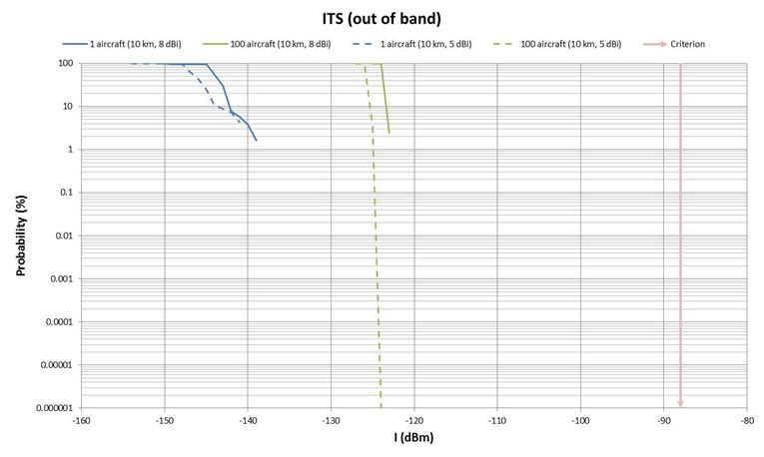
Figure 78: Interference into ITS receiver (out-of-band)

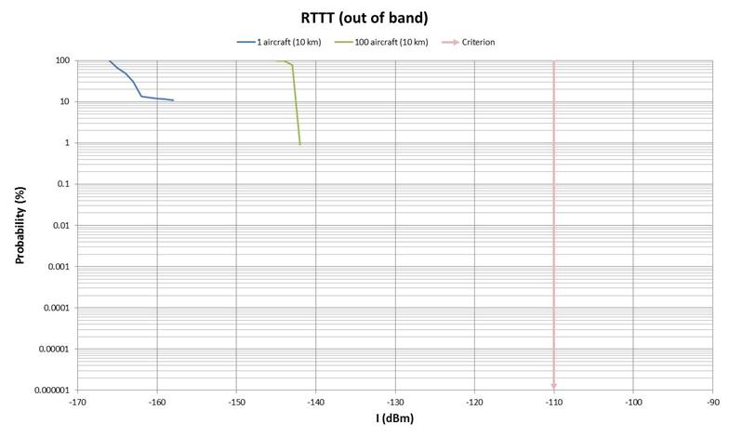
Figure 79: Interference into RTTT receiver (out-of-band)

It can be seen for the two out-of-band cases (ITS in Figure 78 and RTTT in Figure 79) that even with the aggregation of 100 aircraft high margins are still available; 35 dB in the case of RTS and 32 dB in the case of RTTT.
For the ITS co-frequency case (Figure 77) the criterion is exceeded by a few dB. This result is predicated on a smooth earth geometry and therefore does not take account of clutter, screening or horizon elevation due to terrain. Noting that the density of interfering aircraft as seen by the victim ITS terminal is greatest at low elevation angles, 70% being below 2 degrees, it can be seen that the number of simultaneously transmitting aircraft that can be seen by the ITS terminal will be significantly less than the 100 aircraft assumed above. Furthermore, atmospheric loss and other propagation effects will have an impact at very low elevation angles thereby reducing the effect of the aircraft that can still be seen.

Conclusions on compatibility between DA2GC AS (TR 101 599) and ITS
It has been shown for the two out-of-band cases that, even with the aggregation of interference from 100 simultaneously transmitting aircraft, high margins are still available; 35 dB in the case of ITS and 32 dB in the case of RTTT.
For the ITS co-frequency case the criterion is exceeded by a few dB with this number of aircraft. However, this is predicated on a smooth earth geometry and therefore does not take account of clutter, screening or horizon elevation due to terrain. In practice, 70% of aircraft will be below 2 degrees in elevation and therefore will likely be screened from the victim. Furthermore, atmospheric losses and other propagation effects at low elevation angles have not been taken into account.
Overall, it can be concluded that the number of aircraft potentially having an impact on a victim ITS terminal will be significantly less than that assumed in the study and many of the aircraft that do have an effect will be mitigated to a degree by propagation effects such that the criterion will be met in practice in the aggregate case.
[Editorial Note: Include relevant text to link to explanation of how proposed aircraft PFD mask would ensure protection of ITS systems]

Compatibility between DA2GC GS (TR 101 599) and ITS
SE44(12)036
Editor’s Note: This section only deals with ITS. RTTT is covered in a separate section, transfer text covering RTTT]

Methodology
The analysis of interference from DA2GC ground station into ITS / RTTT systems presented here is, as before, based on minimum separation distance calculations corresponding to static interference alignments. This is very much a worst-case assumption since, in practice, the transmitted beams from the DA2GC Ground Station will be dynamically tracking the aircraft with which it is communicating, thereby introducing a further statistical element to the interference results.
Initially, it is assumed that the ITS maximum gain is pointing directly at the DA2GC ground station terminal and that the DA2GC terminal is operating at its maximum power level. In the case of the RTTT RSU it is assumed that there will be a gain of 0 dBi towards the DA2GC ground station.
On the basis of above assumptions, the minimum required path loss values have been calculated for the radar interference criteria using the following equation.
Minimum Required Path Loss (dB) = DA2GC Power into antenna (dBm) + DA2GC Transmit Antenna Gain (dBi) + Radar Receive Antenna Gain (dBi) – Interference Criterion (dBm)
The power into the antenna takes account of the relevant OOB suppression specified by the emission mask (Figure 12). Bandwidth correction also needs to be applied.
Table 31: Worst case minimum path loss requirement
Configuration | Ground station transmitter power (dBm) | Ground station antenna gain (dBi) | OOB suppression (dB) | Victim antenna gain (dBi) | Interference criterion in receive bandwidth (dBm) | Bandwidth correction (dB) | Minimum required path loss (dB)
ITS co-frequency | 24.3 | -7.5 (Note 1) | 0 | 8.0 | -98.0 | -3.0 | 119.8
ITS adjacent | 24.3 | 0 (Note 2) | -40 | 8.0 | -98.0 | -3.0 | 87.3
RTTT adjacent | 24.3 | 0 (Note 2) | -40 | 0 | -107.0 | -16.0 | 75.3
Note 1: Although the ground station antenna gain at 0 degrees elevation is -11.6 dBi a higher gain has been used here to reflect the slightly negative elevation angles (approaching 1.5 degrees) with respect to victim receivers around 800 metres away.
Note 2: Similarly, a residual sidelobe gain has been used here to reflect the greater negative elevation angles (more than 10 degrees) with respect to victim receivers less than 100 metres away.
The minimum required loss values shown in Table 31 above are translated into minimum required separation distances by using a multi-slope median path loss propagation model, as used previously, where the loss is calculated using free space model up to 100 metres and d3.5 for distances greater than 100 m.
Table 32: ITS / RTTT separation distances required
Victim | Path loss (dB) | Distance (m)
ITS co-frequency | 119.8 | 822
ITS adjacent | 87.3 | 95
RTTT adjacent | 75.3 | 24 (Note)
Note: For small distances such as this it is likely that the RTTT reference gain of 0 dBi will be higher at 10 dBi. The distance would then increase to 75 m.
For close distances it also needs to be determined that the RTTT OBU activation level is not exceeded by the DA2GC main emission as the OBU will likely have a wide bandwidth front end. The OBU activation level is -60 dBm. The DA2GC total transmit power is 24.3 dBm EIRP (assuming a 0 dBi antenna gain towards the OBU ) and if the OBU has an antenna gain of 0 dBi then the received power is -51.1 dBm at 24 m, -61 dBm at 75 m and -63.5 dBm at 100 m. A separation distance of 75 metres is therefore required to prevent accidental OBU activation.
As for the case of victim radars (discussed in Section 5.6.3) the separation distance values calculated above have been based on the DA2GC ground station transmitting a single beam. Each ground station will on average be generating 12 simultaneous co-frequency beams and therefore one needs to take account of interfering power towards the victim ITS / RTTT receiver due to the power into the ground station antenna supporting each of these 12 beams.
As before, this is not simply a question of a x12 increase in interfering power as the beams will be distributed in terms of their pointing direction and therefore discrimination will be provided by the DA2GC ground station’s overall antenna azimuth pattern (Figure A2) and further mitigated by grating lobe nulls (discussed earlier and represented by Figure 80: DA2GC ground station azimuth beam pattern for 8 element arrayshowing grating lobes / nulls which enable interference cancellation below).

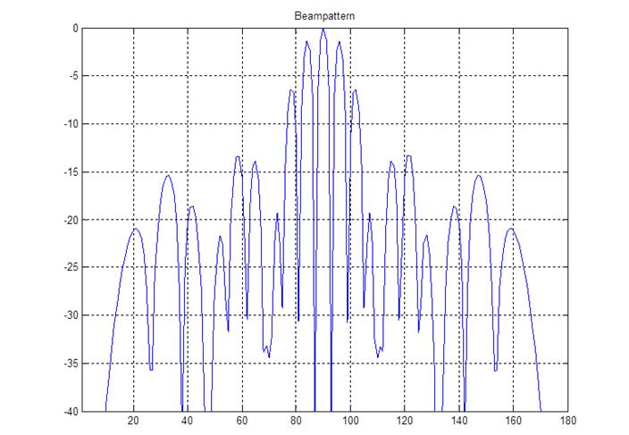
Figure 80: DA2GC ground station azimuth beam pattern for 8 element arrayshowing grating lobes / nulls which enable interference cancellation
The additional interference power due to the aggregation of the remaining 11 beams in the direction of the victim ITS/RTTT receiver will be related to a number that fall in the grating lobe nulls (-30 dB), those that give a discrimination away from the main lobe and which are not subject to grating lobe nulling (-12 to -25 dB), and those where the victim is located behind the ground plane of the array supporting the beam (at least -30 dB).
Under these circumstances the increase in total interference power (over and above that produced by a single beam interference) towards the victim ITS / RTTT receiver will be small (of the order of 0.6 dB) and will make an insignificant difference to the separation distances calculated above.

Conclusions on compatibility between DA2GC GS (TR 101 599) and ITS
The protection of ITS and RTTT receivers (including the prevention of accidental activation) can be achieved with separation distances of less than 100 metres with respect to ITS and RTTT operating adjacent band and around 800 metres with respect to ITS (non-safety) operating co channel.

Compatibility between DA2GC AS (TR 103 108) and ITS
SE44(13)037

Methodology
The unwanted interference has been calculated according to the following equation:

$$Interfering Signal={Eirp}_{Source}-{AS}_{Mitigation}[-ATPC]-{Loss}_{Prop}+{Antenna Gain}_{Rx}$$

Results
[Editor’s Note: Updated results provided after 9th SE44]
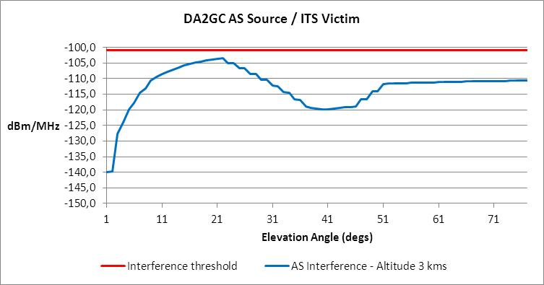
Figure 81: DA2GC AS Source (3 km) / ITS Victim

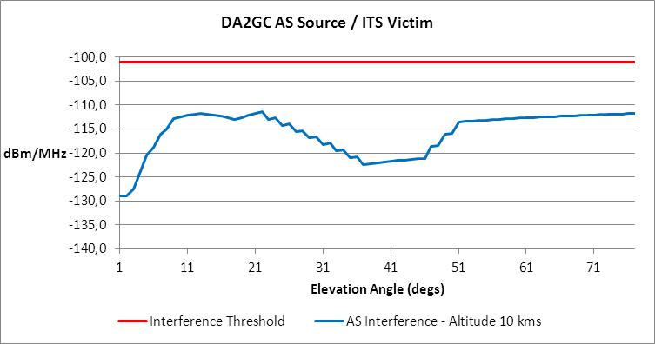
Figure 82: DA2GC AS Source (10 km) / ITS Victim

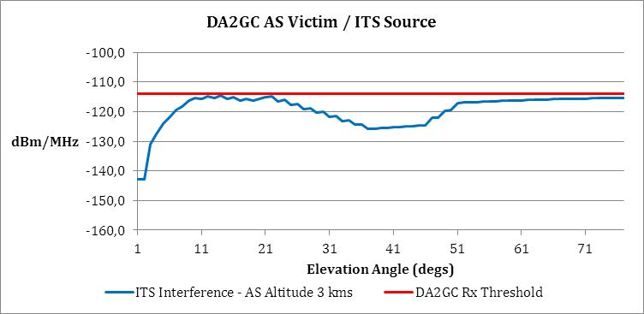
Figure 83: DA2GC AS Victim (3 km) / ITS Source

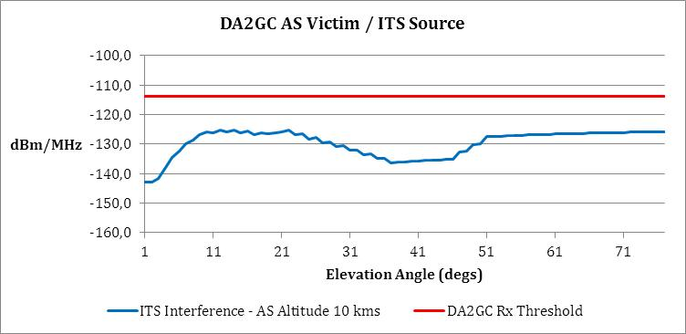
Figure 84: DA2GC AS Victim (10 km) / ITS Source

Compatibility between DA2GC GS (TR 103 108) and ITS
SE44(13)037

Results

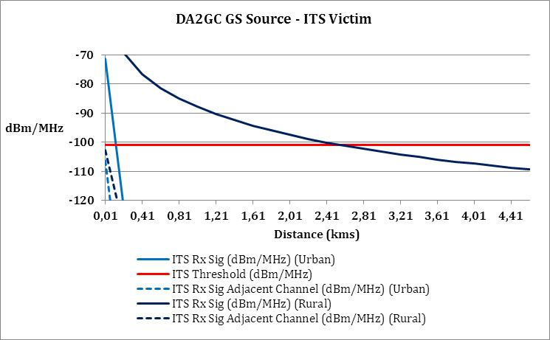
Figure 85: DA2GC GS Source / ITS Victim

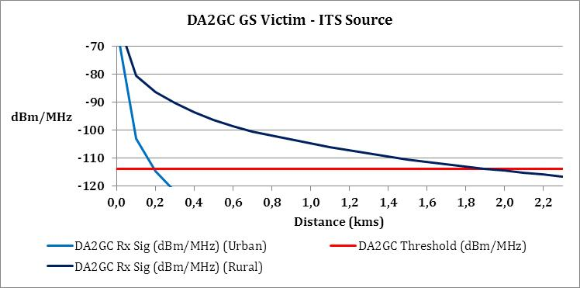
Figure 86: DA2GC GS Victim / ITS Source

Conclusions on the compatibility between DA2GC (ETSI TR 103 108) and ITS
Aircraft Station
Compatibility is achieved for all cases.
Ground Station
Co-channel compatibility is achieved with a separation distance of 2.5 km assuming rural propagation. For the urban case the separation distance is reduced to about 200 metres.
Summary
Co-channel compatibility between DA2GC GS and ITS is considered to be achieved.

Compatibility between DA2GC and RTTT systems

Technical characteristics of RTTT systems

 | Road Side Units | On Board Units
Carrier frequencies (MHz) | 5797.5, 5802.5  (5807.5, 5812.5 MHz for multi-lane road junctions at a national level)
Frequency stability | 5 ppm | modulation 100 ppm
e.i.r.p. | 2 W (33 dBm) standard for 0°≤θ≤70°  18 dBm for θ > 70°  8 W (39 dBm) optional | Maximum re-radiated sub-carrier e.i.r.p.:  -14 dBm
Antenna gain | 10-20 dB (assumed front-to-back ratio of 15 dB) | 1-10dB (assumed front-to-back ratio of 5dB)
Transmitter Bandwidth | 1 MHz | 500 kHz
Modulation scheme transmitter | Two level amplitude | BPSK
Receiver bandwidth | 500 kHz | approx, 300 MHz
Polarization | left circular | left circular
Receiver sensitivity (at the receiver input) | -104 dBm (BPSK) | -60dBm
Co-channel C/I (dB) | 6 dB | 6 dB
Table 31: Summary of characteristics of the RTTT systems
The technical requirements of the RTTT DSRC devices are split into two categories :
- the Road Side Unit is an active device with a high level of emission and the sensitivity value can be
compared to the value of ITS devices
- the On Board Unit is a passive device with reduced level of emission (back-scattering uplink
communication) and poor level of sensitivity (downlink communication).

Technical data from ETSI EN 300 674 V1.2.1 (2004-08) and CEN EN 12253.

Compatibility between DA2GC AS (TR 101 599) and RTTT systems
[RTTT is considered in the ITS section, relevant parts to be included here]

Compatibility between DA2GC GS (TR 101 599) and RTTT systems
[RTTT is considered in the ITS section, relevant parts to be included here]

Compatibility between DA2GC GS (TR 103 108) and RTTT systems

Results

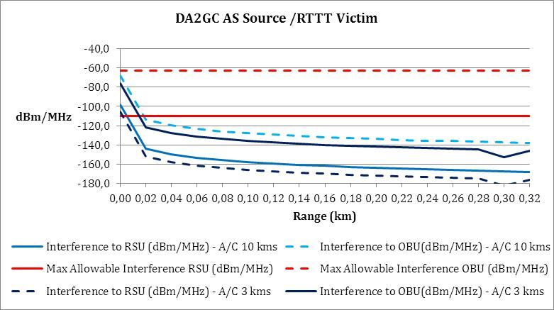
Figure 87: DA2GC AS Source / RTTT Victim

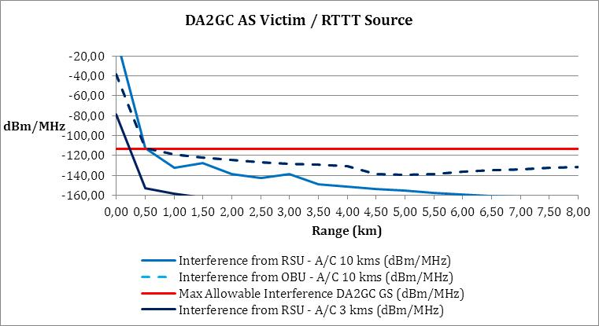
Figure 88: DA2GC AS Victim / RTTT Source

Compatibility between DA2GC GS (TR 103 108) and RTTT systems

Results

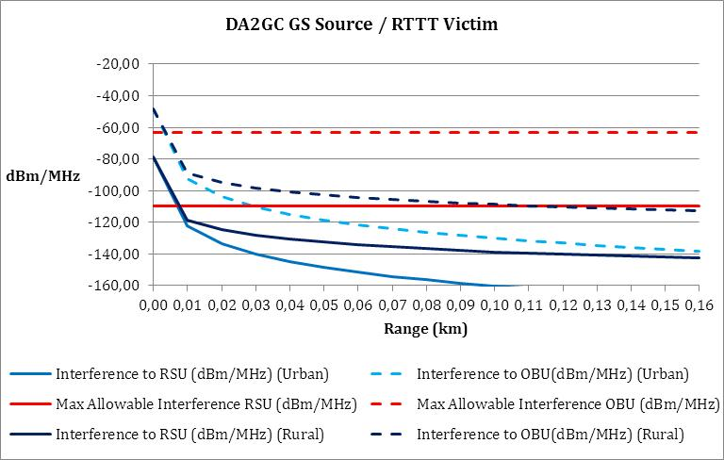
Figure 89: DA2GC GS Source / RTTT Victim

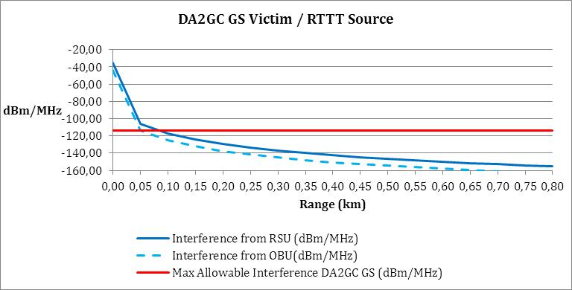
Figure 90: DA2GC GS Victim / RTTT Source

Conclusions on the compatibility between DA2GC (ETSI TR 103 108) and RTTT

Aircraft Station
Compatibility is achieved for all cases.
Ground Station
Compatibility is achieved.
Summary
Compatibility between DA2GC GS and RTTT is considered to be achieved.

Compatibility between DA2GC and Radiolocation systems

Technical characteristics of Radiolocation systems
Recommendation ITU-R M.1638 [25] provides characteristics of radars operating under the Radiolocation services in the frequency range 5250-5850 MHz. Within this range, the band between 5 725 and 5 850 MHz is used by many different types of radars on fixed land-based, ship borne and transportable platforms. It should be noted that most of these radars are designed to operate not only in the 5725-5850 MHz band but in a larger portion of the band 5250-5850 MHz.
Additionally, ITU-R Recommendation M.1851 (2009) provides mathematical models for radiodetermination radar systems antenna patterns for use in interference analyses
Table 32 contains technical characteristics of representative systems deployed in this band. This includes a subset of the radars contained in Recommendation ITU-R M.1638 [25] which are relevant for the frequency band 5725-5850 MHz (radars L, M, N, O and Q) and three additional radars operated by administrations within CEPT (X, Y and Z). This information is generally sufficient for calculation to assess the compatibility between these radars and other systems.

Characteristics | Radar L | Radar M | Radar N | Radar O | Radar Q | Radar X&Y | Radar Z
Function | Instrumentation |  |  |  | Surface and air Search |  | Search
Platform type | Ground |  |  |  | Ship | Ground/Vehicle
Tuning range (MHz) | 5 350-5 850 |  | 5 400-5 850 |  | 5 450-5 825 | 5400 – 5850 | 5250 – 5850
Modulation | None | None | Pulse/chirp pulse | Chirp pulse | None | None | Non-Linear  FM
TX power into antenna | 2.8 MW | 1.2 MW | 1.0 MW | 165 kW | 285 kW | 12 kW peak | 70 kW
Pulse width (µs) | 0.25, 1.0, 5.0 | 0.25, 0.5, 1.0 | 0.25-1 (plain)  3.1-50 (chirp) | 100 | 0.1/0.25/1.0 | 4-20 | 3.5/6/10
Pulse rise/fall time (µs) | 0.02-0.5 | 0.02-0.05 | 0.02-0.1 | 0.5 | 0.03/0.05/0.1 | No detail | N/A
Pulse repetition rate (pps) | 160, 640 | 160, 640 | 20-1 280 | 320 | 2 400/1 200/750 | 1000-7800 | 2500/3750
Chirp bandwidth (MHz) | N/A | N/A | 4.0 | 8.33 | N/A | No detail
RF emission bandwidth (MHz) at 3 dB  at 20 dB | 0.5-5 | 0.9-3.6  6.4-18 | 0.9-3.6  6.4-18 | 8.33  9.9 | 5.0/4.0/1.2  16.5/12.5/7.0 | 5
Antenna pattern type | Pencil | Pencil | Pencil | Pencil | Fan | N/A | N/A
Antenna type | Parabolic | Parabolic | Phased Array | Phased Array | Travelling wave feed horn array | N/A | Phased Array
Antenna polarization | Vertical/Left-hand circular |  |  |  | Horizontal | Vertical | Horizontal
Antenna main beam gain (dBi) | 54 | 47 | 45.9 | 42 | 30.0 | 35 | 31.5
Antenna elevation beamwidth (degrees) | 0.4 | 0.8 | 1.0 | 1.0 | 28.0 | N/A | 43.8
Antenna azimuth beamwidth (degrees) | 0.4 | 0.8 | 1.0 | 1.0 | 1.6 | N/A | 1.75
Antenna rejection (1st SLs and remote SLs) (dB) | -20 | -20 | -22 | -22 | -25 | -40 | N/A
Antenna height (m) | 20 | 8-20 | 20 | 20 | 40 | 10 | 6 – 13
Receiver IF 3 dB bandwidth (MHz) | 4.8, 2.4, 0.25 | 4, 2, 1 | 2-8 | 8 | 1.2,10 | 4 | N/A
Receiver noise figure (dB) | 5 | 5 | 11 | 5 | 10 | 5 | ≤ 13dB
Table 32: Characteristics of radiolocation systems

Compatibility between DA2GC AS (TR 101 599) and Radiolocation systems
LH Systems: SE44(12)036, SE44(13)009, France: SE44(12)031, SE44(12)047rev1, SE44(13)029, NL: SE44(12)054, SE44(13)002, SE44(13)042, Germany, Austria: SE44(13)045,

[Editor’s Note: Text to be included from studies provided by the Netherlands and France, further elements provided in SE44(13)060]

Compatibility between DA2GC GS (TR 101 599) and Radiolocation systems
LH Systems: SE44(12)036, France: SE44(12)031, SE44(12)047rev1, SE44(13)028, NL: SE44(12)054, SE44(13)002, SE44(13)xxx

Editor’s Note: Text to be included from studies provided by the Netherlands and France, further elements provided in SE44(13)060]

Compatibility between DA2GC AS (TR103 108) and Radiolocation systems
Aero3G: SE44(13)006, SE44(13)038, France: SE44(13)029

Methodology
In order to achieve the declared unwanted emissions level it is necessary to include substantial filtering in the design of both ground and aircraft equipment. This filtering enables the specification at 5850 MHz to be achieved. However the impact of filtering continues to increase with frequency offset. The figure below illustrates this.

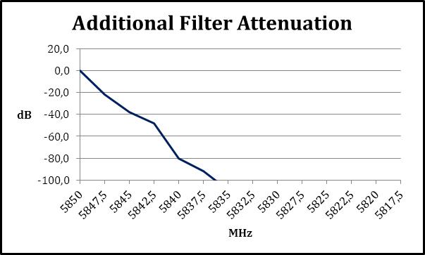

Figure 91: Filter Response

Results

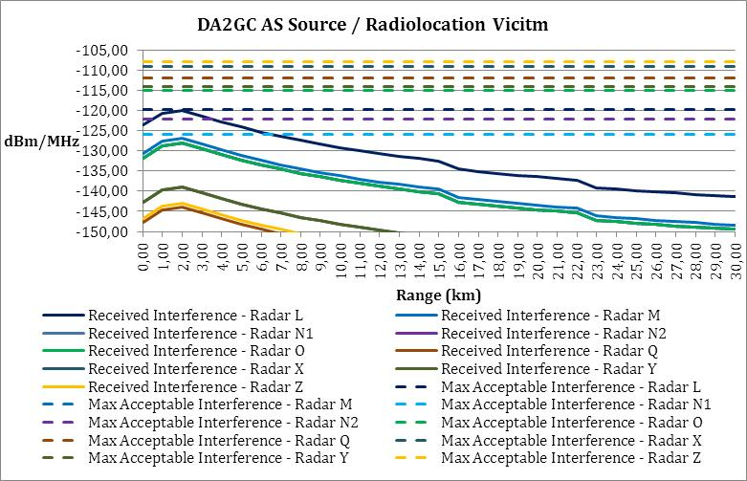
Figure 92: DA2GC AS Source (3 km) / Radiolocation Victim (5850 MHz)

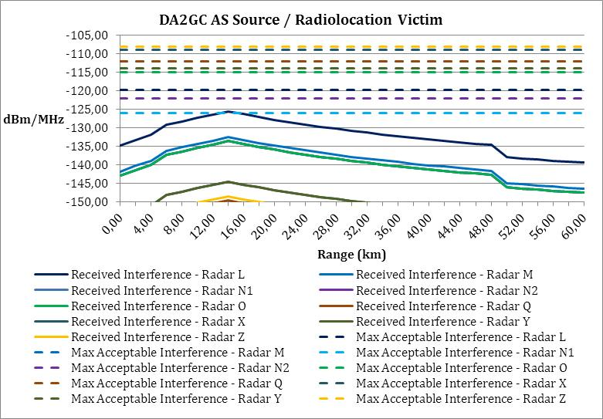
Figure 93: DA2GC AS Source (10 km) / Radiolocation Vicitm (5850 MHz)

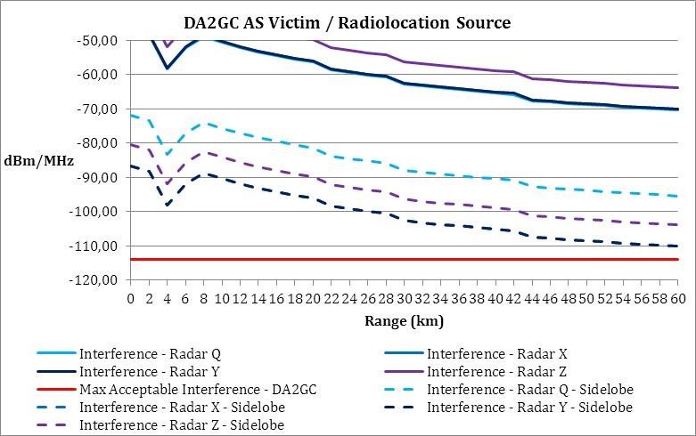
Figure 94: DA2GC AS Victim (3 km) / Radiolocation Source (5850 MHz)

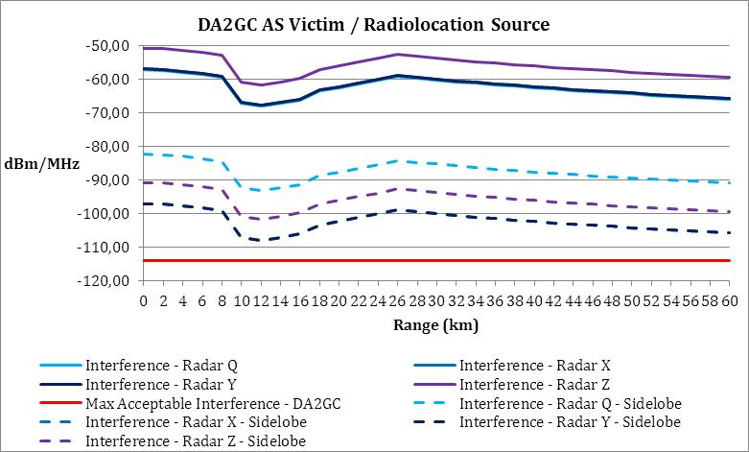
Figure 95: DA2GC AS Victim (10 km) / Radiolocation Source (5850 MHz)

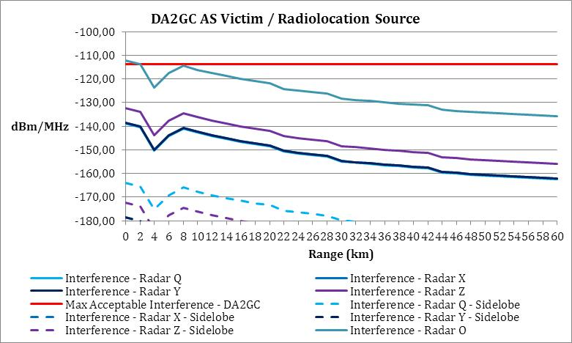
Figure 96: DA2GC AS Victim (3 km) / Radiolocation Source (5839 MHz)

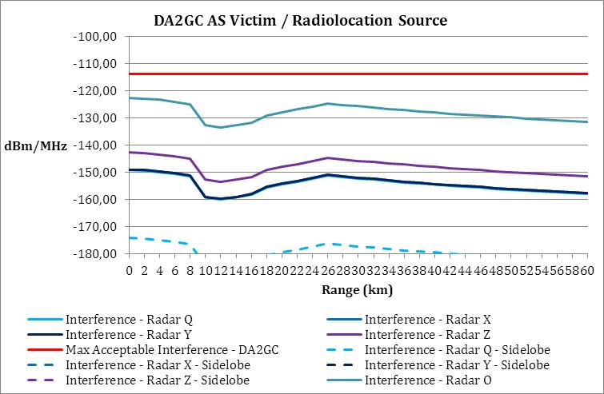
Figure 97: DA2GC AS Victim (3 km) / Radiolocation Source (5839 MHz)

Compatibility between DA2GC GS (TR 103 108) and Radiolocation systems
Aero3G: SE44(13)006, SE44(13)038

Results

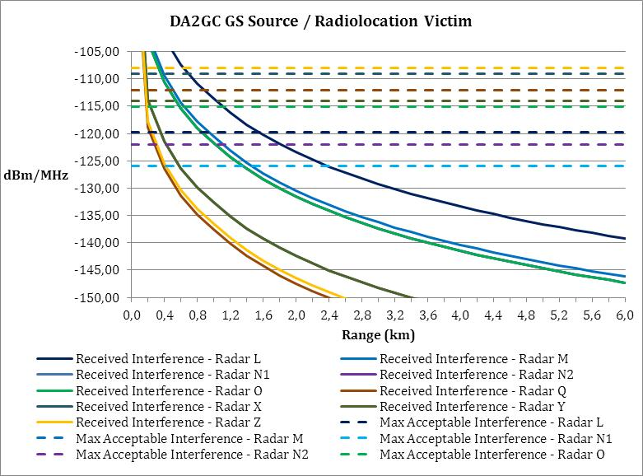
Figure 98: DA2GC GS Source / Radiolocation Victim (5850 MHz)

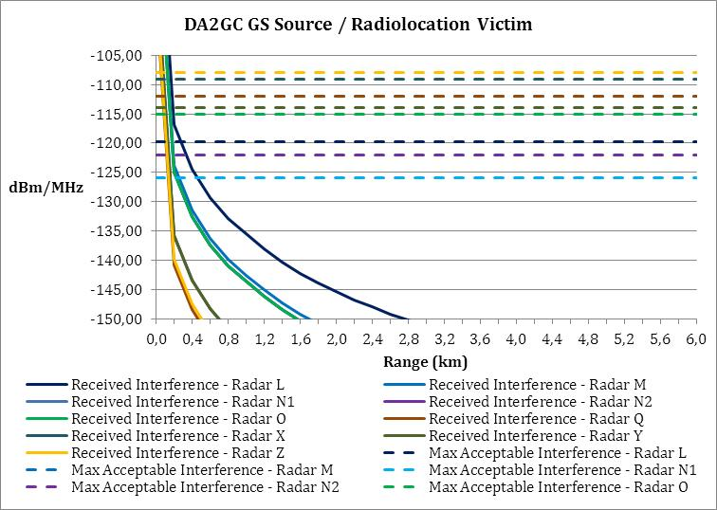
Figure 99: DA2GC GS Source / Radiolocation Victim (5847.5 MHz)

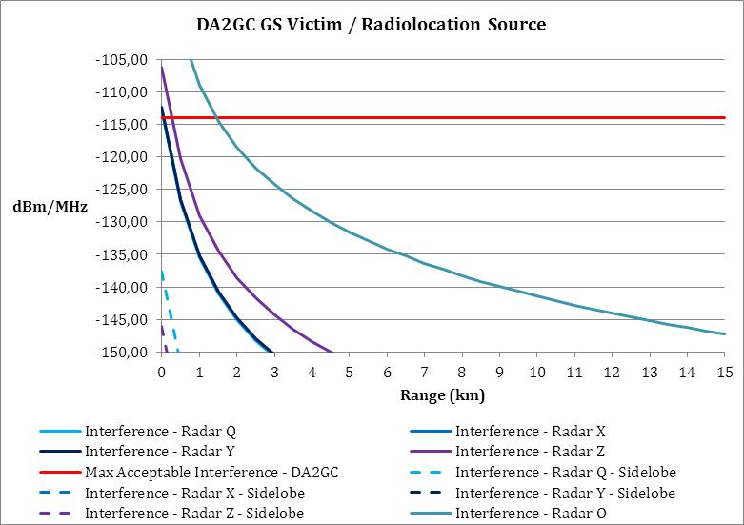
Figure 100: DA2GC GS Victim / Radiolocation Source (5839 MHz)

Conclusions
Aircraft Station

Compatibility is achieved for the case where the DA2GC AS is the source of interference
Compatibility is achieved for the case where the DA2GC AS is the victim of interference provided that the radiolocation system is operating at a frequency less than 5839 MHz. For frequencies above this there will be interference to the DA2GC AS but this will be sporadic and operationally acceptable.

Ground Station

Compatibility is achieved for the case where the DA2GC GS is the source of interference for radiolocation systems operating at 5850 MHz if a separation distance of 2 km is respected. If the operating frequency is 5847.5 MHz or less then the separation distance reduces to 400 metres or less.
Compatibility is achieved for the case where the DA2GC GS is the victim of interference provided that the radiolocation system is operating at a frequency less than 5839 MHz with a separation distance of 2 km or less. For frequencies above this there will be interference to the DA2GC GS but this will be sporadic and operationally acceptable. Furthermore if the siting of the radiolocation system were known then additional screening could be used to further reduce interference to DA2GC GS

Summary

Compatibility between DA2GC GS and Radiolocation is considered to be achieved.

conclusions

- DETECT AND AVOID’ CAPABILITIES FOR THE DA2GC SYSTEM IN TR 101 599
Introduction

In the course of its work, SE44 considered contributions that indicated some BFWA terminals in particular configurations will experience interference above acceptable criteria.
This situation needs to be avoided through a combination of regulatory and technical means and a so called ‘Detect and Avoid’ mechanism is likely to be an important element in the overall solution. This could be a part-solution in the case of DA2GC Ground Stations but is likely to be the only means of dealing with the potential for interference into BFWA systems from DA2GC aircraft stations, since more ‘traditional’ coordination methods would be impracticable for such moving interference sources.

This Annex examines the feasibility of implementing ‘Detect and Avoid’ mechanisms in respect of DA2GC aircraft stations, by way of a two-stage approach. Firstly, in Section 2, the Detection sensitivity of the DA2GC receiver in respect of BFWA transmissions is examined, to determine whether such signals can be detected before the DA2GC transmissions give rise to unacceptable interference at the BFWA receiver. Section 3 then considers the way in which Avoidance techniques could be applied, once the presence of BFWA terminals is detected.

Detection

Digital Signal Processing (DSP) techniques as used in the beam-forming DA2GC system allow for signals 9 dB below the DA2GC receiver noise floor to be detected. The DA2GC receivers used have a noise figure of 4 dB so the noise floor (in the 20 MHz receive bandwidth) is – 97 dBm. Received BFWA signal levels of
-106 dBm can therefore be detected.

BFWA Base Station
Taking a BFWA Base Station in its worst case location which is 15 km from the DA2GC Ground Station towards the aircraft, the interference power received by the BFWA Base Station is shown in Figure 101 and Figure 102 below, where Figure 101 is with reference to elevation angle at the DA2GC Ground Station and Figure 2 is with reference to elevation angle at the BFWA Base Station. It can be seen that interference exceeding the long term criterion occurs over a small range of elevation angles; 5 to 7½ degrees with reference to DA2GC Ground Station elevation angles (Figure 101) and 6 to 9 degrees with reference to BFWA Base Station elevation angles (Figure 102)

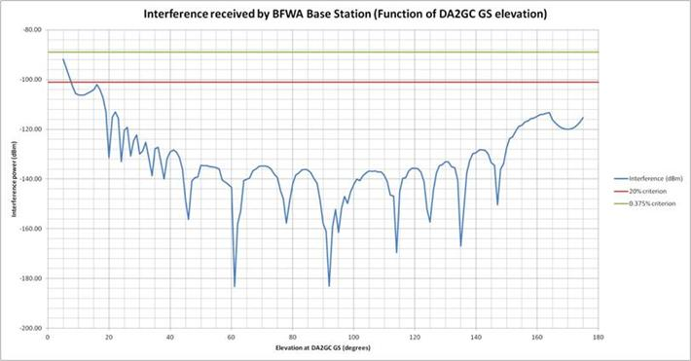
Figure 101: Interference received at worst case location BFWA Base Station (15 km offset from DA2GC Ground Station) with reference to DA2GC Ground Station elevation angle.

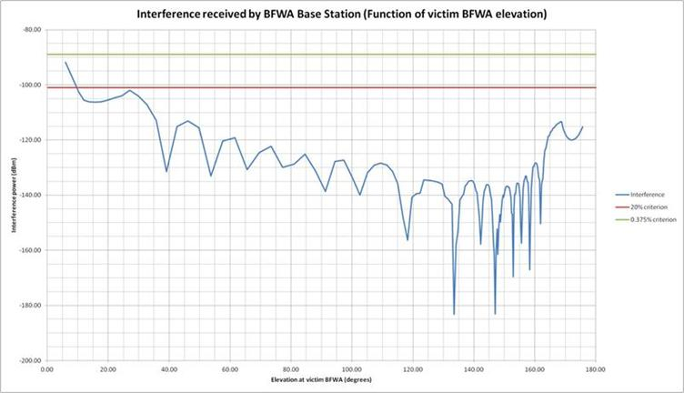
Figure 102: Interference received at worst case location BFWA Base Station (15 km offset from DA2GC Ground Station) with reference to BFWA Base Station elevation angle.

At the same time as the BFWA Base Station is receiving interference power from the DA2GC aircraft as indicated in Figure 101and Figure 102 above, the aircraft is receiving power from the BFWA Base Station (P = 19 dBm, G = 17 dBi) as shown in Figure 103 below.
It can be seen that the DA2GC aircraft receiver will be able to detect BFWA signals greater than -106 dBm which extend from 0 to 15 degrees (with respect to DA2GC Ground Station elevation) and 0 to 32 degrees (with respect to BFWA Base Station elevation).

The Detectable and ‘need to Avoid’ ranges can be compared as follows:

Elevation angle base Interference to be avoided between (degrees) Interference detected between (degrees)
DA2GC Ground Station 5 to 7½ 0 to 15
BFWA Base Station 6 to 9 0 to 32

It is therefore clear that potential BFWA Base Station victims of interference can be detected before they experience unacceptable levels of interference, such that avoidance techniques (see Section 3) can be put in place.

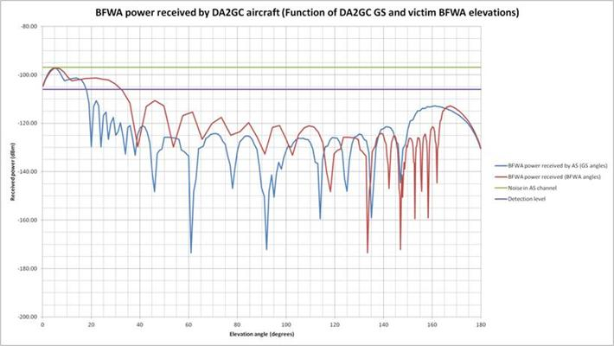
Figure 103: BFWA Base Station power received at DA2GC aircraft with reference to BFWA Base Station (15 km offset) and DA2GC Ground Station elevation angles.

BFWA User Terminal

Taking a BFWA User Terminal in its worst case location which is 65 km from the DA2GC Ground Station towards the aircraft, the interference power received by the BFWA User Terminal is shown in Figure 104 and Figure 105 below, where Figure 104 is with reference to elevation angle at the DA2GC Ground Station and Figure 5 is with reference to elevation angle at the BFWA User Terminal.

It can be seen that interference exceeding the long term criterion occurs over a range of elevation angles; 5 to 7 degrees with reference to DA2GC Ground Station elevation angles (Figure 104) and 14 to 32 degrees with reference to BFWA User Terminal elevation angles (Figure 105).

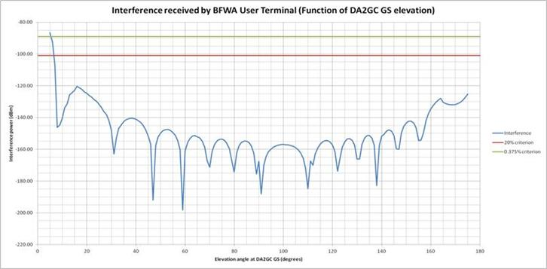
Figure 104: Interference received at worst case location BFWA User Terminal (65 km offset from DA2GC Ground Station) with reference to DA2GC Ground Station elevation angle.

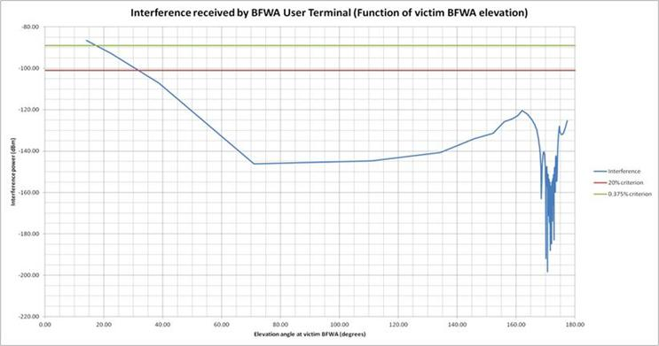
Figure 105: Interference received at worst case location BFWA User Terminal (65 km offset from DA2GC Ground Station) with reference to BFWA User Terminal elevation angle.

At the same time as the BFWA User Terminal is receiving interference power from the DA2GC aircraft as indicated in Figures 4 & 5 above, the aircraft is receiving power from the BFWA User Terminal (P = 19 dBm, G = 17 dBi) as shown in Figure 106 below.

It can be seen that the DA2GC aircraft receiver will be able to detect BFWA signals greater than -106 dBm which extend from 0 to 7 degrees (with respect to DA2GC Ground Station elevation) and 1 to 37 degrees (with respect to BFWA User Terminal elevation).

The Detect and ‘need to Avoid’ ranges can be compared as follows:

Elevation angle base | Interference to be avoided between (degrees) | Interference detected between (degrees)
DA2GC Ground Station | 5 to 7 | 0 to 7
BFWA User Terminal | 14 to 32 | 1 to 37

It is therefore clear that potential BFWA User Terminal victims of interference can be detected before they experience unacceptable levels of interference, such that avoidance techniques (see Section 3) can be put in place.

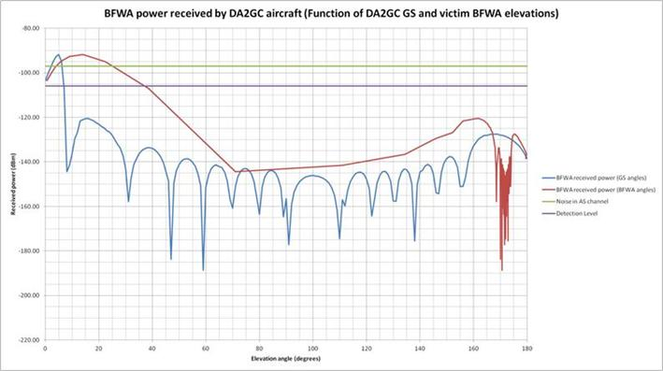
Figure 106: BFWA User Terminal power received at DA2GC aircraft with reference to BFWA User Terminal (65 km offset) and DA2GC Ground Station elevation angles.

Avoidance Techniques

The previous section has shown that BFWA terminals can be detected before the DA2GC transmissions give rise to unacceptable interference at the BFWA receiver. Given this, we need to consider three strategies that can be employed to prevent interference from occurring, namely:
• Antenna nulling
• Adaptive OFDM spectral power density
• DA2GC Ground Station diversity

Antenna Nulling

Each aircraft antenna array has a number of degrees of freedom to manipulate grating lobes dynamically in order to direct nulls and maxima in desired directions. Areas where BFWA terminals are located can therefore be placed in a null where a suppression of interfering power of the order of 40 dB can be achieved. The capability of this technology is shown in Figure 107 below. This diagram is reproduced from SE44(12)036, presented at the SE44 Biel meeting, and relates to the use of this technology for DA2GC Ground Stations in relation to adjacent band radars and other services. However, the technology is equally applicable to the DA2GC aircraft antenna arrays.

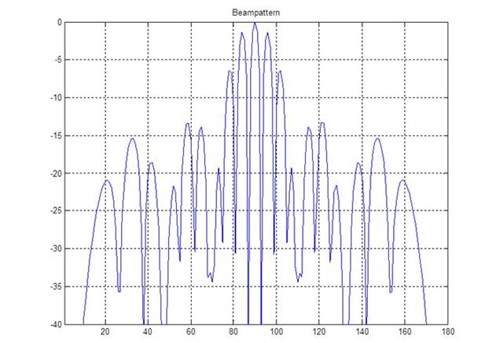
Figure 107: Example DA2GC ground station azimuth beam pattern for 8 element array showing grating lobes / nulls enable interference cancellation – equally applicable to DA2GC aircraft antenna arrays

In the example given above the outline of the main lobe can be seen between approximately 70 and 110 degrees along the x-axis. Within that main lobe six deep nulls have been synthesised. These nulls can either be narrow and deep or wide and less deep; a 40 dB null would subtend approximately 2½ degrees and a 15 dB null would subtend approximately 10 degrees at the aircraft antenna array. The depth / width required can be synthesised as required.

It can be noted from earlier analyses that the potential interference exceedance at a BFWA terminal is, depending on the criterion used, up to 9 dB in the case of a Base Station and up to 15 dB in the case of a User Terminal. It can therefore be seen that complete flexibility is available in terms of how to deal with individual BFWA terminals and groups of terminals over an area.

Figure 105 earlier shows that a BFWA User Terminal in the worst case location receives unacceptable interference from a DA2GC aircraft in the range from 14 to 32 degrees of elevation (at the BFWA terminal). In this geometry, and assuming that there are other potential victim BFWA terminals in a town of radius 2 km, it would be necessary to deploy a null of 6 degrees across at the aircraft antenna which is well within the capability of this technology. The geometry of this is shown in Figure 108 below.

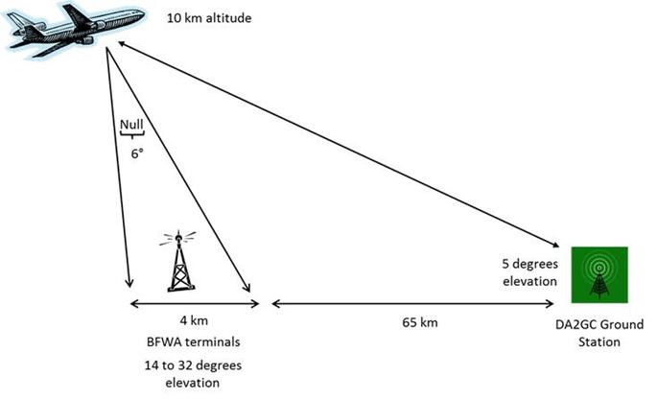
Figure 108: Nulling geometry required to protect a representative town

Adaptive OFDM spectral power density

Where the potential for interference amounts to a few dB, and in rare cases where the nulling technique may not be fully effective, it is also possible to adapt dynamically the transmitted spectral power density by reducing the number of sub-carriers that are used in the OFD Multiplex when a potential BFWA victim is sensed. In this way, the total power received within the victim BFWA receiver bandwidth can be reduced to acceptable levels. This would be at the cost of a temporary lowering of the data rate on the aircraft return (air-to-ground) link, but would be acceptable to the DA2GC operator in the context of a low-cost service, particularly since data traffic is likely to be quite asymmetrical, with a much higher requirement on the forward (ground-to-air) link.

DA2GC Ground Station diversity

As an alternative to the power reduction technique described above, another option to cover those rare cases where nulling may not be a fully effective remedy would be to switch the ‘offending’ aircraft beam to re-point towards the nearest alternative DA2GC Ground Station. This would be an effective mitigation technique, since it is only the alignments involving the main lobe of the aircraft antenna pattern which give rise to interfering powers above the BFWA allowable threshold criteria.

Conclusions

This Annex has described how, in the first instance, the presence of BFWA terminals (both Base Stations and User terminals) can be detected through signal processing at the aircraft receiver. Furthermore, it has been shown that this detection capability is sufficient for the BFWA transmissions to be detected before the DA2GC aircraft transmissions give rise to unacceptable interference at the BFWA receiver.

In the event that BFWA transmissions are detected, there are three techniques that can prevent interference from occurring. The most effective of these is antenna nulling whereby DA2GC transmissions are suppressed to an appropriate level in the direction of the BFWA terminal (or grouping of terminals e.g. in a town). In rare cases where nulling may not be fully effective it is possible to reduce the DA2GC transmitted power spectral density towards the BFWA terminal(s) by reducing the number of sub-carriers in the OFD Multiplex or by switching the DA2GC aircraft beam to an alternative Ground Station.
- COMPATIBILITY AND SHARING SCENARIOS FOR THE BAND 2400 – 2483.5 MHZ
The band 2400 – 2483.5 MHz is heavily used by RLAN, Bluetooth, Zigbee and other applications..According to ERC/REC 25-10 the band is also used by Cordless cameras, portable video links and mobile video links airborne and vehicular. Technical parameters can be found in ERC/REP 038. ECC Report 2 gives information about the spectrum use and future requirements of these systems.
Figure 80 depicts the sharing scenarios in the band 2400 – 2483.5 MHz in both interference directions when assuming TDD mode of the DA2GC system.
Figure 80: Interference scenarios for BDA2GC in the frequency band 2 400 – 2 483.5 MHz

TECHNICAL CHARACTERISTICS OF SRDs
The relevant technical characteristics and protection criteria for the compatibility studies are given in Table 12. An overview of SRD applications is attached to the Table.
Table 33: Technical characteristics and protection criteria for SRDs in the 2.4 GHz band
 | RLAN/ Wifi – Outdoor (including p2p, p2mp, mesh,..) | RLAN/ Wifi – indoor | Bluetooth | Bluetooth  (class 1) | Zigbee – 802.15.4 | RFID
Tx power dBm(conducted) | 10 – 17 dBm | 13 – 17 | 0 – 5 | 13 | 5 – 15 | 14
Bandwidth (MHz) | 20 / 40 | 20 / 40 | 1 | 1 | 5 | 3
Rx sensitivity (dBm) | -82 / -79 | -82 / -79 | -90 | -90 | -83 | -90
Antenna gain (dBi) | 3 – 10 | 3 - 7 | 0 - 3 | 0 - 3 | 0 - 3 | 6
Duty cycle (%) | Up to 100 | Up to 100 | Up to 100 | Up to 100 | 100 | Up to 100
Hopper/non hopper | Non-hopper | Non-hopper | Hopper | Hopper | Hopper | Non-hopper
Uniform density per km² | 50 | 5000 (e.g. Monaco) | 10.000 (e.g. Monaco) | 1000 | 100 | 100
Rural/Urban | Rural + urban | Urban | Urban | Urban | Urban | Rural + urban
Protection Criterion (C/I) | ≥ 10 dB | ≥ 10 dB | ≥ 10 dB | ≥ 10 dB | ≥ 10 dB | ≥ 10 dB
Percentage indoor (%) | 0 | 99 | 75 | 98 | 99 | 75
Wall attenuation | 0 | 15 | 15 | 15 | 15 | 15

Overview of 2.4 GHz applications:

- WIFI or IEEE 802.11 based consumer and enterprise applications, including smart phones etc.. These products comply with EN 300 328 and Annex 3 of ERC Rec 70-03. Maximum output power is 100 mW e.i.r.p.
  - In 2011 only, in total 1 billion (1.000.000.000) chipsets were shipped.

- Bluetooth for short distance links used in Mobile (smart) phones, notebooks, game consoles...). These products comply with EN 300 328 and Annex 3 of ERC Rec 70-03. Maximum output power ranges from 1 mW e.i.r.p. (Class 3) to 100 mW (Class 1).
  - In 2011 only, in total 2 Billion (2.000.000.000) chipsets were shipped.

- ZigBee or 802.15.4 used in applications for Home Automation, Smart Grid, Building Automation, etc... These products comply with EN 300 328 and Annex 3 of ERC Rec 70-03. Maximum output power is 100 mW e.i.r.p.
  - In 2010, in total 60 million chipsets were shipped.

- Other applications include
  - non specific SRDs (ERC Rec 70-03 Annex 1 / EN 300 440)
  - Railway applications in 2446-2454 MHz (ERC Rec 70-03 Annex 4 / EN 300 761)
  - Radiodetermination applications (ERC Rec 70-03 Annex 6 / EN 300 440
  - RFID (ERC Rec 70-03 Annex 11 / EN 300 440).

COMPATIBILITY BETWEEN BROADBAND DA2GC (ETSI TR 103 054) AND RLANs
The most critical compatibility scenario seems to be between Broadband DA2GC and outdoor RLANs as described in Table 5-1. Therefore this scenario has studied first. An RLAN access point with a maximum antenna gain of 10 dBi and a RLAN device equipped with an omni-directional antenna were assumed in this study (see Figures 5-2 and 5-3). The maximum e.i.r.p. for RLANs is 20 dBm according to ERC Recommendation 70-03 (Annex 3). As the band 2400 – 2483.5 MHz is heavily used by RLANs (density of 50 devices per km²) and the location and operating frequencies are not known for each individual device, DA2GC could only be deployed in this band, if co-channel sharing would be feasible.

Figure 81: RLAN AP antenna elevation gain pattern | Figure 82: RLAN omni antenna elevation gain pattern
METHODOLOGY
It is considered that one single DA2GC aircraft station is approaching the RLAN device under consideration at a given altitude (3000m and 10000m). The interference level resulting at the victim receiver was calculated taking into account the transmit power density of the interfering system, the aircraft altitude, the resulting free space loss, the antenna characteristics of the interfering and the victim system and the interference protection level of the victim system. The Interference protection ratio I/N=0 corresponds to C/I of 10dB at Rx power level of -82 dBm.
RESULTS
The below Figure 84Figure 90 show the received power spectral density (PSD) in dBm/MHz at the RLAN GS and the DA2GC AS and the resulting interference-to-noise ratio (I/N) compared to the different thresholds of both systems at aircraft altitudes of 3000 and 10.000 meters. RLANs equipped with omnidirectional antenna and directional antenna were considered. Figure 91 and Figure 92 show the PSD at an RLAN AP receiver input, depending on the aircraft elevation relative to the victim RLAN. Severe interference at the RLAN can be observed at aircraft altitudes of 3000 m and 10000 m.
IMPACT FROM DA2GC AS ON OUTDOOR RLANs
By considering the AS at 3 000 m the protection criterion for the RLAN receiver will be exceeded significantly. Even at 10 000 m severe interference at the RLAN receiver will be caused.
Thus it is concluded that co-channel operation of a BDA2GC reverse link (air-to-ground) and outdoor RLAN systems in the band 2400-2483.5 is not feasible.
IMPACT FROM OUTDOOR RLANS ON DA2GC AS
At higher altitudes the impact of one RLAN transmitter on the receiving BDA2GC AS is negligible due to the low e.i.r.p. of the outdoor RLAN device. This is also the case for larger distances between the outdoor RLAN device and the AS, even at lower altitudes.
The main problem arises due to the high number of outdoor RLAN devices leading to an aggregation of interference signals at the receiving DA2GC AS. Taking into account a density of 50 outdoor RLAN devices / km², there are about 15700 outdoor RLAN devices visible in the range of about 10 km around the receiving DA2GC AS. Even by assuming that these RLAN devices are partly operated on different channels and not during the same time, a sufficient high number of RLAN devices will remain to interfere the reception at the DA2GC AS. This is the case for AS at 3 000 m as well as at 10 000 m. Capacity estimations for BDA2GC based on LTE when aggregated interference of RLANs occurs can be found inANNEX 1:.
RLAN equipped with omni-antenna
Figure 83: Received PSD (aircraft altitude 3000 m) | Figure 84: Resulting I/N ratio (aircraft altitude 3000 m)
Figure 85: Received PSD (aircraft altitude 10000 m) | Figure 86: Resulting I/N ratio (aircraft altitude 10000 m)

RLAN equipped with directional antenna
Figure 87: Received PSD (aircraft altitude 3000 m) |  | Figure 88: Resulting I/N ratio (aircraft altitude 3000 m)
Figure 89: Received PSD (aircraft altitude 10000 m) | Figure 90: Resulting I/N ratio (aircraft altitude 10000 m)
Figure 91: Received PSD at RLAN AP (altitude 3000 m) | Figure 92: Received PSD at RLAN AP (altitude 10000m)

CONCLUSIONS ON DA2GC (ETSI TR 103 054) ON RLANs
Based on a consideration of the BDA2GC system described in ETSI TR 103 054, by taking into account the aggregate effect, it is concluded that co-channel operation of a DA2GC forward link (ground-to-air) and outdoor RLAN devices in the band 2400-2483.5 MHz is not feasible. This would also be the case if only a few RLAN devices were operated on the same channel. It is concluded that co-channel operation of a DA2GC reverse link (air-to-ground) and outdoor RLAN devices in the band 2400-2483.5 MHz is not feasible because the RLAN devices would significantly be interfered (by considering an altitude for the AS of 3 000 m or 10 000 m).

COMPATIBILITY BETWEEN BROADBAND DA2GC (ETSI TR 101 599) AND RLANs
METHODOLOGY

Figure 93 shows the interference scenario. It is considered that one single DA2GC aircraft station is approaching the RLAN device under consideration at an altitude of 10 000m. Co-channel sharing was assumed. The interference level resulting at the victim receiver was calculated taking into account the transmit power of the interfering system, the aircraft elevation (up to 90 degree), the resulting free space loss, the antenna characteristics of the interfering and the victim system and the interference protection level of the victim system. The aircraft antenna beam was assumed to be steered so that the main lobe tracks the ground station as the aircraft traverses its flight path. The antenna pattern of the 2nd generation of the ground station was used in this study. The red line in Figure 94 shows the required e.i.r.p. of the DA2GC AS as a function of the elevation angle in order to achieve an input level of -87 dBm at the ground station receiver as indicated in the system description. It can be observed that the maximum e.i.r.p. of +45 dBm (see section 7.2.2.1 of ETSI TR 101 599) of the AS is needed in case the elevation angle is about 3 degree. Thus the ATPC range between 3 and 90 degree elevation is about 27 dB.
The dotted lines show for information the great-circle distance and the resulting free space loss (values on the right hand vertical coordinate).
Figure 93: Interference scenario
Figure 94: Resulting aircraft station e.i.r.p.

RESULTS

IMPACT FROM DA2GC AS ON RLANs

Figure 95 shows the results of the analyses with regard to an RLAN equipped with a 0 dBi omni-directional antenna. It can be observed that in case the elevation angle of the aircraft in relation to its ground station is equal or above five degree, no interference is observed at the RLAN receiver. For all elevation angles below 5 degree RLANs will experience interference produced by one DA2GC aircraft station. Figure 96 shows the results for RLANs equipped with a 10dBi sector antenna. Interference can be observed for elevation angles up to about 20 degree. The dotted lines in the graphs show the great-circle-distance and the distance on the ground (values on the right hand vertical coordinate). For example Figure 96 shows that in case the aircraft elevation is five degree RLANs may be affected at a distance from 5.5 km to 63 km vertically below the aircraft on the ground. The maximum width of the beam is approximately 11.5 km in case the antenna height is 10 km. In both figures it can be seen that the lower the elevation angle of the aircraft, the higher the interference level at the RLAN receiver. This can be explained by the 3 dB beamwidth of the aircraft antenna of about 60 degree and the higher transmit power required on the aircraft station to get the link with the ground station. Because the distance from the aircraft station to the affected RLANs is lower than the distance to the DA2GC ground station, the resulting power level at the RLAN receiver may rise above the threshold. Looking at the same example in Figure 96 the free space loss to the DA2GC ground station is about 141 dB, whereas to the affected RLANs the FSL varies from 121 to 135 dB. Table 34 shows an example calculation for an RLAN that is in 10 km distance (ground distance) to an aircraft (aircraft altitude 10 km).

Table 34: Interfering Link budget
Link budget DA2GC at 10 km height
Required Rx level at GS receiver (dBm) | -87
Elevation Angle (degree) | 5
Antenna gain AS (dBi) | 10,07
FSL | 141,4
Antenna gain GS (dBi) | 19,13
Required Tx level at AS (dBm) | 25,2
Resulting e.i.r.p. (dBm) | 35,27
RLAN at 10 km distance (on the ground)
Max RLAN antenna gain (dBi) | 10
RLAN gain towards DA2GC AS (dBi) | 3,55
DA2GC AS gain towards RLAN (dBi) | 5,5
FSL (dB) | 123,2
RLAN Rx sensitivity (dBm) | -82
RLAN protection criterion C/I (dB) | 10
I max (dBm) | -92
I calculated (dBm) | -88,95
Limit exceedance (dB) | 3,05

Similar results for lower aircraft altitudes can be expected by taking into account the ATPC range of the transmitter. In that case the affected area will be smaller due to the smaller width of the beam.

Figure 95: Interference level at RLANs with omni-antenna (0 dBi)

Figure 96: Interfering level at RLANs with 10 dBi sector antenna

IMPACT FROM OUTDOOR RLANs ON DA2GC AS

According to the system description the sensitivity of the aircraft station receiver is better than or equal to
-87 dBm in a 20MHz bandwidth. Considering an interference criterion of I/N = 0 dB, the protection threshold of the aircraft station receiver is at -101 dBm.

A simple calculation shows that in case the aircraft is right above (90 degree elevation) its ground station, a separation distance of 11 km for an RLAN equipped with omni-antenna and 3.5 km for an RLAN equipped with a 10 dBi sector antenna is required. The 3 dB beamwidth of the aircraft antenna is about 60 degree, which means that the mainbeam of the antenna will cover an area of 105 km² (9,5 km²) in case the aircraft flies at an altitude of 10 km (3 km). As the uniform density of the RLANs on the ground can be assumed by 50/ km² (see Table 2) an amount of 5250 (475) RLANs can be considered in the mainbeam of the AS receiver. It can be supposed that the receiver of the aircraft station will be continuously affected due to the many sources of interference lying in its mainbeam. Since this is only a static view, the required separation distance as a function of the elevation angle of the aircraft is shown in the following Figure 97.

Figure 97: Separation distances as a function of the elevation angle

The red dotted lines in Figure 97 show the required minimum separation distances for the two types of RLANs considered in this document. Higher separation distances are always required in case of RLANs equipped with omni-directional antennas. The green line represents an aircraft altitude of 3 km. Interference can be observed from 5 to 90 degree elevation angle caused by one of the two types of RLANs. Aircrafts approaching at 10 km altitude will experience interference from 20 – 90 degree elevation angle caused by one omni-directional RLAN and from 22 to 58 degree elevation angle caused by one RLAN equipped with a sector antenna located in the mainbeam of the aircraft station antenna.
Capacity estimations for BDA2GC based on LTE when aggregated interference of RLANs occurs can be found in ANNEX 1:

CONCLUSIONS ON DA2GC (ETSI TR 101 599) ON RLANs
Co-channel single entry compatibility studies between the DA2GC Aircraft Station as described in Draft ETSI TR 101 599 in 10 km altitude and RLANs on the ground in the band 2400 – 2 483.5 MHz have shown that

- RLANs equipped with sector antennas will be interfered by one DA2GC aircraft station in case the angle between the DA2GC aircraft station and the DA2GC ground station is 20 degree or less.
- RLANs equipped with omnidirectional antennas will be interfered by one DA2GC aircraft station in case the angle between the DA2GC aircraft station and the DA2GC ground station is below 5 degree.
- The same results for lower aircraft altitudes can be expected by taking into account the ATPC range of the transmitter.

Co-channel single entry compatibility studies between RLANs on the ground in the band 2400 – 2 483.5 MHz and the DA2GCAircraft Station as described in Draft ETSI TR 101 599 have shown that

- at an aircraft altitude of 3 km interference can be observed on the aircraft station receiver from 5 to 90 degree elevation angle caused by one RLAN located in the mainbeam of the aircraft station.
- at an aircraft altitude of 10 km interference can be observed from 20 – 90 degree elevation angle caused by one omni-directional RLAN and from 22 to 58 degree elevation angle caused by one RLAN equipped with a 10 dBi sector antenna located in the mainbeam of the aircraft station.
- at aircraft altitudes above 14 km, no interference at the DA2GC AS is observed.
- The RLAN transmissions would severely reduce the throughput in the DA2GC system

Additional improvements to mitigate interferences in this band could be considered in a next step. Furthermore it may be expected that a statistical approach using a Monte–Carlo simulation may lead to more favourable results of the studies. However, due to the high density of other applications in the band 2400 – 2483.5 MHz and due to the expected constraints resulting from their protection requirements, other frequency bands may be more favorable for the deployment of DA2GC.

- COMPATIBILITY AND SHARING SCENARIOS FOR THE BAND 3400 – 3600 MHZ
The following services/systems, for which compatibility studies with Broadband DA2GC should be conducted, have been identified:

- FSS (Space-to-Earth)
- MFCN
- BWA,
- ENG/OB, otherwise referred to as SAB/SAP,
- Radiolocation.
- FS

Figure 98 describes the interference scenarios for TDD mode in both directions. In the Radio Regulations, the band 3400-3475 MHz is also allocated on a secondary basis to the Radio Amateur service in two CEPT countries through RR No. 5.431. In the 3400-3410 MHz band, the amateur service operates on a secondary basis in some CEPT countries in accordance with ERC Report 25. Table 35 summarizes the incumbent services/applications in the 3.4 – 3.6 GHz band.
Table 35: Incumbent services deployed in the 3.4 – 3.6 GHz band
System | Frequency range/MHz | Compatibility issues
RADARS | 3 100 – 3 600 | Above 3400 secondary, upper limit for airborne radars is 3410 MHz.
Amateur | 3400 - 3410 | The band 3400-3475 MHz is also allocated on a secondary basis to the Radio Amateur service in two CEPT countries through RR No. 5.431.
BWA | 3400 - 3800 | Technical parameters for BWA systems (Central stations and Terminal stations) can be found in ECC Report 100, EN 302 217, EN 302 326
FSS (s-E) | 3 400 – 4 200 (3400-3625) some MSS feeder links) | Limited number of licensed FSS satellite earth stations receiving transmissions below around 3520MHz within Europe, and particularly those that operate down to 3400 MHz. Report ITU-R S.2199 Studies provides compatibility studies of broadband wireless access system and fixed satellite service network in the 3400 to 4200 MHz band
MFCN (including IMT) | 3400 - 3800 | Two band planes (FDD and TDD) according to ECC/DEC(11)06 for MFCN
SAP/SAB | 3 400 – 3 600 | According to ERC/REC 25-10 the band is used by mobile video links (airborne and vehicular). Technical characteristics can be found in ERC/REP 038. According to ECC/REP 002 for occasional SAP/SAB use on a co-ordinated basis.
Radars | 3 100 – 3 600 | Above 3 400 MHz secondary, upper limit for airborne radars is 3410 MHz. Technical characteristics can be found in ITU-R REC M.1465
FS P-MP | 3 400 – 3800 | Technical parameter according to ITU-R F. 758-5

Figure 98: Interference scenarios for BDA2GC in the frequency band 3400 - 3600 MHz
COMPATIBILITY BETWEEN DA2GC AND FSS
The band 3400-3600 MHz is allocated to the fixed satellite service (FSS) for space-to-Earth operations. A recent survey by the Commission counted 170 earth stations authorized in the band 3400-3800 MHz among the 28 countries of the EEA (see RSCOM10-28, 14 June 2010). In addition, there are likely to be many more receive only earth stations deployed, since such earth stations (generally used for TV reception) are typically not licensed by member states. While it is recognized the band 3400-3600 MHz has a smaller number of earth stations deployed than other parts of the C-band (i.e., 3700-4200 MHz), the licensed earth stations deployed in Europe which operate in the 3400-3600 MHz band and in the band just above 3600 MHz would require protection from interference from proposed BDA2GC systems.
FSS EARTH STATION CHARACTERISTICS
The characteristics of BDA2GC base stations and aircraft stations used in this study are shown in the tables 4-1-1 and 4-1-2. Two examples of existing C-band earth stations are used:
Table 36: Example earth station locations
Earth Station | Location
Brookman’s Park (UK) | N51:43:44, W0:10:39
Burum (Netherlands) | N53:17:2.2, E6:13:2.9

For each earth station, the following parameters values are used.
Table 37: Example earth station parameter values
 | Brookmans Park | Burum
Antenna height a.g.l. (m) | 5
Antenna gain (dBi) | 52
Antenna gain pattern | ITU-R S.465
Antenna elevation (deg) | 9.4 | 12.2
Antenna azimuth (deg) | 114 | 120.4
Delta N (see ITU-R P.452) | 45 | 45

It should be further noted some FSS earth stations deployed in Europe operate to significantly lower elevation angles than assumed above. As a consequence, for such earth stations, the horizon antenna gain will be higher than assumed within this study increasing the necessary separation distance to protect the earth station receivers.
This study adopts the approach identified in ECC Report 100 (Section 4.3), to derive two interference criteria that are used to assess the potential for interference for co-frequency operations. The criteria are specified in terms of a long term and short term interference allowance based on the method in Recommendation ITU-R SF.1006. Using Equation 4 of Annex-1 of Rec. SF.1006 and assuming a receiver noise temperature, Tr, of 76K, a reference bandwidth, B, of 4 kHz, a fade margin, Ms, of 2 dB, a link noise contribution, N_{L,} of 1 dB and ratio of incremental thermal noise power to interference power of 0 dB in the reference bandwidth, and with a value of n₂=1 corresponding to single entry of interference, one can arrive at the long and short term interference criteria for FSS C-band earth stations as follows:
Table 38: Protection criteria for FSS C-band earth stations
 | Permissible interference, Pr(p) in 4 kHz reference bandwidth (dBW) | Equivalent interference to noise (I/N) ratio (dB) | Percentage of time p for which Pr(p) may be exceeded (%)
Long term | -184 | -10.2 | 20
Short term | -175.1 | -1.3 | 0.005

In addition to the potential for interference on the FSS receiver system noise temperature, the potential impact of saturation of the earth station receiver from BDA2GC emissions in the adjacent band should also be considered as a possible interference mechanism. This interference scenario may be relevant for FSS earth stations operating above 3600MHz and which are adjacent to BDA2GC systems operating in the band 3400-3600 MHz. Here, the BDA2GC emissions may cause the earth station low noise amplifier block (LNB) to be driven into non-linearity or possible output saturation, and consequently block the reception of the wanted signal anywhere in the entire 3400-4200MHz band. Again following the approach in ECC Report 100, a separation distance can be estimated assuming a LNB saturation level of -50 dBm. However, such a value may well be considered too high for some earth station receiver designs. ECC Report 100 observes that non-linear effects can start to become significant from interference at about 10dB lower than the saturation power (i.e., -60 dBm), leading to generation of unacceptable intermodulation products within the receiver pass-band and suppression of wanted carriers.
IMPACT FROM DA2GC GS ON FSS EARTH STATIONS
The figures below estimate the exclusion areas for the two example earth stations with respect to BDA2GC base stations operating co-frequency. Terrain data with 90m resolution has been used with the Recommendation ITU-R P.452 propagation model, which includes the diffraction model in Recommendation P.526. Figure 6-3 shows the likely exclusion areas for the two example earth stations, considering the long-term interference criterion and with interference time percentage p=20% in the propagation model. Figure 6-4 shows the exclusion areas for the same BDA2GC base-stations but considering the short term criterion and with p=0.005% in the propagation model. The red shaded areas show where the criterion is exceeded. The blue circles, centred on each FSS earth station are of radius 100km, 200km and 300km.
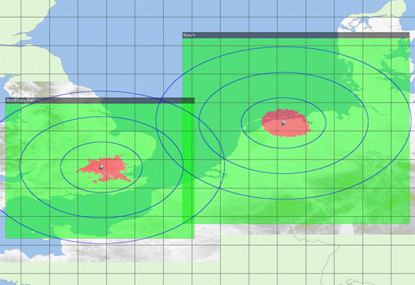
Figure 99: Exclusion areas based on long-term propagation
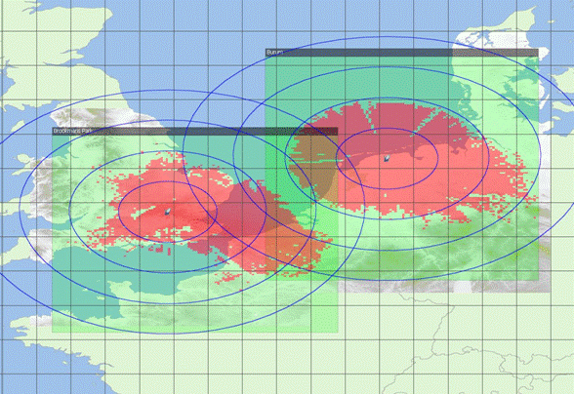
Figure 100: Exclusion areas based on short-term propagation
The results show for the long term interference criteria to be met, the required separation distances between the BDA2GC base-stations and FSS receiver is around 50 km, and with a worst case separation distance for these two example considered of around 85 km. For the short term propagation criteria to be met, the required separation distances increases to around 100-200 km in azimuths around the earth-station, but can extend up to 350 km in specific directions in a worse case
IMPACT FROM DA2GC AS ON FSS EARTH STATIONS
Interference may also be caused to FSS earth station receivers from BDA2GC aircraft transmissions. To assess the potential for interference two separate scenarios are considered: a “boresight” case, where it is assumed that an aircraft transmitter is sighted within the main beam of the FSS earth station antenna; and a “sidelobe” case, where it is assumed that any interference from the aircraft transmitter is received through the FSS earth station antenna sidelobes (having a gain of -10 dBi).
For the boresight scenario, as the occurrence of an aircraft within the main beam will typically be of short duration, the short term interference criterion is used. While for the sidelobe scenario, since interference may occur for long periods of time, the long-term criterion is used. For both scenarios, it is assumed interference occurs from a single aircraft transmitter having a minimum operating altitude of about 10,000 feet, and hence a minimum separation distance of 3 km is assumed. The increase in potential for interference from multiple transmitters or if the operational height is lower than assumed will need to be confirmed and is not taken into account.
Table 39: Interference from a single aircraft to a FSS earth station
 | Boresight | Sidelobe
Aircraft eirp (dBm in 4 kHz) | 6.4 | 6.4
Aircraft eirp (dBW in 4 kHz) | -23.6 | -23.6
Aircraft to earth station distance (km) | 3 | 3
Freq (MHz) | 3600 | 3600
Free space loss | 113.1 | 113.1
Earth station antenna gain (dBi) | 52 | -10
Polarisation discrimination (dB) | 2 | 0
Receiver noise in 4 kHz | -173.8 | -173.8
I/N | -1.3 | -10.2
I max in 4 kHz | -175.1 | -184.0
Interfernce received (dBW in 4 kHz) | -86.7 | -146.7
Excess interference (dB) | 88.4 | 37.3

In the case of boresight interference, the link budget analysis shows interference is received 88.4 dB above the criterion. Consequently, to remove this excess, the aircraft would need to be beyond line-of-sight of the FSS earth station, which for an aircraft at 40,000 feet, is beyond about 450 km from the earth station. While, in the case of interference through the sidelobes, the excess interference is 37.3 dB above the criterion. In this case to meet the interference criterion for sidelobe interference, the aircraft would need to be at least 220 km from the earth station. It is noted even if the aircraft transmission powers were reduced significantly the separation distances are still significant such that compatible co-frequency operation will not be possible.
Table 40 shows a similar analysis, but considering the receiver overload criterion. In this scenario, the potential for aircraft interference necessary to cause the earth station LNB to be overloaded is estimated.
Table 40: Interference from a single aircraft to a FSS earth station compared to overload criterion
 | Boresight | Sidelobe
Aircraft eirp (dBm) | 40 | 40
Aircraft to earth station distance (km) | 3 | 3
Freq (MHz) | 3600 | 3600
Free space loss | 113.1 | 113.1
Earth station antenna gain (dBi) | 52 | -10
Polarisation discrimination (dB) | 2 | 0
I max (dBm) | -50.0 | -50.0
Interference received (dBm) | -23.1 | -83.1
Excess interference (dB) | 26.9 | -33.1

The results show that interference may be cased to earth stations operating in different parts of C-band to BDA2GC systems. As these are frequency independent results, there is a high potential of receiver compression at FSS earth-stations when high power aircraft transmitters pass through the main beam of earth stations antennas.
CONCLUSIONS
The operation of BDA2GC base stations in any parts of the band 3400-3600 MHz would require coordination with FSS earth stations. The exclusion area would need to be determined on a case-by-case basis for each earth station. In the example cases considered in this contribution, in the case of co-frequency operations, the maximum exclusion distance is about 350 km. Although not analysed above, exclusion areas would also be required for BDA2GC base stations operating on different frequencies from the FSS earth stations. This would be necessary due to possible overload (or blocking) of the earth station LNB, and also due to reception of out-of-band emissions from the BDA2GC base station. Examples of required exclusion distances may be provided in due course.
The operation of BDA2GC aircraft stations would also require coordination with FSS earth stations. In the case of co-frequency operations, an aircraft operating within the visibility of an earth station could cause harmful interference. Assuming the maximum altitude of an aircraft of 40,000 feet, the visibility distance (assuming 2/3 earth radius for atmospheric refraction effects) is about 450 km. The potential area of operation of an aircraft station could be controlled by the location of the base stations. If the BDA2GC base station has a range of 100 km, the exclusion distance of the base station with respect to the FSS earth station would need to be extended by this amount to 550 km.
The operation of BDA2GC aircraft stations on different frequencies from the FSS earth station also has the potential to cause harmful interference, due to unwanted emissions from the BDA2GC aircraft station and due to overload of the earth station LNB. In principle, the possibility of overload could be avoided by the inclusion of filters at the earth station however the cost and practicality of adding filters would need to be assessed. As FSS receivers are of very wide-band band, it is viewed filtering will be greatly assisted if any operation of BDA2GC aircraft transmission are identified to specific channels and having a maximum separation with existing FSS earth-stations operations (e.g., identified for operation at frequencies close to 3400MHz instead of close to 3500 MHz).
The effect of receiver blocking can also be reduced if the maximum aircraft eirp is reduced from the 40dBm assumed and/or if directional antenna could be used for any BDA2GC systems deployed in the 3400-3600 MHz band. The potential for compression of FSS receivers through the main beam from interference from high power omni-directional BDA2GC aircraft transmissions should be noted.
COMPATIBILITY BETWEEN DA2GC AND IMT/IMT-A IN THE BAND 3400 – 3600 MHZ
The ECC approved Decision ECC/DEC/(11)06 on harmonised frequency arrangements for mobile/fixed communications networks (MFCN) (including IMT) operating in the bands 3400-3600 MHz and 3600-3800 MHz with the intention to facilitate high data rate International Mobile Telecommunications (IMT) services supported by larger channel bandwidths as an evolution to the existing framework in this band, without the consequential requirement for a replacement of systems based on the existing regulatory framework. Two different arrangements are provided for the implementation of either TDD or FDD operation. The TDD arrangement is based on a block size of 5 MHz starting at the lower edge of 3400 MHz.
- Frequency arrangement for the 3400-3600 MHz band based on TDD
The frequency arrangement is a TDD arrangement, based on a block size of 5 MHz starting at the lower edge of 3400 MHz.
If blocks need to be offset to accommodate other users, the raster should be 100 kHz. Narrower blocks can be defined adjacent to other users, to allow full use of spectrum. It has to be noted that TDD in one extreme case also covers downlink only operation.
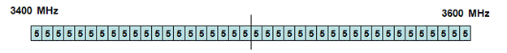
Figure 101: ANNEX 1 of Draft ECC/DEC/(11)HH on Harmonised frequency arrangements for mobile/fixed communications networks (MFCN) (including IMT) operating in the bands 3400-3600 MHz and 3600-3800 MHz
- Frequency arrangement for the 3400-3600 MHz band based on FDD
The frequency arrangement is an FDD arrangement, based on a block size of 5 MHz starting at the lower edge of 3410 MHz. The sub-band 3410-3490 MHz is used for the uplink, the sub-band 3510-3590 MHz is used for the downlink. The resulting duplex gap is 20 MHz (3490-3510 MHz).
If blocks need to be offset to accommodate other uses, the raster should be 100 kHz. Narrower blocks can be defined adjacent to other users, to allow full use of spectrum.
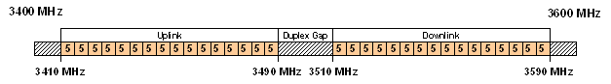
Figure 102: ANNEX 2 of Draft ECC/DEC/(11)HH on Harmonised frequency arrangements for mobile/fixed communications networks (MFCN) (including IMT) operating in the bands 3400-3600 MHz and 3600-3800 MHz
LTE SYSTEM CHARACTERISTICS
The terrestrial IMT/IMT-A system is assumed to be based on 3GPP LTE (also called E-UTRA) standard (Rel. 8 or higher) [1][2]. The unwanted emission requirements for LTE base stations are given in Table 41.
Table 41: Main parameters used for base station LTE (BS)
Parameter | LTE base station (BS)
 | FDD | TDD
Base station type | Macro | Macro
Environment | Rural | Rural
Cell radius (max.) | Up to 5 km (typically 3 km) | Up to 5 km (typically 3 km)
Tx power | 46 dBm | 46 dBm
Antenna type | 3 x 120° sector antenna  (90° half power beam width) | 3 x 120° sector antenna  (90° half power beam width)
Antenna gain | Up to 20 dBi | Up to 20 dBi
Antenna height | 30 m | 30 m
Antenna tilt | -2° (down-tilt) | -2° (down-tilt)
Channel bandwidth | 2 x 10 MHz | 15 or 20 MHz
Frequency re-use factor | 1 | 1
Signal bandwidth  (related to number of occupied resource blocks with bandwidth of 180 kHz) | 9 MHz | 13.5 or 18 MHz
Rx thermal noise | -104.5 dBm | -102.7 or -101.5 dBm
Rx noise figure | 5 dB | 5 dB
Rx noise floor | -99.5 dBm | -97.7 or -96.5 dBm
Rx reference sensitivity level | -101.5 dBm  (Note 1) | -99.7 or -98.5 dBm  (Note 1)
Interference protection ratio I/N | -6 dB | -6 dB
Interference protection level | -105.5 dBm  (Note 1) | -103.7 or -102.5 dBm  (Note 1)
Tx spectrum emission mask (SEM) / Spurious emissions | According to [7] | According to [7]
Adjacent channel leakage ratio (ACLR) limit | 45 dB  (Note 2) | 45 dB  (Note 2)
Rx in-band / out-of-band blocking | According to [7] | According to [7]
Rx adjacent channel selectivity (ACS) | 43.5 dB  (according to [7]) | 43.5 dB  (according to [7])
Note 1: In [14] the sensitivity level of -101.5 dBm is also applied for signal bandwidths above 10 MHz, as only up to 25 resource blocks (RB) are assigned to a single UE link, even if more RBs are feasible.
Note 2: In general the ACLR limit given in the table or the absolute limit of -15 dBm/MHz is valid, whichever is less stringent (macro BS according category B) [7].

For the LTE BS the vertical pattern given in ITU-R Rec. F.1336 was applied, which is usually used for compatibility studies with mobile radio and RLAN systems by ITU-R and CEPT workings groups. The diagram is shown in Figure 103. As proposed in the recommendation the side lobes are not explicitly used in the evaluations, only the approximated characteristic is applied.
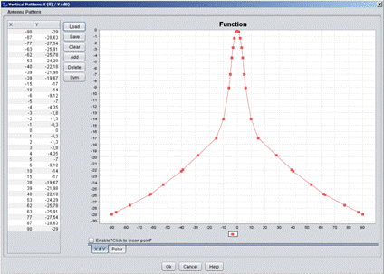
Figure 103: Vertical sector antenna pattern of the LTE BS according to ITU-R Rec. F.1336 (screen shot of SEAMCAT GUI; down-tilt not considered in the diagram)
Table 42: Main parameters used for mobile station LTE (UE)
Parameter | LTE mobile station (UE)
 | FDD | TDD
Tx power (max./min.)  (Note 1) | 23 dBm / -40 dBm | 23 dBm / -40 dBm
Antenna type | Omni-directional | Omni-directional
Antenna gain | 0 dBi | 0 dBi
Antenna height | 1.5 m | 1.5 m
Channel bandwidth | 2 x 10 MHz | 15 or 20 MHz
Signal bandwidth  (related to number of occupied resource blocks with bandwidth of 180 kHz) | 9 MHz | 13.5 or 18 MHz
Rx thermal noise | -104.5 dBm | -102.7 or -101.5 dBm
Rx noise figure | 9 dB | 9 dB
Rx noise floor | -95.5 dBm | -93.7 or -92.5 dBm
Rx reference sensitivity level | -97.5 dBm | -95.7 or -94.5 dBm
Interference protection ratio I/N | -6 dB
Interference protection level | -101.5 dBm | -99.7 or -98.5 dBm
Tx spectrum emission mask (SEM) / Spurious emissions | According to [6] | According to [6]
Adjacent channel leakage ratio (ACLR) limit | 30 dB  (according to [6]) | 30 dB  (according to [6])
Rx in-band / out-of-band blocking | According to [6] | According to [6]
Rx adjacent channel selectivity (ACS) | 33 / 30 / 27 dB for channel bandwidths of 10 / 15 / 20 MHz  (according to [6]) | 33 / 30 / 27 dB for channel bandwidths of 10 / 15 / 20 MHz  (according to [6])
Note 1: The Tx power of the mobile station is dependent on the power control implementation applied by the equipment provider.

The main difference is the maximum Tx power required at the aircraft to get access to the DA2GC BS at locations near the cell edge. The spectrum emission limits defined by 3GPP for LTE UEs are given in Table 43 (according to [6]).
Table 43: General LTE UE spectrum emission limits
Spectrum emission limits (dBm) / Channel bandwidth
Δf_{OOB}  (MHz) | 1.4  MHz | 3.0  MHz | 5  MHz | 10  MHz | 15  MHz | 20  MHz | Measurement bandwidth
± 0-1 | -10 | -13 | -15 | -18 | -20 | -21 | 30 kHz
± 1-2.5 | -10 | -10 | -10 | -10 | -10 | -10 | 1 MHz
± 2.5-2.8 | -25 | -10 | -10 | -10 | -10 | -10 | 1 MHz
± 2.8-5 |  | -10 | -10 | -10 | -10 | -10 | 1 MHz
± 5-6 |  | -25 | -13 | -13 | -13 | -13 | 1 MHz
± 6-10 |  |  | -25 | -13 | -13 | -13 | 1 MHz
± 10-15 |  |  |  | -25 | -13 | -13 | 1 MHz
± 15-20 |  |  |  |  | -25 | -13 | 1 MHz
± 20-25 |  |  |  |  |  | -25 | 1 MHz

CO-CHANNEL CASE
This section presents coexistence studies between a LTE base station in the frequency band 3400-3600 MHz and a BDA2GC AS located on an aircraft at various altitudes from 3000 to 13 000 meters.
Figure 104 below represents the average antenna gain in elevation for an omnidirectional antenna (with 0° tilt) calculated with the model from ITU-R recommendation F.1336.
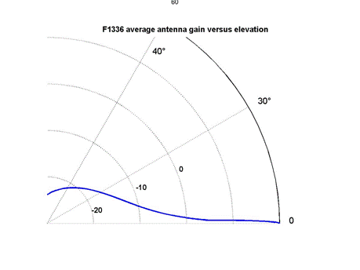
Figure 104: LTE BS antenna pattern in elevation for an omnidirectional antenna
METHODOLOGY
The intent is to study the compatibility between a LTE base station or a LTE-UE and a DA2GC AS in both directions (i.e DA2GC as interferer and then as victim).
The LTE base station (or LTE-UE) is considered to be located at (G0, L0).
When considering the LTE station as the victim and DA2GC AS as the interferer, the interference level arriving to the victim receiver from an aircraft at a given altitude H (from 3000 m up to 13 km) around the LTE station location (i.e. 1° by 1° horizontal square around (G0,L0)) is calculated and mapped as illustrated in the Figure 105 below.
When considering the LTE station as the interferer and DA2GC on board aircraft as the victim, the calculations are very similar since the antenna gain is the same in emission and reception for both systems. The only difference lies in the protection criterion and the emission levels to take into account.

I(i,j)
Victim
(G0, L0)
H=[3000-13000m]
1° by 1° horizontal plane around the victim at altitude H
Aircraft location (i,j)
Figure 105: Illustration of the configuration used for interferences calculations
Negative aircraft elevations relative to the victim receiver are suppressed. For positive aircraft elevations, the free space loss is used.

RESULTS OF IMPACT FROM DA2GC AS ON LTE BS
For Pe below 30 dBm: No interferences are observed whatever the aircraft altitude (i.e. from 3000m to 13000m)
For Pe=30 dBm, interferences occur at 3000m as figure below exemplifies. It can be noted that the DA2GC AS - LTE BS distance of 4365 m corresponding to the maximum distance where interferences occur equals a horizontal radius of 3171 meters. The black annulus in Figure 105 represent the aircraft position where I/N>=-6 dB. This happens for LTE BS – aircraft distances from 3514 m to 4365 m, and relative elevations between 58.62° and 43.40°.
For higher aircraft altitudes higher than 3000 m, the SNR ratio is below the protection criterion (I/N=< -6 dB).
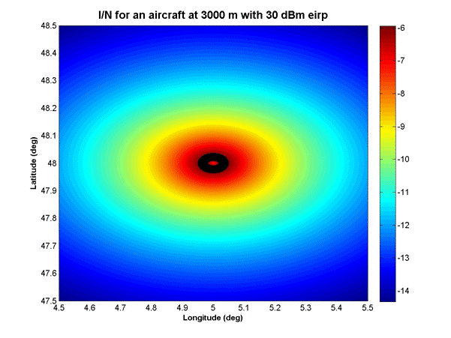
Figure 106: Interfering level at the LTE base station depending on the aircraft position for Pe=30dBm and H=3000m.
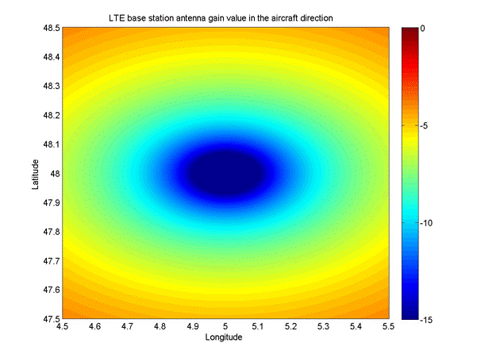
Figure 107: LTE BS antenna gain value in the aircraft direction flying at 3000m height. Maximum value is about -4 dBi at elevations lower than 2.26°, and minimum value is-23.8 dBi at zenith

For Pe=40 dBm, interferences occur for altitudes below 9 500 meters as figure below exemplifies. It can be noted that the DA2GC OBU - LTE BS distance of 11 199 meters corresponding to the minimum distance where interferences occur equals a horizontal radius of 5930 meters, thus interferences occur where the aircraft not above the LTE BS cell.
For aircraft altitudes higher than 9 500 meters, the SNR ratio is below the protection criterion.

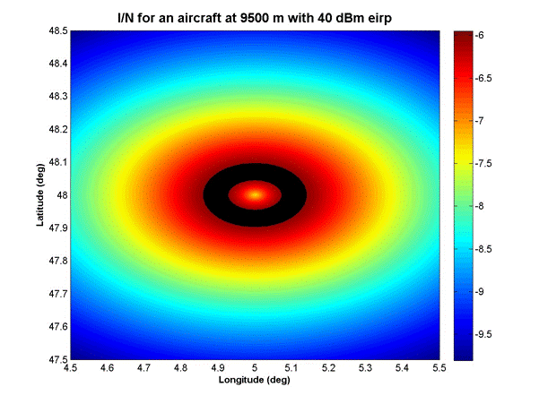
Figure 108: Interfering level at the LTE base station depending on the aircraft position for Pe=40dBm and H=9500m.

The black annulus represent the aircraft position where I/N>=-6 dB. This happens for LTE BS – aircraft distances from 11199m to 13703m, and relative elevations between 58° and 43.85°.

RESULTS OF IMPACT FROM DA2GC AS ON LTE UE
One the one hand the LTE-UE antenna gain value (0 dBi) is higher than the LTE-BS values in the aircraft direction (from -23 dBi to -4 dBi for an aircraft at 3000 meters).
On the other hand the protection criterion for LTE-UE receivers is 4 dB less stringent than for LTE-BS receivers.
Considering co-channel emissions, the critical DA2GC emission level is 11.5 dBm for LTE-UE (instead of 30 dBm for LTE BS see Fehler! Verweisquelle konnte nicht gefunden werden.). Below this value, no interferences are observed at the receiver level even at an aircraft altitude of 3000 m. With an emission power of 11.5 dBm, interferences occur when the aircraft flies above the LTE-UE at 3000 m altitude.

RESULTS OF IMPACT FROM LTE BS ON DA2GC AS
The DA2GC AS suffers from interferences for aircraft altitudes below 12000 m as Figure 109 shows. The black annulus represent the aircraft position where I/N>=-6 dB. This happens for LTE BS – aircraft distances from 14538 m to 16663 m, and relative elevations between 55.59° and 46.01°.

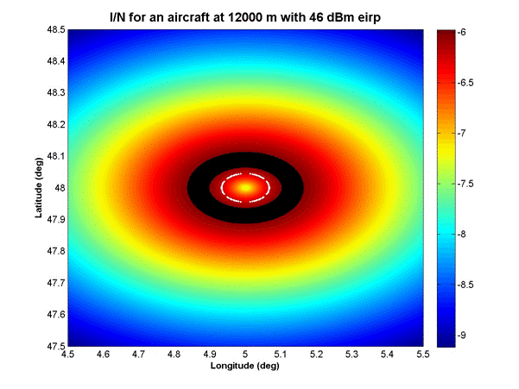
Figure 109: Interfering level at the DA2GC OBU from a LTE base station with Pe=46dBm and H=12000m.

RESULTS OF IMPACT FROM LTE UE ON DA2GC AS
Since the characteristics of LTE-UE and DA2GC AS are identical (protection criterion and antenna pattern), the calculations are the same considering DA2GC AS as interferer or victim and LTE UE as victim or interferer.
SUMMARY
Considering a DA2GC AS with an emission bandwidth of 10 MHz located on an aircraft at various altitudes above a LTE station with a 10 MHz bandwidth, the results can be summarized as follows:
Emissions from DA2GC-AS to LTE-BS
For DA2GC AS power emissions lower than 30 dBm, no interferences occur (whatever the aircraft altitude);
For a DA2GC AS power emission of 30 dBm, interferences occur at 3000m (see black annulus in Figure 5), but not for higher aircraft altitudes;
For a DA2GC AS power emission of 40 dBm, interferences occur until 9500m (see black annulus in Figure 6), but not for higher aircraft altitudes;
Emissions from LTE-BS to DA2GC-OBU
With a LTE-BS power of 46 dBm, interferences will occur at the DA2GC receiver for aircraft altitudes up to 12 km.
Coexistence between DA2GC-OBU and LTE-UE
If one of the systems (either DA2GC-AS or LTE-UE) have a power emission higher than 11.5 dBm, interferences occur if the distance between the LTE UE and the aircraft is less than 3000m;
ADJACENT CHANNEL CASE
For the simulations the block raster for FDD and TDD, respectively, is considered as a basis for implementing the DA2GC system, i.e. only full block numbers of N x 5 MHz are used for spectrum occupation.
Whereas for terrestrial mobile radio networks cross-border coordination between different countries can be applied to keep interferences between IMT/IMT-A systems on a sufficiently low level to avoid noticeable performance degradations, such a procedure is not suitable for a DA2GC system. Inter-frequency channel handovers between base stations are in principle supported by underlying system functionalities. However, due to the required large cell sizes of up to about 100 km and especially by the interference range an aircraft at high altitudes of more than 10 km would cause, a co-channel usage of the DA2GC system with terrestrial IMT/IMT-A systems is not feasible. The introduction of a DA2GC system would require a pan-European designation of the same frequency blocks with a single transmission mode (TDD or FDD). To be at least to some extent independent from the arrangements finally used in the different European countries, an implementation of a DA2GC system using TDD mode using the FDD duplex gap may be one possible solution, if compatibility can be achieved to neighbouring FDD and/or TDD blocks.
This section provides results on the compatibility between DA2GC and IMT/IMT-A in the band 3400-3600 MHz. The results correspond to simulations each with one

- DA2GC Base Station (BS)
- DA2GC aircraft incl. so-called Onboard Unit (OBU)
- IMT/IMT-A Base Station (BS)
- IMT/IMT-A User Equipment (UE).

INTERFERENCE SCENARIO

Figure 110 shows the general interference scenario considered in present evaluations, which is based on single service and interfering links for and in between both systems. The BSs itself can be co-located at the same site or placed at different sites.

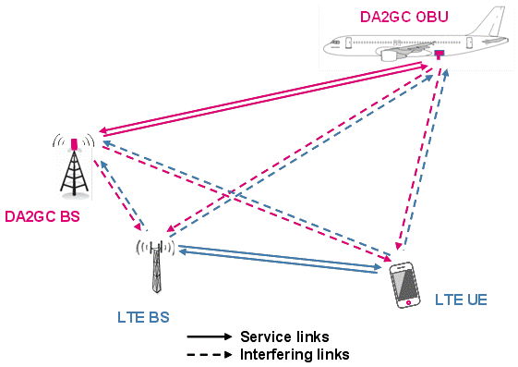

Figure 110: General interference scenarios considered (single link based)
This scenario describes the use of a TDD mode for the terrestrial LTE system as well as for the DA2GC system in an unsynchronized way, i.e. it may happen that one of the systems is transmitting in the downlink direction and the other simultaneously in the uplink (and vice versa) resulting in stronger interference levels compared to FDD transmission.

PROPAGATION MODELS

In the different service and interfering links in the considered scenario are exemplarily shown. There are strong differences in propagation conditions: In one case the transmitter/receiver is near the ground and its counterpart is at high altitudes (DA2GC) and in the other case both are near the ground resulting in additional path loss by terrain and clutter (classical mobile radio use case). Therefore, different propagation models were applied for service and interfering links as shown in Table 44.
Table 44: Propagation models applied for service and interfering links
Link | Link characteristic | Propagation model
DA2GC BS ↔ DA2GC AS | Service link | LOS (free space)
DA2GC GS ↔ LTE BS | Interfering link | LOS (free space)
DA2GC GS ↔ LTE UE | Interfering link | ITU-R P.452-14
DA2GC AS ↔ LTE BS | Interfering link | LOS (free space)
DA2GC AS ↔ LTE UE | Interfering link | LOS (free space)
LTE BS ↔ LTE UE | Service link | ITU-R P.452-14

The LOS model is based on the simple free space path loss model described in ITU-R Rec. P.525-2 [21]. It is applied for the links between the DA2GC AS at higher altitudes and the GS/BS or the LTE UE, respectively. For the link DA2GC AS ↔ LTE UE this is a worst case assumption, as even in a rural environment, the LOS link to the aircraft will be frequently obstructed by terrain or vegetation near the UE at the ground.
Details of the second model, which is suited to predict interference levels between stations at the Earth surface, can be found in ITU-R Rec. P.452-14 [22]. Both models are available in the SEAMCAT tool box. For the P.452-14 model parameters according to the chosen rural environment were set (see [5]). This model was also used in other sharing studies for IMT-A in the 3.5 GHz range (e.g. see [13]).

RESULTS (DETERMINISTIC)
GENERAL INFORMATION ON SCENARIO
Following results are based on the assumption that both GS and BS are co-located at the same site. In addition, adjustment of the sector antennas in the same direction is considered. The positions of the LTE UE as well as of the aircraft with the DA2GC AS are varied on a straight line in the main BS antenna beam (LTE UE for distances up to 5 km, DA2GC AS up to 100 km). Only results for the lowest altitude of the DA2GC AS (about 3 km) have been included in the present document, as this represents the worst case for the interference into the terrestrial LTE network.
For the interference protection ratio a I/N value of -6dB has been considered in the evaluations as already stated in Table 41 and Table 42 Two center frequencies for the LTE and DA2GC signal have been chosen from the middle of the 3400-3600 MHz band with a difference of 20 and 25 MHz each, i.e. the frequency guard band between the channel block edges is 0 and 5 MHz, respectively. The channel bandwidth of both signals is assumed to be 20 MHz, i.e. 100 RBs are assumed to be covered per OFDMA signal resulting in 18 MHz RF bandwidth [1][2].
As said before all evaluations are based on deterministic scenarios only. Statistical evaluations based on Monte-Carlo simulations with SEAMCAT will follow in the next step.

SENARIO 1: IMPACT FROM DA2GC AS INTO LTE SYSTEM
The next figures show the impact of the DA2GC AS on the terrestrial LTE network (see Figure 111 and Figure 112: Resulting I/N by interference caused by DA2GC OBU into LTE UE in the adjacent channel (frequency guard bands of 0 and 5 MHz between channel block edges)

The resulting I/N values are given in relation to the distance between the aircraft and the site with the 2 co-located BSs (please consider the non-linear scaling of the distance axis). Figure 112 it is assumed that the LTE UE is at a distance of 5 km from the site (cell edge).

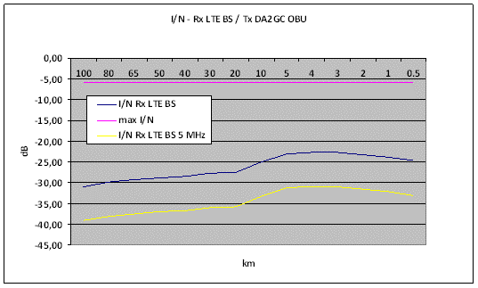
Figure 111: Resulting I/N by interference caused by DA2GC OBU into LTE BS in the adjacent channel (frequency guard bands of 0 and 5 MHz between channel block edges)
The results in Figure 111 are computed for the worst case, i.e. the DA2GC AS is always transmitting with highest power of 40 dBm. Normally the power control mechanism will reduce the Tx power when the aircraft is moving from the cell edge into the main coverage area of a DA2GC ground station, i.e. for the present scenario the I/N would be further reduced at distances nearer the site.
Nevertheless, as the cell size of the DA2GC system is much larger than the size of the LTE cells, the aircraft will often cross other base stations of the LTE network. In the worst case the aircraft is flying at cell edge transmitting with maximum power, and a LTE base station is near to the aircraft. This situation will frequently happen in real scenarios.
The resulting I/N values are below the threshold. This is mainly caused on one hand by the increased ACLR value as a result of an improved emission mask, and on the other hand there is always a signal strength attenuation for a path distance of at least 3 km. In case the DA2GC system should be in operation also for lower altitudes e.g. near airports, additional evaluations need to be performed.
The interference from the DA2GC AS into the LTE UE is also below the threshold (see Figure 112). The comments made before on power control are also valid for this scenario. As omni-directional antennas are assumed for both equipment parts, it is not expected that higher interferences will occur with possibly changed antenna diagrams at the aircraft, because this would result only in higher gain just below the horizontal aircraft plane having only impact at larger distances between the aircraft and the LTE UE, but in such cases the interference level is strongly reduced by the additional path loss.
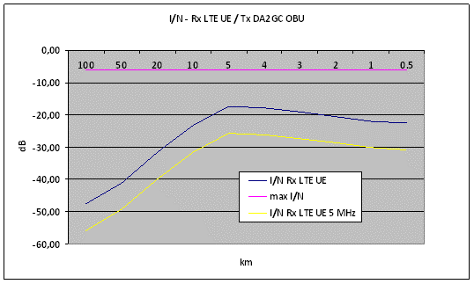
Figure 112: Resulting I/N by interference caused by DA2GC OBU into LTE UE in the adjacent channel (frequency guard bands of 0 and 5 MHz between channel block edges)

SENARIO 2: IMPACT FROM LTE UE INTO DA2GC
Similar to scenario 1 the next figures show the impact of the LTE UE on the DA2GC system. In addition the transmitter mask for the LTE UE has been implemented in SEAMCAT via the maximum emission limit settings given in Table 43 which results in a lower ACLR value compared to the 3GPP specification (about 24 dB instead of 30 dB). Therefore an additional margin of about 6 dB is available.
In Figure 113 the I/N values produced by the LTE UE at the DA2GC BS are given. With the adaptation of the GS antenna diagram (increased side lobe attenuation to the ground) the I/N values are below the threshold even for small distances.
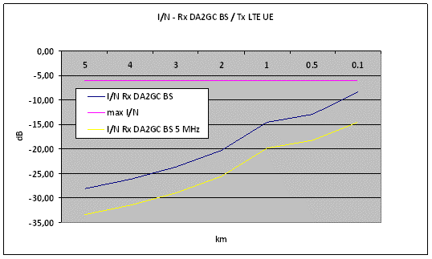
Figure 113: Resulting I/N by interference caused by LTE UE into DA2GC BS in the adjacent channel (frequency guard bands of 0 and 5 MHz between channel block edges)
Figure 114 shows the resulting I/N similar to Figure 112 in the opposite transmission direction with the LTE UE placed at a distance of 5 km from the site. Again the interference impact is negligible due to available path loss for a distance of at least 3 km.
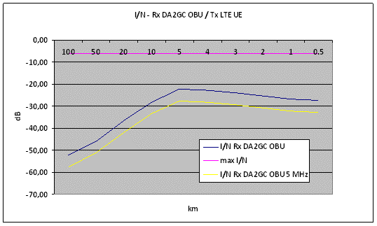
Figure 114: Resulting I/N by interference caused by LTE UE into DA2GC AS in the adjacent channel (frequency guard bands of 0 and 5 MHz between channel block edges)

SENARIO 3: IMPACT FROM DA2GC GS INTO LTE
Figure 115 provides the I/N values caused by the DA2GC GS at the LTE UE.
The threshold is exceeded for distances less than 1 km from the site. With 5 MHz guard band only the locations near the site are affected. As already noted the interference will have only low impact on the final performance in case of co-location of LTE BS and DA2GC GS, as it will decrease in the same manner as the power from the LTE BS service link will go down, i.e. the resulting S/I will stay in the same range or will be improved with increasing distance due to impact of different vertical antenna orientations (up-tilt vs. down-tilt).
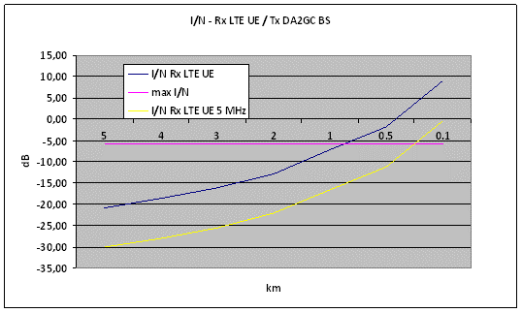
Figure 115: Resulting I/N by interference caused by DA2GC BS into LTE UE in the adjacent channel (frequency guard bands of 0 and 5 MHz between channel block edges)
The impact of co-location of GS and BS for unsynchronized TDD or TDD/FDD usage in adjacent frequency blocks is still a problem, even if the adaptation of the vertical BS antenna side lobes will reduce the disturbance caused by the Tx output of one station to the Rx input of the other station. With the parameter sets used for the evaluation in this document (incl. the path loss for vertical antenna distance of 20 m between both systems) and an ACLR value of 45 dB, about 15 dB additional isolation is required to keep the I/N threshold (6 dB with 5 MHz guard band).
Another issue is the co-location of GS and BS for unsynchronized TDD or TDD/FDD usage in adjacent frequency blocks. In that case the Tx output will disturb the Rx input of the other station (at least during certain time intervals). Possible solutions are seen in improved isolation between the antennas and in increased guard bands. Typical isolation values to be achieved at the same mast are in the order of about 50 dB [2]. Alternatively, the GS and BS have to be placed at different sites to achieve sufficient decoupling in between the antenna links via the resulting path loss.
There is also no difference to the case of common LTE deployments in frequency bands assigned to TDD usage or in bands with mixed FDD/TDD usage [2][15]. The only distinction in the DA2GC case is the GS antenna tilt in the vertical plane.
With the parameter sets used for the evaluation in this document (incl. the path loss for vertical antenna distance of 20 m between both systems) and an ACLR value of 45 dB, about 28 dB additional isolation are required to keep the I/N threshold.

SENARIO 4: IMPACT FROM LTE BS INTO DA2GC
As shown in Figure 116: Resulting I/N by interference caused by LTE BS on DA2GC AS in the adjacent channel (frequency guard bands of 0 and 5 MHz between channel block edges)

for this scenario the I/N threshold at the DA2GC OBU is kept due to sufficient high ACLR values of the LTE BS and the path loss between LTE BS and the aircraft. So even in the case the aircraft is near the edge of a DA2GC cell and also near a LTE BS, the coupling loss should be adequate to avoid any strong impact on the performance of the DA2GC link.
The impact from the LTE BS on the DA2GC GS is the same as the impact from the DA2GC GS on the LTE BS already described in subsection Fehler! Verweisquelle konnte nicht gefunden werden..
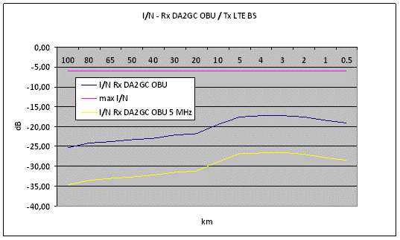
Figure 116: Resulting I/N by interference caused by LTE BS on DA2GC AS in the adjacent channel (frequency guard bands of 0 and 5 MHz between channel block edges)

DYNAMIC INTERFERENCE SCENARIOS
Except of static scenarios SEAMCAT allows to evaluate the impact of interferences in more realistic dynamic network scenarios similar to those applied e.g. for system level simulations, i.e. not only single static links are considered, but also connections between a homogeneous BS network to different users (UEs in the case of terrestrial LTE, OBUs in case of DA2GC), which are randomly placed in the coverage areas.
For both terrestrial LTE and Broadband DA2GC hexagonal cellular networks are applied with cells consisting of 3 sectors each. The main difference between both networks is the radius of the hexagonal cell, which is much smaller for terrestrial LTE. 6-20 shows an exemplary network constellation with DA2GC as victim system and LTE as interfering system. Due to drastically smaller cell radius the LTE network is only seen as the magenta colored part in the middle of the DA2GC network. For the evaluations the inter-site-distance (ISD) of DA2GC was set to 156 km which corresponds to a cell radius of approximately 90 km. The terrestrial LTE system has a radius of 4.33 km, i.e. the ISD is 7.5 km.
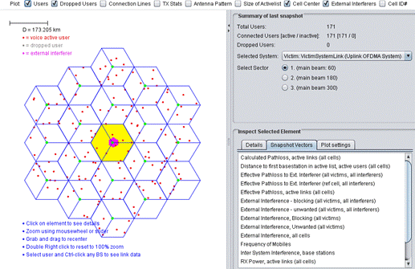
Figure 117: Exemplary network constellation for DA2GC as victim system and terrestrial LTE as interfering system (screen shot of SEAMCAT GUI)
Due to the large difference in the coverage areas of the 2 networks the interference evaluation in SEAMCAT cannot consider all possible situations that could occur in real world. To cover several samples a differentiation was made with respect to the placement of the network centers. The terrestrial LTE network was shifted by 4 km and 50 km, respectively, for some simulations, i.e. the center sites are not co-located in those cases.
For the Monte Carlo simulation it is assumed that always 5 mobile stations (MS, i.e. UEs and OBUs, respectively) are connected to a BS sector (red dots in Figure 117 for DA2GC). Therefore the signal bandwidth of both networks has to be split between the MSs. In the case of a signal bandwidth of 9 MHz used for simulation (LTE channel bandwidth of 10 MHz) 1.8 MHz will be assigned to each user (10 out of 50 resource blocks with bandwidth of 180 kHz each).
In contrast to the terrestrial LTE system where all UEs have the same antenna height of 1.5 m different altitudes have to be assigned to the aircraft OBUs. An altitude distribution has been selected according to a statistical evaluation for European continental air traffic for altitudes between 3 and 11 km. The corresponding cumulative distribution function is shown in Figure 118 (step size of 500 m). There is a higher probability of altitudes above 7 km as altitudes in the low range only occur during departure and landing phases.
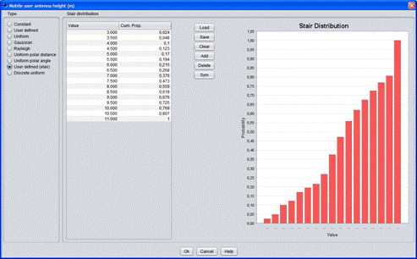
Figure 118: Cumulative distribution function of aircraft altitudes applied for Monte Carlo simulation (screen shot of SEAMCAT GUI)
The Monte Carlo simulation in SEAMCAT is running several repetitions, so called snapshots, for the placement of MSs within the coverage areas to produce results with certain reliability. The simulation was set to 1000 snapshots to guarantee high reliabilities (changes only in second position after decimal point). The exemplary output screen shot of SEAMCAT in Figure 119 is demonstrating the impact of interference on capacity and bit rate of the victim system for each performed snapshot. It has to be noted that SEAMCAT distinguishes between the impact on the inner reference cell (the yellow area in 6-20) and the total system (all cells incorporated).
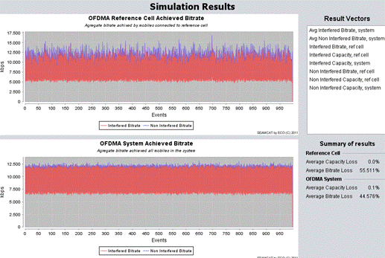
Figure 119: Exemplary output of dynamic compatibility evaluation (screen shot of SEAMCAT GUI)
To allow the determination of capacity and bit rate values in SEAMCAT based on resulting SINR information a suitable conversation curve is needed. In SEAMCAT a default link level data curve is already integrated for LTE systems according to a definition given by 3GPP in [7], which provides the link capacity in bit/s/Hz dependent on SINR. The curve shown in Figure 120 is applied for the terrestrial LTE system. For the DA2GC radio link the curve has been adapted according to measurement results performed under flight conditions with line-of-sight between BS and aircraft antenna (see Figure 121).
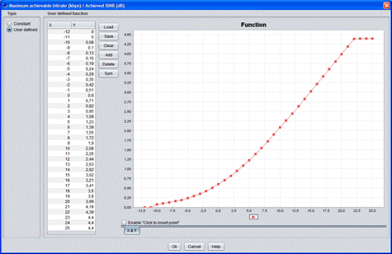
Figure 120: Link level data curve for conversion of SINR to capacity for terrestrial LTE (screen shot of SEAMCAT GUI)
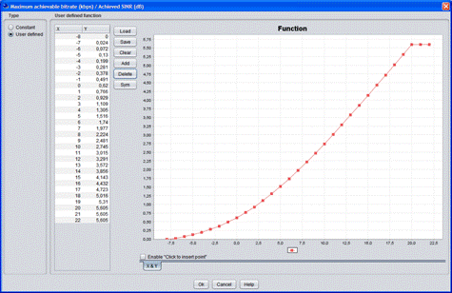
Figure 121: Link level data curve for conversion of SINR to capacity for DA2GC (screen shot of SEAMCAT GUI)

SYSTEM AND NETWORK PARAMETER
In the following table the main parameters for the signals and network constellations applied in the evaluations are summarized. Parameters not listed in Table 45 are unchanged compared to those given in for deterministic scenarios.
Table 45: Main parameters of signal and network constellations used in dynamic interference evaluations with SEAMCAT
Parameter | LTE |  | DA2GC
Parameter | Downlink | Uplink | Downlink | Uplink
Carrier frequency | 3500 MHz | 3500 MHz | 3510 / 3515 MHz | 3510 / 3515 MHz
Channel bandwidth | 10 MHz | 10 MHz | 10 MHz | 10 MHz
Signal bandwidth | 9 MHz | 9 MHz  (1.8 MHz/UE) | 9 MHz | 9 MHz  (1.8 MHz/OBU)
Number of mobile stations | 5 | 5 | 5 | 5
Link level data  (SINR to C) | 3GPP default  (Note 1) | 3GPP default  (Note 1) | Modified 3GPP  (Note 2) | Modified 3GPP  (Note 2)
Cell radius | 4.33 km | 4.33 km | 90 km | 90 km
ISD | 7.5 km | 7.5 km | 156 km | 156 km
BS antenna height | 30 m | 30 m | 50 m | 50 m
Vertical tilt of BS antenna | -2° | -2° | 10° | 10°
Vertical pattern of BS antenna | ITU-R F.1336 | ITU-R F.1336 | Cosecant-squared  (Note 3) | Cosecant-squared  (Note 3)
Gain BS / MS antenna | 17 dBi / 0 dBi | 17 dBi / 0 dBi | 15 dBi / 0 dBi | 15 dBi / 0 dBi
MS height | 1.5 m | 1.5 m | 3 - 11 km  (Note 4) | 3 - 11 km  (Note 4)
Note 1: Link level data applied according to 3GPP TS 36.814 [15]; see also Figure 120: Link level data curve for conversion of SINR to capacity for terrestrial LTE (screen shot of SEAMCAT GUI)

.
Note 2: Link level data applied according to Figure 121.
Note 3: Vertical antenna diagram according to Figure 2
Note 4: Altitude distribution of aircraft OBUs according to Figure 118 Figure 118: Cumulative distribution function of aircraft altitudes applied for Monte Carlo simulation (screen shot of SEAMCAT GUI)

RESULTS
In Table 46 the results achieved on the basis of the SEAMCAT Monte Carlo simulations are listed for the case that the terrestrial LTE system is interfered by a DA2GC system. As mentioned before different cases are considered related to the transmission direction (DL and UL), a possible frequency guard band of 5 MHz between the channel block edges of both signals and a offset of the centers of the two networks.
The impact of the DA2GC network on terrestrial LTE is generally very low except of the UL/DL case for co-located center sites (center offset equal to 0 km). Here the same interference influence arises as in the well-known deterministic case described before where the Tx output of one BS will disturb the Rx input of the other BS for unsynchronized TDD or TDD/FDD usage in adjacent frequency blocks. This is valid for the reference cell. If all cells are incorporated the system-based loss will get smaller, but it is still significant.
Table 46: Output of dynamic interference evaluations (capacity and bit rate loss) with SEAMCAT for terrestrial LTE as victim system and DA2GC as interfering system
Transmit direction  LTE / DA2GC | Output | Loss  [%] | Guard band [MHz] | Center offset [km] | Guard band [MHz] | Center offset [km] | Guard band [MHz] | Center offset [km]
Transmit direction  LTE / DA2GC | Output | Loss  [%] | 0 | 0 | 5 | 0 | 5 | 50
DL / DL | Reference cell | Capacity | 0.0 | 0.0 | 0.0 | 0.0 | 0.0 | 0.0
DL / DL | Reference cell | Bit rate | 0.001 | 0.001 | 0.001 | 0.001 | 0.001 | 0.001
DL / DL | System | Capacity | 0.1 | 0.2 | 0.2 | 0.1 | 0.2 | 0.2
DL / DL | System | Bit rate | 0.036 | 0.019 | 0.147 | 0.036 | 0.019 | 0.147
UL / DL | Reference cell | Capacity | 0.0 | 0.0 | 0.0 | 0.0 | 0.0 | 0.0
UL / DL | Reference cell | Bit rate | 45.534 | 38.856 | 0.0 | 45.534 | 38.856 | 0.0
UL / DL | System | Capacity | 0.401 | 0.2 | 0.2 | 0.401 | 0.2 | 0.2
UL / DL | System | Bit rate | 2.822 | 2.248 | 0.186 | 2.822 | 2.248 | 0.186
DL / UL | Reference cell | Capacity | 0.0 | 0.02 | 0.0 | 0.0 | 0.02 | 0.0
DL / UL | Reference cell | Bit rate | 0.0 | 0.55 | 0.0 | 0.0 | 0.55 | 0.0
DL / UL | System | Capacity | 0.0 | 0.006 | 0.1 | 0.0 | 0.006 | 0.1
DL / UL | System | Bit rate | 0.0 | 0.233 | 0.034 | 0.0 | 0.233 | 0.034
UL / UL | Reference cell | Capacity | 0.0 | 0.0 | 0.0 | 0.0 | 0.0 | 0.0
UL / UL | Reference cell | Bit rate | 0.001 | 0.001 | 0.001 | 0.001 | 0.001 | 0.001
UL / UL | System | Capacity | 0.0 | 0.201 | 0.0 | 0.0 | 0.201 | 0.0
UL / UL | System | Bit rate | 0.001 | 0.174 | 0.001 | 0.001 | 0.174 | 0.001

Also in the opposite case, i.e. when the DA2GC system is interfered by the terrestrial LTE system, the same behavior for the UL/DL case is perceptible, now with increased impact due to different antenna constellations at BSs (see Table 47). In the other cases the finally observable loss in the DA2GC transmission is negligible.
Table 47: Output of dynamic interference evaluations (capacity and bit rate loss) with SEAMCAT for terrestrial LTE as victim system and DA2GC as interfering system
Transmit direction  LTE / DA2GC | Output | Loss  [%] | Guard band [MHz] | Center offset [km] | Guard band [MHz] | Center offset [km] | Guard band [MHz] | Center offset [km]
Transmit direction  LTE / DA2GC | Output | Loss  [%] | 0 | 0 | 5 | 0 | 5 | 4
DL / DL | Reference cell | Capacity | 0.907 | 0.576 | 0.536 | 0.907 | 0.576 | 0.536
DL / DL | Reference cell | Bit rate | 1.05 | 0.885 | 0.923 | 1.05 | 0.885 | 0.923
DL / DL | System | Capacity | 0.252 | 0.198 | 0.228 | 0.252 | 0.198 | 0.228
DL / DL | System | Bit rate | 0.475 | 0.403 | 0.402 | 0.475 | 0.403 | 0.402
UL / DL | Reference cell | Capacity | 0.0 | 0.0 | 0.0 | 0.0 | 0.0 | 0.0
UL / DL | Reference cell | Bit rate | 100.0 | 100.0 | 37.155 | 100.0 | 100.0 | 37.155
UL / DL | System | Capacity | 0.0 | 0.0 | 0.0 | 0.0 | 0.0 | 0.0
UL / DL | System | Bit rate | 12.746 | 12.8 | 4.751 | 12.746 | 12.8 | 4.751
DL / UL | Reference cell | Capacity | 0.0 | 0.0201 | 0.0 | 0.0 | 0.0201 | 0.0
DL / UL | Reference cell | Bit rate | 0.054 | 0.02 | 0.026 | 0.054 | 0.02 | 0.026
DL / UL | System | Capacity | 0.003 | 0.002 | 0.102 | 0.003 | 0.002 | 0.102
DL / UL | System | Bit rate | 0.008 | 0.003 | 0.125 | 0.008 | 0.003 | 0.125
UL / UL | Reference cell | Capacity | 0.0 | 0.0 | 0.0 | 0.0 | 0.0 | 0.0
UL / UL | Reference cell | Bit rate | 0.396 | 0.134 | 0.393 | 0.396 | 0.134 | 0.393
UL / UL | System | Capacity | 0.3 | 0.0 | 0.3 | 0.3 | 0.0 | 0.3
UL / UL | System | Bit rate | 1.016 | 0.017 | 0.426 | 1.016 | 0.017 | 0.426

The evaluations with dynamic system behavior confirm the results achieved with the static scenarios. In particular, co-location of sites of both networks will lead to interference problems, except if both systems would operate in FDD mode.

CONCLUSIONS
The results for static worst case single link scenarios as well as for statistical network evaluations state that in principle a LTE-based DA2GC system can co-exist with a terrestrial mobile radio system with similar characteristics in the adjacent channel. This is primarily true if FDD mode operations are considered for both systems. No additional guard band between the channel block edges is required in that case.
For TDD or mixed FDD/TDD mode operations the main problem to be solved is the decoupling of the BS antennas which requires sufficient isolation in space and/or frequency or alternatively the usage of different sites for the systems. According to ECC decision ECC/DEC/(11)06 [24] both FDD and TDD arrangements for IMT/IMT-A systems in the band 3400 – 3600 MHz are possible in European countries in the future. Therefore, even with an implementation of DA2GC in FDD mode, frequency guard bands > 5 MHz would be required for deployment at least in countries with TDD arrangement for terrestrial IMT/IMT-A.

COMPATIBILITY BETWEEN DA2GC AND FSS IN THE BAND 3400 – 3600 MHZ
This document presents coexistence studies between a station from the Fixed Service in the frequency band 3400-3600 MHz and a BDA2GC aircraft station flying at an altitude from 3000 to 13 000 meters.
DA2GC AS PARAMETER
The DA2GC aircraft station characteristics used in this study are extracted from Chapter 4.1 and summed up in the following table:
Table 48: Characteristics of the DA2GC AS
Parameter | DA2GC aircraft station
 | FDD | TDD
Tx power (max./min.) | 40 dBm / -23 dBm | 40 dBm / -23 dBm
Antenna type | Omni-directional | Omni-directional
Antenna gain | 0 dBi | 0 dBi
Antenna height | 3000 - 13000 m | 3000 - 13000 m
Channel bandwidth | 2 x 10 MHz | 15 or 20 MHz
Signal bandwidth | 9 MHz | 13.5 or 18 MHz
Resulting e.i.r.p in dBm/MHz | 30.4/-32.5 dBm/MHz | 28.7/-34.3 dBm/MHz  27.4/-35.5 dBm/MHz
Rx noise floor (kTF) | -105.5 dBm/MHz | -105.5 dBm/MHz
Interference protection ratio I/N | -6 dB | -6 dB
Tx spectrum emission mask (SEM) / Spurious emissions | See Figure 123 | See Figure 123
Adjacent channel leakage ratio (ACLR) limit | 37 dB | 37 dB

DA2GC aircraft station Out-Of-Band emissions for the aircraft station are derived from Table 6.6.2.1.1-1 of the 3GPP TS 36.101, reproduced below in Figure 122.
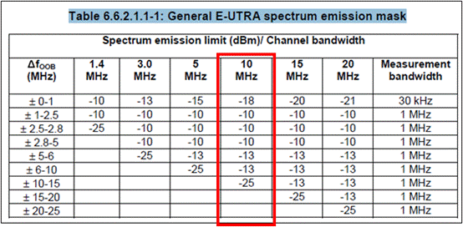
Figure 122: OOB spectrum emission mask for the aircraft AS
For a 10 MHz channel bandwidth, the DA2GC AS spectrum emission mask is illustrated Figure 123.
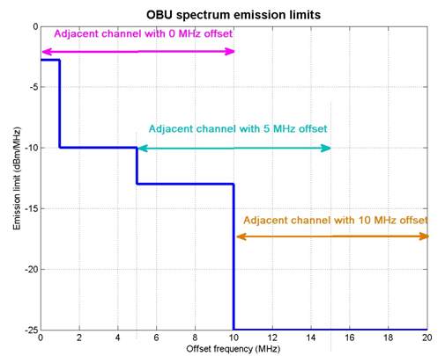
Figure 123: DA2GC spectrum emission limits for 10 MHz emission bandwidth
The total power in the 10 MHz adjacent channels is the following:
Table 49: DA2GC aircraft station emissions in adjacent bands
Frequency offset beween edges (MHz) | Power (in 10 MHz) (dBm)
0 | 0.715
5 | -5.74
10 | -15

FS PARAMETER
The characteristics of the FS stations are extracted from revised ITU-R F.758-4
Table 50: Characteristics of the FS stations from revised ITU-R F.758-4
Frequency range (GHz) | 3.600-4.200 |  | 3.700-4.200
Reference ITU-R Rec. | F.635 |  | F. 382
Modulation | 64-QAM | 512-QAM | QPSK
Channel spacing and receiver noise bandwidth (MHz) | 10,30, 40, 60, 80, 90 | 10,30, 40, 60, 80, 90 | 28, 29
Maximum Tx output power range (dBW) | −1 | 7 | 0
Maximum Tx output power density range (dBW/MHz) | −16…−11 | −9.0 | −15
Minimum feeder/multiplexer loss range (dB) | 0 | 3 | 3
Maximum antenna gain range (dBi) | 42 | 40 | 37
Maximum e.i.r.p. range (dBW) | 41 | 44 | 38
Maximum e.i.r.p. density range (dBW/MHz) | 26…31 | 28 | 23
Receiver noise figure (dB) | 3 | 2 | 4
Receiver noise power density typical (=NRX ) (dBW/MHz) | −141 | −142 | −140
Normalized Rx input level for 1 × 10–6 BER (dBW/MHz) | −114.5 | −106.5 | −126.5
Nominal long-term interference power density (dBW/MHz) | −141 + I/N | −142 + I/N | −140 + I/N
(3) There are two modulations (QPSK and 4FSK) described and QPSK is selected.

The formulas retained for the calculation of the antenna radiation patterns for FS-PP are the ones of the Recommendation ITU-R F.699 which is usually assumed in sharing studies when a single FS system is considered as victim/interferer.
For the antenna elevation, some countries reported an elevation range of 3 to 10 degree. Note that a range of maximum elevation angle from 15 to 30 degree has been reported in some countries in rare cases.
In order to stay in a neutral way and to simplify the calculation, an elevation angle of 0° for P-P FS links was retained to perform the studies. An azimuth direction of 45° was assumed.
Figure 124 shows the antenna gain towards an aircraft flying at 3000m and 13000m altitude considering a FS station which main beam is 45° in azimuth and 0° in elevation.
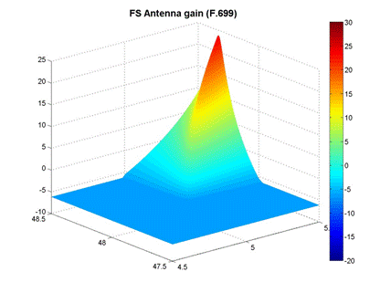
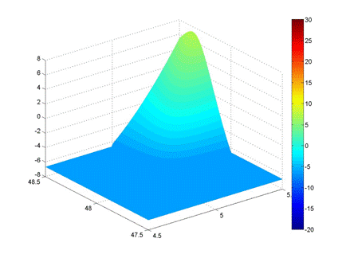
Figure 124: Antenna gain towards an aircraft located at 3000m altitude (top) and 13000m altitude (bottom) for a FS link of 45° azimuth and 0° elevation.
Regarding the I/N protection criteria, FS systems (for both P-P and P-MP systems) commonly adopt I/N ≤ 10 dB. It should be noted that ITU-R SG5 has recently confirmed this criterion in the draft revision of Rec. F.758-4.
Furthermore it is important to highlight that the same characteristics for 3.6-3.8 GHz frequency band can be used for the 3.4-3.6 GHz band.
The OOB emissions for the Fixed Service are described in Annex 12 of Recommendation ITU-R SM.1541. The emission mask is represented in Figure 125 and is used for studies in adjacent bands with the FS station as interferer.
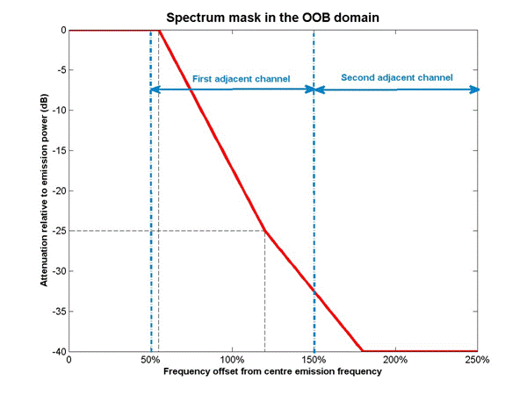
Figure 125: OOB emissions of the FS station

METHODOLOGY
The aim is to study the compatibility between a FS station and a DA2GC AS located on board an aircaft in both directions (i.e DA2GC as an interferer and then as a victim).
The FS station is located at (G0, L0).
When considering the FS station as the victim and DA2GC AS as the interferer, the interference level arriving to the victim receiver from an aircraft at a given altitude H (from 3000 m up to 13 000 m) around the FS station location (i.e. 1° by 1° horizontal square around (G0,L0)) is calculated and mapped with Matlab as illustrated Figure 126.
When considering the FS station as the interferer and DA2GC AS as the victim, the calculations are very similar since the antenna gains remain unchanged for both systems. The only difference lies in the protection criterion and the emission levels.
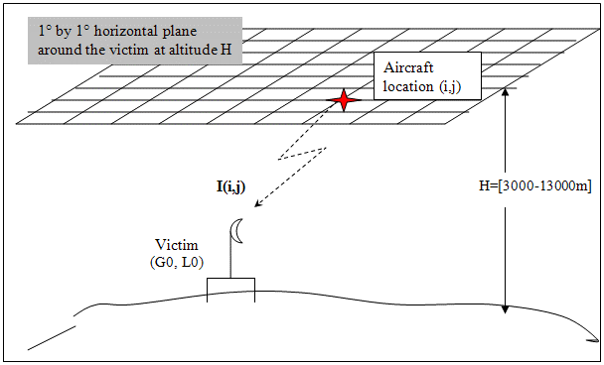
Figure 126: Illustration of the configuration used for interferences calculations
Negative aircraft elevations relative to the victim receiver are suppressed. For positive aircraft elevations, the free space loss attenuation is used.

IMPACT FROM DA2GC AS ON FSS
Co-channel case
By co-channel emission, it is meant that the DA2GC AS emission bandwidth covers the FS receiver bandwidth. Since the receiver bandwidth (10 MHz) is larger than the emission bandwidth (9 MHz), the power received by the FS station is the total emission of the DA2GC AS.
The maximum interference level is -111 dBm (-141 dBW) at the FS station receiver.
Considering a DA2GC AS with full power (40 dBm), the FS station I/N criterion is largely exceeded at 3000m and also at 13000m, whatever the aircraft position (see Figure 127)
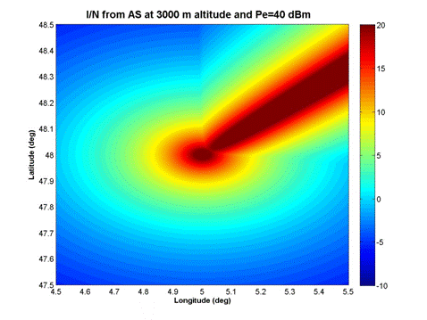
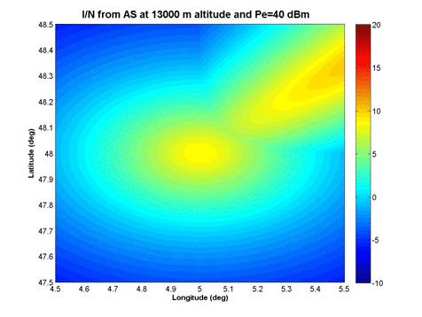
Figure 127: I/N level at the FS station from a DA2GC AS with 40 dBm emission power at 3000m (top) and 13000m (bottom) altitude.
When considering an aircraft at 3000m, interferences disappear when Pe is below 3 dBm and when considering an aircraft at 13000m, interferences disappear when Pe is below 20 dBm.
Full power emissions (40 dBm) from DA2GC-AS lead to interferences to the FS station whatever the aircraft altitude. To avoid interferences, the emission power of the DA2GC must not exceed 3 dBm.
Emissions in adjacent bands

From Figure 122, the power in a 10 MHz receiver in the first adjacent channel is 0.715 dBm, which is below the value of 3 dBm identified above for the DA2GC AS to cause no interferences. Therefore no interferences are expected if the FS receiver is in the first adjacent channel.

IMPACT FROM FSS ON DA2GC AS
Co-channel case
The maximum e.i.r.p. for the FS station is 41 dBW at 0° elevation and 45° azimuth, which correspond to a power emission of 0 dBW (30 dBm).
The maximum interference level is -101.5 dBm at the DA2GC receiver.
Thus the FS emission power is 10 dB lower than the maximum AS emission power and the protection criterion is about 10 dB less stringent, therefore the interferences from the SF station to the AS exists. As Figure 128 shows, an aircraft AS at 3000m altitude will suffer from interferences when the aircraft crosses the SF main lobe azimuth or fly just above the FS station. At 13000m, interferences are observed in the FS main lobe for elevations lower than 0.285°.
Interferences from the FS station to the DA2GC AS occur when the aircraft is in the same azimuth as the FS link (even at 13000m altitude).
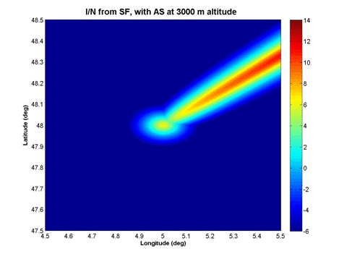
Figure 128: I/N level at the DA2GC AS at 3000m altitude from a FS station
Emissions in adjacent bands
Considering the OOB FS emission mask of Figure 3, the power received in the first adjacent channel of 10 MHz is about 22 dBm. This leads to interferences at the DA2GC-AS receiver in the FS link azimuth for aircraft altitudes lower than 6500m. Figure 129 show that the I/N criterion of -6 dB is exceeded when the aircraft crosses the FS link azimuth at 6000m altitude. For altitudes higher than 6500m, no interferences are observed.
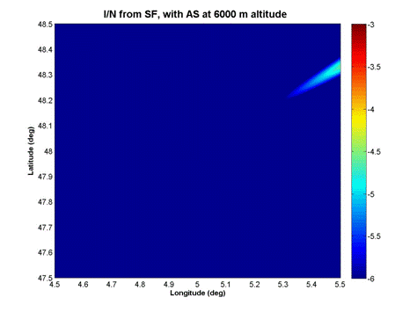
Figure 129: I/N level at the DA2GC AS at 6000m altitude from a FS station

CONCLUSIONS
The scenarios studied here show that coexistence in co-channel is not possible. Co-existence with an offset of 10 MHz (first adjacent channel) is possible, but interferences from FS link to DA2GC-AS may occur when aircraft is in the same azimuth as FS links.

- Capacity estimations for BroAdband DA2GC based on lte
This study tries to investigate what capacity and throughput a BDA2GC system based on LTE can achieve in a rural deployment scenario. The calculations are based on the Shannon bound with LTE specific corrections for effective frequency usage, overhead and pilot tones.
Possible uplink/downlink configurations for a LTE-TDD system are summarized in Table 51.
Table 51: LTE-TDD uplink/downlink configurations. D means downlink, U means uplink and S is the switch between downlink and uplink and consists of three parts, DwPTS(downlink part), GP(guard period) and UpPTS(uplink part).
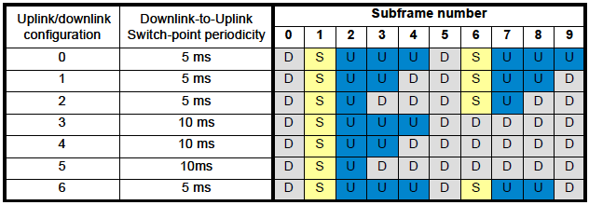

The different DwPTS, GP and UpPTS configurations are in the normal case:
Table 52: Normal LTE-TDD uplink/downlink configurations. The downlink part (DwPTS) can be 3, 9, 10, 11 or 12 symbols. Depending on the DwPTS value the guard period (GP) and the uplink can differ.
 | DwPTS
 | 12 | 11 |  | 10 |  | 9 |  | 3
GP | 1 | 1 | 2 | 2 | 3 | 3 | 4 | 9 | 10
UpPTS | 1 | 2 | 1 | 2 | 1 | 2 | 1 | 2 | 1

Capacity estimations are based on different uplink/downlink configurations as well as different configurations of the special subframe S in order to establish both a best case and a worst case configuration scenario.
The Shannon bound
The channel capacity is the tightest upper bound on the amount of information that can be reliably transmitted over a communications channel in a given scenario (bandwidth, noise and interference).
For a SiSo (single input, single output) system the Shannon bound is (in bits per Hertz). All equations are in logarithmic scale (dB)
$SiSo=\log_{2}\left(1+{10}^{S/{10×N}}\right)$ $\left[\frac{Bit}{Hz}\right]$
For multi antenna systems the theoretical increase in SNR is maximum = N_{receive} × N_{transmit} for none correlated paths.
In figure 1 the Shannon bound for different antenna configurations are depicted. Perfect orthogonality is assumed.
Figure 130: The Shannon bound from SiSo up to 4×4×4 MiMo (4 streams).
Transport capacity of LTE
From a radio point of view, LTE is very close to the Shannon bound and in the following calculations LTE is assumed to have a channel capacity that is only limited by the Shannon bound. This slightly overestimates the LTE capacity but is accurate enough for this study.
Spectral efficiency
The spectral efficiency of a LTE system can be calculated as
$$Spectral efficiency=\frac{BW}{ChBW}$$
Where BW is the bandwidth and ChBW is the channel bandwidth.
BW is calculated by multiplying the number of resource blocks with the subcarrier spacing and the number of subcarriers per resource block.
That is
$$SE=\frac{NRB×SCS×RB}{ChBW}$$
For a 20 MHz (ChBW) LTE system:
NRB (Number of Resource Blocks) = 100
SCS (Sub Carrier Spacing) = 15×10³
RB (Number of subcarriers per Resource Block)
Hence the spectral efficiency of a 20 MHz LTE system is 0,90.
Time domain structure
With normal prefix structure a LTE system transmits 14 OFDM symbols per subframe. With extended prefix structure 12 OFDM symbols are transmitted in one subframe. Each symbol is nominally (1/spectral efficiency).
The efficiency in the time domain can be calculated as
$$TD efficiency=\frac{Number of OFDM symbols per frame}{Length of subframe×spectral efficiency}$$
The length of a subframe is 1 ms, the number of OFDM symbols are 14 or 12 depending on the structure (normal structure gives 12 OFDM symbols per subframe). The spectral efficiency can be calculated as explained in the previous section.
For a LTE system with spectral efficiency of 0,9 that is transmitting 14 OFDM symbols each subframe the TD efficiency is
$TD E=\frac{14}{1×{10}^{-3}×0,9}=$ 0,93
Pilot tones
During one slot (7 symbols, 0,5 ms) 4 reference symbols are transmitted in each resource block. This leads to a reduction of 4/(12*7) for a SiSo system.
For MiMo systems the overhead is increased due to the fact that only one antenna can send a reference signal on each carrier at a specific time. This gives 4×2×2 occupied slots and a reduction of 2×2×4/(12×7×2) for a 2 MiMo system.
A 4 MiMo system has a reduction of (4×2+2×2) ×4/(12×7×4).
Control signaling overhead
In each subframe the 1-3 first symbols are used for control signaling, since there is no mixing of control signaling and data in an OFDM symbol. The more users in a cell, the more control signaling is needed, for the BDA2GC system only 1 symbol for control signaling is assumed.
This gives an available payload of $\frac{14-1}{14}$.
Uplink/downlink configuration
If uplink/downlink configuration number 1 (in Table 51) is used, 4 out of 10 subframes are used for downlink. 2 subframes are switch subframes and 4 are used for uplink. In the switch subframes 3-12 symbols can be used for downlink transmission. This gives a downlink efficiency of
((4×14+2×3)/(10×14) to (4×14+2×12)/(10×14) = 44 to 57 [%]
Capacity for a LTE system as a function of SNR
A LTE system (considered to be on the Shannon boundary) that is subject to the above reductions the result (as a function of Signal to Noise ratio) have a channel capacity that is depicted below, this capacity includes the payload header that needs to be removed before the “user data capacity” is calculated.
Figure 131: Channel capacity for a 20 MHz LTE TDD with different uplink/downlink configurations that gives a downlink efficiency of 44 % and 57 %.
Sharing between RLAN and BDA2GC in the 2,4 GHz band.
In the license exempt 2,4 GHz band numerous transmitters are deployed, the most common are RLAN and Bluetooth. RLAN has been chosen as the aggressor in this sharing study.
Deployment scenario of BDA2GC Base stations according to ETSI TR 103 054.
A BDA2GC cell radius is 150 km and the base station EIRP is 55 dBm.
The RLAN density is 50 RLAN per square km for the rural case. It is assumed that RLAN frequencies are equally spaced in the 2.4 GHz band, i.e. ¼ of the RLAN is transmitting co-channel with the BDA2GC system, resulting in an effective density of 12.5 transmitters per square kilometer.
Rural case
Assuming free space attenuation between the BDA2GC terminal (aircraft) and both the BDA2GC base station and all RLANs. The RLANs are considered to be equally spaced in a circle with 150 km radius. All RLANs are assumed to transmit with 20 dBm (EIRP)
The aggregated co-channel interference from RLAN to the BDA2GC terminal is plotted below as a function of radius, as can be seen in the picture the aggregated interference from RLAN is asymptotically approaching -57 dBm.
Figure 132: Title (style: Caption)

Interference from adjacent bands as well as the channel leakage is assumed to be magnitudes lower than the co channel interference and is therefore not part of the study.
One can easily see that the aggregated interference is asymptotically reaching -57 dBm. As this value is roughly 40 dB higher than the internal noise in the BDA2GC receiver the internal noise is not a limiting factor in the sharing between RLAN and BDA2GC and thus the Signal to Interference ratio will be used in the channel capacity calculations.
BDA2GC channel capacity in the rural case, aircraft on cell edge
The BDA2GC base station, when transmitting 55 dBm to an aircraft on 10 000 m height at the cell edge, is approximately 150 km away from aircraft and will give a received power of 55 (TX EIRP) – 144 (Free space loss) = -89 dBm.
Since the aggregated co channel interference is -57 dBm /20 MHz the signal to interference ratio is -32 dBm.
When the signal to interference ratio is used as SNR in the Shannon model one can see that the maximal channel capacity is almost zero.
Interference from other base stations
On the border between two cells a terminal, belonging to one of the cells, will experience interference from the other cell. This interference will increase the interference and thereby influence the maximal throughput.
Network scheduling
The scheduler controls the allocation of available resources among users at each given time. Depending on the chosen scheduling algorithm and radio environment, a terminal (in a multi terminal environment) is given a ratio of the available resources.
Conclusion on DA2GC according to ETSI TR 103 054
The interference produced by RLANs in the 2400 to 2483.5 MHz frequency range will severely reduce the throughput in the BDA2GC system and for this reason the 2.4 GHz band is not viable for BDA2GC deployment.
Deployment scenario of BDA2GC Base stations according to ETSI TR 101 599.
A BDA2GC cell radius is 90 km and the base station EIRP is 48 dBm.
The RLAN density is 50 RLAN per square km for the rural case. It is assumed that RLAN frequencies are equally spaced in the 2.4 GHz band, i.e. ¼ of the RLAN is transmitting co-channel with the BDA2GC system, resulting in an effective density of 12.5 RLAN transmitters per square kilometer. At any instant, half of the RLAN’s is considered to be transmitting. This gives a density of RLAN’s that can interfere with the aircraft station of 6,25 RLAN’s per square kilometer.
Rural case
Assuming free space attenuation between the BDA2GC terminal (aircraft) and both the BDA2GC base station and all RLANs. The RLANs are considered to be equally spaced in a circle with 150 km radius. All RLANs are assumed to transmit with 20 dBm (EIRP)
Interference from RLAN’s in a rural scenario.
In order to investigate the effect from the aggregated interference from all (from the aircraft visible) RLANs the aircraft station beamforming antenna must be taken into account. Since the system uses beamforming the received interfering power is depending on the angle (as seen from the aircraft station) between the (wanted) signal from the base station and the interfering signal from each RLAN. All affecting RLANs in each square kilometer is (6,25 RLAN tranmitters, see above), for computational reasons, replaced with one transmitter (with increased power 6,25×20 dBm = 28 dBm) in the center of each square kilometer. This does not affect the outcome of the following calculations.

The interference is calculated in the following way:
- A position for the base station is fixed, and the angle (and thereby the antenna gain), a1, b1, c1 etc, to each of the combined transmitters (in each square kilometer) is calculated (assuming free space loss) and the cumulative interfering power is stored as belonging to this position.

a₁

b₁

c₁
Base station
Interference sources (WLAN)

- The base station position is moved to another position and the process in 1. is repeated.
- This is repeated for all possible base station positions, giving the next Figure
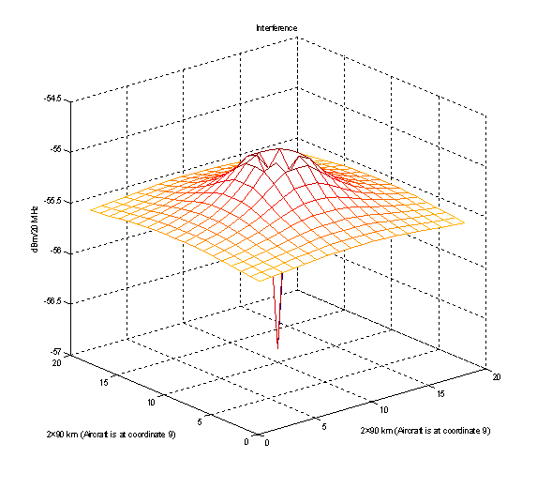
Signal strength from different base station positions relative to the aircraft station and resulting signal to interference ratio.

The received signal strength from each base station position is calculated using the same free space assumption as above, giving the Figure below.

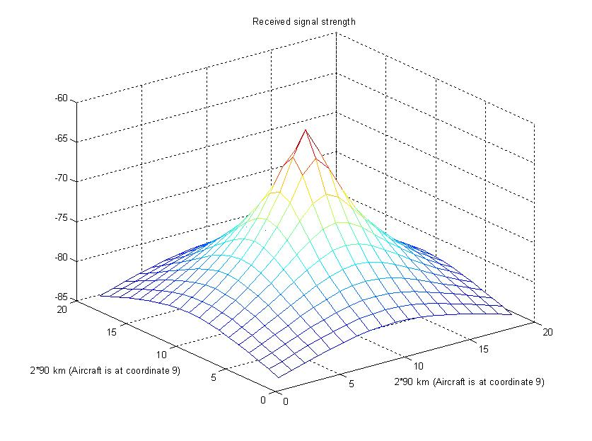
The resulting signal to interference ratio is:
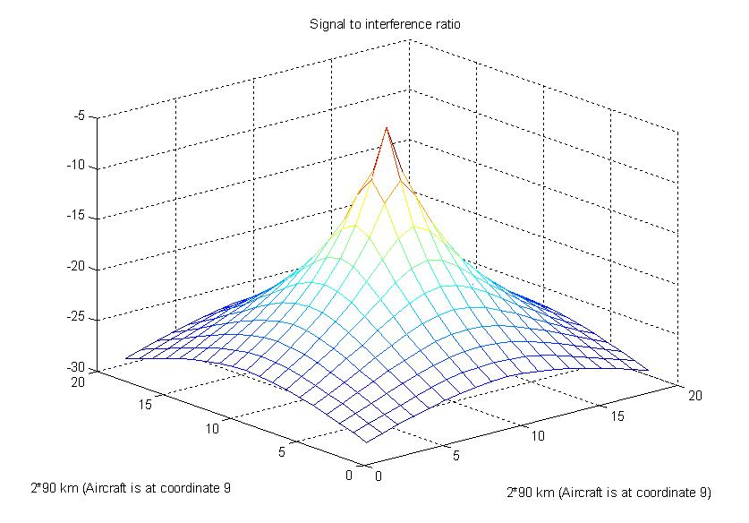
The best signal to interference ratio is achieved when the base station is located directly under the aircraft, in this position there are two conditions that are maximizing the signal to interference ratio; 1. the distance between aircraft station and ground station is minimized and 2. the main lobe foot print is also minimized compared to all other main lobe directions. The signal to interference ratio is however very low even when the base station is located directly under the aircraft, -5 dB.

Interference from adjacent bands as well as the channel leakage is assumed to be magnitudes lower than the co channel interference and is therefore not part of the study.
BDA2GC channel capacity in the rural case.
The BDA2GC base station, when transmitting 25+23 = 48 dBm (eirp) to an aircraft on 10 000 m height at the cell edge, is approximately 90 km away from aircraft and will give a received power of 48 (TX EIRP) + 10 dB (antenna gain in aircraft receiver) – 139 (Free space loss) = -81 dBm.
The aggregated co channel interference from all RLANs (when the aircraft is on the cell edge) is -55 dBm /20 MHz the signal to interference ratio is -36 dBm When the aircraft is right above the base station the received signal is 48 dBm (eirp) + 10 dB (antenna gain in aircraft receiver) – 120 dB = -62 dBm. The interference seen from the aircraft is -57 dBm. This gives a signal to interference ratio of -5 dBm. When the signal to interference ratio is used as SNR in the Shannon model one can see that the maximal channel capacity is almost zero.
Interference from other base stations
On the border between two cells a terminal, belonging to one of the cells, will experience interference from the other cell. This interference will increase the interference and thereby influence the maximal throughput.
Network scheduling
The scheduler controls the allocation of available resources among users at each given time. Depending on the chosen scheduling algorithm and radio environment, a terminal (in a multi terminal environment) is given a ratio of the available resources.
Conclusion on DA2GC according to ETSI TR 101 599
The interference produced by RLANs in the 2400 to 2483.5 MHz frequency range will severely reduce the throughput in the BDA2GC system even when the BDA2GC system is equipped with a beamforming antenna and for this reason the 2.4 GHz band is not viable for BDA2GC deployment.
- List of reference
- 3GPP TS 36.300: Evolved Universal Terrestrial Radio Access (E-UTRA) and Evolved Universal Terrestrial Radio Access Network (E-UTRAN); Overall description; Stage 2; V10.4.0, June 2011.
- Holma, H.; Toskala, A.: LTE for UMTS – OFDMA and SC-FDMA Based Radio Access; John Wiley & Sons, 2009.
- ETSI TR 103 054: Electromagnetic compatibility and Radio spectrum Matters (ERM); System Reference Document; Broadband Direct-Air-to-Ground Communications operating in part of the frequency range from 790 MHz to 5 150 MHz; V1.1.1, July 2010.
- ECC Report 93: Compatibility between GSM equipment on board aircraft and terrestrial networks; May 2008.
- European Communications Office (ECO): SEAMCAT handbook; January 2010.
- 3GPP TS 36.101: User equipment (UE) radio transmission and reception; V10.3.0, June 2011.
- 3GPP TS 36.104: Base station (BS) radio transmission and reception
- 3GPP TS 25.104: Base station (BS) radio transmission and reception (FDD).
- 3GPP TS 25.101: User equipment (UE) radio transmission and reception (FDD).
- ETSI EN 300 175-2 “Digital Enhanced Cordless Telecommunications (DECT); Common Interface (CI); Part 2: Physical Layer”.
- CEPT SE7(12)020: Reference information from DECT Forum to the Guidance paper on DECT antenna gain.
- ITU-R Report M.2109: Sharing studies between IMT-Advanced systems and geostationary satellite networks in the fixed-satellite service in the 3400-4200 and 4500-4800 MHz frequency bands; 2007.
- ITU-R Report M.2111: Sharing studies between IMT-Advanced and the radiolocation service in the 3400 – 3700 MHz bands; 2007.
- ITU-R Report M.2039: Characteristics of terrestrial IMT-2000 systems for frequency sharing/ interference analyses; November 2010.
- 3GPP TS 36.814: Technical Specification Group Radio Access Network; Evolved Universal Terrestrial Radio Access (E-UTRA); Further advancements for E-UTRA physical layer aspects; V9.0.0, March 2010.
- ITU-R Rec. P.528-3: Propagation curves for aeronautical mobile and radionavigation services using the VHF, UHF and SHF bands; February 2012.
- CEPT ERC/Recommendation 74-01: Unwanted emissions in the spurious domain; January 2011
- ITU-R Rec. SA.1154: Provisions to protect the space research (SR), space operations (SO) and Earth exploration-satellite services (EES) and to facilitate sharing with the mobile service in the 2 025-2 110 MHz and 2 200-2 290 MHz bands; 1995.
- Ng, M.H.; Lin, S.; Li, J.; Tatesh, S.: Coexistence studies for 3GPP LTE with other mobile systems; IEEE Communications Magazine, April 2009.
- ITU-R Rec. F.1336-2: Reference radiation patterns of omnidirectional, sectoral and other antennas in point-to-multipoint systems for use in sharing studies in the frequency range from 1 GHz to about 70 GHz; 2007.
- ITU-R Rec. P.525-2: Calculation of free-space attenuation; August 1994.
- ITU-R Rec. P.452-14: Prediction procedure for the evaluation of interference between stations on the surface of the Earth at frequencies above about 0.1 GHz; October 2009
- CEPT FM(11)008: Qualcomm / Information about the impact of antenna selection on the design, practical implementation and performance of a DA2GC system; March 2011
- ECC/DEC/(11)06: Harmonised frequency arrangements for MFCN operating in the bands 3400-3600 MHz/3600-3800 MHz; December 2011.
- ITU-R Rec. M.1638: Characteristics of and protection criteria for sharing studies for radiolocation, aeronautical radionavigation and meteorological radars operating in the frequency bands between 5 250 and 5 850 MHz (2003)
- ITU-R Rec. S.465-6: Reference radiation pattern of earth station antennas in the fixed-satellite service for use in coordination and interference assessment in the frequency range from 2 to 31 GHz (01/2010)
- ITU Radio Regulations (Edition of 2008).
- ETSI EN 300 328 (V1.8.1): "Electromagnetic compatibility and Radio spectrum Matters (ERM); Wideband transmission systems; Data transmission equipment operating in the 2,4 GHz ISM band and using wide band modulation techniques; Harmonized EN covering the essential requirements of article 3.2 of the R&TTE Directive".

The quoted TX output power level is the total transmit power delivered to all antennas and antenna elements of a single ground station or aircraft station antenna array when the transmitter is operating at its maximum power level.
This is the level of the first sidelobe.
Power control is exercised over a 14.7 dB range.
Power control is exercised over a 14.7 dB range.
No value is provided in Recommendation ITU-R M.1368, therefore for the compatibility analyses a value of -40dB was considered.
Intentional overly positive assumption

