ECC Report <No>

Assessment of the technical feasibility of introducing very narrow channel spacing (e.g. similar channel spacing, 25 kHz to 2 MHz, to those used in 1375-1400/1427-1452 MHz) in some existing plans, in guard bands and center gaps of FWS channel arrangement between 3 GHz and 15 GHz

**Month YYYY (Arial 9pt bold)**

# Executive summary

The aim of this report is to assess the feasibility of introducing narrow channel spacings for FS (25 kHz to 2 MHz), similar to those used in 1375-1400/1427-1452 MHz in some existing plans, in guard bands and center gaps of FS channel arrangement between 3 GHz and 15 GHz in terms of the compatibility and sharing considerations with others services as well as within the FS. These narrow channel FS links are used for fixed wireless services for a variety of applications including broadcasting, fixed networks, Oil & Gas, public safety and utilities, often for long hop narrowband communications. The largest users are public safety and utilities sectors. In developing this report it should be noted that the feasibility of using the bands within the range 3 to 15 GHz, for the applications that are currently used in the band 1375-1400/1427-1452 MHz (in terms of hop length and link design), was not part of this work.

During this study, no information have been presented on the feasibility of FS equipment to facilitate these narrow channels on the 6 and 10 GHz bands as well as the availability of the equipment currently on the market supporting these channels. However, one administration who currently implement a large number of links operated in the 1375/1400 – 1427/1452 MHz band, indicated a steady increase of the need for implementing narrow

The feasibility of narrow channels from compatibility/sharing point of view with others services and within FS for the following bands was carried out:

* Compatibility studies carried out for the 10 GHz band, have shown that implementation of narrow channels in guard band and/or center gap would adversely impact the incumbent services, especially those below 10.5 GHz. However, from 10.5 to 10.6 GHz and with additional channels arrangements to those currently presented in CEPT/ERC Recommendation 12-05, the 10 GHz band may be considered.
* The compatibility studies carried out for the 6 GHz band indicate that feasibility of small channel is possible in guard bands and/or center gap. Although the 6 GHz band is already allocated to fixed services as a primary allocation, several scenarios have been considered to take into account the impact of the increase of spectral power density with respect to other services like FSS. It must be noted that worst cases scenarios have pointed out the need of coordination between new FS using these small channels and other incumbent FS uses, as usually done in fixed service planning.

In summary, this report presents different options for those administrations wishing to implement narrow channels which could be considered at national level taking into account the above considerations.

**TABLE OF CONTENTS**

0 Executive summary 2

1 Introduction 6

2 CHARACTERISTICS OF VERY NARROW CHANNEL SPACINGS IN THE BAND 1375-1400/1427-1452 MHZ 7

2.1 RECOMMENDED FREQUENCY BAND PLAN FOR THE 1375-1400/1427-1452 MHZ 7

2.2 SYSTEM PARAMETERS FOR POINT-TO-POINT FS SYSTEMS 8

2.2.1 General parameters 8

2.2.2 FS spectrum emission masks to be used in the 1.4 GHz band 9

2.3 NATIONAL EXAMPLE OF NARROW CHANNEL SPACINGS DEPLOYMENTS 10

2.3.1 Example in France (1375-1400/1427-1452 MHZ) 10

2.3.2 Example in the UK (1350-1375//1492-1517MHz band) 11

3 FREQUENCY BANDS CONSIDERED FOR THE INSERTION OF THE NARROW CHANNELS 12

3.1 10 GHZ BAND 12

3.1.1 Allocation in 10 GHz band 12

3.1.2 Allocation in 10 GHz band 12

3.1.3 FS in the 10 GHz band 13

3.1.4 Characteristics of systems working in the 10.3-10.5 GHz band center gap 15

3.1.4.1 Video Services Ancillary to Program-making/Services Ancillary to Broadcasting (SAP/SAB) links ENG/OB 15

3.1.4.2 Fixed Services Point to Multipoint in 10.15-10.68 GHz frequency band 17

3.1.4.3 UWB services working in 8.5-10.6 GHz frequency band 17

3.1.4.4 Amateur Satellite Services in 10-10,5 GHz frequency band 18

3.1.4.5 Radiolocation 19

3.1.4.6 Military 20

3.1.5 Characteristics of systems working in adjacent band to 10.3-10.5 GHz band 21

3.2 6GHz band 21

3.2.1 The 5925 - 6425 MHz band 21

3.2.2 Allocation in the 5925 - 6425 MHz band 22

3.2.3 Applications in the 5925 - 6425 MHz band 22

3.3 U6 GHz band 23

3.3.1 U6 band in ECC regulations 23

3.3.2 Implementation of narrow channels 23

3.3.2.1 Implementation with 40 MHz channel arrangement 24

3.3.2.2 Implementation with 30 MHz channel arrangement 25

3.3.2.3 Implemention combining L6 and U6 26

3.3.3 Spectrum masks 26

4 Compatibility and sharing studies 29

4.1 COMPATIBILITY/SHARING STUDIES IN THE 10 GHZ BAND 29

4.1.1 Introduction to compatibility and sharing studies 29

4.1.2 Propagation model in 10 GHz frequency band 29

4.1.3 MCL based calculation method 30

4.1.4 Interfering transmitter parameters 31

4.1.5 Co-channel sharing 34

4.1.5.1 Studies with SAP/SAB 34

4.1.5.2 Multimedia Multipoint Distribution System MMDS (downlink) 37

4.1.5.3 Radiolocation 39

4.1.5.4 Amateur and Amateur Satellite Services 40

4.1.5.5 Summary of co-channel coexistence studies 40

4.1.6 Adjacent channel compatibility studies 41

4.1.6.1 Electronic News Gathering (ENG) 41

4.1.6.2 MMDS 44

4.1.6.3 Radiolocation 45

4.1.6.4 Summary of adjacent channel coexistence studies 47

4.1.7 Summary of coexistence studies 47

4.2 COMPATIBILITY/SHARING STUDIES IN THE L6 GHZ BAND 48

4.2.1 Compatibility and sharing studies with fixed service 48

4.2.2 Co-channel sharing studies 49

4.2.2.1 Fixed Satellite Service 49

4.2.2.2 UltraWideband systems/applications (UWB) 49

4.2.2.3 Short Range Devices radiodetermination applications 49

4.2.2.4 Summary of co-channel coexistence studies 50

4.2.3 Adjacent channel compatibility studies 50

4.2.3.1 Intelligent Transport System (ITS) 50

4.2.3.2 Fixed Satellite Systems (FSS)-uplink 54

4.2.3.3 Earth Exploration Satellite Service (EESS) 54

4.2.4 Summary on Lower 6 GHz coexistence studies 57

4.3 COMPATIBILITY/SHARING STUDIES IN THE U6 GHZ BAND 57

4.3.1 Fixed service characteristics 57

4.3.2 Compatibility with FS in adjacent channels 58

4.3.3 Compatibility with FS in the same band 60

4.3.4 Compatibility with other services 60

4.3.4.1 Fixed satellite service (Uplink) 60

4.3.4.2 Fixed satellite service – complementary study 62

4.3.4.3 Conclusions 64

4.4 COMPATIBILITY STUDIES FOR L6 AND U6 BANDS 65

4.4.1 Impact of wide bandwidth channels on narrow channels in the 6 GHz band. 65

4.4.1.1 Scenarios to be considered. 65

4.4.1.2 Compatibility studies. 66

4.4.2 Impact on wide bandwidth channels receiver 71

4.4.2.1 Implementation of channels. 72

4.5 Conclusion on U6 studies 73

5 HOP LENGTH ASSESSMENT 75

6 Information on equipment 79

7 Conclusions 80

ANNEX 1: POSSIBLE CHANNEL ARRANGEMENT IN THE 10 GHZ BAND 81

ANNEX 2: SYSTEM PARAMETERS FOR POINT-TO-POINT FS SYSTEMS IN ALLOCATED BANDS BETWEEN 3 AND 10 GHZ 82

ANNEX 3: CURRENT STATE OF THE ART IN CEPT COUNTRIES FOR THE 10 GHZ BAND 83

ANNEX 4: List of reference 88

**LIST OF ABBREVIATIONS**

|  |  |
| --- | --- |
| **CEPT** | European Conference of Postal and Telecommunications Administrations |
| **CS** | Channel spacing |
| **ECC** | Electronic Communications Committee |
| **ENG** | Electronic news gathering |
| **FS** | Fixed service |
| **IT** | Interfering transmitter |
| **LOS** | Line of sight |
| **L6** | Lower part of 6 GHz band (5 925 – 6 425 GHz) |
| **MCL** | Minimum coupling loss |
| **PP (P-P)** | Point to point |
| **SAP/SAB** | Services ancillary to program making – Service ancillary to broadcast |
| **SEL** | Spurious emissions level |
| **TS** | Terminal station |
| **UWB** | Ultra wide band |
| **U6** | Upper part of the 6 GHz band (6 425 – 7 125 GHz) |
| **VR** | Victim receiver |

# Introduction

The aim of the report is to assess the possibility of introducing narrow channel spacing in some existing plans, in guard bands and center gaps of ERC/ECC Recommendations defining for FWS channel arrangements between 3 GHz and 15 GHz. The following items are evaluated: compatibility /sharing studies, coordination issues, demand versus equipment design/cost challenges.

# CHARACTERISTICS OF VERY NARROW CHANNEL SPACINGS IN THE BAND 1375-1400/1427-1452 MHZ

In some CEPT countries, the channel spacing’s (CS) of the 1.4GHz bands are 0.0250 MHz, 0.250 MHz and 0.500 MHz, 1MHz, 2 MHz and 3.5 MHz in accordance with REC TR 13-01 - annex A and B.

The tables presented below are extracts from Recommendation ITU-R F.758 and ECC REC TR 13-01. They are presented in this document in order to have up-to-date technical characteristics for FS P-P applications in the 1.4 GHz frequency bands.

## RECOMMENDED FREQUENCY BAND PLAN FOR THE 1375-1400/1427-1452 MHZ

The following figure presents the recommended frequency band plan for the 1375-1400/1427-1452 MHz from the ERC/Recommendation T/R 13-01.



Figure 1: Extract of Recommendation T/R 13-01 for Frequency band 1375 - 1400 MHz paired with 1427 - 1452 MHz

## SYSTEM PARAMETERS FOR POINT-TO-POINT FS SYSTEMS

### General parameters

Table 1: System parameters for point-to-point FS systems in band 1.4 GHz

| **Parameters** |  |  |
| --- | --- | --- |
| Frequency range (GHz) | 1.350-1.530 | 1.350-1.530 |
| Reference ITU-R Rec. | F. 1242 | F. 1242 |
| Modulation | MSK | QPSK |
| Channel spacing and receiver noise bandwidth (MHz) | 0.25, 0.5, 1, 2, 3.5 | 0.25, 0.5, 1, 2, 3.5 |
| Maximum Tx output power range (dBW) | 7 | 0…7 |
| Maximum Tx output power density range (dBW/MHz) (1) | 4.0 | −3.0…7 |
| Minimum feeder/multiplexer loss range (dB) | 5 | 1…5 |
| Maximum antenna gain range (dBi) | 16 | 16…33 |
| Maximum e.i.r.p. range (dBW) | 20 | 20…39 |
| Maximum e.i.r.p. density range (dBW/MHz) (1) | 17 | 17…39 |
| Receiver noise figure (dB) | 4 | 4…7 |
| Receiver noise power density typical (=NRX) (dBW/MHz) | −140 | −140…−137 |
| Normalized Rx input level for 1 × 10–6 BER (dBW/MHz) | −126.5 | −126.5…−123.5 |
| Nominal long-term interference power density (dBW/MHz) (2) | −140 + I/N | −140…−137 + I/N |

### FS spectrum emission masks to be used in the 1.4 GHz band

Based on ETSI EN 301 390 v1.2.1 A3 the Spurious Emission Levels (SEL) for application for frequencies above 1 GHz is equal SEL = -50 dBm/1MHz. However for Fixed Service there is ETSI 301 390 A3 (also ITU-R SM.329 Annex 6) determines that reference bandwidth is reduced. The range of reduction is variable from 0.3 kHz up to 100 kHz and is presented in Figure 3 (ETSI document fig.A.1 on p.15).

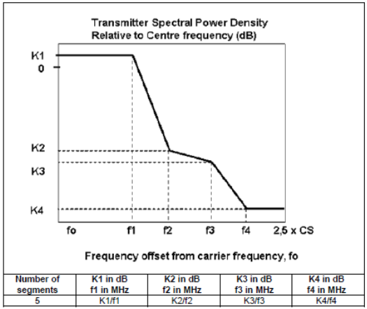

Figure 2: FS Transmitter emission mask (ETSI EN 302 217-2-2 V2.1.1)

Table 2: FS transmitter emission mask

| **Channel separation [MHz]** | **K1 (dB)** | **f1 (MHz)** | **K2 (dB)** | **f2 (MHz)** | **K3 (dB)** | **f3 (MHz)** | **K4 (dB)** | **f4 (MHz)** |
| --- | --- | --- | --- | --- | --- | --- | --- | --- |
| 2 | +3 | 0.84 | -25 | 1.3 | -25 | 1.8 | -45 | 3.2 |

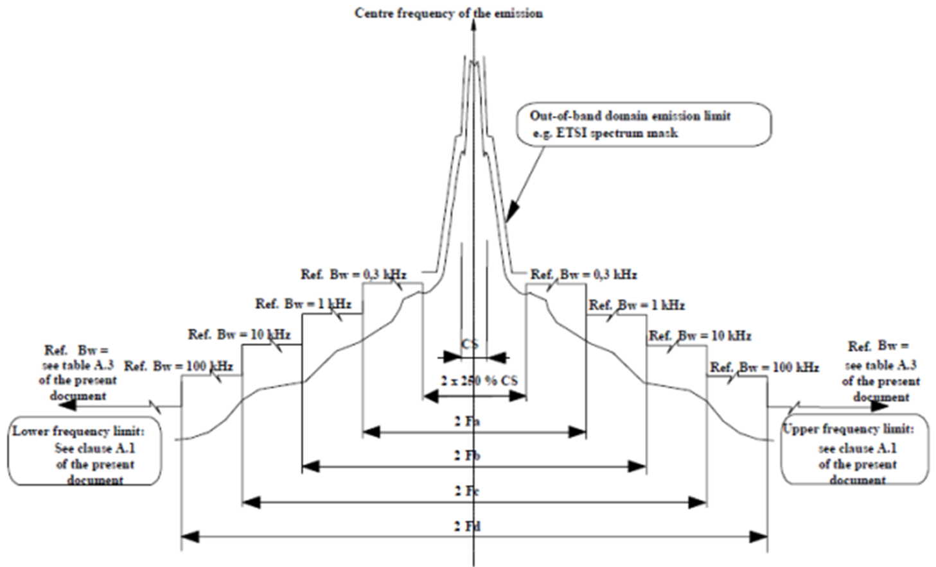

Figure 3: Spectrum emission level from ETSI EN 302 217-2-2 V1.3.1

## NATIONAL EXAMPLE OF NARROW CHANNEL SPACINGS DEPLOYMENTS

### Example in France (1375-1400/1427-1452 MHZ)

Distribution of French narrow channel spacing in the L band is the following one (excerpt from French public consultation on FH (ARCEP, April 2012)).



Figure 4: Distribution of French narrow channel spacing in the L band is the following one (excerpt from French public consultation on FH (ARCEP, April 2012))

From this figure, it can be seen that the more numerous CS are

* first 1 MHz CS
* then the 250 kHz CS
* then the 500 kHz CS
* then the 75 KHz CS
* then the 2 MHz CS
* then the 25 kHz CS

Information provided by administrations in the ECC Report 173, reports an average hop length of 28 Km in this band.

### Example in the UK (1350-1375//1492-1517MHz band)

The 1350-1375MHz//1492-1517MHz is used in the UK for fixed wireless services for a variety of applications including broadcasting, fixed networks, Oil & Gas, public safety and utilities. The largest users are public safety and utilities sectors. The channel plans in use are in accordance with ECC Rec. T/R 13-01 Annex A.

Table 3: Typical parameters used in the UK

| **Parameters** | **value** |
| --- | --- |
| Antenna gain range and typical (dBi) | 4.5 – 29; 16 (typical) |
| Antenna types | Yagi, flat panel, parabolic |
| Path length range (km) | 0.3 – 77 |
| EIRP Range (dBW) | -38 to +33 |
| Channel bandwidths | 25KHz, 75KHz, 250KHz, 500KHz, 1MHz, 2MHz and 3.5MHz. |

# FREQUENCY BANDS CONSIDERED FOR THE INSERTION OF THE NARROW CHANNELS

## 10 GHZ BAND

### Allocation in 10 GHz band in the RR

In the frequency band 10 – 10.68 GHz, there is primary allocation to FS in Region 1 except for the band 10.45-10.5 GHz (see excerpt from Radio Regulations in Table 1 below).

Table 4: Radio Regulation, allocation to FS and MS. Frequency band 10 – 10.68 GHz

| **Allocation to services** | | | |
| --- | --- | --- | --- |
| **Region 1** | | **Region 2** | **Region 3** |
| **10-10.45**  FIXED  MOBILE  RADIOLOCATION  Amateur | | **10-10.45**  RADIOLOCATION  Amateur | **10-10.45**  FIXED  MOBILE  RADIOLOCATION  Amateur |
| 5.479 | | 5.479 5.480 | 5.479 |
| **10.45-10.5** RADIOLOCATION  Amateur  Amateur-satellite  5.481 | | | |
| **10.5-10.55**  FIXED  MOBILE  Radiolocation | | **10.5-10.55**  FIXED  MOBILE  RADIOLOCATION | |
| **10.55-10.6** | FIXED  MOBILE except aeronautical mobile  Radiolocation | | |
| **10.6-10.68** | EARTH EXPLORATION-SATELLITE (passive)  FIXED  MOBILE except aeronautical mobile  RADIO ASTRONOMY  SPACE RESEARCH (passive)  Radiolocation  5.149 5.482 5.482A | | |

### Allocation in 10 GHz band in the CEPT

Table 5: Applications in 10.15- 10.65 GHz (source: www.efis.dk)

| **Frequency** | **Application** | **Short Comments** |
| --- | --- | --- |
| 10.150 - 10.300 GHz | SAP/SAB and ENG/OB |  |
| 10.150 - 10.300 GHz | Defence systems |  |
| 10.150 - 10.300 GHz | Radiolocation (civil) | Civil and military radars. Low power radars in certain subbands |
| 10.150 - 10.300 GHz | Amateur |  |
| 10.150 - 10.300 GHz | Radiodetermination applications | Within the band 10.5-10.6 GHz, and within the band 8.5-10.6 GHz for TLPR application |
| 10.150 - 10.300 GHz | BFWA | Including Point-to-Multipoint |
| 10.150 - 10.300 GHz | Fixed |  |
| 10.300 - 10.450 GHz | Defence systems |  |
| 10.300 - 10.450 GHz | PMSE | SAP/SAB |
| 10.300 - 10.450 GHz | Radiodetermination applications | Within the band 8.5-10.6 GHz for TLPR application |
| 10.300 - 10.450 GHz | Radiolocation (civil) | Civil and military radars. Low power radars in certain subbands |
| 10.300 - 10.450 GHz | Amateur |  |
| 10.450 - 10.500 GHz | Defence systems |  |
| 10.450 - 10.500 GHz | Radiolocation (civil) | Civil and military radars |
| 10.450 - 10.500 GHz | Radiodetermination applications | Within the band 10.5-10.6 GHz, and within the band 8.5-10.6 GHz for TLPR application |
| 10.450 - 10.500 GHz | Amateur |  |
| 10.450 - 10.500 GHz | Amateur-satellite |  |
| 10.450 - 10.500 GHz | Fixed |  |
| 10.450 - 10.500 GHz | PMSE | SAP/SAB |
| 10.500 - 10.550 GHz | Fixed |  |
| 10.500 - 10.550 GHz | PMSE | SAP/SAB |
| 10.500 - 10.550 GHz | BFWA | Including Point-to-Multipoint |
| 10.500 - 10.550 GHz | Radiodetermination applications | Within the band 8.5-10.6 GHz for TLPR application |
| 10.550 - 10.600 GHz | Radiodetermination applications | Within the band 10.5-10.6 GHz, and within the band 8.5-10.6 GHz for TLPR application |
| 10.550 - 10.600 GHz | BFWA | Including Point-to-Multipoint |
| 10.550 - 10.600 GHz | PMSE | SAP/SAB |
| 10.550 - 10.600 GHz | Fixed |  |
| 10.600 - 10.650 GHz | Fixed |  |

The current state of the art for the 10 GHz band for different CEPT countries are presented in ANNEX 3:.

### Current implementation of FS in the 10 GHz band

Among the different bands to be considered, the center gap of 10.3-10.5 Ghz band was proposed.

Before introducing any new services in center gap, potential coexistence risks should be estimated. In this section applications, which may be interfered (Table 1) and its system parameters were presented. The parameters were extracted from ECC/CEPT Reports and recommendations.

The centre gap of the 10150 MHz-10650 MHz CEPT band plan (Figure 5) provides a slot with 200 MHz width (10300-10500 MHz) and in a strictly technical point of view, in terms of occupancy, the 50 MHz could also be accommodated in this centre gap between 10300 and 10500 MHz (actually probably between 10300 MHz and 10450 MHz as the band 10450-10500 MHz is identified for Fixed service in the RR only for a few CEPT countries). A proposal of channel arrangement for this 10300-10450 MHz is given in ANNEX 2: of this document (The proposal is given for a 2x50 MHz channel arrangement as the gap is so wide).

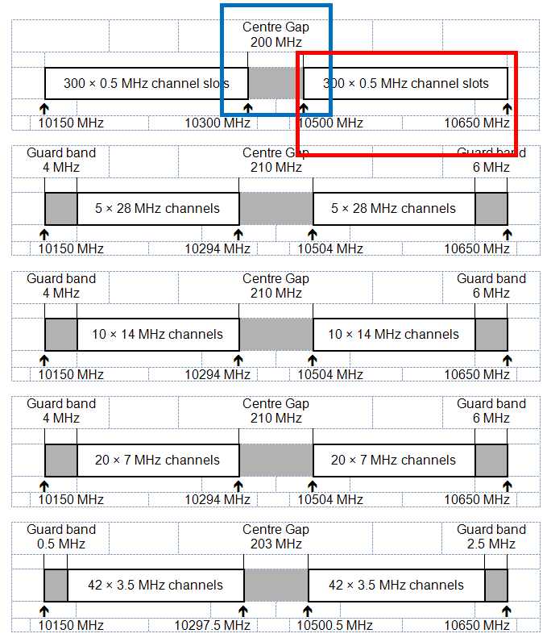

Figure 5: Extract from CEPT/ERC/Recommendation 12-05 E

### Characteristics of systems working in the 10.3-10.5 GHz band center gap

#### PMSE (Video Services Ancillary to Program-making/Services Ancillary to Broadcasting SAP/SAB links ENG/OB)

The following types of SAP/SAB video links (ENG/OB) might be considered within the frequency band 10.0-10.68 GHz:

* cordless cameras,
* portable video links,
* temporary point to point video links.

Table 6: Characteristics of video SAP/SAB links assumed for this study (ERC Report 38)

| **Type of Link** | **Range** | **Max E.I.R.P.** | **Min Tx ant. gain** | **Min**  **Rx ant. gain** | **Radio Link Path** | **Description** |
| --- | --- | --- | --- | --- | --- | --- |
| Cordless Camera | <500m | 6dBW | 0dBi | 6dBi | Usually clear line of sight. | Handheld camera with integrated transmitter, power pack and antenna. |
| Portable Link | <2km | 16dBW | 6dBi | 17dBi | Not always clear line of sight. | Handheld camera but with separate body­worn transmitter, power pack and antenna. |
| Temporary Point-to-point  Link | <80km  each hop  for links at  <10GHz | 40dBW | 13dBi | 17dBi | Usually clear line of sight for OB, but often obstructed for ENG use. | Link terminals are mounted on tripods, temporary platforms, purpose built vehicles or hydraulic hoists.  Two-way links are often required. |

Table 7: Further parameters for cordless camera, portable video link and temporary P-P links.

|  | **cordless camera** | **portable video link** | **temporary P-P link** |
| --- | --- | --- | --- |
| Carrier frequency (MHz) | 10 305 | 10 305 | 10 305 |
| Channel spacing and receiver noise bandwidth (MHz) | 10/20 (ECC Rep. 2)  (ITU-R BT.2069 Report) | 10/20 (ECC Rep. 2)  (ITU-R BT.2069 Report) | 7/8/10/20/14/28  (ECC Rep. 2)  (ITU-R BT.2069 Report) |
| Receiver antenna gain (dBi) | typ. 6 (ERC Rep. 38) | typ. 17 (ERC Rep. 38) | 0.6m parabolic dish (ERC Rep. 38)  34 |
| Antenna pattern | Omni-directional([1]) | Omni-directional2 | Directional based on  ITU-R F.699-7  ITU-R F.1245-1 |
| Receiver antenna height (m) | from 2 to10 (ECC Rep. 100)  2 | from 2 to10 (ECC Rep. 100)  3 | 20 |
| e.i.r.p. range (dBm) | 36 (ERC Rep. 38) | 46 (ERC Rep. 38) | 70 (ERC Rep. 38) |
| e.i.r.p. density range (dBm/MHz) | 26 | 36 | 60 |
| Receiver noise figure (dB) | 5 (ECC Rep. 100) | 5 (ECC Rep. 100) | 5 (ECC Rep. 100) |
| Receiver noise power density typical (=NRX ) (dBm/MHz) | -109 | -109 | -109 |
| I/N criterion | -6 (ECC Report 100) | -6 (ECC Report 100) | -6 (ECC Report 100) |

Table 8: SAP/SAB (ENG OB) parameters from ITU-R F.1777

| **Parameters** | **Value** | | |
| --- | --- | --- | --- |
| Frequency band (GHz) | 5.850 < f < 8.500  10.250 < f < 13.250 | | |
| Modulation | QPSK-OFDM  16-QAM-OFDM  32-QAM-OFDM  64-QAM-OFDM | | QPSK  16-QAM  32-QAM  64-QAM |
| Capacity (Mbit/s) | Up to 30 | Up to 60 | Up to 66 |
| Channel spacing (MHz) | 9 | 18 | 18 |
| Maximum Rx antenna gain (dBi) | 35 | 35 | 35 |
| Feeder/multiplexer loss (minimum) (dB) | Tx 1 Rx 1 | Tx 1 Rx 1 | Tx 1 Rx 1 |
| Antenna type (Tx and Rx) | Parabolic  ITU-R F.699-7  ITU-R F.1245-1 | Parabolic  ITU-R F.699-7  ITU-R F.1245-1 | Parabolic  ITU-R F.699-7  ITU-R F.1245-1 |
| Maximum Tx output power (dBW) | 4 | 7 | 1.76 |
| e.i.r.p. (maximum) (dBW) | 38 | 41 | 36 |
| Receiver IF bandwidth (MHz) | 9 | 18 | 18 |
| Receiver noise figure (dB) | 4 | 4 | 4 |
| Receiver thermal noise (dBW/MHz) | –130.5 | –127.4 | –127.4 |
| Nominal Rx input level (dBW) | –88 | –85 | –91 |
| Rx input level for 1 × 10–3 BER (dBW) | –120 –113 –110.7 –108.2 | –116.9 –109.9 –107.6 –105.1 | –116.9 –109.9 –107.6 –105.1 |
| Nominal long-term interference (dBW) ([2]) | –140.5 | –137.4 | –137.4 |
| Spectral density (dB(W/MHz)) | –146.0 | –146.0 | –146.0 |

#### Fixed Services Point to Multipoint in 10.15-10.68 GHz frequency band

Table 9: FS P-MP parameters from ITU-R F.758-5

| **Parameters** | **Value** | |
| --- | --- | --- |
| Frequency range (GHz) | 10.15-10.68 | 10.15-10.68 |
| Reference ITU-R Rec. | F.747, F.1568 | F.747, F.1568 |
| Modulation format | Central Stations 64-QAM | Terminal Station 64-QAM |
| Channel spacing and receiver noise bandwidth (MHz) | 1.75 (3), 2.5, 5, 28(5), 30(5) | 1.75 (3), 2.5, 5, 28(5), 30(5) |
| Tx output power range (dBW) | −3 | −12 |
| Tx output power density range (dBW/MHz)(1) | −5.43 | −14.4 |
| Feeder/multiplexer loss range (dB) | 0.5 | 0 |
| Antenna type and gain range (dBi) | 15  (90° microstrip sectoral) | 18 (panel) |
| e.i.r.p. range (dBW) | 11.5 | 6 |
| e.i.r.p. density range (dBW/MHz) | 9.07 | 3.57 |
| Receiver noise figure typical (dB) | 5 | 5 |
| Receiver noise power density typical (=NRX) (dBW/MHz) | −139 | −139 |
| Normalized Rx input level for 1 × 10–6 BER (dBW/MHz) | −112.5 | −112.5 |
| Nominal long-term interference power density (dBW/MHz)(2) | −139 + I/N | −139 + I/N |

#### UWB services working in 8.5-10.6 GHz frequency band

Mean EIRP density is -65dBm/MHz. UWB emission mask is presented in figure below.

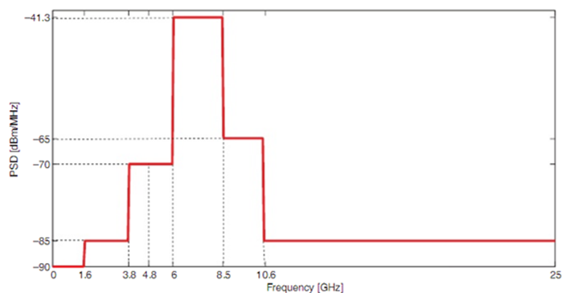

Figure 6: UWB emission mask

According to ECC DEC (06)04 UWB systems operate on a non-interference and non-protected basis- compability studies are not required.

#### Amateur Satellite Services in 10-10.5 GHz frequency band

Table 10: System parameters extracted from ECC 064 Report

| **Radiocommunications Service** | | | **System description** |
| --- | --- | --- | --- |
| Application | | | Receiver stations in the Amateur (Satellite) Service |
| Frequency band | | | 10000-10500 MHz |
| Receiver station | Station description |  | Low noise narrow band receiver |
| Receiver characteristics |  |  |
| Bandwidth | 3 kHz or 500 Hz |
| Noise figure / Noise temperature | 1 dB |
| Signal model | Signals to be received are SSB-Telephony and/or morse telegraphy |
| Receiver antenna |  |  |
| Type | Parabolic dish |
| Gain | 33 dBi boresight/ 0 dBi off boresight |
| Model |  |
| Protection requirement |  |  |
| Criterion | The receiver systems noise shall not increase by more than 1 dB due to the interfering UWB signal |
|  | The “reference/protection distance” between the UWB device is 10 meter |

The interference criterion for Amateur Service receivers is <1 dB increase of the receiver noise level at a “protection distance” of 10 m.

#### Radiolocation

**Radiodetermination**

Table 11: Radiodetermination radar parameters

| **Characteristics** | **Airborne radiodetermination radars (A4)** | **Shipborne radiodetermination radars (S2)** | **Ground-based radiodetermination radars (G4)** | **Other radars (G14)** |
| --- | --- | --- | --- | --- |
| Function | Track radar | Track radar | **Tracking radar** | Intrusion detection |
| Platform type | - | Shipborne | **Ground (trailer)** | Ground |
| Tuning range (MHz) | 10 000-10 500 | 10 000-10 500 | **10 000-10 500** | 10.15-10.65 |
| Modulation | CW, FMCW | CW, FMCW | **CW, FMCW** | CW |
| Peak power into antenna (kW) | 1.5 | 13.3 | **14** | 10 |
| Pulse width (μs) and pulse repetition rate (pps) | Not applicable | Not applicable Not applicable | **Not applicable Not applicable** | Not applicable |
| Maximum duty cycle | 1 | 1 | **1** | 100 |
| Pulse rise/fall time (μs) | Not applicable | Not applicable | **Not applicable** | Not applicable |
| Output device | Travelling wave tube | Travelling wave tube | **Travelling wave tube** |  |
| Antenna pattern type | Pencil | Pencil | **Pencil** | Parabolic |
| Antenna type | Planar array | Planar array | **Planar array** | Parabolic |
| Antenna polarization | Linear | Linear | **Linear** | Vertical |
| Antenna main beam gain (dBi) | 35.5 | 43 | **42.2** | 42 |
| Antenna elevation beamwidth (degrees) | 2.5 | 1 | **1** | 2 |
| Antenna azimuthal beamwidth (degrees) | 2.5 | 1 | **1** | 1.2 |
| Antenna horizontal scan rate (°/s) | 90 | 90 | **90** | Not specified |
| Antenna horizontal scan type (continuous, random, sector, etc.) | Sector: ±60° (mechanical) | 360° (mechanical) | **360° (mechanical)** | Not specified |
| Antenna vertical scan rate (°/s) | 90 | 90 | **90** | Not specified |
| Antenna vertical scan type | Sector: ±60° (mechanical) | Sector: +83/–30° (mechanical) | **Sector: 90° ± array tilt (mechanical)** | Not specified |
| Antenna side-lobe (SL) levels (1st SLs and remote SLs) (dBi) | Not specified | 23 (1st SL) | **Not specified** | 22 at 3° |
| Antenna height | Aircraft altitude | Mast/deck mount | **Ground level** | Not specified |
| Receiver IF 3 dB bandwidth (MHz) | 0.48 | 0.5 | **0.52** | Not applicable |
| Receiver noise figure (dB) | 3.6 | 3.5 | **3.4** | 3.6 |
| Minimum discernible signal (dBm)/ Sensitivity (dBm) |  | −113/- | **−113/-** | -/–152 |
| Chirp bandwidth (MHz) | Not specified | Not specified | **Not specified** | Not applicable |
| RF emission bandwidth (MHz) | Not specified | Not specified | **Not specified** | -40 dB -> 3.2 |
| Antenna radiation pattern | ITU-R M.1851 | ITU-R M.1851 | **ITU-R M.1851**  **(COS type)** | ITU-R M.1851 |
| I/N | -6 | -6 | **-6** | -6 |

Figure 7 presents radar antenna radiation pattern derived from ITU-R M.1851.

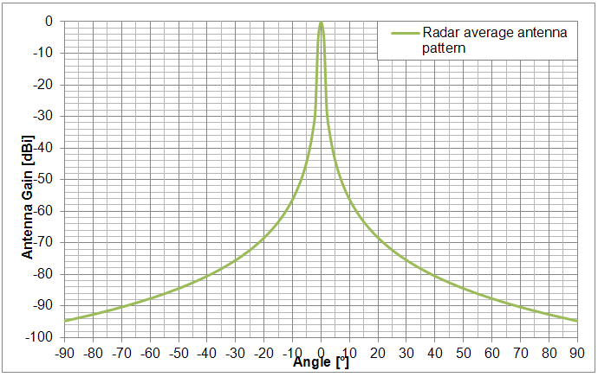

Figure 7: Terminal station horizontal antenna radiation pattern envelope based on ITU-R M.1851

**SRD**

SRD devices operates on non-interference and non-protected basis, therefore interference studies with these services were not carried out.

#### Military

All defense systems and radiolocation military radars are taken under considerations. Studies have not been performed due to the lack of system parameters.

### Characteristics of systems working in adjacent band to 10.3-10.5 GHz band

Motion sensors / interrogation systems are operating in the frequency band 10.5-10.6 GHz. ERC Report 047 “Compatibility fixed service and motion sensors at 10.5 GHz” deals with compatibility issues between the Fixed Service and motion sensors / interrogation systems in the frequency band 10.5-10.6 GHz.

## 6GHz band

### The 5925 - 6425 MHz band

The proposal is to pair the A block (5.375MHz) with the C block (upper part of 14.84 MHz), and, pair the B block (lower part of 14.84MHz) with the D block (5.376MHz) or a part of these blocks. This illustrated in Figure 8 and Figure 9 in as an example of implementation with 0.250 MHz channels.

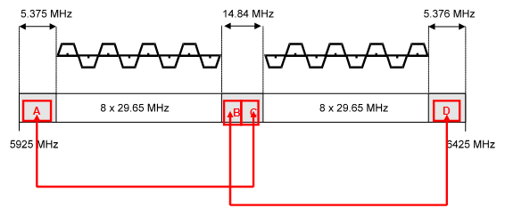

Figure 8: Illustration of the channel arrangements and an example about the paired band for the fixed links.

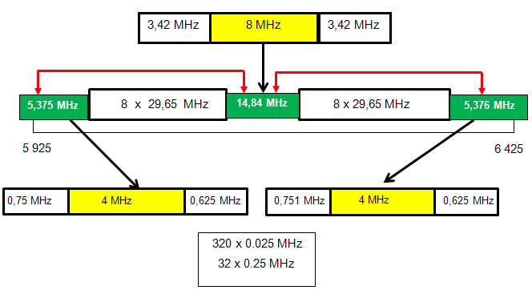

Figure 9: Example of implementation with 0.250 MHz channels

### Allocation in the 5925 - 6425 MHz band in the RR

Table 12: Allocation in the 5925 - 6425 MHz band

| **Frequency** | **Allocation** | **Short Comments/Notes** |
| --- | --- | --- |
| 5850 - 5925 MHz | FIXED FIXED-SATELLITE MOBILE | Footnote 5.150 => The following bands: … ,5 725 - 5 875 MHz (centre frequency 5 800 MHz), … are also designated for industrial, scientific and medical (ISM) applications. Radiocommunication services operating within these bands must accept harmful interference which may be caused by these applications. ISM equipment operating in these bands is subject to the provisions of No. 15.13 |
| 5925 - 6700 MHz | Earth Exploration-Satellite (passive) FIXED-SATELLITE (EARTH-TO-SPACE) FIXED | Footnote 5.457A => In the bands 5 925-6 425 MHz and 14-14.5 GHz, earth stations located on board vessels may communicate with space stations of the fixed-satellite service. Such use shall be in accordance with Resolution 902 (WRC-03). (WRC-03) |

### Applications in the 5925 - 6425 MHz band in the CEPT

Table 13: Applications in the 5925 - 6425 MHz band

| **Frequency** | **Allocation** | **Short Comments/Notes** |
| --- | --- | --- |
| 5850 - 5925 MHz | ISM | Within the band 5725-5875 MHz |
| 5850 - 5925 MHz | FSS Earth stations | Priority for civil networks |
| 5850 - 5925 MHz | Non-specific SRDs | Within the band 5725-5875 MHz |
| 5850 - 5925 MHz | Radiodetermination applications | Within the band 4500-7000 MHz for TLPR application |
| 5850 - 5925 MHz | BFWA | Within the band 5725-5875 MHz |
| 5850 - 5925 MHz | ITS | Within the bands 5875-5925 MHz and 5855-5875 MHz |
| 5925 - 6700 MHz | Fixed | Point-to-point |
| 5925 - 6700 MHz | UWB applications | Generic UWB |
| 5925 - 6700 MHz | Radiodetermination applications | Within the band 4500-7000 MHz for TLPR application and 6000-8500 MHz for LPR applications |
| 5925 - 6700 MHz | Passive sensors (satellite) | For sea surface temperature, sea surface wind speed and soil moisture measurements |
| 5925 - 6700 MHz | FSS Earth stations | Priority for civil networks |
| 6425 – 6700 MHz | Radio astronomy | Spectral line observations (Methanol: 6650-6675.2 MHz) |

## U6 GHz band

### U6 band in the CEPT

CEPT/ERC/Recommendation 14-02 E sets channel arrangements for fixed service in the band from 6 425 MHz up to 7 125 MHz as shown below:



Figure 10: Channel arrangements of the U6 band according ERC/REC 14-02E provisions

### Implementation of narrow channels

As it can been seen above, the fixed service is already implemented in the U6 band in sharing conditions with other services.

Hence, narrow channels could potentially be added in guard bands and center gap as examples shown by figures below.

#### Implementation with 40 MHz channel arrangement

**Option 1**

5 MHz

5 MHz

2.5 MHz

2.5 MHz

600 x 0.025 MHz

60 x 0.25 MHz

30 x 0.5 MHz

15*1 MHz

7*2 MHz

4 x 3,5 MHz

15 MHz

15 MHz

**15 MHz**

**20 MHz**

**25 MHz**

6 425

6 760

6 780

7 125

8 x 40 MHz

8 x 40 MHz

Figure 11: Narrow channels in U6 band with 40 MHz channels option 1

**Option 2**

800 x 0.025 MHz

80 x 0.25 MHz

40 x 0.5 MHz

20 x 1 MHz

10 x 2 MHz

**15 MHz**

**20 MHz**

**25 MHz**

6 425

6 760

6 780

7 125

8 x 40 MHz

8 x 40 MHz

2.5 MHz

10 MHz

2.5 MHz

2.5 MHz

20 MHz

2.5 MHz

5 MHz

10 MHz

5 MHz

Figure 12: Narrow channels in U6 band with 40 MHz channels option 2

**Option 3**

280 x 0.025 MHz

28 x 0.25 MHz

14 x 0.5 MHz

7 x 1 MHz

**15 MHz**

**20 MHz**

**25 MHz**

6 425

7 125

8 x 40 MHz

8 x 40 MHz

3 MHz

7 MHz

5 MHz

15,5 MHz

7 MHz

2.5 MHz

Figure 13: Narrow channels in U6 band with 40 MHz channels option 3

#### Implementation with 30 MHz channel arrangement

2.5 MHz

5 MHz

2.5 MHz

2.5 MHz

5 MHz

2.5 MHz

**20 MHz**

**10 MHz**

**10 MHz**

6 425

6 775

6 785

7 125

11 x 30 MHz

11 x 30 MHz

5 MHz

5 MHz

5 MHz

5 MHz

200 x 0.025 MHz

20 x 0.25 MHz

10 x 0.5 MHz

5 x 1 MHz

Figure 14: Narrow channels in U6 band with 30 MHz channels option

#### Implemention combining L6 and U6

600 x 0.025 MHz

60 x 0.25 MHz

30 x 0.5 MHz

15 x 1MHz

7 x 2 MHz

4 x 3,5 MHz

**20 MHz**

**25 MHz**

7 125

8 x 40

8 x 40

**15 MHz**

9 MHz

6 MHz

5,376

**14.84 MHz**

5 925

6 425

8 x 29,65

8 x 29,65

360 x 0.025 MHz

36 x 0.25 MHz

18 x 0,5 MHz

9 x 1 MHz

4 x2 MHz

2.92 MHz

9 MHz

2.92 MHz

Figure 15: Narrow channels in L6 and U6 band (L6 combined with option 1 in U6 band)

It can be seen that this option provide 24 MHz for implementation of narrow channels without interfering on services below 5 925 MHz (with regard with 25 MHz currently used in 1375-1400/1427-1452 MHz).

### Spectrum masks

According to ITU-R Recommendation SM.329-12 ant the application to fixed service provided by ITU-R Recommendation F.1191-3, CEPT/ERC Recommendation 74-01 defines spurious emissions as any emission at frequencies which are outside the nominal carrier frequency by more than ± 250%.

As illustrated in Figure 11 to Figure 15, the frequency bands dedicated for introducing narrow channels are limited by “sub-guard bands”, which allow considering only spurious domain levels for adjacent channel compatibility studies in countries which implement only one bandwidth. Those spurious emissions are defined in ITU-R Recommendation SM.329 at -50dBm/0.3KHz or -14.77dBm/MHz for channel spacing lower than 1 MHz.

Table 14: Generic Category B fixed service mask for unwanted emissions in the spurious domain (extract from ITU-R SM.329)

| **Fundamental**  **emission**  **frequency** | **CS (MHz)** | **Typical symbol frequency**  **(~Mbit/s)** | **Ref. BW**  **0.3 kHz** | **Ref. BW**  **1 kHz** | **Ref. BW**  **10 kHz** | **Ref. BW**  **100 kHz** |
| --- | --- | --- | --- | --- | --- | --- |
| **Fa**  **(MHz)** | **Fb**  **(MHz)** | **Fc**  **(MHz)** | **Fd**  **(MHz)** |
| Below 21.2 GHz  (terminal stations) | 0.01 ≤ CS < 1 | Fs ≅ 0.006 − 0.8 | – | – | 14 | 70 |
| 1 ≤ CS < 10 | Fs ≅ 0.6 − 8 | – | – | 28 | 70 |
| CS ≥ 10 | Fs ~ > 6 | – | – | 49(1) | 70(1) |
| Below 21.2 GHz  (other stations) | 0.01 ≤ CS < 1 | Fs ≅ 0.006 − 0.8 | 3.5 | 7 | 14 | 70 |
| 1 ≤ CS < 10 | Fs ≅ 0.6 − 8 | – | 14(1) | 28 | 70 |
| CS ≥ 10 | Fs ~ > 6 | – | – | 49(1) | 70(1) |
| Above 21.2 GHz  (all stations) | 1 ≤ CS < 10 | Fs ≅ 0.6 − 8 | – | – | – | 70 |
| CS ≥ 10 | Fs > ~ 6 | – | – | – | – |

(1) Not applicable for CS which 250% exceed these values

ETSI document EN 302 217-2-2 (table A.4) provides following limits of transmitter spectral power density highlighting differences between class 1and 2 (4QAM) and class 4L (16QAM):

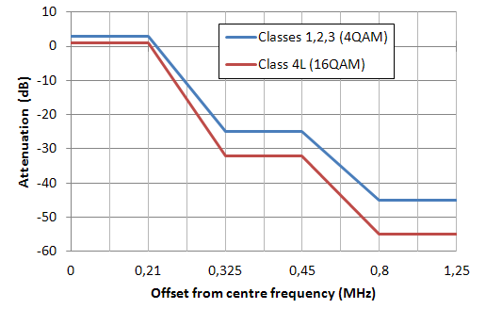

Figure 16: Emission mask for 0.5 MHz channels according ETSI EN 302 217-2-2

# Compatibility and sharing studies

## COMPATIBILITY/SHARING STUDIES IN THE 10 GHZ BAND

### Introduction to compatibility and sharing studies

In the case, the narrow channels are inserted in the 10300-10450 MHz band, the compatibility and sharing studies to be done are presented in the tables below

Table 15: Overview of the study carried out

| **x indicates that studies are needed** | **Co-channel band (sharing)** | | | | | |
| --- | --- | --- | --- | --- | --- | --- |
| **SAP/SAB** | **FS P-MP** | **UWB** | **Radiolocation** | **Amateur Satellite Services** | **Military** |
| FS working in 10.3-10.5 GHz center gap | performed | performed | Not needed | Performed | performed | Not available |

| **x indicates that studies are needed** | **Adjacent channel band (compatibility)** | | |
| --- | --- | --- | --- |
| **FS P-P** | **Motion sensor** | **SRD** |
| FS working in 10.3-10.5 GHz center gap | performed | ERC Report 047 | Not needed |

In all coexistence studies the ITU-R P.452 method is proposed.

All defense systems and radiolocation military radars are taken under considerations. Studies have not been performed due to the lack of system parameters.

### Propagation model in 10 GHz frequency band

Two different methods might be considered coexistence studies:

1. Free space model describes the theoretical minimum propagation path loss between transmitter and receiver in free space, when direct line of sight (LOS) is assumed (earth curvature is not taken into consideration) The model is used for frequency above 30 MHz



Where f is the frequency in MHz and d is the distance between transmitter and receiver in km.

1. ITU-R P.452-14 “Prediction procedure for the evaluation of interference between stations on the surface of the Earth at frequencies above 0.1 GHz” is a method which consider additional losses due to atmospheric gases, rain etc. and also assumes that Earth is curved. In this method also time percentage is taken into consideration (for more details see ITU-R P.452-14). Fixed Services are designed with the time availability of at least 99.99%, which means that interfering signal may occur in 0.01% of time.

Figure 17 presents a comparison of propagation loss between Free space and the ITU-R P452.

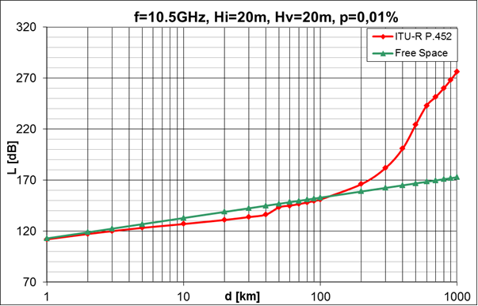

Figure 17: Comparison between free space and ITU-R P.452 model

For coexistence study model ITU-R P.452 is proposed to be chosen. It is seen that for some distances the ITU-R P.452 model gives lower propagation loss than free space model. It is because of subpath diffraction that causes a slight increase in signal level above that normally expected and also because of focusing effects resulting from atmospheric stratification. These two effects are especially important for the short periods of time (low time percentages).

ITU-R P.452 method is used for calculation of interfering signal level. Time percentage of 0.01 % is assumed as the worst case scenario. The prediction procedure employs radio-meteorological parameters to describe the variability of background and anomalous propagation conditions at the different locations. In calculations refraction index gradient ΔN =50 (value for worst-monthly prediction is considered) and sea-level surface refractivity of N0= 325 is used. Both values are typical of temperate climates.

### MCL based calculation method

In order to evaluate maximum interference range of single narrow channel FS P-P to particular victim receiver, MCL-based principles for calculating compliance with I/N criteria methodology will be used. Using I/N criteria has a distinct advantage, there is no need to consider entire victim system for calculating useful received carrier signal (which would be necessary if using C/I-based methods). When using I/N criteria, it is sufficient to consider just the fundamental parameters of victim receiver, such as reference bandwidth and noise figure/temperature, whereas interfering signal could be considered as component degrading the noise floor level of victim receiver.

This study applies the method by following steps:

Step 1: Evaluation of noise power density and I/N interference threshold of victim receiver

Evaluation of noise floor is done by applying the following expressions, derived from fundamental equation of thermal noise:

The victim receiver’s noise power is defined through noise figure for nominal bandwidth:



where -114 dBm/MHz is a value of thermal noise power density. Thermal noise power is given as:

PN=kTΔf, where k=1.38e-23 J/K, T=290K and Δf=1MHz.

The interference threshold is then obtained by referring to I/N objective. Expressed as power level at victim receiver antenna:



where:

* NRx victim receiver’s noise power,
* I/NR noise to interference ratio,

Step 2: Evaluation of MCL

Minimum Coupling Loss is evaluated as path loss isolation that is necessary to shunt interfering signal to below interference threshold identified in step 1. This condition may be expressed as follows:



where:

* PIT- maximum interfering transmitter output power [dBm],
* GIT(θ)- interfering transmitter antenna gain in direction of victim receiver [dBi],
* θ - azimuth angle between victim receiver and interfering transmitter
* LIT- transmitter’s feeder loss,
* GR(θ) – victim receiver’s antenna gain in direction of interfering transmitter [dBi],
* LVR- receiver’s feeder loss [dB],
* mask(Δf)- spectrum mask attenuation at Δf, where Δf is a difference between carrier frequencies of victim receiver and interfering transmitter ,
* Imax -interference threshold,
* BWcorr_factor- correction factor of band ratio:
* 

Step 3: Physical separation calculations based on MCL value

MCL result is taken as a minimum value of path attenuation between victim receiver (VR) and interfering transmitter (IT). The final evaluation of distance (d [km]) between victim receiver and interfering transmitter, which guarantees that systems will not interfere each other is done using specific path loss model i.e. for free space model calculation is as follows:



### Interfering transmitter parameters

In compatibility studies with Fixed Services some parameters have to be assumed. One of the key parameter is antenna radiation pattern, which is defined for FS in two ITU-R Recommendations:

* recommendation ITU-R F.699 gives the peak envelope of side-lobe patterns,
* recommendation ITU-R F.1245 describes antennas radiation patterns with average side-lobe levels.

If the peak envelope radiation pattern is used in the assessment of the aggregate interference consisting of many interference entries, the predicted interferences will result in values that are greater than interferences obtained with average envelope radiation pattern. Figure 18 presents the comparison between the two recommendations for maximum antenna gain of 43 dBi.



Figure 18: Comparison between peak and average antenna radiation pattern side-lobe levels

ITU-R F.1245 Recommendation gives 3-4 dB lower side-lobe levels than ITU-R F.699. On the other hand for very small azimuth angles ITU-R F.1245 gives higher values than ITU.R F-699 (see Figure 19).



Figure 19: Comparison between peak and average antenna radiation pattern side-lobe levels (azimuth zoom)

In calculations worst case scenario is considered assuming flat terrain without obstacles between interfering transmitter and victim receiver (LOS) and antennas working with the same polarizations.

It is assumed that angles between victim receiver and interfering transmitter are changed in horizontal plane (azimuth). In calculations two separate cases are considered:

1. azimuth change of interfering transmitter antenna when victim receiver antenna is not moving (stable/fixed)
2. azimuth change of victim receiver antenna when interfering transmitter antenna is not moving (stable/fixed)

Both cases are considered because of different antenna patterns of the victim receiver and interfering transmitter, which cause different results of calculations. In the whole document figures, which present calculation results, are done for both cases mentioned above. For example in figure 7 for case 1 distance as a function of ITU-R F.699 and F.1245 antenna angle (blue and red curve) is presented. For case 2 distance as function of terminal station antenna angle (green curve) is given.

Due to considerations of the worst case scenario, impact of vertical antenna gain is not taken into account.

Other interfering transmitter parameters used in calculations are summarized

Table 16: FS P-P narrow channel Interfering transmitter parameters

| **Parameters** | **Value** |
| --- | --- |
| Carrier frequency (MHz) | scenario dependent |
| Channel spacing and receiver noise bandwidth (MHz) | 2 |
| Maximum Tx power (dBm) | 28 |
| Maximum TX output power density range (dBm/MHz) | 25 |
| Antenna gain (dBi) | 43 |
| Antenna pattern | ITU-R F.699-7  ITU-R F.1245-1 |
| Antenna height (m) | 20 |
| Minimum feeder/multiplexer loss range (dB) | 0 |
| e.i.r.p. (dBm) | 71 |
| e.i.r.p. density (dBm/MHz) | 68 |
| Receiver noise figure (dB) | 3 |
| Receiver noise power density typical (=NRX ) (dBm/MHz) | -111 |
| Transmitter emission mask | ETSI EN 302 217 |
| Transmitter spurious emission | ETSI EN 301 390 |
| I/N criterion | -10 |
| Nominal long-term interference power density (dBm/MHz) | NRX + I/N |

In calculations maximum interfering transmitter power of 28 dBm is used. This value is assumed as the highest possible value of in channel power (maximum transmission power within emission mask). Figure 20 presents FS transmitter emission mask derived from ETSI EN 302 217 and EN 302 390.

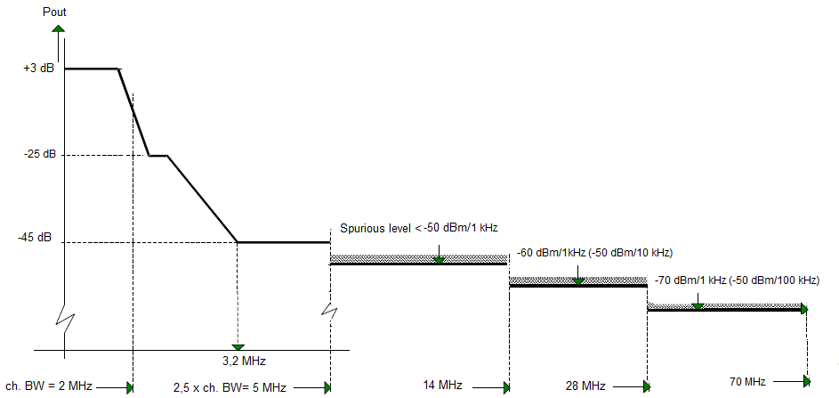

Figure 20: FS transmitter emission mask derived from ETSI EN 302 217 and EN 302 390

### Co-channel sharing

#### Studies with SAP/SAB

**ENG parameters taken from ITU-R F.1777**

Interferences from FS P-P introduced to 10.3-10.45 GHz center gap to ENG working in 10.3- 10.5 GHz were estimated.

The interfering transmitter and victim receivers’ frequency carrier are 10 309 MHz. In the calculations, the parameters indicated in bold letter from table above are used. Victim receiver antenna height is equal to 3 m.

Table 17: Summary of the results for SAP/SAB

| **Results** | **Value** |
| --- | --- |
| MCL (dB) | 212.4* for I/N=-10  208.4* for I/N=-6 |
| Distance (km) | 467.1* for I/N=-10  450.4* for I/N=-6 |
| Minimum distance between IT and VR/antenna azimuth ≥48 ° | 269.99/230.11** km for I/N=-10  244.38/203.32** km for I/N=-6 |

*VR and IT antenna are pointing to each other

** in red colour results for ITU-R F.1245 antenna radiation pattern are presented

In Figure 21, the distance between interfering transmitter and victim receiver as a function of victim receiver antenna azimuth is presented. In this case victim receiver has the same antenna radiation pattern as interfering transmitter,that is why only one case is considered. Antenna azimuth θ is changed between 0.5° and 90°.



Figure 21: Distance between IT and VR as a function of victim and interfering antenna angle (victim antenna radiation patterns are the same as interfering antenna patterns)

Calculation example:

Step 1: Evaluation of noise power density and I/N interference threshold of cordless camera

Victim receiver’s noise power is defined through noise figure for nominal bandwidth:



The interference threshold expressed as power level at victim receiver antenna:

or



Step 2: Evaluation of MCL



PIT+GIT+LIT in calculations were replaced as interfering transmitter e.i.r.p power:



or



Step 3: Physical separation calculations based on MCL value

According to ITU-R P.452 for time percentage of p=0.01%, required distance between IT and VR is equal to:

d= 467.1 km (for I/N=-10) or

d= 450.4 km (for I/N=-6).

**Based on parameters from ECC/ERC Reports**

Interfering transmitter’s frequency carrier is 10.305 GHz. In this case victim receiver has omnidirectional antenna or the same antenna radiation patterns as interfering transmitter (temporary point to point link), that is why only one case is considered.

Table 18: Summary of the results

| **Column title (style: Arial 10pt bold white)** | **Cordless camera** | **Portable video link** | **Temporary P-P link** |
| --- | --- | --- | --- |
| MCL (dB) | 182 | 193 | 210* |
| Distance (km) | 319.5 | 379 | 457* |

*VR and IT antenna are pointing to each other

In Figure 22 the distance between interfering transmitter and victim receivers as a function of victim receiver antenna azimuth is presented. Antenna azimuth θ is changed between 0.5° and 90°.

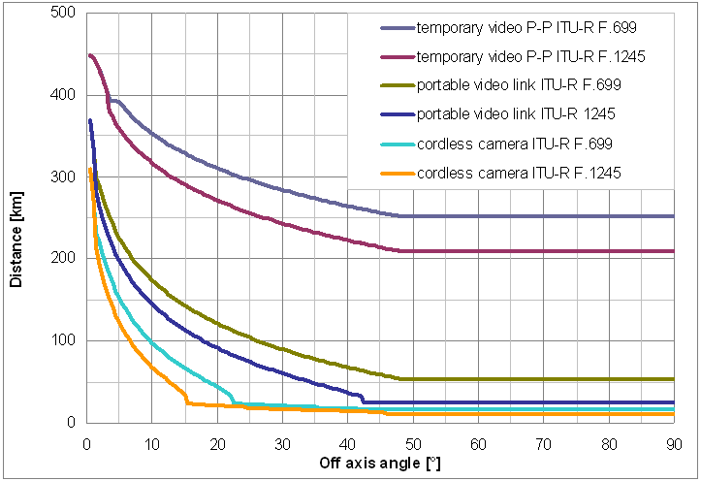

Figure 22: Distance between IT and VR as a function of victim and interfering antenna angle (victim antenna radiation patterns are omnidirectional or the same as interfering antenna patterns)

Table 19 presents results for ITU-R F.1245 antenna radiation pattern.

Table 19: Summary of the results

|  | **Cordless camera** | **Portable video link** | **Temporary P-P link** |
| --- | --- | --- | --- |
| Minimum distance required when Interfering Transmitter antenna is pointing to victim receiver | 319.5 km | 379 km | 457 km* |
| Minimum distance required when antenna azimuth is 0.5° | 309.01 km | 368.23 km | 448.15 km |
| Minimum distance between IT and VR/antenna azimuth ≥48 ° | 16.26 km | 54.07 km | 252 km |
| Minimum distance between IT and VR/antenna azimuth ≥48 °( ITU-R F.1245 antenna radiation pattern) | 10.97 km | 24.91 km | 209.59 km |

*VR and IT antenna are pointing to each other

#### Multimedia Multipoint Distribution System MMDS (downlink)

Interferences from FS P-P introduced to 10.3-10.45 GHz center gap to MMDS terminal station (TS) working on 10 336 MHz were estimated.

Table 20: Victim receiver parameters

| **Parameters** | **Value** |
| --- | --- |
| Carrier frequency (MHz) | 10 336 |
| Channel spacing and receiver noise bandwidth (MHz) | 8(DL)/6.4(UL) |
| Antenna gain (dBi) | 24 |
| Antenna pattern | Directional (ETSI EN 302 326) |
| Antenna height (m) | 20 |
| Minimum feeder/multiplexer loss range (dB) | 0 |
| e.i.r.p. range (dBm) | 23 |
| Receiver noise figure (dB) | 5 [ITU-R F.758-5] |
| Receiver noise power density typical (=NRX ) (dBm/MHz) | -109 |
| I/N criterion (dB) | -10 |
| Nominal long-term interference power density (dBm/MHz) | NRX+I/N |

Figure below presents terminal station horizontal antenna radiation pattern derived from ETSI EN 302 326.

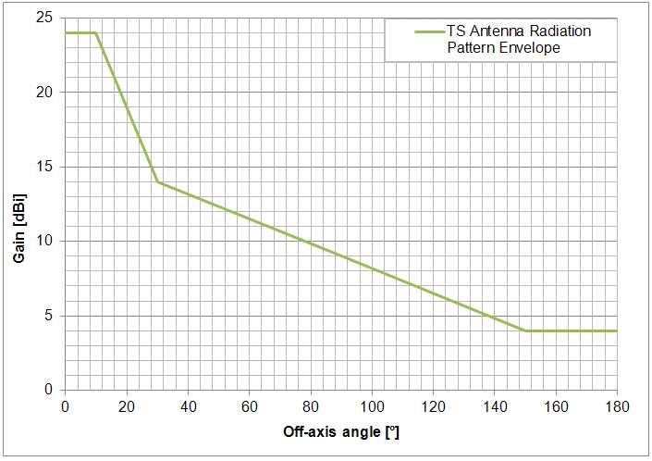

Figure 23: Terminal station horizontal antenna radiation pattern envelope based on ETSI EN 302 326

Interfering transmitter and victim receivers’ frequency carrier is 10.336 GHz. Victim receiver antenna height is equal to 20 m.

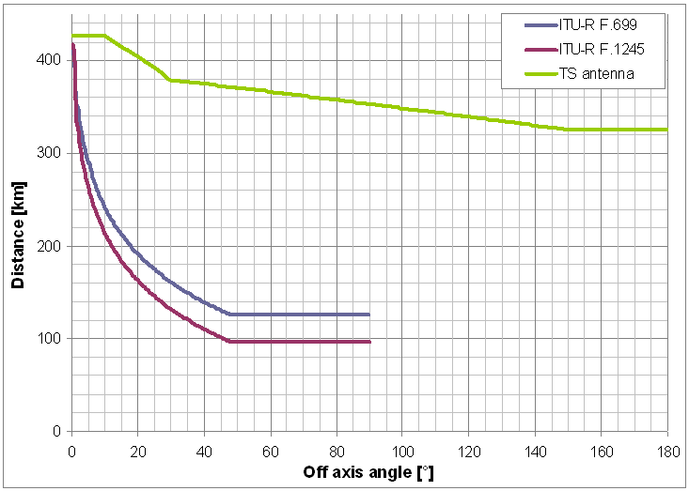

Figure 24: Distance between IT and VR as a function of victim antenna angle (TS antenna) and interfering antenna angle (ITU-R F.699 / F.1245)

In Figure 24 the distance between interfering transmitter and victim receiver as a function of antenna azimuth angle of interfering transmitter (1 case) and victim receiver (2 case) is presented. Antenna azimuth was changed between 0 and 180°. Detailed results are presented in Table 21.

Table 21: Summary of the results for TS

|  | **ITU-R F.699** | **ITU-R F.1245** | **TS antenna** |
| --- | --- | --- | --- |
| Minimum distance required when antennas are pointing each other | 426.8 km | 426.8 km | 426.8 km |
| Minimum distance required when antenna azimuth is 0.5° | 417.14 km | 417.14 km | 426.8 km |
| Minimum distance between IT and VR/antenna azimuth | 125.95 km/≥48° | 96.93 km/≥48° | 325.35 km/≥150 ° |

#### Radiolocation

Radiolocation services are defined as radiodetermination service for the purpose of radiolocation. Radiodetermination is defined as the determination of the position, velocity and/or other characteristics of an object, or the obtaining of information relating to these parameters, by means of the propagation properties of radio waves.

The system parameters were extracted from ITU-R M.1796 recommendation and there are presented in Table 11. The Interfering transmitter and victim receivers’ frequency carrier is 10.301 GHz. The calculations parameters indicated in bold letter from Table 11 are used. The victim receiver antenna height is equal to 8 m. In Figure 25 the distance between interfering transmitter and victim receiver as a function of victim receiver and interfering transmitter antenna azimuth is presented. Antenna azimuth θ was changed between 0° and 90°.

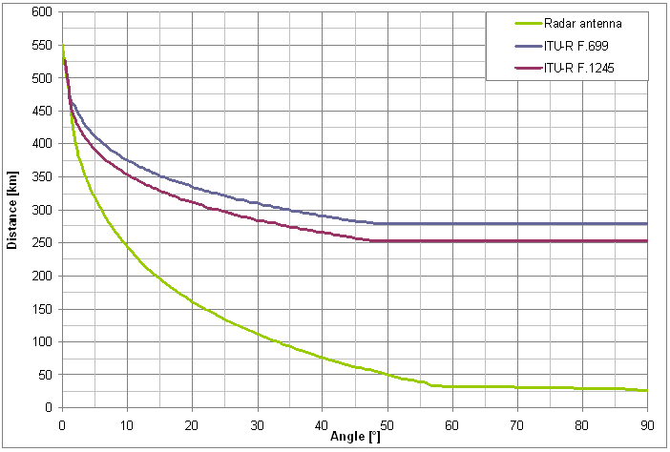

Figure 25: Distance between IT and VR as a function of victim antenna angle (radar antenna) and interfering antenna angle (ITU-R F.699 and F.1245)

Table 22: Summary of the results for ground tracking radar

|  | **ITU-R F.699** | **ITU-R F.1245** | **TS antenna** |
| --- | --- | --- | --- |
| Minimum distance required when antennas are pointing each other | 551.25 km | 551.25 km | 551.25 km |
| Minimum distance required for specified azimuth | 527.18 km/0.5° | 527.18 km/0.5° | 505.14 km/0.5° |
| Minimum distance between IT and VR/antenna azimuth | 279.15 km/≥48° | 252.69 km/≥48° | 25.59 km/90° |

#### Amateur and Amateur Satellite Services

According to ITU in frequencies between 10.3-10.45 GHz some amateur services may work on secondary basis. In the same frequencies also Fixed Services on primary basis are allocated.

Secondary services shall not cause harmful interference to stations of primary services and can’t claim protection from harmful interferences from stations of primary services, therefore coexistence studies with these services are not required and are not performed here.

#### Summary of co-channel coexistence studies

Table 23: summary of the results

|  | **ENG ITU-R F.1777** | | **ENG ECC Reports** | | | **MMDS** | **Radar** |
| --- | --- | --- | --- | --- | --- | --- | --- |
| **equipment with capacity up to 60 Mb/s** | | **cordless camera** | **portable video link** | **temporary P-P link** | **DL** | **Ground tracking** |
| Criterion | I/N=-6 | I/N=-10 | I/N=-6 | I/N=-6 | I/N=-6 | I/N=-10 | I/N=-6 |
| Distance (km) when antennas are pointing each other | 450.4 | 467.1 | 319.5 | 379 | 457 | 426.8 | 551.25 |
| Minimum distance (km) | 244.4 | 270 | 16.7 | 57.1 | 252 | 125.9 | 25.6 |
| Minimum distance (km)  (results for ITU-R F.1245 antenna radiation pattern) | 203.3 | 230.1 | 11 | 24.9 | 209.6 | 96.9 | - |

### Adjacent channel compatibility studies

The study did not consider the impact of receiver selectivity, due to the absence of information on victim receiver selectivity masks. Therefore, only the out-of-band emissions of the narrow spacing FS PP interferences are considered in the conclusions. If the receiver selectivity was also taken into account, the needed separation distances for coexistence between FS and other services would be even higher than the calculated distances below.

#### Electronic News Gathering (ENG)

**Based on ITU-R F. 1777 parameters**

The victim receiver bandwidth is equal to 18 MHz. The first possible channel for ENG is on frequency from 10.300 GHz to 10.318 GHz, with frequency carrier on 10.309 GHz. Interfering transmitter channel bandwidth is 2 MHz, so the interfering FS PP adjacent to ENG, has frequency carrier on fIT= 10.319 GHz (the whole channel is from 10.318 GHz to 10.320 GHz).

The distance between interfering transmitter and victim receiver as a function of antenna azimuth is presented in Figure 26. In this case victim receiver has the same antenna radiation patterns as interfering transmitter, that is why one case only is considered. Antenna azimuth ϕ was changed between 0.5° and 90°.

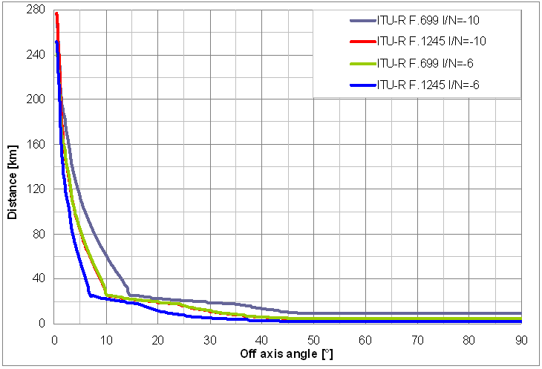

Figure 26: Distance between IT and VR as a function of victim and interfering antenna angle (victim antenna radiations are the same as interfering antenna patterns)

Detailed results are presented in table below (in red results for ITU-R F.1245 are shown).

Table 24: Summary of the results

|  | **I/N=-6** | **I/N=-10** |
| --- | --- | --- |
| Minimum distance required when antennas are pointing to each other | 264.64 km | 289.53 km |
| Minimum distance required for 0.5° azimuth | 251.41 km | 276.79 km |
| Minimum distance between IT and VR/antenna azimuth ≥48° | 4.49 km | 9.34 km |
| Minimum distance between IT and VR/antenna azimuth ≥48° (results for ITU-R F.1245 antenna radiation pattern) | 2.35 km | 4.36 km |

**Calculation example:**

Step 1: Evaluation of noise power density and I/N interference threshold of victim receiver

Victim receiver’s noise power is defined through noise figure for nominal bandwidth:



The interference threshold expressed as power level at victim receiver antenna:

or



Step 2: Evaluation of MCL



Due to separation between frequency carrier of interfering transmitter and victim receiver PIT +mask(Δf) is replaced by spurious emissions, that are defined as emissions at frequencies, which are ±250% of the relevant channel separation outside the nominal carrier frequency of very narrow FS P-P (spurious emission domain).

For separation of Δf=10 MHz between frequency carriers of VR and IT, spurious emission limit is equal to -50 dBm/1 kHz (see fig. 3).

MCL calculation is then as follows:



where:

* SEL- spurious emission limit [dBm],
* GIT- interfering transmitter antenna gain in direction of victim receiver [dBi],
* LIT- transmitter’s feeder loss,
* BWVR- victim receiver bandwidth [MHz],
* SEL_ref.BW- spurious emissions reference bandwidth





Step 3: Physical separation calculations based on MCL value

According to ITU-R P.452 required distance between IT and VR is equal to:

d= 289.53 km (for I/N=-10) or

d= 264.64 km (for I/N=-6).

**Based on parameters from ECC/ERC Reports**

Victim receiver bandwidth is equal to 10 MHz. The first possible channel for ENG is on frequency from 10 300 MHz to 10 310 MHz, with frequency carrier on 10 305 MHz. Interfering transmitter channel bandwidth is 2 MHz, so the interfering FS PP adjacent to ENG, has frequency carrier on fIT= 10 311 MHz (the whole channel is from 10 310 MHz to 10 312 MHz).

Distance between interfering transmitter and victim receiver as a function of antenna azimuth is presented in figure below. In this case victim receiver has omnidirectional antenna or the same antenna radiation patterns as interfering transmitter (temporary point to point link), that is why only one case is considered. Antenna azimuth ϕ was changed between 0.5° and 90°.



Figure 27: Distance between IT and VR as a function of victim and interfering antenna angle (victim antenna radiation patterns are omnidirectional or the same as interfering antenna patterns) Log scale

In table below in red color results for ITU-R F.1245 antenna radiation pattern are presented.

Table 25: summary of the results for SAP/SAB

|  | **Cordless camera** | **Portable video link** | **Temporary P-P link** |
| --- | --- | --- | --- |
| Minimum distance required when antennas are pointing each other | 67.15 km | 143.69 km | 246.49 km |
| Minimum distance required when antenna azimuth is 0.5° | 141.88 km | 152.88 km | 169.88 km |
| Minimum distance between IT and VR/antenna azimuth ≥48 ° | 0.108 km | 0.4 km | 3.81 km |
| Minimum distance between IT and VR/antenna azimuth ≥48 ° (results for ITU-R F.1245 antenna radiation pattern) | 0.067 km | 0.24 km | 2.04 km |

#### MMDS

MMDS terminal station (TS) is working on 10.336 GHz with 8 MHz channel bandwidth. The first adjacent channel is on 10.341 GHz. On this frequency very narrow FS P-P link is introduced. Results for coexistence are presented in Table 26 and Figure 28.

Table 26: Summary of the results for MMDS system (TS – victim antenna, F.699 and F.1245 – interfering transmitter antennas)

|  | **ITU-R F.699** | **ITU-R F.1245** | **TS antenna** |
| --- | --- | --- | --- |
| Minimum distance required when antennas are pointing each other | 206.34 km | 206.34 km | 206.34 km |
| Minimum distance required when antenna azimuth is 0.5° | 191.98 km | 191.98 km | 206.34 km |
| Minimum distance between IT and VR/antenna azimuth | 1.58 km/≥48° | 0.91 km/≥48° | 68.71 km/≥150 ° |

In Figure 28 the distance between interfering transmitter and victim receiver as a function of azimuth antenna angle of interfering transmitter (1 case) and victim receiver (2 case) is presented. Antenna azimuth θ was changed between 0.5° and 90°(0°- 180° for TS antenna).



Figure 28: Distance between IT and VR as a function of victim antenna angle (TS antenna) and interfering antenna angle (ITU-R F.699 and F.1245) – Log scale

#### Radiolocation

Ground tracking radar is working on 10.301 GHz with 0.52 MHz channel bandwidth. The first adjacent channel is on 10301.52 MHz, the second is on 10302.04 and the third is on 10302.56 MHz. Very narrow FS P-P link with 2 MHz bandwidth is introduced on 10 302.56 MHz in order to be adjacent channel to the existing victim receiver.

In the figure below distance between interfering transmitter and victim receiver as a function of victim receiver and interfering transmitter antenna azimuth is presented. Antenna azimuth θ was changed between 0° and 90°.

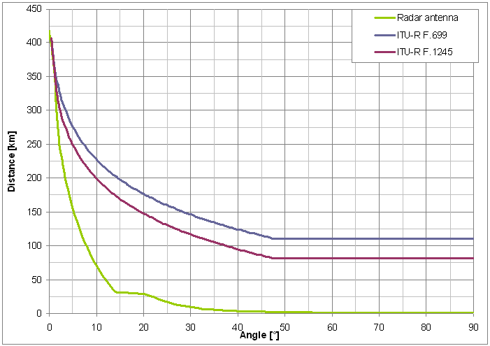

Figure 29: Distance between IT and VR as a function of victim antenna angle (radar antenna) and interfering antenna angle (F.699 and F.1245)

Table 27: summary of the results for ground tracking radar

|  | **ITU-R F.699** | **ITU-R F.1245** | **Radar antenna** |
| --- | --- | --- | --- |
| Minimum distance required when antennas are pointing each other | 417.27 km | 417.27 km | 417.27 km |
| Minimum distance required when antenna azimuth is 0.5° | 407.39 km/0.5° | 407.39 km/0.5° | 393.1 km/0.5° |
| Minimum distance between IT and VR/antenna azimuth | 110.58 km/≥48° | 81.38 km/≥48° | 0.55 km/≥90° |

Step 1: Evaluation of noise power density and I/N interference threshold of ground tracking radar:

Victim receiver’s noise power is defined through noise figure for nominal bandwidth:



The interference threshold expressed as power level at victim receiver antenna:



Step 2: Evaluation of MCL



According to ETSI EN 217, FS PP emission mask for Δf=1.3 MHz introduces 25 dB of attenuation (mask(Δf)=25 dB). Moreover correction factor of 5.85 dB in this case is taken into account. MCL calculation is as follows:



Step 3: Physical separation calculations based on MCL value

According to ITU-R P.452 required distance between IT and VR is equal to:

d=417.27km

#### Summary of adjacent channel coexistence studies

Table 28: summary of the results

|  | **ENG ITU-R F.1777** | | **ENG ECC Reports** | | | **MMDS** | **Radar** |
| --- | --- | --- | --- | --- | --- | --- | --- |
| **equipment with capacity up to 60 Mb/s** | | **cordless camera** | **portable video link** | **temporary P-P link** | **DL** | **Ground tracking** |
| Criterion | I/N=-6 | I/N=-10 | I/N=-6 | I/N=-6 | I/N=-6 | I/N=-10 | I/N=-6 |
| Distance (km) when antennas are pointing each other | 264.64 | 289.53 | 67.15 | 143.69 | 246.49 | 206.34 | 417.27 |
| Minimum distance (km) | 4.49 | 9.34 | 0.108 | 0.4 | 3.81 | 1.58 | 0.55 |
| Minimum distance (km)  (results for ITU-R F.1245 antenna radiation pattern) | 2.35 | 4.36 | 0.067 | 0.24 | 2.04 | 0.91 | - |

### Summary of coexistence studies

Calculations have shown that SAP/SAB (ENG), MMDS and Radiolocation are the systems, which may be interfered by introducing new FS PP services.

Based on MCL calculations it seems that introducing very narrow channel FS PP in 10.3-10.45 GHz band might be difficult. Results show that compatibility with existing systems may be achieved only with some strict coordination. It should be remembered that in calculations the worst case scenario was only considered. Especially antennas vertical radiation patterns were not taken into account. In reality distances between potential narrow channel spacing FS and other services working within center gap might be lower, but coordination would be still needed to make sure that systems are not interfering each other. Note that the calculations were done only with narrow channel spacings of 2 MHz. If the calculations had been made with narrower channel spacings, the results would have been even worse (the coordination distances would have been higher because of the higher power density of the channels). Therefore it was not considered useful to do the calculations with narrower channel spacings as, if it was done, it would not have changed the conclusion that is that it’s not advised to introduce narrow CS in the band 10.3-10.45 GHz.

For introducing very narrow FS PP, we recommend use of existing FS band plan which is probably more suitable than use of 10.3-10.45 GHz frequency gap.

Note that the interferences from narrow channel spacings toward wide channel spacings of FS regular plan was not studied. Actually it was not considered useful as the coexistence studies with other systems have shown that the introduction of narrow channel spacings in 10.3-10.45 GHz band would be difficult.

Between 10500 MHz and 10650 MHz a quantity of 150 MHz spectrum is already allocated to Fixed Service and could be used for the implementation of FS channel arrangements as they are defined in Annex B of the Recommendation T/R 13-01 (see Figure 3 in 4.1). In this 150 MHz of spectrum it could be noted that between 10500 MHz and 10600 MHz there is a quantity of 100 MHz spectrum that is primary allocated to Fixed service/Mobile service (10500 MHz-10550 MHz) and to Fixed service/Mobile service except aeronautical mobile (10550 MHz-10600 MHz) in the three regions (See Table 1). From a technical point of view the 50 MHz of spectrum corresponding to 2x25 MHz between 1375/1400 MHz and 1427/1452 MHz could be included in the channel arrangement between 10500 – 10600 MHz as defined in Table 2 of Annex A in the ECC Recommendation 12-05 which defines the harmonised radio frequency channel arrangements for digital terrestrial fixed systems operating in the band 10.0 - 10.68 GHz, (Table 2 is reported in Figure 2 of this document). The Annex 1 describes a proposal of channel arrangement for this 100 MHz band. In this annex 1 channel arrangement proposal, the duplex bands have 26 MHz widths (10510-10536 MHz and 10564-10590 MHz) while in the 1.5 GHz band, the duplex bands have 25 MHz widths (1375-1400 MHz and 1427-1452 MHz). Also in this annex 1, the duplex gap is 28 MHz (10536 MHz-10564 MHz) while in the 1.5 GHz band, the duplex gap is 27 MHz (1400-1427 MHz).

## COMPATIBILITY/SHARING STUDIES IN THE L6 GHZ BAND

### Compatibility and sharing studies with fixed service

The interfering transmitter parameters are presented in

Table 29: FS P-P narrow channel interfering transmitter parameters

| **Parameters** | **Value** |
| --- | --- |
| Carrier frequency (MHz) | scenario dependent |
| Channel spacing and receiver noise bandwidth (MHz) | 2 |
| MaximumTx power (dBm) | 32 |
| Maximum TX output power density range (dBm/MHz) | 28.99 |
| Antenna gain (dBi) | 45 |
| Antenna pattern | ITU-R F.699-7  ITU-R F.1245-1 |
| Antenna height (m) | 20 |
| Minimum feeder/multiplexer loss range (dB) | 5.6 |
| e.i.r.p. (dBm) | 71.4 |
| e.i.r.p. density (dBm/MHz) | 68.4 |
| Receiver noise figure(dB) | 5 |
| Receiver noise power density typical (=NRX ) (dBm/MHz) | -109 |
| Transmitter emission mask | ETSI EN 302 217 |
| Transmitter spurious emission | ETSI EN 301 390 |
| I/N criterion (dB) | -6 |
| Nominal long-term interference power density (dBm/MHz)([3]) | NRX +I/N |

During coexistence studies two different FS radiation patterns are considered. Antenna radiation patterns are defined in ITU-R Recommendations:

* ITU-R F.699, which gives the peak envelope of side-lobe patterns,
* ITU-R F.1245, which describes antennas radiation patterns with average side-lobe levels.

In calculations worst case scenario is considered assuming flat terrain without obstacles between interfering transmitter and victim receiver (LOS) and antennas working with the same polarizations.

It is assumed that angles between victim receiver and interfering transmitter are changed in horizontal plane (azimuth).Due to considerations of the worst case scenario, impact of vertical antenna gain is not taken into account.

In calculations maximum interfering transmitter power of 32dBm is used. This value is assumed as the highest possible value of in channel power (maximum transmission power within emission mask). Figure 2 below presents FS transmitter emission mask derived from ETSI EN 302 217 and EN 302 390.



Figure 30: FS transmitter emission mask derived from ETSI EN 302 217 and EN 302 3

Free Space Model is used for calculation of interfering signal level when satellite systems are considered as victim.

### Co-channel sharing studies

#### Fixed Satellite Service

Studies with FSS are presented in paragraph 4.3.4

#### UltraWideband systems/applications (UWB)

According to ECC Decision (06)04 UWB systems operate on a non-interference, non-protected basis, therefore compatibility studies are not performed.

According to ECC/DEC (11)02 that LPR shall operate on a non-interference, non-protected basis, therefore coexistence studies are not performed.

#### Short Range Devices radiodetermination applications

SRD devices operates on non-interference and non-protected basis, therefore interference studies with these services are not required.

#### Summary of co-channel coexistence studies

Revision of systems, which may work in the same channel with new narrow channel FS PP shows, that only uplink part of ESV systems might suffer from harmful interferences. However coexistence studies prove that narrow channel fixed links will not cause interference to satellite receivers. The number of fixed links which may work simultaneously is high, however probability of having so many fixed links pointing to the satellite is quite low.

### Adjacent channel compatibility studies

#### Intelligent Transport System (ITS)

Two ITS devices are considered:

* OBU (On Board Unit): mobile ITS device mounted on a car;
* RSU (Road Side Unit): fixed ITS device placed on the ground.

The antenna patterns for these two devices are shown below:



Figure 31: OBU and RSU antenna patterns

The technical parameters used for interference assessment are given in the following tables.

Table 30: ITS receiver characteristics derived from ECC Report 101

| **Parameters** | **Value** |
| --- | --- |
| Carrier frequency (MHz) | 5 920 |
| Channel spacing and receiver noise bandwidth (MHz) | 10 MHz |
| Antenna gain (dBi) | 8 |
| Antenna pattern | Omnidirectional (horizontal) |
| Antenna height (m) | 1.7 m |
| Minimum feeder/multiplexer loss range (dB) | 5.6 |
| Receiver sensitivity (dBm) | -82 |
| Receiver sensitivity at antenna input (dBm/MHz) | -100 |
| C/I(dB) | -6 |
| Allowable Interfering Power at receiver antenna input (dBm/MHz) | -106 |



Figure 32: Maximum limit of mean spectral power density for each channel type in ITS-G5A, ITS-G5B, and ITS-G5D (extract from ETSI EN 302 663)

Table 31: Transmitter unwanted emission limits inside the 5 GHz ITS bands (e.i.r.p.) (extract from ETSI EN 302 571)

| **Power spectral density at the carrier center fc (dBm/MHz)** | **±4.5 MHz**  **Offset**  **(dBm/MHz)** | **±5.0 MHz**  **Offset**  **(dBm/MHz)** | **±5.5 MHz**  **Offset**  **(dBm/MHz)** | **±10 MHz**  **Offset**  **(dBm/MHz)** | **±15 MHz**  **Offset**  **(dBm/MHz)** |
| --- | --- | --- | --- | --- | --- |
| -10 (SCH 5 and 6) | -10 | -36 | -42 | -50 | -60 |

Due to the low elevation of ITS On Board Unit and as mentioned in ECC Report 101, the following propagation model is used for ground to ground propagation:

 if 

Table 32: Propagation parameters

|  | **Urban** | **Suburban** | **Rural** |
| --- | --- | --- | --- |
| Breakpoint distance d0 (m) | 64 | 128 | 256 |
| Pathloss factor n0 beyond the first break point | 3.8 | 3.3 | 2.8 |
| Breakpoint distance d1 (m) | 128 | 256 | 1024 |
| Pathloss factor n1 beyond the second breakpoint | 4.3 | 3.8 | 3.3 |

Using the parameters of Table 32, Figure 33 depicts propagation loss in various environments.

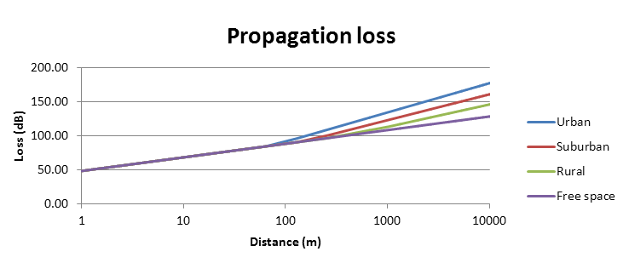

Figure 33: propagation loss for various environment in comparison with free space model

Table 33: Fixed service characteristics

| **Parameters** | **Value** | **Reference** |
| --- | --- | --- |
| Carrier frequency  Receiver Frequency (MHz) | 5925.875 |  |
| Channel spacing and receiver noise bandwidth (MHz) | 0.250 |  |
| Tx power (dBW) | -3 | ETSI TR 102 243-1 |
| Antenna gain (dB) | 45 | ETSI TR 102 243-1 |
| Typical feeder loss (dB) | 2 |  |
| Antenna height (m) | 20 |  |
| Receiver noise figure(dB) | 5 | ITU-R F.758-5 |
| Receiver noise power (dBm/MHz) (1) | -109 |  |

The separation distances calculation to protect ITS On board unit from FS emissions is presented below:

For the following calculation, the fixed service Tx power in spurious domain (note 1) is defined with a value of -24 dBm/MHz:

27 dBm – 2 (feeder loss) – 10 Log (250) – 55 (mask att) = -54dBm/KHz

Note (1): Taking in account ITS at 5 920 MHz and FS at 5 925.875

The required propagation loss LFS is given by the following equation:

LFS = e.i.r.p – Imax + Gr - LITS

where:

* Imax is the maximum interference power (-106 dBm/MHz at receiver antenna input)
* Gris the victim antenna gain in dBi
* e.i.r.p. is the e.i.r.p. of the interferer in dBm

Based on LFS value, the physical separation is derived from propagation model.

LFS = -24 dBm/MHz + 45 dBi (FS antenna gain pointing ITS) +106 dBm/MHz (Imax)

LFS = 127 dB

Table 34 defines separation distance for few values of «off axis» between ITS and Fixed Service (ITS antenna always pointing at FS).

Table 34: Separation distance between ITS and FS to ensure compatibility (Protection of ITS from FS emissions)

| **Results** | **Value** | | | | | |
| --- | --- | --- | --- | --- | --- | --- |
| FS/ITS Off axis (°) | 0 | 1 | 5 | 10 | 15 | 20 |
| FS Antenna Gain (dBi) | 45 | 36.22 | 12.66 | 5.14 | 0.73 | -2.39 |
| Required Loss (dB) | 127.00 | 118.22 | 94.66 | 87.14 | 82.73 | 79.61 |
| Separation distance (m) (Rural) | 2715 | 1471 | 215 | 91 | 55 | 38 |
| Separation distance (m) (Suburban) | 1308 | 769 | 175 | 91 | 55 | 38 |
| Separation distance (m) (Urban) | 689 | 430 | 121 | 77 | 55 | 38 |

Considering the required low separation distances between FS and ITS OBU, and the strong level of down tilt for RSU antenna gain, no study have been carried out for this equipment (much shorter distances should be expected).

The separation distances to protect FS from ITS emissions is studied below where only ITS channel SCH6 has been considered.

ITS power density : -10 dBm/MHz

ITS unwanted emission power density : -42 dBm/MHz at 5920 ± 5.5 MHz

Fixed service maximum allowable interference : - 129 dBm/MHz (I/N = -20 dB)

The same methodology as in 2.1 has been used.

LFS = -42 dBm/MHz + 8 (ITS Ant Gain) – 5.6 (ITS feeder loss) + 45 (FS antenna gain pointing ITS) + 129 dBm/MHz

LFS = 134.4 dB

Table 35 defines separation distance for few values of «off axis» between ITS and Fixed Service (ITS antenna always pointing at FS).

Table 35: Separation distance between ITS and FS to ensure compatibility (Protection of FS from ITS emissions)

| **Results** | **Value** | | | | | |
| --- | --- | --- | --- | --- | --- | --- |
| FS/ITS Off axis (°) | 0 | 1 | 5 | 10 | 15 | 20 |
| FS Antenna Gain (dBi) | 45 | 36.22 | 12.66 | 5.14 | 0.73 | -2.39 |
| Required Loss (dB) | 134.40 | 125.62 | 102.06 | 94.54 | 90.13 | 87.01 |
| Separation distance (m) (Rural) | 4548 | 2565 | 415 | 212 | 128 | 90 |
| Separation distance (m) (Suburban) | 2048 | 1203 | 289 | 174 | 128 | 90 |
| Separation distance (m) (Urban) | 689 | 640 | 181 | 120 | 92 | 77 |

The review of the results highlights the fact that the coexistence between ITS in the band 5 855 MHz – 5 825 MHz and FS with narrow channel (250 KHz) may be achievable with acceptable conditions.

Note that the 250 kHz channel spacing case was only studied here. In this lower part of the 6 GHz band (L6), the bandwidth available is rather restricted compared to the U6. Therefore, it is advised to consider lower narrow channel spacings (between 25 kHz up to 250 kHz) in the L6 whereas it would be more suitable to put higher channel spacings (above 250 kHz) in the U6 where the bandwidth available is higher. That is the reason why only the 250 KHz case was studied here.

#### Fixed Satellite Systems (FSS)-uplink

Studies with FSS are presented in paragraph 4.3.4

#### Earth Exploration Satellite Service (EESS)

The EESS systems are divided into three kinds of systems:

* EESS (passive) - where on-board satellite receivers (radiometers) are able to observe natural emissions of the Earth and its atmosphere
* EESS (active) - where radar signals are sent towards the Earth in order to get an accurate mapping of Earth surface
* EESS - where signals are sent from the Earth to satellites to control them in orbit, and from satellites to the Earth to collect on-board information

Frequency bands designed for different EESS:

* EESS (passive) allocated around 6.9 GHz,
* EESS (active)allocated in 5250-5570 MHz frequency band. Two types of EESS space are operated in this band:
  + Synthetic Aperture Radars (SAR) with frequency carrier on 5 405 MHz,
  + Altimeters with frequency carrier on 5 410 MHz

The 6-7 GHz band channel is essential for observing global soil moisture, global sea surface temperature, temperature of sea ice and sea surface wind through cloud, in combination with other channels.

**EESS passive**

Table 36 presents parameters for EESS passive. In the calculations, the bold parameters are taken into account.

Table 36: EESS (passive) sensor characteristics in the 6.425-7.25 GHz band (from ITU-R RS.1861)

|  | **Sensor B1** | Sensor B2 | **Sensor B3** | **Sensor B4** |
| --- | --- | --- | --- | --- |
| Sensor type | Conical scan | | | |
| **Orbit parameters** | | | | |
| Altitude | 705 km | **828 km** | 835 km | 699.6 km |
| Inclination | 98.2° | **98.7°** | 98.85° | 98.186° |
| Eccentricity | 0.0015 | **0** | 0 | 0.002 |
| Repeat period | 16 days | **17 days** | N/A | 16 days |
| **Sensor antenna parameters** | | | | |
| Number of beams | 1 | | | |
| Reflector diameter | 1.6 m | **2.2 m** | 0.6 m | 2.0 m |
| Maximum beam gain | 38.8 dBi | **-** | - | 40.6 dBi |
| Polarization | V,H | | | |
|  |  |  |  |  |
| –3 dB beamwidth | 2.2° | **1.65°** | - | 1.8° |
| Off-nadir pointing angle | 47.5° | **46.8°** | 55.4° | 47.5° |
| Beam dynamics | 40 rpm | **31.6 rpm** | 2.88 s scan period | 40 rpm |
| Incidence angle at Earth | 55° | **55.7°** | 65° | 55° |
| –3 dB beam dimensions | 40 km (cross-track) | **24 km** |  | 35 km (cross-track) |
| Instantaneous field of view | 43 km × 75 km | **68 km × 40 km** | 112 km × 260 km | 35 km × 61 km |
| Main beam efficiency | 95.1% | **95%** |  | 92% |
| Swath width | 1 450 km | **1 700 km** | 2 000 km | 1 450 km |
| Sensor antenna pattern | See Rec. ITU R RS.1813 | | | |
| Cold calibration ant. Gain | 25.1 dBi | N/A | | 25.6 dBi |
| Cold calibration angle (degrees re. satellite track) | 115.5º | N/A | | 115.5º |
| Cold calibration angle (degrees re. nadir direction) | 97.0º | N/A | | 97.0º |
| **Sensor receiver parameters** | | | | |
| Sensor integration time | 2.5 ms | **5 ms** | N/A | 2.5 ms |
| Channel bandwidth | 350 MHz centred at 6.925 GHz | **350 MHz centred at 6.625 GHz** | 350 MHz centred at 6.9 GHz | 350 MHz centred at 6.925 GHz and at 7.3 GHz |
| **Measurement spatial resolution** | | | | |
| Horizontal resolution | 43 km | **15-50 km** | 38 km | 35 km |
| Vertical resolution | 74 km | **24 km** | 38 km | 1. km |

Protection criterion for protecting operation of EESS (passive) in 6425-7250 frequency band is given by Recommendation ITU-R RS. 1029 as -166 dBW in 200 MHz reference bandwidth. This is described as a maximum interference level from all sources. Interference threshold can be exceeded in 0.1% of area or time. Calculations assume the worst case scenario - main lobe to main lobe coupling (victim receiver antenna is pointing directly to interfering transmitter antenna).

In calculations following formula is used:



where:

* PIT- interfering transmitter power,
* GIT(ϴ)- interfering transmitter antenna gain in direction of victim receiver,
* LIT- transmitter’s feeder loss,
* L- space loss based on free space model for d=828 km L=167.22 dB,
* GR(ϕ)- victim receiver antenna gain in direction of interfering transmitter.

The interfering transmitter frequency carrier is on 6424 MHz, victim receiver frequency is on 6424 MHz which gives 201 MHz frequency separation. FS PP spurious emission level (SEL) for such separation is -50 dBm/1MHz. The calculation for that case is as follows:



$$-80\left(\frac{dBW}{MHz}\right)+10\log\left(200\right)+45-5.6-167.22+40=-144.81 dBW in 200MHz$$

This constitutes a deficit of 21.19 dB with respect to sensor protection level of -166 dBW for bandwidth of 200 MHz. This deficit would occur for single FS PP and does not take into account aggregate effect of multiple FS PP links.

However, situation described above is very unlikely to occur. In figure below power received by EESS receiver as a function of interfering antenna azimuth/elevation angle is presented (antenna has the same horizontal and vertical radiation pattern). Antenna azimuth/elevation θ is changed between 0.5° and 90°.

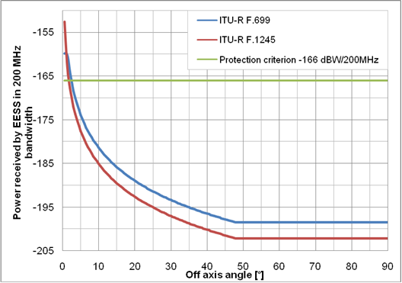

Figure 34: Power received by EESS receiver as a function of interfering antenna angle

As it can be seen only for very low interfering antenna angles protection criterion for EESS receiver is not met.

Table 37: Summary of the results

|  | **ITU-R F.699** | **ITU-R F.1245** |
| --- | --- | --- |
| Interfering antenna angles for which EESS criterion is met | ≥ 2.5° | ≥ 2° |

Note that above calculations are valid only for single FS PP and aggregate effect for multiple FS PP links is not taken into consideration.

**EESS active**

Taking into account the lowest frequency separation between interfering transmitter (fi=5926 MHz) and victim receiver (i.e. fv= 5410 MHz), no coexistence study is needed. There would be no interference from narrow band FS PP to EESS active.

### Summary on Lower 6 GHz coexistence studies

Based on calculations it is shown that introducing very narrow channel FS PP in 5925-6425MHz band gaps might be possible with coordination (actually narrow FS PP may cause the most harmful interferences to system working in adjacent channel/band).

Results of calculation show that there is low probability of interference between very narrow channel FS PP and satellite services.

In this study, the coexistence with FS PP in the harmonized band plan was not addressed. However use of classical rules used in classical FS band plan can help insertion of narrow band FS within center gaps and guard bands:

* avoid use of the closest adjacent channel between center gap and regular plan,
* make/use profits of duplex filter attenuation of fixed links working within harmonized band plan,
* Use of different antenna polarizations,
* Use of regular FS coordination rules specified by national administrations.

## COMPATIBILITY/SHARING STUDIES IN THE U6 GHZ BAND

### Fixed service characteristics

Table 38, the interfering transmitter and victim receiver parameters are presented.

Table 38: interfering transmitter and victim receiver parameters

|  | **FS P-P narrow channel interfering transmitter** | **FS P-P victim receiver** | **Reference** |
| --- | --- | --- | --- |
| Carrier frequency Receiver Frequency (MHz) | 6762.75 | 6740 |  |
| Channel spacing and receiver noise bandwidth (MHz) | 0.5 | 40 |  |
| Tx power (dBW) | -3 |  | ETSI TR 102 243-1 |
| Antenna gain (dB) | 45 | 45 | ETSI TR 102 243-1 |
| Typical feeder loss (dB) | 2 |  |  |
| Antenna height (m) | 20 | 20 |  |
| Receiver noise figure(dB) |  | 5 | ITU-R F.758-5 |
| Receiver noise power (dBm/MHz) (1) |  | -109 |  |

(1) NRx = -114 dBm/MHz + NF

Antenna radiation pattern from ITU-R F.1245:

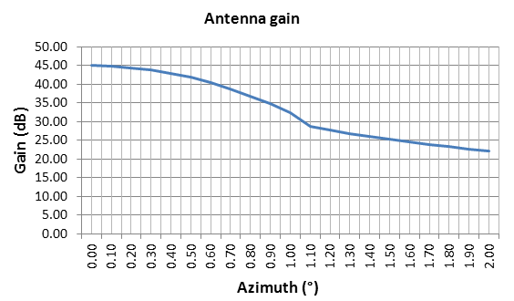

Figure 35: Antenna pattern derived from ITU-R F.1245-2 (f=7100 MHz)

### Compatibility with FS in adjacent channels

This scenario takes in account the assumption that only bandwidth is implemented, as reported by some administrations on their current use of the U6 band (either 40 MHz or 30 MHz channels). Narrow channels are defined according Figure 11.

The results are presented through following figure which shows the distance between IT and VR as a function of victim and interfering antenna angle (off axis).

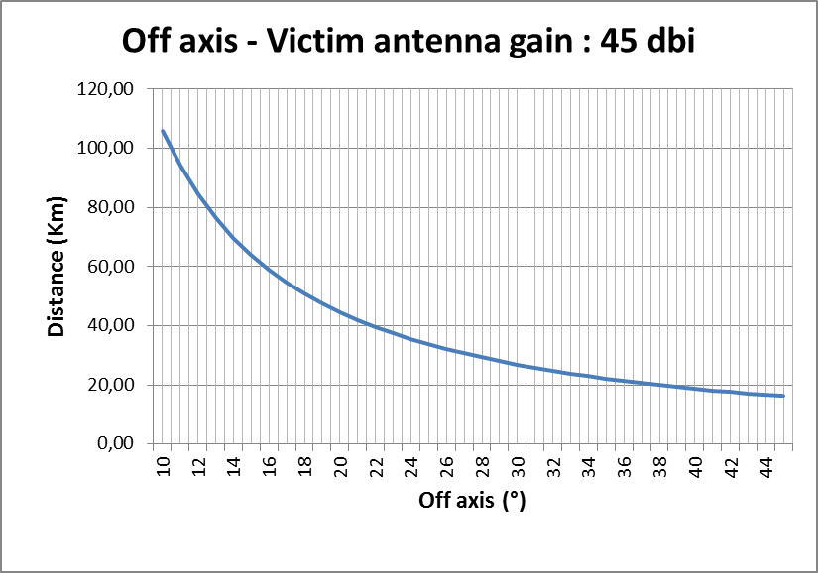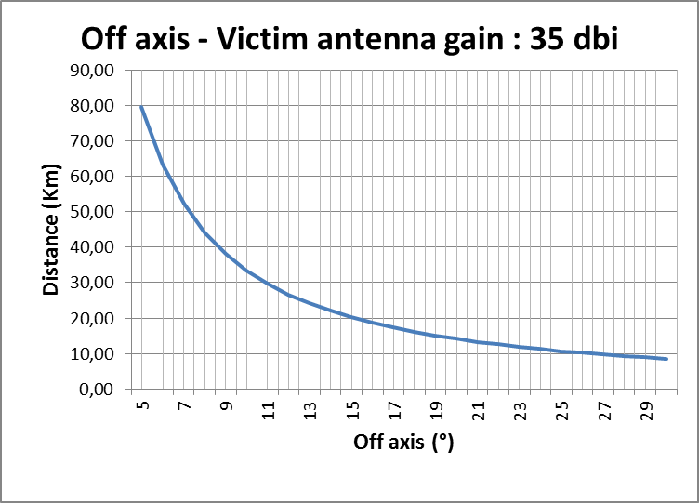

Figure 36: Distance between IT and VR as a function of victim and interfering antenna angle (Txint power in spurious domain according to ITU-R SM.329)

With :

MCL = -14.77 dBm/MHz + Gantint f(off axis angle) + Gantvict (45 or 35 dBi)+115 (I/N=-6 dB)

Distance=d= 10[MCL-32.44-20log(f)]/20

-14.77 = spurious emission level according ITU-R SM.329

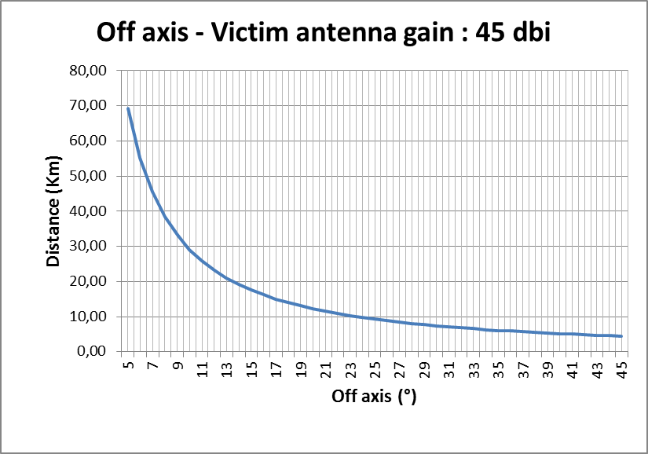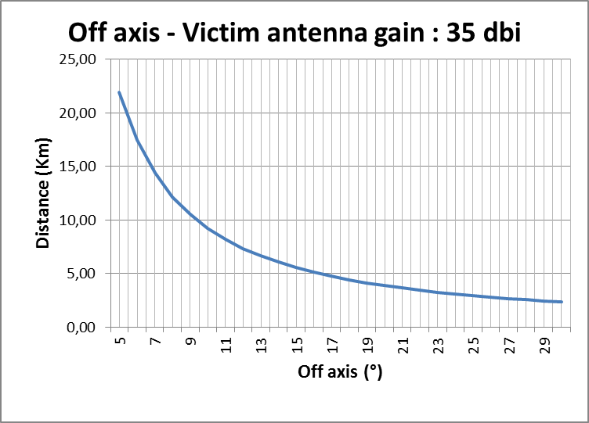

Figure 37: Distance between IT and VR as a function of victim and interfering antenna angle (TX power according ETSI EN 302 217-2-2 Class 4L-16QAM)

MCL = -25.75 dBm/MHz + Gantint [f(off axis angle)]+ Gantvict (45 or 35 dBi) + 115 (I/N=-6dB)

The value of -25.75 dBm/MHz is obtained as shown below:

Tx – Feeder loss: 25 dBm/500KHz

25 – 10 Log (500*0.75) – 55 (mask att) = -55.75 dBm/KHz = -25.75 dBm/MHz

The “0.75” factor is used to take in account average channel occupation.

When applying the option 3 (Figure 13) with simultaneous use of two channel arrangements in the U6 band (e.g. 40 MHz and 30 MHz), the compatibility is achieved in the same fashion that the one described in section 5.2.

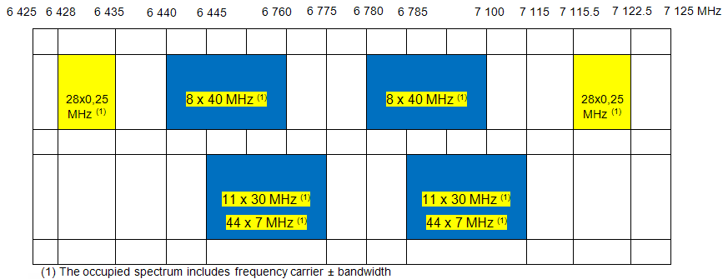

Figure 38: Occupied spectrum with 40 MHz and 30 MHz channels and narrow channels

### Compatibility with FS in the same band

In the cases where several channels arrangements (40 MHz, 30 MHz and 20 MHz) are simultaneously implemented in the same large area, the administrations already have to set coordination requirements.

Consistent coordination may be readily achieved with frequency offset of 2.5x narrow channel spacing and/or cross-polar discrimination.

### Compatibility with other services

#### Fixed satellite service (Uplink)

Typical fixed satellite service (FSS) parameters at 6/8 GHz are presented in Table 39.

Table 39: Typical FSS parameters at 6/8 GHz (Uplink) (from ECC Report 064)

| **Parameter** | **Unit** | **Typical geostationary satellite system** |
| --- | --- | --- |
| Uplink band | GHz | 5 725-7 075, 7 900-8 400(1) |
| Free-space loss | dB | 199.5 |
| Clear-air loss | dB | 0.1 |
| Satellite antenna gain | dBi | 35 |
| Noise temperature | K | 600 |

(1 These typical FSS parameters were assumed to also apply to the 7250-7750 MHz band and 7900-8400 MHz [Note : it has to be confirmed for the European case ]

Typical feeder link satellite parameters are presented in Table 40.

Table 40: Typical MSS parameters at 6/8 GHz (Uplink) (from ECC Report 064)

| **Parameter** | **Inmarsat-3** | **Units** |
| --- | --- | --- |
| Beam | Global |  |
| Frequency Band | 6 425-6 575 | MHz |
| System noise temperature | 891 | K |
| Bandwidth | 32.7 | MHz |

Recommendation ITU-R S.1432 contains the allowable degradations to the FSS below 15 GHz. The Recommendation states that for all sources of long-term interference from systems having co-primary status, the allowable interference noise contribution is 6%.

This study adopts the ΔT/T approach described in Appendix 8 of the ITU Radio Regulations[4]

The limitation of increase of equivalent noise temperature is expressed by the following relationship:

$$\frac{∆T_{sat}}{T_{sat}}<Y \%$$

where

* $Δ$*Tsat* : apparent increase in the receiving system noise temperature at the satellite, due to an interfering emission (K);
* *Tsat*: the receiving system noise temperature at the satellite referred to the output of the receiving antenna of the satellite (K)
* *Y* : noise increase allowed (6% in case of FS).

In the case under consideration here, *ΔTsat* is the contribution of aggregate emissions from FS P-P devices at the input of satellite receiver.

Assuming that FS P-P interference can be treated similarly to thermal noise, the following relationship can be assumed (linear scale, not dB):

$$∆T_{sat}=\frac{E{IRP}_{FS}∙G_{sat}}{k∙l} K$$

where

* *E.I.R.PFS* : the aggregate E.I.R.P spectral density of the FS P-P transmitters in the satellite beam and in the direction of the satellite (W*Hz-1);
* *Gsat*: the gain of receiving antenna of the satellite in the direction of FWA interferer (linear ratio, relative to isotropic);
* *k* : Boltzmann’s constant (1.38x10-23 J.K-1);
* *l* : uplink Free Space path loss (linear power ratio). Note that this could also include gaseous attenuation due to absorption by water vapour and oxygen molecules;

Combining above equations:

$${EIRP}_{FS}=10∙\log\left(X\right)-29.1-10∙log\left(\frac{G_{sat}}{T_{sat}}\right)dB\left(W{Hz}^{-1}\right)$$

$${EIRP}_{FS}=10∙\log\left(X\right)-29.1-G_{sat}+10∙log\left(T_{sat}\right)dB\left(W{Hz}^{-1}\right)$$

Where *Gsat/Tsat* is the “G/T” at the satellite receiver input derived from the values of *Gsat* and *Tsat* given in Table 2 and a particular value of *l* (10*log(*l)*=199.5dB) has been derived from table 2 as free space loss for a distance of 38000 km (distance from Europe to a satellite at the same longitude).

The following presents an example of calculation for Scenario a :

FS location : 48N 2E - FS elevation : 0° - Pointing satellite longitude

Satellite longitude : 7E – Elevation off axis with FS : 34°

$${EIRP}_{FS}=10∙\log\left(0.06\right)-29.1-35+10∙log\left(891\right) =-46.82 dB\left(W{Hz}^{-1}\right)$$

$${EIRP}_{FSchannel}={EIRP}_{FS}+10∙\log\left(B\right)=-46.82+10∙\log\left(500 000\right)=10.18 dBW/0.5MHz$$

EIRPDevice channel is the E.I.R.P density range in dBW/channel of one single FS PP device in the direction of

${EIRP}_{Device channel}=$-3 dBW – 8.54 dBi – 2 dB = - 13.54 dBW/0.5 MHz

(-8.54 dBi = antenna gain at 34° elevation – ref ITU-R F.1245-2)

Number of active devices : ${10\log\left(N\right)=EIRP}_{FSchannel}- {EIRP}_{Device channel}$

Number of active devices : 10.18 dBW – (-13.54dBW) = 23.72 or 235 fixed service devices over 0.5 MHz.

Considering a 15 MHz band (option 1) : 7 050 fixed service devices over 15 MHz.

Table 41: Summary of sharing studies with FSS

| **Scenario** | **a** | **b** | **c** | **d** | **e** | **f** |
| --- | --- | --- | --- | --- | --- | --- |
| FS Bandwidth (MHz) | 0.5 | 0.5 | 0.5 | 0.25 | 0.25 | 0.25 |
| Satellite receiving noise temp. (K) | 891 | 891 | 700 | 891 | 700 | 700 |
| Aggregate FS e.i.r.p for  Tsat/T=6% (dBW/Hz) | -46.82 | -46.82 | -47.56 | -46.82 | -47.56 | -47.56 |
| Satellite antenna gain (dBi) | 35 | 35 | 34.7 | 35 | 34.7 | 34.7 |
| Max aggregate FS e.i.r.p in one channel (dBW/Bandwidth) | 10.18 | 10.18 | 9.44 | 7.15 | 6.44 | 6.44 |
| FS Location | 48N 2E | 48N 2E | 48N 2E | 48N 2E | 48N 2E | 48N 2E |
| FS Elevation (°) | 0 | 5 | 0 | 5 | 0 | 5 |
| Satellite longitude | 7E | 7E | 66E | 7E | 66E | 66E |
| FS Azimuth (°) | 173.2 | 173.2 | 109.9 | 173.2 | 109.9 | 109.9 |
| Fixed service off axis/Satellite (°) | 34 | 29 | 8.45 | 29 | 8.45 | 3.45 |
| FS Antenna Gain (dB) | -8.54 | -6.82 | 6.57 | -6.82 | 6.57 | 16.3 |
| Number of FS links over 15 MHz | 7 050 | 4 950 | 183.6 | 4 933 | 183.6 | 19.2 |
| % of total FS(1) | >100% | 88% | 3.2% | 88% | 3.2% | 0.3% |

(1) 5 600 links reported in Europe between 1350 – 1800 MHz (from 2010 questionnaire – ECC Report 173)

These results disregard the 3 dB factor of polarisation that could be used to improve the compatibility calculations and complete line of sight link between FS and FSS space stations.

Taking in account that the studies have highlighted the major impact of spectral power density when assessing the impact of fixed service links with narrow channels, and with the view of setting relevant parameters for FS links, complementary analysis must be carried out.

#### Fixed satellite service – complementary study

Article 21 of the Radio Regulations contains the appropriate provisions to protect FSS satellites on geostationary orbit from FS emissions.

Moreover, with the view to implement narrow channels on the 6 GHz band in accordance with the applicable requirements, it is proposed to set suitable parameters taking in account the e.i.r.p. spectral density as a relevant basis.

According Recommendation ITU-R F.758, fixed service parameters for 5 925 – 6 425 MHz are defined as following:

Minimum bandwidth: 5 MHz

Maximum Tx power: 2 dBW

Maximum antenna gain: 46.6 dB

Minimum feeder loss: 1.1 dB

From these parameters we can derive the maximum currently allowable e.i.r.p density:

🡺 2dBW – 1.1 + 46.6 – 10 Log (5 MHz)

🡺 40.6 dBW/MHz

Implementation of narrow channels in the L6 GHz band should therefore also consider this e.i.r.p. spectral density value.

Table 42 below contains allowable e.i.r.p levels for each type of carrier bandwidth.

Example of calculation:

For 2 MHz bandwidth:

e.i.r.p. density per MHz + 10 Log (2 MHz)

40.6 + 3 = 43.6 dBW

Table 42: Resulting e.i.r.p in the band 5925- 6425 MHz.

| **Bandwidth (MHz)** | **2** | **1** | **0.5** | **0.25** | **0.025** |
| --- | --- | --- | --- | --- | --- |
| e.i.r.p (dBW) | 43.6 | 40.6 | 37.6 | 34.6 | 24.6 |

According Recommendation ITU-R F.758, fixed service parameters for 6 425 – 7 125 MHz are defined as following:

Minimum bandwidth: 5 MHz (ECC Rec 14-02 sets 3.5 MHz bandwidth channels)

Maximum Tx power: 4 dBW

Maximum antenna gain: 47.4 dB

Minimum feeder loss: 0 dB

From these parameters we can derive the maximum usable e.i.r.p density from a regulatory point of view:

🡺 4dBW + 47.4 – 10 Log (3.5 MHz)

🡺 45.96 dBW/MHz

Implementation of narrow channels in the U6 GHz band should therefore also consider this e.i.r.p. spectral density value.

Table 43 below contains allowable e.i.r.p levels for each type of carrier bandwidth.

Example of calculation:

For 2 MHz bandwidth:

(Tx + Gant) + 10 Log (2 MHz) = 45.96 +3 = 48.96 dBW/MHz

Maximum e.i.r.p for a 2 MHz bandwidth channel: 48.96 dBW

Table 43: Resulting e.i.r.p in the band 6 425 – 7 125 MHz.

| **Bandwidth (MHz)** | **2** | **1** | **0.5** | **0.25** | **0.025** |
| --- | --- | --- | --- | --- | --- |
| Max e.i.r.p (dBW) | 48.96 | 45.96 | 42.96 | 39.96 | 29.96 |

Application

The table below shows some particular scenarios to confirm the feasibility of implementing narrow FS channels in the L6 and U6 GHz bands.

Table 44: Example of scenarios to check the feasibility of implementing narrow FS channels in the L6 and U6 GHz bands

| **Scenario** | **a** | **b** | **c** | **d** | **e** | **f** |  |
| --- | --- | --- | --- | --- | --- | --- | --- |
| FS Bandwidth (MHz) | 2 | 2 | 0.5 | 0.25 | 0.25 | 0.25 | 0.025 |
| Satellite receiving noise temp. (K) | 891 | 700 | 891 | 891 | 700 | 700 | 700 |
| Aggregate FS e.i.r.p for  Tsat/T=6% (dBW/Hz) | -46.82 | -47.56 | -46.82 | -46.82 | -47.56 | -47.56 | -47.56 |
| Satellite antenna gain (dBi) | 35 | 34.7 | 35 | 35 | 34.7 | 34.7 | 34.7 |
| Max aggregate FS e.i.r.p in one channel (dBW/Bandwidth) | 16.18 | 15.44 | 10.18 | 7.15 | 6.44 | 6.44 | -3.56 |
| FS Location | 48N 2E | 48N 2E | 48N 2E | 48N 2E | 48N 2E | 48N 2E | 48N 2E |
| FS elevation (°) | 2 | 0 | 2 | 2 | 0 | 0 | 0 |
| FS antenna gain (dBi) | 46 | 45 | 43 | 45 | 45 | 45 | 40 |
| FS Tx power (dBW) | 2(1) | -3 | -1 | -5 | -5 | -5 | -10 |
| FS e.i.r.p (dBW) | 48 (2) | 42(2) | 42(2) | 40(2) | 40(2) | 40(2) | 30(2) |
| Satellite longitude | 7E | 66E | 7E | 7E | 66E | 66E | 66E |
| Fixed service off axis/Satellite (°) | 32 | 8.45 | 32 | 32 | 8.45 | 8.45 | 8.45 |
| Off axis attenuation (dB) | -53 | -39 | -50.89 | -53 | -39 | -39 | -33.43 |
| Number of FS links in one channel | 207 | 28 | 127 | 164 | 5 | 5.5 | 1.53 |
| Number of FS links over 15 MHz | 1552 | 210 | 3 810 | 9840 | 332 | 330 | 918 |

(1) Typical transmitter highest power (ETSI TR 102 243)

(2) Recommendation ITU-R F.758 reports an e.i.r.p range from 15.8 to 48.8 dBW. One administration (France) reports an average of 32 dBW.

Example of calculation:

*Scenario a* :

FS location : 48N 2E - FS elevation : 2° - Pointing satellite longitude

Satellite longitude : 7E – Elevation off axis with FS : 32°

$${EIRP}_{FS}=10∙\log\left(0.06\right)-29.1-35+10∙log\left(891\right) =-46.82 dB\left(W{Hz}^{-1}\right)$$

$${EIRP}_{FSchannel}={EIRP}_{FS}+10∙\log\left(B\right)=-46.82+10∙\log\left(2 000 000\right)=16.18 dBW/MHz$$

EIRPDevice channel is the E.I.R.P density range in dBW/channel of one single FS PP device in the direction of the satellite.

${EIRP}_{Device channel}=$ 48 dBW – 53 dBi – 2 dB = - 7 dBW/2MHz

(-53 dBi = off axis antenna attenuation at 32° – ref ITU-R F.1245-2)

Number of active devices: ${10\log\left(N\right)=EIRP}_{FSchannel}- {EIRP}_{Device channel}$

Number of active devices: 16.18 dBW + 7 = 23.18 or 207 fixed service devices over 2 MHz.

It must be noted that there is a very low probability that numerous fixed service stations are simultaneously pointing the same low elevation satellite whose footprint spans over Europe, on the same channel.

#### Conclusions

To ensure compatibility between FS with narrow channels and FSS in the 6 GHz band, and in addition of RR Article 21 provisions and e.i.r.p. spectral density values mentioned above, the implementation of narrow channels should also consider the two following conditions:

- Use of the lowest e.i.r.p levels when the fixed service is pointing further East/West positions of GSO;

- Insofar as possible, use of ATPC for FS links.

## COMPATIBILITY STUDIES FOR L6 AND U6 BANDS

### Impact of wide bandwidth channels on narrow channels in the 6 GHz band.

#### Scenarios to be considered.

Scenario a).

The following layout is assumed as the consistent scenario:

Interfering transmitter

Victim receiver

Figure 39: relevant scenario to assess coordination between fixed service links

ITU-R F.1095 points out that for calculating the coordination distance, the antenna discrimination of transmitting and receiving antenna must be integrated in calculation.

Scenario b)

The following layout is assumed as the worst case scenario:

Victim receiver

Interfering transmitter

Figure 40: worst case scenario to assess coordination between fixed service links

Interfering transmitter is always pointing at victim receiver.

#### Compatibility studies.

L6 band – 29.65 bandwidth channels.

We will consider the 29.65 MHz bandwidth upper channel of the lower part of the band:

f0 = f8 as defined in Rec 14-01 = 6 152.75 MHz

The first 0.5 MHz bandwidth channel is operated at:

5 925 MHz + 5.376 MHz+ (8x29.65 MHz) + 2.92 MHz+ 0.25 MHz = 6 170.74 MHz

**6 170.74 MHz.**

**6 152.75 MHz**

5,376

Guard band

5,376

Guard band

**14.84 MHz**

**Center gap**

5 925

6 425

8 x 29,65

8 x 29,65

2.92 MHz

9 MHz

2.92 MHz

Figure 41: example of channels implementation in L6 band

29.65 MHz spectrum mask:

From ETSI EN 302 217 (table B4), spectrum mask for 28 to 30 MHz channels bandwidth operating between 3 and 11 GHz is defined as following :

Table 45: parameters of spectrum mask for a 29.65 MHz bandwidth channel.

|  | **f0** | **f1** | **f2** | **f3** |
| --- | --- | --- | --- | --- |
| Frequency (MHz) | 6 152.75 | 6 163.95 | 6 175.15 | 6 180.75 |
| Frequency offset (MHz) | 0 | 11.2 | 22.4 | 28 |
| Attenuation (dB) | 0 | 1 | -32 | -37 |

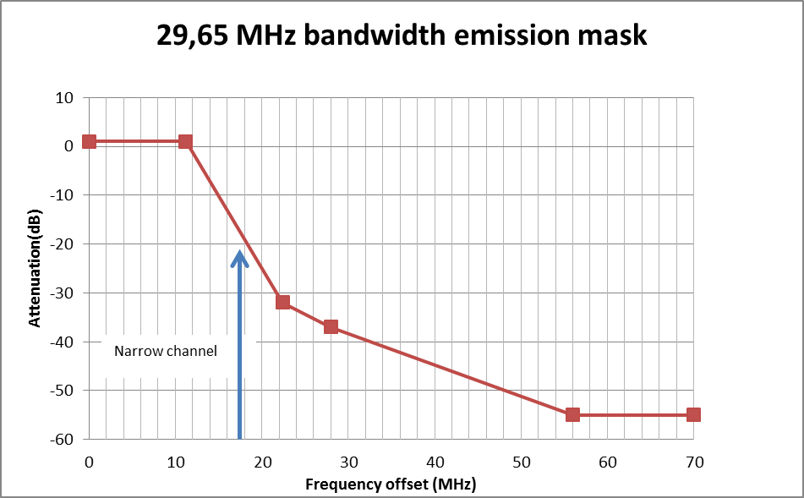

Figure 42: 29.65 MHz bandwidth spectrum emission mask

From spectrum mask, we can derive the attenuation at 6 170.74 MHz (f0 + 17.99 MHz) : - 19 dB

29.65 MHz bandwidth channel Tx power: 27 dBm

Tx power spectral density = 27 dBm – 2 -19 – 10 Log (29.65) = -8.72 dBm/MHz

Scenario a):

With: MCL = -8.72 dBm/MHz + Gantvict [f(off axis angle)]+Gantint [f(off axis angle)] + 115 dBm/MHz (I/N=-6dB)

d = 10[MCL-32.44-20log(f)]/20

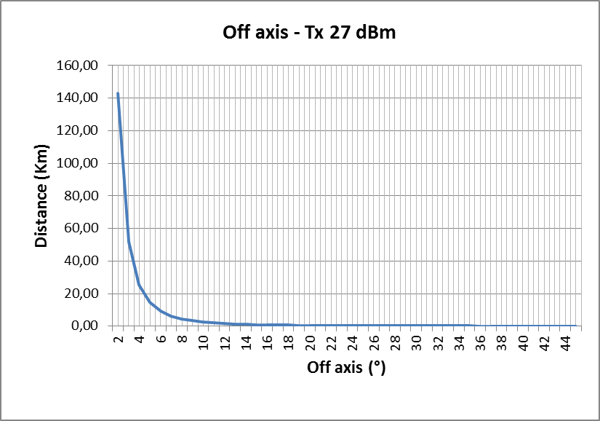

Figure 43: Distance between IT and VR as a function of victim and interfering antenna angle (antenna patterns derived from ITU-R F.1245)

Scenario b)

With: MCL = -8.72 dBm/MHz +Gantint (45 dBi) + Gantvict [f(off axis angle)] + 115 (dBm/MHz) (I/N=-6dB)

d = 10[MCL-32.44-20log(f)]/20

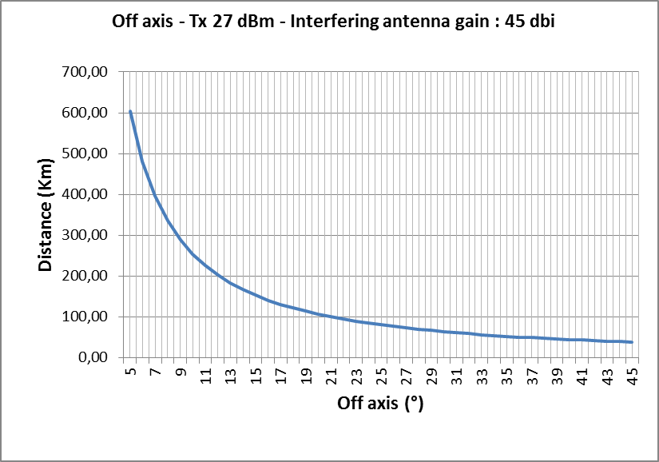

Figure 44: Distance between IT and VR as a function of victim and interfering antenna angle (antenna patterns derived from ITU-R F.1245)

For that worst (and rare) case scenario, a strong and careful coordination is required, as usually, in fixed service engineering.

U6 band – 40 MHz bandwidth channels.

We will consider the 40 MHz bandwidth upper channel of the lower part of the band:

f0 = f8 as defined in Rec 14-02 = 6 740 MHz

The first 0.5 MHz bandwidth channel is operated at:

6 425 MHz + 15 MHz + (8x40MHz) + 2.5 MHz+ 0.25 MHz = 6 762.75 MHz

**6 762.75 MHz.**

**6 740 MHz**

**15 MHz**

**20 MHz Center gap**

**25 MHz**

6 425

6 760

6 780

7 125

8 x 40 MHz

8 x 40 MHz

2.5 MHz

15 MHz

2.5 MHz

Figure 45: example of channels implementation in U6 band

40 MHz channel spectrum mask:

From ETSI EN 302 217 (table C4), spectrum mask for 40 MHz channels bandwidth operating between 3 and 11 GHz is defined as following :

Table 46: parameters of spectrum mask for a 40 MHz bandwidth channel.

|  | **f0** | **f1** | **f2** | **f3** | **F4** |
| --- | --- | --- | --- | --- | --- |
| Frequency (MHz) | 6 740 | 6 757 | 6 759.5 | 6 764 | 6 794 |
| Frequency offset (MHz) | 0 | +17 | +19.5 | 24 | 54 |
| Attenuation (dB) | 0 | +1 | -10 | -35 | -40 |

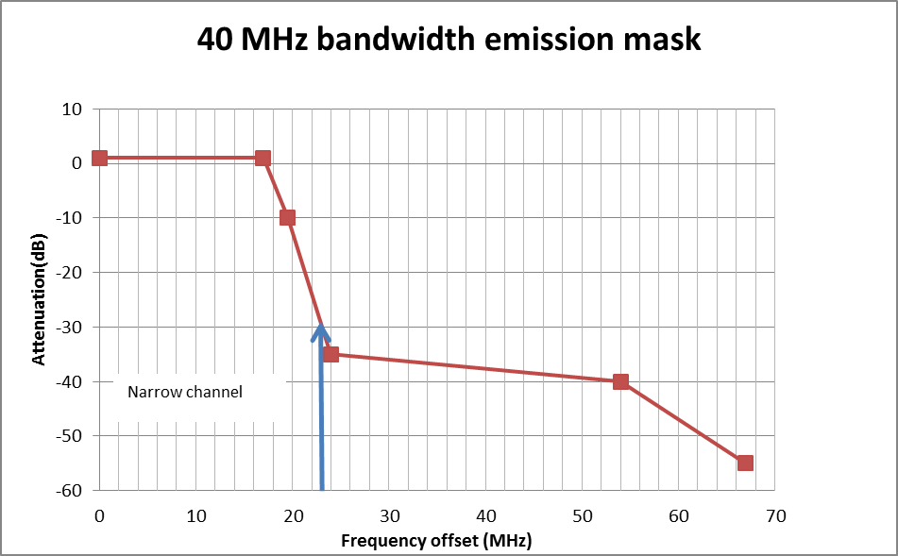

Figure 46: 40 MHz bandwidth spectrum emission mask

From spectrum mask, we can derive the attenuation at 6 762.75 MHz (f0 + 22.75 MHz): -28 dB

40 MHz bandwidth channel Tx power: 27 dBm

Tx power spectral density = 27 dBm – 2 - 28 – 10 Log (40 MHz) = - 19 dBm/MHz

Scenario a)

With: MCL = -19 dBm/MHz + Gantint [f(off axis angle)]+Gantvict [f(off axis angle)] + 115 (dBm/MHz) (I/N=-6dB)

d = 10[MCL-32.44-20log(f)]/20

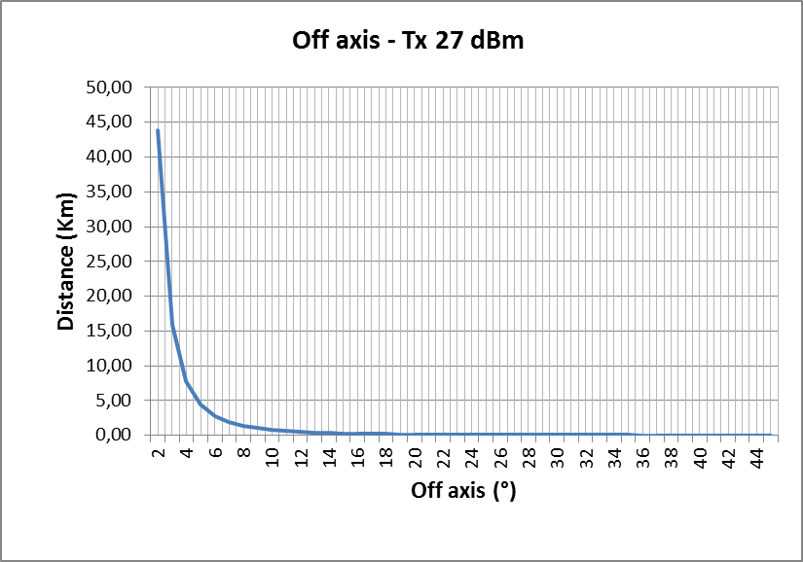

Figure 47: Distance between IT and VR as a function of victim and interfering antenna angle (antenna patterns derived from ITU-R F.1245)

Scenario b)

With: MCL = -19 dBm/MHz +Gantint (45 dBi) + Gantvict [f(off axis angle)] + 115 (dBm/MHz) (I/N=-6dB)

d = 10[MCL-32.44-20log(f)]/20

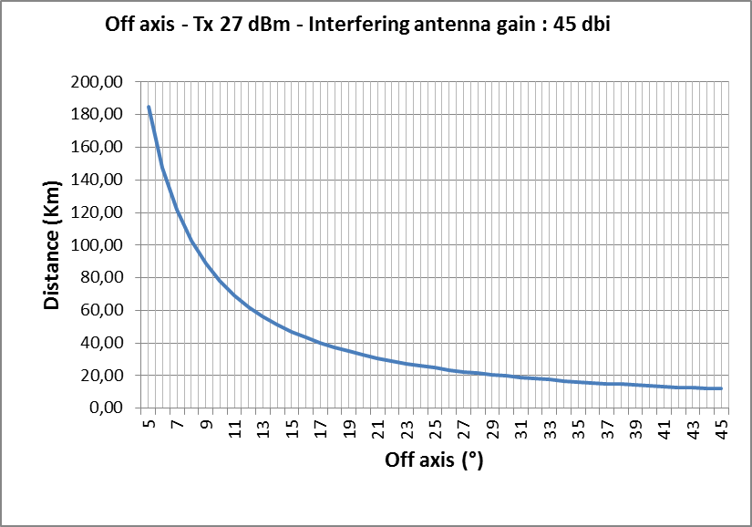

Figure 48: Distance between IT and VR as a function of victim and interfering antenna angle (antenna patterns derived from ITU-R F.1245)

For that worst (and rare) case scenario, a strong and careful coordination is required, as usually, in fixed service engineering.

U6 band – 3.5 MHz bandwidth channels.

We will consider the 3.5 MHz bandwidth upper channel of the lower part of the band:

f0 = f44 as defined in Rec 14-02 = 6 772.25 MHz

The first 0.5 MHz bandwidth channel is operated at:

6 772.25 MHz + 1.75 + 2.5 MHz+ 0.25 MHz = 6 776.75 MHz

3.5 MHz channel spectrum mask:

From ETSI EN 302 217 (table B4), spectrum mask for 3.5 MHz channels bandwidth operating between 3 and 11 GHz is defined as following :

Table 47: parameters of spectrum mask for a 3.5 MHz bandwidth channel.

|  | **f0** | **f1** | **f2** | **f3** | **F4** |
| --- | --- | --- | --- | --- | --- |
| Frequency (MHz) | 6 772.25 | 6 773.65 | 6 775.05 | 6 775.75 | 6 779.25 |
| Frequency offset (MHz) | 0 | + 1.4 | + 2.8 | + 3.5 | + 7 |
| Attenuation (dB) | 0 | +1 | - 32 | - 37 | - 55 |

From spectrum mask, we can derive the attenuation at 6 776.75 MHz (f0 + 4.5 MHz): >- 37 dB

3.5 MHz bandwidth channel Tx power: 27 dBm

Tx power spectral density = 27 dBm – 2 - 37 – 10 Log (3.5 MHz) = < -17.44 dBm/MHz

As the same results than those for 40 MHz channels (-19 dBm/MHz) are expected, no calculation have been carried out.

### Impact on wide bandwidth channels receiver

Figure 11, referred to as “option 1”, presents a possible implementation of such channels with incumbent 40 MHz bandwidth channels.

The studies carried out so far, have highlighted acceptable conditions to achieve compatibility taking in account the impact of narrow channels out of band emissions as interferer.

The present study is a review of compatibility with regard to 40 MHz receiver selectivity.

#### Implementation of channels.

Table C.7 from document ETSI EN 302 217-2-2 defines co-channel and adjacent channel interference sensitivity for 40 MHz bandwidth receiver.

Table 48: Co-channel and adjacent channel interference sensitivity for 40 MHz bandwidth receiver (extract of table C.7 of ETSI EN 302 217-2-2).

| **Spectral efficiency** | | **Minimum RIC rate (Mbits/s)** | **C/I for BER≤ 10-6 RSL degradation of 1 dB** | |
| --- | --- | --- | --- | --- |
| **Reference index** | **Class** | **Co-channel interference** | **First adjacent channel interference** |
| 6 | 5LB | STM-1 or 137 | 33 | -4 |

From this table, it can be deducted that for 40 MHz bandwidth receiver, ACS 1= 37dB.

Thus, the spectral occupancy may be depicted as shown below:

Figure 50: 40 MHz bandwidth channel receiver selectivity

With

f0 = 6 740 MHz

f0 + 20 = 6 760 MHz (start of centre gap)

f0 + 40 = 6 780 MHz (end of centre gap)

3. Compatibility study.

Considering a narrow channel Tx power of -9 dBm/MHz

[27dBm - 2(FS loss) – 10 Log (0.5 MHz) – 37 (receiver selectivity)]

Considering a -25.75 dBm/MHz level for narrow channel out of band emissions on 40 MHz channel (from para 4.3.2)

Total received interfering level: -25.75 dBm/MHz + (– 9 dBm/MHz)(Blocking) = -8.93 dBm/MHz

(Addition in linear)

With: MCL = -8.93dBm/MHz + Gantint [f(off axis angle)]+Gantvict [f(off axis angle)] -2 (FS Loss) + 115 (I/N=-6dB)

d = 10[MCL-32.44-20log(f)]/20]

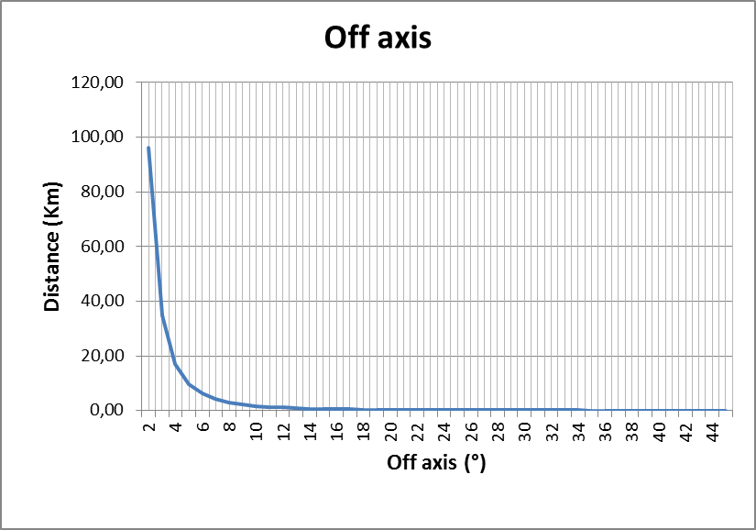

Figure 51: Distance between IT and VR as a function of victim and interfering antenna angle (antenna patterns derived from ITU-R F.1245)

Considering that similar results are expected for the L6 band and 29.65 MHz channels, no studies have been carried out for this band.

## Conclusion on U6 studies

With regard to the results of compatibility and sharing studies herein, introduction of very narrow channels in f the 6 GHz band may be planned in acceptable technical conditions.

This study demonstrates that there is potential feasibility to operate narrow channels in the 6 GHz band. According to the studied options, up to 24 MHz could be used (with regard with 25 MHz currently used in 1375-1400/1427-1452 MHz).

For administrations who implement only one channelization in each band (e.g. 29.65 MHz in L6 and 40 MHz in U6), a channelization as described in Figure 15 appears as the most appropriate one, with the advantage of not interfering with the incumbent and future services below 5 925 MHz.

# HOP LENGTH ASSESSMENT

The next figures are zooms from figures of French public consultation on FS (ARCEP, April 2012). On the left part, the 1.5 GHz FS links are given in red. On the right part, the 6 GHz FS links are presented in blue. What can be seen from this figure, is that generally, there is no correlation between the directions of the two kind of links : therefore, the probability that the coexistence case would be the worst (antenna gain of the interferer in front of the antenna gain of the receiver) is very low. It means that, from this point of view, the coexistence between the two kind of applications could be easily done.

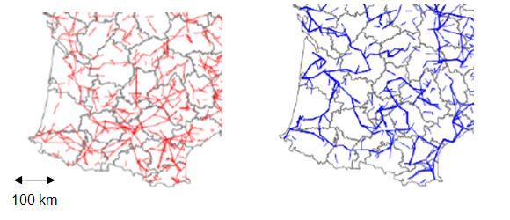

Figure 52: 1.5 GHz FS links in red on the left and 6 GHz FS links in blue on the right. French public consultation on FS (ARCEP, April 2012).

Generally the distances in CEPT countries could be up to 80 km with an average distance of 28 km (ECC Report 173).

The following parameters are proposed for these links in the 6 GHz band, :

* Pout=23 dBm
* Antenna gain=36 dBi (Antenna diameter=1.2 m)

The choice of an antenna having a 1.2 m diameter is done because for low capacity links a bigger antenna would be too expensive. Therefore

* EIRP=23+36=59 dBm
* RSL=-91 dBm

With these proposed parameters, we can deduce, the maximum path loss between the transmitter and the receiver by a simple budget link :

RSL=EIRP+receiving antenna gain-Maximum Path Loss

Maximum Path Loss=EIRP+receiving antenna gain-RSL

Maximum Path Loss=59+36+91

Maximum Path Loss=186 dB

Using a classical propagation model like P.530, the hop length can be deduced for the 6 GHz band and the result is an Hop length=50 km

Therefore, up to 50 km LoS link in climatic zone of moderate severity (i.e. Po about 1.2) is feasible with these parameters. Therefore, it is believed that the proposed parameters are appropriate parameters for low capacity links in the 6 GHz band.

Figure 53 is based on the ETSI normative EN 302 217-2-2. It gives the emission mask for a CS of 0.25 MHz. The transmit power is 27 dBm and two modulations are considered (4QAM and 16 QAM). The spurious emissions are also given.

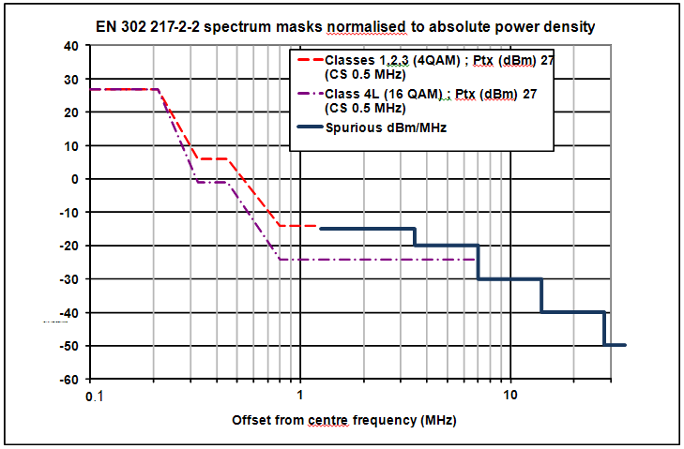

Figure 53: EN 302 217-2 spectrum masks normalised to absolute power density with a transmit power of 27 dBm

Figure 54 is the same as the previous one except for the transmit power which is 23 dBm as the proposed power for the narrow channel spacings in the 6 GHz band. This figure shows that the emission mask can give even lower powers than the spurious emissions. This is particularly interesting with respect to coexistence studies.

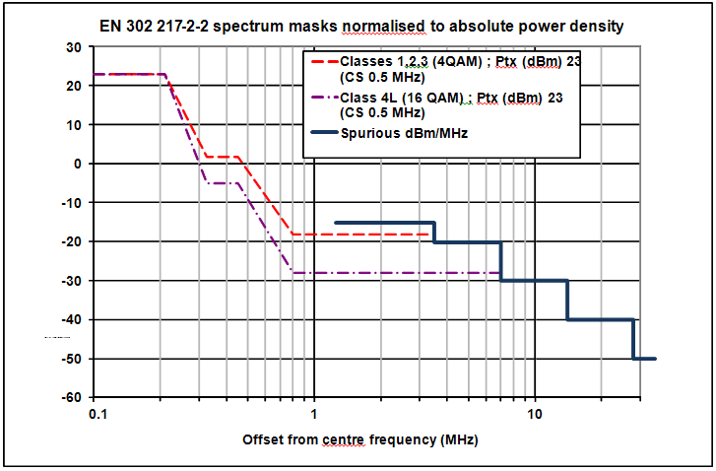

Figure 54: EN 302 217-2 spectrum masks normalised to absolute power density with a transmit power of 23 dBm

Therefore the coexistence between narrow channel spacings and wide channel spacings of the “classical” FWS band plan would be made easier using the proposed parameters of this contribution for the narrow channel spacings (especially considering interferences from narrow channel spacings to wide channel spacings). This is because by decreasing the output power the out of band emission decrease even below spurious emissions according to the current spurious regulation. Furthermore, the diameter of the chosen antenna induces an antenna gain of 36 dBi which also decreases the interferences compared to a 45 dBi antenna gain.

The calculations below gives an example of the results of coupling loss calculations between interfering narrow channel spacings and wide channel spacing of the regular band plan using the parameters (output power, antenna gain) proposed just above in this part 6. The guard band considered between narrow CS and wide CS is 5 MHz just as for the U6 proposed band plan. The results of these calculations show that for an azimuth angle above or equal to 48 degrees between interferer and victim, the coordination distance is of the order of 1 km, which means a lower coordination distance than for the parameters previously used in part 5 of this document.

All calculations were done for 500 kHz narrow channel spacing interferer with output power = 23 dBm, antenna gain = 36 dBi and feeder loss = 2dB.

The calculations for narrow band emission with 16QAM (class 4) are presented in Table 49 where the OOB emission level was -28 dBm/MHz for emission with Pout = 23 dBm

Table 49: Summary of the results OOB MCL for FS PP, Guard band = 5MHz

| **Parameters** | **Value** | | | | | | |
| --- | --- | --- | --- | --- | --- | --- | --- |
| Channel spacing (MHz) | 30 | | | | 40 | | |
| Modulation  scheme | 4QAM | 64QAM | 128OAM (STM-1) | 512QAM 6HA (ACAP) | 64QAM | 128OAM | 512QAM 6HA (ACAP) |
| SEL (dBm/MHz) | -28 | -28 | -28 | -28 | -28 | -28 | -28 |
| Wide Antenna Gain (dBi) | 45 | 45 | 45 | 45 | 45 | 45 | 45 |
| Sensitivity (dBm) | -81 | -68 | -67 | -58.5 | -69 | -63.5 | -57.5 |
| Co channel interference (dB): | 23 | 34 | 37 | 43 | 33 | 37 | 43 |
| I/N (dB) | -6 | -6 | -6 | -6 | -6 | -6 | -6 |
| C/N (dB) | -17 | -28 | -31 | -37 | -27 | -31 | -37 |
| N (dBm) | -97 | -95 | -97 | -94.5 | -95 | -93.5 | -93.5 |
| MCL (dB) | 166.8 | 164.8 | 166.8 | 164.3 | 166.0 | 164.5 | 164.5 |

Table 50: Summary of the results for FS 30MHz victim wide channel spacings worst case: 4QAM (based on ITU-R P.452-14, 0.01% of time, 6770 MHz)

|  | **ITU-R F.699** | **ITU-R F.1245** |
| --- | --- | --- |
| Minimum distance required when antennas are pointing each other | 274.5 km | 274.5 km |
| Minimum distance required when antenna azimuth is 0.5° | 249.4 km | 249.4 km |
| Minimum distance required when antenna azimuth is 10° | 32.5 km | 18.7 km |
| Minimum distance between IT and VR/antenna azimuth | 1.91 km / ≥48° | 1.17 km / ≥48° |

Table 51: Summary of the results for FS 40MHz victim wide channel spacingsworst case: 64 QAM (based on ITU-R P.452-14, 0.01% of time, 6770 MHz)

|  | **ITU-R F.699** | **ITU-R F.1245** |
| --- | --- | --- |
| Minimum distance required when antennas are pointing each other | 268.5 km | 268.5 km |
| Minimum distance required when antenna azimuth is 0.5° | 243.7 km | 243.7 km |
| Minimum distance required when antenna azimuth is 10° | 29.3 km | 16.5 km |
| Minimum distance between IT and VR/antenna azimuth | 1.73 km / ≥48° | 1.07 km / ≥48° |

# Information on equipment

During this study, no information have been presented on the feasibility of FS equipment to facilitate this narrow channels on the 6 and 10 GHz bands as well as the availability of the equipment currently on the market.

However, one administration who currently implement a large number of links operated in the 1375/1400 – 1427/1452 MHz band, indicated a steady increase of the need for implementing narrow channels.

# Conclusions

The aim of this report is to assess the feasibility of introducing narrow channel spacings for FS (25 kHz to 2 MHz), similar to those used in 1375-1400/1427-1452 MHz in some existing plans, in guard bands and center gaps of FS channel arrangement between 3 GHz and 15 GHz in terms of the compatibility and sharing considerations with others services as well as within the FS. These narrow channel FS links are used for fixed wireless services for a variety of applications including broadcasting, fixed networks, Oil & Gas, public safety and utilities, often for long hop narrowband communications. The largest users are public safety and utilities sectors. In developing this report it should be noted that the feasibility of using the bands within the range 3 to 15 GHz, for the applications that are currently used in the band 1375-1400/1427-1452 MHz (in terms of hop length and link design), was not part of this work.

During this study, no information have been presented on the feasibility of FS equipment to facilitate these narrow channels on the 6 and 10 GHz bands as well as the availability of the equipment currently on the market supporting these channels. However, one administration who currently implement a large number of links operated in the 1375/1400 – 1427/1452 MHz band, indicated a steady increase of the need for implementing narrow

The feasibility of narrow channels from compatibility/sharing point of view with others services and within FS for the following bands was carried out:

* Compatibility studies carried out for the 10 GHz band, have shown that implementation of narrow channels in guard band and/or center gap would adversely impact the incumbent services, especially those below 10.5 GHz. However, from 10.5 to 10.6 GHz and with additional channels arrangements to those currently presented in CEPT/ERC Recommendation 12-05, the 10 GHz band may be considered.
* The compatibility studies carried out for the 6 GHz band indicate that feasibility of small channel is possible in guard bands and/or center gap. Although the 6 GHz band is already allocated to fixed services as a primary allocation, several scenarios have been considered to take into account the impact of the increase of spectral power density with respect to other services like FSS. It must be noted that worst cases scenarios have pointed out the need of coordination between new FS using these small channels and other incumbent FS uses, as usually done in fixed service planning.

In summary, this report presents different options for those administrations wishing to implement narrow channels which could be considered at national level taking into account the above considerations.

1. POSSIBLE CHANNEL ARRANGEMENT IN THE 10 GHZ BAND

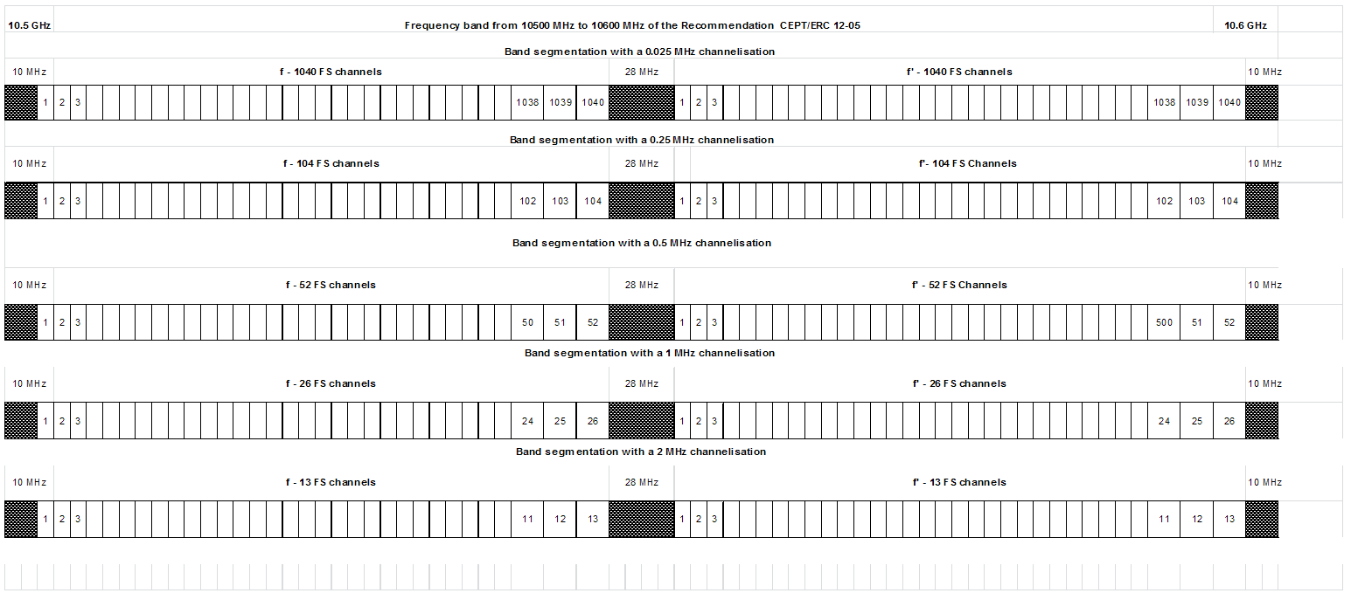

Figure 55: Possible channel arrangements with 0.025 MHz, 0.25 MHz, 0.5 MHz, 1 and MHz slots in 10.5 – 1.6 GHz

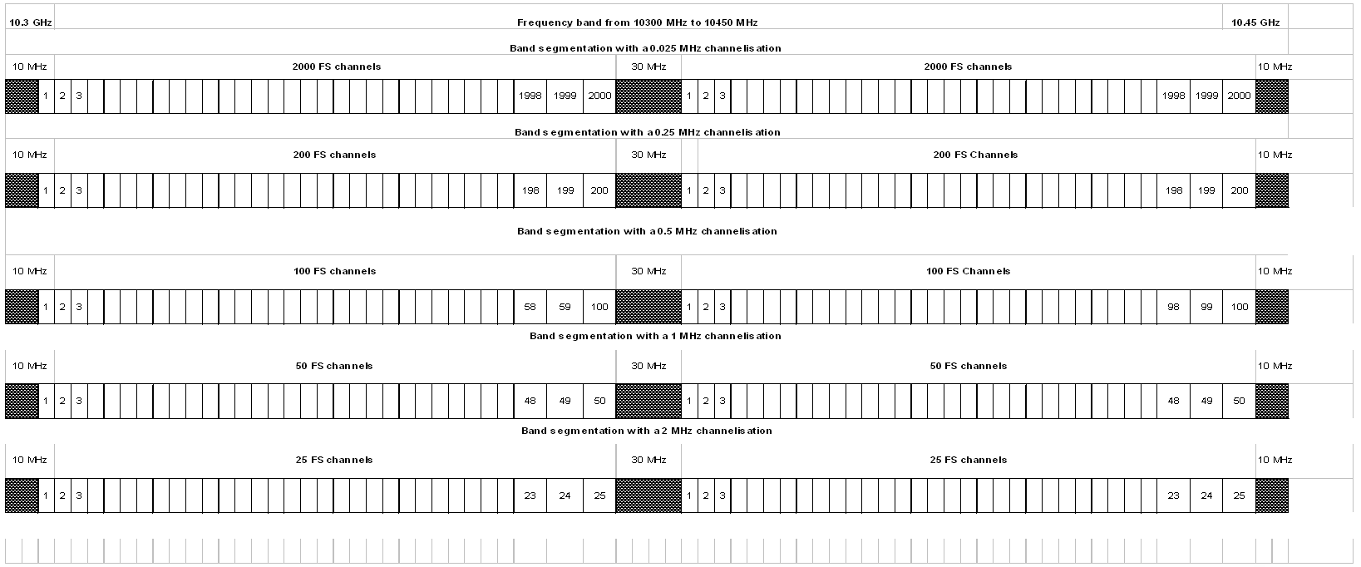

Figure 56: Channel arrangement proposal for 150 MHz centre gap of 10-10.68 GHz band (10300-10450 MHz centre gap)

1. SYSTEM PARAMETERS FOR POINT-TO-POINT FS SYSTEMS IN ALLOCATED BANDS BETWEEN 3 AND 10 GHZ

Table 52: FS P-P parameters from ITU-R F.758-5

| **Parameters** | **Value** | |
| --- | --- | --- |
| Frequency range (GHz) | 10.5-10.68 | 10.5-10.68 |
| Reference ITU-R Recommendation | F.747 | F.747 |
| Modulation | QPSK(3) | 128-TCM |
| Channel spacing and receiver noise bandwidth (MHz) | 1.25, 2.5, 3.5, 7 | 1.25, 2.5, 3.5, 7 |
| Maximum Tx output power range (dBW) | −2 | −3 |
| Maximum Tx output power density range (dBW/MHz)(1) | −10 | −7.0 |
| Minimum feeder/multiplexer loss range (dB) | 0 | 0 |
| Maximum antenna gain range (dBi) | 49 | 51 |
| Maximum e.i.r.p. range (dBW) | 47 | 48 |
| Maximum e.i.r.p. density range (dBW/MHz)(1) | 39 | 44 |
| Receiver noise figure (dB) | 3 | 4 |
| Receiver noise power density typical (=NRX) (dBW/MHz) | −141 | −140 |
| Normalized Rx input level for 1 × 10–6 BER (dBW/MHz) | −127.5 | −116.4 |
| Nominal long-term interference power density (dBW/MHz)(2) | −141 + I/N | −140 + I/N |

1. CURRENT STATE OF THE ART IN CEPT COUNTRIES FOR THE 10 GHZ BAND
   1. Current situation in Germany

**10 GHz general situation**

Currently, in Germany there are no public fixed links in the 10 GHz Band. Since this frequency band is used for military applications in Germany, only limited information can be provided.

**First - sub band 10.00 – 10.40 GHz**

In this sub band there are no civil applications / services because this band is exclusively designated for the military purpose. In the band, some radar-systems are operated in Germany which are covered by the ITU-R Recommendation M.1796-1 (the recommendation is currently in revision in Working Group 5B). These systems are A4, G4, S2 and G14 systems.

**Second - sub band 10.40 – 10.68 GHz**

In Germany, the sub band 10.40 - 10.68 GHz is allocated to the following radio services:

Table 53: 10.4-10.68 GHz allocation

| **Frequency** | **Application** |
| --- | --- |
| 10400 MHz - 10450 MHz | Amateur |
| 10400 MHz - 10450 MHz | FIXED |
| 10400 MHz - 10450 MHz | MOBILE |
| 10450 MHz - 10.5 GHz | Amateur |
| 10450 MHz - 10.5 GHz | Amateur-Satellite |
| 10450 MHz - 10.5 GHz | FIXED |
| 10450 MHz - 10.5 GHz | MOBILE |
| 10.5 GHz - 10.6 GHz | FIXED |
| 10.6 GHz - 10.68 GHz | FIXED |
| 10.6 GHz - 10.68 GHz | Earth Exploration-Satellite |
| 10.6 GHz - 10.68 GHz | Radio Astronomy |

The fixed and the mobile service are designated to electronic news gathering (temporary short P-P link video-audio links / ITU definition news gathering links).

Only occasional temporary point-to-point links should be allowed in the frequency band 10.60 10.68 GHz. Studies concluded that even limited deployment of cordless cameras and portable video links in the band 10.6-10.68 GHz could result in interference to the EESS (passive) (see ECC/REP17 and ERC/REC 25-10).

* 1. Current situation in the Czech Republic

10.301–10.42 GHz: fixed wireless point-to-point links (low/medium/high capacity)

10.42–10.476 GHz: SAP/SAB applications

10.476–10.588 GHz: fixed wireless point-to-point links (low/medium/high capacity)

**10.301–10.42 GHz and 10.476–10.588 GHz**

* Reference ITU-R Recommendation: No relevant ITU-R Rec;
* Mostly used channel bandwidths: 3.5 / 7.0 / 14.0 / 28.0 MHz;
* Most common used antennas: RPE class 2 (diameter 0.65 m / gain 34 dBi);
* No strict duplex is established, i.e. both TDD or FDD systems are possible, however there is a majority of FDD systems;
* Frequency coordination and individual authorization are not applied. Any kind of light licensing is not applied yet.

Channel arrangement is as follows:

Table 54: Channel arrangement

| **Center frequencies [GHz]** | **Maximum occupied bandwidth [MHz]** |
| --- | --- |
| 10.308 | 14 |
| 10.322 | 28 |
| 10.336 | 14 |
| 10.350 | 28 |
| 10.364 | 14 |
| 10.378 | 28 |
| 10.392 | 14 |
| 10.406 | 28 |
| 10.490 | 28 |
| 10.504 | 14 |
| 10.518 | 28 |
| 10.532 | 14 |
| 10.546 | 28 |
| 10.560 | 14 |
| 10.574 | 28 |

Additional channels whose centre frequencies are derived from frequencies listed in the Table 1 can be used for transmission of signal which does not require fully occupied bandwidth. Centre frequencies are as follows:

f = fn ± 7 MHz for maximum occupied bandwidth 14 MHz,

or

f = fn ± 3.5 MHz for maximum occupied bandwidth 7 MHz

where f is rated centre frequency of additional channels [MHz] and fn is rated centre frequency of channel [MHz] listed in Table 1, whereas the channel with rated centre frequency 10.301 MHz shall not be used;

**10.42–10.476 GHz**

Temporary point to point video links;

* 1. Current situation in the greece

Currently, in Greece there are deployed 113 fixed links in the 10 GHz Band (10.00-10.68 GHz) with the following characteristics.

Table 55: fixed links characteristics in Greece

| **Frequency band (MHz)** | **Links (total)** | **Links vs bandwidth** | | **Links vs Modulation states** | | **Links vs Duplex** | | **Links vs Technlogy** | |
| --- | --- | --- | --- | --- | --- | --- | --- | --- | --- |
| **1-25 MHz** | **25-60 MHz** | **2,4,8** | **16,32,64** | **Unidirectional** | **Bi-directional (Symmetric)** | **Analog** | **Digital** |
| 10000-10680 | 113 | 28 | 85 | 23 | 5 | 112 | 1 | 85 | 28 |

**First - sub band 10.00 – 10.40 GHz**

In Greece, the sub band 10.00 - 10.40 GHz is allocated to the following radio services:

Table 56: 10.4-10.68 GHz allocation

| **Frequency** | **Application** |
| --- | --- |
| 10000 MHz - 10150 MHz | FIXED |
| 10000 MHz - 10150 MHz | MOBILE |
| 10000 MHz - 10150 MHz | RADIOLOCATION |
| 10000 MHz - 10150 MHz | Amateur |
| 10150 MHz - 10300 MHz | FIXED |
| 10150 MHz - 10300 MHz | MOBILE |
| 10150 MHz - 10300 MHz | RADIOLOCATION |
| 10150 MHz - 10300 MHz | Amateur |
| 10300 MHz - 10400 MHz | FIXED |
| 10300 MHz - 10400 MHz | MOBILE |
| 10300 MHz - 10400 MHz | RADIOLOCATION |
| 10300 MHz - 10400 MHz | Amateur |

**Second - sub band 10.40 – 10.68 GHz**

In Greece, the sub band 10.40 - 10.68 GHz is allocated to the following radio services:

Table 57: 10.4-10.68 GHz allocation

| **Frequency** | **Application** |
| --- | --- |
| 10400 MHz - 10450 MHz | MOBILE |
| 10450 MHz - 10500 MHz | FIXED |
| 10450 MHz - 10500 MHz | RADIOLOCATION |
| 10450 MHz - 10500 MHz | Amateur |
| 10450 MHz - 10500 MHz | Amateur-Satellite |
| 10500 MHz - 10550 MHz | FIXED |
| 10500 MHz - 10550 MHz | MOBILE |
| 10500 MHz - 10550 MHz | Radiolocation |
| 10550 MHz - 10600 MHz | FIXED |
| 10550 MHz - 10600 MHz | MOBILE except aeronautical mobile |
| 10550 MHz - 10600 MHz | Radiolocation |
| 10600 MHz - 10680 MHz | EARTH EXPLORATION-SATELLITE (passive) |
| 10600 MHz - 10680 MHz | FIXED |
| 10600 MHz - 10680 MHz | MOBILE except aeronautical mobile |
| 10600 MHz - 10680 MHz | RADIO ASTRONOMY |
| 10600 MHz - 10680 MHz | SPACE RESEARCH (passive) |
| 10600 MHz - 10680 MHz | Radiolocation |

* 1. Current situation in Italy

The frequency band 10-10.68 GHz is used in Italy for fixed links of the broadcasting service, with channel bandwidth of 3.5 MHz, 7 MHz 14 and 28 MHz.

The central band from 10.3 to 10.5 GHz can be used for bidirectional and/or monodirectional fixed links following the extension of ECC channel plan described in Recommendation ITU-R F.747-1 Annex 4. Used channel bandwidths are: 3.5, 7, 14 and 28 MHz. Figure 57 better describes the situation.

10.00 – 10.68 GHz: SAP/SAB applications in the whole range in accordance with ERC/REC 12-05 Recommends 4.

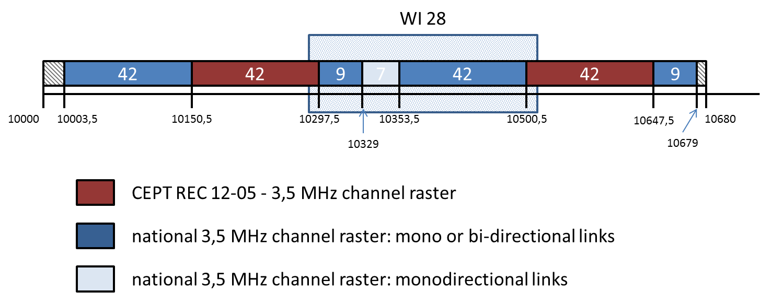

Figure 57: Channel arrangement in Italy

* 1. Current situation in France

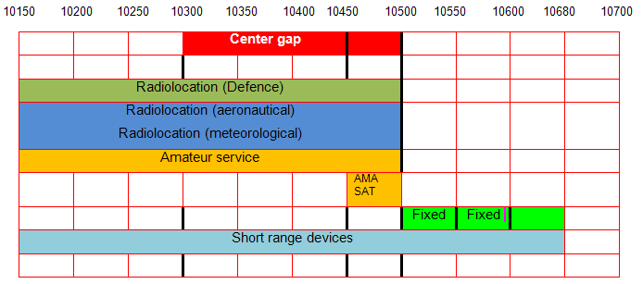

Figure 58: Channel arrangement in France

* 1. Current situation in Switzerland

The current situation in Switzerland for P to P links is as follows and illustrated in Figure 59:

* 10.150 - 10.650 GHz : 3.5; 7; 14 MHz / ACCP / CCDP (ECC REC 12-05) Duplex = 350 MHz
* 3.5 MHz channelling may be used in particularly justified cases only. Number of links per channel spacing : 3.5MHz = 4; 7 MHz = 19; 14 MHz = 34; 28MHz = 0
* Old links: 10322.0 – 10500.5 MHz with Duplex = 65 MHz. Number of links per channel spacing : 1.25MHz = 5; 5MHz = 3

As a general comment, the ACM up to 2048-QAM could be possible in the future. The corresponding C/I should be considered in the study. Very little interest in Switzerland for small channel spacing : 0.025 .. 3.5 MHz .



Figure 59: Channel arrangement in Switzerland

1. List of reference
2. ECC Report 2
3. ECC Report 100
4. ERC Report 38
5. ERC Report 101
6. ECC Report 139
7. ITU-R BT.2069 Report
8. ITU-R F.699
9. ITU-R F.1245
10. ITU-R F.1777
11. ETSI ES 202 239
12. ITU-R M.1851
13. ITU-R M.1796

1. According to ECC Report 38 SAP/SAB receivers on the roof of communication vehicles can use both omnidirectional and directional antennas. Omnidirectional antennas were assumed as the worst case scenario.
2. Based on an *I*/*N*-th criterion of –10 dB.
3. I/N-th = –6 dB is applicable to cases of sharing with other FS applications.
4. ITU Radio Regulations Appendix 8:*Method of calculation for determining if coordination is required between geostationary-satellite networks sharing the same frequency bands*