**O**

|  |  |  |
| --- | --- | --- |
|  | | **Doc. ECC/SE(14)030** |
| **Working Group SE** | |  |
| **66th Meeting of WG SE**  **Sesimbra, Portugal, 27 – 31 January 2014** | |  |
|  | |  |
| **Date issued:** | 21 January 2014 | |
| **Source:** | Inmarsat | |
| **Subject:** | Proposed new Work Item on compatibility studies for the use of aeronautical CGC systems operating in the bands 1980 – 2010 MHz and 2170 – 2200 MHz | |

|  |  |
| --- | --- |
| Password protection required? (Y/N) | **N** |

|  |
| --- |
| **Summary:** |
| MSS/CGC systems involving stations on aircraft in the 1 980 – 2 010 MHz and 2 170 – 2 200 MHz bands are planned to be put in operation in the very near future. Taking into account their characteristics and the geometry in which they will operate, compatibility studies with services operating in adjacent bands are required to make sure that interference-free conditions are guaranteed. |
| **Proposal:** |
| It is proposed that WG SE approves the creation of a new Work Item for the development of a new ECC Report covering the studies needed to make sure that aeronautical CGC systems operating in the 1 980 – 2 010 MHz and 2 170 – 2 200 MHz will not cause harmful interference to terrestrial systems operating in adjacent bands. |
| **Background:** |
| There is currently a high demand for the provision of broadband connectivity to passengers on board aircraft. Recent industry developments suggest that various technologies might be used to meet this growing demand in the future. One of the systems that is planned to be put in operation in the coming years consists of an hybrid architecture composed by a satellite network and a Complementary Ground Component (CGC) operating in the 1 980 - 2 010 MHz and 2 170 - 2 200 MHz bands.  SE 40 recently developed ECC Report 197 dealing with compatibility studies between terrestrial Mobile Satellite Service (MSS) user terminals transmitting to a satellite in the band 1 980 - 2 010 MHz and UMTS services operating in adjacent bands. However this Report did not consider potential use of aeronautical CGC systems, which would introduce new interference scenarios. |

# Introduction

Mobile customers expect to be connected everywhere, all the time, with all kinds of mobile devices. This includes the provision of broadband services on-board aircraft and European airlines have great interest in offering internet services to their flight passengers in their continental fleets as soon as possible.

There currently is a high demand for broadband connectivity for aircraft passengers, as is illustrated in Figure 1 below. Satellite systems providing this service are today operating in either the L-, Ku- or Ka-band and they are not able to meet the demand for all the different segments of this market. Actually, airlines usually have various types of aircraft, depending on the routes they are intended to serve. If relatively big aircraft are employed for covering long-haul routes, smaller aeroplanes are used on a regional basis, in order to connect national and international hubs within few thousand miles.

Considering that the bulk of those customers use such aircraft travels for business reasons, the need of connectivity on-the-move is of utmost importance. Due to the design of small planes, it is sometimes impossible to fit them with the components of a satellite system not suitable for their dimensions (e.g. due relatively big antennas, heavy on-board components, etc.).

Systems operating in the S-band therefore offer a very attractive alternative to such systems, as they are designed to employ small and light components, particularly suitable for aircraft used on short and medium-haul routes.

Moreover, the existing Europe-wide regulatory framework seems particularly suitable for meeting the large demand in terms of throughput even with only 2x30 MHz of spectrum designated to the MSS (1 980 - 2 010 MHz (Earth-to-space) and 2 170 - 2 200 MHz (space-to-Earth)).

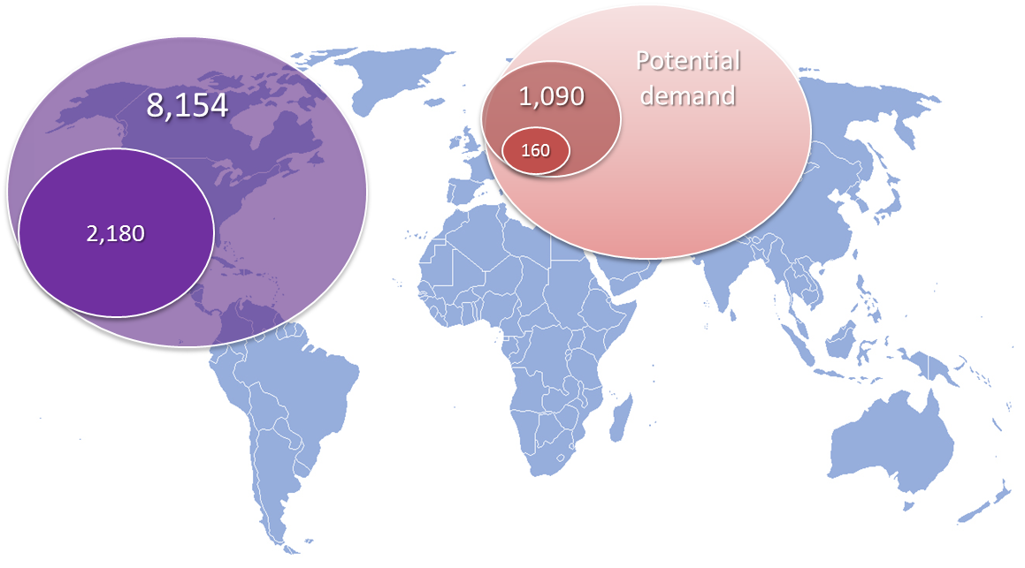

**Figure 1: Number of connected commercial Aircraft (2012 v 2022) – source Euroconsult**

ECC Decision ECC/DEC/(06)09 applies to the bands 1 980 - 2 010 MHz and 2 170 - 2 200 MHz, relating to the use of these frequencies by MSS systems, with or without a CGC.

The assignment of spectrum within the 2 GHz MSS bands is governed by the EC led process, which has recently been reviewed. One of the two satellite operators selected in that process has in place a development programme expected to meet the current EU-agreed milestones and to comply with the selection requirements. The milestone of having a binding and signed satellite contract by 1 December 2013 has been met and evidence provided to relevant Member States. Licence applications are being prepared, to be filed by 1 May 2014 in those countries that require an individual licence. Given the strict deadlines set in the milestone plan, and the imminence of commencement of national licensing processes for MSS and CGC, there is an urgency to establish appropriate technical rules.

# Issue

Figure 2 below illustrates the typical architecture of a system providing an Aero service operating in the S-band.

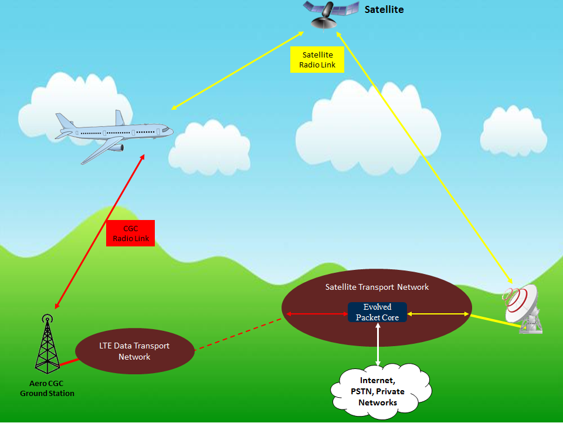**Figure 2: Design of a typical hybrid Aero CGC system**

As can be seen, the system is composed of a ground segment and a space segment, operating under the control of the same network operator. The space segment is composed by a MSS User Terminal (UT) installed on the aircraft, a space station and a feeder-link earth station installed on the ground - most likely operating in a frequency band different from the S-band.

The CGC network is in turn composed by a CGC terminal installed on the aircraft, a set of ground stations covering the wanted air routes on a cellular basis and a data transport network. The ground components of the CGC network are expected to operate using LTE-based technology.

Finally, both the satellite and CGC networks are connected to the same core transport network managed and operated by a single operator, in order to avoid harmful interference between the two segments of the hybrid system.

The following Figure 3 illustrates the spectrum allocations in the 1 900 - 2 200 MHz band.

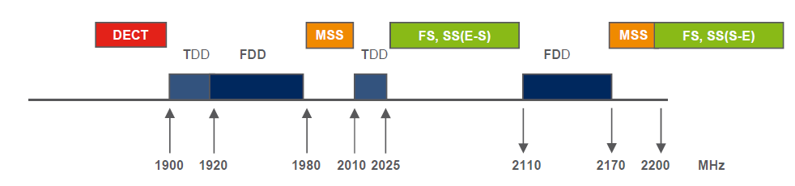

**Figure 3: Spectrum allocation in the S-band**

As per RR Article **5**, MSS frequency bands are adjacent to bands allocated to the Fixed Service (FS) and Mobile Service (MS). In Europe, the bands 1 900 - 1 980 MHz and 2 010 - 2 025 MHz are used by IMT systems on either on a Frequency Division (FDD) or a Time Division Duplexing (TDD) basis.

The following Table 1 summarises the direction of the communication links for adjacent terrestrial and Aero CGC systems.

| **Frequency band** | **Aero MSS/CGC System** | **Adjacent band system** |
| --- | --- | --- |
| 1 920 - 1 980 MHz | - | IMT FDD MS-to-BS |
| 1 980 - 2 010 MHz  (*MSS“uplink” band*) | Aircraft terminal-to-satellite  and  Aircraft terminal-to-CGC ground station | - |
| 2 010 - 2 025 MHz |  | Planned uses being reviewed by CEPT, includes possible DA2GC systems |
| .. | ... | ... |
| 2 110 - 2 170 MHz | - | IMT FDD BS-to-MS |
| 2 170 - 2 200 MHz  (*MSS“downlink” band*) | Satellite-to-aircraft terminal  and  CGC ground station-to-aircraft terminal | - |
| 2 200 - 2 290 MHz |  | PMSE  Space Research (space-to-Earth and space-to-space)  Earth Exploration Satellite Service (space-to-Earth and space-to-space) |

**Table 1: Designation and use of spectrum in the 1 920 - 2 290 MHz range**

Note that the direction of use of the ground to air component follows the convention of “uplink” and “downlink” used in terrestrial mobile networks, even though this actually means that the base station to aircraft link is in the “downlink” band and the aircraft to base station link is in the “uplink” band. Retaining this convention minimises the potential adjacent band compatibility issues.

Inmarsat’s use of the bands 1980-2010 MHz and 2170-2200 MHz for aero services would be within the sub-band identified for Inmarsat within the EU selection process (i.e. 1980-1995 MHz and 2170-2185 MHz). Nonetheless, it is suggested that the studies should address the potential use of any part of the 2 GHz MSS bands for aero services, so that the studies are not specific to one operator.

With regard to the use of the band 2010 - 2025 MHz, since the future use of this band is not yet decided, and also considering that ECC Report 209 has recently been completed by the ECC, it is proposed not to consider compatibility studies in this case. In the event that the band 2 010 - 2 025 MHz is used for a DA2GC system in Europe, any compatibility issues could be addressed bilaterally, between the operators concerned, especially if it also taken into account that the technology used by the ground components of two systems will probably be similar.

Similarly, potential compatibility issues between the two operators with assignments in the 2 GHz MSS bands can be dealt with by the operators themselves. Decides 6 of Decision ECC/DEC/(06)09 requires the MSS operators to take account of inter-system interference issues in frequency coordination.

With regard to potential interference from Aero CGC base stations to the various systems in the band 2 200 - 2 290 MHz, potential interference from CGC base stations to EESS, space research and space operations earth stations is already addressed in Recommendation ECC/REC/(10)01. Regarding potential interference to PMSE from Aero CGC base stations, due to the occasional use characteristics of PMSE, this is not an issue that would drive out-of-band emission limits for CGC base stations.

Any interference caused by the MSS space station to IMT systems need not be considered as the pfd of OOB emissions can be expected to similar to any MSS system operating in these bands, and in any case would be too low to cause any impact on terrestrial services in the adjacent bands.

Taking into account the information above, the compatibility scenarios listed in the following Table 2 can be identified as those requiring further study.

| **Scenario ID** | **Interfering Aero MSS/CGC component** | **Potentially interfered-with system component** |
| --- | --- | --- |
| 1 | Aircraft terminal transmitting to the satellite | IMT Receiving BS |
| 2 | Aircraft terminal transmitting to the CGC ground station | IMT Receiving BS |
| 3 | CGC ground station transmitting to the aircraft terminal | Receiving MS in IMT FDD systems |

**Table 2: Compatibility scenarios to be analysed**

While Aero CGC ground stations are expected to adopt a technology very similar to that used by IMT systems operating in the adjacent frequency bands, it should be noted that there currently is no ETSI standard for the terminals on board the aircraft or specifically for Aero CGC base stations. The current ETSI standards for CGC base stations and terminals (ETSI EN 302 574-1 and -2) might need to be revised, or be supplemented, to cover Aero CGC base systems.

It is expected that the development of those standards will start in parallel with the compatibility studies illustrated above.

# proposal

Due to the fact that this technology is expected to become available to European citizens very soon, this administration urges WG SE to create a new Work Item for studying the compatibility scenarios illustrated in Table 2. It is also proposed to create a new ECC Report summarising the results of such studies and possible recommendations on the regulatory measures to put in place in order to make sure that incumbent systems will operate free from harmful interference.

Given that PT SE40 was responsible for developing ECC Report 197, it is suggested that PT SE40 would be best placed to take on the work.