|  |  |  |
| --- | --- | --- |
|  | | **Doc. ECC/SE(14)031** |
| Working Group SE | |  |
| 66th Meeting of WG SESesimbra, Portugal, 27 – 31 January 2014 | |  |
|  | |  |
| Date issued: | 21 January 2014 | |
| Source: | France | |
| Subject: | RLAN 5 GHz parameters | |

|  |  |  |  |
| --- | --- | --- | --- |
| Password protection required? (Y/N) | | **N** | |
| Summary: | | The attached document CPG-PTD(14)010 was presented by France at the last PTD meeting (Roma) and addresses the issue of RLAN parameters.  The last JTG considered the issue of RLAN parameters and found an agreement on a number of parameters whereas 2 parameters are still with options remaining (see Attachment):  - RLAN vertical antenna pattern  - Number of active RLAN In addition to the work already undertaken during last JTG 4-5-6-7 on RLAN parameters, the present document provides additional considerations on the representative RLAN antenna issue and consideration on RLAN deployment | |
| Proposal: | | Taking into account the fact that, if adopted, RLAN deployed in the various portions of the 5 GHz range will present a number of similar parameters, in particular antennas and overall deployment scenarios, France supports the agreements made in JTG on various RLAN parameters and invites WGSE, when addressing the compatibility studies in the 5725-5925 MHz band, to also consider the attached contribution and in particular :  **RLAN antenna:** the RLAN antenna cannot be only modelled by a single Access Point (AP) pattern in one direction (e.g. as currently proposed in SE24) but needs to account for other installation directions as well as terminals antennas. To this respect France proposes to consistently make use of JTG Option A.  **RLAN deployment**: France still supports his proposal to JTG on the number of active RLAN, represented as Option C of JTG, i.e. “From 0.0008 to 0.008 active devices per 20 MHz channel per inhabitant (0.004 to 0.04 per 100 MHz channel) (based on 3% to 30% activity factor) applied to any population size”. | |
| Background: | | **Document JTG 4-5-6-7/393 (October 2013 Chairman’s Report) (Annex 2 – Appendix 2A) on *“****technical/operational characteristics to be used for sharing studies with RLAN in the 5 GHz band”*  **See Also Attachment 1 of CPG-PTD(14)010** | |

|  |  |  |  |
| --- | --- | --- | --- |
| CPG-15 PTD | | | CPG-PTD(14)010 |
| CPG-15 PTD #5 | |  | |
| Rome, 13-17 January 2014 | |  | |
|  | |  | |
| Date issued: | 20 December 2013 | | |
| Source: | France | | |
| Subject: | Further consideration on technical and operational RLAN parameters to be used for sharing studies in the 5350-5470 MHz band | | |
| N  Password protection required? (Y/N) | | | |
|  | | | |
| Summary: | | | |
| The last JTG considered the issue of RLAN parameters and found an agreement on a number of parameters whereas 2 parameters are still with options remaining (see Attachment):  - RLAN vertical antenna pattern  - Number of active RLAN  In addition to the work already undertaken during last JTG 4-5-6-7 on RLAN parameters, the present document provides additional considerations on the representative RLAN antenna issue and consideration on RLAN deployment | | | |
| Proposal: | | | |
| France supports the agreements made in JTG on various RLAN parameters and invites CPG PTD   * to further consider the issue of RLAN antenna and RLAN deployment in order to reach a more global package.   **RLAN antenna issue:** JTG Option A proposing an antenna pattern Omnidirectional in elevation (i.e. 0 dBi) is representative of a global situation and is on the safe side. However, as a compromise, France could accept considering a -1 or -2 dBi antenna discrimination gain in the case of EESS.  **RLAN deployment**: France still supports his proposal to JTG on the number of active RLAN, represented as Option C of JTG, i.e. “From 0.0008 to 0.008 active devices per 20 MHz channel per inhabitant (0.004 to 0.04 per 100 MHz channel) (based on 3% to 30% activity factor) applied to any population size”. France encourages CPG PTD to support this approach of a range of number allowing for a parametric analysis.   * To develop a CEPT contribution to JTG on that basis | | | |
| Background: | | | |
| **Document JTG 4-5-6-7/393 (October 2013 Chairman’s Report) (Annex 2 – Appendix 2A) on *“****technical/operational characteristics to be used for sharing studies with RLAN in the 5 GHz band”*  **See Also Annex 1 attached** | | | |

ANNEX 1

1. Introduction

Last JTG considered the issue of RLAN parameters and found an agreement on a number of parameters whereas 2 parameters are still with options remaining (see Attachment):

* RLAN vertical antenna pattern
* Number of active RLAN

France supports the agreements made in JTG on various parameters and encourages PTD to further consider the issue of RLAN antenna and numbers in order to reach a more global package.

The present document provides additional considerations on the representative RLAN antenna issue.

On the number of active RLAN, France still supports Option C of JTG.

1. General comment

On a general basis, France will insist on the fact that the whole set of assumptions used in the sharing studies between RLAN and other services in the 5 GHz range needs to depict RLAN parameters and deployments consistent with the requirement for additional spectrum and consistent each other.

As an example, RLAN data rates are linked to RLAN e.i.r.p. and bandwidth that also control the access points coverage area and hence the number of RLAN covered by an access point. Also, one should consider that the maximum RLAN e.i.r.p. will have an impact on the number of access points to cover a certain area.

To this respect, a number of documents presented by the industry to justify such additional spectrum provide a number of information relevant to this discussion. In addition, document 4-5-6-7/137 from WP5A that estimates the spectrum requirement for broadband RLAN in the 5 GHz range, is also a relevant source of information.

Finally, the mass-market and unlicensed nature of RLAN applications mean that any potential introduction in the additional portions of the 5 GHz range will represent a point of no-return. The sharing conditions have therefore to take into account long-term RLAN expectations and all possibilities.

This means that sharing parameters, and in particular RLAN parameters, have to be based on the safe side.

1. RLAN Antenna pattern

## JTG outcomes

JTG agreed that RLAN antenna should be considered omnidirectional in azimuth for all scenarios.

In elevation, for EESS/Aeronautical studies, JTG has listed 3 options:

**Option A**: Omnidirectional in elevation (i.e. 0 dBi gain)

**Option B**: Generic use of the elevation pattern as given in the table below

***Table: RLAN Elevation Antenna Pattern***

|  |  |
| --- | --- |
| **Elevation Angle θ (Degrees)** | **Gain (dBi)** |
| 45 < θ ≤ 90 | -4 |
| 35 < θ ≤ 45 | 0 |
| 0 < θ ≤ 35 | 3 |
| –15 < θ ≤ 0 | -1 |
| –30 < θ ≤ –15 | -4 |
| –60 < θ ≤ –30 | -9 |
| –90 < θ ≤ –60 | -8 |

**Option C**: For these studies, the effect of the antenna discrimination in the vertical plane is covered in the section “Additional losses” below :

“To cover additional losses / attenuations (antenna discrimination in elevation, body loss, etc.) an additional 6 dB factor for RLAN devices for which the studies take into account building loss or 3 dB for the 5% of RLAN devices for which the studies do not take into account building loss should be applied.”

## General principles

When considering the definition of the RLAN antenna pattern to be used in the sharing studies, the following elements are essential to be considered :

* For simplification, only AP emissions are considered in the technical studies but this is recognisant to the fact that, at a given time, either the AP or the terminal is transmitting. Such a situation cannot be described by only AP antenna pattern but should consider a composite antenna pattern representative of an average between the AP and terminal antennas.
* Various type of AP antennas need to be considered, mounted on ceiling, walls, tables, …
* Even though some antennas are designed for some type of mounting (e.g. ceiling), there is no possibility to ensure that they will indeed be implemented as they should. There is therefore a need to consider a certain percentage of misuse in other directions.

## Consideration of JTG Option B

The antenna pattern as in JTG option B was proposed by US and Intel/Cisco to the discussions.

|  |  |
| --- | --- |
| Elevation angle,  (degrees) | Gain (dBi) |
| 45 < θ ≤ 90 | -4 |
| 35 < θ ≤ 45 | 0 |
| 0 < θ ≤ 35 | 3 |
| –15 < θ ≤ 0 | -1 |
| –30 < θ ≤ –15 | -4 |
| –60 < θ ≤ –30 | -9 |
| –90 < θ ≤ –60 | -8 |

Proponents of this pattern claim that it is based on the analysis of several AP antenna patterns. So far, despite multiple requests, no information has been provided.

Several elements advocate the contrary:

* If it was indeed based on existing antennas (i.e. an antenna envelope), its overall gain over the sphere would be positive. On the contrary, it is actually -1.6 dBi.
* comparing this pattern with the pattern currently described in ITU-R Recommendation M.1652, shows that it is only a coarse modification in order to artificially increase the high elevation discrimination (merely increasing the horizontal gain and decreasing the low elevation gain) to be presented to EESS satellite (see figure 1 below)

WAS elevation antenna pattern (Rec ITU-R M.1652 – Table 12)

|  |  |
| --- | --- |
| Elevation angle,  (degrees) | Gain (dBi) |
| 45 < ϕ ≤ 90 | –4 |
| 35 < ϕ ≤ 45 | –3 |
| 0 < ϕ ≤ 35 | 0 |
| –15 < ϕ ≤ 0 | –1 |
| –30 < ϕ ≤ –15 | –4 |
| –60 < ϕ ≤ –30 | –6 |
| –90 < ϕ ≤ –60 | –5 |

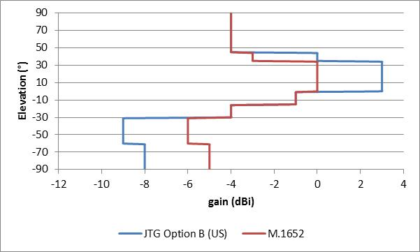

**Figure 1: comparison of antenna pattern in elevation**

On this basis, further considering that it cannot be representative of RLAN terminal antennas, PTD should not consider JTG Option B antenna pattern as representative for the studies between RLAN 5 GHz and incumbent services.

## Impact of antenna orientation

For AP antennas with some level of “directivity” (as on figure 1 above), the antenna orientation has an impact on the antenna gain that will be presented to EESS satellite (considering the range of elevation of EESS Main Beam from 36 to 67 °).

Indeed, the average gain of the above pattern over the 36-67° elevation is -0.8 dBi (increased by 1.6 dBi to normalise the overall pattern to 0 dBi).

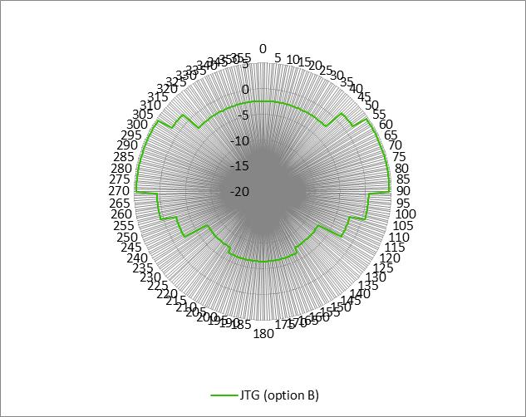

**Figure 2a: JTG Option B antenna pattern (note, horizontal plan is 90°-270° oriented)**

When such pattern is not used on the horizontal plane but in the vertical plane (i.e; rotated by 90°), such average gain over the 36-67 ° elevation range is equal to 0.2 dBi, i.e 1 dB above the same antenna implemented horizontally.

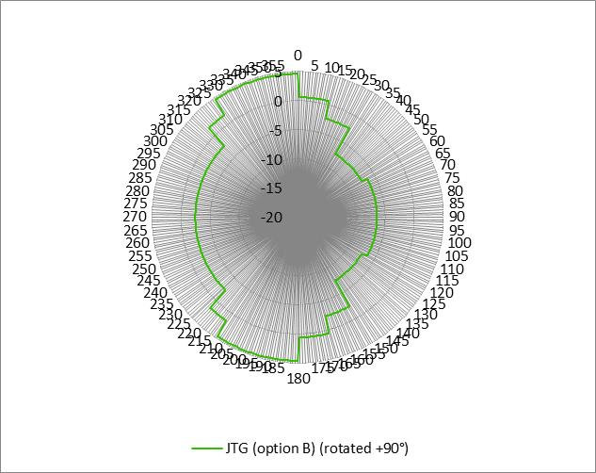

**Figure 2b: JTG Option B antenna pattern rotated 90° (note, horizontal plan is 90°-270° oriented)**

In addition, some comments were made during last JTG that the proposed pattern should be understood up-side-down, i.e. that positive elevations should be seen as downtilted.

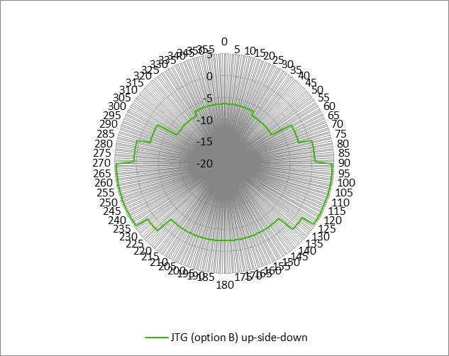

**Figure 2c: JTG Option B antenna pattern upside down (i.e. rotated 180°) (note, horizontal plan is 90°-270° oriented)**

In this case with pattern downtilted (i.e. rotated by 180°), the average gain over the 36-67 ° elevation range is equal to -7.1 dBi, i.e 6.3 dB above the same antenna implemented in the opposite direction.

It is known that, for a number of AP, it will not be possible to control the orientation of the antenna since it can be indiscriminately be installed horizontally and vertically.

The antenna orientation is therefore an important factor to take into account when deriving relevant antenna pattern to be used in the sharing studies with RLAN.

## Determination of an average antenna pattern

As stated above, relevant RLAN antenna pattern to be used in the studies cannot be described by only AP antenna pattern but should consider a composite antenna pattern representative of an average between the AP and terminal antennas.

For **terminals antenna patterns**, it should be expected that they are purely omnidirectional, hence with 0 dBi gain.

For the calculations, it has however been assumed that 50% of the terminal will present a 0 dBi gain whereas the other 50% will be -3 dBi. On average, this represents a situation where terminals present a -1.2 dBi antenna gain.

For **AP antenna patterns**, it has been considered that a high percentage (80%) of antennas are implemented following the nominal orientation (horizontal e.g. ceiling or table mounted) whereas the other 20% are rotated upward (assumed to be e.g. wall mounted) and has been considered with 10% rotated +90° and 10% rotated -90°. Justifications for these assumptions can be found in Annex

On this basis, a combined averaged antenna pattern can be calculated taking into account 50% of terminal antenna pattern and 50 % of AP pattern.

When considering the JTG (option B) pattern, such combined pattern is described on the figure and table below, presenting an average gain in the EESS elevation range of -0.9 dBi.

Finally, considering the maximum gain of the AP antenna (3 dBi in such an case) and the -1.2 dBi gain of terminals, leads to a composite maximum gain of 1.4 dBi.

Overall, the calculated average antenna pattern allows to derive the antenna discrimination to be considered in the direction of the satellite as 1.4 – (-0.9) = 2.3 dB.

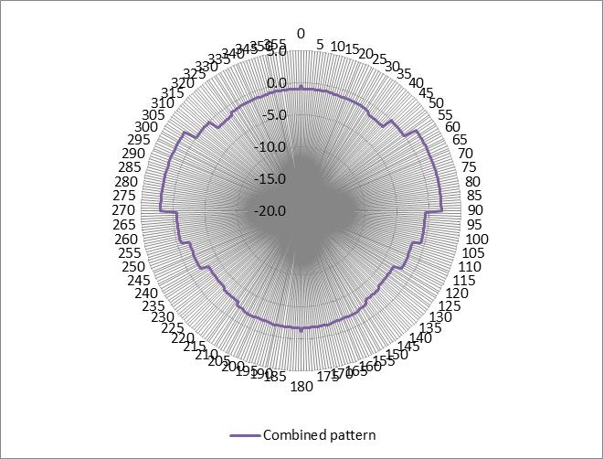

**Figure 3: Combined antenna pattern for the JTG Option B antenna (note, horizontal plan is 90°-270° oriented)**

|  |  |
| --- | --- |
| Elevation angle,  (degrees) | Gain (dBi) |
| 75 < ϕ ≤ 90 | –0.9 |
| 55 < ϕ ≤ 75 | –1.2 |
| 45 < ϕ ≤ 55 | -1.6 |
| 35 < ϕ ≤ 45 | 0 |
| 0 < ϕ ≤ 35 | +2 |

## Consideration of real antenna pattern

Among others, several existing AP antennas pattern have been considered, representing quite low antenna gain.

* The Cisco Aironet OEAP 600 integrated antenna (maximum 5 GHz gain of 2 dBi) (see attachment 2)
* The Cisco Aironet 3600i integrated antenna (maximum 5 GHz gain of 5 dBi) (see attachment 3)
* The Aruba AP-ANT-90 antenna (maximum 5 GHz gain of 3 dBi) (see attachment 4)
* The Aruba AP-ANT-13B antenna (maximum 5 GHz gain of 3.3 dBi) (see attachment 5)

It can first be seen in the attachments that, although all presenting low maximum antenna gain, they present quite different antenna pattern, in different orientations.

On the same principles than in section 3.5 (i.e. taking into account the antenna in various directions as well as terminal antenna pattern), the following sections provides the calculation of the average antenna pattern for the real antennas.

## Cisco Aironet OEAP 600

The following figure X describes the Cisco Aironet OEAP 600 antenna pattern

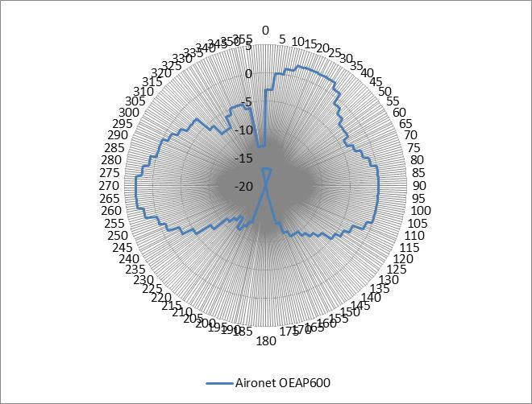

**Figure 4a: Aironet OEAP 600 antenna pattern (note, horizontal plan is 90°-270° oriented)**

When considering the Cisco Aironet OEAP 600 antenna pattern, the combined pattern is described on the figure and table below, presenting **an average gain in the EESS elevation range of -1.5 dBi.** The composite maximum gain is 0.7 dBi hence leading to a 2.2 dB antenna discrimination in the direction of the satellite.

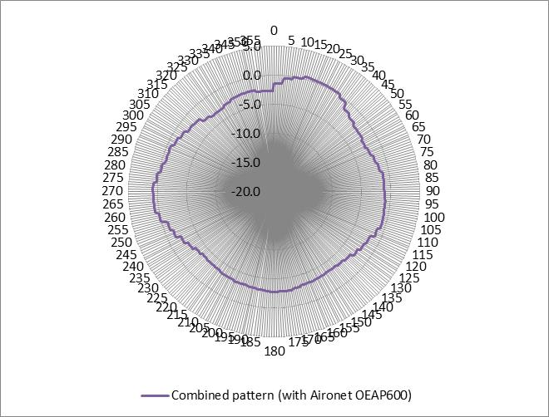

**Figure 4b: Combined antenna pattern for the Aironet OEAP 600 antenna (note, horizontal plan is 90°-270° oriented)**

## Cisco Aironet 3600i

The following figure X describes the Cisco Aironet 3600i antenna pattern

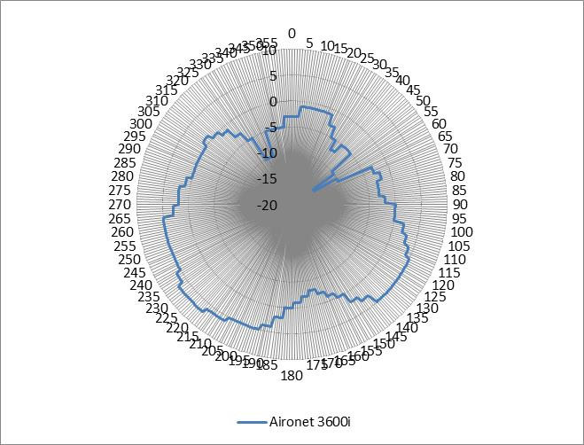

**Figure 5a: Aironet 3600i antenna pattern (note, horizontal plan is 90°-270° oriented)**

When considering the Cisco Aironet 3600i antenna pattern, the combined pattern is described on the figure and table below, presenting **an average gain in the EESS elevation range of -1.2 dBi.** The composite maximum gain is 2.9 dBi hence leading to a 4.1 dB antenna discrimination in the direction of the satellite.

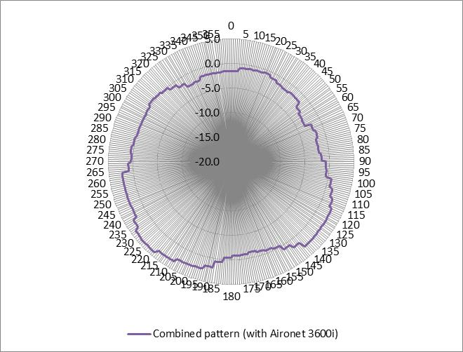

**Figure 5b: Combined antenna pattern for the Aironet 3600i antenna (note, horizontal plan is 90°-270° oriented)**

## Aruba AP-ANT-90

The following figure X describes the Aruba AP-ANT-90 antenna pattern

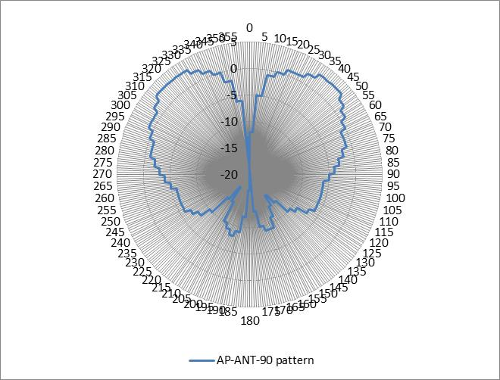

**Figure 6c: AP-ANT-90 antenna pattern (note, horizontal plan is 90°-270° oriented)**

When considering the Aruba AP-ANT-90 antenna pattern, the combined pattern is described on the figure and table below, presenting **an average gain in the EESS elevation range of 0.6 dBi.** The composite maximum gain is 1.3 dBi hence leading to a 0.7 dB antenna discrimination in the direction of the satellite.

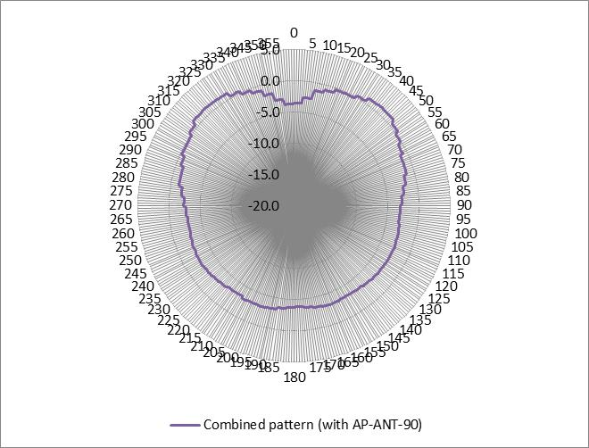

**Figure 6b: Combined antenna pattern for the AP-ANT-90 antenna (note, horizontal plan is 90°-270° oriented)**

## Aruba AP- ANT-13B

The following figure X describes the Aruba AP-ANT-13B antenna pattern

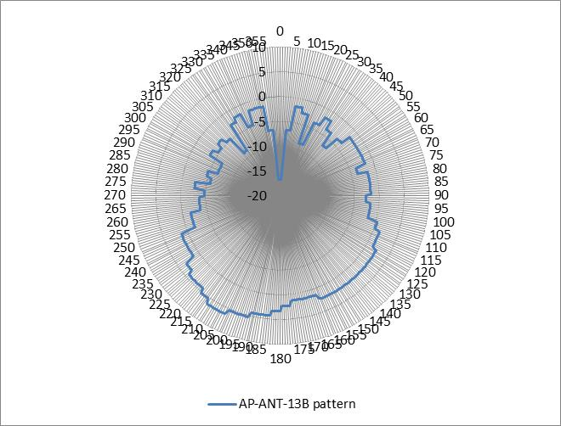

**Figure 7a: AP-ANT-13B antenna pattern (note, horizontal plan is 90°-270° oriented)**

When considering the Aruba AP-ANT-13B antenna pattern, the combined pattern is described on the figure and table below, presenting **an average gain in the EESS elevation range of -1.8 dBi.** The composite maximum gain is 1.6 dBi hence leading to a 3.4 dB antenna discrimination in the direction of the satellite.

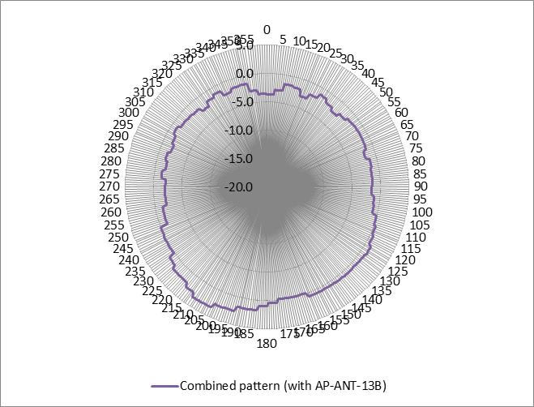

**Figure 7b: Combined antenna pattern for the AP-ANT-13B antenna (note, horizontal plan is 90°-270° oriented)**

1. Conclusion

The mass-market and unlicensed nature of RLAN applications mean that any potential introduction of RLAN in the additional portions of the 5 GHz range (5350-5470 MHz) will represent a point of no-return.

The sharing studies will have therefore to take into account long-term RLAN expectations and all possibilities to avoid any future interference issues that will be impossible to overcome. This means that the sharing parameters, and in particular RLAN parameters, have to be determined and based on the safe side.

France believes that it is the case for the RLAN parameters on which JTG found an agreement at its last meeting and therefore supports such agreement.

France also considers that similar approach is needed for the 2 parameters that are still with options in JTG:

* RLAN vertical antenna pattern
* Number of active RLAN

The RLAN vertical antenna pattern necessarily needs to be a composite pattern in order to reflect a realistic situation of terminals and AP with different orientations. The present document makes use of existing RLAN AP antenna pattern to calculate such combined antenna pattern under the following assumptions :

* 50% AP and 50% terminals
* For terminals : 50% 0 dBi and 50% -3 dBi
* For AP : 80% nominally oriented, 10% oriented +90° in the vertical plane and 10% oriented -90° in the vertical plane %

Such assumptions are further justified by elements listed in Attachment 6 to this contribution, showing numerous scenarios and equipment for which antennas are not mounted on ceiling and hence that the assumption that all (or nearly all) RLAN AP are mounted on ceilings cannot be reasonably made.

On this basis, the calculated combined patterns are described in section 3.6 above, leading to **average gains in the EESS elevation range (36-67°) from of -1.8 dBi to +0.6 dBi** and antenna discrimination in the direction of the satellite from 0.7 to a 4.1 dB.

This is far from the proposed antenna pattern as in JTG option B that is artificially designed to decrease the high elevation antenna gain to be presented to EESS satellite (see figure 1 below), in particular if such pattern is considered up-side-down. Such pattern could only lead to large underestimation of potential impact of RLAN on EESS.

**France is therefore of the view that JTG Option A proposing an antenna pattern Omnidirectional in elevation (i.e. 0 dBi) is representative of a global situation and is on the safe side. However, as a compromise, France could accept considering a -1 or -2 dBi antenna discrimination in the case of EESS.**

**Finally, France still supports his proposal to JTG on the number of active RLAN, represented as Option C of JTG, i.e. “From 0.0008 to 0.008 active devices per 20 MHz channel per inhabitant (0.004 to 0.04 per 100 MHz channel) (based on 3% to 30% activity factor) applied to any population size”. France encourages CPG PTD to support this approach of a range of number allowing for a parametric analysis**.

**Attachment 1**

**Document JTG 4-5-6-7/393 (October 2013 Chairman’s Report)**

**Annex 2 – Appendix 2A**

**DG Parameters**

technical/operational characteristics to be used for sharing studies with RLAN in the 5 GHz band

This document contains the technical and operational parameters of RLAN systems to be used in sharing studies in the 5 350 – 5 470 MHz frequency range. No parameters have yet been submitted for the 5 725 – 5 850 MHz frequency range.

There were lengthy discussions toward a common set of parameters but no agreement was achieved. A common way forward was reached on specific parameters as defined below based on input contributions found in Documents 4-5-6-7/254, 314, 315, 320, 344, and 349. Adoption of a specific parameter for antenna gain/discrimination, body/additional losses and RLAN device density, may result in changes to the common parameters listed below. As stated in the general principles of this Annex, members should provide an explanation for the specific changes in their studies.

## Parameters with a common understanding

## EIRP level distribution

|  |  |  |  |  |
| --- | --- | --- | --- | --- |
| **RLAN EIRP Level** | **200 mW**  **(Omni-Directional)** | **80 mW**  **(Omni-Directional)** | **50 mW**  **(Omni-Directional)** | **25 mW**  **(Omni-Directional)** |
| RLAN Device Percentage | 19% | 27% | 15% | 39% |

Note: RLAN devices are assumed to be indoors only, based on the requirement to help facilitate coexistence. For the purposes of sharing studies, 5% of the devices should be modelled without building attenuation.

These EIRP values apply across the entire RLAN channel bandwidth.

[Alternatively administrations may choose to use a single e. i. r. p level]

## Channel bandwidths distribution

|  |  |  |  |  |
| --- | --- | --- | --- | --- |
| **Channel bandwidth** | **20 MHz** | **40 MHz** | **80 MHz** | **160 MHz** |
| RLAN Device Percentage | 10% | 25% | 50% | 15% |

## Building attenuation

Gaussian distribution with a 17 dB mean and a 7 dB standard deviation (truncated at 1 dB)

## Propagation model

Aeronautical radar case:

Recommendation ITU-R P.528 (as revised – see Document 3/36(Rev.1)) + angular clutter loss model from Recommendation ITU-R P.452 (as revised – see Document 3/52(Rev.1)) + building attenuation as described above

EESS radar case:

Recommendation ITU-R P.619 + angular clutter loss model from Recommendation ITU-R P.452 (as revised – see Document 3/52(Rev.1)) + building attenuation as described above

Angular Clutter Loss Model:

The angular clutter loss model provided by the "RLAN User Defined Height" column of the attached worksheet should be used in conjunction with the antenna heights as described below. The clutter loss values calculated for the "sparse houses", "suburban" and "urban" clutter (ground-cover) categories should be applied in the rural, suburban and urban zones of the RLAN deployment model, respectively.

Theta max (°) provides the angle from the RLAN transmitter to the top of the clutter height. Therefore, if the aircraft/spacecraft is at an elevation angle at or below theta max (°), clutter loss should be added. If the aircraft/spacecraft is above theta max (°) of the respective clutter category, there is no clutter loss.



## Antenna height

|  |  |
| --- | --- |
| **RLAN Deployment Region** | **Antenna Height**  **(meters)** |
| Urban | 1.5 to 28.5 |
| Suburban | 1.5, 4.5 |
| Rural | 1.5, 4.5 |

The antenna heights are randomly selected using a uniform probability distribution from the set of floor heights at 3 meter steps.

## Parameters with options remaining

## Antenna gain/discrimination

Omnidirectional in azimuth for all scenarios

For EESS/Aeronautical studies:

**Option A**: Omnidirectional in elevation

**Option B**: Generic use of the elevation pattern as given in the table below

***Table: RLAN Elevation Antenna Pattern***

|  |  |
| --- | --- |
| **Elevation Angle θ (Degrees)** | **Gain (dBi)** |
| 45 < θ ≤ 90 | -4 |
| 35 < θ ≤ 45 | 0 |
| 0 < θ ≤ 35 | 3 |
| –15 < θ ≤ 0 | -1 |
| –30 < θ ≤ –15 | -4 |
| –60 < θ ≤ –30 | -9 |
| –90 < θ ≤ –60 | -8 |

[**Option C**: For these studies, the effect of the antenna discrimination in the vertical plane is covered in the section “Additional losses” below.]

For terrestrial radar studies:

Antenna gain relative to the radar received e. i. r. p. for RLAN is important in determining DFS threshold values. Received signals should be increased by 3 dB to account for antenna gain in the RLAN access points which will apply DFS.

## Additional/body losses for the EESS/Aeronautical studies

**Option A**: no additional losses

**Option B**: consider body losses

**Option C** : To cover additional losses / attenuations (antenna discrimination in elevation, body loss, etc.) an additional [6] dB factor for RLAN devices for which the studies take into account building loss or [3] dB for the 5% of RLAN devices for which the studies do not take into account building loss should be applied. (note : this Option C is linked to Option C under the antenna gain/discrimination section)

## RLAN device density relevant to sharing studies

The following RLAN device densities are to be used as simultaneously transmitting with the e. i. r. p. distribution as given above.

**Option A**: 2753 active devices per 20 MHz channel based on WRC-03 studies

**Option B**: 5186 active devices per 20 MHz channel or 14931 active devices per 100 MHz channel per 5.25 million inhabitants

**Option C**: From 0.0008 to 0.008 active devices per 20 MHz channel per inhabitant (0.004 to 0.04 per 100 MHz channel) (based on 3% to 30% activity factor) applied to any population size

**Option D**: From 0.0008 to 0.024 active devices per 20 MHz channel per inhabitant (per 0.004 to 0.12 per 100 MHz channel) applied to any population size

**Option E**: Take into account the EESS interference threshold in order to determine the number of simultaneous RLAN connections which can be tolerated. The RLAN density can then be determined for a given population.

---------

**Attachment 2**

**Antenna CISCO Aironet OEAP 600 Series Integrated Antennas**

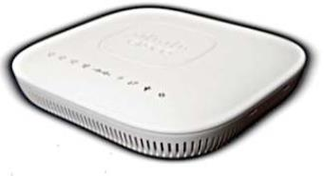

Typical gain = 2 dBi

Bandwidth (degrees)

Horizontal plane = 360°

Vertical plane = 120°

Antenna patterns

(right pattern = azimuth (horizontal), left pattern = elevation (vertical plane))

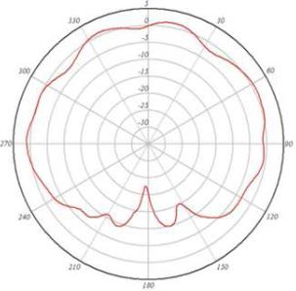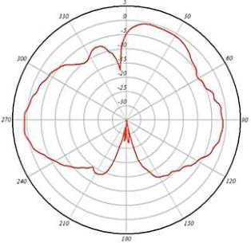

**Attachment 3**

**Antenna CISCO Aironet 3600i Series Integrated Antennas**

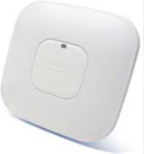

Typical gain = 5 dBi

Bandwidth (degrees)

Horizontal plane = 360°

Vertical plane = 120°

Antenna patterns

(right pattern = azimuth (horizontal), left pattern = elevation (vertical plane))

**5 GHz, Azimuth Plane Radiation**

**Pattern**

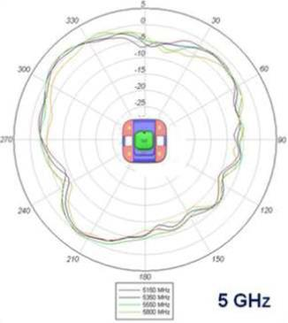 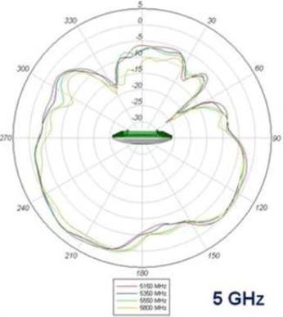

**Attachment 4**

**Antenna ARUBA AP-ANT-90**

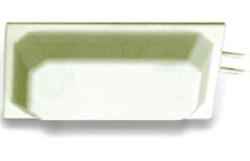

Typical gain = 3 dBi

Bandwidth (degrees)

Horizontal plane = 360°

Vertical plane = 55-59°

Antenna patterns (upper patterns = 2.4 GHz band, lower curves = 5 GHz band, blue curves = vertical, red = horizontal)

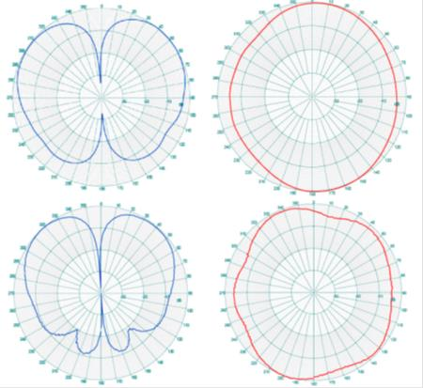

**Attachment 5**

**Antenna ARUBA AP-ANT-13B**

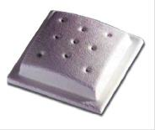

Typical gain = 3.3 dBi

Bandwidth (degrees)

Horizontal plane = 360°

Vertical plane = 60°

Antenna patterns (upper patterns = 2.4 GHz band, lower curves = 5 GHz band, blue curves = vertical, red = horizontal)

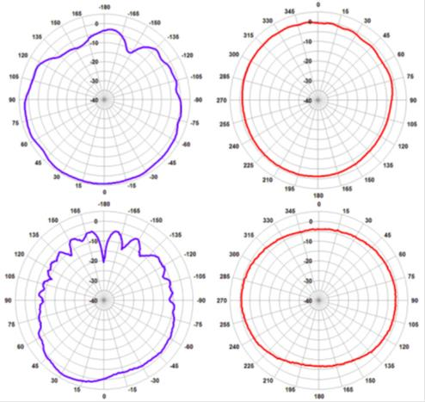

**Attachement 6**

**Internet search on RLAN AP mounting options**

1. **Introduction**

This short annex provides examples of information available on internet on how RLAN Access Points (AP) can be positioned in various high-density and low-density environments

**2 High-density environments.**

In the Aruba Networks document “High-Density WirelessNetworks for Auditoriums.Validated Reference Design”

(<http://www.arubanetworks.com/wp-content/uploads/DG_HighDensity_VRD.pdf>),

the section on Coverage Strategies for Auditoriums indicates 3 strategies for positioning AP in an auditorium (or similar environments):

1. Overhead coverage from the ceiling
2. Side coverage from the walls or pillars
3. Floor coverage from the floor

For the floor coverage the text says: ***“****This design creates picocells using APs mounted in, under, or just above the floor of the auditorium, with a low-gain downtilt antenna reversed to face straight up at the ceiling. This strategy is the only one that can allow for multiple channel reuse inside a*

*room of 10,000 ft2 (930 m2) or less.”*

It is to be noted that this mounting would give the maximum gain of the AP transmitter in the direction of the satellite sensor.



In the CISCO document “Wireless LAN Design Guide for High Density Client Environments in Higher Education” the section “AP placement options” lists the following suitable options: Overhead, Side mounting, Front and Rear Mounting, Shadows, Under Seat Mounting, Under Floor Mounting. Only the first option represents a ceiling mounting all the others are either wall mounting or floor mounting. The text for the Under seat mounting option reads: “*One of the optimal ways to cover a large, dense area is from underneath the users*”

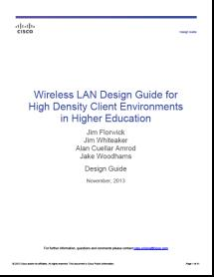

**3 Low-density environments**

As for smaller users (home, shops, small business), some examples of dual-band AP offered on the market are given here below. Their picture shows that they are conceived for table mounting and not for ceiling mounting.

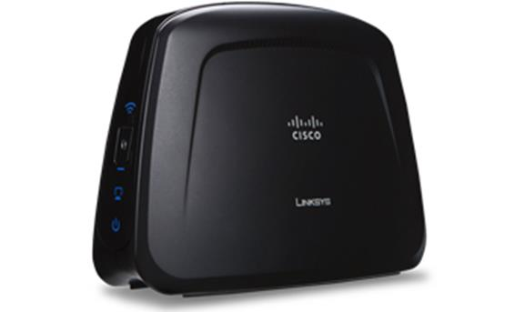

CISCO Access Point Linksys WAP610N.

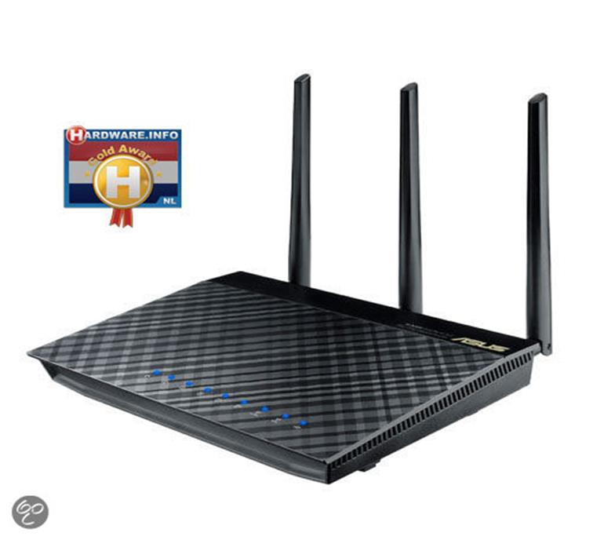

Asus RT-AC66U Dual-band Wireless-AC1750 Gigabit Router

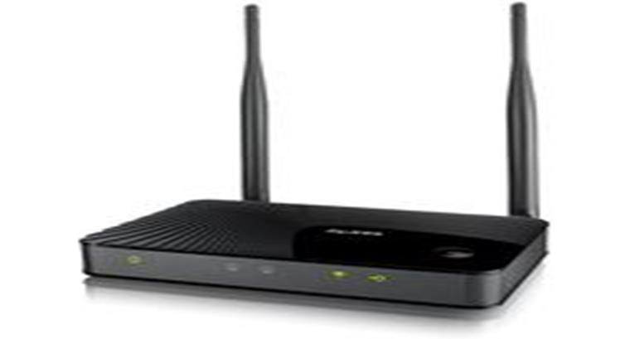

ZyXEL WAP3205 v2

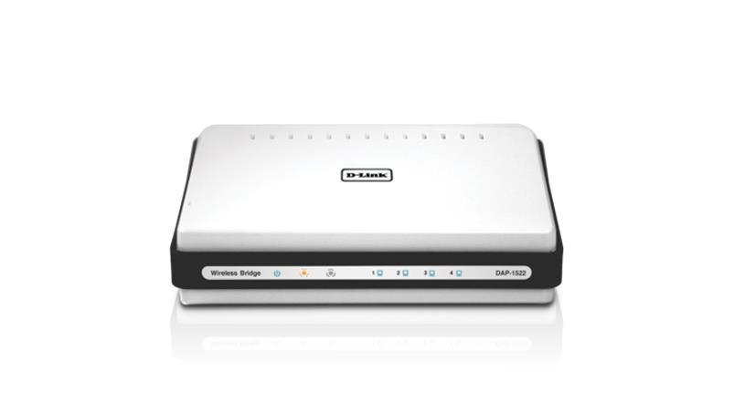

Xtreme N Duo Wireless N Access Point

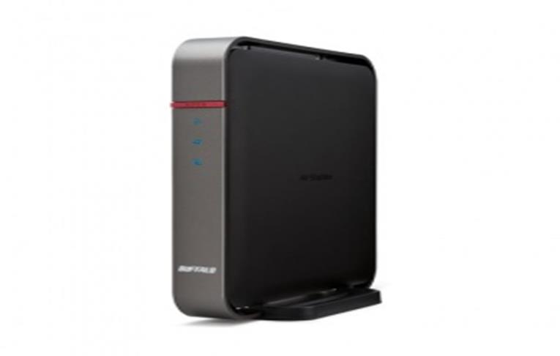

AirStation™ Extreme AC 1750 Gigabit Dual Band

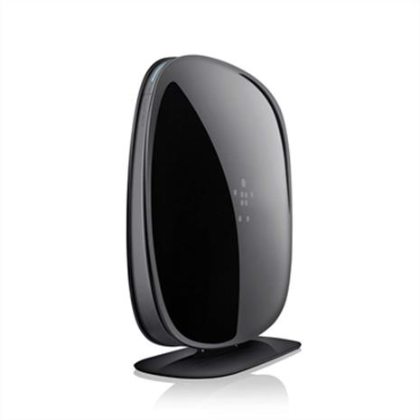

Belkin AC 900 DB Wi-Fi Dual-Band

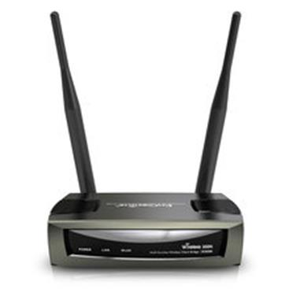

# EnGenius ECB300

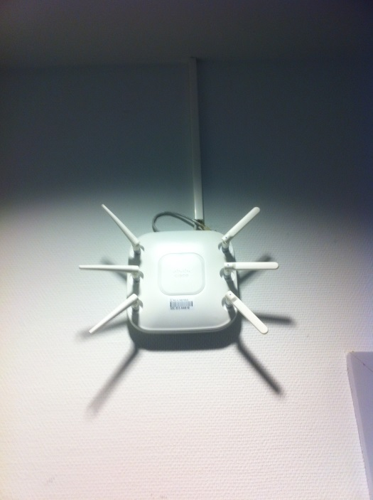

RLAN antenna – Wall – Meeting Room – Charlemagne Building - Brussels

1. **Conclusions**

The results show that the assumption that all (or nearly all) RLAN AP are mounted on ceilings cannot be reasonably made. This reinforces the point made in section 3.5 of the main document: the determination of an average antenna pattern for RLAN AP requires taking into account that a sizable percentage of Access Points will not be mounted on the ceiling.