|  |  |  |
| --- | --- | --- |
|  | | **Doc. ECC/SE(14)037** |
| **Working Group SE** | |  |
| **PT SE Meeting**  **Sesimbra, Portugal, 27 – 31 January 2014** | |  |
|  | |  |
| **Date issued:** | 23 January 2014 | |
| **Source:** | France | |
| **Subject:** | Applicability of the Maastricht, 2002, Special Arrangement (including the revisions) | |

|  |  |
| --- | --- |
| Password protection required? (Y/N) | N |

|  |  |
| --- | --- |
| **Summary:** | This document gives an explanation on how France considers the applicability of the Maastricht Arrangement, 2002 and its revision Constanta, 2007 (MA02revCO07), with an example. |
| **Proposal:** | To consider in the Draft ECC Report on Compatibility Studies for Mobile/Fixed Communications Networks (MFCN) that Maastricht Agreement is applicable with T-DAB applications at the border. |
| **Background:** | Based on the discussion at the SE7 Working Group and on document SE7(13)096 and SE7(13)104 provided by BNetzA, some explanations on French point of view are requested. |

# Introduction

The Maastricht Arrangement, 2002 and his revision Constanta, 2007 (MA02revCO07) purpose is to protect T-DAB from interferences from T-DAB itself and others services at the cross border and defines an allotment per area.

# Bandwidth to consider

The bandwidth to consider for the calculation of the separation distance to the border is the bandwidth of each T-DAB channel to be protected.

The SE7 is invited to consider in its Draft ECC Report in progress, the restricted emission power of MFCN SDL in the 1.536 MHz frequency bandwidth of each T-DAB channel.

As an example for the block LJ, the emission power of the MFCN SDL has to be calculated between the frequencies: 1467.600 MHz and 1469.136 MHz (see Figure 1).

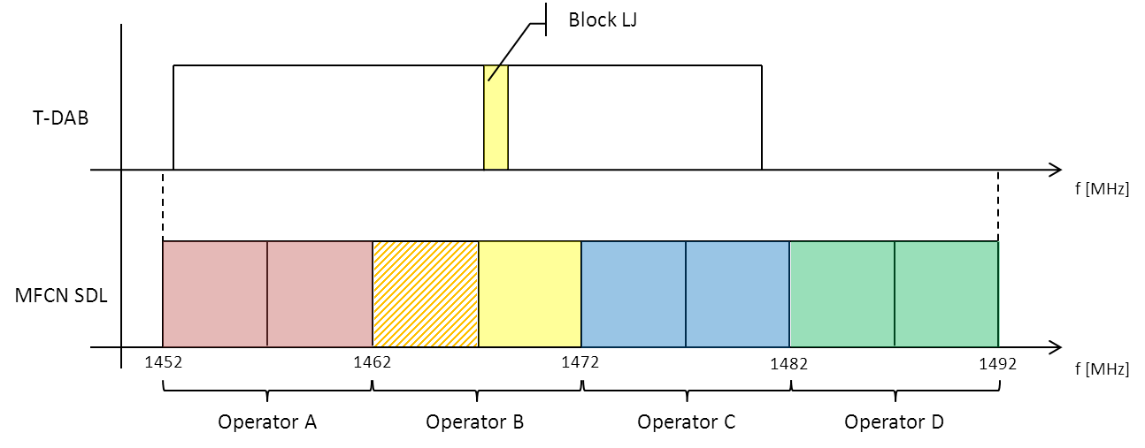

Figure 1: Frequency domain, T-DAB (Block LJ) and MFCN SDL

The same process has to be conducted for each T-DAB channel that is overlapping the MFCN SDL channel bandwidth envelop.

# Coordination analysis

According to the article 6.4.1 of the MA02revCO07 Agreement: “A*n administration may at any time assign frequencies to stations of other radiocommunication services in the band   
1452 – 1479.5 MHz provided that the relevant limits specified in Annex 2 of the Agreement are not exceeded.*

*If they are exceeded, the agreement of any affected administrations shall be obtained by means of bilateral or multilateral agreements*”.

When an MFCN SDL base station is planned to be installed near the border, the coordination analysis has to be done for each T-DAB channel

Different cases can happen:

1. For each T-DAB frequency bloc, the MFCN SDL cause a **field strengths lower than** the relevant limits specified in Annex 2 at the border of an allotment registered in the Plan of the victim country
2. For one or more T-DAB frequency blocs, the MFCN SDL cause a **field strengths greater than or equal to** the relevant limits specified in Annex 2 at the border of an allotment registered in the Plan of the victim country.

For case 1: MFCN SDL station can be fitted in accordance with the MA02revCO07 agreement, and no other coordination work is needed.

For case 2: MFCN SDL station cannot be fitted in accordance with the MA02revCO07 agreement.

* Some mitigation technics have to be considered to reduce the field strengths to be lower than the maximum allowable interfering field strength, defined in MA02revCO07, at the border of an allotment registered in the Plan of the victim country.
* To ask other administration an agreement for specific coordination case to the border.