ECC Report ABC

Adjacent band compatibility between MFCN and PMSE audio applications in the 700 MHz frequency band

**Month 2014**

# executive summary

## Studies included in the report

The purpose of this Report is to find conditions for operation of PMSE audio equipment (wireless microphones) in the 700 MHz frequency range. The exact frequency band is under discussion within CEPT and several options are possible. The report focuses on option 1 (see chapter 2), but the results presented in this report can be easily shifted in frequency if required.

This report considers interference in both directions between PMSE equipment operating in the band 733‑758 MHz[1] and public mobile network equipment operating in the bands 703-733 MHz (uplink) and 758‑788 MHz (downlink). The operation of PMSE below 703 MHz was not studied because the compatibility situation at the boundary between PMSE and MFCN around 733 MHz, is the same at 703 MHz due to the fact that the equipment is the same.

The report considers a total of 9 scenarios corresponding to a specific combination of the following options:

* Indoor/outdoor;
* PMSE interferes with MFCN or MFCN interferes with PMSE;
* MFCN BS or MFCN UE
* The LTE pico BS was sufficiently covered in ECC Report 191, and is not investigated further.

## Methods carried out in the report

In order to address a compatibility study for PMSE in the duplex gap in the 700 MHz frequency band two methods have been used:

* Method 1 - Monte-Carlo simulations carried out with the SEAMCAT tool.
* Method 2 - Minimum Coupling Loss (MCL) analysis.

### Results of the studies

The analyses are limited to cases where there is an interference risk (both audio PMSE equipment and mobile UE/BS are in operation).

The proposed power restriction for PMSE is based on the assumption that LTE mobile system equipment with a 10 MHz channel bandwidth is used. However, the impact of LTE bandwidths other than 10 MHz was also studied, if the MFCN is the victim system. In this report the minimum of a 3 MHz bandwidth, of the 3GPP band 28 (APT band plan) was also assumed. The PMSE system is based on 200 kHz channel bandwidth.

For the scenarios corresponding to audio PMSE equipment interfering with the MFCN UE, a better blocking rejection of 8 dB at 2 MHz offset was assumed. In addition, it is assumed that the duplex filter in the user equipment provides an additional rejection of 2 dB at 2 MHz offset from the channel-edge for narrow band signals. With the proposed power restrictions for PMSE, the compatibility studies between PMSE equipment and MFCN BS is feasible. The critical case is when the PMSE equipment is close to the MFCN UE. If this separation distance is increased, the probability of interference decreases accordingly.

For the scenarios corresponding to mobile equipment (both UE and BS) interfering with audio PMSE equipment, duplex filters in the LTE macro base station and in the user equipment are assumed.

The results of this report do not guarantee that audio PMSE equipment will be able to operate in all the compatibility scenarios, but identifies the scenarios and technical conditions under which PMSE could be operated with sufficient QoS. It was shown that PMSE is able to find an operational channel with sufficient QoS with the assumption of certain spatial distances between the PMSE equipment and the MFCN equipment. The most critical case is if the PMSE is close to a MFCN UE. If this separation distance is increased, the probability of interference decreases accordingly. Proposed power restrictions PMSE

Table 1: power restrictions for handheld microphone

|  |  |  |  |
| --- | --- | --- | --- |
|  | **Frequency Range** | **Handheld e.i.r.p.** | **Reasoning** |
| OOB | < 733 MHz | -45 dBm/200kHz | ETSI EN 300 422 |
|  | 733 – 753.8 MHz | 19 dBm/200kHz |  |
|  | 753.8 – 755.2 MHz | 13 dBm/200kHz |  |
|  | 755.2 – 758 MHz | Guard band |  |
| OOB | > 758 MHz | -45 dBm/200kHz | ETSI EN 300 422 |

Table 2: power restrictions for body worn microphone

|  |  |  |  |
| --- | --- | --- | --- |
|  | **Frequency Range** | **Body worn e.i.r.p.** | **Reasoning** |
| OOB | < 733 MHz | -45 dBm/200kHz | ETSI EN 300 422 |
|  | 733 – 756.8 MHz | 19 dBm/200kHz |  |
|  | 756.8 – 758 MHz | Guard band |  |
| OOB | > 758 MHz | -45 dBm/200kHz | ETSI EN 300 422 |

Notes to Table 1 and Table 2.

Note 1: Option 1 of the frequency band plans under discussion within CEPT was used in the studies, but the frequency ranges can be easily changed if required. The compatibility situation at the boundary between PMSE and MFCN around 733 MHz, is the same at 703 MHz due to the fact that the equipment is the same.

Note 2: PMSE should be operated only if a check of quality of service in the radio environment is performed before use and resulted in sufficient quality. The PMSE setup indicates whether enough PMSE channels with no interference are available to guarantee the needed quality of service. This procedure is described in Annex 5 of ECC Report 191 [7].

**TABLE OF CONTENTS**

0 executive summary 2

0.1 Studies included in the report 2

0.2 Methods carried out in the report 2

0.2.1 Results of the studies 2

1 Introduction 6

2 Frequency environment 7

3 Parameters and scenarios for studies 8

3.1 MFCN and PMSE parameters 8

3.1.1 PMSE receiver 12

3.2 Scenarios 14

4 Results of COMPATIBILITY STUDIES 16

4.1 Methodology 16

4.2 Compatibility results using PMSE emission mask according to ETSI EN 300 422 16

4.2.1 Handheld PMSE interference into MFCN 16

4.2.2 Body Worn PMSE interference into MFCN 17

4.2.3 MFCN interference into PMSE 17

4.2.4 Proposed power restrictions PMSE 18

4.3 Compatibility results with proposed power restrictions for PMSE 18

4.3.1 Hand held PMSE 18

4.3.2 Body worn PMSE 19

4.3.3 Conclusion 19

5 CONCLUSION 20

5.1 Studies included in the report 20

5.2 Methods carried out in the report 20

5.2.1 Results of the studies 20

ANNEX 1: SEAMCAT Simulation 22

ANNEX 2: Derivation of a power restriction based on Minimum Coupling Loss analysis 28

ANNEX 3: Derivation of a power restriction based on mobile UE emission limit requirements 32

ANNEX 4: PMSE body loss in the 700 MHz band 33

ANNEX 5: PMSE spectrum mask from ETSI EN 300 422 36

ANNEX 6: Evaluating PMSE BEMS 38

ANNEX 7: List of references 40

**LIST OF ABBREVIATIONS**

|  |  |
| --- | --- |
| **Abbreviation** | **Explanation** |
| **3GPP** | 3rd Generation Partner Project |
| **BEM** | Block Edge Mask |
| **BS** | Base Station |
| **BW** | Bandwidth |
| **CEPT** | European Conference of Postal and Telecommunications Administrations |
| **DEC** | Decision |
| **DL** | Downlink |
| **ECC** | Electronic Communications Committee |
| **EIRP** | Equivalent Isotropic Radiated Power |
| **EN** | European Norm |
| **ERC** | European Radiocommunications Committee |
| **ERP** | Effective Radiated Power |
| **ETSI** | European Telecommunications Standards Institute |
| **E-UTRA** | Evolved Universal Terrestrial Radio Access |
| **FDD** | Frequency Division Duplex |
| **FFT** | Fast Fourier Transform |
| **IB** | In-Band |
| **IEEE** | Institute of Electrical and Electronics Engineers |
| **IMT** | International Mobile Telecommunication |
| **INR** | Interference to Noise Ratio |
| **ITU** | International Telecommunication Union |
| **LTE** | Long Term Evolution |
| **MCL** | Minimum Coupling Loss |
| **MFCN** | Mobile/Fixed Communications Networks |
| **Mic** | Wireless microphone |
| **NF** | Noise Figure |
| **OOB** | Out-Of-Band |
| **PMSE** | Programme Making and Special Events |
| **PWMS** | Professional Wireless Microphone Systems |
| **RB** | Resource Block |
| **REC** | Recommendation |
| **RF** | Radiofrequency |
| **RFR** | Restricted Frequency Range |
| **RR** | Radio Regulations |
| **SEAMCAT** | Spectrum Engineering Advanced Monte Carlo Analysis Tool |
| **SM** | Spectrum Management |
| **TR** | Technical Report |
| **TS** | Technical Specification |
| **UE** | User Equipment |
| **UL** | Uplink |

# Introduction

The World Radiocommunication Conference 2012 (WRC-12) agreed on an allocation of the 694-790 MHz ('700 MHz') band to the Mobile Service in ITU Region 1 after WRC-15. The European Commission has mandated the CEPT to study technical conditions to ensure the appropriate protection for incumbent uses like PMSE in the 700 MHz band, beside the new usage of MFCN this should take into account the regulatory status of those applications.

This report considers 7 scenarios corresponding to different interference cases: indoor/outdoor, PMSE interfering with MFCN BS (LTE) and MFCN UE (LTE) interfering with PMSE.

Note:   
In this study the band 733-758 MHz is exclusively used by PMSE. The introduction of further application will affect the calculated scenario.

Studies have been performed with 2 different methods, Monte-Carlo simulations (using SEAMCAT 4.1.0) and Minimum Coupling Loss (MCL) analyses.

The Report is structured as follows:

* In Chapter 2, the frequency usages are described (with different options for the allocation for MFCN);
* In Chapter 3, the assumptions, scenarios considered and simulation environments are presented;
* In Chapter 4, the results are provided;
* In Chapter 5, conclusions are drawn;
* In Annexes, simulation and calculation results are presented for different methods.

# Frequency environment

The following figure shows the frequency environments under discussion, option 1 was assumed in this study. The final frequency band plan is under discussion within CEPT but the results presented in this report can be easily shifted in frequency if required. The compatibility situation at the boundary between PMSE and MFCN around 733 MHz, is the same at 703 MHz due to the fact that the equipment is the same.

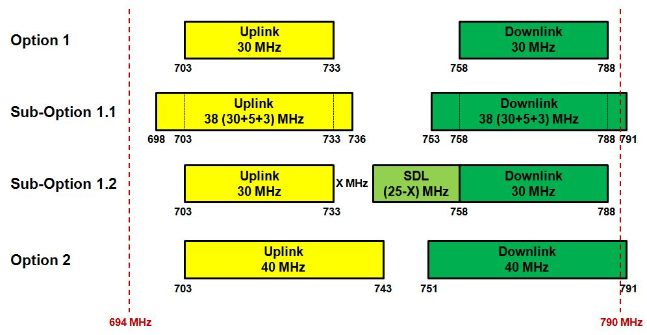

Figure 1: Simplified receiving chain

# Parameters and scenarios for studies

## MFCN and PMSE parameters

In the following tables the relevant parameters are defined.

Table 3: Parameters for an LTE UE

| **Parameter** | **Unit** | | **Value** | | | **Comment** |
| --- | --- | --- | --- | --- | --- | --- |
| Channel Bandwidth | MHz | | 3/10 | | |  |
| Transmission Bandwidth (BW) | MHz | | 2.7/9 | | | ETSI TS 136 101, Table 7.3.1-2  🡪 Sensitivity for a 10 MHz channel is defined for 50 Resource Blocks (RB).  ETSI TS 136 211, section 6.2.3  🡪 1 Resource Block corresponds to 180 kHz |
| Reference Sensitivity (Band 20) | dBm | | -100.2/-94 | | | ETSI TS 136 101, Table 7.3.1-1, Band 20 |
| Reference Sensitivity (Band 28) | | dBm | | -95.5 | ETSI TS 136 101, Table 7.3.1-1 Band 28, 10 MHz System | |
| Noise Figure (NF) | dB | | 9 | | | 3GPP TR 36.824 |
| Noise Floor (N, after FFT processing) | dBm | | -100.7/-95.4 | | | 10∙log(k∙T∙BW∙1000) + NF[2]  This is the noise floor at the output of the FFT, i.e. affecting the transmission bandwidth. |
| Standard Desensitization DSTANDARD | dB | | 13 | | | ETSI TS 136 101, Table 7.6.3.1-1 |
| Standard Narrowband Blocking Level IOOB-STANDARD | dBm | | -55 | | | ETSI TS 136 101, Table 7.6.3.1-1  at 212.5 kHz from the channel edge |
| Blocking Response | dB | | -27.7  then decrease by 0,8 dB every 200 kHz | | | CEPT Report 30, section A5.2.2  🡪 decrease of 8 dB at 2 MHz offset assumed  🡪 the receiver duplex filter provides an additional rejection of 2 dB at 2 MHz offset from the channel-edge for narrow band signals |
| Target Desensitization DTARGET | dB | | 1/3 | | | I/N= -6/0  SE7(12)061  ITU-R Report M.2039 |
| Target Narrowband Blocking Level IOOB-TARGET | dBm | | -67.8  then increase by 0.8 dB every 200 kHz | | | at 212.5 kHz from the channel edge  🡪 the receiver duplex filter provides an additional rejection of 2 dB at 2 MHz offset from the channel-edge for narrow band signals |
| Antenna Height | m | | 1.5 | | |  |
| Body Loss | dB | | 3 | | |  |
| Antenna Gain | dBi | | -4 | | | Average value  Omni directional |
| Maximum Transmit Power | dBm | | 23 | | | ETSI TS 136 101, Table 6.2.2-1 |
| Out-of-band emissions (Monte-Carlo Simulations) | dB | |  | | | ETSI TS 136 101, Table 6.6.2.1.1-1  🡪 values relative to 23 dBm  Duplex filter attenuation:  CEPT Report 30 |
| Duplexer impact |  | | <4 MHz -> 0 dB  4 – 8 MHz -> 6.5 dB per MHz  >8 MHz -> no change | | | Frequency offset seen from the upper boundary of the considered Uplink. Assumption from CEPT Report 30 |

Note: The combination of the spectrum emission mask and the additional duplex filter leads to a spectrum emission mask with reduced OOB emissions. The adopted mask was used to simulate the impact of LTE on PMSE.

Table 4: Parameters for an LTE macro BS (wide area)

| **Parameter** | **Unit** | **Value** | **Comment** |
| --- | --- | --- | --- |
| Channel Bandwidth | MHz | 3/10 |  |
| Transmission Bandwidth (BW) | MHz | 2.7/4.5 | ETSI TS 136 104,  Table 7.2.1-1  🡪 Sensitivity for a 10 MHz channel is defined for 25 Resource Blocks (RB)  ETSI TS 136 211,  section 6.2.3  🡪 1 Resource Block corresponds to 180 kHz |
| Reference Sensitivity | dBm | -103/-101.5 | ETSI TS 136 104, Table 7.2.1-1 |
| Noise Figure (NF) | dB | 5 | 3GPP TR 36.824 |
| Noise Floor (N, after FFT processing) | dBm | -104.7/-102.4 | 10∙log(k∙T∙BW∙1000) + NF over 25 RB  This is the noise floor at the output of the FFT, i.e. affecting the transmission bandwidth. |
| Standard Desensitization DSTANDARD | dB | 6 | ETSI TS 136 104,  Table 7.5.1-1 |
| Standard Narrowband Blocking Level IOOB-STANDARD | dBm | -49 | ETSI TS 136 104,  Table 7.5.1-1 |
| Blocking Response | dB | -48.7 |  |
| Target Desensitization DTARGET | dB | 1 | I/N=-6  SE7(12)061 |
| Target Narrowband Blocking Level IOOB-TARGET | dBm | -59.7 |  |
| Antenna Height | m | 30 |  |
| Antenna Gain (with cable loss) | dBi | 15 |  |
| Maximum Transmit Power | dBm | 46 |  |
| Out-of-band emissions (Monte-Carlo Simulations) | dB |  | ETSI TS 136 104,  Table 6.6.3.2.2-1  🡪 values relative to  46 dBm  Duplex filter attenuation:  CEPT Report 30 |
| BS duplex filter impact |  | <4 MHz -> 0 dB 4 – 9 MHz -> 9 dB/MHz >9 MHz -> no change | Frequency offset seen from the lower boundary of the considered Downlink. Assumption from CEPT Report 30 |
| Vertical antenna pattern (Monte-Carlo Simulations) | dB | A down-tilt of 3° is assumed | SEAMCAT 4.1.0, Library Antenna, 3GPP Tri-Sector Antenna |
| Horizontal antenna pattern | dB | Omni directional | Envelope of a 3-sector-antenna |

Note: The combination of the spectrum emission mask and the additional duplex filter leads to a spectrum emission mask with reduced OOB emissions. The adopted mask was used to simulate the impact of LTE on PMSE.

Table 5: Parameters for handheld audio PMSE

| **Parameter** | **Unit** | **Value** | **Comment** |
| --- | --- | --- | --- |
| Bandwidth (BW) | MHz | 0.2 |  |
| Antenna height | m | 1.5 |  |
| Body loss | dB | 1 around 0°  7 elsewhere |  |
| Maximum EIRP | dBm | 19.15 | ERC/REC 70-03, Annex 10 |
| Transmitter mask (Monte-Carlo Simulations) | dBm |  | ETSI EN 300 422 (revised) |

Table 6: Parameters for body worn audio PMSE

| **Parameter** | **Unit** | **Value** | **Comment** |
| --- | --- | --- | --- |
| Bandwidth (BW) | MHz | 0.2 |  |
| Antenna height | m | 1.5 |  |
| Body loss | dB | 15 |  |
| Maximum EIRP | dBm | 19.15 | ERC/REC 70-03,  Annex 10 |
| Transmitter mask (Monte-Carlo Simulations) | dBm |  | ETSI EN 300 422 (revised) |

Table 7: Parameters for PMSE receivers

| **Parameter** | **Unit** | **Value** | **Comment** |
| --- | --- | --- | --- |
| Bandwidth (BW) | MHz | 0.2 |  |
| Reference Sensitivity | dBm | -90 | ETSI TR 102 546,  section B.4.1.3 |
| Noise Figure (NF) | dB | 6 | ETSI TR 102 546,  section B.3.1 |
| Noise Floor (N) | dBm | -115 | 10∙log(k∙T∙BW∙1000) + NF |
| Standard Desensitization DSTANDARD | dB | 3 | DTARGET = DSTANDARD |
| Blocking Response | dB |  | ETSI TR 102 546  Attachment 2, Applicable Receiver Parameter for PWMS below 1 GHz |
| Antenna Height | m | 3 |  |
| Antenna Gain | dBi | 0 | Omni directional |

Note 1: For the SEAMCAT simulations the minimum required signal of -90 dBm (sensitivity) with a location probability of 95 % has been used. The fading conditions on a stage are simulated with a Gaussian distribution with a standard deviation of 12 dB.

### PMSE receiver

For the scenarios, in which PMSE is the victim system a specific wanted signal was used. The wanted signal of the PMSE equipment is considered as a Gaussian distributed signal, with a wanted signal power of   
-90 dBm with a location probability of 95%. The standard deviation is assumed with σ = 12 dB, this provides a sufficient margin for large signal notches on some places on the stage.

The MFCN LTE macro BS (wide area) uses a duplex filter, the influence is considered as an additional attenuation to the transmitted signal. Due to the lack of other measurements or standard values, a conservative assumption is made, based on the CEPT Report 30. It can be assumed that the duplex filters used in the MFCN BS, are better than the values presented in this report.

#### Modelling the wanted signal for PMSE

The median power of the wanted signal (dRSS) has to be calculated taking account of the used standard deviation and required location probability of 95%. The following equation is based on table 3 of   
ITU-R Rec. P.1546-5.

$${C_{median}}_{new}=C_{median}-σ ∙(-1.645)$$

$${C_{median}}_{new}=-90 \text{dBm}-12 \text{dB}∙\left(-1.645\right)≈-70 \text{dBm}$$

$$dRSS= -70 \text{dBm with} σ=12 \text{dB}$$

The Figure 2 and Figure 3 show the C.D.F. of the wanted signal.

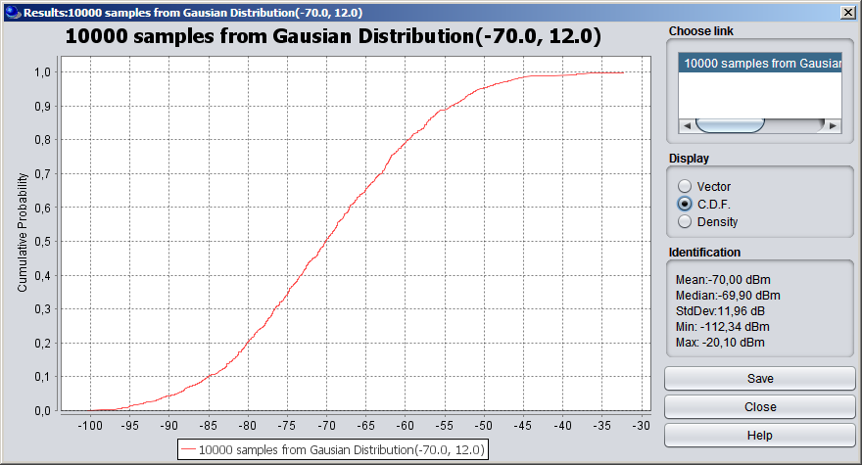

Figure 2: C.D.F. of the used dRSS

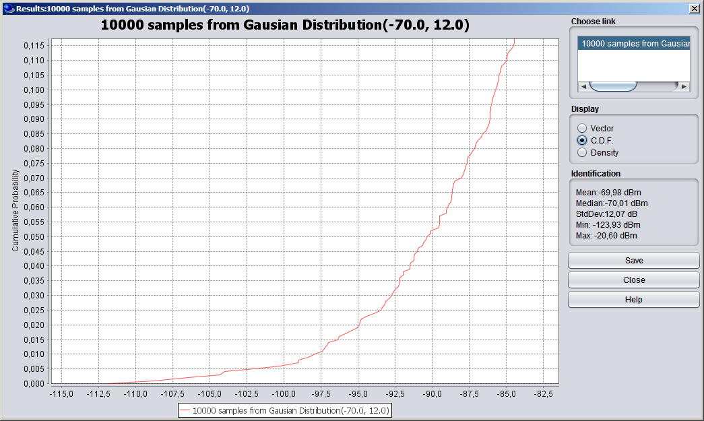

Figure 3: C.D.F. of the used dRSS, detail view for C = -90 dBm and the corresponding probability

To take into account the wanted signal, the criteria to assess the probability of exceedance of a limit is therefore C/(N+I) = 25 dB.

## Scenarios

In the following table the relevant scenarios are listed.

Table 8: Overview of scenarios

| **Scenario** | **Outdoor/ Indoor** | **Interferer** | **Victim** | **Distance (MCL)** | **Distance range (Monte-Carlo Simulations)** | **Propagation model** |
| --- | --- | --- | --- | --- | --- | --- |
| 1 | Outdoor | PMSE | LTE UE | 15 m | 15..100 m | IEEE 802.11 Model C, break-point at 5 m |
| 2 | LTE UE | PMSE |
| 3 | PMSE | LTE BS | Extended Hata, Urban  (Wall attenuation  10 dB) |
| 4 | LTE BS | PMSE |
| 5 | Mixed | LTE BS  (outdoor) | PMSE (indoor) | 100 m | 100..350 m |
| 6 | Indoor | PMSE | LTE UE | 5 m | 5..50 m | IEEE 802.11 Model C, break-point at 5 m |
| 7 | LTE UE | PMSE |
| 8 | PMSE | LTE pico BS | Note 3 | | |
| 9 | LTE pico BS | PMSE |

Note 1: In the distance range of an event area, e.g. theatre or outdoor show, people are present across the propagation link between a transmitter and a receiver and may cause additional loss (of up to 20 to 30 dB), as a result of body loss or multi-path interference due to body scattering[3]. Thus, the propagation model IEEE 802.11 (Model C) is used as in ECC Report 131 [6].

Note 2: An outdoor show is typically a concert performance.

Note 3: The LTE pico BS was sufficiently covered in ECC Report 191, and is not investigated further.

The set-up of distance ranges in the table above in the simulations is illustrated in the figure below.



Figure 4: Illustration of the distance range

PMSE should be operated only if a check of quality of service in the radio environment is performed before and resulted in sufficient quality. The PMSE setup indicates whether enough PMSE channels with no interference are available to guarantee the needed quality of service. This procedure is described in Annex 5 of ECC Report 191 [7].

The two following figures below illustrate the outdoor and indoor scenarios.

.

Figure 5: Outdoor interference scenario



Figure 6: Indoor interference scenario

# Results of COMPATIBILITY STUDIES

## Methodology

In order to address a compatibility study for PMSE in the duplex gap in the 700 MHz frequency band two methods have been used:

* Method 1 - Simulations: In order to investigate the compatibility between PMSE and MFCN, SEAMCAT was used. SEAMCAT is a software tool based on the Monte-Carlo simulation method. The tool permits statistical modelling of different radio interference scenarios for performing sharing and compatibility studies between radiocommunication systems in the same or adjacent frequency bands.
* Method 2 - Minimum Coupling Loss (MCL) calculation: It is simple to use and does not require a computer for implementation in order to have the results for the worst case analysis. The result generated is isolation in dB, which are converted into the required physical separation between PMSE and MFCN systems.

The full descriptions of methods 1 and 2 can be found in Annexes 1 and 2. In addition, ANNEX 3 identifies the current emission limits in the band considered for terminals with similar characteristics as audio PMSE devices. These methods are fully in line with ECC Report 191 [7]. The probability of exceedance is given in percent for the chosen interference criteria, for the mechanisms of unwanted (UW) and blocking (BL). The calculation was done with SEAMCAT 4.1.0 and always the highest value is presented in the following sections. All values and the depending frequency separations could be found in ANNEX 1.

It should be highlighted that for the MCL analyses the minimum body loss for PMSE hand held equipment is assumed as -1 dB, this represents the body loss in front of a user, if the microphone is hand held.

The proposed power restrictions for PMSE are calculated with the MCL analysis of Method 2 (see ANNEX 2). The probabilities of exceedance of MFCN thresholds were calculated, with the assumption that the proposed power restrictions apply and the spectrum emission mask from ETSI EN 300 422 is used by PMSE (see ANNEX 1).

## Compatibility results using PMSE emission mask according to ETSI EN 300 422

### Handheld PMSE interference into MFCN

The results provided by methods 1 for handheld PMSE are summarised in the following table.

Table 9: Summary of results for different scenarios, Handheld PMSE

| **Scenario** | **Interferer** | **Victim** | **Method 1**  **UW / BL in [%]** |
| --- | --- | --- | --- |
| 1 (Band 20) | PMSE | LTE UE | 0 / 3.03 |
| 1 (Band 28) | PMSE | LTE UE | 0 / 3.17 |
| 3 | PMSE | LTE BS | 0.57 / 0.24 |

### Body Worn PMSE interference into MFCN

The results provided by methods 1 for body worn PMSE are summarized in the following table.

Table 10: Summary of results for different scenarios, Body Worn PMSE

| **Scenario** | **Interferer** | **Victim** | **Method 1**  **UW / BL in [%]** |
| --- | --- | --- | --- |
| 1 (Band 20) | PMSE | LTE UE | 0 / 3.14 |
| 1 (Band 28) | PMSE | LTE UE | 0 / 3.02 |
| 3 | PMSE | LTE BS | 0.12 / 0.01 |

### MFCN interference into PMSE

The results provided by method 1 for PMSE receivers are summarized in the following table.

Table 11: Summary of results for different scenarios

| **Scenario** | **Interferer** | **Victim** | **Method 1**  **UW / BL in [%]** |
| --- | --- | --- | --- |
| 2 | LTE UE | PMSE | 6.87 / 0 |
| 4 | LTE BS | PMSE | 18.35 / 0.13 |
| 5 | LTE BS | PMSE | 8.11 / 0.04 |
| 7 | LTE UE | PMSE | 64.25 / 0 |

### Proposed power restrictions PMSE

Table 12: power restrictions for handheld microphone

|  |  |  |  |
| --- | --- | --- | --- |
|  | **Frequency Range** | **Handheld e.i.r.p.** | **Reasoning** |
| OOB | < 733 MHz | -45 dBm/200 kHz | ETSI EN 300 422 |
|  | 733 - 753.8 MHz | 19 dBm/200 kHz |  |
|  | 753.8 - 755.2 MHz | 13 dBm/200 kHz |  |
|  | 755.2 - 758 MHz | Guard band |  |
| OOB | > 758 MHz | -45 dBm/200 kHz | ETSI EN 300 422 |

Table 13: power restrictions for body worn microphone

|  |  |  |  |
| --- | --- | --- | --- |
|  | **Frequency Range** | **Body worn e.i.r.p.** | **Reasoning** |
| OOB | < 733 MHz | -45 dBm/200 kHz | ETSI EN 300 422 |
|  | 733 – 756.8 MHz | 19 dBm/200 kHz |  |
|  | 756.8 - 758 MHz | Guard band |  |
| OOB | > 758 MHz | -45 dBm/200 kHz | ETSI EN 300 422 |

Notes to Table 12 and Table 13

Note 1: Option 1 of the frequency band plans under discussion within CEPT was used in the studies, but the frequency ranges can be easily changed if required. The compatibility situation at the boundary between PMSE and MFCN around 733 MHz, is the same at 703 MHz due to the fact that the equipment is the same.

Note 2: PMSE should be operated only if a check of quality of service in the radio environment is performed before use and resulted in sufficient quality. The PMSE setup indicates whether enough PMSE channels with no interference are available to guarantee the needed quality of service. This procedure is described in Annex 5 of ECC Report 191 [7].

## Compatibility results with proposed power restrictions for PMSE

The proposed power restrictions for PMSE were subject to SEAMCAT simulations in order to simulate the compatibility with MFCN systems.

### Hand held PMSE

The simulations were done for band 28

| **Scenario** | **Interferer** | **Victim** | **UW / BL [%]** | | **PMSE EIRP** |
| --- | --- | --- | --- | --- | --- |
| **3 MHz** | **10 MHz** |
| 1 | PMSE | LTE UE | 0.68/2.51 | 0.79/0.79 | 13 dBm |
| 0.68/0.23 | 0.8/1.59 | 19 dBm |
| 6 | PMSE | LTE UE | 11.60/17.17 | 11.26/11.30 | 13 dBm |
| 11.13/7.24 | 11.19/13.65 | 19 dBm |
| 3 | PMSE | LTE BS | 1.02/1.99 | Note | 19 dBm |

Note: Was not provided due to lack of time, will be similar to the 3 MHz result

### Body worn PMSE

The simulations were done for band 28

| **Scenario** | **Interferer** | **Victim** | **UW / BL [%]** | | **PMSE EIRP** |
| --- | --- | --- | --- | --- | --- |
| **3 MHz** | **10 MHz** |
| 1 | PMSE | LTE UE | 0.0/21.76 | 0.0/3.47 | 19 dBm |
| 6 | PMSE | LTE UE | 6.65/62.86 | 6.65/26.37 | 19 dBm |
| 3 | PMSE | LTE BS | 0.30/0.74 | Note | 19 dBm |

Note: Was not provided due to lack of time, will be similar to the 3 MHz result

In ANNEX 6, compatibility results for other potential BEMs are available.

### Conclusion

The simulations show that for Scenario1 (Outdoor) with a separation distance between 15-100 meters, there will be no compatibility issues for the hand held PMSE device. For the body worn PMSE device, there is no compatibility issue for the 10 MHz band width, but a potential narrow band blocking issue for the 3 MHz LTE UE.

The simulations show that for Scenario3 (Outdoor) with a separation distance between 100-350 meters, there will be no compatibility issues.

The simulations show that for Scenario 6 (Indoor) with a separation distance between 5-50 meters, both hand held and body worn PMSE devices have a potential compatibility issues. In this case, both unwanted emissions and blocking cause degradation of the MFCN performance.

# CONCLUSION

## Studies included in the report

The purpose of this Report is to find conditions for operation of PMSE audio equipment (wireless microphones) in the 700 MHz frequency range. The exact frequency band is under discussion within CEPT and several options are possible. The report focuses on option 1 (see chapter 2), but the results presented in this report can be easily shifted in frequency if required.

This report considers interference in both directions between PMSE equipment operating in the band 733‑758 MHz[4] and public mobile network equipment operating in the bands 703-733 MHz (uplink) and 758‑788 MHz (downlink). The operation of PMSE below 703 MHz was not studied because the compatibility situation at the boundary between PMSE and MFCN around 733 MHz, is the same at 703 MHz due to the fact that the equipment is the same.

The report considers a total of 9 scenarios corresponding to a specific combination of the following options:

* Indoor/outdoor;
* PMSE interferes with MFCN or MFCN interferes with PMSE;
* MFCN BS or MFCN UE
* The LTE pico BS was sufficiently covered in ECC Report 191, and is not investigated further.

## Methods carried out in the report

In order to address a compatibility study for PMSE in the duplex gap in the 700 MHz frequency band two methods have been used:

* Method 1 - Monte-Carlo simulations carried out with the SEAMCAT tool.
* Method 2 - Minimum Coupling Loss (MCL) analysis.

### Results of the studies

The analyses are limited to cases where there is an interference risk (both audio PMSE equipment and mobile UE/BS are in operation).

The proposed power restriction for PMSE is based on the assumption that LTE mobile system equipment with a 10 MHz channel bandwidth is used. However, the impact of LTE bandwidths other than 10 MHz was also studied, if the MFCN is the victim system. In this report the minimum of a 3 MHz bandwidth, of the 3GPP band 28 (APT band plan) was also assumed. The PMSE system is based on 200 kHz channel bandwidth.

For the scenarios corresponding to audio PMSE equipment interfering with the MFCN UE, a better blocking rejection of 8 dB at 2 MHz offset was assumed. In addition, it is assumed that the duplex filter in the user equipment provides an additional rejection of 2 dB at 2 MHz offset from the channel-edge for narrow band signals. With the proposed power restrictions for PMSE, the compatibility studies between PMSE equipment and MFCN BS is feasible. The critical case is when the PMSE equipment is close to the MFCN UE. If this separation distance is increased, the probability of interference decreases accordingly.

For the scenarios corresponding to mobile equipment (both UE and BS) interfering with audio PMSE equipment, duplex filters in the LTE macro base station and in the user equipment are assumed.

The results of this report do not guarantee that audio PMSE equipment will be able to operate in all the compatibility scenarios, but identifies the scenarios and technical conditions under which PMSE could be operated with sufficient QoS. It was shown that PMSE is able to find an operational channel with sufficient QoS with the assumption of certain spatial distances between the PMSE equipment and the MFCN equipment. The most critical case is if the PMSE is close to a MFCN UE. If this separation distance is increased, the probability of interference decreases accordingly.Proposed power restrictions PMSE

Table 14: power restrictions for handheld microphone

|  |  |  |  |
| --- | --- | --- | --- |
|  | **Frequency Range** | **Handheld e.i.r.p.** | **Reasoning** |
| OOB | < 733 MHz | -45 dBm/200kHz | ETSI EN 300 422 |
|  | 733 – 753.8 MHz | 19 dBm/200kHz |  |
|  | 753.8 – 755.2 MHz | 13 dBm/200kHz |  |
|  | 755.2 – 758 MHz | Guard band |  |
| OOB | > 758 MHz | -45 dBm/200kHz | ETSI EN 300 422 |

Table 15: power restrictions for body worn microphone

|  |  |  |  |
| --- | --- | --- | --- |
|  | **Frequency Range** | **Body worn e.i.r.p.** | **Reasoning** |
| OOB | < 733 MHz | -45 dBm/200kHz | ETSI EN 300 422 |
|  | 733 – 756.8 MHz | 19 dBm/200kHz |  |
|  | 756.8 – 758 MHz | Guard band |  |
| OOB | > 758 MHz | -45 dBm/200kHz | ETSI EN 300 422 |

Notes to Table 1 and Table 2.

Note 1: Option 1 of the frequency band plans under discussion within CEPT was used in the studies, but the frequency ranges can be easily changed if required. The compatibility situation at the boundary between PMSE and MFCN around 733 MHz, is the same at 703 MHz due to the fact that the equipment is the same.

Note 2: PMSE should be operated only if a check of quality of service in the radio environment is performed before use and resulted in sufficient quality. The PMSE setup indicates whether enough PMSE channels with no interference are available to guarantee the needed quality of service. This procedure is described in Annex 5 of ECC Report 191 [7].

1. SEAMCAT Simulation

In this annex the results of the SEAMCAT simulations are given. The relevant scenarios used for PMSE can be classified into two basic types: outdoor and indoor. The analyses were based on Monte Carlo simulation (with SEAMCAT version 4.1.0) to cover the various deployment situations of PMSE in the different environments. The parameters used for the studies are presented in chapter 3. These results compared with the MCL analyses givethe possibility to derive power restrictions for PMSE, therefore the same assumptions were made for this Annex and ANNEX 2.

For scenarios where LTE UE the interfering system, power control functionalities are assumed, the results are presented with and without such a power control. For the victim PMSE system a C/(I+N) protection criterion is considered, therefore a wanted signal with 95% location probability is used for PMSE in the simulations (see section 3.1.1).

For scenarios with PMSE as the interfering system, it is assumed that they always transmit with the maximum allowed power; a protection criterion I/N is used for the victim MFCN system in that case.

For the 700MHz band, it could be assumed that the MFCN UE can use the requirements of its receiver for Band 20 or Band 28 (APT band plan), both systems are studied and the results are presented in the following.

Table 16: E-UTRA operating bands

|  |  |  |
| --- | --- | --- |
| Band | Uplink (UL) operating band  BS receive  UE transmit | Downlink (DL) operating band  BS transmit  UE receive |
| 20 | 832 – 862 MHz | 791 – 821 MHz |
| 28 | 703 – 748 MHz | 758 – 803 MHz |

* 1. Results

The results presented in A1.1.1 and A1.1.2 takes not into account the proposed PMSE power restrictions. The results which are taking into account the MFCN UE power control are presented in A1.2. The results presented in A1.1.3 and A1.1.4 use for the simulation the power restrictions as proposed in ANNEX 2 for PMSE. In fact the PMSE equipment transmits always the spectrum mask as described in Table 5 and Table 6 of section 3.1, therefore this spectrum mask is used in the simulations. This mask is defined as relative values in dBc, this reduces also the Out-Of-Band emissions if the maximum allowed transmit power is reduced.

* + 1. Results for Band 20

Table 17: SEAMCAT results (PMSE body worn; PMSE receiver)

|  |  |  |  |  |  |  |  |  |  |  |
| --- | --- | --- | --- | --- | --- | --- | --- | --- | --- | --- |
| Scenario | Victim | Interferer | PMSE Frequency [MHz]  Unwanted / Blocking propability [%] | | | | | | | |
|  | | | 733.1 | 734.1 | 742.9 | 743.9 | 754.9 | 755.9 | 756.9 | 757.9 |
| 1 | LTE UE | PMSE | NN | | | | 0 / 0 | 0 / 0.73 | 0 / 3.14 | 0 / 84.86 |
| 2 | PMSE | LTE UE | 44.38 / 0 | 25.85 / 0 | 0.42 / 0 | 0 / 0 | 0 / 0 | | | |
| 3 | LTE BS | PMSE | 0.12 / 0.01 | | | | | | | |
| 4 | PMSE | LTE BS | 0 / 0.12 | 0 / 0.12 | 0 / 0.12 | 0 / 0.10 | 4.80 / 0.13 | | | 18.35/ 0.13 |
| 5 | PMSE | LTE BS | 0 / 0.03 | 0 / 0.03 | 0 / 0.03 | 0 / 0.03 | 1.73 / 0.03 | | | 8.11/ 0.04 |
| 6 | LTE UE | PMSE | NN | | | | 0 / 7.78 | 0 / 17.20 | 0 / 25.91 | 0 / 99.91 |
| 7 | PMSE | LTE UE | 73.84 / 0 | 55.34 / 0 | 04.19 / 0 | 0.57 / 0 | 0.19 / 0 | | | |

Note: “NN” indicates that these specific frequencies are not simulated due to a lack of a needed technical parameter.

Table 18: SEAMCAT results (PMSE hand held; PMSE receiver)

|  |  |  |  |  |  |  |  |  |  |  |
| --- | --- | --- | --- | --- | --- | --- | --- | --- | --- | --- |
| Scenario | Victim | Interferer | PMSE Frequency [MHz]  Unwanted / Blocking propability [%] | | | | | | | |
|  | | | 733.1 | 734.1 | 742.9 | 743.9 | 754.9 | 755.9 | 756.9 | 757.9 |
| 1 | LTE UE | PMSE | NN | | | | 0.51 / 9.48 | 0.54 / 17.47 | 0.60 / 23.97 | 0.74 / 60.80 |
| 2 | PMSE | LTE UE | 44.38 / 0 | 25.85 / 0 | 0.42 / 0 | 0 / 0 | 0 / 0 | | | |
| 3 | LTE BS | PMSE | 0.57 / 0.24 | | | | | | | |
| 4 | PMSE | LTE BS | 0 / 0.12 | 0 / 0.12 | 0 / 0.12 | 0 / 0.10 | 4.80 / 0.13 | | | 18.35/ 0.13 |
| 5 | PMSE | LTE BS | 0 / 0.03 | 0 / 0.03 | 0 / 0.03 | 0 / 0.03 | 1.73 / 0.03 | | | 8.11/ 0.04 |
| 6 | LTE UE | PMSE | NN | | | | 3.15 / 11.87 | 3.10 / 23.31 | 3.29 / 34.26 | 3.16 / 99.03 |
| 7 | PMSE | LTE UE | 73.84 / 0 | 55.34 / 0 | 04.19 / 0 | 0.57 / 0 | 0.19 / 0 | | | |

Note: “NN” indicates that these specific frequencies are not simulated due to a lack of a needed technical parameter.

* + 1. Results for Band 28

Only the scenarios in which the MFCN UE is the victim are simulated, as only the MFCN UE receiver is affected by a change in band requirements..

Table 19: SEAMCAT results (PMSE body worn; PMSE receiver)

|  |  |  |  |  |  |  |  |  |  |  |
| --- | --- | --- | --- | --- | --- | --- | --- | --- | --- | --- |
| Scenario | Victim | Interferer | PMSE Frequency [MHz]  Unwanted / Blocking propability [%] | | | | | | | |
|  | | | 733.1 | 734.1 | 742.9 | 743.9 | 754.9 | 755.9 | 756.9 | 757.9 |
| 1 | LTE UE | PMSE | NN | | | | 0 / 0 | 0 / 0.6 | 0 / 3.02 | 0 / 99.33 |
| 6 | LTE UE | PMSE | NN | | | | 0 / 7.41 | 0 / 16.72 | 0 / 25.63 | 0 / 100.0 |

Note: “NN” indicates that these specific frequencies are not simulated due to a lack of a needed technical parameter.

Table 20: SEAMCAT results (PMSE hand held; PMSE receiver)

|  |  |  |  |  |  |  |  |  |  |  |
| --- | --- | --- | --- | --- | --- | --- | --- | --- | --- | --- |
| Scenario | Victim | Interferer | PMSE Frequency [MHz]  Unwanted / Blocking propability [%] | | | | | | | |
|  | | | 733.1 | 734.1 | 742.9 | 743.9 | 754.9 | 755.9 | 756.9 | 757.9 |
| 1 | LTE UE | PMSE | NN | | | | 0.53 / 9.73 | 0.58 / 17.51 | 0.64 / 23.92 | 0.61 / 70.78 |
| 6 | LTE UE | PMSE | NN | | | | 3.23 / 12.03 | 3.19 / 24.09 | 3.22 / 34.36 | 3.24 / 100.0 |

Note: “NN” indicates that these specific frequencies are not simulated due to a lack of a needed technical parameter.

* + 1. Results for Band 20, with PMSE power restrictions

In this section the power restrictions for PMSE of ANNEX 2 are taken into account. This means that the PMSE Spectrum Emission Mask is still used, but the output power and usable frequencies are restricted. The first theoretically usable frequency for PMSE to meet the OOB-Limit of -45 dBm is approx. 816 kHz adjacent to the boundaries of the MFCN (see Figure 7, frequency offset of 0 MHz is the boundary).

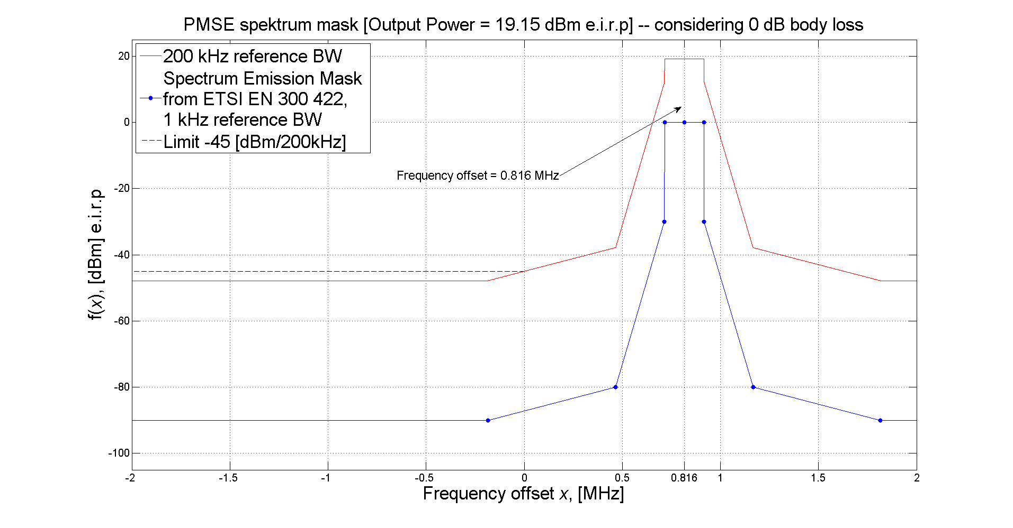

Figure 7: PMSE Spectrum Emission Mask ETSI EN 300 422 (blue curve output power 0dBm)  
and first theoretically usable frequency for PMSE from the band edge of MFCN

Table 21: SEAMCAT results (PMSE body worn; PMSE receiver)

|  |  |  |  |  |  |  |  |  |  |  |
| --- | --- | --- | --- | --- | --- | --- | --- | --- | --- | --- |
| Scenario | Victim | Interferer | PMSE Frequency [MHz]  Unwanted / Blocking propability [%] | | | | | | | |
|  | | | 733.1 | 734.1 | 742.9 | 743.9 | 754.9 | 755.9 | 756.9 | 757.9 |
| 1 | LTE UE | PMSE | NN | | | | 0 / 0 | 0 / 0.73 | 0 / 3.14 | XX |
| 2 | PMSE | LTE UE | 44.38 / 0 | 25.85 / 0 | 0.42 / 0 | 0 / 0 | 0 / 0 | | | |
| 3 | LTE BS | PMSE | 0.12 / 0.01 | | | | | | | |
| 4 | PMSE | LTE BS | 0 / 0.12 | 0 / 0.12 | 0 / 0.12 | 0 / 0.10 | 4.80 / 0.13 | | | XX |
| 5 | PMSE | LTE BS | 0 / 0.03 | 0 / 0.03 | 0 / 0.03 | 0 / 0.03 | 1.73 / 0.03 | | | XX |
| 6 | LTE UE | PMSE | NN | | | | 0 / 7.78 | 0 / 17.20 | 0 / 25.91 | XX |
| 7 | PMSE | LTE UE | 73.84 / 0 | 55.34 / 0 | 04.19 / 0 | 0.57 / 0 | 0.19 / 0 | | | |

Note 1: “NN” indicates that these specific frequencies are not simulated due to a lack of a needed technical parameter.

Note 2: “XX” indicates that these specific frequencies are not useable for PMSE duo to the proposed PMSE power restrictions.

Table 22: SEAMCAT results (PMSE hand held; PMSE receiver)

|  |  |  |  |  |  |  |  |  |  |  |  |
| --- | --- | --- | --- | --- | --- | --- | --- | --- | --- | --- | --- |
| Scenario | Victim | Interferer | PMSE Frequency [MHz]  Unwanted / Blocking propability [%] | | | | | | | | |
|  | | | 733.1 | 734.1 | 742.9 | 743.9 | 754.9 | 755.2 | 756.9 | | 757.9 |
| 1 | LTE UE | PMSE | NN | | | | 0.00 / 2.23 | 0.00 / 3.03 | XX | | |
| 2 | PMSE | LTE UE | 44.38 / 0 | 25.85 / 0 | 0.42 / 0 | 0 / 0 | 0 / 0 | | | | |
| 3 | LTE BS | PMSE | 0.57 / 0.24 | | | | | | | XX | |
| 4 | PMSE | LTE BS | 0 / 0.12 | 0 / 0.12 | 0 / 0.12 | 0 / 0.10 | 4.80 / 0.13 | | | | 18.35 / 0.13 |
| 5 | PMSE | LTE BS | 0 / 0.03 | 0 / 0.03 | 0 / 0.03 | 0 / 0.03 | 1.73 / 0.03 | | | | 8.11 / 0.04 |
| 6 | LTE UE | PMSE | NN | | | | 0.16 / 5.22 | 0.11 / 6.31 | XX | | |
| 7 | PMSE | LTE UE | 73.84 / 0 | 55.34 / 0 | 04.19 / 0 | 0.57 / 0 | 0.19 / 0 | | | | |

Note 1: “NN” indicates that these specific frequencies are not simulated due to a lack of a needed technical parameter.

Note 2: “XX” indicates that these specific frequencies are not useable for PMSE duo to the proposed PMSE power restrictions.

* + 1. Results for Band 28, with PMSE power restrictions

Only the scenarios in which the MFCN UE is the victim are simulated, as only the MFCN UE receiver is affected by a change in band requirements.

Table 23: SEAMCAT results (PMSE body worn; PMSE receiver)

|  |  |  |  |  |  |  |  |  |  |  |
| --- | --- | --- | --- | --- | --- | --- | --- | --- | --- | --- |
| Scenario | Victim | Interferer | PMSE Frequency [MHz]  Unwanted / Blocking propability [%] | | | | | | | |
|  | | | 733.1 | 734.1 | 742.9 | 743.9 | 754.9 | 755.9 | 756.9 | 757.9 |
| 1 | LTE UE | PMSE | NN | | | | 0 / 0 | 0 / 0.6 | 0 / 3.02 | XX |
| 6 | LTE UE | PMSE | NN | | | | 0 / 7.41 | 0 / 16.72 | 0 / 25.63 | XX |

Note 1: “NN” indicates that these specific frequencies are not simulated due to a lack of a needed technical parameter.

Note 2: “XX” indicates that these specific frequencies are not useable for PMSE duo to the proposed PMSE power restrictions.

Table 24: SEAMCAT results (PMSE hand held; PMSE receiver)

|  |  |  |  |  |  |  |  |  |  |  |
| --- | --- | --- | --- | --- | --- | --- | --- | --- | --- | --- |
| Scenario | Victim | Interferer | PMSE Frequency [MHz]  Unwanted / Blocking propability [%] | | | | | | | |
|  | | | 733.1 | 734.1 | 742.9 | 743.9 | 754.9 | 755.2 | 756.9 | 757.9 |
| 1 | LTE UE | PMSE | NN | | | | 0.02 / 2.20 | 0.01 / 3.17 | XX | |
| 6 | LTE UE | PMSE | NN | | | | 0.21/ 5.60 | 0.12 / 6.53 | XX | |

Note 1: “NN” indicates that these specific frequencies are not simulated due to a lack of a needed technical parameter.

Note 2: “XX” indicates that these specific frequencies are not useable for PMSE duo to the proposed PMSE power restrictions.

* 1. Results with MFCN Ue power control

For the power control of an MFCN UE the values in the table below are used.

Table 25: MFCN UE power control values

| **Parameter** | **Unit** | **Value** | **Comment** |
| --- | --- | --- | --- |
| power control step size | dB | 1 |  |
| minimum threshold | dBm | -101.5 | Sensitivity of the MCFN BS |
| dynamic range | dB | 63 |  |

This means if the received power at the base station is higher than the min. threshold the UE will reduce the transmitted power in 1 dBm steps, until a minimum transmit power of -40 dBm is reached. In this context the minimum transmit power is:

Minimum transmit power (UE) = Maximum Transmit Power (UE) - dynamic range

For the interfering path the same scenario requirements and parameters for the components are used as described in section 3. For scenario 7 it is assumed that the MFCN BS is outdoor and the MFCN UE is indoor therefore an additional wall loss is taken into consideration. The default values within SEAMCAT 4.1.0 for the Extended Hata propagation model were used.

* + 1. Results with MFCN UE power control

Table 26: SEAMCAT results (PMSE receiver) with MFCN UE power control

|  |  |  |  |  |  |  |  |  |  |  |
| --- | --- | --- | --- | --- | --- | --- | --- | --- | --- | --- |
| Scenario | Victim | Interferer | PMSE Frequency [MHz]  Unwanted / Blocking propability [%] | | | | | | | |
|  | | | 733.1 | 734.1 | 742.9 | 743.9 | 754.9 | 755.2 | 756.9 | 757.9 |
| 2 | PMSE | LTE UE | 6.87 / 0 | 3.06 / 0 | 0 / 0 | 0 / 0 | 0 / 0 | | | |
| 7 | PMSE | LTE UE | 64.25 / 0 | 47.11 / 0 | 3.16 / 0 | 0.35 / 0 | 0.13 / 0 | | | |

1. Derivation of a power restriction based on Minimum Coupling Loss analysis

One simple power restriction derivation method is to conduct a Minimum Coupling Loss analysis based on the interfered receiver sensitivity/blocking parameters, the loss of the propagation channel over the assumed protection distance and other relevant attenuation factors.

* 1. Results analysis and power restriction

Details on calculation method and assumptions are provided in section A2.2.

* + 1. Results from blocking calculations

Blocking calculations result in in-block EIRP limits. When the maximum EIRP acceptable from a microphone is lower than the EIRP allowed by ERC/REC 70-03 [2], then a restricted frequency range (RFR) is required. The table below summarizes the results.

|  |  |  |  |
| --- | --- | --- | --- |
| **Scenario** | **Victim** | **Handheld PMSE** | **Body worn PMSE** |
| 1 | LTE UE | RFR in 756-758 MHz  10 dBm/200kHz below 756 MHz  13 dBm/channel below 755.2 MHz | 15 dBm/200 kHz in 757.8-758 MHz  17 dBm/channel below 757.2 MHz  19 dBm/channel below 756.8 MHz |
| 3 | LTE macro BS | No requirement | No requirement |

Table 27: Results of blocking MCL analysis

* + 1. Results from out-of-block calculations

Out-of-block calculations result in out-of-block EIRP limits. The table below summarizes the results.

| **Scenario** | **Victim** | **Handheld PMSE: OOB emission level** | **Body worn PMSE: OOB emission level** |
| --- | --- | --- | --- |
| 1 | LTE UE | -43.3 dBm/200 kHz | -29.3 dBm/200 kHz |
| 3 | LTE macro BS | -31.9 dBm/200 kHz | -17.9 dBm/200 kHz |

Table 28: Results of out-of-block MCL analysis

* 1. MCL calculations
     1. Calculation tables for in-block EIRP (blocking case)

***Outdoor, UE, scenario 1:***

For an outdoor UE, the maximum EIRP acceptable from a microphone is given by the following formula:

Mic_EIRPmax,in-block = Blocking_Level + Path_Loss - UE_Antenna_Gain + UE_Body_Loss + Mic_Body_Loss

where path loss is calculated according to IEEE 802.11 Model C propagation model and for a separation distance of 15 m.

| **Parameter** |  | **Value** |
| --- | --- | --- |
| Path loss | dB | 60.7 |
| UE antenna gain | dBi | -4 |
| UE body loss | dB | 3 |
| Handheld mic body loss | dB | 1 |
| Body worn mic body loss | dB | 15 |

Table 29: Parameters for MCL calculation

|  |  |  |  |  |  |
| --- | --- | --- | --- | --- | --- |
| **Frequency range (MHz)** | 758-757.8 | 756-755.8 | 755.2-755 | 754.2-754 | 753.8-753.6 |
| **Offset from the edge (MHz)** | 0-0.2 | 2-2.2 | 2.8-3 | 3.8-4 | 4.2-4.4 |
| **Narrowband blocking level (dBm)** | -67.8 | -58.6 | -55.4 | -51.4 | -49.8 |
| **Max EIRP (dBm)** | 0.9 | 10.1 | 13.3 | 17.3 | 18.9 |

Table 30: Calculation of maximum allowed handheld microphone EIRP for an LTE UE

|  |  |  |  |
| --- | --- | --- | --- |
| **Frequency range (MHz)** | 758-757.8 | 757.2-757 | 756.8-756.6 |
| **Offset from the edge (MHz)** | 0-0.2 | 0.8-1 | 1.2-1.4 |
| **Narrowband blocking level (dBm)** | -67.8 | -65.4 | -63.8 |
| **Max EIRP (dBm)** | 14.9 | 17.3 | 18.9 |

Table 31: Calculation of maximum allowed body worn microphone EIRP for an LTE UE

***Outdoor, macro BS, scenario 3:***

For an outdoor macro BS, the maximum EIRP acceptable from a microphone is given by the following formula:

Mic_EIRPmax,in-block = Blocking_Level + Path_Loss - BS_Antenna_Gain + BS_Antenna_Discrimination + Mic_Body_Loss

where path loss is calculated according to Extended Hata propagation model and for a separation distance of 100 m.

| **Parameter** |  | **Value** |
| --- | --- | --- |
| Path loss | dB | 89.0 |
| BS antenna gain | dBi | 15 |
| Antenna discrimination | dB | 15 |
| Handheld mic body loss | dB | 1 |
| Body worn mic body loss | dB | 15 |

Table 32: Parameters for MCL calculation

|  |  |
| --- | --- |
| **Frequency range (MHz)** | 733.2-733.4 |
| **Offset from the edge (MHz)** | 0.2-0.4 |
| **Narrowband blocking level (dBm)** | -59.7 |
| **Max EIRP (dBm)** | 30.3 |

Table 33: Calculation of maximum allowed handheld microphone EIRP for an LTE BS

|  |  |
| --- | --- |
| **Frequency range (MHz)** | 733.2-733.4 |
| **Offset from the edge (MHz)** | 0.2-0.4 |
| **Narrowband blocking level (dBm)** | -59.7 |
| **Max EIRP (dBm)** | 44.3 |

Table 34: Calculation of maximum allowed body worn microphone EIRP for an LTE BS

* + 1. Calculation tables for out-of-band EIRP (out-of-band emissions case)

The in-band interference level is given in the formula below:

In-band_Interference_Level = Thermal_Noise + Noise_Figure + INR

Thermal_Noise = 10 log (kB·T·BW.1000),

*where kB is the Boltzmann constant, T = 290 K, and BW is the bandwidth considered in Hz*

INR = 10 log (10D/10 - 1)

*where D is the desensitization of the victim receiver (BS or UE)*

***Outdoor, UE, scenario 1:***

For an outdoor UE, the maximum out-of-band emissions EIRP acceptable from a microphone is given by the following formula:

Mic_EIRPmax,oob = In-band_Interference_Level + Path_Loss - UE_Antenna_Gain + UE_Body_Loss + Mic_Body_Loss

where path loss is calculated according to IEEE 802.11 Model C propagation model and a separation distance of 15 m.

|  |  |  |
| --- | --- | --- |
| **Victim UE characteristics** | | |
| Interferer power allowed | dBm/200kHz | -112 |
| **Attenuation calculation** | | |
| Path loss | dB | 60.7 |
| Antenna gain | dBi | -4 |
| UE body loss | dB | 3 |
| **Handheld Microphone** | | |
| Microphone body loss | dB | 1 |
| Max out-of-band EIRP | dBm/200kHz | -43.3 |
| **Body worn Microphone** | | |
| Microphone body loss | dB | 15 |
| Max out-of-band EIRP. | dBm/200kHz | -29.3 |

Table 35: Calculation of maximum allowed out-of-band microphone EIRP for an LTE UE

***Outdoor, macro BS, scenario 3:***

For an outdoor macro BS, the maximum out-of-band emissions EIRP acceptable from a microphone is given by the following formula:

Mic_EIRPmax,oob = In-band_Interference_Level + Path_Loss - BS_Antenna_Gain + BS_Antenna_Discrimination + Mic_Body_Loss

where path loss is calculated according to Extended Hata propagation model and a separation distance of 100m.

|  |  |  |
| --- | --- | --- |
| **Victim BS characteristics** | | |
| Interferer power allowed | dBm/200kHz | -122 |
| **Attenuation calculation** | | |
| Path loss | dB | 89.0 |
| Antenna gain (w/ cable loss) | dBi | 15 |
| Antenna discrimination | dB | 15 |
| **Handheld Microphone** | | |
| Microphone body loss | dB | 1 |
| Max out-of-band EIRP | dBm/200kHz | -31.9 |
| **Body worn Microphone** | | |
| Microphone body loss | dB | 15 |
| Max out-of-band EIRP | dBm/200kHz | -17.9 |

Table 36: Calculation of maximum allowed out-of-band microphone EIRP for an LTE macro BS

1. Derivation of a power restriction based on mobile UE emission limit requirements

The deployment scenario for the power restriction corresponds to low power devices with deployment topology similar to UE. It should be noted that UE specifications already include specific requirements to avoid UE to UE or UE to BS interference. Protection of mobile service can simply be insured through extension of such requirements to other equipment operating in the centre gap.

Any system creating no more interference than LTE terminals in the 700 MHz band should therefore clearly be compatible with services in this band.

Maximum EIRP for an LTE UE is 23 dBm. These values are above the 19 dBm that is the maximum EIRP for a wireless microphone.

* 1. Emissions in the 703-733 MHz band (UL)

The LTE specification ETSI TS 136 101 [9] (see Table 6.6.2.1.1-1) provides the following spectrum emission mask:

|  |  |  |
| --- | --- | --- |
| **Offset from the edge (in MHz)** | **dBm** |  |
| 0..1 | -18 dBm/30 kHz | -9.8 dBm/200 kHz |
| 1..5 | -10 dBm/MHz | -17 dBm/200 kHz |

Table 37: LTE UE spectrum emission mask

As mobile deployments can occur in adjacent channels, and compared to the wireless microphone spectrum emission mask, it is clear that an emission level of -17 dBm/200 kHz in 703-733 MHz does not create undue interference to networks in that band.

* 1. Emissions in the 758-788 MHz band (DL)

The ERC/REC 74-01 [3], Annex 2 Table 2.1, (as ITU-R SM.329-12 [1]) indicates that unwanted emissions in the spurious domain from land mobile terminals and radio microphones should be limited to -36 dBm/100 kHz between 30 MHz and 1 GHz. This limit is quoted in the LTE specification ETSI TS 136 101 [9] (see Table 6.6.3.1-2).

Therefore an emission level of -33 dBm/200 kHz in 758-788 MHz does not create undue interference to networks in that band.

1. PMSE body loss in the 700 MHz band
   1. Definition of body loss

As a brief definition, the term “PMSE body loss effect” can be described as the additional path loss caused by human body absorption and shielding.

* 1. Summary of existing information on PMSE body loss

The ERC REPORT 42 [5] and its successor CEPT Report 30 [8] show body loss plots:

Table 38: Body loss pattern

|  |  |
| --- | --- |
|  |  |
| Body loss for hand held devices: 8 dB | Body loss for body worn devices: 18 dB |

Note: Report 42 refers to 650 MHz and Report 30 to 800 MHz

In addition the document SE7(11)089 [15] incorporate real-live situation pictures

|  |  |
| --- | --- |
|  | SK-027 |
| Figure 8: hand held device | Figure 9: body worn device |

The German DKE (DIN/VDE) provided in 2012 additional measurements. [16]

Unmounted hand held transmitter 822 MHz (P = 30 mW = 14.7 dBm)

|  |  |
| --- | --- |
|  | e.i.r.p. [dBm] |
| Figure 10: device under test   at Styrofoam block | Figure 11: polar pattern of radiated power  of device of Figure 10 |

Note: Each object in the immediate neighbourhood influences the radiation, also the foam block.

Hand held transmitter 822 MHz (P = 30 mW)

|  |  |
| --- | --- |
|  | e.i.r.p. [dBm] |
| Figure 12: hand held device under test | Figure 13: polar pattern of radiated power of device in Figure 12 |

OFCOM engaged the Cobham Technical Services in 2009 for additional measurements in the Theatre environment. The conclusions on the body loss of this study show similar results and more pictures can be found in the study [17].

* 1. Suggestion

A comparison on the available information presented in this document and its references prove that the information of CEPT Report 30 and ERC Report 42 should be applied.

It is therefore proposed an **average body loss effect** in the 700 MHz band:

* for hand held devices = 8 dB
* body worn devices = 18 dB
  1. Further information

The Institute for Applied Physics (Italian National Research Council) provides an Internet resource for the calculation of the “Dielectric Properties of Body Tissues” in the frequency range 10 Hz to 100 GHz: <http://niremf.ifac.cnr.it/tissprop/>

1. PMSE spectrum mask from ETSI EN 300 422

The PMSE spectrum emission mask is given in ETSI EN 300 422 [12] with values in dBc. The values can be easily transferred in dBm. In the figures below the ETSI EN 300 422 mask (reverence bandwidth 1 kHz1kHz) is shown and recalculated for a reverence bandwidth of 200 kHz200kHz and 1 MHz1MHz. The reverence bandwidth for in-band is not changed.

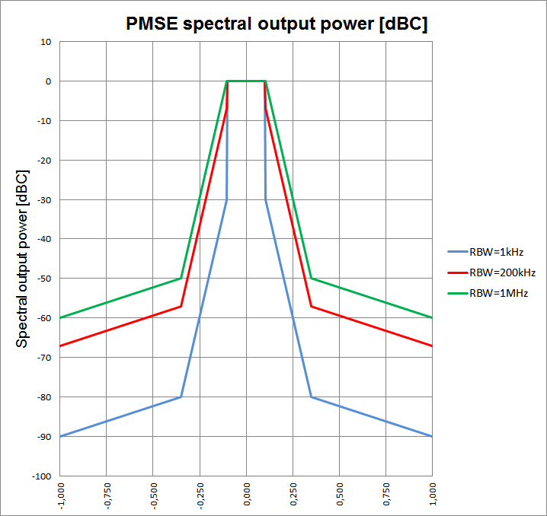

Figure 14: ETSI spectrum mask transferred to differed bandwidth

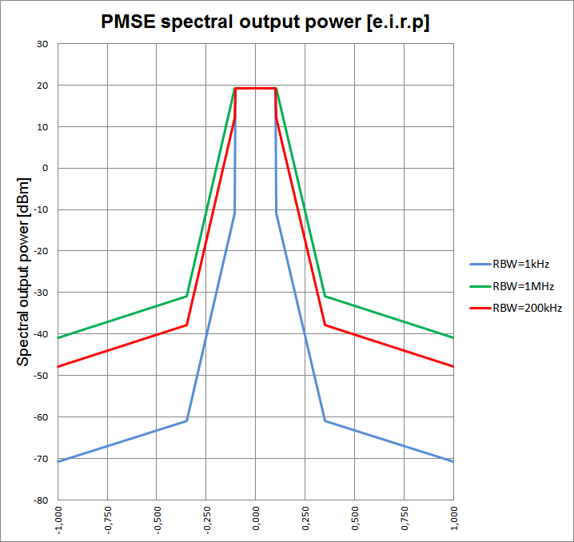

Figure 15: Transfer to maximum isotropic radiated output power (19.15 dBm)

1. Evaluating PMSE BEMS

Interfering probabilities are calculated using three different proposed BEMs for PMSE.

* 1. Evaluating the BEMs

In order to propose a BEM for PMSE, several BEMs were used in the SEAMCAT simulations. The proposed BEM for PMSE would be based on these simulation results.

The following BEMs were used

* BEM 1800 refers to the BEM suggested in ECC Report 191 [7]
* BEM 800 refers to the BEM in CEPT Report 30
* BEM equal to SEM refers to the PMSE spectrum emission mask (SEM) ETSI EN 300 422 (revised) plus the antenna gain
  1. Results

The cases involving the LTE pico BS were sufficiently covered in ECC Report 191, and were not considered in the study. Se extract from ECC Report 191 below

* The operation of PMSE equipment in the same room/hall where a MCFN LTE pico station is used should be avoided, unless additional mitigation techniques are applied.
  + 1. Compatibility between body worn PMSE and MFCN

The results provided by methods 1 and 2 for body worn PMSE are summarized in the following table.

It is clear from the simulation results that the 1800 MHz BEM impacts the MFCN devices with unwanted emissions to a much larger extent than the two other BEMS, the 800 MHz BEM and SEM.

Table 39: Simulation results, MFCN 3 MHz band width

|  |  |  |  |  |  |  |  |  |  |  |
| --- | --- | --- | --- | --- | --- | --- | --- | --- | --- | --- |
| **Scenario** | | **Victim** | **Interf** |  | **PMSE Frequancy [MHz]**  **Unwanted / Blocking propabilety [%]** | | | | | |
|  |  | |  |  | 733.1 | 734.1 | 749.9 | 754.9 | 755.9 | 757.9 |
| 1 | | LTE UE | PMSE | BEM 1800 | 4.54/  0 | | | 4.25/  15.97 | 4.3/  22.65 | 4.46/  31.62 |
| BEM 800 | 0.0/0.0 | | | 0/5 | 0/  16.31 | 0/  30.84 |
| BEM = SEM | 0.0/0.0 | | | 0/  4.80 | 0/  5.88 | 6.85/  31.46 |
| 6 | | LTE UE | PMSE | BEM 1800 | 19.28/  7.97 | | 29.23/7.82 | 28.46/  30.03 | 28.79/  52 | 28.44/77.1 |
| BEM 800 | 0/  7.89 | | 0  /7.49 | 0/  29.98 | 0/  52 | 0/  77.12 |
| BEM = SEM | 3.80/  7.83 | | 3.5/  7.54 | 3.64/  30.2 | 3.5/52 | 17.82/  77.6 |
| 3 | | LTE BS | PMSE | BEM 1800 | 26.56/0.97 | 24.19/0.66 | 25.50/  0.22 | | | |
| BEM 800 | 1.27/ 0.9 | 1.14/ 0.81 | 1.15/  0.21 | | | |

Note: in difference to ANNEX 1 in the frequency range from 733 – 749 MHz, the blocking mask of the MFCN UE has no additional rejection.

1. List of references
2. ITU-R SM.329-12: “Unwanted emissions in the spurious domain”, version of September 2012
3. ERC Recommendation 70-03: “Relating to the Use of Short Range Devices (SRD)”, version of February 2014
4. ERC Recommendation 74-01: “Unwanted emissions in the spurious domain”, version of 2011
5. ERC Report 25: "The European table of frequency allocations and applications in the frequency range 8.3 kHz to 3000 GHz", version of October 2013
6. ERC Report 42: “Handbook on radio equipment and systems radio microphones and simple wide band audio links”, version of October 1996
7. ECC Report 131: “Derivation of a Block Edge Mask (BEM) for Terminal Stations in the 2.6 GHz frequency band (2500-2690 MHz)”, version of January 2009
8. ECC Report 191: “Adjacent band compatibility between MFCN and PMSE audio applications in the 1785-1805 MHz frequency range”, version of September 2013
9. CEPT Report 30: ”The identification of common and minimal (least restrictive) technical conditions for 790-832 MHz for the digital dividend in the European Union“, version of October 2009
10. ETSI TS 136 101: “E-UTRA; User Equipment (UE) radio transmission and reception”
11. ETSI TS 136 104: “E-UTRA; Base Station (BS) radio transmission and reception”
12. ETSI TS 136 211: “E-UTRA; Physical channels and modulation”
13. ETSI EN 300 422: ”Wireless microphones in the 25 MHz to 3 GHz frequency range”
14. ETSI TR 102 546: “Technical characteristics for Professional Wireless Microphone Systems (PWMS); System Reference Document”
15. Extended Hata, <http://tractool.seamcat.org/raw-attachment/wiki/Manual/PropagationModels/ExtendedHata/Hata-and-Hata-SRD-implementation_v2.pdf>
16. APWPT, SE7(11)089_PMSE operation in the band 1800 to 1805 MHz_R1, Annex, 09 December 2011
17. DKE KK 731.0.8, “Measurement of the radiated power of 0.8 / 1.8 GHz hand held PMSE”, May 2012
18. Cobham Technical Services, Report 2009-0333 “Analysis of PMSE Wireless Microphone Body Loss Effects”, June 2009

1. In this study the band 733-758 MHz is exclusively used by PMSE. The introduction of further application will affect the calculated scenario.
2. k = Boltzmann constant; T = 290 K; BW = Bandwidth; NF = Noise figure
3. See ECC Report 131 Annex 2 [6]
4. In this study the band 733-758 MHz is exclusively used by PMSE. The introduction of further application will affect the calculated scenario.