SE(13)021A2
Revision 4 to
Temp 01
12 December 2012

ECC Report 185

Complementary Report to ECC Report 159
Further definition of technical and operational requirements for the operation of white space devices in the band 470-790 MHz
Month YYYY (Arial 9pt bold)
(last updated: Month YYYY) (Arial 9pt)

Executive summary
In response to an increased interest in the possibilities potentially provided by white space devices (WSDs) by its members and the industry, the CEPT developed ECC Report 159 [1] where appropriate technical and operational requirements for such devices in the band 470-790 MHz have been formulated. However, recognizing the preliminary nature of some elements used in the first studies, the innovative nature of cognitive techniques and the ongoing research and industry activities in this field, ECC Report 159 [1] listed a number of technical and regulatory issues requiring further consideration.
The further studies contained in this Report are intended to complement and enhance the findings previously published in ECC Report 159 [1] with some of the additional technical investigations identified by CEPT that were required to facilitate the development of any regulations for WSDs in the band 470-790 MHz. Following on from ECC Report 159 [1] CEPT agreed that these additional technical investigations would be focussed in this report on the following areas of research:
- Technical characteristics of WSDs, including their classification;
- Feasibility of autonomous operation of WSDs using collaborative sensing;
- Fixed maximum permitted power limits for WSDs;
- Protection ratio and overloading levels for PMSE equipment;
- Data on digital PMSE systems;
- Viability of the beacons to achieve protection of PMSE services;
- Protection of aeronautical radionavigation in the band 645-790 MHz;
- Protection of services in the band adjacent to 470-790 MHz;
- Assessment of the spectrum potentially available for WSD;
- Protection of cable head-end receivers.
With this report the CEPT complements ECC Report 159 [1] with additional technical investigations required to facilitate development of the regulation for WSDs in the band 470-790 MHz. In particular:
- A classification of WSDs is proposed and possible approaches (database, hardware, and firmware) to set up fixed maximum permitted power limits for WSDs are considered. In this respect, the conclusions from ECC Report 159 [1] are still valid;
- Some considerations on the collaborative spectral sensing are provided concluding that WSDs receiving weak primary user signals can benefit from cooperative sensing to better detect the signal presence, thus overcoming site-specific bad channel conditions;
- Some basic parameters (location probability, coverage assessment) crucial for the protection of the broadcasting service are explored. Additionally, the performance of DTT receivers in the presence of interference from WSDs has been measured suggesting that
- a number of issues will have to be considered and addressed by regulators when designing the algorithms and protection ratios to be used in the geo-locations databases in order to provide adequate protection for DTT services from interference from WSD deployments;
- more stringent protection ratios may be required for particular combinations of certain DTT receivers and candidate WSD technologies particularly in their idle or low traffic states, as appropriate, which has the potential to reduce considerably the power levels and spectrum that will be made available for WSDs.
- The protection of PMSE systems has been studied, including the measurements of carrier-to-interference protection ratios and overloading thresholds for different candidate WSD technologies, revealing that:
- in line with the previous conclusions from ECC Report 159 [1], sensing techniques have not yet reached a point where it can provide reliable protection for PMSE systems and no practical way of implementing beacons has been found;
- the usage of geo-location databases appears to be the only practical way forward to protect the needs of PMSE users as long as they can manage protection of PMSE use at both permanent and temporary venues within suitable timescales;
- co-channel operation of PMSE and WSDs is not possible in the vicinity of PMSE receivers. One approach to manage interference to PMSE receivers is to calculate appropriate exclusion zones based on the power of the WSD transmitter between WSD and PMSE;
- the database should be able to take into account potential intermodulation effects as the result of WSDs operation that can block PMSE signals. This may involve excluding a number of channels for use by WSDs in the vicinity of PMSE users in addition to the channels used by these PMSE users.
- The protection of the ARNS systems operating in the 645-862 MHz band is found to require a considerable separation distance, taken into account the protected field strengths provided in Recommendation ITU-R M.1830 [14];
- The studies on the impact of WSD interference on services, which are operated in adjacent bands to the 470-790 MHz, have been conducted based on the assumed parameter values and revealed that:
- for the assumed emitted power and WSD density, WSD interference into TETRA TEDS (25 kHz) operating at 450-470 MHz is not significant;
- the protection of CDMA-PAMR operating at 450-470 MHz may require the maximum power of fixed WSDs operating on TV Channel 21 to be limited; the limitation will be dependent of the accepted capacity loss, environment (urban or rural areas) and CDMA-PAMR cell radius.
- the protection of mobile services operating at 790-862 MHz seems to indicate that WSDs operation on TV Channel 60 and additionally for the particular case of portable WSDs on TV Channel 59 are generally not advisable for all scenarios. Also certain limitations in terms of maximum output power for WSDs operating in TV Channel 57 to 59 may be necessary.
- Regarding the considerations on the cable head-end protection within the broadcasting service area, it is reasonable to assume that their protection may be covered in a similar way as it was done for residential receivers in ECC Report 159 [1]. In addition, it was concluded that consideration of the cable head-end protection outside the broadcasting service area is a national issue.
- Amount of spectrum potentially available for WSDs varies on a case-by-case basis as shown in a number of example studies.
It should be noted that the protection of the radiolocation service allocated through footnote RR 5.291A [2] in the band 470-494 MHz in some European countries on a secondary basis and used for the operation of wind profiler radars in accordance with Resolution 217 (WRC-97) [3] was not addressed in this report in the absence of the request from administrations to study this issue.

TABLE OF CONTENTS

0 Executive summary 2
1 Introduction 9
2 WSD technical characteristics 9
2.1 Summary on previous studies 9
2.2 Classification of WSDs 10
2.2.1 Use cases of WSDs 10
2.2.2 Parameters of WSDs 11
2.3 Fixed maximum permitted power limits for WSDs 12
2.3.1 General thoughts 12
2.3.2 Approaches to set the fixed maximum power for WSDs 13
2.3.3 Determination of the fixed maximum power levels 13
2.3.3.1 Statistical approach based on device classes 13
2.3.3.2 Receiver overloading 14
2.3.4 Assumptions on maximum permitted e.i.r.p. limits based on the WSD operational ranges 14
2.4 Autonomous operation of WSDs using sensing 15
2.4.1 Practical assessment of autonomous WSD operation in case of DTT 15
2.4.2 Cooperative sensing 15
2.4.2.1 Single-device energy sensing 16
2.4.2.2 Cooperative energy detection 17
2.4.2.3 Analysis of performance of cooperative versus single device sensing 18
2.4.2.4 Main results 21
2.5 Examples of adjacent channel leakage ratio for WSDs 21
2.6 Operation of WSDs using beacons 22
2.6.1 Introduction to beacons 22
2.6.2 Benefits of a beacon 22
2.6.3 Preventing interference between different WSDs 23
2.6.4 How may a beacon work? 23
2.6.5 Further studies 23
2.7 Operation of WSDs using geo-location database 24
3 Technical considerations on the protection of the broadcasting service 24
3.1 Summary on previous studies 24
3.2 Dependency of location probability on antenna installations and reception modes 24
3.3 Coverage assessment of broadcasting services 25
3.4 Further studies looking at DTT receiver performance in the presence of WSDs 25
3.4.1 Background and previous studies 25
3.4.1.1 Useful Definitions 26
3.4.2 Results from the new measurement campaigns 27
3.4.2.1 Impairment Criteria used When Assessing Interference 27
3.4.2.2 Equipment tested and test setup 27
3.4.2.3 WSD parameters 27
3.4.2.4 Test Procedures 28
3.4.3 Test results 28
3.4.4 Discussion and analysis of these results 34
3.4.4.1 Initial Analysis of results 34
3.4.4.2 WSD to DTT Protection Ratios 35
3.4.5 Conclusions 37
3.4.5.1 Areas for further work 38
4 Technical considerations on the protection of PMSE 38
4.1 Summary of previous studies 38
4.2 Overview of PMSE 39
4.2.1 Changes in use and equipment since ECC Report 159 [1] 39
4.2.2 Multipath Fading 39
4.2.3 Link Budget 40
4.3 Frequency Management Issues 42
4.3.1 PMSE Signal Sensing: Application Scenarios and Channel Models 42
4.3.2 Usability of Beacon Signals 42
4.3.3 Usability of Combined (Sensing and Geo-location) Approach 44
4.4 Protection ratios and overloading thresholds assessed in measurement campaigns 44
4.4.1 PMSE Receiver Testing by the BBC 44
4.4.1.1 Protection Ratio Performance 44
4.4.1.2 Impact of WSD ACLR Performance on PMSE Protection Ratios 45
4.4.1.3 PMSE Sensitivity Degradation Measurements 45
4.4.2 PMSE Receiver Testing by CSR 47
4.4.3 Determining the required C/I for PMSE analogue receivers by APWPT and DKE 48
4.5 Intermodulation Distortion 48
4.5.1 PMSE Considerations 48
4.5.2 Characterisation of Intermodulation Performance 49
4.5.3 PMSE and WSD intermodulation products 49
4.6 An example of a Methodology of Protection of PMSE from WSD 50
4.6.1 Introduction & Overview 50
4.6.2 Interferer to Noise Approach 50
4.6.3 Co-Channel Protection Level 51
4.6.4 Adjacent Channel Protection Level 52
4.6.4.1 Rx ACS Considerations 52
4.6.4.2 Tx ACLR Considerations 53
4.6.4.3 PMSE Receiver Overload Characteristics (Blocking) 54
4.6.5 Propagation Models for Calculation of Exclusion Zones 54
4.6.6 Antenna Gains & Distribution Systems 55
4.7 Summary of conclusions on PMSE from further studies 55
5 Technical considerations on the protection of ARNS 55
5.1 Summary on previous studies 55
5.2 General note 55
5.3 ARNS deployment scenarios 56
5.4 Possible interference scenario from WSD to ARNS systems 59
5.5 Assumptions and methodologies used in the estimations 59
5.6 Estimation results of WSD emission influence to ARNS airborne and ground-based receivers 60
5.7 Conclusion 62
6 Technical considerations on the protection of services in the bands adjacent to 470-790 MHz 62
6.1 Summary on previous studies 62
6.2 Protection of mobile service in the band 450-470 MHz 62
6.2.1 Protection of TETRA TEDS 25 kHz 62
6.2.1.1 Assumptions and scenarios 62
6.2.1.2 Results 64
6.2.1.3 Conclusions 65
6.2.2 Protection of CDMA PAMR 66
6.2.2.1 Scenarios 66
6.2.2.2 Interference criteria 67
6.2.2.3 Parameters of WSD used for simulations 67
6.2.2.4 Parameters of CDMA network used for simulation 68
6.2.2.5 Results 69
6.3 Protection of mobile service in the band 790-862 MHz 70
6.3.1 Common assumptions 70
6.3.1.1 Wideband WSD system (interferer) 70
6.3.1.2 Narrowband WSD system (interferer) 71
6.3.1.3 WSD emissions within LTE UE wanted channel 71
6.3.1.4 Mobile system (LTE) 72
6.3.1.5 LTE UE selectivity 72
6.3.2 Interference modeling 75
6.3.2.1 MCL analysis 75
6.3.3 Scenarios 75
6.3.3.1 Scenario 1: WSD deployed as wide area base station 75
6.3.3.2 Scenario 2: portable WSD or user-deployed access point 76
6.3.3.3 Scenario 3: WSD deployed as fixed mounted CPE 76
6.3.4 Calculation results (MCL analysis) 77
6.3.4.1 Scenario 1: WSD deployed as wide area base station 77
6.3.4.2 Scenario 2: portable WSD or user-deployed access point 78
6.3.4.3 Scenario 3: WSD deployed as fixed mounted CPE 79
6.3.4.4 Impact of the assumed baseline level 79
6.3.5 Conclusion 80
7 Protection of terrestrial cable head-end receivers 81
8 Amount of white space spectrum potentially available for WSDs in the band 470-790 MHz 82
8.1 Summary on previous studies 82
8.2 Result of studies 82
9 Conclusions 82
ANNEX 1: Example Link budget calculations to derive e.i.r.p. values for white space devices 84
ANNEX 2: WSD fixed maximum power limits’ calculation based on overload threshold 86
ANNEX 3: Example spectrum sensor implementation and field test results 89
ANNEX 4: Calculations with SEAMCAT on interference assessment 98
ANNEX 5: coverage assessment of broadcasting services 107
ANNEX 6: DETAILS of DVb-t Protection Ratio MEASurements 109
ANNEX 7: TYPICAL DIGITAL PMSE parameters 111
ANNEX 8: PMSE protection measurements in helsinki city theatre 112
ANNEX 9: PMSE RECEIVER TESTING BY THE BBC 117
ANNEX 10: Intermodulation, WSD and PMSE 120
ANNEX 11: case studies on white space spectrum availability 127
ANNEX 12: List of references 150

LIST OF ABBREVIATIONS

Abbreviation | Explanation
ACLR | Adjacent Channel Leakage Ratio
ACS | Adjacent Channel Selectivity
AGC | Automatic Gain Control
agl | Above ground level
AI | Air Interface
AMS | Audio measurement system
ARNS | Aeronautical Radionavigation Service
AWGN | Additive White Gaussian Noise
BBC | British Broadcasting Corporation
BPL | Building Penetration Loss
BS | Base station
BS | Broadcasting Service
CCDF | Complementary Cumulative Distribution Function
CDMA | Code division multiple access
CEPT | European Conference of Postal and Telecommunications Administrations
CPE | Customer Premise Equipment
CRS | Cognitive Radio System
DTT | Digital Terrestrial Television
DTV | Digital Television
DVB-T | Digital Video Broadcasting – Terrestrial
DVB-H | Digital Video Broadcasting- Handheld
DPSA | Digital Preferred Service Area
DSO | Digital switch over
ECN | Electronic Communication Network
EBU | European Broadcasting Union
ECC | Electronic Communications Committee
e.r.p. | equivalent radiated power
e.i.r.p. | equivalent isotropically radiated power
EMC | Electromagnetic compatibility
ETSI | European Telecommunications Standards Institute
ETSI TC RRS | Technical Committee Reconfigurable Radio Systems
E-UTRA | Evolved Universal Terrestrial Radio Access
FCC | Federal Communications Commission
FDD | Frequency-division duplex
FFT | Fast Fourier transform
FICORA | Finnish Communications Regulatory Authority
FM | Frequency modulation
FSK | Frequency-shift keying
FPGA | Field-programmable gate array
FWA | Fixed Wireless Access
GPIB | General Purpose Interface Bus
IDTV | Integrated DVB-T
IEEE | Institute of Electrical and Electronics Engineers
IEM | In-Ear Monitoring
IMD | Inter-Modulation Distortion
IP | Interference probability
JTG | Joint Task Group
LBT | Listen Before Talk
LP | Location Probability
LTE | Long Term Evolution
M-to-M | Machine-to-Machine communication
MCL | Minimum coupling loss
MFCN | Mobile/Fixed Communications Networks
MFN | Multi Frequency Networks
MI | Multiple interference margin
NF | Noise Figure
OFDM | Orthogonal Frequency-Division Multiplexing
OFDM | Orthogonal frequency-division multiplexing
OOB | Out-of-band
O_{th} | Overloading threshold
PAPR | Peak to Average Power Ratio
PCB | Printed-Circuit Board
PMSE | Program Making and Special Event
PPDR | Public Protection and Disaster Relief
PR | Protection Ratio
PSB | Public Service Broadcasters
QPSK | Quadrature Phase Shift Keying
RF | Radio frequency
RIS | Radio Interface Specifications
RM | Radio Microphones
RRC-06 | Regional Radiocommunication Conference, Geneva, 2006
RFSENS | Reference Sensitivity
RSBN | Radio system of short-range navigation
PAMR | Public Access Mobile Radio
PMR | Private Mobile Radio
PWMS | Professional Wireless Microphone system
RFIC | RF Integrated Circuits
ROC | Receiver Operating Characteristic
SEAMCAT | Spectrum Engineering Advanced Monte Carlo Tool
SFN | Single Frequency Networks
SNR | Signal-to-noise ratio
STB | Set-Top Boxes
TETRA TEDS | TETRA Enhanced Data Service
TDD | Time-division duplexing
THD | Total harmonic distortion
TVWS | TV White Spaces
UE | User Equipment
UART | Universal asynchronous receiver/transmitter
UHF | Ultra-high frequency
WiFi | Wireless Fidelity
WiMAX | Worldwide Interoperability for Microwave Access
WLAN | Wireless Local Area Network
WRAN | Wireless Regional Area Network
WSD | White Space Device

Introduction
Cognitive radio systems (CRS) may be deployed in the “white spaces” of the frequency band 470-790 MHz provided no harmful interference to incumbent services is generated by such a deployment. By other words, the incumbent services need to be protected from any potential WSD interference. This is to be ensured through utilization of cognitive techniques such as spectrum sensing and geo-access to location database.
In response to an increased interest in the possibilities potentially provided by white space devices (WSDs) by its members and the industry, the CEPT developed ECC Report 159 [1] where appropriate technical and operational requirements for such devices in the band 470-790 MHz have been formulated. However, recognizing the preliminary nature of some elements used in the first studies, the innovative nature of cognitive techniques and the ongoing research and industry activities in this field, ECC Report 159 [1] listed a number of technical and regulatory issues requiring further consideration.
This ECC report is intended to complement ECC Report 159 [1] with additional technical investigations required to facilitate development of the regulation for WSDs in the band 470-790 MHz. It needs to be noted here that the issue of the geo-location database, being also complementary to ECC Report 159 [1], is considered in a separate ECC Report 186 [4].
It should be noted that the protection of the radiolocation service allocated through footnote RR 5.291A [2] in the band 470-494 MHz in some European countries on a secondary basis and used for the operation of wind profiler radars in accordance with Resolution 217 (WRC-97) [3] was not addressed in this report in the absence of the request from administrations to study this issue.

WSD technical characteristics

Summary on previous studies
ECC Report 159 [1] identified a range of possible deployment scenarios for WSDs and, in the absence of specific system characteristics related to WSDs, sets up some key assumptions in order to perform first sharing studies. The assumptions are not intended to restrict industry flexibility to innovate in using white spaces.
In particular, ECC Report 159 [1] foresees at least three broad categories of WSDs:
- Personal/portable devices, which are envisaged to be of such a size that they can be carried by individual users, much in the manner of mobile phones or personal media players;
- Non-portable devices, built in flat panel TVs, personal video recorders and other appliances, which are designed to remain primarily in one place;
- Public/private access points or base stations operating in a similar manner as today’s WiFi access points or providing a gateway to the Internet for larger areas.
Deployment scenarios considered in the studies within ECC Report 159 [1] were constructed with respect to propagation and sharing assumptions and do not necessarily represent actual use cases:
  - Deployment either indoor or outdoor;
  - Deployment either at low antenna height or mounted high. Two representative heights are assumed:
1.5 m for low antenna height terminals, and 10 or 30 m for access points or base stations.
The exact transmission technology or technologies to be used by WSDs could not be determined at the time ECC Report 159 [1] was developed. However, since the OFDM family of technologies seemed to represent the most efficient and reliable transmission, it was reasonable to assume this type of technology for the purpose of the first sharing studies. This allowed usage of the values provided in ECC Report 148 [5] regarding the protection ratios and overloading thresholds for interference from LTE into DVB-T. It should be noted that (a) these results only analysed usage profiles when the LTE equipment was in a mode where data traffic was being transmitted and that (b) only one UE transmission signal was simulated (i.e. not working in a network).
Three techniques have been proposed to assist WSDs in finding unoccupied channels:
- With spectrum sensing, WSDs try to detect the presence of the protected incumbent services in each of the potentially available channels. Spectrum sensing essentially involves conducting a measurement within a candidate channel, to determine whether any protected service is present. One of the key parameters for spectrum sensing is the sensing threshold.
- In the geo-location database approach, WSDs would measure their geographical location and consult a “geo-location” database to determine which frequencies they can use at their location (i.e. the location which they have indicated to the database).
- Beacons are signals which can be used to indicate that particular channels are either in use by protected services or vacant.

Classification of WSDs

Use cases of WSDs
ETSI TR 102 907 [6] describes use cases for the operation of Reconfigurable Radio Systems within White Spaces in the UHF 470-790 MHz frequency band. The use cases are categorized according to their intended functionality (internet access, machine-to-machine connectivity, etc.) and operational range (short/mid/long). These use cases and related parameters are informative and do not prejudge future studies and real deployments.
A number of potential, technology related use cases are under discussion in different European research projects. The use cases differentiate according to the services (WiFi, LTE, PPDR, etc.) to be provided via white space spectrum. Depending on the service its operational range could be varying from a few metres to a few kilometres viable for urban, suburban and rural coverage.
CEPT broadly classifies different use cases for WSDs:
- WSDs to provide indoor Internet access from an access point to a user equipment with an operational range of up to 50 m (the operational distances might be reduced due to wall/floor penetration). Indoor access point can provide a limited outdoor coverage. Possible configurations are shown in
Figure 1.

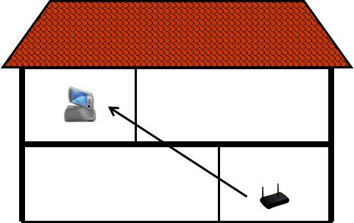 | 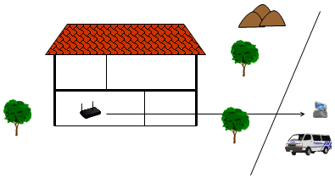
Figure 1: Indoor wireless access
- WSDs to provide outdoor Internet access from a base station to a user equipment with an operational range of up to 10 km. Different scenarios can be envisaged ranging from (i) providing mobile/portable broadband Internet coverage from access points to the public places in the street to (ii) delivering a broadband Internet signal from a base station to fixed installations within and beyond a village or a campus. This equipment is expected to be installed by a professional. A possible configuration is shown in Figure 2.

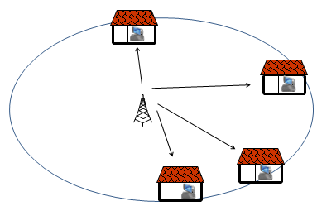
Figure 2: Outdoor wireless access

- WSDs to provide machine-to-machine or device-to-device communication for both short and long ranges. Some possible configurations are shown in Figure 3.
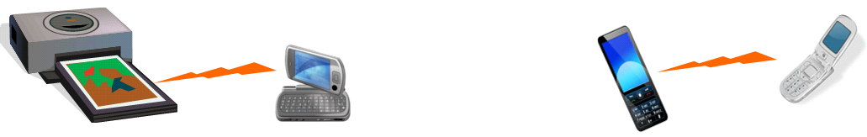
Figure 3: Machine-to-machine connectivity (from Figure 34 of ETSI TR 102 907 [6])

Parameters of WSDs
The parameters assumed for different WSD use cases considered as examples by the CEPT are listed in Table 1 and Table 2 for outdoor and indoor applications, respectively. The parameters for outdoor WSDs are set by analogy with today’s cellular systems. Similarly, the parameters for indoor WSDs are set by analogy with today’s WiFi wireless communication systems. The link budget calculations to derive the power values are detailed in ANNEX 1:
Table 1: Examples of outdoor WSDs parameters
Parameter | Base station | User equipment | M-to-M long range
Data rate (Mbps) | 1-10 | 0.128-2 | 0.5
Transmission bandwidth (MHz) | 5-8 | 0.360-5 | 1
Receiver noise figure (dB) | 4-7 | 5-7 | 5-7
Antenna gain (dBi) | 7-8 | 0-14 | 12
Maximum range (m) | 10'000 | 10'000 | 20'000
e.i.r.p. (dBm) | up to 36 | up to 27 | 14.7
Table 2: Examples of indoor WSDs parameters²
Parameter | Access point | User equipment | M-to-M short range
Data rate (Mbps) | 10-100 | 4 | 10
Transmission bandwidth (MHz) | 8-22 | 8 | 8
Receiver noise figure (dB) | 5-7 | 5 | 7
Antenna gain (dBi) | 0 (isotropic) | -4 (isotropic) | -10 (isotropic)
Maximum range (m) | 15-50 | 15 | 10
e.i.r.p. (dBm) | up to 18 | 4.8 | -10

Fixed maximum permitted power limits for WSDs
ECC Report 159 [1] stipulates that
"In some of the geo-location database usage models it may not be necessary for administrations to define, assume or mandate a fixed value for the maximum permitted e.i.r.p. for WSDs. However, Administrations may still decide to assume or mandate maximum permitted e.i.r.p. of WSDs considering their usage and the DTT implementations they are protecting. "
This section addresses the possibility to set up fixed maximum permitted power limits for WSDs.

General thoughts
For a WSD controlled by a geo-location database, the power levels on which the device is allowed to transmit in a given geographical location will be determined by the database. This determination is to be made either on the basis of the protection requirements for incumbent services/systems on co- and adjacent channels in the WSD location or on the basis of the regulation established in the country the device is located. Also the cross border issues need to be taken into account in the determination of the allowed transmission power levels. The database can be used to communicate the applicable values to the WSDs.
Some administrations have indicated their preference to define fixed maximum power limits for WSD’s to ensure that the device power is limited in case of a database delivers erroneous power limits to the WSD resulting, for example, in the allowance to transmit with higher than the justified power levels, which can create harmful interference. It is also believed that the device power limitation will also help different WSDs to access the spectrum in case when this access is not coordinated. Additional technical argument of setting a fixed power limit include the risk of overload of the DTT receiver in presence of a high interfering signal level and the EMC issue with DTT receivers and cable networks using the same channels as the WSD.
It needs to be noted that operational requirements to WSDs (see § 9.3 of ECC Report 159 [1]) define the situations when the device does not possess sufficient information regarding the frequencies and power levels to be used in a given geographical location. Generally speaking, a WSD should be in compliance with one or a combination of the following requirements shown in options 1 – 3 below:
- It cannot transmit above the location specific power determined by the database for a given frequency on the basis of incumbent service/system protection in a particular geographical location;
- It cannot transmit above the maximum allowable power set by the regulation for secondary services/systems of a country the device operates;
- It cannot transmit at a power level above the fixed maximum power for this device category/type.

Under a correct operation, the maximum power that a WSD will transmit will be determined by the choices made in the administrations with respect to the options 1 – 3 listed above.
The following considerations are important to note:
- If regulators choose to implement the fixed maximum level(s) in options 2 and 3 above, in some locations the allowed transmit power could be restricted by the fixed limit to a lower value than what would be possible from the incumbent protection point of view. The lower the fixed limit, the more often it dominates and restricts the WSD transmission and operational range. The higher the fixed level, the less it acts as a protection measure.
- Some thought will need to be given to how high to set the fixed maximum power limit, with regard to setting the optimum power level that does not restrict the operation of WSD’s in an unnecessary manner, but could still act as a protection measure. Furthermore, devices in different categories would in a certain location have different maximum power limits, whereas the incumbent protection requirements are the same for all devices in the same location.
- Option 3 can be defined in the standardisation process.
- When the geo-location databases are implemented, their reliability and protection measures should be carefully considered. The correctness of the information to be sent to the WSD’s must be ensured. This relates the correctness of the input information to the database, correctness of the algorithms, reliability of the hardware, proper testing, chosen security measures etc. This will significantly minimize the risk that a database would deliver erroneous power limits to the WSDs.

Approaches to set the fixed maximum power for WSDs
Three approaches are foreseen to set the fixed maximum power for WSDs:
- Database approach
Under this approach the fixed maximum power value for different WSDs classes is stored in the database, which is in charge to communicate this value to the WSD’s if it appears to be as an absolute minimum of three power levels listed in 2.3.1. Another possibility is that a one single value is chosen, applicable to all devices, regardless of their class/model.
The database approach gives freedom to administrations to adjust the fixed maximum power depending on national circumstances. Furthermore, it does not restrict the development of devices or applications as the devices could easily adapt to national restrictions and even their possible changes because they will in any case choose their transmit power levels based on the instructions from the database.
- Hardware approach
Under this approach the fixed maximum power limit is set at the hardware level by WSD manufactures. This could mean that either all devices would have one common maximum output power limit or per device class there would be a maximum limit, implemented by the hardware. Conformance guidance for devices to meet the requirements for maximum permitted e.i.r.p. levels for the different categories of WSD would need to be included in an appropriate harmonised standard.
One problem with this approach is the need to define and treat the device classes in the regulation. Furthermore, if the requirement would have to be implemented by device hardware, it would have to be known during the standardisation and device design and manufacturing. Changes to the limits could not be done afterwards. If this case would be country specific, it could not be implemented in devices in any economic manner as there would have to be different hardware implementations for each country that the device is going to operate in or the regulation in the most restrictive country would dominate the WSD implementation
It should be noted that the above text addresses setting regulatory power limits on hardware implementation. This is different from transmit power limits being set by the standardisation process, based on the foreseen use cases. The resulting transmitter power limits would therefore be industry driven and be device class/model specific. The conformance with the power level specifications would be tested as part of the normal conformance tests.
- Firmware approach
The fixed maximum power limit can be set by an algorithm implemented in the firmware. This allows to customise the device to a specific market (i.e. national regulation) or application.

Determination of the fixed maximum power levels

Statistical approach based on device classes
One possibility to derive the limits could be that location specific max output power(s) are calculated for several device classes, noting their foreseen technical characteristics, for each pixel over a chosen representative area, using selected algorithms that implement defined incumbent protection levels.
This would give allowed maximum WSD transmit power values in each pixel over the representative area. The cumulative distribution of the values could be determined (see Figure 4). The administration may then decide on the appropriate fixed maximum power limit (that can be any value in the power range statistically obtained) set on this basis.
Figure 4: Illustrative example of statistical approach to determine the fixed maximum power level
A fixed limit could be determined by an administration, either a general limit for all WSDs, or limit for each foreseen device class. The limits should be chosen in a way that they do not restrict the operation of the WSD’s but would still act as an extra protection measure.

Receiver overloading
The WSD power limit derived from the overload threshold of the DTT receiver is independent of the level of the DTT signal. However, as it depends on the interference scenario, there could be specific limit for each WSD type.
Annex 2 shows a method to derive the WSD maximum power limit based on overload threshold of the DTT receiver. Table 38 of the annex contains an example of the calculated WSD maximum power limits based on the overload thresholds listed in Table 37 of the same annex.
As the overload threshold depends on the offset between the WSD and the DTT channel, it results that the maximum power limit also depends on this offset. The geolocation database could be used to select the suitable figure depending on the actual channel usage at the WSD location.

Assumptions on maximum permitted e.i.r.p. limits based on the WSD operational ranges
It is possible to derive fixed maximum power limits for WSDs on the basis of their classification with related operational ranges. CEPT administrations may decide to use in this case the power values for different WSDs categories listed in Section 2.2 of the Report (Table 1 and Table 2).

This method is simple from the value derivation point of view, but it is not based on the protection criteria for incumbents, and this may limit WSD use cases or technologies that may be able to share with incumbent services.

Autonomous operation of WSDs using sensing

Practical assessment of autonomous WSD operation in case of DTT
Autonomous operation of WSDs using sensing to protect digital broadcasting has been studied by theoretical work, simulations and by practical implementations. Trials have been performed to verify the performance also in the field.
All this work has shown that a -120 dBm performance can be achieved at the sensing receiver input at ideal conditions taking into account specific DTT-transmission characteristics. The key challenge is antenna and sensor integration into the device and the strictest sensing requirements (a -140 dBm performance would be required to meet all sensing requirements) cannot yet be met using a single device and especially single shot decisions. However by collecting more samples, position information and combining the results from several devices better results could be expected.
Single device single snapshot detection is too unreliable due antenna gain minima, interference, and fading to protect incumbent users. Simply tightening the sensitivity requirement does not help, because IM products cause desensitization, masking, and false alarms, thus, as a secondary consequence, reducing available capacity for white space devices. Methods like geo location databases have to be used for reliable operation. Collaborative sensing reduces the antenna gain and radio propagation problem. However trade-offs between sensitivity in sensor linearity requirement and sensitivity has to be taken into account in algorithm development.
The details of practical implementation and field tests are presented in ANNEX 3:
As already highlighted in ECC Report 159 [1] the reliability of detection of the incumbent user signal in the close vicinity of the WSD can be improved by taking into account appropriate hidden node margins, i.e. by lowering the detection threshold. However, it remains an issue as to how to determine autonomously the absence of the incumbent user signal at any given distance from an incumbent user coverage area. If the latter issue is solved (currently there is no indication about such a possibility) the WSD transmission area should not go beyond the area for which the sensing information is valid.

Cooperative sensing
A single-device spectrum sensing is very difficult to be realized in an efficient and effective way. There are easy techniques from a computational point of view that either require a deep knowledge on the signal to be detected (i.e. matched filter), or are very susceptible to noise or false alarm induced by other secondary transmissions (i.e. energy detector). Several sensing algorithms have been proposed as to improve the performance and solve the above issues.
In order to require a low computational level and to obtain good detection performance, cooperation among WSDs is the most effective approach. This section compares the energy detection performance of a single-device with the energy detection performance under a cooperative sensing in terms of false-vacancy-detection and false-occupancy-detection probabilities.
It needs to be noted that the detection performance can be defined from different perspectives:
- WSD operation: Both false-vacancy-detection (i.e. the probability of erroneously identifying a channel as available) and false-occupancy-detection (i.e. the probability that a channel is identified as occupied while it is available) probabilities need to be minimised;
- Protection of incumbent services/systems: The probability of false-vacancy-detection needs to be minimised, whereas the probability of false-occupancy-detection has no influence on the incumbent service/system protection.
It needs to be further noted that the additive value of cooperative sensing is only realised when at least two devices of the cooperative sensing network are within the transmission zone of the incumbent user. If only one device senses within the transmission zone, the cooperative sensor is acting as a single sensing device and no gain in detection performance is realised.
Possible benefits of cooperative sensing in case of autonomous operation of WSDs are investigated hereafter, considering energy detection techniques.

Single-device energy sensing
The block diagram of a typical energy detector is shown in Figure 5, where s(t) is the primary user signal, n(t) the AWGN noise, h(t) the channel time-varying gain and x(t) the signal received at the WSD front-end. The input band-pass filter removes the out-of-band noise by selecting the centre frequency f_{s} and the bandwidth of interest W. This is followed by a squaring device to measure the received energy and an integrator which determines the observation interval T. Finally, the output is compared to a decision threshold (λ), in order to decide whether the signal is present (H₁) or not (H₀).
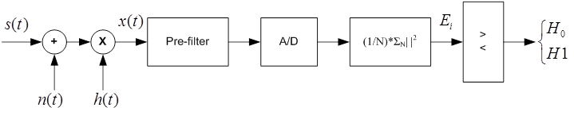
Figure 5: Energy Detector block diagram
The detection performance can be primarily determined on the basis of two metrics: probability-of-false occupancy-detection (P_{FA}) which denotes the probability that a channel is identified as occupied while it is available and probability of detection (P_{D}) which denotes the probability of a WSD declaring that a primary user is present when the spectrum is indeed occupied by the PU. So these probabilities are defined as:
where Y is the detection statistic.
Based on these definitions, the probability of false-vacancy-detection(P_{M}), which denotes the probability of erroneously identifying a channel as available, is defined as:
Figure 6 shows the qualitative distribution of H₀ and H₁.
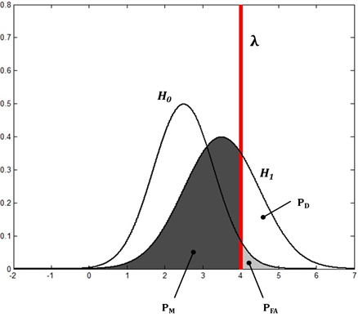
Figure 6: Qualitative distribution of H₀ and H₁
Increasing the threshold would result in lower probability-of-false occupancy-detection and, conversely, higher probability of false-vacancy-detection, corresponding to a rightward movement on the curve. The actual shape of the curve is determined by how much overlap the two distributions have.
The ROC (Receiver Operating Characteristic) curve is a graphical plot, which illustrates the performance of a binary classifier system as its discrimination threshold (λ) is varied. It is created by plotting the probability of false-vacancy-detection (P_{M}) against the probability-of-false occupancy-detection (P_{FA}) at various threshold setting.
In particular, the performance of a detector could be set in terms of its ability to avoid false-vacancy-detection, by requiring specific probability thresholds; the probability-of-false occupancy-detection is determined as a consequence thanks to the ROC curves.
The energy detector provides better performance for higher values of N, i.e. the number of observed symbols: in this case the detector measures higher values of energy, thus being able to counterbalance worse channel conditions like low SNR or high shadowing standard deviation in case of a lognormal channel. Obviously the performance is also better for high SNR values.
The energy detector is extremely easy from a computational point of view, but is deeply affected by bad channel conditions, and it cannot provide reliable detection performance even on AWGN channels with SNR=0 dB. This isn’t sufficient to detect weaker DTT signals, which also should be protected.

Cooperative energy detection
In practice many factors such as multipath fading shadowing, and the receiver uncertainty problem may significantly compromise the detection performance in spectrum sensing. Due to spatial diversity, it is unlikely that distributed WSDs concurrently experience the same fading or receiver uncertainty problem. In case many WSDs can cooperate and share the sensing results with other users, the combined cooperative decision derived from the spatially collected observations can overcome the deficiency of individual observations at each WSD, especially when most WSDs observe a strong Primary User signal.
The selection of WSDs plays a key role in determining the performance of cooperative sensing because it can improve cooperative gain and address the overhead issues. For example, when cooperative WSDs experience correlated shadowing, the selection of independent WSDs for cooperation can improve the robustness of sensing results.
Let us consider a scenario composed of L WSDs and a common receiver, the control centre (Figure 7). It is assumed that each WSD performs spectrum sensing independently and then the local decisions are sent to the common receiver, which can fuse all available decision information to infer the absence (H₀) or presence (H₁) of the primary user.
In cooperative spectrum sensing, each cooperative partner “i” makes a binary decision based on its local observation and then forwards one bit of decision D_{i} (1 standing for the presence of the primary user, 0 for the absence of the primary user) to the common receiver through an error-free channel. At the common receiver, all 1-bit decisions are fused together according to logic rule:
where H₀ and H₁ denote the inference drawn by the common receiver that the primary user signal is not transmitted or transmitted respectively. The threshold p is an integer representing the “p-out-of-L” voting rule.. According to this scheme, if among the L cooperating WSDs at least p detect a signal on that channel, then the control centre which collects the sensed data Figure 7Figure 9, marks the channel as occupied and informs all the devices of this channel state. Note that in the literature, it has been found that the optimal value of p is L/2 [W. Zhang, R. K. Mallik, and K. B. Letaief, “Optimization of Cooperative Spectrum Sensing with Energy Detection in Cognitive Radio Networks,” IEEE Trans. Wireless Commun., vol. 8, no. 12, Dec. 2009]. Different optimal values of p can be found according to the scenario. For example, in case a lower false-vacancy-detection is more important, the optimal value of p can be different from L/2, as well as from the optimal value that minimises the probability of false-occupancy detection.
For sake of simplicity, it is assumed that the distance between two WSDs is small with respect to the distance from the primary transmitter, t, so that the signal received at each WSD experiences almost identical path loss. Therefore, in the case of an AWGN scenario, it can be assumed that the SNR at each WSD is the same (SNR_{i} = SNR_{cost}).
In the case of a Rayleigh fading scenario, it is reasonable to assume that independent and identically distributed Rayleigh fading is experienced by any WSD, with each instantaneous SNRs being an exponentially distributed random variable with the mean value equal to SNR_{cost}.

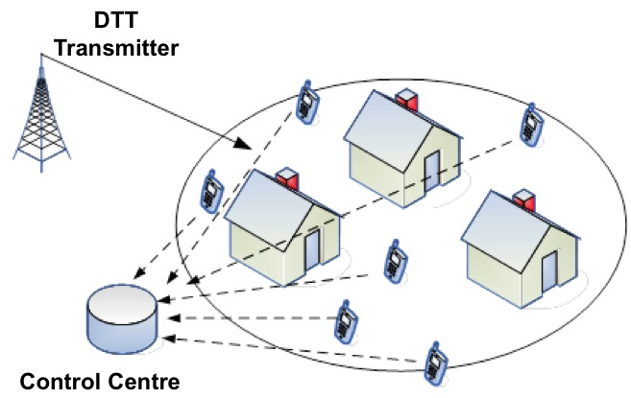
Figure 7: Cooperation detection scenario

Analysis of performance of cooperative versus single device sensing
The performance of the cooperative energy detector on AWGN, Rayleigh and Lognormal channels are provided by means of ROC curves in, respectively, Figure 7, Figure 8 and Figure 9, and are compared to the performance of Single-Device detection in the same scenario. In these figures we are considering L/2 as the optimal value of p for lower probability of false-vacancy-detection. Of course, the gain introduced by cooperation is much more evident for good channel conditions (i.e. high SNR in the figures), but even for bad conditions the gain is remarkable. Indeed, for the same value of probability-of-false occupancy-detection, the probability of false-vacancy-detection decreases, for greater values of SNR and vice versa. For the sake of briefness, we consider a fixed number of observed symbols N, varying the SNR value. However, it is worthwhile highlighting that, as stated above, higher values of N always increase the detection performance.

Figure 8: Single-device versus optimum cooperative detection on a AWGN channel with N=4
Figure 9: Single-device versus optimum cooperative detection on a Rayleigh channel with N=4
Figure 10: Single-Device versus optimum cooperative detection on a Lognormal channel with N=4
In Figure 11 and Figure 12 we show the effect of increasing the number of cooperating WSDs for SNR = -3 dB and SNR = -6 dB. The performance significantly increases for larger values of L, but it should be considered that it is not feasible to increase that number at will, as the WSDs require an available channel either in the WS band or outside this band to communicate the sensed data to the control centre. Even if a dedicated channel is used, when L is too high there would be too much overhead introduced. A possible solution might be using a hybrid cooperative-distributed approach, in which WSDs cooperate among themselves in clusters, i.e. the decision is taken within the WSDs of a cluster.

Figure 11: Optimum cooperative detection on an AWGN channel for different values of L,
with SNR=-3 dB and N=4
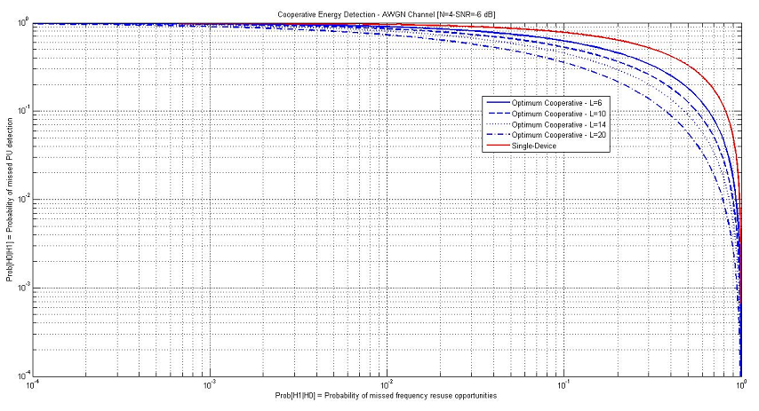
Figure 12: Optimum cooperative detection on an AWGN channel for different values of L,
with SNR=-6 dB and N=4
Furthermore, Figure 11 and Figure 12 show that in order to obtain the same performance, we have to increase the number of cooperating WSDs as SNR decreases. For instance the ROC curves indicate that to obtain P_{FA} = 10⁻¹ and P_{M} = 0.32, we have to consider 3 cooperating WSDs for SNR = -3 dB and 10 WSDs for SNR = -6 dB.

Main results
Cooperative sensing is an effective technique to improve detection performance by exploiting spatial diversity. It is well known that diversity cannot directly address the path loss issue, whereas it can be effective in counterbalancing channel impairments such as multipath fading and log-normal fading, so that autonomous sensing can take significant advantage from cooperation schemes, as also shown in [24].
Therefore, even though cooperation does not directly address path loss, WSDs receiving weak primary user signals can benefit from cooperative sensing to better detect the signal presence, thus overcoming site-specific bad channel conditions.
It needs to be noted also that the communication between the WSDs and the control centre would require an available channel either in the WS band or outside this band. Moreover, in order to take advantage of the cooperative sensing, at least two cooperative WSDs need to be located within the operational range of the incumbent service/system to be sensed.

Examples of adjacent channel leakage ratio for WSDs
As explained later in Section 3.4.4.2 the ACLR (or POOB - Out Of Block unwanted emissions) of the WSDs within the 470-790 MHz band will have an major effect on the Protection Ratios that need to be used to protect DTT and PMSE receivers. Due to the various types of deployment there have been requests by the WSD industry, as part of the ETSI harmonized standard development process, to consider allowing WSDs to be able to declare compliance with different classes of ACLR values in the standard.
For example, the out-of-block EIRP spectral density, POOB, of a WSD could satisfy the following requirement:
POOB (dBm/(100 kHz)) ≤ max{ PIB (dBm/(8 MHz)) - ACLR (dB), -84 (dBm/100 kHz)},
where PIB is the actual output EIRP spectral density over 8 MHz calculated by the geo-location database, and ACLR is the adjacent channel leakage ratio outlined in the Table 3 below for arbitrary WSD classes.
Table 3: Adjacent channel leakage ratios¹ for arbitrary WSD classes
Where POOB falls within the ± nth adjacent DTT channel | ACLR within 470-790 MHz (dB)
Where POOB falls within the ± nth adjacent DTT channel | Class 1 | Class 2 | Class 3 | Class 4
N= ±1 | 74 | 74 | 64 | 54
N= ±2 | 79 | 74 | 74 | 64
N= ±3 | 84 | 74 | 84 | 74
¹ Note that the ACLR values in this table are calculated for the in-block bandwidth of 8 MHz and out-of-block bandwidth of 100 kHz.

An additional constraint to limit the Out-Of-Block emission of a WSD could be considered by setting a baseline level of:
(1) -84 dBm/100 kHz for all the channels with the offset greater of equal to 32 MHz in order to protect portable DTT reception, or
(2) -74 dBm/100 KHz for all the channels with the offset greater of equal to 32 MHz in order to protect fixed DTT reception.
These levels relate to baseline levels recommended in CEPT Report 30 [15] for ECN terminals.
It needs to be noted that Out-Of-Block emission depends on a number of parameters. Besides RF output power and RF bandwidth, other parameters including power ramping and in-band-resource allocation need to be considered.

Operation of WSDs using beacons

Introduction to beacons
WSDs may collect information on available frequencies by sensing, accessing a geo-location database, receiving signals from beacons, or combinations thereof.
Beacons transmit information within the area where possible interference from WSDs could occur.
Such a beacon could be considered as an "umbrella" offering local protection to one or more applications in that area.
A geo-location database may provide the WSDs with the necessary information (e.g. beacon frequency, format) on the beacon(s) within the area where the WSD is operating.
Information provided by beacons can be considered as additional to information provided by the geo-location database.

Benefits of a beacon
Use of a beacon may add complexity to operation of WSDs. However, there are also benefits in use of a beacon in situations where a geo-location database cannot provide up-to-date information on some applications. For example:
- Receive-only equipment not having real-time possibilities to update the geo-location database. In such situations, beacons connected with those receivers may provide the WSDs with necessary information to avoid interference.
- Transmit-receive systems which are deployed at an ad-hoc basis where the equipment is tunable within a wide frequency range may benefit from a beacon. PMSE is an example of such a system (beacon should not be on the same frequency as PMSE). In such a situation the beacon informs the WSD on the actual operating frequencies on site.
On the other hand, sensing on its own has the risk of "false-vacancy-detection" (hidden node) where a channel is detected as not being used when in fact it is occupied. Use of a beacon may offer more reliable protection.
Therefore, beacons may result in more efficient use of spectrum by protecting only those frequencies which are actually in use at a given moment in time and place. Without the use of a beacon, either more spectrum may be protected than necessary, or some applications may not be protected adequately.

Preventing interference between different WSDs
Different WSD systems operating in the same area may interfere with each other. Different access techniques may be used for WSDs, for example FDD or TDD where TDD may interfere locally on the receive frequency of FDD applications. But also other situations are possible where interference may occur between different WSD systems within the same area. The radio characteristics of the different WSD systems may have to be taken into account such as actual used frequency, output power, sensitivity, type of modulation or types of antennas.
A beacon may then inform another WSD system in a harmonized way in order to avoid interference.
Alternatively such information could be exchanged by a geo-location database. It is also possible to have the information exchanged between local beacons.
Therefore, beacons can play an important role to prevent interference between (technically) different WSD systems operating in the same area.

How may a beacon work?
Beacons transmit information intended for WSDs within an area where a WSD may cause interference to applications which cannot be sufficiently protected by sensing and/or by a geo-location database. The important parameters for the operation of a beacon include:
- Transmit power
The necessary transmit power of the beacon is on the one hand related to the potential interference characteristics of the WSD (e.g. power, bandwidth) and on the other hand to the sensitivity or robustness of the receiver to be protected.
- Data format
A geo-location database may provide the WSDs with the necessary information (e.g. beacon frequency, format) on the beacon(s) within the area where the WSD is operating. Information provided by beacons can be considered as additional to information provided by the geo-location database. For this reason, the data format used by beacons should be equal to the data format of the geo-location database.
- Frequency band
Beacon signals may be transmitted either in the same frequency band as used by WSDs, or in a designated frequency band, outside the frequency band used by WSDs. However, a beacon should not be on the same frequency as PMSE.
- Enable & disable beacon
Beacons can be used to indicate to the WSD which frequencies the WSD may use (an "enable beacon") or to indicate to the WSD which frequencies it cannot use (a "disable beacon").
A disable beacon in combination with sensing and a geo-location database seems to be the most promising use of a beacon because then the beacon will only exclude a part of the frequency band at the time when it is actually in use by other applications.

Further studies
Further work is required on technical and practical aspects of beacons. In particular, Scenarios that may benefit of using a beacon need to be defined. See also § 4.5 for the discussion on using beacons to protect PMSE systems.

Operation of WSDs using geo-location database
This issue is addressed in [draft] ECC Report 186 [4].

Technical considerations on the protection of the broadcasting service

Summary on previous studies
The studies presented in ECC Report 159 [1] addressed a method for calculating an appropriate sensing threshold method and the corresponding maximum emission limits for WSD under various configurations.
The sensing thresholds were derived for a limited number of scenarios using the methodology developed within ECC Report 159 [1] and taking into account a range of potential DTT receiver configurations. Some of the values obtained (being in the range from -91 to -155 dBm depending on the DTT planning scenario) appear to be extremely challenging to implement using current technologies. Moreover, in some scenarios, even these low values for the detection threshold do not guarantee a reliable detection of the presence/absence of the broadcasting signals at a distance corresponding to the interference potential of a WSD.
This led to the conclusion that, the sensing technique investigated, if employed by a stand-alone WSD (autonomous operation), is not reliable enough to guarantee protection of nearby DTT receivers using the same or adjacent channel. Therefore, the use of a geo-location database seems to be the most feasible option to avoid possible interference to DTT receivers. In addition it was concluded that in cases where the use of a geo-location database can provide sufficient protection to the broadcast service, sensing is not required. There may be some potential benefit in using a combination of sensing and geo-location database to provide adequate protection to DTT receivers but these benefits would need to be further considered.

ANNEX 4: to this Report presents a set of definitions used for the determination interference into DTT including a concept of ‘degradation of location probability’ and the’ increasing of interference probability’ as well as the relationship between the two parameters. ANNEX 4: describes also a methodology and the associated parameters in order to evaluate location probability and interference probability when calculations are to be performed to determine the interference potential to DTT reception. Calculations were performed using SEAMCAT tool (free software downloadable from www.seamcat.org).
The sections below discuss some basic parameters crucial for the protection of the broadcasting service.

Dependency of location probability on antenna installations and reception modes
The calculation of the location probability during network planning of broadcasting services is carried out on the basis of several assumptions, including in particular, the receiving conditions. Usually, it is distinguished between reception modes such as fixed, portable outdoor and portable indoor reception. These are characterized by certain parameters describing the receiver performance including the antenna characteristics. Making a calculation for fixed reception means to employ a certain standard configuration.
However, listeners and viewers of broadcasting programmes are not obliged to use receivers and antenna installations as they are assumed for the calculation of the location probability as a measure for the quality of service. It is well-known fact that inside the coverage area of a transmitter that for example was planned for fixed reception, two aspects are important for broadcasters in their attempt to protect their services. These are:
- Moving from the coverage edge of a transmitter that was planned for fixed reception towards the transmitter site, first portable outdoor and later portable indoor become feasible due to the increasing field strength provided. As a matter of fact, listeners and viewers are making use of these reception modes.
- Furthermore, at the same time the excess of field strength closer to the transmitter site allows to receive broadcasting services with a fixed reception antenna installation which has only poor performance due to mis-alignment of the antenna with respect to the transmitter location or signal degradation due to unprofessionally installed antenna feeds.
If these conditions would be taken into consideration when calculating the location probability for a given pixel then lower values would result than derived on the basis of the standard configuration used for planning purposes. Additional interference imposed by WSD might not have a great impact on standard receiving conditions. However, listeners and viewers enjoying broadcasting content under the conditions described above could have to cope with significant service quality degradation.
It needs to be noted, however, that in international interference environment, an administration cannot claim protection of its broadcasting service for other reception conditions and associated location probabilities than those used when the international frequency plan (i.e. GE06) was established or for those based on bi- and multilateral agreements.

Coverage assessment of broadcasting services
Assessing the impact of interference from broadcasting or other telecommunication services into the broadcasting services is carried out on the basis of some simple principles. Even though these principles are widely known for a very long time and are permanently applied on a daily basis, there seem to be different perceptions with regard to the interpretation of certain elements of the methodology. This becomes in particular important in relation to the introduction of new non-broadcasting services in the broadcasting frequency bands. ANNEX 5: discusses different elements, which are crucial in the process of evaluating the broadcasting coverage.

Further studies looking at DTT receiver performance in the presence of WSDs

Background and previous studies
DTT receiver design has historically concentrated on DTT to DTT protection requirements. Attention paid to a number of parameters has ensured that self-interference between DTT signals is tightly controlled. These factors include:
- Adjacent Channel Leakage of the DTT signal from the broadcast site is tightly controlled through strict high power RF filtering to control leakage of DTT signals into other services.
- Adjacent Channel Selectivity (ACS) of DTT receivers is well known, and they are able to demodulate the wanted DTT signal even in conditions when the 1st adjacent DTT signal (Protection Ratio) is significant (<-30dB).
- Overload of DTT receivers is well managed due to the design of the transmission networks. Largely this is managed through the design of the antenna (vertical radiation pattern) and the location of the broadcast sites.
- Self-interference within the DTT networks is also well managed due to the design of the transmission networks, with detailed planning of Multi Frequency Networks (MFNs) and tightly controlled Single Frequency Networks (SFNs).
The environment that DTT receivers operate in has already changed significantly with the allocation and deployment of mobile (LTE) services within the 790-862 MHz bands. This environment will change further with the possible deployment of White Space Devices (WSDs) in the 470-790 MHz band.
ECC Report 159 [1] used the values provided in ECC Report 148 [5] regarding the protection ratios and overloading thresholds for interference from LTE into DVB-T for recommendations on possible protection ratios when introducing WSD. These results only analysed usage profiles for LTE equipment. Further measurement campaigns have now been made available that emulate equipment profiles for a number of different candidate WSD technologies. In addition, an analysis of these measurement results and comparison with previous results for protection ratios and overload thresholds shown in ECC Report 159 [1] are discussed in this section of the Report. Additional description and discussion of the issues that have become apparent from this analysis particularly regarding the susceptibility of some DTT receivers to some of the time and frequency characteristics of the transmit signals of some candidate WSD technologies used in the measurements.

Useful Definitions
Radio frequency signal-to-interference ratio (C/I)
It is the ratio, generally expressed in dB, of the power of the wanted signal to the total power of interfering signals and noise, evaluated at the receiver input (see Recommendation ITU-R V.573-5 [13]).
Usually, C/I is expressed as a function of the frequency offset between the wanted and interfering signals over a wide frequency range. In this document, C/I expressed in this way is referred to as “C/I curve”. C/I curves show the ability of a receiver to discriminate against interfering signals on frequencies differing from that of the wanted signal.
Radio frequency protection ratio (PR)
It is the minimum value of the signal-to-interference ratio required to obtain a specified reception quality under specified conditions at the receiver input (note that this differs from the definition in Recommendation ITU-R V.573-5 [13]). In this report, the “specified reception quality” and the “specified conditions” have been defined separately by each entity that has undertaken measurements.
Usually, PR is specified as a function of the frequency offset between the wanted and interfering signals over a wide frequency range. In this document, PR specified in this way is referred to as “PR curve”. PR curves show the ability of a receiver to discriminate against interfering signals on frequencies differing from that of the wanted signal.
It should be stressed that the protection ratios are generally considered and used as independent of the wanted signal level. That is C(I) is supposed to be a linear function with unity slope (a straight line with unity slope). The protection ratio of the receiver is obtained by subtracting I from C(I) at any points on this line and can be used for all wanted signal levels. However, the measurement results show that in most cases the protection ratios of wideband TV receivers vary as a function of the wanted signal level. Consequently, C(I) is not a straight line with unity slope with some variation with the wanted signal strength. Nevertheless, for interfering signals below the overloading threshold such C(I) curves can always be approximated by a straight line with unity slope with an acceptable error.
Receiver Blocking
Receiver blocking is the effect of a strong out-of-band interfering signal on the receiver’s ability to detect a low-level wanted signal. Receiver blocking response (or performance level) is defined as the maximum interfering signal level expressed in dBm reducing the specified receiver sensitivity by a certain number of dB's (usually 3 dB). Consequently, the receiver blocking response is normally evaluated at a wanted signal level which is 3 dB above the receiver sensitivity and at frequencies differing from that of the wanted signal.
Receiver (front-end) overloading threshold
Overloading threshold (Oth) is the interfering signal level expressed in dBm, above which the receiver begins to lose its ability to discriminate against interfering signals at frequencies differing from that of the wanted signal (i.e., the onset of strong non-linear behaviour). Therefore, above the overloading threshold the receiver will behave in a non-linear way, but does not necessarily fail immediately depending on the receiver characteristics and interference characteristics.
“Can” tuners
“Can” tuners are classical super heterodyne tuners housed in a metal enclosure containing discrete components. Classically, there are fixed and tunable circuits made up from discrete inductors and transistors usually with varactor diode frequency control. The metal enclosure should minimize RF interference and eliminate crosstalk and stray radiation.
“Silicon” tuners
“Silicon” tuners are IC-based tuners integrating all tuner circuitry into a small package directly to be fitted onto main boards. The tuned circuits may be completely absent or can be integrated onto the silicon. The silicon chip may be protected from external electromagnetic interference by a metallic cover. When integrated onto the silicon there is a compromise in performance when compared with discrete classical layouts. The units measured represent an early generation on the market. This technology is still developing.

Results from the new measurement campaigns
British Broadcasting Corporation (BBC) carried out measurements of a number of commercially available DVB-T receivers that are representative of those currently being marketed in the UK. A library of interfering waveforms has been captured from a range of prototype WSDs deployed in UK trials. This library has been used to measure the level of protection required to the DVB-T receivers over a range of signal powers and frequency offsets between the wanted and interfering signals.
The aim of these measurements was to make proposals for protection ratio values that can be used when planning the future deployment of WSDs in the UK and explore how the interference characteristics vary with technology and operating point.

Impairment Criteria used When Assessing Interference
The impairment criterion determines the point at which the interfering signal source has degraded the reception to a point at which the quality is deemed unacceptable. This is generally measured by observing the displayed picture and deciding it to be unimpaired at the point where no picture break-ups are observed during the observation period (e.g. 10 seconds). For digitally encoded TV systems, the digital threshold effect means that picture breakup is accompanied by a loss of audio; it is therefore possible to detect the point at which failure occurs by measuring the audio output from the DVB-T receiver. This is achieved in these tests by using the audio measurement system (AMS) to measure the Total Harmonic Distortion (THD) of the demodulated audio. A 1dB increase in THD (compared to the case where the wanted signal is present without any interference) is used as the pass/fail decision point, although in practice the presence of WSD interference results in complete audio loss.

Equipment tested and test setup
A set of 16 DVB-T receivers were tested, 9 of these were set-top boxes (STBs), and the remaining 7 were standalone TV sets with integrated DVB-T receivers (IDTVs). Of these 15 units 8 used silicon tuners and 8 were “Can” type. The information about the tuner type is derived from the protection ratio performance at the image frequency (72 MHz above the wanted signal); a degraded performance is taken as an indication that the receiver uses a can tuner.
The receivers tested were all being marketed in the UK at the time of testing and displayed the “Freeview” logo. This means that they would have passed product testing by the Digital TV Group (DTG) whose procedures include tests of RF performance. For the DVB-T receivers, the wanted signal was generated by a Rohde & Schwarz SFE Broadcast Tester. The signal parameters for the DVB-T signals used were Standard DVB-T in 8 MHz OFDM Mode Modulation 64 QAM with Code Rate 2/3. No channel impairment (e.g. multipath) was added to the DVB-T signal. See ANNEX 6: for the test measurement set up.

WSD parameters
The interfering signal sources were reproduced on an Agilent NX5182A arbitrary signal generator, using waveform sequences previously captured using a system able to record directly the transmitted RF output of the WSD. For this study, 4 candidate technologies were considered; 6 waveforms were used for each candidate technology (i.e. a total of 30 waveforms were used to test each receiver), representing typical outputs from both base station (BS) and user terminal (UE or CPE) at 3 traffic levels.
The following technologies have been considered:
- WSD1 – Proprietary white space device technology, as deployed in the trial of whitespace devices in Cambridge, UK. The waveform is CDMA based with a TDMA frame structure;
- WSD2 - Proprietary white space device technology, as deployed in the trial of whitespace devices in Cambridge, UK. The waveform is OFDM with a CSMA channel access mechanism;
- WIFI – a sample WiFi (802.11g), under-clocked to occupy 5 MHz bandwidth;
- WIMAX – a sample WiMAX (802.16e) in 5 MHz bandwidth.
The 6 waveforms for each technology were generated by transferring data representing a particular proportion of the maximum available throughput. This was achieved by connecting a BS and UE pair to form an end-to-end link using an IP traffic tool to load the link. The waveforms captured represent 3 data transfer rates: 100% 50% and an idle mode (where the data exchange was limited to control traffic) for the BS. For the UE devices, traffic rates of 100%, 50% and 5% were used.
To ensure that the measurements were not contaminated by any out of the band signals captured in the recording process, the test waveforms were band-pass filtered in software prior to playback to fit into an
8 MHz channel. This ensured that the protection ratio measurements are dominated by the receiver selectivity rather than the adjacent channel leakage ratio of the arbitrary signal generator.
The candidate WSD technologies assessed for these tests typically use TDD duplex arrangements where the uplink and downlink segments are multiplexed in time. The signals are characterised by frame duration and a duty cycle. The uplink segment is typically multiplexed between numbers of CPE or UE devices and may not be present for each cycle of the TDD transmission frame. Where the traffic is below maximum from a CPE, it can be carried in occasional full frames or in a greater number of partially filled frames depending on the mapping used. The peak to mean ratio of the uplink waveforms tend to be greater as a result, particularly at low data traffic rate, and the time domain waveforms are quite “bur sty” in nature, although the nature of the bursts depends on the mapping of the traffic to frames as mentioned above.

Test Procedures
Two main tests have been carried out; a test to determine the variation of protection ratio with frequency for various wanted signal powers and another to investigate the precise overload characteristics of the devices for a fixed number of frequency offsets.
C/I vs. Frequency
For the first test, the wanted signal power is fixed and the power of the interfering waveform is increased until the receiver becomes impaired. The interfering signal is then backed off until the receiver can successfully demodulate the wanted signal; the PR is recorded at this point. This is repeated for a range of frequency offsets from -80 MHz to +80 MHz, and for a number of wanted signal powers.
Saturation Characteristics (C vs. I)
For the overload measurements, the level of the interfering signal is fixed and the power of the wanted signal is decreased until the receiver becomes impaired. The wanted signal is then increased until it can be demodulated without error by the receiver. The values of the wanted and interfering signals are then recorded. This is repeated for a number of interfering signal powers and frequency offsets (centre frequency offsets of 8, 16, 24 and 72 MHz have been used).

Test results
The results of the receiver measurements have been analysed in two different ways; the first approach follows the method defined in ECC Report 148 [5], and the second approach considers worst case protection contour for a given percentage of receivers as the wanted signal changes.
The figures returned by either analysis method can be used by database providers to return permitted power levels for white space operation for particular technologies. Both approaches provide a method of capturing the significant variation of performance in the receivers and guarantee the protection of a particular percentage of receivers and maximise the potential operating area for WSDs.
Tables 4-11 present the protection ratios (PR) and overloading threshold (O_{th}) based on the measurement results for the 4 different WSD candidate technologies presented in the ECC Report 148 [5] format, for the 50% and idle/low traffic waveforms. The 90th, 70th and 50th percentile values (for the protection ratio) and 50th, 30th and 10th percentiles (for the overloading threshold) have been computed.
Table 4: DVB-T PR and Oth values in the presence of WSD1 BS interfering signal in a Gaussian channel environment
Offset (MHz) | Protection Ratio (dB) |  |  |  |  |  | Overloading Threshold (dBm)
Offset (MHz) | 90th percentile |  | 70th percentile |  | 50th percentile |  | 50th percentile |  | 30th percentile |  | 10th percentile
Offset (MHz) | BS IDLE | BS 50% | BS IDLE | BS 50% | BS IDLE | BS 50% | BS IDLE | BS 50% | BS IDLE | BS 50% | BS IDLE | BS 50%
8 | -13 | -38 | -38 | -40 | -41 | -41 | -5 | -5 | -7 | -5 | -22 | -9
16 | -34 | -47 | -47 | -46 | -49 | -50 | 0 | 0 | -5 | -3 | -10 | -5
24 | -32 | -38 | -38 | -42 | -46 | -47 | 0 | 0 | -4 | -5 | -17 | -9
72 | -35 | -43 | -43 | -43 | -48 | -48 | 0 | 0 | -3 | -3 | -13 | -10

Table 5: DVB-T PR and Oth values in the presence of WSD2 BS interfering signal in a Gaussian channel environment
Offset (MHz) | Protection Ratio (dB) |  |  |  |  |  | Overloading Threshold (dBm)
Offset (MHz) | 90th percentile |  | 70th percentile |  | 50th percentile |  | 50th percentile |  | 30th percentile |  | 10th percentile
Offset (MHz) | BS IDLE | BS 50% | BS IDLE | BS 50% | BS IDLE | BS 50% | BS IDLE | BS 50% | BS IDLE | BS 50% | BS IDLE | BS 50%
8 | -5 | -16 | -11 | -32 | -24 | -39 | -10 | -5 | -10 | -5 | -15 | -10
16 | -10 | -26 | -24 | -42 | -32 | -48 | -5 | 0 | -5 | -5 | -15 | -5
24 | -9 | -19 | -29 | -33 | -32 | -41 | -5 | 0 | -5 | -5 | -10 | -6
72 | -28 | -29 | -38 | -40 | -44 | -46 | -5 | -3 | -5 | -5 | -5 | -18

Table 6: DVB-T PR and Oth values in the presence of WIFI BS interfering signal in a Gaussian channel environment
Offset (MHz) | Protection Ratio (dB) |  |  |  |  |  | Overloading Threshold (dBm)
Offset (MHz) | 90th percentile |  | 70th percentile |  | 50th percentile |  | 50th percentile |  | 30th percentile |  | 10th percentile
Offset (MHz) | BS IDLE | BS 50% | BS IDLE | BS 50% | BS IDLE | BS 50% | BS IDLE | BS 50% | BS IDLE | BS 50% | BS IDLE | BS 50%
8 | -40 | -39 | -41 | -40 | -42 | -42 | 0 | -5 | -5 | -5 | -5 | -5
16 | -45 | -43 | -48 | -46 | -50 | -49 | 0 | 0 | 0 | 0 | -5 | -2
24 | -34 | -41 | -41 | -44 | -45 | -46 | 0 | 0 | -4 | -4 | -8 | -14
72 | -38 | -42 | -46 | -46 | -50 | -48 | 0 | 0 | -2 | -10 | -4 | -20

Table 7: DVB-T PR and Oth values in the presence of WIMAX BS interfering signal in a Gaussian channel environment
Offset (MHz) | Protection Ratio (dB) |  |  |  |  |  | Overloading Threshold (dBm)
Offset (MHz) | 90th percentile |  | 70th percentile |  | 50th percentile |  | 50th percentile |  | 30th percentile |  | 10th percentile
Offset (MHz) | BS IDLE | BS 50% | BS IDLE | BS 50% | BS IDLE | BS 50% | BS IDLE | BS 50% | BS IDLE | BS 50% | BS IDLE | BS 50%
8 | -25 | -32 | -33 | -39 | -42 | -42 | -5 | -5 | -5 | -5 | -5 | -5
16 | -28 | -37 | -48 | -48 | -52 | -51 | 0 | 0 | -1 | 0 | -7 | -5
24 | -31 | -34 | -42 | -41 | -52 | -51 | 0 | 0 | -2 | 0 | -10 | -2
72 | -34 | -29 | -46 | -47 | -50 | -51 | 0 | 0 | -1 | 0 | -4 | -4

Table 8: DVB-T PR and Oth values in the presence of WSD1 CPE interfering signal in a Gaussian channel environment
Offset (MHz) | Protection Ratio (dB) |  |  |  |  |  | Overloading Threshold (dBm)
Offset (MHz) | 90th percentile |  | 70th percentile |  | 50th percentile |  | 50th percentile |  | 30th percentile |  | 10th percentile
Offset (MHz) | CPE  5 % | CPE 50% | CPE 5 % | CPE 50% | CPE 5 % | CPE 50% | CPE 5 % | CPE 50% | CPE  5 % | CPE 50% | CPE  5 % | CPE 50%
8 | -9 | -10 | -22 | -26 | -37 | -39 | -5 | -5 | -6 | -7 | -14 | -10
16 | -9 | -13 | -19 | -37 | -45 | -45 | -5 | 0 | -10 | -5 | -15 | -10
24 | -15 | -16 | -27 | -31 | -38 | -36 | 0 | -3 | 0 | -5 | -5 | -15
72 | -16 | -35 | -34 | -42 | -45 | -48 | -3 | 0 | -5 | -1 | -15 | -9

Table 9: DVB-T PR and Oth values in the presence of WSD2 CPE interfering signal in a Gaussian channel environment
Offset (MHz) | Protection Ratio (dB) |  |  |  |  |  | Overloading Threshold (dBm)
Offset (MHz) | 90th percentile |  | 70th percentile |  | 50th percentile |  | 50th percentile |  | 30th percentile |  | 10th percentile
Offset (MHz) | CPE  5 % | CPE 50% | CPE 5 % | CPE 50% | CPE 5 % | CPE 50% | CPE 5 % | CPE 50% | CPE 5 % | CPE 50% | CPE  5 % | CPE 50%
8 | -4 | -8 | -8 | -29 | -15 | -38 | -5 | -5 | -10 | -5 | -14 | -18
16 | -10 | -19 | -19 | -43 | -30 | -47 | -5 | 0 | -5 | -5 | -15 | -5
24 | -9 | -10 | -29 | -33 | -32 | -39 | -5 | -5 | -8 | -5 | -15 | -11
72 | -15 | -18 | -36 | -40 | -43 | -44 | -5 | -5 | -5 | -6 | -8 | -14

Table 10: DVB-T PR and Oth values in the presence of WIFI CPE interfering signal in a Gaussian channel environment
Offset (MHz) | Protection Ratio (dB) |  |  |  |  |  | Overloading Threshold (dBm)
Offset (MHz) | 90th percentile |  | 70th percentile |  | 50th percentile |  | 50th percentile |  | 30th percentile |  | 10th percentile
Offset (MHz) | CPE  5 % | CPE 50% | CPE 5 % | CPE 50% | CPE 5 % | CPE 50% | CPE 5 % | CPE 50% | CPE 5 % | CPE 50% | CPE  5 % | CPE 50%
8 | -38 | -38 | -40 | -40 | -43 | -41 | -5 | -3 | -5 | -5 | -10 | -5
16 | -46 | -45 | -49 | -49 | -50 | -49 | 0 | 0 | -1 | 0 | -9 | -2
24 | -37 | -33 | -44 | -42 | -47 | -46 | 0 | 0 | -1 | 0 | -5 | -3
72 | -38 | -37 | -48 | -46 | -49 | -47 | 0 | -5 | -1 | -5 | -4 | -8

Table 11: DVB-T PR and Oth values in the presence of WIMAX CPE interfering signal in a Gaussian channel environment
Offset (MHz) | Protection Ratio (dB) |  |  |  |  |  | Overloading Threshold (dBm)
Offset (MHz) | 90th percentile |  | 70th percentile |  | 50th percentile |  | 50th percentile |  | 30th percentile |  | 10th percentile
Offset (MHz) | CPE  5 % | CPE 50% | CPE 5 % | CPE 50% | CPE 5 % | CPE 50% | CPE 5 % | CPE 50% | CPE 5 % | CPE 50% | CPE  5 % | CPE 50%
8 | -4 | -5 | -8 | -21 | -15 | -27 | -8 | -5 | -10 | -6 | -15 | -14
16 | -10 | -8 | -19 | -17 | -30 | -28 | -5 | -5 | -5 | -10 | -15 | -10
24 | -8 | -9 | -31 | -28 | -33 | -36 | 0 | -5 | -5 | -7 | -15 | -11
72 | -11 | -26 | -30 | -36 | -43 | -43 | -5 | 0 | -8 | -5 | -10 | -7

The alternative approach is to specify protection ratio values based on an analysis of the performance of a set of receivers in the presence of interfering waveforms at different power levels and representing different white space technologies. The resulting figures form a look-up table of recommended protection ratio values that will ensure satisfactory performance for a given percentage of receivers. Individual contours can capture the changes in protection ratio as the power level changes.
Protection ratios that protect a given proportion of the receivers tested were developed and analysed; these sets were comprised of the best performing 2 out of 16 DTT receivers, 8 out of 16 DTT receivers, and 14 out of 16 DTT receivers, respectively.
The receivers to exclude from each set are selected on the basis of having the worst average protection ratio over all the waveforms, input powers and frequency offsets. No weighting of the results by sales figure has been included; it is assumed that the receivers measured are representative of the models currently in general use. The protection ratio is produced for each wanted power level, and is defined as highest protection ratio value required to protect the most vulnerable receiver in the presence of its most degrading waveform.
Tables 12-15 present the results of the level dependent protection ratio analysis for each technology type and frequency offset as a function of the wanted signal power. They are expressed as functions of (a) the power of the wanted signal, C (b) the offset between the wanted and interfering signals, for the analysis sets of different sizes. It should be noted that the tables provide the combined analysis for both base station and CPE.
Table 12: Protection Ratio (dB) for WSD1 Interference Type
C(dBm) | Offset and number of receivers in protection set
C(dBm) | 8 MHz |  |  | 16 MHz |  |  | 24 MHz |  |  | 72 MHz
C(dBm) | 14 | 8 | 2 | 14 | 8 | 2 | 14 | 8 | 2 | 14 | 8 | 2
-70 | -19 | -37 | -38 | -26 | -43 | -47 | -27 | -42 | -48 | -35 | -37 | -46
-60 | -11 | -37 | -38 | -19 | -43 | -46 | -18 | -36 | -48 | -25 | -37 | -46
-50 | -11 | -35 | -36 | -12 | -41 | -44 | -11 | -34 | -45 | -18 | -37 | -46
-40 | -7 | -29 | -31 | -8 | -37 | -41 | -9 | -30 | -36 | -13 | -37 | -44
-30 | -5 | -23 |  | -5 | -29 |  | -5 | -29 |  | -11 | -34
-20

Table 13: Protection Ratio (dB) for WSD2 Interference Type
C(dBm) | Offset and number of receivers in protection set
C(dBm) | 8 MHz |  |  | 16 MHz |  |  | 24 MHz |  |  | 72 MHz
C(dBm) | 14 | 8 | 2 | 14 | 8 | 2 | 14 | 8 | 2 | 14 | 8 | 2
-70 | -19 | -24 | -39 | -25 | -33 | -48 | -24 | -32 | -48 | -34 | -36 | -46
-60 | -9 | -22 | -33 | -18 | -29 | -38 | -26 | -31 | -40 | -25 | -36 | -46
-50 | -4 | -14 | -27 | -11 | -25 | -30 | -9 | -30 | -31 | -16 | -35 | -42
-40 | -4 | -14 | -33 | -5 | -23 | -23 | -7 | -29 | -31 | -14 | -27 | -42
-30 | -4 | -13 |  | -5 | -23 |  | -7 | -24 |  | -11 | -23
-20

Table 14: Protection Ratio (dB) for WIMAX Interference Type
C(dBm) | Offset and number of receivers in protection set
C(dBm) | 8 MHz |  |  | 16 MHz |  |  | 24 MHz |  |  | 72 MHz
C(dBm) | 14 | 8 | 2 | 14 | 8 | 2 | 14 | 8 | 2 | 14 | 8 | 2
-70 | -21 | -23 | -36 | -29 | -31 | -45 | -26 | -32 | -47 | -25 | -36 | -45
-60 | -11 | -22 | -35 | -19 | -29 | -43 | -22 | -31 | -45 | -15 | -36 | -45
-50 | -4 | -13 | -33 | -15 | -28 | -41 | -16 | -27 | -41 | -13 | -33 | -44
-40 | -4 | -13 | -28 | -8 | -26 | -36 | -8 | -25 | -34 | -8 | -24 | -44
-30 | -4 | -13 | -26 | -5 | -21 |  | -5 | -20 |  | -4 | -17
-20

Table 15: Protection Ratio (dB) for WIFI Interference Type
C(dBm) | Offset and number of receivers in protection set
C(dBm) | 8 MHz |  |  | 16 MHz |  |  | 24 MHz |  |  | 72 MHz
C(dBm) | 14 | 8 | 2 | 14 | 8 | 2 | 14 | 8 | 2 | 14 | 8 | 2
-70 | -19 | -37 | -46 | -20 | -47 | -50 | -20 | -46 | -51 | -27 | -37 | -56
-60 | -19 | -37 | -45 | -20 | -46 | -49 | -20 | -46 | -51 | -17 | -37 | -56
-50 | -12 | -36 | -42 | -14 | -43 | -49 | -20 | -44 | -51 | -14 | -37 | -55
-40 | -12 | -33 | -33 | -12 | -33 |  | -13 | -44 |  | -12 | -35
-30 | -12 | -30 |  | -11 |  |  | -9 | -44 |  | -11 | -32
-20 |  |  |  |  |  |  | -9 |  |  | -10

Discussion and analysis of these results

Initial Analysis of results
The tables above present the results of the BBC measurement campaign to assess the performance of DVB-T receivers in terms of measured carrier-to-interference protection ratios and overloading thresholds in the presence of a number of different WSD technologies and their corresponding interfering signals in different operating modes.
In total, 16 DVB-T receivers, which are considered to be typical DVB-T receivers, have been tested against simulated candidate WSD technology interference. These receivers were all implementing either conventional can-type tuners or silicon-based tuners. Interference in co-channel, first adjacent channel and beyond has been considered. Values for the measured protection ratios have been statistically calculated at the 50th, 70th and 90th percentile and for the overloading thresholds at the 10th, 30th and 50th percentiles for all the receivers tested.
As was seen in the previous tests carried out in ECC Report 148 [5] the most noticeable factor in these results is the wide range of performance of individual receivers depending on the nature of the WSD signals. Previous preliminary indications from ECC Report 148 [5] and ECC Report 159 [1] surmised that this effect may be related to the way the automatic gain control (AGC) of the DVB-T receiver is designed in some specific receivers.
In these further measurements the results show that there are a number of WSD technology waveforms that provoke poor DTT receiver protection performance in certain receivers, when operating in their “idle” or “low traffic” mode. The measured protection ratios are significantly degraded when compared to the corresponding waveform which carries full traffic. The cause for this deterioration is unclear, although it is believed that it is the periodic nature of the interfering signal interacting with the AGC of the tuner that results in degraded protection ratios. DTT receiver designs typically use a number of AGC loops to manage the level of signals into the demodulator and the degraded performance effects occur over a range of signal levels.
The degradation in receiver performance with the idle or low traffic signal, as appropriate, splits receivers into three categories (where the degradation criterion is an increase in protection ratio):
- Receivers for which the idle or low traffic waveform, as appropriate, causes no discernible change in performance;
- Receivers for which there is degradation in performance for frequency offsets less than 30 MHz and at 72 MHz;
- Receivers for which there is performance degradation at all frequency offsets.
There is no single waveform that causes degraded performance in the vulnerable receivers; rather each receiver appears to have a waveform to which it is most vulnerable. The degraded performance is a function of the power level of the interfering signal; the level at which the degraded performance occurs is specific to each receiver and WSD waveform type.

WSD to DTT Protection Ratios
The protection ratio is the function of a number of properties characteristic of both the DTT receiver design and the WSD. The resulting protection ratio will vary depending upon the combination of DTT receiver and WS technology. Protection ratio is a function of WSD transmitter ACLR (red line) and DTT receiver ACS (blue line) which are illustrated in Figure 13: WSD to DTT protection ratio below:
ACS
ACLR
Rx
Frequency offset: j channels
Frequency
Receiver
filter
Transmitter
mask
Tx
P₁
P₂
N
N+j
P_{I}
Figure 13: WSD to DTT protection ratio
From these measurements and previous studies it has become apparent that the major elements which characterise the Protection Ratio are the following:
- WSD Adjacent Channel Leakage Ratio (ACLR): this is a measure of the out of block performance of the WSD (PI/P1 from Figure 13). The effect of a poor ACLR is to add noise with the characteristics of the WSD to the DTT signal. This has the effect of reducing the CINR. This is expected not to depend on DTT receiver performance to the first order.
- DTT receiver Adjacent Channel Selectivity (ACS): This is a measure of the receiver frequency response (PI/P2 from Figure 13). DTT receivers with high ACS will have greater rejection to the interfering WSD signal. The effect of insufficient rejection is to add noise with the characteristics of the WSD to the DTT signal. This has the effect of reducing the CINR. This is expected not to depend on the WSD to the first order.
- Blocking and Overloading of the DTT Receiver: The WSD signal is sufficiently strong to totally disrupt the analogue circuitry so that the DVB signal is effectively switched off during WSD transmission. In this condition, the receiver is in saturation and the effect is independent of the level of the wanted signal.
- Time and frequency Characteristics of the WSD: Different WSD technologies operate with a host of different frame structures and lengths, with most technologies designed to operate in a Time Division Duplex (TDD) mode. The characteristics of the TDD structure combined with the design of the DTT receiver AGC plays a significant impact on the outcome of the protection ratio value.
- Frequency offset between the WSD and DTT receiver: larger frequency offsets between the two signals allow better protection ratios as the relationship between the receiver ACS and the WSD ACLR improves.
- The relationship between ACLR, ACS, Co-channel protection ratio and Adjacent channel protection ratio is as follows :

Where
is the co-channel protection ratio, typically 18 dB for WSD interferers into 64-QAM 2/3 DVB-T signal.
is the ACLR of the WSD measured in the j-th adjacent channel
is the ACS of the DTT receiver for the j-th adjacent channel calculated from the protection ratio measurements using:

Where
is the measured protection ratio for the j-th adjacent channel
and
is the ACLR of the interferer source used to measure .

The major findings from these measurements were:
- The protection ratio could be worse for stronger wanted DVB signals – e.g. there is not always a linear relationship between the wanted and interfering signals.
- Added noise is not always the failure mechanism; this was especially the case at high signal levels.
- Overloading was found to be the dominant effect.
- Varying the time structure (TDD configuration) of the WSD also significantly altered the resulting protection ratio measurements.
- Different types of DTT receiver design react differently to different WSD RF levels and TDD configurations. In general the ”Can” tuner provided better co-existence characteristics, and allowed higher white space powers before the onset of failure.

Conclusions
Although there are not as many receivers tested as in the previous campaign undertaken and reported in ECC Report 148 [5] these new measurements do show up a number of issues that will have to be considered and addressed by regulators when designing the algorithms and protection ratios to be used in the geo-location databases in order to provide adequate protection for DTT services from interference from WSD deployments.
The increased protection ratios shown in the results of the measurements to be required for particular combinations of certain DTT receivers and candidate WSD technologies particularly in their “idle or low traffic states, as appropriate,” has the potential to reduce considerably the power levels and spectrum that will be made available for WSDs.
There are still a number of possible approaches to deploy WSD whilst maintaining DTT protection but this will be dependent on the approach of the CEPT countries either individual or collectively to how they approach calculating the protection ratios.
Based on the measurements reported in this document, conservative protection ratios would be required to protect those receivers, which are sensitive to interference from WSDs configured to operate in idle or low traffic mode, as appropriate.
Some options for protecting DTT are presented below with some consideration of their implications:
- Protect for the worst WSD interference to the most susceptible receiver.
In order to protect for the worst WSD interference to the most susceptible receiver the default protection ratio would be very prohibitive to the proposed use cases for WSDs. If however the regulator were to choose the 90th or 70th percentile figures shown from the results for the default protection ratios then enabling more of the possible use cases for WSDs would become more likely.
- Incorporate information about the susceptibility of receivers to different types and levels of interference into the geo-location database.
The measurements show that by incorporating information about the susceptibility of receivers to different WSD technologies and their associated levels of interference into the geo-location database (i.e. have different protection ratios for the various WSD technologies) regulators could significantly improve the protection ratios for certain WSD technologies.
- Regulate to prohibit particular WSDs.
Although it is likely that regulators will adopt a technology neutral approach to white space deployments (rather than seeking to prevent certain WSDs being deployed), as the WSD TDD time structures and frame durations are a key issue; in the short term there may be an option to do some further analysis with the WSD community and with the DTT community to enable better co-existence. If this could be achieved then looking at the results then there are once again possibilities for national regulators to use less stringent protection ratios in the database.
In conclusion, there are a number of issues that will need to be considered by regulators when deciding upon suitable protection ratios but some of the factors affecting how conservative these protection ratios are will depend upon some of the technical parameters chosen by the WSD community at European level particularly how stringent or what level of ACLR can be achieved by WSDs.

Areas for further work
Work is currently ongoing to try to understand better why different signals degrade the protection ratios to a varying degree, and recognising that even changing the time and frame structure, if appropriate, of a given technology can have different effects. There are indications that it should be possible to develop amendments to the time and frame structure, if appropriate, in order to maintain the throughput of a device, whilst also improving the DTT protection ratio and it is hoped that this should lead to improved co-existence between WSDs and DTT receivers in the future. There may be something that can be done in the Harmonised standard for WSD regarding the time frequency structures allowed in “idle or low traffic mode”, as appropriate, to enable better co-existence with existing DTT receivers.
In the long term it would be highly desirable for the some of the issues highlighted in the bullets below concerning DTT performance in the presence of WSD interference to be fully investigated and resolved:
- The overload threshold for DTT receivers from a WSD is a significant issue. What will DTT receiver design aspire to achieve in the future (-20, -10, -5 or even 0 dBm). Should or could this be standardised in ETSI or DVB?
- Are there any ways in which the AGC design of the DTT receiver can be modified for improved co-existence performance, especially looking at the time constants?
- The “Can” type tuners seem to provide better tolerance in strong signal conditions than “silicon” type tuners. Significant numbers of “silicon” type devices are now available and it seems inevitable that silicon tuners will predominate in the future for reasons of size, power, and costs. There may be merit in investigating further modifying the design of future “silicon type” tuners to improve their robustness in dealing with varying time and frame structures of WSD signals whilst maintaining their effectiveness for both portable and fixed DTT reception in challenging environments.

Technical considerations on the protection of PMSE

Summary of previous studies
Since the initial publication of ECC Report 159 [1], various studies and measurement campaigns have been conducted regarding the protection of PMSE. This chapter gives an overview of some of the issues initially considered and concludes with current thinking and methodology making recommendations where appropriate.
Protection of PMSE consideration covers three distinct areas:
- Frequency management issues which include sensing, beacons and a database approach;
- Receiver centric issues including protection ratio and out-of-band blocking;
- Transmitter centric issues including intermodulation.
Spectrum sensing is considered within ECC Report 159 [1] as a problematic approach for the protection of PMSE systems from WSD interference. Taking into account the range of potential PMSE deployment scenarios, the studies showed that there was a great level of variability in the derived sensing thresholds. Temporal fading caused by multipath propagation is likely to be one of the main factors affecting the ability of WSDs to use sensing as a viable technique to protect PMSE systems from interference. In some cases, taking account of this type of fading may lead to a very low detection threshold, far below the WSD receiver noise floor, which would make this technique quite impractical. ERA Report 2009-0011 commissioned by Ofcom, UK from ERA (see http://stakeholders.ofcom.org.uk/binaries/spectrum/spectrum-policy-area/projects/ddr/eracog.pdf) also discusses the ‘hidden node’ problem and thus standalone spectrum sensing will no longer be considered as a means of determining occupied channels.
Although not considered in all details within ECC Report 159 [1], the disable beacon concept, where the detection by the WSD of the beacon implies that the channel is occupied and therefore not available may be an approach which can help to overcome some of difficulties highlighted in relation to implementing sensing. Additional information would be needed from the industry to further consider aspects related to the implementation of this technique and its impact on the efficient use of the spectrum.
Note: Section 4.3.2 addresses the request from Report 159 [1] on beacon issues.
As a result of the above issues consideration was given to using a geo-location database within ECC Report 159 [1] as the most feasible approach for enabling suitable protection of PMSE.

Overview of PMSE

Changes in use and equipment since ECC Report 159 [1]
Increased use of HD TV, 3D film and similar techniques have increased the ‘quality’ requirements on the audio link in any production chain where any disturbance or interference will be noticed more.
Digital equipment is now available (refer to ANNEX 7: for a typical specification) and has been tested in two of the measurement campaigns. Digital PMSE systems for PWMS applications conform to the same emission standard, ETSI EN 300 422 [7], as the analogue FM devices. Initial measurements suggest the receiver ACS performance and the associated protection ratios are similar to those for analogue FM systems. Details of the protection performance based on the measurement of two systems are included in this document. Digital equipment suffers from most of the same interference and technical issues when used in a multi-channel environment as analogue equipment.
In order to deliver higher audio quality required for new transmission systems, certain digital technologies will need to use higher order modulation and coding schemes, which require more stringent protection requirements than audio PMSE systems used today.

Multipath Fading
In outer space, the received signal level from a distant transmitter will be essentially constant and follow an inverse-square law; that is, the received signal level is inversely proportional to the square of the distance. This is not true for real environments such as indoors, or in the presence of many significant conductive surfaces such as one would find on a stage or a TV studio. The result of these conductors is to reflect the radio signal such that the receiving antenna receives a multitude of signals arriving from a number of different paths and different path lengths. The resultant signal thus changes in amplitude with time as the relative phases of these signals change rapidly as shown in Figure 14 (constructive and destructive interference).

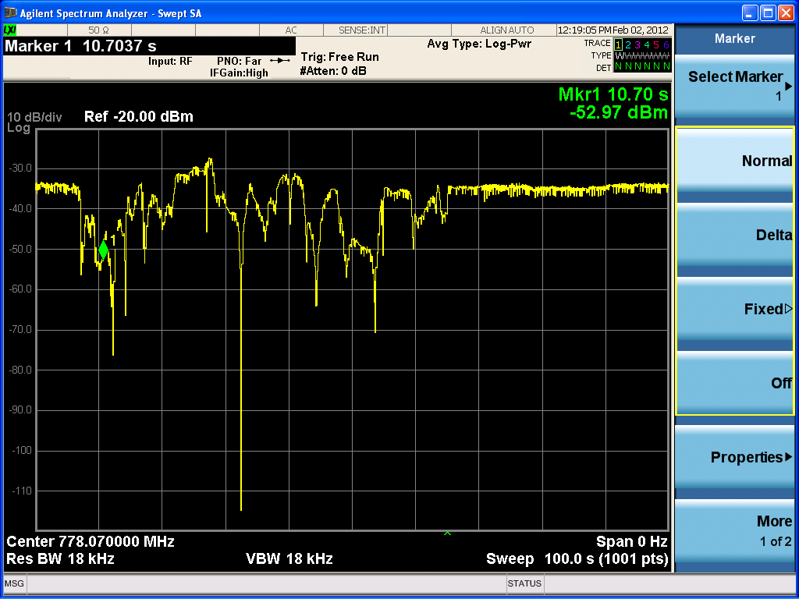
Figure 14: Multipath Fading - Signal Level with Time
Around 30 dB of fading is typical with around 60dB of very deep fades being present some of the time, these deep fades can be reduced somewhat by the use of spatial diversity. If two receiving antennas are used, which must be physically in two different places, they will receive a slightly different mix of multipath signals, thus it is hoped, that while one might be in a deep fade, the other is likely not. This reduces the occurrence of the very deep fades and improves the overall signal level and hence the quality of a performance that the audience hears (Figure 15).
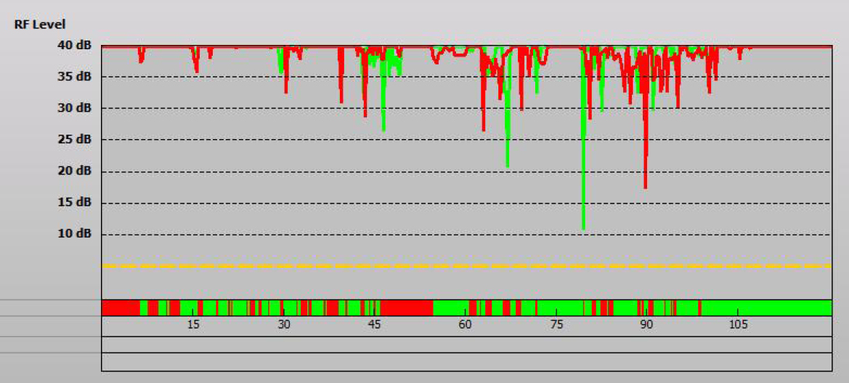
Figure 15: Multipath Fading – Spatial Diversity. Green refers to antenna 1, red refers to antenna 2

Link Budget
The following text discusses the issues to be considered when trying to estimate the expected range of a RM or IEM system. The figures should be taken as a guide as there are large variations in different equipment and deployment locations.
Antenna efficiency is problematic in RMs in general as the wavelength at 470 MHz is 64cm, which means an efficient antenna could be built measuring about 32cm (λ/2). The market demands small, light and out-of-sight products for many shows where the performers need mobility. When an antenna is held next to the human body, the body absorbs a significant amount of the radio energy and the dielectric properties of the body cause the antenna to change effective length and hence becomes less efficient at its intended frequency of operation.
There are two types of RM in common use, hand-held and body-worn. The hand-held RMs tend to have better antenna efficiency as they are held out in front of the body and often facing the audience so there is minimal body-shielding effects. The body-worn RMs, although can be hidden from view suffer from reduced efficiency for the reasons given. The following plots show typical antenna efficiencies from each type of RM. These measurements were performed in an anechoic chamber, further measurements have been done in a theatre [refer to Ofcom 2009-0333 ‘Analysis of PMSE Wireless Microphone Body Loss Effects’] which showed a reduced spread of results which was found to be due to multipath propagation.

Figure 16: RM Antenna Radiation Patterns
The figure below gives an example of a typical PMSE link budget, transmit power is limited by regulation (and acceptable battery life) to a maximum of 50 mW (+17 dBm) but is usually configurable to 1mW/10mW/50mW. From the figure above on the right we can see that a body-worn RM antenna gain of –15dB and a further estimated 10dB lost when the body shields the signal path in a real indoor environment.
We can assume a free-space loss over, some 18 metres (at 600 MHz) of 53 dB and a further 25 dB fading allowance due to multipath propagation which will be present for indoor locations and especially with stage props and lighting gantries etc. Using receive diversity can help reduce the needed fading allowance. Furthermore, when a large number of RMs are used in a production, their IP3s effectively raise the local noise-floor by 25 dB.
The receive antennas are usually mounted at the rear of the auditorium close to the receivers and audio desk and are usually high gain and directional, hence an assumed gain of 7 dBi.
Thermal noise in a 184 kHz bandwidth is –121 dBm, add to this an optimistic receiver noise-figure of 4 dB we get a receiver noise floor of –117 dBm. A 20 dB SNR will provide the minimum audio quality required from the system and so we arrive at the Rx sensitivity of –97 dBm.

Figure 17: PMSE Link Budget

Frequency Management Issues

PMSE Signal Sensing: Application Scenarios and Channel Models
Due to the low power of radio microphones, the variability of path loss, building attenuation and body shielding and current signal sensing sensitivities of a single or multiple WSD’s, does not yet offer any significant change to the information in ECC Report 159 [1]. Therefore, it still does not provide sufficient protection for PMSE devices

Usability of Beacon Signals
A national (and eventually global) network of enabling beacons would be required. To date, there has been no conclusion about how this could practicably be accomplished. In practice therefore, we are effectively dealing only with disabling beacons.
Where a beacon gets its information is an important consideration. If it is coming from a database, then the information will only be as good as that in the database. In this case, the beacon serves mainly as a wireless connection to the database. This is superfluous if the white space device is part of a network that is already connected to the Internet.
If on the other hand a beacon is programmed locally, then it could be used to create a “denial of service” attack. This would be a source of concern to WSD operators, and it was discussed in IEEE Working Group 802.22 which has carried out detailed work on this issue.
The transmission range of a beacon must exceed the interference range of the potentially interfering WSD.
To be effective, a beacon must be situated in close proximity to the device which needs protection; e.g., the wireless microphone receiver(s) in order to minimize path differences. For large events, wireless microphone receivers could be in several locations, so multiple beacons would be required. These beacons would normally need to be synchronized to provide the correct information to WSDs operating in the area.
The presence of a strong beacon signal operating near a sensitive PMSE receiver creates a number of potential problems. If the beacon signal is inside the channel to be protected (as proposed by IEEE standard 802.22.1 [9]) then it effectively consumes a significant portion of the otherwise usable bandwidth - as much as 1 MHz, in practice.
A strong beacon signal is likely to overload a PMSE receiver and either desensitize it or make it vulnerable to interference from other frequencies, due to mixing in the receiver’s front end.
Furthermore, a beacon can interact with transmissions from other devices operating nearby and create IMD interference in the same or nearby channels that would interfere with other PMSE or White Space devices.
The IEEE proposed that a separate beacon would be needed in each channel to be protected for PMSE use. The working group members determined that it would be impractical for a WSD to scan across the entire TV band looking for a beacon signal. Thus for a large event where 10 or more TV channels are in use for PMSE, an equal number of beacons would be required. This would be impractical due to cost and installation logistics.
The best option would be to have the beacon operate entirely outside the TV band. However, this would require including a separate receiver for beacon signals in WSDs.
The beacon signal would need to be standardized to allow all kinds of WSDs to understand it. All WSDs would need to be designed to receive and decode the beacon. IEEE standard 802.22.1 [9] was intended to address this requirement.
It would be necessary to determine how WSDs which are equipped with beacons and those which are not should operate. Unless beacon reception was made mandatory, it would be expected that both types of WSDs could be present and operating in an area where PMSE systems are in use.
A further concern is that dependence upon beacons would mean that PMSE operators would have to pay the cost of purchasing and deploying them to protect their systems from interference. In case multiple beacons are required, this expense could become very significant.
For all of the above reasons, not to mention the further work that would be required to establish that beacons can reliably be received by various kinds of WSD at distances sufficient to protect PMSE receivers from interference, beacons are not currently a practical means for protecting PMSE systems.
If administrations decide to allow WSDs to operate on the basis of sensing only, then simple beacons could be used to augment the ability of these WSDs to determine if a channel is occupied, subject to the cost and radio engineering concerns outlined above. However, it is questionable whether this would be practical for the WSD industry, because it would be difficult for a WSD to distinguish between a PMSE beacon and another WSD - perhaps one that is part of its own “network” - unless the beacon “signature” is standardized.
Some of the issues with the use of beacons are closely related to the open issues with the use of spectrum sensing as a means for determining spectrum availability. It is challenging for a device to correctly determine if a channel is occupied or not unless the signal to be protected has a known signature. An analogue PMSE transmission looks very different from a digital PMSE transmission. On the other hand, a digital PMSE transmission could appear very similar to a narrowband WSD transmission. These obstacles are in addition to the hidden node problems resulting from the fact that for a wireless microphone or In Ear Monitor system, the device to be protected - the receiver - is in a different location than the device to be sensed—the transmitter. Thus, the transmission paths are different. Furthermore, the difficulty of sensing a PMSE system reliably is exacerbated by the fact that both the WSD (the sensing receiver) and the PMSE transmitter can be in motion.

Usability of Combined (Sensing and Geo-location) Approach
As identified in § 4.4 current technology does not provide sufficient protection to the PMSE devices. Work by Ofcom, UK and others has settled on the Geo-Location [23] approach as the best option for early implementation of WSD. At a later date, using sensing in addition to the geo-location approach, may offer some additional protection.

Protection ratios and overloading thresholds assessed in measurement campaigns
A number of measurement campaigns have been undertaken at the time this report was developed. Each of these campaigns provides a different snapshot of the PMSE equipment in use, based on the geographical location, weather and shielding of the sites at the time of the tests.
- A measurement campaign was conducted under the auspices of the WISE-project (White Space test environment for broadcast frequencies) in two different theatres in Helsinki to study the performance of PMSE equipment in the presence of simulated WSD interference. A brief description of the campaign and its findings is provided in ANNEX 8:
- A second measurement campaign has been carried out by the BBC and ETSI ERM TG17 WP3 test group using a range of digital and analogue radio microphone equipment in lab conditions using recorded WSD signals.
- A third measurement campaign using live WSD transmissions was undertaken between the Cambridge White Spaces Consortium represented by CSR and the ETSI ERM TG17 WP3 test group and was completed in several phases (the full report can be downloaded here):
- Further bench testing and characterisation of equipment using actual WS equipment in conducted measurements
- On-location measurements in a cooperating theatre (ADC Theatre in Cambridge). Wireless microphones and WSDs were set to channels available within the Ofcom trial licence allowing co-channel and adjacent channel protection margins to be assessed
- Multi-channel PMSE systems were also tested with multiple WSDs to determine any impact upon both PMSE receivers and PMSE transmitters these tests identified the reverse intermodulation issues.
- A fourth measurement campaign has been conducted by APWPT and DKE to study LTE interference potential with regard to PMSE operation (the full report can be downloaded here).

PMSE Receiver Testing by the BBC

Protection Ratio Performance
Results are presented for convenience in ANNEX 9: The results show that protection ratio values for both the high and low power wanted signals are different; the worse adjacent channel protection ratio for the
–30 dBm wanted signal is as a result of the receiver being overloaded (both wanted and interfering signal powers are large in this case).
Results show that the adjacent channel (±10 MHz) minimum protection ratio is better than –55dB for the non-overloaded case, irrespective of the waveform used. The worst co-channel protection ratio is around 6dB.
The precise characteristics of a licensed PMSE receiver at a protected location are unlikely to be known. It is recommended that the envelope of the performance characteristics should be used, taking into account the performance of all receivers. Example C/I values for geo-location database construction are listed in
Table 16.
.
Table 16: Example Envelope of PMSE Receiver Protection Ratio Performance
Frequency Offset | WSD Type | PMSE C/I
|ΔF| < +5 MHz | CPE / UE / BS | +6dB
5 MHz < |ΔF| < 10 MHz | CPE / UE / BS | –40dB
10 MHz < |ΔF| | CPE / UE / BS | –50dB
Note: Following the tests at the BBC it has been found that some receivers require a C/I value of up to 15dB.

Impact of WSD ACLR Performance on PMSE Protection Ratios
The actual protection ratio required is a function of the selectivity of the victim PMSE receiver and the adjacent channel power emitted by the interfering WSD device.
The protection ratio measurements presented were made using a signal generator to emulate interference from a WSD. The adjacent channel leakage ratio (ACLR) of the signal generator was as good as 83dB for an offset of >10 MHz, almost certainly better than the ACLR performance that would be achieved by a WSD. Commercial WSD devices are expected to exhibit reduced ACLR performance. The protection ratios to be applied in the database should be adjusted to reflect the actual ACLR performance of the WSD. The protection ratio data can be adjusted to take into account the actual ACLR performance of the WSD, by estimating the PMSE receiver ACS:
(1)
This derived value of the DTT ACS will then be used to determine the appropriate co-channel and adjacent channel protection ratios for PMSE for WSDs that may have different ACLR characteristics.
The co-channel protection ratio of the PMSE receiver is not a function of ACLR and can assumed to be still PR₀. By inverting equation 1 the corrected adjacent channel protection ratio, PR′(Δf) can be derived:
(2)
In this way, the protection ratio for PMSE with respect to a WSD with its own particular ACLR, can be calculated on a case by case basis.

PMSE Sensitivity Degradation Measurements
Several analogue PMSE receivers were tested with the purpose to study their sensitivity and measure what WSD interference levels are causing sensitivity degradations in the practical PMSE receiver. Using 1% of the total harmonic distortion (THD) at the audio output as impairment criterion, the sensitivities were found to be typically between -90 and -95 dBm (200 kHz). Two of the PMSE receivers were tested more thoroughly in the presence of simulated co-channel WSD interference. Examples of the measured receiver sensitivity degradation in the presence of WSD co-channel interference for these monophonic analogue receivers are shown in Figures 18 and 19 below. The interference power levels are measured in an 8 MHz channel.
Figure 18: Example 1 of the PMSE Receiver Sensitivity Degradation
Figure 19: Example 2 of the PMSE Receiver Sensitivity Degradation
It was found that co-channel interference at levels of -113 dBm (200kHz)(-97 dBm curve for PMSE E) and -116 dBm (200 kHz)(-100 dBm curve for PMSE A) were not causing any degradation of sensitivity when measured using the impairment criterion of 1% THD at audio output. This seems to indicate that the protection criterion of -115 dBm in section 5.1.3 of ECC Report 159 [1] is usable when no degradation is allowed in the PMSE receiver. It was also shown that when a time variant multipath channel is applied between the microphone and the PMSE receiver, use of a similar interference limit would not cause any additional degradation in the receiver performance.

PMSE Receiver Testing by CSR
Three different receivers were tested against a Neul WSD as interferer, namely:
- Analogue radio microphone receiver;
- Digital radio microphone receiver;
- In-Ear Monitor receiver.
Initially, protection ratios were plotted against frequency offset at a number of different ‘wanted’ levels. By referring to the figure below, it can be seen that protection ratio increases as the wanted level is reduced. The results were plotted again in a more familiar format using absolute signal levels in lieu of ratios in the Figure below.

Figure 20: Analogue PMSE Adjacent Channel Protection Ratio

Figure 21: Analogue PMSE – C/I
The revised plots now show typical receiver behaviour with the interferer level flattening off at larger wanted signal levels. This can be explained thus; as the wanted level increases, the gain of the receiver is reduced to keep the signal amplitude within acceptable limits for the demodulator. This reduced gain means that a larger interferer can be added at the input, until the input stages start to compress where the graph levels off.
Figure 8 also shows the effect of the Neul’s ACLR as for frequency offsets exceeding 8 MHz (one TV channel); a higher interferer level can be tolerated.

Determining the required C/I for PMSE analogue receivers by APWPT and DKE
Figure 22 shows the test LTE signal (2) and a PMSE measuring signal (1) at a measurement bandwidth of 100 kHz. To ensure the minimum necessary production quality, the useful carrier to interference ratio (C/I) can be determined from the difference between the LTE (2) and PMSE (1) signal strengths. Monitoring and control was achieved by means of a headset.
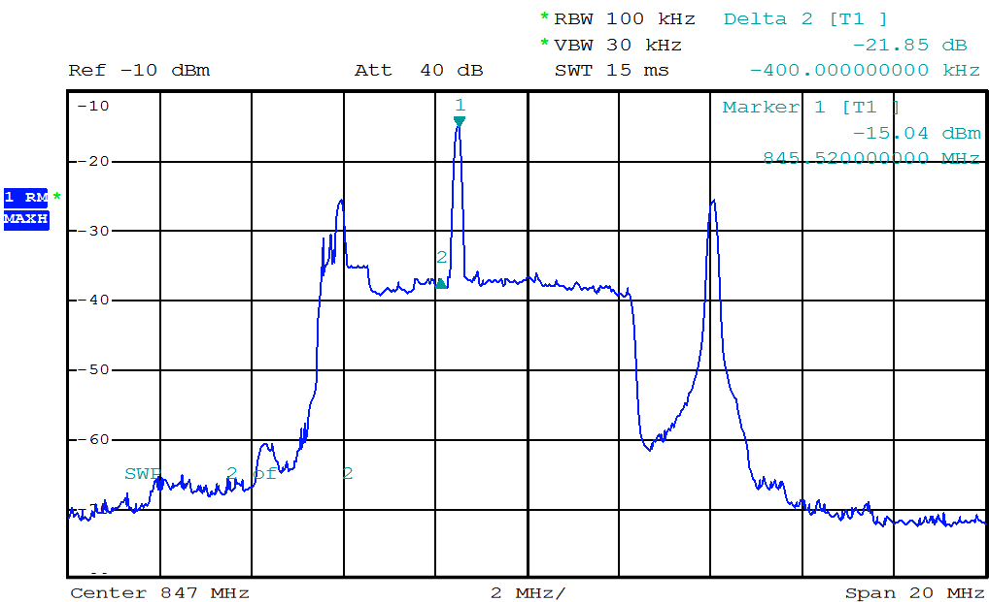
Figure 22: Measurement of C/I for PMSE analogue receivers
The 1 kHz audio test signal was interference free with a C/I value of ~ 22 dB thus conforming the initial hypothesis formulated by ETSI TG17WP3 of a minimal C/I of 20 dB for analogue PMSE use.

Intermodulation Distortion

PMSE Considerations
Intermodulation distortion occurs in all realisable circuits as they contain non-linear elements such as semiconductors. ANNEX 10: discusses intermodulation distortion and the mechanisms for its generation, essentially; non-harmonically related signals are generated and the odd-order intermodulation products (IPs) are more of a concern to radio systems as they are close in frequency to the wanted signal.
When two or more transmitters are allowed to become sufficiently close to each other, the radiated signal from one transmitter is ‘received’ by the other and the two signals combine within the (non-linear) power amplifier and thus produce these IPs. This process is commonly referred to as reverse intermodulation.
PMSE use primarily involves multiple transmitters typically 23-52 for stage productions, 1-20 for Houses of Worship and in excess of 90 for large broadcast events. In common with all transmitters, they generate intermodulation products; in non-PMSE use, in most cases such as PMR, the IPs do not interfere with the wanted transmissions as the transmissions are intermittent. However when large numbers of constant carrier transmitters are in very close proximity (centimetres in many cases), significant numbers of IPs are present and in the case of PMSE, this problem has been solved by careful frequency planning, but this solution is only valid if there is a stable radio environment.
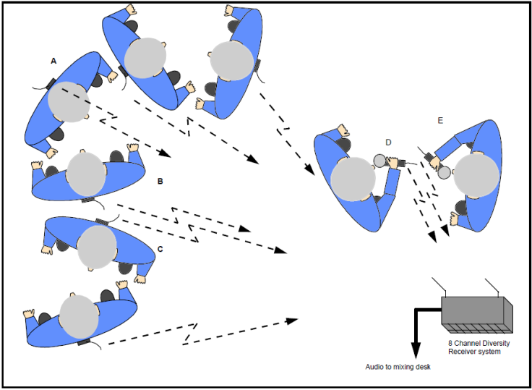
Figure 23: PMSE Use-Cases
The introduction of WSDs as additional interferers into the environment of PMSE receivers will have to be considered further by the regulators especially with regard to the possible effect their transmitter intermodulation products may have in close proximity of PMSE receivers when operating on adjacent channels.

Characterisation of Reverse Intermodulation Performance
The following figure is taken from ETS 300 750 and shows how transmitter reverse intermodulation can be measured in a repeatable way. The level of the IP3s and IP5s shall meet the emission mask, ACLR and spurious emission levels.
Figure 24: Test Bench for Characterising Tx Intermodulation Performance

PMSE and WSD intermodulation products
ANNEX 10: goes on to show how the spectra of intermodulating WSD and RM signals can be calculated, as the distortion products are of a higher order, there is a necessary increase in the bandwidth of the intermodulation product.
Intermodulation between a number of licensed RMs is currently taken into account by the PMSE industry by careful frequency planning. The case where we would like a WSD to be deployed near a PMSE installation, we should avoid the 1st adjacent channel because if the WSD is allowed to become close to a RM, then the reverse intermodulation may well block other RMs. In fact, the more general case, if the RMs are deployed in N sequential TV channels, then N TV channels should be reserved either side of the RMs as guard bands.
Another very important mechanism to consider; that is when two WSDs (or more) are transmitting at the same time and on apparently free channels, but where their IP’s fall on top of the RM signals (see A10.5).
If there are WSDs operating close to wireless microphones, the following conditions may be used to mitigate this problem:
- multiple WSDs are not allowed to simultaneously transmit within the exclusion zone;
- multiple WSDs are guaranteed not to be close to each other to cause reverse IPs;
- frequency management is performed in the database.

An example of a Methodology of Protection of PMSE from WSD

Introduction & Overview
The interference mechanisms discussed in this section need to be considered in their totality, in some instances receiver ACS will be the prime mechanism, in others, the WSD transmitter’s ACLR. In this section we first introduce the concept of interferer-to-noise approach where the level of an interferer is allowed to degrade the receiver noise floor by an acceptable amount which is the basis for all protection mechanisms subsequently discussed. Other methods of PMSE protection, such as an acceptable increase in audio distortion or by taking an interference reference level from a market study of commercial receivers; have been discounted.
In order to calculate the size of the exclusion zone, a suitable propagation model is required this is discussed in Section 4.6.5 and should take account of whether the WSD is indoors or outdoors.
A protection method is described using an interferer-to-noise approach, which would afford good protection to PMSE equipment. When a master WSD requests from the database a free channel given its position, the location positional uncertainty should be taken into account when calculating the size of the exclusion zone.
The analysis shows that ACS, ACLR and blocking should be considered in each case and the largest exclusion zone taken to be the one used. If we consider a typical adjacent channel protection zone of, say, 11m, then at these distances, it is possible for two or more transmitters to be close to each other and thus reverse intermodulation should also be considered. It is for this reason that regulators are considering, at least initially to get a system running, to use the co-channel exclusion zone for adjacent (all) channels. Thus, in the example given below, there would be a total exclusion zone of 334 m radius around the PMSE installation where no WSD will be allowed.

Interferer to Noise Approach
Both the BBC measurements shown in ANNEX 9: and the CSR measurements summarised in Section 4.4.2 have shown that the protection level of a PMSE receiver is highly dependent upon the wanted signal level, that is, the signal level of the radio microphone appearing at the PMSE receiver. Furthermore, this quantity is dependent upon many factors as described in 4.2.2 but may be fading by 60 dB.
One approach is to base the WSD power levels upon a fixed threshold at the PMSE receiver to protect the PMSE event. One method (which affords higher protection to PMSE) is to determine the level of a WSD such that the sensitivity of the PMSE receiver were not degraded significantly, often referred to as an interferer to noise (I/N) approach. This can be expressed mathematically as:
$δ=10∙log10({10}^{\left(γ/{10}\right)}-1)$,
where δ is the relative level of the WSD in dB and γ is the degradation in PMSE Rx sensitivity in dB.

Figure 25: Determining Level of Co-Channel WSD
From the graph above, and ignoring any bandwidth differences for the moment, for 1dB degradation in Rx sensitivity, the WSD power should be 6dB below the PMSE Rx sensitivity. If the WSD signal has a larger bandwidth than the RM signal then a correction factor needs to be added to this power level. By way of an example, suppose that the WSD has a 3dB bandwidth of 5 MHz and the 3dB bandwidth of a typical PMSE signal is 184kHz, then the correction factor becomes:
$${dB}_{correction}=10⋅\log_{10}\left(\frac{184kHz}{5MHz}\right)=-14.3dB$$
We can now calculate the maximum power of the WSD at the PMSE Rx knowing the signal bandwidths and the required performance of the PMSE receiver thus:
${WS_{P}}_{RX} \left(dBm\right)=10⋅log10(k⋅T)+30+ν+10∙log10(β∙{(10}^{\left(γ/{10}\right)}-1))$,
where: k is Boltzmann’s constant, 13.806*10⁻²⁴ J/K
T is temperature in Kelvin, say 290K
ν is the PMSE Rx noise figure in dB (say 7dB)
β is the WS signal bandwidth in Hz (say 5 MHz)
γ is the degradation of PMSE Rx sensitivity in dB (say 1dB)

Co-Channel Protection Level
Assuming the interferer-to-noise approach outlined above, and by way of an example:
$${WS_P}_{RX} (dBm)=-174+7+10∙log10(5e6∙{(10}^{\left(1/{10}\right)}-1))$$
$${WS_P}_{RX} (dBm)=-167+10∙log10(1.29e6)$$
$${WS_P}_{RX} (dBm)=-106$$
Furthermore, as PMSE systems are deployed in live scenarios, with 100% duty cycle, that is, transmitting 100% of the time during the performance, a zero interference policy must be adopted. This means that MCL calculations are more suitable and the statistical approach (such as with DTT) is not applicable.

Adjacent Channel Protection Level
If we proceed by protecting the PMSE system using the interferer-to-noise approach as above, the adjacent channel protection zone depends fundamentally upon a number of factors:
- WSD transmitter adjacent channel leakage ratio (ACLR);
- PMSE receiver adjacent channel selectivity (ACS);
- WSD EIRP;
- PMSE protection margin;
- PMSE receiver noise floor;
- Distance between WSD and PMSE Rx.

Rx ACS Considerations
Taking the same approach as in the co-channel case where we degrade the PMSE receiver noise-floor by an acceptable amount; consider a White-Space signal in the adjacent channel N-1. Assume that the PMSE receiver rejects a signal in the adjacent channel by an amount RxACS dB.
By referring to the BBC’s results in ANNEX 9:, whereby a number of different receivers were tested, the typical spread of Rx ACS is 45dB to 65dB. Initial results from Ofcom Baldock seem to suggest that IEM receivers also fall within this range.
Figure 26: Rx ACS Considerations

$${WS_P}_{RX} \left(dBm\right)=10∙log10 \left(k⋅T\right)+30+ν+10∙log10\left[\frac{b}{{(10}^{\left(γ/{10}\right)}-1}\right]+{Rx}_{ACS}$$
where:
k is Boltzmann’s constant, 13.806*10-24
T is temperature in Kelvin, say 290K
ν is the PMSE Rx noise figure in dB (say 7dB)
γ is the degradation of PMSE Rx sensitivity in dB (say 1dB)
b is the 3dB bandwidth of the PMSE receiver
RxACS is the PMSE receiver’s adjacent channel rejection in dB
For example, if we assume a typical receiver ACS (1st adjacent channel) of 65dB;
$${WS_P}_{RX} (dBm)=-174+7+10∙log10\left[\frac{184kHz}{{(10}^{\left(1/{10}\right)}-1}\right]+65$$
$${WS_P}_{RX} \left(dBm\right)=-43.5$$

Tx ACLR Considerations
Different classes of WSD transmitter, that is, those meeting different performance levels regarding their ACLR, might be considered (see § 2.5).
Existing measurements have shown that the interferer ACLR has a dominant effect on the resulting PMSE performance than the PMSE ACS.
For example, a WSD is deployed in channel N-1 with an adjacent channel leakage ratio of TxACLR. The PMSE receiver will provide no attenuation of the power in the WSD transmitters’ adjacent channel as it appears co-channel as far as the receiver is concerned.

Figure 13: Tx ACLR Considerations
As above, to ensure PMSE protection, we arrange the interfering power level to degrade the PMSE receiver’s noise-floor by an acceptable amount; therefore, we can say that:
$${WS_P}_{RX} \left(dBm\right)=10∙log10 \left(k⋅T\right)+30+ν+10∙log10\left[\frac{b}{{(10}^{\left(γ/{10}\right)}-1}\right]+{Tx}_{ACLR}$$
where:
k is Boltzmann’s constant, 13.806*10⁻²⁴ J/K
T is temperature in Kelvin, say 290K
ν is the PMSE Rx noise figure in dB (say 7dB)
γ is the degradation of PMSE Rx sensitivity in dB (say 1dB)
b is the 3dB bandwidth of the PMSE receiver
TxACLR is the WSD transmitter’s adjacent channel leakage ratio in dB
For example, if we assume a transmitter ACLR of 55dB;
$${WS_P}_{RX}(dBm)=-174+7+10∙log10\left[\frac{184kHz}{{(10}^{\left(1/{10}\right)}-1}\right]+55$$
$${WS_P}_{RX} (dBm)=-53.5$$

PMSE Receiver Overload Characteristics (Blocking)
Protection of PMSE receivers requires consideration of both the ACS ratio performance and the overload characteristics of the receiver. Measurements from several different campaigns suggest the typical PMSE overload level will range from –15 dBm to +5 dBm:
$${WS_P}_{RX} \left(dBm\right)=[-15, +5]$$
The proposed I/N method and the indicative protection ratios suggest that the EIRP limit for the WSD will tend to be determined by the ACS considerations rather than by PMSE receiver overloading.

Propagation Models for Calculation of Exclusion Zones
All of the analysis up to this point is independent of frequency; the propagation models described here are dependent upon frequency.
Given the maximum WSD power level at the PMSE Rx calculated in each of the conditions above (WS_PRX), we need to determine the size of the exclusion zone (or bubble as the problem is three-dimensional) in order to protect the PMSE system, given the maximum WSD EIRP. To do this, we need to know the signal path attenuation, which will be determined by the following:
- PMSE antenna gain in the direction of the WSD;
- WSD antenna gain in the direction of the PMSE Rx;
- PMSE and WSD antenna heights;
- Building attenuation;
- Wavelength;
- Distance;
- Environment.
The attenuation afforded by the building is highly variable ranging from no attenuation to high attenuation with up to 3m of concrete. It would seem impractical to determine the attenuation for each building being used for PMSE events throughout a country, therefore, a fixed value representing near worst-case might be more appropriate.
Some planning models used by the broadcast TV industry would not be suitable to determine the building loss or path loss within an inner city. A Hata model may be more suitable. Regulators would also need to choose a suitable propagation model to take account of differing terrain such as rural, sub-urban and dense urban environments.
The measurements taken at the ADC Theatre (§ 4.3.2) showed that a Neul WSD with an EIRP of +26.5 dBm would not interfere with a RM signal co-channel at a range of greater than 160m. This figure is consistent with current expectations that the building might provide about 20dB attenuation and assuming third-order path-loss outdoors in a built-up area.

Antenna Gains & Distribution Systems
A mobile WSD will likely have an antenna with an omni-directional pattern. Typical larger deployments of PMSE systems use receive diversity with two directional antennas pointing towards the stage with a gain of around 10dB.

Summary of conclusions on PMSE from further studies
The findings from the three measurement campaigns and other inputs indicate that the following conclusions can be made:
- In line with the previous conclusions from ECC Report 159 [1], sensing techniques have not yet reached a point where it can provide reliable protection for PMSE services.
- In line with the previous conclusions from ECC Report 159 [1], no practical way of implementing beacons has been found.
- Geo-location databases appear to be the only practical way forward to protect the needs of PMSE users as long as they can manage protection of PMSE use at both permanent and temporary venues within suitable timescales.
- As it appears that co-channel operation is not possible in the vicinity of PMSE receivers, one approach may be for the WSDB to calculate an appropriate separation distance (exclusion zone) based on the power of the WSD transmitter between WSD and PMSE users. For multi-channel systems, in addition to the proposed exclusion zone it may be necessary to implement a frequency guard band either side of those channels in use by PMSE.
- The database could potentially take into consideration intermodulation products

Technical considerations on the protection of ARNS

Summary on previous studies
Preliminary considerations were provided in ECC Report 159 [1] on the relevance of the sensing and geo-location techniques for the protection of ARNS. However, a need for some additional information on the ARNS deployment considerations was pointed out in order to perform an appropriate analysis.

General note
The sections below provide the study carried out to assess the compatibility between WSDs and ARNS. Only one deployment scenario for WSDs was considered, whereas a number of other WSD deployment scenarios (both indoor and outdoor) discussed in Section 2.2 have been neglected.
In particular, it was assumed that WSD will be used to provide the mobile service and, therefore, will use the same emission and power characteristics as the mobile service in the frequency band 790-862 MHz. This gave rise to using the WSD e.i.r.p. of 55 dBm, which is obviously much higher than example power levels for WSDs derived on the basis of expected operational ranges and provided in Section 2.2.2.
Therefore, the analysis conducted and the results obtained provide just a guideline to how the issue needs to be addressed and should not be used to derive any conclusions regarding the compatibility between the WSDs and ARNS in the band the 645-790 MHz band.

ARNS deployment scenarios
In accordance with No.5.312 RR the frequency band 645-862 MHz is allocated to aeronautical radionavigation service (ARNS) in several countries on a primary basis. Several types of the radionavigation systems are used in this service including:
- radio system of short-range navigation (RSBN);
- air traffic control secondary radars, including terrestrial radar and airborne transmitter;
- airfield and route primary radars for ATC
The indicated systems are used to support navigation and air traffic control.
The European table of frequency allocations and applications in the frequency range 9 kHz to 3000 GHz Table (ERC Report 25) [22] includes the footnote EU13 [22] in Annex 1.
(EU13 CEPT Administrations are urged to take all practical steps to clear the band 645-960 MHz of the assignments to the aeronautical radionavigation service.)
The main characteristics of different types of the aeronautical radionavigation stations operating in the frequency band 645-862 MHz are in JTG (Joint Task Group) 5-6 output documents (Annex 5 to Document 5-6/180) and CPM Report and presented in Table 17 and Table 18.

Table 17: Technical characteristics of ARNS systems operating in the 645-862 MHz frequency band
Type of station | RSBN | RLS 2 (Type 1) |  | RLS 1 (Type 1) |  | RLS 1 (Type 1) | RLS 1 (Type 2)
Characteristics
Application | “Air-to-Ground” | Secondary radars – Type 1  (air traffic control) |  | Secondary radars – Type 2 |  | Primary radars – Type 1 | Primary radars – Type 2
Transmitter characteristics
Station name | Aircraft transmitter | Ground radar transmitter | Aircraft transponder transmitter | Ground radar transmitter | Aircraft transponder transmitter | Ground radar transmitter | Ground radar transmitter
Place of station | Aircraft | Airfields | Aircraft | Airfields | Aircraft | Airfields | Airfields
Maximum effective radiated pulse power (e.r.p.), dBW | 30.5 | 48 | 35 | 69,5 | 34,5 | 82 | 82
Pulse power, dBW | 27 | 31 | 32 | 40 | 31 | 52,5 | 52,5
Mean power, dBW | 0.5 | 1 | 14 | 10,5 | 10,5 | 19,5 | 19,5
Pulse repetition cycle, ms | 2.3 | 1,3 | 0,6 | 1,8 | 1,8 | 1,8 | 1,8
Pulse length, μs | 5.1 | 1,3 | 8,7 | 2 | 16 | 0,9-2 | 0,9-2
Necessary emission bandwidth, MHz | 3/0,7 | 4 | 4 | 3 | 3 | 3 | 3
Antenna height, m | 10 000 | 10 | 10 000 | 10 | 10 000 | 10 | 10
Maximum antenna gain (dBi) | 3,5 | 17 | 3 | 29,5 | 3,5 | 29,5 | 29,5
Antenna pattern | ND | 3 dB beamwidth: vert. pl. = 28°  hor. pl. = 4° | ND | 3 dB beamwidth: vert. pl. = 45°  hor. pl. = 3-5° | ND | 3 dB beamwidth:  vert. pl. = 45°  hor. pl. = 4° | 3 dB beamwidth:  vert. pl. = 45°  hor. pl. = 4°
Direction of the antenna main beam | Lower hemisphere | Azimuth:  0-360°  Scan rate:  6 min⁻¹ | Lower hemisphere | Azimuth: 0-360°  Scan rate:  10 min⁻¹ | Lower hemisphere | Azimuth: 0-360°  Scan rate:  6/10 min⁻¹ | Azimuth: 0-360°  Scan rate:  6/10 min⁻¹

Table 18: Technical characteristics of ARNS systems operating in the 645-862 MHz frequency band
Type of station | RSBN | RLS 2 (Type 1)  (air traffic control) |  | RLS 1 (Type 2) |  | RLS 1 (Type 1) | RLS 1 (Type 2)
Characteristics
Receiver characteristics
Station name | Ground radar receiver | Aircraft responder of ground radar | Ground radar receiver | Aircraft responder of ground radar | Ground radar receiver | Ground radar receiver | Ground radar receiver
Antenna height, m | 10 | 0–10 000 | 10 | 0–10 000 | 10 | 10 | 10
Polarization | Linear, horizontal | Linear, vertical | Linear, vertical | Linear, horizontal | Linear, horizontal | Linear, horizontal | Linear, horizontal
Maximum antenna gain (dBi) | 22 | 3 | 17 | 3 | 28,4 | 29,5 | 29.5
Antenna pattern | 3 dB beamwidth:  vert. pl. = 50°  hor. pl. = 360° | ND | 3 dB beamwidth:  vert. pl. = 28°  hor. pl. = 4° | ND | 3 dB beamwidth:  vert. pl. = 45°  hor. pl. = 3-5° | 3 dB beamwidth:  vert. pl. = 45°  hor. pl. = 3-5° | 3 dB beamwidth:  vert. pl. = 45°  hor. pl. = 3-5°
Direction of antenna main beam | Azimuth: 0-360°  Revolution speed 100 rev/min | Lower hemisphere | Azimuth:  0-360°  Scan rate:  6 min⁻¹ | Lower hemisphere | Azimuth:  0-360°  Scan rate:  10 min⁻¹ | Azimuth:  0-360°  Scan rate:  6/10 min⁻¹ | Azimuth: 0-360°  Scan rate:  6/10 min⁻¹
Permissible aggregate co-channel interference field strength provided for the necessary emission bandwidth (from all services), E, dB(μV/m)* | 42 | 52 / 59 | 29¹ / 33² | 73 | 24¹ / 28² | 13 | 13

*The values given in the Table are the permissible values of the aggregate co-channel interference field strength presented for the required emission bandwidth (from all services). There are two values that can be used for sharing studies and these values shall be updated after detailed consideration of study results and should not contradict GE06 Agreement.
∆f
P
The analysis of the presented data showed that in the considered frequency band mainly 3 types of ARNS systems are used:
- radio system of short-range navigation (RSBN) (radiolink aircraft – ground);
- Secondary radar Type 1 (radiolinks ground– aircraft, aircraft – ground);
- Secondary radar Type 2 (radiolink aircraft – ground).
The indicated systems are considered below in the studies of sharing feasibility of WSD with ARNS systems.

Possible interference scenario from WSD to ARNS systems
The analysis of WSD deployment scenario given in Section 2 and the analysis of ARNS characteristics operating in the considered frequency band showed that the following interference scenario can be possible:
- WSD causes interference to ARNS ground station;
- WSD causes interference to ARNS airborne station.
Taking into account possible usage of WSD presented in Section 2 it can be assumed that WSD will be deployed mainly in the mobile service and will have characteristics similar to characteristics of MS which are planned to be used in the frequency band 790-862 MHz.
The studies of the required protection measures of ARNS from mobile service planned to be used in the frequency band 790-862 MHz were carried out in the framework of ITU-R JTG 5-6.This group developed methodologies for defining the required coordination distances (see Doc. 5-6/180).The indicated methodologies can be used for defining the required protection distances for ARNS systems in the considered frequency band from WDS network systems.
The frequency band 645-790 MHz subject to GE-06 Agreement. This Agreement includes allotment plan for broadcasting service. This Plan was developed in 2006 based on the assumption that only ARNS and broadcasting service systems will operate in the indicated frequency band. It was developed taking into account no any margins for interference caused by other systems to ARNS systems excluding broadcasting service allotments/assignments. While planning the usage of the frequency band 645-790 MHz by WSD it should be taken into account.
In case interference caused by broadcasting service allotments/assignments to ARNS are exceeded or meet ARNS protection criteria without margins then operation of WSD (under the assumed deployment scenario) is practically impossible. In this case distance between WSD and ARNS station can be no less 1000 km (in accordance with Recommendation ITU-R P.1546-4 [11]). This case is mostly common since when broadcasting plan was developed administrations did their utmost to receive maximum broadcasting allotment parameters.
If interference caused by broadcasting allotments/assignments to ARNS do not exceed ARNS protection criteria and there is a margin for interference then in this case minimum protection distance for ARNS systems can be defined. It is obvious that this protection distance will be defined by margin values, MS antenna height, its deployment scenario and etc. The example of estimation of the required separation distances between ARNS stations and WSD is given below.

Assumptions and methodologies used in the estimations
For defining the protection distances it was assumed that interference margin caused by systems excluding broadcasting systems is minimum and do not exceed 0.1 dB. This interference margin was used for defining the permissible interference field strength values from WSD given in Table 19.
Table 19: Permissible interference field strength values caused by WSD
ARNS systems | Protected field strength dB (µV/m) (under Recommendation ITU-R M.1830) | Permissible interference field strength from WSD, dB (µV/m)
RSBN ground-based receiver | 42 | 25.6
RLS 2 Type 1 ground-based receiver | 29 | 12.6
RLS 2 Type 2 ground-based receiver | 24 | 7.6
RLS 2 Type 1 airborne receiver | 52 | 35.6

Taking into account uncertainty with respect to WSD types and characteristics methodology based on statistical approach was used for defining separation distances between WSD and ground-based ARNS stations. This methodology was developed in the framework of ITU-R JTG 5-6 and given in detail in Doc. 5-6/180.
Two e.i.r.p values for WSDs were considered in the simulations:
- 36 dBm (as the highest value listed in Table 1 of Section 2.2.2) and
- 55 dBm (comply with typical e.i.r.p. of MS base stations).
It was further assumed that WSD antenna heights are 40-60 m (set randomly) and that WSD stations form a network with the following deployment densities of stations:
- 0.008 per km² for rural area;
- 0.13 per km² for suburban area;
- 2.05 per km² for urban area.

Estimation results of WSD emission influence to ARNS airborne and ground-based receivers
In defining protection distances two following options are considered:
- Interference caused by WSD stations, located in rural area;
- Interference caused by WSD stations, located in accordance with urban-suburban-rural scenario considered by JTG 5-6 see Figure 27
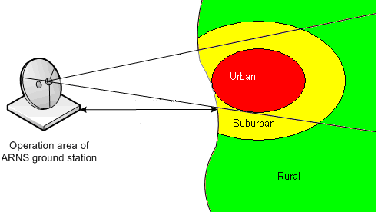

Figure 27: Urban suburban-rural scenario
For both options land path (100 % land) and mixed (5 % land, 95 % sea) path were considered.
The results for defining protection distances are given in Table 20 and Table 21. Table 20 presents estimation results of the required protection distances for WSD in rural area. Table 21 presents estimation results of the required protection distances for WSD in accordance with urban-suburban-rural scenario.

Table 20: Separation distance for protection of ARNS for land path
e.i.r.p = 36 dBm
System | Transmitter antenna height, m | Distance up to the first line of transmitters, km
System | Transmitter antenna height, m | 100% land | 5% land, 95% sea
RSBN | 40 … 60 | 19 | 51
RLS 2 Type 1 | 40 … 60 | 49 | 111
RLS 2 Type 2 | 40 … 60 | 76 | 154

e.i.r.p = 55 dBm
System | Transmitter antenna height, m | Distance up to the first line of transmitters, km
System | Transmitter antenna height, m | 100% land | 5% land, 95% sea
RSBN | 40 … 60 | 83 | 162
RLS 2 Type 1 | 40 … 60 | 225 | 278
RLS 2 Type 2 | 40 … 60 | 280 | 335

Table 21: Separation distance for protection of ARNS for urban-suburban-rural scenarios
e.i.r.p = 36 dBm
System | Transmitter antenna height, m | Distance up to the first line of transmitters, km
System | Transmitter antenna height, m | 100% land | 5% land, 95% sea
RSBN | 40 … 60 | 62 | 132
RLS 2 Type 1 | 40 … 60 | 145 | 214
RLS 2 Type 2 | 40 … 60 | 183 | 257

e.i.r.p = 55 dBm
System | Transmitter antenna height, m | Distance up to the first line of transmitters, km
System | Transmitter antenna height, m | 100% land | 5% land, 95% sea
RSBN | 40 … 60 | 190 | 262
RLS 2 Type 1 | 40 … 60 | 320 | 375
RLS 2 Type 2 | 40 … 60 | 370 | 430

The analysis of the results shows that in rural area the required protection distance for WSD base stations with e.i.r.p. of 36 dBm is not less than 76 km and 154 km for the land and mixed paths, respectively. In urban-suburban-rural scenario the required protection distance is not less than 183 km and 257 km for the land and mixed paths, respectively.
For example, if a WSD transmits an e.i.r.p of 55 dBm the required protection distance is increased up to 280 km and 335 km for the land and mixed paths, respectively. In urban-suburban-rural scenario the required protection distance is increased up to 370 km and 430 km for the land and mixed paths, respectively.
Except the above-mentioned cases an impact of WSD interference on ARNS airborne receivers was also considered. It was found that the required protection distance shall be not less than line-of-sight distance (444 km) for all ARNS type systems and for both e.i.r.p. values considered.

Conclusion
One study has shown that the protection of ARNS from interference generated by typical WSD deployment scenarios would require separation distances to be in the range of 76-257 km for WSD transmitters with e.i.r.p. 36 dBm or in the range 280-430 km for WSD transmitters with e.i.r.p. 55 dBm depending on the area (rural, urban-suburban-rural), WSD deployment densities and propagation path type.

Technical considerations on the protection of services in the bands adjacent to 470-790 MHz

Summary on previous studies
Two different methodologies for deriving suitable protection for the mobile services in the bands adjacent to 470-790 MHz were proposed in ECC Report 159 [1]. Both methodologies were not fully developed and required further studies to be carried out.

Protection of mobile service in the band 450-470 MHz

Protection of TETRA TEDS 25 kHz

Assumptions and scenarios
The band 450-470 MHz is predominantly expected to be used by PMR/PAMR applications, including TETRA and its evolution, which have to be protected with respect to the introduction of WSD operating in the UHF band between 470-790 MHz.
The interference scenario is generally represented by different systems or devices, which operate in adjacent bands over the same geographical areas, as exemplified in Figure 28, where several WSDs, whose possible position is marked with X, share the same area as a mobile network.
WSDs may cause potentially harmful interference towards the incumbent services operating in the lower adjacent band. The proposed methodology to assess potential harmful impact of WSDs is based on Monte Carlo simulations, where victim receivers are randomly generated inside the simulation areas.
Link budget assessments both for wanted signals and interferers allow the evaluation of possible performance degradation. Adjacent channel interference is computed taking into account ACLR (Adjacent Channel Leakage Ratio), which describes out-of-band emissions of the interfering transmitter, and ACS (Adjacent Channel Selectivity), which describes the selectivity of the victim receiver (see Figure 29).
Depending on the channel arrangement and duplexing techniques the most critical link has to be identified. In Figure 30, it is shown an example where, due to the channel arrangement, the downlink of the incumbent service must be considered for protection. In this case the mobile user equipment (UE) is the victim, which receives both the wanted signal from the mobile base station and the interferer signal(s) from WSDs.
Parameters and requirements that must be considered in order to evaluate performance degradation may vary according to the specific system or service to be protected.
The overloading effect due to multiple WSDs can also be assessed.
Figure 28: Cellular layout (different colours are used for different frequencies).
In the inner part of the area several WSDs operate, whose possible position is marked with X

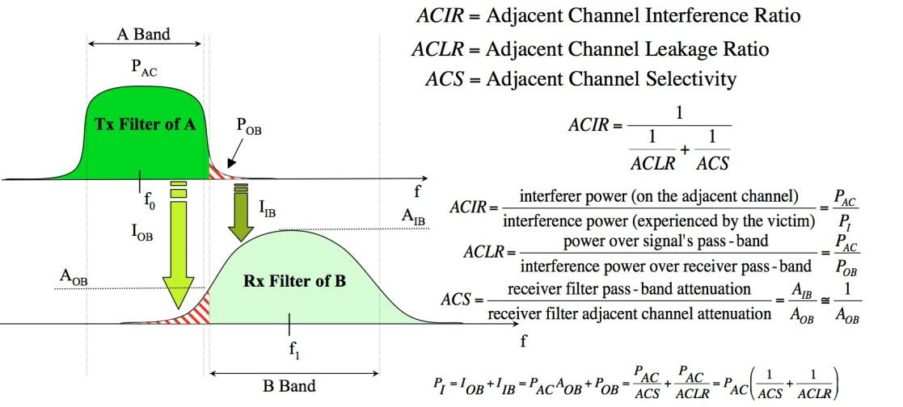
Figure 29: Assessment of adjacent channel interference

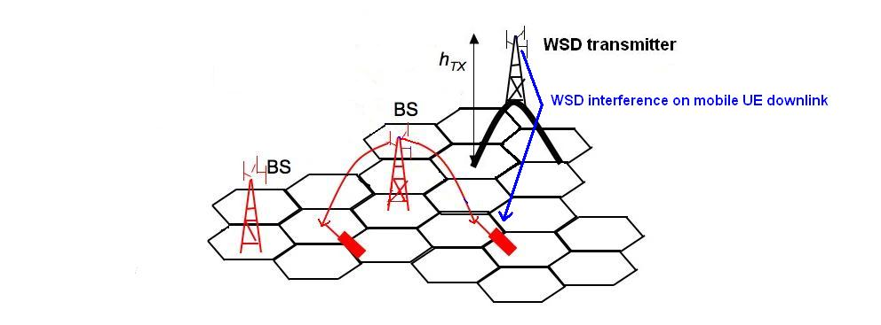
Figure 30: Example of mobile UE as victim receivers (downlink)

Results
A first example considering the coexistence between TEDS 25 kHz with WSDs is provided. It has also to be noted that currently the 450-470 MHz band is used by many analog PMR systems, partially switching to DMR.
A TEDS mobile network composed of 54 base stations deployed in a regular hexagonal layout has been taken into account. In order to avoid border effects, only the innermost 15 base stations have been analysed and, in the identified area, it is assumed that a WSD network is deployed for applications such as wireless access see Figure 32; a maximum number of 35 WSDs is considered.
TEDS downlink has been identified as the most critical link due to the FDD channel arrangement and WSDs are assumed to operate immediately above 470 MHz, with 5 MHz channel bandwidth. Systems characteristics and simulation parameters are summarized in Table 22.
Table 22: Main simulation parameters
TEDS 25 kHz characteristics
Cell radius | 5 Km
Simulation area | 60x48 Km²
Operating frequency | 469.9875 MHz
Total number of base stations (BSs) | 54
Number of TETRA BSs in central area | 15
Cluster size | 7
BS antenna height | 30 m
BS antenna gain | 12 dB
BS transmitted power | 28 dBm
Number of User Equipments (UEs) generated for each Monte Carlo simulation | 200
UE antenna height | 1.5 m
UE Tx antenna gain | 0 dB
UE transmitted power | 27.5 dBm
WSD characteristics
Transmitter power | 33 dBm
Antenna height | 10 m
Antenna pattern | Omnidirectional in azimuth
Antenna gain | 9 dBi
Operating frequency | 472.5 MHz
Total number or WSDs | 35

TEDS UE receiver mask is derived from [ETSI EN 300 392-2 [10] , “Terrestrial Trunked Radio (TETRA); Voice plus Data (V+D); Part 2: Air Interface (AI)”, European Standard (Telecommunication Series), v 2.3.2, March 2001], whereas WSD SEM is assumed equal to SEM for LTE base stations (ECC Report 148 [5]), “Measurements on the performance of DVB-T receivers in the presence of interference from the mobile service (especially from LTE)”, Final Report by the Electronic Communication Committee (ECC) within the European Conference of Postal and Telecommunications Administrations (CEPT), Marseille, June 2010] (see Figure 31). The derived masks are needed to evaluate adjacent channel interference.

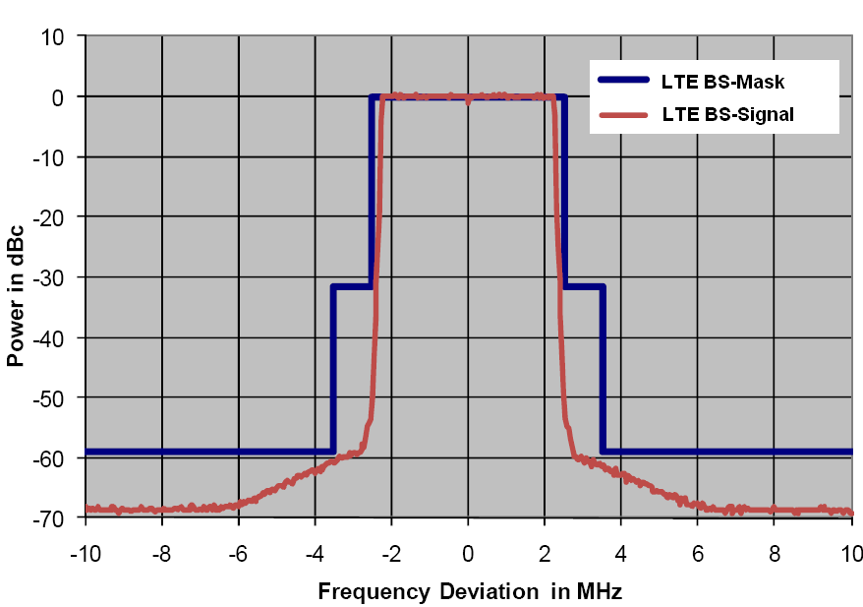
Figure 31: TEDS UE receiver mask and WSD SEM
Performance degradation is assessed considering both wanted and unwanted power received by the TEDS UE, whose positions are randomly generated by means of a Monte Carlo simulation.
TEDS requirements are given in terms of C/Ic (signal to co-channel interference ratio), C/Ia (signal to adjacent channel interference ratio) and receiver blocking power [ETSI EN 300 392-2 [10], “Terrestrial Trunked Radio (TETRA); Voice plus Data (V+D); Part 2: Air Interface (AI)”, European Standard (Telecommunication Series), v 2.3.2, March 2001] [ECC Report 104 [12], “Compatibility between mobile radio systems operating in the range 450-470 MHz and Digital Video Broadcasting-Terrestrial (DVB-T) systems operating in UHF TV Channel 21 (470-478 MHz)”, Amstelveen, June 2007]. Numerical values are reported below:
    - minimum C/I_{c} =19 dB;
    - minimum C/I_{a} = -40 dB;
    - receiver blocking= -40 dBm.

Co-channel interference (Ic) includes both TEDS intra system interference and interference due to the imperfection of the WSDs transmitter. Adjacent channel interference (Ia) is specifically referred to the first 25 kHz adjacent channels below and above the operating band of the TEDS victim receiver. Receiver blocking power is then computed considering the interference generated by WSDs in all the adjacent channels but the first.
In order to gather information on the overloading effect of WSDs for the protection of TEDS, Monte Carlo simulations have been performed varying randomly the number of active WSDs (transmitters ON): all, one half, 1/5 and 1/12.
Simulations have highlighted that the most stringent constraint is represented by the requirement in terms of C/Ic. In Table 23 the estimated outage is reported. The overloading effect is also visible.
Table 23: Simulation results
Estimated outage for TETRA receivers (%)
All transmitters ON | Half of the transmitters ON | One fifth of the transmitters ON | One twelfth of the transmitters ON
1.16% | 0.87% | 0.67% | 0.56%

Conclusions
The studies for the protection of TETRA TEDS (25 kHz) operating at 450-470 MHz have shown that the interference caused by WSD is not significant, taken into account the assumptions in terms of emitted power and WSD density.

Protection of CDMA PAMR

Scenarios
In the simulations CDMA mobile stations and portable WSD are randomly placed within the CDMA BS and fixed WSD service areas according to the uniform distribution. Fixed WSD is placed at the edge of a CDMA cells. Cell size of CDMA network depends on the propagation conditions urban, suburban or rural which correspond to 2 km, 5 km and 15 km accordingly. During the simulations, emission power of WSD had been gradually decreased until the tolerable level of capacity loss has been obtained. Once tolerable level is determined, maximum emission power for WSD is recorded. Calculations are done for three frequency offsets between channels of mobile network CDMA and fixed WSD Figure 32. Only impact from fixed WSD on CDMA mobile units has been estimated.
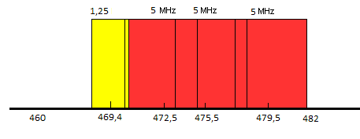
Figure 32: Frequency offsets of fixed WSD (red) and BS CDMA (yellow)
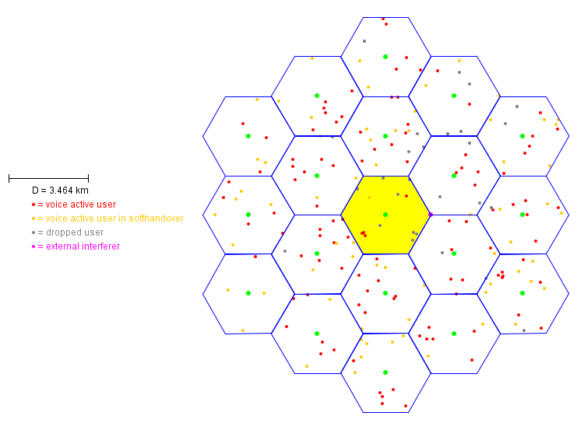
Figure 33: Scenario for assessment compatibility between WSD and CDMA networks
with 2 km cell size

Interference criteria
Network capacity loss has been selected as the interference criteria in order to assess compatibility between CDMA and WSD. The calculations have been conducted for 1% and 5% network capacity loss.

Parameters of WSD used for simulations
Table 24: Interfering transmitter parameters (fixed WSD)
Parameter | Value
Carrier frequency (MHz) | 472.5 MHz, 475.5 MHz and 479.5 MHz
Antenna height (m) | 30
Antenna maximum Gain (dBi) | 17
Feeder losses (dB) | 3

Table 25: Wanted receivers parameters (portable WSD)
Parameter | Value
Antenna height (m) | 1.5
Antenna gain (dBi) | 0
Sensitivity (dBm) | -94

Emission mask of the fixed WSD has been taken in accordance with characteristics of WiMax (shown in Figure 34, see CEPT Report 40 [16], Annex 2) or LTE (shown in Figure 35, see CEPT Report 40 [16], Annex 1) systems in UHF for 5 MHz channel. This assumption based on the fact that some of WSD standards could use WiMax or LTE technologies as a basis.
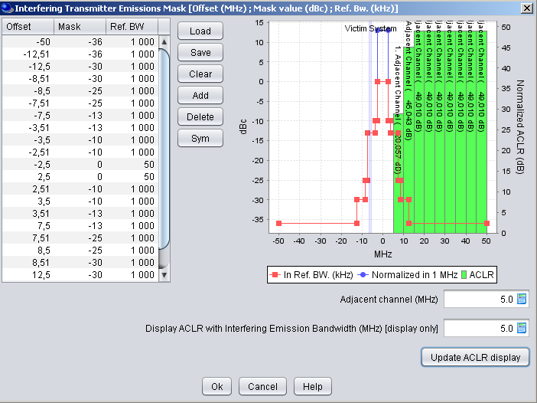
Figure 34: Emission mask of fixed WSD based on the WiMax emission technology
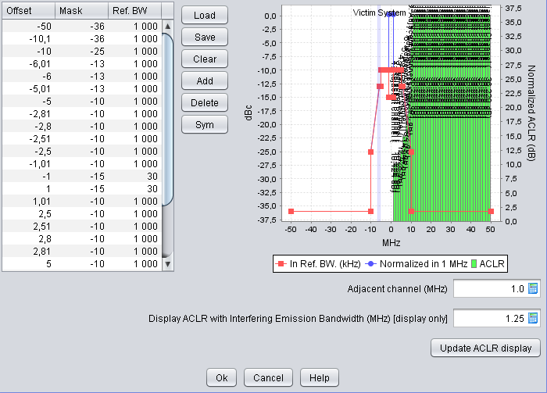
Figure 35: Emission mask of fixed WSD based on the LTE emission technology
The fixed WSD antenna with Horizontal and Vertical patterns has been taken from Recommendation ITU-R F.1336-2 [18] for a 120 degrees sector antenna with a maximum gain of 17 dBi.

Parameters of CDMA network used for simulation
Characteristics of CDMA system have been taken in accordance with the ECC Report 099 [17], Annex B. Parameters being used are presented in tables below.
Table 26: Parameters Assumed for CDMA PAMR Systems
Parameter | Mobile Station | BS
Channel Spacing | 1250 kHz | 1250 kHz
Transmit Power | 23 dBm | 40 dBm
Receiver Bandwidth | 1250 kHz | 1250 kHz
Antenna Height | 1.5 m | 30 m
Antenna Gain | 0 dBi | 9 dBi
Active Interferer Density Range | Variable | variable
Receiver Static Sensitivity | - 117 dBm | - 124 dBm
Receiver Dynamic Sensitivity 75% system loading | - 107 dBm | - 113 dBm
Power Control Characteristic | Used at SEAMCAT Simulation | Used at SEAMCAT Simulation
Cell size :  Urban / Suburban / Rural | 2 km / 5 km / 15 km

Table 27: Receiver Blocking for CDMA PAMR Systems
Frequency Offset | Mobile Station | BS
> 900 kHz | - 30 dBm | - 21 dBm

Results
Tables 28, 29, 30 present the results of the simulations of the dependence of the mean capacity loss on the WSDs output power for three frequency offsets between the BS CDMA and fixed WSD and for three different cell size of CDMA PAMR system – 2 km, 5 km and 15 km.

Table 28: Average capacity loss in CDMA PAMR reference cell (cell size 2 km)
∆f |  | 3.1 MHz | 6.1 MHz | 10.1 MHz
Pwsd |  | 3.1 MHz | 6.1 MHz | 10.1 MHz
0 dBm | LTE | 0 | 0 | 0
0 dBm | WiMax | 0 | 0 | 0
10 dBm | LTE | 0 | 0 | 0
10 dBm | WiMax | 0 | 0 | 0
20 dBm | LTE | 0,65 | 0,46 | 0,22
20 dBm | WiMax | 0,47 | 0,35 | 0,12
30 dBm | LTE | 2,72 | 2,42 | 1,18
30 dBm | WiMax | 4,01 | 2,03 | 0,82
46 dBm | LTE | 12,83 | 10,71 | 9,42
46 dBm | WiMax | 15,8 | 11,62 | 4,1

Table 29: Average capacity loss in CDMA PAMR reference cell (cell size 5 km)
∆f |  | 3.1 MHz | 6.1 MHz | 10.1 MHz
Pwsd |  | 3.1 MHz | 6.1 MHz | 10.1 MHz
0 dBm | LTE | 0 | 0 | 0
0 dBm | WiMax | 0 | 0 | 0
10 dBm | LTE | 0 | 0 | 0
10 dBm | WiMax | 0.1 | 0 | 0
20 dBm | LTE | 0.89 | 0.61 | 0.34
20 dBm | WiMax | 1.1 | 0.45 | 0.12
30 dBm | LTE | 3.01 | 2.67 | 1.89
30 dBm | WiMax | 4.3 | 3.1 | 2.03
46 dBm | LTE | 13.15 | 11.69 | 10.03
46 dBm | WiMax | 16.71 | 13.32 | 11.26

Table 30: Average capacity loss in CDMA PAMR reference cell (cell size 15 km)
∆f |  | 3.1 MHz | 6.1 MHz | 10.1 MHz
Pwsd |  | 3.1 MHz | 6.1 MHz | 10.1 MHz
0 dBm | LTE | 0 | 0 | 0
0 dBm | WiMax | 0 | 0 | 0
10 dBm | LTE | 0 | 0 | 0
10 dBm | WiMax | 0.14 | 0 | 0
20 dBm | LTE | 1.51 | 1.24 | 0.96
20 dBm | WiMax | 1.7 | 1.47 | 1.02
30 dBm | LTE | 5.64 | 3.88 | 2.57
30 dBm | WiMax | 6.01 | 4.13 | 2.85
46 dBm | LTE | 18.07 | 17.25 | 14.36
46 dBm | WiMax | 18.75 | 17.87 | 14.81

As one could see from the results above the maximum power for fixed WSD should be limited to 30 dBm for TV channel 21 regardless technologies used for WSD (LTE or WiMax) in case the capacity loss 5 % is set for CDMA PAMR network. Whereas 1% allowance for the capacity loss would lead to limitation of WSD maximum power up to 20 dBm. In case of the rural terrain and cell radius of CDMA PAMR networks 15 km power should also be limited to 20 dBm.

Protection of mobile service in the band 790-862 MHz

Common assumptions

Wideband WSD system (interferer)
The WSD system is assumed to use 8 MHz system bandwidth and time-division duplexing (TDD).
Out-of-band (OOB) emissions are assumed to be similar to the performance of LTE and are thus defined according to 3GPP specifications. For fixed mounted WSDs BS-like performance is assumed, for portable and user-deployed WSDs UE-like performance is assumed.
BS-like OOB emissions: ACLR1 = ACLR2 = 45 dBc, for larger frequency offsets spurious emissions
-36 dBm/100 kHz.
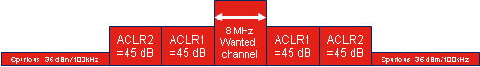
Figure 36: Assumed out-of-band emission for BS-like WSDs

UE-like OOB emissions: ACLR1 = 30 dBc, for larger frequency offsets spurious emissions -36 dBm/100 kHz.

Figure 37: Assumed out-of-band emission for UE-like WSDs

Narrowband WSD system (interferer)
No OOB specs for narrowband WSDs are available yet, so that only the MCL method can be applied to those. This implies that no special assumptions on this device type are required except that slightly different LTE UE selectivity figures have to be considered. This is addressed in section 6.3.1.5 below.
A WSD would classify as a narrowband device in the sense of this differentiation if its occupied bandwidth is in the order of 1-2 MHz or less.

WSD emissions within LTE UE wanted channel
Note that the spurious emissions requirements are given as absolute powers and are thus independent from the in-band transmit power of the WSD. In cases where WSD spurious emissions fall into the victim wanted channel it is therefore possible that the maximum possible level of spurious emissions itself is limited by the combination of I/N threshold and coupling gain.
Therefore, WSD emissions falling into the victim system’s wanted channel are assumed to be subject to a regulatory baseline level, which is independent of frequency offset. This concept is illustrated in Figure 38.
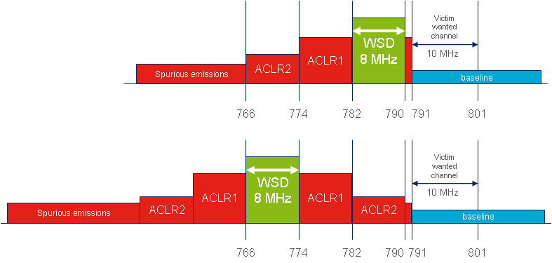
Figure 38 WSD emissions within victim wanted channel assumed to be limited by a regulatory baseline level
Instead of using a generic value for the baseline limit, scenario-specific assumptions are made in this study since the combination of (scenario-specific) allowable in-band emission limit and baseline limit results in a certain ACLR requirement. It is expected that different ACLR limits will be achievable for different WSD types. The assumed baseline limits are stated in the scenario descriptions in section 6.3.3 below.

Mobile system (LTE)
The LTE system is modelled as a 10 MHz FDD system, downlink (BS transmit, UE receive) operating in
791-801 MHz. LTE UEs are assumed to have an omni antenna (0 dBi gain), noise figure 6 dB, and are located at 1.5 m height above local ground.
A receiver bandwidth of 9 MHz is assumed, which leads to a thermal noise floor of -104.43 dBm.
Adding a noise figure of 6 dB leads to a LTE UE receiver noise floor of -98.43 dB.

LTE UE selectivity
The LTE UE selectivity characterises the ability of the UE to operate in the presence of unwanted signals outside its operating channel. The RF performance of UE terminals is defined in 3GPP specification TS 36.101 [20], and the UE selectivity in the 470-862 MHz band is defined in section 7.6.2 “Out of band blocking” in 3GPP specification TS 36.101 [20]. The relevant part of the requirements table is copied below.
Table 31: 3GPP TS 36.101 [20] (Table 7.6.2.1-2: Out of band blocking)
E-UTRA band | Parameter | Units | Frequency
E-UTRA band | P_{Interferer} | dBm | range 1 | range 2 | range 3
E-UTRA band | P_{Interferer} | dBm | -44 | -30 | -15
790-862 MHz band (LTE Band 20) | F_{Interferer} (CW ) | MHz | FDL_low -15 to  FDL_low -60 | F_{DL_low} -60 to  F_{DL_low} -85 | F_{DL_low} -85 to  1 MHz
790-862 MHz band (LTE Band 20) | F_{Interferer} (CW ) | MHz | F_{DL_high} +15 to  F_{DL_high} + 60 | F_{DL_high} +60 to  F_{DL_high} +85 | F_{DL_high} +85 to  +12750 MHz

This requirement applies for a desensitisation (i.e. degradation of receiver sensitivity) of 6dB with a reduction in data throughput of less than 5%. The receiver sensitivity specification in the absence of unwanted signals is -97 dBm for a 5 MHz channel and -94 dBm for a 10 MHz channel.
The receiver blocking requirement is “band independent” – i.e. it applies to all bands (with one exception) in the 3GPP specifications. However, it is recognised that, in practice, the performance of UE will be significantly better than 3GPP specifications, because of the characteristics of the duplexers currently used in terminals. This typical out-of-band performance can be derived by combining the 3GPP in-band performance requirements (which do not assume any benefit from RF filtering) with the assumed performance of a duplexer for this band.
A number of manufacturers produce duplexers for terminals for this frequency band, but only one has published the specification for its device. The data sheet provides a specification below 750 MHz; between 750 MHz and 790 MHz, measured values can be read from a frequency response plot.
Table 32: Characteristics of B7679 duplexer filter
Characteristics Antenna-RX, 0.3-750 MHz
 | Absolute attenuation | Passband insertion loss | Rejection
Typical @25ºC | 53dB | 2.6dB | 50.4dB
Worst case | 40dB min | 4dB max | 36 dB min

These characteristics will have been measured in a test jig. When the device is installed in the phone, the performance will inevitably be worsened to some degree by a number of factors:
- leakage across the duplexer, eg coupling between PCB tracks and through other components such as switches for other bands;
- Mutual ground impedance;
- Impedance mismatch (especially for the antenna, which will vary with surroundings);
- Temperature drift and manufacturing tolerance (for typical values).

The RF selectivity for some frequency offsets can be estimated from the 3GPP ACS and blocking requirements (see 3GPP TS 36.101 [20]). The resulting numbers are illustrated in Figure 39. It should be noted that the blocking requirement (used for channel 59 and below) assumes a 6dB degradation of the receiver sensitivity for a 10 MHz LTE channel.
The ACS for the first 5 MHz outside the LTE wanted channel is 33 dB. The first in-band blocking requirement is to be tested at 10 MHz offset, and the required suppression is ~33 dB as well. At 15 MHz offset the second in-band blocking requirement implies a suppression of 45 dB, which, according to the first OOB blocking requirement, can then assumed to be flat (the increase for the out-of-band blocking can be assumed to be due to the duplexer). For larger offsets the suppression of OOB interference increases further until it reaches 75 dB at 80 MHz offset.

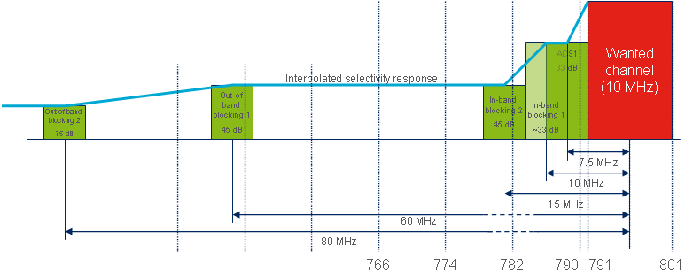
Figure 39: RF selectivity
Assumptions on LTE UE ACS values for the different UHF channels have to be made differently for wideband WSDs (i.e. WSDs using a whole 8 MHz channel) and narrowband WSDs. In the following the assumptions for both cases are explained.
WSDs using 8 MHz wide channels
Based on these values it is possible to calculate the ACS for the first couple of TV channels when interferers are using 8 MHz instead of 5 MHz bandwidth. For channels 56 to 59 this is straightforward; the ACS is 45 dB. For channel 60, the ACS has to be averaged over 33 dB for the upper 6.5 MHz of the channel, and 45 dB for the lower 1.5 MHz of the channel. This averaging is done according to
. (3)
Interference coming from the TV band will be additionally attenuated by the LTE UE’s duplex filter. It is difficult to estimate the duplexer performance from the existing 3GPP requirements, since those target at defining the suppression of the UE’s transmit frequency range (i.e. frequencies above 821 MHz), and current filter technology typically has asymmetric frequency responses (i.e. the shape of the filter response at frequencies above the pass band is different from below the pass band). It is however possible to estimate the actual resulting total selectivity (contributions from RF plus duplexer) by studying data sheets of duplexers currently available on the market. The values in the table below represent conservative assumptions based on expected duplexer performance across different duplexer vendors and device platform manufacturers.
The duplexer suppression is modelled according to the values listed in Table 33 below. These values include margins for temperature drift, manufacturing tolerance, aging, and losses when integrated on a printed-circuit board (PCB) compared to the stand-alone measurement performance typically found in data sheets. The assumed duplexer suppression has to be summed up with the ACS due to RF selectivity as explained above. The resulting total ACS figures are given in Table 33 below for reference.
Table 33: ACS values used in simulations for WSDs using 8 MHz bandwidth
 | RF selectivity | Duplexer suppression | Total ACS
Ch. 60  782-790 MHz | 34 dB | 3dB | 37 dB
Ch. 59  774-782 MHz | 45 dB | 25 dB | 70 dB
Ch. 58  766-774 MHz | 45 dB | 35 dB | 80 dB
Ch. 57  758-766 MHz | 45 dB | 45 dB | 90 dB
Ch. 56 and below | 45 dB | 50 dB | 95 dB

Narrowband WSDs
For narrowband WSDs the values that are valid for the upper edge frequency of a UHF channel have to be used instead of values averaged over the whole channel. For the RF selectivity contribution it is hence appropriate to consider 33 dB suppression for interferers in channel 60; for the other channels the RF selectivity assumptions are the same as for the wideband case. The duplexer contributions need to be modified in order to represent the value at the upper edge of a TV channel instead of an average over the whole channel.
For narrowband WSDs the values as shown below should be used.
Table 34: ACS values used in simulations for narrowband WSDs
 | RF selectivity | Duplexer suppression | Total ACS
Ch. 60  782-790 MHz | 33 dB | 0.5 dB | 33.5 dB
Ch. 59  774-782 MHz | 45 dB | 15 dB | 60 dB
Ch. 58  766-774 MHz | 45 dB | 30 dB | 75 dB
Ch. 57  758-766 MHz | 45 dB | 40 dB | 85 dB
Ch. 56 and below | 45 dB | 50 dB | 95 dB

Interference modeling

MCL analysis
For MCL analysis interference is calculated based on WSD leakage into LTE UE wanted channel (according to assumptions on baseline emission limits as described below), see the area marked in green in Figure 40, and LTE UE selectivity within the WSD wanted channel (according to total ACS (RF + duplexer)) as indicated by the blue area in the below figure. Contributions from other frequency ranges (i.e. frequencies below the blue area, between blue and green area, and above green area) are neglected. This is equivalent to the approach that has been used for the MCL analysis results in ECC Report 159 [1].
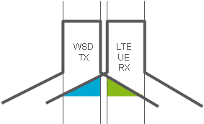
Figure 40: WSD leakage into LTE UE
The blue area in Figure 40 is calculated (in logarithmic domain) as:

The green area in Figure 40 is calculated (in logarithmic domain) as:

The maximum permitted interference power (in logarithmic domain) is calculated as:

The maximum permitted interference power (in linear domain) should not exceed the sum of the blue area and the green area (both specified in linear domain). Therefore, in the maximum case:

Consequently, within MCL analysis the WSD e.i.r.p. limit is calculated according to the formula:

where
is the WSD e.i.r.p. limit,
is the required I/N threshold,
is the LTE UE receiver noise floor (thermal noise plus noise figure),
is the baseline emission limit,
is the minimum coupling loss,
is the adjacent channel selectivity.

Scenarios
The range of deployment scenarios for WSDs considered for the scenarios encompasses:
- Wide area base station (mounted on a mast or on roof of higher building);
- Portable device or similar to WLAN access point (same height as LTE UE and potentially very short distance);
- fixed wireless access Customer Premise Equipment (CPE) (somewhat higher as LTE UE and has directional antenna).
Victim: typical LTE UE

Scenario 1: WSD deployed as wide area base station
The WS BS antenna consists of three sectors with typical 120 degree antennas (ITU-R F.1336 [18], average model) with 17 dBi gain in main direction, 30 m antenna height, 3 degree mechanical down-tilt.
However, for MCL analysis only one sector needs to be modelled. In this case a fixed geometry is considered where the distance between the victim and the interferer is assumed to be 20 m in the horizontal plane. Together with the antenna heights of 30 m for the WSD and 1.5 m for the LTE UE this means that the elevation angle at which the vertical antenna diagram of the WSD antenna has to be read is 52 degrees. According to ITU-R Recommendation F.1336 [18] the suppression at this angle for a 120 degree sector antenna with 17 dBi max.gain (k-value = 0.7, peak model used) is 14.86 dB. The corresponding free space path gain considering antenna heights is 60.73 dB, leading to a total MCL of 75 dB.
The baseline emission level within the victim’s wanted channel has to be below the theoretical limit of receiver noise floor plus I/N plus MCL (-98.4 + 75 + I/N dBm/10 MHz = -26.4 + I/N dBm/5 MHz in this scenario). For the purpose of this study, a baseline level of -65 dBm/5 MHz for emissions above 790 MHz (see Section 6.3.1.1) has been assumed. This value is based on the assumption that such values are technically feasible (especially given that the results of the study indicate that WSDs would likely not be operating in channel 60, leaving an 8 MHz roll-off space for reaching the baseline level) and that WSD device manufacturers would try to maximize the allowable in-band transmit power by minimizing the unwanted emissions (note that there is a trade-off between allowable in-band power and OOB emission levels as shown below).
The COST-Hata propagation model is used to construct the link budget although this model was intended originally for the frequency range 1 500 to 2 000 MHz. Using the COST-Hata propagation model to construct the link budget is a reasonable approach noting that the results would be the same as the Hata or Extended Hata propagation models which apply below 1 000 MHz, except for dense urban (metropolitan) environments where the results differ by 3 dB.

Scenario 2: portable WSD or user-deployed access point
An omni-directional antenna with 0 dBi gain is assumed for portable WSDs.
Both LTE UE and WSD UE antennas are assumed to be at 1.5 m agl leading to no additional suppression from the vertical antenna pattern of the WSD antenna.
For MCL analysis, a distance of 2 m is assumed between the victim and the interferer, leading to an MCL of 36.53 dB.
The baseline emission level within the victim’s wanted channel has to be below the theoretical limit of receiver noise floor plus I/N plus MCL (-98.4 + 36.5 + I/N dBm/10 MHz = -64.9 + I/N dBm/5 MHz in this scenario). For the purpose of this study, a baseline level of -85 dBm/5 MHz for emissions above 790 MHz (see Section 6.3.1.1) has been assumed. This value is based on the assumption that such values are technically feasible (especially given that the results of the study indicate that portable WSDs would likely not be transmitting in channels 59 and 60, leaving a 16 MHz roll-off space for reaching the baseline level) and that WSD device manufacturers would try to maximize the allowable in-band transmit power by minimizing the unwanted emissions (note that there is a trade-off between allowable in-band power and OOB emission levels as shown below).
Recommendation ITU-R P.1411 [21] or free space is used to construct the link budget between victim and interferer.

Scenario 3: WSD deployed as fixed mounted CPE
The WSD CPE is assumed to be mounted at 10 m height. The Yagi antenna according to ITU-R BT.419-3 with 10 dBi gain, always pointing to a serving BS location, is considered. No downtilt on the WSD antenna is assumed.
For MCL analysis a distance of 10 m in the horizontal plane is considered. This leads to an elevation angle of 40 degrees, which corresponds to a suppression of 7.32 dB.
The baseline emission level within the victim’s wanted channel has to be below the theoretical limit of receiver noise floor plus I/N plus MCL (-98.4 + 60.2 + I/N dBm/10 MHz = -41.2 + I/N dBm/5 MHz in this scenario). For the purpose of this study, a baseline level of -65 dBm/5 MHz for emissions above 790 MHz (see Section 6.3.1.1) has been assumed, based on the same considerations as described in scenario 1 above.
Recommendation ITU-R P.1411 [21] or free space is used to construct the link budget between victim and interferer.

Calculation results (MCL analysis)

Scenario 1: WSD deployed as wide area base station
Figure 41: e.i.r.p. limit for narrowband WSD deployed as wide area base station

Figure 42: e.i.r.p. limit for wideband WSD deployed as wide area base station
For both cases it can be observed that in this scenario WSD usage on channel 60 is only possible with transmit powers that likely are in practice prohibitively low for a base station. For channels 59 and 58 and for some cases also channel 57 limits below typical maximum e.i.r.p. levels of base stations are needed (note that typical BS antenna gains are in the order of 17 dBi). From channel 56 and onwards no further limitations (except those needed for protection of broadcasting and PMSE) appear to be necessary.

Scenario 2: portable WSD or user-deployed access point
Figure 43: e.i.r.p. limit for portable narrowband WSD or user-deployed access point

Figure 44: e.i.r.p. limit for portable wideband WSD or user-deployed access point
For both cases WSD usage on channels 60 and 59 does not seem to allow practically useful transmit powers. Whether channel 58 can be of practical use will depend on the use case and requirements for the WSDs. Power levels that are typical for operation of portable devices seem to be possible with some limitations on channel 57 and onwards. It should be noted that except for an I/N threshold of only -10 dB power limits for portable devices below the typical EMF limit of 23 dBm are necessary also for channels 56 and lower.

Scenario 3: WSD deployed as fixed mounted CPE
Figure 45: e.i.r.p. limit for narrowband WSD deployed as fixed mounted CPE

Figure 46: e.i.r.p. limit for wideband WSD deployed as fixed mounted CPE
Also for scenario 3 the necessary limits on channel 60 seem to be too low to allow any practical usage. To what extent the channels 57-59 can be useful depends on the requirements for a given use case scenario. The limits needed for channels 56 and below seem not to limit usage for CPEs in practice but it might be advisable to establish regulatory certainty that these limits are not exceeded in practice.

Impact of the assumed baseline level
For a given I/N threshold the assumed baseline level settles what fraction of the total “interference budget” will come from WSD leakage into the LTE UE (victim) wanted channel, and thus influences the permissible in-band e.i.r.p. for a WSD. This is illustrated in Figure 47 at the example of channel 58 and I/N thresholds of -10 dB and -20 dB. Here it can be seen that if the baseline level is sufficiently below the theoretical maximum (which is defined by LTE UE noise floor plus allowed I/N minus MCL), the dependency of the WSD in-band e.i.r.p. is low. However, getting close to the maximum the allowable WSD in-band e.i.r.p. starts to drop significantly since leakage becomes the dominating interference mechanism.
Figure 47: Impact of the assumed baseline level

Conclusion
The studies for the protection of mobile services operating at 790-862 MHz seem to indicate that WSDs operation on TV Channel 60 and additionally for the particular case of portable WSDs on TV Channel 59 are generally not advisable for all scenarios. Also certain limitations in terms of maximum output power for WSDs operating in TV Channel 57 to 59 may be necessary.
For channel 56 and below the required e.i.r.p. limits do no longer depend on frequency offset since it is assumed that the LTE UE selectivity does not increase further beyond the corresponding frequency offsets. The allowable WSD e.i.r.p. levels on these channels seem not to be constraining the respective use case scenarios significantly.
It should be noted that these results are based on a number of assumptions, particularly with regard to the WSD baseline levels, UE antenna gain, and the performance of the LTE duplex filters.

Protection of terrestrial cable head-end receivers
In general, there are two interference scenarios based on either inclusion into or exclusion from the broadcasting service area. Figure 48 shows some typical scenarios with the cable head-end installations being both inside and outside the stations’ service area for residential terrestrial receivers.
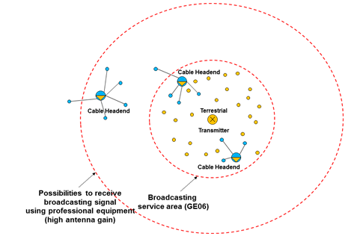
Figure 48: Typical scenarios for cable head end installations
It has been decided by the ECC that protection for cable head-end receivers outside the broadcasting service area should not be considered.
In many cases, the cable head-end will use an antenna with a high gain mounted high on a tower to receive TV station signals beyond the station’s service area for residential terrestrial receivers.
Regarding the cable head-end protection outside the broadcasting service area, this scenario is a national issue that an administration may wish to consider. For example, this can be achieved by definition of so-called exclusion zones around each cable head-end installation situated outside the broadcasting coverage area, and subsequent recording of these exclusion zones in the geo-location database.
Considering the cable head-end receivers within the broadcasting service area the following approach is applicable. ECC Report 159 [1] defines the protection criteria for the broadcasting service for different reception modes and receiving environment. The technical and operational requirements to WSD are established to protect receivers within the GE06 service area. Understanding that cable head-end receivers are the receivers of terrestrial broadcasting services, it is reasonable to assume that their protection may be covered in a similar way as it was done for residential receivers in ECC Report 159 [1].

Amount of white space spectrum potentially available for WSDs in the band 470-790 MHz

Summary on previous studies
ECC Report 159 [1] specifies that the amount of spectrum available for WSDs depends upon a number of factors including decisions on the level of protection given to the incumbent services and how well the WSD can cope with interference from these incumbent services and other WSDs.
The exact amount of available spectrum at any location will be dependent upon each national situation or circumstances (e.g. DTT planning configuration, PMSE use, Radio Astronomy use). The objectives of the study presented in ECC Report 159 [1] were to provide a general methodology to assess the amount of spectrum potentially available and some examples of the technical parameters that will be required to protect incumbent services based on specific scenarios.

Result of studies
Case study of Germany (Bavaria region) is provided in Annex 11 (Section 11.1).
Case study of the UK is provided in Annex 11 (Section 11.2).
Case study of Poland is provided in Annex 11 (Section 11.3).
Case study of Finland is provided in Annex 11 (Section 11.4).

Conclusions
With this report the CEPT complements ECC Report 159 [1] with additional technical investigations required to facilitate development of the regulation for WSDs in the band 470-790 MHz. In particular:
- A classification of WSDs is proposed and possible approaches (database, hardware, and firmware) to set up fixed maximum permitted power limits for WSDs are considered. In this respect, the conclusions from ECC Report 159 [1] are still valid;
- Some considerations on the collaborative spectral sensing are provided concluding that WSDs receiving weak primary user signals can benefit from cooperative sensing to better detect the signal presence, thus overcoming site-specific bad channel conditions;
- Some basic parameters (location probability, coverage assessment) crucial for the protection of the broadcasting service are explored. Additionally, the performance of DTT receivers in the presence of interference from WSDs has been measured suggesting that
- a number of issues will have to be considered and addressed by regulators when designing the algorithms and protection ratios to be used in the geo-locations databases in order to provide adequate protection for DTT services from interference from WSD deployments;
- more stringent protection ratios may be required for particular combinations of certain DTT receivers and candidate WSD technologies particularly in their idle or low traffic states, as appropriate, which has the potential to reduce considerably the power levels and spectrum that will be made available for WSDs.
- The protection of PMSE systems has been studied, including the measurements of carrier-to-interference protection ratios and overloading thresholds for different candidate WSD technologies, revealing that:
- in line with the previous conclusions from ECC Report 159 [1], sensing techniques have not yet reached a point where it can provide reliable protection for PMSE systems and no practical way of implementing beacons has been found;
- the usage of geo-location databases appears to be the only practical way forward to protect the needs of PMSE users as long as they can manage protection of PMSE use at both permanent and temporary venues within suitable timescales;
- co-channel operation of PMSE and WSDs is not possible in the vicinity of PMSE receivers. One approach to manage interference to PMSE receivers is to calculate appropriate exclusion zones based on the power of the WSD transmitter between WSD and PMSE;
- the database should be able to take into account potential intermodulation effects as the result of WSDs operation that can block PMSE signals. This may involve excluding a number of channels for use by WSDs in the vicinity of PMSE users in addition to the channels used by these PMSE users.
- The protection of the ARNS systems operating in the 645-862 MHz band is found to require a considerable separation distance, taken into account the protected field strengths provided in Recommendation ITU-R M.1830 [14];
- The studies on the impact of WSD interference on services, which are operated in adjacent bands to the 470-790 MHz, have been conducted based on the assumed parameter values and revealed that:
- for the assumed emitted power and WSD density, WSD interference into TETRA TEDS (25 kHz) operating at 450-470 MHz is not significant;
- the protection of CDMA-PAMR operating at 450-470 MHz may require the maximum power of fixed WSDs operating on TV Channel 21 to be limited; the limitation will be dependent of the accepted capacity loss, environment (urban or rural areas) and CDMA-PAMR cell radius.
- the protection of mobile services operating at 790-862 MHz seems to indicate that WSDs operation on TV Channel 60 and additionally for the particular case of portable WSDs on TV Channel 59 are generally not advisable for all scenarios. Also certain limitations in terms of maximum output power for WSDs operating in TV Channel 57 to 59 may be necessary.
- Regarding the considerations on the cable head-end protection within the broadcasting service area, it is reasonable to assume that their protection may be covered in a similar way as it was done for residential receivers in ECC Report 159 [1]. In addition, it was concluded that consideration of the cable head-end protection outside the broadcasting service area is a national issue.
- Amount of spectrum potentially available for WSDs varies on a case-by-case basis as shown in a number of example studies.

- Example Link budget calculations to derive e.i.r.p. values for white space devices
  - WSD’s parameters
The parameters assumed for outdoor and indoor WSDs are listed, respectively, in Table 1 and Table 2 of Section 2.2.2.
The Shannon formula was used to compute the signal-to-noise ratio as a function of the transmission bandwidth and the data rate. It was then assumed that the WSDs are performing 2 dB off from the Shannon capacity bound.
  - Propagation calculations
The Okumura-Hata model for open land and rural area was used to calculate the path loss in outdoor scenario. The base station and user terminal were assumed to be at 30 m and 1.5 m height, respectively.
For indoor path loss calculations the model described in Recommendation ITU-R P.1238-6 [19] was applied. It should be noted that this model is adopted for the assessment of the propagation characteristics of indoor radio systems between 900 MHz and 100 GHz. However, as the path loss difference between the frequency 900 MHz and, for example, the frequency 600 MHz is only about 3.5 dB, the usage of Recommendation
ITU-R P.1238-6 [19] was considered acceptable, at least, to a 1st order approximation. The distance power loss coefficient of 33 was used. The access point and the user terminal were assumed to be on the same floor (i.e. no floor penetration loss was considered).
The outdoor and indoor shadow fading statistics were assumed to be log-normal with the standard deviation of 5.5 dB. Gaussian confidence factor µ of 1.64 was used that relates to target location percentage of 95%. The shadowing margin related to the variation of the signal can be then calculated as dB.
  - Link budget assessment
Thermal noise power N_{T} is calculated using Boltzmann's equation:
N_{T} = kTB (6)
where k is the Boltzmann’s constant,
T is the temperature,
B is the receiver bandwidth.
Receiver inherent noise (noise figure) is used to compute the receiver noise floor N:
N = N_{T} + F (7)
where F is the noise figure.
With signal-to-noise ratio SNR the receiver sensitivity C is determined:
C = SNR + N (8)
In order to account for the increase in the thermal noise level caused by other interference sources an interference margin IM of 3 dB is further assumed.
With the path loss calculated over the expected operation range it becomes then possible to determine the required transmitter e.i.r.p.:
e.i.r.p = C + Lb + IM – Gi (9)
where Lb is the path loss including the shadow fading statistics,
Gi is the receiver antenna gain.
  - Results
Example of details of links budget calculations are given in Table 35 and Table 36 for outdoor and indoor WSDs, respectively. Note that in the outdoor link budget the data rate, signal to noise ratio and range can be traded so that with a higher data rate (for example 10 Mbps) a higher C/N is required and the range is reduced with the same e.i.r.p. Alternatively, an increased e.i.r.p. figure and/or increased antenna gain could enable higher data rates to be achieved.
Table 35: Link budget calculations for outdoor WSD categories
Parameter | Base station | User equipment | M-to-M
Date rate (Mbps) | 1 | 0.128 | 0.5
Transmission bandwidth (MHz) | 8 | 0.360 | 1
Thermal noise (dBm) | -104.9 | -118.4 | -114.0
Receiver noise figure (dB) | 7 | 5 | 7
Receiver noise floor (dBm) | -97.9 | -113.4 | -107.0
Signal-to-noise ratio (Shannon + 2 dB) (dB) | -8.4 | -3.5 | 5.0
Receiver sensitivity (dBm) | -106.4 | -116.9 | -102.0
Interference margin (dB) | 3 | 3 | 3
Maximum operational range (km) | 10 | 10 | 20
Propagation loss (dB) | 139.5 | 139.5 | 121.7
Receiver antenna gain (dBi) | 0 | 8 | 12
Required e.i.r.p. (dBm) | 36.2 | 17.6 | 19.7
Required e.i.r.p. (mW) | 4118 | 57 | 93.5
Table 36: Link budget calculations for indoor WSD categories
Parameter | Base station | User equipment | Access point
Date rate (Mbps) | 10 | 5 | 100
Transmission bandwidth (MHz) | 8 | 4 | 22
Thermal noise (dBm) | -104.9 | -108 | -100.5
Receiver noise figure (dB) | 7 | 7 | 7
Receiver noise floor (dBm) | -97.9 | -101 | -93.6
Signal-to-noise ratio (Shannon + 2 dB) (dB) | 10 | 5 | 15.5
Receiver sensitivity (dBm) | -87.9 | -96 | -78.1
Interference margin (dB) |  |  | 3
Maximum operational range (km) | 0.015 | 0.015 | 0.05
Propagation loss (dB) | 52 | 52 | 93.1
Receiver antenna gain (dBi) | 0 | -4 | 0
Required e.i.r.p. (dBm) | 14.0 | 2.0 | 18.0
Required e.i.r.p. (mW) | 25.1 | 1.6 | 63

- WSD fixed maximum power limits’ calculation based on overload threshold
  - INTRODUCTION
DTT receivers present limitations with respect to the interference level that they can handle. Above a certain level of interference, overloading effects arise and the receiver begins to lose the ability to discriminate the wanted signal from the interference one. These effects are independent of the receiver location, the wanted DTT field strength, and the location probability degradation.
Therefore, the protection of DTT receivers against overloading effects leads to fixed maximum levels of permissible interference at the receiver. As a consequence fixed maximum WSD e.i.r.p. limit can be calculated by considering the maximum permissible levels of interference and the reference geometries for WSD transmitters and DTT receivers.
  - WSD e.i.r.p. LIMITS based on DTT overloading
The maximum WSD e.i.r.p. can be limited by consideration of protecting the DTT receiver from overload, using the following equation:
P_{t} ≤ O_{th} – µ_{x%}σ_{wsd} + POL + DISC_{TV} + DISC_{WSD} – G_{a} + LOSS(d)
Using this Equation the maximum WSD e.i.r.p. limits are calculated for the scenarios given in Annex 2 of [4]. We use the overload threshold values given below.
Table 37: 10th percentile O^{th} values taken from Tables 5b and 7b of ECC Report 148 [5]
Adjacent channel | DVB-T Oth for 64-QAM 2/3 DVB-T signal (dBm)
 | BS (constant average power) | UE (TPC off)
 | Fixed or Mobile DTTB reception | Fixed or Mobile DTTB reception*
1 | -13 | -23 (to -19)
2 | -8 | -46 (to -5)
3 | -19 | -47 (to -26)
4 | -13 | -44 (to -11)
5 | -8 | -43 (to -7)
6 | -6 | -41 (to -7)
7 | -5 | -39 (to -5)
8 | -5 | -35 (to -7)
9 | -6 | -32 (to -10)

*For each adjacent channel, the values in parenthesis are the minimum of the maximum values for the ‘can’ receivers and the ‘silicon’ receivers in Table 7b of ECC Report 148 [5].

The results are presented below.
Table 38: WSD UE and BS maximum e.i.r.p. levels (dBm)
Adjacent channel # | Scenario #
Adjacent channel # | UE* WSD (dBm) |  |  | BS WSD (dBm)
Adjacent channel # | #1 | #2 | #3 | #4 | #5 | #7** | #8
1 | 13.6 | 11.7 | -1.3 | 24.8 | 39.5 | 40.3 | 52.7
2 | -9.4 | -11.3 | -24.3 | 29.8 | 44.5 | 45.3 | 57.7
3 | -10.4 | -12.3 | -25.3 | 18.8 | 33.5 | 34.3 | 46.7
4 | -7.4 | -9.3 | -22.3 | 24.8 | 39.5 | 40.3 | 52.7
5 | -6.4 | -8.3 | -21.3 | 29.8 | 44.5 | 45.3 | 57.7
6 | -4.4 | -6.3 | -19.3 | 31.8 | 46.5 | 47.3 | 59.7
7 | -2.4 | -4.3 | -17.3 | 32.8 | 47.5 | 48.3 | 60.7
8 | 1.6 | -0.3 | -13.3 | 32.8 | 47.5 | 48.3 | 60.7
9 | 4.6 | 2.7 | -10.3 | 31.8 | 46.5 | 47.3 | 59.7
* The O_{th} values used relate to ‘TPC off’; with ‘TPC on’, the values of O_{th} become smaller and the corresponding values of ‘UE maximum e.i.r.p.’ become smaller by the same amount.
** Note: because the propagation path is greater than 40 m, σ_{wsd} = 5.5 dB was used.
  - DTT ADJACENT CHANNEL CONFIGURATIONS
WSD power limits should be based on the limit in each column/Scenario (or set of related columns/Scenarios, e.g. Scenarios #1 & #2 and possibly #3, Scenarios #4 & #5, Scenarios #7 & #8).
  - CONCLUSIONS
The following conclusions refer to the results given in Table 38
SCENARIOS #1 AND #2
Scenarios #1 and #2 correspond to WSD UE protection of fixed DTT reception. Scenario #2 is about 2 dB more stringent than Scenario 1.To protect fixed DTT reception in all adjacent channel configurations, a maximum UE power limit would have to be set in the range -12.3 to 2.7 dBm depending on the frequency offset.
SCENARIO #3
Scenario #3 corresponds to WSD UE protection of portable outdoor DTT reception. Scenario #3 is about 15 dB more stringent than Scenario 2. To protect mobile DTT in all adjacent channel configurations, a maximum UE power limit would have to be set in the range -25.3 dBm to -10.3 dBm depending on the frequency offset.
SCENARIOS #4 AND #5
Scenarios #4 and #5 correspond to WSD BS (at 10 m height) protection of fixed and portable DTT reception, respectively. Scenario #4 is up to 16 dB more stringent than Scenario #5.
To protect fixed DTT reception in all adjacent channel configurations, a maximum BS power limit would have to be set in the range 18.8 dBm to 32.8 dBm depending on the frequency offset.
To protect portable outdoor DTT reception in all adjacent channel configurations, a maximum BS power limit would have to be set in the range 33.5 to 47.5 dBm depending on the frequency offset.
SCENARIOS #7 AND #8
Scenarios #6 and #7 correspond to WSD BS (at 30 m height) protection of fixed and portable DTT reception, respectively. Scenario #7 is up to 12 dB more stringent than Scenario #8.
To protect fixed DTT reception in all adjacent channel configurations, a maximum BS power limit would have to be set in the range 34.3 dBm to 48.3 dBm depending on the frequency offset.
To protect portable outdoor DTT reception in all adjacent channel configurations, a maximum BS power limit would have to be set in the range 46.7 to 60.7 dBm depending on the frequency offset.
A further restriction concerning Scenarios #7 an #8 is the following. If 30 m BS transmit antennas are foreseen, this type of usage should be restricted to rural areas. In urban environments, fixed DTT receive antenna installations might also be foreseen at 30 m. In this case the WSD e.i.r.p. restrictions mentioned above for Scenario #6 would be the same as that calculated for Scenario #4.
Furthermore, with respect to Scenarios #5 and #8 when portable DTT reception is to be protected, because of the portability of the mobile DTT apparatus, the siting of such equipment can also be located at higher than 1.5 m (e.g. at 10 m or 20 m at the window of a high rise).
Another major concern is the overload situation in the channels outside of N ± 9. According to Tables 5b and 7b of ECC Report 159 [1], for any given interference configuration, the overload threshold values are, in general, ‘relatively constant’ over the range N + 1 to N + 9 and N – 1 to N – 8. If this same behaviour extends much above channel N + 9 and/or below channel N – 8, then the adjacent channel WSD e.i.r.p. restrictions would have to cover this extended adjacent channel range as well. In other words, a WSD which wishes to use channel N + 12 within a channel N DTT coverage area should be subject to the same e.i.r.p. limitations – at least this is a matter to be studied further.

- Example spectrum sensor implementation and field test results
  - Spectrum sensor implementation
    - Spectrum sensor embedded to a mobile device
In order to conduct field tests using a device with realistic form factor a spectrum sensor was embedded into a Nokia N900 mobile computer with all functionalities. The choice caused some extra challenges since the N900 has not been designed for a mobile TV receiver. Spectrum sensor hardware has been designed on a separate printed circuit board (PCB) and it has been equipped with hardware which enables to receive desired frequency bands and realize all spectrum sensor functionality, see Figure 49. Figure 50 shows the two complete signal paths that have been implemented on the PCB from an antenna element to a FPGA (Field-programmable Gate Array). Two separate RF frontend chips were required: one for UHF frequencies and one for IEEE Standard 802.11a/b/g (2.4/5.8 GHz) [9]. The used RF receivers are commercial RFIC (RF Integrated Circuits) and they are controlled by the FPGA. The analogue baseband data is digitized for the FPGA using two dual 10 bit AD converters operating at maximum rate of 80 MHz, depending on the system under detection. Feature detector algorithms for spectrum sensing have been implemented on the FPGA.
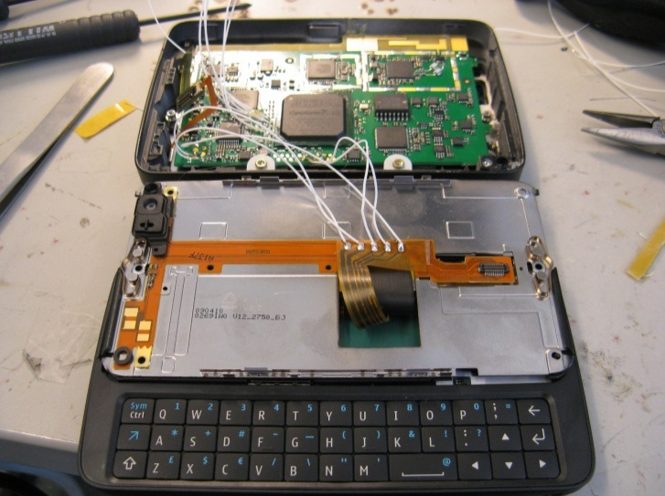
Figure 49: The spectrum sensor detector board inside N900 mobile phone

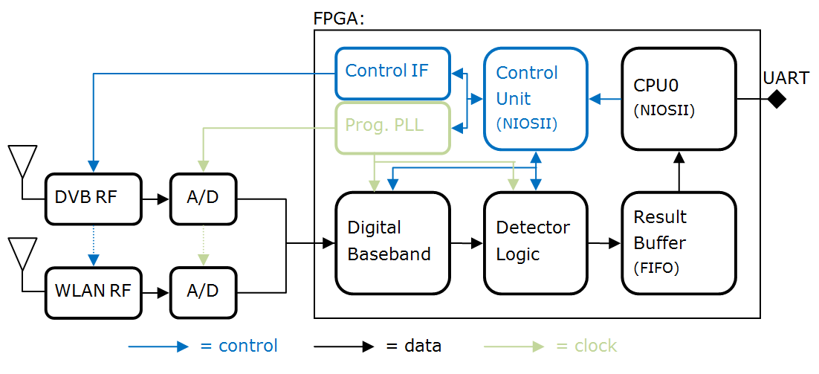
Figure 50: Blocks on the detector board
Communication between sensor board and the mobile device is done using a universal asynchronous receiver/transmitter (UART). The data rate between the sensor board and mobile device is 1 Mbit/s.
The spectrum sensor board is located inside the display slider case of the device. A custom plastic riser, see Figure 51 was required between the display and the bottom of the case to allow sufficient space for the board. Sensor board is located just behind of the display and on top of the slider mechanic. The slider mechanic is made of metal, as is the background of the display element. To ensure sufficient antenna efficiency both antennas had to be placed to the fin of the plastic riser that is outside the metal frame. It should however be noted that this is only due to the fact that the device has not been designed for spectrum sensor use.
Antenna design, especially at UHF band, is the utmost challenge in a spectrum sensor design. Best efficiency can be achieved with external antennas but for consumer devices embedded antennas have become de facto solutions. Relative bandwidths of the both antennas, UHF and WLAN, are reasonably high. Size and the location of the antennas inside the mobile device limit their efficiency and matching as well as the surrounding mechanics. Sizes of the antennas has been tried to keep as small as possible without losing performance too much. Antenna miniaturization in a mobile device scale is more problematic for an UHF antenna due to its longer electrical (and physical) length compared to a WLAN antenna.
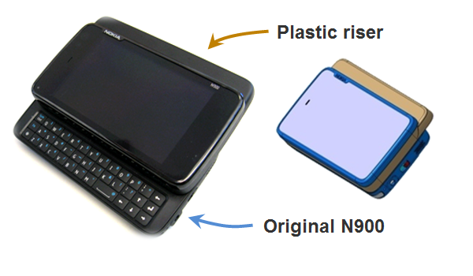
Figure 51: Spectrum sensor prototype implementation on N900 mobile phone
    - System requirements related to spectrum sensing
Two very different kinds of target systems were addressed: DVB-T as an example of rather static TV primary system and IEEE Standard 802.11a/g [9] as an example of system having very dynamic traffic characteristics. Goal was to implement sensing strategy to measure both temporal and spectral characteristics of target systems. Another aspect was to measure spatial channel utilization in the field. We ended up in this phase to traditional channel numbering instead of generalized notation for cognitive radios in order to simplify control.
TV primary sensing requirement by FCC is -114 dBm sensitivity level averaged over a 6 MHz channel. This corresponds to -112.7 dBm averaged over a 8 MHz DVB-T channel. In order to measure UHF channel utilization, selected strategy is to make single detection per channel at each studied location. This requires quite low false alarm rate e.g. 1% and high probability of detection e.g. 99%. Excluding antenna losses, the sensor prototype presented in this work could reach these requirements with a sensing time of approximately 115 ms. However, for the longest detection time, i.e. 460ms, the headroom for antenna losses is only about 5dB.
In order to understand practical limitations of the platform and analyse filed test properly the prototype and its core entities were characterized both separately and as a complete system.
    - Antenna
Two antennas were implemented inside the presented mobile spectrum sensing device. For UHF frequencies a commercial antenna based on planar technology has been used. Dimensions of the antenna are 45 mm x 5 mm and it has been designed to work at frequency range from 470 to 750 MHz (DVB-H EU). Antenna for 802.11a/b/g has been realized as a wideband structure which covers frequency range from 2 to 6 GHz. It has been implemented directly to the same PCB than the spectrum sensor. It requires slightly more area than the UHF antenna (32 mm x 8 mm).
Both antennas were measured with and without the device mechanics to understand differences compared to conventional stand-alone antenna testing, and to evaluate actual performance in the field. Measurement results for the UHF antenna are presented in Figure 52 (left) and wideband antenna in Figure 52 (right). Deterioration of the efficiency of the UHF antenna due to mechanics is significant (6-8 dB) at low frequencies. The wideband antenna behaves better and its efficiency deterioration due to mechanics is only 1-2 dB over the whole band. The efficiencies of the antennas are -18-(-7)/-3/-6-(-4) dBs at UHF/2.4/5 GHz bands, respectively, depending on the specific channel. The results clearly indicate the issue of antenna performance at UHF band in small devices.
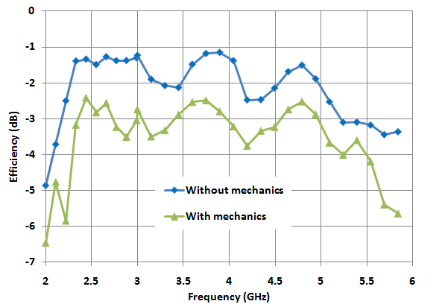
Figure 52: Efficiency of the UHF antenna (left) and for comparison the WLAN-antenna (right)
    - RF-parts
The used RF receivers are commercial RFIC and they are based on direct-conversion architecture. Baseband filters are adjustable and they support several bandwidths used in different standards. Block diagrams of the receivers are presented in
Figure 53. Typical noise figure (NF) of all receivers without front-end filter is around 4 dB depending on the band. Typical insertion-losses of front-end filter are 1.8 dB at UHF/2.4 GHz bands and 1.4 dB at 5 GHz band.

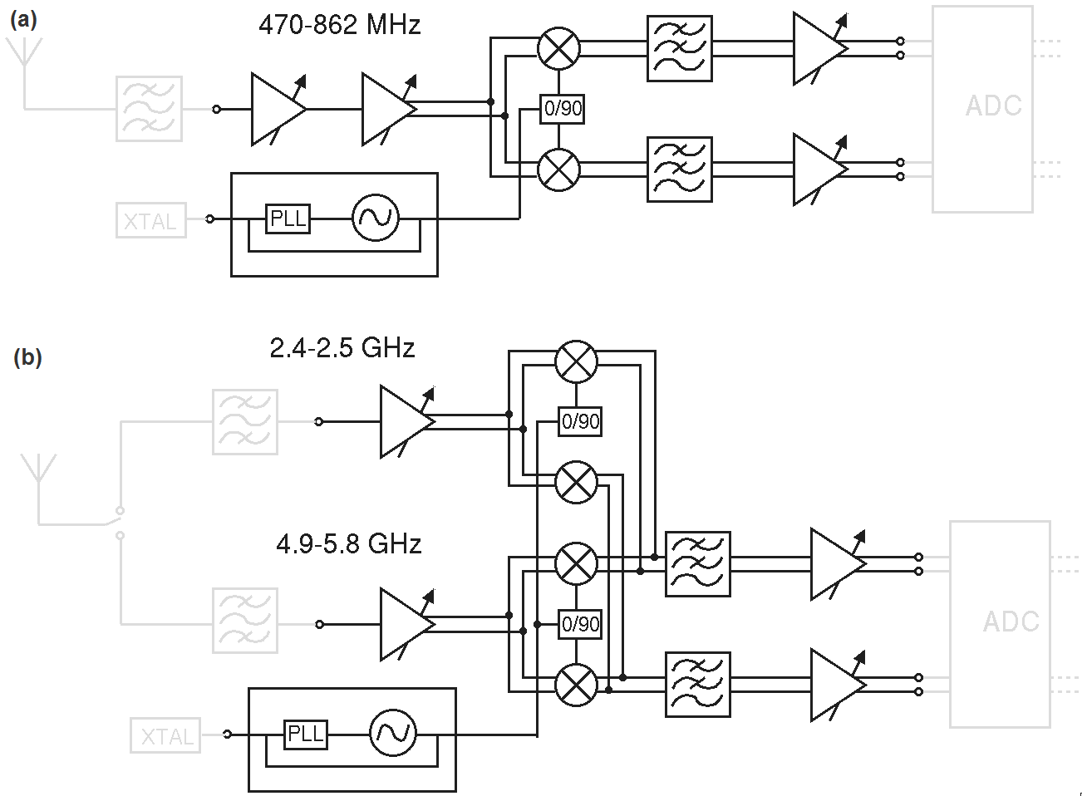

Figure 53: Block diagram of the UHF (a) and 802.11 a/b/g (b) receiver
    - Detector
Detector core on the FPGA is developed from the FFT-based cyclostationary feature detector formerly presented by the authors in [V. Turunen, et al, “Implementation of cyclostationary feature detector for cognitive radios,” in Proc. Int. Conf. Cognitive Radio Oriented Wireless Networks and Communications, 2009, pp. 1-4.]. The structure of the detector is shown in Figure 54. The fixed-size-FFT implementation utilizes decimation after autocorrelation to control the detection time. Test for the presence of cyclostationary at given cyclic frequency (α) is performed from the FFT of the decimated autocorrelation signal.
Figure 54: Structure of the implemented cyclostationary feature detector
In this implementation, the range of selectable decimation ratios is extended up to M=2048 to support longer detection times. Similarly, the maximum autocorrelation delay (Tmax) is increased to 8192. The modifications were required to enable detection of very long OFDM symbols used in DVB-T signals. The detector implementation utilizes 16k logic elements, 406k memory bits and 84 9-bit multiplier elements. The figures are 10.2%, 13.7% and 14.6% of all available resources on the FPGA, accordingly.
Detector sensitivity was measured for a WLAN signal at 2.4 GHz ISM band and for a DVB-T signal at the UHF band. Parameters related to modulation, signal bandwidth and transmit frequency of both systems are summarized in Table 39. During the measurements, the antennas were bypassed and the signal generator was connected directly to the RF receiver inputs, therefore the results exclude any antenna effects. The RF receivers operate at maximum gain. Detection times for WLAN and DVB-T were set to 0.8 ms and 460ms, accordingly. False alarm rate is 5%.
Table 39: Specifications of the primary signals used in detector performance measurements
 | WLAN | DVB-T
Modulation: | OFDM | OFDM
FFT-size (N_{FFT}) | 64 | 8192
Length of cyclic prefix (N_{CP}) | 16 | 1024
No. of non-zero subcarriers | 52 | 6817
Subcarrier modulation | 16-QAM | 16-QAM
Transmit frequency | 2437 MHz | 670 MHz
Bandwidth | 20 MHz | 8 MHz

The measured sensitivities are presented in Figure 55 (left) for DVB-T and in Figure 55 (right) for WLAN signal. DVB-T detection reaches 95% probability of detection when the received power is about -117 dBm, while for the WLAN detection received power of -102 dBm is required. Both figures are below the thermal noise floor. Figure 55 also show ideal simulation results for the same signals. The differences between simulated and measured probability of detections almost entirely match and are accounted by the non-zero noise figures of the RF receivers. The primary reason that DVB-T detection outperforms WLAN detection by such a large margin is the longer detection time that can be utilized in DVB-T detection. WLAN detection time is limited on the other hand by implementation, where larger FFT would be required to keep the cyclic frequency under the Nyquist frequency for larger decimation ratios, and on the other hand by duration of WLAN signal bursts which is already on the same scale with the detection time.
Figure 55: Measured DVB-T (left) and WLAN (right) probability of detection compared to simulated performance. Simulation utilizes ideal receiver (NF=0dB)
    - Platform Performance
Overall performance for the spectrum sensor hardware has been determined in the laboratory measurements. A 5 dB NF for UHF receiver path was measured at 660 MHz and it is only 1 dB more than NF of the pure UHF receiver. For dual-band 802.11a/b/g receiver, 5 dB and 6.5 dB NF at 2.427 and 5.130 GHz were measured, respectively. IIP3 of –10 dBm, -1 dBm and -1 dBm were measured for UHF, 2.4 and 5 GHz bands, respectively.
When combined with antenna results the overall sensitivity of the signal detection for DVB-T signals at UHF band will be from –100 to –108 dBm depending on the channel of interest. This is significantly higher than FCC requirements but shows feasible values for small devices if the integration time of the detection is kept reasonable. IIP3 of the UHF receiver with antenna corresponds 8 - (-3) dBm compared to 0 dB antenna in the field tests, At some channels platform noise caused by processors and other noisy components in the device will further deteriorate the performance. However, those could be mostly avoided with proper design when UHF band requirements will be taken into account initially in the design of the device and its mechanics. For WLAN OFDM signal detection, the sensitivities using parameters given earlier in this paper will be –101 and –98 dBm (2.4 /5 GHz) including the antenna.
  - Field measurements
Two sets of field tests were carried out in capital area in Finland. First measurement set was done mostly outdoors in urban Ruoholahti area in Helsinki. Two sensors were used, both using internal antennas. The measurement set consists of spectral samples from 37 different locations, shown in Figure 56. One spectral sample includes detection time, GPS location, band, channel, received signal strength in dBm and DVB-T detection statistics from UHF channels 34 to 60 (578-784 MHz). Detection time was set to 460 ms and detection statistics positive detection threshold to produce constant false alarm rate of 1%. Measured signal strengths are shown in Figure 57. Corresponding estimated probabilities of DVB-T detections on different channels are shown in Figure 58. There is DVB-H repeater in the area, detected on channel 35. Espoo TV transmitter station is transmitting on channels 32, 35, 44, 46, and 53.
Table 40: DVB-T transmitter parameters
DVB-T transmitters | Espoo | Tallinn
Latitude: | 60.1778 | 59.4713
Lognitude: | 24.6403 | 24.8875
Mast heigth: | 313 m | 272 m
Transmission power: | 47 dBm | 42 dBm
Occupied channels | 32, 35, 44, 46, 53 | 45, 59, 64

TV transmissions on measurement range are detected with high probability. Channel 59 is occupied by Tallinn TV transmitter on average 78 km away. Open source Splat! (http://www.qsl.net/kd2bd/splat.html) radio propagation calculation tool, using Longley-Rice Irregular Terrain Model (http://flattop.its.bldrdoc.gov/itm.html) and NASA SRTM-3 Version 2 Elevation Models (http://www2.jpl.nasa.gov/srtm/), was used for field strength estimation. Used transmitter parameters are shown in Table 40, receiver was assumed to be 3m above sea surface. Estimated field strength, shown in Figure 59 in Ruoholahti area is 20-60 dBµV/m. Field strength has large variation within 1 km radius in urban area. With measured prototype antenna efficiency of -7.5 dB, it corresponds -123 – (-83) dBm signal input power at the receiver. Taking measured detector sensitivity into account we end up 0.6 to 1 detection probability of Tallinn TV transmitter in Ruoholahti, Helsinki. Tallinn transmission on channel 45, adjacent to much stronger Espoo TV transmitter on channel 44 and 46, is masked and it cannot be detected. One must remember that transmissions from Tallinn are out of the reach for typical TV reception setups in Helsinki households.

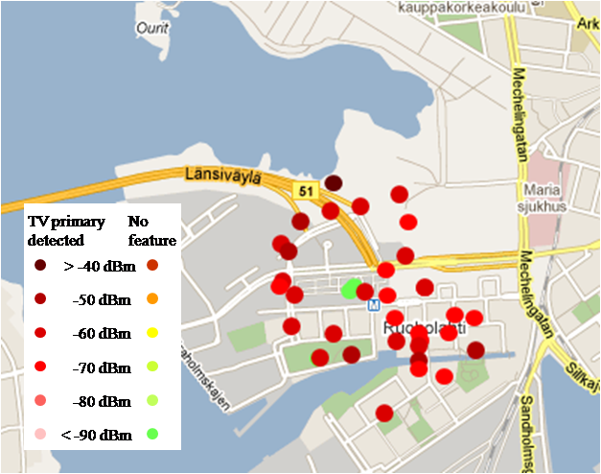
Figure 56: Measurements results on UHF channel 44 (658 MHz) in Ruoholahti, Helsinki

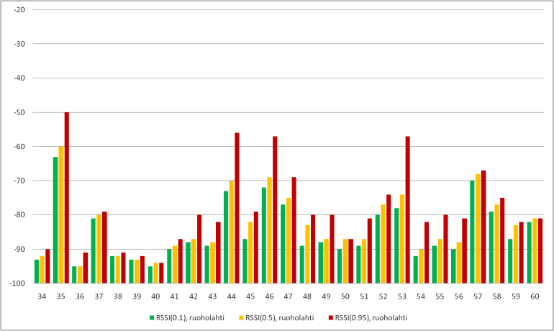
Figure 57: Received signal strength (RSSI [dBm]) upper limit for 10%,
50% and 95% of measured samples in Ruoholahti

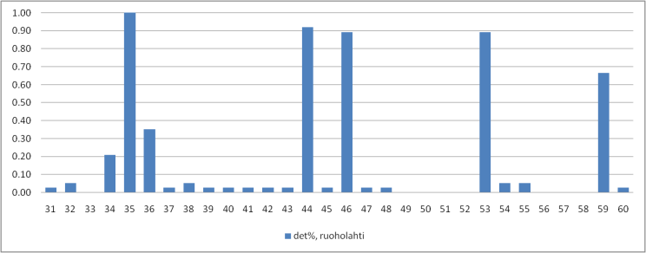
Figure 58: Measured probability of DVB-T detection, n = 37 per UHF channel,
average distance to Espoo transmitter 15 km and 78 km to Tallinn transmitter

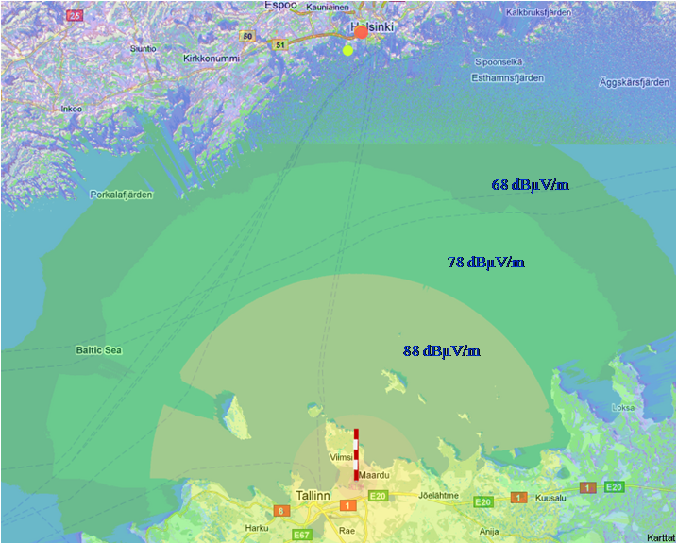

Figure 59: Simulated field strengths on UHF channel 59 (778 MHz) from Tallinn TV tower,
distance to Helsinki 77 km

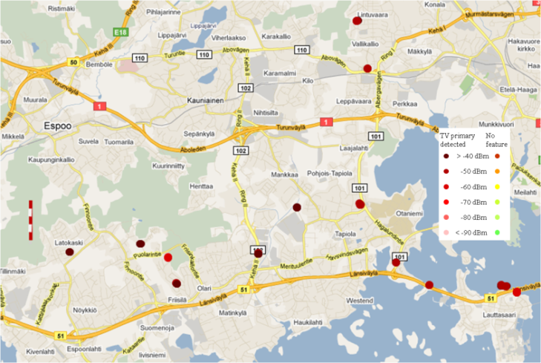
Figure 60: Results on UHF channel 44 (658 MHz) in Espoo,
average distance to Espoo TV tower is 8 km
Second set was measured outdoors in suburban Espoo and target was to evaluate performance of the spectrum sensor in the vicinity of strong TV transmitter. Measurements were done using two sensors one with internal antenna and another with external reference dipole. Measurement locations and results for occupied channel 44 (658 MHz) are shown in Figure 60. Measured signal power on occupied channels was from -65 dBm up to -32 dBm, when using external reference dipole, as shown in Figure 61. The RSSI[dBm] limits tell how many percent of measurement samples have smaller RSSI value than presented. Basically this presents values of observed cumulative distribution function with 10%, 50% and 95% probabilities. TV signal strength is from 10 to 30 dB more than in the Helsinki measurement set. Main difference between results measured using internal and external antennas is that antenna efficiency of internal antenna is on average 7.5 dB lower than external reference dipole. Results using internal antenna are shown in Figure 62. Difference in antenna efficiency means additional noise figure of 7.5 dB, which decreases sensitivity and increases linearity of receiver. In addition there is also device induced noise in internal antenna measurements.
Figure 63 shows the detection results over all channels with external and internal antennas. The antenna performance difference is very clear. Overall it can be seen that a high number of false detections happen due to the IM-products. There is also clear tradeoff between sensitivity and linearity. This is evident with the lower false alarm rate of the internal (lower gain, less signal power) antenna.
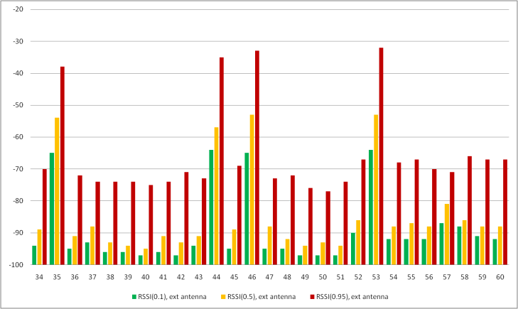
Figure 61: Received signal strength (RSSI[dBm]) with external antenna, upper limit for 10%, 50% and 95% of measured samples in Espoo
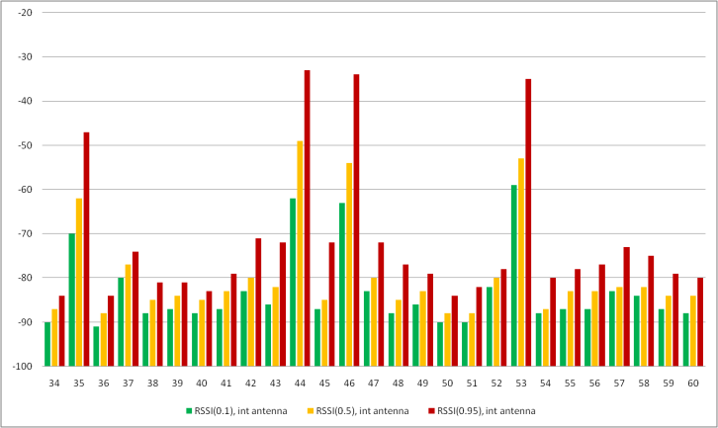
Figure 62: Received signal strength (RSSI [dBm]) with internal antenna, upper limit for 10%, 50% and 95% of measured samples in Espoo
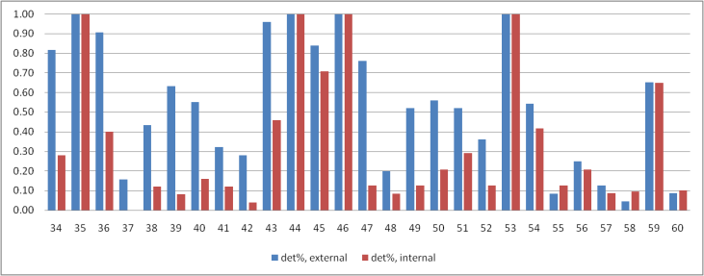
Figure 63: Measured probability of DVB detection, number of detections is 26 per channel, average distance to Espoo transmitter 9km and 78 km to Tallinn transmitter

- Calculations with SEAMCAT on interference assessment
  - Introduction
The purposes of these analyses are:
- to define the concept of ‘degradation of location probability’, Δ_{LP};
- to coordinate the basis of work, involving Δ_{LP}, being carried out within SE43 and in particular to describe/define the calculation methodology for the relevant studies;
- to carry out relevant (independent) technical studies (for SE43) and to provide results which can be compared with similar studies using the same calculation methodology;
- to set the framework for future SE43 calculations and studies.
For sake of verification, the EBU TECHNICAL was asked to make calculations with a given set of parameters and the results were compared with the output of SEAMCAT using the same parameters, as shown in the tables throughout the document.
  - Definitions
Pixel
A ‘pixel’ is a small area, about [50 m x 50 m] to [100m x 100m], within which DTT reception quality is to be evaluated. Reception quality, ‘acceptable’ or ‘unacceptable’, is calculated/measured at a large number of sites/points within the pixel,
Location Probability
The location Probability, LP, is the ratio of the number of sites/points/events within the pixel where an acceptable/agreed DTT reception quality is achieved to the total number of sites/points where calculations/measurements are carried out. It is emphasized that LP is a local parameter, pertaining to, and evaluated within, areas of the size of a pixel.
‘Degradation of Location Probability’
LP evaluated in a given interference situation will change when an additional interference (or set of interferences) is introduced. In particular, the LP will be reduced as additional interference is introduced. For example, if LP_{b} is the LP in the original, given situation and LP_{a} is the LP after the additional interference is introduced, the degradation in LP, Δ_{LP}, is defined as:
Δ_{LP} = LP_{b} – LP_{a}.
Example of Monte Carlo simulation (e.g. SEAMCAT).
Events are treated within a pixel. For each event, the wanted DTT power, P_{w}, is calculated at a (randomly chosen) point, as well as the equivalent noise power, N, the interfering WSD power, P_{i}. The noise nuisance field is defined as N´ = N + C/N and the nuisance power is defined as P_{i}´= P_{i} + PR. The total nuisance field is defined as the power sum of P_{i}´ and N´, N´ ⊕ P_{i}´. The point is covered if
Pw ≥ N´, in the presence of noise only
Pw ≥ N´ ⊕ Pi´(power sum), in the presence of noise and the interferer.
The location probability is the ratio of the number of trials where
Pw ≥ N´ (yielding the location probability ‘before’, LPb), and
Pw ≥ N´ ⊕ Pi´ (yielding the location probability ‘after’, LPa),
respectively, to the total number of trials.

Interference Probability
Interference Probability, IP, is the ratio of the number of sites/points/events within an area (of any size) where an acceptable/agreed DTT reception quality is not achieved (due to noise, interference, etc) to the total number of sites/points where calculations/measurements are carried out within that area.
It is to be emphasized that IP is not necessarily a local parameter, and in particular may not necessarily be evaluated within areas the size of a pixel. Furthermore LP and IP have a meaningful relationship only when both are calculated within the context of a pixel.
‘Degradation of Interference Probability’
IP evaluated in a given interference situation will change when an additional interference (or set of interferences) is introduced. In particular, the IP will be increased as additional interference is introduced. For example, if IP_{b} is the IP in the original, given situation and IP_{a} is the IP after the additional interference is introduced, then the degradation in IP, Δ_{IP}, is defined as:
Δ_{IP} = IP_{a} – IP_{b}.
Example of Monte Carlo simulation (e.g. SEAMCAT)
Events are treated within a pixel. For each event, the wanted DTT power, P_{w}, is calculated at a (randomly chosen) point, as well as the equivalent noise power, N, the interfering WSD power, P_{i}, and the power sum of the nuisance fields P_{i}´ and N´, N´ ⊕ P_{i}´. The point is interfered with if
Pw < N´, in the presence of noise only
Pw < N´ ⊕ Pi´(power sum), in the presence of noise and the interferer.
The interference probability, IP, is the ratio of the number of trials where
Pw < N´ (yielding the interference probability ‘before’, IPb), and
Pw < N´ ⊕ Pi´ (yielding the interference probability ‘after’, IPa),
respectively, to the total number of trials.

Relationship between Interference Probability and Location Probability (IP vs. LP)
In compatibility calculations, SEAMCAT calculates the IP in particular situations.
In compatibility calculations, broadcasters calculate the LP in particular situations.
It is seen in the 2 examples above, involving Monte Carlo simulation, that the calculation of LP and the calculation of IP are very similar, and in fact that LP = 100 – IP, expressed in percent.
In order for IP and LP calculations to be comparable, the areas where the respective calculations are carried out must be the same. This means that the area considered in SEAMCAT calculations must be restricted to areas the size of a pixel. LP calculations for areas significantly larger than a pixel have no meaning or relevance.
GOLDEN RULE: LP and IP calculations are to be carried out only for areas the size of a pixel (or smaller)
When IP and LP calculations are to be compared, the relationship between the two parameters must be kept in mind:
LP(%) = 100 – IP(%)

Just as the LP can be calculated before (LP_{b}) and after (LP_{a}) the introduction of additional interference, so can the IP, yielding IP_{b} and IP_{a}. Just as the LP decreases (‘degrades’) with additional interference, the IP increases (‘degrades’) with additional interference. Then the degradation in location probability Δ_{LP} = LP_{b} – LP_{a} corresponds to the degradation in interference probability Δ_{IP} = IP_{a} – IP_{b}. Expressed this way, both quantities are positive and equal.
Note that the calculation to determine LP_{b} (and IP_{b}) and LP_{a} (and IP_{a}) should be carried out in common Monte Carlo simulations.
  - Description of the set-up for the first task
    - Assumptions used in calculations
Broadcast pixel: 100 m x 100 m
Frequency: 600 MHz
Environment: rural
WSD antenna height: 10.1 m
DTT receive antenna height: 10 m
DTT receiver antenna gain: 0 dBi
Propagation model: JTG 5-6.

Equivalence between loss L (dB) and field strength E (dBμV/m) for 1 kW e.r.p.:
L = 139.3 + 20 log f(MHz) – E = 194.863 – E

Relationship between field strength and received power:
Pr dBm = E dBμV/m - 20 log f MHz - 77.2 = E – 132.76.
    - Protection requirements of DTT
(C/N) = 20 dB required C/N
PRco = 20 dB protection ratio
Pmed = -77.1 dBm ≡ 55.663 dBμV/m: median receive power/field strength (median received power was used only for the task 1 and task 2)
Initial Location Probability (LP): 95%
μ = 1.645, σ = 5.5 dB statistics
Pmin = Pmed - μσ = -86.148 dBm ≡ 46.615 dBμV/m minimum receive power/field strength
N = Pmin – (C/N) = -106.148 dBm ≡ 26.615 dBμV/m equivalent noise power/field strength.

Interference distance to be considered and corresponding propagation loss:
1 km: loss = 102.044 dB (102.05 dB in SEAMCAT); 13 km: loss = 145.011 dB (145.01 dB in SEAMCAT);

    - Methodology
The LP within a pixel at the DTT coverage edge, in the presence of noise only, is LPb = 95%.
The interferer’s e.i.r.p is to be determined at each distance (1 km and 13 km) such that, in the presence of noise and the interference, the resulting LPa is either 94.9% or 94.5% or 94% (i.e., the degradation in LP is 0.1% or 0.5% or 1.0%).
In SEAMCAT, the corresponding IPs are calculated to be IP = 5.1%, 5.5% or 6 % (i.e., the degradation in IP is 0.1% or 0.5% or 1.0%).
For highest precision, 100’000 trials are used to determine the LP, or IP.
The degradation in LP, ΔLP is determined by ΔLP = LPb – LPa.
The degradation in IP, ΔIP is determined by ΔIP = IPa – IPb.
For SEAMCAT, 2 interfering transmitters (It) were used in the calculations:
The 1st It corresponds to the background noise i.e. degradation of location probability became 95% which corresponds to 5% interference probability in SEAMCAT. iRSS (interfering signal strength) in this case is -106.148 dBm.
The 2nd It is a WSD device under consideration.
Note that the standard deviation for the noise is 0 dB, whereas for the WSD it is 5.5 dB for the propagation distances under consideration.
    - First set of results
There are two options to define background noise in SEAMCAT, the first one will be to define 2 interferers (1) and the second one is to use Noise floor as a background noise (2).
In SEAMCAT, 2 interfering transmitters (It) were used in the calculations:
The 1st It corresponds to the background noise i.e. natural degradation of location probability became 95% which corresponds to 5% interference probability in SEAMCAT. iRSS (interfering signal strength) calculated by SEAMCAT in this case is -106.148 dBm. In order to simulate this noise interference at 1 km and at 13 km, a ‘noise transmit power’ N_{tx} was assumed for the 1st interferer: N_{tx} = -4.098 dBm for 1 km separation distance, and N_{tx} = 38.86 dBm for 13 km separation distance.
The 2nd interferer is merely a WSD device.
In this simulations Noise Floor (in tab Victim link) was set to -106.148 dBm (standard deviation = 0 dB). Such settings give user possibility to use Interference criterion C/(N+I) = 20 dB. See results of the calculations in the Table 41.
Table 41: Results for 1 WSD in the presence of noise power (-106.148 dBm)
Separation distance (km) (JTG 5/6, 600 MHz, rural) | Pwsd_max (dBm)
Separation distance (km) (JTG 5/6, 600 MHz, rural) | IP = 5.1% (LPa=94.9%) |  | IP = 5.5% (LP_{a}=94.5%) |  | IP = 6% (LP_{a}=94%)
Separation distance (km) (JTG 5/6, 600 MHz, rural) | SEAMCAT | EBU | SEAMCAT | EBU | SEAMCAT | EBU
1 km | -26.5 | -26.71 | -19.8 | -19.78 | -16.7 | -16.80
13 km | 16.3 | 16.26 | 23.0 | 23.18 | 26.2 | 26.16

For the SEAMCAT simulation, calibration has been done for an effective ‘noise transmit power’, N_{tx}, i.e. assuming that the noise is produced by a transmitting interferer (with standard deviation = 0 dB for the propagation statistics) with the derived power, N_{tx}, based on the loss for the distances 1 km and 13 km (see example in Table 42.
For the EBU simulations, the noise power was taken to be -106.148 dBm at the DTT receiver input.
The Table 42 and Table 43 present results of the calculations of noise power impact, WSD median power and Noise power + WSD median power on DTT reception, and the corresponding degradations, Δ_{IP} and Δ_{LP}, respectively.
Table 42: SEAMCAT calibration results for Ntx noise power and WSD impact separately, ΔIP
Separation distance (km)  (JTG 5/6, 600 MHz, rural) | Ntx (Noise power only)  (std = 0.0 dB) |  | WSD median power  (std = 5.5 dB) |  | Noise power + WSD median power
Separation distance (km)  (JTG 5/6, 600 MHz, rural) | N_{tx}  dBm | Interference probability  IP_{b} % | Power max  dBm | Interference probability  IP % | Interference probability  IP_{a} % | Δ_{IP} =  IP_{a} – IP_{b}
1 km  (SEAMCAT propagation) | -4.098 | 5.00 | -7.843 | 5.01 | 12.08 | 7.08
13 km  (SEAMCAT propagation) | 38.862 | 5.00 | 35.087 | 5.00 | 12.10 | 7.10

Table 43: EBU calibration results for noise power and WSD impact separately, ΔLP
Separation distance (km)  (JTG 5/6, 600 MHz, rural) | Noise power  (std = 0.0 dB) |  | WSD median power  (std = 5.5 dB) |  | Noise power + WSD median power
Separation distance (km)  (JTG 5/6, 600 MHz, rural) | Noise power  dBm | Location probability  LPb % | Power max  dBm | Location probability  LP % | Location probability  LPa % | ΔLP =  LPb – LPa
1 km  (EBU propagation) | -106.148 | 94.99 | -7.850 | 95.00 | 87.98 | 7.01
13 km  (EBU propagation) | -106.148 | 94.99 | 35.117 | 95.00 | 87.98 | 7.01

Comparing the last column of Table 42 and Table 43, it is seen that the degradation of LP and LP, respectively, correspond to each other (to within 0.1 %) as they should if the calculations have been carried out on the same basis.
  - Description of the set-up for the second task.
    - Methodology
In this task the same assumptions as in the first one were considered.
The LP within the pixel, in the presence of noise only, is LP_{b} = 95%. From 1 to 40 equivalent interferers are
considered (in addition to the noise).

Case 1:
N interferers with equal e.i.r.p. were set at 1 km distance. The P_{wsd_max} value is taken from Table 43 (for both EBU and ECO calculations). Δ_{LP} was calculated such that, in the presence of noise and any WSD interference acting alone, the resulting LP_{a} is either 94.9% or 94.5% or 94% (i.e., Δ_{LP} is 0.1% or 0.5% or 1.0%). In SEAMCAT the calculation leads to IP 5.1%, 5.5% or 6 % (i.e. Δ_{IP} is 0.1% or 0.5% or 1.0%). These results are as shown in the first row (‘1 WSD’) of Table 44. The succeeding rows show how the cumulative interference effects increase as the number of equivalent interferers increases.
Table 44: ΔLP results for N WSDs with equal e.i.r.p. in the presence of noise power (-106.148 dBm)
Separation distance (km) (JTG 5/6, 600 MHz, rural) | ΔLP (=ΔLP) for N WSDs (with equal Pwsd) at 1 km distance
Separation distance (km) (JTG 5/6, 600 MHz, rural) | SEAMCAT  -26.5 dBm | EBU  -26.7 dBm | SEAMCAT  -19.8 dBm | EBU  -19.8 dBm | SEAMCAT  -16.7 dBm | EBU  -16.8 dBm
1 WSD | 0.1% | 0.1% | 0.5% | 0.5% | 1.0% | 1.0%
2 WSDs | 0.2% | 0.2% | 1.04% | 1.0% | 1.95% | 2.0%
5WSDs | 0.47% | 0.5% | 2.5% | 2.5% | 5.2% | 5.0%
10 WSDs | 1.0% | 1.0% | 5.1% | 5.1% | 10.2% | 10.0%
20 WSDs | 2.2% | 2.1% | 5.1% | 10.2% | 19.5% | 19.4%
40 WSDs | 4.4% | 4.2% | 19.3% | 19.5% | 34.7% | 34.1%

Case 2:
2 equivalent interferers are considered (in addition to the noise). The common e.i.r.p. of 2 WSD interferers is to be determined such that the Δ_{LP}/Δ_{IP} is 0.1%, 0.5%, 1.0%.
The results are summarized in Table 44. It is seen that the e.i.r.p. of each of the WSDs must be reduced by about 3 dB compared to the single-entry case (see Table 45) in order for the degradation to LP (and IP) reach the same value that was achieved for a single WSD interferer.
Table 45: Results for 2 WSDs, equal e.i.r.p., in the presence of noise power (-106.148 dBm)
Separation distance (km) (JTG 5/6, 600 MHz, rural | Pwsd_max (dBm) for each of 2 WSD’s
Separation distance (km) (JTG 5/6, 600 MHz, rural | IP = 5.1% (LPa=94.9%) |  | IP = 5.5% (LPa=94.5%) |  | IP = 6% (LPa=94%)
Separation distance (km) (JTG 5/6, 600 MHz, rural | SEAMCAT | EBU | SEAMCAT | EBU | SEAMCAT | EBU
1 km | -29.6 | -29.71 | -22.7 | -22.79 | -19.8 | -19.81
13 km | 13.2 | 13.24 | 20.2 | 20.18 | 23.2 | 23.16
  - Conclusions
This contribution describes a methodology and the associated parameters involved in evaluating location probabilities and interference probabilities when calculations are to be performed to determine the interference potential to DTT reception.
The basic parameters so far established are:
- the definition and interconnection of location probability and interference probability, and their usage;
- the propagation model (the JTG 5-6 model);
- the Monte Carlo techniques to be used to arrive at statistically meaningful conclusions;
- the power sum of noise and interferers to determine total interference levels.
Preliminary calculations have been carried out which show that:
- the propagation model used by EBU Technical and by ECO yield essentially the same results with very small variation (less than 0.1 dB);
- the Monte Carlo approaches to calculate interference to DTT reception require a minimum set of assumptions (e.g. number of trials, interference criteria, calculation of noise levels, standard deviations, power summing of interference contributions, etc.);
- the calculation of location probabilities and interference probabilities within a pixel yield essentially the same results with very small variation (less than 0.1 %).
Further work needs to be performed on tasks which seem to be of relevance to the current work of SE43. Some of the elements, parameters, etc. for such future tasks are given in the Annex.
APPENDIX 1 TO ANNEX 6
Assumptions that may be used in calculations:
Broadcast pixel: 100 m x 100 m
Frequency: 600 MHz
Environment: rural
WSD antenna height: 10.1 m
Propagation model: JTG 5-6 (rural area, 50% time for the path between DTT transmitter (BS) and DTT receiver, clutter height = 0 m)
P_{med} = -77.1 dBm (at the edge of the coverage area)
σ = 5.5 dB
DTT:
DTT receive antenna height: 1.5 m, 10 m
DTT receiver antenna gain: 0 dBi, 9.15 dBi
(C/N) = 20 dB required C/N
PR_{co} = 20 dB co-channel protection ratio
PR_{adj} adjacent channel protection ratio
DTT BS powers (examples):
Case 1:
DTT e.r.p.: 1kW
DTT transmit power: 62.15 dBm
DTT transmitter antenna height: 150 m
DTT transmitter antenna gain: 0 dB
Coverage radius: ≈24.965 km
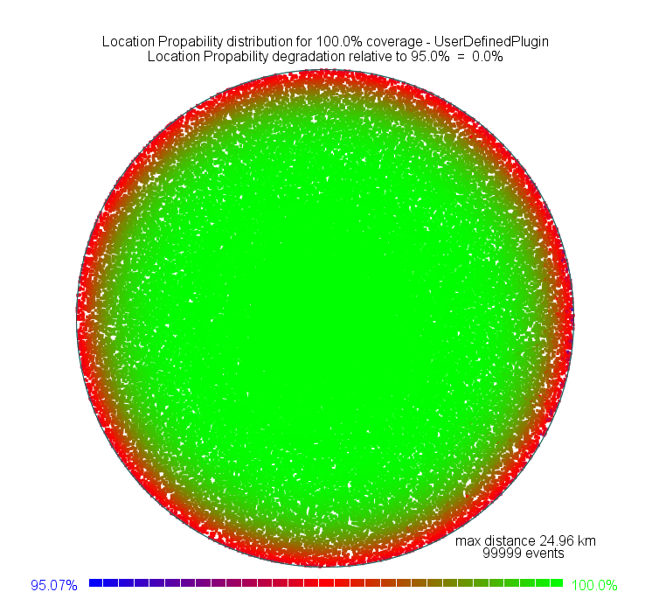
Figure 64: DTT coverage area, in the presence of noise only is 95%

Case 2:
DTT e.r.p.: 10kW
DTT transmit power: 72.15 dBm
DTT transmitter antenna height: 300 m
DTT transmitter antenna gain: 0 dBr.
Coverage radius: ≈ 50.110 km
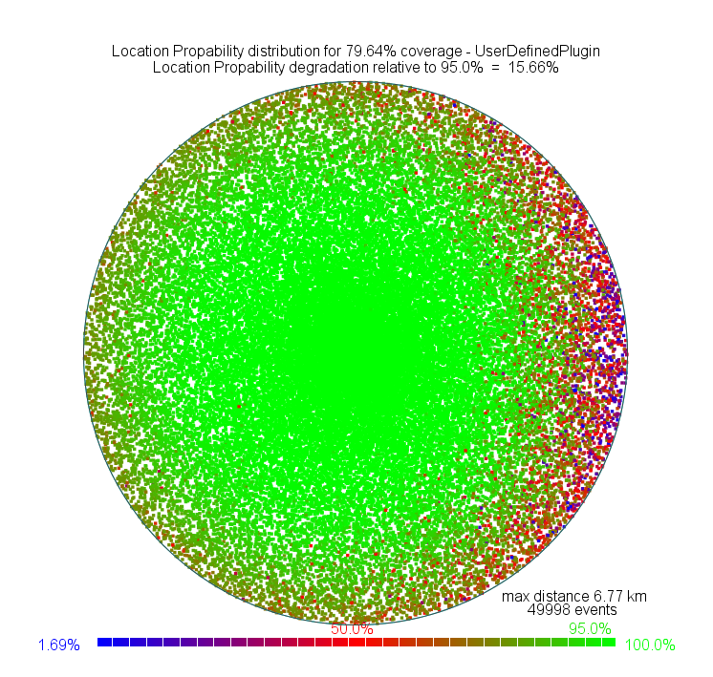

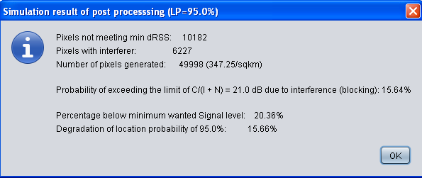
Figure 65: Results for 2 WSDs, equal e.i.r.p., in the presence of noise power (-106.148 dBm)

Case 3:
DTT e.r.p.: 100kW
DTT transmit power: 82.15 dBm
DTT transmitter antenna height: 600 m
DTT transmitter antenna gain: 0 dB.
Coverage radius:≈ 86.490 km
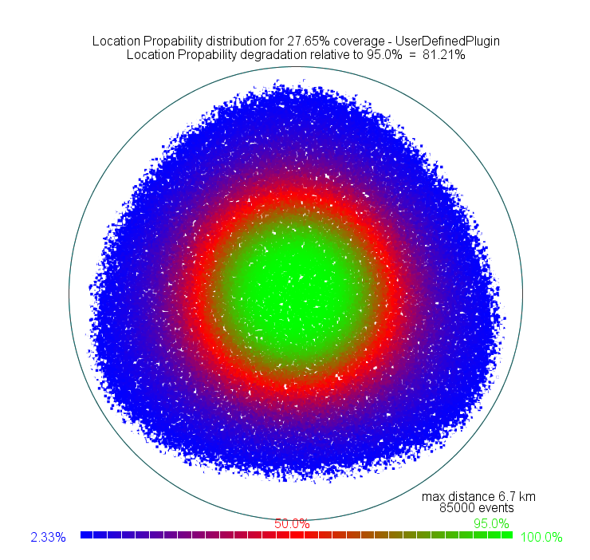

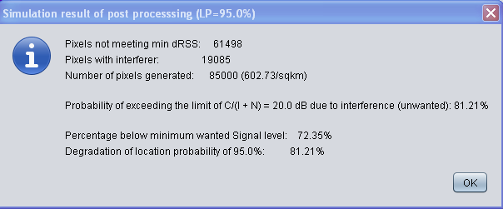
Figure 66: Coverage area + 3 Interferer

- coverage assessment of broadcasting services
Irrespective of the reception mode for which a given broadcasting transmitter has been planned for, different receiving conditions can be encountered throughout the coverage area of this transmitter. That means that for example around a transmitter which is intended to provide fixed reception, there will always be (smaller) areas where portable outdoor and portable indoor reception is feasible. This is known to broadcasters and constitutes an integral part of their network planning strategy. As consequence, broadcasters need to protect all these reception modes throughout the respective coverage areas. The next sections discuss elements, which are crucial in the process of evaluating the achieved coverage.
  - Target Coverage Area
Different countries have different regulatory frameworks when it comes to issuing licenses for spectrum usage. Public Service Broadcasters (PSB) usually have special coverage obligations associated to the coverage of a very high percentage of the population or area, if not all. Broadcasters have to provide evidence if these objectives are met. To this end, coverage calculations are performed in order to determine the covered area or the portion of the population that is covered.
For commercial broadcasters this may be different.
  - Planning Parameters and Planning Approaches
Calculations are carried out in order to design the transmitter networks to comply with the regulatory constraints. These calculations rest on an agreed planning methodology including wave propagation models (e.g. Recommendation ITU-R P.1546 [11]), service and protection requirements (e.g. link budgets, protection ratios, receiving conditions, etc.) and methods to derive parameters that allow a meaningful quantification of the service quality at a given location (e.g. location probability).
  - Coverage Calculation
In order to determine the coverage of a given network, wave propagation models are employed to predict the field strength of wanted and interfering fields at given locations. However, the spatial resolution for all wave propagation models used in broadcasting planning is limited. This means that reliable field strength predictions can only be given for points separated by a minimum distance of 100m. Under special conditions a resolution of 50m can be reached.
It is known that the field strength varies over a distance of 100m in a characteristic way due to shadow fading. Since this variation cannot be predicted as a consequence of the limited resolution of the wave propagation models at hand, statistical methods are employed to capture this behavior. To this end, the target coverage area is subdivided into a set of small pixel areas. These pixels can have different sizes depending on the granularity of the coverage analysis and the resolution of the wave propagation model. Typical values are 100 m * 100 m up to 1000 m * 1000 m. For each of the pixels a field strength value is predicted with the help of the wave propagation model at hand. The variation of the field strength throughout the pixel area is assumed to follow a defined distribution function (usually log-normal). The mean value of the distribution is assumed to be equal to the predicted field strength value for this pixel. Further assumptions on the standard deviation of the distribution are made. Then, the probability is calculated that a given minimum field strength or a certain ratio between wanted and interfering fields is exceeded. This probability corresponds to the location probability for that pixel. It has to be interpreted as the fraction of locations within the pixel area in which the broadcasting service can be received without problems.
  - Coverage Assessment
For each broadcasting service a required location probability is defined that has to be reached in each pixel. Typical values for this required location probability is 99% (mobile reception), 95% (portable reception) or 70% (fixed reception). After the calculation of the location probability for all pixels in the target coverage area, each pixel is classified either as being covered or not being covered. The label “being covered” is attached if the calculated location probability in a pixel is equal or larger than the required location probability. If it is less than the required value then the pixel is considered as not being covered. Based on these individual decisions the coverage obligation, i.e. full coverage of the target area, is analysed. There are at least two different approaches for this. In both cases the values of location probabilities of the pixels are modified according to given criteria.
- Approach 1: Black-and-white (B/W) counting
The location probabilities of the pixels are either set to one or zero, depending on whether they are labelled as covered or not covered.
- Approach 2: Proportional counting
The location probability of all pixels (covered and not covered) is left unchanged.
In both approaches, all location probabilities are averaged over the entire set of pixels constituting the target coverage area. This gives the total area coverage.
  - Population Coverage
A further level of coverage analysis is often carried out or even demanded by the licenses issued by national regulators. This refers to calculating the fraction of covered population. To this end, a population data base has to be employed from which a number of inhabitants living within the area of a pixel can be deduced. Hence, each pixel is associated with a corresponding number of people. Sometimes, instead of inhabitants the number of households is used. The results are different then, however, the principle of the analysis remains the same. Again, the two approaches mentioned above can be used.
- Approach 1: Black-and-White counting
If the location probability of a pixel is one then the number of inhabitants associated with this pixel is attached to the pixel. If the location probability of a pixel is zero then the number of people for that pixel is set to zero as well.
- Approach 2: Proportional counting
The number of people covered people in the pixel is calculated by multiplying the number of people of the pixel with its location probability.
In both approaches the numbers of inhabitants associated after the modifications are summed to give the total number of inhabitants covered throughout the target coverage area.
B/W counting (Approach 1) is applied in many European countries both in terms of network planning and as part of the licenses for terrestrial broadcasting networks when checking coverage obligations. But also for the purpose of analysing the interference imposed by one broadcasting service onto another one, B/W counting is employed in different countries in Europe.
Nevertheless, it is also quite common to use proportional counting when a more refined analysis is required. This applies especially to situations where detailed information about the number of people or households expected to be impaired is sought. In particular, in the case of non-broadcasting services interfering broadcasting services proportional counting proves to be the preferred method of analysing the coverage and interference calculations.

- DETAILS of DVb-t Protection Ratio MEASurements

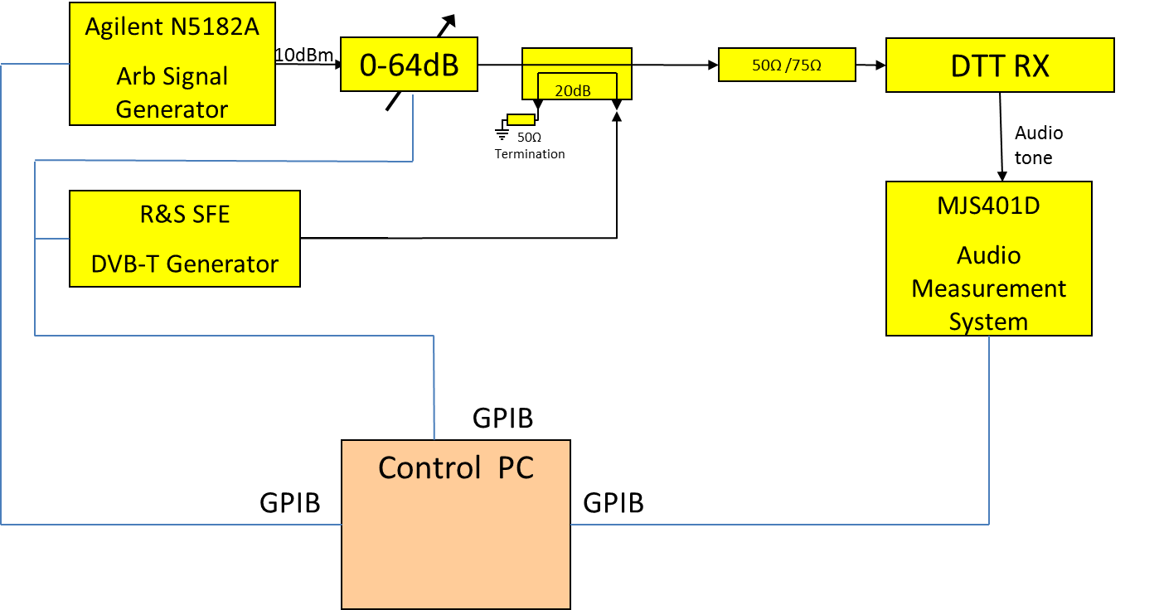
Figure 67: Test arrangement
The test equipment arrangement is shown in the above Figure 67. The interfering (WSD waveform) and wanted (DVB-T) transmissions are combined using a 20dB coupler. The signal generator’s waveform selection and frequency are under GPIB control from a control PC, its output power is selected by means of a GPIB controlled variable attenuator. Similarly, the level of wanted signal generated by the DVB-T generator is controlled by the PC. Further details of the signal sources are given in Section 3.4.

The impairment of the wanted signal is assessed by a Technical Projects MJS401D Audio Measurement System (AMS), also under GPIB control. The AMS input source is the audio output of the DVB-T receiver.
The protection ratio is measured under automatic control from the control PC. A wanted signal of 706 MHz (Ch. 50) has been used. For an interfering signal at a particular frequency, the powers of the interfering and wanted waveforms are automatically adjusted until the measured audio impairment falls below a pre-determined threshold.
  - Waveform Power Correction
Figure 68: Lincensed power
In order to use the signal levels provided by these measurements for regulatory purposes, it is necessary to establish how the measured values are related to the power value that would be permitted as a licensed value P_{lic.}

The value provided directly by reading the signal generator output power would be the calculated RMS value of the waveform. Using the RMS value of the waveform for P_{lic} is inappropriate, as some of the interfering WSD waveforms investigated are TDD based, with duty cycles as low as 2% and a high peak to average power ratio (PAPR). This would result in a high peak power for a nominally low licensed power. As it is the peak powers of the interfering waveform which cause harmful interference to the wanted DVB-T signals, it is important to capture this in the measurement.

An appropriate value for P_{lic} is derived by investigating the portion of the interfering waveform that represents the transmission being active (the “On” period). The licensed power is then taken to be the RMS power value of the waveform during the “on” period.

The value of P_{lic} will still be less than the peak power value (as shown in Figure 68). Protection ratio measurements made in this report use P_{lic} for the value of the interfering waveform generated by the signal generator.

- TYPICAL DIGITAL PMSE parameters
The technical characteristics of Digital PMSE systems vary and are in general proprietary to the manufacturer. Typical parameters are listed below:
- Audio coding: 100-200kb/s, typ.
- Modulation: pi/4:DQPSK, MSK, FSK
- RF Emissions: EN 300422
- IF bandwidth: 200 kHz
- Noise Figure: 7dB typ.
- Receiver Noise floor: -114 dBm
- Sensitivity: >-95 dBm.

- PMSE protection measurements in helsinki city theatre
PMSE is an important topic in Finland currently as the devices have been operating in the 800 MHz band in past and now it has been decided that the band 792-862 MHz will be used for mobile application with LTE. Therefore all the PMSE-devices will have to be moved to the lower UHF-band covering 470-792 MHz. The basic idea in the campaign was to use a few devices operating in the new lower band around 600 MHz and install them in a real environment where the PMSE-equipment is usually deployed and then try to cause interference to them by a simulated WSD operating in the same or adjacent frequency. The WSD was then be moved to different locations inside and outside the test building and power level was be adjusted to cause interference. Some qualitative spectrum measurements were also performed at the WSD-locations to get an understanding how feasible sensing of the microphones would be.
A summary of the measurement campaign is given in this Annex.
  - Locations
Two theatres in Helsinki were used for the measurement campaign. The Helsinki City Theatre, located in Kallio, is the biggest theatre in Helsinki. The main building has been built in the 1960’s and is traditional concrete/steel construction. It has two stages, a big one with 947 seats and a smaller one with 400 seats. The Arena Theatre is a smaller 515 seat theatre nearby the main theatre. Arena is located in a larger brick building, which has been built in 1923. Figures of the theatres can be found in the measurement report.
  - Microphones
Two sets of analogue microphones were used in the measurements, altogether four microphones and two receivers. The purpose was to use microphones in real conditions and therefore the receivers were placed a realistic places in the theatres. In the main stage the receiver was placed in the centre of a light balcony above the audience. In the Arena theatre the receivers were placed on the balcony as well and close to the existing antennas. In both classes the microphone to receiver link was somewhat more demanding than with the existing installations. The microphone receivers were using small whip antennas attached directly to the receivers.
During the measurements it was found out that there is a big difference in the results depending how the microphones are used. The worst, but also realistic, case being the belt pack microphone attached to a person and the person moving in the stage. Therefore to get most realistic scenarios the microphones were attached to people and they were moving in the stage simulating the actors, even sometimes going behind the sets used for the plays.
  - WSD signals and measurement principle
The WSD signal was simulated with a constant OFDM-signal from a Pro Television PT5780 DVB-T signal generator and boosted with a power amplifier. This set up was chosen because we were interested especially in the uplink part. Also the signal bandwidth was 7.6 MHz filling the whole channel and covering all the microphone signals at once. WSD-signal generation principle is shown in Figure 69.
Figure 69: Block diagram of the WSD-signal generation
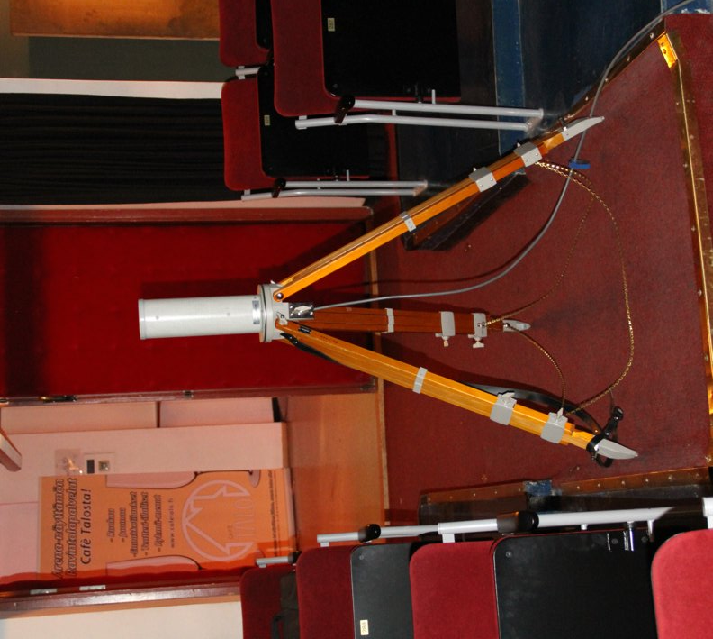
The measurements were done so that the WSD-power was increased until interference was heard in any of the used microphones, then the power level was decreased until no interference was observed and the attenuator reading was taken. Typical measurement situation is shown in Figure 70, where people can be seen on the stage with the microphones and other people observing the microphone receivers.

Figure 70: Typical measurement situation in the Arena theatre
Co-channel and adjacent channel cases were measured and location of the WSD interferer was varied both inside and outside of the theatres.
  - Spectrum measurements
To get better understanding of the microphone signals in a big theatre a spectrum measurement was done with the existing 800 MHz microphones during a musical where a large number of actors were performing simultaneously. Altogether 38 microphone channels were in use.
As can be seen the signals are not uniformly spread, but are in groups and even within the group not uniformly spaced. This is due to the performance optimization by minimizing the IM-products and internal interference. Typically the microphone signals are between -50 and -60 dBm when the players were at stage well placed, but dropping when moving out from the stage. Approximately 80 MHz of spectrum is used although not continuously.
Figure 71: Spectrum measurement during the performance. Span is from 780 - 870 MHz
  - Summary of the results
The results of the measurement in the Arena theatre are summarised in Table 46.
Table 46: Summary of the results in the Arena theatre

Location of the measurement spots in the Arena theatre are shown in Figure 72.

Figure 72: Side and plan views of the Arena theatre and measurement spots
Summary of the results from the main theatre is shown in Table 47 and the location of the measurement spots is shown in Figure 73.

Table 47: Summary of the results in the main theatre

Figure 73: Measurement spots outside the main theatre

Figure 74: WSD interference and microphone spectrum at the microphone receivers
In both locations path losses between the WSD and microphone receiver were measured. In the Arena theatre this was done directly and in the main theatre based on the WSD Tx e.i.r.p. values and the power levels measured using R&S FSH spectrum analyser and biconical antenna close by the microphone receivers. An example of such a measurement is shown in Figure 74. Results are shown the respective places in Table 46 and Table 47.
During the measurements the microphone signals were monitored using the WSD antenna and spectrum analyser to get an understanding how difficult it would be to sense the microphones. In all locations the microphones were clearly visible in the spectrum.

- PMSE RECEIVER TESTING BY THE BBC
The following paragraphs provide the initial results of the BBC tests.
To provide some indication of the expected PMSE receiver performance, experimental measurements on protection ratios have been conducted using a range of candidate WSD interferers. The candidate interfering signals have been used to assess the performance of a range of PMSE receivers including digital (QPSK, FSK), analogue FM and IEM devices. Initial results are shown for LTE FDD interferers (UE and BS), operating at three data traffic levels. The protection ratios for six types of interfering signal are shown in Figures 75 to 80. Two wanted signal levels have been used, –30 dBm and –80 dBm. The wanted signal frequency, Fc, was chosen for each receiver to be in the centre its specified operating bandwidth. The interfering signal was swept in 5 MHz steps from Fc – 30 MHz to Fc + 30 MHz and in 1 MHz steps from Fc – 10 MHz to Fc + 10 MHz.
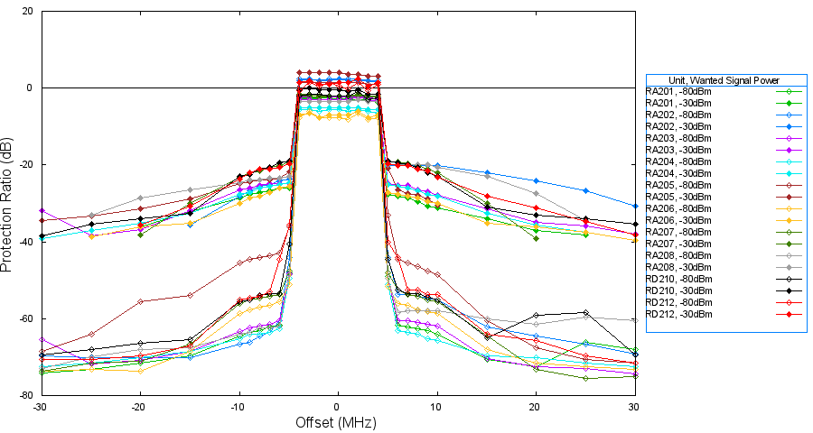
Figure 75: Protection Ratio for LTE BS Interference 100% Traffic
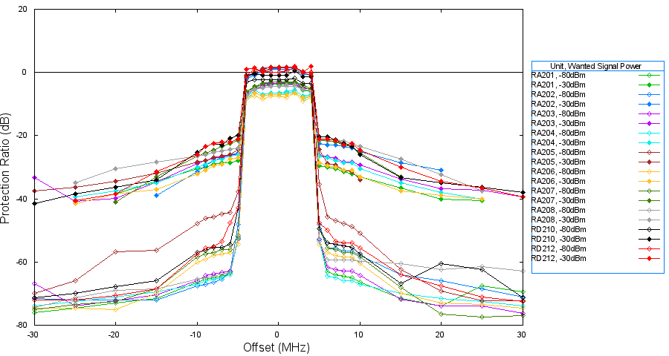
Figure 76: Protection Ratio for LTE BS Interference 50% Traffic

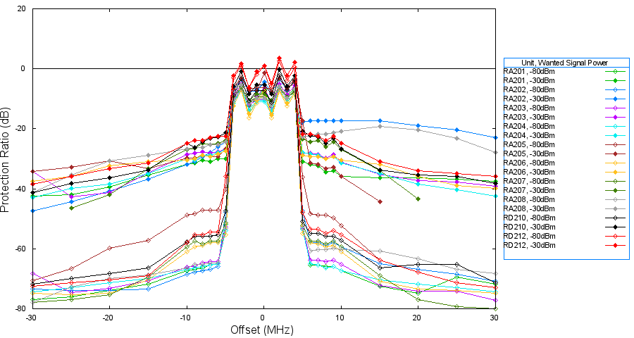
Figure 77: Protection Ratio for LTE BS Interference Idle (no traffic)

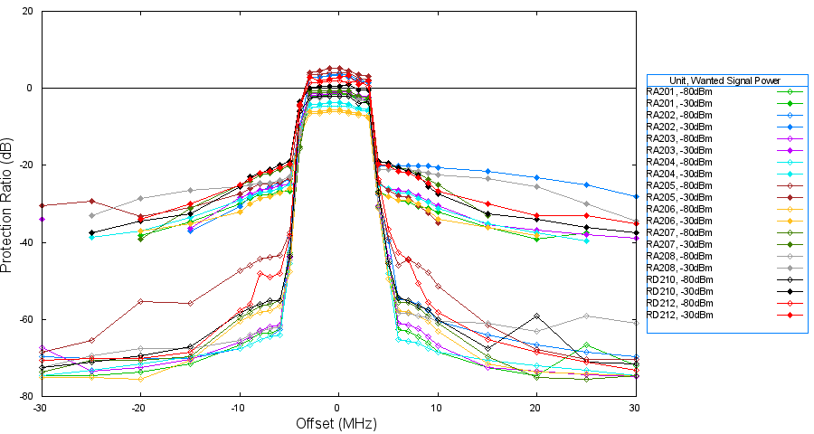
Figure 78: Protection Ratio for LTE UE Interference 100% Traffic
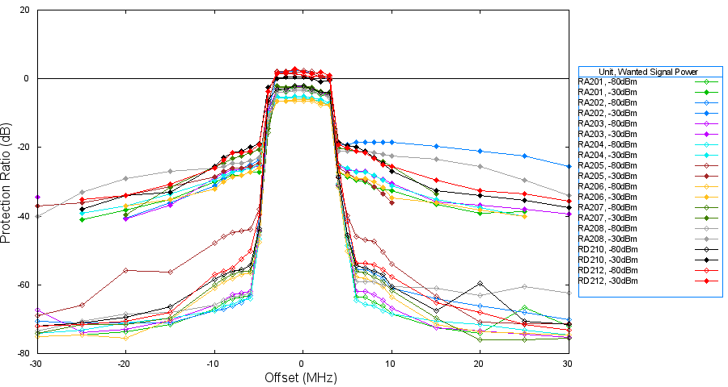
Figure 79: Protection Ratio for LTE UE Interference 50% Traffic

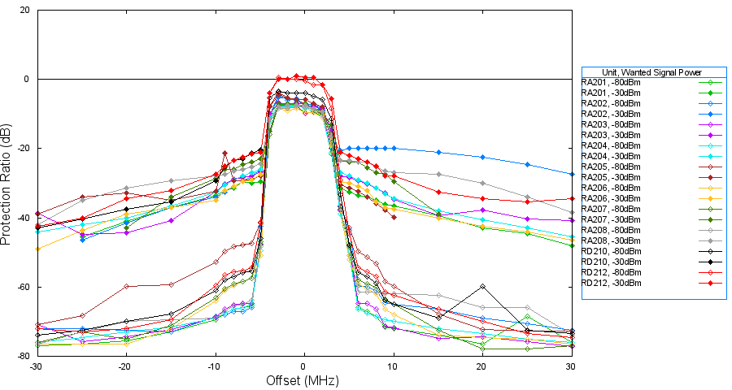
Figure 80: Protection Ratio for LTE UE Interference Idle (no traffic)

- Intermodulation, WSD and PMSE
  - Review of Intermodulation
If two pure sinusoidal signals are fed through a non-realisable theoretically linear and noise-less amplifier; the output signal will be two pure sinusoids. Now if the amplifier is non-linear, (all practical amplifiers are non-linear as they contain non-linear components such as semiconductors) then as a consequence of amplitude distortion, additional signals will be present; both harmonically and non-harmonically related to the original sinusoids. Essentially, the following tones are present in the output signal:
- Fundamental tones, f₁ and f₂
- odd harmonics, 3.f₁, 5.f₁, 7.f₁ … and 3.f₂, 5.f₂, 7.f₂ …
- even harmonics, 2.f₁, 4.f₁, 6.f₁ … and 2.f₂, 4.f₂, 6.f₂ …
- third-order products 2.f₂ – f₁ and 2.f₁ – f₂.
- fifth-order products 3.f₂ – 2.f₁ and 3.f₁ – 2.f_{2.}
- further odd-order products …
- and even-order products.
In radio systems, the odd-order IPs are often more problematic as these fall close to the wanted signal. The figure below shows two original tones (in blue) f₁ and f₂, two third-order intermodulation products (IPs) are produced (in red) at 2.f₂ – f₁ and 2.f₁ – f₂. Two fifth-order IPs are also shown (in green) at 3.f₂ – 2.f₁ and 3.f₁ – 2.f_{2.}
Figure 81: Intermodulation Product Frequencies

Points to note are:
The spacing of the third and fifth-order products is the same as the spacing of the original tones
As the order of the IPs increase, so the spacing from the original tones increases
The amplitude of higher-order IPs is smaller.

  - Reverse Intermodulation
When two or more transmitters are sufficiently close to each other the radiated signal from one transmitter is ‘received’ by the other and the two signals combine within the (non-linear) power amplifier. The level of the IPs will depend upon several factors:
- Transmit power;
- Distance between devices;
- Antenna coupling;
- PA design;
- PA linearity;
- Type of feedback around the PA;
- Whether or not a circulator has been used.
Manufacturers can control the susceptibility of their equipment to reverse intermodulation and significant differences in performance exist between different brands and models.
  - Intermodulation and PMSE
During a recent trial at the ADC Theatre in Cambridge UK (SE43(12)43), a series of spectrum analyser screen-shots were obtained as 12 radio microphones (RM) were switched on in sequence; this enabled any IPs to be observed. The spectrum analyser was connected to an RF-out port of the PMSE receiver.
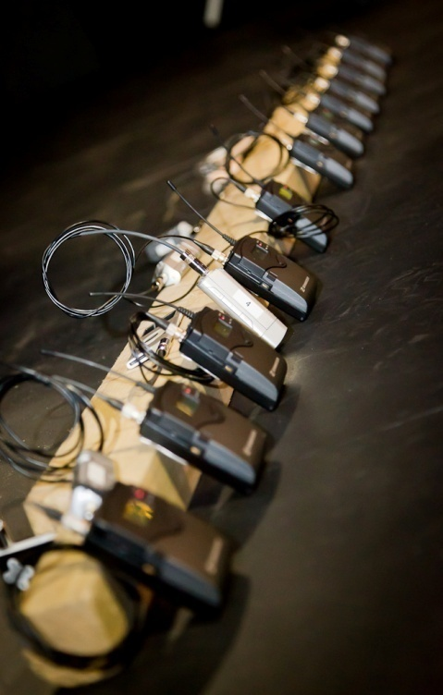
Figure 82: A set of 12 Radio Microphones on Stage
The following set of images show initially one RM with no IPs present, then two RM’s and two third-order products can be observed. The amplitude of the fifth and higher order products are smaller than the noise floor of the measurement and so cannot be seen.
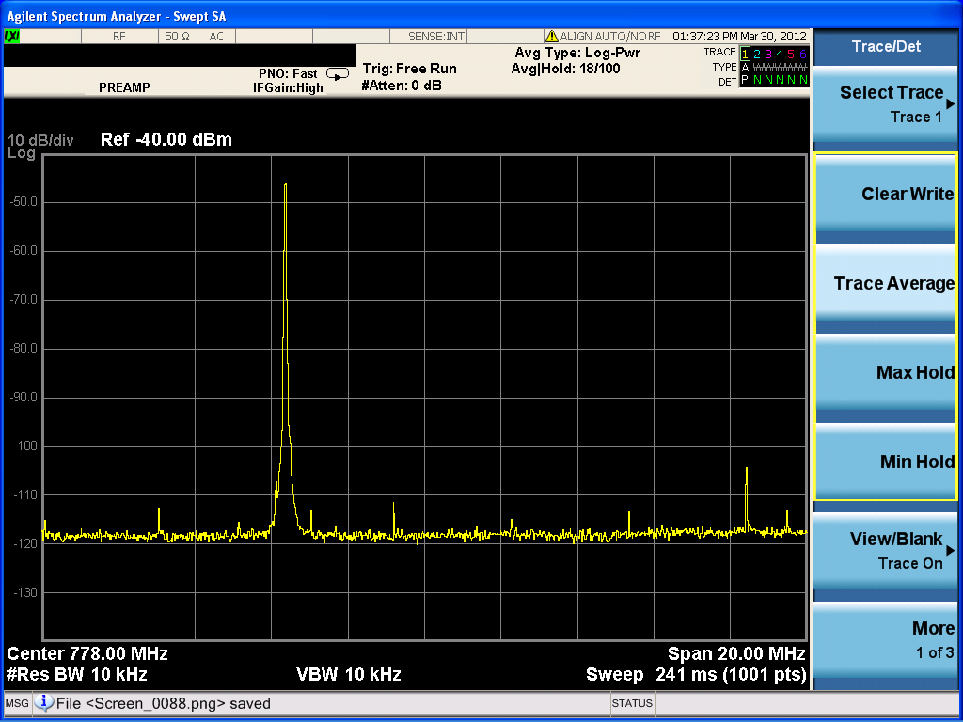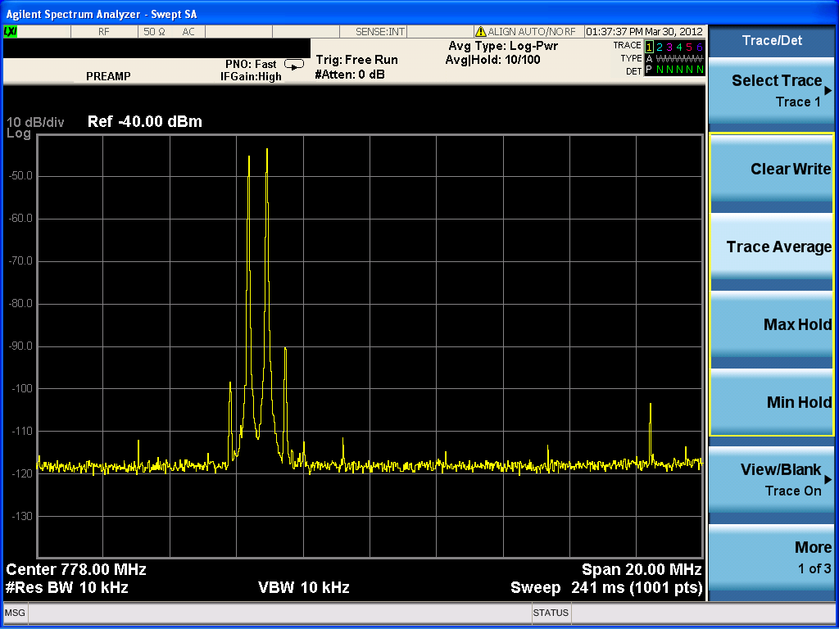
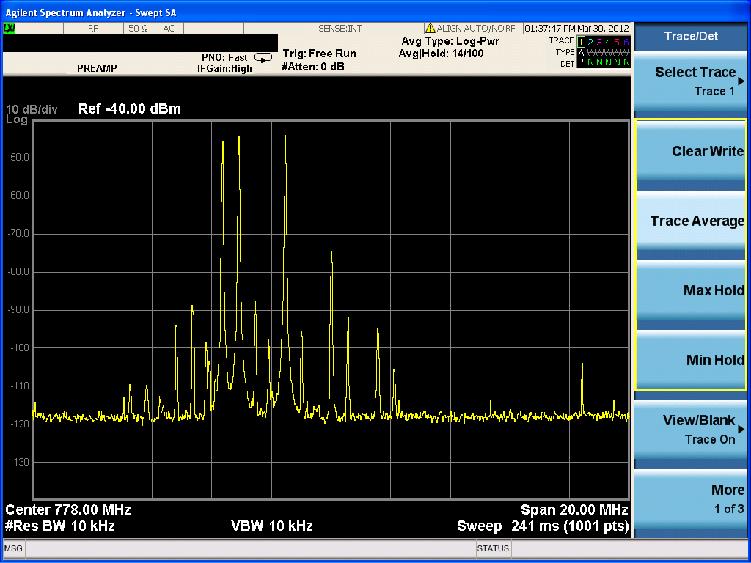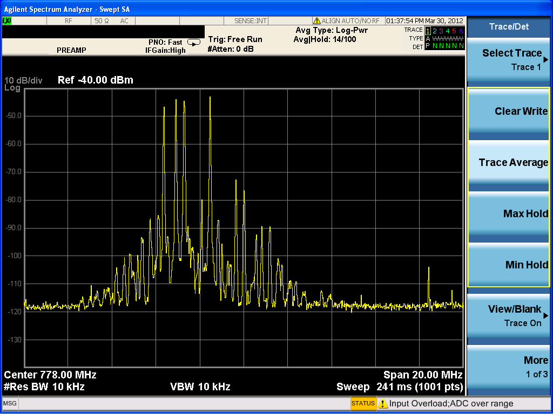
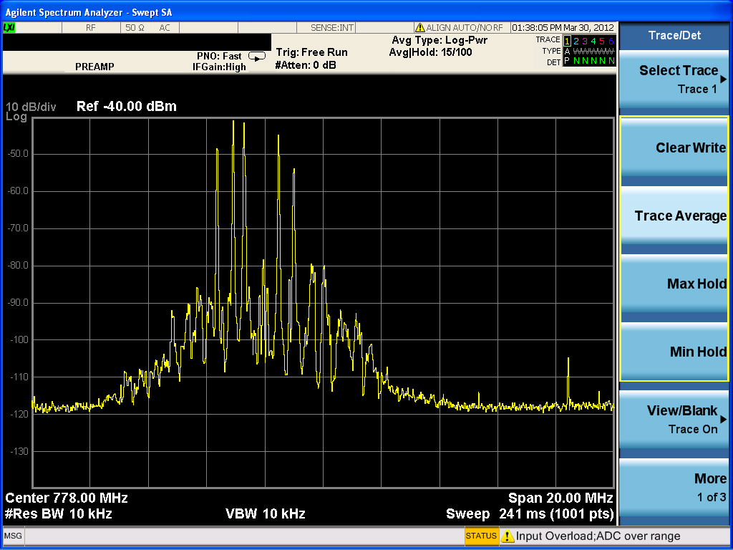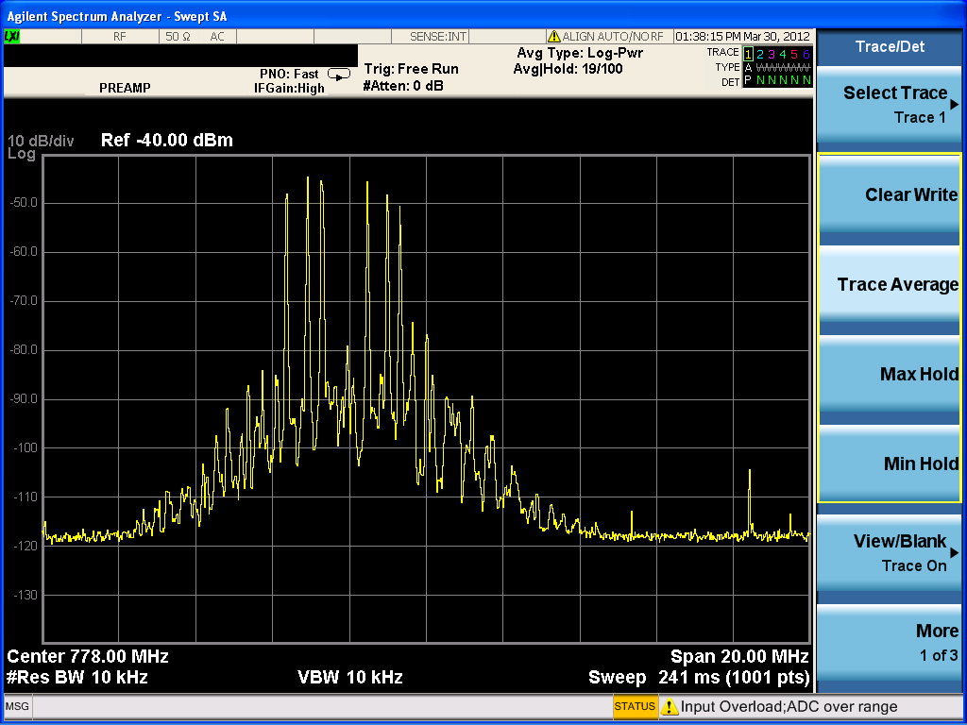
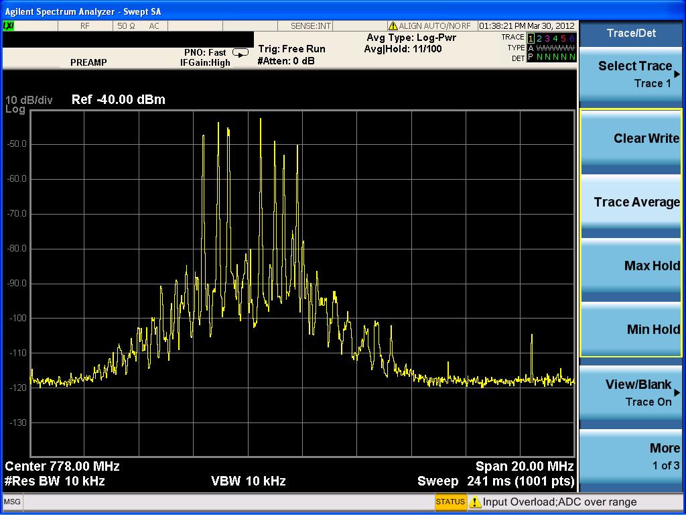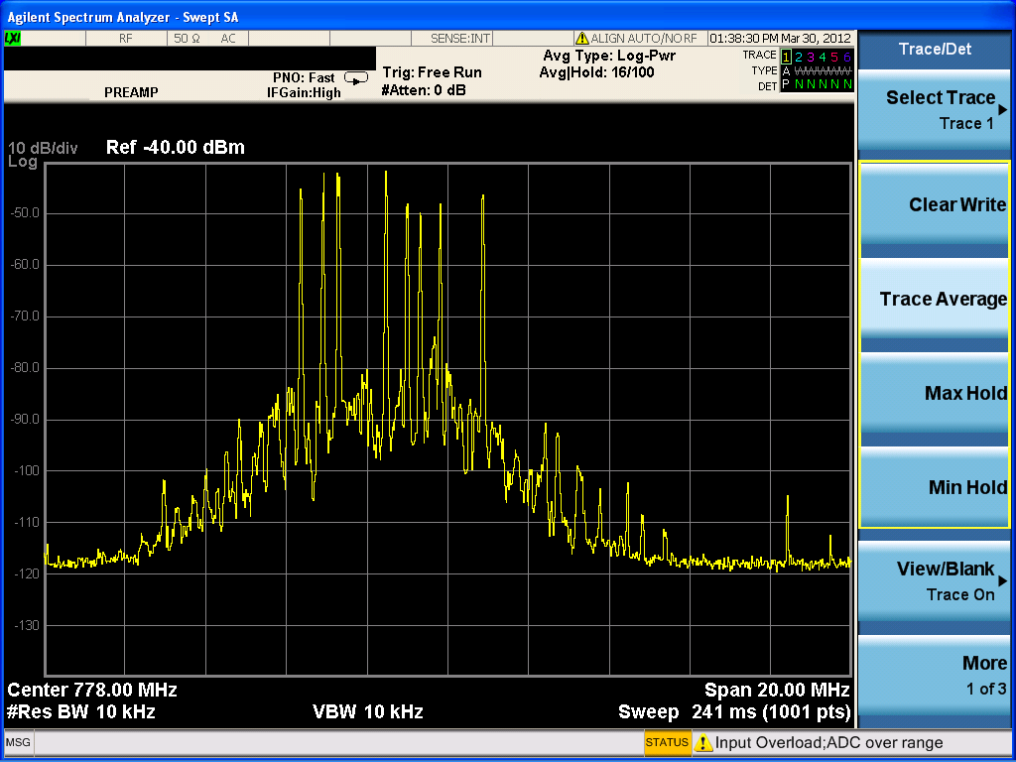
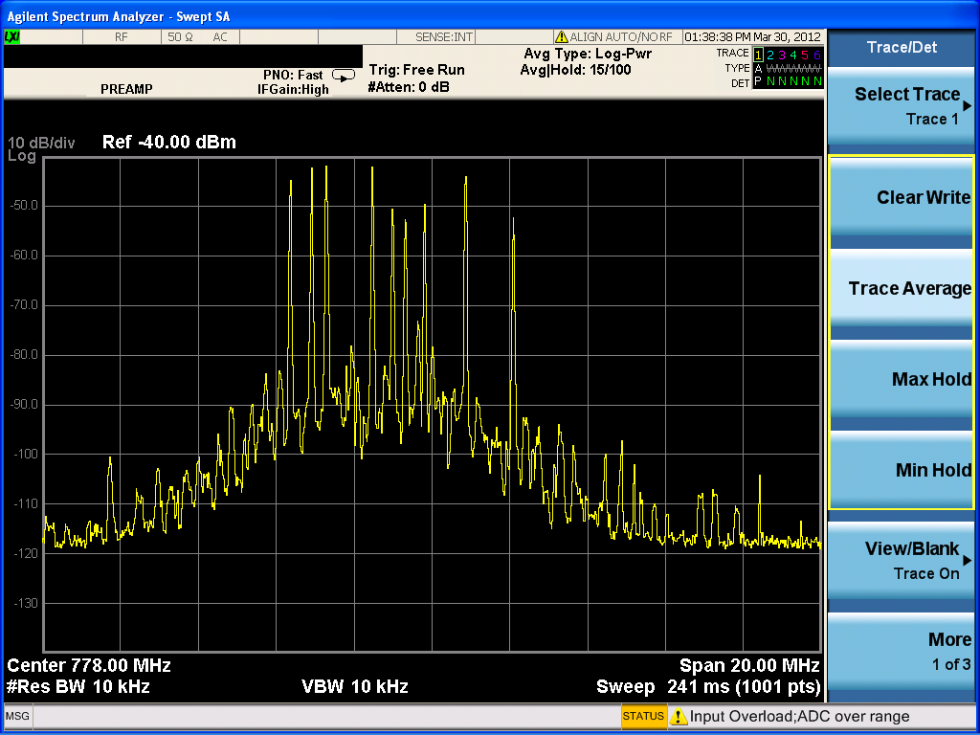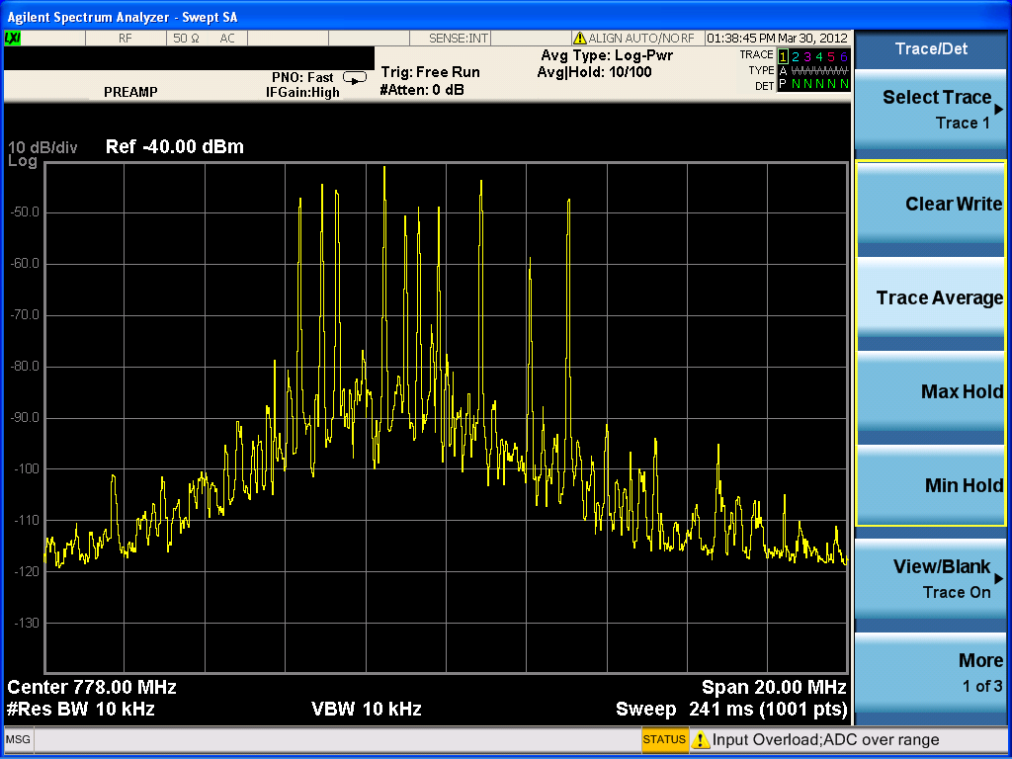
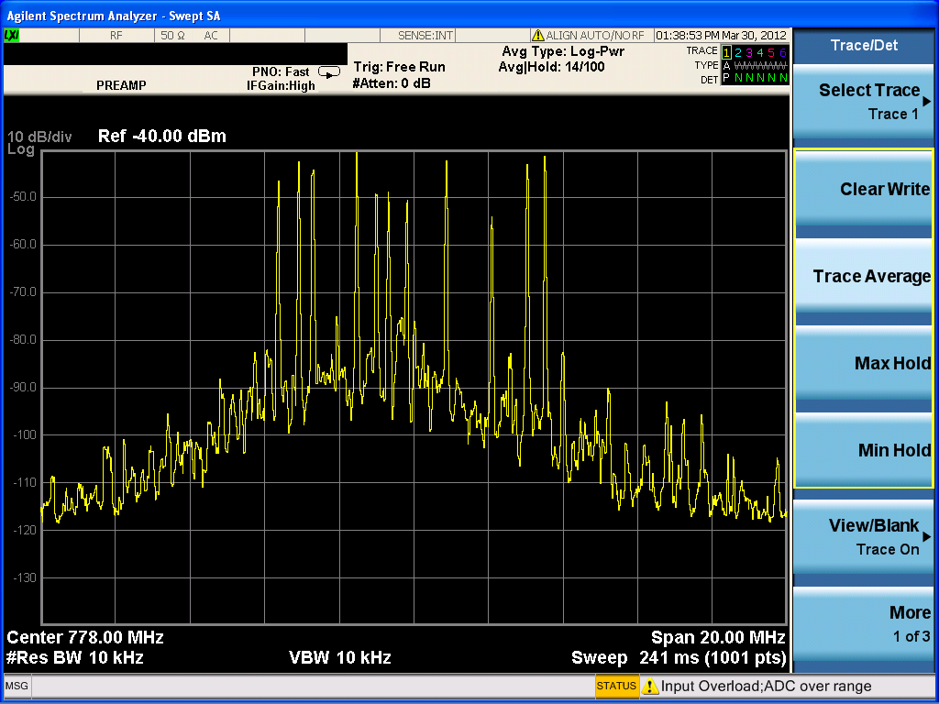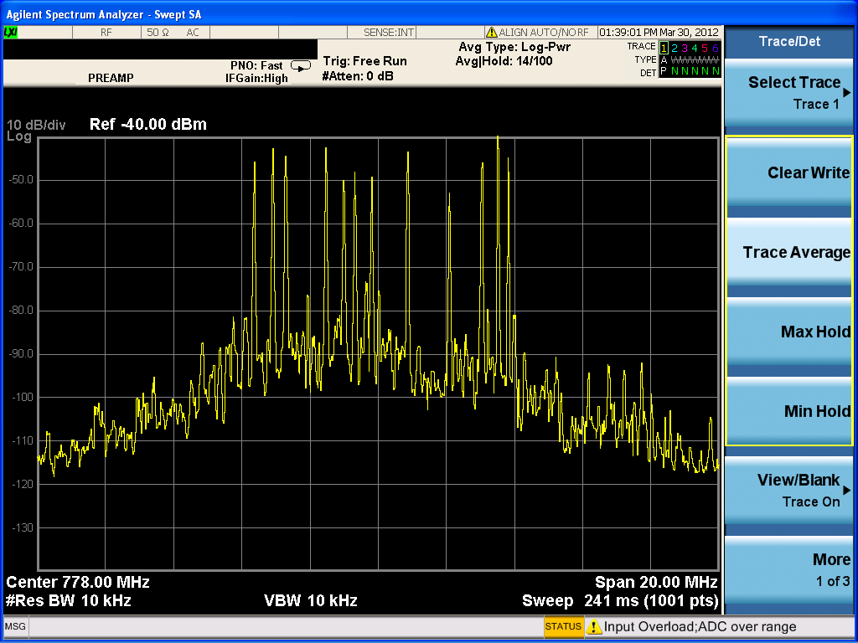
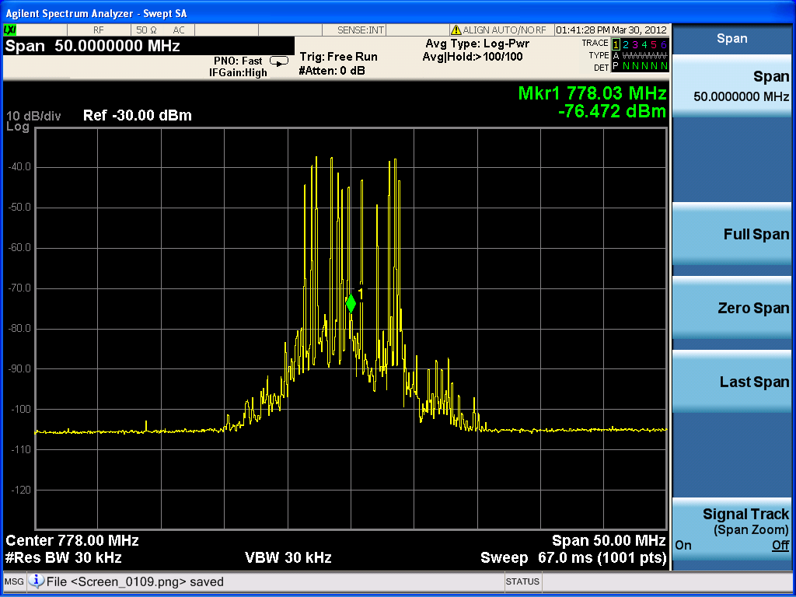
Figure 83: Set of Screenshots Showing IPs from 12 Radio Microphones
The number of third-order components produced is related to the number of wanted tones n thus:
$$Number of IP3s= n^{2}-n$$
For a 12 radio microphone system, 132 IP3s will be present. Higher order products are also produced and although these will be at a lower level are sometimes considered by the industry for a more robust frequency plan. However the IP3s generate their own IPs and therefore we find that the effective local ‘noise-floor’ increases. The figure above shows a received spectrum when 12 RMs are turned on sequentially, each modulated by a 1 kHz tone and all within a single TV channel. The final image is with a wider span and it clearly shows the 12 RM signals and the TV channels either side containing significant energy.
As was shown in Section 4.2.3, it is very probable during a live performance for the RM signal to enter deep fades as the performer moves around the stage. This means that careful frequency planning is essential to ensure that no IP falls on the same frequency as another RM else it risks blocking the signal and threatening the integrity of that production. Indeed, prior to productions that use a large number of RM’s, carefully frequency planning is performed to minimize the number of TV channels used (and hence licenses) whilst guaranteeing a low risk of self-intermodulation.
Thus with the introduction of unlicensed WSD’s, we must carefully consider this issue of intermodulation distortion and how it might affect a live PMSE production.
  - Intermodulation with Wideband Signals
    - Single Radio Microphone
Now consider that one of the tones is much wider than the other, such is the case with a WSD and a RM signal. Suppose that we deploy a WSD in TV channel 58 and a radio microphone in the middle of TV channel 59 (first adjacent channel) and contrive that the WSD is close to the RM so that their signals are coupled into their respective transmitters where intermodulation occurs. We would expect the following third-order products to be produced:
Figure 84: Graphic Showing Location of IP3s – Scenario 1
Note that the original WSD and RM are in different TV channels (in blue) and that both third-order IPs (IP3’s) are clear of the RM channel 59. Note also that when the coefficient of 2 multiplies f₁ (the wider bandwidth signal) we get a doubling of bandwidth of the IP3 (the lower IP3 is twice the bandwidth of the higher IP3). Additionally, for this scenario, the lower IP3 overlaps the WSD signal and might, in some circumstances, affect the WS link.
Now consider deploying the single radio microphone towards the low-end of TV channel 59. The following graph shows that there is more overlap of the lower IP3 on top of the WS signal, but also note, that the upper IP3 is within the same TV channel as the RM signal. For this single RM system, this RM signal should not be affected by the presence of this IP3 as the PMSE receiver selectivity is probably sufficient to reject it completely.
Figure 85: Graphic Showing Location of IP3s – Scenario 2
We can see from the figure above, that if any other RM’s existed in TV channel 59, they would be at risk of being blocked by the upper IP3 due to the intermodulation of the RM and the WSD.
    - Multi Radio Microphones
Now consider deploying the WSD in channel 59 (N+2 the 2nd adjacent channel) and adding a number of RM’s into TV channel 57, we’ll show only two at the lower (f₁) and upper (f₂) bounds of the TV channel to make the analysis easier.
Figure 86: Graphic Showing Location of IP3s – Scenario 3
We can see that all the RMs are contained within TV channel 57 and that the IP3’s due to these RM’s all fall within channels 56–58, these are clear of the WSD in channel 59 and so the WSD will not be affected by the RMs. As f₃ is further from f₁ than f₂, the frequency separation of the IP3s will be greater (shown in green). The IP3s due to f₂ and f₃ are shown in purple. So now when we consider a number of RMs between f1 and f2 we can see that all the different IP3s from them and the WSD will fall between the ones shown in the figure. In other words, the lower IP3s fall in TV channels 54–56 whilst the upper IP3s fall in TV channels 60–62.
Thus by leaving a guard band of one TV channel between RM and WSD, both PMSE and WSD’s can coexist.
  - WSD to WSD
It is difficult to predict at this time what technology may be developed for White Space applications. The Neul Weightless system currently in development uses TDD and the Master communicates with a number of slaves on the same RF channel at different times. Thus, it is not possible for any IPs to be generated as no two devices are transmitting at the same time. However, we should consider systems of the future where it might be possible for two slaves to be physically close to each other, possibly operated by two different service providers, and thus not synchronized in any way. These would potentially generate IP and thus risk the integrity of a PMSE production.
Consider deploying a number of RMs in TV channel 55 and two WSD’s in, for example, N+2 and N+4. If these WSDs are allowed to become close to each other, they may potentially generate a third-order product that will fall in the TV channel used by the RMs, as outlined below.
Figure 87: Poor IP3 Planning for Two Simultaneous WSDs
The lower IP3 from the two WSD falls over three TV channels 54–56 which overlaps TV channel 55 used by the PMSE system and thus risks the integrity of the performance.
  - Large PMSE Systems
For PMSE deployments in the larger productions, the number of RMs do not fit within one TV channel (for self-intermodulation reasons) and so usually a number of TV channels are used, these are often contiguous, but not always. By way of an example, refer to Figure 21; consider a number of RMs using TV channels 47/48/49, their IP3s will fall in channels 44-52. As discussed above, a WSD should be not be deployed within 44-52 as any IP3 due in part to the WSD will potentially block a RM. Suppose then that the WSD were deployed in TV channel 53. The new IP3’s due to the WSD will fall on channels 40-46 and 56-60 and so no IP will fall co-channel of the PMSE RMs (47-49) and will thus be protected.
Figure 88: Guard-Bands for a Three TV Channel PMSE System

- case studies on white space spectrum availability
  - Bavaria
    - Introduction
A study considering the case of fixed DVB-T reception only protecting co- channel from TVWS base station was performed for the case of Bavaria, the largest federal state of Germany. A map of the area and the transmission sites is shown below.
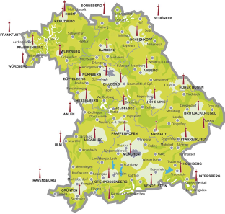
Figure 89: DVB-T Transmitters in Bavaria
    - Methodology to calculate maximum transmit Power for TVWS devices in the UHF band

The following section outlines the methodology which was used to calculate maximum transmit power.

Figure 90 shows the flow chart that describes the methodology to calculate maximum TVWS device transmit power.

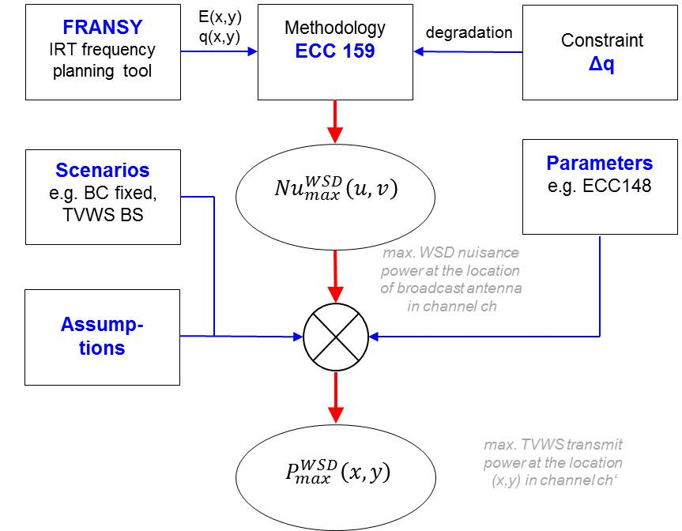

Figure 90: Calculation Procedure
The methodology described in ECC Report 159 [1], Section 4.3.2. “e.i.r.p. limits in case of geo-location database operation” is used. The input parameters field strength and location probability of the DVB-T Service were calculated with IRT’s frequency planning system FRANSY and a propagation model taking into account terrain and morphology data.

The maximum acceptable interference of an additional TVWS device at the location of a broadcast reception antenna is calculated by using the simplification of ECC 159 [1] in Section 4.3.2.2.1.

The protection ratios and overload thresholds for the calculations are based on average values given in ECC Report 148 [5] (LTE as interferer).
After assumptions on the reception scenario the maximum TVWS device power was calculated.
    - Summary of the results
Based on 1% degradation of location probability and only protecting co-channel the following results were calculated. Assumed is fixed broadcast reception and TVWS base station. In Figure 91 four diagrams indicate the number of free channels in the range of channel 40 to 60 versus the percentage of the area for different maximum power levels.

Pmax = -20 dBm Pmax = 8 dBm

Pmax = 20 dBm Pmax = 33 dBm
Figure 91: Availability of white spaces for channels 40 to 60
(only co-channel protection considered)

Due to the fact that adjacent channel protection is not considered a general conclusion based on the given results may be misleading.
As a clear tendency the results shown in Figure 91 show that the number of channels for applications with higher power levels is already quite limited when only protecting co-channel.
  - UK
    - Introduction
In the UK, UHF TV spectrum is planned as a multi frequency network (MFN) to allow regional variations across the country. Following DSO (digital switch over) six digital multiplexes will be broadcast across the 32 UHF channels retained for broadcast. In any particular region, up to 26 UHF channels, known as the “TV White Space” could potentially be made available for low power transmissions on a non-interfering basis to the primary DTT service.
The UK regulator Ofcom has stated its intentions to make the interleaved spectrum available on a licence-exempt basis to White Space Devices (WSDs). The spectrum will be available to the WSDs using geolocation databases. Proposals for the construction of this database have also been published and these follow the methodology developed in ECC Report 159 [1]. For this study a UK-wide database has been constructed using these rules and the resulting spectrum availability has been assessed.
The study considers the TV whitespace availability in the UK, taking into account the protection of fixed DTT reception. Preliminary assumptions regarding receiver performance have been made and the restrictions necessary to protect portable reception and PMSE assignments have not been considered.
    - Database Construction Method
The calculation is based on the detailed DTT coverage predictions made for the UK. The country is split into 100m by 100m squares, called pixels, and coverage predictions are made for each pixel. The DTT coverage is expressed in terms of location probability, which defines the percentage of locations within a given pixel that are predicted to receive a DTT service. WSD signals will always cause some interference and this will reduce the location probability.
In this study a 1% degradation in location probability has been permitted for a mobile WSD operating at 20m from a rooftop DTT antenna. This reference geometry used is that proposed in ECC Report 159 [1].
The UK is currently in the process of switching off analogue services and increasing the power of the DTT services. For this study, the analysis is based on the predictions for post switchover DTT coverage taking account the 1% time DTT interference from other parts of the network, including continental interference from international neighbours.
    - Database limitations
A number of simplifications have been made in the construction of the database and the following assumptions have been made.
- DTT reception on indoor antennas, including loft-mounted and portable set-top antennas, has not yet been protected;
- No allowance has yet been made for PMSE assignments;
- No margins have yet been added for interference aggregation from multiple WSDs operating in a pixel;
- Receiver saturation has not yet been modelled and low level receiver protection ratios from the Ofcom 2010 consultation have been used. WSD signals at greater frequency offsets from DTT will cause less interference. The WSD power has been capped at 30 dBm, corresponding to a WSD interference level of -20 dBm at the DTT receiver;
- DTT protection has been limited currently to a subset of the Digital Preferred Service Area (DPSA) layers. Typically only 1 or 2 transmitters will be protected in a given pixel.
    - Presentation of UK TV White Space Availability
White space availability can potentially support a diverse range of applications. This section describes the different approaches considered in presenting the availability of white space channels in the UK. It is useful to analyse the availability in the context of the intended application. In this study the white space availability is presented using three different approaches:
- The first approach presents the white space availability in terms of number of channels to a given percentage of the populated UK land area (considered on a pixel by pixel basis). This type of analysis may be particularly appropriate for identifying channels for rural broadband applications to support a limited numbers of users.
- For mass-market applications, e.g. supplementing WiFi spectrum for broadband connectivity, it is useful to weight the data to account for the population in a given pixel. Therefore in the second approach the availability is expressed in terms of the number of white space channels available to a given percentage of UK households.
- Finally, it is also useful to illustrate this data on a map showing how the white space availability varies with location. This is helpful to identify regions with restricted availability. The availability maps are presented as a function of WSD power.
As WSD e.i.r.p. is increased, the number of available channels can be expected to fall. For example, white space channels in the first adjacent channel to primary DTT services may become unavailable for higher power WSDs due to the finite ACS performance of the DTT receivers. Therefore in all of the above approaches the white space availability is shown for WSD e.i.r.p. levels ranging from -30 dBm to +30 dBm in 10dB intervals.
    - TVWS availability calculated for populated pixel area
Figure 92 presents the white space availability in the UK based on the populated pixel area. This is expressed in terms of the availability of white space channels for a given percentage of coverage pixels as a function of the WSD e.i.r.p. level.
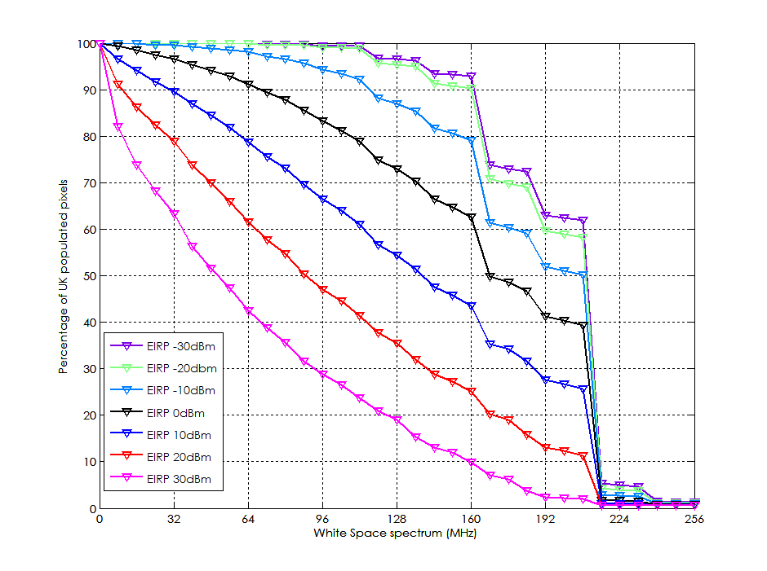
Figure 92: White space availability in the UK as a percentage of pixel area
The graph shows that, for a WSD power of 10 dBm, 50% of the populated pixels have access to approximately 144 MHz of spectrum.
    - TVWS availability accounting for population density
Figure 93 presents the white space availability in the UK taking account of the population density considering the number of households per pixel. The analysis considers the populated pixels, but the data has now been weighted taking into account the number of households in each pixel. The graph thus shows the TVWS availability for a given percentage of households as a function of WSD e.i.r.p.
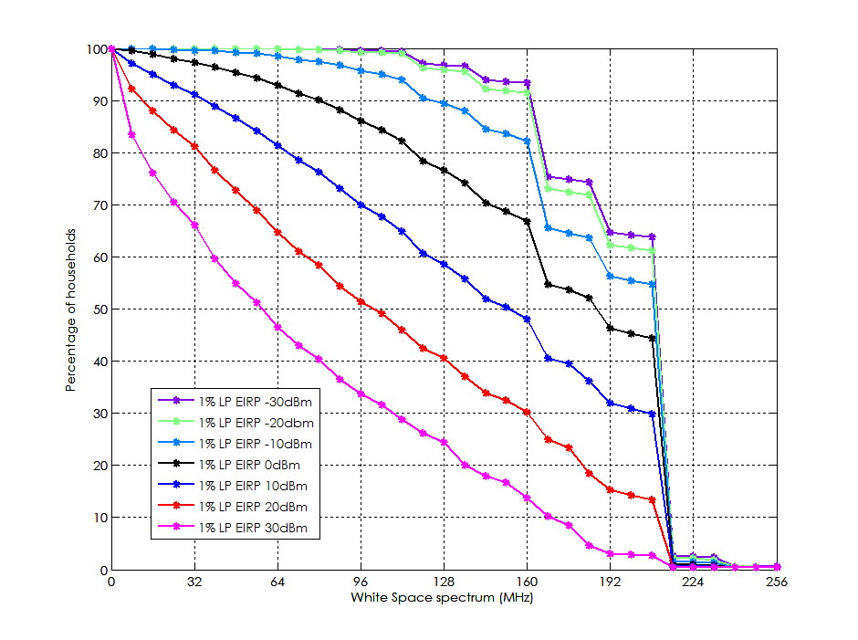
Figure 93: White space availability in the UK as a percentage of households
The graph shows that 50% of households have access to 152 MHz of spectrum at a power of 10 dBm. As the device e.i.r.p. is increased the amount of available spectrum decreases.
    - White Space availability maps for the UK
The maps presented in this section illustrate the white space availability for the whole of the UK. The maps are colour coded to show how the number of available white space channels varies across the UK in each region. Cooler colours (shades of blue) indicate low availability and the warmer colours denote increased availability of white space channels. The maps represent white space availability as a function of WSD e.i.r.p. level ranging from -30 dBm to +30 dBm in 10 dB intervals.
      - White Space availability for all the pixels
The white space availability maps are generated considering the reference geometry for all the pixels in the UK. All pixels, whether populated or unpopulated, are protected for DTT coverage using the 20m-separation reference geometry for mobile WSD into fixed DTT Figure 94. Figure 94: WSD e.i.r.p. of -30 dBm (left side); WSD e.i.r.p. of -20 dBm (right side).Figures 94 to 97 (section A11.2.7.1) shows the availability maps for this scenario as a function of WSD power. As the WSD power is increased, the number of channels available decreases.

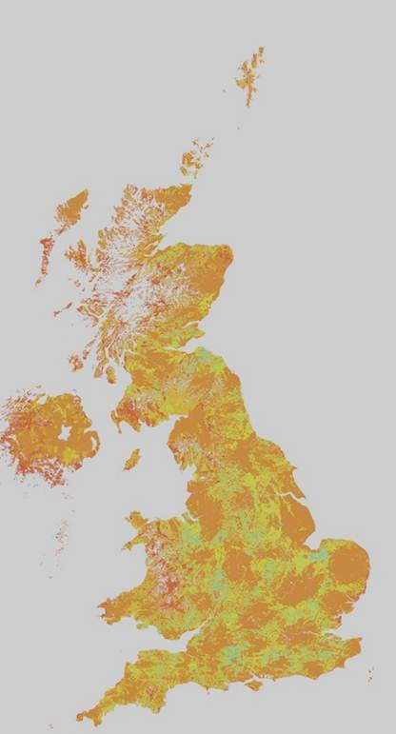 | WS channels  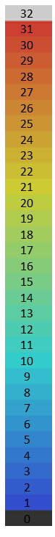 | 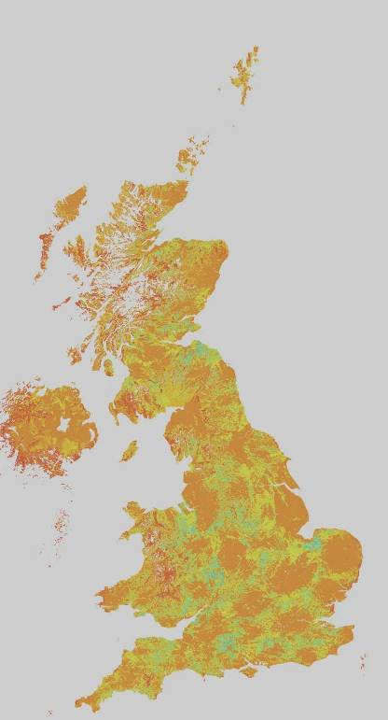
Figure 94: WSD e.i.r.p. of -30 dBm (left side); WSD e.i.r.p. of -20 dBm (right side).
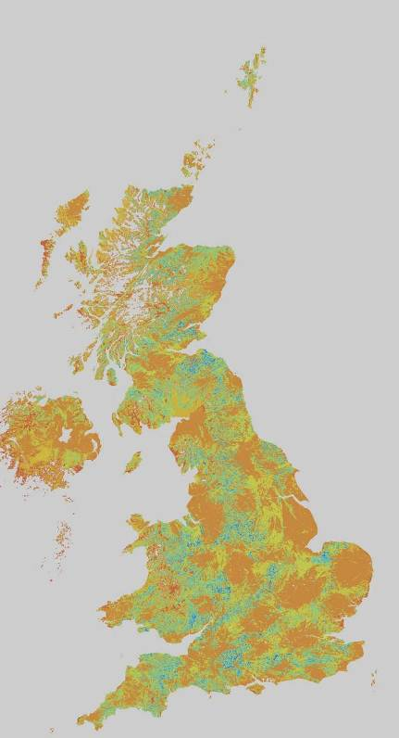 | WS channels | 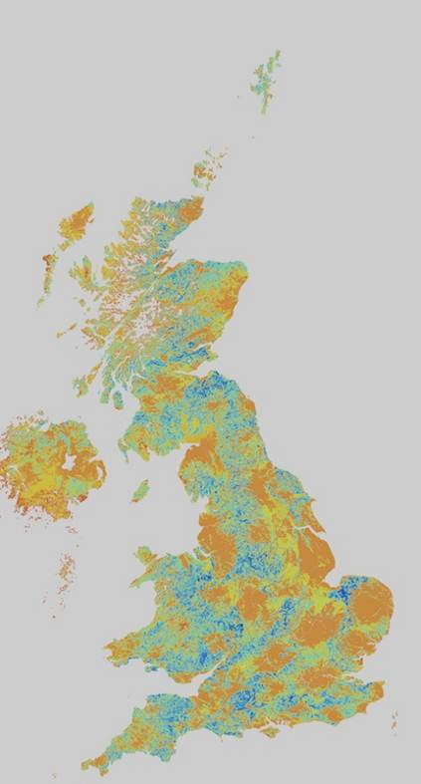
Figure 95: WSD e.i.r.p. -10 dBm (left side); WSD e.i.r.p. 0 dBm (right side)
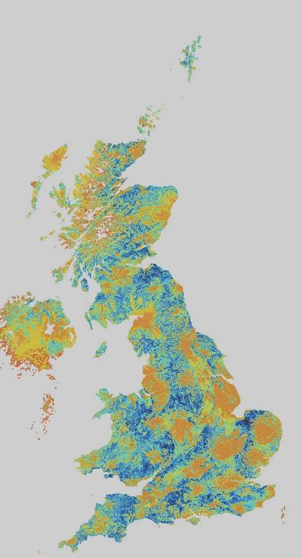 | WS channels | 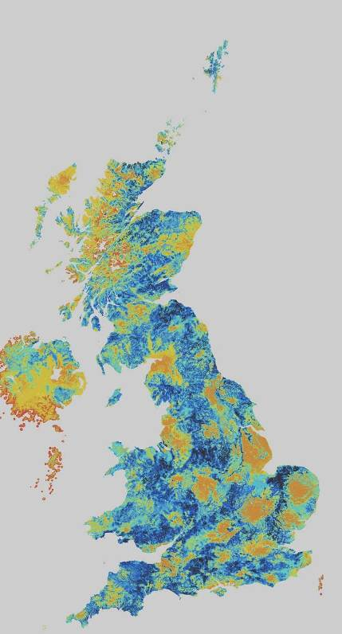
Figure 96: WSD e.i.r.p. 10 dBm (left side); WSD e.i.r.p. 20 dBm (right side)
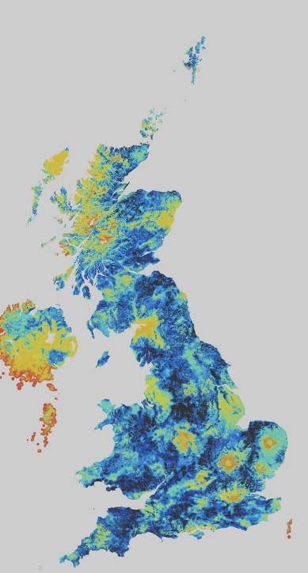 | WS channels
Figure 97: WSD e.i.r.p. 30 dBm
      - White Space availability maps protecting populated pixels
The maps in this section show the TVWS availability for the case where the reference geometry is modified according to the distance to the nearest populated pixel. For populated pixels and their immediate neighbours, the 20m reference geometry is used to calculate the WSD e.i.r.p. For unpopulated pixels, the reference geometry is relaxed from 20m to consider the distance to the nearest populated pixel. Figure 98 (section A11.2.7.2) presents the resulting availability maps for this scenario. It can be seen that this approach increases the white space availability, particularly for sparsely populated rural areas in the UK.
 |  | WS channels |  |  | 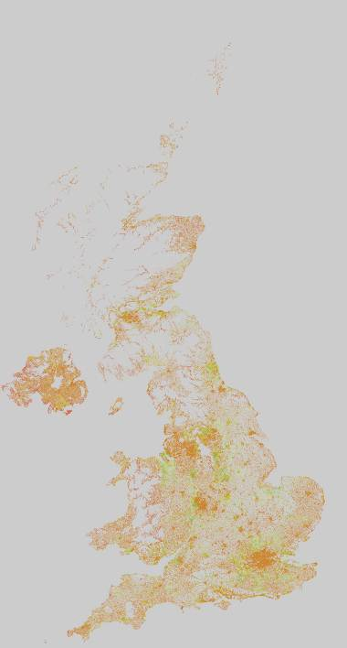
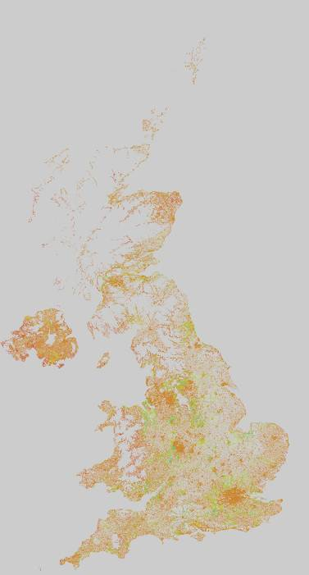 |  | WS channels |  | 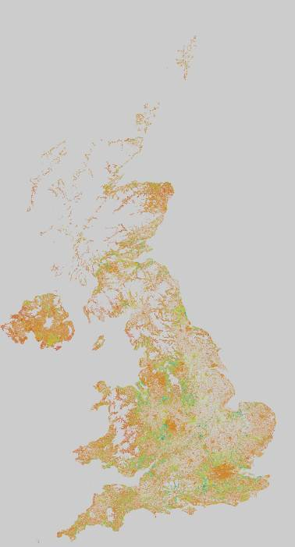
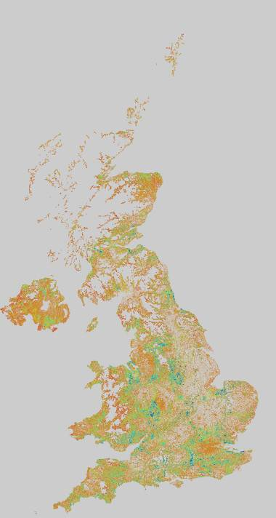 |  | WS channels | 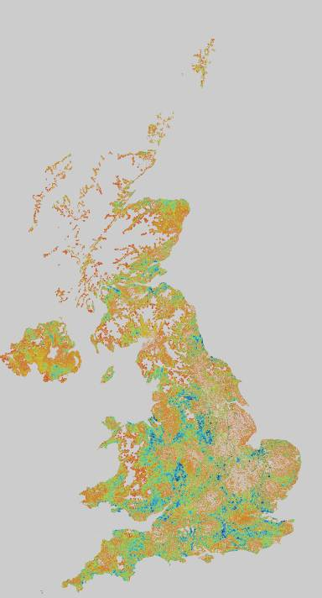
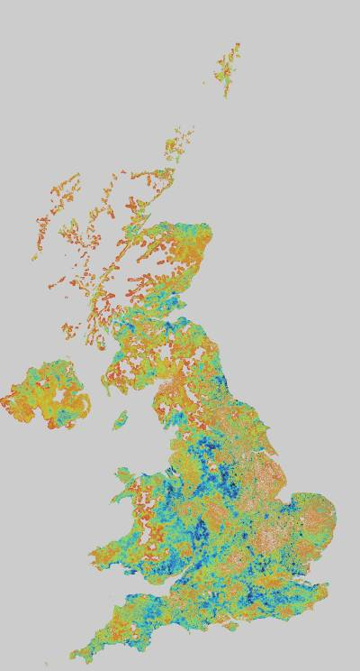 | WS channels
Figure 98: WSD e.i.r.p. of -30 dBm (left side), WSD e.i.r.p. of -20 dBm (right side) (fist row);
WSD e.i.r.p. of -10 dBm (left side), WSD e.i.r.p. of 0 dBm (right side) (second row);
WSD e.i.r.p. of 10 dBm (left side), WSD e.i.r.p. of 20 dBm (right side) (third row);
WSD e.i.r.p. of 30 dBm (left side) (forth row)
    - Conclusions
An initial study of TV White Space in the UK based on the geolocation database approach has been presented. A geolocation database has been constructed by deriving the maximum permitted power levels for WSDs in a given specific location. The database has been analysed to illustrate the resulting availability. The e.i.r.p. calculations for the database follow the methodology described in Ofcom’s ‘Implementing Geolocation’ consultation document.
The TVWS availability varies with the WSD device power. Availability is significantly reduced at higher device powers, particularly in populated areas and in the vicinity of over-lapping coverage areas between the DTT transmitters. Relaxing the reference geometry in unpopulated pixels can increase the white space availability. An approach has been developed where the 20m separation used in the reference geometry is replaced by the distance between the candidate WSD pixel and the nearest populated pixel, This could enable higher power applications such as rural base stations in remote areas and on the edges of populated areas.
  - Poland
    - Introduction
The National Institute of Telecommunications, Poland presents example results of analysis of the TVWS availability in the UHF TV band in Poland. The first section shows example of results of the TVWS analysis calculated in accordance with methodology presented in the ECC Report 159 [1]. In the second part an alternative methodology for calculating TVWS availability and its basic principles is presented.
    - TV White Space availability in Poland (according to the ECC Report 159 [1])
This section presents example result of analysis of the TVWS availability for the Polish territory in accordance with methodology presented in the ECC Report 159 [1]. In this analysis basic assumptions were the 0.1 % degradation of required 95 % location probability and protection of coverage areas calculated taking into account full detailed characteristics of the DTT stations in Poland. The noise-limited fixed reception condition values from GE06 Agreement have been also used.
Example result of the analysis is show in Figure 99 and includes calculating availability of WSD TV channels in the UHF band in Poland for CPE fixed type WSD: 10 m a.g.l. with e.r.p. 30 dBm. Services other than broadcasting, e.g., ARNS or PMSE, were not taken into account which may lead to an important reduction of available channels, at least in certain areas. Average number of channels available for WSD in this example shown in Figure 99 is 9.7.
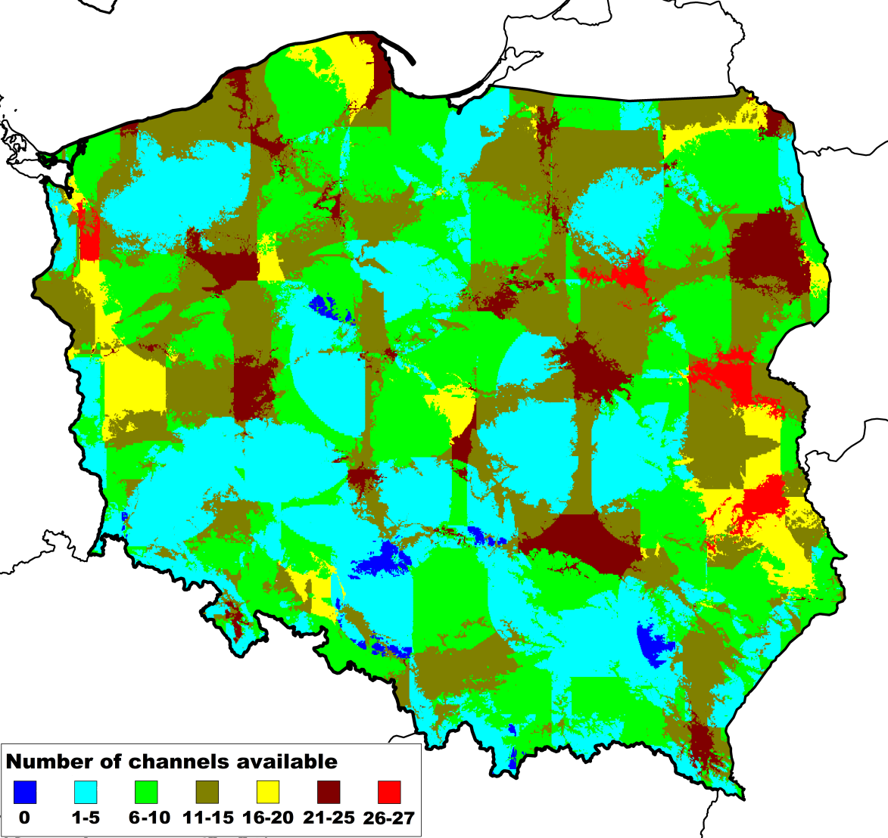
Figure 99: Result of the analysis – WSD availability in Poland; average number of available channels – 9.7 (rules from ECC Report 159 [1])
    - TV White Space availability in Poland: alternative methodology
The National Institute of Telecommunications Poland presented also alternative methodology of the TV White Space Spectrum assessment which can be considered for some countries especially where high interferences levels coming from broadcasting stations exists and which cannot be neglected.
The methodology is based on protection of interference-limited DTT coverage areas and respective higher values of required median field strength. Using such methodology it is possible to obtain a valuable number of available White Space Spectrum TV channels, while ensuring adequate protection of DTT coverage areas in the frequency range 470-790 MHz.
      - The methodology for White Space calculations in the TV bands
The methodology for the protection of DTT in such cases assumes protection of calculated interferences limited coverage areas and also GE06 Allotment areas. The coverage’s are calculated taking into account real (operational) Polish DTT station parameters and also known DTT station parameters from neighbouring countries as well as characteristic of broadcasting receiving antennas. For neighbouring regions the neighbouring DTT stations coverage areas protection were limited for the neighbouring countries areas only (i.e. no protection of neighbouring country DTT stations reception on Polish territory)
The main assumptions of the methodology are as follows:
- values of the median field strength to be protected are calculated in accordance with the current existing interference situation i.e. taking into account cumulative effect of interferences from other known broadcasting stations,
- coverage areas to be protected are defined by calculation for own country: the interference limited DTT stations coverage areas and GE06 allotments and for neighbouring countries: the ECC Report 159 [1] noise-limited coverage areas and GE06 allotments,
- maximum permissible nuisance field strength from WSD (taking into account also 10 dB margin for the cumulative effects of WSD interferences) is 10-20 dB lower (exact value to be decided by Administration) then existing power sum of nuisance field strengths coming from other broadcasting stations,
- WSD transmission in adjacent channels (N+1, N-1) is not allowed in the coverage area of channel N to be protected,
- in overlapping areas where the certain TV multiplex can be received from two or more TV stations it can be decided to protect only one coverage area. However this may depend on local conditions and other technical parameters of TV multiplexes (transmitters) involved.
      - Example result of the analysis using alternative methodology
Example result of the analysis is show in Figure 100 and includes calculating availability of WSD TV channels in the UHF band in Poland for CPE fixed type WSD: 10 m a.g.l. with e.r.p. 30 dBm.
Calculations availability of all TV channels (21-60) on Polish territory was checked in around 600,000 points, which means approx. raster 1km x 1km with DEM/DTM.
Methodology presented here is based on existing interference levels in TV bands and results in more TV channels availability assuring protection of realistic interference limited DTT coverage areas. Average number of channels available for WSD in this example shown in Figure 100 is 14.5.
Based on presented methodology it can be expected an average around 10-15 channels available in a country depending on local conditions (from 0 to 30 channels) giving also protection for adjacent DTT channels (N+1, N-1).
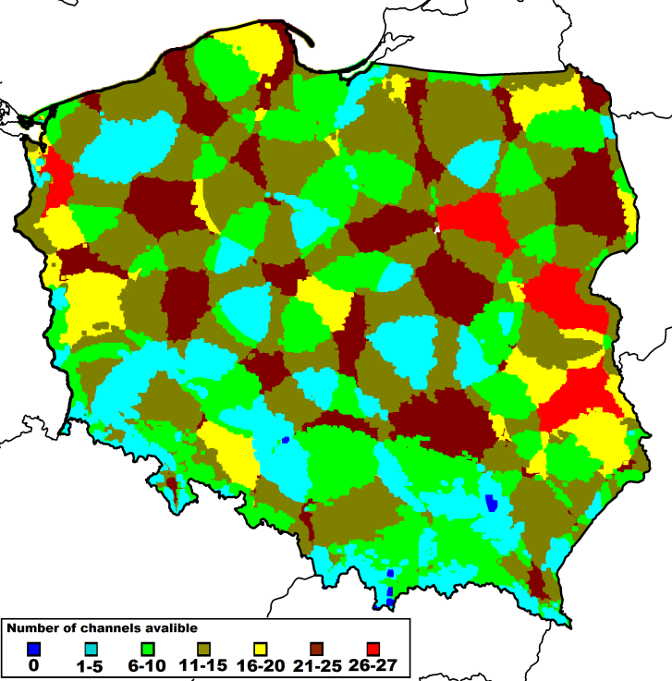
Figure 100: Result of the analysis – WSD availability in Poland; average number of available channels – 14,5 (alternative methodology)
    - TV White Space availability without 700 MHz band
The ITU WRC-12 approved Resolution 232 referring to a potential allocation of the frequency range 694-790 MHz in Region 1 to the mobile services on a co-primary basis with other services, including broadcast services, after WRC-15.
Some countries are considering the 700 MHz band exclusive allocations for mobile services. Such allocation will limit available number of channels for broadcasting but it will also reduce the potential availability of TV channels for WSDs.
This section presents results of analysis of the TVWS availability, assuming that available TV channels are ranged from 21 to 48 (470-694 MHz). It is noted that this study is based on the existing GE06 Digital Plan, and that it does not take into account any re-planning activity which would be needed in order to maintain the general principle of equitable access to spectrum amongst neighbouring administrations. Such re-planning may have a negative impact on the number of potentially available channels for WSD.
In Figure 101 result of analysis of the availability of channels WSD is presented, calculated in accordance with the ECC Report 159 [1] (CPE fixed type WSD: 10 m a.g.l. with e.r.p. 30 dBm). Average number of channels available for WSD’s in this example shown in Figure 101 is 6.7. It is average 3 channels less (approx. 30% less) then in case when we use TV channels 21 – 60.
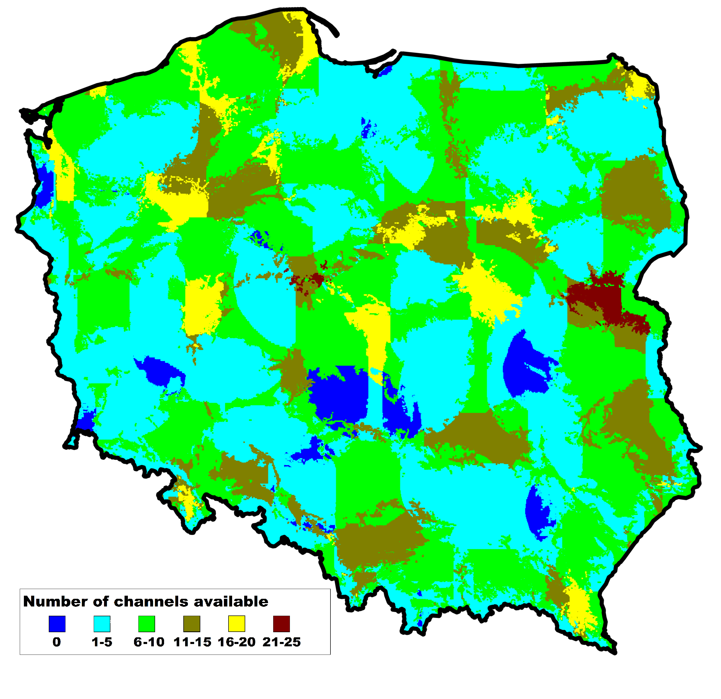
Figure 101: Result of the analysis – WSD availability in Poland without 700 MHz band; average number of available channels – 6.7 (rules from ECC Report 159 [1])

In Figure 102 result of analysis of availability of channels WSD is presented, calculated in accordance with presented an alternative methodology (CPE fixed type WSD: 10 m a.g.l. with e.r.p. 30 dBm). Average number of channels available for WSD in this example shown in Figure 102 is 10.1. It is average 4.6 channels less (approx. 30% less) then in case of the whole UHF TV channels band: 21 – 60.

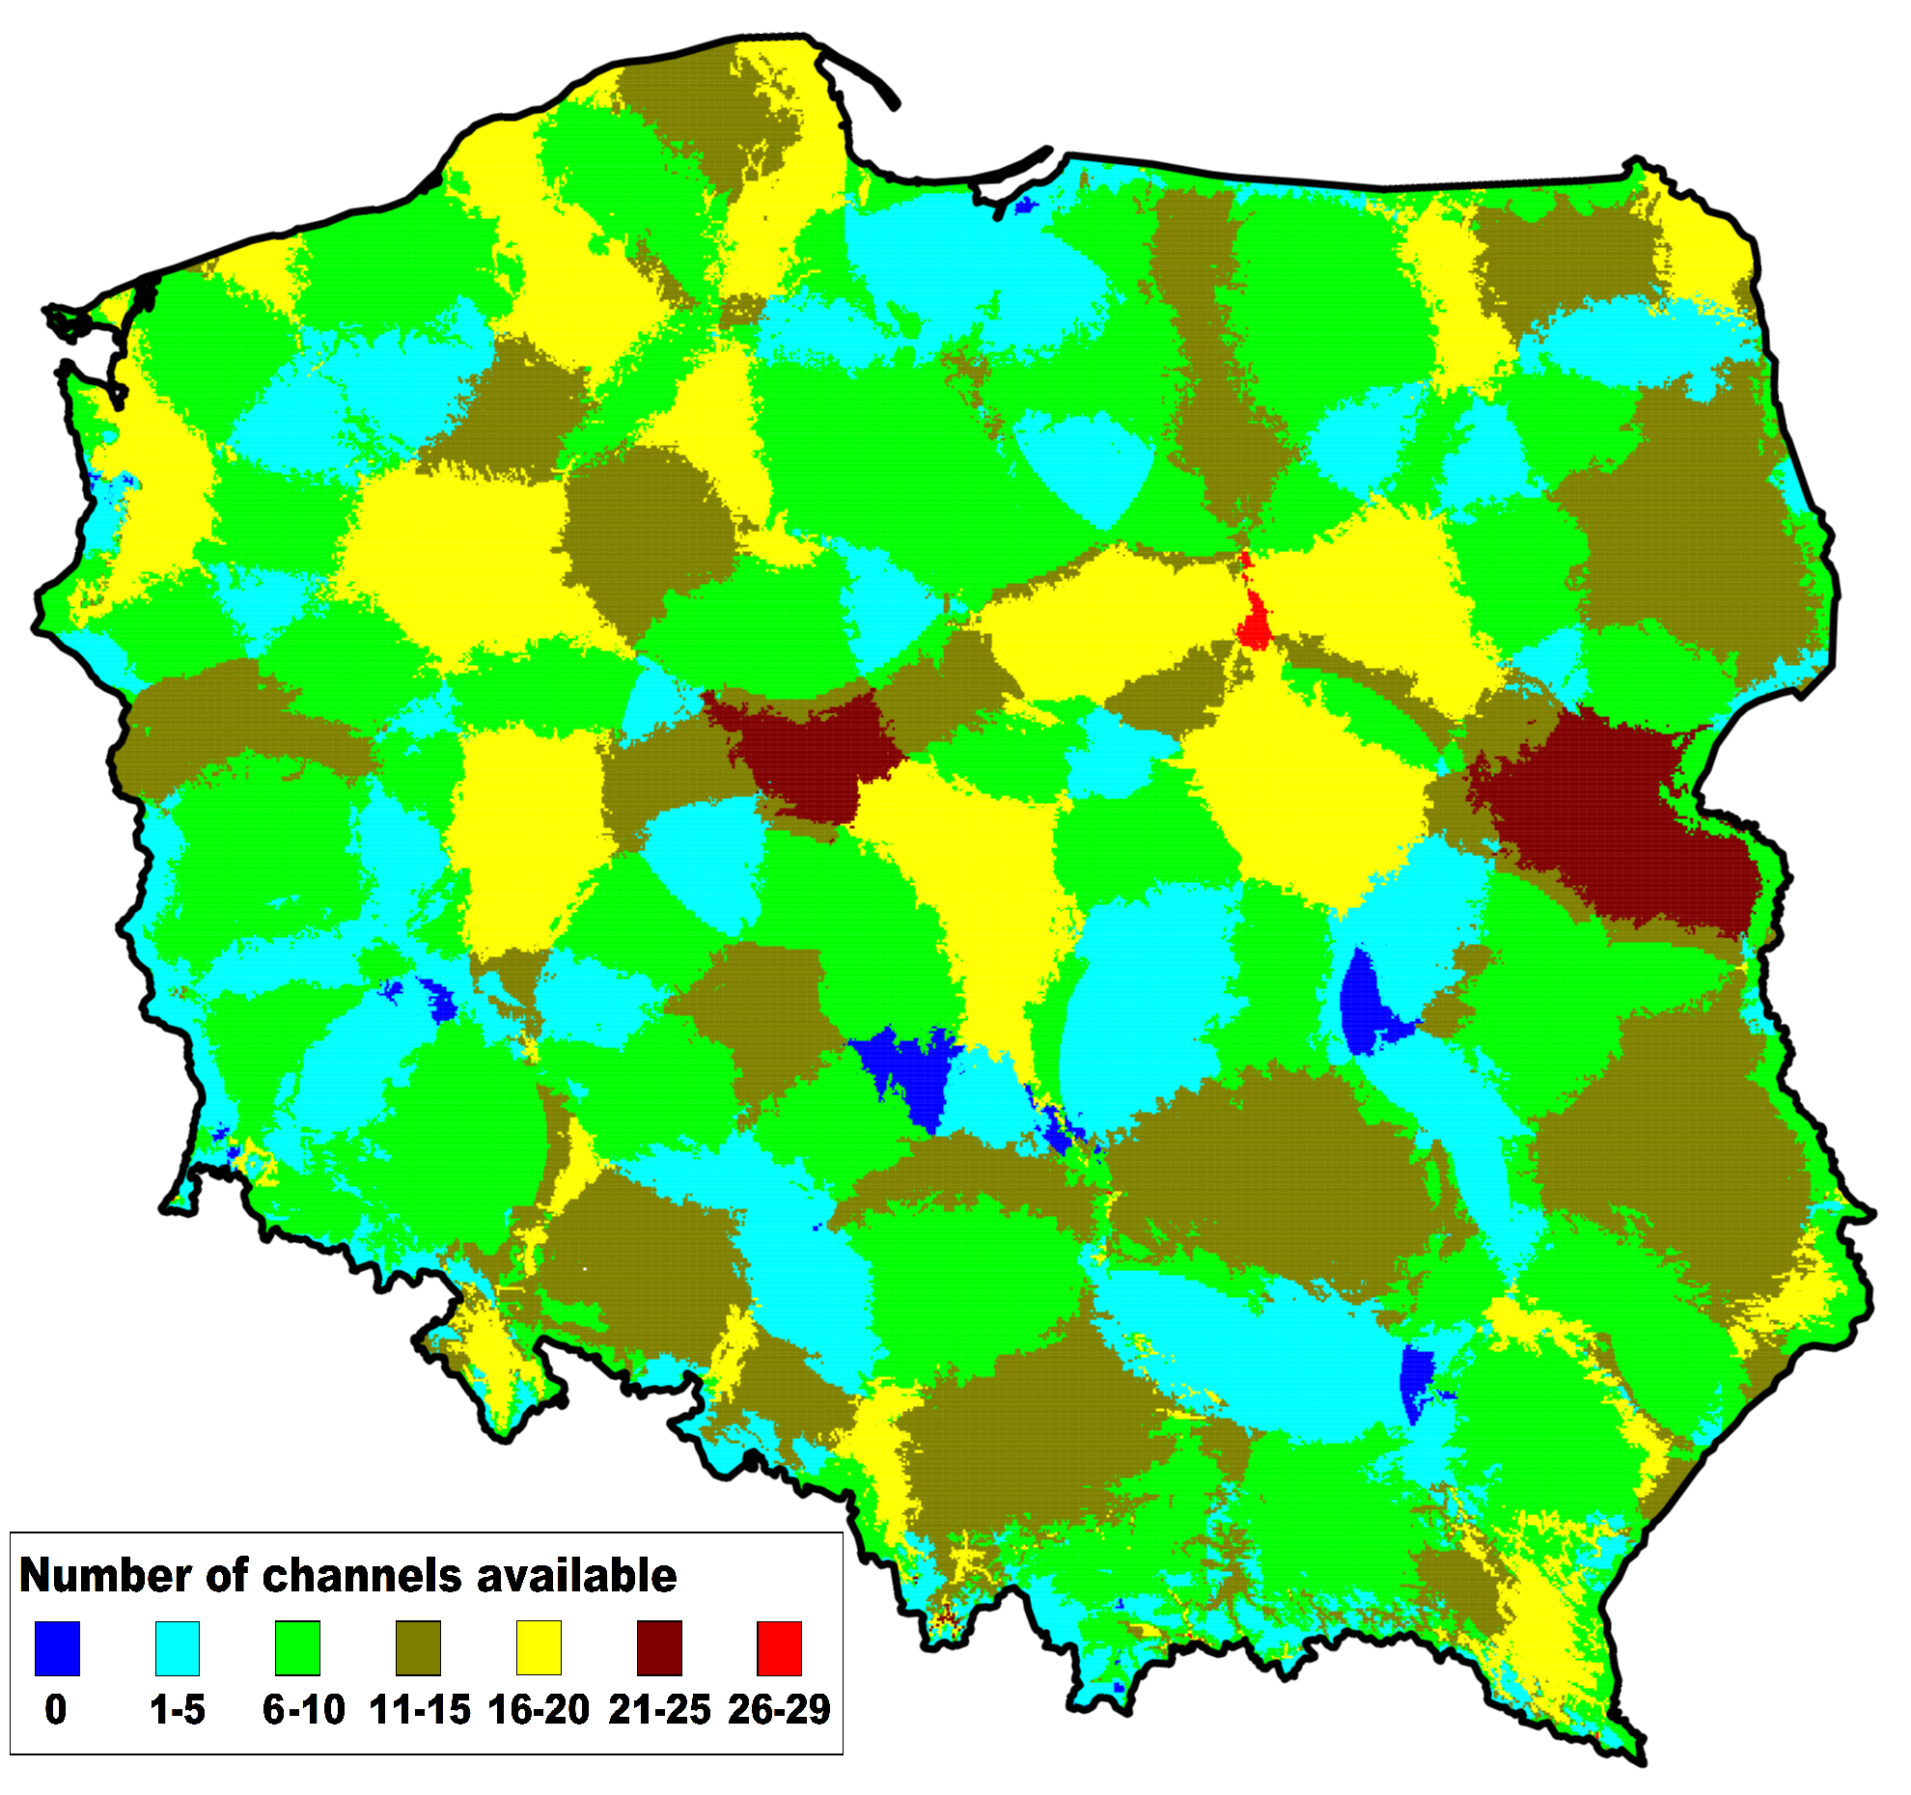
Figure 102: Result of the analysis – WSD availability in Poland without 700 MHz band; average number of available channels – 10.1 (alternative methodology)
    - Conclusions
These studies show examples of TVWS availability channels maps in Poland. The results were achieved according to the ECC Report 159 [1] methodology and also on presented alternative methodology.
Proposed alternative methodology can be applied especially in countries where high levels of DTT interferences exist which cannot be neglected. In such cases it is possible to increase number of available channels for WSD. In real implementation of this methodology the geolocation WSD database data may be also dynamically adjusted (kind of “tuning”) in case of any interference coming from WSD devices to the TV reception would appear – which can be assumed as an additional safe margin at the implementation stage.
If in future the 700 MHz band would be exclusively allocated for mobile services in some countries, number of TV channels available for WSD will decrease significantly. This section may be also used for WSD spectrum availability estimation in such cases.
  - Finland
The study of the WSD capacity in Finland is based on GE06 Plan assignments and allotments and Finnish Communications Regulatory Authority's (FICORA) station database which includes additions to the GE06 Plan. The GE06 Plan assignments and allotments of the neighbouring countries were taken into account and protected. The noise limited coverage areas and allotments for fixed reception (RPC1) were protected. Co- and adjacent channels to DTT inside DTT coverage areas were not allowed for WSD.
    - Method used for White Space calculations
The noise limited DTT station coverage areas and allotments are protected with selected protection criteria. The DTT coverage areas and WSD interferences are calculated by using Recommendation ITU-R P.1546-1 [11] method. Effective heights of WSD stations are calculated by using GTOPO30 terrain height data. One percent of time is used in WSD interference calculations. The use of DTT receiving antenna discrimination is optional.
The main steps of the method are as follows:
- the noise limited coverage areas of all GE06 assignments and FICORA stations are calculated;
- the WSD test point coordinate file with specified distance increment is created;
- WSD parameters, e.r.p. and antenna height, are specified;
- calculation is performed in all test points and channels;
- WSD transmissions on co- and adjacent channels (N+1, N-1) are not allowed in the coverage areas of channel N to be protected;
- WSD interferences in the nearest DTT coverage and allotment area points are calculated;
- If the interference is below the specified protection criteria the point is accepted for WSD.
    - Example of WS capacity calculations
In the example WS-stations with e.r.p. 36 dBm and antenna height of 30 meters were used. The interfering field strength was calculated at reception height of 10 meters and DTT receiving antenna discrimination was used. The used WSD to DTT protection was 44 dB, 21 dB co-channel protection ratio plus13 dB combined location variation plus 10 dB combined multiple interference and safety margin.
The distance between WSD test points was selected as 2 km, total number of test points was 91075. Channels 22-60 were included, channel 21 is not in DTT use in Finland.
Figure 103 shows the map of the numbers of WSD channels.
Figure 104 shows the average number of WSD channels as a function of WSD to DTT protection.
Figure 105 shows an example of WSD channel map.
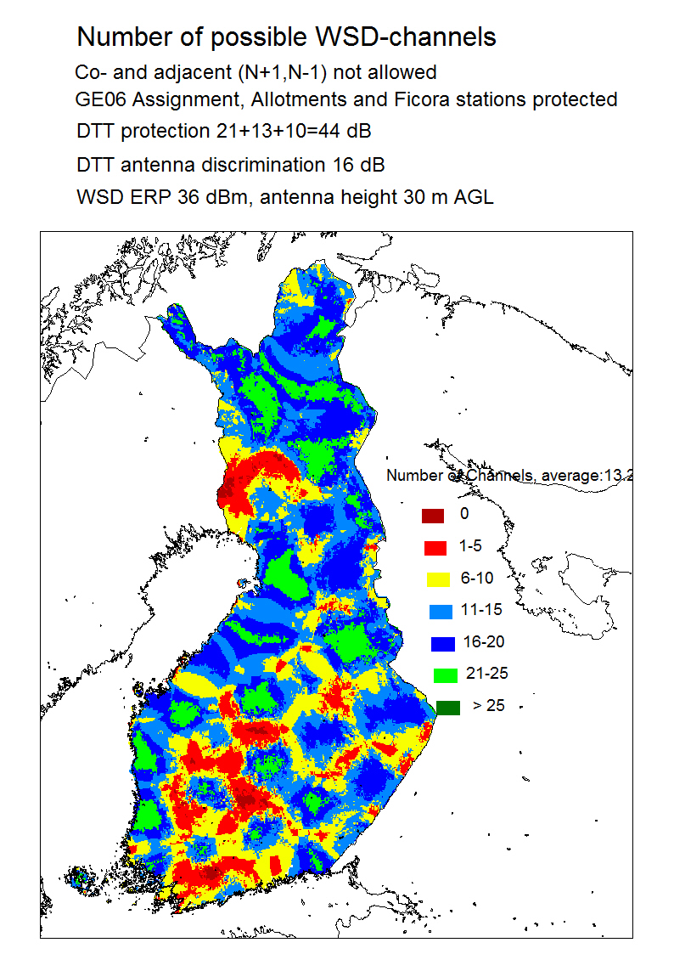
Figure 103: Calculation result, number of WSD channels in Finland
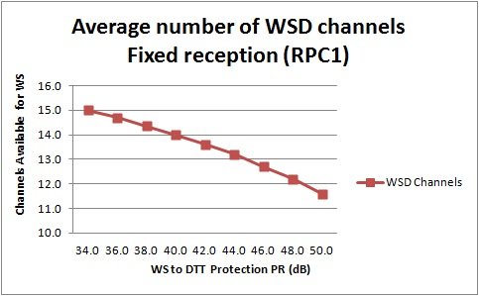
Figure 104: Average number of WSD channels

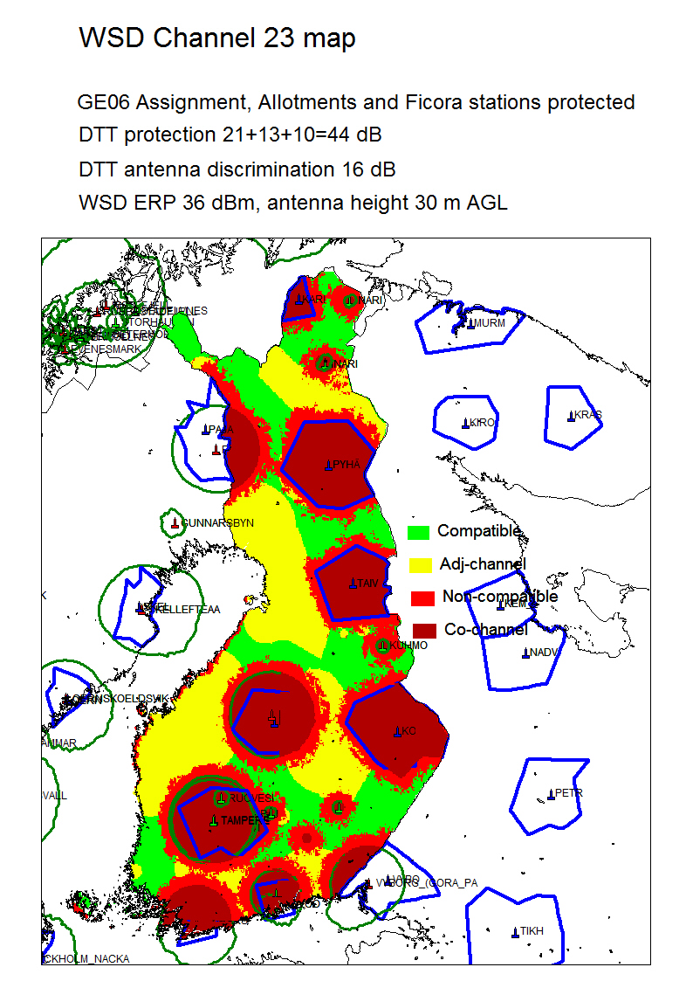
Figure 105: Example of WSD channel map
  - Russian federation
The frequency band 470-790 MHz is widely used by the broadcasting service and is the main frequency resource for the implementation and development of digital terrestrial broadcasting in the Russian Federation.
An assessment of the available frequency spectrum as white space in the Russian Federation within digital TV terrestrial broadcasting has been carried out for the Arkhangelsk region (the north-west part of the country). This assessment did not take into the use of this spectrum by ARNS systems (645-790 MHz), by services auxiliary to broadcasting (SAB/SAP), cable broadcasting systems and, in some instances, by analog TV broadcasting stations.
    - Methodology
The following assumptions were made regarding the methodology used to assess the amount of white space spectrum:
- Simultaneous use of 470-694 MHz by broadcasting service and white space devices was considered;
- Based on ECC Report 159 the 1% degradation of location probability of digital television was chosen as a criterion of availability;
- WSDs is assumed to be mounted at 30 m above ground;
- Worst case protection ratios from Recommendation ITU-R BR. 1368 for LTE interference were used (protection of 90% of silicon tuners and 0% payload option for WSD);
- Propagation model: free space and standard deviation of 3.5 dB for distances up to 80 m, Recommendation ITU-R P.1546 and standard deviation of 5.5 dB for longer distances;
- The summation of interfering signals was not taken into account;
- Directivity discrimination of receiving antenna was considered at each point;
- The 5 MHz bandwidth for WSD channel was considered and WSD channels were allocated in such a way that centre frequencies of WSD channels coincided with centre frequencies of TV channels (Figure 106).
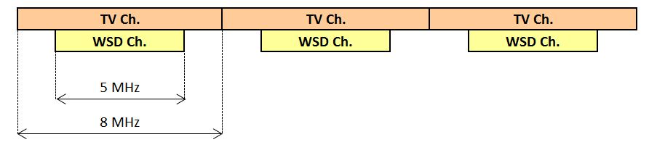
Figure 106: TV and WSD channel grid
    - Estimation of available spectrum
The map with an amount of spectrum available across the region is presented in Figure 107 for an e.i.r.p of 20 dBm. The region is characterized by a uniform relief and low density of television stations and settlements, especially in its northern part.
Figure 108 presents the dependence of the number of free channels for cognitive device on the percentage of the region territory for which this amount of free channels is available. Figure 109 presents the dependence of the number of free channels on the percentage of population living in the region, for which this amount of free channels is available.
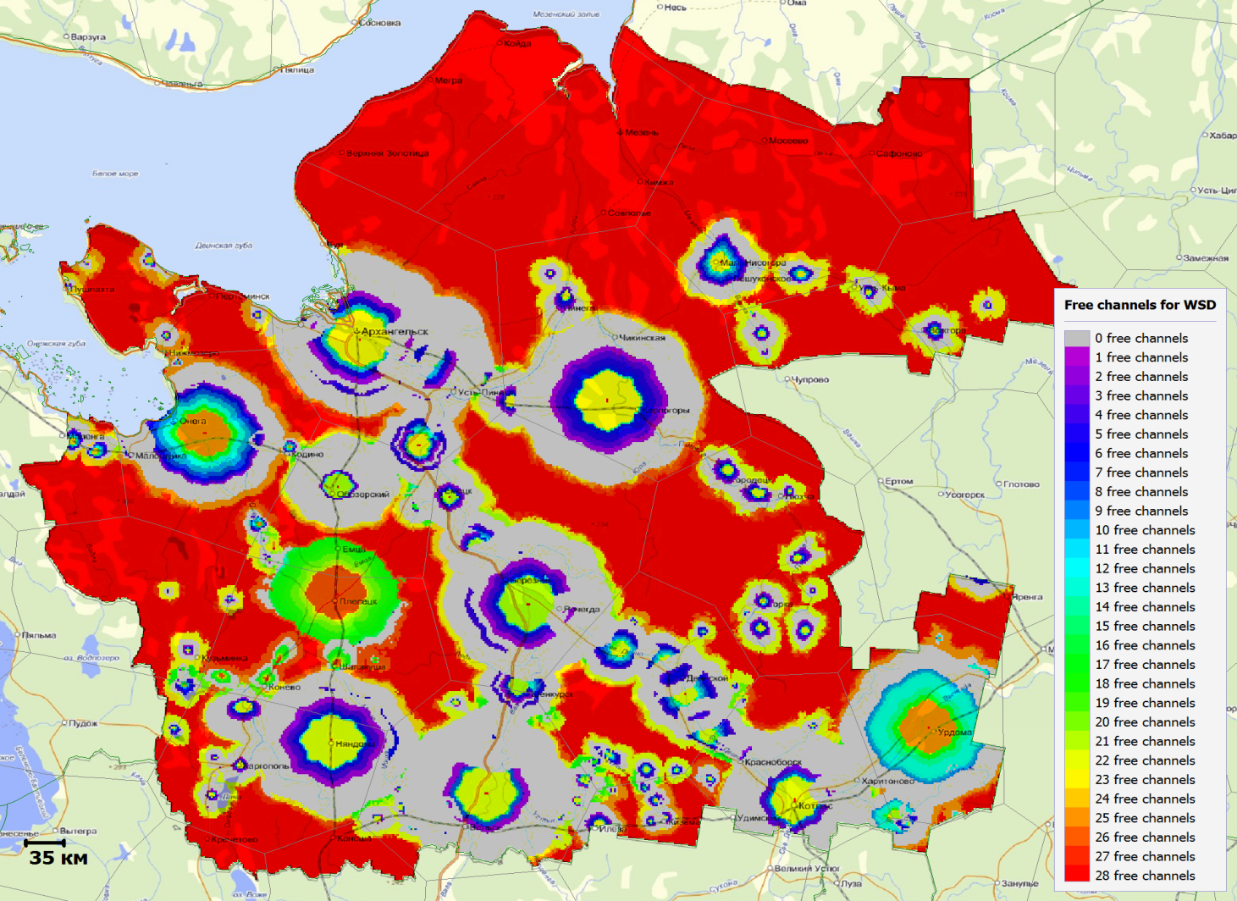Figure 107: Example of the map of frequency spectrum availability for cognitive device with power
20 dBm(100 mW) for Arkhangelsk region.

Figure 108: The results of analysis of available channels for cognitive device depending on the % pixels, for which this amount of free channels is available.

Figure 109: The results of analysis of available channels for cognitive device depending on the % of population of the region, for which this amount of free channels is available.

    - Conclusions
The estimation of available spectrum for implementation of WSDs was carried out in one region of Russian Federation. Results of calculations show that with low power WSD (e.i.r.p. 0 dBm) 20 channels are available for 90% of the regional population, but with high power WSD (e.i.r.p. 36 dBm) 20 channels are available only for 20% of the regional population. And these settlements (which constitute 20% of population) are situated near the TV stations.
It needs to be noted that the calculations presented did not consider aggregated interference from multiple WSDs, which could decrease an amount of available spectrum for WSD.

- List of references
- ECC Report 159 on technical and operational requirements for the possible operation of cognitive radio systems in the ‘white spaces’ of the frequency band 470-790 MHz;
- Radio Regulations footnote 5.291A: Additional allocation: in Germany, Austria, Denmark, Estonia, Finland, Liechtenstein, Norway, Netherlands, the Czech Republic and Switzerland, the band 470 - 494 MHz is also allocated to the radiolocation service on a secondary basis. This use is limited to the operation of wind profiler radars in accordance with Resolution 217 (WRC-97);
- Resolution 217 (WRC-97): Implementation of wind profiler radars;
- [draft] ECC Report 186 on Technical and operational requirements for the operation of white space devices under geo-location approach;
- ECC Report 148 on measurements on the performance of DVB-T receivers in the presence of interference from the mobile service (especially from LTE);
- ETSI TR 102 907: Use Cases for Operation in White Space Frequency Bands;
- ETSI EN 300 422: Wireless microphones in the 25 MHz to 3 GHz;
- ECC/DEC/(09)03 on harmonised conditions for Mobile/Fixed Communications Networks (MFCN) operating in the band 790-862 MHz;
- IEEE standard 802.22.1: Wireless Regional Area Network (WRAN) using white spaces in the TV frequency spectrum;
- ETSI EN 300 292-2 : Functional specification of call routing information management on the Operations System/Network Element (OS/NE) interface;
- Recommendation ITU-R P.1546: Method for point-to-area predictions for terrestrial services in the frequency range 30 MHz to 3 000 MHz; ;
- ECC Report 104 on compatibility between mobile radio systems operating in the range 450-470 MHz and Digital Video Broadcasting-Terrestrial (DVB-T) systems operating in UHF TV Channel 21 (470-478 MHz);
- Recommendation ITU-R V.573-5: Radiocommunication vocabulary;
- Recommendation ITU-R M.1830: Technical characteristics and protection criteria of aeronautical radionavigation service systems in the 645-862 MHz frequency;
- CEPT Report 30 on the identification of common and minimal (least restrictive) technical conditions for 790 - 862 MHz for the digital dividend in the European Union;
- CEPT Report 40 on compatibility between LTE and WiMAX operating within the bands 880-915 MHz / 925-960 MHz and 1710-1785 MHz / 1805-1880 MHz (900/1800 MHz bands) and systems operating in adjacent bands;
- ECC Report 099 on Impact on existing PMR/PAMR and Air Ground Air (AGA) systems in the 400 MHz band;
- Recommendation ITU-R F.1336-2: Reference radiation patterns of omnidirectional, sectoral and other antennas in point-to-multipoint systems for use in sharing studies in the frequency range from 1 GHz to about 70 GHz;
- Recommendation ITU-R P.1238-6: Propagation data and prediction methods for the planning of indoor radiocommunication systems and radio local area networks in the frequency range 900 MHz to 100 GHz
- 3GPP specification TS 36.101: 3rd Generation Partnership Project; Technical Specification Group Radio Access Network; Evolved Universal Terrestrial Radio Access (E-UTRA); User Equipment (UE) radio transmission and reception;
- Recommendation ITU-R P.1411: Propagation data and prediction methods for the planning of short-range outdoor radiocommunication systems and radio local area networks in the frequency range 300 MHz to 100 GHz;
- European-footnotes included in the ECA Table: EU13 – CEPT administrations are urged to take all practical steps to clear the band 645-960 MHz of the assignments to the aeronautical radionavigation service;
- Implementing Geolocation, Ofcom Consultation Document published 9th November 2010, http://stakeholders.ofcom.org.uk/binaries/consultations/geolocation/summary/geolocation.pdf
- A. Ghasemi, E. Sousa, Collaborative spectrum sensing for opportunistic access in fading environments, in: Proc. of IEEE DySPAN 2005, 2005, pp. 131–136

The location probability in this report is understood to be the percentage of locations within a small area, referred in this document as “pixel” (a small area of typically about 100 m x 100 m where the percentage of covered receiving locations is indicated), where the wanted signal is high enough to overcome noise and interference for a given percentage of time taking into account the temporal and spatial statistical variations of the relevant fields.
See § 2.4 of ECC Report 159 [1] for definition of incumbent services/systems in the band 470-790 MHz.
These parameters may not be simultaneous achievable and other values can be used including higher values
In the European Union the technical conditions and the licensing regimes for equipment using the radio spectrum in the frequency range up to 3000 GHz are described in the “Radio Interface Specifications” (RIS). Most CEPT administrations not being part of the EU have meanwhile also introduced RIS. The available RIS are published in the European EFIS-database (see www.efis.dk) where information field Nr. 7 defines the maximum allowed transmission power or power density.
Firmware is the processor code implemented by the time of manufacture and cannot be modified by the user.
This generator was chosen as it has good ACLR performance, typically 83 dB for offsets > 10MHz.
It should be noted that the measurement procedure differs from that presented in ECC Report 148 [5], in that the ECC Report 148 [5] method specifies that that the wanted power C is fixed and the interfering signal is varied to find the protection point of the receiver under test. The latter method is preferred.
Data for 15 out of 16 receivers was used for this analysis.
For alternative DTT modes appropriate correction factors should be applied (see ECC Report 148).
Presented by RCC countries
Can be used with regard to several other countries mentioned in No. 5.312, except RCC countries
See Section 5.2 for the note regarding the validity of the results.
See Section 5.2 for the note regarding the validity of the results.
The analysis assumed 0 dBi antenna gain for UE, which may not be achievable in practice. UE with lower antenna gain will allow the restrictions on WSDs e.i.r.p. to be relaxed.
EPCOS B7679: http://www.epcos.com/inf/40/ds/mc/B7679.pdf
For the purpose of this scenario and the description of the technical parameters the ITU-R Recommendation F.1336 was used as an appropriate reference. It should be noted that ITU-R Recommendation F.1336 is subject to ITU- R studies in order to extend the applicability of the recommendation to frequencies below 1000 MHz.
If an interference source is removed, the LP will increase, and the IP will decrease, and both ‘degradations’ will be negative.
Because the results of a Monte Carlo simulation can vary slightly from simulation to simulation, the most accurate determination of the difference LPb – LPa (or IPa – IPb) would involve the calculation of LPb and LPa (IPa and IPb) using the same randomly generated values for the wanted field in the presence of noise and interference as those for the wanted field in the presence of noise only.
Here, sufficiently close depends upon the power of the transmitter, for PMSE equipment this distance is typically less than 0.5m but it is very probable in many use-cases (such as two dancers, or outside broadcast interviews) that this distance is not unreasonable.

