ECC Report <No>

Technical assessment of the benefit and additional complexity of using asymmetric channel arrangements for point-to-point links
Month YYYY (Arial 9pt bold)
[last updated: DD Month YYYY) (Arial 9pt) [date of the latest update]]

Executive summary
(advice: the Executive Summary should provide a short and concise explanation on the purpose of the respective ECC Report and should clearly indicate the covered subjects to which it applies. In addition, it should clearly explain the application of the document.)
[Rapporteur note: t.b.c.]

TABLE OF CONTENTS

0 Executive summary 2
1 Introduction 6
1.1 Scope 6
1.2 Background 7
1.3 Radio Technology 8
1.4 Planning tools 8
1.5 Frequency bands 9
2 Definitions 9
3 Asymmetry in access networks and user data 9
3.1 Asymmetry in the backhaul of access network 9
3.1.1 NGMN 9
3.1.2 Other transport asymmetry constraints 10
3.1.3 Carrier Aggregation 10
3.1.4 TDD in LTE standards 11
3.1.5 Traffic Asymmetry 11
3.1.5.1 Main drivers of traffic asymmetry 11
3.1.5.2 Measured DL/UL traffic asymmetry 12
3.1.5.3 Mobile traffic per application 12
3.1.6 DL/UL asymmetry 14
3.2 Impact of asymmetry in the equipment design 16
3.3 Impact of asymmetry use within conventional symmetric channel arrangements 16
3.3.1 Implementation of asymmetry in wireless transport networks 16
3.3.1.1 EXAMPLE 1: Adding DL capacity 16
3.3.1.2 EXAMPLE 2: Saving spectrum 17
3.3.1.3 EXAMPLE 3: Adding tail sites 19
3.4 Potential increase of spectral efficiency 21
3.4.1 Symmetrical approach 21
3.4.2 Asymmetrical approach 21
4 New channel arrangements and their usage 21
4.1 Arrangements compatible with the existing channel arrangement 21
4.1.1 Service granularity using Nx7MHz with N=1, 2, 4, 8 21
4.1.2 Using both 14 and 28 MHz go/return within the same wider channel 22
4.1.3 Confining smaller channels in the innermost part of the band 22
4.2 Arrangements not- compatible with the existing channel arrangement 23
4.2.1 Alternate 28 MHz +7MHz 23
4.3 Service granularity using Nx7MHz 24
4.3.1 Change of channel raster (n x 7MHz) 24
4.4 Various asymmetrical assignment solutions 24
4.4.1 Option 1: Using asymmetrical channel assignment 25
4.4.2 Option 2: Spectrum aggregation by adding unidirectional links 25
4.4.3 Option 3: Spectrum aggregation of unidirectional links 25
4.5 What is to be changed in the Recommendations 26
5 Demonstration of the benefit when using different go/return channel sizes 26
6 Demonstration of the possible benefits versus the increase of equipment and coordination complexity due to the need for “flexible duplex”. 26
6.1 Benefit. 26
6.2 Increased equipment complexity due to “flexible duplex” 27
6.3 Increased co-ordination complexity due to “flexible T/R separation” 27
6.4 Reuse of potentially orphan spectrum 28
7 Burden to the frequency coordination process 29
7.1 Cross border coordination with countries which do not follow this asymmetry proposal. 29
7.2 Mixed symmetric and asymmetric deployment in homogeneous networks 29
7.3 Need to change planning tool for the administration 29
7.4 Cost/workload impact for the administration 29
8 Block assignment vs Link by Link assignment challenges difference need further precision Fees 30
9 Factors affecting the degree of asymmetry on the mobile backhauling traffic 30
10 Definition of study case on large scale for the link by link assignment case 30
10.1 Rural scenario. 30
10.1.1 Methodology 30
10.1.2 Parameters 31
10.1.3 Results 31
10.2 Urban scenario. 31
10.2.1 Methodology 31
10.2.2 Parameters 32
10.2.3 Results for Symmetrical Scenario 33
10.2.4 Results for Asymmetrical Scenario 37
11 Conclusions 37
ANNEX 1: NGMN Traffic model 38
ANNEX 2: Backhaul dimensioning based on LTE-FDD access network capacit 39
A1.1 Peak and mean cell throughput to be considered 39
A1.2 Asymmetry ratio for the last hop 39
A1.3 Asymmetry ratio for agreggated links 39

Note on the Table of Contents (delete after reading)
This is automatically styled and compiled from the headings, subheadings and page numbers from the document that follows. To update the Table of Contents move cursor within the table and press F9.

LIST OF ABBREVIATIONS

Abbreviation | Explanation
2G | Second Generation digital cellular network
3G | Third Generation digital cellular network
4G | Fourth Generation digital cellular network
AMC | Adaptive Modulation and Coding
ANFR | Agence Nationale des Fréquences
ARCEP | Autorité de Régulation des Communications Electroniques et des Postes
ATM | Asynchronous Transfer Mode
ATPC | Automatic Transmit Power Control
BER | Bit Error Rate
BFWA | Broadband Fixed Wireless Access
BWA | Broadband Wireless Access
CA | Carrier Aggregation
CAGR | Compound Annual Growth Rate
CCDP | Co-Channel Dual-Polarization
CEPT | European Conference of Postal and Telecommunications Administrations
CA | Carrier aggregatopn
CS | Channel Spacing or Channel Separation
DBPSK | Dual-Polarization Binary Phase-Shift Keying
DFS | Dynamic Frequency Selection
DSL | Digital Subscriber Line
ECC | Electronic Communications Committee
ECO | European Communications Office
eICIC | Enhanced Inter-Cell Interference Coordination
EIRP | Equivalent (or Effective) isotropically radiated power
ERC | European Radiocommunications Committee
ERO | European Radiocommunications Office
ETSI | European Telecommunication Standard Institute
FDD | Frequency Division Duplex
FM | Fade Margin
FS | Fixed Service
FWA | Fixed Wireless Access
GSM | Global System for Mobile Communications
HSPA | High-Speed Packet Access
HSPA+ | Evolved HSPA
ICIC | Inter-Cell Interference Coordination
IMT | International Mobile Telecommunications
IMT-2000 | International Mobile Telecommunications-2000
IMT-Advanced | International Mobile Telecommunications Advanced: requirements for 4G Standards
IP | Internet Protocol
LMDS | Local Microwave (or Multipoint) Distribution Service
LTE | Long Term Evolution
MFCN | Mobile / Fixed Communication Networks
MGWS | Multi Gigabit Wireless Systems
MIMO | Multiple Input Multiple Output
MMDS | Multichannel Multipoint Distribution Service,
MP-MP | Multipoint-to-Multipoint
MW | Microwave
MWA | Mobile Wireless Access
MWS | Multimedia Wireless System
NGMN | Next Generation Mobile Networks
NLOS | Non Line of Sight
OFDM | Orthogonal Frequency-Division Multiplexing
OFDMA | Orthogonal Frequency-Division Multiple Access
PHY | Physical Layer
P-MP | Point-to-Multipoint
PMR | Professional (or Private) Mobile Radio
POP | Point of Presence
P-P | Point-to-Point
PTT | Post and Telecommunication
QAM | Quadrature Amplitude Modulation
QoS | Quality of Service
RPE | Radiation Pattern Envelope
RR | Radio Regulations
RSL | Received Signal Level
SME | Small Medium Enterprise
SOHO | Small Office Home Office
SW | Software
TDD | Time Division Duplex
TDM | Time-Division Multiplexing
TDMA | Time-Division Multiple Access
UMTS | Universal Mobile Telecommunications System
WRC | World Radiocommunications Conference
XPIC | Cross Polarization Interference Cancellation

Introduction
WI rapporteur : Mariana Goldhamer (marianna001@gmail.com) (Ceragon)
WI: SE19_27
Final approval targeted (Deadline of PC resolution): February 2014

Editor note: Requested contributions on rules suggestion with supporting rationales for Tx/Rx deviation from the duplex spacing:
- Producer declaration
- Any other suitable rule.

Scope
It is commonly understood that, while in the old GSM times when only voice/SMS signals were used the DL/UL traffic was symmetric, in the new generation of mobile access the DL/UL data traffic has become asymmetric. This may be also reflected in the relevant backhauling network.
It is undoubted that if a P-P link may be deployed with DL/UL asymmetric channel size there is, in principle, some spectrum saving; however, it is still needed to be analysed if such “unidirectional” spectrum saving can effectively be reused in the same area network and which is the possible additional burden in term of frequency coordination and equipment complexity.
Therefore, the possible use of asymmetric go/return capacity in P-P links for mobile backhauling networks, while adding flexibility for the user and potential spectrum saving, poses a number of questions for its practical application. The main differences from conventional symmetric applications are related to the unavoidable variable transmit-receive frequency separation, which may change the existing design considerations. In a specific frequency band, this separation should be indicated by each equipment producer.

Standing the significant impact, the possible asymmetric P-P link practice is intended as a “medium-long term” improvement; therefore, it should be seen in the light of the most updated forecast on the expected DL/UL user data asymmetry. In addition, the asymmetry factor can be influenced by the access network asymmetry, in FDD and TDD deployments, which is presently under study with a focus on the LTE networks.
Consequently, the content of this Report aims to address:
- The possible amount, in forthcoming data usage patterns in LTE and HSDPA+ networks backhauling, of the uplink/downlink asymmetry and its distribution in links carrying aggregated traffic in different segments of backhauling network from periphery to the core network gateways;
- The possible benefits in terms of spectrum saving, downlink capacity increase, network versatility, of using asymmetric go/return in Point-to-Point links within the backhauling networks;
- The impact of go/return asymmetry (“channel size asymmetry” implying also a variable transmit/receive separation on typical P-P equipment design;
- The impact of such asymmetric links practice on the conventional link-by-link coordinated assignment and of the necessary coexistence of symmetric links (e.g. for the conventional high capacity core networks) with asymmetric links.
- The impact of go/return “channel size asymmetry” on recommended channel arrangements and the consequent frequency assignments in bands where symmetric and constant duplex arrangements are currently established and their possible modifications for accommodating both symmetric and asymmetric go/return channels, while minimizing coordination and equipment hardware problematic.

Background
Where block assignment is used, the possibility of asymmetric connections is already recognised in some ECC Recommendations (e.g. ECC/REC(01)04) referring to the 42GHz band, typically for P-MP applications, but, when technology neutrality is foreseen in the auction rules or P-P infrastructures are explicitly anticipated, the concept is easily extendable to the P-P networks as well.
The rationale is that, in block assignment environment, the following conditions, that in the general case could highly impact the balancing between equipment design and coordination versus the possible benefits, are already limited to an acceptable degree rendering attractive, when needed, the asymmetric P-P use:
- The owner may uniquely define any degree of asymmetry and any other requirements for his network; therefore, he may autonomously define a suitable subdivision of the blocks providing asymmetrical UL and DL channel sizes as already recognised in some ECC Recommendations for PMP applications (see Figure 1:).
- The limited portion of spectrum implicitly reduces the degree of variance of the duplex separation.
- The owner is fully responsible of its own coordination process (from technical and economical point of view).
Therefore the content of this report may be regarded also as guidance for the block owner, in cases where he wishes to establish asymmetric links within the block.
- Examples of FDD asymmetric systems within an assigned block
(reprinted from ECC/REC(01)04)

Radio Technology
The radio technology which is intended for use in asymmetrical links is actually the same as the in the symmetrical case. The MODEM which is the physical heart of every radio system, can be SW configured to control the spectral utilization of the system. In fact, all MW vendors are already doing so, by offering SW configurable modulation and BW utilization schemes in their systems.

In symmetrical systems (referring to the non-AMC case) the modulator and demodulator are configured to the same symbol rate. In an asymmetrical system the modulator (Tx) and demodulator (Rx) located on the same site of the link are configured to different symbol rates and modulations according to the specific system serving as a DL transmitter or UL transmitter. Typically the TX symbol rate of the DL Transmitter is higher than the RX symbol rate, while the TX symbol rate of the UL transmitter is lower than the RX symbol rate.

Planning tools
For analyzing the frequency coordination impact, both the commercially available planning SW and the administrations tools should be considered.
From the point of view of commercially available planning tools, planning an asymmetrical link is not different than planning a symmetrical link due to the following reasons:
  - Propagation – Symmetrical and Asymmetrical links behave the same, with the only difference being in planning for a different working point looking from transmitter or receiver point of view.
  - Planning – Commercially available radio planning software is either ready or will be adapted to support the planning of asymmetrical links. Planning an asymmetrical link requires different parameters within the same framework of inputs (C/I, NFD…). Both stations of the p-p link being coordinated are independently assessed in terms of the interference they receive from the existing network and the interference they present to the existing network, such that the asymmetric link co-ordination is not a paradigm-change.
However, most administrations have developed their proprietary radio planning SW and administrative procedures which presently foresee frequency coordination in a symmetric way. In case that asymmetric planning will be adopted, that SW and administrative procedures will have to be adapted as appropriate.

Frequency bands
If appropriate, the asymmetrical approach may be applied to any current channel arrangement between the frequency bands within 6GHz and 80GHz (see Annex 3 of ECC Report 173 [1]).

Definitions
Term | Definition
T/R spacing | The frequency difference between the centre of the transmit and receive channels of an individual link

Asymmetry of user data in access networks
In the past, the main usage of mobile networks was to facilitate voice communication. This in turn, influenced the symmetrical nature of the protocols in use (SDH, PDH) and the symmetrical nature of the transport networks.
The major part of today’s and future mobile device use is data and video streamming oriented, which dictates an asymmetrical orientation by its very nature. This in turn influences the utilization of the transport networks as the largest P-P spectrum users (Mobile network operators: ref. 4.1.1 of ECC Report 173) move their transport networks from TDM to packet data oriented, which leads to P-P links being designed to meet traffic requirements in downlink (DL) direction only, leaving the possible lesser utilization of links in uplink (UL) direction.
There are two main causes contributing to the asymmetrical behavior of the cellular networks:
- Physical limitations of the UL/DL wireless access network capacity (e.g. for LTE);
- Real traffic asymmetry.
Editor note: the real traffic asymmetry is much higher than the access network capacity – why do we need to consider the access network asymmetry?

Asymmetry in the backhaul of access network

The traffic asymmetry analysis shall be based on measured data, however historically the first guidance on the asymmetry ratio has been provided by NGMN in ‎[2]. As indicated in ‎[2], its guidance is based on simulations assessing the maximum access network capacity and NOT on real traffic measurements. This
capacity has been evaluated based only on FTP traffic, while as it can be seen from real traffic measurements presented below that the dominant type of traffic is the video streaming. The consideration of the FTP traffic, characterized by quasi random packet arrival times, conducted to distorted conclusions regarding the asymmetry of the aggregation links.

In continuation we begin with the presentation of the NGMN guidance on backhaul provisioning, based on the access network maximum capacity simulation, followed by the results of the backhaul asymmetry based on real traffic measurements.

NGMN
The mobile system behavior is such that introduces some difference between the DL and UL achievable system capacity. This depends on the technology choices for the system design.
The amount of DL/UL asymmetry in future LTE networks, to which this report is focused, is subject of various studies from major mobile operators. A specific study was made in a NGMN (Next Generation Mobile Networks Alliance) white paper [1] for the LTE-Release 8 based systems; comparing the DL/UL achievable access network capacity while using the FTP traffic model in ‎[3].For the FDD 10 MHz or 20 MHz used channel, it is shown that the degree of asymmetry will range from 2:1 (for the traffic collected by a single tricell eNodeB) to aprox. 1.5:1 (for aggregation of more than three tricell eNodeBs).. Figure 2: (reprinted from the NGMN white paper) gives the summary results as function of the number of aggregated eNodeBs.

- LTE Transport Provisioning for Downlink and Uplink (no IPsec)
(from [1])
A number of operators active in SE-19 (Telia-Sonera, Telecom Italia and Vodafone) have confirmed the validity of the above mentioned NGMN study.

More background on the interpretation of NGMN study may be found in Annexes 1 and 2
[Unfortunately we [Text from TI – section 2] are not in a position to share UL/DL ratios measured in our network, as they are considered confidential data and most of all they reflect the present situation, while, for the definition of possible future asymmetry use, a longer term forecast on LTE traffic is necessary. However it is clear that the level of asymmetry is decreasing. And this trend is continuing. TI believes that a certain level of asymmetry will remain in the network but does not justify the implementation of asymmetric links. Therefore we support the conclusions of Figure 13 of the NGMN White Paper (Info Doc 1), to which we contributed: 1:2 for a single Trisectorial base station, and 1:1,5 for inner access links (with a certain level of base stations aggregation).]

Other transport asymmetry constraints
The backhauling links for our mobile base stations are often shared with the fixed core network. This is especially true when is needed to deploy high capacity links. High capacity radio links are needed in areas where it is impossible to deploy optical fiber network, or it is economically too expensive. In these conditions, once were deployed the radio link(s), the operator may also use themto backhaul the traffic of the fixed network (i.e. backhauling of the DSLAM or E1 links for fixed network customers). These kinds of links have different levels of asymmetry. The overall level of asymmetry should therefore take into account all these varying figures.
The deployment of an asymmetrical link with a fixed asymmetry ratio imposes limiting constrains on the flexibility of the network.

Carrier Aggregation
CA, introduced in 3GPP Release 9 for LTE and HSPA+ and in IEEE 802.16m, is the main standardized approach for supporting the DL-centric access networks, as it allows aggregating more downlink carriers than uplink carriers..

TDD in LTE standards

TDD usage in LTE networks is an important factor in considering the asymmetrical allocations for the LTE backhauling. The largest new access spectrum resides in 3.4GHz-3.5GHz and 3.6GHz-3.8GHz bands and is planned to be used in TDD mode. Indeed, the 3GPP TS 36.104, transposed by ETSI in TS 136105 ‎[13], indicates the following TDD frequency bands with European relevance:
Table ‎3-1 Relevant LTE spectrum allocation using TDD

Note 1: in band 41, most European TDD licenses cover only 2570MHz-2620MHz band.
Note 2: Using 3400-3600 also in FDD mode is under study in ECC PT1, but is not included yet in Table 5.5-1 of ‎[13].

The backhauling of the TDD base stations should use the asymmetry factors as considered by operators. The LTE PHY standard ‎[10], in its “Frame structure 2”, defines TDD subframe usage for a variety of asymmetry factors as detailed in the next figure:

Table ‎3-2 Uplink-downlink TDD configurations
Uplink-downlink  configuration | Downlink-to-Uplink  Switch-point periodicity | Subframe number
Uplink-downlink  configuration | Downlink-to-Uplink  Switch-point periodicity | 0 | 1 | 2 | 3 | 4 | 5 | 6 | 7 | 8 | 9
0 | 5 ms | D | S | U | U | U | D | S | U | U | U
1 | 5 ms | D | S | U | U | D | D | S | U | U | D
2 | 5 ms | D | S | U | D | D | D | S | U | D | D
3 | 10 ms | D | S | U | U | U | D | D | D | D | D
4 | 10 ms | D | S | U | U | D | D | D | D | D | D
5 | 10 ms | D | S | U | D | D | D | D | D | D | D
6 | 5 ms | D | S | U | U | U | D | S | U | U | D

While considering that the special subframe S is almost equally split between DL and UL, the table below indicate the resulting TDD asymmetry choices:

Table ‎3-3 Supported spectrum resource asymmetry in a TDD frame
Uplink-downlink  configuration | DL:UL asymetry | Subframe number
Uplink-downlink  configuration | DL:UL asymetry | 0 | 1 | 2 | 3 | 4 | 5 | 6 | 7 | 8 | 9
0 | 0.42 | D | S | U | U | U | D | S | U | U | U
1 | 1 | D | S | U | U | D | D | S | U | U | D
2 | 2.33 | D | S | U | D | D | D | S | U | D | D
3 | 1.85 | D | S | U | U | U | D | D | D | D | D
4 | 3 | D | S | U | U | D | D | D | D | D | D
5 | 5.7 | D | S | U | D | D | D | D | D | D | D
6 | 0.67 | D | S | U | U | U | D | S | U | U | D

We can see that there is a quite large asymmetry in the time-frequency resource allocation for DL and UL, ranging from 0.4 to 5.7. From 7 possibilities, 4 are dedicated to DL centric traffic.

Traffic Asymmetry
Adapting to this new reality gives rise to the opportunity to adjust the bandwidth of the lesser used direction of transmission to the traffic load. The saved spectrum may be either used elsewhere in network or, when combined with novel frequency allocation approaches, may provide an additional spectrum resource in the downlink direction, allowing capacity increase such to satisfy the user traffic demands.
In continuation are provided details related to the major traffic-generating applications: Video streaming, file sharing and Internet browsing.
Main drivers of traffic asymmetry
The traffic asymmetry is driven by the asymmetrical applications, as shown in [3]: “In the access network, the explosion in data traffic has not been symmetrical in both the downlink and uplink directions. It is dominated by downlink data flowing to the consumer (online audio and video, online gaming, mapping requests, apps etc…). Indeed, mobile users download much more data than they upload and this puts more pressure on the downlink spectrum capacity. Downlink traffic on mobile networks is today several orders higher than uplink traffic”.
Editor note: the text deleted below has been moved

Mobile traffic per application
The evolution of mobile traffic is Reported by Allot in [7]. The main findings of the report are:
- “Global mobile broadband traffic grew by 83% in the second half of the year with a CAGR of 234% during 2011.”
- “Video streaming traffic continues to dominate mobile broadband, with a 42% share of all global bandwidth.”
The graphic illustration by Allot of the traffic per application is given below.

Figure ‎3-1 Mobile data usage per application – H2/2011; Source: Allot
The definition of the main applications is given below [7]:
Video Streaming
Refers to communication directed through video sites including either user generated content (UGC) such as YouTube or content provided by sites such as Hulu, cnn.com and BBC iPlayer.

Web Browsing
Refers to HTTP traffic associated with website browsing or other HTTP traffic which is not downloading or streaming. In addition, web browsing also includes apps delivering real time updates and statistics over HTTP.

File Sharing
Refers to HTTP download services, in particular from One-Click hosting sites such as RapidShare and Megaupload and P2P applications such as Bittorrent and eMule.

We note that the main DL-centric applications have reached a total of 92% in H2-2011. The strongest message of the dramatic increase of the DL-centric applications is given by Cisco in [8]. Based on this paper, “Mobile video traffic exceeded 50 percent for the first time in 2011. Mobile video traffic was 52 percent of traffic by the end of 2011”, number which is aligned with the H2/2011 estimation by Allot. Cisco previews a dramatic increase of the downlink-centric applications, as summarized in [8].

Figure ‎3-2 DL-centric applications will generate more than 90% of mobile traffic by 2016
Based on this prediction, the DL-centric application will generate more than 90% of the mobile traffic.
As has been shown, the DL:UL asymmetry data measured in a number of cellular deployments back in 2010 as well as the downlink-centric existing and predicted mobile services indicate a significant traffic asymmetry factor of the mobile networks, which has an important influence on the spectrum usage by the transport networks.

DL/UL measured asymmetry
Qualcomm Report
A number of available sources report the existing usage of different applications. Back in 2010, the measured median DL/UL traffic ratio per cell (no aggregation assumed) in four deployments was reported by Qualcomm [4] and used in a multitude of studies, including [5].

Figure ‎3-3 Measured DL/UL Traffic Asymmetry – 2010; Source: Qualcomm
The impact of smartphone usage was first experimented in US AT&T markets using iPhone, where the traffic asymmetry DL:UL was almost 9. In all the other tested deployments this factor was higher than 4. The evolution of usage patterns of the preponderantly downlink video and Internet browsing can indicate the further increase of the asymmetry ratio.

Another source of DL: UL split for 2010 is a report of RedMobile Consulting [6], indicating that:
“For 2010, the assumption is that Downlink traffic is 87% of the total, i.e. a UL: DL ratio of
approximately 1:7”.
Ericsson Report
Another important input has been provided by Ericsson, in its Mobility Report ‎[11]. Ericsson states in this Report that “today more than 40% of the world mobile’s traffic goes through Ericsson networks and we support costomers’ networks servicing more than 2.5billion subscribers”.

The report presents the global results of the measured traffic and its asymmetry. We provide below a quote summarizing the Ericsson’s conclusions on these aspect: “Depending on the popularity of different applications and terminals, the overall ratio of uplink traffic volume can vary a lot between networks. However, it can be as low as 10% in networks where there is a lot of HTTP video usage and can reach up to 25% in mobile PC-dominated networks with a lot of P2P file sharing or P-P TV usage.

In most measured networks, there have been no major changes in uplink-downlink traffic ratios for the past two years. However there are few exceptions, the ratio of uplink traffic volume has slightly decreased in a few mobile-PC dominated networks with high P2P application usage (mainly in Asia). This is a result of increased smartphone traffic volume shares and hence decreasing P2P traffic share from mobile PC.”

The following picture reproduced from this Report summarizes the DL/UL asymmetry per application, The variation of the results reflects the different results obtained in different networks.

Figure ‎3-4 Ratio of uplink traffic volume for different applications – source Ericsson, ‎[11]
It can be seen that a high number of applications is download dominated; among them HTTP video, HTTP audio, Software update, Android market, iTunes. The UL average traffic percentage is less than 5%, creating an asymmetry factor of aprox. 20:1.

The application categorized as request-response, including WEB browsing, email and social networking have an average asymmetry of 5:1.

Finally, a less used category including P-to-P TV and P-P file sharing are rather symmetrical.

Another important exibit in the report, which is directly reflected in the capacity (and the spectrum) required by the wireless backhauling links is shown in the figure below:

Figure ‎3-5 Global mobile traffic: voice and data 2010-2018 (source: Ericsson)
From the figure above it can be seen an increase of more than 10 times between 2012 and 2018, increase which is consistent with other predictions presented above and which will put a high pressure on the spectrum resource for the backhauling links.

While Ericsson presents a an average 40% of the downlink video, Clearwire, an US operator which owns high amounts of spectrum in 2.5GHz band, has declared in ‎[12] that “60% of our network traffic is video”, creating a significant case for asymmetry ratios higher than 10:1.

Measured mobile backhaul asymmetry

The presented network is a real network deployed by H3G in Austria providing 3G services to its subscribers.
The data was collected during a time period of three months. The network segments are located in Austria, and consist of more than 5400 wireless terminals.
This is the first time that the traffic analysis is performed on different aggregation levels of a real live network, for showing backhaul traffic patterns in terms of UL:DL ratios.

Link Asymmetry per Aggregation Level
The data is presented for several network aggregation levels. We defined Tail sites as aggregation level 0. Each upper aggregation level is accumulating the traffic coming from the level beneath, thus increasing the traffic amount at each level.
Since the data has been analyzed per actual traffic and not per the provisioned capacity, the traffic ranges based on the measured traffic levels for each aggregation level are presented in Table ‎3-4:

Table ‎3-4: Traffic Range per Aggregation Level
Aggregation level | Traffic range
0 | 0…25 Mbps
1 | 25…50 Mbps
2 | 50…100 Mbps
3 | 100…200 Mbps
4 | 200…400 Mbps

Analyzing the throughput data from the measured links, we can see in Figure ‎3-6 the DL:UL ratio indicated as the asymmetry level per each network aggregation level.

Figure ‎3-6 Traffic levels
As can be seen from the graph in Figure ‎3-6, for every aggregation level most of the links are asymmetrical and the majority of the links have an asymmetry ratio of 3:1.
Going up to the next aggregation level, we don’t see the move towards a more symmetrical data usage, on the contrary, as we go up through the aggregation levels, less and less links are found to hold symmetrical properties of UL and DL.
Analyzing the data further, as it can be seen from the graph below, more than 80% of the links in every aggregation level are characterized by an asymmetry level higher than 3:1.

Figure ‎3-7 Percentage of links with DL:UL ratio higher than 3:1

Place keeper: other studies

Impact of asymmetry in the equipment design
With the current symmetric use of PP links, the T/R separation (i.e. the go/return frequency difference between TX and RX in any single equipment supplied for a certain radio frequency band) is constant, whichever is the actual channel selected for a particular link.
If asymmetry is sought, the T/R separation shall be variable because the go and return centre frequency lays on different channel arrangements and are not uniquely linked together.
This implies that:
- TX and RX frequency synthesisers shall be independent, while in some implementations they are sometimes synchronised to a single reference counting on the constant duplex shift.
- The RF duplex filters shall take into account of such duplex variation; the larger is the variation with respect to the symmetric case, the more complex becomes their implementation in term of number of different HW variants in the same band. This would mostly impact the delivery time of the appropriate equipment for a specific channel.
Therefore, it is of utmost importance that the transition to a larger frequency variation will be done within a time-frame allowing the re-design of the P-P equipment, when necessary.

[SIAE contribution 21]

RF duplex filter technology
The most challenging technology element for implementing the asymmetry is related to the need of flexible duplex; in particular with reference to the RF duplex filters that guarantee the suitable TX/RX local isolation.

In most cases of current radio frequency channel arrangements the relatively small centre-gap prevents the practical design of one single filter design covering all channels of the arrangement.
The common practice implies that each channel arrangement is covered by a number of such duplex filters as shown in the example of Figure 1, where 3 different filters are used.

As it may be seen in Figure 1, the use of asymmetric TX and RX in the equipment is relatively simple as far as the wider channel in DL direction and the smaller channel in UL direction lay within the same duplex filter (e.g. 56 MHz channels 3 and 4, 28 MHz channels 5 to 8 and 14 MHz channels 9 to 16 might be coupled each other). Coupling a DL channel falling within one duplex RF filter with an UL channel falling in different duplex frequency is not possible.

Regulatory impact on channel arrangements
In previous discussions about this WI, it has already been concurred that a rule for limiting in the possible selections of DL and UL licensed frequencies of a link will be necessary.
As any “regulatory rule” it should be simple, unique and unambiguous.

However, from the example in Figure ‎3-8, it may be seen that the coordination process cannot follow the same rule for the whole band.
The preliminary regulatory working assumption (simple, unique and unambiguous) is insofar:
- The narrower UL channel frequency should remain within the DL paired channel ± 1 28 MHz adjacent channels.

However, from Figure ‎3-8 we can see that the assumption is:
- valid for some channels (e.g. the 28 MHz DL channel 6 can be coupled only with a 14 MHz UL channel 9 to 14); in Figure ‎3-8 example the rule is valid only for 28 MHz channels n° 1, 2, 3, 6,7, 10, 11 and 12 (for 1 and 12 apply because they have only one possible adjacent).
- not valid for other channels (e.g. the 28 MHz DL channel 5 cannot be coupled with a 14 MHz UL channel 7 or 8 even if laying within the assumed rule); in Figure 1 example the rule is not valid for all 28 MHz channels at the border of the RF filters coverage n° 4, 5, 8 and 9.

Therefore, the preliminary assumed rule is not “unique and unambiguous”.
In addition, it should be taken into account that the subdivision of the channel arrangement might have some differences among different supplier; in particular when the number of channel is high (e.g. 32 x 28 MHz, 42 x 28 MHz and 50 x 28 MHz in 26 GHz, 38 GHz and 42 GHz band, respectively) and the number of different spare parts is subject to competition among supplier.
Last, but not least, it seems mandatory that symmetric and asymmetric equipment should be coincident within the same HW/SW. A user is expected to use symmetric and asymmetric links contemporarily in his network, according the link requirement and would hardly accept different equipment, spare parts, …..).

Possible solutions
From the above analysis, we see only two possibilities:
- Each channel arrangement should also include the “recommended subdivision of the channels” within which the DL/UL frequencies should be confined;
- Further limit the flexibility of the DL/UL frequencies to:
“The narrower UL channel frequency should remain within the DL paired channel.

The first option seems difficult to implement because limiting the “market competition” described above.
On the other hand, all examples presently in present section 3.3 of the working document for the ECC Report, the narrower UL channels are within the wider DL paired channel; there is no evidence that in “star” or “chain” topology this simple coupling could fail. This would support option 2, which would also greatly simplify both the link planning and the asymmetric system design.

If the report conclusion would recommend it, there would no longer be any major problematic in adopting this methodology.

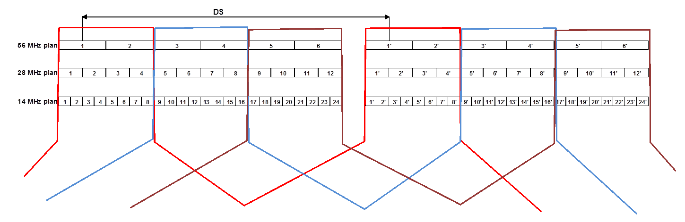
Figure ‎3-8 Example of RF duplex filter subdivision in a given channel arrangement

[Ceragon contribution 27]
[Editor note: it will be necessary of rearengement of text, to put first the general diplexer comments.]

The efficient use of spectrum while planning an asymmetrical links network may requires the use of a TRD (Tx/Rx deviation) slightly different than specified by the European channelization recommendation.
The purpose of this contribution is to set a recommendation and planning guidelines for efficient spectrum usage while keeping the current TRS (Tx/Rx spacing) and channelization per frequency band.

Practical Equipment Restrictions
In modern RF systems, the main component which sets the flexibility to operate in different RF channels is the RF diplexer. A diplexer is combined of two band pass filters (1 for RX and 1 for TX) which are spaced in such a way to allow for specific signal rejection between the TX and the RX signals of the system, to avoid a sensitivity degradation during operation.
The diplexers are planned in line with the currently available channelization and their specification varies according to channelization in each frequency band.

The following diagram shows a spectral representation of a diplexer specification:

Figure ‎3-9 Typical diplexer

We can observe the lower and the upper pass bands which represent the TX and RX band pass filters.

Depending on frequency band a different number of diplexers is used to cover the entire “workable” frequency range. These diplexers vary also between bands in the pass band of each diplexer.
The following table shows practical 38GHz diplexers covering the entire 38GHz ETSI band:

TX-RX Separation | Lower Passband | Upper Passband | f1 | f2 | f3 | f4
1260 | 631 | 620 | 37045 | 37676 | 38316 | 38936
1260 | 620 | 620 | 37560 | 38180 | 38820 | 39440

On the other hand some diplexers from the 6GHz range are characterised by much narrower filter options:

TX-RX Separation | Lower Passband | Upper Passband | f1 | f2 | f3 | f4
252.04 | 119.95 | 119.95 | 5929.7 | 6049.65 | 6181.74 | 6301.69
252.04 | 119.95 | 119.95 | 5989 | 6108.95 | 6241.04 | 6360.99
252.04 | 119.95 | 119.95 | 6048.3 | 6168.25 | 6300.34 | 6420.29

Setting Rules on TRD
Taking the previous examples into considerations, results that a rule must take into account the different channelization in each frequency band. A rigid rule may cripple the benefits which can be achieved in one band due to limitations in the other.
We must also take into account that since each equipment vendor is splitting the band into diplexers according to his own practice, setting a rigid rule here would in fact inhibit competition and cause higher equipment costs to vendors and operators alike.
This is why it is recommended that TRD should be stated by Operator, when asking the license, based on the information provided by the equipment producer for each band.
In this way symmetric and asymmetric equipment will be based on the same HW/SW modules, thus enabling the user to use the same type of equipment in a network which maybe symmetrical and asymmetrical in some of it’s parts.

Frequency Band Management
Setting a rule based on TRD self-declaration in asymmetrical design does not interfere with current frequency management practice, because the same band plans and the same TRS can be used.

Conclusions
In conclusion, to benefit from asymmetrical planning it is mandatory to allow for maximal TRD flexibility in network design and availability of equipment. This flexibility should be only constrained by the current channelization and vendor ability to design and implement suitable diplexers.

Impact of asymmetrical channels usage within conventional symmetric channel arrangements
In comparison to symmetric deployment, when the asymmetry deployment is considered, the T/R separation would impose an amount of variation from the nominal duplex separation of the relevant channel arrangement. The amount of acceptable variation will also be addressed in this study as appropriate.
In addition, for a more effective asymmetry improvement, also the channel size might be, in principle, rendered more variable than the present doubling rate (e.g. 7, 14, 28, 56 MHz) of current ECC channel arrangements, which, assuming the same modulation format is used in both directions, would permit only 2^{n} asymmetry degree. For example if a continuous channel spacing granularity of 7 MHz (e.g. 7, 14, 21, 28, 35, …56 MHz) is adopted other asymmetry degree may be obtained, however this may imply more complicated spectrum management procedures.

Implementation of asymmetry in wireless transport networks
EXAMPLE 1: Adding DL capacity
The first example demonstrates how can be added downlink capacity by re-allocating 7 MHz blocks of spectrum in an asymmetrical way. In the left-hand side of Figure 3-4 the symmetrical allocated spectrum uses 4 channels in DL and 4 channels in UL. On the right-hand side only two channels are used in UL, allowing the DL use of 6 channels, to match an asymmetry rate of 3:1. In the second hop, assuming that the collocation of receivers is not possible, are used in each tail 4 channels, preserving the same asymmetry rate of 3:1.
The capacity of the backhaul network is increased from two channels in the symmetric case to three channels in the asymmetric case, conducting to a capacity increase of 50% in the last case. For implementing this approach it is needed a better granularity of channel width in the second tail, i.e. 7 MHz instead of 14MHz.
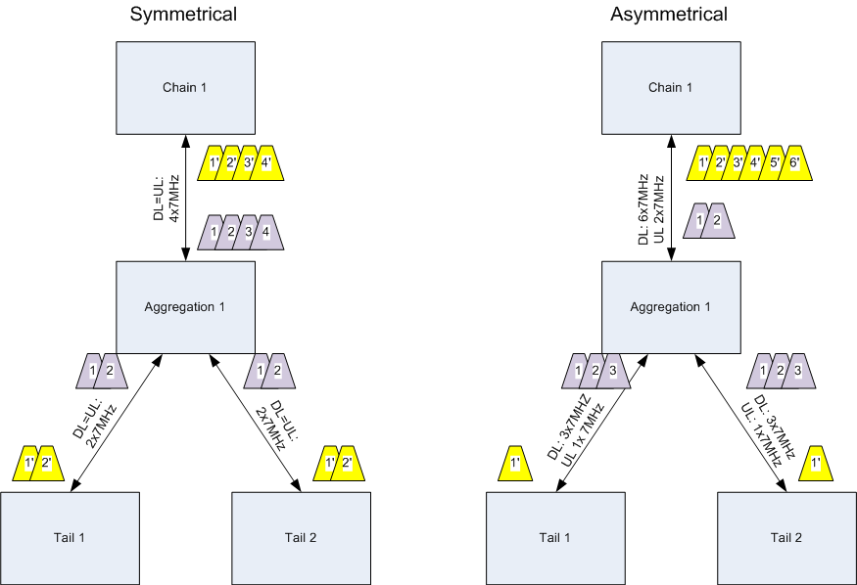
Figure ‎0-1 Example 1: Same spectrum, 50% more DL capacity
Redistributing the 7MHz channels in a different way and taking into account a 3:1 DL:UL ratio, allows to increase the downlink capacity without the use of additional spectrum resources.

EXAMPLE 2: Saving spectrum
In this example is shown how can be saved 25% of the spectrum by using asymmetrical planning. For this example we assume an asymmetric traffic profile of 1:2 UL:DL

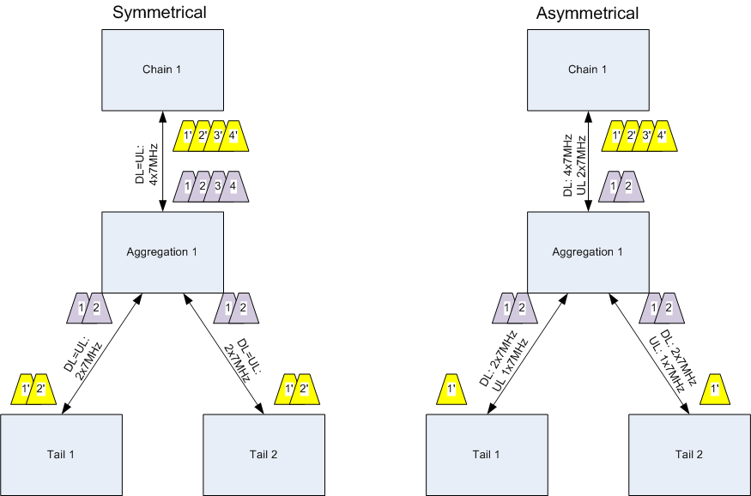
Figure ‎0-2 Example 2: same DL capacity, 25% less spectrum
We can clearly see in the right-hand side of Figure 3-5 the:
- saving of paired channels 7 and 8 in the first hop;
- saving of channels 3 and 4 in the second hop.
It is well known that, for obvious saving of frequency (and fees) links converging in a node makes, as far as possible, use of the same channel (i.e. whenever the angular separation of links permits enough antenna decoupling (e.g. at least for angles > 90° is commonly true).
In case that the frequency channels in the second hop can be re-used at the “Aggregation 1” point, will result:
- Figure 3-4: the DL capacity in the asymmetric case is still 50% higher as compared with the symmetric case.
- Figure 3-5: spectrum saving, as in the second hop will be used two channels in the symmetric case and one channel in the asymmetric case, for both cases being provided the same DL capacity.
In case that the frequency channels cannot be reused in the second hop, there will be no spectrum saving. This case is illustrated in Figure 3-6.
Figure ‎0-3 Example 2: Spectrum use when the frequency channels cannot be reused in the second hop
[Editor note to SIAE: please provide a figure without arrow; the explanations are provided in text
EXAMPLE 3: Adding tail sites
This example will demonstrate how it is possible to conserve BW while adding additional tail sites to an existing hub.
Figure 3-7 shows a symmetrical network with a broadband connection between the POP and the HUB utilizing both polarizations and in each hop, a different channel of 28MHz in a symmetrical paired-allocation. The 28MHz channel includes the 7MHz channels 1-4. In this example tail sites are geographically located in a way which is suitable for frequency reuse in the second hop.
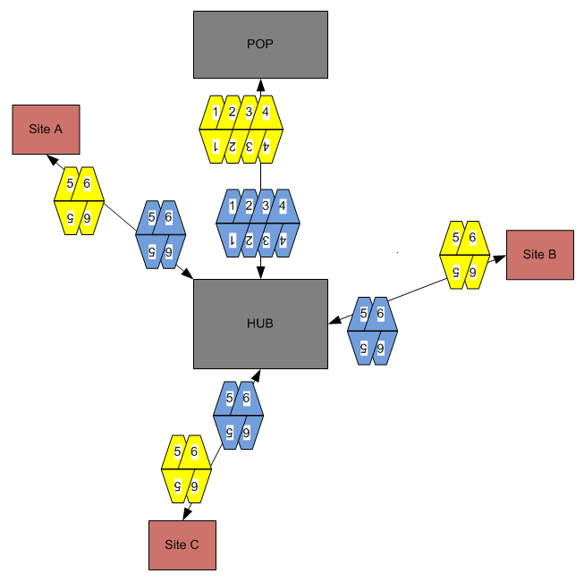
Figure ‎0-4 Example 3: Initial symmetrical spectrum usage

Adding two additional nodes will require the utilization of additional spectral resources because the additional links require separation in frequency, as can be seen in Figure 3-8. All in all the design utilizes channels 1-8.
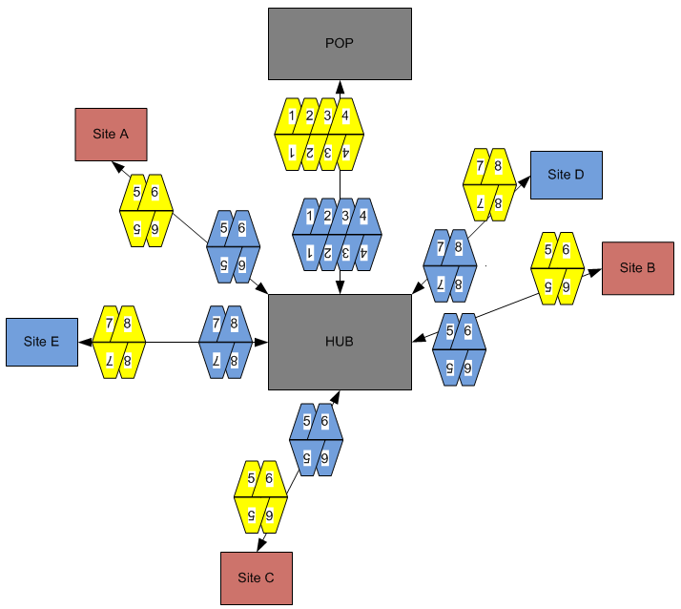

Figure ‎0-5 Example 3: Adding two nodes with symmetrical allocations
Planning asymmetrically while using a 2:1 DL:UL ratio allows to add the sites D and E without additional spectrum resources. In this planning example are utilised channels 1-6 only.

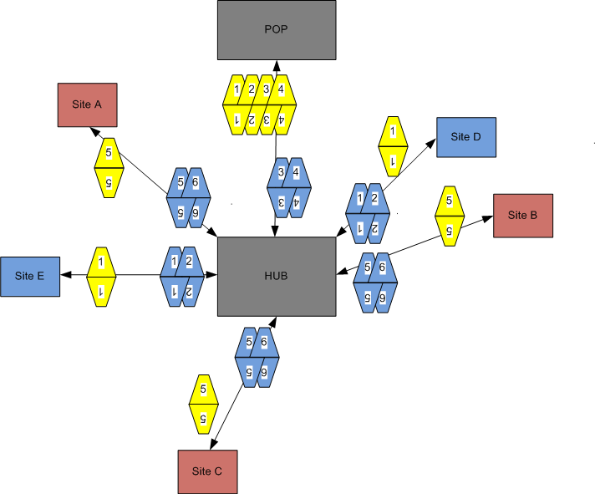

Figure ‎0-6 Example 3: Adding two nodes with asymmetrical allocations
As the spectral resource becomes scarcer, the ability to utilize it better, meaning increase of the network densification while utilizing the same spectral resources, presents a major benefit for regulators and operators alike.

Potential increase of spectral efficiency

The different views expressed during this study are presented below.

Symmetrical approach
Given that it is expected the cellular backhaul application, especially 3G/LTE/WiMAX, is the most likely scenario where the impact of asymmetric demand is foreseen, then this can be addressed by using different modulation schemes within the existing channelization arrangements, where different traffic capacities can be accommodated by utilising a different modulation scheme for the downlink than for the uplink. This technique has the further advantage over the solution proposed in SE19_11_26 in that it is a dynamic solution that can adjust to varying traffic loads, whereas the solution in SE19_11_26 is a fixed solution that may not suit future changes user/operator demands. This solution can also be deployed now, without the need to wait for the process of changing ECC Recommendations and national interface specifications to be completed, thus enabling operators to cope with asymmetric traffic loading today. The disadvantage of this solution is that the underused links occupy large channels, the spectral efficiency being relatively low. With the exponential traffic increase the saturation of the spectrum will become a bottleneck for achievable data rates in the LTE networks.

Asymmetrical approach
Frequency reuse is an efficient planning strategy to better utilize the spectrum in cases where the geographic arrangement of sites allows it. It does not contradict the use of asymmetrical links planning. When used jointly with asymmetrical planning both methods can introduce a better frequency utilization compared to the regular planning practice.
Using symmetric channels and applying different modulation schemes cannot be described as spectrum saving. In fact reducing modulation and keeping the same symbol rate with response to capacity decrease, is abusing the spectrum since a better bit/Hz ratio could have been achieved, by reducing the BW and symbol rate according to the needed capacity. The only reasonable implementation of such scheme is the AMC approach which reduced modulation and subsequently throughput, based on link conditions and that is with the goal of link survivability.
In addition, in distance-limited or interference-limited cases, is not always possible to increase the modulation and coding rate due to the negative impact on system availability performance.

New channel arrangements and their usage

Arrangements compatible with the existing channel arrangement

Service granularity using Nx7MHz with N=1, 2, 4, 8
The existing channel rasters based on 7, 14, 28, or 56MHz have been with us for over 3 decades and were based on legacy requirements, where spectrum was not in contention and it was generally used by only one wireless operator (the incumbent) on a per-country basis. Today the view of spectrum-use is substantially different; in some countries there are 100s of wireless licensed operators using fixed-link spectrum and congestion is rife in many areas and set only to increase.
The goal is to support legacy requirements as well as providing flexibility to most efficiently exploit of the available spectrum. If the ECC/CEPT Recommendations would allow for requesting Nx7MHz unidirectional parts of spectrum, then the operators would apply for precisely the amount of bandwidth in direction that it is needed, as opposed to the chunks that provide poor granularity of service bandwidth increment and which are shown in the following figure:

Figure ‎4-1 Service granularity with 7, 14, 28, 56MHz channels
Under these assumptions, the following examples demonstrate the usage of the existing channel arrangements in an asymmetric way.
In comparison to symmetric deployment, when the asymmetric deployment is considered the T/R separation would impose an amount of variation from the nominal duplex separation of the relevant channel arrangement.
[Editor note: The amount of acceptable T/R variation should also be addressed in this study as appropriate.]

Using both 14 and 28 MHz go/return within the same wider channel
This is the simplest way of using asymmetry; no specific subdivision of the band for wider and narrower channels was done.
In this example, the coordination of narrower “return” channels has only two choices within the same wider return channel. For having more flexibility, the return channels may be selected also in the adjacent 28MHz, e.g. channels 1’…4’ in the figure below. The duplex variation is limited, for example to: T/R = DS ± 7 MHz (or ± 35MHz if more flexibility is required).
Figure ‎4-2 Simplest asymmetrical channel plan: smaller channels within the larger ones

Confining smaller channels in the innermost part of the band
Another example is based on the approach used by some administrations (mostly in the past) of confining smaller channels in the innermost part of the band.

Figure ‎4-3 Confining smaller channels in the innermost part of the band

Also in this case, by subdividing the band in an equal number of 28 and 14 MHz paired channels, their go/return coupling shows:
- The duplex variation is reduced: T/R_{asym} DS − 7 MHz to DS − 49 MHz (value depends on the actual number of available 28 MHz channels), but there is less flexibility in assigning the return channels.
Symmetric channels can still be assigned in the conventional way.
Editor note: contributions on mixing symmetric and asymmetric

Arrangements not- compatible with the existing channel arrangement

Alternate 28 MHz +7MHz
In the next example the channels are arranged in an alternate 28 MHz +7MHz(1:4 asymmetry assumption), 7MHz +28MHz etc, as shown in figure d, resulting in no unused spectrum as all channels are taken.
If we examine the 23GHz band, instead of 20 symmetrical pairs of 28MHz + 28MHz, we now have 16 asymmetrical pairs of 28MHz + 7MHz interleaved with 16 asymmetrical pairs of 7MHz + 28MHz, resulting in a total of 32 FDD pairs.

1 | 2 | 3 | 4 | 5 | 6 | 7 | 8 | 9 | 10
Figure ‎4-4 Alternate 28 MHz +7MHz – lower band

In this example the T/R spacing alternates between DS (1008MHz) and DS-11MHz ( 987MHz).

1’ | 2’ | 3’ | 4’ | 5’ | 6’ | 7’ | 8’ | 9’ | 10’
Figure ‎4-5 Alternate 28 MHz +7MHz – upper band

Service granularity using Nx7MHz

Change of channel raster (n x 7MHz)
It is proposed to allow Nx7MHz channels to be aggregated for forming the following channel sizes: 7, 14, 21, 28, 35, 42, 49, 56MHz using any value of “N” from 1 to 8.
The reason for this change in approach is to allow full flexibility to operators planning new services such that they can apply a granularity of increment commensurate with likely minimum service bandwidth increase of 50Mb/s (equates to 256QAM in 7MHz channel, without packet compression techniques applied).

Figure ‎4-6 Frequency allocation granularity
Editor note: such flexible allocations do not match the existing channel plans. Text needed to show how to accommodate them in practice

Various asymmetrical assignment solutions

In order to provide asymmetrical capacity in a point-to-point link the bandwidth of both directions is different. Below we present a number of solutions based on spectrum aggregation. We note that these solutions have the ability to provide more flexible solutions for matching the increasing traffic needs and can add a better granularity of the required spectrum. We present here down the options considered in this study.

The first option was actually considered above; the spectrum asymmetry is obtained by allocating channels of different sizes for the go and return links.

Option 1: Using asymmetrical channel assignment

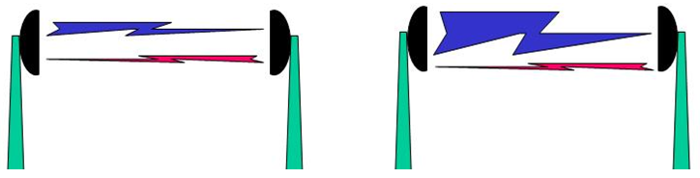
- Symmetrical link (b) asymmetrical link

Figure ‎4-7 Symetrical and asymmetrical links as considered above

Option 2: Spectrum aggregation by adding unidirectional links

Another approach is to add to a symmetrical bi-directional point-to-point link an extra uni-directional link (i.e. 2 radio systems are needed). This approach involves getting 2 licenses.

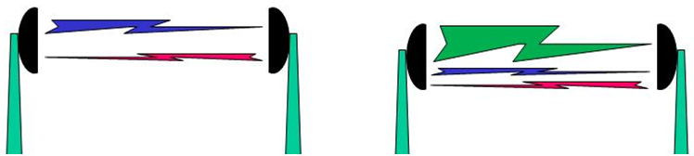

- Symmetrical link (b) Symmetrical + uni-directional link

Figure ‎4-8 Adding an asymmetrical link

From the point of Administrations licensing uni-directional links is already feasible. The unidirectional links should be allocated within the same frequency allocation or in other frequency allocations, such that both the symmetrical and the uni-directional link will have similar path-losses.

The resulting channel allocation, when the asymmetrical and symmetrical spectrum is located within the same frequency band is shown in the

Figure ‎4-9 Symmetrical and uni-directional allocation in the same frequency band

Option 3: Spectrum aggregation of unidirectional links

A third option is to generate an asymmetrical link using 2 uni-directional links of different capacity.

In case that the uni-directional links are in the same frequency band, it should be avoided placing them on the same side of the duplex GAP.
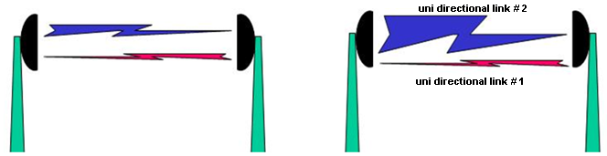

- Symmetrical link (b) asymmetrical link done with
      - two uni-directional links
Figure ‎4-10 Aggregation of unidirectional links

What is to be changed in the Recommendations
It is recommended to add a new annex to the recommendations listed above simply stating that the unidirectional use of aggregated and contiguous Nx7MHz channels is allowed according to national regulatory conditions of use.
In this way operators and regulators are free to implement asymmetric links in whatever manner suits their best interest, whether block allowances or central frequency co-ordination is used.

Demonstration of the benefit when using different go/return channel sizes

The asymmetrical spectrum usage examples in section 3indicate the major benefits:
- Increased downlink capacity, accommodating the end user needs, while using the same amount of spectrum;
- Increased spectral efficiency;
- Installation of additional links in the remaining spectrum;
- Increased number of serviced sites, if is used a suitable channel arrangement.

[Ficora email]

I'm sorry that I'm unable to attend the SE19 meeting next week (again), so I send my thoughts about the WI-27 with this email.

I have read the documents sent on WI-27 to be discussed during the meeting. There is a thought that has been growing in my mind, and that is that the report as is discusses the benefits of asymmetric planning versus symmetrical spectrum planning only when the whole network is planned as either symmetric or asymmetric from scratch (for example see Figures 3-11, 3-12 and 3-13).

As a regulator I see a problem here (and would maybe even see as an operator). The bands which could possibly benefit from asymmetric planning are mainly fully utilised (with symmetric links), and cannot easily be converted to wholly asymmetric.

So I think that the benefits of taking in to use the asymmetric links also on bands which are already utilising symmetric links should be discussed in the report.

I did some small scale undocumented testing on one band in one city (mainly star topology and mainly max one or two consecutive links in chain, 28 MHz channels) and added some new sites at random locations in our planning software. I then created new links to these sites using either symmetric (28/28MHz) or asymmetric (28/7MHz) approach.

The biggest problem was with the starsites (as indicated also in Croatian input) and specially the downlink part of link. I noticed that if I could find a usable channel in asymmetric case for downlink I could find (usually the same) usable channel in symmetric case. If I could not find a channel, I could not find it in either case. So this would indicate that the use of asymmetric channels does not have benefits if existing network is using symmetrical links and has many starsites (at least when only one or two links are added to the network).

But as I said, this was only random testing, and probably the simulation/tests should be run with the same software as in other cases in the report.

Summary of the email discussions
[T.B.C. by Rapporteur;
The emailes are pasted in the attachment; not sure all are included due to the taken trees]

Demonstration of the possible benefits versus the increase of equipment and coordination complexity due to the need for “flexible duplex”.

Benefit.
Efficient spectrum usage in geographical areas of spectrum congestion where operators use point-to-point radio transport systems employing a degree of asymmetry >= 2:1.
The increase of the spectrum efficiency takes place in the following scenarios:
- The spectrum utilized for the backhaul network is optimized such to match the data rates of the access network. Two sub-cases appear:
  - Reduced spectrum usage for the same DL traffic;
  - Higher DL capacity while using the same amount of spectrum as in the symmetrical case.
- Possibility of adding additional nodes while using the same spectrum.

Increased equipment complexity due to “flexible duplex”

[Editor note: for channel assignment planning is needed a rule to define the recommended maximum deviation of T/R spacing from the existing duplex separation in each channel plan – text needed]

Since all modern digital point to point radio systems are “software-based” and support software configurable transmit & receive characteristics (e.g. adaptive modulations, channel filtering) then supporting different channel occupancy in transmit and receive is ‘just’ a further software development.
Due to the fixed diplexer ranges used in modern high frequency radio systems, it is envisaged that any duplex deviation from the present ‘standard’ will be within the limits of the hardware capability. [This is generally for most radio vendors restricted to a minimum of half of the band at the bands of interest, i.e. at most only two sub-bands are required to cover the entire band.
In summary, for modern digital radio systems, no increase in equipment hardware complexity is expected. Developments will be in software only to cater to set TX & RX centre frequencies and channel bandwidth independently.]
[Unidirectional links: contribution needed]

Increased co-ordination complexity due to “flexible T/R separation”
Asymmetric channel spacing does not necessarily imply flexible duplex spacing, as it can use the existing duplex allocations. However it may occur a degree of T/R separation which is different from the initial duplex separation.
The term “flexible duplex” is actually misleading since it suggests a change to the currently available frequency plans and channelizations.
This is not the case as using asymmetrical planning does not mandate changing the channelization and frequency plans, but rather setting TX and RX center frequency within those existing plans but without the stringent duplex setting, as can be seen in the example in Figure 6-1:
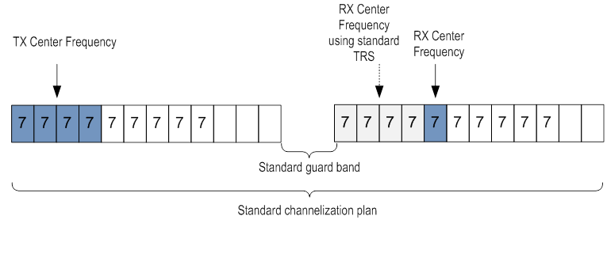
Figure ‎6-1 Change of the existing T/R separation
So all frequency allocations for asymmetric links will be “paired allocations” observing the central gap principle.
An example of how to co-ordinate a new link between the sites A and B into an existing network is given below:
For site A:
- assess that the impact of the new TXA upon the existing network is less than a predefined threshold;
- assess that the impact upon the new RXA of the existing network is less than a predefined threshold.

For site B:
- assess that the impact of the new TXB upon the existing network is less than a predefined threshold.
- assess that the impact upon the new RXB of the existing network is less than a predefined threshold
It is seen for a new link to be co-ordinated into the existing network that it is necessary to successfully and independently test that the effects of both new transmitters will not cause undue performance degradation to the existing ecosystem & similarly that both receivers will not be affected by same ecosystem so as to degrade the performance of the new link.
The method of choosing suitable channels can be by starting at a predefined frequency, running the tests & stepping the frequency to the next value if any one of the four steps above fails, until a successful co-ordination is made.
So any increase in complexity can be seen not in the base method of interference calculation, but in allowing TX & RX frequencies at the same station to step on different channel spacings and independently of each other. To view it another way, there is a greater chance of successful co-ordination with less iterations because one of the systems channelisation will be smaller than it would be in a symmetric system, giving it greater chance to find a ‘free’ smaller channel.

Reuse of potentially orphan spectrum

[Editorial’s note: remember to present, from the simulation results, what spectrum is saved and how it may be re-used.
Taking into account the frequency co-ordination process discussed above, it is envisaged that this “orphaned spectrum” phenomena should not occur because the automated frequency planning systems will by their nature seek out any spectrum lying “unused.” In addition, such spectrum can be used in a uni-directional mode, as shown in section ‎4.4.
If the implementation of planning systems can ‘miss’ such spectrum, then their underlying programming requires review anyway.
The whole “raison d'être” of asymmetric spectrum use is to free un-needed spectrum for use elsewhere in the network ecosystem to make better use of this scarce resource as user demands rise exponentially. It’s not the only answer to the universally forecasted upsurge in user demand over the coming years, but a proposed addition to other spectrum efficiency tools such as increasing modulation complexity, advanced data compression techniques, etc.
Comparing a symmetrical to asymmetrical planning test case scenario, might give the impression that a unilateral spectrum BW remains without use. This in fact is not the case since given the fact that in the symmetrical scenario this spectrum was underutilized as is, it was in-fact orphaned but “concealed”.

Burden to the frequency coordination process

Cross border coordination with countries which do not follow this asymmetry proposal.
Additional inter-country co-ordination is not needed as long as the existing, standard, paired channel arrangements are respected.

Mixed symmetric and asymmetric deployment in homogeneous networks
From a frequency planning perspective the challenge is almost the same as utilising different channelisations in the same frequency band, which has been achieved without major problem for decades already by operators and regulators alike using techniques like soft-partitioning or ‘mixed-bathing.’
As discussed previously in the section on “demonstration of benefits...” as part of standard frequency co-ordination practices, for each link, in each direction, at both transmitter and receiver, the interference is assessed for inclusion into the existing ecosystem. There is no difference whether the link is asymmetric or symmetric to this process because the co-ordination is made separately in both directions. Furthermore, the addition of asymmetric (or unidirectional) capability will decouple the dependence of co-ordination on both directions’ ability to achieve co-ordination at the fixed duplex, thereby allowing more efficient spectrum planning.

Need to change planning tool for the administration
This point is very similar to the immediately previous one as well as the “demonstration of benefits...” issues discussed above.
One change that may be necessary to planning tools is to allow TX & RX to be set to different channelisations per transceiver. This ability to set parameters of TX & RX differently may be already feasible, following the logic of assessing AMC-enabled systems which operate at different modulations in TX & RX. For example, a commercial planning tool, Pathloss by CTE, already supports different TX & RX parameters (e.g. modulation, channel bandwidth) in the same radio terminal.
Depending on the free-frequency/channel searching algorithm employed, it should be permissible when necessary to iteratively step, using different channel bandwidths in each direction of the link, while using the standard rasters according to the channel bandwidth described by the equipment used. Note that to step using different channel bandwidths is already possible due to the coexistence of all channel schemes in the same spectrum.
An optional limitation of the frequency band searching range to describe soft-partitions if needed, but most likely if a regulator uses this method, this capability already exists.

Cost/workload impact for the administration
- Cost impact.
Cost to the regulator can be associated with:
- Any of the changes outlined above in relation to software programming for the frequency planning.
- Advising customers of change of policy, maybe updating online link licensing application forms. This is covered by normal website maintenance associated with regular policy updates therefore should not be factored in.
Benefit to the regulator can be substantial savings of spectrum through efficiency of use, allowing more users & therefore more potential income from link licensing.
- Workload impact.
None, as all the frequency co-ordination systems are automatic.

Block assignment vs Link by Link assignment challenges difference need further precision Fees
Impact on existing approaches
[Editor note: text needed]
- [Proposal >> Discuss congestion in the bands. Demonstrate that the regulator can price the spectrum per channel and sell more spectrum to more operators. ECC report 173.
- Discuss ‘per-link’ pricing in which case the regulator actually benefits from an increase in links density.]

Factors affecting the degree of asymmetry on the mobile backhauling traffic

Due to real deployment requirements of the UE – Base Station Link, 3GPP has defined in Release 8 the following UE categories and their respective DL/UL rates:
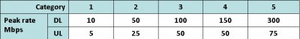
Table ‎9-1 UE categories in 3GPP Release 8
As can be seen from this table the inherent definition of the UE to ENode-b link is asymmetrical up to a ratio of 4:1 in UE category 5.

Definition of study case on large scale for the link by link assignment case
In this study was considered a more complex network situation scenario, encompassing the cases of a rural and an urban scenario. The results are provided below.

Rural scenario.

Methodology
The site locations and the linking topology were provided based on an existing real case scennario.
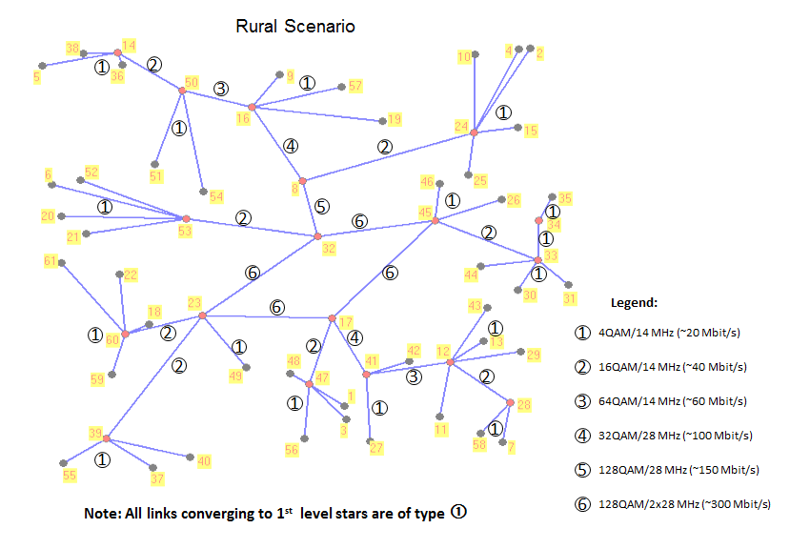
Figure ‎10-1 Topology and connectivity of the Rural scenario
[Editorial’s note: provide explanation why the Rural is not attractive for asymmetrical proposal.]
[Editor action: the text below was moved to this place]
The rural scenario will not benefit the use of asymmetrical links, since the links in this scenario are severely underutilized – capacity loading wise, planning this scenario with asymmetrical links will not show a major benefit in spectrum saving nor in capacity upgrade.

Parameters
[editor’s note: text needed]

Results
[editor’s note: text needed]

Urban scennario

The urban deployment scenario was selected in the studies related to the asymmetrical spectrum usage for evaluating the benefits of asymmetrical planning on a “real life” network. The following map shows the geographic connectivity of the nodes.

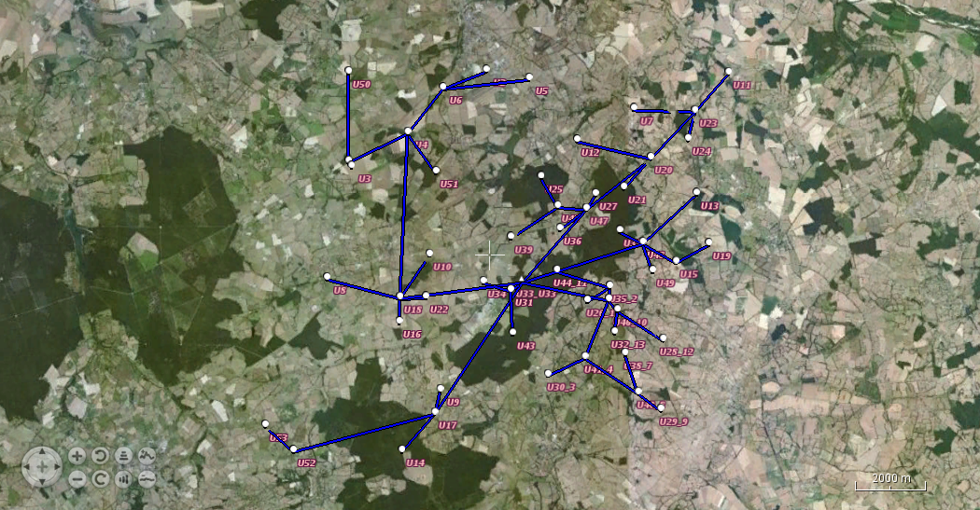

Figure ‎10-2 Deployment topology

The parameters which were used in the planning of this network for both symmetrical and asymmetrical approaches are as follows:
- Availability objective: 99.995% for BER=10^-6;
- The fade margin used for the availability calculation includes the threshold degradation due to the interference;
- Maximum threshold degradation is 3dB;
- Rain zone: K;
- Maximum antenna size: 3ft;
- Antennas type: class 3;
- Propagation model: ITU-R P.530-14 (the latest available model) for inland flat terrain, with pL=20% ;
- Presence of LOS between all sites (no losses due to terrain obstacles);
- Apply frequency reuse techniques as much as possible.

Data dimensioning:
- Capacity for aggregated link = Max (Peak capacity, NxBTM)
  - Peak capacity = 130Mbps
  - BTM = Busy Time Mean = 72Mbps
- Asymmetry Ratio
  - Traffic ratio A, used as reference point: 1:1, symmetrical traffic;
  - Traffic ratio B: 1:2, uplink to downlink.
  - Traffic ratio C: 1:4, uplink to downlink.

Spectrum Usage

The following tables show the difference between the symmetrical and asymmetrical spectrum planning. The tables present the comparison between the asymmetrical planning for the traffic ratios of 1:2 and 1:4 relative to the existing 1:1 (symmetrical) planning.
Each of the graphs shows the number of links per channel in the upper and lower frequency bands:
- Figure ‎2-1: Planning approach 1:1 (symmetrical) and 1:2 (asymmetrical) in the low frequency band;
- Figure 2-2: Planning approach 1:1 and 1:2 in the high frequency band;
- Figure ‎2-3: Planning approach 1:1 and 1:4 in the low frequency band;
- Figure ‎2-4: Planning approach 1:1 and 1:4 in the high frequency band.

Looking at the entire spectral usage, the design utilized 24 x 7MHz symmetrical channels for the symmetric scenario.

Comparison of planning results for traffic ratio A(1:1) and B(1:2)

The low frequency band usage of the channels is presented in Figure ‎2-1. The bar graph indicates how many times the same frequency channel was used in different links.

Figure ‎10-3 Comparison of 1:1 and 1:2 planning approaches in the low band

It can be observed that using the asymmetrical planning for 1:2 traffic asymmetry saves four channels in the low band.

The high frequency band usage of the channels is presented below:

Figure ‎10-4 Comparison of 1:1 and 1:2 scenarios in the high band
It can be observed that using the asymmetrical planning for the 1:2 traffic asymmetry saves three channels in the high band.
Overall symmetric channels wise, planning with 1:2 scenario saves 3 channels.

Comparison of the planning results for traffic ratio A(1:1) and C(1:4)

The low frequency band usage of the channels is presented below:

Figure ‎10-5 Comparison of 1:1 and 1:4 scenarios in the low band

It can be observed that using the asymmetrical planning for 1:4 traffic asymmetry saves five full channels in the low band.

The high frequency band usage of the channels is presented below:

Figure ‎10-6 Comparison of 1:1 and 1:4 scenarios in the high band
It can be observed that using the asymmetrical planning for 1:4 traffic asymmetry saves four channels in the high band.
Overall using a 1:4 asymmetry ratio saves 4 symmetric channels.

The overall frequency usage for each planning approach and traffic asymmetry is presented in Table ‎2-1:

Table ‎2-1 Summary of the spectrum usage for different asymmetrical scenarios
 | 1:1 | 1:2 | 1:4
Total BW used - high band [MHz*number of links] | 1,456 | 1,120 | 1,029
Total BW used - low band [MHz*number of links] | 1,456 | 1,064 | 910
High Band un-used spectrum [%] |  | 23% | 29%
Low Band un-used spectrum [%] |  | 27% | 38%

Spectral Efficiency

Because the asymmetrical planning for the 1:2 and 1:4 traffic asymmetry represents the actual capacity requirement of the network in the uplink direction, the resulting spectral efficiency is correspondingly higher.
The hereunder comparison presents the spectral efficiency difference between the symmetrical and the asymmetrical planning for different asymmetry factors. In Table ‎3-1 the value of the uplink capacity is resulting from the asymmetrical factor.
Table ‎3-1 Computation of the spectral efficiency
 | Comparison of scenarios 1:1 to 1:2 |  | Comparison of scenarios 1:1 to 1:4
Downlink Capacity [Mbps] | 12155 |  | 12155
Uplink Capacity [Mbps] | 6305 |  | 4420
Total Required Capacity [Mbps] | 18460 |  | 16575
 | 1:1 | 1:2 | 1:1 | 1:4
Spectrum used in Downlink [MHz*number of links] | 1456 | 1456 | 1456 | 1456
Spectrum used in Uplink [MHz*number of links] | 1456 | 728 | 1456 | 483
Total used spectrum [MHz*number of links] | 2912 | 2184 | 2912 | 1939
Average spectral efficiency [b/s/Hz] | 6.34 | 8.45 | 5.69 | 8.55
Spectral efficiency improvement [%] |  | 33% |  | 50%

It can be observed from the comparison of the improvement in spectral efficiency that the asymmetrical planning utilizes significantly less spectrum.

Conclusions of this simulation

Analysing the results of the asymmetrical planning, we can clearly observe the benefits of using asymmetrical planning. We can conserve between 30% and 40% of spectrum, and increase the spectral efficiency up to 50%.

Detailed results

Detailed simulation results can be found in the embedded Excel file. For every link, the following parameters were used:
Parameter | Description
LINK_ID | Link indication on the map
LENGTH | Link length in [km]
LEVEL | Aggregation level of the link, the last link connecting the tail site is aggregation 4, while links stemming from the hub is level 1
RD TRAFFIC | Required Downlink Traffic [Mb/s]
CD TRAFFIC | Actual Downlink Traffic [Mb/s]
RU TRAFFIC | Required Uplink Traffic [Mb/s]
CU TRAFFIC | Actual Uplink Traffic [Mb/s]
RATIO | Downlink to Uplink capacity ratio
DIAM_DL | Antenna diameter downlink [m]
CH_DL | Channels numbers for Downlink. Example: 001->004;V means: ch1 to ch4 in Vertical polarization (each channel is a 7MHz channel)
TX DL | Downlink Transmitter High or Low
FREQ_DL | Center frequency Downlink [GHz]
BW_DL | BW Downlink [MHz]
TX Power DL | TX power Downlink [W]
DIAM_UL | Antenna diameter uplink [m]
CH_UL | Channels numbers for Uplink. Example: 001->004;V means: ch1 to ch4 in Vertical polarization (each channel is a 7MHz channel)
TX_UL | Uplink Transmitter High or Low
FREQ_UL | Center frequency Uplink [GHz]
BW_UL | BW Uplink [MHz]
TX POWER UL | TX power Uplink [W]
CARRIERS | Number of carriers used for this link
XPIC | Is the link deployed in XPIC configuration
MOD_DL_1 | Modulation scheme for Downlink
MOD_UL_1 | Modulation scheme for Uplink
RSL_DL_1 | Received Signal Level Downlink [dBm]
RSL_UL_1 | Received Signal Level Uplink [dBm]
FM_DL_1 | Fade Margin Downlink [dB]
FM_UL_1 | Fade Margin Uplink [dB]
TD_DL | Threshold degradation Downlink [dB]
TD_UL | Threshold degradation Uplink [dB]
AV_AN_DL_1 | Availability for Downlink
AV_AN_UL_1 | Availability for Uplink
Note:
- Downlink site – A site which transmits the higher capacity needed for downlink
- Uplink site – A site which transmits the lower capacity needed for uplink

The detailed planning results are presented in the embedded Excel file:

Croatia simulation

The document gives some insight into the effects of using asymmetric microwave links on the overall network spectrum usage. The study was performed on realistic network scenarios and with flexible channel arrangement in order to get the most of the asymmetric approach. Tested rural scenario was delivered from a real-life network used by one of the operators in a typical rural environment, with the difference that all links in tested scenario operate in the same frequency band. Geographical configuration and link capacities have been preserved. Tested urban scenario is delivered from a real-life network in a typical urban scenario, so the actual RF channels used have been preserved.
In both cases the total spectrum used in the whole network for symmetric and asymmetric case has been compared.

Frequency plan
Channel arrangement used for asymmetric links was idealistic with fully flexible duplex, as proposed section 2.3 in SE19(12)28 (Fig. 1). For symmetric links, typical channel arrangement was used.
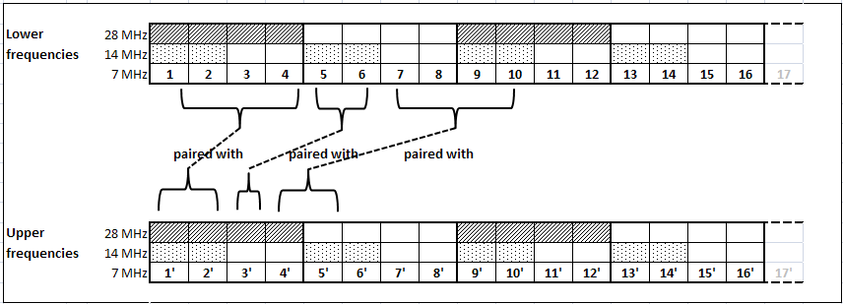
Fig. 1. Frequency assignment table for asymmetric case
Both sub-bands consist of 7 MHz raster only. Other channels are derived by channel aggregation, meaning that there is a possibility to combine as many 7 MHz channels as needed to create a larger one (e.g. 28 MHz would consist of four 7 MHz channels). Frequency assignment was done following some standard principles: applying frequency reuse and avoiding high-low conflict. Frequency reuse was applied only if links were separated more than 90°, which is in most cases enough to avoid interferences between links. Alternation of polarization was also used in planning the network.

10.3.1 Rural scenario

The rural network under consideration (Fig. 2) was delivered from a real-life network used by one of the operators in a typical rural environment (Fig. 3), with the difference that all links in tested scenario operate in the same frequency band. It consists of 43 nodes (marked with numbers) and 42 links, typical chain or star configurations. Downlink capacity was the same for both symmetric and asymmetric case. Link capacities were grouped into three categories with respect to the spectrum needed: 8-30 Mbps (channel width 7 MHz), 31-79 Mbps (channel width 14 MHz) and more than 80 Mbps (channel width 28 MHz). In this scenario, 1:2 asymmetric case was applied.
The list of links and designated channels for both symmetric and asymmetric case is depicted in Table I.

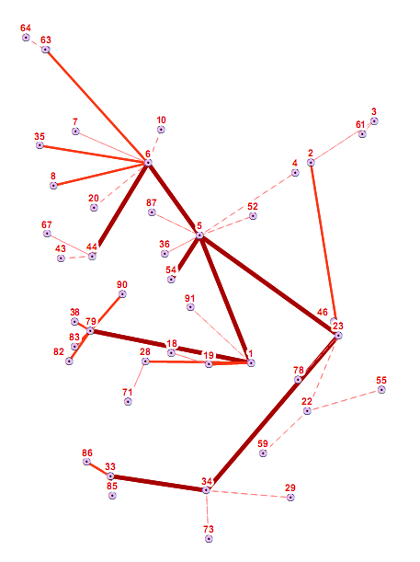

28 MHz (> 100 Mbps)

14 MHz (40–90 Mbps)

7 MHz (8-34 Mbps)

Fig. 2 Considered network with all links operating in the same frequency band, with three categories of capacities marked with lines of different width

7 GHz

13 GHz

23 GHz

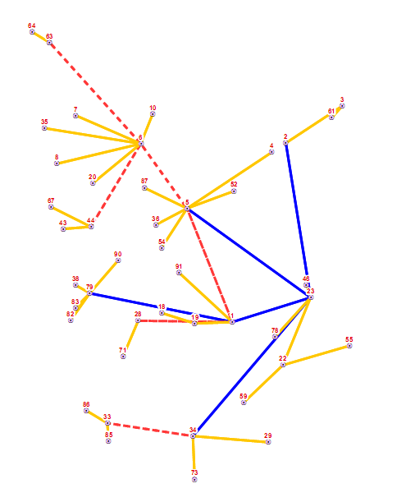

Fig. 3 The real network in a typical rural scenario indicating in which frequency band links operate

TABLE I
List of links in tested network and channels assigned for Symmetric and Asymmetric Case

Link (lower - upper) | Symmetrical case |  | Asymmetrical case
Link (lower - upper) | TX ch. | RX ch. | TX ch. | RX ch.
N6 - N5 | 1 (28) | 1' (28) | 1, 2 (14) | 1', 2', 3', 4' (28)
N1 - N5 | 1 (28) | 1' (28) | 1, 2 (14) | 1', 2', 3', 4' (28)
N23 - N5 | 2 (28) | 2' (28) | 3, 4 (14) | 5', 6', 7', 8' (28)
N54 - N5 | 3 (28) | 3 (28) | 5, 6 (14) | 9', 10', 11', 12' (28)
N6 - N44 | 2 (28) | 2' (28) | 3, 4, 5, 6 (28) | 5', 6' (14)
N1 - N79 | 2 (28) | 2' (28) | 3, 4, 5, 6 (28) | 5', 6' (14)
N23 - N34 | 1 (28) | 1' (28) | 5, 6, 7, 8 (28) | 1', 2' (14)
N33 - N34 | 1 (28) | 1' (28) | 1, 2 (14) | 1', 2', 3', 4' (28)
N6 - N35 | 1 (14) | 1' (14) | 1, 2 (14) | 1' (7)
N6 - N8 | 2 (14) | 2' (14) | 7, 8 (14) | 2' (7)
N6 - N63 | 3 (14) | 3' (14) | 3, 4 (14) | 3' (7)
N1 - N19 | 6 (14) | 6' (14) | 7, 8 (14) | 7' (7)
N1 - N28 | 5 (14) | 5' (14) | 9, 10 (14) | 8' (7)
N79 - N90 | 1 (14) | 1' (14) | 1 (7) | 1', 2' (14)
N79 - N82 | 1 (14) | 1' (14) | 1 (7) | 1', 2' (14)
N79 - N38 | 2 (14) | 2' (14) | 3 (7) | 5', 6' (14)
N79 - N83 | 3 (14) | 3' (14) | 2 (7) | 3', 4' (14)
N23 - N46 | 2 (14) | 2' (14) | 1, 2 (14) | 1' (7)
N23 - N2 | 1 (14) | 1' (14) | 5, 6 (14) | 2' (7)
N33 - N86 | 1 (14) | 1' (14) | 1, 2 (14) | 1' (7)
N33 - N85 | 3 (14) | 3' (14) | 5, 6 (14) | 5' (7)
N87 - N5 | 5 (7) | 5' (7) | 3 (7) | 5' (7)
N36 - N5 | 6 (7) | 6' (7) | 4 (7) | 6' (7)
N4 - N5 | 2 (7) | 2' (7) | 2 (7) | 2' (7)
N52 - N5 | 1 (7) | 1' (7) | 1 (7) | 1' (7)
N6 - N10 | 1 (7) | 1' (7) | 1 (7) | 1' (7)
N6 - N7 | 9 (7) | 9' (7) | 9 (7) | 4' (7)
N6 - N20 | 10 (7) | 10' (7) | 10 (7) | 7' (7)
N64 - N63 | 1 (7) | 1' (7) | 1 (7) | 1' (7)
N67 - N44 | 1 (7) | 1' (7) | 1 (7) | 1' (7)
N43 - N44 | 2 (7) | 2' (7) | 2 (7) | 2' (7)
N3 - N2 | 3 (7) | 3' (7) | 3 (7) | 3' (7)
N3 - N61 | 1 (7) | 1' (7) | 4 (7) | 4' (7)
N1 - N91 | 13 (7) | 13' (7) | 11 (7) | 9' (7)
N28 - N19 | 1 (7) | 1' (7) | 1 (7) | 1' (7)
N23 - N22 | 5 (7) | 5' (7) | 2 (7) | 4' (7)
N59 - N22 | 1 (7) | 1' (7) | 2 (7) | 2' (7)
N55 - N22 | 6 (7) | 6' (7) | 1 (7) | 1' (7)
N23 - N78 | 9 (7) | 9' (7) | 1 (7) | 3' (7)
N71 - N28 | 2 (7) | 2' (7) | 2 (7) | 2' (7)
N73 - N34 | 1 (7) | 1' (7) | 2 (7) | 1' (7)
N29 - N34 | 7 (7) | 7' (7) | 1 (7) | 3’ (7)

Channels are marked with the number and size indicated in brackets. For symmetric case, channel size and number are in line with the typical frequency assignment table (for example, 1 (14) denotes the first channel in 14 MHz channelization). For asymmetric case, where channel aggregation was applied, numbers correspond to the 7 MHz channelization in Fig. 6 and brackets indicates the total channel width (e.g. channel 5,6 (14) denotes a 14 MHz channel consisting of 7 MHz channels 5 and 6).
Node 5 (N5) in Fig. 2 is the main node of the considered network and the starting position for frequency planning of channels with higher capacity requirement (hereafter, downlink channels - DL). Uplink channels (UL) were assigned for symmetric and asymmetric case accordingly: in symmetric case UL channels were simply paired with assigned DL channels and in asymmetric case UL channels were chosen with respect to the UL/DL ratio being 1:2. For simplicity, links which used 7 MHz channels in the symmetric case remained symmetric as 7 MHz channel was set as the minimum “spectrum element”.
The total RF spectrum used for all links in the network for both symmetric and asymmetric case is represented in the following figures. Fig. 4 shows the total RF spectrum used in symmetric case, thus reflecting the actual spectrum usage in the real-life network (as link capacities from the real network have been preserved). Fig. 5 depicts the total RF spectrum usage after the re-planning into the asymmetric case.
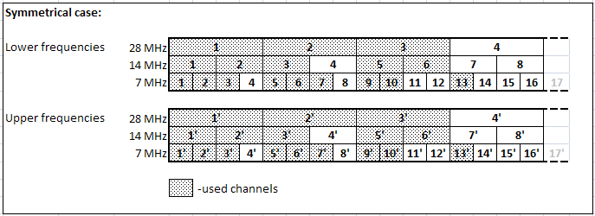
Fig. 4 Total spectrum used in symmetric case (rural case)
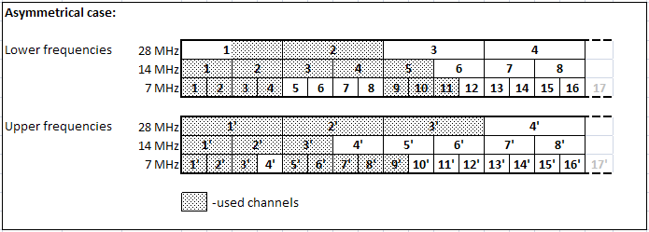
Fig. 5 Total spectrum used in asymmetric case (rural case)

In symmetric case, 2x84 MHz in 28 MHz channel raster, 2x70 MHz in 14 MHz and 2x63 MHz in 7 MHz channel raster have been used. It can be noted that channel 4-4’ (28 MHz raster) is effectively also occupied due to the assignment of 7 MHz channel 13.
In asymmetric case, 42+84 MHz (lower + upper) in 28 MHz channel raster, 70+42 MHz in 14 MHz and 49+56 MHz in 7 MHz channel raster have been used. Channel 4-4’ in 28 MHz channel raster has been preserved.

Urban Scenario

The urban scenario network (Fig. 6) is a real-network from one of the operators in 38 GHz frequency band. It consists of 41 nodes (marked with numbers) and 40 links, typical chain and star configuration.
Links in the original network have rather different capacities, but this is (mainly) due to different modulation techniques used. On the physical layer, they all operate only on 14 and 28 MHz channels. Since this analysis was focused on the total spectrum usage, only the physical channels used were taken into account, so all links in the considered network were grouped into 2 categories, based on the channel width: 28 MHz links (most of the links) and 14 MHz channel links. When re-planning into the asymmetric case, 1:4 asymmetry was applied for 28 MHz channels and 1:2 for 14 MHz channel links (i.e. 7 MHz channel was used as a smallest frequency segment)

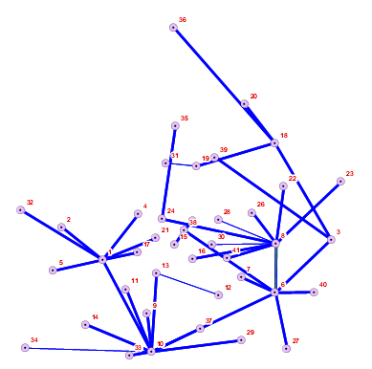

Fig. 6 Considered network for urban scenario. Thinner lines represent 14 MHz links, the thicker ones 28 MHz links

In urban scenario in Fig. 6, there are 5 main nodes (nodes N1, N10, N6, N3 and N8), which are kept symmetric, as the main line of the network considered. As in rural scenario, UL channels for symmetric case were simply paired with assigned DL channels. For asymmetric case, UL channels were chosen with UL/DL ratio being 1:4 for 28 MHz channels (i.e. 28 MHz DL channel was paired with 7 MHz UL channel) and 1:2 for 14 MHz channels (i.e. 14 MHz DL channels were paired with 7 MHz UL channels), thus keeping 7 MHz channel as the minimum “spectrum element”.
The list of links and designated channels for both symmetric and asymmetric case in urban scenario is depicted in Table II.

Link (lower - upper) | Symmetrical case |  |  | Asymmetrical case
Link (lower - upper) | TX ch. | RX ch. | Polarization | TX ch. (7 MHz) | RX ch. (7 MHz) | Polarization
N10 - N33 | 2₍₂₈₎ | 2'₍₂₈₎ | V | 3_{(7),} 4_{(7),} 5_{(7),} 6₍₇₎ | 2'₍₇₎ | V
N10 - N34 | 1₍₁₄₎ | 1'₍₁₄₎ | H | 1_{(7),} 2₍₇₎ | 1'₍₇₎ | H
N10 - N14 | 3₍₂₈₎ | 3'₍₂₈₎ | H | 7_{(7),} 8_{(7),} 9_{(7),} 10₍₇₎ | 3'₍₇₎ | H
N10 - N1 | 2₍₂₈₎ | 2'₍₂₈₎ | V | 1₍₇₎, 2₍₇₎, 3₍₇₎, 4₍₇₎ | 7'₍₇₎, 8'₍₇₎,9'₍₇₎, 10'₍₇₎ | V
N5 - N1 | 1₍₂₈₎ | 1'₍₂₈₎ | H | 1₍₇₎ | 1'₍₇₎, 2'₍₇₎, 3'₍₇₎, 4'₍₇₎ | V
N32 - N1 | 3₍₂₈₎ | 3'₍₂₈₎ | H | 3₍₇₎ | 6'₍₇₎, 7'₍₇₎, 8'₍₇₎, 9'₍₇₎ | V
N2 - N1 | 2₍₂₈₎ | 2'₍₂₈₎ | V | 1₍₇₎ | 1'₍₇₎, 2'₍₇₎, 3'₍₇₎, 4'₍₇₎ | H
N4 - N1 | 3₍₂₈₎ | 3'₍₂₈₎ | H | 3₍₇₎ | 9'₍₇₎, 10'₍₇₎, 11'₍₇₎, 12'₍₇₎ | H
N21 - N1 | 2₍₂₈₎ | 2'₍₂₈₎ | V | 1₍₇₎ | 5'_{(7),} 6'_{(7),} 7'_{(7),} 8'₍₇₎ | V
N17 - N1 | 1₍₂₈₎ | 1'₍₂₈₎ | H | 2₍₇₎ | 1'₍₇₎, 2'₍₇₎, 3'₍₇₎, 4'₍₇₎ | H
N10 - N11 | 1₍₂₈₎ | 1'₍₂₈₎ | H | 6_{(7),} 7_{(7),} 8_{(7),} 9₍₇₎ | 3'₍₇₎ | V
N10 - N9 | 4₍₂₈₎ | 4'₍₂₈₎ | V | 11_{(7),} 12_{(7),} 13_{(7),} 14₍₇₎ | 5'₍₇₎ | V
N10 - N13 | 3₍₂₈₎ | 3'₍₂₈₎ | H | 1₍₇₎, 2₍₇₎, 3₍₇₎, 4₍₇₎ | 2'₍₇₎ | H
N12 - N13 | 5₍₁₄₎ | 5'₍₁₄₎ | V | 1₍₇₎ | 1'₍₇₎, 2'₍₇₎ | V
N10 - N37 | 2₍₂₈₎ | 2'₍₂₈₎ | V | 5_{(7),} 6_{(7),} 7_{(7),} 8₍₇₎ | 1'₍₇₎ | V
N10 - N29 | 1₍₂₈₎ | 1'₍₂₈₎ | H | 1₍₇₎, 2₍₇₎, 3₍₇₎, 4₍₇₎ | 2'₍₇₎ | H
N10 - N6 | 4₍₂₈₎ | 4'₍₂₈₎ | V | 10₍₇₎, 11_{(7),} 12_{(7),} 13₍₇₎ | 4'_{(7),} 5'_{(7),} 6'_{(7),} 7'₍₇₎ | H
N27 - N6 | 1₍₂₈₎ | 1'₍₂₈₎ | V | 1₍₇₎ | 1'₍₇₎, 2'₍₇₎, 3'₍₇₎, 4'₍₇₎ | V
N40 - N6 | 2₍₂₈₎ | 2'₍₂₈₎ | H | 5₍₇₎ | 5'_{(7),} 6'_{(7),} 7'_{(7),} 8'₍₇₎ | H
N3 - N6 | 1₍₂₈₎ | 1'₍₂₈₎ | V | 1₍₇₎, 2₍₇₎, 3₍₇₎, 4₍₇₎ | 1'₍₇₎, 2'₍₇₎, 3'₍₇₎, 4'₍₇₎ | V
N8 - N6 | 2₍₂₈₎ | 2'₍₂₈₎ | H | 5_{(7),} 6_{(7),} 7_{(7),} 8₍₇₎ | 5'_{(7),} 6'_{(7),} 7'_{(7),} 8'₍₇₎ | H
N38 - N6 | 1₍₂₈₎ | 1'₍₂₈₎ | V | 1₍₇₎ | 1'₍₇₎, 2'₍₇₎, 3'₍₇₎, 4'₍₇₎ | V
N7 - N6 | 3₍₂₈₎ | 3'₍₂₈₎ | V | 3₍₇₎ | 6'₍₇₎, 7'₍₇₎, 8'₍₇₎, 9'₍₇₎ | V
N38 - N25 | 1₍₂₈₎ | 1'₍₂₈₎ | V | 1₍₇₎, 2₍₇₎, 3₍₇₎, 4₍₇₎ | 1'₍₇₎ | V
N38 - N15 | 1₍₂₈₎ | 1'₍₂₈₎ | V | 1₍₇₎, 2₍₇₎, 3₍₇₎, 4₍₇₎ | 1'₍₇₎ | V
N8 - N23 | 2₍₂₈₎ | 2'₍₂₈₎ | H | 1₍₇₎, 2₍₇₎, 3₍₇₎, 4₍₇₎ | 1'₍₇₎ | V
N8 - N22 | 1₍₂₈₎ | 1'₍₂₈₎ | V | 5_{(7),} 6_{(7),} 7_{(7),} 8₍₇₎ | 2'₍₇₎ | H
N8 - N26 | 3₍₂₈₎ | 3'₍₂₈₎ | H | 1₍₇₎, 2₍₇₎, 3₍₇₎, 4₍₇₎ | 1'₍₇₎ | V
N8 - N28 | 3₍₁₄₎ | 3'₍₁₄₎ | H | 5_{(7),} 6₍₇₎ | 2'₍₇₎ | H
N8 - N30 | 4₍₁₄₎ | 4'₍₁₄₎ | V | 9_{(7),} 10₍₇₎ | 3'₍₇₎ | H
N8 - N16 | 3₍₂₈₎ | 3'₍₂₈₎ | H | 5_{(7),} 6_{(7),} 7_{(7),} 8₍₇₎ | 2'₍₇₎ | V
N8 - N41 | 1₍₂₈₎ | 1'₍₂₈₎ | V | 1₍₇₎, 2₍₇₎, 3₍₇₎, 4₍₇₎ | 1'₍₇₎ | H
N8 - N24 | 4₍₂₈₎ | 4'₍₂₈₎ | V | 11_{(7),} 12_{(7),} 13_{(7),} 14₍₇₎ | 4'₍₇₎ | V
N35 - N24 | 1₍₂₈₎ | 1'₍₂₈₎ | H | 1₍₇₎ | 1'₍₇₎, 2'₍₇₎, 3'₍₇₎, 4'₍₇₎ | H
N3 - N39 | 2₍₂₈₎ | 2'₍₂₈₎ | H | 5_{(7),} 6_{(7),} 7_{(7),} 8₍₇₎ | 2'₍₇₎ | V
N3 - N18 | 1₍₂₈₎ | 1'₍₂₈₎ | V | 1₍₇₎, 2₍₇₎, 3₍₇₎, 4₍₇₎ | 1'₍₇₎ | H
N36 - N18 | 2₍₂₈₎ | 2'₍₂₈₎ | H | 2₍₇₎ | 5'_{(7),} 6'_{(7),} 7'_{(7),} 8'₍₇₎ | H
N20 - N18 | 1₍₂₈₎ | 1'₍₂₈₎ | V | 3₍₇₎ | 9'₍₇₎, 10'₍₇₎, 11'₍₇₎, 12'₍₇₎ | V
N19 - N18 | 4₍₂₈₎ | 4'₍₂₈₎ | V | 1₍₇₎ | 1'₍₇₎, 2'₍₇₎, 3'₍₇₎, 4'₍₇₎ | V
N19 - N31 | 5₍₁₄₎ | 5'₍₁₄₎ | V | 1_{(7),} 2₍₇₎ | 1'₍₇₎ | H
The total RF spectrum used for all links in the network for both symmetric and asymmetric case, including the number of times each channel was used in the network, is represented in the following figures. Fig. 7 shows the total RF spectrum used in symmetric case, thus reflecting the actual spectrum usage in the real-life network (as link capacities from the real network have been preserved). Fig. 8 depicts the total RF spectrum usage after the re-planning into the asymmetric case. It can be noticed that in some cases the polarization of the link was changed, which is due to frequency planning “rules” described above in paragraph 2.

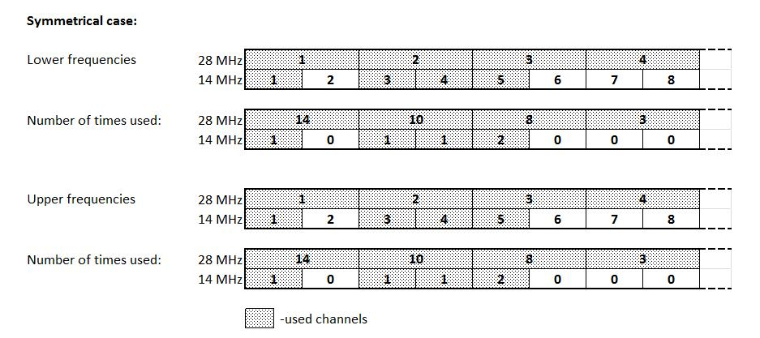
Fig. 7 Total spectrum used in symmetric case (urban network), with the number of times a channel was used indicated

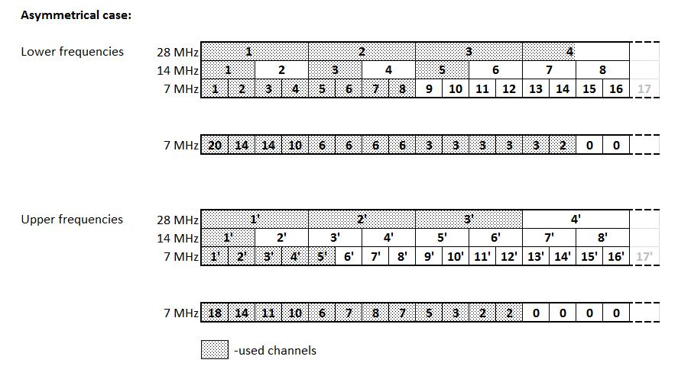
Fig. 8 Total spectrum used in asymmetric case (urban network), with the number of times a channel was used indicated

In symmetric case, 4 channels in 28 MHz channel raster (2x112 MHz of spectrum) and 4 channels in 14 MHz raster (2x56 MHz) have been used.
In asymmetric case, 98+84 MHz (lower + upper) in 28 MHz channel raster, 42+14 MHz in 14 MHz and 56+35 MHz in 7 MHz channel raster have been used. It is clear that some amount of spectrum has been saved and it can be argued whether the amount of the saved spectrum is considerable or not having in mind the number of links and the fact that frequency assignment with flexible variable duplex was used. Flexible duplex can also be credited for the grouping of used channels towards the beginning of the band (as depicted in Fig. 8).

Conclusion of this simulation
The results for both rural and urban scenarios show some level of spectrum savings. As expected, the amount of saved spectrum is more significant in the urban case, where only one frequency band is used. In the real-life networks in the rural environment, given the large variation in the length of links, different frequency bands are used, so the saved spectrum in the uplink of the asymmetric links (star configuration to one central node) is not reused in the rest of the network since different frequency bands have been used for connection to other nodes. Therefore, benefits of asymmetric links in rural scenarios on the overall spectrum usage are rather poor.
In urban scenarios the amount of the saved spectrum seems considerable. However, it should be noted that some of the saved spectrum in both cases is because of the flexibility in frequency assignment used only in asymmetric case. Also, it is clear that the most problematic part of the network in terms of channels used (spectrum used) are the parts where frequency reuse was not possible (dense star configurations) resulting in spread of used channels.
To summarize, asymmetry provides some benefits in spectrum efficiency based but its overall impact when applied on the whole network is rather poor since dominating factor in spectrum saving is still frequency reuse.
Lots of those benefits depend on the type of channel plan used. Applying asymmetry in real networks when using existing fixed duplex frequency plans would result in wasted spectrum rather than saved. Some possible solutions include changes in the existing frequency plans, though each option has its own up and down sides (as discussed in SE19(12)28).

Conclusions
Body text (style: ECC Paragraph)
(advice: a conclusion may review the main points of the ECC Report. A conclusion might elaborate on the results of the ECC Report and suggest extensions.)

- NGMN Traffic model

The backhaul capacity and asymmetry were determined by NGMN in simulations and are based only on the FTP traffic model. The considered traffc model and simulation assumption have a big influence on the system capacity and its asymmetrical ratio.
The FTP traffic model used by NGMN in ‎[3] considers separate downlink and uplink simulations, such that there is no relation between the FTP traffic asymmetry and the asymmetry of the backhaul network. As it can be seen, there is a 3 minutes gap time between the FTP sessions of relatively small files (i.e. 2Mbyte in average). Given the very high LTE speeds, with more than 10Mb/s/user, the actual transmission time is less than 2sec. When the user traffic is averaged, the gap time is strongly reducing the traffic average, which conducts to a more realistic dimensioning of the backhaul capacity, as compared with considering peak LTE data rates..

Figure ‎12-1 Reproduction of FTP traffic model from ‎[3]

- Backhaul dimensioning based on LTE-FDD access network capacity

The example in this annex describes the step-by-step process for dimensioning of MW backhauling network based on the NGMN White Paper [1].
It is here reminded that NMGM approach aims to give the maximum DL/UL capacity achievable by the LTE technology itself.
The reader should note that in the NGMN white-paper:
- The term “cell” is used in conjunction with the coverage area of a sector of a base station, equipped with omni or directional antennas.
- The term “tri-cell” is used for identifying a complete eNodeB composed by three “cells” equipped with sector antennas.
- The simulations used only the FTP traffic model.
  - Peak and mean single cell throughput to be considered
With reference to section 2.5 of document [1] (in particular to Figure 5), the LTE performances in a paired FDD allocation when targeting most common system options using for downlink 2x2 MIMO either with 10 MHz (category 3) and 20 MHz channels (category 4). For the 20 MHz uplink we target 1x2 MIMO, 20 MHz category 3 (50 Mbps): all considerations within this document do not change if we consider other 20 MHz UL solutions having the same MIMO configuration, because cat.3 and cat.4 devices, when used in 20MHz, provide very similar downlink and uplink capacities for the busy time operation. This results in the following reference figures for peak and mean cell throughput.
Table 1 of the NGMN report estimates the available cell capacities. The peak and mean data flow of a single cell is summarised in next Table A1-1. At this level, the possible network overhead is not yet considered because it would be added at complete eNodeB (i.e. tri-cell) level.
Table A1-1: DL and UL peak and mean cell capacity.
LTE Bandwidth | Downlink (DL) |  | Uplink (UL)
LTE Bandwidth | Peak | Mean | Peak | Mean
10 MHz | 58.5 | 11 | 20.8 | 8
20 MHz | 117.7 | 21 | 38.2 | 15

From these figures it is worth noting that:
- Peak to mean ratio is 5:1 for DL and 5:2 for UL
- Therefore, there is a different ratio DL/UL if we consider peak or mean values.
  - Asymmetry ratio for the last hop
The last hop in the access microwave (MW) network is carrying one eNodeB macro site. In general such macro site will be a tri-cell base station as considered in section 3.2 of [1]: specifically we can make reference to throughput figures reported in Table 1 of document [1], which are reprinted, for the mentioned 10 MHz and 20 MHz channel widths, as Downlink (DL) and Uplink (UL) columns in Table A1.2.
At this level signalling, transport overheads and the X2 protocol data add a fixed (10%) overhead.
An alternative IPsec optional encapsulation (total overhead 25 %) may be used. It is known that an operator may decide not to use the optional IPsec overhead; however, it should be noted that its use will eventually increase the average required capacity of both UL and DL backhaul, but, the DL/UL asymmetry ratio, subject of the analysis in this ECC Report, would not change. Nevertheless both variants are provided for reader reference.
MW link dimensioning criteria is well represented by formula provided by NGMN document [1] in section 2.3:
Backhaul Provisioning for N cells = max (N x busy time mean, Peak)
Which, for the tri-cell base considered (N=3), means the data summarised in next table A1-2 (derived from Table 1 of NGMN document). It shall be noted that for the tri-cell case (N=3) the peak is still considered equal to that of a single cell (with only the overhead added).
Table A1-2: DL and UL peak and mean tri–cell site capacity
LTE bandwidth | Tri-cell Downlink |  |  |  | Tri-cell Uplink |  |  |  | MW backhaul dimensioning
LTE bandwidth | Peak |  | Mean |  | Peak |  | Mean |  | DL (Tri-cell peak) |  | UL (Tri-cell mean)
LTE bandwidth | w/o IPsec | with IPsec | w/o IPsec | with IPsec | w/o IPsec | with IPsec | w/o IPsec | with IPsec | w/o IPsec | with IPsec | w/o IPsec | with IPsec
10 MHz | 64.4 | 73.2 | 37.8 | 42.9 | 22.8 | 26 | 27.5 | 31.2 | 64.4 | 73.2 | 27.5 | 31.2
20 MHz | 129.5 | 147.1 | 72.1 | 81.9 | 42 | 47.7 | 51.5 | 58.5 | 129.5 | 147.1 | 51.5 | 58.5

As you can see (red values, with IPsec, and green values, w/o IPsec in previous table) MW dimensioning is driven by:
- peak capacity (of one cell selected also for the tri-cell under same site) for downlink
- mean capacity (of the 3 cells under same site, equivalent to 3 x 1 cell mean) for uplink.
This results in DL/UL ratio on the MW link dimensioning range from 2.3:1 to 2.5:1.
  - Asymmetry ratio for agreggated links
Aggregated links are hops based on capacity of 2 or more eNodeB macro sites (N ≥ 6). MW link dimensioning criteria for such links is well represented by similar formulas provided by NGMN document [1] in section 4.1.
That means (i.e. for N ≥ 6, equivalent to two Tri-cells sites or more) both downlink and uplink will be dimensioned proportional to relevant mean values: e.g. from Table A1-2, the ratios (2 x 42.9)/(2 x 31.2) or (2 x 37.8)/(2 x 27.5) for 10 MHz cases with or w/o IPsec, respectively, a DL/UL ratio of about 1.4:1, slightly less than 3:2, is derived.
The overall asymmetry resulting along the backhauling network is then summarised in Figure 13 of the NGMN document (reprinted as Figure 1 in the main body of the present ECC report).

ANNEX 3 – list of exchanged emails

Thread “Thoughts”
Dear Mariana, All,
Thanks for explaining the concept of two licenses for (bidirectional symmetric+ unidirectional asymmetric), where both licenses may not have to address two adjacent frequency channels.
When upgrading an existing link it could be considered to keep the license for the existing link and only request for an extra license for an unidirectional link. This under the condition that the parameters for the first license are not changed. Such approach could be helpful where there is insufficient space left in a specific band.
Best regards,
Herman
Van: Mariana Goldhamer [mailto:marianna001@gmail.com]
Verzonden: vrijdag 4 januari 2013 12:40
Aan: Roberto.Macchi@siaemic.it; 'Ian Marshall'; SE19@list.cept.org
Onderwerp: RE: [SE-19] WI-27: Thoughts
Dear Roberto, All,
Indeed, two licenses are necessary. This is what is written in the working document.
However there is no need that the two spectrum allocations will be in adjacent channels or even in the same band, because this view of spectrum assignment is not based on the concepts initially presented by Ceragon. It is possible to use two different radios, each serving one of the allocations, with evident advantages for producers ☺
Regards,
Mariana

From: Roberto.Macchi@siaemic.it [mailto:Roberto.Macchi@siaemic.it]
Sent: Friday, January 04, 2013 1:25 PM
To: Ian Marshall; marianna001@gmail.com; SE19@list.cept.org
Subject: RE: [SE-19] WI-27: Thoughts

Hi Ian and All,
we need to consider that symmetric+asymmetric assignment would, in principle, requires two separate licenses.
In addition, those licenses should be "locked" together in order to have the DL (bidirectional symmetric+ unidirectional asymmetric) in adjacent channels and the further clear possibility of using a single emission in the merged channel. This is not trivial in some countries where the frequency assignment is made by the administration freely selecting channels in the whole band.
In those cases it could imply big "bureaucratic/legal" problems beyond the simple modification of the planning tools.

Regards
Roberto
>>>
From:
Ian Marshall <Ian.Marshall@Aviatnet.com>
To:
Mariana Goldhamer <marianna001@gmail.com>, 'Vaittinen Juhani' <juhani.vaittinen@ficora.fi>, "jean-philippe.kermoal@eco.cept.org" <jean-philippe.kermoal@eco.cept.org>, "SE19@list.cept.org" <SE19@list.cept.org>
Date:
04/01/2013 12.03
Subject:
RE: [SE-19] WI-27: Thoughts
Mariana
Thanks for the clarification. Whether uni-directional links are normal practice with all administrations is a debatable point. However I understand the proposal and agree this does use the spectrum made available by asymmetric allocations. However my point about no more space for more bi-directional FDD links also still stands.
Regards
Ian Marshall
Regulatory Manager
AVIAT NETWORKS
Direct: + 44 (0) 7740 671232
Mobile: + 44 (0) 7740 671232
Email: ian.marshall@aviatnet.com
Web: www.aviatnetworks.com
-----Original Message-----
From: Mariana Goldhamer [mailto:marianna001@gmail.com]
Sent: 04 January 2013 10:49
To: Ian Marshall; 'Vaittinen Juhani'; jean-philippe.kermoal@eco.cept.org; SE19@list.cept.org
Subject: RE: [SE-19] WI-27: Thoughts
Hi Ian,
Not clear what means "others :)", but the scenario, already captured in the output WI-27 document of the last meeting and attached here, is different from what you say.
It proposes to use the symmetrical spectrum together with an unidirectional allocation.
See the attached figures in TEMP2:
- the first picture shows a reference symmetrical allocation vs. the asymmetrical allocation as proposed by Ceragon
- the bottom figure shows the same symmetrical reference vs. a symmetrical allocation + an unidirectional link.
- I have to make you aware of the sentence: " From the point of Administrations licensing uni-directional links is normal practice.".
Hope this explains.
Regards,
Mariana
-----Original Message-----
From: Ian Marshall [mailto:Ian.Marshall@Aviatnet.com]
Sent: Friday, January 04, 2013 12:32 PM
To: Mariana Goldhamer; 'Vaittinen Juhani'; jean-philippe.kermoal@eco.cept.org; SE19@list.cept.org
Subject: RE: [SE-19] WI-27: Thoughts
Mariana,
As I wasn't present at the last meeting I need to understand this fully.
Are you saying that the gaps or saved spectrum that is produced by using asymmetric allocations can be used by uni-directional links? If so then whilst that uses the spectrum it does so in a way that is not usable by bi-directional FDD technology, thus we haven't expanded the usage possibilities for current technology but opened up "our" bands to others!
Regards
Ian Marshall
Regulatory Manager
AVIAT NETWORKS
Direct: + 44 (0) 7740 671232
Mobile: + 44 (0) 7740 671232
Email: ian.marshall@aviatnet.com
Web: www.aviatnetworks.com
-----Original Message-----
From: Mariana Goldhamer [mailto:marianna001@gmail.com]
Sent: 04 January 2013 09:41
To: Ian Marshall; 'Vaittinen Juhani'; jean-philippe.kermoal@eco.cept.org;
SE19@list.cept.org
Subject: RE: [SE-19] WI-27: Thoughts
Dear Juhani and Ian,
Thanks for sharing your thoughts :)
I want to remind you a new element which appeared last meeting, actually a proposal from Herman Teinsma, RA Netherlands: the use of the unidirectional spectrum together with symmetrical allocations.
Now, after this proposal, the claim that the saved spectrum is not usable will not apply anymore. Even today is possible to use the aggregation of symmetrical and unidirectional links.
Regarding the topologies: Croatia simulation is very interesting, because is taking a new deployment scenario and lower frequency bands. In our understanding at the end the numbers are confirming the Ceragon results in urban deployment for the 2:1 asymmetry, but are missing the summary tables such that this confirmation is not straight forward, especially if you read their conclusion.
Dear Juhani, thanks a lot for your suggestion to discuss the use of asymmetrical deployments in conjunction with the existing symmetrical spectrum allocation in the same band.
Best Regards,
Mariana
-----Original Message-----
From: Ian Marshall [mailto:Ian.Marshall@Aviatnet.com]
Sent: Friday, January 04, 2013 10:59 AM
To: Vaittinen Juhani; 'Mariana Goldhamer'; jean-philippe.kermoal@eco.cept.org; SE19@list.cept.org
Subject: RE: [SE-19] WI-27: Thoughts
All,
This also reflects our concerns. Given that not every link will need (or want ) to be asymmetric it will be very difficult to mix both symmetric and asymmetric in the same band and if you do the "savings" from asymmetric will not be usable savings. We can only envisage asymmetric being able to be deployed within wholly single operator spectrum.
Regards
Ian Marshall
Regulatory Manager
AVIAT NETWORKS
Direct: + 44 (0) 7740 671232
Mobile: + 44 (0) 7740 671232
Email: ian.marshall@aviatnet.com
Web: www.aviatnetworks.com
-----Original Message-----
From: Vaittinen Juhani [mailto:juhani.vaittinen@ficora.fi]
Sent: 04 January 2013 07:27
To: 'Mariana Goldhamer'; jean-philippe.kermoal@eco.cept.org;
SE19@list.cept.org
Subject: [SE-19] WI-27: Thoughts
Dear Jean-Philippe, Mariana and colleagues
I'm sorry that I'm unable to attend the SE19 meeting next week (again), so I send my thoughts about the WI-27 with this email.
I have read the documents sent on WI-27 to be discussed during the meeting.
There is a thought that has been growing in my mind, and that is that the report as is discusses the benefits of asymmetric planning versus symmetrical spectrum planning only when the whole network is planned as either symmetric or asymmetric from scratch (for example see Figures 3-11,
3-12 and 3-13).
As a regulator I see a problem here (and would maybe even see as an operator). The bands which could possibly benefit from asymmetric planning are mainly fully utilised (with symmetric links), and can not easily be converted to wholly asymmetric.
So I think that the benefits of taking in to use the asymmetric links also on bands which are already utilising symmetric links should be discussed in the report.
I did some small scale undocumented testing on one band in one city (mainly star topology and mainly max one or two consecutive links in chain, 28 MHz
channels) and added some new sites at random locations in our planning software. I then created new links to these sites using either symmetric
(28/28MHz) or asymmetric (28/7MHz) approach.
The biggest problem was with the starsites (as indicated also in Croatian
input) and specially the downlink part of link. I noticed that if I could find a usable channel in asymmetric case for downlink I could find (usually the same) usable channel in symmetric case. If I could not find a channel, I could not find it in either case. So this would indicate that the use of asymmetric channels does not have benefits if existing network is using symmetrical links and has many starsites (atleast when only one or two links are added to the network).
But as I said, this was only random testing, and propably the simulation/tests should be run with the same software as in other cases in the report.
I hope you all a productive meeting!
Yours,
Juhani .
Thread: [SE-19] WI-27: Contribution on simulation results - contribution SE19(13)17
Dear Ms. Goldhamer,

I belive that all relevant things are mentioned in our contribution, but I will present it in more detail during the meeting next week.
As an quick overview, we have used two scenarios, one for rural area (or let say larger area that included several cities, vilages and sites on Istrian peninsula in Croatia, all from one mobile operator) and one urban scenario (part of other operators network in 38 GHz in city of Zagreb). In both scenarios real network configuration is used (sites, links and capacities). What we have done is we replaned existing network from scratch (for both symmetrical and asymmertrical case) using existing configuration of the network and existing capacities.
In frequency planning we have followed simple rules such as reuse of frequency on particular site if the angle between links is greater than 90° (and that is for most antennas angle at which you get highest possible discrimination, usualy greater than 50 dB allowing to have sufficient C/I value), and also used different polarization to „squeeze“ and reuse frequencies as much as possible. What we haven't done is prediction of wanted links and interference analysis of that replanned network (and for that you would need all the parameters that are usually used for MW planning).The reason is that asymmetric links are not supported by most of the program tools. The workaround would be to fill the data to the software tool for asymmetric link as two unilateral links but in the and we skipped that as unnecessary for this analysis. At first glance, it seems as rather plain approach, but since it is used in the same way in both symmetrical and asymmetrical case it doesn't make any difference.
For frequency planning in asymmetrical case we used fully flexible duplex as mentioned in our input doc - SE19(13)17, so this is probably not the reason for differences in the result. What seems to be a reason for difference are the number of „levels“ used in the network since in our case we have network that goes only two „levels down“ from the presumed central node or nodes. But since this is the real network (and we couldn't find network that has so much „levels“ and that is in use in Croatia) we belive that it reflects a real situation in which potential asymmetrical links would be used. The „problem“ of not having a uniform network that uses only microwave links to colect traffic from base stations of mobile network, is even greater if you take into account rural scenario where different „levels“ of the network use different frequency bands (different lenghts of hops). Also, some parts of the network (especially in urban areas) use wired (optical) links to transport traffic. In the end real microwave networks (at least in Croatia) using only one frequency band are rather „shallow“.

Best regards,

Krunoslav Bejuk, M.Sc.
Project Manager



From: Mariana Goldhamer [mailto:marianna001@gmail.com]
Sent: Wednesday, January 02, 2013 6:23 PM
To: SE19@list.cept.org
Subject: FW: [SE-19] WI-27: Contribution on simulation results - contribution SE19(13)17

Dear Krunoslav Bejuk,

Thanks very much for your interesting simulations!

Please provide us with all the parameters used in your simulation, if possible at the same level of details as in the Ceragon contribution SE19(13)16 (see the embedded Excel). This will help us to find the cause of the difference in results. I’ve seen that in your contribution the Tx/Rx separation is constrained to four-five 7MHz channels (as Roberto mentioned below), but there may be also other causes.

Kind Regards,
Mariana

From: Mariana Goldhamer [mailto:marianna001@gmail.com]
Sent: Wednesday, January 02, 2013 7:06 PM
To: Roberto.Macchi@siaemic.it; jean-philippe.kermoal@eco.cept.org; SE19@list.cept.org
Subject: RE: [SE-19] WI-27: Contribution on simulation results

Dear Roberto,

I do not think that we have fixed the variation of the Tx/Rx separation for simulations. The scope of these simulations was to demonstrate the benefits of two asymmetrical approaches, with no constraint on the equipment realization. The simulation scope was to demonstrate the increased spectral efficiency and not to provide solutions backward compatible with the existing equipment.

Regarding the diplexer implementation approach in SIAE contribution: in fact there are used band-pass filters instead of diplexers. This approach reduces very much any flexibility. I am sure that using just diplexers will conduct to a much more flexible approach.

In addition, the usage of the uni-directional links is not subject to the Tx/Rx variation constraints, allowing much higher flexibility even with the existing equipment.

Best Regards,
Mariana

From: Roberto.Macchi@siaemic.it [mailto:Roberto.Macchi@siaemic.it]
Sent: Wednesday, January 02, 2013 6:34 PM
To: jean-philippe.kermoal@eco.cept.org; Mariana Goldhamer; SE19@list.cept.org
Subject: Re: [SE-19] WI-27: Contribution on simulation results

Dear Mariana and All,
I would like to share with you one point that needs attention for further discussion.

From the simulation spreadsheet, I note that the TX/RX separation for the asymmetric cases show differences from the nominal 1260 MHz to about +- 100 MHz (max is -126 MHz).

This is large variation and certainly quite larger than the about 28/35 MHz taken in so far as working assumption.

SIAE contribution (13)21 ((13)dd distributed today) shows why this might be problematic.

Kind regards
Roberto

From: | "Mariana Goldhamer" <marianna001@gmail.com>
To: | <jean-philippe.kermoal@eco.cept.org>, <SE19@list.cept.org>
Date: | 27/12/2012 7.11
Subject: | [SE-19] WI-27: Contribution on simulation results

Dear Jean-Philippe, All,

Please see attached the Ceragon contribution for the next SE-19 meeting, providing the results of the agreed simulations.

Happy New Year and all the best for 2013!

Mariana

List of references
- ECC Report 173: Fixed Service in Europe; Current use and future trends post 2011, March 2012
- NGMN: Guidelines for LTE Backhaul Traffic Estimation, July 2011 (link)
- NGMN Radio Access Performance Evaluation Methodology”, v1, Jan 2008,
- http://www.ngmn.org/nc/downloads/techdownloads.html

- DIGITALEUROPE: Call For Timely Harmonisation of the 1452-1492MHz and 2300-2400MHz Bands to Support Delivery of the EU Radio Spectrum Policy Programme Objectives, Brussels, 21st February 2012
- Qualcomm: Wireless broadband future and challenges, Oct 27th, 2010
- Plum: Economic study of the benefits from use of 1452-1492MHz for a supplemental mobile downlink for enhanced multimedia and broadband services, 4June 2011
- RedMobile Consulting: Study of future Demand for radio spectrum in Canada, 2011-2015
- Allot: Allot Mobile Trends; Global Mobile Traffic Report H2/2011
- Cisco: Cisco Visual Networking Index: Global Mobile; Data Traffic Forecast Update, 2011–2016, February 14, 2012.
- 3GPP TS 36.211 V8.9.0 (2009-12) “3rd Generation Partnership Project; Technical Specification Group Radio Access Network; Evolved Universal Terrestrial Radio Access (E-UTRA); Physical Channels and Modulation (Release 8)
- Ericsson Mobility Report, November 2012.
- “Clearwire CEO: 60% of our network traffic is video”, http://www.fiercewireless.com/story/clearwire-ceo-60-our-network-traffic-video/2012-10-29.
- ETSI TS 136 104 V11.2.0 (2012-11) “LTE, E-UTRA, Base Station (BS) radio transmission and reception; (3GPP TS 36.104 version 11.2.0 Release 11).
,

