SE(13)014A3

ECC Report <No>

Compatibility studies in the band 5725 – 5875 MHz between SRD equipment for wireless industrial applications using technologies different from UltraWideBand (UWB) and other systems
Approved DD Month YYYY (Arial 9pt bold)
[last updated: DD Month YYYY) (Arial 9pt) [date of the latest update]]

Executive summary

TABLE OF CONTENTS

0 Executive summary 2
1 Introduction 7
2 Overview of industrial applications using technologies different from Ultra-WideBand (UWB) 8
3 INDUSTRIAL APPLICATIONS USING TECHNOLOGIES DIFFERENT FROM ULTRA-WIDEBAND (UWB) PARAMETERS AND DEPLOYMENT SCENARIOS 13
3.1 Technical Parameters 13
3.1.1 Transmitter Parameters 13
3.1.1.1 Transmitter output power 13
3.1.1.2 Transmitter masks 13
3.1.1.3 Antenna Characteristics 15
3.1.1.4 Bandwidth 16
3.1.2 Receiver parameters 16
3.1.2.1 Receiver sensitivity 16
3.1.2.2 Other receiver parameters 17
3.1.3 Channel access parameters 17
3.1.4 Conclusion of technical parameters 17
3.2 Deployment Scenarios 17
3.2.1 Operation of wireless industrial applications 18
3.2.2 Geographical deployment 19
4 OTHER SERVICES IN THE BAND 5725 - 5875 MHZ 21
4.1 Radiolocation Service 23
4.1.1 Technical characteristics 23
4.1.2 Operational characteristics of Radiolocation systems 24
4.1.3 Protection criteria 24
4.2 Road Transport and Traffic Telematics (RTTT) Systems 26
4.2.1 Parameters 26
4.2.2 Protection Criteria 28
4.3 Fixed Service 28
4.3.1 Point-to-Point Links 29
4.3.2 Broadband Fixed Wireless Access (BFWA) Systems 29
4.3.2.1 Parameters 29
4.3.3 Protection criteria [to be deleted?] 32
4.4 FIXED SATELLITE (E-S) SERVICE (FSS) 32
4.5 AMATEUR AND AMATEUR-SATELLITE (S-E) SERVICES 33
4.5.1 Characteristics for the Amateur Service 34
4.5.2 Characteristics for the Amateur-Satellite Service 35
4.6 INTELLIGENT TRANSPORT SYSTEMS (ITS) 35
4.6.1 Parameters 35
4.6.2 Protection criteria 39
4.7 Short Range Devices (SRD) 39
4.7.1 General (non-specific) SRD 39
4.7.2 Tank Level Probing Radar (TLPR) 40
5 COMPATIBILITY STUDIES 46
5.1 Radiolocation Service 46
5.1.1 Step 1: MCL Calculations 46
5.1.1.1 Methodology for calculating interference from WIA into Radar 46
5.1.1.2 Determination of required separation distance 49
5.1.1.3 Step 2 50
5.1.1.4 DFS consideration 50
5.1.2 The use of mitigation techniques as a method to enable sharing between Radiolocation service and WIA systems in the 5.8 GHz band 54
5.1.3 Conclusion 54
5.2 Road Transport and Traffic Telematics (RTTT) Systems 54
5.2.1 Compatibility between interferer WIA (indoor) and victim RTTT 55
5.2.2 COMPATIBILITY BETWEEN interferer RTTT and victim WIA (indoor) 57
5.2.3 COMPATIBILITY BETWEEN interferer WIA (outdoor) and victim RTTT 60
5.2.4 Compatibility between interferer RTTT and victim WIA (outdoor) 61
5.2.5 Conclusions 63
5.2.5.1 Conclusion for interferer WIA and victim RTTT 63
5.2.5.2 Conclusion for interferer RTTT (RSU) and victim WIA 64
5.3 BFWA 65
5.3.1 MCL calculations 65
5.3.2 Sensing procedure 66
5.3.3 SEAMCAT simulations 69
5.3.3.1 WIA 20 MHz 72
5.4 Fixed Satellite (E-s) Service (FSS) 75
5.5 Amateur Service and Amateur-satellite (s-E) Service 75
5.5.1 Compatibility between WIA and the Amateur Service 75
5.5.1.1 Step 1: MCL calculations 75
5.5.1.2 Step 2: SEAMCAT simulations 78
5.5.1.3 Conclusions 78
5.5.2 Compatibility between WIA and the Amateur-Satellite Service 78
5.5.2.1 Step 1: MCL calculations 78
5.5.2.2 Step 2: SEAMCAT simulations 80
5.5.2.3 Conclusions 81
5.6 Compatibility between WIA and General (non-specific) short range devices 81
5.6.1 Assumptions 81
5.6.2 Impact of WIA devices on SRD 81
5.6.2.1 Step 1: MCL calculation 81
5.6.2.2 Conclusion on WIA sharing with SRDs 84
5.7 INTELLIGENT TRANSPORT SYSTEMS (ITS) 84
5.7.1 Compatibility between interferer WIA (indoor) and victim ITS 84
5.7.2 COMPATIBILITY BETWEEN interferer ITS and victim WIA (indoor) 86
5.7.3 COMPATIBILITY BETWEEN interferer WIA (outdoor) and victim ITS 88
5.7.4 Compatibility between interferer ITS and victim WIA (outdoor) 89
5.7.5 Conclusion 91
5.7.5.1 Conclusion for interferer WIA and victim ITS 91
5.7.5.2 Conclusion for interferer ITS and victim WIA 92
6 Initial consideration on the license regime 93
6.1 Coexistence management for license exempt usage 93
6.2 Light licensing procedures 93
ANNEX 1: TYPICAL WIA ANTENNA EXAMPLES 94
ANNEX 2: List of referenceS 97

LIST OF ABBREVIATIONS

Abbreviation | Explanation
AFA | Adaptive Frequency Agility
ACK | Acknowledgement
APC  AS | Adaptive Power Control  Amateur Service
BC  CD | Best case scenario  Collision Detection
CEPT | European Conference of Postal and Telecommunications Administrations
CS | Carrier Sensing
CSMA | Carrier Sensing Multiple Access
CW | Continuous Wave
CR | Cognitive Radio
DAA | Detect and Avoid
DC | Duty Cycle
DFS | Dynamic Frequency Selection
DP | Combination of Data volume and Power consumption
dRSS | desired Received Signal Strength
DS | Combination of Data volume and size issues
DSI | Digital Spectrum Investigation
DSSS | Direct Sequence Spread Spectrum
EC | European Commission
ECC | Electronic Communications Committee
e.i.r.p. | Equivalent Isotropic Radiated Power
ERP | Effective Radiated Power
FHSS | Frequency Hopping Spread Spectrum
FWA | Fixed Wireless System
RFID | Radio Frequency Identification
GSE | Group spectrum efficiency
ITS | Intelligent Transport System
ITU-R | International Telecommunication Union-Recommendation
LBT | Listen Before Talk
LC | Combination of Latency and Cost issues
LDC | Low Duty Cycle
LHCP | left-hand circular polarization
LO | Local Oscillator
LP | Level Probing
LS | Combination of Latency and Size issues
M2M | Machine to Machine
MCL | Minimum Coupling Loss
OSI | Open Systems Interconnection
RAKE | Radio Activated Key Entry
RC | Combination of Reliability and cost issues
RHCP | right-hand circular polarization
RKE | Remote Keyless Entry
RP | Combination of Reliability and Power consumption
RSPG | Radio Spectrum Policy Group
RS | Combination of Reliability and Size issues
SAE | Single system Absolute Efficiency
SAW | Surface Acoustic Wave
SGRE | Single system in a Group Relative Efficiency
SNR | Signal to Noise Ration
SRD | Short Range Device
SRE | Single system Relative Efficiency
SUE | Spectrum usage Efficiency
TDMA | Time Duplex Modulation Access
TPMS | Tyre Pressure Monitoring System
TRP | Total radiated Power
TCXOs | Temperature Compensated Oscillators
TLPR | Tank Level Probing Radar
ULP | Ultra Low Power
UWB | Ultra Wide Band
VLDC | Very Low Duty Cycle
WC  WGFM | Worst case scenario  Working Group Frequency Management
WIA | Wireless Industrial Applications
WT | Wanted Transmitter
[Editor’s note: check the lit]

Introduction
Industrial automation requires "robust" wireless technologies to be used for their critical wireless links in industrial applications. Wireless applications allow savings of often complex and expensive cables, cable protection and plugs, the increased mobility and flexibility as well as the wear and tear free transmission medium. These advantages are particularly high in the area of:
- monitoring and mobile worker communication;
- wireless sensors and actuators at moving parts;
- setups that require flexibility in terms of tool or machine reconfigurations.
Different functions can be mastered substantially more efficient by a wireless network of data acquisition terminals, robotic type equipment or automated guided vehicles. Those wireless applications are intended to be operated in the frequency range 5725 to 5875 MHz and are further described in an SRdoc [1].The current regulations allows for the deployment of SRDs in the frequency range from 5725 to 5875 MHz but limited to 25 mW.
Table 1: Regulatory parameters related to Annex 1 to ERC Rec. 70-03 [2]
Frequency Band | Power / Magnetic Field | Spectrum access and mitigation requirement | Channel spacing | ECC/ERC Decision | Notes
i: 5725 - 5875 MHz | 25 mW (14 dBm) e.i.r.p | No requirements | No spacing | - | -

This report investigates the possible deployment of Wireless Industrial Application (WIA) using technologies different from Ultra-Wide Band in the frequency range 5725 to 5875 MHz and their possible impact on the others systems / services allocated/identified in this frequency range.
[note: consider updating the introduction to reflect the case of manufacturing cells which can be deployed in the existing regulations.]

Overview of industrial applications using technologies different from Ultra-WideBand (UWB)
In a larger industrial plant, if a chemical or oil-/and gas industry process plant ("process automation") or e.g. an automotive discrete manufacturing plant (discrete or "factory automation"), there are and will be always many different wireless systems and technologies for different purposes in parallel to each other (partly or completely overlapping).
The subdivision of such systems into three main classes can be typically done according to Table 2 into:
- cell or sub-unit automation;
- factory hall or plant sub-unit automation; and
- plant level automation.
The classes are described below in more detail.
- Cell (or subunit) automation:
Lowest control system level, can be a part of a line in an automotive plant or a normal discrete manufacturing cell or a subunit in process automation (e.g. a reactor with a local control to which sensors and actuators are connected). Typically lower range (e.g. 10 m to 30 m range) but most demanding for latency and robustness, are capable to live with fast movements, integrated antennas and many obstacles (nearly complete shielding).
- One such cell unit has one wireless system with in average 30 devices.
- Up to 10 such units/manufacturing cells can be in close proximity, so that their interference area overlaps.
- The area related local device density at 10 m range therefore is typically 10x30 devices per 10x10 m² or 0,33 to 3 devices per m² (at 30 m to 10 m range respectively).
- The cell automation data packets as such are typically quite small and have 16 octets on air (e.g. 4 octets of user data, 12 octets for addressing, control and error protection) and have to be sent every 50 ms in each direction.
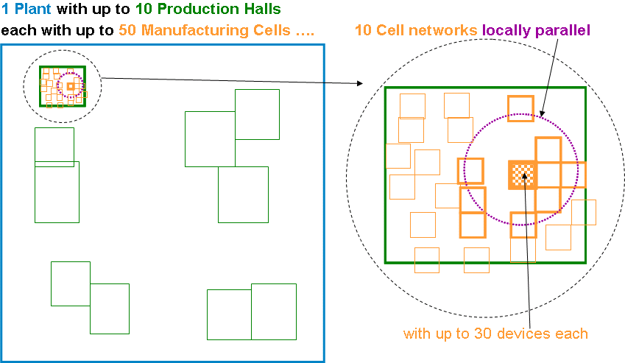
Figure 1: Example of a 1 plant with 10 production halls and 50 manufacturing cells
- Factory hall (or plant subunit) automation:
Medium Control System level, where e.g.:
- whole production lines or moving applications (e.g. moving through a factory hall in discrete manufacturing e.g. automated guided vehicles, rail hanging power screwdrivers), or
- whole production units in process automation:
    - Cover a larger area (e.g. 100 m x 100 m). This is solved by an industrial WLAN or a mesh type technology (TDMA schemes used) to safely cover a larger area with.
    - In average 100 devices and still low latencies.
Also here the master is in need of a higher duty cycles and high power to cover the range without line of sight:
- Up to 5 such independent systems can be within range of each other (are within "interference" range).
- The area related local device density at 100 m range therefore is approx. 5 x 100 devices per 100 x 100 m² or 0,022 per m² at 100 m range.
- The hall/subunit automation data packets as such are typically medium size with 200 octets on air (e.g. 140 octets of user data, 60 octets for addressing, networking, control and error protection) and have to be sent every 200 ms in each direction.
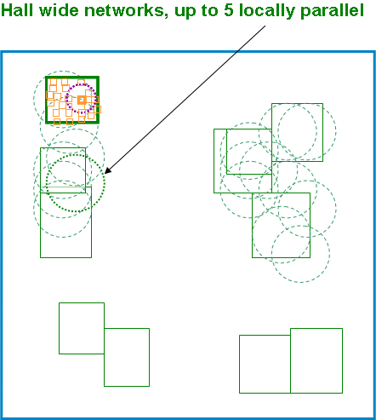
Figure 2: Example of hall wide networks, up to locally parallel
- Plant level wide applications:
Control system level covering up to the whole plant, typically an industrial mesh technology:
- Able to cover e.g. 1 km x 1 km but typically with mesh technology to increase robustness against typical industrial influences (moving obstacles, interference/coexistence).
- One such mesh system can have up to 1000 connected devices, but each device only having to cover a smaller range (100 m) and the mesh covers the larger distances needed, without excessive power needs.
- There may be up to 3 independent such mesh networks operating in parallel in the whole plant.
- Up to max. 50 devices of the 3 clusters can be within range of each other (are within "interference" range).
- The area related local device density at 100 m range therefore is approx. 50 devices per 100x100 m² or
- 0,025 per m² at 100 m range.
The plant level automation data packets are typically medium size with 105 octets on air (e.g. 50 octets of user data, 55 octets for addressing, networking, control and error protection) and have to be sent every 500 ms in each direction.
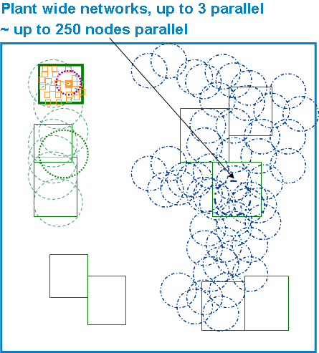
Figure 3: Example of plant wide networks, up to 3 parallel
All of these 3 levels are operated in parallel (partially or completely overlapping interference area), and often by different operators and connected to different Control Systems. Each of the many wireless systems has to be allowed to switch on and off and vary the number of connected active devices and data amount transferred, depending of the needs of the many different production cells/subunits/ lines in order to maximise individually production, quality, safety and do service, troubleshooting and installation work on the productions units.
Parallel means that at most parts of the plant, the three "wireless" classes operate overlapping, preferably in the same frequency band for maximal flexibility of coexistence management reasons, to increase spectrum efficiency and to have the same needed spectrum properties like industrial-interference-free, power efficiency (range) and bending/damping by obstacles.
Normally, in total more than 70 MHz of spectrum would be required to support applications from the 3 classes to operate seamless within a given environment without any restriction. This would still require a clever site planning which is not always possible as the different wireless solutions are from different vendors. However, recent and future developments of more intelligent sharing mechanisms will facilitate automatic seamless operation of these 3 classes even in less spectrum is made available.
Figure 4: Example of a combination of 3 classes
The total estimation of needed spectrum to share can be estimated from Table 2 by adding up the spectrum estimated for the three classes to be in the order of 76 MHz of continuous spectrum.
Table 2 shows the extreme low latency and application availability requirements of many industrial wireless applications.
Table 2: Industrial application
Characteristic | Manufacturing cell | Factory hall | Plant level
Indoor/outdoor application | Indoor | Mostly indoor | Mostly outdoor
Spatial dimension LxWxH [m³] | 10 x 10 x 3 | 100x100x10 | 1000 x 1000 x 50
Number of devices (typically) | 30 | 100 | 1000
Number of parallel networks  (= clusters) | 10 | 5 | 5
Number of such clusters per plant | 50 | 10 | 1
Min. Number of locally parallel devices | 300 | 500 | 250
Network type | Star | Star/Mesh | Mesh
S, Typ. packet size [on air, byte] | 16 | 200 | 105
Maximum allowable latency (end-to-end) incl. jitter/retransmits [ms] | 5 ± 10 % | 20 ± 10 % | 20 ± 10 %
DC, Max. on-air duty cycle related to media utilisation  (see clause 5) / DC?? | 20 % | 20 % | 20 %
T, Update Time [ms] | 50 ± 10 % | 200 ± 10 % | 500 ± 10 %
Packet Loss Rate  (involved outside latency) | 10⁻⁹ | 10⁻⁹ | 10⁻⁹
E, Spectral efficiency (typically) [Bit/s/Hz] | 1 | 1,18 | 0,13
B, Resulting min. Bandwidth requirement [MHz] | 8 | 34 | 34
Application availability | Exceeds 99,999 % (less than 300 s accumulated outage per annum).
Typical operational distance | Depends on individual use case and frequency of operation.
NOTE: To account for up and downlink information, 2 telegrams have been assumed.

Additional technical details are provided in section 3 (see also the SRdoc [1]).

[Editor’s note: the concept of DC / DC, Max. on-air duty cycle related to media utilisation
(see clause 5) may need to take into account the current discussion within ETSI – check the reference document. Discussions are ongoing on this subject.]

INDUSTRIAL APPLICATIONS USING TECHNOLOGIES DIFFERENT FROM ULTRA-WIDEBAND (UWB) PARAMETERS AND DEPLOYMENT SCENARIOS

Technical Parameters

Transmitter Parameters

Transmitter output power
E.i.r.p. up to 400 mW (26 dBm) is required.

Transmitter masks
The following figures provide the transmitter spectrum masks for 1 MHz, 3 MHz and 20 MHz systems respectively.

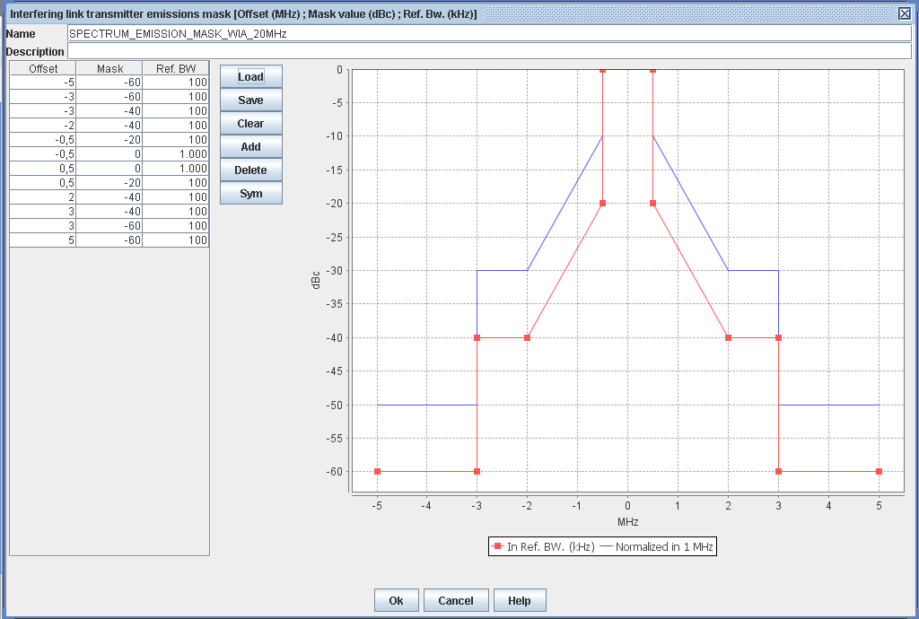
Figure 5: Transmitter spectral mask for 1 MHz bandwidth

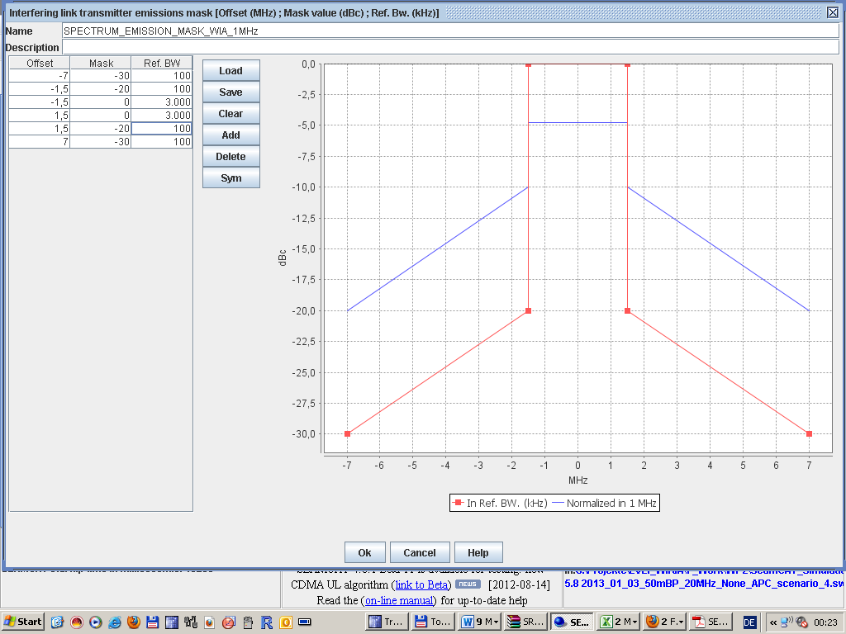
Figure 6: Transmitter spectral mask for 3 MHz bandwidth

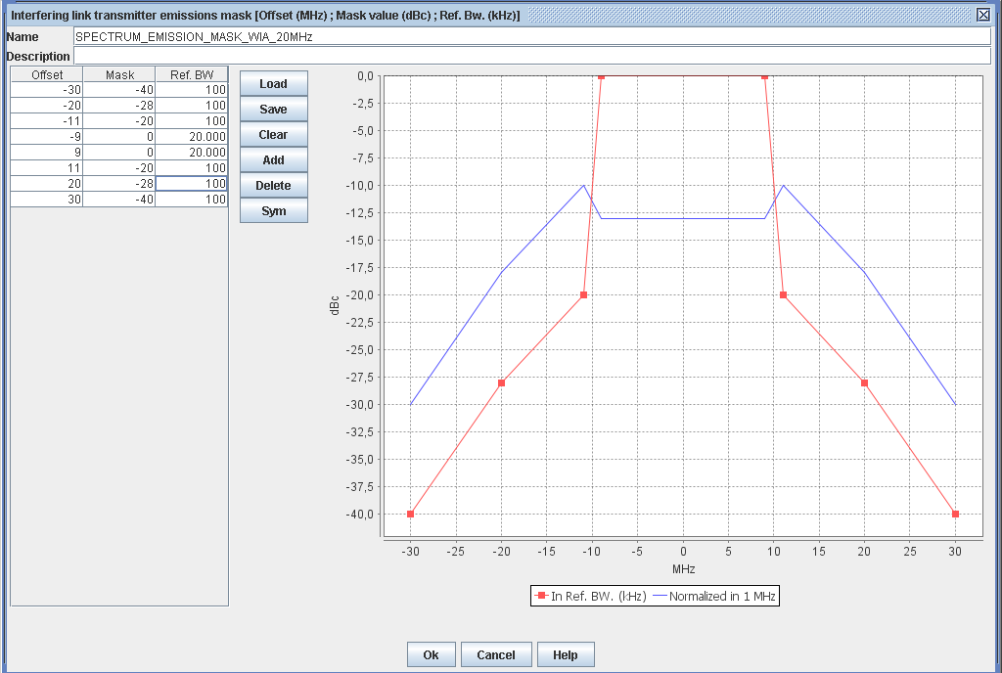
Figure 7: Transmitter Spectral Mask for 20 MHz bandwidth

Antenna Characteristics
No restrictions on antenna characteristics, according to the description in section 6.3.2 of ETSI TR 102 889-2 V1.1.1 (2011-08) [1].

The default antenna type is omnidirectional (collinear dipole antenna). Therefore, Recommendation ITU-R F.1336-3 [3] should be used. Following section (1.a) in section formula (2.1) Rec. ITU-R F.1336-3, the expression of antenna gain in dBi at elevation angle Θ in degrees is given by:

where:
Θ: absolute value of the elevation angle relative to the angle of maximum gain (degrees)
Θ₃: the 3 dB beamwidth in the vertical plane (degrees)
k: sidelobe factor for all antennas operating in the 3-70 GHz range, the parameter k should be 0.
G(Θ) : gain relative to an isotropic antenna (dBi)
G₀ : the maximum gain in the azimuth plane (dBi)

The WIA antenna is shown in ANNEX 1:, Figure 31. The hinge mounting allows various orientations. Therefore, in Seamcat simulations, a random antenna tilt between 0º and 90º (for azimuths between 0º and 360º) is taken into account.

Figure 8: Antenna pattern according ITU-R F.1336
Additional information on the antenna pattern is given in ANNEX 1:.
[Ben: ITU-R Rec. F.1336-3 has several formulas for antenna diagram and side-lobe levels. A reference to the right formula number (2.1) in ITU-R F.1336-3 would be appropriate, as well as a motivation of that choice. The motivation of the choice is not 100% clear to me, so I have no suggestion for an appropriate text.]

Bandwidth
As different technologies are used, the typical occupied bandwidth for a single device varies between 1 MHz and 20 MHz. Frequency Hopping as well as non-frequency hopping technologies is used. The parallel use of all tree classes requires a continuous spectrum of 76 MHz.

Receiver parameters

Receiver sensitivity
Most of the technologies used in the industrial applications are based on specifications such as IEEE 802.11 [4], IEEE 802.15.1 [5] and IEEE 802.15.4 [6]. Therefore, the relevant receiver parameters including the receiver sensitivity can be found in those standards.

Other receiver parameters
The performance of certain sharing mechanisms may require certain specific receiver requirements. The sharing study will show if additional receiver parameters are required.

Channel pattern
The establishment of coexistence is a combination of technical and/or organizational measures to ensure the interference-free operation of wireless industrial applications in their environments. Coexistence between wireless industrial automation communication systems can be achieved by uncoupling the dimensions frequency; time and space. Consequential the WIA systems with 1 MHz, 3 MHz and 20 MHz use separate frequency bands.

Figure 9: Possible channelization
The use of WIA systems with 1 MHz, 3 MHz and 20 MHz bandwith depends on the requirement of industrial application. Figure 9 depict three different examples of WIA channelization.
It is possible to use the following channel by WIA systems with 1 MHz bandwidth:

Channel centre frequency = Channel starting frequency + 1 × n (MHz) Eq. 1

n = 0,…, 140
Channel starting frequency is defined as 5.730 GHz.

The possible channel centre frequency for the WIA systems with 3 MHz and 20 MHz bandwidth can calculate with equation 2:

Channel centre frequency = Channel starting frequency + 5 × n_{ch} (MHz) Eq. 2

n_{ch} = 147,…, 173
Channel starting frequency is defined as 5 GHz.

For WIA systems with 3 MHz bandwidth is it possible to use the channels 146 to 151, 153 to 167 and 169 to 174.

For WIA systems with 20 MHz bandwidth is it possible to use the non-overlapping channels 148, 155, 159, 163 and 172 or 173.

The first 2.5 MHz at the edges of the band are not planned to be used.

Table 3: Possible channels
Channel No. | Channel centre frequency [MHz] | Channel No. | Channel centre frequency [MHz] | Channel No. | Channel centre frequency [MHz]
145 | 5725 | 156 | 5780 | 167 | 5835
146 | 5730 | 157 | 5785 | 168 | 5840
147 | 5735 | 158 | 5790 | 169 | 5845
148 | 5740 | 159 | 5795 | 170 | 5850
149 | 5745 | 160 | 5800 | 171 | 5855
150 | 5750 | 161 | 5805 | 172 | 5860
151 | 5755 | 162 | 5810 | 173 | 5865
152 | 5760 | 163 | 5815 | 174 | 5870
153 | 5765 | 164 | 5820 | 175 | 5875
154 | 5770 | 165 | 5825
155 | 5775 | 166 | 5830

Channel access parameters
For maximised spectrum efficiency, including sharing among all wireless industrial applications present, a spectrum sharing mechanism appropriate for industrial applications is required.
An example of that is Frequency Agility. Frequency Agility is the ability of a system to operate according to frequency or channel assignments of a centralized or distributed control mechanism, which will define the configuration of all devices within an industrial site or subarea thereof. Configurations may change over time depending on the application requirements. If non-contiguous spectrum is assigned, then the Frequency Agility feature is supposed to operate across all assigned sub-bands.

Conclusion of technical parameters
The considered WIA systems may typically use 1 MHz, 5 MHz, 10 MHz or 20 MHz channelization, which is necessary to obtain sufficiently high data rates.
Table 4: Technical parameters of WIA system
Parameter | System for Manufacturing Cell | System for Production Hall | System for Plant
max e.i.r.p. | 25 mW (14 dBm) | 400 mW (26 dBm) | 400 mW (26 dBm)
Receiver sensitivity | -70 dBm in 1 MHz | -70 dBm in 1 MHz  - 90 dBm in 3 MHz  -88 dBm @ 6 MBit/s in 20 MHz | - 90 dBm in 3 MHz  -88 dBm in 20 MHz
Channel bandwidth (MHz) | 1 MHz | 1 MHz, 3 MHz and 20 MHz | 3 MHz and 20 MHz
Channel spacing (MHz) | 1 MHz | 1 MHz, 5 MHz and 20 MHz | 5 MHz and 20 MHz
Min. Number of hopping channels | no requirements | - | no requirements
Max. Number of hopping channels | BW_{Total}/1 MHz | - | BW_{Total}/5 MHz
Topology33 | Star | Star/Mesh | Mesh
Duty Cycle | 20 % | 20 % | 20 %
Antenna type | N/A | N/A | N/A
Antenna gain | N/A | N/A | N/A
Antenna pattern | N/A | N/A | N/A
Polarisation | N/A | N/A | N/A
Antenna height (m) | 0,5 m to 3 m | 0,5 m to 10 m | 0,5 m to 50 m
The manufacturing cells can be deployed under the existing regulatory framework of Rec. 70-03 Annex 1.

Deployment Scenarios
All of these three wireless classes (cell or sub-unit automation; factory hall or plant sub-unit automation and plant level automation) are operated in parallel. Parallel means that at most parts of the plant, the three "wireless" classes operate overlapping, preferably in the same frequency band for maximal flexibility of coexistence management reasons, to increase spectrum efficiency and to have the same needed spectrum properties like industrial-interference-free, power efficiency (range) and bending/damping by obstacles.
That means the available spectrum is occupied by the three wireless classes of industrial applications. The medium utilisation is 100 %. The instance of coexistence manager guarantees the parallel work of different wireless devices and systems, therefore only one device use a certain piece of available spectrum (bandwidth) at a certain place and at a certain time. The e.i.r.p. is equal over the spectrum and time and the aggregate interference effect will not increase.
Table 4: Parameters for deployment scenario
Frequency Band | Maximum mean power | Duty Cycle | Channel spacing | Remark
5725 to 5850 MHz | 26 dBm | 100 % | No requirements | -
5850 to 5875 MHz | 26 dBm | 100 % | No requirements | -
[Note: there are still some ongoing discussion relating to the DC subject.]

Geographical deployment of WIA
The following table provides an estimation of the number of wireless industrial automation devices other than UWB (WIA) over Germany. The information relating to Germany is then extended to the whole Europe.
Table 6: Deployment of WIA in Europe
Parameters | Values
Population / Germany | 80 000 000
Population / Frankfurt am Main | 690 000
Plants / Frankfurt am Main | 4
Plants / Germany | 533
Wireless Devices / Germany | 12 266 667
Area Germany km² | 357 000
Wireless devices Germany/km² | 34.4
Automation ratio EU/Germany | 3
Wireless Devices EU | 36 800 000
area EU km² | 10 180 000
device density EU/km² | 3.6

OTHER SERVICES IN THE BAND 5725 - 5875 MHZ
Table 7 provides the extract from the ITU Radio Regulations [7] for the bands used through this report.
Table 7: Extract of Article 5 of the ITU Radio Regulations
Region 1 | Region 2 | Region 3
5 725-5 830  FIXED-SATELLITE (Earth-to-space)  RADIOLOCATION  Amateur  5.150 5.451 5.453 5.455 5.456 | 5 725-5 830  RADIOLOCATION  Amateur  5.150 5.453 5.455
5 830-5 850  FIXED-SATELLITE (Earth-to-space)  RADIOLOCATION  Amateur  Amateur-satellite (space-to-Earth)  5.150 5.451 5.453 5.455 5.456 | 5 830-5 850  RADIOLOCATION  Amateur  Amateur-satellite (space-to-Earth)  5.150 5.453 5.455
5 850-5 925  FIXED  FIXED-SATELLITE (Earth-to-space)  MOBILE  5.150 | 5 850-5 925  FIXED  FIXED-SATELLITE (Earth-to-space)  MOBILE  Amateur  Radiolocation  5.150 | 5 850-5 925  FIXED  FIXED-SATELLITE (Earth-to-space)  MOBILE  Radiolocation  5.150

Footnotes of RR Art. 5 relevant for CEPT countries:
5.150 The following bands: ... 5 725-5 875 MHz (centre frequency 5 800 MHz), and ... are also designated for industrial, scientific and medical (ISM) applications. Radio communication services operating within these bands must accept harmful interference which may be caused by these applications. ISM equipment operating in these bands is subject to the provisions of No. 15.13.
5.451 Additional allocation: in the United Kingdom, the band 5 470-5 850 MHz is also allocated to the land mobile service on a secondary basis. The power limits specified in Nos. 21.2, 21.3, 21.4 and 21.5 shall apply in the band 5 725-5 850 MHz.
5.455 Additional allocation: in Armenia, Azerbaijan, Belarus, Cuba, the Russian Federation, Georgia, Hungary, Kazakhstan, Latvia, Moldova, Mongolia, Uzbekistan, Kyrgyzstan, Tajikistan, Turkmenistan and Ukraine, the band 5 670-5 850 MHz is also allocated to the fixed service on a primary basis. (WRC-03)
The following table provides an overview ERC Report 25 [8] for the bands 5725 – 5875 MHz.
Table 8: Allocation / Identification of spectrum according to ERC Report 25 [8]
Frequency range | European Common Allocation | ECC/ERC  harmonisation  measures | Application | European  footnotes | Standard | Notes
5725 - 5830 MHz | FIXED-SATELLITE (E/S)  RADIOLOCATION  Amateur  Mobile  5.150 EU2  EU22 |  | Amateur |  | EN 301 783
5725 - 5830 MHz |  | ECC/REC/(06)04 | BFWA |  | EN 302 592 | Within the band 5725-5875 MHz
5725 - 5830 MHz |  |  | Defence systems |  |  | Tactical and weapon system radars
5725 - 5830 MHz |  |  | ISM |  | EN 300 440 | Within the band 5725-5875 MHz
5725 - 5830 MHz |  | ERC/REC 70-03 | Non-Specific SRD |  | EN 302 372 | Within the band 5725-5875 MHz
5725 - 5830 MHz |  | ERC/REC 70-03 | Radiodetermination applications |  |  | Within the band 4500-7000 MHz for  TLPR application
5725 - 5830 MHz |  | ECC/DEC/(02)01  ERC/REC 70-03 | RTTT |  |  | Within the band 5795-5805 MHz.  RTTT in the band 5805-5815 MHz  on a national basis
5725 - 5830 MHz |  |  | Weather Radars |  |  | Ground based and airborne
5830 - 5850 MHz | FIXED-SATELLITE (E/S)  RADIOLOCATION  Amateur  Amateur Satellite (S/E)  Mobile  5.150 EU2  EU22 |  | Amateur Satellite (S/E) | EU23 |  | Within the band 5830-5850 MHz
5830 - 5850 MHz |  | ECC/REC/(06)04 | BFWA |  | EN 302 502 | Within the band 5725-5875 MHz
5830 - 5850 MHz |  |  | Defence systems |  |  | Tactical and weapon system radars
5830 - 5850 MHz |  |  | ISM |  |  | Within the band 5725-5875 MHz
5830 - 5850 MHz |  | ERC/REC 70-03 | Non-Specifics SRDs |  | EN 300 440 | Within the band 5725-5875 MHz
5830 - 5850 MHz |  | ERC/REC 70-03 | Radiodetermination applications |  | EN 302 372 | Within the band 4500-7000 MHz for  TLPR application
5830 - 5850 MHz |  |  | Weather radars |  |  | Ground based and airborne
5850 - 5925 MHz | FIXED  FIXED-SATELLITE (E/S)  MOBILE  5.250 | ECC/REC/(06)04 | BFWA | EN 302 502 |  | Within the band 5725-5875 MHz
5850 - 5925 MHz | FIXED  FIXED-SATELLITE (E/S)  MOBILE  5.250 |  | FSS |  | EN 301 443 | Priority for civil networks
5850 - 5925 MHz | FIXED  FIXED-SATELLITE (E/S)  MOBILE  5.250 |  | ISM |  |  | Within the band 5725-5875 MHz
5850 - 5925 MHz | FIXED  FIXED-SATELLITE (E/S)  MOBILE  5.250 | ECC/DEC/(08)01  ECC/REC/(08)01 | ITS |  | EN 302 571 | Within the band 5875-5925 MHz.  Within the band 5855-5875 MHz
5850 - 5925 MHz | FIXED  FIXED-SATELLITE (E/S)  MOBILE  5.250 | ERC/REC 70-03 | Non-Specific SRDs |  | EN 300 440 | Within the band 5725-5875 MHz
5850 - 5925 MHz | FIXED  FIXED-SATELLITE (E/S)  MOBILE  5.250 | ERC/REC 70-03 | Radiodetermination applications |  | EN 302 372 | Within the band 4500-7000 MHz for  TLPR application
EU2: Civil-military sharing.
EU22: The band 5250-5850 MHz is utilised for a variety of radiodetermination applications falling within the radionavigation and radiolocation services. This band will be subject to further detailed consideration.
EU23 In the sub-bands 5660-5670 MHz (earth to space), 5830-5850 MHz (space to earth) and 10.45-10.50 GHz the amateur-satellite additionally operates on a secondary and non interference basis to other services. In making assignments to other services, CEPT administrations are requested wherever possible to maintain these allocations in such a way as to facilitate the reception of amateur emissions with minimal power flux densities.

The following services and systems are covered within this study following the approach considered in previous ECC Reports ([ref to ECC Report 101]):
- 4.1Radiolocation Service
- 4.2 Road Transport and Traffic Telematic (RTTT) Systems
- 4.3 Fixed Service (Point-to-Point Links) and Broadband Fixed Wireless Access (BFWA)
- 4.4 Fixed-Satellite (E-s) Service (FSS)
- 4.5 Amateur Service, Amateur-satellite (s-E) Service
- 4.7 Intelligent Transport Systems (ITS)
- 4.8 Short Range Devices including:
  - Non-specific Short Range Devices and
  - Tank Level Probing Radar (TLPR) applications
- 4.9 Direct Air To Ground Communications [Editor’s note: for these systems we may need to wait for the output of the studied undertaken within CEPT.]

Radiolocation Service
The bands between 5725 MHz and 5850 MHz are allocated to the Radiolocation service on a primary basis.

Technical characteristics
Recommendation ITU-R M.1638 [9] provides characteristics of radars operating under the Radiolocation services in the frequency range 5250-5850 MHz. Within this range, the band between 5725 MHz and 5850 MHz is used by many different types of radars on fixed land-based, ship borne and transportable platforms. It should be noted that most of these radars are designed to operate not only in the 5725-5850 MHz band but in a larger portion of the band 5250 – 5850 MHz.
Table 9 contains technical characteristics of representative systems deployed in this band. This includes a subset of the radars contained in Recommendation ITU-R M.1638 [9], which are relevant for the frequency band 5725 – 5850 MHz (radars L, M, N, O and Q) and three additional radars operated by administrations within CEPT (X, Y and Z). This information is generally sufficient for calculation to assess the compatibility between these radars and other systems.
Frequency hopping is one of the most common Electronic-Counter-Counter-Measures (ECCM). Radar systems that are designed to operate in hostile electronic attack environments use frequency hopping as one of its ECCM techniques. This type of radar typically divides its allocated frequency band into channels. The radar then randomly selects a channel from all available channels for transmission. This random occupation of a channel can occur on a per beam position basis where many pulses on the same channel are transmitted or on a per pulse basis. This important aspect of radar systems should be considered and the potential impact of frequency hopping radar should be taken into account in sharing studies.

Operational characteristics of Radiolocation systems
There are numerous radar types, accomplishing various missions, operating within the Radiolocation service throughout the whole range 5250 – 5850 MHz, and specifically within the 5725 – 5850 MHz band. Test range instrumentation radars are used to provide highly accurate position data on space launch vehicles and aeronautical vehicles undergoing developmental and operational testing. These radars are typified by high transmitter powers and large aperture parabolic reflector antennas with very narrow pencil beams. The radars have auto-tracking antennas which either skin-track or beacon-track the object of interest. Periods of operation can last from minutes up to 4-5 hours, depending upon the test program. Operations are conducted at scheduled times 24 hours/day, 7 days/week.
Shipboard sea and air surveillance radars are used for ship protection and operate continuously while the ship is underway as well as entering and leaving port areas. These surveillance radars usually employ moderately high transmitter powers and antennas which scan electronically in elevation and mechanically a full 360 degrees in azimuth. Operations can be such that multiple ships are operating these radars simultaneously in a given geographical area. Other special-purpose radars are also operated in the band 5250 – 5850 MHz.

Protection criteria
The de-sensitising effect on radars operated in this band from other services of a CW or noise-like type modulation is predictably related to its intensity. In any azimuth sectors in which such interference arrives, its power spectral density can simply be added to the power spectral density of the radar receiver thermal noise, to within a reasonable approximation. If power spectral density of radar-receiver noise in the absence of interference is denoted by N₀ and that of noise-like interference by I₀, the resultant effective noise power spectral density becomes simply I₀+N₀. An increase of about 1 dB for the Radiolocation radar would constitute significant degradation. Such an increase corresponds to an (I+N)/N ratio of 1.26, or an I/N ratio of about –6 dB. These protection criteria represent the aggregate effects of multiple interferers, when present. The tolerable I/N ratio for an individual interferer depends on the number of interferers and their geometry, and needs to be assessed in the course of analysis of a given scenario. The aggregation factor can be very substantial in the case of certain communication systems, in which a great number of stations can be deployed.
Table 9: Characteristics of Radiolocation systems
Characteristics | Radar l | Radar M | Radar N | Radar O | Radar Q | Radar X (Note 1) | Radar Y (Note 1) | Radar Z
Function | Instrumentation |  |  | Surface and air search |  |  |  | Search
Platform type | Ground |  |  |  | Ship | Ground /Vehicle
Tuning range (MHz) | 5350-5850 |  | 5400-5850 |  | 5450-5825 | 5400 – 5850 |  | 5250-5850
Modulation | None |  | Pulse /  chirp pulse | Chirp pulse | None |  |  | Non-Linear FM
Tx power into antenna (kW) | 2800 | 1200 | 1000 | 165 | 285 | 12 | 12 | 70
Pulse width (µs) | 0.25, 1.0, 5.0 | 0.25, 0.5, 1.0 | 0.25-1 (plain)  3.1-50 (chirp) | 100 | 0.1, 0.25, 1.0 | 4-20 | 4-20 | 3.5, 6, 10
Pulse rise/fall time (µs) | 0.02-0.5 | 0.02-0.05 | 0.02-0.1 | 0.5 | 0.03/0.05/ 0.1 | No detail | No detail | N/A
Pulse repetition rate (pps) | 160, 640 | 160, 640 | 20-1 280 | 320 | 2 400/1 200/  750 | 1000-7800 | 1000-7800 | 2500/3750
Chirp bandwidth (MHz) | N/A | N/A | 4.0 | 8.33 | N/A | No detail | No detail
RF emission bandwidth  –3 dB –20 dB (MHz) | 0.5-5 | 0.9-3.6  6.4-18 | 0.9-3.6  6.4-18 | 8.33  9.9 | 5.0/4.0/1.2  16.5/12.5/7.0 | 5 | 5
Antenna pattern type | Pencil |  |  |  | Fan | N/A
Antenna type | Parabolic |  | Phased Array |  | Travelling wave feed horn array | N/A |  | Phased Array
Antenna polarization | Vertical/Left-hand circular |  |  |  | Horizontal | Vertical |  | Horizontal
Antenna main beam gain (dBi) | 54 | 47 | 45.9 | 42 | 30.0 | 35 | 35 | 31.5
Antenna elevation beam width (degrees) | 0.4 | 0.8 | 1.0 | 1.0 | 28.0 | N/A | N/A | 43.8
Antenna azimuthal beam width (degrees) | 0.4 | 0.8 | 1.0 | 1.0 | 1.6 | N/A | N/A | 1.75
Antenna horizontal scan rate (degrees/s) | N/A (Tracking) |  |  |  | 90 | N/A (tracking) | 180/360 | 120/180
Antenna horizontal scan type | N/A (Tracking) |  |  |  | 30-270 °  Sector | N/A
Antenna vertical scan rate (degrees/s) | N/A (Tracking) |  |  |  | N/A
Antenna vertical scan type (degrees) | N/A (Tracking) |  |  |  | Fixed | N/A
Antenna sidelobe (SL) levels (dB) | -20 | -20 | -22 | -22 | -25 | -40 | -40 | N/A
Antenna height (m) | 20 | 8-20 | 20 | 20 | 40 | 10 | 10 | 6 – 13
Receiver IF 3 dB bandwidth (MHz) | 4.8, 2.4, 0.25 | 4, 2, 1 | 2-8 | 8 | 1.2, 10 | 4 | 4 | N/A
Receiver noise figure (dB) | 5 | 5 | 11 | 5 | 10 | 5 | 5 | ≤ 13
Minimum discernable signal (dBm) | –107 | –100 | –107,–117 | –100 | -94 (short)  -102 (wide) | -103 | -103 | -108
Note 1: Radars X and Y can operate both in fixed frequency and in hopping mode: the following parameters have to be taken into account in the different compatibility studies in the band 5725-5875 between industrial applications using technologies different from UWB and Radiolocation service.
Frequency hopping characteristics
Frequency band: 5250 to 5850 MHz or 5470 to 5850 MHz
type of frequency hopping: random
hopping rate: 300 to 1500 Hz
number of frequency: 1 frequency /10 MHz

Road Transport and Traffic Telematics (RTTT) Systems
ECC Decision (02)01 [10] designates the frequency bands 5795-5805 MHz, with possible extension to 5815 MHz, for RTTT. The band 5795-5805 MHz is for use by initial road-to-vehicle systems, in particular road toll systems, with an additional sub-band, 5805-5815 MHz, to be used on a national basis to meet the requirements of multi-lane road junctions.

Parameters
The regulatory parameters (maximum power levels) for RTTT are given in Annex 5 of ERC Recommendation 70-03 [2]. The RTTT parameters used in this Report are taken from the EN 300 674 [11] developed by ETSI and the EN12253 [12] developed by CENELEC. It should be noted that the EN 300 674 deals with both Road Side Units (RSU) and On-Board Units (OBU) and is divided in two parts, the part 1 providing general characteristics and test methods, the part 2 containing the essential requirements under article 3.2 of the R&TTE Directive [13].
Table 10: Summary of characteristics of the RTTT systems
 | Road Side Units | On Board Units
Frequency range (MHz) | 5795 and 5815
e.i.r.p. | 2 W (33 dBm) standard for -35° ≤ θ ≤ 35°  18 dBm for θ > 35°  8 W (39 dBm) optional | Maximum re-radiated sub-carrier e.i.r.p.:  -24 dBm (Medium data rate)  -14 dBm (High data rate)
Antenna gain | 10 – 20 dB (assumed front-to-back ratio of 15 dB) | 1 – 10 dB (assumed front-to-back ratio of 5 dB)
Transmitter Bandwidth | 1 MHz | 500 kHz
Receiver bandwidth | 500 kHz | 200 MHz – 1.4 GHz (not used)
Polarization | left circular | left circular
Receiver sensitivity (at the receiver input) | -104 dBm (BPSK) | -60 dBm
Co-channel C/I (dB) | 6 for 2-PSK,  9 for 4-PSK,  12 for 8-PSK | Not defined
Figure 10 depicts the RTTT frequency utilization for 1,5 MHz sub-carrier frequency, according the EN 300 674. The location of downlink channels from RSU to OBU and the location of uplink channels from OBU to RSU become visible.
Figure 10: RTTT frequency utilization for 1,5 MHz sub-carrier frequency, according the EN 300 674
The transmit power limits of RTTT downlink, uplink and out of band emissions are depicted in Figure 11.
Figure 11: e.i.r.p. limits of RTTT
Furthermore the typically antenna pattern of RSU is depict in Figure 12 [EN12253]

Figure 12: Antenna pattern RSU

Protection Criteria
On Board Unit (OBU)
The OBU requires a -60 dBm signal in order to function at all and to understand commands from the RSU. Assuming negligible re-radiation loss and a signalling distance of 8 m, the received signal strength at the OBU should be -59 dBm or higher . This corresponds to power density of -56 dBm/MHz. Assuming that simple BPSK is used, the required margin is 6 dB and thus the protection criterion for the OBU would be -62 dBm/MHz on-axis and -57 dBm/MHz off-axis.
Road Site Unit (RSU)
The RSU, when operating in BPSK mode requires a 6 dB margin over its receiver sensitivity: this gives -107 dBm at the receiver input or density of -98 dBm/MHz at the input to an antenna with a -9 dB off-axis gain. Since the RSU antenna points at the road surface, no on-axis gain is taken into consideration.

Fixed Service
In this frequency range, two types of Fixed Service links may be deployed Point-to-Point links and Point-to-Multipoint links as Broadband Fixed Wireless Access (BFWA) systems.
ECC Report 173 [14] indicates that in “the lightly licensed 5.8 GHz frequency band FWA (fixed and nomadic) operation continues to be possible on a national basis under the framework set by ECC Recommendation ECC/REC(06)04 [15] and ETSI Harmonised Standard EN 302 502 [16]. Coexistence considerations result in a low EIRP constraints and a need to implement a demanding Dynamic Frequency Selection (DFS) feature for the protection of primary Radiodetermination service.”
“The band is unlicensed/light licensed, from 5.725 to 5.850 GHz.
From 5.85 to 5.95, some use is indicated, mostly for P-MP. The licensing regime appears to be mostly link-based. Few countries indicated a significant use, including the Russian Federation (1400 P-P links, 600 P-MP Base Stations, infrastructure and broadcasting).
National frequency plans have been declared in majority of answers.”

Point-to-Point Links
ITU-R Recommendation F.383-7 [17] defines the channel arrangements for the lower 6 GHz band. Depending on which channel arrangements are chosen, the frequency range may extend from 5850 – 6425 MHz. ERC Recommendation 14-01 [18] defines the CEPT harmonised channel plans for Radio-frequency channel arrangements for high capacity analogue and digital radio-relay systems operating in the band 5925 MHz – 6425 MHz.
The harmonised CEPT arrangements are based on recommends 1 of Recommendation F.383-7 [17], which do not extend below 5925 MHz. There is a limited deployment of Point-to_point links,therefore this case is not considered in the compatibility studies.

Broadband Fixed Wireless Access (BFWA) Systems
ECC Report 101 [19] indicated that Broadband Fixed Wireless Access (BFWA) is used here to refer to wireless systems that provide local connectivity for a variety of applications and using a variety of architectures, including combinations of access as well as interconnection. ECC Report 68 [20] depicts the different architectures of BFWA and provides the relevant information on these different kinds of networks including technical parameters to ensure compatibility with other systems. The Table 11 below gives the main parameters for two BFWA architectures, Point to Multipoint (P-MP) and Mesh.
The 5.725-5.875 GHz band should be able to provide sufficient spectrum for commercial BFWA operations, even though exclusive frequency allocations and channel co-ordination is not envisaged in this band.
[Editor’s note: we probably need to reflect some of the material received in response to the ECC Questionnaire on FWA.]

Parameters
[The following table provides an overview of the characteristics for BFWA systems [ref to ECC Rep. 101].
Table 11: Interferer and victim technical parameters
Device | Unit | BFWA P-MP | BFWA Mesh
e.i.r.p. | dBm | 36 | 36
Bandwidth | MHz | 20 | 20
Antenna Gain | dBi | 18 | 10
Human losses | dB | 0 | 0
Sidelobe attenuation | dB | 15 | 15
TPC | dB | 10 | 10
Sensitivity (at the antenna input) | dBm | -86 | -86
Protection criterion | C/I | 6 (BPSK) | 6 (BPSK)
]

The technical parameters of the BFWA systems were provided by a BFWA operator in Germany. A P-MP system with a Central Station (sector antenna 120°) and a Terminal Station (direction antenna, 22dBi) was assumed to be representative for the majority of BFWA systems
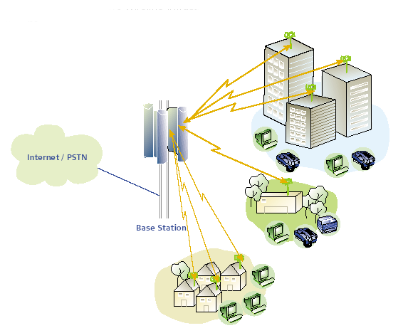
Figure 13: Typical BFWA P-MP deployment scenario (from ECC Report 68)
The technical parameters of the BFWA system used in this study can be found in Table 12.

Table 12: BFWA system parameters
Parameter | BFWA P-MP
Topology | Receiver Sectored Central Station (CS)  Transmitter Terminal Stations (TS).
Channel bandwidth | 20 MHz
Duplex/  Access scheme | TDD/TDMA
Max Tx power dBm TS (conducted) | 14 dBm
Max e.i.r.p. | 36 dBm
Max Power density spectral (dBm/MHz) e.i.r.p. | 23 dBm/MHz
Adaptive power control dB | 12 dB
Antenna CS (Rx antenna-> Victim Link Receiver) | 16 dBi, sector antenna 120°, 4° down tilt See Figure 14 and Figure 15
Antenna height CS | 30 m
Antenna TS (Tx antenna-> Victim Link Transmitter) | 22 dBi: See Figure 16 and Figure 17
Antenna height TS | 10 m
Receiver sensitivity 64-QAM | -68 dBm
Fading Margin | 10 dB
Minimum wanted power at TS and BS (Sensitivity – fade margin) | -58 dBm
Protection ratio 64 QAM | C/(I+N) 24 dB  C/N=C/I=27 dB
Receiver Noise floor | -95 dBm
Link lenght | Typical 1 km
Path loss model | Spherical diffraction (outdoor, outdoor) see Annex 1

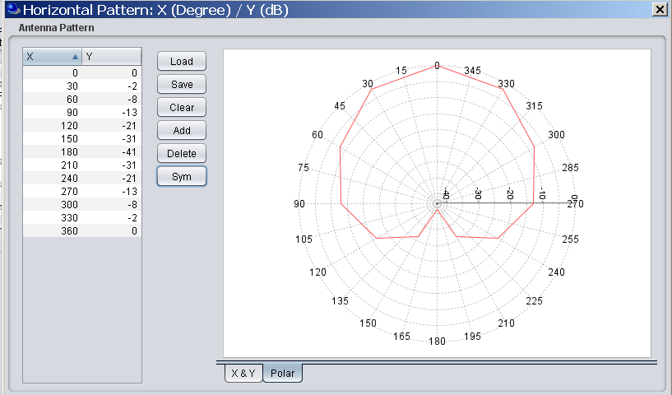
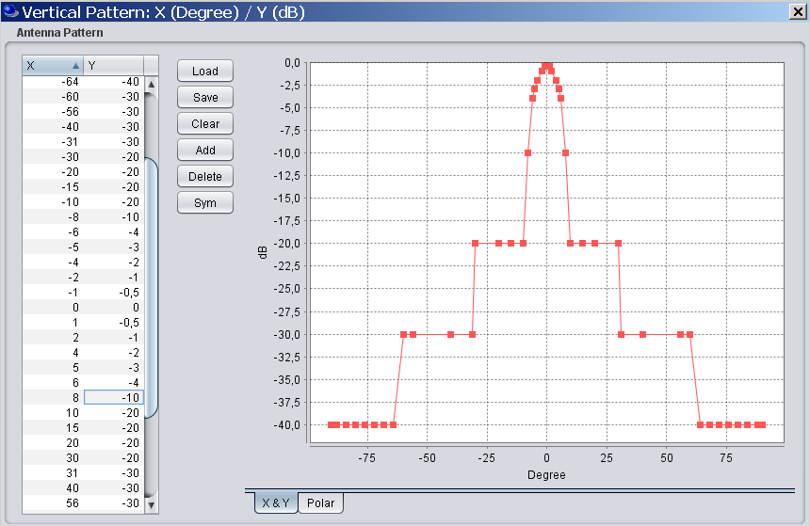
Figure 14: Typical P-MP Central station antenna pattern ((Ubiquiti Networks, www.ubnt.com))

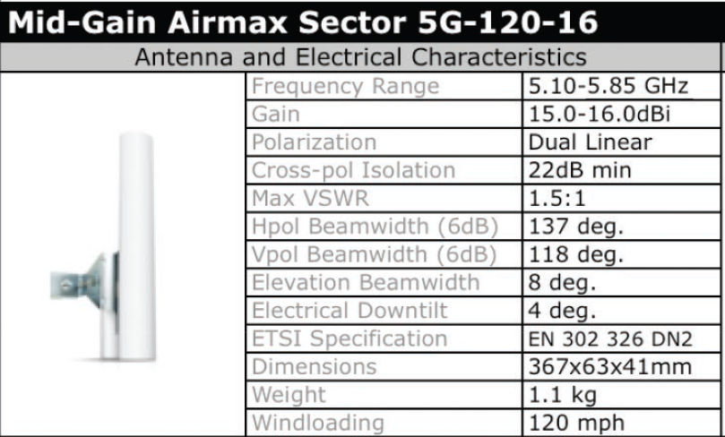
Figure 15: Typical P-MP Central station (Ubiquiti Networks, www.ubnt.com)

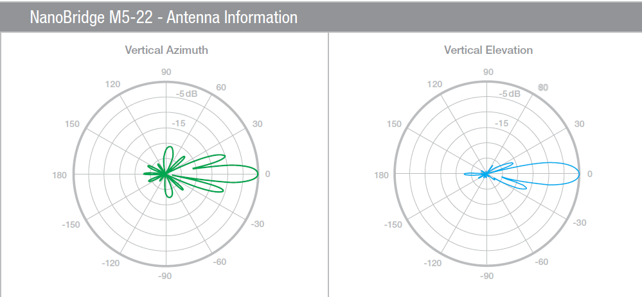

Figure 16: Typical BFWA Terminal Station antenna pattern (Ubiquiti Networks, www.ubnt.com)

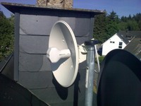
Figure 17: Typical BFWA TS antenna (Ubiquiti Networks, www.ubnt.com)

Protection criteria [to be deleted?]

FIXED SATELLITE (E-S) SERVICE (FSS)
As shown in Table 13, FSS deployments use the whole band 5725 – 5875 MHz and it is used by transmitting earth stations in the Earth-to-space direction operating only to satellites in geostationary orbits. In the 125 MHz portion of the band up to 5850 MHz, this is a Region 1 allocation only (i.e. only Europe, Africa, and some of the northernmost countries in Asia). Above 5850 MHz the band is part of the heavily utilised FSS global uplink band and most of the currently operating satellites (INTELSAT & New Skies for instance) have receive transponders in this upper portion of the band.
Table 13 provides details of the selection of satellites that have been taken as representative of those requiring protection in the visible portion of the geostationary orbit from Europe. The parameters shown are those required in sharing studies with the industrial applications using technologies different from UWB systems. In these frequency bands, the satellite beams cover very large areas of the Earth (using global, hemispherical, zonal or regional beams) as can be seen by the satellite footprint coverage plots in Annex 6. These gain contour plots are used to determine the receive gain in the direction of the non UWB devices.
Table 13: Sample Satellite Data taken from ITU filings for the band 5725 – 5875MHz
Satellite | Sub-satellite longitude | Part of Frequency range  5725-5875 MHz used | Satellite Maximum Receive Gain G_{sat}(dBi) | Space Station Receiving System Noise Temperature T_{sat} (Kelvin)
A | 5º West | Whole band | 34 | 773
B | 14º West | Whole band | 26.5 | 1200
C | 31.5º West | > 5850 MHz | 32.8 | 700
D | 3º East | Whole band | 34 | 773
E | 18º West | >5850MHz | 32.8 | 700
F | 53º East | Whole band | 26.5 | 1200
G | 59.5º East | Whole band | 34 | 1200
H | 66º East | >5850 MHz | 34.7 | 700
I | 359º East | >5850 MHz | 32.8 | 700

Figure 18 shows the basic sharing scenario between FWA terminals and the FSS service. The studies reported on in Section 5.4 address the aggregate emissions of a large number of FWA terminals into the satellite receivers.

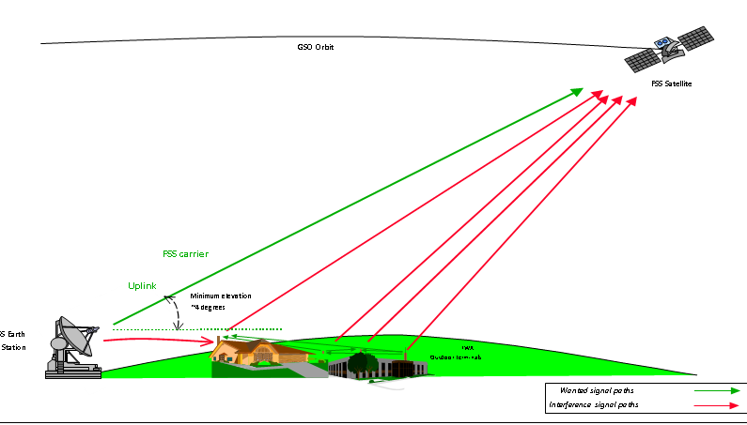
Figure 18: FSS/FWA Sharing Scenario in the band 5725-5875 MHz

AMATEUR AND AMATEUR-SATELLITE (S-E) SERVICES
The amateur and amateur-satellite (s-E) services have harmonised allocations in all three ITU Regions in the frequency range 5725 – 5850 MHz with secondary status as follows:
Table 14: Allocations for Amateur Services
Frequency | Service
5725 - 5830 MHz | Amateur
5830 - 5850 MHz | Amateur  Amateur Satellite (space-to-Earth)

The operational characteristics of amateur stations and amateur-satellite stations vary significantly. However based on the IARU Region-1 VHF Managers Handbook they can be categorised as:-

- Weak signal reception of Narrowband Terrestrial and EME (Moonbounce) operation in the sub-band 5760 - 5762 MHz, including propagation beacons.
- Data and multimedia systems (point to-point links and area repeaters) in other parts of the band
- Low-power satellite downlinks within 5830 – 5850 MHz (typically from LEO Cubesat satellites)

Characteristics for the Amateur Service
Recommendation ITU-R M.1732-1 [21] provides characteristics of stations operating in the amateur service for use in sharing studies:-

Table 15: Examples of Amateur Service characteristics in the band 5725-5850 MHz
Parameter | CW-Morse, EME | SSB Voice | FM Voice | Digital Voice and Multimedia
Transmitter Power⁽¹⁾ (dBW) | 3 – 20  (typically: 13) | 3 – 20  (typically: 13) | 3 – 20  (typically: 10) | 1-10  (typically: 6)
Transmitter Feeder Loss (dB) | 1 – 2 | 0 – 10 | 0 - 10 | 1 – 6
Antenna gain (dBi) | 0 – 40 | 0 – 40 | 0 - 40 | 0-30
Typical e.i.r.p.(dBW) | 1 -45 | 1 – 45 | 1 – 45 | 10-40
Antenna polarisation | Horizontal, Vertical, | Horizontal, Vertical | Horizontal, Vertical | Horizontal, Vertical.
Receiver IF bandwidth (kHz) | 0.4 | 2.7 | 9  15 | 2.7, 6, 16, 130, 10500
Receiver Noise Figure⁽²⁾ (dB) | 1 – 7  (typically: 1 ) | 1 – 7  (typically 1) | 1 – 3  (typically: 2) | 2
(1) Maximum powers are determined by each administration.
(2) Receiver noise figures for bands above 50 MHz assume the use of low-noise preamplifiers.

In order to simplify studies, it is assumed a typical terrestrial CW/SSB amateur station uses a 0.9 m (33 dBi) dish directional antenna, 13 dBW (20 Watt transmitter), and has a 1 dB NF receiver optimised for the 5760-5762 MHz band.

The determination of the maximum tolerable interference level from emissions of a single WIA device at the Amateur Service (AS) receiver is based on ECC Report 172 [22], where it is said that this level should be lower than N + (I/N) where N is the AS receiver inherent noise level and I/N the interference to noise ratio. The interference to noise ratio can be taken as –10 dB as given in ECC Report 172 [22].

Characteristics for the Amateur-Satellite Service
Recommendation ITU-R M.1732-1 [21] provides characteristics of stations operating in the amateur-satellite service for use in sharing studies:
Table 16: Characteristics of Amateur-Satellite systems in the space-to-Earth direction
Parameter | CW-Morse | SSB, FM, Digital Voice, Data
Transmitter Power ⁽¹⁾ (dBW) | 10 | 10
Transmitter Feeder Loss (dB) | 0.2 – 1 | 0.2 – 1
Transmitting antenna gain (dBi). | 0 – 6 | 0
Typical e.i.r.p.(dBW) | 0 – 15 | 9 – 15
Antenna polarisation | Horizontal, Vertical,  LHCP, RHCP | Horizontal, Vertical,  LHCP, RHCP
Receiver IF bandwidth (kHz) | 0.4 | 2.7, 16, 50, 100
Receiver Noise Figure ⁽²⁾ (dB) | 1 – 3  (typically: 1) | 1 – 3  (typically: 2)
⁽¹⁾ Maximum powers are determined by each administration.
⁽²⁾ Receiver noise figures for bands above 50 MHz assume the use of low-noise preamplifiers.

Most current amateur satellites are typically picosats (also called ‘cubesats’) that occupy slightly elliptical Sun-Synchronous low earth orbits (LEO) of 600-800km altitude. These smaller satellites have relatively low power and antenna gain.

For sharing studies 0 dBW Tx Power, 0.5 dB feeder loss and 3 dB antenna gain for a patch antenna are assumed for the satellite; and the amateur receiving groundstation is assumed to be similar to the amateur service.

It should be noted that most amateur satellite downlinks are coordinated and harmonised in a sub-band at 5840-5842 MHz.

INTELLIGENT TRANSPORT SYSTEMS (ITS)
Radiocommunication systems in the 5 GHz range can today offer communications with a high data rate, ranges up to 1 000 m, low weather-dependence, and global compatibility and interoperability for ITS communication.
The connectivity required by the applications can be summarized as:
- Inter-Vehicles (IVC) (this includes multi-hop routing involving several vehicles):
- Linear (e.g. for convoys of vehicles);
- Vehicle cluster covering several lanes (e.g. for lane management, overtaking assist).
- Vehicle to Roadside (uplink) V2R and roadside to vehicle R2V (downlink):
- One vehicle to beacon;
- Beacon to one vehicle;
- Beacon to many vehicles (broadcast, short range and long range);
- Beacon to selected vehicles.
- Cluster of vehicles communication, including to roadside beacon.
This is further described in ECC Report 101 [19]. ITS use for non-safety application the frequency range from 5855 MHz to 5875 MHz.

Parameters
ECC Report 101 [19] considers the following list of parameters for ITS systems.
Table 17: Systems parameters (not exhaustive)
Parameter | Value | Comments
Frequency stability | 1ppm | This figure takes account of the frequency tolerance allowed by IEEE 802.11, together with the expected Doppler variation from a vehicle closing speed of 400 km/h.
Maximum radiated power (e.i.r.p.) | Equipment classes:  A 10 dBm  B 20 dBm  C 33 dBm | Transmitter power control (TPC) with a 30 dB range.
Antenna beam shape/gain | RSU: 10 dBi  OBU: 5; 8 dBi | See Figure 20 and Figure 21
Polarization | TBD | Circular and linear polarisations each have certain benefits. Some degree of rejection of emissions from oppositely travelling vehicles may be required.
Modulation scheme | BPSK  QPSK 16QAM 64QAM | This is the standard set within IEEE 802.11
Data rates | 3/4.5 /6/9/ 12/18 /24/27 Mbit/s | This is the standard set within IEEE 802.11. As an option two channels may be combined to produce double data rates (up to 54 Mbit/s). Default data rate is 6Mbit/s.
Channel Bandwidth | 10 MHz, option 20 MHz | This is the standard set within EEE 802.11.
Communication mode | Half-duplex, broadcast | Half-duplex and broadcast are believed to be adequate for the applications considered to date.
Receiver sensitivity | -92dBm/MHz | Based on a -82 dBm for a bandwidth of 10 MHz
Protection criterion | C/I=6dB | For a classical BPSK signal

Communication channels will be open for the applications within the respective usage category (either road safety related or not, i.e. used for traffic management).
The required power levels (e.i.r.p.) range from 3 dBm to 33 dBm to achieve communication distances of up to 1000 m.
The technical parameters used for interference assessment are given in the following table.
Table 18: Technical requirements of ITS devices
Characteristics | Value | Unit
Receiver bandwidth | 10 | MHz
Receiver sensitivity | -82 | dBm
Antenna gain (see note 1) | 8 | dBi
Receiver sensitivity at antenna input | -100 | dBm/MHz
C/I | 6 | dB
Allowable Interfering Power at receiver antenna input | -106 | dBm/MHz
Transmitter Characteristics
Bandwidth | 10 | MHz
Tx_{out}, e.i.r.p | 33 | dBm
Tx_{out} e.i.r.p per MHz | 23 | dBm/MHz
Assumed value for TPC | 8 | dB
Net Tx_{out} e.i.r.p | 15 | dBm/MHz
Antenna Gain | 8 | dBi

Table 19: ITS Channel utilization
Channel type | Centre frequency | CH No. | Channel spacing | Default data rate | TX power limit | TX power density limit
G5CC | 5 900 MHz | 180 | 10 MHz | 6 Mbit/s | 33 dBm EIRP | 23 dBm/MHz
G5SC2 | 5 890 MHz | 178 | 10 MHz | 12 Mbit/s | 23 dBm EIRP | 13 dBm/MHz
G5SC1 | 5 880 MHz | 176 | 10 MHz | 6 Mbit/s | 33 dBm EIRP | 23 dBm/MHz
G5SC3 | 5 870 MHz | 174 | 10 MHz | 6 Mbit/s | 23 dBm EIRP | 13 dBm/MHz
G5SC4 | 5 860 MHz | 172 | 10 MHz | 6 Mbit/s | 0 dBm EIRP | -10 dBm/MHz
G5SC5 | As required in EN 302 571 for the band 5 470 MHz to 5 725 MHz |  | several | dependent on channel spacing | 30 dBm EIRP (DFS master) | 17 dBm/MHz
 |  |  |  |  | 23 dBm EIRP (DFS slave) | 10 dBm/MHz

Unwanted emission levels are given by Rec. ITU-R SM.1541 [23] for the out of band domain and SM.329 [24] and ERC Recommendation 74-01 [25] for the spurious domain. Table 20 provides unwanted emissions for ITS, which are considered in the following sections of this report.

Table 20: Attenuation (dBr) below the e.i.r.p. (dBm/MHz)
 | e.i.r.p. (dB/MHz) | ±4,5 MHz (dBr) | ±5 MHz (dBr) | ±5,5 MHz (dBr) | ±10 MHz (dBr) | ±25 MHz (dBr)
Class A | 0 | 0 | -10 | -20 | -28 | -40
Class B | 10 | 0 | -16 | -20 | -28 | -40
Class C | 23 | 0 | -26 | -32 | -40 | -50

Figure 19: Power spectral density of ITS device
Typical antenna pattern for the two ITS devices RSU and OBU are shown in Figure 20 and Figure 21. It is an essential design feature of communications between vehicles, or between vehicles and local infrastructure beacons, that they are directed more or less horizontally in a typical omni-directional pattern with typically 8 dBi gain in the horizontal plane.

Figure 20: Antenna pattern RSU (antenna gain: 10 dBi)
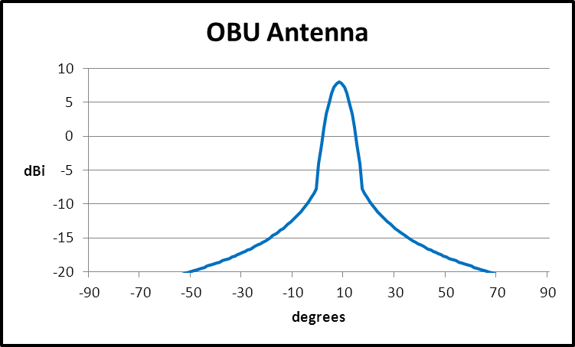
Figure 21: Antenna pattern OBU (antenna gain: 8 dBi)

Protection criteria

Short Range Devices (SRD)

General (non-specific) SRD
As specified in Annex 1 of ERC Recommendation 70-03 [2], the frequency band 5725-5875 MHz is used by non-specific SRD. This use should comply with the technical characteristics as shown below.
Table 21: Technical characteristics of SRD
Frequency Band | Power | Antenna | Channel Spacing | Duty Cycle (%)
5725-5875 MHz | 25 mW e.i.r.p | Integral (no external antenna socket) or dedicated | No channel spacing - the whole stated frequency band may be used | No duty cycle restriction

In addition to these regulatory technical characteristics, assumptions on some parameters had to be made in order to carry out compatibility studies. Three kinds of SRD are considered for the interference assessment (see the following table) as in previous CEPT studies [20] or [19] ?.
Table 22: Assumed SRD parameters
Parameter | SRD I | SRD II | SRD III | Comments
Typical bandwidth BW (MHz) | 0.25 MHz | 20 MHz | 8MHz | Note 1, Note 2.
TX Power, dBm e.i.r.p. | +14 | +14 | +14
Ant. Gain, dBi | 2 to 20 | 2 to 24 | 2
Ant. Polarization | Circular | Circular | Vertical
Receiver sensitivity, dBm | -110 | -91 | -84
Receiver noise dBm/MHz | -114 | N/A | N/A
Protection criterion, dB | I/N=0dB | C/I=8dB | C/I=20dB
SRD Noise figure F | 9.00 dB | N/A | N/A
FkTB | -105 dBm/MHz | N/A | N/A
Max OoB RX interference, dBm | -35 | -35 | -35 | E.g. limit for Rx blocking
Duty cycle : % | Up to 100% | Up to 100% | 100%
RX wake-up time (if applicable) | 1 sec | 1 sec | N/A | For battery operated equipment
Note 1: The given bandwidths are for non-spread spectrum modulation.
Note 2: For spread spectrum modulation (FHSS, DSSS and other types) the bandwidth can be up to 100 MHz

Tank Level Probing Radar (TLPR)
Tank Level Probing Radar (TLPR) are installed in closed metallic tanks or reinforced concrete tanks, or similar enclosure structures made of comparable attenuating material, holding a substance, liquid or powder. TLPR utilizes bandwidths that extend over multiple frequency bands allocated to numerous radio services. The emission limits for TLPR are specified outside the tank (see EN 302 372 [26]).

The power levels for these bands are -41.3 dBm/MHz e.i.r.p. but in reality the power levels outside the actual tank are much lower than this maximum value. The value of -41.3 dBm/MHz e.i.r.p. is based on a standard test tank of 500 litre. The reason for doing so is as follows. Levels outside an installed tank are in many cases difficult if not impossible to measure because average is ranging from 8 to 100,000 cubic meters. In practice therefore a test tank of 500 litre is used that fits for example in an anechoic chamber. The practical outside levels of an installed tank however are lower (varying from 20dB to 30dB thanks the cavity attenuation) than the -41.3 dBm/MHz limit the test tank emits.

Given the specificities of TLPRs, in particular of typical deployment scenarios (low numbers, at fixed location, in industrial plant areas…), CEPT administrations had considered in the past that compatibility studies for TLPR are not necessary (see CEPT Report 26 [28]). A similar approach was adopted in this report and no compatibility studies were developed.

COMPATIBILITY STUDIES
The section details the compatibility studies between the industrial applications using other technologies different from UWB (WIA) systems detailed in section 4 and other radio communications services and systems which were detailed in section 5.

Radiolocation Service
This section of the report examines the prospects of co-channel sharing between radar systems and the industrial applications using other technologies different from UWB operating in frequency band 5725 – 5850 MHz. Information and technical characteristics of the considered radars can be found in section 4.1. This section provides basic calculations of the interference level from a single WIA device into radars and identifies the need for mitigation techniques which are described in subsequent sections.

Step 1: MCL Calculations

Methodology for calculating interference from WIA into Radar
The determination of the maximum tolerable interference level from emissions of a single WIA device at the radar receiver is based on Recommendation ITU-R M.1461, where it is said that this level should be lower than N + (I/N) where N is the radar receiver inherent noise level and I/N the interference to noise ratio. The interference to noise ratio can be taken as –6 dB as given in Recommendations ITU-R M.1461 [24] and ITU-R M.1638 [25].
Interference from WIA into Radars
In this section, the method used to calculate the potential interference to Radiolocation devices is based on the Minimum Coupling Loss (MCL) required between radars and WIA systems. The separation distances can be calculated using the free space propagation model.
$$MCL=P_{T_WIA}+Corr-I_{Radar}$$
where
MCL Minimum Coupling Loss in dB
P_{T_WIA} Maximum Transmit Power, before antenna and feeders (WIA) in dBW
Corr Bandwidth correction factor:
if BW_{Radar} smaller than BW_{WIA} : $10log\left(\frac{{BW}_{Radar}}{{BW}_{WIA}}\right)$
if BW_{Radar} larger than BW_{WIA}: 0
and where:
BW_{Radar} Receiver Noise Bandwidth (Radar) in Hz
BW_{WIA} Transmitter Bandwidth (WIA) in Hz
I_{Radar} Maximum Permissible Interference at Receiver after antenna and feeder (Radar) in dB
The MCL is then converted into the required propagation loss L_{P} as follows:
$$L_{P}=MCL+G_{T_WIA}-L_{T_WIA}+G_{R_Radar}-L_{R_Radar}-L_{Wall Loss}$$
where
G_{T_WIA} Gain of the WIA antenna in dBi
L_{T_WIA} WIA feeder loss in dB
G_{R_Radar} Gain of Radar antenna in dBi
L_{R_Radar} Radar feeder loss in dB
L_{Wall Loss} Wall loss in dB, 15 dB for indoor systems and 0 dB for outdoor systems
The required separation distances d (in meters) were calculated, assuming free space propagation, from:
$$d=\frac{λ}{4π}∙{10}^{\left(\frac{L_{P}}{20}\right)}$$
where λ is the wavelength given in meters.
For these calculations, basic assumptions have been chosen for the WIA parameters transmit power and antenna gain, leading to an e.i.r.p. of 26 dBm:
- in a bandwidth of 1 MHz and 20 MHz for the indoor case (WIA I and WIA II)
- In a bandwidth of 3 MHz and 20 MHz for the outdoor case (WIA III and WIA IV)
Table 23: Separation distances WIA I – Radar systems
Parameter |  | I | M | N | O | Q | X & Y | Z
Radar | Tx power into antenna peak (kW) | 2800 | 1200 | 1000 | 165 | 285 | 12 | 70
 | Tx power into antenna peak (dBm) | 94.5 | 90.8 | 90.0 | 82.2 | 84.5 | 70.8 | 78.5
 | Receiver IF3dB bandwidth (MHz) | 4.8 | 4 | 8 | 8 | 10 | 4 | 1
 | Antenna main beam gain | 54 | 47 | 45.9 | 42 | 30 | 35 | 31.5
 | Antenna height (m) | 20 | 15 | 20 | 20 | 40 | 10 | 10
 | Radar feeder loss (dB) | 0 | 0 | 0 | 0 | 0 | 0 | 0
 | E.i.r.p radar (dBm) | 148.5 | 137.8 | 135.9 | 124.2 | 114.5 | 105.8 | 110.0
 | Mini discernible signal (dBm) | -107 | -100 | -107 | -100 | -102 | -103 | -108
 | Receiver noise figure (dB) | 5 | 5 | 11 | 5 | 10 | 5 | 13
 | Noise level NBW (dBm) | -107.2 | -108.0 | -104.9 | -104.9 | -104.0 | -108.0 | -114.0
 | Noise level N (dBm) | -102.2 | -103.0 | -93.9 | -99.9 | -94.0 | -103.0 | -101.0
 | Noise level protection criterion (dBm) | -108.2 | -109.0 | -99.9 | -105.9 | -100.0 | -109.0 | -107.0
WIA I | WIA e.i.r.p (dBm) outdoor | 26 | 26 | 26 | 26 | 26 | 26 | 26
WIA I | WIA feeder loss | 0 | 0 | 0 | 0 | 0 | 0 | 0
WIA I | Antenna Gain (dBi) | 0 | 0 | 0 | 0 | 0 | 0 | 0
WIA I | Bandwidth (MHz) | 1 | 1 | 1 | 1 | 1 | 1 | 1
Calculations | Bandwidth correction factor (dB) | 0.0 | 0.0 | 0.0 | 0.0 | 0.0 | 0.0 | 0.0
Calculations | Minimum coupling loss (dB) | 134.2 | 135.0 | 125.9 | 131.9 | 126.0 | 135.0 | 133.0
Calculations | Wall Loss (dB) | 15.0 | 15.0 | 15.0 | 15.0 | 15.0 | 15.0 | 15.0
Calculations | Required propagation loss (dB) | 173.2 | 167.0 | 156.8 | 158.9 | 141.0 | 155.0 | 149.5
Calculations | Frequency (MHz) | 5800 | 5800 | 5800 | 5800 | 5800 | 5800 | 5800
Calculations | Wavelength (m) | 0.05 | 0.05 | 0.05 | 0.05 | 0.05 | 0.05 | 0.05
Calculations | Free space distance (km) | 1873 | 916 | 286 | 364 | 46 | 230 | 122

Table 24: Separation distances WIA II – Radar systems
Parameter |  | I | M | N | O | Q | X & Y | Z
Radar | Tx power into antenna peak (kW) | 2800 | 1200 | 1000 | 165 | 285 | 12 | 70
 | Tx power into antenna peak (dBm) | 94.5 | 90.8 | 90.0 | 82.2 | 84.5 | 70.8 | 78.5
 | Receiver IF3dB bandwidth (MHz) | 4.8 | 4 | 8 | 8 | 10 | 4 | 1
 | Antenna main beam gain | 54 | 47 | 45.9 | 42 | 30 | 35 | 31.5
 | Antenna height (m) | 20 | 15 | 20 | 20 | 40 | 10 | 10
 | Radar feeder loss (dB) | 0 | 0 | 0 | 0 | 0 | 0 | 0
 | E.i.r.p radar (dBm) | 148.5 | 137.8 | 135.9 | 124.2 | 114.5 | 105.8 | 110.0
 | Mini discernible signal (dBm) | -107 | -100 | -107 | -100 | -102 | -103 | -108
 | Receiver noise figure (dB) | 5 | 5 | 11 | 5 | 10 | 5 | 13
 | Noise level NBW (dBm) | -107.2 | -108.0 | -104.9 | -104.9 | -104.0 | -108.0 | -114.0
 | Noise level N (dBm) | -102.2 | -103.0 | -93.9 | -99.9 | -94.0 | -103.0 | -101.0
 | Noise level protection criterion (dBm) | -108.2 | -109.0 | -99.9 | -105.9 | -100.0 | -109.0 | -107.0
WIA II | WIA e.i.r.p (dBm) outdoor | 26 | 26 | 26 | 26 | 26 | 26 | 26
WIA II | WIA feeder loss | 0 | 0 | 0 | 0 | 0 | 0 | 0
WIA II | Antenna Gain (dBi) | 0 | 0 | 0 | 0 | 0 | 0 | 0
WIA II | Bandwidth (MHz) | 20 | 20 | 20 | 20 | 20 | 20 | 20
Calculations | Bandwidth correction factor (dB) | -6.2 | -7.0 | -4.0 | -4.0 | -3.0 | -7.0 | -13.0
Calculations | Minimum coupling loss (dB) | 128.0 | 128.0 | 122.0 | 128.0 | 123.0 | 128.0 | 120.0
Calculations | Wall Loss (dB) | 15.0 | 15.0 | 15.0 | 15.0 | 15.0 | 15.0 | 15.0
Calculations | Required propagation loss (dB) | 167.0 | 160.0 | 152.9 | 155.0 | 138.0 | 148.0 | 136.5
Calculations | Frequency (MHz) | 5800 | 5800 | 5800 | 5800 | 5800 | 5800 | 5800
Calculations | Wavelength (m) | 0.05 | 0.05 | 0.05 | 0.05 | 0.05 | 0.05 | 0.05
Calculations | Free space distance (km) | 917 | 410 | 181 | 230 | 33 | 103 | 27

Table 25: Separation distances WIA III – Radar systems
Parameter |  | I | M | N | O | Q | X & Y | Z
Radar | Tx power into antenna peak (kW) | 2800 | 1200 | 1000 | 165 | 285 | 12 | 70
 | Tx power into antenna peak (dBm) | 94.5 | 90.8 | 90.0 | 82.2 | 84.5 | 70.8 | 78.5
 | Receiver IF3dB bandwidth (MHz) | 4.8 | 4 | 8 | 8 | 10 | 4 | 1
 | Antenna main beam gain | 54 | 47 | 45.9 | 42 | 30 | 35 | 31.5
 | Antenna height (m) | 20 | 15 | 20 | 20 | 40 | 10 | 10
 | Radar feeder loss (dB) | 0 | 0 | 0 | 0 | 0 | 0 | 0
 | E.i.r.p radar (dBm) | 148.5 | 137.8 | 135.9 | 124.2 | 114.5 | 105.8 | 110.0
 | Mini discernible signal (dBm) | -107 | -100 | -107 | -100 | -102 | -103 | -108
 | Receiver noise figure (dB) | 5 | 5 | 11 | 5 | 10 | 5 | 13
 | Noise level NBW (dBm) | -107.2 | -108.0 | -104.9 | -104.9 | -104.0 | -108.0 | -114.0
 | Noise level N (dBm) | -102.2 | -103.0 | -93.9 | -99.9 | -94.0 | -103.0 | -101.0
 | Noise level protection criterion (dBm) | -108.2 | -109.0 | -99.9 | -105.9 | -100.0 | -109.0 | -107.0
WIA III | WIA e.i.r.p (dBm) outdoor | 26 | 26 | 26 | 26 | 26 | 26 | 26
WIA III | WIA feeder loss | 0 | 0 | 0 | 0 | 0 | 0 | 0
WIA III | Antenna Gain (dBi) | 0 | 0 | 0 | 0 | 0 | 0 | 0
WIA III | Bandwidth (MHz) | 3 | 3 | 3 | 3 | 3 | 3 | 3
Calculations | Bandwidth correction factor (dB) | 0.0 | 0.0 | 0.0 | 0.0 | 0.0 | 0.0 | -4.8
Calculations | Minimum coupling loss (dB) | 134.2 | 135.0 | 125.9 | 131.9 | 126.0 | 135.0 | 128.2
Calculations | Wall Loss (dB) | 0.0 | 0.0 | 0.0 | 0.0 | 0.0 | 0.0 | 0.0
Calculations | Required propagation loss (dB) | 188.2 | 182.0 | 171.8 | 173.9 | 156.0 | 170.0 | 159.7
Calculations | Frequency (MHz) | 5800 | 5800 | 5800 | 5800 | 5800 | 5800 | 5800
Calculations | Wavelength (m) | 0.05 | 0.05 | 0.05 | 0.05 | 0.05 | 0.05 | 0.05
Calculations | Free space distance (km) | 10530 | 5152 | 1609 | 2049 | 259 | 1294 | 398
Table 26: Separation distances WIA IV – Radar systems
Parameter |  | I | M | N | O | Q | X & Y | Z
Radar | Tx power into antenna peak (kW) | 2800 | 1200 | 1000 | 165 | 285 | 12 | 70
 | Tx power into antenna peak (dBm) | 94.5 | 90.8 | 90.0 | 82.2 | 84.5 | 70.8 | 78.5
 | Receiver IF3dB bandwidth (MHz) | 4.8 | 4 | 8 | 8 | 10 | 4 | 1
 | Antenna main beam gain | 54 | 47 | 45.9 | 42 | 30 | 35 | 31.5
 | Antenna height (m) | 20 | 15 | 20 | 20 | 40 | 10 | 10
 | Radar feeder loss (dB) | 0 | 0 | 0 | 0 | 0 | 0 | 0
 | E.i.r.p radar (dBm) | 148.5 | 137.8 | 135.9 | 124.2 | 114.5 | 105.8 | 110.0
 | Mini discernible signal (dBm) | -107 | -100 | -107 | -100 | -102 | -103 | -108
 | Receiver noise figure (dB) | 5 | 5 | 11 | 5 | 10 | 5 | 13
 | Noise level NBW (dBm) | -107.2 | -108.0 | -104.9 | -104.9 | -104.0 | -108.0 | -114.0
 | Noise level N (dBm) | -102.2 | -103.0 | -93.9 | -99.9 | -94.0 | -103.0 | -101.0
 | Noise level protection criterion (dBm) | -108.2 | -109.0 | -99.9 | -105.9 | -100.0 | -109.0 | -107.0
WIA IV | WIA e.i.r.p (dBm) outdoor | 26 | 26 | 26 | 26 | 26 | 26 | 26
WIA IV | WIA feeder loss | 0 | 0 | 0 | 0 | 0 | 0 | 0
WIA IV | Antenna Gain (dBi) | 0 | 0 | 0 | 0 | 0 | 0 | 0
WIA IV | Bandwidth (MHz) | 20 | 20 | 20 | 20 | 20 | 20 | 20
Calculations | Bandwidth correction factor (dB) | -6.2 | -7.0 | -4.0 | -4.0 | -3.0 | -7.0 | -13.0
Calculations | Minimum coupling loss (dB) | 128.0 | 128.0 | 122.0 | 128.0 | 123.0 | 128.0 | 120.0
Calculations | Wall Loss (dB) | 0.0 | 0.0 | 0.0 | 0.0 | 0.0 | 0.0 | 0.0
Calculations | Required propagation loss (dB) | 182.0 | 175.0 | 167.9 | 170.0 | 153.0 | 163.0 | 151.5
Calculations | Frequency (MHz) | 5800 | 5800 | 5800 | 5800 | 5800 | 5800 | 5800
Calculations | Wavelength (m) | 0.05 | 0.05 | 0.05 | 0.05 | 0.05 | 0.05 | 0.05
Calculations | Free space distance (km) | 5159 | 2304 | 1017 | 1296 | 183 | 579 | 154

Determination of required separation distance
The results of Table 5.1.1 below show that, with all the radars under consideration, the necessary separation distances are determined by the value of the radio-horizon H_{e} which is calculated with the following formula:
$$H_{e}\left[km\right]=4.12∙\left(\sqrt{h_{WIA}}+\sqrt{h_{Radar}}\right)$$
where h_{WIA} and h_{Radar} correspond to the antenna heights of the WIA and radar respectively.
Figure 22: Radar and WIA horizon

Table 27: Separation distance - horizon
Characteristic | Factory hall | Plant level
Range of antenna high WIA | 2 to 6 m | 1.5 to 50 m
Typical Antenna high WIA | 4 m | 2 m to 50 m
He (hRadar=10 m) | 21.2 km | 18.9 km to 42.2 km
He (hRadar=15 m) | 24.2 km | 21.8 km to 45.1 km
He (hRadar=20 m) | 26.7 km | 24.3 km to 47.6 km
He (hRadar=40 m) | 34.3 km | 31.9 km to 55.2 km

Note: manufacturing cells are not considered since they are intended to be deployed in the framework of the existing regulations Rec. 70-03 Annex 1 – band i.
With the assumed antenna heights for h_{WIA} and h_{Radar}, the required separation distance is in the order of 20 to 35 km in the indoor case and 20 to 55 km for the outdoor case for single device with a very low duty cycle of 0.02 %.

Step 2: aggregated impact
Assumptions
Parameters
Attenuation wall: 10dB [note: 15 dB used in other sections of the report]
Radar antenna height: 10m
Same polarisation for victim and interferer

Methodology
To achieve cohabitation without constraint, WIA signal (considered as an interferer) seen by radar receiver should not be upper than radar interference criteria (Ic). Calculations are realised between WIA and radar with the following equation:
Necessary Attenuation Loss = EIRP_WIA + Gant_rad – 10 x log(BW_WIA/BW_rad) – Ic
Necessary attenuation loss can be expressed in terms of separation distance between the two systems. Distances are calculated with Free Space propagation model.

Then, propagation loss has to be converted into a separation distance between radar and WIA (using a propagation model).

Configuration
Considering the WIA system as the interferer, the intent is to study the compatibility between WIA and radars in two configurations.
Configuration 1: Factory hall (or plant sub unit)
  (indoor)  WIA  10 cell networks with  50 devices per cell  or  (mostly indoor)  WIA in a factory hall  5 parallel network with 100 devices per cell | 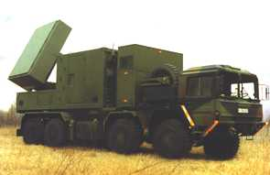  C band radar
Figure 23: Cohabitation synoptic of WIA and military radar

Configuration 2: Combination of 3 classes (manufacturing cell, factory hall, plant level)
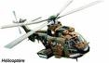
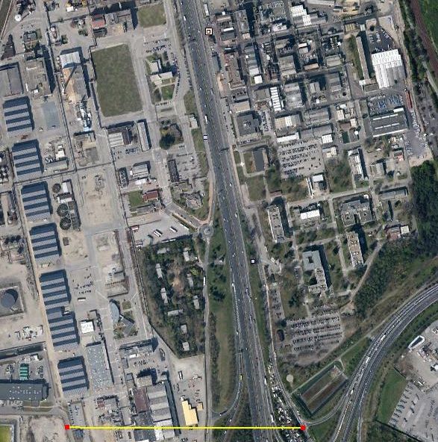
750m
500 m
example or industrial area | 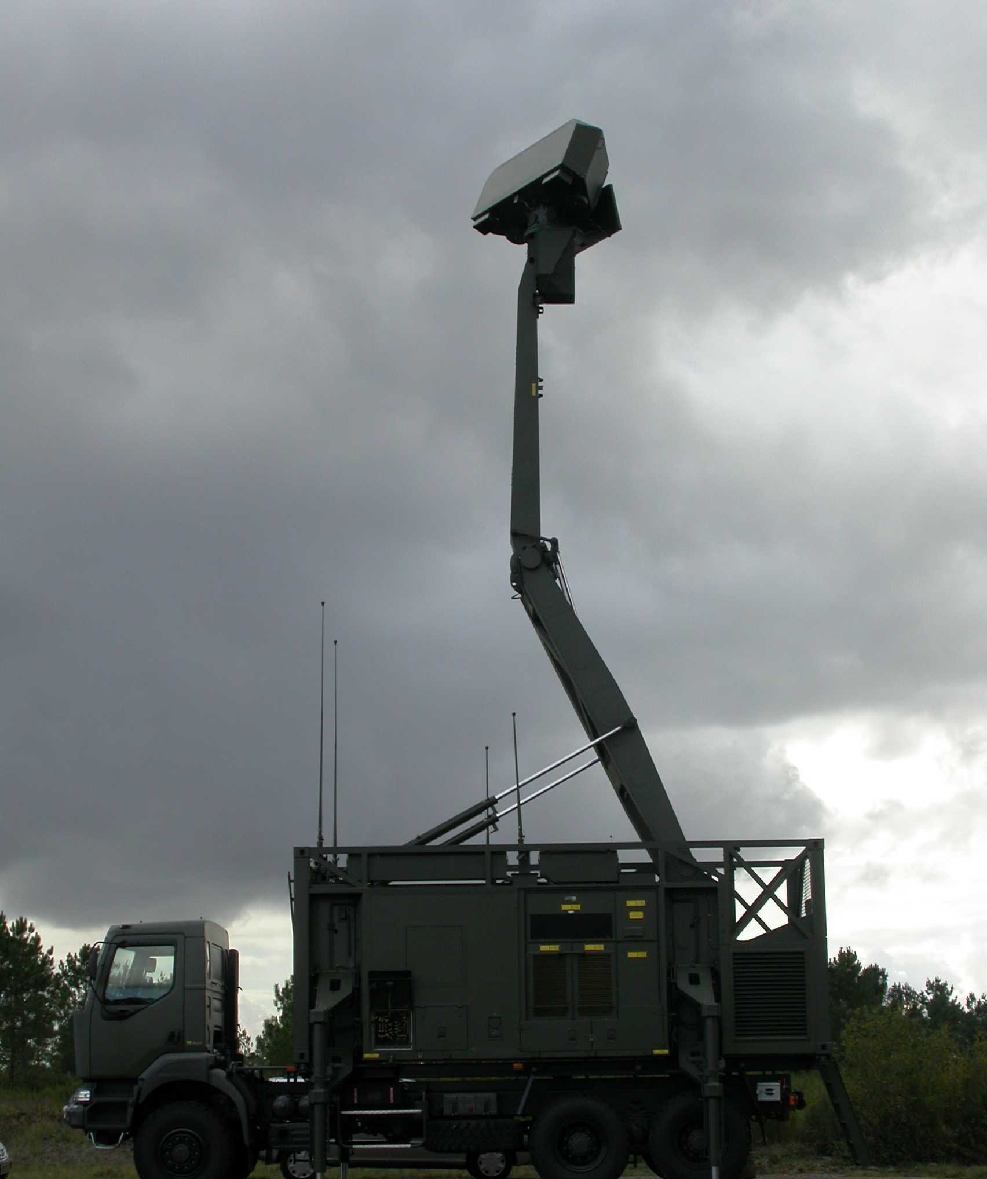
Figure 24: cohabitation synoptic of WIA in an industrial area and military radar
The number of WIA seen by a radar is function of the distance between radar and WIA location and the radar antenna beam width. An aproximative number of WIA seen by a radar (in the example above, i.e. in a particular azimuth) is given in the table below:
Table 27: Number of WIA seen by a radar [format table]
Antenna | Radar l | Radar M | Radar N | Radar O | Radar Q | Radar X Y | Radar Z
elevation beam width | 0.4 | 0.8 | 1.0 | 1.0 | 28.0 | N/A | 43.8
azimuthal beam width | 0.4 | 0.8 | 1.0 | 1.0 | 1.6 | N/A | 1.75
Aperture at 10km (A_1) | 70m | 140m | 174m | 174m | 280m |  | 305
A_1 x 750m | 0,05km² | 0,1km² | 0,12km² | 0,12km² | 0,21km² |  | 0,22km²
Number of devices | 50 | 105 | 127 | 127 | 210 |  | 228
Aperture at 20km (A_2) | 140m | 280m | 348m | 348m | 560m |  | 610
A_2 x 750m | 0,1km² | 0,21km² | 0,25km² | 0,25km² | 0,42km² |  | 0,44km²
Number of devices | 100 | 210 | 254 | 254 | 420 |  | 456

In this example, number of devices seen by a radar is bounded by 50 and 456.

Results

WIA in configuration 1
In the first configuration,, this case is based on a point-to-point link budget on a cochannel frequency basis between only one device and a radar. It is assumed that at least one transmitter uses the same frequency than radar.

Necessary Attenuation Loss = EIRP_WIA + Gant_rad – 10 x log(BW_WIA/BW_rad) – Ic

WIA (Indoor) interference into radar receiver

EIRP_WIA = 26dBm -10dB = 16dBm
Table 29: WIA indoor link budget [format table]
 |  | Radar Q | Radar X & Y | Radar Z
Necessary Attenuation Loss | WIA 1 (1MHz) | 154dB | 160dB | 161,5dB
Necessary Attenuation Loss | WIA 2 (2MHz) | 154dB | 160dB | 158,5dB
Necessary Attenuation Loss | WIA 3 (20MHz) | 151,5dB | 154dB | 148,5dB
Separation Distance | WIA 1 (1MHz) | 204km | 408km | 490km
Separation Distance | WIA 2 (2MHz) | 204km | 408km | 343km
Separation Distance | WIA 3 (20MHz) | 153km | 204km | 109km
Table 4:
WIA (Outdoor) interference into radar receiver
EIRP_WIA = 26dBm

Table 29: WIA outdoor link budget [format table]

 |  | Radar Q | Radar X & Y | Radar Z
Necessary Attenuation Loss | WIA 1 (1MHz) | 164dB | 170dB | 171,5dB
Necessary Attenuation Loss | WIA 2 (2MHz) | 164dB | 170dB | 168,5dB
Necessary Attenuation Loss | WIA 3 (20MHz) | 161,5B | 164dB | 158,5dB
Separation Distance | WIA 1 (1MHz) | 652km | 1300km | 1540km
Separation Distance | WIA 2 (2MHz) | 652km | 1300km | 1540km
Separation Distance | WIA 3 (20MHz) | 490km | 652km | 346km

In these two cases (§ 3.1.1 and 3.1.2), several devices can transmit in the same time:
In the first case, up to 10 cells with 50 devices per cell can be used,
In the second case up to 5 parallel networks with 100 devices per cell in the second case can be used.
However only one WIA device is taken into account in the calculation, because there are no sufficient details about “intelligent sharing mechanism” (§2 overview of industrial applications using technologies different from UWB).

WIA in configuration 2
In this second configuration, 2 cases of cohabitation are studied:

Radar on a fixed frequency
One WIA manufacturing cell, one factory hall, and one Plant level.
This case can be considered as studied in §3.1, if it is assumed that only one device transmit on radar frequency.
As written in the draft report, “the aggregate interference effects will not increase”.
This statement has to be justified, for example when several hundreds devices are used. The number of devices on the same frequency has to be identified, in order to calculate the corresponding aggregate level.

Radar on a hopping mode
In §3.2 of draft ECC report, it is written, the aggregate interference effects will not increase, eirp is equal all over the spectrum and time.
That means all channels in the 5725-5850MHz band will be occupied, and a radar in a hopping mode will not find one available channel in this part of its frequency band. A calculation to evaluate the collision probability, between the WIA in a frequency agility mode and a radar in a hopping mode is necessary to confirm that radar receiver will see WIA signal(s) in each of its channel.

Step 3
DFS consideration (taken from ECC Report 110:
SEAMCAT simulations

DFS consideration

This section provides the methodology based on link budget analysis, that is used for the determination of the DFS detection threshold to protect radars. Such a methodology has been used to determine DFS detection thresholds for RLAN and BFWA at 5 GHz and is also considered in this report for the BBDR detection threshold.

The threshold is determined from two link budget analyses, (1) and (2) whose description is provided below. This is based on the assumption of a symmetrical propagation path between the interfering system with DFS (this system is quoted as Int in this Annex, it can be either BBDR, BFWA or RLAN) and the radar (RL) and also that the transmitter and receiver bandwidths of the radar are the same:
(1): The link budget gives the propagation losses PL to limit the interference level coming from the interfering system Int towards the radar receiver below the noise level minus 6dB (I/N=-6dB). Let d be the separation distance.
(2): The link budget gives the propagation losses PL to allow the interferer Int to detect at the distance d the presence of a radar. Therefore, the interference level coming from the radar towards the receiver of the Int system will be used as the detection threshold at the antenna connector (Th).

Note that:
: spectral density of the interferer (dBm/MHz)
: Antenna gain of the interferer
: Bandwidth of the interferer
: power of the interferer (dBm)

: Ambient noise (dBm/MHz) with noise temperature of T=290°K,
a reference bandwidth B_{o}=1 MHz and F the noise figure in dB
the maximum allowable level of interference on the RL

: spectral desity of the radar (dBm/MHz)
: Antenna gain of the radar
: Bandwidth of the radar
: power of the radar (dBm)

: Detection threshold at the antenna connector (dBm/MHz)
: Detection threshold at the antenna connector (dBm) in the bandwidth of the interferer

PL: Propagation losses

If B_{Int}>B_{Radar}
(1)
(2)
=>

If BInt<BRadar
(1)
(2)
=>
Finally, these calculations lead to the same formula
in dBm over the bandwidth of the interferer

Note: The ECC Report 68 indicated that an appropriate detection threshold Th_{FWA} should be -69dBm (close to -67.18dBm which can be calculated using this method) over the BFWA bandwidth.

Calculations for WIA, applying the same equations as for FWA give the following results.
Table 29: DFS threshold WIA – 1 MHz [table format]
Characteristics of the Radars | L | M | N | O | Q | X & Y | Z
Tx power into antenna peak (kW) | 2800 | 1200 | 1000 | 165 | 285 | 12 | 70
Tx power into antenna peak (dBm) | 94,47 | 90,79 | 90,00 | 82,17 | 84,55 | 70,79 | 78,45
Radar bandwidth (MHz) | 4,8 | 4 | 8 | 8 | 10 | 4 | 1
Noise figure (dB) | 7 | 4 | 2,3 | 3 | 3 | 5 | 13
Characteristics of a WIA device
WIA e.i.r.p (dBm) outdoor | 26 | 26 | 26 | 26 | 26 | 26 | 26
Bandwith (MHz) | 1 | 1 | 1 | 1 | 1 | 1 | 1
Antenna gain (dBi) | 0 | 0 | 0 | 0 | 0 | 0 | 0
WIA spectral density power (dBm/MHz) at the antenna connector | 22,99 | 22,99 | 22,99 | 22,99 | 22,99 | 22,99 | 22,99
Characteristics of the DFS | L | M | N | O | Q | X & Y | Z
Noise level (dBm/MHz) | -106,98 | -109,98 | -111,68 | -110,98 | -110,98 | -108,98 | -100,98
DFS Detection threshold Th (dBm) | -44,51 | -51,19 | -53,68 | -60,80 | -58,43 | -70,19 | -54,53

Table 30: DFS threshold WIA – 3 MHz [format table]
Characteristics of the Radars | L | M | N | O | Q | X & Y | Z
Tx power into antenna peak (kW) | 2800 | 1200 | 1000 | 165 | 285 | 12 | 70
Tx power into antenna peak (dBm) | 94,47 | 90,79 | 90,00 | 82,17 | 84,55 | 70,79 | 78,45
Radar bandwidth (MHz) | 4,8 | 4 | 8 | 8 | 10 | 4 | 1
Noise figure (dB) | 7 | 4 | 2,3 | 3 | 3 | 5 | 13
Characteristics of a BFWA device
WIA e.i.r.p (dBm) outdoor | 26 | 26 | 26 | 26 | 26 | 26 | 26
Bandwith (MHz) | 3 | 3 | 3 | 3 | 3 | 3 | 3
Antenna gain (dBi) | 0 | 0 | 0 | 0 | 0 | 0 | 0
WIA spectral density power (dBm/MHz) at the antenna connector | 22,99 | 22,99 | 22,99 | 22,99 | 22,99 | 22,99 | 22,99
Characteristics of the DFS | L | M | N | O | Q | X & Y | Z
Noise level (dBm/MHz) | -106,98 | -109,98 | -111,68 | -110,98 | -110,98 | -108,98 | -100,98
DFS Detection threshold Th (dBm) | -39,73 | -46,41 | -48,91 | -56,03 | -53,66 | -65,41 | -49,76

Table 31: DFS threshold WIA – 20 MHz [table format]
Characteristics of the Radars | L | M | N | O | Q | X & Y | Z
Tx power into antenna peak (kW) | 2800 | 1200 | 1000 | 165 | 285 | 12 | 70
Tx power into antenna peak (dBm) | 94,47 | 90,79 | 90,00 | 82,17 | 84,55 | 70,79 | 78,45
Radar bandwidth (MHz) | 4,8 | 4 | 8 | 8 | 10 | 4 | 1
Noise figure (dB) | 7 | 4 | 2,3 | 3 | 3 | 5 | 13
Characteristics of a WIA device
WIA e.i.r.p (dBm) outdoor | 26 | 26 | 26 | 26 | 26 | 26 | 26
Bandwith (MHz) | 20 | 20 | 20 | 20 | 20 | 20 | 20
Antenna gain (dBi) | 0 | 0 | 0 | 0 | 0 | 0 | 0
WIA spectral density power (dBm/MHz) at the antenna connector | 22,99 | 22,99 | 22,99 | 22,99 | 22,99 | 22,99 | 22,99
Characteristics of the DFS | L | M | N | O | Q | X & Y | Z
Noise level (dBm/MHz) | -106,98 | -109,98 | -111,68 | -110,98 | -110,98 | -108,98 | -100,98
DFS Detection threshold Th (dBm) | -31,50 | -38,18 | -40,67 | -47,79 | -45,42 | -57,18 | -41,52

Same level for the DFS threshold for indoor case and outdoor case if:
- The wall attenuation is compensated on the two paths.
- Scenarios: outdoor device linked with indoor device are not considered (note: it is not planned but can not be completely excluded…)
- Check the EN to check the characteristics which are used in the standard
- Mostly mobile radar systems. Fixed radar systems, but limited.

The use of mitigation techniques as a method to enable sharing between Radiolocation service and WIA systems in the 5.8 GHz band
To be done:
Indoor/Outdoor use
Mitigation techniques: Dynamic frequency selection (DFS); Listen before talk (LBT), Adaptive frequency hopping (AFH);

Conclusion
It can be concluded that an indoor use or mitigation techniques are required to enable the sharing between WIA systems and radars.
It is assumed that the indoor outdoor wall loss is 15 dB as in ECC Report 101 [9] . Therefore the WIA systems for an industrial environment with a transmitter maximum e.i.r.p. of 400 mW are complied with the limit values of generic use SRD as defined in [10].

Road Transport and Traffic Telematics (RTTT) Systems
WIA and RTTT systems can operate on the same channel, therefore coexistence problems can be expected at both sites.

[note: we also need to cover the situation when the mobile unit of the RTTT system is entering in a factory]

The following propagation model is used in this section:

The calculations developed in the different compatibility studies used the same propagation model as in ECC Report 68.
$$L_{FS}=\left\{\begin{matrix}20log⁡\left(\frac{λ}{4πd}\right) & d≤d_{0} \\ 20\log\left(\frac{λ}{4πd_{0}}\right)-10n_{0}log\left(\frac{d}{d_{0}}\right) & d_{0}≤d≤d_{1} \\ 20\log\left(\frac{λ}{4πd_{0}}\right)-10n_{0}log\left(\frac{d_{1}}{d_{0}}\right)-10n_{1}log\left(\frac{d}{d_{0}}\right) & d>d_{1}\end{matrix}\right.$$

Another propagation model is also proposed in the ITS SRdoc ETSI TR 102 492-1 [2] [3]. Assumptions are a first breakpoint distance do at 15 m and exponent beyond n_{o}=2.7 separation distances presented below will investigate both cases.
Table 34: Parameters of propagation
 | Urban | Suburban | Rural | ETSI
Breakpoint distance d₀ (m) | 64 | 128 | 256 | 15
Pathloss factor n₀ beyond the first break point | 3.8 | 3.3 | 2.8 | 2.7
Breakpoint distance d₁ (m) | 128 | 256 | 1024 | 1024
Pathloss factor n₁ beyond the first break point | 4.3 | 3.8 | 3.3 | 2.7

This section provides results of calculation for the separation distances to protect SRD in the band 5725 to 5875 MHz from WIA. The characteristics of SRD systems are provided in section 4.7.1. The WIA characteristics are provided in section 3.

Compatibility between interferer WIA (indoor) and victim RTTT
The compatibility between interferer WIA (indoor) with 1 MHz bandwidth and the victim RTTT RSU is listed in Table 2. The final result of compatibility consideration is a required separation distance between interferer WIA an victim RTTT.
Table 35: Interferer WIA I bandwidth 1 MHz, victim RTTT RSU (format)
LINK BUDGET | Value | Units | Urban | Suburban | Rural | ETSI
Emission part: WIA-I: 1 MHz
Bandwidth | 1 | MHz
Tx out, eirp | 26 | dBm | 26 | 26 | 26 | 26
effect of TPC (dB) | 0 | dB | 0 | 0 | 0 | 0
Wall loss | 15 | dB | -15 | -15 | -15 | -15
Antenna Gain | 0 | dBi
Bandwidth correction factor (I_{tBW} > V_{rBW}) | 3 | dB | -3 | -3 | -3 | -3
Net Tx Out eirp (spurious level) |  | dBm/MHz | 8 | 8 | 8 | 8
Reception part: RSU RTTT
Receiver bandwidth | 0,5 | MHz | 0,5 | 0,5 | 0,5 | 0,5
Receiver sensitivity | -104 | dBm | -104 | -104 | -104 | -104
Antenna gain | 10 | dBi | 10 | 10 | 10 | 10
C min per MHz at antenna input |  | dBm/MHz | -114 | -114 | -114 | -114
Protection criterion
Criterion C/I | 6 | dB | 6 | 6 | 6 | 6
Allowable Interfering power level 'I' at receiver antenna input |  | dBm/MHz | -117 | -117 | -117 | -117
MAIN LOBE WIA - MAIN LOBE RTTT
Separation distance WIA RTTT |  | M | 618 | 1157 | 2358 | 1432
MAIN LOBE WIA - SIDE LOBE RTTT
Sidelobe attenuation (dB) | 20 | dB | 20 | 20 | 20 | 20
Separation distance WIA RTTT |  | M | 212 | 344 | 528 | 260

The compatibility consideration between interferer WIA (indoor) with 20 MHz bandwidth and the victim RTTT RSU is listed in Table 4.

Table 36: Interferer WIA III bandwidth 20 MHz, victim RTTT RSU (format table)
LINK BUDGET | Value | Units | Urban | Suburban | Rural | ETSI
Emission part: WIA III 20 MHz
Bandwidth | 20 | MHz
Tx out, eirp | 26 | dBm | 26 | 26 | 26 | 26
effect of TPC | 0 | dB
Wall loss | 15 | dB | -15 | -15 | -15 | -15
Antenna Gain | 0 | dBi
Bandwidth correction factor (ItBW > VrBW) | 16 | dB | -16 | -16 | -16 | -16
Net Tx Out eirp (spurious level) |  | dBm/MHz | -5 | -5 | -5 | -5
Reception part: RSU RTTT
Receiver bandwidth | 0,5 | MHz | 0,5 | 0,5 | 0,5 | 0,5
Receiver sensitivity | -104 | dBm | -104 | -104 | -104 | -104
Antenna gain | 10 | dBi | 10 | 10 | 10 | 10
C min per MHz at antenna input |  | dBm/MHz | -111 | -111 | -111 | -111
Protection criterion
Criterion C/I | 6 | dB | 6 | 6 | 6 | 6
Allowable Interfering power level 'I' at receiver antenna input |  | dBm/MHz | -117 | -117 | -117 | -117
MAIN LOBE WIA - MAIN LOBE RTTT
Separation distance WIA RTTT |  | M | 308 | 526 | 939 | 472
MAIN LOBE WIA - SIDE LOBE RTTT
Sidelobe attenuation RTTT | 20 | dB | 20 | 20 | 20 | 20
Separation distance WIA RTTT |  | M | 103 | 145 | 181 | 86

COMPATIBILITY BETWEEN interferer RTTT and victim WIA (indoor)
The compatibility consideration between interferer RTTT RSU (outdoor) and the victim WIA (indoor) with 1 MHz bandwidth is listed in Table 5.

Table 37: Interferer RTTT RSU; victim WIA I bandwidth 1 MHz (format table)
LINK BUDGET | Value | Units | Urban | Suburban | Rural | ETSI
Emission part: RTTT RSU
Bandwidth | 1 | MHz
Tx out, eirp | 33 | dBm | 33 | 33 | 33 | 33
effect of TPC (dB) | 0 | dB
Wall loss | 15 | dB | -15 | -15 | -15 | -15
Antenna Gain | 0 | dBi
Bandwidth correction factor (ItBW > VrBW) | 0 | dB
Net Tx Out eirp (spurious level) |  | dBm/MHz | 18 | 18 | 18 | 18
Reception part: WIA 1
Receiver bandwidth | 1 | MHz | 1 | 1 | 1 | 1
Receiver sensitivity | -82 | dBm | -82 | -82 | 82 | -82
Antenna gain | 0 | dBi | 0 | 0 | 0 | 0
C min per MHz at antenna input |  | dBm/MHz | -82 | -82 | -82 | -82
Protection criterion
Criterion C/I | 6 | dB | 6 | 6 | 6 | 6
Allowable Interfering power level 'I' at receiver antenna input |  | dBm/MHz | -88 | -88 | -88 | -88
MAIN LOBE RTTT - MAIN LOBE WIA I
Separation distance RTTT WIA |  | m | 224 | 366 | 575 | 284
SIDE LOBE RTTT - MAIN LOBE WIA I
Sidelobe attenuation (dB) | 20 | dB | 20 | 20 | 20 | 20
Separation distance RTTT WIA |  | m | 72 | 96 | 111 | 52

The compatibility consideration between interferer RTTT RSU (outdoor) and the victim WIA (indoor) with 20 MHz bandwidth is listed in Table 7.

Table 38: Interferer: RTTT RSU; Victim: WIA III bandwidth 20 MHz (format table)
LINK BUDGET | Value | Units | Urban | Suburban | Rural | ETSI
Emission part: WIA I 1 MHz
Bandwidth | 1 | MHz
Tx out, eirp | 33 | dBm | 33 | 33 | 33 | 33
effect of TPC | 0 | dB
Wall loss | 15 | dB | -15 | -15 | -15 | -15
Antenna Gain | 0 | dBi
Bandwidth correction factor (ItBW > VrBW) | 0 | dB
Net Tx Out eirp (spurious level) |  | dBm/MHz | 18 | 18 | 18 | 18
Reception part: RSU RTTT
Receiver bandwidth | 20 | MHz | 20 | 20 | 20 | 20
Receiver sensitivity | -88 | dBm | -88 | -88 | -88 | -88
Antenna gain | 0 | dBi
C min per MHz at antenna input |  | dBm/MHz | -101 | -101 | -101 | -101
Protection criterion
Criterion C/I | 6 | dB | 6 | 6 | 6 | 6
Allowable Interfering power level 'I' at receiver antenna input |  | dBm/MHz | -107 | -107 | -107 | -107
MAIN LOBE WIA - MAIN LOBE RTTT
Separation distance WIA RTTT |  | m | 619 | 1159 | 2363 | 1435
MAIN LOBE WIA - SIDE LOBE RTTT
Sidelobe attenuation RTTT | 20 | dB | 20 | 20 | 20 | 20
Separation distance WIA RTTT |  | m | 212 | 345 | 530 | 261

COMPATIBILITY BETWEEN interferer WIA (outdoor) and victim RTTT
The compatibility consideration between interferer WIA (outdoor) with 3 MHz and the victim RTTT RSU (outdoor) is listed in Table 8.

Table 39: Interferer WIA II bandwidth 3 MHz, victim RTTT RSU (format table)
LINK BUDGET | Value | Units | Urban | Suburban | Rural | ETSI
Emission part: WIA I 1 MHz
Bandwidth | 3 | MHz
Tx out, eirp | 26 | dBm | 26 | 26 | 26 | 26
effect of TPC | 0 | dB
Wall loss | 0 | dB
Antenna Gain | 0 | dBi
Bandwidth correction factor (I_{tBW} > V_{rBW}) | -10 | dB | -10 | -10 | -10 | -10
Net Tx Out eirp (spurious level) |  | dBm/MHz | 18 | 18 | 18 | 18
Reception part: RSU RTTT
Receiver bandwidth | 0,5 | MHz | 0,5 | 0,5 | 0,5 | 0,5
Receiver sensitivity | -104 | dBm | -104 | -104 | -104 | -104
Antenna gain | 10 | dBi | 10 | 10 | 10 | 10
C min per MHz at antenna input |  | dBm/MHz | -111 | -111 | -111 | -111
Protection criterion
Criterion C/I | 6 | dB | 6 | 6 | 6 | 6
Allowable Interfering power level 'I' at receiver antenna input |  | dBm/MHz | -117 | -117 | -117 | -117
MAIN LOBE WIA - MAIN LOBE RTTT
Separation distance WIA RTTT |  | m | 1069 | 2151 | 4813 | 3425
MAIN LOBE WIA - SIDE LOBE RTTT
Sidelobe attenuation RTTT | 20 | dB | 20 | 20 | 20 | 20
Separation distance WIA RTTT |  | m | 366 | 640 | 1192 | 622

The compatibility consideration between interferer WIA (outdoor) with 20 MHz and the victim RTTT RSU (outdoor) is listed in Table 9.

Table 40: Interferer WIA III bandwidth 20 MHz, victim RTTT RSU (format table)
LINK BUDGET | Value | Units | Urban | Suburban | Rural | ETSI
Emission part: WIA III 20 MHz
Bandwidth | 20 | MHz
Tx out, eirp | 26 | dBm | 26 | 26 | 26 | 26
effect of TPC | 0 | dB
Wall loss | 0 | dB
Antenna Gain | 0 | dBi
Bandwidth correction factor (I_{tBW} > V_{rBW}) | -16 | dB | -16 | -16 | -16 | -16
Net Tx Out eirp (spurious level) |  | dBm/MHz | 10 | 10 | 10 | 10
Reception part: RSU RTTT
Receiver bandwidth | 0,5 | MHz | 0,5 | 0,5 | 0,5 | 0,5
Receiver sensitivity | -104 | dBm | -104 | -104 | -104 | -104
Antenna gain | 10 | dBi | 10 | 10 | 10 | 10
C min per MHz at antenna input |  | dBm/MHz | -111 | -111 | -111 | -111
Protection criterion
Criterion C/I | 6 | dB | 6 | 6 | 6 | 6
Allowable Interfering power level 'I' at receiver antenna input |  | dBm/MHz | -117 | -117 | -117 | -117
MAIN LOBE WIA - MAIN LOBE RTTT
Separation distance WIA RTTT |  | m | 688 | 1305 | 2709 | 1696
MAIN LOBE WIA - SIDE LOBE RTTT
Sidelobe attenuation RTTT | 20 | dB | 20 | 20 | 20 | 20
Separation distance WIA RTTT |  | m | 236 | 389 | 622 | 308

Compatibility between interferer RTTT and victim WIA (outdoor)
The compatibility consideration between interferer RTTT RSU (outdoor) and the victim WIA (outdoor) with 3 MHz is listed in Table 10.

Table 41: Interferer RTTT RSU; victim WIA II bandwidth 3 MHz (format table)
LINK BUDGET | Value | Units | Urban | Suburban | Rural | ETSI
Emission part: RTTT RSU
Bandwidth | 1 | MHz
Tx out, eirp | 33 | dBm | 33 | 33 | 33 | 33
effect of TPC (dB) | 0 | dB
Wall loss | 0 | dB
Antenna Gain | 0 | dBi
WIA Bandwidth / RTTT Bandwidth ratio | 0 | dB
Net Tx Out eirp (spurious level) |  | dBm/MHz | 33 | 33 | 33 | 33
Reception part: WIA 1
Receiver bandwidth | 3 | MHz | 3 | 3 | 3 | 3
Receiver sensitivity | -92 | dBm | -92 | -92 | -92 | -92
Antenna gain | 0 | dBi
C min per MHz at antenna input |  | dBm/MHz | -97 | -97 | -97 | -97
Protection criterion
Criterion C/I | 6 | dB | 6 | 6 | 6 | 6
Allowable Interfering power level 'I' at receiver antenna input |  | dBm/MHz | -103 | -103 | -103 | -103
MAIN LOBE RTTT - MAIN LOBE WIA
Separation distance RTTT WIA |  | m | 1102 | 2225 | 5006 | 3594
SIDE LOBE RTTT - MAIN LOBE WIA
Sidelobe attenuation (dB) | 20 | dB | 20 | 20 | 20 | 20
Separation distance RTTT->ITS |  | m | 378 | 662 | 1240 | 653

The compatibility consideration between interferer RTTT RSU (outdoor) and the victim WIA (outdoor) with 20 MHz is listed in Table 11.

Table 42: Interferer RTTT RSU; victim WIA II bandwidth 20 MHz (format table)
LINK BUDGET | Value | Units | Urban | Suburban | Rural | ETSI
Emission part: RTTT RSU
Bandwidth | 1 | MHz
Tx out, eirp | 33 | dBm | 33 | 33 | 33 | 33
effect of TPC (dB) | 0 | dB
Wall loss | 0 | dB
Antenna Gain | 0 | dBi
WIA Bandwidth / RTTT Bandwidth ratio | 0 | dB
Net Tx Out eirp (spurious level) |  | dBm/MHz | 33 | 33 | 33 | 33
Reception part: WIA 1
Receiver bandwidth | 20 | MHz | 20 | 20 | 20 | 20
Receiver sensitivity | -88 | dBm | -88 | -88 | -88 | -88
Antenna gain | 0 | dBi | 0 | 0 | 0 | 0
C min per MHz at antenna input |  | dBm/MHz | -101 | -101 | -101 | -101
Protection criterion
Criterion C/I | 6 | dB | 6 | 6 | 6 | 6
Allowable Interfering power level 'I' at receiver antenna input |  | dBm/MHz | -107 | -107 | -107 | -107
MAIN LOBE RTTT - MAIN LOBE WIA
Separation distance RTTT WIA |  | m | 1383 | 2877 | 6729 | 5159
SIDE LOBE RTTT - MAIN LOBE WIA
Sidelobe attenuation (dB) | 20 | dB | 20 | 20 | 20 | 20
Separation distance RTTT WIA |  | m | 474 | 856 | 1667 | 937

Conclusions

Conclusion for interferer WIA and victim RTTT
The antenna main beam of RTTT RSU is directed to the lane (show Figure 5). Therefor only the RTTT side loop is consider for coexistence between WIA and RTTT.
Figure 23: Sharing RSU on the road
The protection of RTTT receivers can be achieved with a maximum separation distances of 528 metres with respect to WIA systems operating indoor with 1 MHz bandwidth. The separation distance is much smaller than 528 meters for all other indoor WIA systems 357 m for WIA with 3 MHz bandwidth and 181 m for WIA with 20 MHz bandwidth. The detailed values are listed in Table 11.

Table 43: Required separation distance interferer WIA (indoor) and victim RTTT RSU (format table)
 | Units | Urban | Suburban | Rural | ETSI
WIA I --> RTTT main loop | m | 618 | 1157 | 2358 | 1432
WIA III --> RTTT main loop | m | 308 | 526 | 939 | 472
WIA I --> RTTT side loop | m | 212 | 344 | 528 | 260
WIA III --> RTTT side loop | m | 103 | 145 | 181 | 86

For outdoor WIA applications is the required separation distance to RTTT receiver much high. The maximum required separation distance between RTTT and WIA system with 3 MHz bandwidth is 828 m. Even for the WIA systems with 20 MHz bandwidth, a separation distance of 622 m is required.

Table 44: Required separation distance interferer WIA (outdoor) and victim RTTT RSU (format table)
 | Units | Urban | Suburban | Rural | ETSI
WIA II --> RTTT main loop | m | 828 | 1611 | 3450 | 2280
WIA III --> RTTT main loop | m | 688 | 1305 | 2709 | 1696
WIA II --> RTTT side loop | m | 284 | 479 | 828 | 414
WIA III --> RTTT side loop | m | 236 | 389 | 622 | 308

Conclusion for interferer RTTT (RSU) and victim WIA
The RTTT system has also an influence on all WIA systems. The separation distance amounts 111 m for indoor WIA systems with 1 MHz bandwidth, 374 m for indoor WIA systems with 3 MHz bandwidth and 530 m for WIA systems with 20 MHz bandwidth. The detailed values depicted in Table 13.
Table 45: Required separation distance interferer RTTT RSU and victim WIA (indoor) (format table)
 | Units | Urban | Suburban | Rural | ETSI
RTTT main loop --> WIA I | m | 224 | 366 | 575 | 284
RTTT main loop --> WIA III | m | 619 | 1159 | 2363 | 1435
RTTT side loop --> WIA I | m | 72 | 96 | 111 | 52
RTTT side loop --> WIA III | m | 212 | 345 | 530 | 261

The influence from RTTT to outdoor WIA systems is much higher, because there is no positive wall attenuation. The required separation distance between interferer RTTT RSU side loop and outdoor WIA with 3 MHz bandwidth is between 378 m and 1240 m depending on propagation model. The required separation distance between interferer RTTT RSU and outdoor WIA with 20 MHz bandwidth is between 474 m and 1667 m depending on propagation model.

Table 46: Required separation distance interferer RTTT RSU and victim WIA (outdoor) (format table)
 | Units | Urban | Suburban | Rural | ETSI
RTTT main loop --> WIA II | m | 1102 | 2225 | 5006 | 3594
RTTT main loop --> WIA III | m | 1383 | 2877 | 6729 | 5159
RTTT side loop --> WIA II | m | 378 | 662 | 1240 | 653
RTTT side loop --> WIA III | m | 474 | 856 | 1667 | 937

The final results of required separation distance shown that RTTT and WIA systems interact at same dimension. The installation and long-life operation of industrial wireless communication networks require a coexistence management according to “IEC/TS 62657-2 Industrial communication networks – Wireless communication network - Part 2: Coexistence management” [ref]. This means that the frequency band of WIA systems must check for potential interferer. If a interferer (e.g. RTTT) is detected, the occupied/interferer frequency band can’t use for WIA real-time applications.
[note: if the reference to the IEC is kept, a reference to the appropriate section should be inserted alternatively, the relevant process considered in the IEC document could be described in the current document.]

BFWA
The technical parameters of the WIA systems used in this study are summarised in Table 2.

Table 47: BFWA system parameters (format table)
Parameter | WIA parameter
Channel bandwidth | 1MHz, 3 MHz, 20 MHz
Duplex/
Access scheme
Max Tx power dBm (conducted) | 21 dBm
Antenna | Dipol 5dBi  See Figure 6
TX mask | See Annex 2
Antenna height Tx and Rx | 0.5 to 5 m
Link lenght | 5 to 100m
Path loss model used in SEAMCAT | IEEE plugin (Model_C_IEEE_802_11_rev2)  see Annex 1

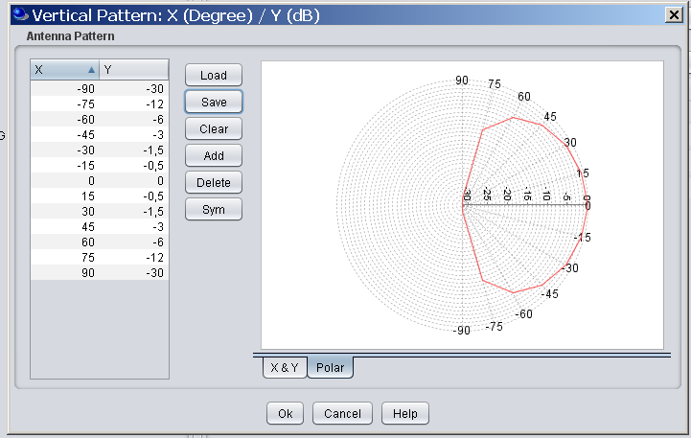
Figure 24: dipol antenna (5dBi), vertical antenna pattern WIA (horizontal pattern omni)

MCL calculations
Table 3 shows required separation distances based on the parameters provided in the previous sections.

Table 48: MCL calculations (format table)

The obvious consequence is that under worst case conditions (Free Space loss) the BFWA link can be affected within a radius around the WIA between 3 and 10 km. This situation is much less critical in urban environments. This scenario will be further analysed in the following sections.

Sensing procedure

In this section the requirements forWIA systems (Interfering transmitter IT, transmitting to its wanted receiver WR) to detect BFWA systems (Wanted transmitter WT transmitting to the victim receiver VR) is analysed. IT is able to monitor the WT, which is the basis for the sensing mechanism which is called LBT in this section.

The following abbreviations and definitions are valid in this annex:
- Dimensions: r/m, P/dBm, S/dBm, SIR/dB, f/GHz, All antennas 0dBi
- VR Victim receiver (BFWA)
  - N: Noise floor kTBF of VR (-95 dBm/20MHz)
  - F: Noise figure of VR, (BFWA 6 dB)
  - S: Signal strength received at the VR from WT (Pwt)
  - SNR: signal to noise ratio, or C/N at VR
  - SIRmin: Signal to interference ratio, or C/I at VR (27 dB)
  - WT Wanted transmitter (victim link, BFWA)
  - Pwt Transmit power of WT (CS) (BFWA 14 dBm)
  - Gs Antenna gain WT (22 dBi)
- IT Interfering Transmitter (WIA)
  - Pit Transmit power of IT (SRD 21 dBm)
  - Antenna gain IT 5dBi
  - WR Wanted receiver (Interfering Link)
  - Plbt: LBT power received at WR from WT (Pwt)
  - Pthr: power threshold for the LBT mechanism at IT
- I: Interfering power at VR,
- n: Path loss exponent n (e.g. n=2 free space loss)
- Rint: radius around VR; inside interference can occur (S-I<SIRmin)
- Rsig: radius around VR; inside the victim link works wit S-N<SNRmin
- Rdet: radius around WT; inside the IT can detect the WT
- Wall: wall attenuation dB

The following figure explains the investigated scenario. Within a radius of Rint around the VR the IT can exceed the protection objective of the VR (e.g. C/I). Within a radius of Rdet around the WT the IT can detect the WT (Threshold is exceeded).
In the light blue area in the following figure 7 LBT is working effectively. The red area is the so called “hidden node”, where the IT is not able to detect the WT.

Figure 25: Title?

The situation is simplified because each BFWA station is assumed to transmit and receive simultaneously (TDD).

Figure 28: Illustration of the scenario

The formulas given hereafter are the basis for the analysis.

Signal strength at the BFWA receiver:
S (at VR)= N + SNR = Pwt (BFWA)+ Gsbfwa+Gebfwa- PL(Rsig) (1)

The interference power at the BFWA receiver:
I (at VR)= S - SIRmin = Pit (SRD)+Gswia(p)+Gebfwa(p)-Wall- PL(Rint) (2)

The threshold power at the SRD:
Pthr (at SRD) = Pwt (BFWA)+Gsbfwa(p)+Gewia(p)-Wall- PL(Rdet) (3)

Path loss model:
PL = 32.5+10*n*log(R/m)+20*log(f/GHz) (4)

(1)+(4) -> 10n*log(Rsig) = Pwt+ Gsbfwa+Gebfwa -N-SNR-32.5-20logf (5)
(2)+(4) -> 10n*log(Rint) = Pit+ Gswia(p)+Gebfwa(p)-Wall-N-SNR+SIRmin-32.5-20logf (6)
(3)+(4) -> 10n*log(Rdet) = Pwt+ Gsbfwa(p)+Gewia(p)-Wall-Pthr-32.5-20logf (7)

Relation Rdet/Rint: (7)-(6) -> 10n*log(Rdet/Rint)=Pwt-Pit-Pthr+N+SNR-SIRmin (8)

Under the assumption Rdet=Rint the WI system should be perfectly able to detect the BFWA system and thus with formula (8) it follows:

. Pthr=Pwt-Pit+N+SNR-SIRmin (9)

Table 49 shows the required LBT threshold values using formula (9), with variable WIA bandwidth (1MHz, 3 MHz, 20 MHz) and 3 different SNR values (27dB, 37 dB, 47 dB).

Table 49: LBT threshold [table format]

In the above calculation it is assumed that all links having the same path loss model. For the case of a specific sensing antenna on top of the WIA plant, with better propagation conditions for the detection path (propagation exponent n2) the situation is more complicated and can not be reduced to a simple formula, but the situation can be improved

10n1*log(Rint) = Pit+ Gswia(p)+Gebfwa(p)-Wall-N-SNR+SIRmin-32.5-20logf (10)
10n2*log(Rdet) = Pwt+ Gsbfwa(p)+Gesensing- Pthr-32.5-20logf (11)

Table 50 shows the interference and detection ranges using the above formulas (10) and (11).
Table 50: Interference and detection ranges [table format]
Table 5: interference and detection range comparison

The calculations in Table 50 shows that a sensing antenna improves the situation because the detection distance is always higher as the interference distance; only for unrealistic combination of a outdoor WIA usage (0dB wall loss) and the same propagation conditions in the sensing and interfering path the advantages of a sensing antenna are disappearing. This issue will be analysed in more detail in the next section.

SEAMCAT simulations

In this section a probabilistic analysis is provided using the SEAMCAT tool (www.seamcat.org).

The IEEE plugin was used in SEAMCAT in order to be able to consider also an urban-like propagation model (Model_C_IEEE_802_11_rev2, Date 17/10/2012), see also Annex 1 and http://tractool.seamcat.org/wiki/Manual/PropagationModels/IEEE_802.11_Model_C_modified).
The following configuration was used in the simulations:
- Breakpoint distance 5m for urban environments
- Breakpoint distance 50m for suburban environments
- Breakpoint distance 500m for rural environments

It is assumed that mainly TDMA access techniques are used in this environment, that means the spectrum usage appears like one WIA device (1MHz, 3MHz and 20 MHz) being active at the same time on each WIA channel, but for 100% of time.
The BFWA Victim (20 MHz BW) sees either 1x 20 MHz WIA systems, or 6 x 3 MHz WIA or 20 x 1MHz WIA systems

The below figures are explaining the SEAMCAT scenario.
Figure 27: WIA spectrum utilisation
Figure 28: The SEAMCAT scenario

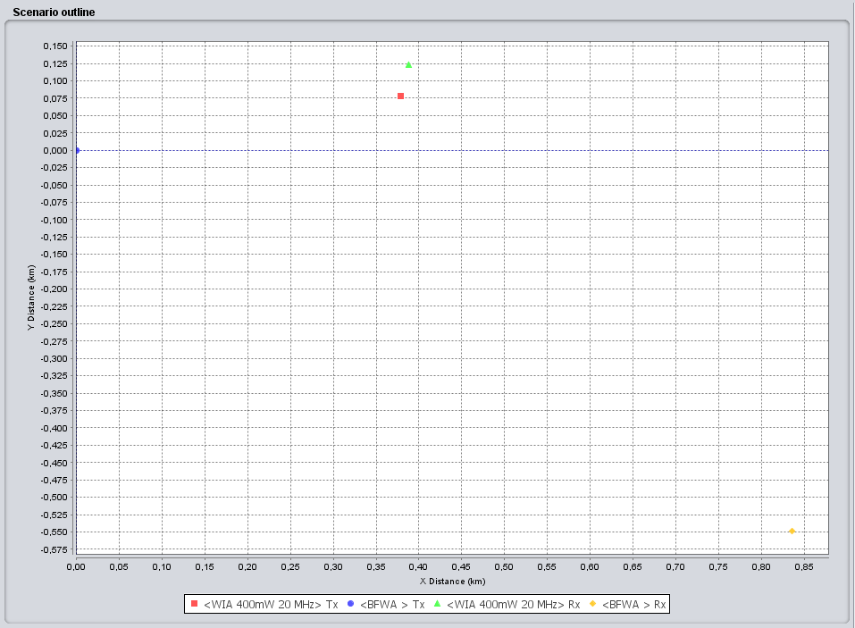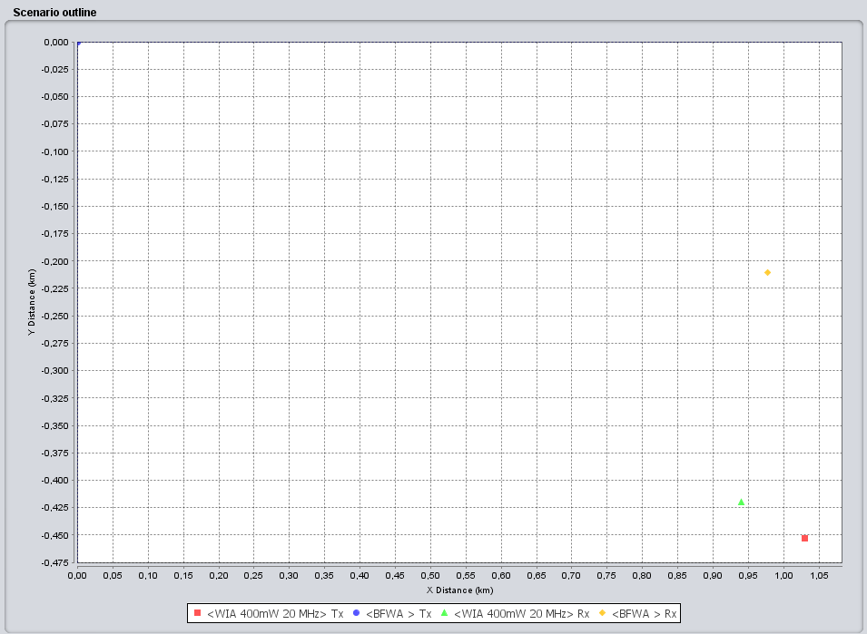
Interfering Link
Interfering Link
Wanted Link
Wanted Link

Figure 29: Two Snapshots from the SEAMCAT simulations

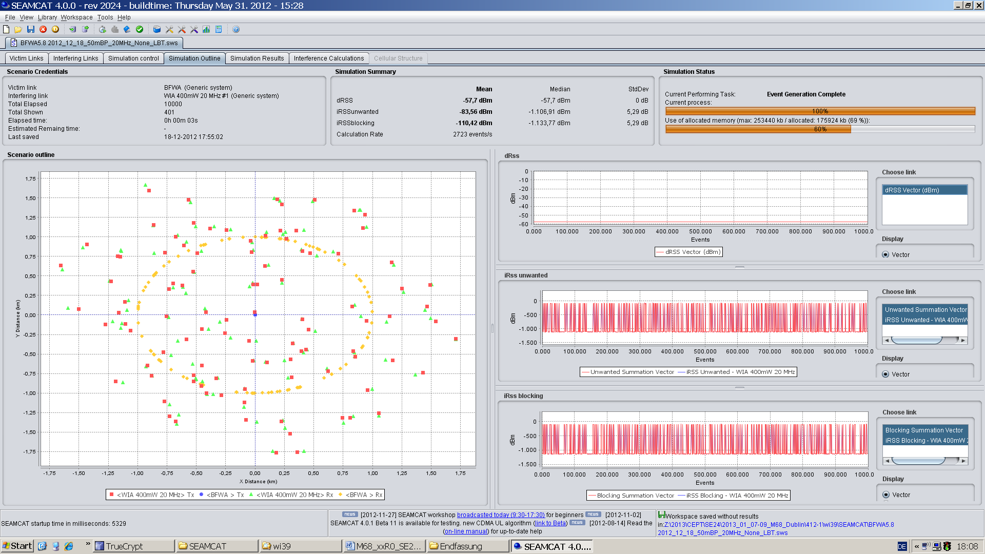
Figure 30: Scenario outline 20 MHz

WIA 20 MHz

Table 6 summarises the SEAMCAT simulations without any consideration of mitigation techniques. The only difference between scenario 1, 2 and 3 are the used propagation conditions in the interfering path (Interfering Link Transmitter to Victim Link Receiver):
- Scenario 1 and 3: Urban propagation conditions (see Annex 1)
- Scenario 2: Suburban/rural propagation conditions (see Annex 1)

Table 52: Seamcat results 20 MHz WI systems without mitigations [table format]
 | Scenario 1 | Scenario 2 | Scenario 3
Victim link
Frequency | 5750 MHz
Victim link receiver | BFWA CS
Reception bandwidth | 20.000 kHz
Propagation model | Spherical diffraction outdoor- outdoor (see Annex 1)
C/(I+N) | 24 dB
Coverage radius | 1000 m
Interfering link
Frequency | 5750 MHz
Type | WIA 20MHz
Tx power | 21 dBm
antenna | 5 dBi
ILT-> ILR path | IEEE 802.11 plugin  Breakpoint distance 5m (see Annex 1)
ILT->VLR path | IEEE 802.11 plugin  Breakpoint distance 5m (see Annex 1) | IEEE 802.11 plugin  Breakpoint distance 50m (see Annex 1) | IEEE 802.11 plugin  Breakpoint distance 10m (see Annex 1)
ILT->VLR | None, Interfering link distributed around the VLR  - 1 active device  - Distance between VLR and ILT from 100m to 1000m
dRSS | -56 dBm | -56 dBm | -56 dBm
iRSS | -120 dBm +/- 15dB | -91 dBm +/- 15dB | -110 dBm +/- 15dB
Prob that dRSS/iRSS<C/(I+N) | 0% | 25.8% | 1.2%

The results from Table 6 are confirming the MCL calculations in section 1.2, that in urban environments (breakpoint distance 5m/10m in the path loss model) no problem is expected but in rural and suburban environments (break point distance 50m) harmful interference can occur.

Based on the propagation path loss from the worst case scenario 2 the effect of the mitigation techniques APC (Table 7) and LBT (Table 8) are analysed below.
Table 53: Seamcat results 20 MHz WI systems, APC consideration [table format]
 | Scenario 4 | Scenario 5 | Scenario 6
Victim link
Frequency | 5750 MHz
Victim link receiver | BFWA CS
Reception bandwidth | 20.000 kHz
Propagation model | Spherical diffraction outdoor- outdoor (see Annex 1)
C/(I+N) | 24 dB
Coverage radius | 1000 m
Interfering link
Frequency | 5750 MHz
Type | WIA 20MHz
Tx power | 21 dBm
antenna | 5 dBi
ILT-> ILR path | IEEE 802.11 plugin  Breakpoint distance 5m (see Annex 1)
APC | 20 dB,  threshold -87dBm | 10 dB,  threshold -87dBm | 20dB,  threshold -77dBm
ILT->VLR path | IEEE 802.11 plugin  Breakpoint distance 50m (see Annex 1)
ILT->VLR | None, Interfering link distributed around the VLR  - 1 active device  - Distance between VLR and ILT from 100m to 1000m
dRSS | -56 dBm
iRSS | -108 dBm +/- 15dB | -101 dBm +/- 15dB | -102 dBm +/- 17dB
Prob that dRSS/iRSS<C/(I+N) | 2.5% | 8.3% | 10%

Table 7 shows that APC is efficient to improve the situation and with an APC threshold of -87 dBm plus a dynamic range of 20dB the impact can be essentially improved (25.8% without and 2.5% with APC).

Table 54: Seamcat results 20 MHz WI systems, LBT consideration [table format]
 | Scenario 7 | Scenario 8 | Scenario 9
Victim link
Frequency | 5750 MHz
Victim link receiver | BFWA CS
Reception bandwidth | 20.000 kHz
Propagation model | Spherical diffraction outdoor- outdoor
C/(I+N) | 24 Db
Coverage radius | 1000 m
Interfering link
Frequency | 5750 MHz
Type | WIA 20MHz
Tx power | 21 dBm
antenna | 5 dBi
ILT-> ILR path | IEEE 802.11 plugin  Breakpoint distance 5m (see Annex 1)
LBT | - path (VLT->ILT): IEEE 802.11 plugin, Breakpoint distance 50m path (see Annex 1)  - threshold -97 dBm/20MHz | - path (VLT->ILT): IEEE 802.11 plugin, Breakpoint distance 500m path (see Annex 1)  - threshold -97 dBm/20MHz | - path (VLT->ILT): IEEE 802.11 plugin, Breakpoint distance 500m path (see Annex 1)  - threshold -90 dBm/20MHz
ILT->VLR path | IEEE 802.11 plugin  Breakpoint distance 50m (see Annex 1)
ILT->VLR | None, Interfering link distributed around the VLR  - 1 active device  - Distance between VLR and ILT from 100m to 1000m
sRSS | -101 dBm +/- 10dB | -86 dBm +/- 9dB | -86 dBm +/- 9dB
dRSS | -56 dBm | -56 dBm | -56 dBm
iRSS | -94 dBm +/- 14dB | -99 dBm +/- 9dB | -97 dBm +/- 12dB
Prob that dRSS/iRSS<C/(I+N) | 11% | 0.2% | 2.5%
 |  | The changed propagation condition between the BFWA CS and the WIA can only be considered by a separate sensing antenna on top of the building | The changed propagation condition between the BFWA CS and the WIA can only be considered by a separate sensing antenna on top of the building

The LBT simulations in Table 8 are confirming the results in the manual analysis in section 1.3 that a simple LBT mechanism within the WIA devices is not very efficient and improves the situation only marginal (26% without LBT, 11% with LBT and a very low threshold value of -97dBm). More efficient would be a sensing antenna to be installed on top of the industrial plant, with the advantage of better propagation conditions to the victim link and the possibility to choose a higher gain antenna for the sensing purpose.

The simulations in this section are only provided for 20 MHz bandwidth for the WIA devices, which is a best case scenario. The same simulations can be conducted as appropriate for WIA with 1MHz and 3 MHz BW, but the results are expected to be more critical (e.g. in worst case 1MHz systems could appear like 20x 20 MHz systems, resulting in a 20 times higher risk of interference). One simple solution without any further study for the other WIA bandwidths would be to limit the power spectral density to 13dBm/1MHz e.i.r.p..

:

Fixed Satellite (E-s) Service (FSS)
To be done:

Amateur Service and Amateur-satellite (s-E) Service

Compatibility between WIA and the Amateur Service
The determination of the maximum tolerable interference level from emissions of a single WIA device at the Amateur Service (AS) receiver is based on ECC Report 172 [11], where it is said that this level should be lower than N + (I/N) where N is the AS receiver inherent noise level and I/N the interference to noise ratio. The interference to noise ratio can be taken as –10 dB as given in ECC Report 172 [11].

Step 1: MCL calculations
The same approach as in section 5.1.1 is considered.
Table 55: Separation distances WIA I – Radio Amateur Service
Parameter |  | CW Voice | SSB Voice | FM Voice | Digital Voice and Multimedia
Radio Amateur | Tx power into antenna peak (dBm) | 43.0 | 43.0 | 43.0 | 43.0
Radio Amateur | Receiver IF3dB bandwidth (kHz) | 0.4 | 2.7 | 9 | 2.73
Radio Amateur | Antenna main beam gain | 33 | 33 | 33 | 33
Radio Amateur | Feeder loss (dB) | 1 | 1 | 1 | 2
Radio Amateur | E.i.r.p Amateur Service (dBm) | 76.0 | 76.0 | 76.0 | 76.0
Radio Amateur | Receiver noise figure (dB) | 1 | 1 | 1 | 2
Radio Amateur | Noise level NBW (dBm) | -148.0 | -139.7 | -134.4 | -139.6
Radio Amateur | Noise level N (dBm) | -147.0 | -138.7 | -133.4 | -137.6
Radio Amateur | Noise level protection criteria (dBm) | -153.0 | -144.7 | -139.4 | -143.6
WIA I | WIA e.i.r.p (dBm) outdoor | 26 | 26 | 26 | 26
WIA I | WIA feeder loss | 0 | 0 | 0 | 0
WIA I | Antenna Gain (dBi) | 0 | 0 | 0 | 0
WIA I | Bandwidth (MHz) | 1 | 1 | 1 | 1
Calculations | Bandwidth correction factor (dB) | -34.0 | -25.7 | -20.5 | -25.6
Calculations | Minimum coupling loss (dB) | 145.0 | 145.0 | 145.0 | 144.0
Calculations | Wall Loss (dB) | 15.0 | 15.0 | 15.0 | 15.0
Calculations | Required propagation loss (dB) | 162.0 | 162.0 | 162.0 | 160.0
Calculations | Frequency (MHz) | 5800 | 5800 | 5800 | 5800
Calculations | Wavelength (m) | 0.05 | 0.05 | 0.05 | 0.05
Calculations | Free space distance (km) | 516 | 516 | 516 | 410
Table 56: Separation distances WIA II – Radio Amateur Service
Parameter |  | CW Voice | SSB Voice | FM Voice | Digital Voice and Multimedia
Radio Amateur | Tx power into antenna peak (dBm) | 43.0 | 43.0 | 43.0 | 43.0
Radio Amateur | Receiver IF3dB bandwidth (kHz) | 0.4 | 2.7 | 9 | 2.73
Radio Amateur | Antenna main beam gain | 33 | 33 | 33 | 33
Radio Amateur | Feeder loss (dB) | 1 | 1 | 1 | 2
Radio Amateur | E.i.r.p Amateur Service (dBm) | 76.0 | 76.0 | 76.0 | 76.0
Radio Amateur | Receiver noise figure (dB) | 1 | 1 | 1 | 2
Radio Amateur | Noise level NBW (dBm) | -148.0 | -139.7 | -134.4 | -139.6
Radio Amateur | Noise level N (dBm) | -147.0 | -138.7 | -133.4 | -137.6
Radio Amateur | Noise level protection criteria (dBm) | -153.0 | -144.7 | -139.4 | -143.6
WIA II | WIA e.i.r.p (dBm) outdoor | 26 | 26 | 26 | 26
WIA II | WIA feeder loss | 0 | 0 | 0 | 0
WIA II | Antenna Gain (dBi) | 0 | 0 | 0 | 0
WIA II | Bandwidth (MHz) | 20 | 20 | 20 | 20
Calculations | Bandwidth correction factor (dB) | -47.0 | -38.7 | -33.5 | -38.6
Calculations | Minimum coupling loss (dB) | 132.0 | 132.0 | 132.0 | 131.0
Calculations | Wall Loss (dB) | 15.0 | 15.0 | 15.0 | 15.0
Calculations | Required propagation loss (dB) | 149.0 | 149.0 | 149.0 | 147.0
Calculations | Frequency (MHz) | 5800 | 5800 | 5800 | 5800
Calculations | Wavelength (m) | 0.05 | 0.05 | 0.05 | 0.05
Calculations | Free space distance (km) | 115 | 115 | 115 | 92

Table 57: Separation distances WIA III – Radio Amateur Service
Parameter |  | CW Voice | SSB Voice | FM Voice | Digital Voice and Multimedia
Radio Amateur | Tx power into antenna peak (dBm) | 43.0 | 43.0 | 43.0 | 43.0
Radio Amateur | Receiver IF3dB bandwidth (kHz) | 0.4 | 2.7 | 9 | 2.73
Radio Amateur | Antenna main beam gain | 33 | 33 | 33 | 33
Radio Amateur | Feeder loss (dB) | 1 | 1 | 1 | 2
Radio Amateur | E.i.r.p Amateur Service (dBm) | 76.0 | 76.0 | 76.0 | 76.0
Radio Amateur | Receiver noise figure (dB) | 1 | 1 | 1 | 2
Radio Amateur | Noise level NBW (dBm) | -148.0 | -139.7 | -134.4 | -139.6
Radio Amateur | Noise level N (dBm) | -147.0 | -138.7 | -133.4 | -137.6
Radio Amateur | Noise level protection criteria (dBm) | -153.0 | -144.7 | -139.4 | -143.6
WIA III | WIA e.i.r.p (dBm) outdoor | 26 | 26 | 26 | 26
WIA III | WIA feeder loss | 0 | 0 | 0 | 0
WIA III | Antenna Gain (dBi) | 0 | 0 | 0 | 0
WIA III | Bandwidth (MHz) | 3 | 3 | 3 | 3
Calculations | Bandwidth correction factor (dB) | -38.8 | -30.5 | -25.2 | -30.4
Calculations | Minimum coupling loss (dB) | 140.2 | 140.2 | 140.2 | 139.2
Calculations | Wall Loss (dB) | 0.0 | 0.0 | 0.0 | 0.0
Calculations | Required propagation loss (dB) | 172.2 | 172.2 | 172.2 | 170.2
Calculations | Frequency (MHz) | 5800 | 5800 | 5800 | 5800
Calculations | Wavelength (m) | 0.05 | 0.05 | 0.05 | 0.05
Calculations | Free space distance (km) | 1677 | 1677 | 1677 | 1332

Table 58: Separation distances WIA IV – Radio Amateur Service
Parameter |  | CW Voice | SSB Voice | FM Voice | Digital Voice and Multimedia
Radio Amateur | Tx power into antenna peak (dBm) | 43.0 | 43.0 | 43.0 | 43.0
Radio Amateur | Receiver IF3dB bandwidth (kHz) | 0.4 | 2.7 | 9 | 2.73
Radio Amateur | Antenna main beam gain | 33 | 33 | 33 | 33
Radio Amateur | Feeder loss (dB) | 1 | 1 | 1 | 2
Radio Amateur | E.i.r.p Amateur Service (dBm) | 76.0 | 76.0 | 76.0 | 76.0
Radio Amateur | Receiver noise figure (dB) | 1 | 1 | 1 | 2
Radio Amateur | Noise level NBW (dBm) | -148.0 | -139.7 | -134.4 | -139.6
Radio Amateur | Noise level N (dBm) | -147.0 | -138.7 | -133.4 | -137.6
Radio Amateur | Noise level protection criteria (dBm) | -153.0 | -144.7 | -139.4 | -143.6
WIA IV | WIA e.i.r.p (dBm) outdoor | 26 | 26 | 26 | 26
WIA IV | WIA feeder loss | 0 | 0 | 0 | 0
WIA IV | Antenna Gain (dBi) | 0 | 0 | 0 | 0
WIA IV | Bandwidth (MHz) | 20 | 20 | 20 | 20
Calculations | Bandwidth correction factor (dB) | -47.0 | -38.7 | -33.5 | -38.6
Calculations | Minimum coupling loss (dB) | 132.0 | 132.0 | 132.0 | 131.0
Calculations | Wall Loss (dB) | 0.0 | 0.0 | 0.0 | 0.0
Calculations | Required propagation loss (dB) | 164.0 | 164.0 | 164.0 | 162.0
Calculations | Frequency (MHz) | 5800 | 5800 | 5800 | 5800
Calculations | Wavelength (m) | 0.05 | 0.05 | 0.05 | 0.05
Calculations | Free space distance (km) | 649 | 649 | 649 | 516

[During the web meeting 04/10/2012, it was proposed to consider C/I as interference criterion for the FM and digital systems.
Murray and Marko to go on exchanging on the protection of the systems given in the two last columns]

Step 2: SEAMCAT simulations
[During the web meeting 04/10/2012, it was proposed to consider C/I as interference criterion for the FM and digital systems.
To simplify a co-frequency situation, assume an average antenna height of 25 metres for a terrestrial amateur station, as used in ECC Report 172 [11].
During the web meeting 04/10/2012, it was proposed to develop SEAMCAT simulations. In order to develop such simulations additional parameters are needed:
- Radio Amateur antenna patterns (ITU-R Recommendations F.699 or F1245).
- WIA characteristics:
  - Distribution of power
  - Deployment
  - Duty Cycle

Conclusions
In co-channel case where the antenna main lobes are pointing at each other, the required MCL between WIA and stations in the Amateur Service can be significant.
It should be noted that the most sensitive amateur service operations are globally harmonised at 5760-5762 MHz (CW, SSB etc), where long distance reception occurs close to the noise floor. A reduction of the power density of WIA would reduce the risk of interference to Radio Amateur Service. Mitigations techniques in this frequency range include:
- [Avoid the most sensitive channels
- A reduction of the power density (using a larger bandwidth)]
[Note: during the web meeting 04/10/2012, it was indicated that a I/N of -6dB is also considered for some of the links, this may need to be reflected in the conclusions.]

Compatibility between WIA and the Amateur-Satellite Service

Step 1: MCL calculations
The same approach as for the Radio Amateur is considered. The following tables provide the results of the calculated separation distances.
Table 59: Separation distances WIA I – Radio Amateur-Satellite Service (space-to-Earth)
Parameter |  | CW Voice | SSB Voice
Radio Amateur | Tx power into antenna peak (dBm) | 43.0 | 43.0
Radio Amateur | Receiver IF3dB bandwidth (kHz) | 0.4 | 2.7
Radio Amateur | Transmitter antenna main beam gain | 30.0 | 30.0
Radio Amateur | Receiver antenna main beam gain | 0.4 | 2.7
Radio Amateur | Feeder loss (dB) | 3 | 3
Radio Amateur | E.i.r.p Amateur Service (dBm) | 33 | 33
Radio Amateur | Receiver noise figure (dB) | 0.5 | 0.5
Radio Amateur | Noise level NBW (dBm) | 32.5 | 32.5
Radio Amateur | Noise level N (dBm) | 1 | 2
Radio Amateur | Noise level protection criteria (dBm) | -148.0 | -139.7
WIA I | WIA e.i.r.p (dBm) outdoor | 26 | 26
WIA I | WIA feeder loss | 0 | 0
WIA I | Antenna Gain (dBi) | 0 | 0
WIA I | Bandwidth (MHz) | 1 | 1
Calculations | Bandwidth correction factor (dB) | -34.0 | -25.7
Calculations | Minimum coupling loss (dB) | 145.0 | 144.0
Calculations | Wall Loss (dB) | 15.0 | 15.0
Calculations | Required propagation loss (dB) | 162.5 | 161.5
Calculations | Frequency (MHz) | 5800 | 5800
Calculations | Wavelength (m) | 0.05 | 0.05
Calculations | Free space distance (km) | 547 | 488

Table 60: Separation distances WIA II – Radio Amateur-Satellite Service (space-to-Earth)
Parameter |  | CW Voice | SSB Voice
Radio Amateur | Tx power into antenna peak (dBm) | 43.0 | 43.0
Radio Amateur | Receiver IF3dB bandwidth (kHz) | 0.4 | 2.7
Radio Amateur | Transmitter antenna main beam gain | 30.0 | 30.0
Radio Amateur | Receiver antenna main beam gain | 0.4 | 2.7
Radio Amateur | Feeder loss (dB) | 3 | 3
Radio Amateur | E.i.r.p Amateur Service (dBm) | 33 | 33
Radio Amateur | Receiver noise figure (dB) | 0.5 | 0.5
Radio Amateur | Noise level NBW (dBm) | 32.5 | 32.5
Radio Amateur | Noise level N (dBm) | 1 | 2
Radio Amateur | Noise level protection criteria (dBm) | -148.0 | -139.7
WIA II | WIA e.i.r.p (dBm) outdoor | 26 | 26
WIA II | WIA feeder loss | 0 | 0
WIA II | Antenna Gain (dBi) | 0 | 0
WIA II | Bandwidth (MHz) | 20 | 20
Calculations | Bandwidth correction factor (dB) | -47.0 | -38.7
Calculations | Minimum coupling loss (dB) | 132.0 | 131.0
Calculations | Wall Loss (dB) | 15.0 | 15.0
Calculations | Required propagation loss (dB) | 149.5 | 148.5
Calculations | Frequency (MHz) | 5800 | 5800
Calculations | Wavelength (m) | 0.05 | 0.05
Calculations | Free space distance (km) | 122 | 109

Table 61: Separation distances WIA III – Radio Amateur-Satellite Service (space-to-Earth)
Parameter |  | CW Voice | SSB Voice
Radio Amateur | Tx power into antenna peak (dBm) | 43.0 | 43.0
Radio Amateur | Receiver IF3dB bandwidth (kHz) | 0.4 | 2.7
Radio Amateur | Transmitter antenna main beam gain | 30.0 | 30.0
Radio Amateur | Receiver antenna main beam gain | 0.4 | 2.7
Radio Amateur | Feeder loss (dB) | 3 | 3
Radio Amateur | E.i.r.p Amateur Service (dBm) | 33 | 33
Radio Amateur | Receiver noise figure (dB) | 0.5 | 0.5
Radio Amateur | Noise level NBW (dBm) | 32.5 | 32.5
Radio Amateur | Noise level N (dBm) | 1 | 2
Radio Amateur | Noise level protection criteria (dBm) | -148.0 | -139.7
WIA III | WIA e.i.r.p (dBm) outdoor | 26 | 26
WIA III | WIA feeder loss | 0 | 0
WIA III | Antenna Gain (dBi) | 0 | 0
WIA III | Bandwidth (MHz) | 20 | 20
Calculations | Bandwidth correction factor (dB) | -47.0 | -38.7
Calculations | Minimum coupling loss (dB) | 132.0 | 131.0
Calculations | Wall Loss (dB) | 0.0 | 0.0
Calculations | Required propagation loss (dB) | 164.5 | 163.5
Calculations | Frequency (MHz) | 5800 | 5800
Calculations | Wavelength (m) | 0.05 | 0.05
Calculations | Free space distance (km) | 688 | 613

[During the web meeting 04/10/2012, it was proposed to consider C/I as interference criterion for the FM and digital systems.]

Step 2: SEAMCAT simulations
During the web meeting 04/10/2012, it was proposed to develop SEAMCAT simulations. In order to develop such simulations additional parameters are needed:
- Radio Amateur antenna patterns (ITU-R Recommendations F.699 or F.1245).
- WIA characteristics:
  - Distribution of power
  - Deployment
  - Duty Cycle

Conclusions
In co-channel case where the antenna main lobes are pointing at each other, the required MCL between WIA and stations in the Amateur-Satellite Service can be significant.
It should be noted that the most sensitive Amateur-Satellite Service operations are globally harmonised at 5840-5842 MHz (CW, SSB etc), where long distance reception occurs close to the noise floor. A reduction of the power density of WIA would reduce the risk of interference to Radio Amateur Service. Mitigations techniques in this frequency range include:
- [Avoid the most sensitive channels
- A reduction of the power density (using a larger bandwidth)]
[Note: during the web meeting 04/10/2012, it was indicated that a I/N of -6dB is also considered for some of the links, this may need to be reflected in the conclusions.]

Compatibility between WIA and General (non-specific) short range devices

Assumptions
The analysis was based on the following assumptions and parameters:
- The SRD antenna is omni-directional;
- It is considered that the majority of SRD are likely to be operated indoors and that the number of SRD currently using this band is very low.
- The SRD is typically used indoors, thus a 15 dB wall loss was assumed;
- There is clear separation between indoor WIA and indoor SRD; thus a 30 dB wall loss was assumed

Impact of WIA devices on SRD

Step 1: MCL calculation
The same propagation model as in section 5.2 is considered for the MCL calculations. Characteristics of SRD are given in section 4.
Table 62: WIA characteristics
Characteristic | Manufacturing cell | Factory hall | Plant level | Plant level
 | WIA I | WIA II | WIA III | WIA IV
Indoor/Outdoor | Indoor | mostly indoor | Outdoor | Outdoor
Transmit power (dBm) | 26 | 26 | 26 | 26
Bandwidth (MHz) | 1 | 20 | 3 | 20
Transmit power (dBm/MHz) | 26 | 13 | 21 | 13

The separation distance depends from the required attenuation between the interferer WIA and the victim SRD.

[Note: in the following calculations, the bandwidth correction factor should be changed.]
Table 63: Interference assessment for SRD type I with maximum antenna gain
SRD Type I
(Antenna Gain max. 20 dBi)
Characteristic | Unit | Propagation model
Characteristic | Unit | Urban | Suburban | Rural | ETSI
Protection criterion | I/N (dB) | 0,0 | 0 | 0 | 0
Allowable Interfering power level | dBm/MHz | -105,0 | -105,0 | -105,0 | -105,0
Interference power level (at the antenna port) | dBm/MHz | -125,0 | -125,0 | -125,0 | -125,0
Wall loss (building penetration) | L_{Wall} (dB) | 15 | 15 | 15 | 15
Required Attenuation (WIA I) | L_{FS} (dB) | 121 | 121 | 121 | 121
Required Attenuation (WIA II) | L_{FS} (dB) | 108 | 108 | 108 | 108
Separation distance WIA I | d (m) | 500 | 909 | 1786 | 1020
Separation distance WIA II | d (m) | 249 | 414 | 721 | 336
Table 64: Interference assessment for SRD type I with minimum antenna gain
SRD Type I
(Antenna Gain max. 2 dBi)
Characteristic | Unit | Propagation model
Characteristic | Unit | Urban | Suburban | Rural | ETSI
Protection criterion (C/I) | I/N (dB) | 0,0 | 0 | 0 | 0
Allowable Interfering power level I | dBm/MHz | -105,0 | -105,0 | -105,0 | -105,0
Interference power level (at the antenna port) | dBm/MHz | -107,0 | -107,0 | -107,0 | -107,0
Wall loss (building penetration) | L_{Wall} (dB) | 15 | 15 | 15 | 15
Required Attenuation (WIA I) | L_{FS} (dB) | 103 | 103 | 103 | 103
Required Attenuation (WIA II) | L_{FS} (dB) | 93 | 93 | 93 | 93
Separation distance WIA I | d (m) | 191 | 305 | 509 | 220
Separation distance WIA II | d (m) | 112 | 167 | 253 | 94

Table 65: Interference assessment for SRD type II with maximum antenna gain
SRD Type II
(Antenna Gain max. 24 dBi)
Characteristic | Unit | Propagation model
Characteristic | Unit | Urban | Suburban | Rural | ETSI
Protection criterion (C/I) | C/I (dB) | 8,0 | 8,0 | 8,0 | 8,0
Allowable Interfering power level I | dBm/MHz | -112,0 | -112,0 | -112,0 | -112,0
Interference power level (at the antenna port) | dBm/MHz | -136,0 | -136,0 | -136,0 | -136,0
Wall loss (building penetration) | L_{Wall} (dB) | 15 | 15 | 15 | 15
Required Attenuation (WIA I) | L_{FS} (dB) | 132 | 132 | 132 | 132
Required Attenuation (WIA II) | L_{FS} (dB) | 122 | 122 | 122 | 122
Separation distance WIA I | d (m) | 901 | 1772 | 3851 | 2608
Separation distance WIA II | d (m) | 527 | 967 | 1917 | 1111
Table 66: Interference assessment for SRD type II with minimum antenna gain
SRD Type II
(Antenna Gain max. 2 dBi)
Characteristic | Unit | Propagation model
Characteristic | Unit | Urban | Suburban | Rural | ETSI
Protection criterion (C/I) | C/I (dB) | 8,0 | 8,0 | 8,0 | 8,0
Allowable Interfering power level I | dBm/MHz | -112,0 | -112,0 | -112,0 | -112,0
Interference power level | dBm/MHz | -114,0 | -114,0 | -114,0 | -114,0
Wall loss (building penetration) | L_{Wall} (dB) | 15 | 15 | 15 | 15
Required Attenuation (WIA I) | L_{FS} (dB) | 110 | 110 | 110 | 110
Required Attenuation (WIA II) | L_{FS} (dB) | 100 | 100 | 100 | 100
Separation distance WIA I | d (m) | 277 | 467 | 830 | 399
Separation distance WIA II | d (m) | 162 | 255 | 413 | 170

Table 67: Interference assessment for SRD type III
SRD Type III
Characteristic | Unit | Propagation model
Characteristic | Unit | Urban | Suburban | Rural | ETSI
Protection criterion (C/I) | C/I (dB) | 20 | 20 | 20 | 20
Allowable Interfering power level I | dBm/MHz | -113,0 | -113,0 | -113,0 | -113,0
Interference power level | dBm/MHz | -115,0 | -115,0 | -115,0 | -115,0
Wall loss (building penetration) | L_{Wall} (dB) | 15,0 | 15,0 | 15,0 | 15,0
Required Attenuation (WIA I) | L_{FS} (dB) | 111 | 111 | 111 | 111
Required Attenuation (WIA II) | L_{FS} (dB) | 101 | 101 | 101 | 101
Separation distance WIA I | d (m) | 293 | 497 | 891 | 436
Separation distance WIA II | d (m) | 172 | 271 | 443 | 186
[Note: the outdoor calculations should be included for WIA III and WIA IV.]
Consider adding calculations with the SRDs operating above their sensitivity
Consider developing SEAMCAT simulations

Conclusion on WIA sharing with SRDs
Refer to side lobe calculations…

[Given that SRD devices and WIA systems are likely to use channelisation with maximum bandwidths in the region of 20 MHz it is feasible to introduce FWA systems into the same environment as SRD devices for the following reasons:
- The majority of SRD devices are likely to be operated indoors;
- The number of SRD devices currently using this band is very low.]

INTELLIGENT TRANSPORT SYSTEMS (ITS)
WIA and ITS systems can operate on the same channel, therefor coexistence problems can be expected at both sites.
Regarding coexistence studies, two main types of potential problems have been identified:
- interference from WIA (indoor / outdoor) on the ITS On-board unit (OBU),
- interference from the ITS OBU to WIA (indoor/outdoor),
[Note: we should also insert some consideration to address the case where OBU is entering in a factory.]
The same propagation model as in section 5.2 is considered for the MCL calculations.

Compatibility between interferer WIA (indoor) and victim ITS
The compatibility between interferer WIA (indoor) with 1 MHz bandwidth and the victim ITS is listed in Table 4. The final result of compatibility consideration is a required separation distance between interferer WIA an victim ITS.
Table 68: Interferer WIA I bandwidth 1 MHz, victim ITS [table format]
LINK BUDGET | Value | Units | Urban | Suburban | Rural | ETSI
Emission part: WIA-I: 1 MHz
Bandwidth | 1 | MHz
Tx out, eirp | 26 | dBm | 26 | 26 | 26 | 26
effect of TPC (dB) | 0 | dB | 0 | 0 | 0 | 0
Wall loss | 15 | dB | 15 | 15 | 15 | 15
Antenna Gain | 0 | dBi
Bandwidth correction factor ( I_{tBW} > V_{rBW}) | 0 | dB
Net Tx Out eirp (spurious level) |  | dBm/MHz | 11 | 11 | 11 | 11
Reception part: ITS
Receiver bandwidth | 10 | MHz | 10 | 10 | 10 | 10
Receiver sensitivity | -82 | dBm | -82 | -82 | -82 | -82
Antenna gain | 8 | dBi | 8 | 8 | 8 | 8
C min per MHz at antenna input |  | dBm/MHz | -100 | -100 | -100 | -100
Protection criterion
Criterion C/I | 6 | dB | 6 | 6 | 6 | 6
Allowable Interfering power level 'I' at receiver antenna input |  | dBm/MHz | -106 | -106 | -106 | -106
MAIN LOBE WIA - MAIN LOBE ITS
Separation distance WIA ITS |  | m | 403 | 714 | 1351 | 725
MAIN LOBE WIA - SIDE LOBE ITS
Sidelobe attenuation (dB) | 12 | dB | 12 | 12 | 12 | 12
Separation distance WIA ITS |  | m | 212 | 345 | 529 | 261

The compatibility consideration between interferer WIA (indoor) with 3 MHz bandwidth and the victim ITS is listed in Table 5.

The compatibility consideration between interferer WIA (indoor) with 20 MHz bandwidth and the victim ITS is listed in Table 6.

Table 69: Interferer WIA III bandwidth 20 MHz, victim ITS [table format]
LINK BUDGET | Value | Units | Urban | Suburban | Rural | ETSI
Emission part: WIA III 20 MHz
Bandwidth | 20 | MHz
Tx out, eirp | 26 | dBm | 26 | 26 | 26 | 26
effect of TPC | 0 | dB
Wall loss | -15 | dB | -15 | -15 | -15 | -15
Antenna Gain | 0 | dBi
Bandwidth correction factor ( I_{tBW} > V_{rBW}) | -3 | dB | -3 | -3 | -3 | -3
Net Tx Out eirp (spurious level) |  | dBm/MHz | 8 | 8 | 8 | 8
Reception part: ITS
Receiver bandwidth | 10 | MHz | 10 | 10 | 10 | 10
Receiver sensitivity | -82 | dBm | -82 | -82 | -82 | -82
Antenna gain | 8 | dBi | 8 | 8 | 8 | 8
C min per MHz at antenna input |  | dBm/MHz | -100 | -100 | -100 | -100
Protection criterion
Criterion C/I | 6 | dB | 6 | 6 | 6 | 6
Allowable Interfering power level 'I' at receiver antenna input |  | dBm/MHz | -107 | -107 | -107 | -107
MAIN LOBE WIA - MAIN LOBE ITS
Separation distance WIA ITS |  | m | 343 | 595 | 1095 | 561
MAIN LOBE WIA - SIDE LOBE ITS
Sidelobe attenuation ITS | 12 | dB | 12 | 12 | 12 | 12
Separation distance WIA ITS |  | m | 181 | 287 | 413 | 202

COMPATIBILITY BETWEEN interferer ITS and victim WIA (indoor)
The compatibility consideration between interferer ITS (outdoor) and the victim WIA (indoor) with 1 MHz bandwidth is listed in Table 7.

Table 70: Interferer ITS; victim WIA I bandwidth 1 MHz [table format]
LINK BUDGET | Value | Units | Urban | Suburban | Rural | ETSI
Emission part: ITS
Bandwidth | 10 | MHz
Tx out, eirp | 33 | dBm | 33 | 33 | 33 | 33
effect of TPC (dB) | 8 | dB | -8 | -8 | -8 | -8
Wall loss | -15 | dB | -15 | -15 | -15 | -15
Antenna Gain | 8 | dBi
Bandwidth correction factor ( I_{tBW} > V_{rBW}) | -10 | dB | -10 | -10 | -10 | -10
Net Tx Out eirp (spurious level) |  | dBm/MHz | 0 | 0 | 0 | 0
Reception part: WIA 1: 1 MHz
Receiver bandwidth | 1 | MHz | 1 | 1 | 1 | 1
Receiver sensitivity | -82 | dBm | -82 | -82 | 82 | -82
Antenna gain | 0 | dBi | 0 | 0 | 0 | 0
C min per MHz at antenna input |  | dBm/MHz | -82 | -82 | -82 | -82
Protection criterion
Criterion C/I | 6 | dB | 6 | 6 | 6 | 6
Allowable Interfering power level 'I' at receiver antenna input |  | dBm/MHz | -88 | -88 | -88 | -88
MAIN LOBE ITS - MAIN LOBE WIA I
Separation distance ITS WIA |  | m | 81 | 110 | 131 | 61
SIDE LOBE ITS - MAIN LOBE WIA I
Sidelobe attenuation (dB) | 12 | dB | 12 | 12 | 12 | 12
Separation distance ITS WIA |  | m | 39 | 48 | 49 | 22

The compatibility consideration between interferer ITS (outdoor) and the victim WIA (indoor) with 3 MHz bandwidth is listed in Table 8.

Table 71: Interferer ITS; victim WIA II bandwidth 3 MHz [table format]
LINK BUDGET | Value | Units | Urban | Suburban | Rural | ETSI
Emission part: ITS
Bandwidth | 10 | MHz
Tx out, eirp | 33 | dBm | 33 | 33 | 33 | 33
effect of TPC | 8 | dB | -8 | -8 | -8 | -8
Wall loss | 15 | dB | -15 | -15 | -15 | -15
Antenna Gain | 8 | dBi
Bandwidth correction factor ( I_{tBW} > V_{rBW}) | -5 | dB | -5 | -5 | -5 | -5
Net Tx Out eirp (spurious level) |  | dBm/MHz | 5 | 5 | 5 | 5
Reception part: WIA II 3 MHz
Receiver bandwidth | 3 | MHz | 3 | 3 | 3 | 3
Receiver sensitivity | -92 | dBm | -92 | -92 | -92 | -92
Antenna gain | 0 | dBi
C min per MHz at antenna input |  | dBm/MHz | -97 | -97 | -97 | -97
Protection criterion
Criterion C/I | 6 | dB | 6 | 6 | 6 | 6
Allowable Interfering power level 'I' at receiver antenna input |  | dBm/MHz | -103 | -103 | -103 | -103
MAIN LOBE ITS - MAIN LOBE WIA II
Separation distance ITS WIA |  | m | 243 | 402 | 652 | 324
SIDE LOBE ITS - MAIN LOBE WIA II
Sidelobe attenuation ITS | 12 | dB | 12 | 12 | 12 | 12
Separation distance ITS WIA |  | m | 128 | 186 | 243 | 116

The compatibility consideration between interferer ITS (outdoor) and the victim WIA (indoor) with 20 MHz bandwidth is listed in Table 9.

Table 72: Interferer: ITS; Victim: WIA III bandwidth 20 MHz [table format]
LINK BUDGET | Value | Units | Urban | Suburban | Rural | ETSI
Emission part: ITS
Bandwidth | 10 | MHz
Tx out, eirp | 33 | dBm | 33 | 33 | 33 | 33
effect of TPC | 8 | dB | -8 | -8 | -8 | -8
Wall loss | 15 | dB | -15 | -15 | -15 | -15
Antenna Gain | 8 | dBi
Bandwidth correction factor ( I_{tBW} > V_{rBW}) | 0 | dB
Net Tx Out eirp (spurious level) |  | dBm/MHz | 10 | 10 | 10 | 10
Reception part: WIAIII – 20 MHz
Receiver bandwidth | 20 | MHz | 20 | 20 | 20 | 20
Receiver sensitivity | -88 | dBm | -88 | -88 | -88 | -88
Antenna gain | 0 | dBi
C min per MHz at antenna input |  | dBm/MHz | -101 | -101 | -101 | -101
Protection criterion
Criterion C/I | 6 | dB | 6 | 6 | 6 | 6
Allowable Interfering power level 'I' at receiver antenna input |  | dBm/MHz | -107 | -107 | -107 | -107
MAIN LOBE WIA - MAIN LOBE ITS
Separation distance WIA ITS |  | m | 404 | 714 | 1352 | 726
MAIN LOBE WIA - SIDE LOBE ITS
Sidelobe attenuation ITS | 12 | dB | 20 | 20 | 20 | 20
Separation distance WIA ITS |  | m | 212 | 345 | 530 | 261

COMPATIBILITY BETWEEN interferer WIA (outdoor) and victim ITS
The compatibility consideration between interferer WIA (outdoor) with 3 MHz and the victim ITS RSU (outdoor) is listed in Table 10.

Table 73: Interferer WIA II bandwidth 3 MHz, victim ITS [table format]
LINK BUDGET | Value | Units | Urban | Suburban | Rural | ETSI
Emission part: WIA I 1 MHz
Bandwidth | 3 | MHz
Tx out, eirp | 26 | dBm | 26 | 26 | 26 | 26
effect of TPC | 0 | dB
Wall loss | 0 | dB
Antenna Gain | 0 | dBi
Bandwidth correction factor ( I_{tBW} > V_{rBW}) | 0 | dB
Net Tx Out eirp (spurious level) |  | dBm/MHz | 26 | 26 | 26 | 26
Reception part: ITS
Receiver bandwidth | 10 | MHz | 10 | 10 | 10 | 10
Receiver sensitivity | -82 | dBm | -82 | -82 | -82 | -82
Antenna gain | 8 | dBi | 8 | 8 | 8 | 8
C min per MHz at antenna input |  | dBm/MHz | -100 | -100 | -100 | -100
Protection criterion
Criterion C/I | 6 | dB | 6 | 6 | 6 | 6
Allowable Interfering power level 'I' at receiver antenna input |  | dBm/MHz | -106 | -106 | -106 | -106
MAIN LOBE WIA - MAIN LOBE ITS
Separation distance WIA ITS |  | m | 900 | 1771 | 3848 | 2605
MAIN LOBE WIA - SIDE LOBE ITS
Sidelobe attenuation ITS | 12 | dB | 12 | 12 | 12 | 12
Separation distance WIA ITS |  | m | 474 | 856 | 1666 | 936

The compatibility consideration between interferer WIA (outdoor) with 20 MHz and the victim ITS (outdoor) is listed in Table 11.

Table 74: Interferer WIA III bandwidth 20 MHz, victim ITS [table format]
LINK BUDGET | Value | Units | Urban | Suburban | Rural | ETSI
Emission part: WIA III 20 MHz
Bandwidth | 20 | MHz
Tx out, eirp | 26 | dBm | 26 | 26 | 26 | 26
effect of TPC | 0 | dB
Wall loss | 0 | dB
Antenna Gain | 0 | dBi
Bandwidth correction factor ( I_{tBW} > V_{rBW}) | -3 | dB | -3 | -3 | -3 | -3
Net Tx Out eirp (spurious level) |  | dBm/MHz | 23 | 23 | 23 | 23
Reception part: ITS
Receiver bandwidth | 10 | MHz
Receiver sensitivity | -82 | dBm | -82 | -82 | -82 | -82
Antenna gain | 8 | dBi | 8 | 8 | 8 | 8
C min per MHz at antenna input |  | dBm/MHz | -100 | -100 | -100 | -100
Protection criterion
Criterion C/I | 6 | dB | 6 | 6 | 6 | 6
Allowable Interfering power level 'I' at receiver antenna input |  | dBm/MHz | -106 | -106 | -106 | -106
MAIN LOBE WIA - MAIN LOBE ITS
Separation distance WIA ITS |  | m | 766 | 1476 | 3119 | 2015
MAIN LOBE WIA - SIDE LOBE ITS
Sidelobe attenuation ITS | 12 | dB | 12 | 12 | 12 | 12
Separation distance WIA ITS |  | m | 403 | 713 | 1350 | 724

Compatibility between interferer ITS and victim WIA (outdoor)
The compatibility consideration between interferer ITS (outdoor) and the victim WIA (outdoor) with 3 MHz is listed in Table 12.

Table 75: Interferer ITS; victim WIA II bandwidth 3 MHz [table format]
LINK BUDGET | Value | Units | Urban | Suburban | Rural | ETSI
Emission part: ITS
Bandwidth | 1o | MHz
Tx out, eirp | 33 | dBm | 33 | 33 | 33 | 33
effect of TPC (dB) | 8 | dB | 8 | 8 | 8 | 8
Wall loss | 0 | dB
Antenna Gain | 8 | dBi
Bandwidth correction factor ( I_{tBW} > V_{rBW}) | -5 | dB | -5 | -5 | -5 | -5
Net Tx Out eirp (spurious level) |  | dBm/MHz | 20 | 20 | 20 | 20
Reception part: WIA 1
Receiver bandwidth | 3 | MHz | 3 | 3 | 3 | 3
Receiver sensitivity | -92 | dBm | -92 | -92 | -92 | -92
Antenna gain | 0 | dBi | 0 | 0 | 0 | 0
C min per MHz at antenna input |  | dBm/MHz | -97 | -97 | -97 | -97
Protection criterion
Criterion C/I | 6 | dB | 6 | 6 | 6 | 6
Allowable Interfering power level 'I' at receiver antenna input |  | dBm/MHz | -103 | -103 | -103 | -103
MAIN LOBE ITS - MAIN LOBE WIA
Separation distance ITS WIA |  | m | 543 | 998 | 1989 | 1163
SIDE LOBE ITS - MAIN LOBE WIA
Sidelobe attenuation (dB) | 12 | dB | 12 | 12 | 12 | 12
Separation distance ITS WIA |  | m | 285 | 482 | 835 | 418

The compatibility consideration between interferer ITS (outdoor) and the victim WIA (outdoor) with 20 MHz is listed in Table 13.

Table 76: Interferer ITS; victim WIA III bandwidth 20 MHz [table format]
LINK BUDGET | Value | Units | Urban | Suburban | Rural | ETSI
Emission part: ITS
Bandwidth | 10 | MHz
Tx out, eirp | 33 | dBm | 33 | 33 | 33 | 33
effect of TPC (dB) | -8 | dB | -8 | -8 | -8 | -8
Wall loss | 0 | dB
Antenna Gain | 8 | dBi
Bandwith correction ItBW > VrBW | 0 | dB
Net Tx Out eirp (spurious level) |  | dBm/MHz | 25 | 25 | 25 | 25
Reception part: WIA III
Receiver bandwidth | 20 | MHz
Receiver sensitivity | -88 | dBm | -88 | -88 | -88 | -88
Antenna gain | 0 | dBi | 0 | 0 | 0 | 0
C min per MHz at antenna input |  | dBm/MHz | -101 | -101 | -101 | -101
Protection criterion
Criterion C/I | 6 | dB | 6 | 6 | 6 | 6
Allowable Interfering power level 'I' at receiver antenna input |  | dBm/MHz | -107 | -107 | -107 | -107
MAIN LOBE ITS - MAIN LOBE WIA
Separation distance ITS WIA |  | m | 901 | 1772 | 3851 | 2608
SIDE LOBE ITS - MAIN LOBE WIA
Sidelobe attenuation (dB) | 20 | dB | 20 | 20 | 20 | 20
Separation distance ITS WIA |  | m | 474 | 856 | 1667 | 937

Conclusion

Conclusion for interferer WIA and victim ITS
The protection of ITS receivers can be achieved with a separation distance of 1351 m to WIA systems with a bandwidth less than 10 MHz in the main loop of ITS antenna. The separation distance between victim ITS and interferer WIA with 20 m ranged between 343 m and 1095 m depending on considered propagation model.
The result looks much better for the case of interferer WIA and victim ITS side loop. For interferer WIA with a bandwidth less than 1o MHz ranged the separation distance between 212 m and 529 m. The separation distance ranged between 181 m and 412 in the case of interferer WIA with 20 MHz bandwidth and victim ITS side loop. The detailed values are listed in Table 14.
Table 77: Required separation distance interferer WIA (indoor) and victim ITS [table format]
 | Units | Urban | Suburban | Rural | ETSI
WIA I --> ITS main loop | m | 403 | 714 | 1351 | 725
WIA II --> ITS main loop | m | 403 | 714 | 1351 | 725
WIA III --> ITS main loop | m | 343 | 595 | 1095 | 561
WIA I --> ITS side loop | m | 212 | 345 | 529 | 261
WIA II --> ITS side loop | m | 212 | 345 | 529 | 261
WIA III --> ITS side loop | m | 181 | 287 | 413 | 202

For outdoor WIA applications is the required separation distance to protect ITS receivers much higher. In the case of interferer bandwidth less than 1o MHz, the separation distance between interferer and victim ITS main loop ranged between 900 m and 3848 m for depend on the considered propagation model. In the case of WIA system with 20 MHz bandwidth and victim ITS main loop the separation distance ranged between 766 m and 3119 m. The detail results listed in Table 15.
Table 78: Required separation distance interferer WIA (outdoor) and victim ITS [table format]
 | Units | Urban | Suburban | Rural | ETSI
WIA II --> ITS main loop | m | 900 | 1771 | 3848 | 2605
WIA III --> ITS main loop | m | 766 | 1476 | 3119 | 2015
WIA II --> ITS side loop | m | 474 | 856 | 1666 | 936
WIA III --> ITS side loop | m | 403 | 713 | 1350 | 724

Conclusion for interferer ITS and victim WIA
The ITS system has also an influence on all WIA systems. The separation distance ranged between 81 m and 131 m depending on environment for indoor WIA systems with 1 MHz bandwidth, ranged between 243 m and 652 for indoor WIA systems with 3 MHz bandwidth and for WIA systems with 20 MHz bandwidth the separation distance to interferer ITS ranged between 404 m and 1352 m. The detailed values depicted in Table 16.
Table 79: Required separation distance interferer ITS and victim WIA (indoor) [table format]
 | Units | Urban | Suburban | Rural | ETSI
ITS main loop --> WIA I | m | 81 | 110 | 131 | 61
ITS main loop --> WIA II | m | 243 | 402 | 652 | 324
ITS main loop --> WIA III | m | 404 | 714 | 1352 | 726
ITS side loop --> WIA I | m | 39 | 48 | 49 | 22
ITS side loop --> WIA III | m | 128 | 186 | 243 | 116
ITS side loop --> WIA III | m | 212 | 345 | 530 | 261

The influence from ITS to outdoor WIA systems is much higher, because the positive wall attenuation be away. The required separation distance between interferer ITS and WIA with 3 MHz bandwidth ranged between 543 m and 1989 m, depending on propagation model. The required separation distance between interferer ITS and outdoor WIA with 20 MHz bandwidth ranged between 901 m and 3851 m depending on propagation model.
The ITS side loop less influence the victim WIA. Nevertheless the required separation distance between interferer (ITS side loop) and victim WIA with 3 MHz bandwidth ranged between 285 m and 835 m. For victim WIA with 20 MHz bandwidth the required separation distance to interferer ITS side loop ranged between 474 m and 1667 m depending on considered propagation model.

Table 80: Required separation distance interferer ITS and victim WIA (outdoor)
 | Units | Urban | Suburban | Rural | ETSI
ITS main loop --> WIA II | m | 543 | 998 | 1989 | 1163
ITS main loop --> WIA III | m | 901 | 1772 | 3851 | 2608
ITS side loop --> WIA II | m | 285 | 482 | 835 | 418
ITS side loop --> WIA III | m | 474 | 856 | 1667 | 937

The final results of required separation distance shown that ITS and WIA systems interact at similar distances.

Initial consideration on the license regime

Coexistence management for license exempt usage
It is shown in the previous sections that it is not a simple task to detect the emission of the victim link in order to avoid those frequencies; a specific sensing antenna with better propagation conditions to the surrounding and thus to the potentially affected victim system, would be required. A threshold value of -87 dBm together with an omnidirectional 10dBi (only in azimuth) could be sufficient to detects the BFWA usage. That means if the sensing antenna is receiving any signal with a level above -87 dBm, the band where the threshold is exceeded needs to be avoided.

Light licensing procedures
Here the avoidance of the BFWA channels could be enforced with a practical coordination procedure between the Administration and the BFWA and WIA operators.
A similar proposal is documented in ECC Report 167 (“Practical implementation of registration/coordination mechanism for UWB LT2 systems”) and a regulatory proposal is given in ECC/REC(11)09.
This procedure is imaginable and definitely an issue in the future as it is similar to cognitive radio. But it is not expected to be available in short or mid-term.

CONCLUSIONs
[to be developed]

- TYPICAL WIA ANTENNA EXAMPLES

Figure 31: Example of dual band antenna (Siemens AG)

Figure 32: Antenna pattern of dual band antenna (Siemens AG)

Figure 33: Antenna pattern of dual band antenna (Hirschmann Automation and Control GmbH)

Figure 34: H-Plane field pattern (WIMo GmbH) | Figure 35: E-plane field pattern (WIMo GmbH)

- Path loss models
Figure 13: comparison IEEE model with 5m breakpoint distance with spherical diffraction and LOS/exp3.5
Figure 14: in SEAMCAT used IEEE model compared to LOS and exponent 3.5

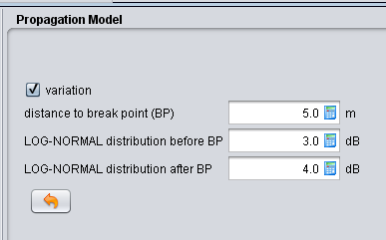
Figure 15: IEEE 802.11 plugin for SEAMCAT

Figure 16: comparison of other indoor path loss models

- List of referenceS

- ETSI TR 102 889-2 V1.1.1: Electromagnetic compatibility and Radio spectrum Matters (ERM); System Reference Document; Short Range Devices (SRD); Part 2: Technical characteristics for SRD equipment for wireless industrial applications using technologies different from Ultra-Wide Band (UWB)
- ERC/REC 70-03: Short Range Devices (SRD)
- Recommendation ITU-R F:1336-3: Title?
- IEEE 802.11: IEEE Standard for Information technology--Telecommunications and information exchange between systems Local and metropolitan area networks--Specific requirements Part 11: Wireless LAN Medium Access Control (MAC) and Physical Layer (PHY) Specifications
- IEEE 802.15.1: IEEE Standard for Information technology-- Local and metropolitan area networks-- Specific requirements-- Part 15.1a: Wireless Medium Access Control (MAC) and Physical Layer (PHY) specifications for Wireless Personal Area Networks (WPAN)
- IEEE 802.15.4: IEEE Standard for Local and metropolitan area networks--Part 15.4: Low-Rate Wireless Personal Area Networks (LR-WPANs)
- Radio Regulations (www.itu.int)
- ERC Report 25: The European table of frequency allocations and utilisations covering the frequency range 9 kHz to 3000 GHz
- Recommendation ITU-R M.1638: “Characteristics of and protection criteria for sharing studies for radiolocation, aeronautical radionavigation and meteorological radars operating in the frequency bands between 5 250 and 5 850 MHz”
- ECC Decision (02)01: ECC Decision of 15 March 2002 on the frequency bands to be designated for the coordinated introduction of Road Transport and Traffic Telematic Systems
- EN 300 674: Dedicated Short Range Communication (DSRC) transmission equipment (500 kbit/s / 250 kbit/s) operating in the 5,8 GHz Industrial, Scientific and Medical (ISM) band; Part 2: Harmonized EN under article 3.2 of the R&TTE Directive
- EN12253: Road transport and traffic telematics. Dedicated short-range communication. Physical layer using microwave at 5.8 GHz
- R&TTE Directive: Radio and telecommunications terminal equipment
- ECC Report 173: Fixed Service in Europe
- ECC/REC(06)04: Use of the band 5725-5875 MHz BFWA
- EN 302 502: Broadband Radio Access Networks (BRAN); 5,8 GHz fixed broadband data transmitting systems; Harmonized EN covering essential requirements of article 3.2 of the R&TTE Directive
- ITU-R Recommendation F.383-7: Radio-frequency channel arrangements for high-capacity fixed wireless systems operating in the lower 6 GHz (5 925 to 6 425 MHz) band
- ERC Recommendation 14-01: Radio-frequency channel arrangements for high capacity analogue and digital radio-relay systems operating in the band 5925 MHz - 6425 MHz
- ECC Report 101: Compatibility Studies in the band 5855– 5925 MHz between Intelligent Transport System (ITS) and other Systems
- ECC Report 68: Compatibility studies in the band 5725-5875 MHz between Fixed Wireless Access (FWA) systems and other systemsHenley, A.; Bond, S.: Radiocommunications Agency Radio Technology & Compatibility Group - Building Shielding Loss at 5GHz. Amended Report, RTCG Project no. 424, 27th October 1997
- Recommendation ITU-R M.1732-1: Characteristics of systems operating in the amateur and amateur-satellite services for use in sharing studies
- ECC Report 172, Broadband Wireless Systems Usage in 2300-2400 MHz
- Recommendation ITU-R SM. 1541 Title?
- Recommendation ITU-R SM. 329 Title?
- ERC Recommendation 74-01 Title?
- EN 302372 : TLPR Title?
- ECC Report 110: Compatibility studies between Broad-Band Disaster Relief (BBDR) and other systems
- CEPT Report 26: Report from CEPT to the European Commission in response to the Permanent Mandate to CEPT regarding the “annual update of the technical annex of the Commission Decision on the technical harmonisation of radio spectrum for use by short range devices”

- Recommendation ITU-R M.1461: Procedures for determining the potential for interference between radars operating in the radiodetermination service and systems in other services
- Recommendation ITU-R M.1638: Characteristics of and protection criteria for sharing studies for radiolocation, aeronautical radionavigation and meteorological radars operating in the frequency bands between 5 250 and 5 850 MHz
- Nobles and F. Halsall: "Radiowave Propagation Measurements within a Building at 2GHz, 5GHz and 17GHz"; Wireless '97 Conference paper, Calgary, July 1997.
- EN 300 440 v.1.6.1, Electromagnetic compatibility and Radio spectrum Matters (ERM); Short range devices; Radio equipment to be used in the 1 GHz to 40 GHz frequency range; Part 1: Technical characteristics and test methods. 2010-08
- INTERNATIONAL AMATEUR RADIO UNION REGION 1, VHF MANAGERS HANDBOOK. Version 6.00, December 2011
- ITU-R Report SM.2154: Short-range radiocommunication devices spectrum occupancy measurement techniques
- ECO Report XX on Summary of the responses to the questionnaire on the use of the frequency band 863-870 MHz and preliminary conclusions of the SRD/MG
- European Commission Directive 2009/140/EC on the authorisation of electronic communications networks and services
- Recommendation ITU-R SM.1046-2: Definition of spectrum use and efficiency of a radio system
- Taking Sides on Technology Neutrality - Chris Reed Professor of Electronic Commerce Law, Centre for Commercial Law Studies, Queen Mary University of London.2007
- B.A. Witvliet, "PhD Research Plan - Spectrum Access Mechanism for Licence Exempt radio systems", Radiocommunications Agency Netherlands, 2010.
- ERC Report 101 on Comparison of the minimum coupling loss method, enhanced minimum coupling loss method, and the Monte-Carlo simulation
- EN 300 220, ElectroMagnetic Compatibility and Radio Spectrum Matters (ERM);Short Range Devices (SRD);Radio equipment to be used in the 25 MHz to 1 000 MHz frequency range with power levels ranging up to 500 mW; Part 1: Technical characteristics and test methods
- Tanenbaum, “Computer Networks” 4th Ed, 2003, Pearson Education Inc.
- prEN13757-4: Communication systems for meters and remote reading of meters - Part 4: Wireless meter readout (Radio Meter reading for operation in the 868-870 MHz SRD band)
- ETSI TR 102 886: Technical characteristics of Smart Metering (SM) Short Range Devices (SRD) in the UHF Band;System Reference Document, SRDs, Spectrum Requirements for Smart Metering European access profile Protocol (PR-SMEP)
- FM22(09)077 Report on monitoring 863-870 MHz
- EC Decision on on harmonisation of the radio spectrum for use by short-range devices
- ETSI TR 103 056: Short Range Devices (SRD); Technical characteristics for SRD equipment for social alarm and alarm applications
- CEPT Report 14 - Develop a strategy to improve the effectiveness and flexibility of spectrum availability for Short Range Devices (SRDs)

The value for the transmitter output power is higher than the specified value of 250 mW (24 dBm) in the technical report ETSI TR 102 889-2 V1.1.1 [1]. Explanation: The specified transmitter output power in [1] refers to the 2.4 GHz frequency band. In the frequency band from 5.725 to 5.875 GHz, the electromagnetic wave propagation conditions are worse; therefore a higher level of transmitter output power is needed to meet the requirements of industrial wireless applications also within this frequency band.
The receiver sensitivity of the RSU is -104 dBm for BPSK. The free space loss over 8 m is 18dB, antenna gain is assumed to be 15 dB at the RSU and 5dB at the OBU; the 1 m loss factor is 47 dB
Recommendation ITU-R M.1732-1 [21] the specific 5.7GHz band is combined with other amateur bands. Therefore some adjustments have been made in order to be more representative of 5.7GHz equipment
According IEEE 802.11-2012

