SE(13)014A6

ECC Report [WI 41]

Impact of SRD and RFID applications on radio services and their Co-existence in the frequency bands 870-876 MHz and 915-921 MHz

[Month 2013]
(last updated: 7.January.2013) Draft v.0.16.1

NOTE: This draft Report is still a working document subject to changes.
Compared to v.0.15.2 the v.0.16.0 version contains the following major amendments:
- RFID updates from JF (conclusions in 5.1.2.3, beginning of 5.1.3, in 5.5.1.3 new text below Table 34);
- update in 3.1.2 to reflect results of Berlin tests;
- Amendments in 4.1 on SRD vs GSM-R based on inputs from WL and RK as well as reflection on the outcoes of Berlin tests;
- Amendment of results in section 4.2 on GSM-R vs SRD in adjacent band to reflect updated GSM-R interference criterion, mask, antenna, etc.;
- WPR side enclosure attenuation changed to 10 dB as reported by UK measurements, and simulation results updated accordingly;
- Development of LTE parameters section 3.3 and respective simulations of adjacent band LTE to SRD interference in re-arranged section 4.2;
- Update of UAV parameters section 3.5 and new section 5.5.2 on UAV case for 915 MHz band;
- New section 5.4.1 on intra-SRD co-existence in 915-921 MHz.

- Compared to v.0.16.0 the v.0.16.1 version contains the following amendments (updated areas highlighted in turquoise colour):
- Updates from John Falck in sections 3.7 and 5.5.3.3 wrt WPR;
- Changes in GSM-R sections 3.2, 4.1.2 and 4.2.1 with the effect of reverting to original (i.e. pre-version 0.16.0) assumptions on GSM-R cell range.

Executive summary
This ECC report is addressing the need for co-existence studies identified within the CEPT Roadmap for designating additional spectrum for various SRD applications in UHF spectrum, notably in the 870 – 876 MHz and 915 – 912 MHz bands.
[TBD]

TABLE OF CONTENTS

0 Executive summary 2
1 Introduction 6
1.1 Current situation in the band 870-876/915-921 MHz 6
1.2 Future SRD/RFID requirements within the band 870-876/915-921 MHz 7
1.3 Proposed approach for the co-existence study 9
1.4 Simulation methods and tools 10
1.4.1 Use of SEAMCAT 10
1.4.2 Modelling of DC and AF in SEAMCAT 11
2 Definitions 13
3 CHARACTERISTICS OF STUDIED SYSTEMS AND APPLICATIONS 14
3.1 Short Range Devices and RFID 14
3.1.1 Non-specific SRDs 14
3.1.2 Specific SRDs 15
3.1.3 SRD densities, placement and activity factors 17
3.1.4 RFID in 915-921 MHz band 20
3.1.5 Summary of requirements 24
3.2 GSM-R system 25
3.3 GSM/LTE Cellular systems 29
3.4 Tactical Radio Relay Systems 31
3.5 Telecommand to Unmanned Aerial Vehicles 32
3.6 Governmental Telemetry Systems 33
3.7 Wind Profiler Radars 33
4 CO-EXISTENCE STUDIES IN 870-876 MHz BAND 36
4.1 IN-BAND CO-EXISTENCE OF PROPOSED SRD AND GSM-R APPLICATIONS 36
4.1.1 Description of co-existence scenario 36
4.1.2 Results of simulations 37
4.1.2.1 Non-specific SRDs in the band 37
4.1.2.2 Specific SRDs in the band 42
4.2 ADJACENT BAND CO-EXISTENCE AROUND 870-876 MHz 46
4.2.1 Adjacent band interference from SRD to GSM-R around 876 MHz 46
4.2.1.1 Description of co-existence scenario 46
4.2.1.2 Results of simulations 46
4.2.2 Adjacent band interference from LTE below 862 MHz to SRD in 870-876 MHz 47
4.2.2.1 Description of co-existence scenario 47
4.2.2.2 Results of simulations 48
4.3 INTRA-SRD CO-EXISTENCE WITHIN 870-876 MHz 49
4.3.1 Description of co-existence scenario 49
4.3.2 Results of simulations 50
4.4 CO-EXISTENCE WITH OTHER SYSTEMS IN THE BAND 870-876 MHz 57
4.4.1 Co-existence with Tactical Radio Relays 57
4.4.1.1 Parameters and use of TRR 57
4.4.1.2 TRR vs. SRD co-existence scenarios 58
4.4.1.3 Results of simulations 59
4.4.2 Co-existence with systems for Telecommand to Unmanned Aircraft Vehicles 66
4.4.2.1 Parameters and use of UAV devices 66
4.4.2.2 UAV vs. SRD co-existence scenarios 66
4.4.2.3 Results of simulations – MCL single entry 67
4.4.2.4 Results of simulations – SEAMCAT statistical analysis 67
4.5 CONCLUSIONS ON CO-EXISTENCE STUDIES IN 870-876 MHz 72
5 CO-EXISTENCE STUDIES IN 915-921 MHz BAND 73
5.1 IN-BAND CO-EXISTENCE OF PROPOSED SRD/RFID AND ER-GSM APPLICATIONS 73
5.1.1 Description of co-existence scenario 73
5.1.2 The impact of RFID on ER-GSM without mitigation techniques 73
5.1.2.1 Lessons from ETSI TR 101 537 73
5.1.2.2 Consequences of the Kolberg measurements 75
5.1.2.3 Conclusions on RFID vs. ER-GSM co-existence without mitigation techniques 77
5.1.3 The impact of RFID on ER-GSM with mitigation techniques 78
5.1.3.1 Site licensing and coordination with ER-GSM operators 79
5.1.3.2 ER-GSM Downlink detection 80
5.1.4 Analytical analysis and SEAMCAT simulations of efficiency of detecting ER-GSM downlink 82
5.1.4.1 Analytical analysis of downlink detection 82
5.1.4.2 SEAMCAT analysis of downlink detection 86
5.1.4.3 Conclusions from analytical and SEAMCAT analysis of ER-GSM downlink detection 88
5.1.5 Summary and conclusions on RFID vs. ER-GSM coexistence 88
5.1.5.1 Coexistence without mitigation techniques 88
5.1.5.2 Downlink detection 88
5.1.5.3 Uplink detection 88
5.2 ADJACENT BAND CO-EXISTENCE AROUND 915 MHz 89
5.2.1 Description of co-existence scenario 89
5.2.2 Results of simulations 89
5.3 ADJACENT BAND CO-EXISTENCE AROUND 921 MHz 89
5.3.1 Description of co-existence scenario 89
5.3.2 Results of simulations 89
5.4 INTRA-SRD AND SRD Vs. RFID CO-EXISTENCE WITHIN 915-921 MHz 89
5.4.1 Description of co-existence scenarios 89
5.4.2 Results of simulations 89
5.5 CO-EXISTENCE WITH OTHER SYSTEMS IN THE BAND 915-921 MHz 89
5.5.1 Co-existence with TRR 89
5.5.1.1 Parameters and use of TRR 89
5.5.1.2 TRR vs. RFID co-existence scenarios 89
5.5.1.3 Results of simulations 90
5.5.2 Co-existence with systems for Telecommand to Unmanned Aircraft Vehicles 92
5.5.3 Co-existence with Wind Profiler Radars 92
5.5.3.1 Parameters and use of WPR 92
5.5.3.2 WPR vs. RFID co-existence scenarios 92
5.5.3.3 Results of simulations 92
6 Conclusions 95
ANNEX 1: heading 96
ANNEX 2: List of referencES 97

LIST OF ABBREVIATIONS

Abbreviation | Explanation
AF | Activity Factor
AFA | Adaptive Frequency Agility
ALD | Assistive Listening Device
ARFCN | Absolute Radio Frequency Channel Number, a unique channel number in GSM
BCCH | Broadcast Control Channel (of GSM-R base station)
BTS | Base Transmitting Station (feeder station serving a cell in mobile radio system)
BWA | Broadband Wireless Access
CDMA | Code Division Multiple Access
CEPT | European Conference of Postal and Telecommunications Administrations
CSMA | Carrier Sensing Multiple Access
DC | Duty Cycle
dRSS | desired Received Signal Strength (term used in SEAMCAT)
DVB-T | Digital Video Broadcasting – Terrestrial
ECC | Electronic Communications Committee
ER-GSM | Extended (in frequency) Railways’ GSM
ETSI | European Telecommunications Standards Institute
FHSS | Frequency Hopping Spread Spectrum
ILK | Interfering Link
ILT | Interfering Link Transmitter
iRSS | interference Received Signal Strength (term used in SEAMCAT)
ITS | Intelligent Transport Systems
LBT | Listen Before Talk (Transmit)
LDC | Low Duty Cycle
M3N | Metropolitan Mesh Machine Networks
MCL | Minimum Coupling Loss
MS | Mobile Station (user terminal)
PAMR | Public Access Mobile Radio (e.g. trunking system such as TETRA or similar)
PMR | Private Mobile Radio
RF | Radio Frequency
RFID | Radio Frequency Identification System
R-GSM (GSM-R) | Railways’ GSM
SM | Smart Metering
SRD | Short Range Device
TRR | Tactical Radio Relay links (systems used in military environments)
UHF | Ultra High Frequency band (300-3000 MHz)
VLK | Victim Link
VLR | Victim Link Receiver
WPR | Wind Profiler Radar
[to be completed]

Introduction
This ECC report addresses the need for co-existence studies identified within the CEPT Roadmap for designating additional spectrum for various SRD and RFID applications in the UHF spectrum. It builds on the previous SRD and RFID co-existence studies in the UHF band. Most notably it could be seen as continuation of work started with the ECC Report 37 [1] related to SRDs and RFID in 863-870 MHz band.

Current situation in the band 870-876/915-921 MHz
Up to now the European Common Allocations table designated this band for the following applications and users:
- Defence systems;
- Digital land mobile (PMR/PAMR), duplex: 870-876 MHz (uplink) paired with 915-921 MHz (downlink).

The CEPT questionnaire conducted in May-June 2012 and responded by 39 administrations revealed the following picture of how the bands 870-876 MHz and 915-921 MHz were used or planned to be used across Europe:
- Status of using bands 870-876 MHz and 915-921 MHz in 39 European countries (June 2012)
The PMR/PAMR designation in 870-876/915-921 MHz was meant to provide an additional paired band for wide-area digital PMR networks, e.g. utilising TETRA or CDMA PAMR band class 12. However, as of today, no PMR/PAMR installations exist in European countries at these frequencies. ETSI technical committee responsible for TETRA have informed ERM that they have no plans to use these bands. Instead TETRA prefers to operate at lower frequencies. Currently the frequency range 915-921 MHz serves as a guard band between GSM uplink and downlink emissions.
Seeing this prolonged vacancy the European railways’ digital system, known as “GSM for Railways” (GSM-R) requested an extension of their operating frequencies to include the paired bands 873-876 MHz and 918-921 MHz. Subsequently CEPT agreed to this request. The additional frequencies are referred to as ER-GSM (Extended Railways GSM) band; see EC/DEC(04)06 amended June 2009. Already some European countries have issued licenses for the operation of GSM-R systems in the ER-GSM bands and such ER-GSM-enabled systems are expected to appear on the market by 2013. It is envisaged, that ER-GSM will be deployed mostly at locations with high railway use, e.g. shunting areas, urban areas or for high speed trains. In other more remote areas, or in some countries with no dense railways infrastructure, ER-GSM may be not used at all.

Future SRD/RFID requirements within the band 870-876/915-921 MHz
SRD devices are already in operation in the adjacent band 863-870 MHz and their use is steadily growing. To make provision for this expansion, ETSI has developed a System Reference Document (SRDoc) TR 102 649-2 [2] that requests additional frequencies for SRD applications (incl. RFID and other types of specific and non-specific SRD applications). The bands 870-876/915-921 MHz were identified as the prime candidates since they were assumed to be unused and also due to the proximity of the band 870-876 MHz to the existing SRD designation in 863-870 MHz. Also the frequency range 915 – 921 MHz is widely used by SRDs and RFID in many countries outside Europe, which makes it an attractive band for systems deployed on an international basis.
SRD devices are already installed in large numbers across a wide range of applications within Europe and their use is expected to grow rapidly over the next decade. It is anticipated that the current designations of spectrum for RFID and SRDs will be inadequate to meet their future needs. Several relevant ETSI SRDocs contain description of constantly developing traditional SRD application families (such as automotive, home and building automation, alarms, etc.) as well as some newly emerging SRD applications. The ETSI SRDocs contain independent marketing data that predicts considerable market growth in RFID and SRDs and offers the following justification for new SRD/RFID band designation:
- The SRD industry has expanded considerably over recent years and has now developed into a number of different industrial sectors. These include metering, automotive applications, alarms, and in wider terms, non-specific SRDs such as home and building automation, telemetry, data transmissions, etc. It is anticipated that the present trend in diversification and expansion will continue. An indication of the potential size of the market for SRDs is provided in annex A of ETSI TR 102 649-2 [2];
- New emerging applications are being constantly developed, such as SRDs for Smart Metering (SM), described in ETSI TR 102 886 [3], Metropolitan Mesh Machine Networks (M3N) in TR 103 055 [13], Assistive Listening Devices in TR 102 791 [20] and new Social Alarms and Alarms in TR 103 056 [21]. Based on these recent developments and predictions of market growth contained in the referenced SRDocs, it is very evident that additional spectrum will be necessary for a plethora of emerging new SRD application families;
- Market predictions show robust growth potential for RFID applications. Already the sale of RFID tags in 2010 significantly exceeded the early market predictions. As the commercial benefits of RFID become more widely recognized, the technology will be adopted by many new industries. Some of these applications will require improvements to existing RFID performance. Typical examples include greater reading range, improved reading performance, faster data rates and the use of sensors (e.g. temperature, pressure, etc.) within tags. These requirements can only be met by the provision of additional spectrum. The RFID community is contributing to this process by developing novel methods for co-existence, such as the techniques described in the recently adopted ETSI report TS 102 902 [4].

The necessity of finding additional spectrum for SRD and RFID applications was already identified in November 2006 in CEPT Report 14 [14] in response to a mandate from the European Commission. This document developed a strategy to improve the effectiveness and flexibility of the spectrum designation for SRDs and RFID. The CEPT Report 14 recommended that:
- All services in the subject band make more efficient use of spectrum and that full opportunity is taken of possibilities for sharing. Regulators can promote this by providing suitable incentives for spectrum efficiency;
- CEPT should ensure that only the minimum regulations are specified in Recommendation 70-03 and, where appropriate, the application-specific constraints to spectrum use are removed;
- New bands should preferably be extensions of SRD bands or close to them;
- Any efficiency benefit possibly accrued from the introduction of co-existence techniques such as LBT and/or AFA may be short lived if the anticipated growth in SRDs occurs. Therefore the identification of new spectrum for SRDs employing these techniques is nevertheless important.

In accordance with these strategic guidelines, CEPT held a public workshop on the future use of UHF spectrum for SRDs and RFID on 4-5 April 2011 at Mainz, Germany. As a result of this consultation, the CEPT has developed a Roadmap for studies and actions aimed at designating additional spectrum for various SRD and RFID applications at UHF. The band 870-876/915-921 MHz was named in this roadmap as the prime candidate for co-existence studies.
Although RFID may be seen as part of the SRD family, some of their operational features, most notably their comparatively high transmit power, make them a distinctive application. The TR 102 649-2 notes that it would be desirable to separate the high power transmissions of devices like RFID from the lower power levels generally associated with SRDs. It therefore proposes that the band 870-876 MHz is designated for use by SRDs with transmit powers at less than 100 mW (or little bit higher depending study results). The band 915-921 MHz is identified for high power devices such as RFID.
Initially, it was considered in TR 102 649-2 to possibly divide the band 870-876 MHz into two segments. One of these segments would cover devices which use duty cycle up to 1 % or LBT with AFA (or equivalent techniques). The other segment is aimed at SRDs that transmit intermittent very short bursts of power and rely on duty cycle for mitigation. The originally proposed band plan is shown in Fig. 1 below.
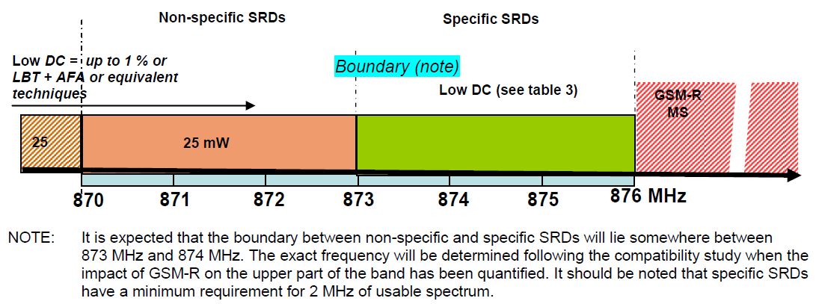
- Tentative band plan for 870-876 MHz originally proposed in TR 102 649-2 [2]

However it should be noted that the originally proposed boundary may be further affected by the new requirement to accommodate ER-GSM in 873-876 MHz. This represents an important issue for this co-existence study, because this band split is just a hypothetical proposal contained in TR 102 649-2. If this study shows that there is no really reason to have that band split, then this could be the recommendation of this report for different band arrangement.
In that regard it may be noted that the principle of sub-dividing the band into segments for different SRD applications is now discouraged (see CEPT Report 44) but dividing in segments (if necessary) based on different signal types and/or access methods is possible. Therefore this approach is a valid option to consider in this study.
In somewhat similar manner, the TR 102 649-2 also originally proposed a band-plan for RFID in the frequency range 915-921 MHz. But the, following feasibility studies between EG-GSM and RFID, the centre frequencies of the four proposed high power RFID channels were amended to give a 100 kHz offset from the centre frequencies of the GSM-R channels. This change gave an additional protection margin of 9 dB [15]. The latest version of the amended band plan is shown in Fig. 2 below.
- Tentative band plan for 915-921 MHz, based on amended TR 102 649-2 [2] proposal

Feasibility studies have been undertaken within ETSI between RFID and the railways to investigate whether sharing of the band is feasible. The results from this work were provided as input to this study [15, 16, 17]. These studies have subsequently been validated by some practical tests which are available in TR 101 602.
The proposed sharing of the band 915-921 MHz between RFID and non-specific SRD would provide additional spectrum reserve for SRD applications and will be of particular benefit in situations where higher powers are required (e.g. some kinds of automotive or smart metering SRDs that may require higher output powers) or where the candidate SRD applications were unlikely to be present in the same locality as RFID.

Proposed approach for the co-existence study
When considering the co-existence study two issues should be taken into account:
- Power coupling aspects, i.e. the primary physical fact of whether the considered interferer has sufficient transmit power to overcome propagation loss on interference and interact with the victim receiver. In itself, this aspect may have two components: individual interference when interferer is a single device, or group interference from multiple devices, such as many SRDs deployed in a limited geographic area. In the latter case, the aggregate interference effect would be akin to the “interference noise floor” concept.
- Time domain aspects, i.e. given that there is a risk of direct power coupling between the interferer and the victim, to consider what will be the protracted effect of interference over reasonable periods of time, expressed by statistical measures such as probability of interferer’s and victim’s packet collisions in time, BER on the victim link, voice quality deterioration, etc. This aspect may be especially relevant to consider for the case of interference from SRDs that often operate with a very low Duty Cycles, and thus even when having sufficient power coupling into victim link, their effect may be but a transient glitch on victim link that could be possibly corrected by the error correction layers of the receiver application.

The first of the above aspects, the power coupling and interference noise generation, should be considered by traditional link-budget oriented interference simulation tools. In view of the highly dispersed and irregular deployment of SRD applications, it was decided that the best approach for the co-existence study was to adopt statistical modelling using the SEAMCAT tool [5, 6]. However, where appropriate, the MCL method was also considered useful e.g. for the analysis of some identified critical co-existence scenarios and the general identification of some boundary-conditions. Such boundary conditions could be either in terms of adjacent frequencies or physical separation, or verifying the maximum range of interference.
Then, for the identified critical cases where there is shown to exist a risk of interference due to sufficient power coupling on the interference link, the time domain aspects will need to be considered. An example of such recent analysis applied to the case of SRD vs. ER-GSM is reported in [17], showing that even with direct power coupling the effect of interference from SRD to ER-GSM may be negligible thanks to combined effects of DC of less than 2.5% and exploiting channel coding, such as using single Tx bursts of less than 20-25 ms.
The purpose of co-existence study is therefore first to check whether the existing and proposed applications can co-exist both power level wise and time domain wise. If they are shown to co-exist without problems, the goal is achieved and the study may stop. But if incompatibility is detected, then a discussion on improving the co-existence potential (and hence increasing spectrum efficiency) is a logical next step.
Given the high complexity of investigating so many applications in the proposed bands, it was decided to structure the study in several stages as follows.
- Firstly, addressing the situation in 870-876 MHz:
  - In-band inter-system co-existence studies between SRD and ER-GSM use – this establishes the possibility and scope for sharing and any impact on the overall range of SRD use within the limits of 870-876 MHz as well as the proposed splitting into two sub-bands for SRD use as shown in Fig. 1;

  - Adjacent-band inter-system co-existence studies at 876 MHz between SRD and R-GSM. The need for this aspect of investigation will become clear after completion of the first stage;
  - Intra-SRD sharing (i.e. between different SRD applications, including Smart Metering and M3N) studies within 870-876 MHz – this stage focuses on different SRD applications in order to establish the minimum mechanisms necessary (LBT/AFA, LDC, FHSS, etc.) for their co-existence;
  - In-band intra-system studies with any other residual uses of the band, such as defence systems - Tactical Radio Relay links, UAVs and nationally implemented CDMA and similar Broadband Wireless Access (BWA) networks – subject to national requests and provision of suitable information;

- Secondly, addressing the 915-921 MHz band:
  - In-band inter-system co-existence studies between SRD/RFID and ER-GSM – this will establish the potential for sharing and the types of SRD/RFID use within the band 915-921 MHz;
  - Adjacent-band inter-system co-existence studies below 915 MHz between SRD/RFID and GSM/LTE and above 921 MHz between SRD/RFID and R-GSM;
  - Intra-SRD sharing (i.e. between RFID and SRD applications) studies within 915-921 MHz in order to establish suitable mitigation techniques (AFA, LDC, etc.) for their internal co-existence;
  - In-band intra-system studies with any other residual users of the band, such as defence systems and nationally implemented BWA networks – subject to national requests and provision of suitable information.

The structure of the report therefore reflects the above proposed approach and identified steps.

Simulation methods and tools

Use of SEAMCAT
Taking note of discussion of general approach in the previous sub-section and in accordance with general practice of sharing studies, the official CEPT simulation tool SEAMCAT was the prime instrument for carrying out most of the basic co-existence simulations.
The simulations were carried out using SEAMCAT Version [4.0.0]. It may be useful at this point to reminisce on the basic constituent elements of any SEAMCAT simulation, as shown in the following figure.

ILR
ILT
VLR
VLT
iRSS
dRSS
Victim System
Link
Interfering System
Link
Interference
Link
Sensing Link for Cognitive Radio (LBT) feature
sRSS
Simulated signals:
dRSS: desired Received Signal Strength
iRSS: interfering Received Signal Strength
sRSS: sensing Received Signal Strength

- Modernised representation of SEAMCAT scenario elements
Note that although the traditional configuration for a SEAMCAT scenario has not changed and remains based on two pairs of interacting peer transmitters and receivers, it was recently decided to abandon the previous naming convention (Wanted Transmitter → Victim Receiver pair and Interfering Transmitter → Wanted Receiver pair), and now refer to them as: Victim Link’s Transmitter (VLT) and Receiver (VLR) and correspondingly the Interfering Link’s Transmitter (ILT) and Receiver (ILR). This was to make the naming more intuitively clear for the casual user/reader. Therefore this report will adopt this new naming nomenclature and the above mentioned references to transceivers.

Modelling of DC and AF in SEAMCAT
Modelling of Duty Cycle (DC) and Activity Factor (AF) is a very critical element in simulating co-existence of SRDs since the DC/AF is the natural primary mitigation factor for these ubiquitous power savvy devices characterised by transmission patterns, which occur in sparse bursts.
The SEAMCAT allows modelling DC/AF in two major ways, both of which would be considered and used in simulations of this report as required.
The first and most typical method would be to reflect the AF value in settings of ILT-VLR placement modes. When using “Uniform density” or “Closest interferer” placement modes, the SEAMCAT allows the description of the density and activity of interferers. Then during simulations, the SEAMCAT assumes that all generated interferers are active (i.e. transmitting the signal burst at the time instance of the snapshot). However their placement is statistically spread throughout the area, based on density and activity (i.e. AF) parameters, using the following formula:
(1-1)
where:
- n^{active}: number of active interferers in the simulation;
- dens_{it}^{active}: density of active transmitters, calculated as follows:
(1-2)
where:
- dens_{it}: nominal density of interferers;
- p_{it}^{tx}: probability of transmission of interferer, i.e. it’s AF equivalent;
- activity_{it}(time): temporal activity function, i.e. accounting for different activity periods as a function of time of the day (rush hour effect vs. night time). Note: this function is set in SEAMCAT by first creating a reference look-up table and then separately defining the time determinant. In most scenarios users opt to set this function to 1 and instead directly modify in one go the probability of transmission, to scale it as required by changing the AF;
So by looking at these formulas, it could be concluded that in this manner SEAMCAT derives the simulation radius as a straightforward geometric function of probability of encountering the desired number of “simultaneously active” interferers based on their density and activity. Given that the two latter parameters are usually easily available as part of the scenario definition, this method is the obvious preferred choice to incorporate the respective input data.
Another different option is to model the DC by direct toggling (ON/OFF) of the ILT power between the snapshots. This could be easily done by the users through respectively adjusting ILT’s transmit power distribution function, where any desired pattern of interferer’s activity could be implemented. In this manner the probability of collisions in the time domain could be analysed directly for the desired number of modelled interferers.
The above described methods allow modelling the statistical impact of DC and AF over long time periods of real-life scenarios. However, since the succession of SEAMCAT snapshots is not linked to any specific time reference, these methods do not completely address the “time dynamics” of possible interaction between bursty digital signals in the specific systems. This means that in some instances the above methods may need to be complemented by additional time domain analysis, as discussed in the following subsection.
[BNetzA: this is a very new approach and needs to be proven. It should be discussed if the following main assumption in ECC Report 131 is valid in this coexistence case: “This is relevant in cases where the radio technologies used by the victim and the interferer incorporate some element of time-division multiple-access (TDMA), as is the case, for example, in packet-based transmission.” In ECC Report 131 the coexistence of two identical systems is considered, which is not the case here.
In addition it is not understood how the overlapping time will be determined; ECC Report 131 startes: “The extent of packet overlap, and hence the value of GColl , is re-calculated at each Monte Carlo trial when a collision between interferers and the victim in the time domain exists.”. That means in ECC Report 131 a time domain analysis was performed; do we intend to do the same ?
ET: really, I do not see any need to go deep into this, so I propose to delete this and let’s try to live without this section for a while, perhaps at the end we do not need it all. At least so far nothing in the report had been using these considerations. Then any future external inputs on this issue – be it new Kolberg measurements or results of Simon’s work or else, may be plugged directly to where they would belong, e.g. SRD vs. GSM-R section]
2012-11-16 GoTo mtg: AGREED however the above was left as a kind of reminder for possible future texts/actions within those sections as proposed by ET as relevant.

Definitions
Term | Definition
SRD | “Short Range Devices” refers to radio transmitters, which provide either unidirectional or bi-directional communication, and which have low capability of causing interference to other radio equipment (ECC/REC 70-03). Important to note that by themselves SRDs are not considered a distinctive “Radio Service” in the meaning established by ITU Radio Regulations.
R-GSM | “Railways GSM” refers to radiocommunications network that uses GSM technology to provide closed user group mobile communications services for railways, by connecting trains and railway workers to their respective controlling entities. It is deployed along the railway tracks and railway hubs/logistics centres.
TRR | “Tactical Radio Relay” is a radiocommunications system used in military operations to provide connectivity between various army units. Once deployed it acts as fixed link, however its terminal points may be randomly re-deployed to new places at any time, depending on tactical requirements.
UAV | “Unmanned Aerial Vehicle” is a pilot-less small aircraft, normally operated at the heights of up to 200 m, and used by public agencies for ad hoc air reconnaissance and surveillance, especially in urban environments, such as observation of public order, tracking of persons and objects, etc.
DAA | “Detect and Avoid” is a technique employed by a wireless transceiver device for mitigating interfering impact on other (primary) users of the band. The essence of DAA functioning is that before first transmission and then at regular intervals during operation, the device scans the entire operational frequency range and “blacklists” the channels (sub-bands) where other transmissions had been identified. The sensitivity threshold for DAA detecting function is normally linked to sensitivity threshold of receivers, whereas other technical parameters (listening time, power detection mechanism, repeat cycle, etc) are to be established in relevant normative technical specifications, such as harmonised standard for a given family of devices.
APC | “Automatic Power Control” is a technique employed by a wireless transceiver device in order to minimise energy consumption and at the same time reduce overall interference level to other terminals of the same system as well as to different systems/users of the band. The essence of APC functioning is that the receiver constantly monitors the level of received wanted signal and if that level exceeds certain threshold of sufficient signal level (e.g. C/I over sensitivity threshold), the peer transmitter is instructed to reduce its transmit power level accordingly. The technical parameters (threshold, dynamic range, power adjustment step size, timing, etc.) are to be established in relevant normative technical specifications, such as harmonised standard for a given family of devices.
[To be completed]

CHARACTERISTICS OF STUDIED SYSTEMS AND APPLICATIONS
This section describes characteristics and operational scenarios of various radiocommunications systems, whose co-existence is studied in this report.

Short Range Devices and RFID

Non-specific SRDs
This family of SRD was proposed for deployment in the lower sub-band of 870-876 MHz, as illustrated in Fig. 1. Their primary co-existence mechanisms might be Duty Cycle (DC) or Listen Before Talk (LBT) and Adaptive Frequency Agility (AFA), in different possible combinations, or equivalent techniques.
A non-exhaustive list of applications for SRDs using either duty cycle or LBT + AFA (or equivalent techniques) is provided below, based on information in A.2 of [2]:
- Home and Building automation (some examples):
- Lighting control;
- Shutter, awnings and blinds control;
- Windows, doors and gates openers control, garage doors, electrical door lock systems;
- Heating, ventilation regulation and air condition control;
- Swimming pool surveillance and control;
- Combined scenarios;
- Sensors (temperature, wind, light, rain);
- Presence monitoring;
- Telemetry and telecommand (some examples):
- Pumping station monitoring;
- Electricity network monitoring;
- Crane and machinery control;
- Mixed speech and data (some examples):
- Wireless door entry;
- Alarm ambiance background scanning;
- Baby and elderly monitoring;
- Access control (some examples):
- Disabled persons access;
- Security applications;
- Machine to Machine (some examples):
- Remote data collection (state of machines);
- Remote control (management);
- Remote payment;
- Remote restaurant/bar customer orders data collection;
- Portable Bar Code Scanner;
- Aviation and Maritime applications (some examples):
- Remote data maintenance collection (service information of aircraft downloaded while taxiing).

Given the very wide variety of such non-specific SRDs already in existence and that may be developed by innovative wireless industry in the future, it appears futile to try predicting specific deployment densities for various concerned applications. Therefore, it was considered that the density of generic non-specific SRDs may be within the range of 10-1000/km², the latter limit representing urban scenarios. The densities of some prominent derivative specific SRD applications are further discussed in sub-section 3.1.3.
In accordance with the request in [2], ETSI envisaged the following regulatory parameters for this family of SRDs, as given in Table 1.
- ETSI proposal for parameters of non-specific SRDs in lower part of 870-876 MHz [2]
Sub-band | Max Power | Max DC/  Mitigation technique | Channel BW
870-873 MHz ⁽¹⁾ | 25 mW | 1% or LBT/AFA ⁽²⁾ | No spacing

1. Upper limit may change depending on the outcome of these studies
2. The specifics of DC and/or LBT/AFA use require additional study, such as whether they are substitute or complement for each other, and whether it would be useful for intra-SRD sharing or for protection of primary services in the band, or both. Clarifying this issue is one of objectives for studies presented in this report.

In accordance with TR 102 649-2 [2], the characteristics of transmitters and receivers for this family of SRDs are defined in EN 300 220 [7], most notably:
- maximum occupied bandwidth of 600 kHz (cf. Table 7 in Clause 7.4.2.2 of [7]);
- unwanted emission mask derived from Figure 7/Table 10 in Clause 7.7 of [7].

Specific SRDs
This family of specific SRDs was proposed by ETSI for deployment in the upper sub-band of 870-876 MHz, as illustrated in Fig. 1. The ETSI envisaged [2] that the distinctive feature of this family of devices would be their reliance on DC as sole co-existence mechanism, inter-linked with transmitted power. The regulatory parameters are summarised in Table 2.
- ETSI proposal for parameters of DC-limited SRDs in upper part of 870-876 MHz [2]
Sub-band | Max Power | Max DC | Channel BW
873-876 MHz ⁽¹⁾ | 1 mW | 5% | No spacing
873-876 MHz ⁽¹⁾ | 25 mW | 1% | No spacing
873-876 MHz ⁽¹⁾ | 100 mW | 0.1% | No spacing

1. Upper and lower limits may change depending on the outcome of these studies. It should be noted that specific SRDs have a minimum requirement for 2 MHz of usable spectrum

Examples of practical SRD applications proposed for this sub-band are listed in the TR 102 649-2 and include the following:
- Metering: 25 mW, channel BW of 200 kHz, DC up to 1%;
- Alarms: 25 mW, channel BW of 200 kHz, DC up to 1%;
- Portable Alarms (for personal security): 100 mW, channel BW of 25 kHz, DC up to 0.1%;
- Automotive Devices: 100 mW and more, channel BW up to 500 kHz, DC up to 0.1% (transmit power and DC are inter-linked as shown in Table 2).

Some other ETSI SRDocs offer description of various functionally focused derivatives from the generic families described in TR 102 649-2. For example, , the focused analysis of various Alarm & Social Alarm SRD applications is offered in TR 103 056 [21], arguing for necessity of spectrum access arrangements characterised by low latency and high reliability for these socially important applications, with powers of up to 25-100 mW and flexible channel bandwidth.
Another emerging specific application proposed for this band is Smart Metering (SM), see TR 102 886 [3]. This application is intended to support the smart utility networks e.g. electricity grid installation, and requires greater operating ranges in order provide acceptable indoor-to-outdoor communication. To achieve this, they have requested the following parameters for SM applications:
- transmit power: 100 - 500 mW;
- channel BW of 200 kHz;
- DC up to 2.5% (as suggested by results of compatibility study, see [17]).

Another family of emerging SRD applications is Metropolitan Mesh Machine Networking (M3N), see TR 103 055 [13], which requires similar parameters to SM except that DC might be smaller: up to 1-1.25%.
When comparing the emerging Automotive, SM and M3N requirements against the original TR 102 649-2 proposal outlined in Table 2, it becomes clear that this study needs to determine acceptable DC limits at different power levels up to 500 mW.
It is also important to take into account the [draft] ETSI ES 202 630, which provides the European profile for SRDs in the frequency band 870 MHz to 876 MHz and, in particular, the proposed 200 kHz channelling for SRDs operated in the upper sub-band as well as certain transmitter timing options. This study has taken into account these tentative requirements.
It is also important to take into account SRD receiver parameters to be used for consideration of interference impact to SRDs. The table below lists some of the essential parameters for this kind of analysis. These were derived from formulas in clauses 8.1.4 (sensitivity) and 8.3.3 (selectivity) of EN 300 220-1 [7].
- Assumed parameters of specific SRDs as victims [2, 7]
SRD receiver bandwidth | Sensitivity, dBm | Min C/I, dB | Selectivity, dB
25 | -105 | 8 | 50
200 | -96 | 8 | 47
500 | -92 | 8 | 43
600 | -91 | 8 | 42

Another example of Specific SRD is the family of Assistive Listening Devices (ALD), as described in TR 102 791 [20]. It is envisaged that these devices may be operated in the frequency band 915-921 MHz with DC of 100% when in use. They would be deployed as groups of 10 dBm “base stations”, installed indoors in public buildings (stations, museums, etc.) and employing up to 6 channels of 200 kHz. It is also possible that ALD terminal devices carried by people may be provided with return channel, with emission power of -3 dBm. It is proposed to use EN 301 357 as the basis for defining the radio emission parameters of ALD, such as spectrum mask.
Note: more details on ALD may be expected from ETSI according to ECC WGFM#75 Liaison Statement request.

Measurements at the BNetzA test laboratory in Kolberg [17] investigated the use of duty cycle techniques to mitigate the impact of SRD devices on E-GSM-R. This measurement suggests the following criteria in order to improve the situation:
  - Maximum Tx_{ON} for a single burst = 25 ms;
  - Minimum Tx_{OFF} period = 500 ms;
  - Maximum DC within 1 s interval = 2.5%.

Additional sets of measurements were later carried out in November 2012 at Siemens’ Berlin laboratories to investigate the impact of interference from SRD to GSM-R in real life settings [23]. These measurements addressed two distinct cases of interference to “transparent data bearers” and “voice bearers” of GSM-R. They also looked at the interference impact during setting up of calls as well as during on-going calls.
These latest measurements suggested that as regards temporal effect of duration of individual SRD transmissions, the victim GSM-R link might withstand disturbances from SRD transmissions of up to 20 to 40 ms for GSM-R link transparent data and voice bearer modes respectively.

SRD densities, placement and activity factors
SRD densities
An important issue to consider is the anticipated deployment densities of the various types of SRD. The following table provides the data gathered from the relevant ETSI System Reference Documents and consultations with various SRD industry groups. In cases where specific deployment densities for various scenarios were provided in the referenced document, these were taken directly into the table. When only the total estimates of the European market size were provided, the average density was derived by dividing the number of anticipated devices used in Europe by the combined area of five European countries: France (550 000 km²), Germany (350 000 km²), Italy (300 000 km²), Poland (300 000 km²) and Spain (500 000 km²), i.e. 2 million km². By choosing only these five larger countries in the core of Europe, with a reasonably uniformly spread population, we tried to balance out the uneven spread of population across the entire European continent (total area 10.2 million km²). Although this is not precise, the method could be used to derive some reference numbers, in the absence of any better predictions. However these figures are no more than a European average and therefore may not be fully representative of specific deployment scenarios.

- Representative average deployment densities for various SRD families
Family of SRDs | Deployment density (1/sq.km)
Family of SRDs | Pan-Europan Average | Suburban | Urban
Generic Alarms | 12 ⁽¹⁾ | - | -
Assistive Listening Devices | 18 ⁽²⁾ | - | 750 ⁽³⁾
ITS/Automotive high power (100+ mW) | 80 ⁽⁴⁾ | - | -
Home Automation, incl. sub-metering, specialised home alarms, etc. | 100 ⁽⁵⁾ | 1500 | 50000 ⁽⁷⁾
Automotive low power (up to 25 mW) | 400 ⁽⁶⁾ | - | -
Metropolitan utilities, such as Smart Metering/M3N | - | 1000 | 7500 ⁽⁸⁾
1. Based on European market size of 24 million devices divided by area of five reference countries (ref. TR 102 649-2)
2. Based on projections in TR 102 791 of number of people needing hearing assistance in five reference countries (35.2 million) divided by area of those countries
3. Based on projecting predictions of ca. 10% of population needing Assistive Listening Devices in TR 102 791 to the case of average reference city of 150 000 population over 20 sq. km
4. Based on UNECE data on number of passenger vehicles in five reference countries (ca. 160 mio), divided by total area of those countries and the assumption of one active high power automotive SRD per vehicle. Note that this “active device” might be different automotive device at different times, e.g. some security enabling device during car movement, or functional comfort control system in parking position, etc.
5. Based on extrapolated from TR 102 649-2 figure of 200 million devices, divided by area of five reference countries
6. Based on UNECE data on number of passenger vehicles in the same five reference countries (ca. 160 mio), divided by total area of those countries and the assumption of five active low power automotive SRD per vehicle (such as TPM, etc.)
7. Based on Home Automation SRD industry’s long-term (10 years) forecasts, assuming up to 20 devices per household.
8. Based on estimate of 150 000 nodes for a 20 sq. km city area (ref. TR 103 055)

Inspection of this table shows that the average deployment densities of the various SRD applications may vary between 10-3000 devices/km². This will depend on the particular nature of each device family. For instance, the types of SRDs used for machine-to-machine automated operations are likely to see ever increasing penetration, especially in densely populated urban areas, leading to deployment densities in the range of several to several tens of thousands devices per square kilometre. Conversely person -linked applications are likely to remain at relatively “low” densities in the range of up to 100 devices per square kilometre.
The automotive represents an interesting example of increasingly proliferating application; the average number of such devices shown in the above table is derived from the recent standardisation activities, and is effectively the sum of two broadly different types of device: on average one active at a given time “high-power” SRD for what could be described as environmental sensing/communication (inter-vehicle communication while driving, remotely controlled functional comfort systems, etc), and on average 5 (active) low power/low duty cycle devices for various functionalities inside the vehicle and for vehicle-driver communication, such as wireless keys, tire pressure monitoring (TPM) devices and the likes. In such manner the automotive devices may be seen as a mid-way between the person-linked and machine-to-machine application scenarios.
Other important and interlinked issues are the placement mode and activity factor of the SRDs that need to be taken into account in statistical simulations of interference scenarios.

SRD placement modes in SEAMCAT simulations
As regards the placement mode, the issue is for modelling Interferer-Victim interaction in SEAMCAT, and the main question is whether it may be assumed that the nearest interferer (i.e. one per ILK of given type) is likely to pose the largest danger due to most direct power coupling (in which case the “Closest interferer” mode should be used in SEAMCAT), or whether the preference would be to consider the aggregated interference from multiple interferers (modelled in SEAMCAT through the “Uniform density” mode). The former choice would provide for a reasonable estimation of “average” probability of interference. The latter choice would provide estimation of probability of interference on the more conservative side, i.e. the worst case maximum envelope of the interference. This study has chosen to use as a reasonable compromise the combination of simulations with both placement modes and judge that the “real” interference potential should be somewhere between the estimates derived by using the two different modes. Note however, that when both the victim and the interferer may be closely located, especially assuming scenarios with some kind of low-placed low-antenna-gain devices, such as would be the case with handheld mobile terminal vis-à-vis an SRD device, then the “Closest interferer” mode may be the most logical option to use.
SRD activity considerations
When using the “Uniform” placement mode, one critical parameter is the "number of active devices” which effectively means the number of devices that are transmitting simultaneously at any given time. Note that when considering SRDs as interferer, this number may be different for different SRD systems and scenarios. This study has chosen to use the assumption that this number could be up to 10 and could be derived using the following formula to evaluate a number of instantaneously active SRDs within the impact range of victim receiver:
N_{active}=Density x Impact Area x DC. (3-1)

The following represents an example of applying this method to a specific case:
- assume the impact area of 50 km² and the density of considered SRDs being 3000 devices/km², this results in a pool of 50 x 3000 = 150 000 potentially interfering devices;
- assuming 0.1% DC, uniformly distributed in time, then it follows that 150 000 x 0.001= 150 devices may be active at any given time instance;
- the impact area should be chosen carefully; the radius of the impact area should be at least the protection distance, which is dependent on a number of parameters..

Accordingly, calculations of applicable impact areas and numbers of active devices shall be considered for each specific scenario as reported in respective sections of this report.

The case of FHSS
The case of SRDs using FHSS deserves separate notice due to the specifics of defining their activity on a given channel. Following consultations with FHSS device manufacturers, this study will assume the following principles for modelling FHSS SRDs:
- the activity will be expressed for a single channel, i.e. the static channel used by a victim;
- the per-device and per-channel DC are interlinked by a factor which is the number of channels used by FHSS system. For example, if the per-device DC is 1% then system employing 100 hopping channels will produce a per-channel DC of 0.01%;
- specific channel dwell time and Tx ON-OFF limits (such as outlined by Kolberg tests [17]) may be implemented through appropriate configuration of microprocessor-controlled radio devices. However they need to take into account the system-level specifics of the considered FHSS systems, such that the system-centric FHSS will cause “wave” effects whereas all population of devices jointly moves from one channel to another and the total Tx_{ON} time affecting the victim may be composed of multiple transmissions from individual devices. The periodicity of “wave” may be calculated as T_{wave} = T_{dwell} · N_{channels}, i.e. for system with dwell time of 20 ms and utilising 30 channels, the periodicity of all devices “flooding” any given channel will be 20 ms x 30 = 600 ms. This value could be used as averaging window over which the interference is spread.

RFID in 915-921 MHz band
It is proposed that SRD & RFID should operate in the band 915 MHz – 921 MHz in accordance with TR 102 649-2 [2]. The parameters of SRDs for this band would generally conform to those described in previous sub-sections, and any band-specific deviations will be addressed during simulations. This section will therefore focus on the RFID applications.
To enable multiple RFID interrogators to transmit simultaneously in the same geographic space and to minimise possible interference with other users of the same spectrum, it is proposed in [2] to use a 4 channel plan. To obtain maximum benefit from this arrangement, it is proposed that RFID systems operate in the dense interrogator mode. The principle of the dense interrogator mode is shown in the diagram below for illustration of the concept.
- The RFID transmissions arrangement in dense interrogator mode

As seen from the figure, the transmit signal from an RFID interrogator may be at a power level of up to 4 W e.r.p. and occupies the centre channel of 400 kHz. The two channels on each side of the transmit channel are reserved for the backscatter response from the tag. Typically tags will respond at offset frequencies of approximately 600 kHz or 300 kHz, which is set by the configuration of the interrogator. The power level of the response from a tag will be –10 dBm e.r.p. or less depending on its distance from the interrogator and the nature of the material to which it is attached. The dense interrogator mode separates the high power transmission of the interrogator from the low power signals of the tags, which improves system performance. It also permits transmissions from multiple interrogators on the same channel. In fact provided that an adequate minimum working distance is maintained between adjacent interrogators, there is no upper limit to the number of interrogators that may simultaneously operate at the same frequency. In all high density applications alternate interrogators will operate on different channels. Typically no more than two channels will be in use at a given time/place.
Using the principle of the dense interrogator mode illustrated above, TR 102 649-2 [2] has proposed four channels for high power SRD/RFID use, as previously shown in the diagram in Figure 2. This diagram proposes that both high power SRDs & RFID Interrogators may operate on any of the four specified high power channels within the band 915 MHz to 921 MHz at power levels up to 4 W e.r.p. The centre frequencies of the four high power channels as in the SRDoc TR 102 649-2 are 916.3 MHz, 917.5 MHz, 918.7 MHz and 919.9 MHz. This will ensure that an interrogator transmitting at 917.5 MHz will not interfere with an ER-GSM device operating at its lowest channel frequency. The bandwidth of each high power channel is 400 kHz. Tags respond in the dense interrogator mode within the adjacent low power channels. Such scheme also ensures that the 3 upper ER-GSM channels in the band 918-921 MHz will always remain free from interference from RFID.
The SRDoc specifies the maximum transmitted power from a tag as -18 dBm/100 kHz. For an ER-GSM device with a channel bandwidth of 200 kHz this would be subject to a maximum interfering signal from a tag of -15 dBm. Assuming a value for σ of 3.5, the maximum power level experienced by an ER-GSM device from a tag, which is outdoors at 20 m would be given by {-15 – 32 – 35*log (20)}. This equates to a figure of - 92.5 dBm.
Measurements at the BNetzA test laboratory in Kolberg [15] demonstrated that the introduction of an offset of 700 kHz between the centre frequencies of ER-GSM and RFID gave an improvement in mitigation of 9 dB. Full details of these measurements are available in section 5.1.2.
TS 102 902 [4] showed that the worst case scenario for interference from RFID is produced in the portal scenario. Therefore the report will use this scenario as the basis for simulations, and omit any analysis of handheld readers and checkout tables.
The simulations were performed on the assumption that RFID interrogators transmitted only in the four specified channels with the mandatory requirement for DAA in the upper two high power channels. Tags responded in the adjacent low power channels. Five different scenarios were considered representative of the way in which RFID might be used. These included:
- “Hotspot”: multiple RFID interrogators in a hotspot such as a large warehouse/distribution centre (dense interrogator scenario);
- “Airport”: RFID readers on conveyors at airport terminals for baggage handling (e.g. a baggage handling hall in an airport terminal building. Such systems would be carefully designed and have to satisfy the requirements of the airport frequency management department);
- “Store”: a line of interrogators at the check-outs of a store (a row of check-out counters at a supermarket; due to shorter distances only 500 mW e.r.p. is assumed);
- “Other”: a typical concentration of RFID interrogators in an outdoor environment (any other usage not specially defined);
- “Item tagging”: RFID in a store, i.e. an additional variation of the store scenario, in which individual items are tagged so that they may be identified.

The table below lists the RFID parameters suitable for simulations of respective usage scenarios.
- Parameters used for RFID as interferer
 | RFID use scenarios
Parameter | Hotspot | Airport | Store/Item tagging | Industrial | Other
E.r.p. (dBm) | 36 | 36 | 27 | 24 | 36
Antenna gain (dBi) | 8 ⁽²⁾ | 8 ⁽³⁾ | 8 ^{(3 and 4)} | 8 ⁽³⁾ | 8 ⁽³⁾
Density (per hotspot or per sq.km, see text below the table) | 480 | 480 | 20 | 400 | 12
Duty Cycle (%)⁽¹⁾ | 5.0 | 4 | 25 | 50 | 2
Duty Cycle per active channel ⁽⁶⁾ | 2.5 | 2 | 12.5 | 50 | 1
Environment | Outdoor | Indoor | Indoor | Indoor | Outdoor
Protection zone (m) | 20 | 1000 | 20 | 20 | 20
Notes:
1. Ratio of Tx_on to (Tx_off+Tx_on) time
2. RFID antenna Type 1, as defined further below
3. RFID antenna Type 2, as defined further below
4. RFID antenna Type 3, as defined further below
5. As a worst case 4 interrogators have been simulated on a single floor (radius of 150 m), i.e. one per channel
6. Assuming that only half the population of interrogators will ever transmit simultaneously on the same channel

A number of factors affect the values assumed for interferers in the different scenarios. The densities used for the “Hotspot” and “Airport” scenarios were derived from [2]. A large distribution centre may have up to 120 dock doors, each equipped with an interrogator. It is possible in an industrial park for up to 4 distribution centres to be located within a square kilometre, which equates to a density of 480 interrogators per sq. km. It was considered reasonable to assume this same unit density for interrogators in airport terminals.
In the “Hotspot” scenario it is probable that less than a quarter of the portals would ever be in operation at any time. Each portal requires the use of one interrogator, which typically is connected to four antennas that transmit in accordance with a pre-arranged sequence. Also based on observations at a distribution centre the typical total time taken to load a pallet onto a truck is 10 s. During the loading operation an interrogator would be active for less than 2 s. The combination of the maximum number of portals in use and the transmission time for each loading cycle leads to an overall duty cycle of 5%. At a distribution centre it is normal for portals to be arranged close to each other in a line. To avoid co-channel interference, adjacent interrogators are configured to operate on alternate channels. This means that the duty cycle per channel is effectively halved to 2.5%.
All transmitting devices at an airport come under the jurisdiction of the airport frequency management department. This department will consider the proposed location of each interrogator and satisfy themselves that there are no incompatibilities. Therefore for airport applications only those victims situated outside the airport perimeter will be of interest to this study. For this reason a minimum (protection) distance of 1000 m was used for the airport application case.
For the checkout terminals in a “Store” scenario, a power level of 500 mW is assumed. This is because the application must be tightly controlled and powers kept to a minimum, otherwise there is a risk of incorrectly charging customers in adjacent lanes. The reading of tagged items for stock inventories is carried out manually and is usually undertaken at close range using low powers
The densities of interrogators assumed for both the “Store” and the “Other” scenario were derived from data contained in the industry report on European Passive RFID Market Sizing 2007 – 2022.
The mitigation technique described in TS 102 902 [4] Clause 6.4.2.2 to protect ER-GSM shall be initiated if an interrogator detects a signal from a base station in excess of -38.5 dBµV/m (equivalent to -98 dBm). Following discussions with an ER-GSM operating company, it is proposed to implement downlink detection using the information transmitted by the BCCH to identify both BCCH and TCH channels.
The parameters of RFID as a victim are presented below. Note that only the RFID interrogator will be considered since the RFID tags are some 60 dB less sensitive than the receivers of interrogators.

- Parameters used for RFID as victim
RFID device | BW (kHz) | Sensitivity (dBm) | C/I (dB) | Selectivity (dBm)
Interrogator receiver | 400 | -75 | 12 | ≤ -35

The antenna patterns for the different types of RFID antennas are shown in the following figure. Note that the radiation pattern of the “Type 1” antenna, used in the “Hotspot” scenario, takes into account the loss of 10 dB caused by the portal, which is positioned in front of the main beam
(a) (b)
- Radiation pattern of RFID interrogator antenna Type 1 (a) and Type 2 (b)

The following Figure shows horizontal and vertical patterns of antenna “Type 3” used in handheld RFID interrogators.
(a) (b)
- Radiation patterns of RFID antenna Type 3: horizontal (a) and vertical (b) planes
The transmit spectrum mask of the RFID interrogator is taken from ETSI TR 102 649-2 [2].and was used in the SEAMCAT simulations. A diagram of the spectrum mask is provided below

- Spectrum emissions mask of RFID interrogator’s transmitter

It should be noted that the values for unwanted emissions within the necessary band are measured in a 1 kHz resolution bandwidth. In addition, outside of 250 % of the necessary bandwidth, the values specified for the resolution bandwidth shall be in accordance with CEPT/ERC/Rec 74-01.

Summary of requirements
The original vision for the frequency bands 870-976/915-921 MHz as defined in TR 102 649-2 is given in Figs. 1 and 2. From the latest SRD/RFID requirements as described above, it is possible to re-draw the proposed bands 870-876 MHz and 915-921 MHz as shown in Figs. X1 and X2 below
.
- The updated summary of TRs outlining SRD requirements in the band 870-876 MHz
- The updated summary of TRs outlining SRD/RFID requirements in the band 915-921 MHz
These requirements will be therefore considered in the studies reported further in this document.

GSM-R system
The frequency bands 876-880 MHz (uplink) and 921-925 MHz (downlink) are harmonised within CEPT for the operational communication of railway companies using so called GSM for Railways (GSM-R) technology in accordance with ECC/DEC(02)05. As the name suggests, this communications system in essence uses the well-known GSM technology.
In addition to the above mentioned R-GSM frequency band, the ER-GSM frequency bands 873-876 MHz (uplink) and 918-921 MHz (downlink) may also be used as extension bands for GSM-R on a national basis as primary user, in accordance with ECC/DEC(04)06. These frequencies are known as Extended R-GSM (ER-GSM) bands. Seen from the results of the recent CEPT questionnaire on the subject (May-June 2012), 8 of 39 responding European administrations indicated their interest in using this extension band. Further details collected through the questionnaire show that the ER-GSM frequencies are planned to be used at local hotspots such as some metropolitan stations or big shunting sites only in the vast majority of cases. At the present time, it should also be noted that 3GPP has not yet assigned the Mobile Class Mark (identity for ER-GSM capability in the GSM protocol for GSM equipment), i.e. ER-GSM is still in the planning stage with the first tests expected in 2013.
Apart from the frequency, the other technical parameters of systems deployed in ER-GSM band are generally identical to those of R-GSM (except that different sharing situation in the shifted band may have an impact on RF filtering inside the GSM-R terminals). Therefore when further in this report references are made to R-GSM, this should be understood to cover both R-GSM and ER-GSM frequency bands, unless a specific distinction is made, such as in cases of in-band (ER-GSM vs. SRD/RFID) and adjacent-band (R-GSM vs. SRD/RFID) interference mechanisms.
To conclude, the official terminology for railways radio system based on GSM standards is:
- R-GSM: Frequency band from 876-880/921-925 MHz
- ER-GSM: Frequency band from 873-876/918-921 MHz
- GSM-R: GSM system for Railways

GSM-R provides the operational communication used exclusively by the European Railways. GSM-R supports services for train-network management such as speech communications and command and control (data) for trains travelling at speeds of up to 500 km/h. GSM-R frequencies may generally not be used for public and commercial services. For more details refer online to the European Frequency Information System (EFIS) or document UIC O-8700
GSM-R networks offer a linear coverage of railway lines with dedicated radio sites installed along the track, as shown in the following Fig. 3. Two different cell site configurations are commonly used (composite cells and cells with two or more sectors).
- GSM-R typical deployment along railway tracks [10]
In Europe, most of the GSM-R networks are designed with a BTS antenna height of about 30 m and a cell range of around 5-6 km. The assumption used in this study of BTS antenna height of 45 m and cell range of 8 km in rural areas and antenna height of 20 m and cell range of 2 km in urban areas, which would represent the worst case scenario for the sharing study. The maximum speed of the trains influences the cell overlap and the nominal radio network design of the various GSM-R networks in Europe.
There are two types of GSM-R Mobile Stations (MS): handheld MS and train-mounted MS. The train-mounted MS is mounted permanently inside the driver’s cabin. It is able to take advantage of the train’s electricity mains supply to transmit at greater power levels. Also the external antenna mounted on the roof of the train improves the link conditions with the BTS. Handheld MS may be used by railway personnel for such tasks as servicing tracks, marshalling trains in shunting yards, by station attendants, etc. Examples of different types of users are illustrated in Fig. 4.
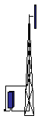


Train MS
Locomotive
Handheld MS
R-GSM BTS

- Different types of stations/users in GSM-R
Below Figure 5 shows an example of train-mounted MS antenna with its radiation pattern in vertical plain. It demonstrates that the effective antenna gain in horizontal plane may be even negative due to the fact that the antenna pattern is tilted upwards to provide better reception towards mast-mounted BTS antennas. In the horizontal plane the omni-directional radiation pattern shall be assumed.
The antennas used at GSM-R BTS are assumed not to be identical to those used in conventional GSM BTS. The antennas used at GSM-R have main beam of around 30 degrees and gain of up to 21 dBi. The signal is typically split between two antennas with a splitting loss of 3 dB and a cable loss of additional 3 dB, therefore an efficient antenna gain reduction of 6 dB may be assumed in order to calculate EIRP. With reference to a typical GSM-R systems in Germany as an example, this study shall use for SEAMCAT simulations the BTS antenna pattern based on the example of Kathrein Type 80010642 antenna (32^{O} half-power beamwidth in horizontal plane, 14^{O} in vertical plane, gain 17.6 dBi), shown in Figure 12 below.

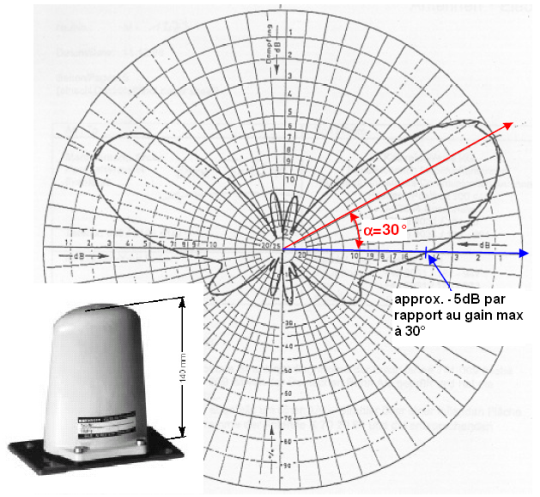
-5 dB compared with max radiation at +30^{O}
- Example of train-mounted GSM-R MS antenna and its vertical radiation pattern [11]

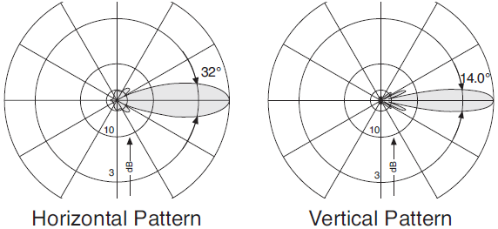
- Radiation pattern of directional GSM-R BTS antenna (ref. Kathrein Type 80010642)
It may be thus concluded that, from a deployment point of view, GSM-R networks have almost a linear structure along the railway tracks. However, the locally higher traffic demand close to railway traffic nodes requires a higher network density which also implies a reuse of radio frequencies in such traffic hot spots. Considering the limited number of radio channels available in the R/ER-GSM frequency bands, this leads to difficulty in radio network planning.
Details of the GSM-R RF performance and system parameters can be found in 3GPP technical specification TS45.005 [8]. The specific ETSI standard for GSM-R that incorporates GSM specifications by reference is EN 301 515 [9] and additionally the EIRENE requirements (SRS 15.1 and FRS 7.1) applies.
The main GSM-R system characteristics are summarized in Table below, as used in previous CEPT studies, such as ECC Report 96 [10] in combination with newest inputs from GSM-R community.
- Main GSM-R system parameters
Parameter | Values
Channel bandwidth, kHz | 200
Modulation | GMSK
BTS-MS Minimum Coupling Loss, dB | 60 (urban) / 70 (rural)
Considered transceiver types | BTS | Handheld MS | Train MS
Maximum Tx power, dBm | Up to 46 | 33 | 39
Thermal noise, dBm | -121
Rx noise figure, dB | 5 | 9 | 7
Noise floor, dBm | -116 | -112 | -114
Rx sensitivity, dBm | -104 | -102 | -104
Derived protection ratio C/(N+I), dB | 9 ⁽¹⁾ | 10 | 10
Antenna height above ground, m | 20 (urban)  20/45 (rural) | 1.5 | 4.5
Antenna gain, dBi | 18 | 0 | 0
Antenna down tilt, deg | 3 | NA | NA
Feeder loss, dB | 3 | 0 | 0
Splitter loss, dB | 3 | 0 | 0
Spurious emissions ⁽²⁾, dBm | -36 | -36 | -36
1. At the hand-over area a C/(N+I) of 12 dB is applied.
2. Based on 100 kHz. Measurement band depends on the carrier separation, which is defined in TS45.005 [8]

The unwanted emissions mask of GSM-R MS is assumed identical to that of regular GSM MS, and is depicted below.
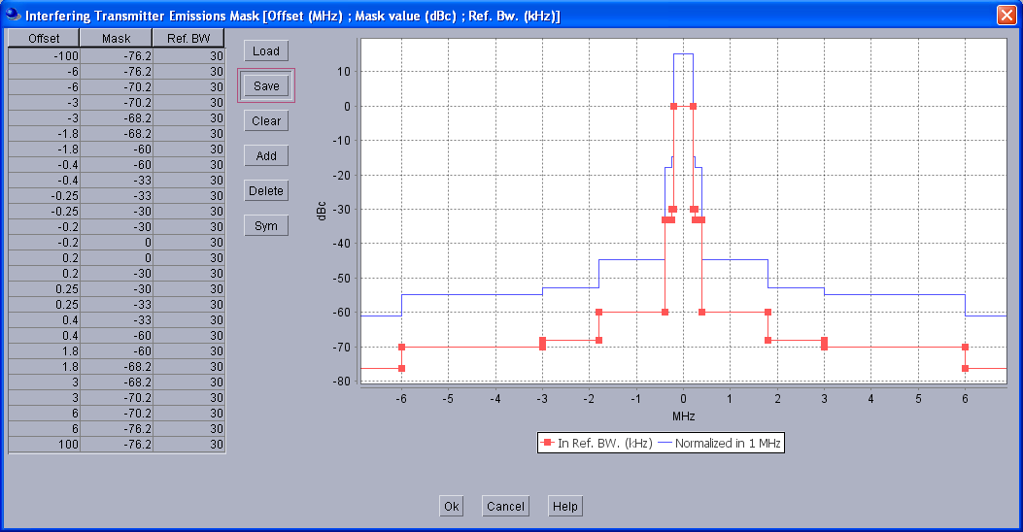
- Unwanted emissions mask of GSM-R MS (based on GSM MS specs)
Similarly, the unwanted emissions mask for GSM-R BTS is depicted below.
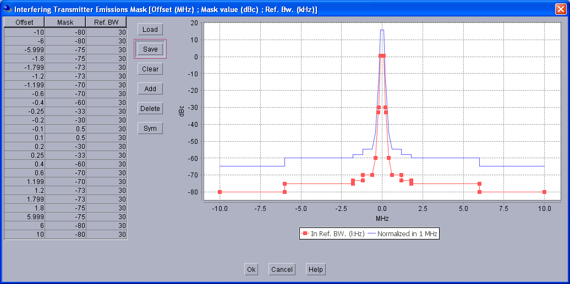
- Unwanted emissions mask of GSM-R BTS [10]
Blocking levels of GSM-R receivers are provided in tabular form in the below Table, showing the differences between the parameters of different GSM-R receiver types.
- Blocking levels (maximum tolerable interfering signal level) of GSM-R receivers, dBm/200kHz [10]
Frequency range | Handheld MS ⁽¹⁾ | Train MS ⁽²⁾ | BTS
|f-f_{o}| ≤ 100 kHz | -116 | -116 | -116
100 kHz < |f-f_{o}| < 300 kHz | -98 | -98 | -98
300 kHz ≤ |f-f_{o}| < 600 kHz | -66 | -66 | -66
600 kHz ≤ |f-f_{o}| < 800 kHz | -43 | -38 | -26
800 kHz ≤ |f-f_{o}| < 1.6 MHz | -43 | -33 | -16
1.6 MHz ≤ |f-f_{o}| < 3 MHz | -33 | -23 | -16
3 MHz ≤ |f-f_{o}| | -23 | -23 | -13
For OOB signals | 0 | 0 | 8

1. Understood to correspond to category “Small MS”
2. Understood to correspond to category “Other MS”

It is thus obvious, that co-existence studies involving GSM-R will have to take into account distinction between various types of transceivers, especially between two types of MS. The latter would have not only different RF parameters, but would also exhibit different deployment patterns.

GSM/LTE Cellular systems
Currently the band below 915 MHz is utilised by cellular 2G systems (GSM), for uplink transmissions from mobile units. In the medium-to-long term this spectrum will be gradually converted for use by broadband LTE technology. Meanwhile LTE deployment is already happening in the lower band 790-862 MHz, which was recently reallocated for broadband wireless systems after conversion of old analogue TV to more efficient digital TV technologies.
It therefore appears warranted to analyse adjacent band interference potential between broadband LTE transmissions in adjacent bands and SRD/RFID operation.
Due to their mode of operation the risk of interference from LTE could be significantly greater than from GSM devices. This is because they operate at much higher data rates and consequently require greater bandwidth, with consequently greater out-of-band emissions that may extend well into the adjacent bands.

The following parameters of LTE uplink were assumed in the study, based on information communicated by ECC PT1:

- LTE Uplink parameters and values used in simulations
 | LTE User Equipment Tx | LTE BS Rx
Bandwidth (MHz) | 10
APC/output power range (dBm) | -39…23 = 62 dB (Note) | n/a
Antenna Height (m) | 1.5 | 30
Antenna Gain (dBi) | 0 | 17
Number of active users | 1 to 5
Max no of Resource Blocks (RB) | 50
Cell size (km) | 0.35
Note: the lower UE output power taken from EN 301908-13.

For LTE User Equipment (UE) an omni-directional antenna with 0 dBi gain was assumed, whereas the BS receiver antenna was a typical 3GPP type 3-sector 120 deg beamwidth antenna. The LTE UE has automatic power control with following parameters:
- Step size – 1 dB;
- Min threshold -91 dBm;
- Dynamic range 62 dB.

The following LTE UE emissions mask was assumed, defined based on EN 301 908-13 specifications relative to in-band power of 23 dBm/9 MHz, but corrected for measurement uncertainty (1.5 dB) and LTE UE power tolerance (2.7 dB).

- Comparison of LTE UE OOB limits (channel bandwidth 10 MHz)
Δf_{OOB} (MHz) | Spectrum emission limit, dBm |  | Measurement bandwidth
Δf_{OOB} (MHz) | EN 301 908-13 | Corrected by measurement uncertainty power tolerance | Measurement bandwidth
±0 to 1 | -16,5 | -12.3 | 30 kHz
±1 to 2,5 | -8,5 | -4.3 | 1 MHz
±2,5 to 2,8 | -8,5 | -4.37 | 1 MHz
±2,8 to 5 | -8,5 | -4.37 | 1 MHz
±5 to 6 | -11,5 | -7.3 | 1 MHz
±6 to 10 | -11,5 | -7.3 | 1 MHz
±10 to 15 | -23,5 | -19.3 | 1 MHz

Similar previous studies for interference between LTE and SRD in other bands have identified the most critical co-existence scenario where LTE and SRD devices are closely co-located (same room scenario). Therefore only this scenario shall be considered in this report.

- Note: The Tx mask in Table 10 is pending on ongoing discussions between PT1 and SE24.

Tactical Radio Relay Systems
Tactical Radio Relay (TRR) systems are transportable fixed links used by military forces in some European countries in the frequency bands 870-876/915-921 MHz and in some cases within 870-880/915-925 MHz. Due to the tactical nature of their operation, their operational sites could not be coordinated in advance and therefore frequency coordination and sharing wise the TRR systems are akin to mobile systems.
As shown by the results of the recent CEPT questionnaire on the subject (May-June 2012), 10 out of 39 responding European administrations indicated that they designate the subject bands for military systems. Of those countries using these bands for military services, at least 5 intend to maintain military use in the near future, while 4 considered reducing the military use of the bands.
Typical RF parameters of TRR systems are presented in the Table below as taken from the previous CEPT studies presented in ECC Report 146 [12].
- Parameters of TRR systems [12]
Parameter | Value
Channel spacing | 750 kHz
Link distance | 30-70 km
Tx power | 37 dBm
Rx bandwidth | 1500 kHz
Rx sensitivity | -93 dBm
Required protection ratio (C/I) | 15 dB
Antenna height above ground | 25 m
Antenna gain (bore sight) | 16 dBi

Note that TRR user community proposed to also consider other protection criteria in this study, such as I/N (-6 dB, -10 dB, -20 dB).
An example of TRR antenna pattern is depicted below.
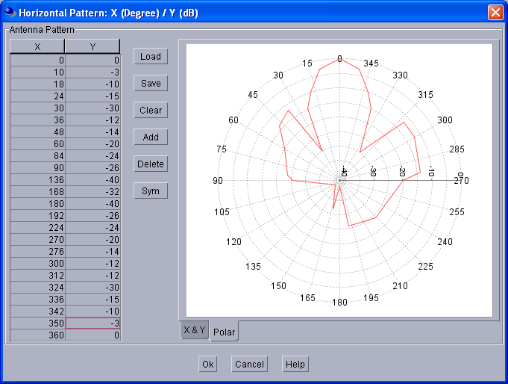
- Radiation pattern of TRR antenna [12]
For the considered example of TRR reference type based on STANAG 4212 agreement, the transmitter unwanted emissions mask is shown below. The receiver blocking function is shown in Figure 15.
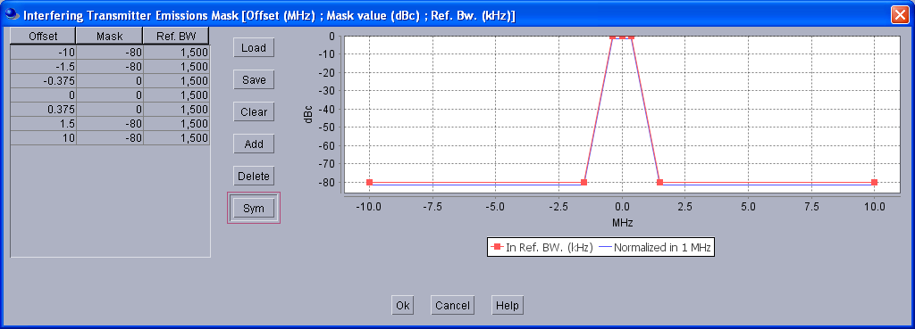
- Unwanted emissions mask of TRR (ref. STANAG-4212 [12])
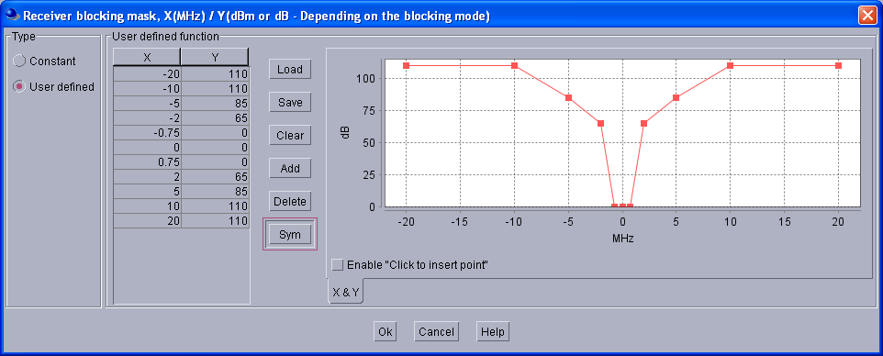
- Receiver blocking function of TRR (ref. STANAG-4212 [12])
During the simulations of this study, the TRR would be modelled as a PMR-like system, i.e. with one fixed central station and one transportable terminal.

Telecommand to Unmanned Aerial Vehicles
According to the findings of the CEPT questionnaire (May-June 2012), some European countries used the European designation of the frequency band 870-880 MHz and 915-921 MHz for Defence applications to deploy the wireless systems for remote controlling of Unmanned Aerial Vehicles (UAV), i.e. pilot-less aircraft. These systems are also referred to as Unmanned Aircraft Systems (UAS), see e.g. ITU-R Reports M.2171 and M.2233
The reported parameters of UAV systems as will be used in this study are presented in the Table below.
- Parameters of UAV transceivers
Parameter | Value
e.i.r.p. | 43 dBm (30-52 dBm)
Centre frequency of the tuning range | 874 MHz ⁽¹⁾
Width of the tuning range | 8 MHz
Tx/Rx channel bandwidth | 200 kHz ⁽²⁾
Rx noise figure | 5-6 dB
Rx sensitivity | -90 dBm
Required protection ratio (I/N) | - 6 dB ⁽³⁾
Antenna height agl (terrestrial/airborne) | 3/100…300 m
Antenna gain (terrestrial/airborne) | 3/0 dBi
1. Additional frequency will be considered in the 915-921 MHz band to suit possible requirements of some countries
2. ITU-R Report M.2171 estimates bit-rate of approx. 30 kbps for command-and-control communications with low flying UAS
3. Value confirmed by practical measurements

Only miniature UAV (also called micro Air Vehicles (MAVs) will be considered by the study in this report, that is, UAV flying at an altitude of up to 300 m.
Note that according ITU-R Report M.2171 also other frequency bands are envisaged for operation of UAV/UAS, such as (960-1 164 MHz and 5 000-5 150 MHz frequency bands for line-of-sight (LoS), 1 545-1 555 MHz, 1 610-1 626.5 MHz, 1 646.5-1 656.5 MHz, 5 030-5 091 MHz, 12/14 GHz and 20/30 GHz frequency bands for Beyond LoS). This broad range of frequencies may allow for certain redundancy of primary and back-up operational bands.

Governmental Telemetry Systems
According to the information received by this study, at least one European country plans to move wireless telemetry systems currently operated in the band 862-863 MHz and used by governmental agencies that provide emergency and rescue services, to the band 870-872 MHz. This move was conceived in order to avoid the anticipated danger of adjacent band interference from the newly deployed mobile services below 862 MHz.
Such governmental telemetry systems feature a number of fixed base stations and mobile units with omni-directional antennas and transmitting at a low duty cycle. The emissions from both fixed and mobile transmitters are FM-modulated bursty signals of 5 seconds to 1 minute duration. Each has a duty cycle of 0.1% to 3%, biased towards daytime and highest in the large cities.
Another special case of the same European country’s governmental telemetry operations is a breathing apparatus equipment (BA Telemetry) used by Fire Rescue services. Telemetry collects real-time data during incidents, allowing the continued monitoring of the air supply of each individual fire-fighter’s breathing apparatus and other data to assist the operational response to incidents. These systems also currently use the 862-863 MHz band and plan to be relocated to other bands in order to avoid interference from anticipated deployment of mobile services below 862 MHz’s. In the short term they are planned to be re-located to the frequency of 869.5 MHz and in the longer term further on to a new dedicated frequency within the 870-876 MHz band.
However, it was noted by the above mentioned European country’s administration that these nationally deployed systems would comply with general SRD requirements and therefore do not need a separate co-existence study.

Wind Profiler Radars
According to the information provided to this study, two Wind Profiler Radars (WPRs) are being operated at remote sites in the UK by the meteorological services using the frequency of 915 MHz. UK Administration considers it unlikely that any additional sites will be deployed in the UK at this frequency.
The technical parameters of WPR operated at 915 MHz are provided in the Table 12 below.

- Parameters of WPR at 915 MHz
Parameter | Value
Transmit power (average/peak) | 100/600 W
Pulse width | 0.4-2.8 µs
Pulse repetition frequency | 1-50 kHz
Tx/Rx channel bandwidth | 2500 kHz
Rx noise figure | 0.6 dB
kTBF | -146.2 dBW/MHz
Required protection ratio (I/N) | - 6 dB
Maximum interference level at receiver input | -152.2 dBW/MHz
Antenna height agl | 0 m
Antenna gain in the main beam | 26.3 dBi
Number of beams (see Fig. 21(a) | 5
Antenna elevation angle | 74.5° - 90°
Antenna radiation pattern (see Fig. 20) | 26.3 - 0.044 (1.1 + ϕ)^{2.83} ϕ < 6.66°  35 - 28.2 log(ϕ) 6.66° ≤ϕ < 80°  -18.7 80°≤ϕ

- Antenna pattern of WPR at 915 MHz
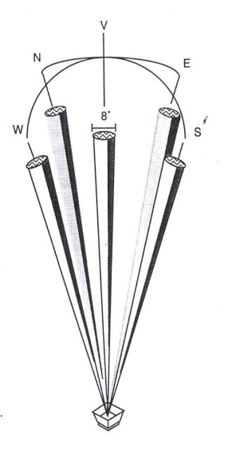
(a) (b)
- WPR antenna radiation pattern (a) and installation within screened enclosure (b)
Since SRDs are assumed to be ground based or near ground based, it is expected that compatibility with WPR will be controlled by the WPR relative antenna gain at horizon. Taking into account WPR antenna beam elevation ranging 74.5-90°, as illustrated by Fig. 21(a), and the antenna pattern shown in Fig. 20, the WPR relative gain at horizon will roughly range -17.7 to -18.7 dBi. It was agreed to consider an approximate figure of -18 dBi in the compatibility analysis.
In addition, as seen on figure 2 (b) above, the protection of WPR operations is improved by consideration of the fact that the installed WPRs are fitted within a screened enclosure intended to provide a high level of off-axis attenuation in order to limit at maximum the ground clutter to the radar. It is expected that this screened enclosure will also give an additional attenuation to the potential SRD interference on the horizontal plane. Based on results of ad hoc measurements on real WPR installations in the UK, this additional attenuation was estimated at 10 dB.

CO-EXISTENCE STUDIES IN 870-876 MHz BAND
This section presents the results of compatibility studies that were undertaken in the band 870-876 MHz, addressing both in-band and adjacent band co-existence issues. The particular considered SRD types and respective co-existence peer systems are presented as a series of relevant co-existence scenarios in the following sub-sections.

IN-BAND CO-EXISTENCE OF PROPOSED SRD AND GSM-R APPLICATIONS

Description of co-existence scenario
In this case the proposed SRD applications would have to co-exist with GSM-R deployment in the uplink part of “ER-GSM” frequency band 873-876 MHz. Illustration of the situation with the interference coupling paths is shown below (only two units and two types of SRD devices are shown to keep the picture simpler).



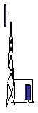

Train MS
Locomotive
Handheld MS
R-GSM BTS
Smart metering collector
Automotive SRD
Smart metering SRD
SRD to R-GSM interference direction
R-GSM to SRD interference direction

- In-band SRD vs. ER-GSM co-existence: wanted and interfering paths in 873-876 MHz
This means that the following two interference directions and cases should be studied:
- Multiple SRDs to ER-GSM BTS Rx
- Multiple ER-GSM MS (appropriate mix of handheld and train-mounted units) to SRD Rx

Geographically this situation could be modelled as a number of MSs (VLT) and SRDs (ILT and ILR) operated within a coverage sector (cell) of ER-GSM BTS (VLR), as shown in the figure below.

ER-GSM BTS
2-8 km
ER-GSM cell
- SRDs
- ER-GSM MSs

- Geographic representation of SRD vs. ER-GSM co-existence scenario in SEAMCAT
Note that in this scenario modelling the ER-GSM MS devices are being clustered along a single line representing the railway track. An example of how the above scenario would appear after being programmed in SEAMCAT is presented below.
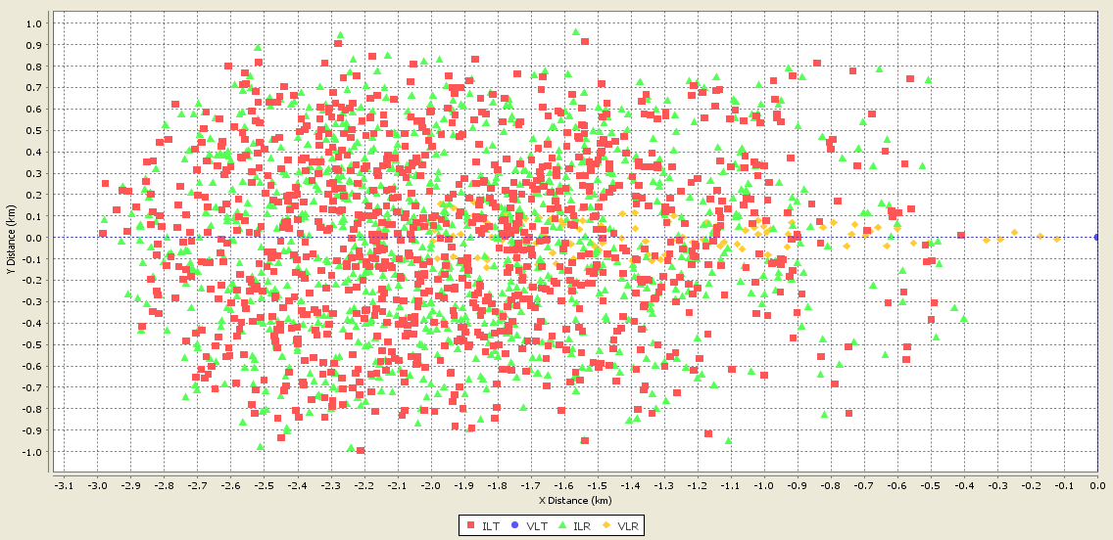
- Example of SEAMCAT simulation window: SRD to ER-GSM
It may be seen from the picture that the victim receivers are positioned along the central line with interfering devices clustered around them in the limits of the cell. Note that due to specific peculiarity of SEAMCAT (namely, that in graphical rendering the position of VLT is taken to correspond to (0;0) coordinates), it appears that BTS is moving with respect to the MS, not the other way around. This has no impact on the simulation results, because the true essence of simulations is the changing link distance and configuration, regardless of which transceiver in the pair moved and which was stationary.
In order to evaluate sensitivity of interference scenario to different types and densities of SRDs, the simulations will first look at interference from single type of SRD for a set of different densities. This would be then followed by a mixed scenario where several types of SRDs are sharing the same band.

Results of simulations
This sub-section describes the results of SEAMCAT simulations in power-level domain of the above described scenario of in-band interference between the different kinds of SRDs and ER-GSM.

Non-specific SRDs in the band
This case reflects upon the original vision in TR 102 649-2 [2] for placing non-specific SRDs in the lower part of the band 870-876 MHz, i.e. around 870-873…874 MHz (see Fig. 1 and Fig. 7), with the upper limit to be determined by the requirements derived from this sharing study. Therefore the following analysis will attempt to investigate the sensitivity of this sharing scenario to the changing upper limit of the operational range for non-specific SRDs by testing three upper limit values: 873 MHz, 874 MHz and 876 MHz.
Direction of interference: SRD to ER-GSM BTS receiver, no LBT used by SRD. The SRD transmitter parameters used in simulations correspond to those outlined in Table 1, including the DC of 1% and channel bandwidth of 600 kHz. It was assumed that non-specific SRDs would be predominantly deployed indoors, with deployment density in the order of 10-1000/km². Accordingly the lower bound was used for rural scenario and upper bound for urban. The Table XX below provides calculation of impact area and respective numbers of active interferers according to the procedure in section 3.1.3.
- Estimating impact area and number of active transmitters for Non-specific SRD case
Parameter | Rural scenario | Urban scenario
Frequency, f, GHz | 0.873 | 0.873
SRD interferer
Tx power, mW | 25 | 25
Receiver bandwidth, BWi, kHz | 200 | 200
Tx power normalised, dBm/BWi | 13.98 | 13.98
SRD uniform density, 1/sq.km | 10 | 1000
Duty Cycle, % | 1 | 1
GSM-R BS victim
Receiver bandwidth, BWv, kHz | 200 | 200
Sensitivity threshold, dBm/BWv | -104 | -104
Useful signal level above sensitivity, dB | 12 | 12
S/(I+N), dB | 9 | 9
Feeder loss, dB | 3 | 3
Splitter loss, dB | 3 | 3
Max permissible interference, dBm/BWv | -95 | -95
Receiver antenna gain, dBi | 18 | 18
Impact range and active interferers
Propagation exponent n ⁽¹⁾ | 2.5 | 3.5
Additional wall loss, Aw ⁽¹⁾, dB | 0 | 10
Calculated impact range (simulation radius), R ⁽¹⁾, m | 6704 | 280
Impact area, sq. km | 141 | 0.25
Number of active transmitters⁽²⁾ | 14 | 3

Note 1: Propagation model PL (dB) = 32.5 + 20*log(f [GHz])+n*10*log(R [m])+ Aw
Note 2: According to Formula 3-1

Note that in order to ensure consistency with SEAMCAT simulations, propagation exponents (2.5 for rural case and 3.5 for urban case) were chosen based on comparison with mean path loss curves obtainable from Extended Hata rural and urban models respectively, see Fig. XX below.
- Chosing propagation exponents to represent Extended Hata rural and urban modes
The complete results of the simulations for non-specific SRDs interference to ER-GSM are reported below, first for rural cell, then for urban cell configurations.

- Simulation results: non-specific SRDs to ER-GSM in RURAL scenario
 | Settings/Results
Simulation input/output parameters | Case I | Case II | Case III
Victim Link (VLK): ER-GSM uplink
Frequency | 873.2 MHz
VLR N | -116 dBm/200 kHz
VLR C/(N+I) threshold | 9 dB
VLR BS antenna (incl. feeder/splitter losses) | 12 dBi
VLR BS height | 45 m
VLR BS antenna down tilt | 3º
VLT power e.i.r.p. | 33 dBm
VLT → VLR path | Extended-Hata, rural, outd-outd/above roof, R=8 km
Interfering Link (ILK): Non-specific SRD
ILK Channel bandwidth | 600 kHz
ILT power e.i.r.p. | 14 dBm/600 kHz
ILT density | 10/km²
Simulation radius | 6.7 km
ILT probability of transmission | 0.01
ILT → VLR interfering path | Extended Hata, rural, ind-outd/below roof
ILT → VLR positioning mode | Uniform density
ILT → VLR minimum distance ⁽¹⁾ | 100 m
ILK: frequency range, MHz | 870-873 | 870.4-874 ⁽²⁾ | 870-876
ILT: number of active transmitters | 14 | 14 | 14
Simulation results
dRSS, dBm/200 kHz (Std.dev., dB) | -75 (11.5)
iRSS_{unwanted}, dBm/200 kHz (Std.dev., dB) | -128 (11.5) | -114.5 (13) | -120 (13.5)
Probability of interference, C/(N+I), % | 0.6 | 4.3 | 2.7
Probability of interference, C/(N+I), % (including blocking ) | 0.6 | 6.2 | 3.8
Note 1: minimum distance is also elsewhere in this report and within SEAMCAT settings referred to as “protection distance”, e.g. in this case as may be ensured by BTS’ and railways safety enclosures
Note 2: in this case the lower bound increased to make up the whole number of 600 kHz channels

- Simulation results: non-specific SRDs to ER-GSM in URBAN Scenario
 | Settings/Results
Simulation input/output parameters | Case I | Case II | Case III
Victim Link (VLK): ER-GSM uplink
Frequency | 873.2 MHz
VLR N | -116 dBm/200 kHz
VLR C/(N+I) threshold | 9 dB
VLR BS antenna (incl. feeder/splitter losses) | 12 dBi, 30º
VLR BS height | 20 m
VLR BS antenna down tilt | 3º
VLT power e.i.r.p. | 33 dBm
VLT → VLR path | Extended-Hata, urban, outd-outd/below roof, R=2 km
Interfering Link (ILK): Non-specific SRD
ILK Channel bandwidth | 600 kHz
ILT power e.i.r.p. | 14 dBm/600 kHz
ILT density | 1000/km²
Simulation radius | 0.3 km
ILT probability of transmission | 0.01
ILT → VLR interfering path | Extended Hata, urban, ind-outd/below roof
ILT → VLR positioning mode | Uniform density
ILT → VLR minimum distance | 100 m
ILK: frequency range, MHz | 870-873 | 870.4-874 ⁽¹⁾ | 870-876
ILT: number of active transmitters | 3 | 3 | 3
Simulation results
dRSS, dBm/200 kHz (Std.dev., dB) | -88.7 (12.1)
iRSS_{unwanted}, dBm/200 kHz (Std.dev., dB) | -135 (17) | -124 (19.5) | -129.5 (19.5)
Probability of interference, C/(N+I), % | 6.5 | 14.3 | 10.5
Probability of interference, C/(N+I), % (including blocking ) | 6.5 | 16.4 | 11.9
Note 1: in this case the lower bound increased to make up the whole number of 600 kHz channels

Note that the dRSS value of the ER-GSM link budget was modelled by SEAMCAT itself depending on randomised placement of handheld ER-GSM MS terminals within the victim BTS sector (30 degrees angle from BTS). Therefore this reflects the actual tendencies of dRSS performance in the real systems, such as the observation that the urban cell scenario exhibits lower dRSS values than in the rural open-space environment.
Another interesting observation from the above tables is that if the non-specific SRDs were allowed to infringe across the 873 MHz border line of ER-GSM sub-band, then it would make more sense to allow them operating across the entire band 870-876 MHz (in other words, upper limit of 876 MHz would be better than the considered previously 874 MHz). This may be explained by the fact, that the larger tuning range the non-specific SRDs have, the more evenly their random transmissions would be spread, thus minimising impact on any specific ER-GSM channel.
As regards the acceptable limit of probability of interference, it may be observed that the previous CEPT studies often inherently assumed the soft limit of 5% as acceptable. The origin of this specific number may probably be linked to the fact that originally SEAMCAT (and the whole Monte-Carlo concept) was brought into CEPT as a tool for evaluating interference to/from the early public cellular mobile systems, most notably - GSM, and those systems usually had licence obligation that operators should provide GOS - Grade of Service for mobile telephony of better than 5%, and on a similar line the rate of dropped calls of not more than 5%. So since then the 5% limit became a generally accepted interference cap for mobile networks and similar services.
Also the urban scenario of interference appears more critical (because of lower dRSS values, which are understood to correspond to real life situation) and therefore it shall be used in future simulations as a reference worst-case scenario.

The following text is a very preliminary and needs to be reviewed
Conclusion:

The above simulations may allow the following conclusions for SRDs with 25mW and 1% DC, 600kHz bandwidth, channel randomly chosen:
- Co-channel:
  - SRDs deployed in rural areas with a very low density of about 10/km² may be able to coexist with the GSM-R uplink;
  - however, these results are based on a statistical approach and in theory even one single SRD could be able to produce under worst case conditions (LOS) harmful interference to GSM-R;
  - SRDs deployed in urban areas with densities of about 1000/km² and without any mitigation mechanism additional to Duty Cycle cannot coexist with GSM-R, as even under optimistic assumptions the probability is above between 10%.
- Adjacent channel:
  - SRDs working restricted to the band 870-873 MHz and deployed in rural areas with a very low density of about 10/km² may be able to coexist with the GSM-R uplink
  - SRDs deployed below 873 MHz in urban areas may be exceeding interference threshold of 5% and therefore would need some additional mitigation mechanism or otherwise some additional protection band.

Specific SRDs in the band
In this case we consider the scenario envisaged to develop in the upper part of the band, where a mix of various specific SRD families is expected to co-exist (see Fig. 7). The table below lists the modelled representative mix of four different types of SRD, each having different output powers, bandwidth and DCs. It was prepared with due note of the overview of SRD requirements and typical deployment densities as discussed in sections 3.1.2 and 3.1.3. Note that in order to reflect the most pessimistic scenario, the applications with higher powers were chosen in a mix, with DC chosen as per principle shown in Table 2.
- Simulated mix of different types of SRD in the band 870-876 MHz
Interferer set | Power, mW | BW, kHz | Density, 1/km² | DC, % | Deployment
Alarms | 100 | 25 ⁽¹⁾ | 12 | 0.1 | Outdoor
Automotive (high power variety) | 500 | 500 ⁽²⁾ | 80 | 0.1 | Outdoor
Home automation/Sub-metering | 25 | 200 | 50000 | 0.0025 | Indoor
Metropolitan utilities (Smart Metering) | 500 | 200 | 3000 | 0.1 | Indoor
1. Emissions mask according Fig. B.4 in [2]
2. Emissions mask according Fig. B.5 in [2]

The respective sizes of impact areas and numbers of active devices to be used in the SEAMCAT simulations were derived in Table XX below according to the procedure in section 3.1.3 and noting urban deployment scenario, which was identified as more critical during simulations in previous sub-section.
- Estimating impact area and number of active transmitters for Specific SRDs
Parameter | Alarms | Home Automation | Smart Metering | Automotive high power
Frequency, f, GHz | 0.873 | 0.873 | 0.873 | 0.873
SRD interferer
Tx power, mW | 100 | 25 | 500 | 500
Receiver bandwidth, BWi, kHz | 200 | 200 | 200 | 200
Tx power normalised, dBm/BWi | 20 | 13.98 | 26.99 | 26.99
SRD uniform density, 1/sq.km | 12 | 50000 | 3000 | 80
Duty Cycle, % | 0.1 | 0.0025 | 0.1 | 0.1
GSM-R BS victim
Receiver bandwidth, BWv, kHz | 200 | 200 | 200 | 200
Sensitivity threshold, dBm/BWv | -104 | -104 | -104 | -104
Useful signal above sensitivity, dB | 12 | 12 | 12 | 12
S/(I+N), dB | 9 | 9 | 9 | 9
Feeder loss, dB | 3 | 3 | 3 | 3
Splitter loss, dB | 3 | 3 | 3 | 3
Max interference level, dBm/BWv | -95 | -95 | -95 | -95
Receiver antenna gain, dBi | 18 | 18 | 18 | 18
Impact range and active interferers
Propagation exponent n ⁽¹⁾ | 3.5 | 3.5 | 3.5 | 3.5
Additional wall loss, Aw ⁽¹⁾, dB | 0 | 10 | 10 | 0
Calculated impact range, R ⁽¹⁾, m | 804 | 280 | 659 | 1273
Impact area, sq. km | 2 | 0.25 | 1.4 | 5
Number of active transmitters⁽²⁾ | 1 | 1 | 4 | 1

- Propagation model PL (dB) = 32.5 + 20*log(f [GHz])+n*10*log(R [m])+ Aw
- According to formula 3-1

Below Figure 25 depicts outline of simulated SEAMCAT scenario.

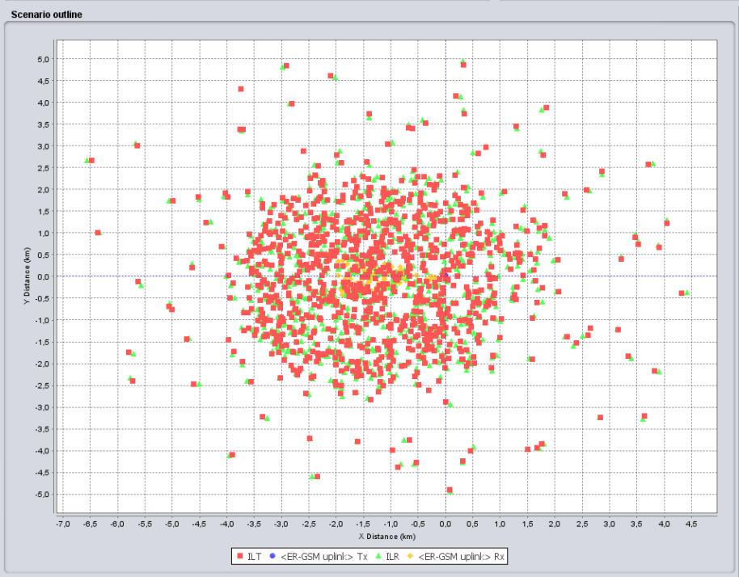
- Outline of the SEAMCAT simulation in this section
The results of simulations are reported in the following table. Noting the observation in the previous sub-section that extending operational range to the maximum might positively impact co-existence, it was decided to test here two cases of operational frequency range: one where specific SRDs were limited in the upper sub-band 873-876 MHz and the other one with using the entire band 870-876 MHz.

- Simulation results: representative mix of SRDs to ER-GSM Urban Cell
 | Settings/Results
Simulation input/output parameters | Case I | Case II
Victim Link (VLK): ER-GSM uplink
Frequency | 873.2 MHz
VLR N | -116 dBm/200 kHz
VLR C/(N+I) threshold | 9 dB
VLR BS antenna (incl. feeder/splitter losses) | 12 dBi, 30º
VLR BS height | 20 m
VLT power e.i.r.p. | 33 dBm
VLT → VLR path | Extended-Hata, urban, outd-outd/below roof, R=2 km
Interfering Link (ILK) #1: Metropolitan utilities (Smart Metering/M3N)
Channel bandwidth | 200 kHz
ILT power e.i.r.p. | 27 dBm/200 kHz
ILT density | 3000/km²
ILT number of active transmitters | 4
ILT probability of transmission | 0.001
ILT → VLR interfering path | Extended Hata, urban, ind-outd/below roof
ILK2: Home automation
Channel bandwidth | 200 kHz
ILT power e.i.r.p. | 14 dBm/200 kHz
ILT density | 50000/km²
ILT number of active transmitters | 1
ILT probability of transmission | 0.000025
ILT → VLR interfering path | Extended Hata, urban, ind-outd/below roof
ILK3: Alarms
Channel bandwidth | 25 kHz
ILT power e.i.r.p. | 20 dBm/25 kHz
ILT density | 12/km²
ILT number of active transmitters | 1
ILT probability of transmission | 0.001
ILT → VLR interfering path | Extended Hata, urban, outd-outd/below roof
ILK4: Automotive (high power variety)
Channel bandwidth | 500 kHz
ILT power e.i.r.p. | 27 dBm/500 kHz
ILT density | 80/km²
ILT number of active transmitters | 1
ILT probability of transmission | 0.001
ILT → VLR interfering path | Extended Hata, urban, outd-outd/below roof
General settings for all ILKs
ILT → VLR positioning mode | Uniform density
ILT → VLR minimum distance | 100 m
ILK frequency range | 873-876 MHz | 870-876 MHz
Simulation results
dRSS, dBm/200 kHz (Std.dev., dB) | -89 (15)
iRSS_{unwanted}, dBm/200 kHz (Std.dev., dB) | -121 (19.5) | -130 (18)
Probability of interference, C/(N+I), % | 15.8 | 10.8
Probability of interference, C/(N+I), % including blocking | 18.1 | 12.2

By considering results reported in the above table, it may be suggested that having a mix of different SRD families operating in the same frequency band relying solely on DC, i.e. without any additional mitigation techniques would produce probability of interference of between 15-18%. Expanding the operating range to include the entire band 870-876 MHz would reduce the probability of interference to around 10-12%.

- why are the results limited to specific SRDs and whats the difference between non-specific and specific; the mixed scenario here is similar to the 1000/km^2 non-specific simulations and therefore we needs to remain application neutral!

- Separate section on measurements;
- 4.1.2.3
The above results should be seen in the light of the practical tests that were carried out in November 2012 at Siemens’ Berlin laboratories to investigate the impact of interference from SRD operating in the same band as operational GSM-R radio links (ref. SE24 Doc. M68_06).
Investigations into the feasibility of sharing between SRDs and GSM-R bearers have shown that:
For transparent data bearers
Aggregate interference activity that can be withstood (both setting up calls and established bearers) into a victim operating towards the limit of its performance envelope lies between 15 and 25%. This appears to be true irrespective of the interfering power. The impact of the duration of individual transmissions is inconclusive, but keeping transmissions below 20ms would appear to be sensible.
Operation (up to 100% duty cycle) in adjacent and next adjacent channels is feasible, but the protection ratio (C/I) for the former should be at most -25 dB (eg -65 dBm adjacent channel interferer into a victim receiving -90 dBm) in order for calls to be able to be set up reliably. The protection ratio for next adjacent channel is -65 dB.
For voice bearers
Aggregate interference activity that can be withstood (both setting up calls and established bearers) into a victim operating towards the limit of its performance envelope lies around 10%. This appears to be true irrespective of the interfering power. Again, the impact of the duration of individual transmissions is inconclusive, but transmissions of up to 40 ms appear feasible.
Operation (up to 100% duty cycle) in adjacent and next adjacent channels is feasible with a protection ratio of at least -65 dB.
Comparing the results of practical stress tests allows making a conclusion that co-existence between a mix of application-specific SRDs and GSM-R might be feasible, because the simulated probability of interference lies within the tolerable limits observed during practical tests. However, the practically established limits on length of individual SRD transmissions (as verified during both Kolberg and Berlin tests) need to be observed during design and operation of respective SRD applications allowed to operate in co-channel mode in the band 873-876 MHz.

ADJACENT BAND CO-EXISTENCE AROUND 870-876 MHz
This section shall consider two sub-cases of adjacent band interference around 876 MHz that were identified as critical for co-existence. The first case will look at the interference from SRDs operated in the band 870-876 MHz into GSM-R system uplink above 876 MHz. The second case will consider interference potential from out-of-band emissions of broadband LTE systems deployed below 862 MHz into SRDs deployed in 870-876 MHz.

Adjacent band interference from SRD to GSM-R around 876 MHz

Description of co-existence scenario
Having completed the simulations reported in previous section 4.1, it would appear that the scenario of adjacent band co-existence around 876 MHz will represent a simplified sub-set of the same case. Indeed in this scenario the interference is again between R-GSM uplink and the SRDs and the only difference would be the shift of MS transmissions and BTS Victim receiver to adjacent R-GSM frequency. Otherwise the description of scenarios would be identical to what was depicted in Figures 16-17.
It may be therefore suggested that it should be sufficient to test here only one (the most severe in terms of interference potential) co-existence case of the different ones studied in the previous section. It would appear natural to use for that the Mixed SRD case, as reported in section 4.1.2.2.

Results of simulations
The results of simulations of the Mixed SRD use case in configuration of adjacent band interference are presented in Table below. The only difference in scenario settings from that of in-band interference in section 4.1.2.2 was that the operating frequency of R-GSM BTS victim receiver was set to 876.2 MHz, i.e. the nearest adjacent channel of the original R-GSM band.

- Simulation results: mix of SRDs to ER-GSM Urban Cell in ADJACENT BAND
 | Settings/Results
Simulation input/output parameters | Case I | Case II
Victim Link (VLK): ER-GSM uplink
Frequency | 876.2 MHz
VLR N | -116 dBm/200 kHz
VLR C/(N+I) threshold | 9 dB
VLR BS antenna (incl. feeder/splitter loss) | 12 dBi, 30º
VLR BS height | 20 m
VLT power e.i.r.p. | 33 dBm
VLT → VLR path | Extended-Hata, urban, outd-outd/below roof, R=2 km
Interfering Link (ILK) #1: Smart Metering
Channel bandwidth | 200 kHz
ILT power e.i.r.p. | 27 dBm/200 kHz
ILT density | 3000/km²
ILT number of active transmitters | 4
ILT probability of transmission | 0.001
ILT → VLR interfering path | Extended Hata, urban, ind-outd/below roof
ILK2: Home automation
Channel bandwidth | 200 kHz
ILT power e.i.r.p. | 14 dBm/200 kHz
ILT density | 50000/km²
ILT number of active transmitters | 1
ILT probability of transmission | 0.01
ILT → VLR interfering path | Extended Hata, urban, ind-outd/below roof
ILK3: Alarms
Channel bandwidth | 25 kHz
ILT power e.i.r.p. | 20 dBm/25 kHz
ILT density | 12/km²
ILT number of active transmitters | 1
ILT probability of transmission | 0.001
ILT → VLR interfering path | Extended Hata, urban, outd-outd/below roof
ILK4: Automotive
Channel bandwidth | 500 kHz
ILT power e.i.r.p. | 27 dBm/500 kHz
ILT density | 80/km²
ILT number of active transmitters | 1
ILT probability of transmission | 0.001
ILT → VLR interfering path | Extended Hata, urban, outd-outd/below roof
General settings for all ILKs
ILT → VLR positioning mode | Uniform density
ILT → VLR minimum distance | 100 m
ILK frequency range | 873-876 MHz | 870-876 MHz
Simulation results
dRSS, dBm/200 kHz (Std.dev., dB) | -88.5 (12.3)
iRSS_{unwanted}, dBm/200 kHz (Std.dev., dB) | -137.5 (13.5) | -138 (13.5)
Probability of interference, C/(N+I), % | 4.0 | 3.8
Probability of interference, C/(N+I), % + blocking | 4.0 | 3.8

Why is the result here different to section 4.1???? e.g. Table 16 with 6%
As seen in the table, the modelling shows that the probability of SRD interference to ER-GSM reception in the adjacent band is around 3-4% and does not much depend on the size of SRD operational sub-bands in the 870-876 MHz range. These results relate well with the results of practical testing [23] which showed that GSM-R receiver can tolerate presence of adjacent interfering signals exceeding the wanted signal by up to 25 dB in the first adjacent channel and up to 65 dB in the following. ????

Adjacent band interference from LTE below 862 MHz to SRD in 870-876 MHz

Description of co-existence scenario
The parameters of LTE uplink were listed in section 3.3. As mentioned there, in this report only one, most critical co-existence scenario shall be considered, namely the scenario of closely co-located LTE UE and SRD devices.
The configuration of this scenario is illustrated in the following figure.

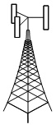
Interfering signal
Interferer:
LTE UE
Victim
SRD
LTE BS
LTE uplink
R_{LTE cell} = 350 m
R_{interference} = 0…10 m

- Adjacent band scenario: co-located LTE UE and SRD (“same room”)
This scenario may be considered quite typical since majority of LTE use (broadband data services) is expected to take place indoors. For this scenario only two representative victim SRD device families shall be considered, which are expected to be deployed completely (i.e. both transmitter and receiver) indoors, namely non-specific SRDs and Home Automation SRDs.

Results of simulations
The results of simulations from LTE UE deployed in the channel immediately adjacent to 862 MHz into SRDs deployed randomly across the band 870-876 MHz are depicted in the following table.
- Simulations of adjacent band interference from LTE below 862 MHz to SRD in 870-876 MHz
Simulation input/output parameters | Settings/Results
ILK: LTE UE
Frequency, MHz | 857.0
ILT power, dBm | 23 (APC range 62 dB)
ILT antenna gain and height | 0 dBi, 1.5 m agl
ILR antenna gain and height | 17 dBi, 30 m agl
ILT → ILR path | Random distance 50…350 m  Extended Hata model (Urban, ind-outd/above roof)
Victim Link - SRD Family Type: | Non-specific | Home Automation
Frequency, MHz | 870-876 | 870-876
VLT output power e.i.r.p., dBm | 14 | 14
VLR sensitivity, dBm | -91 | -96
VLR bandwidth, kHz | 600 | 200
VLR selectivity, dB | 42 | 47
VLR antenna gain and height | 0 dBi, 1.5 m agl
VLT → VLR wanted signal path | Random distance 0…40 m,  Hata-SRD model (Urban, ind-ind, below roof)
ILK → VLK positioning mode | “None”, random distance 0…10 m,  Hata-SRD model (Urban, ind-ind, below roof)
Simulation results
dRSS, dBm/Ch. BW | -72 (18)
iRSS_{unwanted}, dBm/Ch. BW | -91.5 (20) | -97 (20)
iRSS_{blocking}, dBm/Ch. BW | -93,5 (20) | -98.5 (20)
Probability of interf. (unw+block), C/I = 8 dB, % | 30 | 26

These results illustrate the observation that the broadband systems may affect systems in quite remote adjacent bands because their OOB emissions, if not sufficiently supressed, appear as in-channel noise increase and therefore could not be filtered out by victim receiver filter.

INTRA-SRD CO-EXISTENCE WITHIN 870-876 MHz

Description of co-existence scenario
In this co-existence case the subject of study is the interference potential amongst the different SRD families. Again taking stance in the studies reported in previous section, it would appear logical to shortcut the initial deliberations of partial cases and start the analysis from the most complex of considered scenarios, namely, the co-existence within the dense mix of several SRD device families.
Therefore this study will continue using the previous example of Mixed-SRD scenario in dense urban environment but will be in turn considering one of the subject SRDs as the victim, while three other SRD families will act as in-band interferers. Differently from the case of co-existence with ER-GSM, in this situation all interfering and victim devices shall be mixed in one random spot, as illustrated in the following figure that shows a screenshot of SEAMCAT simulation window for this scenario.

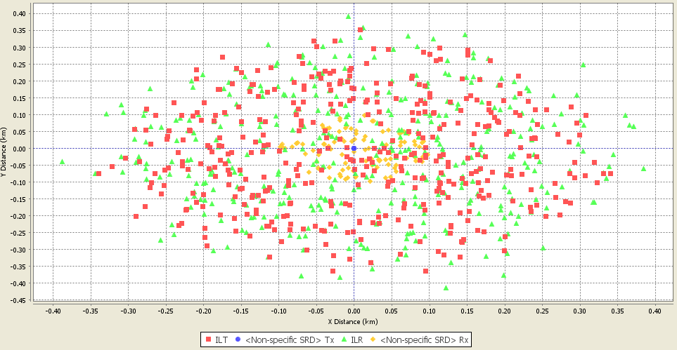
- Example of SEAMCAT simulation window: Intra-SRD co-existence scenario
Hata-SRD propagation path loss model shall be used in this scenario, as it is well suited to model propagation in cluttered environment between similarly low placed transceivers. However, when using this model it is required to set a hard ceiling on the maximum simulation distances, as this model is defined only up to 300 m (which is also natural assumption for intra-SRD impact range). Therefore in SEAMCAT scenario settings the “None” ILT-VLR placement mode was used because only this mode allows user to define maximum radius of simulations.
Another important related element is the derivation of number of active interfering transmitters within impact area of victim. The calculation method used for this purpose in previous sections 4.1-4.2 is not well suited here due to having a hard ceiling on maximum simulation area. Also in None placement mode there are no settings for respective densities and activity factors of interferers. Therefore, simulations reported in this section used a different approach to model the number of interferers and their activity:
  - the number of affecting interferers is derived by multiplying the area of 0.3 km² (which corresponds to simulation radius of 300 m) by the respective SRD density value:
    - Alarms: N=12/km² x 0.3 km² = 4
    - Home Automation: N=50000/km² x 0.3 km² = 15000
    - Smart Metering: N=3000/km² x 0.3 km² = 900
    - Automotive (high power): N=80/km² x 0.3 km² = 24
    - Non-specific SRDs: N=1000/km² x 0.3 km² = 300
  - the activity factor of respective interferer is set through transmit power distribution function (full power for the probability of time equal to DC, -200 dBm for the remaining time).
Due to close physical placement of interferers and victims and noting that various SRD families will have different output power levels, the study will also consider possibility of RF blocking interference mode.
Note that in all following simulations no activity-periods/DC impact was considered on the victim, i.e. it was “receptive to interference” constantly, without any sleep time or similar inactivity periods.
Further particular details of the various parameter settings are reported in the simulation tables in the following section.

Results of simulations
The following tables show the results of simulations for urban Mixed SRD scenario by considering different representative non-specific and specific SRD families as victims.

- Intra-SRD co-existence simulation results: Non-specific SRD as a victim
Simulation input/output parameters | Settings/Results
VLK: Non-specific SRD
Frequency | 870-876 MHz, 0.6 MHz steps
VLR sensitivity | -91 dBm/600 kHz
VLR selectivity | 42 dB
VLR C/I threshold | 8 dB
VLR/Tx antenna | 0 dBi, Non-directional
VLR/Tx antenna height | 1.5 m
VLK Tx power e.i.r.p. | 14 dBm/600 kHz
VLK Tx → Rx path | Hata-SRD, urban, ind-ind/below roof, R=0.04 km
ILK1: Smart Metering
Frequency | 870-876 MHz, 0.2 MHz steps
ILT power e.i.r.p. | 27 dBm/200 kHz
ILT probability of transmission | 0.1%
ILT → VLR interfering path | Hata-SRD, urban, ind-ind/below roof
ILT → VLR minimum distance | 0 m
ILT → VLR positioning mode | None (simulation radius 300 m)
ILT density | 3000/km²
Number of active transmitters | 900
ILK2: Portable Alarms
Frequency | 870-876 MHz, 0.025 MHz steps
ILT power e.i.r.p. | 20 dBm/25 kHz
ILT probability of transmission | 0.1%
ILT → VLR interfering path | Hata-SRD, urban, outd-ind/below roof
ILT → VLR minimum distance | 0 m
ILT → VLR positioning mode | None (simulation radius 300 m)
ILT density | 12/km²
Number of active transmitters | 4
ILK3: Automotive
Frequency | 870-876 MHz, 0.5 MHz steps
ILT power e.i.r.p. | 27 dBm/500 kHz
ILT probability of transmission | 0.1%
ILT → VLR interfering path | Hata-SRD, urban, outd-ind/below roof
ILT → VLR minimum distance | 0 m
ILT → VLR positioning mode | None (simulation radius 300 m)
ILT density | 80/km²
Number of active transmitters | 24
ILK4: Home Automation/Sub-Metering applications
Frequency | 870-876 MHz, 0.2 MHz steps
ILT power e.i.r.p. | 14 dBm/200 kHz
ILT probability of transmission | 0.0025%
ILT → VLR interfering path | Hata-SRD, urban, ind-ind/below roof
ILT → VLR minimum distance | 0 m
ILT → VLR positioning mode | None (simulation radius 300 m)
ILT density | 50000/km²
Number of active transmitters | 15000
Simulation results
dRSS, dBm/600 kHz (Std.dev., dB) | -72 (18)
iRSS_{unwanted}, dBm/600 kHz (Std.dev., dB) | -155.3 (56)
iRSS_{blocking}, dBm/600 kHz (Std.dev., dB) | 154.9 (56)
Probability of interference (unwanted and blocking modes), C/I, % | 4.5

- Intra-SRD co-existence simulation results: Portable Alarms SRD as a victim
Simulation input/output parameters | Settings/Results
VLK: Portable Alarms
Frequency | 870-876 MHz, 0.025 MHz steps
VLR sensitivity | -105 dBm/25 kHz
VLR selectivity | 50 dB
VLR C/I threshold | 8 dB
VLR/Tx antenna | 0 dBi, Non-directional
VLR/Tx antenna height | 1.5 m
VLK Tx power e.i.r.p. | 20 dBm/25 kHz
VLK Tx → Rx path | Hata-SRD, urban, outd-outd/below roof, R=0.1 km ⁽¹⁾
ILK1: Smart Metering
Frequency | 870-876 MHz, 0.2 MHz steps
ILT power e.i.r.p. | 27 dBm/200 kHz
ILT probability of transmission | 0.1%
ILT → VLR interfering path | Hata-SRD, urban, ind-outd/below roof
ILT → VLR minimum distance | 0 m
ILT → VLR positioning mode | None (simulation radius 300 m)
ILT density | 3000/km²
Number of active transmitters | 900
ILK2: Non-specific SRDs
Frequency | 870-876 MHz, 0.6 MHz steps
ILT power e.i.r.p. | 14 dBm/600 kHz
ILT probability of transmission | 1%
ILT → VLR interfering path | Hata-SRD, urban, ind-outd/below roof
ILT → VLR minimum distance | 0 m
ILT → VLR positioning mode | None (simulation radius 300 m)
ILT density | 1000/km²
Number of active transmitters | 300
ILK3: Automotive
Frequency | 870-876 MHz, 0.5 MHz steps
ILT power e.i.r.p. | 27 dBm/500 kHz
ILT probability of transmission | 0.1%
ILT → VLR interfering path | Hata-SRD, urban, outd-outd/below roof
ILT → VLR minimum distance | 0 m
ILT → VLR positioning mode | None (simulation radius 300 m)
ILT density | 80/km²
Number of active transmitters | 24
ILK4: Home Automation/Sub-Metering applications
Frequency | 870-876 MHz, 0.2 MHz steps
ILT power e.i.r.p. | 14 dBm/200 kHz
ILT probability of transmission | 0.0025%
ILT → VLR interfering path | Hata-SRD, urban, ind-outd/below roof
ILT → VLR minimum distance | 0 m
ILT → VLR positioning mode | None (simulation radius 300 m)
ILT density | 50000/km²
Number of active transmitters | 15000
Simulation results
dRSS, dBm/25 kHz (Std.dev., dB) | -55 (14)
iRSS_{unwanted}, dBm/25 kHz (Std.dev., dB) | -116 (26)
iRSS_{blocking}, dBm/25 kHz (Std.dev., dB) | -120 (24)
Probability of interference (unwanted and blocking modes), C/I, % | 3.2
Note 1: note that in this case victim’s normal operational (simulation) radius is assumed equal 100 m because as established in 4.1.2.2, the Alarms here are considered to be of “Portable Alarms” variety, as described e.g. in A.3.1.2 of TR 102 649-2, i.e. devices worn by people, such as over factory area, hospital area or similar. It is important not to mix them with various kinds of domestic alarms, such as smoke detectors, intruder alarms etc, which are considered in these simulations as being part of Home Automation family with indoor usage at distances of up to 40 m.

- Intra-SRD co-existence simulation results: Smart Metering SRD as a victim
Simulation input/output parameters | Settings/Results
VLK: Smart Metering
Frequency | 870-876 MHz, 0.2 MHz steps
VLR sensitivity | -96 dBm/200 kHz
VLR selectivity | 47 dB
VLR C/I threshold | 8 dB
VLR/Tx antenna | 0 dBi, Non-directional
VLR/Tx antenna height | 1.5 m
VLK Tx power e.i.r.p. | 27 dBm/200 kHz
VLK Tx → Rx path | Hata-SRD, urban, ind-outd/below roof, R=0.1 km ⁽¹⁾
ILK1: Portable Alarms
Frequency | 870-876 MHz, 0.025 MHz steps
ILT power e.i.r.p. | 20 dBm/25 kHz
ILT probability of transmission | 0.1%
ILT → VLR interfering path | Hata-SRD, urban, outd-outd/below roof
ILT → VLR minimum distance | 0 m
ILT → VLR positioning mode | None (simulation radius 300 m)
ILT density | 12/km²
Number of active transmitters | 4
ILK2: Non-specific SRDs
Frequency | 870-876 MHz, 0.6 MHz steps
ILT power e.i.r.p. | 14 dBm/600 kHz
ILT probability of transmission | 1%
ILT → VLR interfering path | Hata-SRD, urban, ind-outd/below roof
ILT → VLR minimum distance | 0 m
ILT → VLR positioning mode | None (simulation radius 300 m)
ILT density | 1000/km²
Number of active transmitters | 300
ILK3: Automotive
Frequency | 870-876 MHz, 0.5 MHz steps
ILT power e.i.r.p. | 27 dBm/500 kHz
ILT probability of transmission | 0.1%
ILT → VLR interfering path | Hata-SRD, urban, outd-outd/below roof
ILT → VLR minimum distance | 0 m
ILT → VLR positioning mode | None (simulation radius 300 m)
ILT density | 80/km²
Number of active transmitters | 24
ILK4: Home Automation/Sub-Metering applications
Frequency | 870-876 MHz, 0.2 MHz steps
ILT power e.i.r.p. | 14 dBm/200 kHz
ILT probability of transmission | 0.0025%
ILT → VLR interfering path | Hata-SRD, urban, ind-outd/below roof
ILT → VLR minimum distance | 0 m
ILT → VLR positioning mode | None (simulation radius 300 m)
ILT density | 50000/km²
Number of active transmitters | 15000
Simulation results
dRSS, dBm/200 kHz (Std.dev., dB) | -61 (16)
iRSS_{unwanted}, dBm/200 kHz (Std.dev., dB) | -118 (33)
iRSS_{blocking}, dBm/200 kHz (Std.dev., dB) | -127 (30)
Probability of interference (unwanted and blocking modes), C/I, % | 5.0
Note 1: note that in this case victim’s normal operational (simulation) radius is extended from 40 m to 100 m in order to justify requested increased power of 27 dBm.

- Intra-SRD co-existence simulation results: Automotive SRD as a victim
Simulation input/output parameters | Settings/Results
VLK: Automotive
Frequency | 870-876 MHz, 0.5 MHz steps
VLR sensitivity | -92 dBm/500 kHz
VLR selectivity | 43 dB
VLR C/I threshold | 8 dB
VLR/Tx antenna | 0 dBi, Non-directional
VLR/Tx antenna height | 0.5 m
VLK Tx power e.i.r.p. | 27 dBm/500 kHz
VLK Tx → Rx path | Hata-SRD, urban, outd-outd/below roof, R=0.1 km ⁽¹⁾
ILK1: Portable Alarms
Frequency | 870-876 MHz, 0.025 MHz steps
ILT power e.i.r.p. | 20 dBm/25 kHz
ILT probability of transmission | 0.1%
ILT → VLR interfering path | Hata-SRD, urban, outd-outd/below roof
ILT → VLR minimum distance | 0 m
ILT → VLR positioning mode | None (simulation radius 300 m)
ILT density | 12/km²
Number of active transmitters | 4
ILK2: Non-specific SRDs
Frequency | 870-876 MHz, 0.6 MHz steps
ILT power e.i.r.p. | 14 dBm/600 kHz
ILT probability of transmission | 1%
ILT → VLR interfering path | Hata-SRD, urban, ind-outd/below roof
ILT → VLR minimum distance | 0 m
ILT → VLR positioning mode | None (simulation radius 300 m)
ILT density | 1000/km²
Number of active transmitters | 300
ILK3: Smart Metering
Frequency | 870-876 MHz, 0.2 MHz steps
ILT power e.i.r.p. | 27 dBm/200 kHz
ILT probability of transmission | 0.1%
ILT → VLR interfering path | Hata-SRD, urban, ind-outd/below roof
ILT → VLR minimum distance | 0 m
ILT → VLR positioning mode | None (simulation radius 300 m)
ILT density | 3000/km²
Number of active transmitters | 900
ILK4: Home Automation/Sub-Metering applications
Frequency | 870-876 MHz, 0.2 MHz steps
ILT power e.i.r.p. | 14 dBm/200 kHz
ILT probability of transmission | 0.0025%
ILT → VLR interfering path | Hata-SRD, urban, ind-outd/below roof
ILT → VLR minimum distance | 0 m
ILT → VLR positioning mode | None (simulation radius 300 m)
ILT density | 50000/km²
Number of active transmitters | 15000
Simulation results
dRSS, dBm/500 kHz (Std.dev., dB) | -46 (16)
iRSS_{unwanted}, dBm/500 kHz (Std.dev., dB) | -106 (27)
iRSS_{blocking}, dBm/500 kHz (Std.dev., dB) | -110 (27)
Probability of interference (unwanted and blocking modes), C/I, % | 3.7
Note 1: note that in this case victim’s normal operational (simulation) radius is extended from 40 m to 100 m in order to justify requested increased power of 27 dBm.

- Intra-SRD co-existence simulation results: Home Automation SRD as a victim
Simulation input/output parameters | Settings/Results
VLK: Home Automation/Sub-Metering Applications
Frequency | 870-876 MHz, 0.2 MHz steps
VLR sensitivity | -96 dBm/200 kHz
VLR selectivity | 47 dB
VLR C/I threshold | 8 dB
VLR/Tx antenna | 0 dBi, Non-directional
VLR/Tx antenna height | 1.5 m
VLK Tx power e.i.r.p. | 14 dBm/200 kHz
VLK Tx → Rx path | Hata-SRD, urban, ind-ind/below roof, R=0.04 km
ILK1: Portable Alarms
Frequency | 870-876 MHz, 0.025 MHz steps
ILT power e.i.r.p. | 20 dBm/25 kHz
ILT probability of transmission | 0.1%
ILT → VLR interfering path | Hata-SRD, urban, outd-ind/below roof
ILT → VLR minimum distance | 0 m
ILT → VLR positioning mode | None (simulation radius 300 m)
ILT density | 12/km²
Number of active transmitters | 4
ILK2: Non-specific SRDs
Frequency | 870-876 MHz, 0.6 MHz steps
ILT power e.i.r.p. | 14 dBm/600 kHz
ILT probability of transmission | 1%
ILT → VLR interfering path | Hata-SRD, urban, ind-ind/below roof
ILT → VLR minimum distance | 0 m
ILT → VLR positioning mode | None (simulation radius 300 m)
ILT density | 1000/km²
Number of active transmitters | 300
ILK3: Smart Metering
Frequency | 870-876 MHz, 0.2 MHz steps
ILT power e.i.r.p. | 27 dBm/200 kHz
ILT probability of transmission | 0.1%
ILT → VLR interfering path | Hata-SRD, urban, ind-ind/below roof
ILT → VLR minimum distance | 0 m
ILT → VLR positioning mode | None (simulation radius 300 m)
ILT density | 3000/km²
Number of active transmitters | 900
ILK4: Automotive
Frequency | 870-876 MHz, 0.5 MHz steps
ILT power e.i.r.p. | 27 dBm/500 kHz
ILT probability of transmission | 0.1%
ILT → VLR interfering path | Hata-SRD, urban, outd-ind/below roof
ILT → VLR minimum distance | 0 m
ILT → VLR positioning mode | None (simulation radius 300 m)
ILT density | 80/km²
Number of active transmitters | 24
Simulation results
dRSS, dBm/200 kHz (Std.dev., dB) | -72 (18)
iRSS_{unwanted}, dBm/200 kHz (Std.dev., dB) | -122 (30)
iRSS_{blocking}, dBm/200 kHz (Std.dev., dB) | -129 (29)
Probability of interference (unwanted and blocking modes), C/I, % | 6.8

It may be concluded from the above reported simulation results of several intra-SRD interference case studies, that in general the prospects of intra-SRD co-existence appear to be cautiously good with interference probabilities around the borderline of acceptable, i.e. between 3-7%, even for very dense urban deployment scenarios and without assuming band segmentation or any special co-existence requirements except the intrinsic operational DC limits.
However, it may be seen that especially the lower powered applications, such as Non-specific SRDs or Home Automation/Sub-Metering devices with transmit powers on the order of 25 mW, might suffer interference from higher power SRD neighbours. Therefore implementation of additional mitigation mechanisms would be helpful to drive the probability of interference safely below 5% objective limit. More detailed consideration of this issue would require knowing the ultimate choice of mitigation techniques for SRDs, as demanded by co-existence requirements put up by radiocommunication services, such as GSM-R, TRR and UAV.
[AP from 2012-11-16 GoTo mtg.: ET and RF will exchange each other some rationale information to better understand and describe about APC and DAA in general that it might be relevant to above cases too. Also better description to fix questions/responses as above. The material should be then incorporated into working draft Report, as relevant, and passed to WI-41 D.G. accordingly.
ET: action in progress]

CO-EXISTENCE WITH OTHER SYSTEMS IN THE BAND 870-876 MHz

Co-existence with Tactical Radio Relays
This sub-section will consider co-existence of SRD applications with the legacy Tactical Radio Relay (TRR) systems that are used in some European countries.

Parameters and use of TRR
The main radio parameters of TRR systems were given in section 3.4, with reference to STANAG – an interoperability agreement for use of specific equipment type (not to be mixed up with the ETSI standard). As regards the operational usage, the TRR systems are used exclusively by military, i.e. for establishing tactical transportable links to the remote military units. As such, during times of peace such systems would be mostly used for military exercises in designated but not necessarily enclosed/fenced areas and also for Public Protection & Disaster Relief operations in public areas.
It may be possible in some cases that (i.e. not war, nor military exercise area, nor some disaster) the use of TRR and civil radiocommunications devices would be geographically separated. This concept was introduced for TRR co-existence studies reported in ECC Report 34 under the name of “population pockets”, see figure below for illustration.

TRR use area

R=35 km
Civil use area, i.e. “population pocket”
Gap

- Illustration of civil-use “population pockets” vs. TRR use areas
The radius of TRR deployment area is chosen at 35 km, which corresponds to typical link distance.

TRR vs. SRD co-existence scenarios
In order to analyse co-existence between TRR and SRD, this study would have to consider the case of in-band (co-channel) operation of TRR and SRD within the band 870-876 MHz. Two principal scenarios will be considered to judge the boundaries of the co-existence problem. First scenario will be based on the concept of “population pockets” would be used, as illustrated in Fig. 20 above. Previous studies had addressed different gap sizes. As a worst case assumption, in this study it was proposed to consider gap size of 0 km, primarily because in dense European environments the military exercise areas may be very closely interspersed with civil areas.
Moreover, the TRR user community contributing to this study indicated that TRR links may be established to the predefined spots that are outside the military exercise areas. To model such an occurrence, the second scenario will be used where the victim receiver of the stationary TRR link is placed right in the middle of the SRD deployment area, as was used with the GSM-R BTS in section 4.1.
The resulting representation of two scenarios in SEAMCAT is illustrated by simulation window screenshots in the figure below.
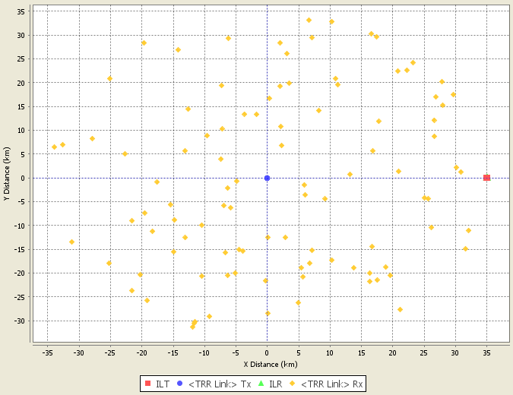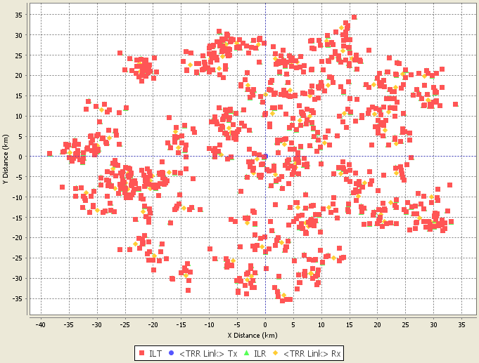
(a) (b)
- Illustration of TRR vs. SRD simulation scenarios: (a) SRD civil-use “population pockets” vs. TRR in military exercise area; (b) TRR victim surrounded by SRD devices
Note that in the first screenshot of this figure the interferers – the pocket of SRD use – registers just as one large red dot, due to very large scale of the simulation field.

In order to model such displaced operational areas, in the first scenario with “population pockets” the Interferer to Victim placement has to follow the so called “Correlated” modes in SEAMCAT scenario setting. In this placement mode each modelled Interfering link can only have one active transmitter. So for this scenario only one transmitter is active in each link, but they are made to operate with DC=100%, thus effectively representing a larger population of devices, e.g. for SRD devices with nominal DC=0.1% this would represent a populace of 1000 active devices.
- For the second scenario with TRR victim surrounded by the SRD devices, the Uniform placement mode could be used. The corresponding numbers of simultaneously active devices of the representative mix of SRD families were assumed to be 1/3 of the values derived for simulations in section 4.1.2.2. This was to account for the fact that in this scenario we consider rural/sub-urban case as opposed to urban case considered in 4.1.2.2. Except for the automotive applications, since the roads are omnipresent and the used value of SRD density is based on a pan-Euorpean average.

Results of simulations
The following table describes the SEAMCAT scenario settings and corresponding results of simulations of interference from mixed SRD use into a TRR link for the two above described deployment scenarios: SRDs operating in “population pocket” immediately adjacent to military exercise area (Case I in the table) and the TRR victim being in the centre of the SRD deployment area (Case II).

- Simulation results: mix of SRDs to TRR links
 | Settings/Results
Simulation input/output parameters | Case I  (Adjacent areas) | Case II  (Same operation area)
VLK: TRR Link (reference type as per STANAG-4212 agreement [12])
Frequency | 875.25 MHz
VLR sensitivity | -93 dBm/1500 kHz
VLR antenna | 16 dBi
VLR height | 25 m
VLK Tx power e.i.r.p. | 37 dBm
VLK Tx → Rx path | Extended-Hata, rural, outd-outd/above roof, R=35 km
ILK1: Metropolitan utilities (Smart Metering/M3N)
Frequency | 870-876 MHz, 0.2 MHz steps
ILT power e.i.r.p. | 27 dBm/200 kHz
ILK → VLK interfering path | Extended Hata, rural, ind-outd/below roof
ILK → VLK positioning mode | Correlated:  VLT → ILR = 35 km | Uniform density, 1 km protection distance
ILT density | Not applicable | 1000/km²
ILT probability of transmission | 1.0 | 0.001
ILT: number of active transmitters | 1 | 19
ILK2: Home automation
Frequency | 870-876 MHz, 0.2 MHz steps
ILT power e.i.r.p. | 14 dBm/200 kHz
ILK → VLK interfering path | Extended Hata, rural, ind-outd/below roof
ILK → VLK positioning mode | Correlated:  VLT → ILR = 35 km | Uniform density around VLR
ILT density | Not applicable | 17000/km²
ILT probability of transmission | 1.0 | 0.000025
ILT: number of active transmitters | 1 | 1
ILK3: Alarms
Frequency | 870-876 MHz, 0.025 MHz steps
ILT power e.i.r.p. | 20 dBm/25 kHz
ILK → VLK interfering path | Extended Hata, rural, outd-outd/below roof
ILK → VLK positioning mode | Correlated:  VLT → ILR = 35 km | Uniform density, 1 km protection distance
ILT density | Not applicable | 12/km²
ILT probability of transmission | 1.0 | 0.001
ILT: number of active transmitters | 1 | 1
ILK4: Automotive (high power variety)
Frequency | 870-876 MHz, 0.5 MHz steps
ILT power e.i.r.p. | 27 dBm/500 kHz
ILK → VLK interfering path | Extended Hata, rural, outd-outd/above roof
ILK → VLK positioning mode | Correlated:  VLT → ILR = 35 km | Uniform density, 1 km protection distance
ILT density | Not applicable | 80/km²
ILT probability of transmission | 1.0 | 0.001
ILT: number of active transmitters | 1 | 7
Simulation results
dRSS, dBm/1500 kHz (Std.dev., dB) | -50.2 (11)
iRSS_{unwanted}, dBm/1500 kHz (Std.dev., dB) | -148.9 (20) | -77.5 (10)
Probability of interference, C/I = 15 dB, % | 0.0 | 19.6
Probability of interference, I/N = -6 dB, % | 4.0 | 100.0
Probability of interference, I/N = -20 dB, % | 20.0 | 100.0
Note 1: STANAG-4212 is an agreement, which defines interoperability parameters and is often the least common denominator between TRR equipment of different nations. National systems can differ significantly from a STANAG as long as they can fulfil the STANAG requirements.

The results of simulations provided in this table indicate that there would be small risk of interference from SRDs to TRR use only if they were restricted to dedicated military exercise areas (Case I). Note that the result for the interference criteria of I/N=-20 dB may be seen as a conservative assumption, given the anticipated immunity of TRR equipment to withstand the hostile interference environments of modern warfare. If TRR were to be deployed in the same areas as SRD (Case II in the above table), the simulation results indicate clearly the high interference levels, unless some additional co-existence arrangements and interference mitigation techniques are implemented.
The first measure that could be considered is introduction of Automated Power Control (APC), which is logical precaution mechanism especially for the cases of SRDs allowed higher power up to 500 mW. To model the effect of this mechanism on interference potential, the APC range of 20 dB was assumed for SRDs, with sensitivity threshold set to (RX_{sens}+10 dB). The results of simulations with APC are shown in the below table.
- Simulation results: mix of SRDs (with APC mechanism) to TRR links
 | Settings/Results
Simulation input/output parameters | Case I  (Adjacent areas) | Case II  (Same operation area)
VLK: TRR Link (reference type as per STANAG-4212 agreement [12])
Frequency | 875.25 MHz
VLR sensitivity | -93 dBm/1500 kHz
VLR antenna | 16 dBi
VLR height | 25 m
VLK Tx power e.i.r.p. | 37 dBm
VLK Tx → Rx path | Extended-Hata, rural, outd-outd/above roof, R=35 km
ILK1: Metropolitan utilities (Smart Metering/M3N)
Frequency | 870-876 MHz, 0.2 MHz steps
ILT power e.i.r.p. | 27 dBm/200 kHz
APC threshold and range/step | -86 dBm/200 kHz; range 20 dB, step 2 dB
ILT → ILR path | 0…0.3 km, rural`? ind-outd/below roof
ILK → VLK interfering path | Extended Hata, rural, ind-outd/below roof
ILK → VLK positioning mode | Correlated:  VLT → ILR = 35 km | Uniform density, 1 km protection distance
ILT density | Not applicable | 1000/km²
ILT probability of transmission | 1.0 | 0.001
ILT: number of active transmitters | 1 | 19
ILK2: Home automation
Frequency | 870-876 MHz, 0.2 MHz steps
ILT power e.i.r.p. | 14 dBm/200 kHz
APC threshold and range/step | -86 dBm/200 kHz; range 20 dB, step 2 dB
ILT → ILR path | 0…0.01 km, Rural? ind-ind/below roof
ILK → VLK interfering path | Extended Hata, rural, ind-outd/below roof
ILK → VLK positioning mode | Correlated:  VLT → ILR = 35 km | Uniform density around VLR
ILT density | Not applicable | 17000/km²
ILT probability of transmission | 1.0 | 0.000025
ILT: number of active transmitters | 1 | 1
ILK3: Alarms
Frequency | 870-876 MHz, 0.025 MHz steps
ILT power e.i.r.p. | 20 dBm/25 kHz
APC threshold and range/step | -95 dBm/25 kHz; range 20 dB, step 2 dB
ILT → ILR path | 0…0.3 km, Rural?? outd-outd/below roof
ILK → VLK interfering path | Extended Hata, rural, outd-outd/below roof
ILK → VLK positioning mode | Correlated:  VLT → ILR = 35 km | Uniform density, 1 km protection distance
ILT density | Not applicable | 12/km²
ILT probability of transmission | 1.0 | 0.001
ILT: number of active transmitters | 1 | 1
ILK4: Automotive (high power variety)
Frequency | 870-876 MHz, 0.5 MHz steps
ILT power e.i.r.p. | 27 dBm/500 kHz
APC threshold and range/step | -82 dBm/500 kHz; range 20 dB, step 2 dB
ILT → ILR path | 0…0.3 km, rural? outd-outd/below roof
ILK → VLK interfering path | Extended Hata, rural, outd-outd/above roof
ILK → VLK positioning mode | Correlated:  VLT → ILR = 35 km | Uniform density, 1 km protection distance
ILT density | Not applicable | 80/km²
ILT probability of transmission | 1.0 | 0.001
ILT: number of active transmitters | 1 | 7
Simulation results
dRSS, dBm/1500 kHz (Std.dev., dB) | -50.2 (11)
iRSS_{unwanted}, dBm/1500 kHz (Std.dev., dB) | -166 (21) | -92 (11)
Probability of interference, C/I = 15 dB, % | 0.0 | 4.0
Probability of interference, I/N = -6 dB, % | 0.4 | 99.5
Probability of interference, I/N = -20 dB, % | 3.4 | 100.0

[BNetzA: the APC configurations are unrealistic (see figures below), as the lower value is used from 70% (smart metering) to 100% (home automation) of events; a higher distance or another suburban/urban environment should be considered
ET: sorry, you lost me here – where the below plots come from? But even if your observation is correct, the conclusions might be different:
- The culprit might be that the propagation model returns too optimistic results, but then the same would apply to the ILT-VRK path, hence the overall impact being essentially the same mean C/I ratio;
- The use of other scenarios, such as suburban/urban, is hard to justify, because there should not be normally actively working TRRs in suburban/urban environments, unless it is really some trouble time.]

]

[BNetzA: that conclusion is not acceptable. here we need to tell some more! We need to refer to the protection objectives.
ET: the proposed text is fine in principle, however it is still proposed to trim it a bit just to be consistent with similar conclusions in other parts of this draft report and to avoid repeating too technical details from simulation tables (by the way, the sentence proposed for deletion was incorrectly speaking of “assumed wanted signal”, whereas the wanted signal (dRSS) was obtained through simulations)]
[BNetzA]:Administrations accepting a C/I protection objective the impact may be considered as acceptable (with a separation distance of 35 km and more the probability of interference is 0%, without a protection zone the interference probability is 4 %).Here it is important to note that the simulated wanted signal at the TRR receiver is assumed to be -50 dBm +/- 11 dB.
For administrations wishing to consider an I/N protection objective of ≤-6dB, a protection zone of at least 35 km would be required.
Another mitigation mechanism that could be considered for SRDs is DAA. It may be assumed that DAA would be especially helpful in the same area deployment scenarios, as then SRDs could easily detect the presence of strong TRR signal (on the level of -50 dBm in the neighbourhood of the victim station, as the above simulations demonstrate).
The table below reports the results of simulation for the case of SRD with DAA employed. The effect of DAA mechanism was modelled by excluding the channels from SRD operational range that overlap with the TRR channel.
[AP from 2012-11-16 GoTo mtg.: ET and RF will exchange each other some rationale information to better understand and describe about TRR and to fix questions/responses as above. The material should be then incorporated into working draft Report, as relevant, and passed to WI-41 D.G. accordingly.
ET: action in progress]

- Simulation results: mix of SRDs (with DAA mechanism) to TRR links
 | Settings/Results
Simulation input/output parameters | Case I  (Adjacent areas) | Case II  (Same operation area)
VLK: TRR Link (reference type as per STANAG-4212 agreement [12])
Frequency | 875.25 MHz (i.e. bandwidth 874.5-876 MHz)
VLR sensitivity | -93 dBm/1500 kHz
VLR antenna | 16 dBi
VLR height | 25 m
VLK Tx power e.i.r.p. | 37 dBm
VLK Tx → Rx path | Extended-Hata, rural, outd-outd/above roof, R=35 km
ILK1: Metropolitan utilities (Smart Metering/M3N)
Frequency | 870-874.4 MHz, 0.2 MHz steps
ILT power e.i.r.p. | 27 dBm/200 kHz
ILK → VLK interfering path | Extended Hata, rural, ind-outd/below roof
ILK → VLK positioning mode | Correlated:  VLT → ILR = 35 km | Uniform density, 1 km protection distance
ILT density | Not applicable | 1000/km²
ILT probability of transmission | 1.0 | 0.001
ILT: number of active transmitters | 1 | 19
ILK2: Home automation
Frequency | 870-874.4 MHz, 0.2 MHz steps
ILT power e.i.r.p. | 14 dBm/200 kHz
ILK → VLK interfering path | Extended Hata, rural, ind-outd/below roof
ILK → VLK positioning mode | Correlated:  VLT → ILR = 35 km | Uniform density around VLR
ILT density | Not applicable | 17000/km²
ILT probability of transmission | 1.0 | 0.000025
ILT: number of active transmitters | 1 | 1
ILK3: Alarms
Frequency | 870-874.5 MHz, 0.025 MHz steps
ILT power e.i.r.p. | 20 dBm/25 kHz
ILK → VLK interfering path | Extended Hata, rural, outd-outd/below roof
ILK → VLK positioning mode | Correlated:  VLT → ILR = 35 km | Uniform density, 1 km protection distance
ILT density | Not applicable | 12/km²
ILT probability of transmission | 1.0 | 0.001
ILT: number of active transmitters | 1 | 1
ILK4: Automotive (high power variety)
Frequency | 870-874.5 MHz, 0.5 MHz steps
ILT power e.i.r.p. | 27 dBm/500 kHz
ILK → VLK interfering path | Extended Hata, rural, outd-outd/above roof
ILK → VLK positioning mode | Correlated:  VLT → ILR = 35 km | Uniform density, 1 km protection distance
ILT density | Not applicable | 80/km²
ILT probability of transmission | 1.0 | 0.001
ILT: number of active transmitters | 1 | 7
Simulation results
dRSS, dBm/1500 kHz (Std.dev., dB) | -50.2 (11)
iRSS_{unwanted}, dBm/1500 kHz (Std.dev., dB) | -171.5 (11) | -107 (7)
Probability of interference, C/I = 15 dB, % | 0.0 | 0.1
Probability of interference, I/N = -6 dB, % | 0.05 | 96.5
Probability of interference, I/N = -20 dB, % | 0.2 | 100

[The results obtained for the DAA case are identical to those obtained for when using APC, as the probabilities of interference dropped to negligible levels, except remaining potential for the OOB emissions of SRDs operating in adjacent channels to exceed noise floor of TRR receivers for the same area deployment scenario.]
[BNetzA: we can not agree on such an approach, to assume that DAA is always avoiding any co-channel interference! SEAMCAT is able to do deliver such results.
ET: please elaborate more on this position, like why you think that DAA mechanism would not detect strong TRR signals? And please confirm the meaning of the last sentence about SEAMCAT]
AP from 2012-11-16 GoTo mtg.: see AP previous page
ET: action in progress]

Co-existence with systems for Telecommand to Unmanned Aircraft Vehicles

Parameters and use of UAV devices
The technical parameters of UAV transceivers are described in section 3.5.
The considered UAVs in subject frequency band are envisaged to be mainly used by the Police forces, especially in urban environments for various surveillance operations such as during international summits, observation of public order or tracking of dangerous people on a case by case basis. The same type of UAVs could be also used by military, normally over military training grounds but also possibly over civil population areas during crisis periods.
It is to be expected that the use of UAV (and also terrestrial robots and maritime unmanned vehicles) will increase in the near future. For example, the customs may use mini UAVs for maritime and terrestrial surveillance (illegal traffic, control of maritime routes, suspicious movements near borders) and civil security authorities could use UAV for fire surveillance or rescue operations in difficult access areas.

UAV vs. SRD co-existence scenarios
The following simulations will consider an interference scenario where ground-based SRD devices create interference to the UAV-mounted victim receiver, as depicted in the following figure. In this case an example of SRD use is shown to simplify the picture.
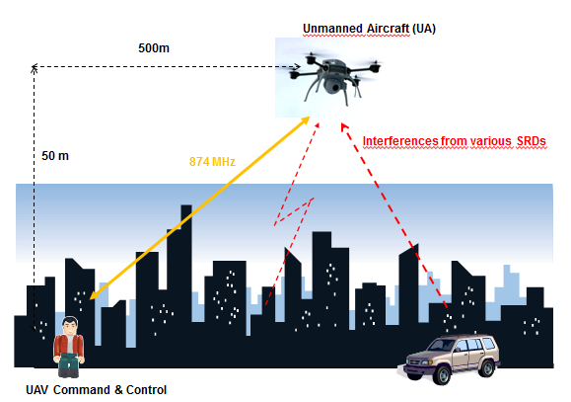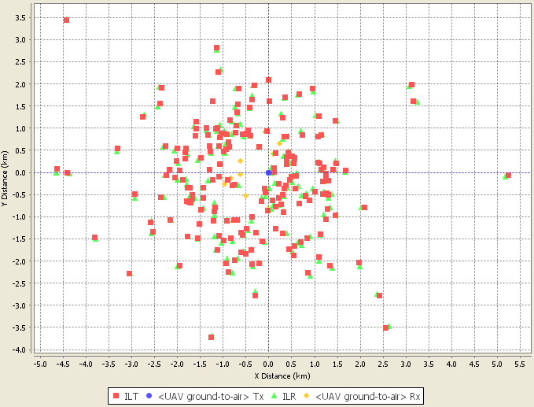
0.2-4.5 km
100-300 m
200 m
0…1 km
(a) (b)
- Scenario of SRD vs. UAV co-existence in 870-876 MHz: (a) – general vision in urban environment, (b) – snapshot view in SEAMCAT with 10 active interferers

The altitude of the flying UAV poses the most critical challenge, as it ensures the line of sight visibility to large areas on the ground.
Otherwise, the overall set-up of SRD-UAV co-existence simulations scenario will follow the configuration and principles that were used for SRD-TRR scenario in the preceding sub-section, except that in this case the SEAMCAT scenario settings will assume urban deployment environment.

Results of simulations – MCL single entry
The high altitudes of UAV operation mean that the Line-of-sight conditions could not be disregarded even at a larger distances. In such situations even a single interfering device could have good power coupling conditions on the interference path and may potentially affect the operation of UAV. In order to check what kind of impact distances could be considered for such case, first of all the MCL analysis is applied for the case of single interferer. The Table below provides results of calculations for a set of interfering SRD devices. The respective radio parameters of UAVs and SRDs are in accordance with what was described in section 3.
- Results of single entry MCL analysis for interference to UAV
Victim system: UAV receiver
Operating frequency | MHz | 874
Bandwidth (IF) | MHz | 0.2
Ga (in the direction of Interferer) | dBi | 0
System noise temperature | degK | 290
Noise figure | dB | 5
Noise | dBm | -115.99
I/N protection criterion |  | -6
Max interference at receiver input | dBm | -122.0
Max interference at receiver input | dBm/MHz | -115.0
Additional attenuation (wall loss) | dB | 0 | 10 | 0 | 0 | 10
Interfering systems: SRD transmitters
 |  | Non-  spec SRDs | Home auto-mation | Portable  alarms | Auto-motive | Metro utilities (SM/M3N)
Nominal output power | dBm | 14 | 14 | 20 | 20 | 27
Reference bandwidth | MHz | 0.6 | 0.2 | 0.025 | 0.5 | 0.2
Transmitter output power density | dBm/MHz | 18.77 | 14.00 | 10.97 | 23.98 | 27.00
Antenna gain | dBi | 0 | 0 | 0 | 0 | 0
Interferer EIRP density | dBm/MHz | 18.77 | 14.00 | 10.97 | 23.98 | 27.00
Impact range calculation:
Required Minimum Coupling Loss margin | dB | 133.8 | 119.0 | 126.0 | 139.0 | 132.0
Impact range using FSL model | km | 133.4 | 24.3 | 54.3 | 242.9 | 108.8
Impact range using Hata Suburban model | km | >30 | >30 | >30 | >30 | >30
Impact range using Hata Urban model | km | 22 | 9 | 14 | 30 | 21

As may be seen from these results, the worst case static impact ranges for SRD to UAV interference could be very large.

Results of simulations – SEAMCAT statistical analysis
In order to complement the static MCL analysis reported in the previous sub-section, it is worth also performing the statistical simulations. These would evaluate the dynamic and random conditions observed in real life, such as the sporadic nature of SRD transmissions and their random scattering in the interference area.
The selected SEAMCAT scenario will be identical to Case II of the previous SRD vs TRR study, except that an urban environment is assumed. This will have an impact both on the SRD deployment densities and the propagation path losses. The same area of deployment will be considered given the previously described UAV pattern of use in civil environments.
Noting that the transmit antenna would be placed at the street level and comparing this to the operating range of 4.5 km, it would be illogical to assume the prevalence of LOS conditions and therefore the Hata path loss model (urban mode) shall be used.
The representative mix of SRD device families and their respective deployment densities for urban scenario will be identical to those derived for SRD vs. GSM-R simulations in section 4.1.2.2.

- Simulation results: mix of SRDs to UAV telecommand link
 | Settings/Results
Simulation input/output parameters | Settings/Results
VLK: UAV Telecommand link (airborne receiver)
Frequency | 874.00 MHz
VLR sensitivity | -90 dBm/200 kHz
VLR antenna | 0 dBi
VLR height | 100-300 m (uniformly distributed)
VLK Tx power e.i.r.p. | 43 dBm
VLK Tx → Rx path | Uniform (distance/polar angle), R=0.2…4.5 km
ILK1: Metropolitan utilities (Smart Metering/M3N)
Frequency | 870-876 MHz, 0.2 MHz steps
ILT power e.i.r.p. | 27 dBm/200 kHz
ILK → VLK interfering path | Ind-outd/below roof
ILT density | 3000/km²
ILT probability of transmission | 0.001
ILT: number of active transmitters | 57
ILK2: Home automation
Frequency | 870-876 MHz, 0.2 MHz steps
ILT power e.i.r.p. | 14 dBm/200 kHz
ILK → VLK interfering path | Ind-outd/below roof
ILT density | 50000/km²
ILT probability of transmission | 0.000025
ILT: number of active transmitters | 3
ILK3: Alarms
Frequency | 870-876 MHz, 0.025 MHz steps
ILT power e.i.r.p. | 20 dBm/25 kHz
ILK → VLK interfering path | Outd-outd/above roof
ILT density | 12/km²
ILT probability of transmission | 0.001
ILT: number of active transmitters | 1
ILK4: Automotive (high power variety)
Frequency | 870-876 MHz, 0.5 MHz steps
ILT power e.i.r.p. | 27 dBm/500 kHz
ILK → VLK interfering path | Outd-outd/above roof
ILT density | 80/km²
ILT probability of transmission | 0.001
ILT: number of active transmitters | 7
General settings for all ILKs
ILT → VLR positioning mode | Uniform density around VLR position
ILT → VLR minimum distance | 200 m ⁽¹⁾
VLK Tx → Rx & ILT → VLR path loss | Extended Hata, urban mode
Simulation results
dRSS, dBm/200 kHz (Std.dev., dB) | -78 (13)
iRSS_{unwanted}, dBm/200 kHz (Std.dev., dB) | -93 (10)
Probability of interference, C/I = 15 dB, % | 40.5
Probability of interference, I/N = -6 dB, % | 100
Note 1: Minimum (protection) distance corresponds to average 200 m vertical separation between ground based interferer and airborne victim

The simulation results indicate clearly the high interference levels; unless some additional co-existence arrangements and interference mitigation techniques were employed.
Similarly as was done with the analysis of SRD vs. TRR in the previous section, two SRD interference mitigation techniques may be considered: APC and DAA. The following tables report the results of such simulations with respectively APC and DAA assumed.

- Simulation results: mix of SRDs (with APC mechanism) to UAV telecommand link
 | Settings/Results
Simulation input/output parameters | Settings/Results
VLK: UAV Telecommand link (airborne receiver)
Frequency | 874.00 MHz
VLR sensitivity | -90 dBm/200 kHz
VLR antenna | 0 dBi
VLR height | 100-300 m (uniformly distributed)
VLK Tx power e.i.r.p. | 43 dBm
VLK Tx → Rx path | Uniform (distance/polar angle), R=0.2…4.5 km
ILK1: Metropolitan utilities (Smart Metering/M3N)
Frequency | 870-876 MHz, 0.2 MHz steps
ILT power e.i.r.p. | 27 dBm/200 kHz
APC threshold and range/step | -86 dBm/200 kHz; range 20 dB, step 2 dB
ILT → ILR path | 0…0.3 km, ind-outd/below roof
ILK → VLK interfering path | Ind-outd/below roof
ILT density | 3000/km²
ILT probability of transmission | 0.001
ILT: number of active transmitters | 57
ILK2: Home automation
Frequency | 870-876 MHz, 0.2 MHz steps
ILT power e.i.r.p. | 14 dBm/200 kHz
APC threshold and range/step | -86 dBm/200 kHz; range 20 dB, step 2 dB
ILT → ILR path | 0…0.01 km, ind-ind/below roof
ILK → VLK interfering path | Ind-outd/below roof
ILT density | 50000/km²
ILT probability of transmission | 0.000025
ILT: number of active transmitters | 3
ILK3: Alarms
Frequency | 870-876 MHz, 0.025 MHz steps
ILT power e.i.r.p. | 20 dBm/25 kHz
APC threshold and range/step | -95 dBm/25 kHz; range 20 dB, step 2 dB
ILT → ILR path | 0…0.3 km, outd-outd/below roof
ILK → VLK interfering path | Outd-outd/above roof
ILT density | 12/km²
ILT probability of transmission | 0.001
ILT: number of active transmitters | 1
ILK4: Automotive (high power variety)
Frequency | 870-876 MHz, 0.5 MHz steps
ILT power e.i.r.p. | 27 dBm/500 kHz
APC threshold and range/step | -82 dBm/500 kHz; range 20 dB, step 2 dB
ILT → ILR path | 0…0.3 km, outd-outd/below roof
ILK → VLK interfering path | Outd-outd/above roof
ILT density | 80/km²
ILT probability of transmission | 0.001
ILT: number of active transmitters | 7
General settings for all ILKs
ILT → VLR positioning mode | Uniform density around VLR position
ILT → VLR minimum distance | 200 m ⁽¹⁾
VLK Tx → Rx & ILT → VLR path loss | Extended Hata, urban mode
Simulation results
dRSS, dBm/200 kHz (Std.dev., dB) | -78 (13)
iRSS_{unwanted}, dBm/200 kHz (Std.dev., dB) | -98 (11)
Probability of interference, C/I = 15 dB, % | 29
Probability of interference, I/N = -6 dB, % | 98.5
[BNetzA: APC configuration to be adjusted, see comments under TRR
ET: pending resolution of discussion under TRR]

- Simulation results: mix of SRDs (with DAA mechanism) to UAV telecommand link
 | Settings/Results
Simulation input/output parameters | Settings/Results
VLK: UAV Telecommand link (airborne receiver)
Frequency | 875.9 MHz
VLR sensitivity | -90 dBm/200 kHz
VLR antenna | 0 dBi
VLR height | 100-300 m (uniformly distributed)
VLK Tx power e.i.r.p. | 43 dBm
VLK Tx → Rx path | Uniform (distance/polar angle), R=0.2…4.5 km
ILK1: Metropolitan utilities (Smart Metering/M3N)
Frequency | 870-875.8 MHz, 0.2 MHz steps
ILT power e.i.r.p. | 27 dBm/200 kHz
ILK → VLK interfering path | Ind-outd/below roof
ILT density | 3000/km²
ILT probability of transmission | 0.001
ILT: number of active transmitters | 57
ILK2: Home automation
Frequency | 870-875.8 MHz, 0.2 MHz steps
ILT power e.i.r.p. | 14 dBm/200 kHz
ILK → VLK interfering path | Ind-outd/below roof
ILT density | 50000/km²
ILT probability of transmission | 0.000025
ILT: number of active transmitters | 3
ILK3: Alarms
Frequency | 870-875.8 MHz, 0.025 MHz steps
ILT power e.i.r.p. | 20 dBm/25 kHz
ILK → VLK interfering path | Outd-outd/above roof
ILT density | 12/km²
ILT probability of transmission | 0.001
ILT: number of active transmitters | 1
ILK4: Automotive (high power variety)
Frequency | 870-875.5 MHz, 0.5 MHz steps
ILT power e.i.r.p. | 27 dBm/500 kHz
ILK → VLK interfering path | Outd-outd/above roof
ILT density | 80/km²
ILT probability of transmission | 0.001
ILT: number of active transmitters | 7
General settings for all ILKs
ILT → VLR positioning mode | Uniform density around VLR position
ILT → VLR minimum distance | 200 m ⁽¹⁾
VLK Tx → Rx & ILT → VLR path loss | Extended Hata, urban mode
Simulation results
dRSS, dBm/200 kHz (Std.dev., dB) | -78 (13)
iRSS_{unwanted}, dBm/200 kHz (Std.dev., dB) | -117 (7.5)
Probability of interference, C/I = 15 dB, % | 1.4
Probability of interference, I/N = -6 dB, % | 73.7

[These results indicate that introducing APC requirement on SRDs would have insufficient effect, whereas DAA would reduce the interference potential significantly, such as that C/I-referenced probability of interference would be marginal 1%. In this case the SRDs operating in adjacent channels would still have a high potential for their OOB emissions to exceed the noise floor of UAV receivers. However, noting the information that UAVs may have a back-up link in a different frequency band, probably such risk may be tolerable.]
[BNetzA: we can not agree on such an approach. The real impact of a sensing mechanism needs to be assessed!
ET: see previous response. And also to this more explicit statement here – do you have a specific proposal for how better to assess it?]

CONCLUSIONS ON CO-EXISTENCE STUDIES IN 870-876 MHz
[TBD]

CO-EXISTENCE STUDIES IN 915-921 MHz BAND
This part of the report presents the results of compatibility studies that were undertaken in the band 915 - 921 MHz, addressing both in-band and adjacent band co-existence issues. In the following sub-sections the relevant SRD/RFID types are presented together with their respective co-existence scenarios.

IN-BAND CO-EXISTENCE OF PROPOSED SRD/RFID AND ER-GSM APPLICATIONS

Description of co-existence scenario
In this case the proposed SRD & RFID applications would have to co-exist with ER-GSM deployment in the frequency band 918-921 MHz (downlink). The co-existence scenario would be somewhat similar to the case of SRD vs. ER-GSM in the 870-876 MHz band, except that in this case the direction of interference paths would be different (directed towards ER-GSM mobile station receivers). Also the different types of SRD/RFID devices and their applications might lead to significant differences in their deployment. This situation is illustrated in the figure below (Note that for simplicity only two units and two types of SRD/RFID devices are shown).

Train MS
Locomotive
Handheld MS
R-GSM BTS
Automotive SRD
RFID reader at a warehouse
ER-GSM to SRD/RFID interference
SRD/RFID to ER-GSM interference

- In-band SRD/RFID vs. ER-GSM co-existence: wanted and interfering paths in 918-921 MHz
This means that the following two interference directions and cases should be studied:
- Multiple SRD/RFIDs to ER-GSM MS Rx
- ER-GSM BTS Tx to SRD/RFID Rx in ER-GSM cell

The geographic representation of the co-existence scenario will be identical to the one described for SRD vs. ER-GSM in the 870-876 MHz band, see Figure 13.

The impact of RFID on ER-GSM without mitigation techniques

Lessons from ETSI TR 101 537
The results of a co-existence test between ER-GSM and RFID are described in ETSI TR 101 537 V1.1.1 (2011-02). These tests were undertaken at the BNetzA Test Laboratory at Kolberg to determine the parameters necessary to permit RFID to share the band 918 MHz to 921 MHz with ER-GSM.
During the tests it was possible to monitor the interference threshold of the ER-GSM receiver using the RxQual level. An RxQual level of 0 indicated a perfect connection while a level of 7 showed that the connection was broken. The tests showed that there was a sharp knee of only a 1 dB change between a good connection and one which failed. For the tests the interference threshold was determined by increasing the interference power until the level at the ER-GSM device dropped to a value of 2.
Three wanted power levels were used for the measurements:
- Cab low power -96 dBm.
- Cell edge -86 dBm
- Good link -76 dBm.

Figure 25 below shows the max acceptable interference power vs frequency offset at the ER-GSM mobile, which was the main purpose of the campaign.

- Main results of TR 101 537: max acceptable interference power at ER-GSM receiver
These tests showed that a minimum frequency offset of 700 kHz between the centre of the R-GSM channel and the centre of the RFID channel would be necessary, and confirmed the results of measurements taken previously in June 2009. This means that if an interrogator detects an ER-GSM channel with a power above a certain limit, the interrogator should use a channel with a centre frequency which is at least 700 kHz away from the centre frequency of the detected ER-GSM channel. For RFID channel planning this means that the highest RFID channel should be at least 700 kHz below the centre frequency of the lowest existing R-GSM channel of 921.2 MHz. This equates to a centre frequency for the RFID system of 920.5 MHz.
The 700 kHz frequency offset was not affected by variations in the channel width or depth of modulation of the RFID interrogator. This means that an RFID Interrogator cannot influence the required offset frequency of 700 kHz. A more stringent RFID spectrum mask will not improve the 700 kHz spacing of the channels, because the 700 kHz spacing is dependent on the filter width and filter steepness of the R-GSM receivers.
The test confirmed that RFID interrogators, which maintain a 700 kHz frequency offset from an operational R-GSM, cannot cause interference to it provided the RFID interrogator is more than 20 m away from the R-GSM terminal. The test also showed that it is useful to implement a 100 kHz offset between the ER-GSM channels and the RFID channels because this adds an additional mitigation factor of around 9 dB independent of the deployed RFID channel bandwidth (200 kHz and 400 kHz). This result is important for the further discussion related to the channelization.
The measured protection levels in the tests in which R-GSM was the victim represent worst-case scenarios (voice mode). R-GSM terminals in idle mode require between 5 and 10 dB lower protection levels. This should be considered in further discussion of the protection level for the different ER-GSM protection models.
As in the tests in June 2009, it was again possible to generate IM3 products. One test showed that the interrogator did not generate the IM3 products, which interfered with the R-GSM system. This means that a stringent IM3 test in the relevant RFID standards will not improve the level of mitigation for the co-existence of R-GSM and RFID.
Assuming that the current GSM band below 915 MHz uses 200 kHz channels (centre frequency at 914.8 MHz) and based on the presented measurement results, RFID transmit channels can be placed at a minimum frequency separation between the GSM centre frequency and the RFID systems centre frequency of 800 kHz. This means that the first RFID channel could be placed above 915.6 MHz.

Consequences of the Kolberg measurements
Based on the protection criteria derived as a result of the Kolberg measurements (see figure 25), the next two figures show respectively the corresponding protection distances for 4 W RFID interrogators under line of sight condition (LOS), and under NLOS condition (propagation exponent 3).
- Protection distance between RFID interrogator and ER-GSM mobile under LOS conditions
- Protection distance between RFID interrogator and ER-GSM mobile under NLOS conditions
Figure 28 shows the protection distances for RFID tags with a Tx power of -15/200 kHz dBm (-18 dBm/100 kHz) under line of sight condition (LOS), and Figure 29 under NLOS conditions (propagation exponent 3). Due to the wider Tx mask of the RFID tags and the fact that the tag responds passively to the request from the interrogator (that means around the same frequency as the interrogator) only the co-channel results are applicable (frequency offset = 0).

- Protection distance between RFID tags and ER-GSM mobile under LOS conditions

- Protection distance between RFID tags and ER-GSM mobile under NLOS conditions
The response of –15 dBm/200 kHz from the tag represents the very maximum that is achievable when it is mounted in free space at close proximity to and in optimum orientation with respect to the interrogator. Where a tag is in a non-preferred orientation or operating at a greater range, the strength of its response will be less. Furthermore in normal use tags are attached to the items that are to be identified. Depending on the nature of the particular item, the response from the tag may be reduced either due to mistuning or absorption. Also in practice the majority of RFID applications take place indoors. In typical operation therefore only a very small number of tags will ever transmit outdoors at the maximum permitted value.

Furthermore for a normal read operation of a single tag in the band 915 – 921 MHz the whole cycle is completed within approximately 2 ms with the tag reply taking approximately 0.5 ms. In a situation where multiple tags are read the time taken to read the first tag is 2 ms and the time to read all subsequent tags is 1 ms. In this latter scenario the transmit time of each tag is 0.3 ms or less, depending on the encoding format.

Conclusions on RFID vs. ER-GSM co-existence without mitigation techniques
Summarising the material presented in this section, for a protection criterion SIR of 0 dB, 100kHz offset between RFID and the ER-GSM channels and a minimum signal level of -86 dBm at the ER-GSM mobile, the following conclusions may be reached
- Co-channel operation of the RFID interrogators and the ER-GSM downlink in the band 918-921 MHz should be avoided due to the large protection distances required:
  - for non-specific outdoor 4 W RFIDs between 400m (NLOS conditions, propagation exponent 3.5) and up to 30 km (LOS conditions);
  - for handheld indoor 1W RFIDs between 150m (NLOS conditions, propagation exponent 3.5) and up to 5 km (LOS conditions);
  - for low power indoor 500 mW RFIDs between 80m (NLOS conditions, propagation exponent 3.5) and up to 2.5 km (LOS conditions);
- For the protection of ER-GSM mobiles from RFID interrogators a frequency offset of ≥ 700kHz is required assuming a separation distance of more than 20m;
- The avoidance procedure for RFID interrogators should be specified:
  - Manually (e.g. just the bands below 918 MHz to be used);
  - Or a dynamic DAA where the threshold levels and the timing should be specified;
  - This is further studied in the next section;
- For the protection of ER-GSM mobiles from RFID tags the following protection distances are necessary:
  - for outdoor Tags between 40 m (NLOS conditions, propagation exponent 3.5) and 260 m (LOS conditions);
  - for indoor Tags between 20 m (NLOS conditions, propagation exponent 3.5) and 80 m (LOS conditions);
  - In a multiple tag scenario, the average power transmitted by an RFID tag over its interrogation cycle is one third of its maximum value, which corresponds to a reduction of 4.8 dB. Since the maximum possible power from a tag while transmitting is -15 dBm/200 kHz, its average power over an interrogation cycle will be -19.8 dBm/200 kHz. This equates to a reduction in the worst case protection distances of approximately 60% of the values shown above.
  - This may be seen as acceptable as the use of this application is predominantly indoor;
- There is no impact from the proposed two RFID channels in the band 915-918 MHz (916.3 and 917.5 MHz) on ER-GSM mobiles. Furthermore the 3 upper ER-GSM channels in the 918 – 921 MHz band are also free from interference from RFID. However, the impact on other services in this band should be analysed (e.g. tactical radio relay, UAV) before this band can be seen as “interference free”;
- No harmful interference is expected to the GSM band below 915 MHz due to the frequency separation;

Section 5.1.4 provides both an analysis of the effectiveness of the DL detection and a SEAMCAT simulation.

The impact of RFID on ER-GSM with mitigation techniques
From the previous section it follows that RFID needs to avoid any co-channel interference in the ER-GSM band 918-921 MHz. Proposals for the avoidance procedure are provided in an updated version of ETSI TS 102 902 V1.2.2, which was adopted by ETSI TC ERM for publication in November 2012. Additionally the results of a demonstration of principal of the mitigation technique are described in ETSI TS 102 903 V1.1.1 (2011-08). The latter document also describes the various compliance tests necessary to verify proper operation of the proposed mitigation technique for inclusion in an ETSI standard.
Subsequently the effectiveness of the avoidance procedure was investigated in a series of tests using modified interrogators (demonstrators) that incorporated the proposed mitigation technique. Preliminary tests were performed at a test house in Kolleda that was equipped with GSM-R mobile radios and base stations. The demonstrators were subjected to a series of scenarios as defined in a test plan that were designed to show whether the mitigation technique performed as intended. The results from the tests verified that the technique behaved correctly.
The preliminary tests were followed by a trial at Wiesbaden Hauptbahnhof where GSM-R is in continuous use. Two demonstrators were set up close to platforms where there was frequent movement of trains. The demonstrators were again subjected to a set of scenarios similar to those at Kolleda. The outcome of the tests was satisfactory and demonstrated that the mitigation technique would allow RFID to share the spectrum with ER-GSM without causing unacceptable levels of interference. Full details of the preliminary tests and the trail are available in TR 101 602.
The ideas from TS 102 902: In the short term regulatory methods may be used in order to allow operators of RFID systems a simple way to occupy the new band (915 MHz to 921 MHz). In particular the band 915 MHz to 918 MHz will be of special interest since use of the two RFID high power channels may give interference free operation with ER-GSM. In the medium term active mitigation techniques should be implemented in RFID systems. This will permit more flexible deployment across the entire new band without adding interference risks to potential victim systems sharing the band.
An illustration of the coexistence strategy presented in TS 102 902 is given in the following Figure.
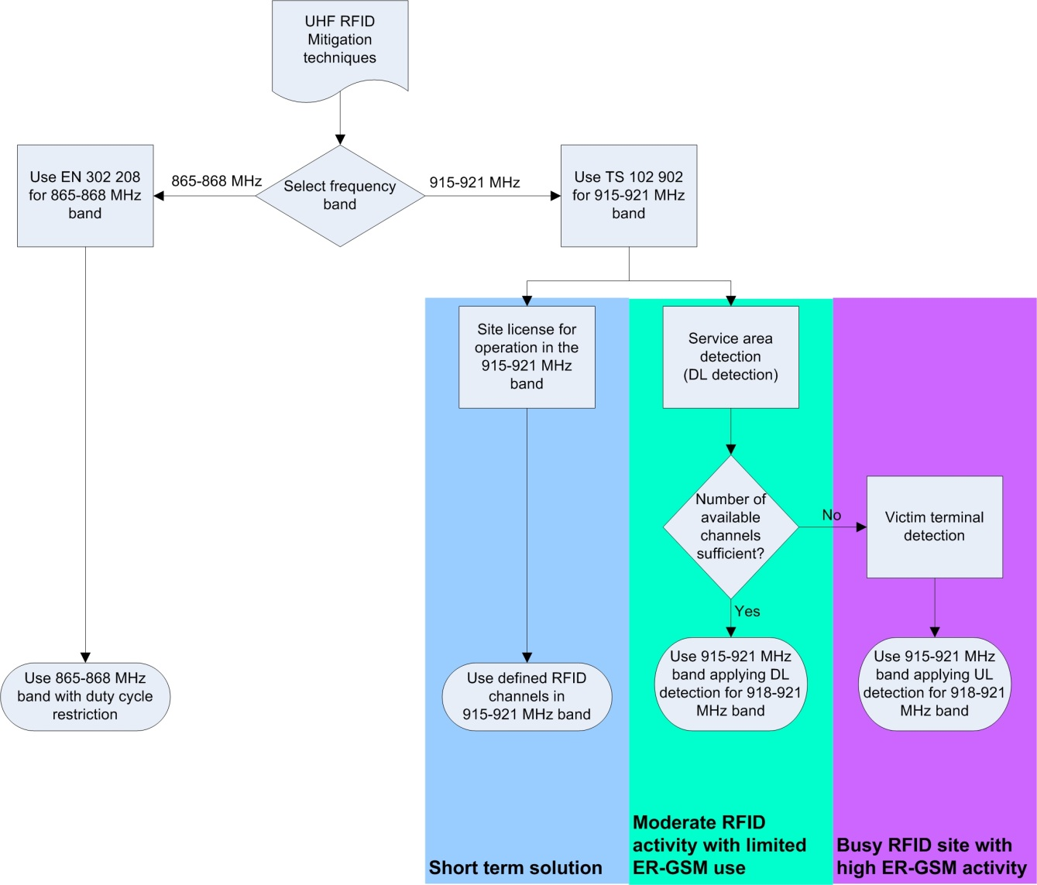
- Overall coexistence strategy between ER-GSM and RFID
For the foreseeable future it is anticipated that the deployment of ER-GSM will be restricted to a few very busy sites. Under these circumstances it is expected the users of RFID will achieve acceptable performance by implementation of the mid-term solution described in Figure 36. It will only be necessary to implement the “long term solution” if ER-GSM is deployed across most railway tracks.

Site licensing and coordination with ER-GSM operators
The so called “site licensing” proposal is presented in TS 102 902 and TS 102 903 for operation in the short term. Here the avoidance of the ER-GSM downlink channels will be enforced by a practical coordination procedure between the Administration and the ER-GSM and RFID operators. This is seen as a feasible solution.
A kind of “light licensing” is proposed in the mid term. Here access by RFID interrogators to the channel allocations transmitted regularly by the BCCH will make it possible to avoid any interference to ER-GSM. Responsibility for avoidance of interference with ER-GSM will therefore rest with the RFID operators. A similar proposal is documented in ECC Report 167 (“Practical implementation of registration/coordination mechanism for UWB LT2 systems”) and a regulatory proposal is given in ECC/REC(11)09.
This procedure is imaginable and is definitely an option in the future as it is similar to cognitive radio. However it is not expected to be commercially available in less than two years.

ER-GSM Downlink detection
The idea of downlink and uplink detection is illustrated in the following Figure.
- Illustration of concept of spectrum sensing by RFID
As illustrated in the flow diagram below, interrogators will monitor the BCCH messages transmitted by the BTS. By decoding the content of the BCCH messages it will be possible, in almost all situations, for interrogators to assign channels that will avoid interference to ER-GSM.
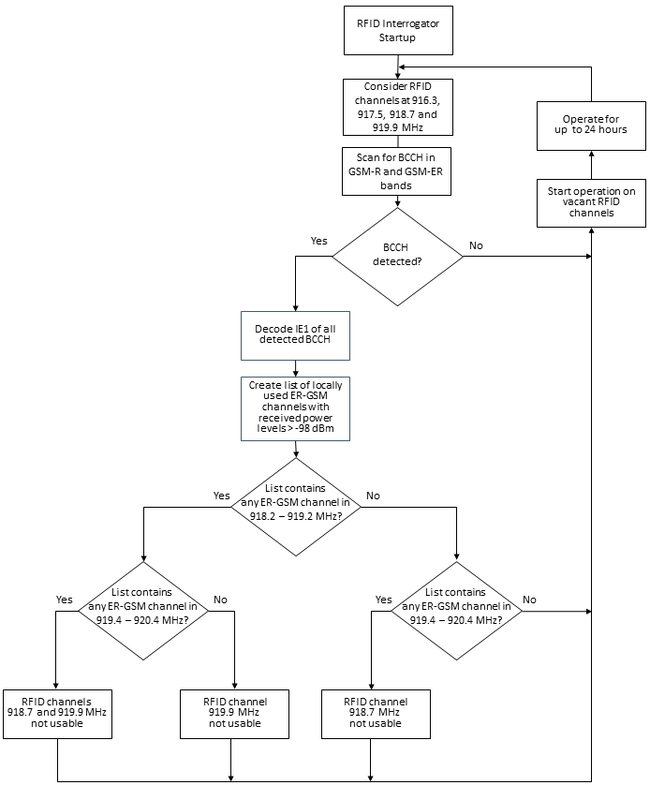
- GSM-R Downlink detection for ER-GSM band and RFID DAA process

To permit sharing of the band 918 – 921 MHz, interrogators will scan all downlink channels used by ER-GSM and R-GSM for BCCH and TCH transmissions. BCCH and TCH channels require the same protection although TCH channels are only temporarily allocated while, once configured, BCCH channels are assigned permanently.
Scanning for BCCH or TCH channels will take place immediately an interrogator is initialised and before it starts to transmit. Thereafter, assuming the interrogator is permanently switched on, scanning for a BCCH channel will be repeated at least once every 24 hours. The detection threshold at the antenna of the interrogator shall be 38.5 dBµV/m (equivalent to -98 dBm at the antenna port) at the centre frequency of the ER-GSM or R-GSM channel. This is the minimum signal level specified for coverage of non-high-speed railway tracks (see [i.15]).
The RFID interrogator shall scan the entire (E)R-GSM downlink band (918 – 924 MHz) for BCCH transmissions. The RFID interrogator shall successfully receive and decode every BCCH transmission above the threshold level. The message of relevance within the Broadcast Channel is the SYSTEM INFORMATION TYPE 1 (See Section 9.1.31 of 3GPP TS 44.018 [i.13]) message containing the Cell Channel Description IE.
From the received information corresponding to the BCCH Cell Channel Description IE, the RFID interrogator shall create a list of all ARFCN used by (E)R-GSM in the local area of operation.
An interrogator shall not use any RFID TX channel with a centre frequency of less than 700 kHz from any channel stored in the ARFCN list, if the received BCCH signal level at the antenna of the interrogator is greater than 38.5 dBµV/m (equivalent to -98 dBm).
The following figure shows those ER-GSM channels that prevent the use of either the 918.7 MHz or the 919.9 MHz RFID TX channel.

- Illustration of interference between ER-GSM and RFID channels

Analytical analysis and SEAMCAT simulations of efficiency of detecting ER-GSM downlink
This section provides an analysis of the effectiveness of the DL detection with threshold of 38.5 dBµV/m (equivalent to -98 dBm) using both the MCL approach and a SEAMCAT simulation.

Analytical analysis of downlink detection
In this sub-section the compatibility of the RFID (Interfering transmitter IT, transmitting to its wanted receiver WR) with ER-GSM (Wanted transmitter WT transmitting to the victim receiver VR) is analysed. IT is able to monitor the WT, which is the basis for the sensing mechanism, which is called LBT in this section.
The following abbreviations and definitions are valid in this sub-section:
- Dimensions: r/m, P/dBm, S/dBm, SIR/dB, f/GHz, All antennas 0dBi
- VR Victim receiver (GSM-R MS)
- N_{th}: Thermal noise floor kTB of VR (-120 dBm/200kHz)
- F: Noise figure of VR, (GSM-R mobile 7 dB)
- N: Receiver noise floor kTBF (-111 dBm/200kHz, including 2dB cable loss)
- S: Signal strength received at the VR from WT (Pwt)
- SNR: signal to noise ratio, or C/N at VR
- SIRmin: Signal to interference ratio, or C/I at VR (9 dB, with 100kHz offset 0 dB)
- WT Wanted transmitter (victim link, GSM-R BS)
- Pwt Transmit power of WT (GSM-R BS 38 dBm =43 dBm-2dB attenuation – 3 dB splitter)
- Gs Antenna gain WT (20 dBi, see Annex 4)
- IT Interfering Transmitter (RFID)
- Pit Transmit power e.i.r.p. of IT (RFID 36 dBm)
- WR Wanted receiver (Interfering Link, RFID) :
- I: Interfering power at VR,
- Plbt: LBT power received at WR from WT (Pwt)
- Pthr: power threshold for the LBT mechanism at IT
- n: Path loss exponent n (n=2 free space loss)
- Rint: radius around VR; inside interference can occur (S-I<SIRmin)
- Rsig: radius around VR; inside the victim link works with S-N<SNRmin
- Rdet: radius around WT; inside the IT can detect the WT
- Wall: wall attenuation dB (RFID indoor 10dB).

The following figure explains the investigated scenario. Within a radius of Rint around the VR the IT can exceed the protection objective of the VR (e.g. C/I). Within a radius of Rdet around the WT the IT can detect the WT (Threshold is exceeded).
In the light blue area in the following figure LBT is working effectively. The red area is the so called “hidden node”, where the IT is not able to detect the WT.

- Illustration of the analysed hidden node scenario
The formulas given hereafter are the basis for the analysis.
Minimum usable Signal strength at the GSM-R receiver:
S (at MS) = N + SNR = Pwt (BS)+Gsmax - PL(Rsig) (5-1)
The interference power at the GSM-R receiver:
I (at MS) = S - SIRmin = Pit (RFID)-Wall- PL(Rint) (5-2)
The threshold power at the interrogator:
Pthr (at RFID) = Pwt (BS)+Gs-Wall- PL(Rdet) (5-3)
Path loss model:
PL = 32.5+10*n*log(R/m)+20*log(f/GHz) (5-4)
The size of the circles in the previous figure can be calculated as follows (the detection zone is for directional antennas not a circle and depends on the antenna diagram of the WT, the GSM-R base station; thus Gs is meant as a function of the angle between the mainbeam direction of the BS antenna and the RFID location):
(1)+(4) -> 10n*log(Rsig) = Pwt+Gsmax-N-SNR-32.5-20logf (5-5)
(2)+(4) -> 10n*log(Rint) = Pit-Wall-N-SNR+SIRmin-32.5-20logf (5-6)
(3)+(4) -> 10n*log(Rdet) = Pwt+Gs-Wall-Pthr-32.5-20logf (5-7)
Relation Rint/Rsig: (6)-(5) -> 10n*log(Rint/Rsig)=Pit-Pwt-Gsmax-Wall+SIRmin (5-8)
Relation Rdet/Rint: (7)-(6) -> 10n*log(Rdet/Rint)=Pwt-Pit-Pthr+Gs+N+SNR-SIRmin (5-9)
Under the assumption Rsig+Rdet≤Rint the hidden node portion could be easily calculated as 1-(Rdet/Rint)^2, but this is not realistic in this case.
The following two figures show the distances for R_{sig}, R_{int} and R_{det} as a function of the signal strength at the GSM-R mobile for indoor RFID applications; and for outdoor RFID applications respectively. A propagation exponent of 3.5 was assumed in the calculations.

- Calculated area sizes for indoor RFID case

- Calculated area sizes for outdoor RFID case
The following observations can be made:
- R_{sig} is the distance between WT (GSM-R BS) and VR (GSM-R MS) to achieve the corresponding signal strength S at the GSM-R mobile, e.g. for S of -96dBm is reached at about 2km with a propagation exponent of 3.5;
- R_{int} is the protection distance around the VR required to achieve a SIR of 0dB (under the assumption that with 100kHz frequency offset between RFID and GSM-R channels this is sufficient), e.g. with S=-86 dBm the protection zone is 400m for RFID outdoor and 200m for RFID indoor;
- R_{det} is the radius around the GSM-R base station, where the RFIDs can detect WT. Outside this radius the detection is not working. What can be seen is that the detection range is changing according to the distance of the RFIDs to the railway tracks, which is a consequence of the antenna gain the RFID sees from the GSM-R base station. R_{det} is a function of the distance of the RFID to the tracks. The above figures show the results for R_{det} for 100 m distance to the tracks.

The two following figures illustrate the main results of this analysis. The first figure shows the detection areas and hidden nodes for indoor RFIDs, and the second one for outdoor RFIDs.

- Hidden nodes (red areas) and detection areas (blue), RFID indoor

- Hidden nodes (red areas) and detection areas (blue), RFID outdoor
The hidden node disappears for the RFID outdoor case and only a small section remains for indoor RFID.
It has to be noted that this analysis is limited to equal propagation conditions in all links (exponent 3.5). For unbalanced conditions the situation can be less critical (e.g. sensing link with better propagation conditions as the wanted and interfering link) and more critical (e.g. e.g. sensing link with worse propagation conditions as the wanted and interfering link)

SEAMCAT analysis of downlink detection
The following simplifications were made when programming this scenario in SEAMCAT:
- Victim is the ER-GSM downlink at fixed frequency of 918 MHz
- Interferer is an RFID with LBT, modelled using SEAMCAT’s “Cognitive Radio” feature, tuned at the same frequency as ER-GSM (worst case);
Limitation by SEAMCAT:
- When using the option “Cognitive Radio”, the receive frequency range of the Victim Link should be equal to that of the Interfering Link.
Victim Link
The victim link is the downlink between an ER-GSM base station and an ER-GSM terminal with a normal distance of up to about 6 km. Within the simulation the distance was set between 3 and 12 km. The transmit power of the base station is assumed to be 38dBm (43 dBm minus 2 dB cable attenuation minus 3dB splitter) with a 20 dBi antenna.
Interfering Link
The interfering link is the link between the RFID interrogator and the ER-GSM mobile. The interrogator transmits with 36 dBm with the antenna of RFID Type 2 (see section 3.1.4), with the horizontal pattern reproduced below.
- Horizontal antenna pattern of RFID Type 2 antenna

The interferer has a listen receiver with 200 kHz bandwidth.
Sensing Link
The detection threshold was set to -98 dBm/200kHz.

Scenario
A single interferer is located arbitrarily in a circle around the ER-GSM terminal. The protection criterion for ER-GSM is assumed with a C/I=SIR value of 9 dB and alternatively 0 dB. The used propagation model is Extended Hata with following parameter: Suburban, Outdoor Outdoor, Above roof. To simulate worse propagation conditions in sensing path as in the wanted and interfering path, the propagation model in the sensing link was set to Extended Hata (urban mode).
Simulation
Dependent on the value of the detection threshold and the propagation path, the RFID interrogator will detect the base station up to a certain distance. If the distance is lower the RFID interrogator will never transmit and if the distance is higher it will always transmit.
Figure 38 below illustrates the simulation scenario for a 3 km wanted link length.

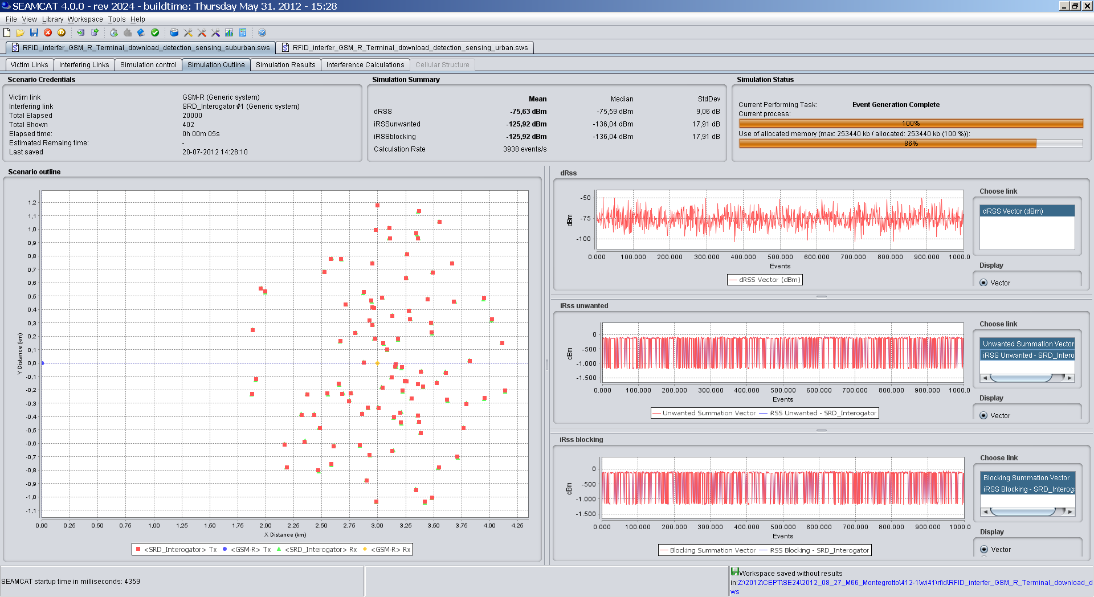
- SEAMCAT simulation of RFID downlink sensing scenario
The following tables contain the results of SEAMCAT simulations under the assumptions that: (1) all links have the same propagation model (Extended Hata, suburban, outdoor), and (2) the propagation model was set to Extended Hata, urban only for the sensing link, in order to assess the impact of different propagation conditions.
- SEAMCAT simulation results of ER-GSM downlink sensing by RFID (RFID outdoor, antenna Type 2)
d_{victim} , km | dRSS  Mean, dBm (Std. Dev, dB) | Probability of interference, %
d_{victim} , km | dRSS  Mean, dBm (Std. Dev, dB) | With SIR=9 dB | With SIR=0 dB
Case I: all links with the same propagation model: Extended Hata, suburban, outdoor-outdoor
3 | -76 (9) | 2.1 | 0.8
6 | - 86 (9) | 5.9 | 2.7
12 | -96 (9) | 11.3 | 5.4
Case II: sensing link propagation model set to Extended Hata, urban, outdoor-outdoor
3 | -76 (9) | 2.7 | 1
6 | -86 (9) | 6.7 | 2.8
12 | -96 (9) | 12 | 5.9

- SEAMCAT simulation results of ER-GSM downlink sensing by RFID (RFID indoor, antenna Type 2)
d_{victim} , km | dRSS  Mean, dBm (Std. Dev, dB) | Probability of interference, %
d_{victim} , km | dRSS  Mean, dBm (Std. Dev, dB) | With SIR=9 dB | With SIR=0 dB
Case I: all links with the same propagation model: Extended Hata, suburban, outdoor-outdoor
3 | -76 (9) | - | 0.3%
6 | - 86 (9) | - | 1.1%
12 | -96 (9) | - | 2.3%

Conclusions from analytical and SEAMCAT analysis of ER-GSM downlink detection
The results presented in the two previous sub-sections show that with a threshold value of -98 dBm the GSM-R is protected in most of the cases.

Summary and conclusions on RFID vs. ER-GSM coexistence

Coexistence without mitigation techniques
Assuming a protection criterion SIR of 0 dB and 100kHz offset between RFID and the ER-GSM channels, the following can be summarised:
- Co-channel operation of the RFID interrogators and the ER-GSM downlink in the band 918-921 MHz needs to be avoided due to the large protection distances required;
- For the protection of ER-GSM mobiles from RFID interrogators a frequency offset of ≥ 700kHz is required assuming a separation distance of more than 20m;
- For the protection of ER-GSM mobiles from RFID tags protection distances of up to some 60 m are necessary (see clause 5.1.2.3). This may be seen as acceptable as the use of RFID applications is predominantly indoors;
- No impact is expected from the two proposed high power RFID channels in the band 915-918 MHz (916.3 and 917.5 MHz) on ER-GSM mobiles (NB: the centre frequency of the lowest ER-GSM channel is 918.2 MHz);

- Also no harmful interference is expected to the GSM band below 915 MHz due to the frequency separation;
- The results of some practical tests at an operational site between ER-GSM and RFID are reported in draft TR 101 602. These tests were carried out with modified interrogators that were fitted with DAA operating in accordance with the proposed mitigation technique. The results showed that RFID can share the band with ER-GSM without causing unacceptable interference.

Downlink detection
The results show that, with a threshold value of -98 dBm, the ER-GSM mobile is protected in most cases.

Uplink detection
It was possible to validate the threshold values proposed in ETSI TS 102 902 under the assumption that the max acceptable interference power received by the ER-GSM mobile is -86dBm. This means that a SIR of 0dB (which comes from the proposed channel offset of 100 kHz)) and minimum signal strength of -86 dBm might be acceptable. For the usual minimum signal strength of -96 dBm the threshold values should be 10 dB more stringent.

ADJACENT BAND CO-EXISTENCE AROUND 915 MHz

Description of co-existence scenario
[Co-existence studies at 915 MHz between SRD and GSM/LTE]

Results of simulations
Text

ADJACENT BAND CO-EXISTENCE AROUND 921 MHz

Description of co-existence scenario
[Co-existence studies at 921 MHz between SRD and R-GSM]

Results of simulations
Text

INTRA-SRD AND SRD Vs. RFID CO-EXISTENCE WITHIN 915-921 MHz
In this band it is proposed to place high power RFIDs along with several types of lower power SRDs, as illustrated in Fig. X2 in section 3.1.5. This section therefore shall look at two distinct cases: first of all on intra-SRD co-existence potential, and secondly on potential of co-existence between SRDs and RFIDs if they were deployed in the same band.

Intra-SRD co-existence in 915-921 MHz
In this co-existence case the subject of study is the interference potential amongst the different SRD families proposed for the band 915-921 MHz. This case will be analysed similarly to the case of intra-SRD co-existence in 870-876 MHz with the only difference that in this band the mix of considered SRD families will be different. As illustrated in section 3.1.5, the following set of SRDs shall be considered in this band:
- Non-specific SRDs Type A: deployed across the entire band, 25 mW, 1% DC;
- Non-specific SRDs Type B: deployed with power up to 100 mW in the same 4 “high-power” channels as assigned to RFIDs;
- Home Automation such as Home Alarms (HA), 200 kHz channels, 25 mW, 0.0025% DC;
- Assistive Listening Devices (ALDs), in 6 channels of 200 kHz, 10 mW, up to 100% DC.
Note that since the band 915-921 MHz anyway assumes pre-defined placement of some “high-power” channels, as made necessary for RFID placement, it may logically assumed that other systems may be placed taking due note of those channels. For instance, ALDs requiring up to 6 channels may be placed in channels that would be not-overlapping with the “high-power” channels. Similarly, it may assumed that also other devices that are supposed to randomly choose their operating channel (such as non-specific SRDs or HAs), may be pre-programmed to avoid “high-power” channels as a precautionary measure. This may be seen as inherent reserve for intra-SRD interference mitigation.
Similarly as with previous intra-SRD analysis (see section 4.3), all interfering and victim devices shall be mixed in one random spot. Hata-SRD propagation path loss model shall be used in this scenario, as it is well suited to model propagation in cluttered environment between similarly low placed transceivers. However, when using this model it is required to set a hard ceiling on the maximum simulation distances, as this model is defined only up to 300 m (which is also natural assumption for intra-SRD impact range). Therefore in SEAMCAT scenario settings the “None” ILT-VLR placement mode was used because only this mode allows user to define maximum radius of simulations.
Another important related element is the derivation of number of active interfering transmitters within impact area of victim. The approach used here is similar to what was used previously in 4.3, except assuming some different user densities:
  - the number of affecting interferers is derived by multiplying the area of 0.3 km² (which corresponds to simulation radius of 300 m) by the respective SRD density value:
    - Home Automation and Home Alarms: N=50000/km² x 0.3 km² = 15000
    - Non-specific SRDs: N=1000/km² x 0.3 km² = 300
    - ALD “base stations”: N=750/km² x 0.3 km² = 225
  - the activity factor of respective interferer is set through transmit power distribution function (full power for the probability of time equal to DC, -200 dBm for the remaining time).
Due to close physical placement of interferers and victims and noting that various SRD families will have different output power levels, the study will also consider possibility of RF blocking interference mode.
Note that in all following simulations no activity-periods/DC impact was considered on the victim, i.e. it was “receptive to interference” constantly, without any sleep time or similar inactivity periods.
Further particular details of the various parameter settings are reported in the simulation tables in the following section.
The following tables show the results of simulations for urban Mixed SRD scenario by considering different representative non-specific and specific SRD families as victims.

- Intra-SRD co-existence in 915-921 MHz: Non-specific SRD (Type A) as a victim
Simulation input/output parameters | Settings/Results
VLK: Non-specific SRD Type A
Frequency | 915-921 MHz, 0.6 MHz steps
VLR sensitivity | -91 dBm/600 kHz
VLR selectivity | 42 dB
VLR C/I threshold | 8 dB
VLR/Tx antenna | 0 dBi, Non-directional
VLR/Tx antenna height | 1.5 m
VLK Tx power e.i.r.p. | 14 dBm/600 kHz
VLK Tx → Rx path | Hata-SRD, urban, ind-ind/below roof, R=0.04 km
ILK1: Non-specific SRD Type B
Frequency | 916.3; 917.5; 918.7; 919.9 MHz; 400 kHz channels
ILT power e.i.r.p. | 20 dBm/400 kHz
ILT probability of transmission | 1%
ILT → VLR interfering path | Hata-SRD, urban, ind-ind/below roof
ILT → VLR minimum distance | 0 m
ILT → VLR positioning mode | None (simulation radius 300 m)
ILT density | 1000/km²
Number of active transmitters | 300
ILK2: ALD
Frequency | 916.8; 917.0; 918.0; 918.2; 919.2; 919.4 MHz; 200 kHz channels placed between RFID channels
ILT power e.i.r.p. | 10 dBm/200 kHz
ILT probability of transmission | 100%
ILT → VLR interfering path | Hata-SRD, urban, ind-ind/below roof
ILT → VLR minimum distance | 0 m
ILT → VLR positioning mode | None (simulation radius 300 m)
ILT density | 750/km²
Number of active transmitters | 225
ILK3: HA
Frequency | 915-921 MHz, 0.2 MHz steps
ILT power e.i.r.p. | 14 dBm/200 kHz
ILT probability of transmission | 0.0025%
ILT → VLR interfering path | Hata-SRD, urban, ind-ind/below roof
ILT → VLR minimum distance | 0 m
ILT → VLR positioning mode | None (simulation radius 300 m)
ILT density | 50000/km²
Number of active transmitters | 15000
Simulation results
dRSS, dBm/600 kHz (Std.dev., dB) | -72 (18)
iRSS_{unwanted}, dBm/600 kHz (Std.dev., dB) | -73 (17)
iRSS_{blocking}, dBm/600 kHz (Std.dev., dB) | -71 (17)
Probability of interference (unwanted and blocking modes), C/I, % | 62

- Intra-SRD co-existence in 915-921 MHz: Non-specific SRD (Type B) as a victim
Simulation input/output parameters | Settings/Results
VLK: Non-specific SRD Type B
Frequency | 916.3; 917.5; 918.7; 919.9 MHz; 400 kHz channels
VLR sensitivity | -93 dBm/400 kHz
VLR selectivity | 43 dB
VLR C/I threshold | 8 dB
VLR/Tx antenna | 0 dBi, Non-directional
VLR/Tx antenna height | 1.5 m
VLK Tx power e.i.r.p. | 20 dBm/400 kHz
VLK Tx → Rx path | Hata-SRD, urban, ind-ind/below roof, R=0.04 km
ILK1: Non-specific SRD Type A
Frequency | 915-921 MHz, 0.6 MHz steps
ILT power e.i.r.p. | 14 dBm/600 kHz
ILT probability of transmission | 1%
ILT → VLR interfering path | Hata-SRD, urban, ind-ind/below roof
ILT → VLR minimum distance | 0 m
ILT → VLR positioning mode | None (simulation radius 300 m)
ILT density | 1000/km²
Number of active transmitters | 300
ILK2: ALD
Frequency | 916.8; 917.0; 918.0; 918.2; 919.2; 919.4 MHz; 200 kHz channels placed between RFID channels
ILT power e.i.r.p. | 10 dBm/200 kHz
ILT probability of transmission | 100%
ILT → VLR interfering path | Hata-SRD, urban, ind-ind/below roof
ILT → VLR minimum distance | 0 m
ILT → VLR positioning mode | None (simulation radius 300 m)
ILT density | 750/km²
Number of active transmitters | 225
ILK3: HA
Frequency | 915-921 MHz, 0.2 MHz steps
ILT power e.i.r.p. | 14 dBm/200 kHz
ILT probability of transmission | 0.0025%
ILT → VLR interfering path | Hata-SRD, urban, ind-ind/below roof
ILT → VLR minimum distance | 0 m
ILT → VLR positioning mode | None (simulation radius 300 m)
ILT density | 50000/km²
Number of active transmitters | 15000
Simulation results
dRSS, dBm/600 kHz (Std.dev., dB) | -66.5 (18)
iRSS_{unwanted}, dBm/600 kHz (Std.dev., dB) | -91.5 (9.5)
iRSS_{blocking}, dBm/600 kHz (Std.dev., dB) | -89.5 (9.5)
Probability of interference (unwanted and blocking modes), C/I, % | 21.5

- Intra-SRD co-existence in 915-921 MHz: Assistive Listening Device as a victim
Simulation input/output parameters | Settings/Results
VLK: ALD
Frequency | 918.0 MHz
VLR sensitivity | -96 dBm/200 kHz
VLR selectivity | 47 dB
VLR C/I threshold | 8 dB
VLR/Tx antenna | 0 dBi, Non-directional
VLR/Tx antenna height | 1.5 m
VLK Tx power e.i.r.p. | 10 dBm/200 kHz
VLK Tx → Rx path | Hata-SRD, urban, ind-ind/below roof, R=0.04 km
ILK1: Non-specific SRD Type A
Frequency | 915-921 MHz, 0.6 MHz steps
ILT power e.i.r.p. | 14 dBm/600 kHz
ILT probability of transmission | 1%
ILT → VLR interfering path | Hata-SRD, urban, ind-ind/below roof
ILT → VLR minimum distance | 0 m
ILT → VLR positioning mode | None (simulation radius 300 m)
ILT density | 1000/km²
Number of active transmitters | 300
ILK2: Non-specific SRD Type B
Frequency | 916.3; 917.5; 918.7; 919.9 MHz; 400 kHz channels
ILT power e.i.r.p. | 20 dBm/400 kHz
ILT probability of transmission | 1%
ILT → VLR interfering path | Hata-SRD, urban, ind-ind/below roof
ILT → VLR minimum distance | 0 m
ILT → VLR positioning mode | None (simulation radius 300 m)
ILT density | 1000/km²
Number of active transmitters | 300
ILK3: HA
Frequency | 915-921 MHz, 0.2 MHz steps
ILT power e.i.r.p. | 14 dBm/200 kHz
ILT probability of transmission | 0.0025%
ILT → VLR interfering path | Hata-SRD, urban, ind-ind/below roof
ILT → VLR minimum distance | 0 m
ILT → VLR positioning mode | None (simulation radius 300 m)
ILT density | 50000/km²
Number of active transmitters | 15000
Simulation results
dRSS, dBm/600 kHz (Std.dev., dB) | -76 (18)
iRSS_{unwanted}, dBm/600 kHz (Std.dev., dB) | -117 (20)
iRSS_{blocking}, dBm/600 kHz (Std.dev., dB) | -123 (16)
Probability of interference (unwanted and blocking modes), C/I, % | 7

- Intra-SRD co-existence in 915-921 MHz: Home Alarms as a victim
Simulation input/output parameters | Settings/Results
VLK: HA
Frequency | 915-921 MHz, 0.2 MHz steps
VLR sensitivity | -96 dBm/200 kHz
VLR selectivity | 47 dB
VLR C/I threshold | 8 dB
VLR/Tx antenna | 0 dBi, Non-directional
VLR/Tx antenna height | 1.5 m
VLK Tx power e.i.r.p. | 14 dBm/200 kHz
VLK Tx → Rx path | Hata-SRD, urban, ind-ind/below roof, R=0.04 km
ILK1: Non-specific SRD Type A
Frequency | 915-921 MHz, 0.6 MHz steps
ILT power e.i.r.p. | 14 dBm/600 kHz
ILT probability of transmission | 1%
ILT → VLR interfering path | Hata-SRD, urban, ind-ind/below roof
ILT → VLR minimum distance | 0 m
ILT → VLR positioning mode | None (simulation radius 300 m)
ILT density | 1000/km²
Number of active transmitters | 300
ILK2: Non-specific SRD Type B
Frequency | 916.3; 917.5; 918.7; 919.9 MHz; 400 kHz channels
ILT power e.i.r.p. | 20 dBm/400 kHz
ILT probability of transmission | 1%
ILT → VLR interfering path | Hata-SRD, urban, ind-ind/below roof
ILT → VLR minimum distance | 0 m
ILT → VLR positioning mode | None (simulation radius 300 m)
ILT density | 1000/km²
Number of active transmitters | 300
ILK3: ALD
Frequency | 916.8; 917.0; 918.0; 918.2; 919.2; 919.4 MHz; 200 kHz channels placed between RFID channels
ILT power e.i.r.p. | 10 dBm/200 kHz
ILT probability of transmission | 100%
ILT → VLR interfering path | Hata-SRD, urban, ind-ind/below roof
ILT → VLR minimum distance | 0 m
ILT → VLR positioning mode | None (simulation radius 300 m)
ILT density | 750/km²
Number of active transmitters | 225
Simulation results
dRSS, dBm/600 kHz (Std.dev., dB) | -73 (18)
iRSS_{unwanted}, dBm/600 kHz (Std.dev., dB) | -84 (17)
iRSS_{blocking}, dBm/600 kHz (Std.dev., dB) | -82 (17)
Probability of interference (unwanted and blocking modes), C/I, % | 45

The results of simulations of intra-SRD co-existence in 915-921 MHz band clearly demonstrate the danger of having 100% DC devices added to the mix, as only the case where ALD is considered as victim and only other devices with various low DC are acting as interferers, the probability of interference is at reasonably low levels. In all other cases the interference potential is very high. However it may be noted that the case with Non-specific SRD Type B as victim is special, because in this case the victim and ALD never operate co-channel due to each working in its dedicated set of channels, which helps to reduce probability of interference by a factors of two.
These observations suggest that the introduction of SRDs with DC of up to 100% DC would require finding them some dedicated channels, preferably with some guard band. On the other hand, if other devices were equipped with DAA type of mitigation, that should be very helpful to reduce interference due to easy identification of ever transmitting ALD base stations in the neighbourhood of victim.

SRD vs. RFID co-existence in 915-921 MHz
[TBD]

CO-EXISTENCE WITH OTHER SYSTEMS IN THE BAND 915-921 MHz

Co-existence with TRR

Parameters and use of TRR
This sub-section shall describe the results of technical co-existence analysis between RFID devices and TRR operating in the band 915-918 MHz. The technical parameters of these systems are as defined in sections 3.1.4 and 3.4 respectively.

TRR vs. RFID co-existence scenarios
The scenarios of TRR vs. RFID co-existence shall be the same as were described in section 4.4.1 on TRR vs. SRD co-existence in 870-876 MHz. Since all TRR stations operate in full duplex mode, there is no differentiation between the uplink-downlink types of deployment as is the case with cellular mobile systems.
Given that RFID interrogators may be using one of four pre-defined frequencies, starting above 916 MHz, the centre frequency of victim TRR would be set to 917.25 MHz so as to overlap with one of the RFID channels.

Results of simulations
The following table provides the results of SEAMCAT simulations for the two considered scenarios: RFIDs operating in “population pocket” immediately adjacent to military exercise area (Case I in the table) and the TRR victim being in the centre of the RFID deployment area (Case II). For the Case II, the density of RFID interferers was taken from Table 5 for the Hotspot scenario (in this situation antenna pattern shown in Figure 6a should be used). This leads to total number of 480 interferers in a single area of around one square kilometre, and assuming DC of 2.5% on any given channel, this means up to 12 simultaneously active interferers per channel.

- Simulation results: RFID to TRR links in 915-918 MHz
 | Settings/Results
Simulation input/output parameters | Case I  (Adjacent areas) | Case II  (Same operation area)
VLK: TRR Link (reference type as per STANAG-4212 agreement [12])
Frequency | 917.25 MHz
VLR sensitivity | -93 dBm/1500 kHz
VLR antenna | 16 dBi
VLR height | 25 m
VLK Tx power e.i.r.p. | 37 dBm
VLK Tx → Rx path | Extended-Hata, rural, outd-outd/above roof, R=35 km
ILK: RFID
Frequency | 916.3; 917.5; 918.7; 919.9 MHz; 400 kHz channels
ILT power e.i.r.p. | 36 dBm (antenna pattern according Fig. 6a in section 3.1.4)
ILK → VLK interfering path | Extended Hata, rural, ind-outd/below roof
ILK → VLK positioning mode | Correlated:  VLT → ILR = 35 km | Uniform density, 1 km protection distance
ILT density | Not applicable | 480/km²
ILT probability of transmission | 1.0 | 0.025
ILT: number of active transmitters | 1 | 12
Simulation results
dRSS, dBm/1500 kHz (Std.dev., dB) | -50.5 (11)
iRSS, dBm/1500 kHz (Std.dev., dB) | -159 (35) | -47 (14)
Probability of interference, C/I = 15 dB, % | 0.2 | 86.6
Probability of interference, I/N = -6 dB, % | 17.6 | 100
Probability of interference, I/N = -20 dB, % | 25.6 | 100
Note 1: STANAG-4212 is an agreement, which defines interoperability parameters and is often the least common denominator between TRR equipment of different nations. National systems can differ significantly from a STANAG as long as they can fulfil the STANAG requirements.

The results of simulations provided in the above table indicate that similarly as in the band 870-876 MHz, if the TRR use was restricted to separate military areas, then the interference risk would be moderate on the C/I criterion, although TRR receivers’ noise level would suffer noticeable increases. However if RFIDs were to be deployed in the same areas as TRR (Case II in the above table), the simulation results across all criteria indicate clearly the high interference potential.
On the other hand, it may be observed that for the same scenario, the use by RFID of DAA-type of mitigation mechanism could be a reliable option for detecting the presence of a strong TRR signal. In this case the co-channel operation may be avoided and the results for such case are provided in the table below.
- Simulation results: DAA-enabled RFID to TRR links in the same operational area
Simulation input/output parameters | Settings/Results
VLK: TRR Link
Frequency | 915.75 MHz
VLR sensitivity | -93 dBm/1500 kHz
VLR antenna | 16 dBi
VLR height | 25 m
VLK Tx power e.i.r.p. | 37 dBm
VLK Tx → Rx path | Extended-Hata, rural, outd-outd/above roof, R=35 km
ILK: RFID
Frequency | 917.5; 918.7; 919.9 MHz; 400 kHz channels ⁽¹⁾
ILT power e.i.r.p. | 36 dBm (antenna pattern according Fig. 6a in section 3.1.4)
ILK → VLK interfering path | Extended Hata, rural, ind-outd/below roof
ILK → VLK positioning mode | Uniform density, 0.1 km protection distance
ILT density | 480/km²
ILT probability of transmission | 0.025
ILT: number of active transmitters | 12
Simulation results
dRSS, dBm/1500 kHz (Std.dev., dB) | -50.5 (11)
iRSS, dBm/1500 kHz (Std.dev., dB) | -112.7 (7)
Probability of interference, C/I = 15 dB, % | 0.0
Probability of interference, I/N = -6 dB, % | 71.5
Probability of interference, I/N = -20 dB, % | 99.9
Note 1: RFID channel 916.3 MHz excluded to model the effect of DAA, which detected active signal in overlapping TRR channel 915.75 MHz.

[ET: action in progress pending internal discussions on DAA functioning]
For Administrations accepting a C/I protection objective the impact may be considered as acceptable. Here it is important to note that the assumed wanted signal at the TRR receiver is assumed to be -50 dBm +/- 11 dB.
For administrations wishing to consider an I/N protection objective of ≤-6dB, a protection zone of at least 35km would be required.
These results show that, assuming the use by RFID of DAA as a mitigation technique, the C/I- interference criterion would drop to zero. Under the four channel plan in Figure 10, interrogators operating within the band 915 – 918 MHz will only transmit at centre frequencies of 916.3 MHz and 917.5 MHz. Furthermore it is anticipated that the mitigation technique used by RFID for TRR will behave in a similar manner as for ER-GSM. Prior to the operation of an interrogator, its receiver will scan all of the channels in the band 915-921 MHz. If it detects transmissions by either TRR or GSM-R, the interrogator will select a high power channel that will not cause interference. In the unlikely event that all four high power channels might cause interference, the interrogator will cease to transmit until it detects that a high power channel is available. By this means RFID will be able to co-exist with TRR without causing unacceptable interference.

Co-existence with systems for Telecommand to Unmanned Aircraft Vehicles

As was discussed previously in section 3.5, the UAVs may be considered in use in some countries also in the band 915-921 MHz. Therefore this section had considered co-existence of envisaged RFID/SRD applications with UAV systems.
All scenario settings and technical parameters for UAV systems shall be as discussed in section 4.4.2. Clearly the impact ranges would be comparably high as was already shown in 4.4.2.3, therefore the following focuses solely on SEAMCAT simulations trying to establish an overall probability of interference in dynamic real-life settings.
The interfering RFID parameters were chosen similarly as in 5.5.1. Noting that because UAV is using just one 200 kHz channel, there may be two cases considered: (1) when one of interfering RFID channels overlaps with victim UAV channel, and (2) when RFID and UAV channels do not overlap. The results of respective SEAMCAT simulations are reported in the two following tables.

- Simulation of RFID to UAV telecommand link in 915-921 MHz: channel overlap
Simulation input/output parameters | Settings/Results
VLK: UAV Telecommand link (airborne receiver)
Frequency | 916.2 MHz
VLR sensitivity | -90 dBm/200 kHz
VLR antenna | 0 dBi
VLR height | 100-300 m (uniformly distributed)
VLK Tx power e.i.r.p. | 43 dBm
VLK Tx → Rx path | Uniform (distance/polar angle), R=0.2…4.5 km
ILK: RFID
Frequency | 916.3; 917.5; 918.7; 919.9 MHz; 400 kHz channels
ILT power e.i.r.p. | 36 dBm (antenna pattern according Fig. 6a in section 3.1.4)
ILK → VLK interfering path | Extended Hata, urban, ind-outd/above roof
ILT density | 480/km²
ILT probability of transmission | 0.025
ILT: number of active transmitters | 12
ILT → VLR positioning mode | Uniform density around VLR position
ILT → VLR minimum distance | 200 m ⁽¹⁾
VLK Tx → Rx & ILT → VLR path loss | Extended Hata, urban mode
Simulation results
dRSS, dBm/200 kHz (Std.dev., dB) | -78 (13)
iRSS_{unwanted}, dBm/200 kHz (Std.dev., dB) | -50 (16.5)
Probability of interference, C/I = 15 dB, % | 96
Probability of interference, I/N = -6 dB, % | 99
Note 1: Minimum (protection) distance corresponds to average 200 m vertical separation between ground based interferer and airborne victim

- Simulation of RFID to UAV telecommand link in 915-921 MHz: non-overlapping channels
Simulation input/output parameters | Settings/Results
VLK: UAV Telecommand link (airborne receiver)
Frequency | 916.2 MHz
VLR sensitivity | -90 dBm/200 kHz
VLR antenna | 0 dBi
VLR height | 100-300 m (uniformly distributed)
VLK Tx power e.i.r.p. | 43 dBm
VLK Tx → Rx path | Uniform (distance/polar angle), R=0.2…4.5 km
ILK: RFID
Frequency | 917.5; 918.7; 919.9 MHz; 400 kHz channels
ILT power e.i.r.p. | 36 dBm (antenna pattern according Fig. 6a in section 3.1.4)
ILK → VLK interfering path | Extended Hata, urban, ind-outd/above roof
ILT density | 480/km²
ILT probability of transmission | 0.025
ILT: number of active transmitters | 12
ILT → VLR positioning mode | Uniform density around VLR position
ILT → VLR minimum distance | 200 m ⁽¹⁾
VLK Tx → Rx & ILT → VLR path loss | Extended Hata, urban mode
Simulation results
dRSS, dBm/200 kHz (Std.dev., dB) | -78 (13)
iRSS_{unwanted}, dBm/200 kHz (Std.dev., dB) | -122 (6.5)
Probability of interference, C/I = 15 dB, % | 0.2
Probability of interference, I/N = -6 dB, % | 48
Note 1: Minimum (protection) distance corresponds to average 200 m vertical separation between ground based interferer and airborne victim

The simulation results indicate clearly that unless some mitigation mechanism is implemented in RFID, they may create very large interference potential to UAV systems. Employing mitigation mechanisms that would allow avoiding the channel used for UAV would lead to significant reduction of interference potential, although the noise level disruption would be felt also from operation in adjacent channels.

Co-existence with Wind Profiler Radars

Parameters and use of WPR
The technical parameters of Wind Profiler Radars (WPR) were described in section 3.7.

WPR vs. RFID co-existence scenarios

It was assumed that WPRs might be operated in populated areas, e.g. suburban zones, where also typically various industrial and warehousing operations may take place. Hence it would be logical to assume that WPR installation may be surrounded by, e.g. warehouses using RFIDs, i.e. corresponding to the “same operational area” scenario used for TRR vs. RFID co-existence analysis.
However, it is also reasonable to assume that WPR installations would be made on special meteorological sites with a fenced perimeter. Therefore a guaranteed minimum protection distance of at least 100 m may be assumed for simulations.

Results of simulations
The following table provides the results of SEAMCAT simulations for the above discussed scenario. The density of RFID interferers was taken from Table 5 for the Hotspot scenario. This leads to total number of 480 interferers in a single area of around one square kilometre, and assuming DC of 2.5% on any given channel, this means up to 12 simultaneously active interferers per channel.

- Simulation results: RFID to WPR at 915 MHz
Simulation input/output parameters | Settings/Results
VLK: WPR installation (see section 3.7)
Frequency | 915 MHz
VLR noise floor | -112.2 dBm/2500 kHz
VLR user-defined dRSS | -100 dBm/2500 kHz
VLR antenna gain in horizontal plane | -18.7 dBi
VLR antenna metallic enclosure loss | 10 dB
VLR antenna effective gain (G_{horiz} – L_{enclosure}) | -28.7 dBi
VLR height, a.g.l. | 1 m
ILK: RFID
Frequency | 916.3; 917.5; 918.7; 919.9 MHz; 400 kHz channels
ILT power e.i.r.p. | 36 dBm (antenna pattern according Fig. 6a in section 3.1.4)
ILK → VLK interfering path | Extended Hata, rural, ind-outd/below roof
ILK → VLK positioning mode | Uniform density, 1 km protection distance
ILT density | 480/km²
ILT probability of transmission | 0.025
ILT: number of active transmitters | 12
Simulation results
iRSS, dBm/2500 kHz (Std.dev., dB) | -104.5 (14)
Probability of interference, I/N = -6 dB, % | 92

JF I am puzzled by the horizontal antenna pattern for WPR used in the SEAMCAT simulation. Surely it should approximate to a circle with a value of – 18.7 dBm as specified in Fig 20. Also the simulation uses a protection distance of 100 m instead of 1 km as proposed by OFCOM. (Please note that, together with Brian Copsey, I plan to perform some practical tests at the site in Cornwall to determine the extent of any interference problems.)
ET response: not sure what you meant when referring to horizontal antenna pattern in the SEAMCAT simulation, because there was not used one. As the supplied scenario file shows, for simulation reasons a non-directional antenna with the total effective gain of -28 dBi was used. Anyway, following your comment the antenna gain was now slightly adjusted to -18.7 dBi – 10 dB for enclosure loss = - 28.7 dBi, again without any pattern associated. Also the protection distance was increased to 1 km as you request. The results above and in the following tables had been updated accordingly.

The results reported in the above table show that without any mitigation techniques, the RFID emissions would constitute significant potential for disrupting the WPR receiver’s noise floor.
If RFID were to use DAA mechanism, this should help avoiding the first of four RFID channels due to RFID receiver detecting the presence of WPR. WPR emissions power escaping the antenna enclosure in horizontal plane may be assumed to be in the order of 50 dBm – 33 dBi = 17 dBm/2500 kHz or 9 dBm/400 kHz, hence the RFID Rx DAA sensing threshold of some -95 dBm/400 kHz should allow maximum detection path loss of some 105 dB or reliable detection distance at some 100-200 m (assuming Hata-rural model). Results of simulations for such scenario with DAA mitigation mechanism implemented in RFID are reported in the following table.
- Simulation results: RFID with DAA to WPR at 915 MHz
Simulation input/output parameters | Settings/Results
VLK: WPR installation (see section 3.7)
Frequency | 915 MHz
VLR noise floor | -112.2 dBm/2500 kHz
VLR user-defined dRSS | -100 dBm/2500 kHz
VLR antenna gain in horizontal plane | -18.7 dBi
VLR antenna metallic enclosure loss | 10 dB
VLR antenna effective gain (G_{horiz} – L_{enclosure}) | -28.7 dBi
VLR height, a.g.l. | 1 m
ILK: RFID
Frequency | 917.5; 918.7; 919.9 MHz; 400 kHz channels
ILT power e.i.r.p. | 36 dBm (antenna pattern according Fig. 6a in section 3.1.4)
ILK → VLK interfering path | Extended Hata, rural, ind-outd/below roof
ILK → VLK positioning mode | Uniform density, 1 km protection distance
ILT density | 480/km²
ILT probability of transmission | 0.025
ILT: number of active transmitters | 12
Simulation results
iRSS, dBm/2500 kHz (Std.dev., dB) | -164.5 (5)
Probability of interference, I/N = -6 dB, % | 0

These results show that indeed with DAA mechanism and assuming the 1 km protection distance for remote WPR installations the probability of interference drops to zero.

Conclusions
[tbd].

- heading
Body text (style: ECC Paragraph)
  - heading 2
    - Heading 3
      - Heading 4

- List of referencES
- ECC Report 37. Compatibility of planned SRD applications with currently existing radiocommunications applications in the frequency band 863 – 870 MHz.
- ETSI TR 102 649-2 V1.2.1 (2010-06). System Reference Document for Radio Frequency Identification (RFID) and SRD equipment; Part 2: Additional spectrum requirements for UHF RFID, non-specific SRDs and specific SRDs
- ETSI TR 102 886 V1.1.1 (2011-07). Technical characteristics of Smart Metering SRD in the UHF Band; Spectrum Requirements for Smart Metering European access profile Protocol (PR-SMEP)
- ETSI TS 102 902 V1.1.1 (2011-02). Methods, parameters and test procedures for cognitive interference mitigation towards ER-GSM for use by UHF RFID using Detect-And-Avoid (DAA) or other similar techniques
- ERC Report 68. Monte Carlo Simulation Methodology for use in sharing and compatibility studies between different radio services or systems
- SEAMCAT Version 3.2.4 - free download and user manual at: www.seamcat.org
- ETSI EN 300 220 (all parts) (V2.1.2). Radio equipment to be used in the 25 MHz to 1 000 MHz frequency range with power levels ranging up to 500 mW
- 3GPP TS45.005: GSM/EDGE Radio Access Network, Radio Transmission and Reception
- ETSI EN 301 515 V2.3.0 (2005-02): Global System for Mobile communication (GSM). Requirements for GSM operation on railways
- ECC Report 96. Compatibility between UMTS 900/1800 and Systems Operating in Adjacent Bands
- ECC Report 162. Practical mechanism to improve the compatibility between GSM-R and public mobile networks and guidance on practical coordination
- ECC Report 146. Compatibility between GSM MCBTS and other services (TRR, RSBN/PRMG, HC-SDMA, GSM-R, DME, MIDS, DECT) operating in the 900 and 1800 MHz frequency bands
- ETSI TR 103 055 V1.1.1 (2011-09). Spectrum Requirements for Short Range Device, Metropolitan Mesh Machine Networks (M3N) and Smart Metering (SM) applications
- CEPT Report 14. Report from CEPT to the European Commission in response to the Mandate to: Develop a strategy to improve the effectiveness and flexibility of spectrum availability for Short Range Devices (SRDs)
- ETSI TR 101 537 V1.1.1 (2011-02). Second co-existence test between ER-GSM with RFID
- ETSI TS 102 902 V1.1.1 (2011-02). Methods, parameters and test procedures for cognitive interference mitigation towards ER-GSM for use by UHF RFID using Detect-And-Avoid (DAA) or other similar techniques
- Feasibility Tests between E-GSM-R and Low Duty Cycle SRD. Measurement report, Federal Network Agency, Kolberg, Germany, 19th to 20th August 2009
- ETSI EN 302 208-1 V1.4.1 (2011-07). Radio Frequency Identification Equipment operating in the band 865 MHz to 868 MHz with power levels up to 2 W; Part 1: Technical requirements and methods of measurement
- ECC Report 34. Compatibility between Narrowband digital PMR/PAMR and tactical radio relay in the 900 MHz band. Cavtat, May 2003
- ETSI TR 102 791 V1.2.1 (2012-02). Technical characteristics of wireless aids for hearing impaired people operating in the VHF and UHF frequency range
- ETSI TR 103 056 V1.1.1 (2012-03). Technical characteristics for SRD equipment for social alarm and alarm applications
- ECC Report 131. Derivation of a block edge mask (BEM) for terminal stations in the 2.6 GHz frequency band (2500-2690 MHz). Dublin, January 2009.
- SE24 Doc. M68_06. Measurements on the impact of SRDs on GSM-R (15.12.2012)

For the benefit of potential world-wide harmonisation of SRD & RFID use, it may be useful to compare possible options for 915-921 MHz band with the existing regulatory provisions for the 902-928 MHz ISM band in the USA
The requirements for Automotive family of SRDs may need revision, noting the currently discussed draft revision of TR 102 649, where Automotive applications, such as Vehicle-to-Vehicle communications may require up to 500 mW transmit power and up to 1 MHz channel bandwidth, with TPC mitigation technique
The document is expected to be finalised and published prior to completion of this report.
Report ITU-R M.2171 (12/2009). Characteristics of unmanned aircraft systems and spectrum requirements to support their safe operation in non-segregated airspace.
Report ITU-R M.2233 (11/2011). Examples of technical characteristics for unmanned aircraft control and non-payload communications links.
Duty Cycle is not specified in the same terms as EN 300 220.

