ECC Report <No>

Compatibility/sharing studies related to Broadband Direct-Air-to-Ground Communications (DA2GC) in the frequency bands 1900 – 1920 MHz / 2010 – 2025 MHz, 2400-2483.5 MHz, 3400 – 3600 MHz and 5855-5875 MHz.

Month YYYY (Arial 9pt bold)
(last updated: Month YYYY) (Arial 9pt)

Executive summary (style: heading 1)
Body text (style: ECC Paragraph)
(advice: the Executive Summary should provide a short and concise explanation on the purpose of the respective ECC Report and should clearly indicate the covered subjects to which it applies. In addition, it should clearly explain the application of the document.)

TABLE OF CONTENTS

0 Executive summary (style: heading 1) 2
1 Introduction 7
2 Definitions (optional section) 8
3 Frequency usage 9
3.1 Frequency usage in the band 1900 – 1920 MHz 9
3.2 Frequency usage in the band 2010 – 2025 MHz 9
3.3 Frequency usage in the band 2400 – 2483.5 MHz 10
3.4 Frequency usage in the band 3400 – 3600 MHz 10
3.5 Frequency usage in the band 5855 – 5875 MHz 11
3.6 Other frequency bands 11
4 broadband DA2GC System characteristics 12
4.1 DA2GC system according to ETSI TR 103 054 12
4.1.1 Ground station parameters 12
4.1.1.1 Antenna characteristics 13
4.1.1.2 Unwanted emissions 14
4.1.2 Aircraft station parameters 14
4.2 DA2GC system according to ETSI TR 101 599 16
4.2.1 Overall system architecture 16
4.2.2 Ground station equipment 17
4.2.3 Transmitter parameters 18
4.2.3.1 Transmitter Output Power / Radiated Power 18
4.2.3.2 Example radiation patterns 19
4.2.3.3 Operating Frequency 22
4.2.3.4 Bandwidth 22
4.2.3.5 Unwanted emissions 22
4.2.4 Receiver parameters 23
4.2.6 Channel access parameters 23
4.3 DA2GC system according to ETSI TR 103 108 23
4.3.1 Technical Description 23
4.3.1.1 Transmitter 23
4.3.1.2 Receiver 23
4.3.1.3 Ground Antennas Characteristics 24
4.3.1.4 Aircraft Antenna Characteristics 24
4.3.1.5 System Parameters 27
5 Compatibility studies in the unpaired 2 GHz bands 28
5.1 Introduction 28
5.2 Compatibility and sharing scenarios in the band 1900 – 1920 MHz 28
5.3 Technical characteristics of UMTS 28
5.4 Technical characteristics of DECT systems 30
5.5 DA2GC Reverse Link in the band 1900 – 1920 MHz 31
5.5.1 Impact of DA2GC AS on UMTS BS 32
5.5.1.1 Results 32
5.5.2 Impact of UMTS UE on DA2GC GS 36
5.5.2.1 Results 36
5.5.3 Impact of DA2GC AS on DECT station/terminal 38
5.5.3.1 Results 38
5.5.4 Impact of DECT station on DA2GC GS 42
5.5.4.1 Results 42
5.5.5 Conclusions on compatibility between DA2GC and UMTS/DECT systems 43
5.6 DA2GC Foreward Link in the Band 1900 – 1920 MHz 44
5.7 Compatibility and sharing scenarios for the band 2010 – 2025 MHz 44
5.8 Technical characteristics of Space service receivers in the band 2025 – 2110 MHz 44
5.9 Technical characteristics of Satellite Earth Stations 45
5.10 Technical characteristics of other victim systems 45
5.11 DA2GC Reverse Link in the band 2010 – 2025 MHz 45
5.12 DA2GC Forward link in the band 2010 – 2025 MHz 46
5.12.1 Impact of DA2GC GS on Satellite receivers 46
5.12.1.1 Methodology 46
5.12.1.2 Results 47
5.12.1.3 Conclusions on Impact of DA2GC GS on Satellite receivers 53
5.12.2 Impact of Satellite Earth Stations on DA2GC Aircraft Stations 53
5.12.2.1 Methodology 53
5.12.2.2 Results 54
5.12.2.3 Conclusions on Impact of DA2GC GS on Satellite receivers 57
6 Compatibility and sharing scenarios for the band 2400 – 2483.5 MHz 58
6.1 Technical characteristics of SRDs 58
6.2 Compatibility between Broadband DA2GC (ETSI TR 103 054) and RLANs 60
6.2.1 Methodology 60
6.2.2 Results 60
6.2.2.1 Impact on outdoor RLANs from DA2GC Aircraft Station 60
6.2.2.2 Impact on DA2GC Aircraft Station from outdoor RLANs 60
6.2.3 Conclusions on the compatibility between DA2GC (ETSI TR 103 054) and RLANs 63
6.3 Compatibility between Broadband DA2GC (ETSI TR 101 599) and RLANs 63
6.3.1 Methodology 63
6.3.2 Results 64
6.3.3 Impact on outdoor RLANs from DA2GC Aircraft Station 64
6.3.4 Impact on DA2GC Aircraft Station from outdoor RLANs 67
6.3.5 Conclusions on the compatibility between DA2GC (ETSI TR 101 599) and RLANs 67
7 compatibility and sharing scenarios for the band 3400 – 3600 MHz 69
7.1 Compatibility between DA2GC and FSS at 3.5 GHz 71
7.1.1 FSS Earth station characteristics 71
7.1.1.1 Interference from BDA2GC GS (ETSI TR 103 054) to FSS Earth Station 72
7.1.1.2 Interference from BDA2GC AS (ETSI TR 103 054) to FSS Earth Station 74
7.1.2 Conclusion with regard to the DA2GC system described in ETSI TR 103 054 75
7.2 Compatibility between DA2GC and IMT/IMT-A in the band 3400-3600 MHz 75
7.2.1 LTE system characteristics 76
7.2.2 Co-channel-case 79
7.2.2.1 Methodology 80
7.2.2.2 Results of Interferences from DA2GC AS to LTE BS 81
7.2.2.3 Results of Interferences from DA2GC AS to LTE UE 84
7.2.2.4 Results of Interferences from LTE BS to DA2GC AS 84
7.2.2.5 Results of Interferences from LTE UE to DA2GC AS 85
7.2.2.6 Summary 85
7.2.3 Adjacent channel case 86
7.2.3.1 Interference scenario considered for evaluation 86
7.2.3.2 Propagation models applied for interference evaluations 87
7.2.4 Results (deterministic) 88
7.2.4.1 General information to the scenario 88
7.2.4.2 Scenario 1: Interference from DA2GC AS into the LTE system 88
7.2.4.3 Scenario 2: Interference from LTE UE into the DA2GC system 89
7.2.4.4 Scenario 3: Interference from DA2GC GS into the LTE system 90
7.2.4.5 Scenario 4: Interference from LTE BS into the DA2GC system 91
7.2.4.6 Dynamic interference scenarios 92
7.2.4.7 System and network parameters used for evaluations 95
7.2.5 Results (SEAMCAT simulations) 96
7.2.6 Conclusions 98
7.3 Compatibility between DA2GC and FS at 3.5 GHz 98
7.3.1 Assumptions and characteristics 98
7.3.1.1 DA2GC aircraft station emitter characteristics 98
7.3.1.2 FS characteristics 100
7.3.2 Methodology 102
7.3.3 Interferences from DA2GC aircraft station to FS 103
7.3.4 Interferences from FS to DA2GC aircraft station 105
7.3.5 Conclusions 106
8 Compatibility and sharing scenarios for the band 5855 – 5875 MHz 107
8.1 Compatibility between DA2GC and BFWA at 5.8 GHz 108
8.1.1 Technical characteristics of BFWA systems 108
8.1.2 Compatibility between DA2GC AS (ETSI TR 103 054) and BFWA 110
8.1.3 Methodology 110
8.1.4 Results 110
8.1.5 Compatibility between DA2GC GS (ETSI TR 103 054) and BFWA 113
8.1.6 Methodology 114
8.1.7 Results 114
8.1.8 Conclusions on the compatibility between DA2GC (ETSI TR 103 054) and BFWA 114
8.1.8.1 Impact on BFWA 114
8.1.8.2 Impact on DA2GC AS 114
8.1.8.3 Interference between BFWA CS and BDA2GC GS 114
8.1.9 Compatibility between DA2GC AS (ETSI TR 101 599) and BFWA 115
8.1.10 Methodology 115
8.1.11 Results 115
8.1.12 Compatibility between DA2GC GS (ETSI TR 101 599) and BFWA 115
8.1.13 Methodology 115
8.1.14 Results 115
8.1.15 Conclusions on the compatibility between DA2GC (ETSI TR 101 599) and BFWA 115
8.1.16 Compatibility between DA2GC AS (ETSI TR 103 108) and BFWA 115
8.1.17 Methodology 115
8.1.18 Results 115
8.1.19 Compatibility between DA2GC GS (ETSI TR 103 108) and BFWA 115
8.1.20 Methodology 115
8.1.21 Results 115
8.1.22 Conclusions on the compatibility between DA2GC (ETSI TR 103 108) and BFWA 115
8.2 Compatibility between DA2GC and FSS 116
8.2.1 Technical characteristics of GSO satellite systems 116
8.2.2 Technical characteristics of FSS Earth stations 116
8.3 Compatibility between DA2GC and SRD 117
8.3.1 Technical characteristics of SRDs 117
8.4 Compatibility between DA2GC and ITS 117
8.4.1 Technical characteristics of ITS 117
8.5 Compatibility between DA2GC and RTTT systems 120
8.5.1 Technical characteristics of RTTT systems 120
8.6 Compatibility between DA2GC and Radiolocation systems 120
8.6.1 Technical characteristics of Radiolocation systems 121
9 conclusions 125
ANNEX 1: LIST OF STATIONS USED BY ESA OR COOPERATING SPACE AGENCIES in Europe 126
ANNEX 2: Capacity estimations for BroAdband DA2GC based on lte 127
ANNEX 3: List of reference 136

LIST OF ABBREVIATIONS

Abbreviation | Explanation (style: Arial 10pt bold red (colour values RGB: 210, 35, 42)
<abbr> | <explanation – edit the table as necessary>
3GPP | 3rd Generation Partnership Project
ACLR | Adjacent channel leakage power ratio
ACS  AS | Adjacent channel selectivity  Aircraft station
CEPT | European Conference of Postal and Telecommunications Administrations
DA2GC | Direct air-to-ground communication
ECC | Electronic Communications Committee
FDD | Frequency division duplex
FSS  GS | Fixed-satellite service  Ground station
IMT | International mobile telecommunications
IMT-A | IMT-Advanced (4G)
I/N | Interference-to-noise ratio
ITU | International Telecommunication Union
LOS | Line-of-sight
LTE | Long term evolution
OBU | Onboard Unit
OFDMA | Orthogonal Frequency-Division Multiple Access
SEM | Spectrum emission mask
S/I | Signal-to-interference ratio
TDD | Time division duplex
UE | User equipment
UL | Uplink

Introduction
Body text (style: ECC Paragraph)
(advice: this document gives a template for preparing an ECC Report. All existing contents including the annexes are given for information purposes, only, and they shall be replaced by the relevant contents of the new ECC Report.)

Definitions (optional section)
Term | Definition (style: Arial 10pt bold red (colour values RGB: 210, 35, 42)
<Term 1> | <Definition 1>
<Term 2> | <Definition 2>

Frequency usage
Services/systems currently operating in the bands and in adjacent bands (Source: European Common Allocation Table, Kyiv 2009).

Frequency usage in the band 1900 – 1920 MHz

Table 1: Utilisations in the 1.9 GHz band
European Common Allocation | Frequency range  MHz | Utilisation
MOBILE  Fixed | 1 835 – 1 900 | DECT
MOBILE  Fixed | 1 900 – 1 930 | IMT  Fixed services on a national basis
MOBILE  Fixed | 1 930 – 1 970 | IMT  Fixed services on a national basis

Frequency usage in the band 2010 – 2025 MHz

Table 2: Utilisations in the 2 GHz band
European Common Allocation | Frequency range  MHz | Utilisation
MOBILE  MOBILE-SATELLITE (E/S)  Fixed | 1 980 – 2 010 | IMT  Mobile Satellite applications including CGC  Fixed services on a national basis
MOBILE  Fixed | 2 010 - 2025 | IMT  Fixed services on a national basis
EARTH EXPLORATION-SATELLITE (E/S) (S/S)  FIXED  MOBILE  SPACE OPERATION (E/S) (S/S)  SPACE RESEARCH (E/S) (S/S) | 2 025 – 2 110 | Space Research / EESS  Tactical radio relay (2025 – 2070 MHz)  SAP/SAB on a tuning range  Fixed links

Frequency usage in the band 2400 – 2483.5 MHz
Table 3: Utilizations in the 2.4 GHz band
European Common Allocation | Frequency range  MHz | Utilisation
FIXED  MOBILE  Amateur  Radiolocation | 2 300 – 2 400 | Aeronautical Telemetry  Amateur  Mobile applications  SAP/SAB
FIXED  MOBILE  Amateur-satellite  Radiolocation | 2 400 – 2 450 | Amateur  Amateur Satellite  ISM  Non-Specific SRDs  Radiodetermination applications  Railway applications  RFID  Wideband Data Transmission
FIXED  MOBILE | 2 450 – 2 483.5 | ISM  Non-Specific SRDs Radiodetermination applications  Railway applications  RFID  Wideband Data Transmission
FIXED  MOBILE  MOBILE-SATELLITE (S/E)  5.371: Radiodetermination-satellite (S/E) | 2 483.5 – 2 500 | IMT Satellite component  ISM  Mobile applications  Mobile satellite applications  SAP/SAB

Frequency usage in the band 3400 – 3600 MHz
Table 4: Utilizations in the 3.5 GHz band
European Common Allocation | Frequency range  MHz | Utilisation
RADIOLOCATION | 3 300 – 3 400 | Defence systems  Radars (Upper limit for airborne radars 3410  MHz)
FIXED  FIXED-SATELLITE (S/E)  MOBILE 5.430A  Amateur  Radiolocation | 3 400 – 3 500 | Amateur  BWA  FSS  IMT (planned for future applications)  Mobile applications (SAB/SAP)  Radars
FIXED  FIXED-SATELLITE (S/E)  MOBILE | 3 500 – 3 600 | BWA  FSS  IMT (planned for future applications)  Mobile applications (SAB/SAP)
FIXED  FIXED-SATELLITE (S/E)  MOBILE | 3 600 – 3 800 | BWA  FSS  Medium/high capacity fixed links

Frequency usage in the band 5855 – 5875 MHz
Table 5: Utilizations in the 5.8 GHz band
European Common Allocation | Frequency range  MHz | Utilisation
FIXED  FIXED-SATELLITE (E-s)  MOBILE | 5 850 – 5 925 | BFWA  FSS  ISM  ITS  Non-Specific SRDs Radiodetermination applications

Other frequency bands

broadband DA2GC System characteristics

DA2GC system according to ETSI TR 103 054
The system parameters used for evaluation of interference impact are chosen according to information given by 3GPP on LTE transmitter and receiver characteristics for UE [6] and BS [7]. The DA2GC systems parameter are modified according to the need for the aeronautical use case (mainly related to antenna characteristics as well as Tx power of the AS).The following Table 6 and Table Table 8 give an overview of the main characteristics used for the ground station and aircraft station according to the ETSI system reference document TR 103 054 of the DA2GC. Paired spectrum of 2 x 10 MHz for FDD operation is considered necessary to cope with short- to medium-term demand. Unpaired spectrum for TDD operation (20 MHz) would also be an option, but it might be more complicated to identify a contiguous block of 20 MHz for TDD operation. The DA2GC system is applied only as transport medium to transfer data from user terminals onboard aircraft to the internet or vice versa. The relevant radio link is between the aircraft station and the ground stations of the ground network. Onboard aircraft passengers have access to internet services via separate radio technologies like GSM and WiFi. These onboard networks were already considered in other CEPT activities (e.g. see [4]). As they have no relevance for the DA2GC system implementation in the 3400-3600 MHz band, they are not considered in this document.

Ground station parameters
As it is assumed that DA2GC base stations will be mainly implemented in rural environments due to better line-of-sight (LOS) conditions to aircraft compared to sites in urban areas, only macro cell stations of the terrestrial LTE network are considered for the evaluations. Due to the propagation conditions at about 3500 MHz and different GS antenna adjustment, sufficient decoupling should be achieved between the DA2GC ground stations and possible micro or pico cell stations of the terrestrial LTE network in neighboring urban areas.
Table 6 gives an overview of the main parameters used for the ground stations.
Table 6: Main parameters used for ETSI DA2GC ground stations (TR 103 054)
Parameter | DA2GC ground station
 | FDD |  | TDD
Base station type |  | Macro | Macro
Environment |  | Rural | Rural
Cell radius (max.) |  | Up to 100 km | Up to 100 km
Tx power |  | 46 dBm | 46 dBm
Antenna type |  | 3 x 120° sector antennas  (90° half power beam width) | 3 x 120° sector antennas  (90° half power beam width)
Antenna gain |  | Up to 20 dBi | Up to 20 dBi
Antenna height |  | 50 m | 50 m
Antenna tilt |  | 10°(up-tilt)  (Note 1) | 10°(up-tilt)  (Note 1)
Channel bandwidth |  | 2 x 10 MHz (FDD) | 15 or 20 MHz (TDD)
Frequency re-use factor |  | 1 | 1
Signal bandwidth  (related to number of occupied resource blocks with bandwidth of 180 kHz) |  | 9 MHz (FDD) | 13.5 or 18 MHz (TDD)
Rx thermal noise |  | -104.5 dBm (FDD) | -102.7 or -101.5 dBm (TDD)
Rx noise figure |  | 5 dB
Rx noise floor |  | -99.5 dBm (FDD) | -97.7 or -96.5 dBm (TDD)
Rx reference sensitivity level |  | -101.5 dBm (FDD)  (Note 2) | -99.7 or -98.5 dBm (TDD)  (Note 2)
Interference protection ratio I/N |  | -6 dB | -6 dB
Interference protection level |  | -105.5 dBm (FDD)  (Note 2) | -103.7 or -102.5 dBm (TDD)  (Note 2)
Tx spectrum emission mask (SEM) / Spurious emissions |  | According to [7] | According to [7]
Adjacent channel leakage ratio (ACLR) limit |  | 45 dB  (Note 3) | 45 dB  (Note 3)
Rx in-band / out-of-band blocking |  | According to [7] | According to [7]
Rx adjacent channel selectivity (ACS) |  | 43.5 dB  (according to [7]) | 43.5 dB  (according to [7])
Note 1: The antenna up-tilt is dependent on the final characteristic of the antenna and the cell radius to be covered. The value used here is suitable for large cells; for cells with smaller radius the main lobe should have higher up-tilt.
Note 2: In [10] the sensitivity level of -101.5 dBm is also applied for signal bandwidths above 10 MHz, as only up to 25 resource blocks (RB) are assigned to a single UE link, even if more RBs are feasible.
Note 3: In general the ACLR limit given in the table or the absolute limit of -15 dBm/MHz is valid, whichever is less stringent (macro BS according category B) [7]

Antenna characteristics
For the DA2GC GS antennas with 3 sectors per site are assumed. The horizontal and vertical antenna patterns used in the evaluations are shown in Figure 1 and Figure 2, respectively, as screen shots of SEAMCAT.
The horizontal antenna pattern is based on the characteristics defined in 3GPP TR 36.814 [11]. The pattern is very similar to the antenna characteristics given in ITU-R Rec. F.1336 [13] which were applied for compatibility studies in the ITU-R Report M.2109.
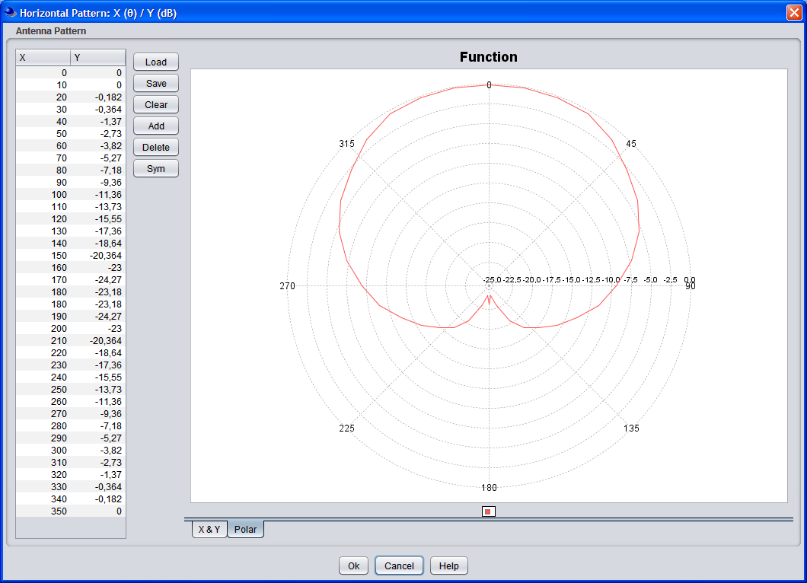
Figure 1: Horizontal sector antenna pattern of the base stations
The vertical diagram of the DA2GC GS has been adapted to a cosecant-squared characteristic which is better suited for air coverage compared to usual sector antennas for terrestrial mobile radio systems as the Rx power is nearly constant with increasing distance between GS and aircraft [16].
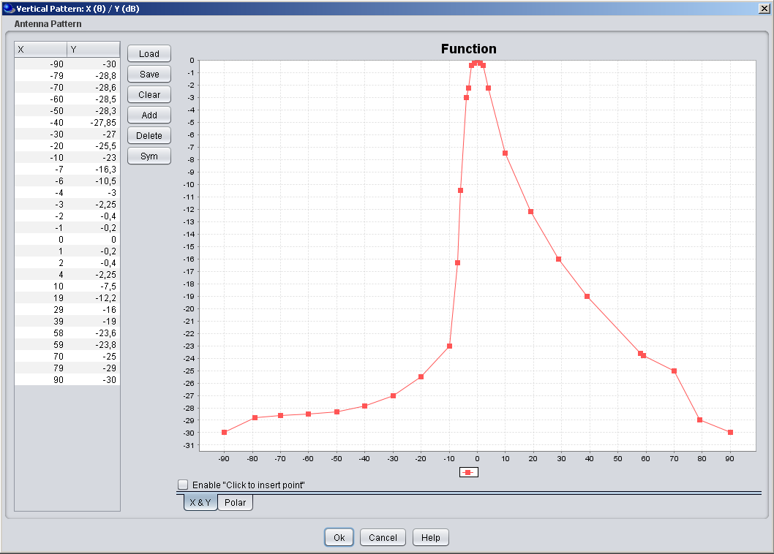
Figure 2: Vertical sector antenna pattern (cosecant-squared) characteristic of the DA2GC BS (screen shot of SEAMCAT GUI; up-tilt not considered in the diagram)

Unwanted emissions
The spectrum emission limits for DA2GC and terrestrial LTE BSs are assumed to be the same. The corresponding values are defined by 3GPP and can be found in Table 7.
Table 7: Unwanted emission limits for DA2GC ground stations adapted to LTE base stations for channel bandwidth of 10 MHz according to [7]

Frequency offset of measurement filter -3dB point, Δf | Frequency offset of measurement filter centre frequency, f_offset | Minimum requirement | Measurement bandwidth
0 MHz ≤ Δf < 5 MHz | 0.05 MHz ≤ f_offset < 5.05 MHz |  | 100 kHz
5 MHz ≤ Δf < 10 MHz | 5.05 MHz ≤ f_offset < 10.05 MHz | -14 dBm | 100 kHz
10 MHz ≤ Δf < 25 MHz | 10.5 MHz ≤ f_offset < 24.5 MHz | -15 dBm | 1MHz
25 MHz ≤ Δf | 25.5 MHz ≤ f_offset | -30 dBm (Note 1) | 1MHz
Note 1: Spurious emissions valid for frequency offset larger than 250% of necessary bandwidth [13].

Aircraft station parameters
Table 8 provides the main parameters of the aircraft station.
Table 8: Main parameters used for ETSI DA2GC aircraft stations (TR 103 054)
Parameter | DA2GC aircraft station
 | FDD |  | TDD
Tx power (max./min.)  (Note 1) |  | 40 dBm / -23 dBm | 40 dBm / -23 dBm
Antenna type |  | Azimuth: Omni-directional  Elevation: See Figure 3 | Azimuth: Omni-directional  Elevation: See Figure 3
Antenna gain |  | 6.54 dBi  (Note 2) | 6.54 dBi  (Note 2)
Antenna height |  | 3000 - 13000 m  (Note 3) | 3000 - 13000 m  (Note 3)
Channel bandwidth |  | 2 x 10 MHz | 15 or 20 MHz
Signal bandwidth  (related to number of occupied resource blocks with bandwidth of 180 kHz) |  | 9 MHz | 13.5 or 18 MHz
Rx thermal noise |  | -104.5 dBm | -102.7 or -101.5 dBm
Rx noise figure |  | 9 dB | 9 dB
Rx noise floor |  | -95.5 dBm | -93.7 or -92.5 dBm
Rx reference sensitivity level |  | -97.5 dBm | -95.7 or -94.5 dBm
Interference protection ratio I/N |  | -6 dB | -6 dB
Interference protection level |  | -101.5 dBm | -99.7 or -98.5 dBm
Tx spectrum emission mask (SEM) / Spurious emissions |  | According to [6] | According to [6]
Adjacent channel leakage ratio (ACLR) limit |  | 37 dB  (Note 4) | 37 dB  (Note 4)
Rx in-band / out-of-band blocking |  | According to [6] | According to [6]
Rx adjacent channel selectivity (ACS) |  | 33 / 30 / 27 dB for channel bandwidths of 10 / 15 / 20 MHz  (according to [6]) | 33 / 30 / 27 dB for channel bandwidths of 10 / 15 / 20 MHz  (according to [6])
Note 1: The Tx power of the mobile station is dependent on the power control implementation applied by the equipment provider.
Note 2: For former evaluation a simple omni-directional characteristic with 0 dBi gain was assumed. The final diagram incl. the gain will be dependent on further antenna optimization steps as well as on limits set by the regulation. In the range just below the horizontal aircraft plane the antenna gain will normally be higher (up to about 6 dBi) to allow access of the OBU to the BS at the cell edge.
Note 3: The current assumption for a DA2GC OBU is that it will not transmit for altitudes below 3000 m as the GSM/WiFi onboard wireless access networks for the passengers have to be switched off below that threshold. In case the airlines are interested to use the DA2GC also for their operational services (non-safety relevant), it has to be clarified with the regulatory authorities under which conditions DA2GC radio links can kept until the aircraft reaches the airport ground (only wired access in the aircraft below the altitude threshold allowed).
Note 4: A higher ACLR value is required to keep the maximum allowed out-of-band emission level given in [6] in case of higher maximum Tx power of up to 40 dBm for the DA2GC OBU.

Figure 3: Vertical antenna pattern (monopol) for the DA2GC AS (gain of 6.54 dBi; direction to earth at 0°, to the horizon at ±90°)

DA2GC system according to ETSI TR 101 599

Overall system architecture
The broadband DA2G system using beamforming antennas is designed to provide bi-directional ground-to-aircraft connectivity as part of an overall broadband communications system which will offer a variety of IP-based applications for the use of passengers as well as operational (non-safety) data for airline use.
Figure 3 gives a high-level overview of how the DA2G system fits within the end-to-end system architecture. The elements which constitute the DA2G link are those elements which provide connectivity between the Air Network and the Ground Network, including the Air Station and Wireless Base Station shown in the top left hand corner of the figure
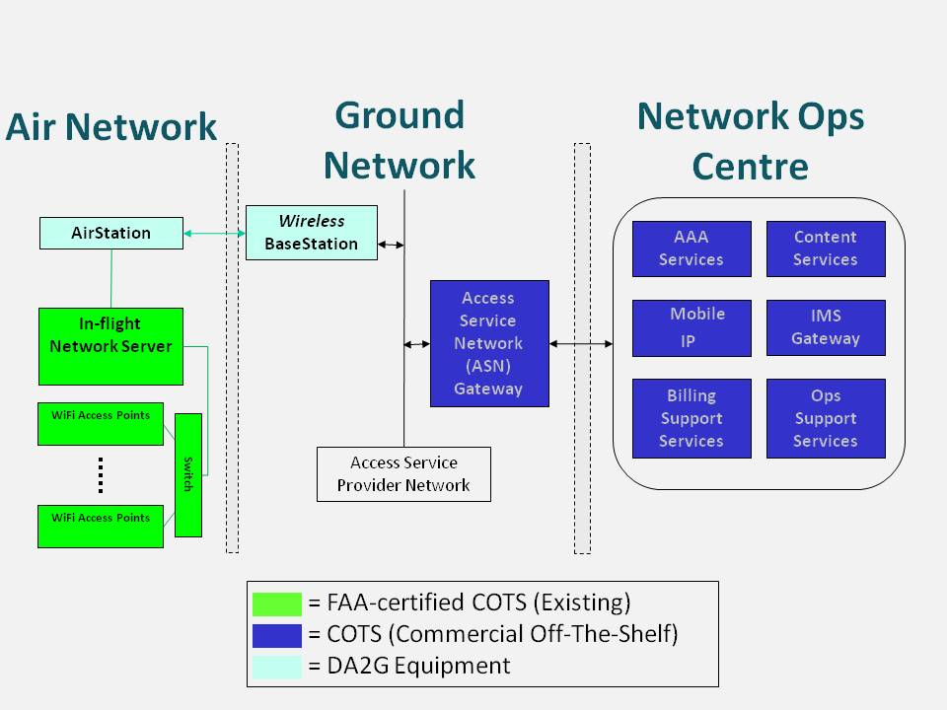
Figure 4: DA2G system, as part of overall end-to-end architecture

Ground station equipment
An unique feature of this DA2GC system is the simultaneous use of four separate integrated radio transceivers/phased array antenna assemblies at the ground station. Such an arrangement enables each ground station to cover the entire visible air space, from horizon to horizon, at all azimuths. Each integrated antenna array is capable of simultaneously producing at least two co-frequency shaped beams which are spatially separated, thereby allowing for a minimum of two beams per sector (or quadrant), or eight beams per ground station. This is shown diagrammatically in Figure 4.
Figure 5: Typical Ground Station antenna arrangement producing multiple beams
Although the illustration in Figure 4 shows a total of 8 aircraft being served per ground station, this assumes that each sector is served by a 4-element beamforming antenna array. The number of beams can be increased to 4 beams per quadrant or 16 per ground station in the case where 8-element antenna arrays are used. In addition, the use of TDMA and FDMA can further increase the number of individual data paths established (and hence number of aircraft served) to much higher numbers, albeit at the cost of reduced data rate per aircraft. Potential problems of cross-talk between the transmit and receive paths of the various aircraft links at a given ground station antenna are eliminated due to the use of TDD, together with synchronisation of signals such that all paths are in transmit or receive mode at the same time when each beamforming array is generating multiple beams.

Transmitter parameters

Transmitter Output Power / Radiated Power
Table 9: DA2GC Transmitter characteristics
Parameter | Tx output | e.i.r.p.
Maximum ground station TX output power (dBm) | 25 | 45
Maximum aircraft TX output power (dBm) | 28 | 45
ATPC used? | Yes
Maximum operational ATPC range (dB) | 30
Max e.i.r.p. GS | 32 dBm/MHz
Max e.i.r.p. AS | 32 dBm/MHz
Maximum number of antenna arrays per Ground Station | 4
Maximum number of beams per antenna array | 4

NOTE: The e.i.r.p. levels in Table 9 represent the maximum operational levels at all times for a single beam, including link acquisition, since the periodic beacon signal transmitted from the ground station radiates lower transmit powers than the signals used to carry data once the aircraft links are established.
Antenna Characteristics
Table 10: DA2GC Antenna characteristics
Parameter | Value
Ground station peak gain using 4 antenna array (dBi) | 20
Ground station peak gain using 8 antenna array (dBi) | 23
Aircraft peak gain (dBi) using 4 antenna array | 10
Aircraft peak gain (dBi) using >4 antenna array | 17
NOTE: The Ground Station peak gains given above are for a single antenna array.

Use of phased array antennas and beamforming results in beam shapes which can be optimised for the intended operational frequency bands and co-existence scenarios. The beamforming algorithms used at the ground station and on the aircraft station permit highly accurate beam pointing, i.e. with an accuracy of 0.1 degrees, and the pointing is refreshed at a rate of at least 200 times per second implying a 5 ms minimum refresh period. This enables accurate control to be maintained during all phases of a flight, including the ability to maintain pointing direction to within 0.5 degrees or less even during periods of flight turbulence or extreme manoeuvres.

Example radiation patterns
Example radiation patterns are shown in Figure 5 and Figure 6, for the ground station and aircraft station antennas respectively, when operating in the 2.4 GHz band. These are based on the current first-generation product using 4-antenna arrays at the ground station and on the aircraft. Figures 10 and 11 show the elevation and azimuth patterns respectively for this 8-antenna array. This 2nd generation product can operate in the 2,4 GHz and/or the 5,8 GHz bands, but the plots shown in Figure 6 and Figure 7 are based on measurements performed at 5,8 GHz. Figure 8 and Figure 9 show examples of the elevation and azimuth patterns for a 16-element aircraft antenna.

Figure 6: Ground Station Antenna Pattern (1st generation 4-antenna array)
The Ground Station antenna array has a fixed pattern in the vertical plane, but is designed to use beamforming in azimuth so that one or more aircraft can be tracked during flight. Although, in practise, the radiation pattern will vary as the beam is scanned, the pattern given in Figure 5 can be assumed to be the worst case for all azimuths. i.e. the gain at any azimuth pointing direction will be less than or equal to the values shown, for any given elevation angle.
Figure 7: Aircraft Station Antenna Pattern (1st generation 4-antenna array)
The beam produced by the aircraft antenna array is steered in both azimuth and elevation so that the main lobe tracks the ground station as the aircraft traverses its flight path. The off-axis radiation pattern shown in Figure 6 can be assumed to be the worst case for all main lobe pointing directions.
-
30
-
20
-
10
0
10
20
30
-
90
-
80
-
70
-
60
-
50
-
40
-
30
-
20
-
10
0
10
20
30
40
50
60
70
80
90
Gain (dBi)
Elevation angle (deg)
Figure 8: Ground Station Antenna Elevation Pattern (2nd generation 8-antenna array)
-
40
-
35
-
30
-
25
-
20
-
15
-
10
-
5
0
-
90
-
80
-
70
-
60
-
50
-
40
-
30
-
20
-
10
0
10
20
30
40
50
60
70
80
90
Gain, relative to peak boresight gain (dB)
Azimuth Angle, relative to pointing direction (deg)
Figure 9: Ground Station Antenna Azimuth Pattern (2nd generation 8-antenna array)
Note that, for three dimensional computations, the resulting ground station antenna gain in any given pointing direction is the sum of the relevant elevation and azimuth gains shown in Figure 7 and Figure 8 respectively.
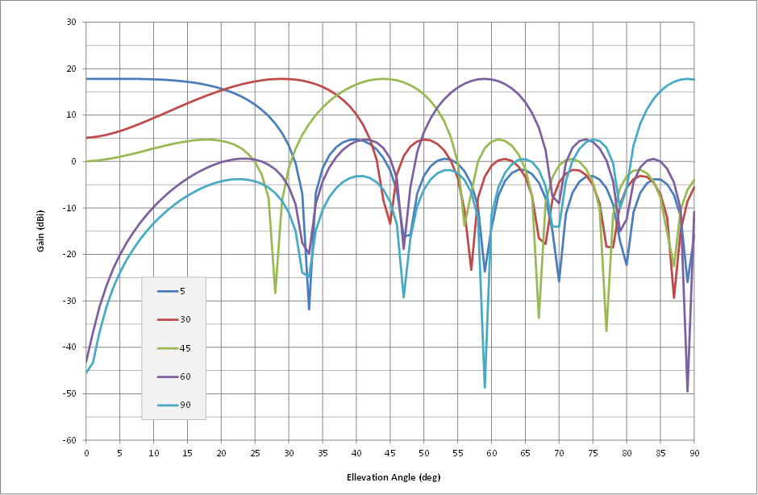
Figure 10: Aircraft Station Antenna Elevation Patterns (2nd generation 16-antenna array)
Note that, in the above sample plots, an elevation angle of 0 degrees represents the horizon pointing direction and 90 degrees is straight down.
-
50
-
40
-
30
-
20
-
10
0
0
10
20
30
40
50
60
70
80
90
100
110
120
130
140
150
160
170
180
Gain, relative to peak boresight gain (dB)
Azimuth Angle, relative to pointing direction (deg)
Figure 11: Aircraft Station Antenna Azimuth Pattern (2nd generation 16-antenna array)
Note that, for three dimensional computations, the resulting aircraft station antenna gain for any given pointing direction is the sum of the relevant elevation and azimuth gains shown in Figure 9 and Figure 10 respectively.

Operating Frequency
The scope of the present document is restricted to operation within the 2 400 MHz to 2 483,5 MHz band and/or the 5 855 MHz to 5 875 MHz band. However, the technology is capable of operating in any frequency band within the range from 790 MHz to 6 GHz.

Bandwidth
The necessary bandwidth (as defined by Articles 1.152 and 1.153 of the ITU Radio Regulations) is 20 MHz and the occupied bandwidth complies with Clause 4.3.2.6 of ETSI EN 300 328 V1.8.1 [21] for operation in the 2400 MHz to 2483.5 MHz band and falls within the emission mask specified in Figure 11 for operation in the 5855 MHz to 5875 MHz band.

Unwanted emissions
The unwanted emissions, including spurious emissions and out-of-band emissions (as defined by Article 1.146 of the ITU Radio Regulations [20] fall within the limits specified in Clauses 4.3.2.7 and 4.3.2.8 of EN 300 328 V1.8.1 [21] for operation in the 2 400 MHz to 2 483,5 MHz band. The ground station and aircraft station emissions when operating in the 5 855 MHz to 5 875 MHz band fall within the limits given in Figure 11 when operating under highest output power conditions.

Figure 12: Emission mask
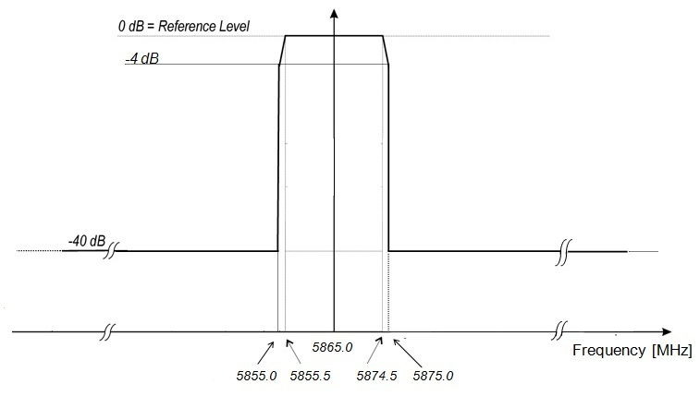

Receiver parameters
The sensitivity is better than or equal to -87 dBm in a 20MHz bandwidth on both the ground station and aircraft station receivers. Adjacent channel selectivity is 43.5 dB for the ground station and 27 dB for the aircraft station, as specified in 3GPP TS 36.104 and 3GPP TS 36.101 respectively. Other receiver parameters comply with, or exceed, the requirements within these 3GPP specifications.

4.2.6 Channel access parameters
The operational channel access parameters such as frame duration, resource grouping and allocation in time and frequency, random access procedures, are fully configurable.

DA2GC system according to ETSI TR 103 108

Technical Description
The system is based on UMTS TDD technology whose signal in space characteristics is compliant with 3GPP release 7 apart from a frequency converted from 2.6 GHz to 5.8 GHz. Doppler shift and range compensation is introduced by the air station such that the base station considers the mobile to be near stationary with a fixed range. A vertical polarization is used.

Transmitter
The Ground Station has a maximum transmitter power of 10 watts (40 dBm). The bandwidth may be either 5 MHz or 10 MHz with a preferred bandwidth of 10 MHz. 10 MHz has been used for the compatibility analyses.
The Aircraft Station has a maximum transmitter power of 10 watts (40 dBm). The bandwidth may be either 5 MHz or 10 MHz and is determined by the Ground Station.
The system is designed to be used during all phases of flight. However when the use of passenger equipment is not permitted, for example during the landing phase, the available capacity may be used exclusively for non-safety of life airline applications (e.g. AOC, AAC).

Receiver
Frequency conversion to/from 5.8 GHz as well as range and Doppler shift compensations are achieved within the avionics receiver. The receiver modem characteristics are compliant with 3GPP release 7 at the physical layer. The modem itself operates at 2.6 GHz.

Ground Antennas Characteristics

Figure 13: Omni Antenna Pattern - Elevation

Figure 14: Omni Antenna Pattern - Azimuth

Figure 15: Sector Antenna Pattern - Elevation

Figure 16: Sector Antenna Pattern - Azimuth

Aircraft Antenna Characteristics

The elevation pattern of the aircraft antenna used for analysis is illustrated below:

Figure 17: Aircraft Antenna Pattern - Elevation

Figure 18: Aircraft Antenna Pattern - Azimuth

Some measured patterns are presented below for information purposes:

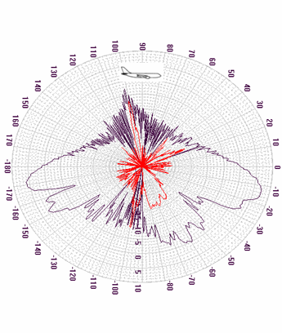
Figure 19: A/C Antenna Pattern – Elevation (Measured)
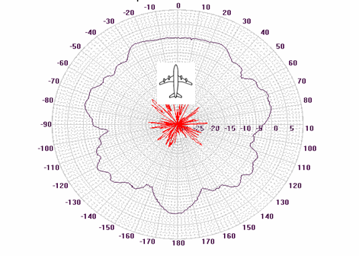
Figure 20: A/C Antenna - Azimuth (Measured)

System Parameters
Table 11: DA2G (Aero3G) System Parameters
Parameter | Unit | Value
Max transmitter power | dBm | 40
Transmitter feeder loss | dB | 4
Transmitter duty cycle | % | 50
Transmitter bandwidth | MHz | 10
Receiver interference threshold | dBm/MHz | -113.9
Polarisation |  | Vertical

Editorial Note: Parameters were also delivered in doc SE44(11)027 with different receiver interference threshold

Compatibility studies in the unpaired 2 GHz bands

Introduction

Compatibility and sharing scenarios in the band 1900 – 1920 MHz
Compatibility and sharing studies for DA2GC might be necessary versus the following services and systems
- Adjacent channel compatibility:
  - IMT (UMTS FDD UL),
  - DECT (indoor + outdoor),
  - Non-specific SRDs (indoor + outdoor),
  - PMSE (indoor + outdoor),
  - FS (secondary).
- Co-channel compatibility:
  - Non-specific SRDs (indoor + outdoor),
  - PMSE (indoor + outdoor),
  - FS (secondary).

According to the information given in 3.1 two systems already commercially deployed within Europe are in the focus of first compatibility evaluations for DA2GC:
- DECT (TDD) in the adjacent band below 1900 MHz.
- UMTS FDD (UL) in the adjacent band above 1920 MHz.
UMTS TDD services within the band 1900-1920 MHz will be not considered as there are no relevant commercial deployments within European area.

Technical characteristics of UMTS
The UMTS system parameters are based on 3GPP specifications for transmitter and receiver characteristics for BS [8] and UE [9].

Table 12: Main parameters for the UMTS system
Parameter | UMTS BS | UMTS UE
 | FDD | FDD
Type | Macro / Wide area | Power class 3
Tx power | 43 dBm | 24 dBm
Antenna type | 3 x 120° sector antennas  (according to ITU-R F.1336) | Omni
Antenna gain | 17 dBi | 0 dBi
Antenna height | 30 m | 1.5 m
Antenna tilt | -2.5°(down-tilt) | 0°
Channel bandwidth | 5 MHz | 5 MHz
Frequency re-use factor | 1 | 1
Signal bandwidth | 3.84 MHz | 3.84 MHz
Rx thermal noise | -108 dBm | -108 dBm
Rx noise figure | 5 dB | 9 dB
Rx noise floor | -103 dBm | -99 dBm
Rx reference sensitivity level | -121 dBm | -117 dBm
Interference protection ratio I/N | -6 dB | -6 dB
Interference protection level | -109 dBm | -105 dBm
Tx spectrum emission mask (SEM) / Spurious emissions | According to [8] | According to [9]
Adjacent channel leakage ratio (ACLR) limit (related to UMTS) | 45 dB / 50 dB (1st/2nd channel) | 33 dB / 43 dB (1st/2nd channel)
Rx in-band / out-of-band blocking | According to [8] | According to [9]
Rx adjacent channel selectivity (ACS) | 46 dB | 33 dB

Figure 21: Vertical sector antenna pattern characteristic of the UMTS BS (according to ITU-R F.1336 with k = 0.2 [18]; down-tilt not considered in the diagram)

Technical characteristics of DECT systems
The DECT system parameters used in the study are based on ETSI EN 300 175-2 [10] and on additional information provided by the DECT Forum (e.g.[11]).
DECT technology has been deployed worldwide since many years with applications for residential cordless telephones, enterprise (multi-cell) local mobility systems, public wireless local loop (WLL) systems and public pedestrian mobility systems. According to information of the DECT Forum the dominating applications are residential cordless phones followed by enterprise systems. Public DECT systems exist in a few places in Eastern Europe, and the market is very small.
Table 13: Main parameters for DECT stations/terminals
Parameter | DECT station/terminal
 | TDD
Tx power (max./min.) | 24 dBm
Antenna type | Directional / Omni-directional
Antenna gain | Up to 12 dBi / Up to 3 dBi  (Note 1)
Antenna height | 5 m  (Note 2)
Channel separation | 1.728 MHz
Signal bandwidth | 1.152 MHz
Rx thermal noise | -114 dBm
Rx noise figure | 11 dB
Rx noise floor | -103 dBm
Rx reference sensitivity level | -93 dBm  (Note 3)
Interference protection ratio I/N | 0 dB
Interference protection level | -103 dBm  (Note 4)
Tx spectrum emission mask (SEM) / Spurious emissions | According to [10]
Adjacent channel leakage ratio (ACLR) limit | See Table 9
Rx in-band / out-of-band blocking | According to [10]
Rx adjacent channel selectivity (ACS) | See Table 15

Note 1: Typically DECT equipment uses omni-directional antennas with 0 dBi (due to asymmetries in the diagram peak gains up to 3 dBi may occur). About 5 % of the enterprise base stations have external antennas with 6-12 dBi. This corresponds to 0,026% of all DECT base stations, and 0,01 % of all DECT transmitters. The 12 dBi value has been considered as worst case assumption for the interference computation in the present study.
Note 2: Similar to the antenna gain a height of 5 m has been assumed corresponding to an outdoor enterprise or WLL station.
Note 3: The reference sensitivity level given in ETSI EN 300 175-2 [10] is only -83 dBm, but DECT manufacturers very early succeeded to make cost efficient DECT phones with -93 dBm sensitivity, which is the industry standard since then.
Note 4: Interfering signal level to allow a 3dB desensitization of the DECT receiver.

Ten RF carriers are defined for DECT in the frequency band 1880-1900 MHz with center frequencies Fc given by:
Fc = F0 - c x 1.728 MHz where F0 = 1897.344 MHz and c = 0, 1, ..., 9.
Figure 22: Position of DECT carriers and adjacent channels extended outside the DECT band (related to UMTS TDD channelization)

Table 14: Adjacent channel leakage ratio for DECT channelization (bandwidth of about 1 MHz)
Adjacent channel # | Maximum power level | ACLR
1st adj. channel | -8 dBm | 32 dB
2nd adj. channel | -30 dBm | 54 dB
3rd adj. channel | -41 dBm | 65 dB
4th & higher adj. channel | -44 dBm | 68 dB

Table 15: Adjacent channel selectivity for DECT-like interferer
Adjacent channel # | ACS
1st adj. channel | 24 dB
2nd adj. channel | 45 dB
3rd adj. channel | 51 dB
4th adj. channel | 55 dB
5th & higher adj. channel | 58 dB

DA2GC Reverse Link in the band 1900 – 1920 MHz
Following interference scenarios are evaluated based on the assumption that the DA2GC reverse link (RL) is applied in the band 1900-1920 MHz (see Figure 2):
- UMTS:
  - The reception at the UMTS base station (UMTS UL) is interfered with by the DA2GC RL from the onboard unit (OBU) of the aircraft station (AS).
  - The reception at the DA2GC ground station (GS), i.e. the DA2GC RL, is interfered with by the UMTS UL (UE).
- DECT:
  - The reception at a DECT station is interfered with by the DA2GC RL.
  - The reception at the DA2GC GS (DA2GC RL) is interfered with by the signal transmission of a DECT station.
The evaluation results described later are based on worst case single link scenarios between the interferer and the victim system to get an overview about scenarios which might perhaps require a more deep analysis based on statistical evaluations e.g. by use of the SEAMCAT Monte Carlo simulation functionality.

Figure 23: Interference scenarios for BDA2GC Reverse Link in the frequency band 1900 – 1920 MHz

Impact of DA2GC AS on UMTS BS

Results
The following diagrams always show
- path loss with and without consideration of the vertical antenna characteristic at the DA2GC AS and UMTS BS (antenna gain not included),
- received interference power at the UMTS BS (related to the signal bandwidth of 3.84 MHz),
- resulting interference-to-noise ratio (I/N) compared to the threshold of victim system
along the great circle distance from 0 km to 100 km considering different aircraft altitudes of 3 km and 10 km, respectively.
With respect to interference the worst case assumption is to have line-of-sight propagation between interferer and victim. Therefore, only free space loss was applied [21]. In real scenarios there may be a strong shadowing of the interfering signal resulting in drastically improved system performance compared to the results given in the present document.
The carrier frequency of the interfering DA2GC RL is placed at 1915 MHz, the UMTS UL carrier is at 1922.5 MHz, i.e. there is no frequency guard band in between the 2 channels.
For the I/N computation the resulting adjacent channel interference ratio (ACIR) was considered which is based on following relationship of the Tx and Rx characteristics of interferer and victim equipment:
The ACLR value of the DA2GC AS for the frequency separation given before corresponds to 42.5 dB, which can be increased to 47.2 and 59.2 dB by shifting the carrier frequency in direction of the lower edge of the band 1900-1920 MHz (i.e. to 1910 MHz and 1905 MHz, respectively).
Figure 24: Path loss with and without consideration of the vertical antenna characteristic (antenna gain not included) at the DA2GC AS and UMTS BS (aircraft altitude of 3 km)
Figure 25: Interference signal power at UMTS BS w/ & w/o consideration of ACIR (aircraft altitude of 3 km)

Figure 26: Resulting I/N at UMTS BS w/ & w/o consideration of ACIR (aircraft altitude of 3 km)
Figure 27: Path loss with and without consideration of the vertical antenna characteristic (antenna gain not included) at the DA2GC AS and UMTS BS (aircraft altitude of 10 km)
Figure 28: Interference signal power at UMTS BS w/ & w/o consideration of ACIR (aircraft altitude of 10 km)
Figure 29: Resulting I/N at UMTS BS w/ & w/o consideration of ACIR (aircraft altitude of 10 km)
It can be seen that the resulting interference margin is in the range of about 10 dB in the considered worst case scenario occurring at an aircraft altitude of 3 km. The margin increases to about 20 dB for an altitude of 10 km.

Impact of UMTS UE on DA2GC GS

Results
The following diagrams always show – similar to the case of scenario 5.5.1 but now there is no need to consider any aircraft altitude – the interference impact of a UMTS UE on the DA2GC GS. In principle this scenario is the identical to the one if LTE and UMTS carriers, both for terrestrial mobile radio coverage, are deployed on adjacent channels. Therefore it is not only related to the DA2GC case.
Figure 30: Path loss with and without consideration of the vertical antenna characteristic (antenna gain not included) at the DA2GC GS and UMTS UE
Figure 31: Interference signal power at DA2GC GS w/ & w/o consideration of ACIR
Figure 32: Resulting I/N at DA2GC GS w/ & w/o consideration of ACIR
In the hypothetical case considered here the I/N threshold is exceeded for a UE placement near the site of the DA2GC GS, requiring an unobstructed line-of-sight path between the antennas. In case of co-located BSs for UMTS and DA2GC the UMTS power control would reduce the UE Tx power level of 24 dBm which was assumed here. The maximum interference impact may occur if there is no site sharing and the UMTS UE is near the cell edge which is also near by a DA2GC site. As rural areas are favored for deployment of DA2GC sites, the occurrence of such an interference situation is strongly limited.

Impact of DA2GC AS on DECT station/terminal

Results
The interference impact of a DA2GC AS on a DECT station is shown in the following diagrams. For the examinations a worst case scenario is created with DECT outdoor reception (transmission in case of Scenario (5.5.2) at rooftop level (i.e. line-of-sight between both antennas) and applying a directional high gain antenna towards the aircraft (or to the DA2GC GS, respectively).
As reference the DECT channel F0 is applied as victim carrier frequency and the DA2GC signal was placed near the DECT band in the adjacent channel with a carrier frequency of 1905 MHz.
The ACLR values of the AS transmitter were adapted to the DECT signal bandwidth and the spacing between the carrier frequencies resulting in a value of 50 dB for the example considered here (carrier spacing of about 7.66 MHz). Shifting the DA2GC signal to the upper edge of the 1900-1920 sub-band (i.e. carrier frequency of 1915 MHz as already considered in Scenario (1a/b)) the ACLR increases to about 65 dB.
For the computation of ACIR also modified values for the DECT Rx ACS are needed as the ones given in Table 10 are only for DECT carrier frequency spacing and signal bandwidth. A similar approach as proposed by the DECT Forum in [11] was applied to get ACS values for other frequency separations and bandwidths. The resulting values are 56 dB for the considered carrier spacing as well as 58 dB for additional increase of carrier frequency distance by more than 5 MHz. The corresponding ACIR values are 49 dB and 55.5 dB, respectively.
Figure 33: Path loss with and without consideration of the vertical antenna characteristic (antenna gain not included) at the BDA2GC AS and DECT station (aircraft altitude of 3 km)
Figure 34: Interference signal power at DECT station w/ & w/o consideration of ACIR (aircraft altitude of 3 km)
Figure 35: Resulting I/N at DECT station w/ & w/o consideration of ACIR (aircraft altitude of 3 km)
Figure 36: Path loss with and without consideration of the vertical antenna characteristic (antenna gain not included) at the BDA2GC AS and DECT station (aircraft altitude of 10 km)
Figure 37: Interference signal power at DECT station w/ & w/o consideration of ACIR (aircraft altitude of 10 km)
Figure 38: Resulting I/N at DECT station & w/o consideration of ACIR (aircraft altitude of 10 km)
There is no noticeable impact of the DA2GC AS on the reception at the DECT station even in the examined worst case scenario with outdoor reception using the high gain antenna. One reason for that is the achieved ACIR based on relatively high ACLR of the DA2GC AS and ACS of the DECT station.

Impact of DECT station on DA2GC GS

Results

The interference impact of a DECT station on a DA2GC GS is presented in the following diagrams.

Figure 39: Path loss with and without consideration of the vertical antenna characteristic (antenna gain not included) at the BDA2GC GS and DECT station
Figure 40: Interference signal power at DA2GGC GS w/ & w/o consideration of ACIR
Figure 41: Resulting I/N at DA2GC BS w/ & w/o consideration of ACIR
Similar to the case with a UMTS UE as interferer (same Tx power of 24 dBm) the I/N threshold is exceeded for a placement of a DECT station near the DA2GC GS (up to a distance of about 0.4 km). Further frequency separation between the DECT and the DA2GC carrier will not significantly improve the results (only by 0.5 dB) as the ACIR is dominated by the ACS of the DA2GC BS (43.5 dB), even if the DECT ACLR is increased from 51 to 58.5 dB.
Nevertheless, the final interference impact of DECT stations on the DA2GC RL reception is rated as rather small due to very low number of deployed outdoor stations with high gain antennas in Europe in combination with the low number of DA2GC GS (about 400) required for pan-European coverage. As a simple mitigation measure sufficient link distances between DECT stations and DA2GC GS should be considered during network deployment.

Conclusions on compatibility between DA2GC and UMTS/DECT systems
The worst case link evaluations presented in the present document have shown that there will be no negative impact on DECT and UMTS FDD UL, if the DA2GC RL is implemented in the band 1900-1920 MHz independent of the positioning of the carrier frequency in the range between 1905 and 1915 MHz.
On the other hand DECT stations as well as UMTS UEs may disturb the DA2GC RL reception at the GS, if they are placed near the GS with unobstructed line-of-sight path to the GS antenna and, in addition, if they are required to transmit with their maximum power (e.g. a UE at cell edge). But as such a situation will only seldom occur for UMTS UEs and as DECT outdoor stations are only rarely deployed there is only a very low risk for any performance degradation of the DA2GC RL transmission.
Possible mitigation measures are sufficient separation distances between DECT outdoor stations and DA2GC GS as well as an improvement of the ACS of the GS receiver.

DA2GC Foreward Link in the Band 1900 – 1920 MHz

Compatibility and sharing scenarios for the band 2010 – 2025 MHz
Compatibility and sharing studies for DA2GC might be necessary versus the following services and systems
- Adjacent channel compatibility:
  - MSS UL,
  - Non-specific SRDs (indoor + outdoor),
  - PMSE (indoor + outdoor),
  - FS (secondary),
  - Tactical radar,
  - Space research/earth exploration satellite services (E-S).
- Co-channel compatibility:
  - Non-specific SRDs (indoor + outdoor),
  - PMSE (indoor + outdoor),
  - FS (secondary).

Technical characteristics of Space service receivers in the band 2025 – 2110 MHz
The band 2025-2110 MHz is used by a great multiplicity of satellite systems ranging from LEO polar satellites to distant SRS satellites at the Lagrangian point, from geostationary telecom satellites in LEOP/emergency phase to the International Space Station (including all the vessels that are used for ferrying people and material to/from the ISS), from the Galileo RNSS satellites to HEO SRS satellites. In total, several hundred filings can be found in the ITU database for this band.
The protection criterion for this band is -177 dBW/kHz at the satellite receiver input for 0.1% of the time as identified in ITU-R Rec. SA.609-2 [6]. Although the recommendation refers only to SRS systems, this protection criterion is normally used for sharing studies also for the other satellite services in this band. It is to be noted that this value presents the maximum aggregate interference from all the interference sources and from all the different services. This means:

1. that the total number of interfering systems in visibility of the spacecraft receiver has to be taken into account and
2. that an apportionment of the allowed interference level has to be made among the various terrestrial services sharing the band (or emitting unwanted emissions from adjacent bands)

For point 2, in the case of the studies made in the past for sharing with mobile systems the "interference budget" was divided 50/50 between FS and MS, resulting in a threshold of
-180 dBW/kHz (see ITU-R Rec. SA.1154 [14]). ESA suggested to start the studies by applying the same value as used for the studies with mobile systems and to further discuss this point at a later stage. Unfortunately there is wide variety of satellite systems in this band, therefore it is not possible to define a single technical parameter set for all of them.
One common element is the fact that all these systems use a hemispherical quasi-omnidirectional antenna for the satellite receiver. Figure 22 shows an example from an ESA EESS satellite (Sentinel-1) that could be considered as representative of these antennae and therefore be used in the present studies.

Figure 42: Exemplary vertical satellite receive antenna pattern for S-Band uplink: co-polar (red lines) and cross-polar (blue lines)
Another relevant parameter is the satellite orbit. As said above, the orbits vary extremely depending on the type of satellite. The most critical case for compatibility with DA2GC GS transmissions is the case of the International Space Station (ISS) and all the related vessels, since the other satellite systems fly at higher orbital altitudes. The ISS itself flies at a height between 330 and 410 km and therefore a satellite altitude of 330 km is used for the worst case analysis.

Technical characteristics of Satellite Earth Stations
There are currently more than 112 missions and 126 uplinks only for Earth Exploration Satellite Service (EESS) and many planned for the near future. Under the Space Operations Service a high numbers of uplinks are used for connections to the International Space Station (ISS), its payloads and all related vehicles. Some low orbiting SRS systems use these bands. Also the European Radionavigation system Galileo uses these bands for TT&C, as well as the Ariane launchers. The number of military links in these bands is not known, but expected to be high. Several hundreds of GSO and NGSO telecom satellite links are filed in these bands. These bands are also beginning to be used by microsatellite systems (see WRC AI 9.1.8).
In addition, only for ESA usage, there are about 25 Earth stations in Europe (see ANNEX 1) and a number of other Earth stations are deployed by various satellites operators. The following technical parameters of Satellite Earth Stations were provided by ESA:

- G, Antenna gain (3 to 15 m diameter) : 34 to 48 dBi
- Antenna pattern : F.1245 (average side lobes)
- P, Power : 50 to 70 dBm
- B, Bandwidth : 0.1 to 3 MHz

Technical characteristics of other victim systems

DA2GC Reverse Link in the band 2010 – 2025 MHz

DA2GC Forward link in the band 2010 – 2025 MHz

Figure 43: Interference scenarios for BDA2GC in the frequency band 2010 – 2025 MHz

Impact of DA2GC GS on Satellite receivers

Methodology
For the compatibility evaluations a DA2GC set-up of 377 sites across Europe, covering the main flight corridors for continental aircraft traffic, has been assumed. The exemplary site positions arranged in a regular hexagonal grid are shown in Figure 23.
DA2GC GS sites are typically deployed with 3 sector antennas each, which are assumed here to result in a near omnidirectional coverage. In order to simplify the model and reduce the calculation time, omnidirectional antennas are applied for the DA2GC GS sites in the present evaluation, i.e. only the vertical GS antenna diagram is correctly modelled. This represents a worst case interference situation caused by the DA2GC system.

Figure 44: Regular hexagonal grid with possible site positions for a DA2GC system across Europe

Results

Figure 24 and Figure 25 show the interference power density level in dBm/Hz in the co-channel case between a single DA2GC GS and the satellite/space station at an altitude of 330 km versus the distance (great circle distance, i.e. distance mapped on the earth surface, as well as signal path distance). For the computation of the path loss line-of-sight propagation [14] until the radio horizon is assumed. A carrier frequency of 2 GHz has been taken into account without loss of generality as it is seen worse with respect to the upper adjacent band compared to carrier frequencies of 2015 to 2020 MHz.
For the interference power density shown in Figure 24 only the GS antenna diagram is considered, i.e. the satellite Rx antenna is assumed to be omnidirectional with gain of 0 dBi. Figure 25 shows the final interference power density if the co-polar vertical satellite receive antenna pattern according to Figure 22 is included in the computation (gain of 3.2 dBi). No polarization discrimination has been taken into account.
In Figure 26 the interference power density above Europe is given considering GS as well as satellite antennas, the corresponding 3D view of the power density is shown in Figure 27. Values behind the radio horizon are not considered in the evaluation due to strongly increased signal attenuation. Figure 28 and Figure 29 show the corresponding results for the aggregated co-channel interference caused by all active DA2GC GS sites.

Figure 45: Co-channel interference power density of a single DA2GC GS at a space station with altitude of 330 km vs. distance (only main lobe of GS antenna diagram considered)

Figure 46: Co-channel interference power density of a single DA2GC GS at a space station with altitude of 330 km vs. distance (GS as well as satellite antenna diagram considered)

Figure 47: Co-channel interference power density of a single DA2GC GS at a space station with altitude of 330 km
Figure 48: 3D view of the co-channel interference power density of a single DA2GC GS at a space station with altitude of 330 km

Figure 49: Aggregate co-channel interference power density of all DA2GC GS sites at a space station with altitude of 330 km
Figure 50: 3D view of aggregate co-channel interference power density of all DA2GC GS sites at a space station with altitude of 330 km

Already one single DA2GC GS running with full DL data load would cause a peak interference level of -165.6 dBm/Hz (-168.5 dBm/Hz in case of an omnidirectional antenna with 0 dBi) which is 13.4 dB (11.5 dB) above the threshold of -180 dBm/Hz (equal to -180 dBW/kHz). The peak level of the total ground network (worst case) corresponds to -143.7 dBm/Hz (-146.5 dBm/Hz), i.e. the interference level has to be reduced by at least 36.3 dB (33.5 dB) to keep the threshold.
As the DA2GC system is planned to be used in the band 2025-2110 MHz just below the band 2025-2110 MHz. Thus the interference level noted above is mainly caused by out-of-band emissions and spurious emissions, respectively, dependent on the frequency separation between the DA2GC signal and space station link signal. For the DA2GC GS the same unwanted emission limits as defined by 3GPP for LTE base stations are assumed (see Table 7).

The DA2GC DL signal with 10 MHz channel bandwidth could be placed within the band 2010-2025 MHz on a carrier frequency in the range between 2015 and 2020 MHz. The possible reduction of the interference power level based on the values given in Table 7 and the resulting peak interference level from the DA2GC network (all active GS) at a space station with an altitude of 330 km are calculated given for DA2GC signal carrier frequencies at 2015 MHz, 2017.5 MHz and 2020 MHz, i.e. the DA2GC signal is placed at the band edges as well as in the middle of the band. The corresponding results are given in Table 12, Table 13 and Table 14, respectively. The values in parentheses in the last column are valid if the omnidirectional satellite Rx antenna is applied. Figure 30 includes a graphical presentation of the results.

Table 16: Resulting adjacent peak interference power density level of all DA2GC GS sites with carrier frequency of 2015 MHz at a space station with altitude of 330 km
Frequency range in MHz | Max. power density level in dBm/Hz | Attenuation vs.  Tx power level in dB | Peak interference level in dBm/Hz
2025 ≤ f < 2030 | -64 | 40.5 | -184.2 (-187)
2030 ≤ f < 2045 | -75 | 51.5 | -195.2 (-198)
2045 ≤ f ≤ 2110 | -90 | 66.5 | -210.2 (-213)

Table 17: Resulting adjacent peak interference power density level of all DA2GC GS sites with carrier frequency of 2017.5 MHz at a space station with altitude of 330 km
Frequency range in MHz | Max. power density level in dBm/Hz | Attenuation vs.  Tx power level in dB | Peak interference level in dBm/Hz
2025 ≤ f < 2027.5 |  |  | ()
2027.5 ≤ f < 2032.5 | -64 | 40.5 | -184.2 (-187)
2032.5 ≤ f < 2047.5 | -75 | 51.5 | -195.2 (-198)
2047.5 ≤ f ≤ 2110 | -90 | 66.5 | -210.2 (-213)

Table 18: Resulting adjacent peak interference power density level of all DA2GC GS sites with carrier frequency of 2020 MHz at a space station with altitude of 330 km
Frequency range in MHz | Max. power density level in dBm/Hz | Attenuation vs.  Tx power level in dB | Peak interference level in dBm/Hz
2025 ≤ f < 2030 |  |  | ()
2030 ≤ f < 2035 | -64 | 40.5 | -184.2 (-187)
2035 ≤ f < 2050 | -75 | 51.5 | -195.2 (-198)
2050 ≤ f ≤ 2110 | -90 | 66.5 | -210.2 (-213)

Figure 51: Resulting adjacent peak interference power density level of all DA2GC GS sites for different carrier frequencies at a space station with altitude of 330 km

Conclusions on Impact of DA2GC GS on Satellite receivers
With the DA2GC GS carrier frequency at 2015 MHz, the peak interference level in the band part directly above 2025 GHz band is at least about 4 dB below the threshold. For the parts of the band above 2030 MHz the safety margin is higher than 15 dB. Also by shifting the DA2GC GS carrier frequency to 2017.5 MHz, the protection criterion for the SRS UL is still met with present assumptions for the OOB emissions. Only if a DA2GC GS carrier frequency of 2020 MHz is chosen the SRS UL protection threshold is exceeded within a range of about 2 MHz.
Thus it can be concluded that a DA2GC forward link implementation with 10 MHz signal bandwidth within the band 2010-2025 MHz would not cause harmful interference to SRS UL operations in the band 2025-2110 MHz, if DA2GC GS carrier frequencies between 2015 MHz and 2018 MHz are chosen.
Further mitigation, if necessary, could be achieved by adaptation of the DA2GC GS TX spectrum mask, e.g. enhanced TX filtering leading to lower adjacent channel leakage ratio. Moreover, the actual degree of possible interference from DA2GC into SRS depends on the signal bandwidth of the SRS transmission, e.g. the impact on a broadband signal at the band edge would be less than on a narrowband signal.

Impact of Satellite Earth Stations on DA2GC Aircraft Stations

Methodology
By nature, EESS, SO and SRS Earth Stations in the 2025-2110 MHz band operates at very high e.i.r.p. levels up to 85/90 dBW.
At present, no situation exists where possible receivers of others services in closely adjacent bands are able to operate within the Earth Stations main beam.
With a potential use of DA2GC in the 2010-2025 MHz band, such situations would occur and could represent interference situations difficult to overcome by “regular” mobile systems.

2 scenarios are considered:

- SCENARIO-1 : In-band emissions of Space service Earth Station in the sensitivity filter of the DA2GC receiver, that could lead DA2GC receivers LNA into blocking/saturation
- SCENARIO-2 : Unwanted emissions of the Space service Earth Station in the band of the DA2GC receiver.

Results

For the second scenario, it is also necessary to consider the unwanted emissions specifications of the Earth Stations. Considering their quite small bandwidth, one can assume that, in the DA2GC band, they would more likely relate to the “spurious” domain, as given in RR Appendix 3 as (for Space service (earth stations)):

43 + 10 log (P), or 60 dBc, whichever is less stringent

The maximum unwanted emissions power level produced by 2 GHz Earth stations into a 10 MHz bandwidth DA2GC receivers are hence given as :

Punw = P - 60 dBc + 10*log(10/B)

This leads to the following maximum unwanted emissions power in the DA2GC receiver:

Table 19: Space services unwanted emissions
P (dBm) | B (MHz) | Punw (dBm/ 10 MHz)
50 | 0.1 | 10
 | 1 | 0
 | 3 | -4.8
70 | 0.1 | 30
 | 1 | 20
 | 3 | 15.2

DA2GC receiver parameters
- Go, Antenna gain: 0 dBi (omnidirectional is assumed)
- Bo, Bandwidth = 10 MHz
- Operation altitude : from 3000 to 10000 m
- Speed : 900 km/h
- Protection criteria : -105 dBm/10MHz
- Saturation/blocking level : -43 dBm

Main beam coupling

Based on parameters above, and considering an Earth station pointing at 90°, the following Table 16 provides relevant levels of potential interference for SCENARIO-1. In all cases, the assumed “blocking level“ of -43 dBm is exceeded, in a range 8 to 53 dB.

Table 20: Scenario 1
P (dBm) | G (dBi) | 3000 m altitude | 10000 m altitude
50 | 34 | -24.0 | -34.5
50 | 48 | -10.0 | -20.5
70 | 34 | -4.0 | -14.5
70 | 48 | 10.0 | -0.5

Similarly, the following Table 17 provides relevant levels of potential interference for SCENARIO-2. Here also, in all cases, the protection criteria (-105 dBm/10 MHz) is exceeded, in a range 16 to 75 dB.

Table 21: Scenario 2
P (dBm) | G (dBi) | B (MHz) | 3000 m altitude | 10000 m altitude
50 | 34 | 0.1 | -64.0 | -74.5
50 | 34 | 1 | -74.0 | -84.5
50 | 34 | 3 | -78.8 | -89.2
50 | 48 | 0.1 | -50.0 | -60.5
50 | 48 | 1 | -60.0 | -70.5
50 | 48 | 3 | -64.8 | -75.2
70 | 34 | 0.1 | -44.0 | -54.5
70 | 34 | 1 | -54.0 | -64.5
70 | 34 | 3 | -58.8 | -69.2
70 | 48 | 0.1 | -30.0 | -40.5
70 | 48 | 1 | -40.0 | -50.5
70 | 48 | 3 | -44.8 | -55.2
Note : interference levels in dBm/10 MHz

These calculations are indeed worst case and only representative of the situation of a plane passing right in the Earth Station main beam. This would more than likely relate to low probability of occurrence but, some of these levels are very high and could be quite disruptive to DA2GC receiver or even, under SCENARIO-1, destructive (levels of 10 dBm).

Exclusion and duration of disruption

Taking into account the Earth stations antenna pattern (F.1245) and the above calculation allow to determine a potential “exclusion volume” around each Earth Stations in which the DA2GC will still be interfered or blocked.
The situation of an Earth Station pointing at 90° has been considered at this stage (see Figure 31below).

Figure 52:

On this basis, the following figures provide, at 3000m and 10000 altitude, the angles of discrimination from the main beam within which the interference will remain above the relevant criteria (for various combination of parameters).

Figure 53

Figure 54

For SCENARIO-1, results from Figure 32 and Figure 33 can be summarized and interpreted as in Table 4 below, showing that the potential blocking situation of DA2GC receivers can last over 2 to 12 s for one single earth Station (assuming a plane speed of 900 km/h).

P (dBm) | G (dBi) |  | 3000 m altitude | 10000 m altitude
50  (Figure 32) | 34 | Discrimination (°) | 32.5 | 14
50  (Figure 32) | 34 | exclusion radius (m) | 1610 | 2420
50  (Figure 32) | 34 | duration at 900 km/h | 13 | 19
50  (Figure 33) | 34 | Discrimination (°) | 79.5 | 53.5
50  (Figure 33) | 34 | exclusion radius (m) | 2950 | 8040
50  (Figure 33) | 34 | duration at 900 km/h | 24 | 64

Conclusions on Impact of DA2GC GS on Satellite receivers
Calculations provide a rough demonstration that DA2GC on-board receivers will experience quite high levels of blocking or interference from Earth stations emissions:
- The blocking threshold (-43 dBm) can be exceeded by up to 53 dB during periods from 2 to 12s. One could expect that the maximum level at 10 dBm could be destructive to DA2GC receivers.
- The interference threshold (-105 dBm/10 MHz) can be exceeded by up to 75 dB during periods from 13s to more than a minute.
These calculations are worst case but they tend to demonstrate that DA2GC “uplinks“ operated in the 2010-2025 MHz band are not compatible with Space services uplink in the 2025-2110 MHz band.
Therefore it is concluded that an inversion of the DA2GC transmission direction could improve the situation (i.e. the DA2GC forward link (ground-to-air) in the band 1900-1920 MHz).

Compatibility and sharing scenarios for the band 2400 – 2483.5 MHz
The band 2400 – 2483.5 MHz is heavily used by RLAN, Bluetooth, Zigbee and other applications..According to ERC/REC 25-10 the band is also used by Cordless cameras, portable video links and mobile video links airborne and vehicular. Technical parameters can be found in ERC/REP 038. ECC Report 2 gives information about the spectrum use and future requirements of these systems.
Figure 20 depicts the sharing scenarios in the band 2400 – 2483.5 MHz in both interference directions when assuming TDD mode of the DA2GC system.
Figure 55: Interference scenarios for BDA2GC in the frequency band 2 400 – 2 483.5 MHz

Technical characteristics of SRDs
The relevant technical characteristics and protection criteria for the compatibility studies are given in Table 12. An overview of SRD applications is attached to the Table.
Table 12: Technical characteristics and protection criteria for SRDs in the 2.4 GHz band
 | RLAN/ Wifi – Outdoor (including p2p, p2mp, mesh,..) | RLAN/ Wifi – indoor | Bluetooth | Bluetooth  (class 1) | Zigbee – 802.15.4 | RFID
Tx power dBm(conducted) | 10 – 17 dBm | 13 – 17 | 0 – 5 | 13 | 5 – 15 | 14
Bandwidth (MHz) | 20 / 40 | 20 / 40 | 1 | 1 | 5 | 3
Rx sensitivity (dBm) | -82 / -79 | -82 / -79 | -90 | -90 | -83 | -90
Antenna gain (dBi) | 3 – 10 | 3 - 7 | 0 - 3 | 0 - 3 | 0 - 3 | 6
Duty cycle (%) | Up to 100 | Up to 100 | Up to 100 | Up to 100 | 100 | Up to 100
Hopper/non hopper | Non-hopper | Non-hopper | Hopper | Hopper | Hopper | Non-hopper
Uniform density per km² | 50 | 5000 (e.g. Monaco) | 10.000 (e.g. Monaco) | 1000 | 100 | 100
Rural/Urban | Rural + urban | Urban | Urban | Urban | Urban | Rural + urban
Protection Criterion (C/I) | ≥ 10 dB | ≥ 10 dB | ≥ 10 dB | ≥ 10 dB | ≥ 10 dB | ≥ 10 dB
Percentage indoor (%) | 0 | 99 | 75 | 98 | 99 | 75
Wall attenuation | 0 | 15 | 15 | 15 | 15 | 15

Overview of 2.4 GHz applications:

- WIFI or IEEE 802.11 based consumer and enterprise applications, including smart phones etc.. These products comply with EN 300 328 and Annex 3 of ERC Rec 70-03. Maximum output power is 100 mW e.i.r.p.
  - In 2011 only, in total 1 billion (1.000.000.000) chipsets were shipped.

- Bluetooth for short distance links used in Mobile (smart) phones, notebooks, game consoles...). These products comply with EN 300 328 and Annex 3 of ERC Rec 70-03. Maximum output power ranges from 1 mW e.i.r.p. (Class 3) to 100 mW (Class 1).
  - In 2011 only, in total 2 Billion (2.000.000.000) chipsets were shipped.

- ZigBee or 802.15.4 used in applications for Home Automation, Smart Grid, Building Automation, etc... These products comply with EN 300 328 and Annex 3 of ERC Rec 70-03. Maximum output power is 100 mW e.i.r.p.
  - In 2010, in total 60 million chipsets were shipped.

- Other applications include
  - non specific SRDs (ERC Rec 70-03 Annex 1 / EN 300 440)
  - Railway applications in 2446-2454 MHz (ERC Rec 70-03 Annex 4 / EN 300 761)
  - Radiodetermination applications (ERC Rec 70-03 Annex 6 / EN 300 440
  - RFID (ERC Rec 70-03 Annex 11 / EN 300 440).

Compatibility between Broadband DA2GC (ETSI TR 103 054) and RLANs
The most critical compatibility scenario seems to be between Broadband DA2GC and outdoor RLANs as described in Table 5-1. Therefore this scenario has studied first. An RLAN access point with a maximum antenna gain of 10 dBi and a RLAN device equipped with an omni-directional antenna were assumed in this study (see Figures 5-2 and 5-3). The maximum e.i.r.p. for RLANs is 20 dBm according to ERC Recommendation 70-03 (Annex 3). As the band 2400 – 2483.5 MHz is heavily used by RLANs (density of 50 devices per km²) and the location and operating frequencies are not known for each individual device, DA2GC could only be deployed in this band, if co-channel sharing would be feasible.

Figure 56: RLAN AP antenna elevation gain pattern | Figure 57: RLAN omni antenna elevation gain pattern

Methodology
It is considered that one single DA2GC aircraft station is approaching the RLAN device under consideration at a given altitude (3000m and 10000m). The interference level resulting at the victim receiver was calculated taking into account the transmit power density of the interfering system, the aircraft altitude, the resulting free space loss, the antenna characteristics of the interfering and the victim system and the interference protection level of the victim system. The Interference protection ratio I/N=0 corresponds to C/I of 10dB at Rx power level of -82 dBm.

Results
The below Figure 24Figure 30 show the received power spectral density (PSD) in dBm/MHz at the RLAN GS and the DA2GC AS and the resulting interference-to-noise ratio (I/N) compared to the different thresholds of both systems at aircraft altitudes of 3000 and 10.000 meters. RLANs equipped with omnidirectional antenna and directional antenna were considered. Figure 31 and Figure 32 show the PSD at an RLAN AP receiver input, depending on the aircraft elevation relative to the victim RLAN. Severe interference at the RLAN can be observed at aircraft altitudes of 3000 m and 10000 m.

Impact on outdoor RLANs from DA2GC Aircraft Station
By considering the AS at 3 000 m the protection criterion for the RLAN receiver will be exceeded significantly. Even at 10 000 m severe interference at the RLAN receiver will be caused.
Thus it is concluded that co-channel operation of a BDA2GC reverse link (air-to-ground) and outdoor RLAN systems in the band 2400-2483.5 is not feasible.

Impact on DA2GC Aircraft Station from outdoor RLANs
At higher altitudes the impact of one RLAN transmitter on the receiving BDA2GC AS is negligible due to the low e.i.r.p. of the outdoor RLAN device. This is also the case for larger distances between the outdoor RLAN device and the AS, even at lower altitudes.
The main problem arises due to the high number of outdoor RLAN devices leading to an aggregation of interference signals at the receiving DA2GC AS. Taking into account a density of 50 outdoor RLAN devices / km², there are about 15700 outdoor RLAN devices visible in the range of about 10 km around the receiving DA2GC AS. Even by assuming that these RLAN devices are partly operated on different channels and not during the same time, a sufficient high number of RLAN devices will remain to interfere the reception at the DA2GC AS. This is the case for AS at 3 000 m as well as at 10 000 m. Capacity estimations for BDA2GC based on LTE when aggregated interference of RLANs occurs can be found inANNEX 1..
RLAN equipped with omni-antenna
Figure 58: Received PSD (aircraft altitude 3000 m) | Figure 59: Resulting I/N ratio (aircraft altitude 3000 m)
Figure 60: Received PSD (aircraft altitude 10000 m) | Figure 61: Resulting I/N ratio (aircraft altitude 10000 m)

RLAN equipped with directional antenna
Figure 62: Received PSD (aircraft altitude 3000 m) |  | Figure 63: Resulting I/N ratio (aircraft altitude 3000 m)
Figure 64: Received PSD (aircraft altitude 10000 m) | Figure 65: Resulting I/N ratio (aircraft altitude 10000 m)
Figure 66: Received PSD at RLAN AP (altitude 3000 m) | Figure 67: Received PSD at RLAN AP (altitude 10000m)

Conclusions on the compatibility between DA2GC (ETSI TR 103 054) and RLANs
Based on a consideration of the BDA2GC system described in ETSI TR 103 054, by taking into account the aggregate effect, it is concluded that co-channel operation of a DA2GC forward link (ground-to-air) and outdoor RLAN devices in the band 2400-2483.5 MHz is not feasible. This would also be the case if only a few RLAN devices were operated on the same channel. It is concluded that co-channel operation of a DA2GC reverse link (air-to-ground) and outdoor RLAN devices in the band 2400-2483.5 MHz is not feasible because the RLAN devices would significantly be interfered (by considering an altitude for the AS of 3 000 m or 10 000 m).

Compatibility between Broadband DA2GC (ETSI TR 101 599) and RLANs

Methodology
Figure 33 shows the interference scenario. It is considered that one single DA2GC aircraft station is approaching the RLAN device under consideration at an altitude of 10 000m. Co-channel sharing was assumed. The interference level resulting at the victim receiver was calculated taking into account the transmit power of the interfering system, the aircraft elevation (up to 90 degree), the resulting free space loss, the antenna characteristics of the interfering and the victim system and the interference protection level of the victim system. The aircraft antenna beam was assumed to be steered so that the main lobe tracks the ground station as the aircraft traverses its flight path. The antenna pattern of the 2nd generation of the ground station was used in this study. The red line in Figure 34 shows the required e.i.r.p. of the DA2GC AS as a function of the elevation angle in order to achieve an input level of -87 dBm at the ground station receiver as indicated in the system description. It can be observed that the maximum e.i.r.p. of +45 dBm (see section 7.2.2.1 of ETSI TR 101 599) of the AS is needed in case the elevation angle is about 3 degree. Thus the ATPC range between 3 and 90 degree elevation is about 27 dB.
The dotted lines show for information the great-circle distance and the resulting free space loss (values on the right hand vertical coordinate).
Figure 68: Interference scenario

Figure 69: Resulting aircraft station e.i.r.p.

Results

Impact on outdoor RLANs from DA2GC Aircraft Station
Figure 35 shows the results of the analyses with regard to an RLAN equipped with a 0 dBi omni-directional antenna. It can be observed that in case the elevation angle of the aircraft in relation to its ground station is equal or above five degree, no interference is observed at the RLAN receiver. For all elevation angles below 5 degree RLANs will experience interference produced by one DA2GC aircraft station. Figure 36 shows the results for RLANs equipped with a 10dBi sector antenna. Interference can be observed for elevation angles up to about 20 degree. The dotted lines in the graphs show the great-circle-distance and the distance on the ground (values on the right hand vertical coordinate). For example Figure 36 shows that in case the aircraft elevation is five degree RLANs may be affected at a distance from 5.5 km to 63 km vertically below the aircraft on the ground. The maximum width of the beam is approximately 11.5 km in case the antenna height is 10 km. In both figures it can be seen that the lower the elevation angle of the aircraft, the higher the interference level at the RLAN receiver. This can be explained by the 3 dB beamwidth of the aircraft antenna of about 60 degree and the higher transmit power required on the aircraft station to get the link with the ground station. Because the distance from the aircraft station to the affected RLANs is lower than the distance to the DA2GC ground station, the resulting power level at the RLAN receiver may rise above the threshold. Looking at the same example in Figure 36 the free space loss to the DA2GC ground station is about 141 dB, whereas to the affected RLANs the FSL varies from 121 to 135 dB. Table 13 shows an example calculation for an RLAN that is in 10 km distance (ground distance) to an aircraft (aircraft altitude 10 km).

Table 13: Interfering Link budget
Link budget DA2GC at 10 km height
Required Rx level at GS receiver (dBm) | -87
Elevation Angle (degree) | 5
Antenna gain AS (dBi) | 10,07
FSL | 141,4
Antenna gain GS (dBi) | 19,13
Required Tx level at AS (dBm) | 25,2
Resulting e.i.r.p. (dBm) | 35,27
RLAN at 10 km distance (on the ground)
Max RLAN antenna gain (dBi) | 10
RLAN gain towards DA2GC AS (dBi) | 3,55
DA2GC AS gain towards RLAN (dBi) | 5,5
FSL (dB) | 123,2
RLAN Rx sensitivity (dBm) | -82
RLAN protection criterion C/I (dB) | 10
I max (dBm) | -92
I calculated (dBm) | -88,95
Limit exceedance (dB) | 3,05

Similar results for lower aircraft altitudes can be expected by taking into account the ATPC range of the transmitter. In that case the affected area will be smaller due to the smaller width of the beam.

Figure 70: Interference level at RLANs with omni-antenna (0 dBi)

Figure 71: Interfering level at RLANs with 10 dBi sector antenna

Impact on DA2GC Aircraft Station from outdoor RLANs

According to the system description the sensitivity of the aircraft station receiver is better than or equal to
-87 dBm in a 20MHz bandwidth. Considering an interference criterion of I/N = 0 dB, the protection threshold of the aircraft station receiver is at -101 dBm.

A simple calculation shows that in case the aircraft is right above (90 degree elevation) its ground station, a separation distance of 11 km for an RLAN equipped with omni-antenna and 3.5 km for an RLAN equipped with a 10 dBi sector antenna is required. The 3 dB beamwidth of the aircraft antenna is about 60 degree, which means that the mainbeam of the antenna will cover an area of 105 km² (9,5 km²) in case the aircraft flies at an altitude of 10 km (3 km). As the uniform density of the RLANs on the ground can be assumed by 50/ km² (see Table 2) an amount of 5250 (475) RLANs can be considered in the mainbeam of the AS receiver. It can be supposed that the receiver of the aircraft station will be continuously affected due to the many sources of interference lying in its mainbeam. Since this is only a static view, the required separation distance as a function of the elevation angle of the aircraft is shown in the following Figure 37.

Figure 72: Separation distances as a function of the elevation angle

The red dotted lines in Figure 37 show the required minimum separation distances for the two types of RLANs considered in this document. Higher separation distances are always required in case of RLANs equipped with omni-directional antennas. The green line represents an aircraft altitude of 3 km. Interference can be observed from 5 to 90 degree elevation angle caused by one of the two types of RLANs. Aircrafts approaching at 10 km altitude will experience interference from 20 – 90 degree elevation angle caused by one omni-directional RLAN and from 22 to 58 degree elevation angle caused by one RLAN equipped with a sector antenna located in the mainbeam of the aircraft station antenna.
Capacity estimations for BDA2GC based on LTE when aggregated interference of RLANs occurs can be found in ANNEX 1:

Conclusions on the compatibility between DA2GC (ETSI TR 101 599) and RLANs

Co-channel single entry compatibility studies between the DA2GC Aircraft Station as described in Draft ETSI TR 101 599 in 10 km altitude and RLANs on the ground in the band 2400 – 2 483.5 MHz have shown that

- RLANs equipped with sector antennas will be interfered by one DA2GC aircraft station in case the angle between the DA2GC aircraft station and the DA2GC ground station is 20 degree or less.
- RLANs equipped with omnidirectional antennas will be interfered by one DA2GC aircraft station in case the angle between the DA2GC aircraft station and the DA2GC ground station is below 5 degree.
- The same results for lower aircraft altitudes can be expected by taking into account the ATPC range of the transmitter.

Co-channel single entry compatibility studies between RLANs on the ground in the band 2400 – 2 483.5 MHz and the DA2GCAircraft Station as described in Draft ETSI TR 101 599 have shown that

- at an aircraft altitude of 3 km interference can be observed on the aircraft station receiver from 5 to 90 degree elevation angle caused by one RLAN located in the mainbeam of the aircraft station.
- at an aircraft altitude of 10 km interference can be observed from 20 – 90 degree elevation angle caused by one omni-directional RLAN and from 22 to 58 degree elevation angle caused by one RLAN equipped with a 10 dBi sector antenna located in the mainbeam of the aircraft station.
- at aircraft altitudes above 14 km, no interference at the DA2GC AS is observed.
- The RLAN transmissions would severely reduce the throughput in the DA2GC system

Additional improvements to mitigate interferences in this band could be considered in a next step. Furthermore it may be expected that a statistical approach using a Monte–Carlo simulation may lead to more favourable results of the studies. However, due to the high density of other applications in the band 2400 – 2483.5 MHz and due to the expected constraints resulting from their protection requirements, other frequency bands may be more favorable for the deployment of DA2GC.

compatibility and sharing scenarios for the band 3400 – 3600 MHz
The following services/systems, for which compatibility studies with Broadband DA2GC should be conducted, have been identified:

- FSS (Space-to-Earth)
- MFCN
- BWA,
- ENG/OB, otherwise referred to as SAB/SAP,
- Radiolocation.
- FS

Figure 37 describes the interference scenarios for TDD mode in both directions. In the Radio Regulations, the band 3400-3475 MHz is also allocated on a secondary basis to the Radio Amateur service in two CEPT countries through RR No. 5.431. In the 3400-3410 MHz band, the amateur service operates on a secondary basis in some CEPT countries in accordance with ERC Report 25. Table 14 summarizes the incumbent services/applications in the 3.4 – 3.6 GHz band.

Table 14: Incumbent services deployed in the 3.4 – 3.6 GHz band
System | Frequency range/MHz | Compatibility issues
RADARS | 3 100 – 3 600 | Above 3400 secondary, upper limit for airborne radars is 3410 MHz.
Amateur | 3400 - 3410 | The band 3400-3475 MHz is also allocated on a secondary basis to the Radio Amateur service in two CEPT countries through RR No. 5.431.
BWA | 3400 - 3800 | Technical parameters for BWA systems (Central stations and Terminal stations) can be found in ECC Report 100, EN 302 217, EN 302 326
FSS (s-E) | 3 400 – 4 200 (3400-3625) some MSS feeder links) | Limited number of licensed FSS satellite earth stations receiving transmissions below around 3520MHz within Europe, and particularly those that operate down to 3400 MHz. Report ITU-R S.2199 Studies provides compatibility studies of broadband wireless access system and fixed satellite service network in the 3400 to 4200 MHz band
MFCN (including IMT) | 3400 - 3800 | Two band planes (FDD and TDD) according to ECC/DEC(11)06 for MFCN
SAP/SAB | 3 400 – 3 600 | According to ERC/REC 25-10 the band is used by mobile video links (airborne and vehicular). Technical characteristics can be found in ERC/REP 038. According to ECC/REP 002 for occasional SAP/SAB use on a co-ordinated basis.
Radars | 3 100 – 3 600 | Above 3 400 MHz secondary, upper limit for airborne radars is 3410 MHz. Technical characteristics can be found in ITU-R REC M.1465
FS P-MP | 3 400 – 3800 | Technical parameter according to ITU-R F. 758-5

Figure 73: Interference scenarios for BDA2GC in the frequency band 3400 - 3600 MHz

Compatibility between DA2GC and FSS at 3.5 GHz
The band 3400-3600 MHz is allocated to the fixed satellite service (FSS) for space-to-Earth operations. A recent survey by the Commission counted 170 earth stations authorized in the band 3400-3800 MHz among the 28 countries of the EEA (see RSCOM10-28, 14 June 2010). In addition, there are likely to be many more receive only earth stations deployed, since such earth stations (generally used for TV reception) are typically not licensed by member states. While it is recognized the band 3400-3600 MHz has a smaller number of earth stations deployed than other parts of the C-band (i.e., 3700-4200 MHz), the licensed earth stations deployed in Europe which operate in the 3400-3600 MHz band and in the band just above 3600 MHz would require protection from interference from proposed BDA2GC systems.

FSS Earth station characteristics
The characteristics of BDA2GC base stations and aircraft stations used in this study are shown in the tables 4-1-1 and 4-1-2. Two examples of existing C-band earth stations are used:
Table 15: Example earth station locations
Earth Station | Location
Brookman’s Park (UK) | N51:43:44, W0:10:39
Burum (Netherlands) | N53:17:2.2, E6:13:2.9

For each earth station, the following parameters values are used.
Table 16: Example earth station parameter values
 | Brookmans Park | Burum
Antenna height a.g.l. (m) | 5
Antenna gain (dBi) | 52
Antenna gain pattern | ITU-R S.465
Antenna elevation (deg) | 9.4 | 12.2
Antenna azimuth (deg) | 114 | 120.4
Delta N (see ITU-R P.452) | 45 | 45

It should be further noted some FSS earth stations deployed in Europe operate to significantly lower elevation angles than assumed above. As a consequence, for such earth stations, the horizon antenna gain will be higher than assumed within this study increasing the necessary separation distance to protect the earth station receivers.
This study adopts the approach identified in ECC Report 100 (Section 4.3), to derive two interference criteria that are used to assess the potential for interference for co-frequency operations. The criteria are specified in terms of a long term and short term interference allowance based on the method in Recommendation ITU-R SF.1006. Using Equation 4 of Annex-1 of Rec. SF.1006 and assuming a receiver noise temperature, Tr, of 76K, a reference bandwidth, B, of 4 kHz, a fade margin, Ms, of 2 dB, a link noise contribution, N_{L,} of 1 dB and ratio of incremental thermal noise power to interference power of 0 dB in the reference bandwidth, and with a value of n₂=1 corresponding to single entry of interference, one can arrive at the long and short term interference criteria for FSS C-band earth stations as follows:
Table 17: Protection criteria for FSS C-band earth stations
 | Permissible interference, Pr(p) in 4 kHz reference bandwidth (dBW) | Equivalent interference to noise (I/N) ratio (dB) | Percentage of time p for which Pr(p) may be exceeded (%)
Long term | -184 | -10.2 | 20
Short term | -175.1 | -1.3 | 0.005

In addition to the potential for interference on the FSS receiver system noise temperature, the potential impact of saturation of the earth station receiver from BDA2GC emissions in the adjacent band should also be considered as a possible interference mechanism. This interference scenario may be relevant for FSS earth stations operating above 3600MHz and which are adjacent to BDA2GC systems operating in the band 3400-3600 MHz. Here, the BDA2GC emissions may cause the earth station low noise amplifier block (LNB) to be driven into non-linearity or possible output saturation, and consequently block the reception of the wanted signal anywhere in the entire 3400-4200MHz band. Again following the approach in ECC Report 100, a separation distance can be estimated assuming a LNB saturation level of -50 dBm. However, such a value may well be considered too high for some earth station receiver designs. ECC Report 100 observes that non-linear effects can start to become significant from interference at about 10dB lower than the saturation power (i.e., -60 dBm), leading to generation of unacceptable intermodulation products within the receiver pass-band and suppression of wanted carriers.

Interference from BDA2GC GS (ETSI TR 103 054) to FSS Earth Station
The figures below estimate the exclusion areas for the two example earth stations with respect to BDA2GC base stations operating co-frequency. Terrain data with 90m resolution has been used with the Recommendation ITU-R P.452 propagation model, which includes the diffraction model in Recommendation P.526. Figure 6-3 shows the likely exclusion areas for the two example earth stations, considering the long-term interference criterion and with interference time percentage p=20% in the propagation model. Figure 6-4 shows the exclusion areas for the same BDA2GC base-stations but considering the short term criterion and with p=0.005% in the propagation model. The red shaded areas show where the criterion is exceeded. The blue circles, centred on each FSS earth station are of radius 100km, 200km and 300km.
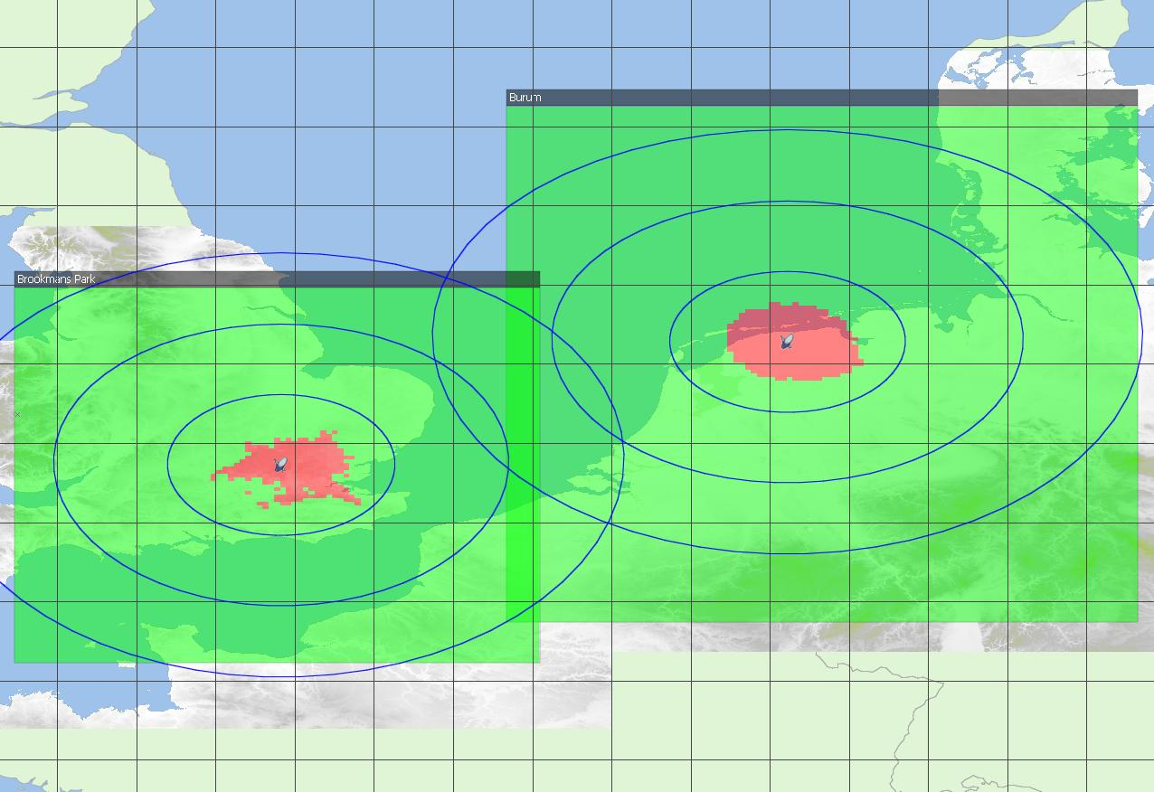
Figure 74: Exclusion areas based on long-term propagation
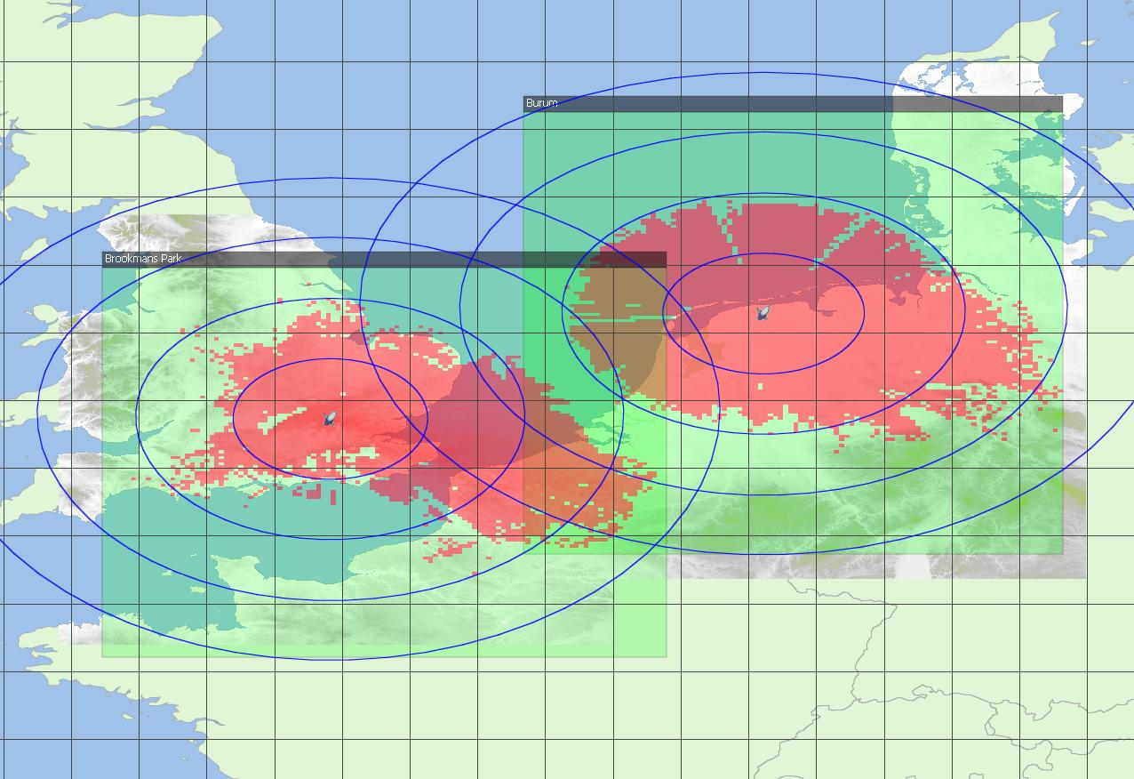
Figure 75: Exclusion areas based on short-term propagation
The results show for the long term interference criteria to be met, the required separation distances between the BDA2GC base-stations and FSS receiver is around 50 km, and with a worst case separation distance for these two example considered of around 85 km. For the short term propagation criteria to be met, the required separation distances increases to around 100-200 km in azimuths around the earth-station, but can extend up to 350 km in specific directions in a worse case

Interference from BDA2GC AS (ETSI TR 103 054) to FSS Earth Station
Interference may also be caused to FSS earth station receivers from BDA2GC aircraft transmissions. To assess the potential for interference two separate scenarios are considered: a “boresight” case, where it is assumed that an aircraft transmitter is sighted within the main beam of the FSS earth station antenna; and a “sidelobe” case, where it is assumed that any interference from the aircraft transmitter is received through the FSS earth station antenna sidelobes (having a gain of -10 dBi).
For the boresight scenario, as the occurrence of an aircraft within the main beam will typically be of short duration, the short term interference criterion is used. While for the sidelobe scenario, since interference may occur for long periods of time, the long-term criterion is used. For both scenarios, it is assumed interference occurs from a single aircraft transmitter having a minimum operating altitude of about 10,000 feet, and hence a minimum separation distance of 3 km is assumed. The increase in potential for interference from multiple transmitters or if the operational height is lower than assumed will need to be confirmed and is not taken into account.
Table 18: Interference from a single aircraft to a FSS earth station
 | Boresight | Sidelobe
Aircraft eirp (dBm in 4 kHz) | 6.4 | 6.4
Aircraft eirp (dBW in 4 kHz) | -23.6 | -23.6
Aircraft to earth station distance (km) | 3 | 3
Freq (MHz) | 3600 | 3600
Free space loss | 113.1 | 113.1
Earth station antenna gain (dBi) | 52 | -10
Polarisation discrimination (dB) | 2 | 0
Receiver noise in 4 kHz | -173.8 | -173.8
I/N | -1.3 | -10.2
I max in 4 kHz | -175.1 | -184.0
Interfernce received (dBW in 4 kHz) | -86.7 | -146.7
Excess interference (dB) | 88.4 | 37.3

In the case of boresight interference, the link budget analysis shows interference is received 88.4 dB above the criterion. Consequently, to remove this excess, the aircraft would need to be beyond line-of-sight of the FSS earth station, which for an aircraft at 40,000 feet, is beyond about 450 km from the earth station. While, in the case of interference through the sidelobes, the excess interference is 37.3 dB above the criterion. In this case to meet the interference criterion for sidelobe interference, the aircraft would need to be at least 220 km from the earth station. It is noted even if the aircraft transmission powers were reduced significantly the separation distances are still significant such that compatible co-frequency operation will not be possible.
Table 19 shows a similar analysis, but considering the receiver overload criterion. In this scenario, the potential for aircraft interference necessary to cause the earth station LNB to be overloaded is estimated.
Table 19: Interference from a single aircraft to a FSS earth station compared to overload criterion
 | Boresight | Sidelobe
Aircraft eirp (dBm) | 40 | 40
Aircraft to earth station distance (km) | 3 | 3
Freq (MHz) | 3600 | 3600
Free space loss | 113.1 | 113.1
Earth station antenna gain (dBi) | 52 | -10
Polarisation discrimination (dB) | 2 | 0
I max (dBm) | -50.0 | -50.0
Interference received (dBm) | -23.1 | -83.1
Excess interference (dB) | 26.9 | -33.1

The results show that interference may be cased to earth stations operating in different parts of C-band to BDA2GC systems. As these are frequency independent results, there is a high potential of receiver compression at FSS earth-stations when high power aircraft transmitters pass through the main beam of earth stations antennas.

Conclusion with regard to the DA2GC system described in ETSI TR 103 054
The operation of BDA2GC base stations in any parts of the band 3400-3600 MHz would require coordination with FSS earth stations. The exclusion area would need to be determined on a case-by-case basis for each earth station. In the example cases considered in this contribution, in the case of co-frequency operations, the maximum exclusion distance is about 350 km. Although not analysed above, exclusion areas would also be required for BDA2GC base stations operating on different frequencies from the FSS earth stations. This would be necessary due to possible overload (or blocking) of the earth station LNB, and also due to reception of out-of-band emissions from the BDA2GC base station. Examples of required exclusion distances may be provided in due course.
The operation of BDA2GC aircraft stations would also require coordination with FSS earth stations. In the case of co-frequency operations, an aircraft operating within the visibility of an earth station could cause harmful interference. Assuming the maximum altitude of an aircraft of 40,000 feet, the visibility distance (assuming 2/3 earth radius for atmospheric refraction effects) is about 450 km. The potential area of operation of an aircraft station could be controlled by the location of the base stations. If the BDA2GC base station has a range of 100 km, the exclusion distance of the base station with respect to the FSS earth station would need to be extended by this amount to 550 km.
The operation of BDA2GC aircraft stations on different frequencies from the FSS earth station also has the potential to cause harmful interference, due to unwanted emissions from the BDA2GC aircraft station and due to overload of the earth station LNB. In principle, the possibility of overload could be avoided by the inclusion of filters at the earth station however the cost and practicality of adding filters would need to be assessed. As FSS receivers are of very wide-band band, it is viewed filtering will be greatly assisted if any operation of BDA2GC aircraft transmission are identified to specific channels and having a maximum separation with existing FSS earth-stations operations (e.g., identified for operation at frequencies close to 3400MHz instead of close to 3500 MHz).
The effect of receiver blocking can also be reduced if the maximum aircraft eirp is reduced from the 40dBm assumed and/or if directional antenna could be used for any BDA2GC systems deployed in the 3400-3600 MHz band. The potential for compression of FSS receivers through the main beam from interference from high power omni-directional BDA2GC aircraft transmissions should be noted.

Compatibility between DA2GC and IMT/IMT-A in the band 3400-3600 MHz
The ECC approved Decision ECC/DEC/(11)06 on harmonised frequency arrangements for mobile/fixed communications networks (MFCN) (including IMT) operating in the bands 3400-3600 MHz and 3600-3800 MHz with the intention to facilitate high data rate International Mobile Telecommunications (IMT) services supported by larger channel bandwidths as an evolution to the existing framework in this band, without the consequential requirement for a replacement of systems based on the existing regulatory framework. Two different arrangements are provided for the implementation of either TDD or FDD operation. The TDD arrangement is based on a block size of 5 MHz starting at the lower edge of 3400 MHz.
- Frequency arrangement for the 3400-3600 MHz band based on TDD
The frequency arrangement is a TDD arrangement, based on a block size of 5 MHz starting at the lower edge of 3400 MHz.
If blocks need to be offset to accommodate other users, the raster should be 100 kHz. Narrower blocks can be defined adjacent to other users, to allow full use of spectrum. It has to be noted that TDD in one extreme case also covers downlink only operation.
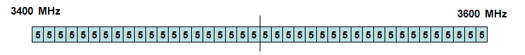
Figure 76: ANNEX 1 of Draft ECC/DEC/(11)HH on Harmonised frequency arrangements for mobile/fixed communications networks (MFCN) (including IMT) operating in the bands 3400-3600 MHz and 3600-3800 MHz
- Frequency arrangement for the 3400-3600 MHz band based on FDD
The frequency arrangement is an FDD arrangement, based on a block size of 5 MHz starting at the lower edge of 3410 MHz. The sub-band 3410-3490 MHz is used for the uplink, the sub-band 3510-3590 MHz is used for the downlink. The resulting duplex gap is 20 MHz (3490-3510 MHz).
If blocks need to be offset to accommodate other uses, the raster should be 100 kHz. Narrower blocks can be defined adjacent to other users, to allow full use of spectrum.
Figure 77: ANNEX 2 of Draft ECC/DEC/(11)HH on Harmonised frequency arrangements for mobile/fixed communications networks (MFCN) (including IMT) operating in the bands 3400-3600 MHz and 3600-3800 MHz

LTE system characteristics
The terrestrial IMT/IMT-A system is assumed to be based on 3GPP LTE (also called E-UTRA) standard (Rel. 8 or higher) [1][2]. The unwanted emission requirements for LTE base stations are given in Table 20.
Table 20: Main parameters used for base station LTE (BS)
Parameter | LTE base station (BS)
 | FDD | TDD
Base station type | Macro | Macro
Environment | Rural | Rural
Cell radius (max.) | Up to 5 km (typically 3 km) | Up to 5 km (typically 3 km)
Tx power | 46 dBm | 46 dBm
Antenna type | 3 x 120° sector antenna  (90° half power beam width) | 3 x 120° sector antenna  (90° half power beam width)
Antenna gain | Up to 20 dBi | Up to 20 dBi
Antenna height | 30 m | 30 m
Antenna tilt | -2° (down-tilt) | -2° (down-tilt)
Channel bandwidth | 2 x 10 MHz | 15 or 20 MHz
Frequency re-use factor | 1 | 1
Signal bandwidth  (related to number of occupied resource blocks with bandwidth of 180 kHz) | 9 MHz | 13.5 or 18 MHz
Rx thermal noise | -104.5 dBm | -102.7 or -101.5 dBm
Rx noise figure | 5 dB | 5 dB
Rx noise floor | -99.5 dBm | -97.7 or -96.5 dBm
Rx reference sensitivity level | -101.5 dBm  (Note 1) | -99.7 or -98.5 dBm  (Note 1)
Interference protection ratio I/N | -6 dB | -6 dB
Interference protection level | -105.5 dBm  (Note 1) | -103.7 or -102.5 dBm  (Note 1)
Tx spectrum emission mask (SEM) / Spurious emissions | According to [7] | According to [7]
Adjacent channel leakage ratio (ACLR) limit | 45 dB  (Note 2) | 45 dB  (Note 2)
Rx in-band / out-of-band blocking | According to [7] | According to [7]
Rx adjacent channel selectivity (ACS) | 43.5 dB  (according to [7]) | 43.5 dB  (according to [7])
Note 1: In [10] the sensitivity level of -101.5 dBm is also applied for signal bandwidths above 10 MHz, as only up to 25 resource blocks (RB) are assigned to a single UE link, even if more RBs are feasible.
Note 2: In general the ACLR limit given in the table or the absolute limit of -15 dBm/MHz is valid, whichever is less stringent (macro BS according category B) [7].

For the LTE BS the vertical pattern given in ITU-R Rec. F.1336 was applied, which is usually used for compatibility studies with mobile radio and RLAN systems by ITU-R and CEPT workings groups. The diagram is shown in Figure 42
. As proposed in the recommendation the side lobes are not explicitly used in the evaluations, only the approximated characteristic is applied.
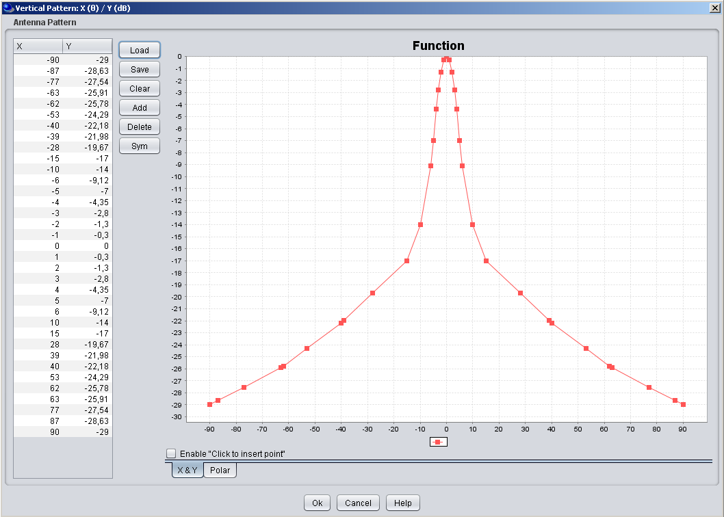
Figure 78: Vertical sector antenna pattern of the LTE BS according to ITU-R Rec. F.1336 (screen shot of SEAMCAT GUI; down-tilt not considered in the diagram)
Table 21: Main parameters used for mobile station LTE (UE)
Parameter | LTE mobile station (UE)
 | FDD | TDD
Tx power (max./min.)  (Note 1) | 23 dBm / -40 dBm | 23 dBm / -40 dBm
Antenna type | Omni-directional | Omni-directional
Antenna gain | 0 dBi | 0 dBi
Antenna height | 1.5 m | 1.5 m
Channel bandwidth | 2 x 10 MHz | 15 or 20 MHz
Signal bandwidth  (related to number of occupied resource blocks with bandwidth of 180 kHz) | 9 MHz | 13.5 or 18 MHz
Rx thermal noise | -104.5 dBm | -102.7 or -101.5 dBm
Rx noise figure | 9 dB | 9 dB
Rx noise floor | -95.5 dBm | -93.7 or -92.5 dBm
Rx reference sensitivity level | -97.5 dBm | -95.7 or -94.5 dBm
Interference protection ratio I/N | -6 dB
Interference protection level | -101.5 dBm | -99.7 or -98.5 dBm
Tx spectrum emission mask (SEM) / Spurious emissions | According to [6] | According to [6]
Adjacent channel leakage ratio (ACLR) limit | 30 dB  (according to [6]) | 30 dB  (according to [6])
Rx in-band / out-of-band blocking | According to [6] | According to [6]
Rx adjacent channel selectivity (ACS) | 33 / 30 / 27 dB for channel bandwidths of 10 / 15 / 20 MHz  (according to [6]) | 33 / 30 / 27 dB for channel bandwidths of 10 / 15 / 20 MHz  (according to [6])
Note 1: The Tx power of the mobile station is dependent on the power control implementation applied by the equipment provider.

The main difference is the maximum Tx power required at the aircraft to get access to the DA2GC BS at locations near the cell edge. The spectrum emission limits defined by 3GPP for LTE UEs are given in Table 22 (according to [6]).
Table 22: General LTE UE spectrum emission limits
Spectrum emission limits (dBm) / Channel bandwidth
Δf_{OOB}  (MHz) | 1.4  MHz | 3.0  MHz | 5  MHz | 10  MHz | 15  MHz | 20  MHz | Measurement bandwidth
± 0-1 | -10 | -13 | -15 | -18 | -20 | -21 | 30 kHz
± 1-2.5 | -10 | -10 | -10 | -10 | -10 | -10 | 1 MHz
± 2.5-2.8 | -25 | -10 | -10 | -10 | -10 | -10 | 1 MHz
± 2.8-5 |  | -10 | -10 | -10 | -10 | -10 | 1 MHz
± 5-6 |  | -25 | -13 | -13 | -13 | -13 | 1 MHz
± 6-10 |  |  | -25 | -13 | -13 | -13 | 1 MHz
± 10-15 |  |  |  | -25 | -13 | -13 | 1 MHz
± 15-20 |  |  |  |  | -25 | -13 | 1 MHz
± 20-25 |  |  |  |  |  | -25 | 1 MHz

Co-channel-case
This section presents coexistence studies between a LTE base station in the frequency band 3400-3600 MHz and a BDA2GC AS located on an aircraft at various altitudes from 3000 to 13 000 meters.
Figure 43 below represents the average antenna gain in elevation for an omnidirectional antenna (with 0° tilt) calculated with the model from ITU-R recommendation F.1336.
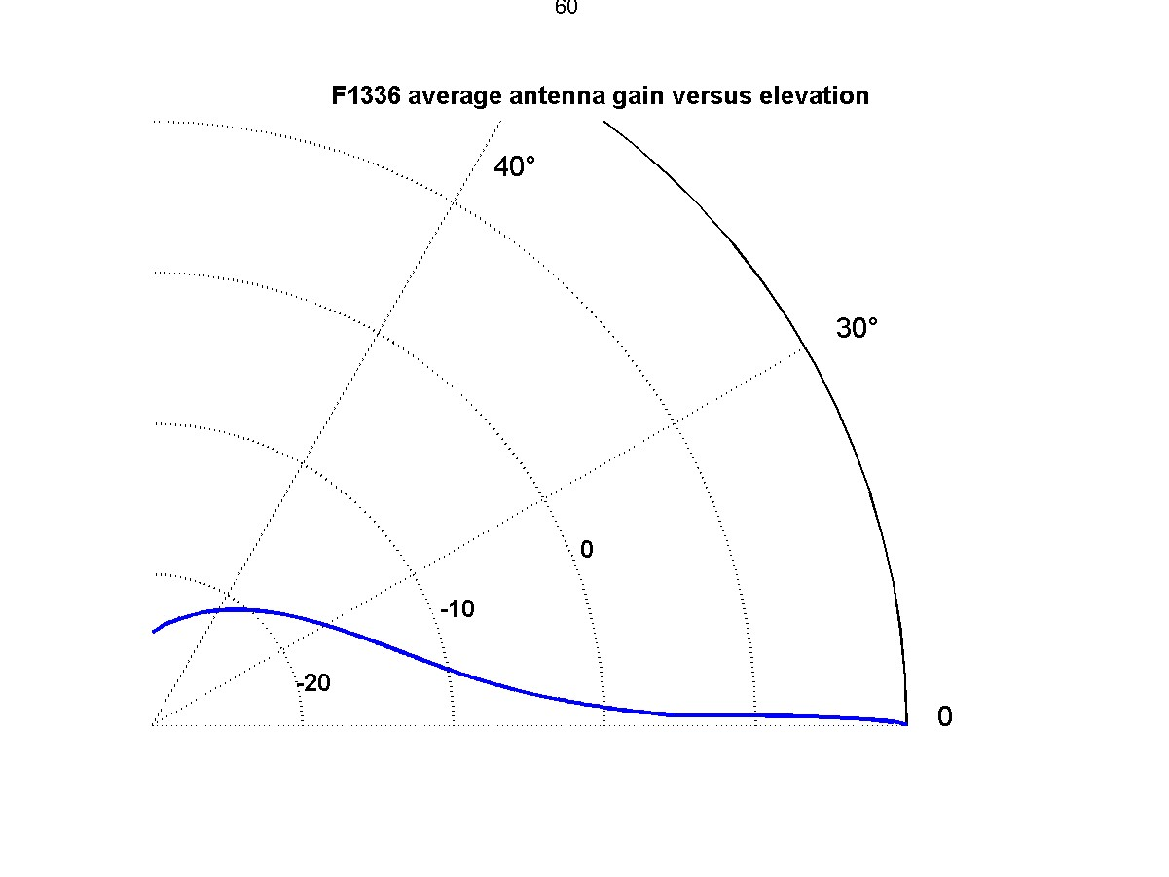
Figure 79: LTE BS antenna pattern in elevation for an omnidirectional antenna

Methodology
The intent is to study the compatibility between a LTE base station or a LTE-UE and a DA2GC AS in both directions (i.e DA2GC as interferer and then as victim).
The LTE base station (or LTE-UE) is considered to be located at (G0, L0).
When considering the LTE station as the victim and DA2GC AS as the interferer, the interference level arriving to the victim receiver from an aircraft at a given altitude H (from 3000 m up to 13 km) around the LTE station location (i.e. 1° by 1° horizontal square around (G0,L0)) is calculated and mapped as illustrated in the Figure 44 below.
When considering the LTE station as the interferer and DA2GC on board aircraft as the victim, the calculations are very similar since the antenna gain is the same in emission and reception for both systems. The only difference lies in the protection criterion and the emission levels to take into account.

I(i,j)
Victim
(G0, L0)
H=[3000-13000m]
1° by 1° horizontal plane around the victim at altitude H
Aircraft location (i,j)
Figure 80: Illustration of the configuration used for interferences calculations
Negative aircraft elevations relative to the victim receiver are suppressed. For positive aircraft elevations, the free space loss is used.

Results of Interferences from DA2GC AS to LTE BS
For Pe below 30 dBm: No interferences are observed whatever the aircraft altitude (i.e. from 3000m to 13000m)
For Pe=30 dBm, interferences occur at 3000m as figure below exemplifies. It can be noted that the DA2GC AS - LTE BS distance of 4365 m corresponding to the maximum distance where interferences occur equals a horizontal radius of 3171 meters. The black annulus in Figure 44 represent the aircraft position where I/N>=-6 dB. This happens for LTE BS – aircraft distances from 3514 m to 4365 m, and relative elevations between 58.62° and 43.40°.
For higher aircraft altitudes higher than 3000 m, the SNR ratio is below the protection criterion (I/N=< -6 dB).
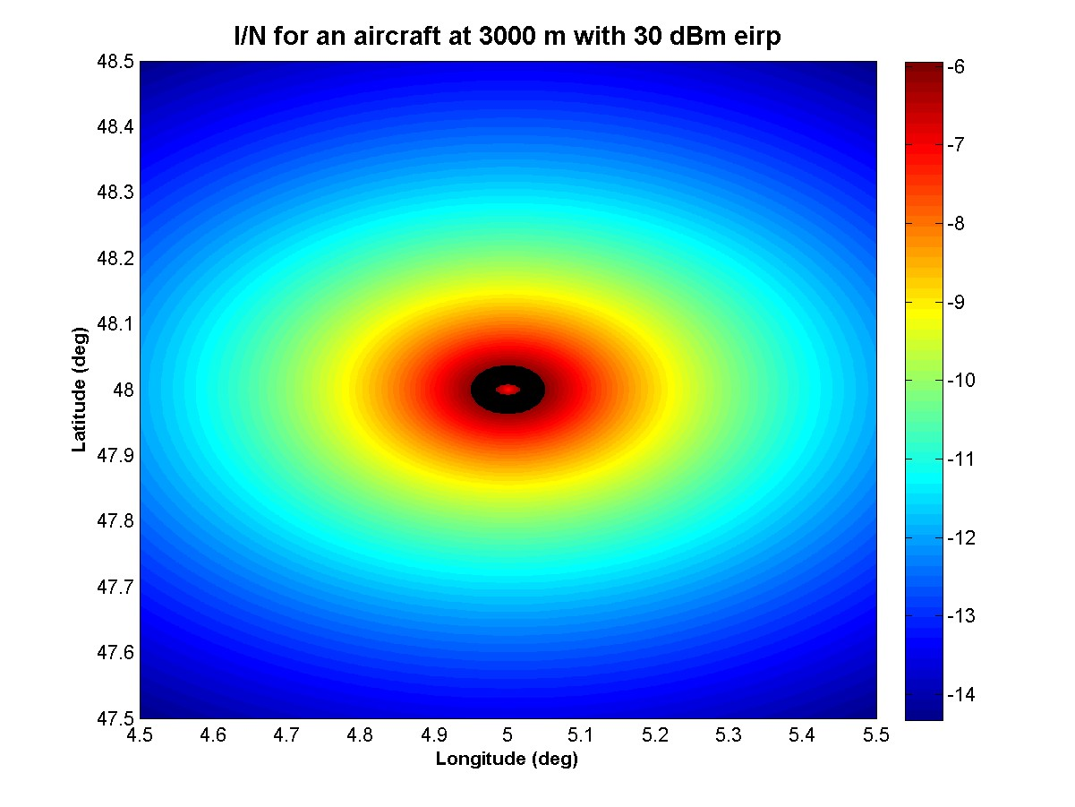
Figure 81: Interfering level at the LTE base station depending on the aircraft position for Pe=30dBm and H=3000m.
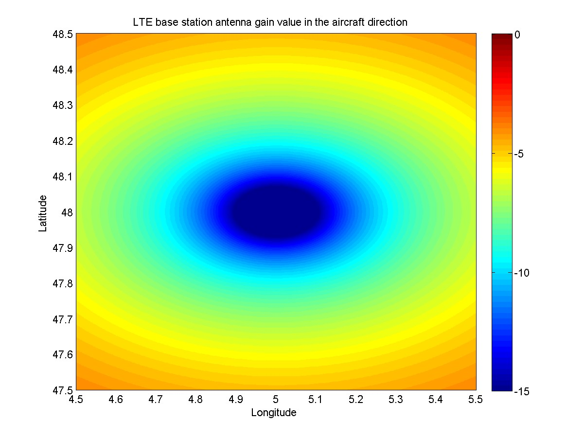
Figure 82: LTE BS antenna gain value in the aircraft direction flying at 3000m height. Maximum value is about -4 dBi at elevations lower than 2.26°, and minimum value is-23.8 dBi at zenith

For Pe=40 dBm, interferences occur for altitudes below 9 500 meters as figure below exemplifies. It can be noted that the DA2GC OBU - LTE BS distance of 11 199 meters corresponding to the minimum distance where interferences occur equals a horizontal radius of 5930 meters, thus interferences occur where the aircraft not above the LTE BS cell.
For aircraft altitudes higher than 9 500 meters, the SNR ratio is below the protection criterion.

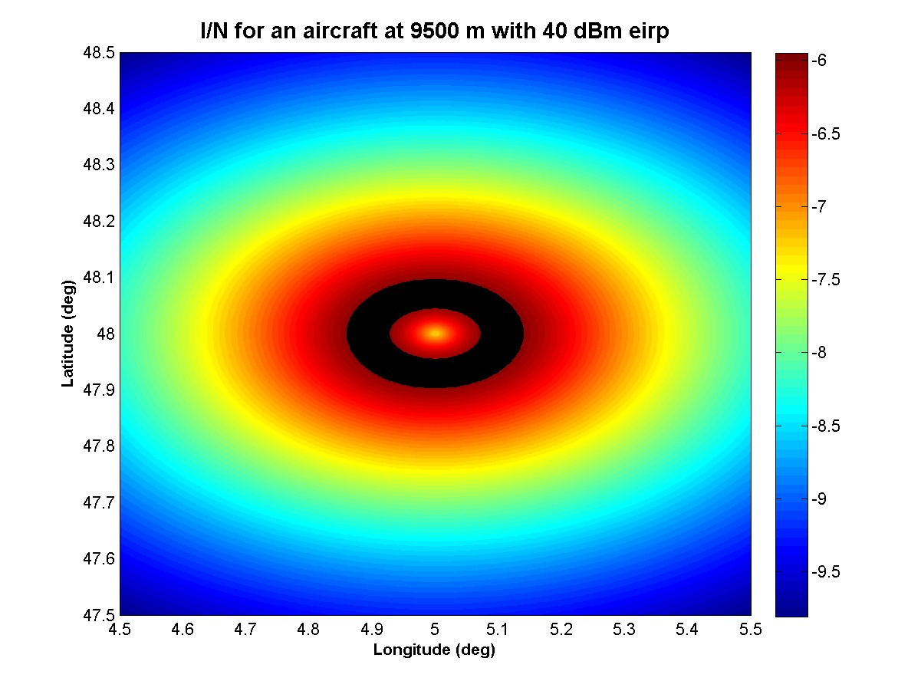
Figure 83: Interfering level at the LTE base station depending on the aircraft position for Pe=40dBm and H=9500m.

The black annulus represent the aircraft position where I/N>=-6 dB. This happens for LTE BS – aircraft distances from 11199m to 13703m, and relative elevations between 58° and 43.85°.

Results of Interferences from DA2GC AS to LTE UE
One the one hand the LTE-UE antenna gain value (0 dBi) is higher than the LTE-BS values in the aircraft direction (from -23 dBi to -4 dBi for an aircraft at 3000 meters).
On the other hand the protection criterion for LTE-UE receivers is 4 dB less stringent than for LTE-BS receivers.
Considering co-channel emissions, the critical DA2GC emission level is 11.5 dBm for LTE-UE (instead of 30 dBm for LTE BS see 6.2.2.2). Below this value, no interferences are observed at the receiver level even at an aircraft altitude of 3000 m. With an emission power of 11.5 dBm, interferences occur when the aircraft flies above the LTE-UE at 3000 m altitude.

Results of Interferences from LTE BS to DA2GC AS
The DA2GC AS suffers from interferences for aircraft altitudes below 12000 m as Figure 48 shows. The black annulus represent the aircraft position where I/N>=-6 dB. This happens for LTE BS – aircraft distances from 14538 m to 16663 m, and relative elevations between 55.59° and 46.01°.

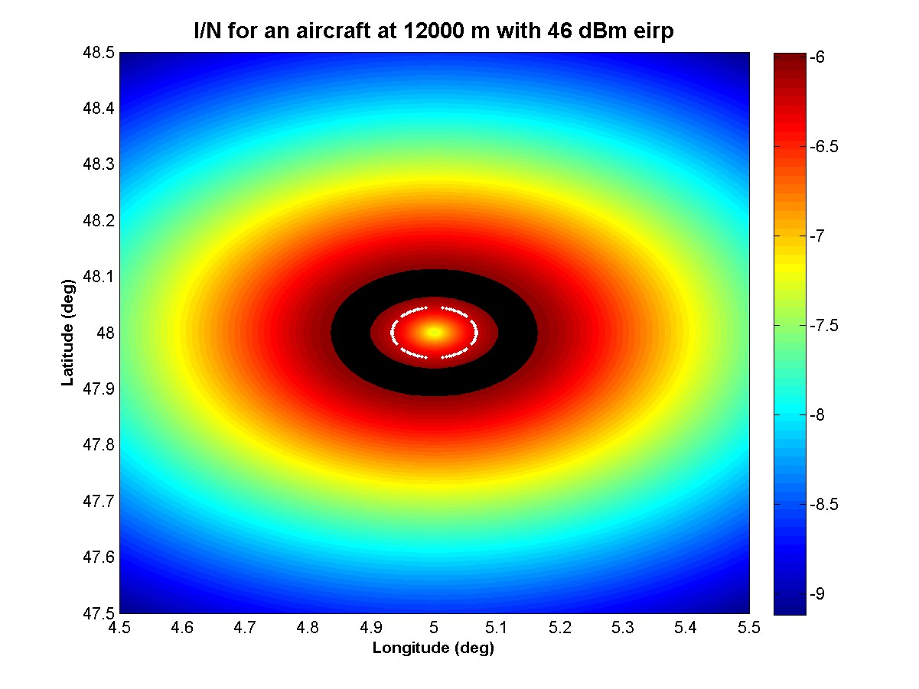
Figure 84: Interfering level at the DA2GC OBU from a LTE base station with Pe=46dBm and H=12000m.

Results of Interferences from LTE UE to DA2GC AS
Since the characteristics of LTE-UE and DA2GC AS are identical (protection criterion and antenna pattern), the calculations are the same considering DA2GC AS as interferer or victim and LTE UE as victim or interferer.

Summary
Considering a DA2GC AS with an emission bandwidth of 10 MHz located on an aircraft at various altitudes above a LTE station with a 10 MHz bandwidth, the results can be summarized as follows:
Emissions from DA2GC-AS to LTE-BS
For DA2GC AS power emissions lower than 30 dBm, no interferences occur (whatever the aircraft altitude);
For a DA2GC AS power emission of 30 dBm, interferences occur at 3000m (see black annulus in Figure 5), but not for higher aircraft altitudes;
For a DA2GC AS power emission of 40 dBm, interferences occur until 9500m (see black annulus in Figure 6), but not for higher aircraft altitudes;
Emissions from LTE-BS to DA2GC-OBU
With a LTE-BS power of 46 dBm, interferences will occur at the DA2GC receiver for aircraft altitudes up to 12 km.
Coexistence between DA2GC-OBU and LTE-UE
If one of the systems (either DA2GC-AS or LTE-UE) have a power emission higher than 11.5 dBm, interferences occur if the distance between the LTE UE and the aircraft is less than 3000m;

Adjacent channel case
For the simulations the block raster for FDD and TDD, respectively, is considered as a basis for implementing the DA2GC system, i.e. only full block numbers of N x 5 MHz are used for spectrum occupation.
Whereas for terrestrial mobile radio networks cross-border coordination between different countries can be applied to keep interferences between IMT/IMT-A systems on a sufficiently low level to avoid noticeable performance degradations, such a procedure is not suitable for a DA2GC system. Inter-frequency channel handovers between base stations are in principle supported by underlying system functionalities. However, due to the required large cell sizes of up to about 100 km and especially by the interference range an aircraft at high altitudes of more than 10 km would cause, a co-channel usage of the DA2GC system with terrestrial IMT/IMT-A systems is not feasible. The introduction of a DA2GC system would require a pan-European designation of the same frequency blocks with a single transmission mode (TDD or FDD). To be at least to some extent independent from the arrangements finally used in the different European countries, an implementation of a DA2GC system using TDD mode using the FDD duplex gap may be one possible solution, if compatibility can be achieved to neighbouring FDD and/or TDD blocks.
This section provides results on the compatibility between DA2GC and IMT/IMT-A in the band 3400-3600 MHz. The results correspond to simulations each with one

- DA2GC Base Station (BS)
- DA2GC aircraft incl. so-called Onboard Unit (OBU)
- IMT/IMT-A Base Station (BS)
- IMT/IMT-A User Equipment (UE).

Interference scenario considered for evaluation
Figure 49
shows the general interference scenario considered in present evaluations, which is based on single service and interfering links for and in between both systems. The BSs itself can be co-located at the same site or placed at different sites.

Figure 85: General interference scenarios considered (single link based)
This scenario describes the use of a TDD mode for the terrestrial LTE system as well as for the DA2GC system in an unsynchronized way, i.e. it may happen that one of the systems is transmitting in the downlink direction and the other simultaneously in the uplink (and vice versa) resulting in stronger interference levels compared to FDD transmission.

Propagation models applied for interference evaluations
In
the different service and interfering links in the considered scenario are exemplarily shown. There are strong differences in propagation conditions: In one case the transmitter/receiver is near the ground and its counterpart is at high altitudes (DA2GC) and in the other case both are near the ground resulting in additional path loss by terrain and clutter (classical mobile radio use case). Therefore, different propagation models were applied for service and interfering links as shown in Table 23.
Table 23: Propagation models applied for service and interfering links
Link | Link characteristic | Propagation model
DA2GC BS ↔ DA2GC AS | Service link | LOS (free space)
DA2GC GS ↔ LTE BS | Interfering link | LOS (free space)
DA2GC GS ↔ LTE UE | Interfering link | ITU-R P.452-14
DA2GC AS ↔ LTE BS | Interfering link | LOS (free space)
DA2GC AS ↔ LTE UE | Interfering link | LOS (free space)
LTE BS ↔ LTE UE | Service link | ITU-R P.452-14

The LOS model is based on the simple free space path loss model described in ITU-R Rec. P.525-2 [14]. It is applied for the links between the DA2GC AS at higher altitudes and the GS/BS or the LTE UE, respectively. For the link DA2GC AS ↔ LTE UE this is a worst case assumption, as even in a rural environment, the LOS link to the aircraft will be frequently obstructed by terrain or vegetation near the UE at the ground.
Details of the second model, which is suited to predict interference levels between stations at the Earth surface, can be found in ITU-R Rec. P.452-14 [15]. Both models are available in the SEAMCAT tool box. For the P.452-14 model parameters according to the chosen rural environment were set (see [5]). This model was also used in other sharing studies for IMT-A in the 3.5 GHz range (e.g. see [9]).

Results (deterministic)

General information to the scenario
Following results are based on the assumption that both GS and BS are co-located at the same site. In addition, adjustment of the sector antennas in the same direction is considered. The positions of the LTE UE as well as of the aircraft with the DA2GC AS are varied on a straight line in the main BS antenna beam (LTE UE for distances up to 5 km, DA2GC AS up to 100 km). Only results for the lowest altitude of the DA2GC AS (about 3 km) have been included in the present document, as this represents the worst case for the interference into the terrestrial LTE network.
For the interference protection ratio a I/N value of -6dB has been considered in the evaluations as already stated in Table 20 and Table 21 Two center frequencies for the LTE and DA2GC signal have been chosen from the middle of the 3400-3600 MHz band with a difference of 20 and 25 MHz each, i.e. the frequency guard band between the channel block edges is 0 and 5 MHz, respectively. The channel bandwidth of both signals is assumed to be 20 MHz, i.e. 100 RBs are assumed to be covered per OFDMA signal resulting in 18 MHz RF bandwidth [1][2].
As said before all evaluations are based on deterministic scenarios only. Statistical evaluations based on Monte-Carlo simulations with SEAMCAT will follow in the next step.

Scenario 1: Interference from DA2GC AS into the LTE system
The next figures show the impact of the DA2GC AS on the terrestrial LTE network (see Figure 50
and Figure 51: Resulting I/N by interference caused by DA2GC OBU into LTE UE in the adjacent channel (frequency guard bands of 0 and 5 MHz between channel block edges)

The resulting I/N values are given in relation to the distance between the aircraft and the site with the 2 co-located BSs (please consider the non-linear scaling of the distance axis).
Figure 51 it is assumed that the LTE UE is at a distance of 5 km from the site (cell edge).

Figure 86: Resulting I/N by interference caused by DA2GC OBU into LTE BS in the adjacent channel (frequency guard bands of 0 and 5 MHz between channel block edges)
The results in Figure 50 are computed for the worst case, i.e. the DA2GC AS is always transmitting with highest power of 40 dBm. Normally the power control mechanism will reduce the Tx power when the aircraft is moving from the cell edge into the main coverage area of a DA2GC ground station, i.e. for the present scenario the I/N would be further reduced at distances nearer the site.
Nevertheless, as the cell size of the DA2GC system is much larger than the size of the LTE cells, the aircraft will often cross other base stations of the LTE network. In the worst case the aircraft is flying at cell edge transmitting with maximum power, and a LTE base station is near to the aircraft. This situation will frequently happen in real scenarios.
The resulting I/N values are below the threshold. This is mainly caused on one hand by the increased ACLR value as a result of an improved emission mask, and on the other hand there is always a signal strength attenuation for a path distance of at least 3 km. In case the DA2GC system should be in operation also for lower altitudes e.g. near airports, additional evaluations need to be performed.
The interference from the DA2GC AS into the LTE UE is also below the threshold (see Figure 51)
. The comments made before on power control are also valid for this scenario. As omni-directional antennas are assumed for both equipment parts, it is not expected that higher interferences will occur with possibly changed antenna diagrams at the aircraft, because this would result only in higher gain just below the horizontal aircraft plane having only impact at larger distances between the aircraft and the LTE UE, but in such cases the interference level is strongly reduced by the additional path loss.
Figure 87: Resulting I/N by interference caused by DA2GC OBU into LTE UE in the adjacent channel (frequency guard bands of 0 and 5 MHz between channel block edges)

Scenario 2: Interference from LTE UE into the DA2GC system
Similar to scenario 1 the next figures show the impact of the LTE UE on the DA2GC system.
In addition the transmitter mask for the LTE UE has been implemented in SEAMCAT via the maximum emission limit settings given in Table 22 which results in a lower ACLR value compared to the 3GPP specification (about 24 dB instead of 30 dB). Therefore an additional margin of about 6 dB is available.
In Figure 52 the I/N values produced by the LTE UE at the DA2GC BS are given. With the adaptation of the GS antenna diagram (increased side lobe attenuation to the ground) the I/N values are below the threshold even for small distances.
Figure 88: Resulting I/N by interference caused by LTE UE into DA2GC BS in the adjacent channel (frequency guard bands of 0 and 5 MHz between channel block edges)
Figure 53 shows the resulting I/N similar to Figure 51 in the opposite transmission direction with the LTE UE placed at a distance of 5 km from the site. Again the interference impact is negligible due to available path loss for a distance of at least 3 km.
Figure 89: Resulting I/N by interference caused by LTE UE into DA2GC AS in the adjacent channel (frequency guard bands of 0 and 5 MHz between channel block edges)

Scenario 3: Interference from DA2GC GS into the LTE system
Figure 54 provides the I/N values caused by the DA2GC GS at the LTE UE.
The threshold is exceeded for distances less than 1 km from the site. With 5 MHz guard band only the locations near the site are affected. As already noted the interference will have only low impact on the final performance in case of co-location of LTE BS and DA2GC GS, as it will decrease in the same manner as the power from the LTE BS service link will go down, i.e. the resulting S/I will stay in the same range or will be improved with increasing distance due to impact of different vertical antenna orientations (up-tilt vs. down-tilt).
Figure 90: Resulting I/N by interference caused by DA2GC BS into LTE UE in the adjacent channel (frequency guard bands of 0 and 5 MHz between channel block edges)
The impact of co-location of GS and BS for unsynchronized TDD or TDD/FDD usage in adjacent frequency blocks is still a problem, even if the adaptation of the vertical BS antenna side lobes will reduce the disturbance caused by the Tx output of one station to the Rx input of the other station. With the parameter sets used for the evaluation in this document (incl. the path loss for vertical antenna distance of 20 m between both systems) and an ACLR value of 45 dB, about 15 dB additional isolation is required to keep the I/N threshold (6 dB with 5 MHz guard band).
Another issue is the co-location of GS and BS for unsynchronized TDD or TDD/FDD usage in adjacent frequency blocks. In that case the Tx output will disturb the Rx input of the other station (at least during certain time intervals). Possible solutions are seen in improved isolation between the antennas and in increased guard bands. Typical isolation values to be achieved at the same mast are in the order of about 50 dB [2]. Alternatively, the GS and BS have to be placed at different sites to achieve sufficient decoupling in between the antenna links via the resulting path loss.
There is also no difference to the case of common LTE deployments in frequency bands assigned to TDD usage or in bands with mixed FDD/TDD usage [2][11]. The only distinction in the DA2GC case is the GS antenna tilt in the vertical plane.
With the parameter sets used for the evaluation in this document (incl. the path loss for vertical antenna distance of 20 m between both systems) and an ACLR value of 45 dB, about 28 dB additional isolation are required to keep the I/N threshold.

Scenario 4: Interference from LTE BS into the DA2GC system
As shown in Figure 55: Resulting I/N by interference caused by LTE BS on DA2GC AS in the adjacent channel (frequency guard bands of 0 and 5 MHz between channel block edges)

for this scenario the I/N threshold at the DA2GC OBU is kept due to sufficient high ACLR values of the LTE BS and the path loss between LTE BS and the aircraft. So even in the case the aircraft is near the edge of a DA2GC cell and also near a LTE BS, the coupling loss should be adequate to avoid any strong impact on the performance of the DA2GC link.
The impact from the LTE BS on the DA2GC GS is the same as the impact from the DA2GC GS on the LTE BS already described in subsection 6.2.4.4.
Figure 91: Resulting I/N by interference caused by LTE BS on DA2GC AS in the adjacent channel (frequency guard bands of 0 and 5 MHz between channel block edges)

Dynamic interference scenarios
Except of static scenarios SEAMCAT allows to evaluate the impact of interferences in more realistic dynamic network scenarios similar to those applied e.g. for system level simulations, i.e. not only single static links are considered, but also connections between a homogeneous BS network to different users (UEs in the case of terrestrial LTE, OBUs in case of DA2GC), which are randomly placed in the coverage areas.
For both terrestrial LTE and Broadband DA2GC hexagonal cellular networks are applied with cells consisting of 3 sectors each. The main difference between both networks is the radius of the hexagonal cell, which is much smaller for terrestrial LTE. 6-20 shows an exemplary network constellation with DA2GC as victim system and LTE as interfering system. Due to drastically smaller cell radius the LTE network is only seen as the magenta colored part in the middle of the DA2GC network. For the evaluations the inter-site-distance (ISD) of DA2GC was set to 156 km which corresponds to a cell radius of approximately 90 km. The terrestrial LTE system has a radius of 4.33 km, i.e. the ISD is 7.5 km.
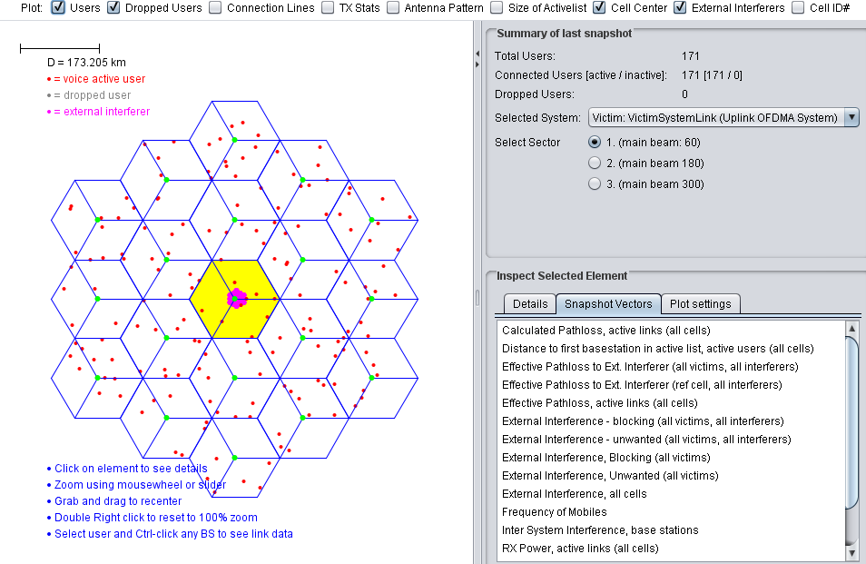
Figure 92: Exemplary network constellation for DA2GC as victim system and terrestrial LTE as interfering system (screen shot of SEAMCAT GUI)
Due to the large difference in the coverage areas of the 2 networks the interference evaluation in SEAMCAT cannot consider all possible situations that could occur in real world. To cover several samples a differentiation was made with respect to the placement of the network centers. The terrestrial LTE network was shifted by 4 km and 50 km, respectively, for some simulations, i.e. the center sites are not co-located in those cases.
For the Monte Carlo simulation it is assumed that always 5 mobile stations (MS, i.e. UEs and OBUs, respectively) are connected to a BS sector (red dots in Figure 56 for DA2GC). Therefore the signal bandwidth of both networks has to be split between the MSs. In the case of a signal bandwidth of 9 MHz used for simulation (LTE channel bandwidth of 10 MHz) 1.8 MHz will be assigned to each user (10 out of 50 resource blocks with bandwidth of 180 kHz each).
In contrast to the terrestrial LTE system where all UEs have the same antenna height of 1.5 m different altitudes have to be assigned to the aircraft OBUs. An altitude distribution has been selected according to a statistical evaluation for European continental air traffic for altitudes between 3 and 11 km. The corresponding cumulative distribution function is shown in Figure 57 (step size of 500 m). There is a higher probability of altitudes above 7 km as altitudes in the low range only occur during departure and landing phases.
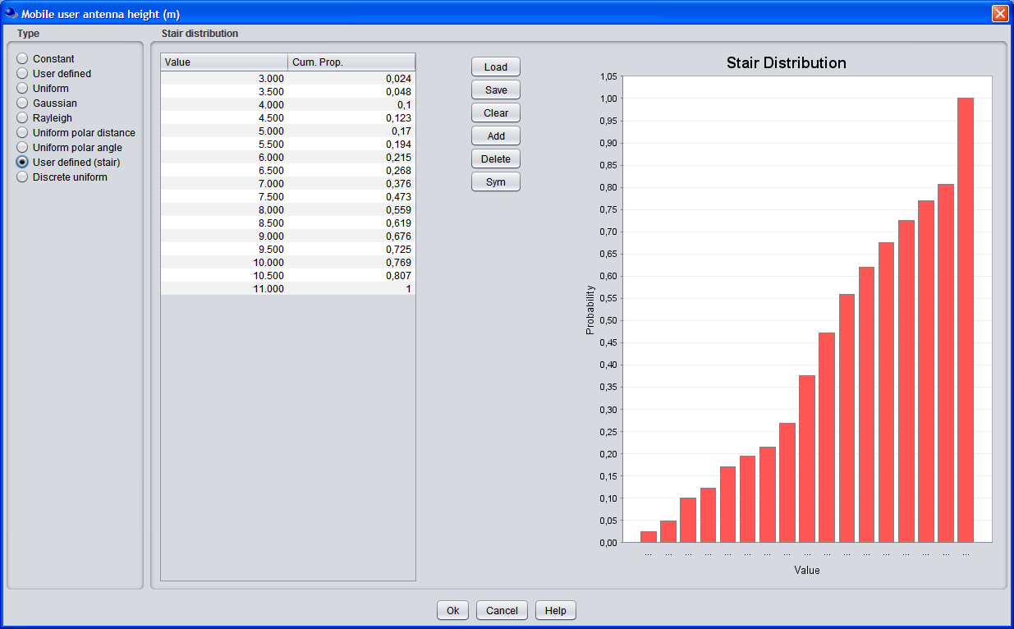
Figure 93: Cumulative distribution function of aircraft altitudes applied for Monte Carlo simulation (screen shot of SEAMCAT GUI)
The Monte Carlo simulation in SEAMCAT is running several repetitions, so called snapshots, for the placement of MSs within the coverage areas to produce results with certain reliability. The simulation was set to 1000 snapshots to guarantee high reliabilities (changes only in second position after decimal point). The exemplary output screen shot of SEAMCAT in Figure 58 is demonstrating the impact of interference on capacity and bit rate of the victim system for each performed snapshot. It has to be noted that SEAMCAT distinguishes between the impact on the inner reference cell (the yellow area in 6-20) and the total system (all cells incorporated).
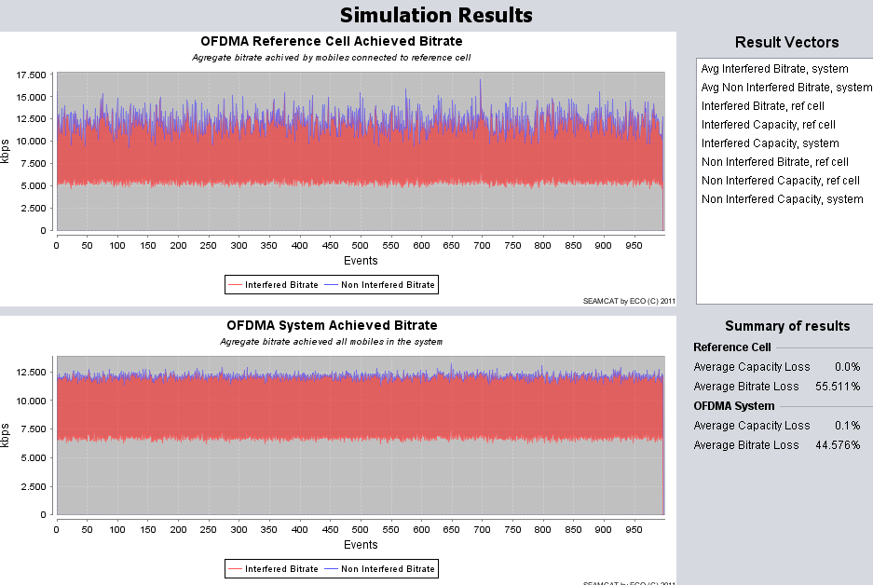
Figure 94: Exemplary output of dynamic compatibility evaluation (screen shot of SEAMCAT GUI)
To allow the determination of capacity and bit rate values in SEAMCAT based on resulting SINR information a suitable conversation curve is needed. In SEAMCAT a default link level data curve is already integrated for LTE systems according to a definition given by 3GPP in [7], which provides the link capacity in bit/s/Hz dependent on SINR. The curve shown in Figure 59 is applied for the terrestrial LTE system. For the DA2GC radio link the curve has been adapted according to measurement results performed under flight conditions with line-of-sight between BS and aircraft antenna (see Figure 60).
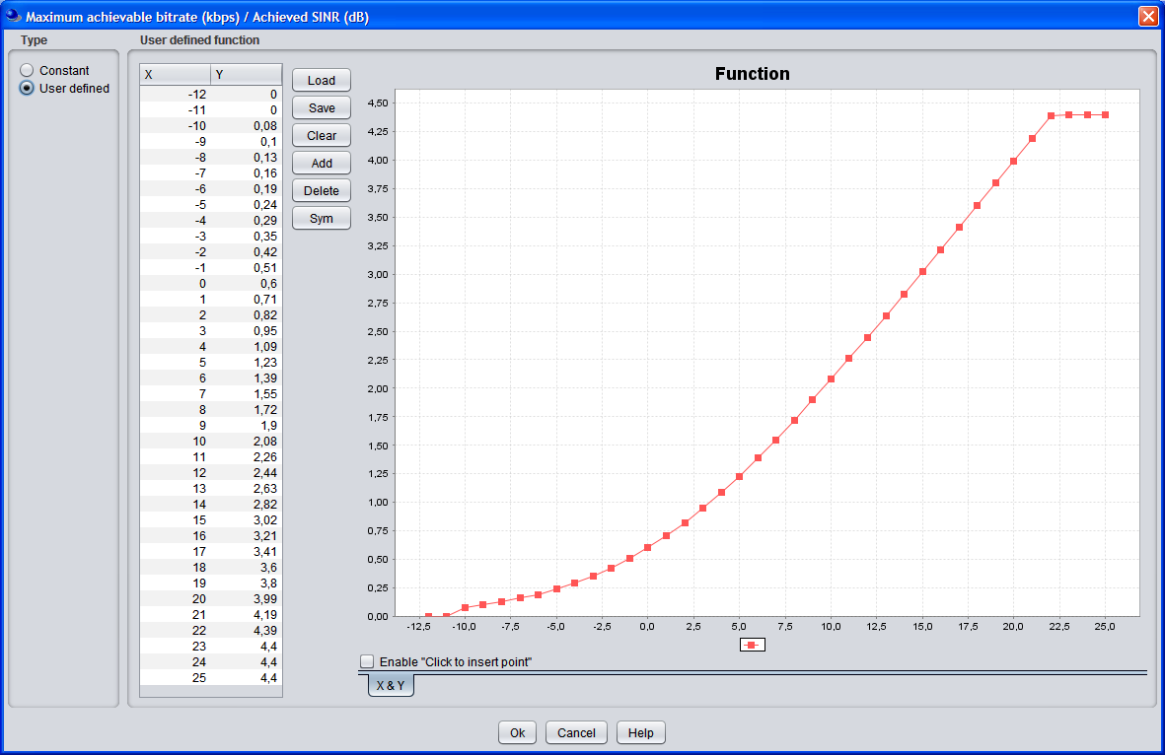
Figure 95: Link level data curve for conversion of SINR to capacity for terrestrial LTE (screen shot of SEAMCAT GUI)
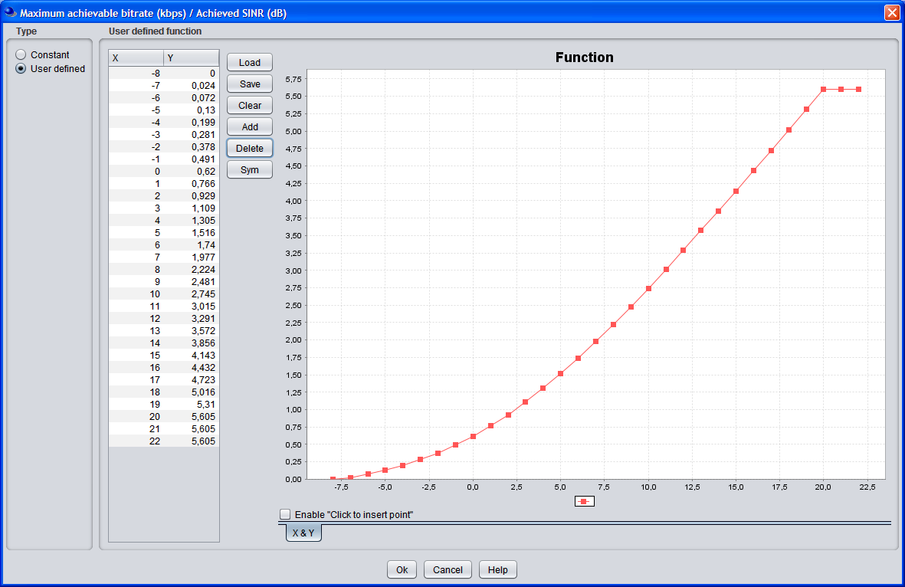
Figure 96: Link level data curve for conversion of SINR to capacity for DA2GC (screen shot of SEAMCAT GUI)

System and network parameters used for evaluations
In the following table the main parameters for the signals and network constellations applied in the evaluations are summarized. Parameters not listed in Table 24 are unchanged compared to those given in for deterministic scenarios.
Table 24: Main parameters of signal and network constellations used in dynamic interference evaluations with SEAMCAT
Parameter | LTE |  | DA2GC
Parameter | Downlink | Uplink | Downlink | Uplink
Carrier frequency | 3500 MHz | 3500 MHz | 3510 / 3515 MHz | 3510 / 3515 MHz
Channel bandwidth | 10 MHz | 10 MHz | 10 MHz | 10 MHz
Signal bandwidth | 9 MHz | 9 MHz  (1.8 MHz/UE) | 9 MHz | 9 MHz  (1.8 MHz/OBU)
Number of mobile stations | 5 | 5 | 5 | 5
Link level data  (SINR to C) | 3GPP default  (Note 1) | 3GPP default  (Note 1) | Modified 3GPP  (Note 2) | Modified 3GPP  (Note 2)
Cell radius | 4.33 km | 4.33 km | 90 km | 90 km
ISD | 7.5 km | 7.5 km | 156 km | 156 km
BS antenna height | 30 m | 30 m | 50 m | 50 m
Vertical tilt of BS antenna | -2° | -2° | 10° | 10°
Vertical pattern of BS antenna | ITU-R F.1336 | ITU-R F.1336 | Cosecant-squared  (Note 3) | Cosecant-squared  (Note 3)
Gain BS / MS antenna | 17 dBi / 0 dBi | 17 dBi / 0 dBi | 15 dBi / 0 dBi | 15 dBi / 0 dBi
MS height | 1.5 m | 1.5 m | 3 - 11 km  (Note 4) | 3 - 11 km  (Note 4)
Note 1: Link level data applied according to 3GPP TS 36.814 [11]; see also Figure 59: Link level data curve for conversion of SINR to capacity for terrestrial LTE (screen shot of SEAMCAT GUI)

.
Note 2: Link level data applied according to Figure 60.
Note 3: Vertical antenna diagram according to Figure 2
Note 4: Altitude distribution of aircraft OBUs according to Figure 57 Figure 57: Cumulative distribution function of aircraft altitudes applied for Monte Carlo simulation (screen shot of SEAMCAT GUI)

Results (SEAMCAT simulations)
In Table 25 the results achieved on the basis of the SEAMCAT Monte Carlo simulations are listed for the case that the terrestrial LTE system is interfered by a DA2GC system. As mentioned before different cases are considered related to the transmission direction (DL and UL), a possible frequency guard band of 5 MHz between the channel block edges of both signals and a offset of the centers of the two networks.
The impact of the DA2GC network on terrestrial LTE is generally very low except of the UL/DL case for co-located center sites (center offset equal to 0 km). Here the same interference influence arises as in the well-known deterministic case described before where the Tx output of one BS will disturb the Rx input of the other BS for unsynchronized TDD or TDD/FDD usage in adjacent frequency blocks. This is valid for the reference cell. If all cells are incorporated the system-based loss will get smaller, but it is still significant.
Table 25: Output of dynamic interference evaluations (capacity and bit rate loss) with SEAMCAT for terrestrial LTE as victim system and DA2GC as interfering system
Transmit direction  LTE / DA2GC | Output | Loss  [%] | Guard band [MHz] | Center offset [km] | Guard band [MHz] | Center offset [km] | Guard band [MHz] | Center offset [km]
Transmit direction  LTE / DA2GC | Output | Loss  [%] | 0 | 0 | 5 | 0 | 5 | 50
DL / DL | Reference cell | Capacity | 0.0 | 0.0 | 0.0 | 0.0 | 0.0 | 0.0
DL / DL | Reference cell | Bit rate | 0.001 | 0.001 | 0.001 | 0.001 | 0.001 | 0.001
DL / DL | System | Capacity | 0.1 | 0.2 | 0.2 | 0.1 | 0.2 | 0.2
DL / DL | System | Bit rate | 0.036 | 0.019 | 0.147 | 0.036 | 0.019 | 0.147
UL / DL | Reference cell | Capacity | 0.0 | 0.0 | 0.0 | 0.0 | 0.0 | 0.0
UL / DL | Reference cell | Bit rate | 45.534 | 38.856 | 0.0 | 45.534 | 38.856 | 0.0
UL / DL | System | Capacity | 0.401 | 0.2 | 0.2 | 0.401 | 0.2 | 0.2
UL / DL | System | Bit rate | 2.822 | 2.248 | 0.186 | 2.822 | 2.248 | 0.186
DL / UL | Reference cell | Capacity | 0.0 | 0.02 | 0.0 | 0.0 | 0.02 | 0.0
DL / UL | Reference cell | Bit rate | 0.0 | 0.55 | 0.0 | 0.0 | 0.55 | 0.0
DL / UL | System | Capacity | 0.0 | 0.006 | 0.1 | 0.0 | 0.006 | 0.1
DL / UL | System | Bit rate | 0.0 | 0.233 | 0.034 | 0.0 | 0.233 | 0.034
UL / UL | Reference cell | Capacity | 0.0 | 0.0 | 0.0 | 0.0 | 0.0 | 0.0
UL / UL | Reference cell | Bit rate | 0.001 | 0.001 | 0.001 | 0.001 | 0.001 | 0.001
UL / UL | System | Capacity | 0.0 | 0.201 | 0.0 | 0.0 | 0.201 | 0.0
UL / UL | System | Bit rate | 0.001 | 0.174 | 0.001 | 0.001 | 0.174 | 0.001

Also in the opposite case, i.e. when the DA2GC system is interfered by the terrestrial LTE system, the same behavior for the UL/DL case is perceptible, now with increased impact due to different antenna constellations at BSs (see Table 26). In the other cases the finally observable loss in the DA2GC transmission is negligible.
Table 26: Output of dynamic interference evaluations (capacity and bit rate loss) with SEAMCAT for terrestrial LTE as victim system and DA2GC as interfering system
Transmit direction  LTE / DA2GC | Output | Loss  [%] | Guard band [MHz] | Center offset [km] | Guard band [MHz] | Center offset [km] | Guard band [MHz] | Center offset [km]
Transmit direction  LTE / DA2GC | Output | Loss  [%] | 0 | 0 | 5 | 0 | 5 | 4
DL / DL | Reference cell | Capacity | 0.907 | 0.576 | 0.536 | 0.907 | 0.576 | 0.536
DL / DL | Reference cell | Bit rate | 1.05 | 0.885 | 0.923 | 1.05 | 0.885 | 0.923
DL / DL | System | Capacity | 0.252 | 0.198 | 0.228 | 0.252 | 0.198 | 0.228
DL / DL | System | Bit rate | 0.475 | 0.403 | 0.402 | 0.475 | 0.403 | 0.402
UL / DL | Reference cell | Capacity | 0.0 | 0.0 | 0.0 | 0.0 | 0.0 | 0.0
UL / DL | Reference cell | Bit rate | 100.0 | 100.0 | 37.155 | 100.0 | 100.0 | 37.155
UL / DL | System | Capacity | 0.0 | 0.0 | 0.0 | 0.0 | 0.0 | 0.0
UL / DL | System | Bit rate | 12.746 | 12.8 | 4.751 | 12.746 | 12.8 | 4.751
DL / UL | Reference cell | Capacity | 0.0 | 0.0201 | 0.0 | 0.0 | 0.0201 | 0.0
DL / UL | Reference cell | Bit rate | 0.054 | 0.02 | 0.026 | 0.054 | 0.02 | 0.026
DL / UL | System | Capacity | 0.003 | 0.002 | 0.102 | 0.003 | 0.002 | 0.102
DL / UL | System | Bit rate | 0.008 | 0.003 | 0.125 | 0.008 | 0.003 | 0.125
UL / UL | Reference cell | Capacity | 0.0 | 0.0 | 0.0 | 0.0 | 0.0 | 0.0
UL / UL | Reference cell | Bit rate | 0.396 | 0.134 | 0.393 | 0.396 | 0.134 | 0.393
UL / UL | System | Capacity | 0.3 | 0.0 | 0.3 | 0.3 | 0.0 | 0.3
UL / UL | System | Bit rate | 1.016 | 0.017 | 0.426 | 1.016 | 0.017 | 0.426

The evaluations with dynamic system behavior confirm the results achieved with the static scenarios. In particular, co-location of sites of both networks will lead to interference problems, except if both systems would operate in FDD mode.

Conclusions
The results for static worst case single link scenarios as well as for statistical network evaluations state that in principle a LTE-based DA2GC system can co-exist with a terrestrial mobile radio system with similar characteristics in the adjacent channel. This is primarily true if FDD mode operations are considered for both systems. No additional guard band between the channel block edges is required in that case.
For TDD or mixed FDD/TDD mode operations the main problem to be solved is the decoupling of the BS antennas which requires sufficient isolation in space and/or frequency or alternatively the usage of different sites for the systems. According to ECC decision ECC/DEC/(11)06 [17] both FDD and TDD arrangements for IMT/IMT-A systems in the band 3400 – 3600 MHz are possible in European countries in the future. Therefore, even with an implementation of DA2GC in FDD mode, frequency guard bands > 5 MHz would be required for deployment at least in countries with TDD arrangement for terrestrial IMT/IMT-A.

Compatibility between DA2GC and FS at 3.5 GHz
This document presents coexistence studies between a station from the Fixed Service in the frequency band 3400-3600 MHz and a BDA2GC aircraft station flying at an altitude from 3000 to 13 000 meters.

Assumptions and characteristics

DA2GC aircraft station emitter characteristics
The DA2GC aircraft station characteristics used in this study are extracted from Chapter 4.1 and summed up in the following table:
Table 27: Characteristics of the DA2GC AS
Parameter | DA2GC aircraft station
 | FDD | TDD
Tx power (max./min.) | 40 dBm / -23 dBm | 40 dBm / -23 dBm
Antenna type | Omni-directional | Omni-directional
Antenna gain | 0 dBi | 0 dBi
Antenna height | 3000 - 13000 m | 3000 - 13000 m
Channel bandwidth | 2 x 10 MHz | 15 or 20 MHz
Signal bandwidth | 9 MHz | 13.5 or 18 MHz
Resulting e.i.r.p in dBm/MHz | 30.4/-32.5 dBm/MHz | 28.7/-34.3 dBm/MHz  27.4/-35.5 dBm/MHz
Rx noise floor (kTF) | -105.5 dBm/MHz | -105.5 dBm/MHz
Interference protection ratio I/N | -6 dB | -6 dB
Tx spectrum emission mask (SEM) / Spurious emissions | See Figure 62 | See Figure 62
Adjacent channel leakage ratio (ACLR) limit | 37 dB | 37 dB

DA2GC aircraft station Out-Of-Band emissions for the aircraft station are derived from Table 6.6.2.1.1-1 of the 3GPP TS 36.101, reproduced below in Figure 61.
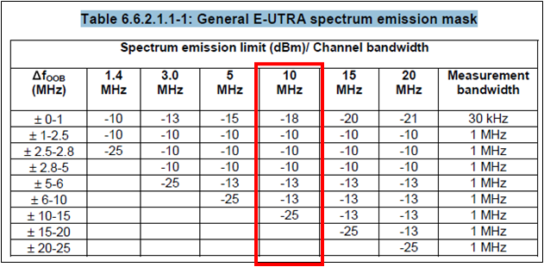
Figure 97: OOB spectrum emission mask for the aircraft AS
For a 10 MHz channel bandwidth, the DA2GC AS spectrum emission mask is illustrated Figure 62.
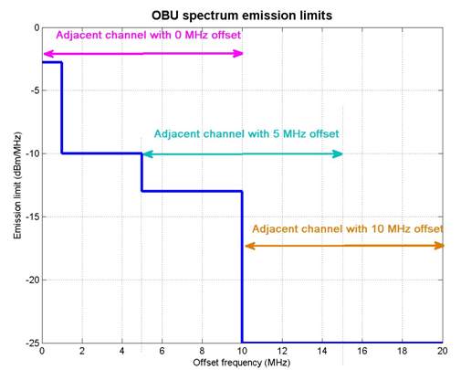
Figure 98: DA2GC spectrum emission limits for 10 MHz emission bandwidth
The total power in the 10 MHz adjacent channels is the following:
Table 28: DA2GC aircraft station emissions in adjacent bands
Frequency offset beween edges (MHz) | Power (in 10 MHz) (dBm)
0 | 0.715
5 | -5.74
10 | -15

FS characteristics
The characteristics of the FS stations are extracted from revised ITU-R F.758-4
Table 29: Characteristics of the FS stations from revised ITU-R F.758-4
Frequency range (GHz) | 3.600-4.200 |  | 3.700-4.200
Reference ITU-R Rec. | F.635 |  | F. 382
Modulation | 64-QAM | 512-QAM | QPSK
Channel spacing and receiver noise bandwidth (MHz) | 10,30, 40, 60, 80, 90 | 10,30, 40, 60, 80, 90 | 28, 29
Maximum Tx output power range (dBW) | −1 | 7 | 0
Maximum Tx output power density range (dBW/MHz) | −16…−11 | −9.0 | −15
Minimum feeder/multiplexer loss range (dB) | 0 | 3 | 3
Maximum antenna gain range (dBi) | 42 | 40 | 37
Maximum e.i.r.p. range (dBW) | 41 | 44 | 38
Maximum e.i.r.p. density range (dBW/MHz) | 26…31 | 28 | 23
Receiver noise figure (dB) | 3 | 2 | 4
Receiver noise power density typical (=NRX ) (dBW/MHz) | −141 | −142 | −140
Normalized Rx input level for 1 × 10–6 BER (dBW/MHz) | −114.5 | −106.5 | −126.5
Nominal long-term interference power density (dBW/MHz) | −141 + I/N | −142 + I/N | −140 + I/N
(3) There are two modulations (QPSK and 4FSK) described and QPSK is selected.

The formulas retained for the calculation of the antenna radiation patterns for FS-PP are the ones of the Recommendation ITU-R F.699 which is usually assumed in sharing studies when a single FS system is considered as victim/interferer.
For the antenna elevation, some countries reported an elevation range of 3 to 10 degree. Note that a range of maximum elevation angle from 15 to 30 degree has been reported in some countries in rare cases.
In order to stay in a neutral way and to simplify the calculation, an elevation angle of 0° for P-P FS links was retained to perform the studies. An azimuth direction of 45° was assumed.
Figure 63 shows the antenna gain towards an aircraft flying at 3000m and 13000m altitude considering a FS station which main beam is 45° in azimuth and 0° in elevation.
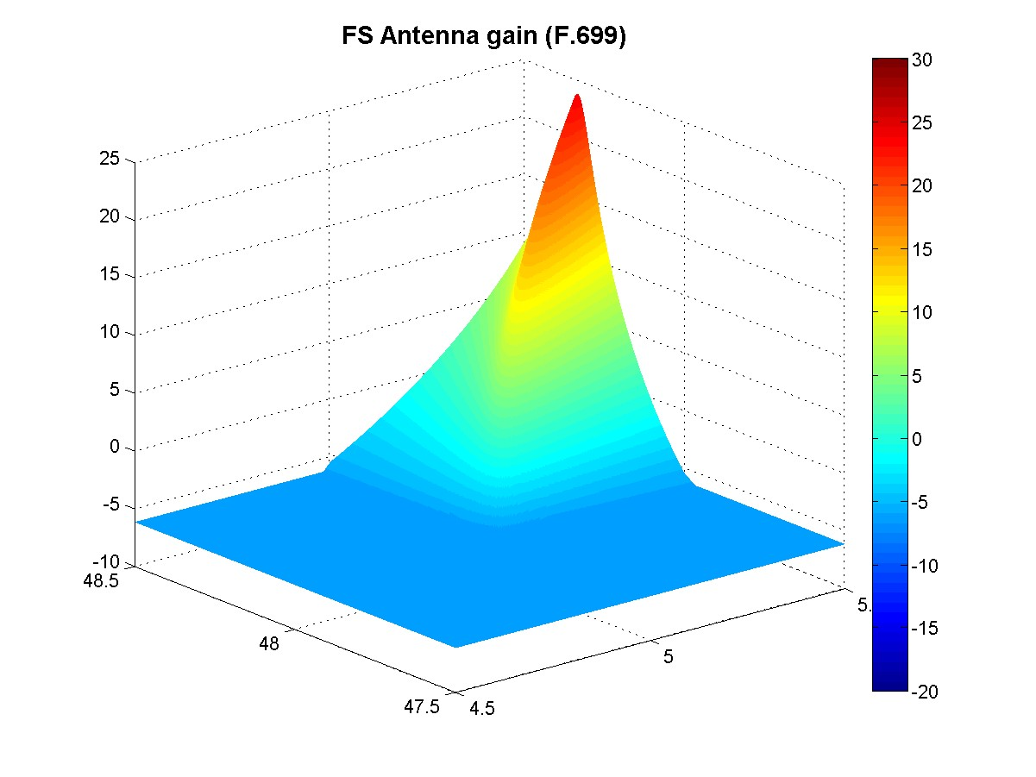
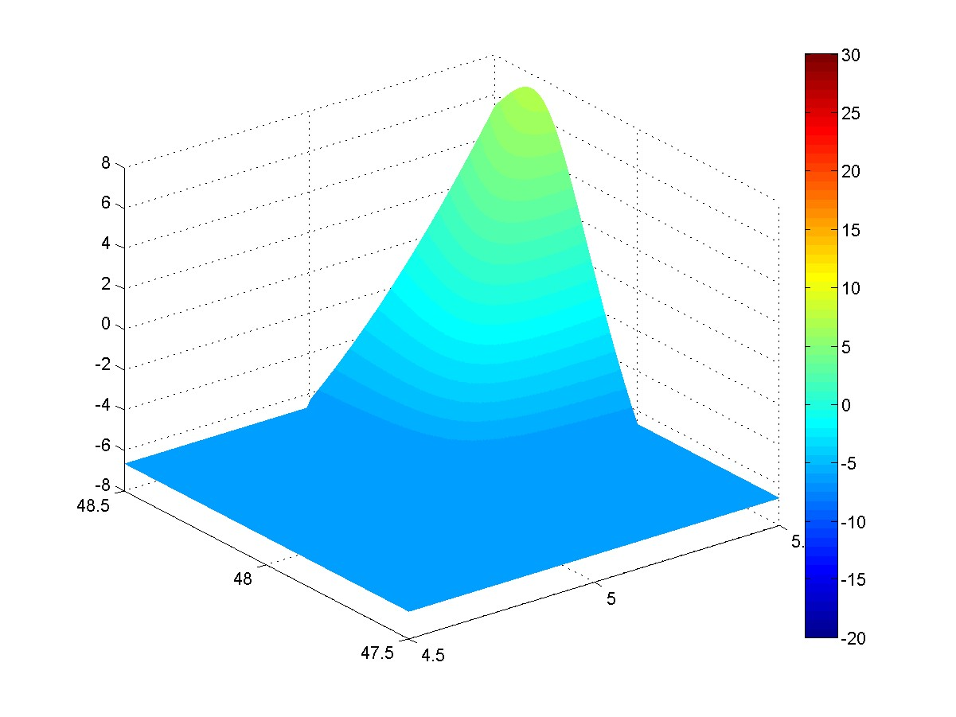
Figure 99: Antenna gain towards an aircraft located at 3000m altitude (top) and 13000m altitude (bottom) for a FS link of 45° azimuth and 0° elevation.
Regarding the I/N protection criteria, FS systems (for both P-P and P-MP systems) commonly adopt I/N ≤ 10 dB. It should be noted that ITU-R SG5 has recently confirmed this criterion in the draft revision of Rec. F.758-4.
Furthermore it is important to highlight that the same characteristics for 3.6-3.8 GHz frequency band can be used for the 3.4-3.6 GHz band.
The OOB emissions for the Fixed Service are described in Annex 12 of Recommendation ITU-R SM.1541. The emission mask is represented in Figure 64 and is used for studies in adjacent bands with the FS station as interferer.
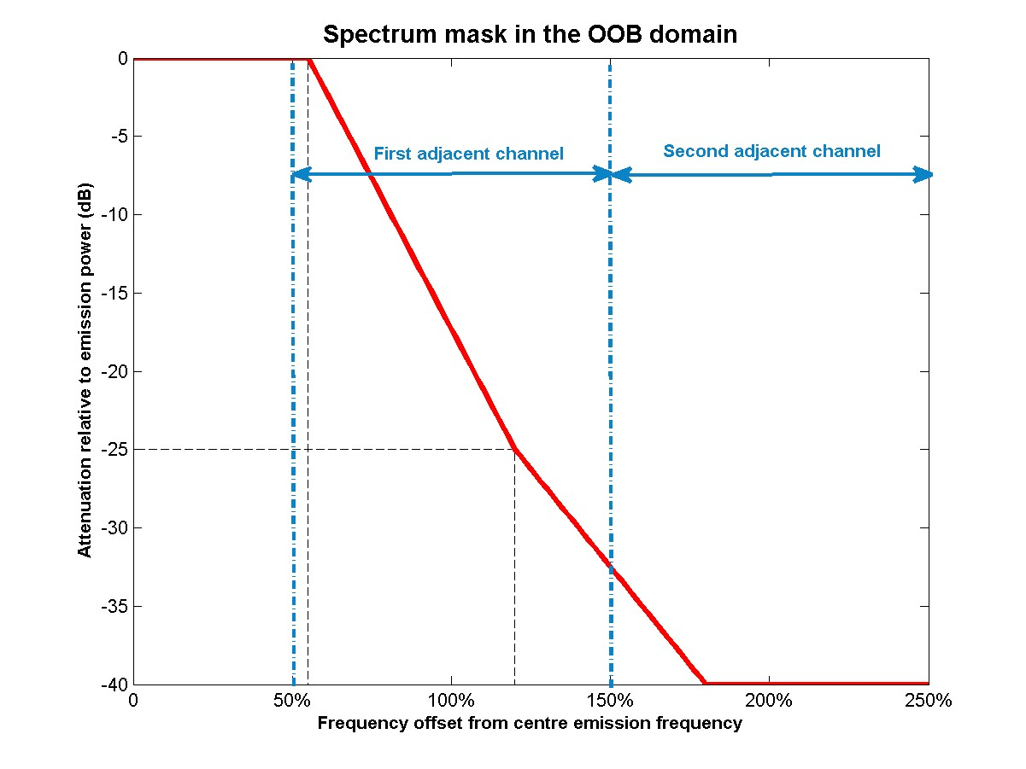
Figure 100: OOB emissions of the FS station

Methodology
The aim is to study the compatibility between a FS station and a DA2GC AS located on board an aircaft in both directions (i.e DA2GC as an interferer and then as a victim).
The FS station is located at (G0, L0).
When considering the FS station as the victim and DA2GC AS as the interferer, the interference level arriving to the victim receiver from an aircraft at a given altitude H (from 3000 m up to 13 000 m) around the FS station location (i.e. 1° by 1° horizontal square around (G0,L0)) is calculated and mapped with Matlab as illustrated Figure 65.
When considering the FS station as the interferer and DA2GC AS as the victim, the calculations are very similar since the antenna gains remain unchanged for both systems. The only difference lies in the protection criterion and the emission levels.
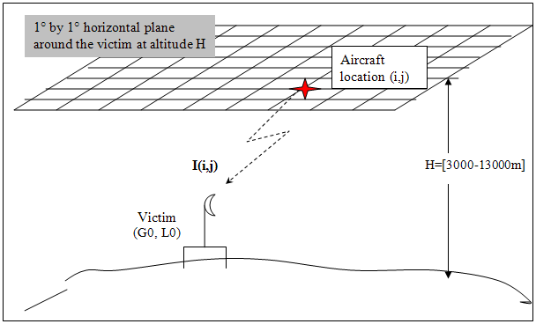
Figure 101: Illustration of the configuration used for interferences calculations
Negative aircraft elevations relative to the victim receiver are suppressed. For positive aircraft elevations, the free space loss attenuation is used.

Interferences from DA2GC aircraft station to FS
Co-channel case
By co-channel emission, it is meant that the DA2GC AS emission bandwidth covers the FS receiver bandwidth. Since the receiver bandwidth (10 MHz) is larger than the emission bandwidth (9 MHz), the power received by the FS station is the total emission of the DA2GC AS.
The maximum interference level is -111 dBm (-141 dBW) at the FS station receiver.
Considering a DA2GC AS with full power (40 dBm), the FS station I/N criterion is largely exceeded at 3000m and also at 13000m, whatever the aircraft position (see Figure 66)
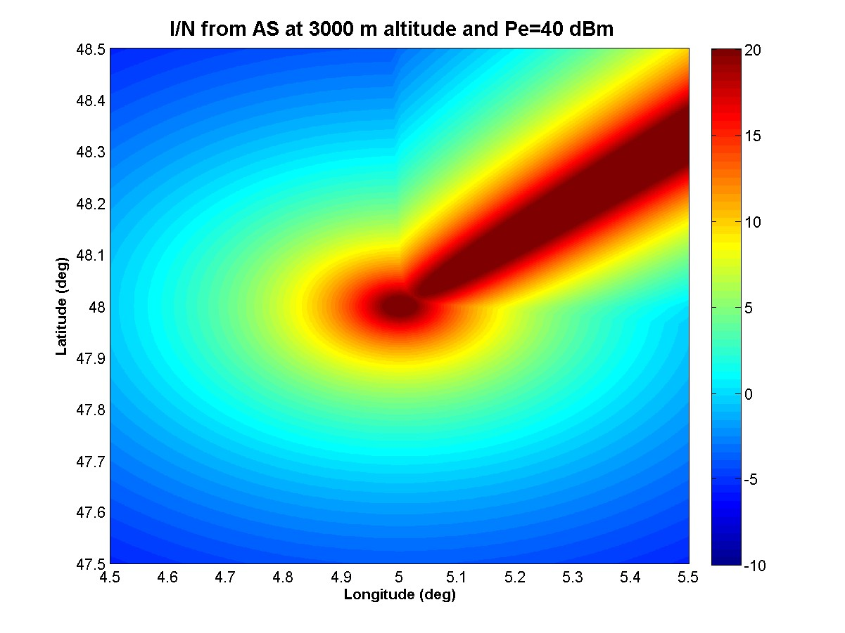
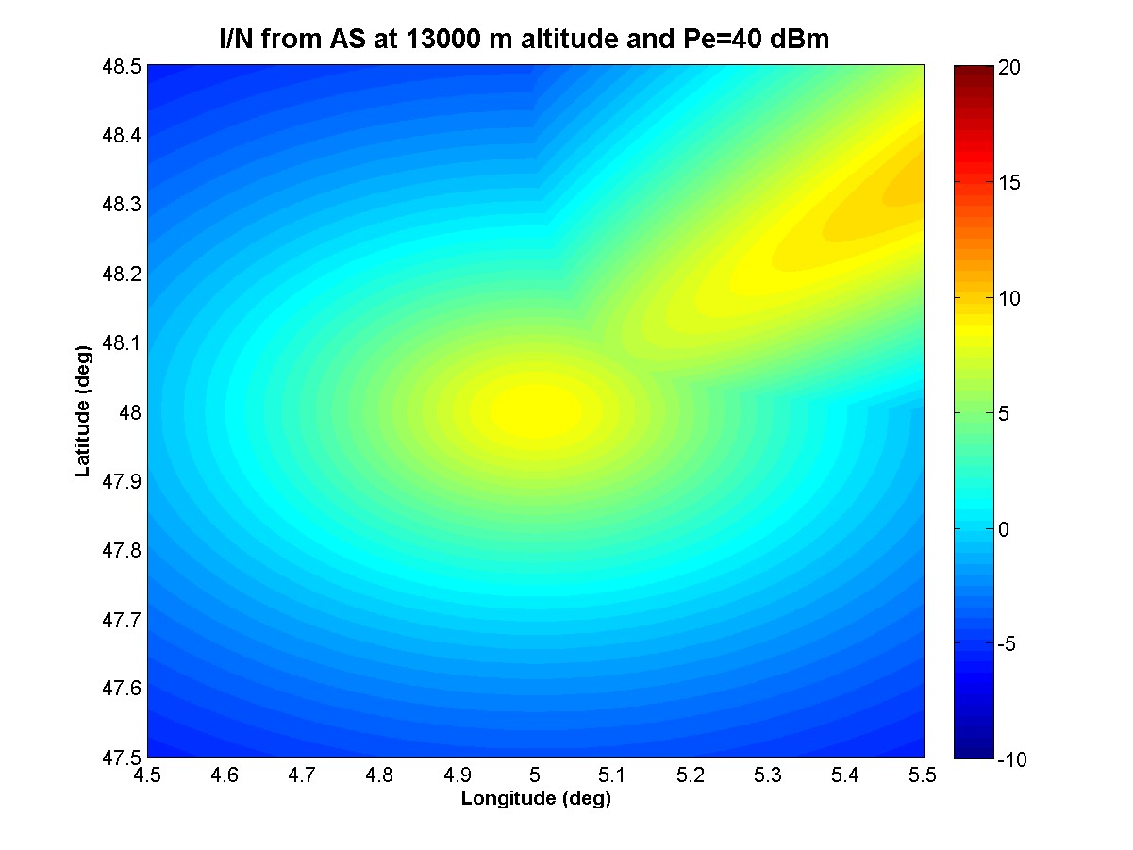
Figure 102: I/N level at the FS station from a DA2GC AS with 40 dBm emission power at 3000m (top) and 13000m (bottom) altitude.
When considering an aircraft at 3000m, interferences disappear when Pe is below 3 dBm and when considering an aircraft at 13000m, interferences disappear when Pe is below 20 dBm.
Full power emissions (40 dBm) from DA2GC-AS lead to interferences to the FS station whatever the aircraft altitude. To avoid interferences, the emission power of the DA2GC must not exceed 3 dBm.
Emissions in adjacent bands

From Figure 61, the power in a 10 MHz receiver in the first adjacent channel is 0.715 dBm, which is below the value of 3 dBm identified above for the DA2GC AS to cause no interferences. Therefore no interferences are expected if the FS receiver is in the first adjacent channel.

Interferences from FS to DA2GC aircraft station
Co-channel case
The maximum e.i.r.p. for the FS station is 41 dBW at 0° elevation and 45° azimuth, which correspond to a power emission of 0 dBW (30 dBm).
The maximum interference level is -101.5 dBm at the DA2GC receiver.
Thus the FS emission power is 10 dB lower than the maximum AS emission power and the protection criterion is about 10 dB less stringent, therefore the interferences from the SF station to the AS exists. As Figure 67 shows, an aircraft AS at 3000m altitude will suffer from interferences when the aircraft crosses the SF main lobe azimuth or fly just above the FS station. At 13000m, interferences are observed in the FS main lobe for elevations lower than 0.285°.
Interferences from the FS station to the DA2GC AS occur when the aircraft is in the same azimuth as the FS link (even at 13000m altitude).
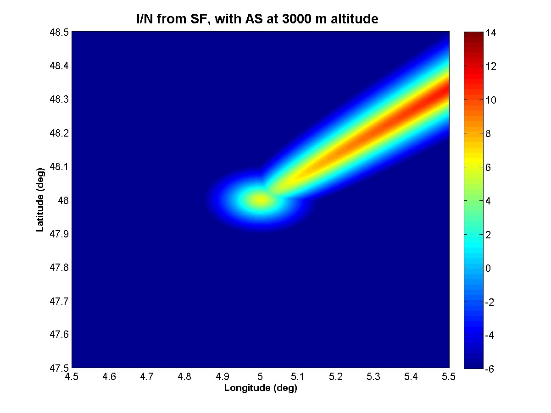
Figure 103: I/N level at the DA2GC AS at 3000m altitude from a FS station
Emissions in adjacent bands
Considering the OOB FS emission mask of Figure 3, the power received in the first adjacent channel of 10 MHz is about 22 dBm. This leads to interferences at the DA2GC-AS receiver in the FS link azimuth for aircraft altitudes lower than 6500m. Figure 68 show that the I/N criterion of -6 dB is exceeded when the aircraft crosses the FS link azimuth at 6000m altitude. For altitudes higher than 6500m, no interferences are observed.
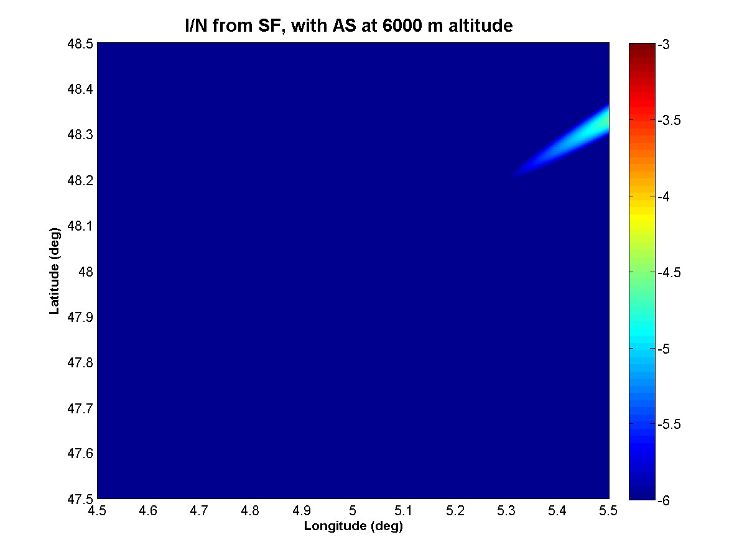
Figure 104: I/N level at the DA2GC AS at 6000m altitude from a FS station

Conclusions
The scenarios studied here show that coexistence in co-channel is not possible. Co-existence with an offset of 10 MHz (first adjacent channel) is possible, but interferences from FS link to DA2GC-AS may occur when aircraft is in the same azimuth as FS links.

Compatibility and sharing scenarios for the band 5855 – 5875 MHz
Table 30 contains the services and systems deployed in the frequency band 5.8 GHz. Figure 69 shows the sharing scenarios in both interference directions when assuming TDD mode of the DA2GC system.
Table 30: Incumbent services/systems deployed in the 5.8 GHz band
System | Frequency range/MHz | Compatibility issues
BFWA | 5 725 – 5 875 | ECC/REC (06)04 Technical characteristics ETSI TR 102 079 EN 302 502, Fixed Systems according to ITU-R F.758.
FSS (E-s) | 5 725 – 5 875 | ECC Report 68 contains sample of GSO satellite data taken from the ITU filings for the band 5 725 – 5 875 MHz. Annex 3 of ECC REC (06)04 contains e.i.r.p. spectral density limits in the elevation plane to protect GSO satellite receivers in the FSS.
SRDs | 5 725 – 5 875 | Non-Specific SRDs according ERC/REC 70-03 Annex 1, Technical parameters EN 300 440, 25 mW e.i.r.p.  ECC Report 68 contains compatibility studies between BFWA and SRD.
ITS | 5 875 – 5 925  5 855 – 5 875 | Safety related ITS applications  Non-safety related ITS applications  ECC Report 101 details spectrum sharing studies between ITS systems (Roadside and onboard unit) within the frequency band 5855-5925 MHz and the other services and applications in this frequency range and identifies conditions for ITS applications that facilitate spectrum sharing. ECC Reports 109 and 110 supplement these studies. Technical parameters can also be found in EN 302 571
Radiolocation | 5 725 – 5 850 | Recommendation ITU-R M.1638 provides characteristics of radars operating under the Radiolocation services in the frequency range 5250-5850 MHz

Figure 105: Interference scenarios for BDA2GC in the frequency band 5855 -5875 MHz

Compatibility between DA2GC and BFWA at 5.8 GHz

Technical characteristics of BFWA systems
For BFWA, the system parameters as provided in ECC Report 68 and in ETSI TR 102 079 (System Reference Document for BFWA (HIPERMAN) in the 5.8 GHz band) have been used. The following Table 7-2 contains the technical parameters of a BFWA P-MP system. Annex D of ETSI TR 102 079 provides various radio parameters, especially table D.7 shows the parameters for different modulation schemes In this analysis the 16-QAM system was used as a reference. A protection criterion (C/I) of 20 dB was assumed in the calculations. It should be noted that systems operating with high data rates may need a C/I of up 30 dB for their operation. For both station types (CS and TS) a maximum power spectral density of 23 dBm/MHz was considered in this study.
Table 31: BFWA system parameter
Parameter | P-MP
Topology | Sectored Central Station (CS) Terminal Stations (TS).
Channel bandwidth | 20 MHz
Duplex/  Access scheme | TDD/TDMA
Max e.i.r.p. | 36 dBm
Power density spectral (dBm/MHz) e.i.r.p. | 23 dBm/MHz
Antenna gain | 17 dBi
Antenna pattern CS | See Figure 1
Antenna pattern TS | See Figure 2
Receiver sensitivity (16-QAM) | -74 dBm (in 20 MHz BW)
Interference protection ratio C/I | 20 dB
Interference protection level (16-QAM system) | -107 dBm /MHz

Figure 106: Typical P-MP Central station antenna pattern (see Annex 1 of ECC Report 68)
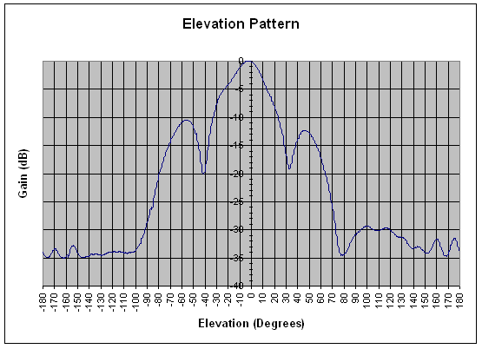
Figure 107: BFWA Terminal Station Elevation pattern (20 degree beam width)

Compatibility between DA2GC AS (ETSI TR 103 054) and BFWA

Methodology
It is considered that the DA2GC aircraft station is approaching the BFWA CS at a given altitude (3000m and 10000m). The interference level arriving at the victim receiver was calculated taking into account the transmit power density of the interfering system, the great circle distance, the aircraft elevation (up to 90 degrees), the resulting free space loss, the antenna characteristics of the interfering and the victim system and the interference protection level of the victim system. The following Figure 4 illustrates the scenario between a BFWA BS and a DA2GC AS.
Figure 108: Interference scenario

Results
Figure 73 to Figure 80 show the

- received power spectral density (PSD) in dBm/MHz at the BFWA stations and the DA2GC AS and also
- resulting interference-to-noise ratio (I/N) compared to the different thresholds of both systems

along the great circle distance from 0 km to 100 km.
Line-of-sight propagation was assumed between BFWA CS/TS and DA2GC AS. Therefore, free space loss was considered. Only co-channel transmission was evaluated.
Interference scenarios between BFWA CS and DA2GC AS as well as between BFWA TS and DA2GC AS are considered for aircraft altitudes of 3 km and 10 km, respectively.

Figure 109: Received PSD (aircraft altitude 3000 m) | Figure 110: Resulting I/N ratio (aircraft altitude 3000 m)
Figure 111: Received PSD (aircraft altitude 10.000 m) | Figure 112: Resulting I/N ratio (aircraft altitude 10.000 m)
Figure 113: Received PSD (aircraft altitude 3000 m) | Figure 114: Resulting I/N ratio (aircraft altitude 3000 m)
Figure 115: Received PSD (aircraft altitude 10000 m) | Figure 116: Resulting I/N ratio (aircraft altitude 10000 m)

Figure 81 to Figure 84 show the resulting PSD at the BFWA (CS and TS) receiver input in dependence of the aircraft elevation. Considering an aircraft approaching at an altitude of 3000 meters, it can be observed (Figure 81 and Figure 82), that the protection criterion of the BFWA will be exceeded by a wide margin. Figure 83 and Figure 84 shows the situation, when the aircraft is approaching at an altitude of 10000 meters. It can be observed that an additional free space loss of 10.5 dB is achieved independently of the aircraft elevation. In case of the BFWA CS for aircraft heights above 8000 meters, the protection level is continuously met. Interference at the TS can still be observed up to 10.000 meters (see Figure 84).
Figure 117: Resulting interference at the BFWA CS antenna input caused by a DA2GC AS (altitude 3000m) | Figure 118: Resulting interference at the BFWA TS antenna input caused by a DA2GC AS (altitude 3000m)
Figure 119: Resulting interference at the BFWA CS antenna input caused by a DA2GC AS (altitude 10.000 m) | Figure 120: Resulting interference at the BFWA TS antenna input caused by a DA2GC AS (altitude 10.000m)
Figure 121: Resulting interference at the DA2GC AS antenna input caused by a BFWA CS (aircraft altitude 3000m) | Figure 122: Resulting interference at the DA2GC AS antenna input caused by a BFWA TS (aircraft altitude 3000m)

Figure 85 and Figure 86 showing an approach of an aircraft at an altitude of 3000m.It can be noted that the protection criterion is continuously met in case of the CS. In case of the BFWA TS as the interfering system interference of 2.3 dB can still be observed. Above an aircraft altitude of about 3900 meters compatibility is achieved.

Compatibility between DA2GC GS (ETSI TR 103 054) and BFWA
Table 32 shows the technical parameters of the DA2GC Ground Station. According to the system description of the DA2GC Ground station an antenna up-tilt of 10 degree was assumed, leading to a maximum horizontal gain of 8 dBi, which was used in the calculation.
Table 32: Technical parameters of the DA2GC GS (TR 103 054)
DA2GC GS Parameter | Value | Unit
DA2GC Tx power | 46,0 | dBm
Antenna gain (mainlobe) | 20,0 | dBi
e.i.r.p. max | 66,0 | dBm
Power spectral density | 53,4 | dBm/MHz
GS Antenna tilt | 10,0 | degree
Antenna gain(horizontal) | 8,0 | dBi
DA2GC GS antenna height | 50,0 | m
Signal bandwidth | 18,0 | MHz
Rx thermal noise | -101,4 | dBm
Rx noise figure | 5,0 | dB
Rx noise floor | -96,4 | dBm
Rx sensitivity level | -98,5 | dBm
Interference protection ratio I/N | -6,0 | dB
Interference protection level | -102,5 | dBm
Interference protection level | -115,1 | dBm/MHz

Methodology

Results
The following Table 33 and Table 34 show the calculated separation distances between a DA2GC Ground station and a BFWA Central station by using the free space loss model and the ITU-R P.452 model.
Table 33: Required separation distances (DA2GC victim)
BFWA to DA2GC GS (SRDoc) | Required  attenuation | Unit | FSL | ITU-R P.452 | Unit
BFWA ML - DA2GC | 146,0 | dB | 82,2 | 51,4 | km
BFWA 1st SL (0 dBi) - DA2GC | 129,0 | dB | 11,6 | 11,6 | km
BFWA 2nd SL (-20 dBi) - DA2GC | 109,0 | dB | 1,2 | 1,2 | km
Table 34: Required separation distances (BFWA victim)
DA2GC GS (SRDoc) to BFWA | Required  attenuation | Unit | FSL | ITU-R P.452 | Unit
DA2GC - BFWA ML | 165,5 | dB | 768,6 | 58,9 | km
DA2GC - BFWA 1st SL (0 dBi) | 148,5 | dB | 108,6 | 52,0 | km
DA2GC - BFWA 2nd SL (-20 dBi) | 128,5 | dB | 10,9 | 10,8 | km

Conclusions on the compatibility between DA2GC (ETSI TR 103 054) and BFWA

Impact on BFWA
For aircraft altitudes of about 3 km the I/N threshold will be generally exceeded at the BFWA TS, and also in a large range at the CS. The results are strongly dependent on the antenna characteristic applied for BFWA installation, especially the impact of the side lobes is recognizable in the I/N curves.
The I/N threshold at the TS is exceeded even at an aircraft altitude of 10 km. For the CS single critical peaks occur only near its location, but for medium altitudes the threshold can no more be kept in that area.
Thus, it is concluded that co-channel operation of DA2GC reverse link (air-to-ground) and BFWA systems in the band 5855-5875 is not feasible.

Impact on DA2GC AS
At higher altitudes the impact of BFWA transmitters on the receiving DA2GC AS is negligible. Only in distances below 10 km from a BFWA TS the receiving DA2GC AS at altitudes of 3 km and below can be slightly affected by interference.
Thus it is concluded that single BFWA CS and TS should be uncritical for the DA2GC forward link (ground-to-air), but a larger deployment of BFWA CS and TS in an area may create noticeable performance degradation due to the aggregation of interference signals at the receiving DA2GC AS.

Interference between BFWA CS and BDA2GC GS
Compatibility studies between BFWA CS (Central Station) and BDA2GC GS (Ground Stations according to ETSI TR 103 054 have been carried out. The separation distances for all possible cases have been calculated. However, there is no need to consider the suitability of the separation distances more in detail because the compatibility studies between BFWA and DA2GC AS (ETSI TR 103 054) have shown that co-channel sharing is not feasible.

Compatibility between DA2GC AS (ETSI TR 101 599) and BFWA

Methodology

Results

Compatibility between DA2GC GS (ETSI TR 101 599) and BFWA

Methodology

Results

Conclusions on the compatibility between DA2GC (ETSI TR 101 599) and BFWA

Compatibility between DA2GC AS (ETSI TR 103 108) and BFWA

Methodology

Results

Compatibility between DA2GC GS (ETSI TR 103 108) and BFWA

Methodology

Results

Conclusions on the compatibility between DA2GC (ETSI TR 103 108) and BFWA

Compatibility between DA2GC and FSS

Technical characteristics of GSO satellite systems
Satellite | Satellite orbital position | Receiver Gain, G_{Sat} | Satellite Receiving system | Aggregate e.i.r.p. dB(W Hz⁻¹) | Satellite Name | Administration | Beam
A | 5º West | 34 | 773 | -54.1 | TELECOM-2B | Fr | MET
B | 14º West | 26.5 | 1200 | -44.7 | EXPRESS-2 | RUS | ZER
C | 31.5º West | 32.8 | 700 | -53.3 | INTELSAT8 | USA | 9Z3
D | 3º East | 34 | 773 | -54.1 | TELECOM-2C | Fr | MET
E | 18º West | 32.8 | 700 | -53.3 | INTELSAT8 | USA | 9Z3
F | 53º East | 26.5 | 1200 | -44.7 | EXPRESS-5 | RUS | ZER
G | 59.5º East | 34 | 1200 | -52.2 | No longer existing
H | 66º East | 34.7 | 700 | -55.2 | INTELSAT9 | USA | 9Z1
I | 359º East | 32.8 | 700 | -53.3 | INTELSAT8 | USA | 9Z3
Table 35: Derivation of acceptable aggregate e.i.r.p. from interferers in the satellite beam (see ECC Report 101)

Technical characteristics of FSS Earth stations

Earth Station | ST1 | ST2 | ST3 | ST4
Elevation (deg) | 10 | 10 | 33 | 33
Antenna Diameter (m) | 4.6 | 32.5 | 4.6 | 32.5
Power (dBW/MHz) | 21.3 | 2.0 | 21.3 | 2.0
Max antenna gain (dBi) | 47.8 | 63 | 47.8 | 63
Height (m) | 4.3 | 18.25 | 4.3 | 18.25
Antenna pattern | ITU-R Rec. S.465 [19]
Table 36: Assumed FSS parameters (see ECC Report 101)

Compatibility between DA2GC and SRD

Technical characteristics of SRDs
- General (Non-Specific) Short Range Devices characteristics
As specified in Annex 1 of ERC Recommendation 70-03, the frequency band 5725-5875 MHz is used by non-specific SRD. This use should comply with the technical characteristics as shown below.

Frequency Band | Power | Antenna | Channel Spacing | Duty Cycle
5725-5875 MHz | 25 mW e.i.r.p. | Integral (no external antenna socket)  or dedicated | No channel spacing - the whole stated frequency band may be used | No duty cycle restriction
Table 47: Technical characteristics of SRD

In addition to these regulatory technical characteristics, assumptions on some parameters had to be made in order to carry out compatibility studies. Three kinds of SRD are considered for the interference assessment (see the following table).

Parameter | SRD I | SRD II | SRD III | Comments
Typical bandwidth BW (MHz) | 0.25 MHz | 20 MHz | 8MHz | Note 1, Note 2.
TX Power, dBm e.i.r.p. | +14 | +14 | +14
Ant. Gain, dBi | 2 to 20 | 2 to 24 | 2
Ant. Polarization | Circular | Circular | Vertical
Receiver sensitivity, dBm | -110 | -91 | -84
Receiver noise dBm/MHz | -114 | N/A | N/A
Protection criterion, dB | I/N=0dB | C/I=8dB | C/I=20dB
SRD Noise figure F | 9.00 dB | N/A | N/A
FkTB | -105 dBm/MHz | N/A | N/A
Max OoB RX interference, dBm | -35 | -35 | -35 | E.g. limit for Rx blocking
Duty cycle : % | Up to 100% | Up to 100% | 100%
RX wake-up time (if applicable) | 1 sec | 1 sec | N/A | For battery operated equipment
Note 1: The given bandwidths are for non-spread spectrum modulation.
Note 2: For spread spectrum modulation (FHSS, DSSS and other types) the bandwidth can be up to 100 MHz
Table 48: Assumed SRD parameters

Compatibility between DA2GC and ITS

Technical characteristics of ITS

Parameter | Value | Comments
Frequency stability | 10 ppm | According to ETSI EN 302 571 V1.2.2 (2011-10)
Maximum radiated power (e.i.r.p.) | Channel 5860, 5910 and 5920 MHz:  0 dBm, -10 dBm/MHz  Channel 5870 and 5890 MHz:  23 dBm, 13 dBm/MHz  Channel 5880 and 5900 MHz:  33 dBm, 23 dBm/MHz | According to ETSI EN 302 571 V1.2.2 (2011-10) and ETSI EN 302 663 V1.3.1 (2012-06)  There are no equipment classes anymore. There are different power limits for different channels with highest allowed power for the most critical channels.  See figure 1.
Antenna beam shape/gain | For RSU and OBU use antenna model ITU-R F.1336-3 with parameters G0 5 dB, k 1.2, max gain in +10 deg elevation | See figure 2 and equation 1. In ECC Report 101 there were 2 possible antennas, one very directional and one omnidirectional ITU-R F.1336-1. However ITS systems development shows that the omnidirectional will be the dominant type and therefore only this should be used in these compatibility studies. There is a new version of model ITU-R F.1336-3 which should be used. Both versions 1 and 3 results in exactly the same antenna performance with these parameter settings.
Polarization | Vertical linear | The antenna performance is not described in ETSI ITS however the vertical linear polarization is dominant.
Modulation scheme | BPSK QPSK 16QAM 64QAM | According to ETSI EN 302 571 V1.2.2 (2011-10) and ETSI EN 302 663 V1.3.1 (2012-06)
Data rates | 3/4.5 /6/9/12/18 /24/27 Mbit/s  Mandatory: 3/6/12 Mbit/s | According to ETSI EN 302 571 V1.2.2 (2011-10) and ETSI EN 302 663 V1.3.1 (2012-06)
Channel Bandwidth | 10 MHz | According to ETSI EN 302 571 V1.2.2 (2011-10) and ETSI EN 302 663 V1.3.1 (2012-06)
Communication mode | Half-duplex, broadcast | Half-duplex and broadcast are believed to be adequate for the applications considered to date.
Receiver sensitivity | Add 10 dB better sensitivity to the minimum requirements shown in table 3 | ETSI EN 302 571 V1.2.2 (2011-10) specifies minimum required sensitivity. For compatibility studies, add 10 dB better sensitivity.
Protection criterion | Channel 5880, 5890 and 5900 MHz:  C/I=12dB  Other channels:  C/I=6dB | The three ITS-G5A channels are decided by the European Commission to be used for road safety communication and therefore a higher C/I value of 12 dB should be used for these channels.
Table 37: System parameter of ITS (not exhaustive)
Communication channels will be open for the applications within the respective usage category (either road safety related or not, i.e. used for traffic management).
The required power levels (e.i.r.p.) range from 3 dBm to 33 dBm to achieve communication distances of up to 1000 m.
To avoid collisions of radio messages in areas with a lot of vehicles, a mechanism DCC (dynamic congestion control) in ITS radios will when necessary reduce the output power and the available time to transmit.
There is a mechanism in ITS radios which will reduce the output power or available time to transmit when the radios are close to 5.8 GHz RTTT road tolling stations.

Unwanted emission levels are given by to ETSI EN 302 571 V1.2.2 (2011-10) for the out of band domain and SM.329 and ERC Recommendation 74-01 for the spurious domain.

Power spectral density at the carrier center fc (dBm/MHz) | ±4,5 MHz  Offset  (dBm/MHz) | ±5,0 MHz  Offset  (dBm/MHz) | ±5,5 MHz  Offset  (dBm/MHz) | ±10 MHz  Offset  (dBm/MHz) | ±15 MHz  Offset  (dBm/MHz)
23 | 23 | -3 | -9 | -17 | -27
The limits are reduced by 10 dB for the 5870 and 5890 channels and by 33 dB for 5860, 5910 and 5920 channels.
Table 38: Transmitter unwanted emission limits inside the 5 GHz ITS bands (e.i.r.p.)

Figure 123: Maximum limit of mean spectral power density for each channel type in ITS-G5A, ITS-G5B, and ITS-G5D

Figure 124: OBU and RSU antenna pattern

Modulation | Coding rate | Minimum sensitivity (dBm)
BPSK | 1/2 | –85
BPSK | 3/4 | –84
QPSK | 1/2 | –82
QPSK | 3/4 | –80
16-QAM | 1/2 | –77
16-QAM | 3/4 | –73
64-QAM | 2/3 | –69
64-QAM | 3/4 | –68
Table 39: Minimum required receiver sensitivity; receivers will have up to 10 dB better sensitivity.

(1a)

with:

(1b)

(1c)

where:
G(θ) : gain relative to an isotropic antenna (dBi)
G0 : the maximum gain in the azimuth plane (dBi)
θ : elevation angle relative to the angle of the maximum gain (degrees) θ
θ3 : the 3 dB beamwidth in the elevation plane (degrees)
k: parameter which accounts for increased side-lobe levels above what would be expected for an antenna with improved side-lobe performance

Equation 1: Antenna model ITU-R F.1336-3; use G0 5 dB, k 1.2, max gain in +10 deg elevation

Compatibility between DA2GC and RTTT systems

Technical characteristics of RTTT systems

 | Road Side Units | On Board Units
Carrier frequencies (MHz) | 5797.5, 5802.5  (5807.5, 5812.5 MHz for multi-lane road junctions at a national level)
Frequency stability | 5 ppm | modulation 100 ppm
e.i.r.p. | 2 W (33 dBm) standard for 0°≤θ≤70°  18 dBm for θ > 70°  8 W (39 dBm) optional | Maximum re-radiated sub-carrier e.i.r.p.:  -14 dBm
Antenna gain | 10-20 dB (assumed front-to-back ratio of 15 dB) | 1-10dB (assumed front-to-back ratio of 5dB)
Transmitter Bandwidth | 1 MHz | 500 kHz
Modulation scheme transmitter | Two level amplitude | BPSK
Receiver bandwidth | 500 kHz | approx, 300 MHz
Polarization | left circular | left circular
Receiver sensitivity (at the receiver input) | -104 dBm (BPSK) | -60dBm
Co-channel C/I (dB) | 6 dB | 6 dB
Table 40: Summary of characteristics of the RTTT systems
The technical requirements of the RTTT DSRC devices are split into two categories :
- the Road Side Unit is an active device with a high level of emission and the sensitivity value can be
compared to the value of ITS devices
- the On Board Unit is a passive device with reduced level of emission (back-scattering uplink
communication) and poor level of sensitivity (downlink communication).

Technical data from ETSI EN 300 674 V1.2.1 (2004-08) and CEN EN 12253.

Compatibility between DA2GC and Radiolocation systems

Technical characteristics of Radiolocation systems
Recommendation ITU-R M.1638 [18] provides characteristics of radars operating under the Radiolocation services in the frequency range 5250-5850 MHz. Within this range, the band between 5 725 and 5 850 MHz is used by many different types of radars on fixed land-based, ship borne and transportable platforms. It should be noted that most of these radars are designed to operate not only in the 5725-5850 MHz band but in a larger portion of the band 5250-5850 MHz. contains technical characteristics of representative systems deployed in this band. This includes a subset of the radars contained in Recommendation ITU-R M.1638 [18] which are relevant for the frequency band 5725-5850 MHz (radars L, M, N, O and Q) and three additional radars operated by administrations within CEPT (X, Y and Z). This information is generally sufficient for calculation to assess the compatibility between these radars and other systems.

Characteristics | Radar L | Radar M | Radar N | Radar O | Radar Q | Radar X&Y | Radar Z
Function | Instrumentation |  |  |  | Surface and air Search |  | Search
Platform type | Ground |  |  |  | Ship | Ground/Vehicle
Tuning range (MHz) | 5 350-5 850 |  | 5 400-5 850 |  | 5 450-5 825 | 5400 – 5850 | 5250 – 5850
Modulation | None | None | Pulse/chirp pulse | Chirp pulse | None | None | Non-Linear  FM
TX power into antenna | 2.8 MW | 1.2 MW | 1.0 MW | 165 kW | 285 kW | 12 kW peak | 70 kW
Pulse width (µs) | 0.25, 1.0, 5.0 | 0.25, 0.5, 1.0 | 0.25-1 (plain)  3.1-50 (chirp) | 100 | 0.1/0.25/1.0 | 4-20 | 3.5/6/10
Pulse rise/fall time (µs) | 0.02-0.5 | 0.02-0.05 | 0.02-0.1 | 0.5 | 0.03/0.05/0.1 | No detail | N/A
Pulse repetition rate (pps) | 160, 640 | 160, 640 | 20-1 280 | 320 | 2 400/1 200/750 | 1000-7800 | 2500/3750
Chirp bandwidth (MHz) | N/A | N/A | 4.0 | 8.33 | N/A | No detail
RF emission bandwidth (MHz) at 3 dB  at 20 dB | 0.5-5 | 0.9-3.6  6.4-18 | 0.9-3.6  6.4-18 | 8.33  9.9 | 5.0/4.0/1.2  16.5/12.5/7.0 | 5
Antenna pattern type | Pencil | Pencil | Pencil | Pencil | Fan | N/A | N/A
Antenna type | Parabolic | Parabolic | Phased Array | Phased Array | Travelling wave feed horn array | N/A | Phased Array
Antenna polarization | Vertical/Left-hand circular |  |  |  | Horizontal | Vertical | Horizontal
Antenna main beam gain (dBi) | 54 | 47 | 45.9 | 42 | 30.0 | 35 | 31.5
Antenna elevation beamwidth (degrees) | 0.4 | 0.8 | 1.0 | 1.0 | 28.0 | N/A | 43.8
Antenna azimuth beamwidth (degrees) | 0.4 | 0.8 | 1.0 | 1.0 | 1.6 | N/A | 1.75
Antenna rejection (1st SLs and remote SLs) (dB) | -20 | -20 | -22 | -22 | -25 | -40 | N/A
Antenna height (m) | 20 | 8-20 | 20 | 20 | 40 | 10 | 6 – 13
Receiver IF 3 dB bandwidth (MHz) | 4.8, 2.4, 0.25 | 4, 2, 1 | 2-8 | 8 | 1.2,10 | 4 | N/A
Receiver noise figure (dB) | 5 | 5 | 11 | 5 | 10 | 5 | ≤ 13dB
Table 41: Characteristics of radiolocation systems

conclusions

- LIST OF STATIONS USED BY ESA OR COOPERATING SPACE AGENCIES in Europe
Location | Latitude | Longitude | Country | Operator
Kiruna/Salamijärvi | 67° 51' 26" N | 20° 57' 57" E | Sweden | ESA/SSC
Kiruna/Esrange | 67° 53′ N | 21° 4′ E | Sweden | ESA/SSC
Svalbard | 78° 13' 18" N | 15° 24' 03" E | Norway | KSAT/EUMETSAT
Tromso | 69 36‘ 44“ N |  | Norway | KSAT
  18 56‘ 30“ E
Surrey Guildford | TBD | TBD | UK | SSTL
Villafranca | 40° 26' 33" N | 03° 57' 06" W | Spain | ESA
Cebreros | 40° 27' 15" N | 04° 22' 03" W | Spain | ESA
Robledo | 40° 25' 43" N | 04° 14' 57" W | Spain | NASA
Maspalomas | 27° 45' 46" N | 15° 38' 02" W | Spain (Canary Islands) | INTA/Eumetsat
Redu | 50° 00' 07" N | 05° 08' 43" E | Belgium | ESA
Monte da Flores | 36° 59' 49" N | 25° 08' 09" W | Portugal (Azores) | ESA
Aussaguel | 43° 25' 26" N | 01° 30' 22" E | France | CNES
Neustrelitz | 53° 19' 47" N | 13° 04' 12" E | Germany | DLR
Weilheim | 47° 52' 55" N | 11° 04' 54" E | Germany | DLR
Usingen | 50° 20' 03" N | 08° 29' 00" E | Germany | Media Broadcast/Eumetsat
Brandenburg | 52° 24' 37'' N | 12° 33' 51'' E | Germany | Rapid Eye
Gelsdorf | 50° 34' 09'' N | 07° 02' 09'' E | Germany | Government
Fucino | 42° 03' 32" N | 13° 37' 30" E | Italy | ASI/Eumetsat
Torrejon de Ardoz | 40° 27' 32" N | 03° 28' 18" W | Spain | INTA/Eumetsat
Cheia | 45° 28' 01" N | 25° 18' 03" E | Romania | Eumetsat
Wessling | 48° 05' 06" N | 11° 12' 00" E | Germany | DLR
[Editor’s Note: Berlin-Adlershof and Leeheim deleted from the list provided by ESA (Receive only stations), Wessling added].
- Capacity estimations for BroAdband DA2GC based on lte
This study tries to investigate what capacity and throughput a BDA2GC system based on LTE can achieve in a rural deployment scenario. The calculations are based on the Shannon bound with LTE specific corrections for effective frequency usage, overhead and pilot tones.
Possible uplink/downlink configurations for a LTE-TDD system are summarized in Table 42.
Table 42: LTE-TDD uplink/downlink configurations. D means downlink, U means uplink and S is the switch between downlink and uplink and consists of three parts, DwPTS(downlink part), GP(guard period) and UpPTS(uplink part).
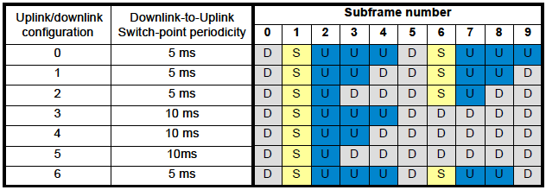

The different DwPTS, GP and UpPTS configurations are in the normal case:
Table 43: Normal LTE-TDD uplink/downlink configurations. The downlink part (DwPTS) can be 3, 9, 10, 11 or 12 symbols. Depending on the DwPTS value the guard period (GP) and the uplink can differ.
 | DwPTS
 | 12 | 11 |  | 10 |  | 9 |  | 3
GP | 1 | 1 | 2 | 2 | 3 | 3 | 4 | 9 | 10
UpPTS | 1 | 2 | 1 | 2 | 1 | 2 | 1 | 2 | 1

Capacity estimations are based on different uplink/downlink configurations as well as different configurations of the special subframe S in order to establish both a best case and a worst case configuration scenario.
The Shannon bound
The channel capacity is the tightest upper bound on the amount of information that can be reliably transmitted over a communications channel in a given scenario (bandwidth, noise and interference).
For a SiSo (single input, single output) system the Shannon bound is (in bits per Hertz). All equations are in logarithmic scale (dB)
$SiSo=\log_{2}\left(1+{10}^{S/{10×N}}\right)$ $\left[\frac{Bit}{Hz}\right]$
For multi antenna systems the theoretical increase in SNR is maximum = N_{receive} × N_{transmit} for none correlated paths.
In figure 1 the Shannon bound for different antenna configurations are depicted. Perfect orthogonality is assumed.
Figure 125: The Shannon bound from SiSo up to 4×4×4 MiMo (4 streams).
Transport capacity of LTE
From a radio point of view, LTE is very close to the Shannon bound and in the following calculations LTE is assumed to have a channel capacity that is only limited by the Shannon bound. This slightly overestimates the LTE capacity but is accurate enough for this study.
Spectral efficiency
The spectral efficiency of a LTE system can be calculated as
$$Spectral efficiency=\frac{BW}{ChBW}$$
Where BW is the bandwidth and ChBW is the channel bandwidth.
BW is calculated by multiplying the number of resource blocks with the subcarrier spacing and the number of subcarriers per resource block.
That is
$$SE=\frac{NRB×SCS×RB}{ChBW}$$
For a 20 MHz (ChBW) LTE system:
NRB (Number of Resource Blocks) = 100
SCS (Sub Carrier Spacing) = 15×10³
RB (Number of subcarriers per Resource Block)
Hence the spectral efficiency of a 20 MHz LTE system is 0,90.
Time domain structure
With normal prefix structure a LTE system transmits 14 OFDM symbols per subframe. With extended prefix structure 12 OFDM symbols are transmitted in one subframe. Each symbol is nominally (1/spectral efficiency).
The efficiency in the time domain can be calculated as
$$TD efficiency=\frac{Number of OFDM symbols per frame}{Length of subframe×spectral efficiency}$$
The length of a subframe is 1 ms, the number of OFDM symbols are 14 or 12 depending on the structure (normal structure gives 12 OFDM symbols per subframe). The spectral efficiency can be calculated as explained in the previous section.
For a LTE system with spectral efficiency of 0,9 that is transmitting 14 OFDM symbols each subframe the TD efficiency is
$TD E=\frac{14}{1×{10}^{-3}×0,9}=$ 0,93
Pilot tones
During one slot (7 symbols, 0,5 ms) 4 reference symbols are transmitted in each resource block. This leads to a reduction of 4/(12*7) for a SiSo system.
For MiMo systems the overhead is increased due to the fact that only one antenna can send a reference signal on each carrier at a specific time. This gives 4×2×2 occupied slots and a reduction of 2×2×4/(12×7×2) for a 2 MiMo system.
A 4 MiMo system has a reduction of (4×2+2×2) ×4/(12×7×4).
Control signaling overhead
In each subframe the 1-3 first symbols are used for control signaling, since there is no mixing of control signaling and data in an OFDM symbol. The more users in a cell, the more control signaling is needed, for the BDA2GC system only 1 symbol for control signaling is assumed.
This gives an available payload of $\frac{14-1}{14}$.
Uplink/downlink configuration
If uplink/downlink configuration number 1 (in Table 42) is used, 4 out of 10 subframes are used for downlink. 2 subframes are switch subframes and 4 are used for uplink. In the switch subframes 3-12 symbols can be used for downlink transmission. This gives a downlink efficiency of
((4×14+2×3)/(10×14) to (4×14+2×12)/(10×14) = 44 to 57 [%]
Capacity for a LTE system as a function of SNR
A LTE system (considered to be on the Shannon boundary) that is subject to the above reductions the result (as a function of Signal to Noise ratio) have a channel capacity that is depicted below, this capacity includes the payload header that needs to be removed before the “user data capacity” is calculated.
Figure 126: Channel capacity for a 20 MHz LTE TDD with different uplink/downlink configurations that gives a downlink efficiency of 44 % and 57 %.
Sharing between RLAN and BDA2GC in the 2,4 GHz band.
In the license exempt 2,4 GHz band numerous transmitters are deployed, the most common are RLAN and Bluetooth. RLAN has been chosen as the aggressor in this sharing study.
Deployment scenario of BDA2GC Base stations according to ETSI TR 103 054.
A BDA2GC cell radius is 150 km and the base station EIRP is 55 dBm.
The RLAN density is 50 RLAN per square km for the rural case. It is assumed that RLAN frequencies are equally spaced in the 2.4 GHz band, i.e. ¼ of the RLAN is transmitting co-channel with the BDA2GC system, resulting in an effective density of 12.5 transmitters per square kilometer.
Rural case
Assuming free space attenuation between the BDA2GC terminal (aircraft) and both the BDA2GC base station and all RLANs. The RLANs are considered to be equally spaced in a circle with 150 km radius. All RLANs are assumed to transmit with 20 dBm (EIRP)
The aggregated co-channel interference from RLAN to the BDA2GC terminal is plotted below as a function of radius, as can be seen in the picture the aggregated interference from RLAN is asymptotically approaching -57 dBm.
Figure 127: Title (style: Caption)

Interference from adjacent bands as well as the channel leakage is assumed to be magnitudes lower than the co channel interference and is therefore not part of the study.
One can easily see that the aggregated interference is asymptotically reaching -57 dBm. As this value is roughly 40 dB higher than the internal noise in the BDA2GC receiver the internal noise is not a limiting factor in the sharing between RLAN and BDA2GC and thus the Signal to Interference ratio will be used in the channel capacity calculations.
BDA2GC channel capacity in the rural case, aircraft on cell edge
The BDA2GC base station, when transmitting 55 dBm to an aircraft on 10 000 m height at the cell edge, is approximately 150 km away from aircraft and will give a received power of 55 (TX EIRP) – 144 (Free space loss) = -89 dBm.
Since the aggregated co channel interference is -57 dBm /20 MHz the signal to interference ratio is -32 dBm.
When the signal to interference ratio is used as SNR in the Shannon model one can see that the maximal channel capacity is almost zero.
Interference from other base stations
On the border between two cells a terminal, belonging to one of the cells, will experience interference from the other cell. This interference will increase the interference and thereby influence the maximal throughput.
Network scheduling
The scheduler controls the allocation of available resources among users at each given time. Depending on the chosen scheduling algorithm and radio environment, a terminal (in a multi terminal environment) is given a ratio of the available resources.
Conclusion on DA2GC according to ETSI TR 103 054
The interference produced by RLANs in the 2400 to 2483.5 MHz frequency range will severely reduce the throughput in the BDA2GC system and for this reason the 2.4 GHz band is not viable for BDA2GC deployment.
Deployment scenario of BDA2GC Base stations according to ETSI TR 101 599.
A BDA2GC cell radius is 90 km and the base station EIRP is 48 dBm.
The RLAN density is 50 RLAN per square km for the rural case. It is assumed that RLAN frequencies are equally spaced in the 2.4 GHz band, i.e. ¼ of the RLAN is transmitting co-channel with the BDA2GC system, resulting in an effective density of 12.5 RLAN transmitters per square kilometer. At any instant, half of the RLAN’s is considered to be transmitting. This gives a density of RLAN’s that can interfere with the aircraft station of 6,25 RLAN’s per square kilometer.
Rural case
Assuming free space attenuation between the BDA2GC terminal (aircraft) and both the BDA2GC base station and all RLANs. The RLANs are considered to be equally spaced in a circle with 150 km radius. All RLANs are assumed to transmit with 20 dBm (EIRP)
Interference from RLAN’s in a rural scenario.
In order to investigate the effect from the aggregated interference from all (from the aircraft visible) RLANs the aircraft station beamforming antenna must be taken into account. Since the system uses beamforming the received interfering power is depending on the angle (as seen from the aircraft station) between the (wanted) signal from the base station and the interfering signal from each RLAN. All affecting RLANs in each square kilometer is (6,25 RLAN tranmitters, see above), for computational reasons, replaced with one transmitter (with increased power 6,25×20 dBm = 28 dBm) in the center of each square kilometer. This does not affect the outcome of the following calculations.

The interference is calculated in the following way:
- A position for the base station is fixed, and the angle (and thereby the antenna gain), a1, b1, c1 etc, to each of the combined transmitters (in each square kilometer) is calculated (assuming free space loss) and the cumulative interfering power is stored as belonging to this position.

a₁

b₁

c₁
Base station
Interference sources (WLAN)

- The base station position is moved to another position and the process in 1. is repeated.
- This is repeated for all possible base station positions, giving the next Figure
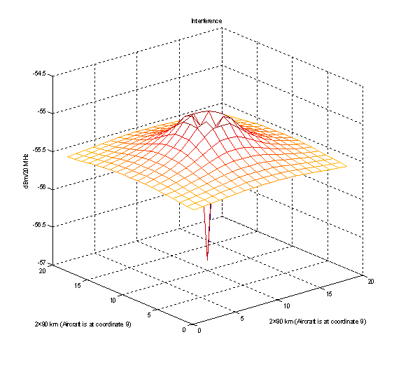
Signal strength from different base station positions relative to the aircraft station and resulting signal to interference ratio.

The received signal strength from each base station position is calculated using the same free space assumption as above, giving the Figure below.

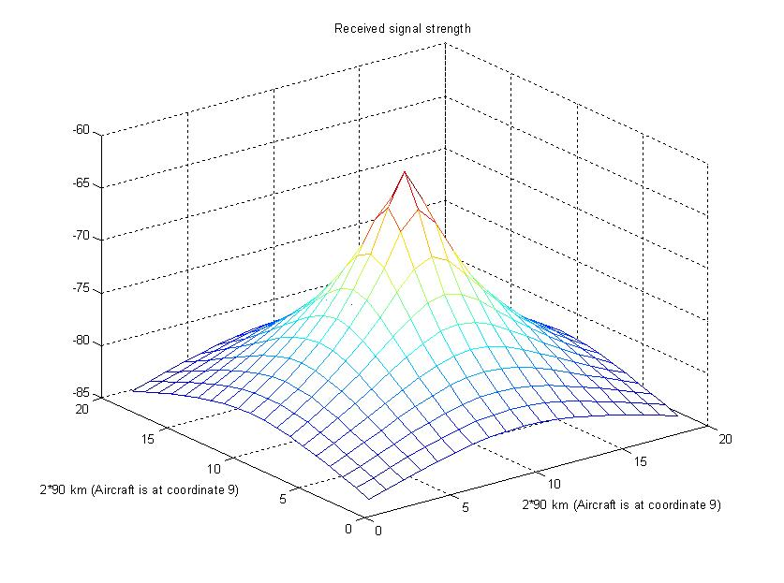
The resulting signal to interference ratio is:
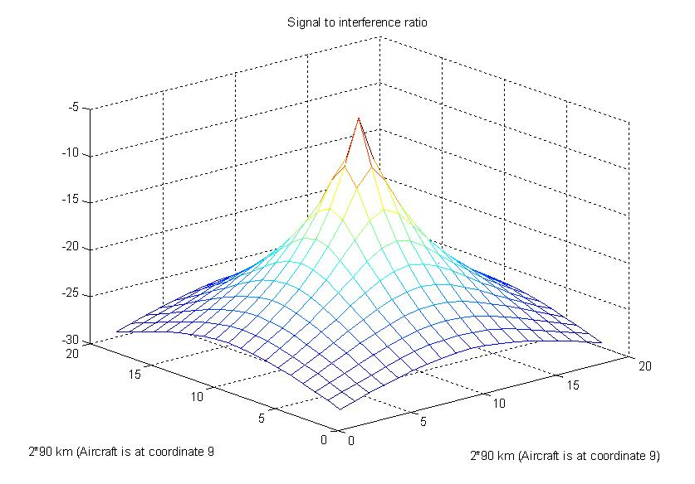
The best signal to interference ratio is achieved when the base station is located directly under the aircraft, in this position there are two conditions that are maximizing the signal to interference ratio; 1. the distance between aircraft station and ground station is minimized and 2. the main lobe foot print is also minimized compared to all other main lobe directions. The signal to interference ratio is however very low even when the base station is located directly under the aircraft, -5 dB.

Interference from adjacent bands as well as the channel leakage is assumed to be magnitudes lower than the co channel interference and is therefore not part of the study.
BDA2GC channel capacity in the rural case.
The BDA2GC base station, when transmitting 25+23 = 48 dBm (eirp) to an aircraft on 10 000 m height at the cell edge, is approximately 90 km away from aircraft and will give a received power of 48 (TX EIRP) + 10 dB (antenna gain in aircraft receiver) – 139 (Free space loss) = -81 dBm.
The aggregated co channel interference from all RLANs (when the aircraft is on the cell edge) is -55 dBm /20 MHz the signal to interference ratio is -36 dBm When the aircraft is right above the base station the received signal is 48 dBm (eirp) + 10 dB (antenna gain in aircraft receiver) – 120 dB = -62 dBm. The interference seen from the aircraft is -57 dBm. This gives a signal to interference ratio of -5 dBm. When the signal to interference ratio is used as SNR in the Shannon model one can see that the maximal channel capacity is almost zero.
Interference from other base stations
On the border between two cells a terminal, belonging to one of the cells, will experience interference from the other cell. This interference will increase the interference and thereby influence the maximal throughput.
Network scheduling
The scheduler controls the allocation of available resources among users at each given time. Depending on the chosen scheduling algorithm and radio environment, a terminal (in a multi terminal environment) is given a ratio of the available resources.
Conclusion on DA2GC according to ETSI TR 101 599
The interference produced by RLANs in the 2400 to 2483.5 MHz frequency range will severely reduce the throughput in the BDA2GC system even when the BDA2GC system is equipped with a beamforming antenna and for this reason the 2.4 GHz band is not viable for BDA2GC deployment.
- List of reference
- 3GPP TS 36.300: Evolved Universal Terrestrial Radio Access (E-UTRA) and Evolved Universal Terrestrial Radio Access Network (E-UTRAN); Overall description; Stage 2; V10.4.0, June 2011.
- Holma, H.; Toskala, A.: LTE for UMTS – OFDMA and SC-FDMA Based Radio Access; John Wiley & Sons, 2009.
- ETSI TR 103 054: Electromagnetic compatibility and Radio spectrum Matters (ERM); System Reference Document; Broadband Direct-Air-to-Ground Communications operating in part of the frequency range from 790 MHz to 5 150 MHz; V1.1.1, July 2010.
- ECC Report 93: Compatibility between GSM equipment on board aircraft and terrestrial networks; May 2008.
- European Communications Office (ECO): SEAMCAT handbook; January 2010.
- 3GPP TS 36.101: User equipment (UE) radio transmission and reception; V10.3.0, June 2011.
- 3GPP TS 36.104: Base station (BS) radio transmission and reception
- 3GPP TS 25.104: Base station (BS) radio transmission and reception (FDD).
- 3GPP TS 25.101: User equipment (UE) radio transmission and reception (FDD).
- ETSI EN 300 175-2 “Digital Enhanced Cordless Telecommunications (DECT); Common Interface (CI); Part 2: Physical Layer”.
- CEPT SE7(12)020: Reference information from DECT Forum to the Guidance paper on DECT antenna gain.
- ITU-R Report M.2109: Sharing studies between IMT-Advanced systems and geostationary satellite networks in the fixed-satellite service in the 3400-4200 and 4500-4800 MHz frequency bands; 2007.
- ITU-R Report M.2111: Sharing studies between IMT-Advanced and the radiolocation service in the 3400 – 3700 MHz bands; 2007.
- ITU-R Report M.2039: Characteristics of terrestrial IMT-2000 systems for frequency sharing/ interference analyses; November 2010.
- 3GPP TS 36.814: Technical Specification Group Radio Access Network; Evolved Universal Terrestrial Radio Access (E-UTRA); Further advancements for E-UTRA physical layer aspects; V9.0.0, March 2010.
- ITU-R Rec. P.528-3: Propagation curves for aeronautical mobile and radionavigation services using the VHF, UHF and SHF bands; February 2012.
- CEPT ERC/Recommendation 74-01: Unwanted emissions in the spurious domain; January 2011
- ITU-R Rec. SA.1154: Provisions to protect the space research (SR), space operations (SO) and Earth exploration-satellite services (EES) and to facilitate sharing with the mobile service in the 2 025-2 110 MHz and 2 200-2 290 MHz bands; 1995.
- Ng, M.H.; Lin, S.; Li, J.; Tatesh, S.: Coexistence studies for 3GPP LTE with other mobile systems; IEEE Communications Magazine, April 2009.
- ITU-R Rec. F.1336-2: Reference radiation patterns of omnidirectional, sectoral and other antennas in point-to-multipoint systems for use in sharing studies in the frequency range from 1 GHz to about 70 GHz; 2007.
- ITU-R Rec. P.525-2: Calculation of free-space attenuation; August 1994.
- ITU-R Rec. P.452-14: Prediction procedure for the evaluation of interference between stations on the surface of the Earth at frequencies above about 0.1 GHz; October 2009
- CEPT FM(11)008: Qualcomm / Information about the impact of antenna selection on the design, practical implementation and performance of a DA2GC system; March 2011
- ECC/DEC/(11)06: Harmonised frequency arrangements for MFCN operating in the bands 3400-3600 MHz/3600-3800 MHz; December 2011.
- ITU-R Rec. M.1638: Characteristics of and protection criteria for sharing studies for radiolocation, aeronautical radionavigation and meteorological radars operating in the frequency bands between 5 250 and 5 850 MHz (2003)
- ITU-R Rec. S.465-6: Reference radiation pattern of earth station antennas in the fixed-satellite service for use in coordination and interference assessment in the frequency range from 2 to 31 GHz (01/2010)
- ITU Radio Regulations (Edition of 2008).
- ETSI EN 300 328 (V1.8.1): "Electromagnetic compatibility and Radio spectrum Matters (ERM); Wideband transmission systems; Data transmission equipment operating in the 2,4 GHz ISM band and using wide band modulation techniques; Harmonized EN covering the essential requirements of article 3.2 of the R&TTE Directive".

The quoted TX output power level is the total transmit power delivered to all antennas and antenna elements of a single ground station antenna array when the transmitter is operating at its maximum power control level. This power level applies when using a 4-antenna array with a maximum antenna gain of 20 dBi. This power level will be reduced when using higher gain antenna arrays (e.g. an 8-antenna array) to maintain a maximum e.i.r.p. of +45 dBm.
The quoted power level is the total transmit power delivered to all antennas and antenna elements of the aircraft station when the transmitter is operating at its maximum power control level.
The LoS propagation model is valid for 50% of the time. An adequate adaptation to 0.1% of time is for further discussion, e.g. for 1% of the time the propagation loss is about 5 dB less than for 50% of the time according to ITU-R Rec. P.528-3 [12].
No value is provided in Recommendation ITU-R M.1368, therefore for the compatibility analyses a value of -40dB was considered.
Intentional overly positive assumption

