 |  |  | Doc (17) 19 rev1
Sofia, Bulgaria
4-6.07.2017

Date issued: | 22 June 2016
Source: | Com-ITU Chair
Subject: | Summary and follow to the Questionnaire on CEPT objectives for PP-18
N
Password protection required? (Y/N)

Summary:
This document presents the responses to the Questionnaire on CEPT objectives for PP-18 and a follow-up proposal.
This document and its Annex II are open to the public, and therefore the respondents that provided confidential responses are not identified.
Annex I is password protected.

Proposal:
For consideration
Background:

Com-ITU questionnaire on CEPT objectives for PP-18

Eighteen Member States responded the Com-ITU questionnaire on CEPT objectives for PP-18. In order to facilitate the reading, Annex I to this document contains the collated responses.

A summary of the responses is presented in this document as well as a follow-up proposal. The document has three Sections:

Section I – Summary of closed questions (question 2- 27) 3
Section II – Summary of Open questions (questions 28 – 36) 18
Follow up Proposal 29

In Section I, based on the responses, a brief conclusion is presented for each group of questions (PART 1-A Strategic Goals; PART 1-B ITU-T objectives; Part 1C: ITU-D Objectives; Part 1D: ITU-R Objectives; Part 1E: Intersectoral Objectives). These conclusions aim at identifying some tendencies in relation to the general sentiment of European respondent Countries regarding the priorities of the Union and the objectives of each Sector and Intersectoral objectives.

In Section II, the responses are grouped by topic.

In Section III, the follow-up proposal is divided in two parts:
- Proposal for a coordinated response to the 1st public consultation of the CWG-SFP (Annex II);
- Evaluation of a possible European proposal for a new ITU Goal or Sector / Intersectoral objectives.

Section I – Summary of closed questions (question 2- 27)

The Summary of the closed questions are displayed in a graphic manner.

PART 1-A Strategic Goals

How the Strategic Goals should be prioritized in CEPT activity?
Question 2: Goal 1: Growth – Enable and foster access to an increased use of telecommunications / ICTs
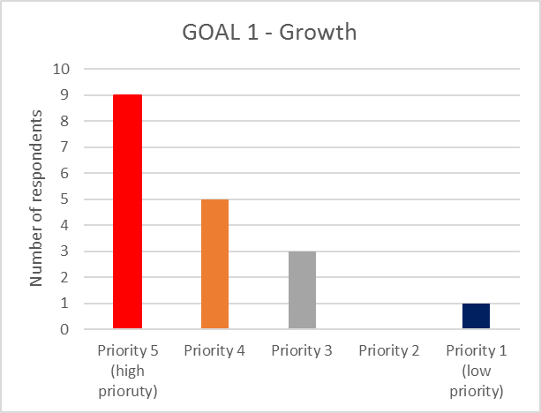
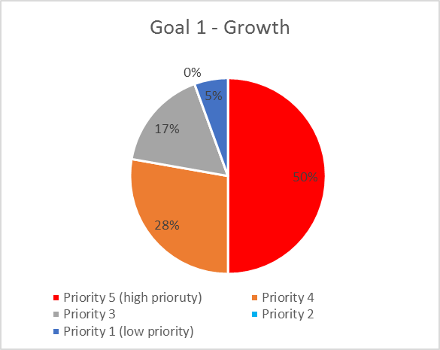

Average: 4,2

Question 3: Goal 2: Inclusiveness – Bridge the digital divide and provide broadband for all
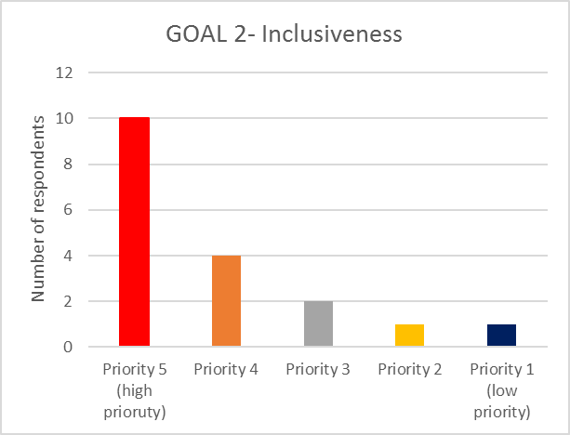
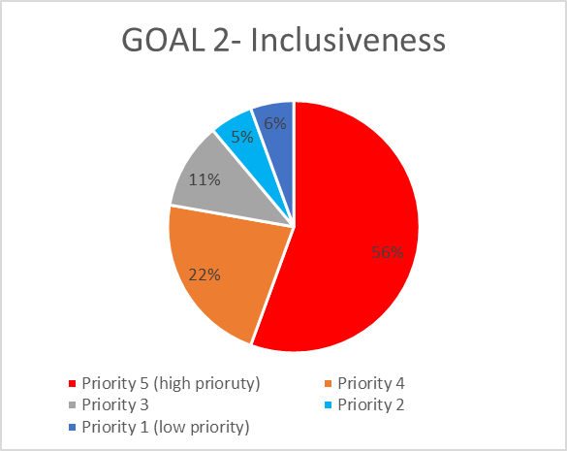

Average: 4,2

Question 4: Goal 3: Sustainability – Manage challenges resulting from the telecommunication / ICT development
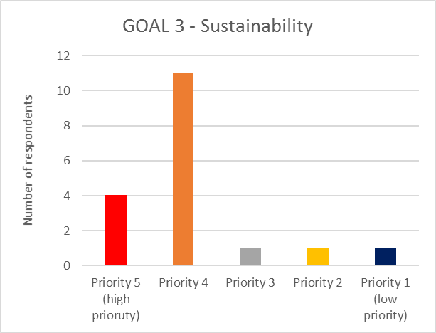
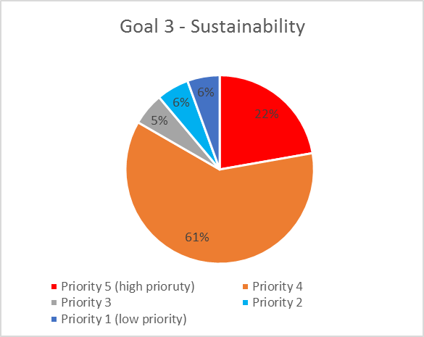

Average: 3,9

Question 5: Goal 4: Innovation and partnership – Lead, improve and adapt to the changing telecommunication/ICT environment

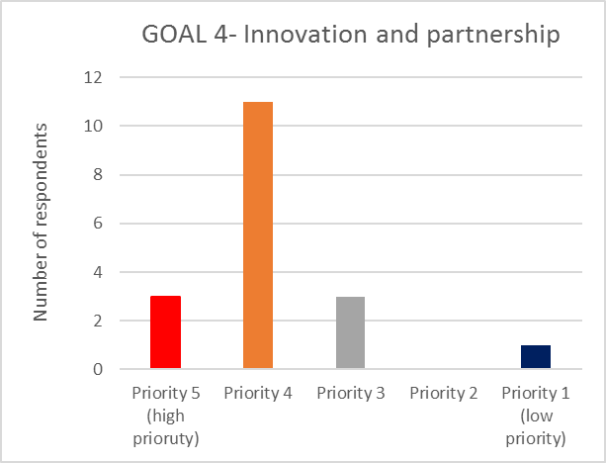
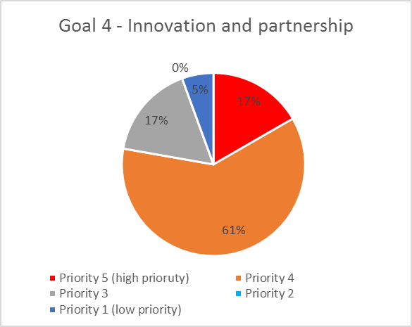

Average: 3,8

Conclusion:

Generally, respondent countries tend to consider that Goal 1 and Goals 2 deserve a slightly higher priority than Goal 3 and Goal 4.

There were proposals to add new and amend existing Goals:
- On line security and user data protection (Montenegro)
- Digital dividend (Montenegro)
- Accountability, responsibility, and transparency (Switzerland)
- New draft for Goal 1: “Connectivity - connect the unconnected” (instead of Growth – Enable and foster access to and increased use of telecommunications/ICTs) (Portugal)
- Sustainable Growth (combination of Goal 1 and 3) (Belgium)

PART 1-B ITU-T objectives

How the ITU-T Objectives should be prioritized in CEPT activity?
Question 7: Objective: Promote the active participation of the membership, in particular developing countries, in the definition and adoption of non-discriminatory international standards (ITU-T Recommendations) with a view to bridging the standardisation gap
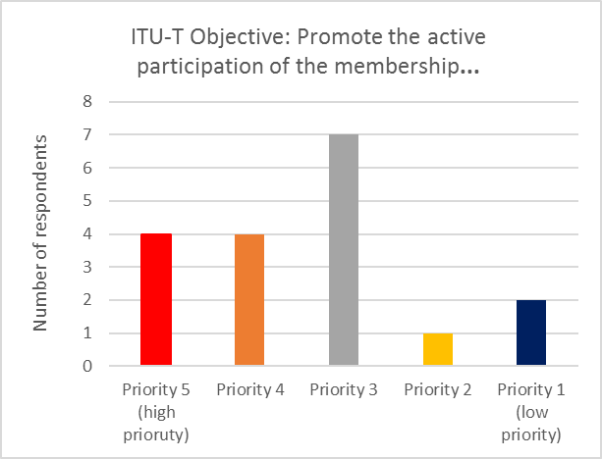
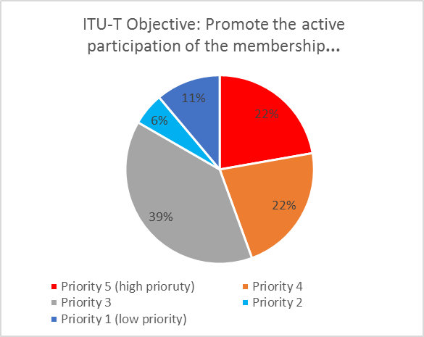

Average: 3,4

Question 8: Objective: Ensure effective allocation and management of international telecommunication numbering, naming, addressing and identification resources in accordance with ITU-T recommendations and procedures
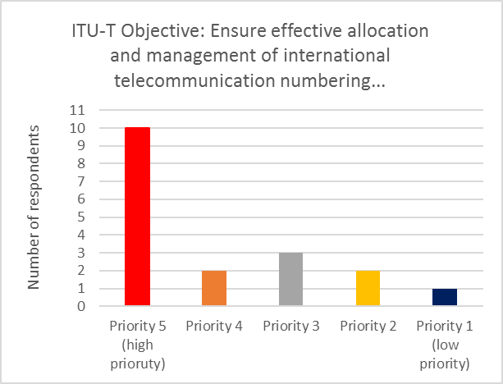
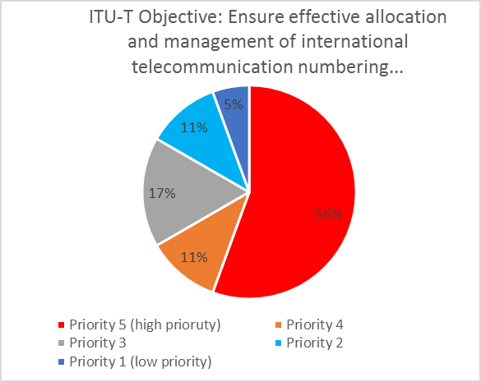

Average: 4

Question 9: Objective: Foster the acquisition and sharing of knowledge and know-how on the standardisation activities of ITU-T
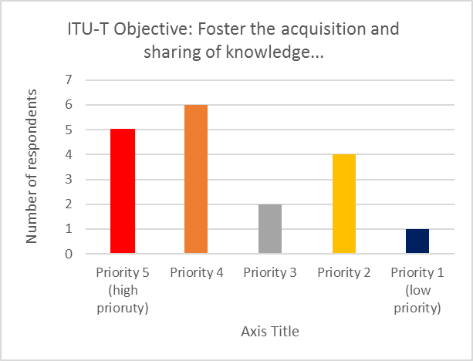
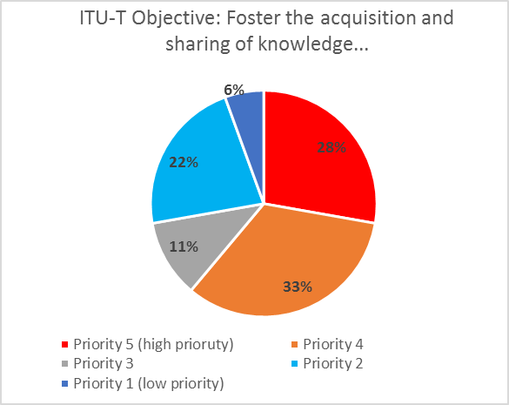

Average: 3,6

Question 10: Objective: Extend and facilitate cooperation with international, regional and national standardisation bodies

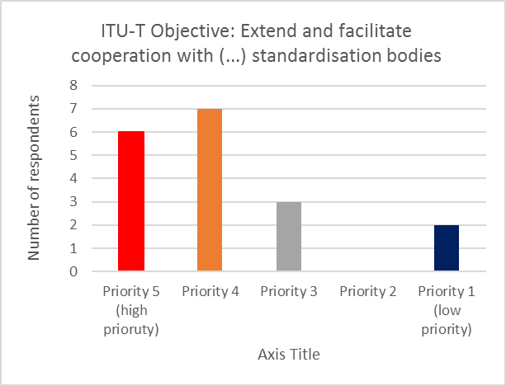
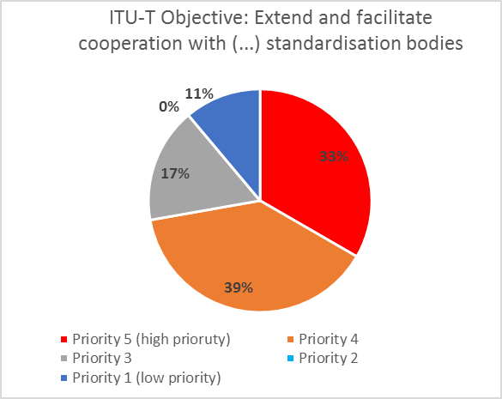

Average: 3,8

Conclusions:

Ensuring “effective allocation and management of international telecommunication numbering, naming, addressing and identification resources in accordance with ITU-T recommendations and procedures” tends to be the highest priority in T Sector for some respondents.

There were proposals to add new ITU-T objectives:

- Promote global standardization through the participation/contribution in H2020 projects, having ITU-T leading an SDO Consortium, aiming to produce Consortium Global Standards (CGSs) through the participation in Large Scale Pilots or projects, that have WPs on Standardization (Greece).

- Strengthen cooperation in ensuring safe world communication

Part 1C: ITU-D Objectives

How the ITU-D Objectives should be prioritized in CEPT activity?
Question 12: Objective: Foster international cooperation on telecommunication / ICT development issues
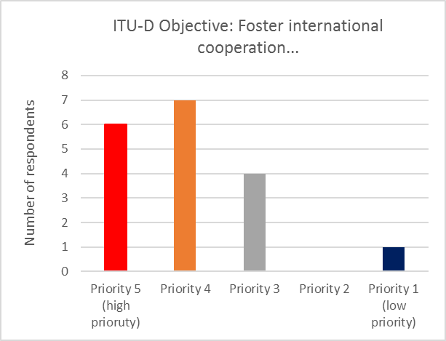
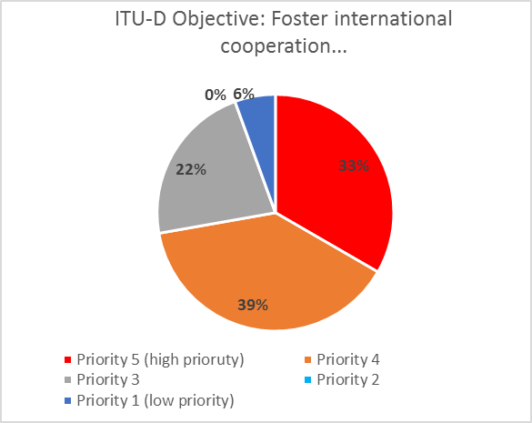

Average: 3,9

Question 13: Objective: Foster an enabling environment for ICT development and foster the development of telecommunication/ICT networks as well as relevant applications and services, including bridging the standardisation gap
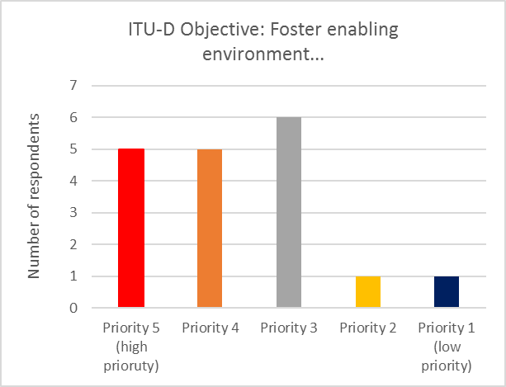
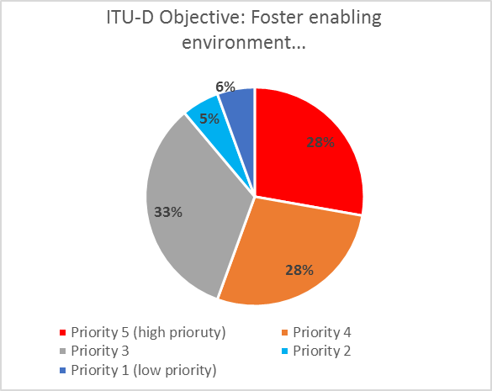

Average: 3,7

Question 14: Enhance confidence and security in the use of telecommunications/ICTs, and roll-out of relevant applications and services

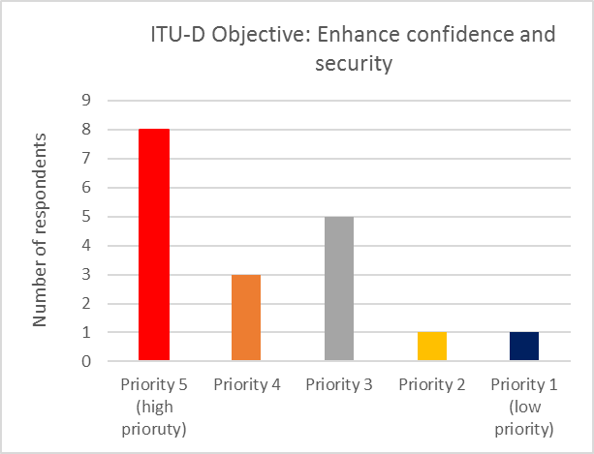
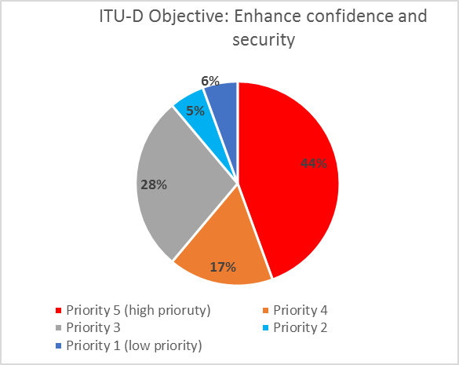

Average: 3,9

Question 15: Objective: Build human and institutional capacity, provide data and statistics, promote digital inclusion and provide concentrated assistance to countries in special need
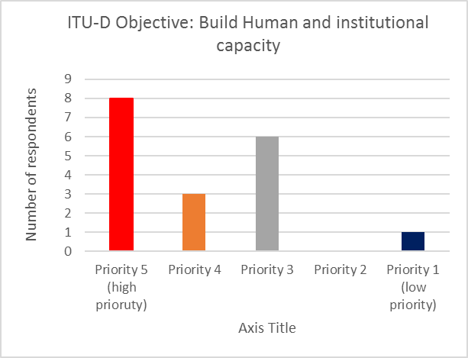
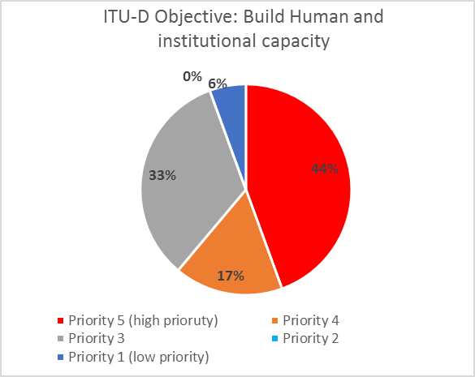

Average: 3,9

Question 16: Objective: Enhance environmental protection, climate-change adaptation and mitigation and disaster-management efforts through telecommunications/ICTs

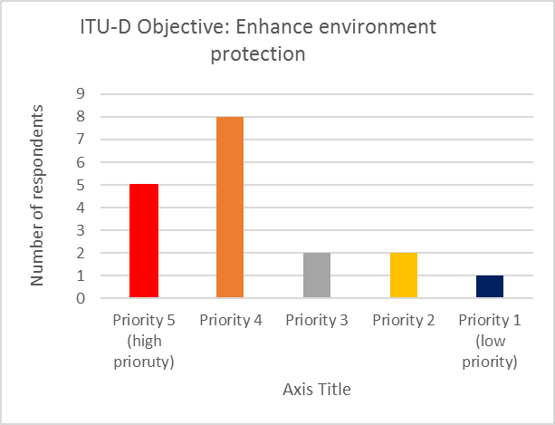
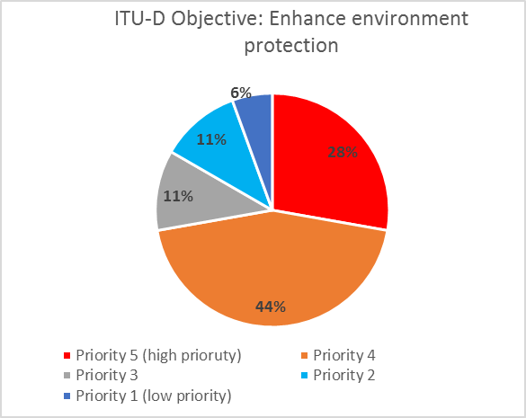

Average: 3,8

Conclusions:

The responses do not show a clear tendency to prioritise any particular ITU-D objective.
There were no proposals for new ITU-D objectives.

Part 1D: ITU-R Objectives

How the ITU-R Objectives should be prioritized in CEPT activity?
Question 18: Objective: Meet, in a rational, equitable, efficient, economical and timely way, the ITU membership's requirements for radiofrequency spectrum and satellite-orbit resources, while avoiding harmful interference
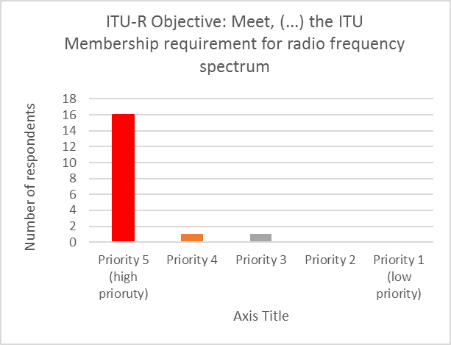
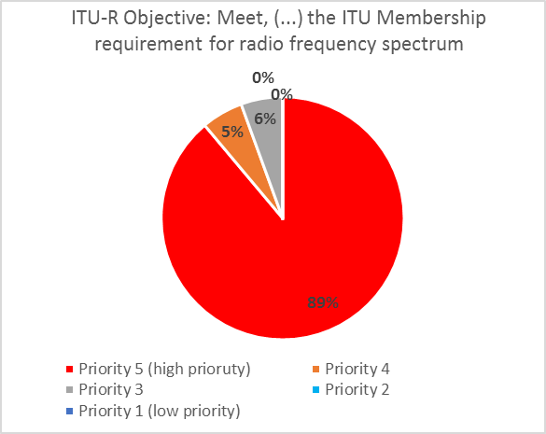

Average: 4,8

Question 19: Objective: Provide for worldwide connectivity and interoperability, improved performance, quality, affordability and timeliness of service and overall system economy in radiocommunications, including through the development of international standards
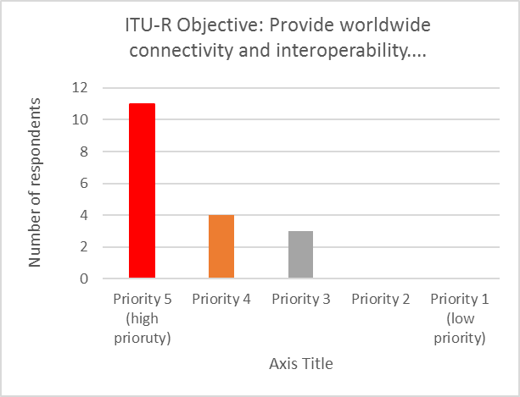
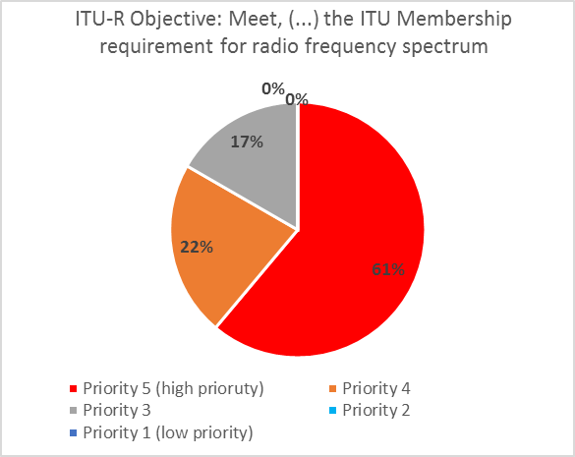

Average: 4,4

Question 20: Objective: Foster the acquisition and sharing of knowledge and know-how on radiocommunications
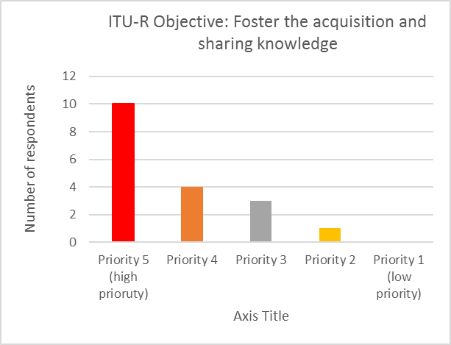
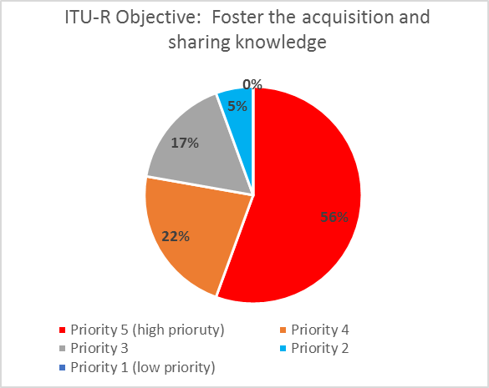

Average: 4,3

Conclusion
ITU-R tends to collect higher priority ranks when compared to other sectors. 16 respondents out of 18, ranked Objective 1 with the highest priority level.

As for proposals for new ITU-R objectives:

- Efficient resolution of claims for the orbital position of the new member states of the ITU and better and assistance from international organizations (Montenegro);

- Sharing of best practices on frequency/stations international coordination in radiocommunications

Part 1E: Intersectoral Objectives
How the intersectoral objectives should be prioritised in CEPT activity?

Question 22: Objective: Enhance international dialogue among stakeholders
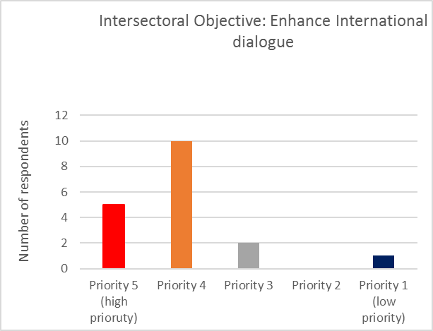
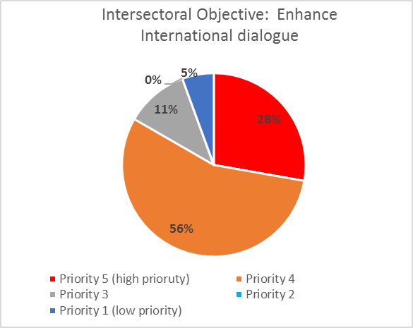

Average: 4

Question 23: Enhance partnerships and cooperation within the telecommunication / ICT environment
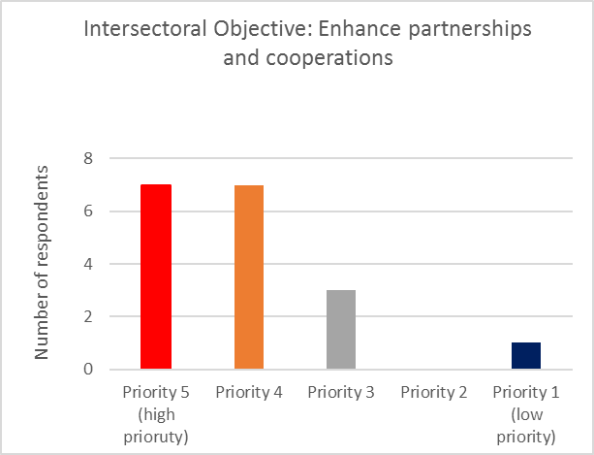
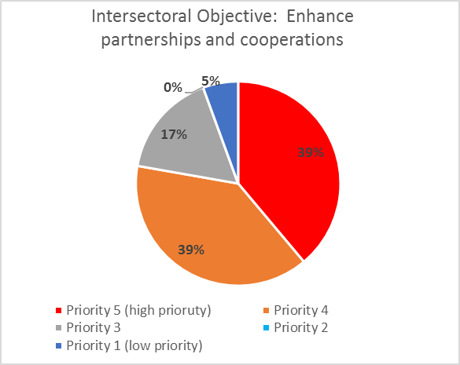

Average: 4,1

Question 24: Enhance identification and analysis of emerging trends in the telecommunication/ICT environment
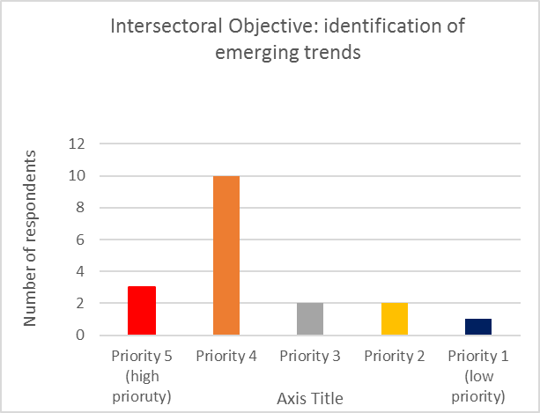
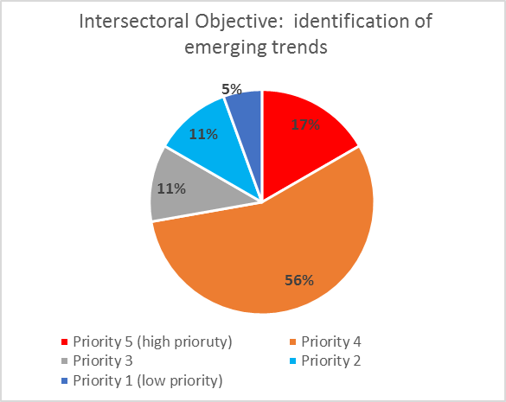

Average: 3,7

Question 25: Enhance/promote recognition of (importance of) telecommunications / ICTs as a key enabler of social, economic and environmentally sustainable development
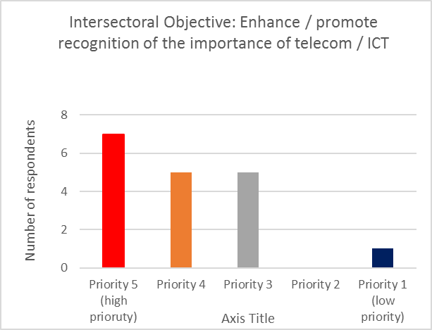
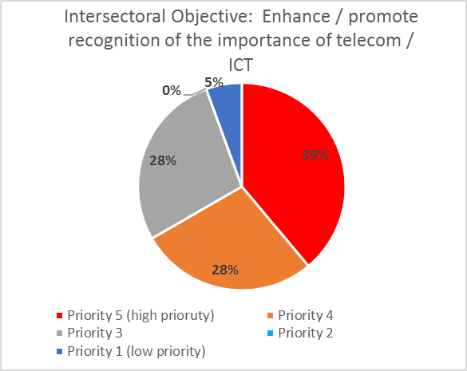

Average: 3,9

Question 26: Enhance access to telecommunications/ICTs for persons with disabilities and specific needs
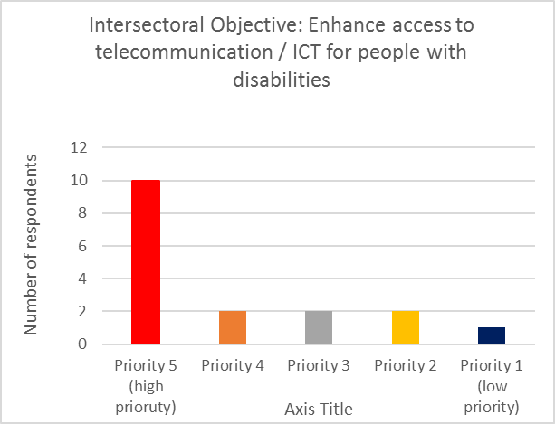
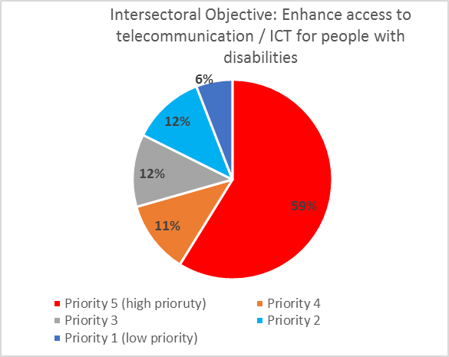

Average: 4,1

Conclusion

There is a tendency to find that the intersectoral objective “Enhance identification and analysis of emerging trends in the telecommunication/ICT environment” has a lower priority compared to other intersectoral objectives.

A number of New Intersectoral Objectives were put under consideration:

- Enhance the concept of "One ITU" by means of reinforcing the complementarity of the activities in the three sectors (Portugal)
- Provide for worldwide connectivity and interoperability, improved performance, quality, affordability and timeliness of service (Portugal)

- Participation and involvement of developing countries (Moldova)
- Electronic meetings, including remote participation (Moldova)
- Electronic document handling (Moldova)
- Registration for participation in meetings, including remote participation. (Moldova)
- Participation by correspondence. (Moldova)
- Further enhancement and optimization of seminars/symposia/workshops/capacity building (Moldova)
- Improvement of the ITU webpages taking into account best practices (Moldova)
- Improvement of interaction between working parties and study groups of different Sectors (Moldova)
- Identification and dissemination of best practices for the design, installation and operation of Internet exchange points (IXPs) (Moldova)
- Sector membership (Moldova)
- Chairmen/vice-chairmen issues (Moldova)
- Language issues (Moldova)
- Document access (Moldova)
- Non-member participation (Moldova)
- Preparation to conferences and meetings (Moldova)
- Streamlined establishment procedures of inter-Sector Rapporteur group (IRG) (Moldova)
- Meeting planning. (Moldova)
- Collaboration and cooperation on events (Moldova)

Section II – Summary of Open questions (questions 28 – 36)
Question 28: What are the opportunities for CEPT in PP-18?

Some opportunities were identified in the way CEPT organizes itself:
“CEPT should show strong leadership from a unified regional group”;
CEPT should “Draft a plan to maintain the important role of ITU for the next decade” (Netherlands).
Additional opportunities were identified in the way CEPT position and presents itself to the outside world:
“To keep positions” (Czech Republic);
“Show that CEPT is a reliable and a constructive partner of ITU” (Switzerland);
“Increasing CEPT visibility, increasing negotiation position, creating alliances.”
Other respondents found opportunities related to the structure and functioning of ITU:
CEPT “to inspire other regions to take part in optimizing ITUs structure, processes and day to day functioning”.
“CEPT should lay down a clear marker that the way the ITU is structured and how the budget is allocated between the four arms (Gen Sec, ITU-D, ITU-T, ITU-R) need to drastically change. The percentage of funds used by the General Secretariat seems to exceed 50% which is not appropriate”;
“Promote the multi-stakeholder approach. The membership should be more aware that ITU is a relevant player, however not on the whole telecommunications/CT world/environment. In some parts of the telecoms/ICT world there are other relevant players, maybe even more relevant than ITU.” (Netherlands);
“Openness, transparency and inclusiveness are key for a healthy Union” (Romania)
“Focus on the core activities of ITU, focus on financial sustainability of ITU without increasing the financial burden on the CEPT countries and sector members, improving of efficiency and effectiveness of the ITU” (Belgium).
Finally, some respondents found opportunities related to promotion of the debate of certain topics / objectives:
“The CEPT has to continue to support the development of telecommunication/ICT networks, global connectivity and interoperability, the promotion of digital inclusion” (Romania);
“Continuous support for the development of telecommunication/ICT networks, promote digital inclusion and global connectivity and interoperability by sharing from the best European practices and examples” (Moldova);
Set connectivity as a Primary Goal to ITU by supporting an enabling environment and sharing with the Union initiatives with the aim of connecting the unconnected are supported and funded by European Countries and companies (Portugal).

Question 29: What are the challenges for CEPT in PP-18?
In line with the previous question, challenges were found in how CEPT organizes itself:
“Effective coordination and influencing decision making at the PP-18. Having good candidates for the leading posts”;
”The main challenge is to find a unified position on major issues and to represent CEPT unanimously during PP-18”;
“The main challenge at this point is making sure all CEPT countries are involved in the preparatory process, as currently, due to several reasons, just some part of all CEPT member states participate in the meetings. A letter has been sent out to the absent countries, but more efforts should be undertaken to represent the voice of all countries in CEPT;
CEPT coordination for PP-18 could also be a challenge due to the fact that in some cases compromise is impossible to achieve.”
“Organise efficient coordination between members in order to speak with one voice; (…) find coordinators who take initiative” (Belgium)
As far as the CEPT position is concerned, it was mentioned that
CEPT should “find common ground with other regions on ways to achieve ITUs effectivity”;
CEPT “Not be considered as unreliable and noxious” (Switzerland);
“From a Portuguese point of view, in order to be credible, CEPT cannot position itself as being against that emerging topics are discussed, but CEPT should position itself as a facilitator of compromises in defining the role of ITU in a digital age in which emerging technologies play a vital role.
Therefore, we consider that the main challenge that CEPT faces is to find the right balance between supporting new topics to be discussed, while avoiding that the unmeasurable impacts of ICTs are discussed in ITU meetings without any apparent criteria or long term vision making it difficult, or impossible, to bring practical benefits for the citizens we serve.” (Portugal);
Avoid a shift of Internet Governance from multi-stakeholder approach to state controlled approach through ITU” (Netherlands).

Belgium referred the importance of coordinating “more effectively with the EU”.

The functioning of ITU and its decision-making process also raises some challenges:
“The CEPT should be keen on the fact that ITU has to remain a consensus-based organization and work environment, even though this way of working takes more time than others, it is the healthiest one” (Romania);
“Main challenge is to have consensus-based proposals, keeping in mind the future role of ITU in the constantly changing digital world” (Republic of Moldova);
“CEPT should aim to ensure that the (elected) Secretary General has a vision to make the ITU a relevant 21st century entity. Not that it should be relevant to the 21st century citizen, but rather relevant to the industry sectors. The “Strategic plan for the Union for 2020-2023” should ensure that all non-core ITU functions and programs are radically reduced with a view to eradication, freeing budget and resources to strengthen the core of the ITU which is ITU-R and ITU-T. After PP-22 the Gen Sec should be allocated no more than 20% of the budget and the 36% saving used to strengthen ITU-R and ITU-T”;
“Avoid dominance of the countries that promote state intervention as the only solution to societal problems. Avoid a shift of Internet Governance from multi-stakeholder approach to state controlled approach through ITU” (Netherlands).

In terms of the remit of ITU, some respondents indicated that
“As the ICT/telecommunications domain is now touching upon every other domain, it is difficult to keep a clear vision on what the role of ITU has to be in the constantly changing digital world, but the steps in regard to what the ITU's role is have to be analyzed step by step, with a view of compromise” (Romania);
Portugal also expressed concerns about the proliferation of new topics in ITU “While acknowledging that ICTs are present in every human activity, one needs to take in consideration that it is not possible to follow / study all impacts of ICTs in a single organization such as the ITU” (Portugal);
“Avoid a shift of Internet Governance from multi-stakeholder approach to state controlled approach through ITU” (the Netherlands)

Question 30: How CEPT can improve its influence and impact in the ITU?

Many responses relate to the way CEPT coordinate and the involvement of Member States:
“By active participation in its activities and be willing to accept a more prominent role. Find ways to increase the capacity that CEPT members states are prepared to make available for CEPT activities (…) Effective coordination in CEPT itself. Secure sufficient capacity and involvement.” (the Netherlands);
“Strong Member State coordination and increasing the voice of CEPT members on ITU meetings. It is important that CEPT voice is heard and that we support each other in discussion, where priorities split apart”;
“Improve coordination for PP-18” (Belgium)

Belgium also added the importance of influencing elections and mentioned that “CEPT countries together are the biggest financial contributor of ITU, but this doesn't add any weight to CEPT in financial decision making of ITU”.

The “agenda” that CEPT could bring to ITU was mentioned by some respondents:
One respondent said that CEPT could improve its influence by “bringing forward contributions that are relevant to ITUs core functions and minimizing contributions that are overly compromising”.
Portugal also mentioned that CEPT influence could be improved by identifying a key Goal for ITU.
The Netherlands said that ITU should demonstrate the importance of stakeholder involvement with concrete examples.
Romania and Moldova mentioned that CEPT should proactively respond to the needs of developing countries.

Some mentioned the relations with other regions as a way to improve the influence:
Romania and Moldova said that CEPT should make efforts in the sense of cooperation with other countries and regions.
“CEPT should make efforts to strengthen its connections to other regional organizations and/or by intensifying cooperation actions with other countries outside CEPT” (Portugal).

Finally, a respondent raised one issue that could be detrimental for the European influence in the context of ITU:
“CEPT influence in ITU is reduced by nature of being part of an "ITU Region" which has 4 regional groups. Thus, in matters which relate to what happens in Region 1, CEPT has to compromise with the other three regional groups. CEPT performs reasonably in relation to generally influencing other regional groups. A strong unified group is needed to express our positions with confidence and maximise influence”.

Question 31: What are the key roles for the ITU and what should its future priorities should be?

When it comes to the roles and priorities of ITU, a number of respondents mentioned the issue of “bridging digital divide” (Romania, Moldova and another respondent)
In a similar tone, the issue of supporting developing countries was mentioned by Czechia (“through assistance and projects” and Montenegro raised the importance of a “Better assistance for administrations in small countries”

Connectivity was mentioned by:
Romania (“connect all citizens of the world”); one respondent said that “ITU should be continually making sure that world citizens are connected through affordable, secure, nondiscriminatory and effective services”;
Portugal (“The priority should be to connect the unconnected. In particular, we consider that ITU should serve to promote connectivity among all, to contribute to lower any existing obstacles - economical and/or technological - to facilitate connectivity among all.”);
Netherlands (“Connectivity and inclusiveness are of specific importance”) and
Moldova (“ensuring global connectivity and interoperability at a high quality and performance of services”).
Spectrum Management / Radiocommunications issues were also raised as a priority for ITU by Romania (“to ensure worldwide spectrum harmonization”), Moldova (“spectrum harmonization”), Belgium (“ensure worldwide efficient frequency management and harmonisation of spectrum”) and one additional respondent.
In addition, two additional respondents mentioned as an ITU priority:
the “Worldwide exchange of leading and innovative spectrum management trends in radiocommunications”;
“The ITU needs to be leaner and focused on its core purpose as a technical body supporting the Radio Regulations – all the ancillary activities which have been added over the years, which cost money and which have not produced any meaningful results, need to be split off into another UN body (focusing on the "soft" developmental and social schemes), the ITU must return to its core competencies”.
Besides Radiocommunications, one respondent also mentioned “numbering, cyber security and standardization”.
Romania and Moldova mentioned the importance of “knowledge sharing”.
Belgium said that promotion of “the development of global standards” is also an ITU core activity and highlighted that “ITU should be mainly a technical body and avoid to be a forum for political disputes”.
Switzerland referred that the roles and priorities of ITU are detailed in Resolution 71.
One respondent stated: “Identification of new, emerging, ICT trends, bridging digital divide, identifying and overcoming gaps, identifying, analyzing and overcoming challenges, creating new ICT opportunities, encouraging cooperation between countries”.

As for the role of the ITU, Romania and Portugal referred Article 1 of the Constitution.

Question 32: What is the value added in the R Sector?

The Netherlands and three other respondents stated that R Sector has the most relevant function in ITU.

Harmonisation, coordination and efficient spectrum management were mentioned in almost every response to this question:
“Providing worldwide harmonized and efficient spectrum management” (Romania); “Assistance for better management of RF” (Montenegro);
“Harmonization of frequency bands for new services“;
“All harmonization measures are a key enabler to reach these goals” (Portugal);
“To guarantee the efficient and economical use of the radio-frequency spectrum by all radio-communication services” (Greece);
“Without effective harmonisation and co-operation in frequencies worldwide telecoms will not develop and mass markets will not flourish”;
“Spectrum coordination issues are particularly relevant to us in order to enable the development of new technologies, as well as to coordinate spectrum usage together with neighboring countries”;
“International spectrum coordination/harmonization” (the Netherlands);
“Worldwide exchange of leading and innovative spectrum management trends in radiocommunications”;
“Efficient spectrum management” (Moldova);
“Worldwide Spectrum harmonisation” (Belgium)

The issue of connectivity was also mentioned by some countries:
“The ITU-R ensures for global connectivity and interoperability, quality, timeliness, affordability and high performance of services” (Romania);
“Radiocommunications are vital to provide radio connectivity everywhere (even in sparsely populated areas), at any time and in a very fast way (Portugal);
“Ensuring global connectivity and interoperability at a high quality and performance of services” (Moldova)

Montenegro mentioned the importance of the management of satellite orbits.

Sharing of knowledge was mentioned by Romania: “Sharing of knowledge and know-how in the field of Radiocommunications, including in the development of international standards is crucial for a healthy Telecommunications environment” and Moldova “sharing best practices in the field of radiocommunications”.

One respondent mentioned that “the value of the R sector is in its administration of the RR treaty” and another respondent mentioned the importance of “being able to create environment for existing and innovative services”

Finally, Switzerland referred to Resolution 71.

Question 34: What is the value added in the T Sector?

Developing technical standards was obviously mentioned by some respondents:
ITU-T should “develop non-discriminatory technical telecommunications standards (…), in order to bridge the standardization gap and keep pace with the developing digital environment” (Romania);
“ITU-T should focus on those areas within its core mandate: developing technical standards for Telecommunications” (Portugal);
“The value added of the ITU-T Sector is the development of high quality international standards that are industry driven, offering openness and interoperability” (Greece);
“Producing global standards” (Belgium)
Ensuring effective and allocation and management of international numbering, naming, addressing and identification resources was mentioned by Romania and Moldova, while another respondent mentioned “The T-sector has a important role to play in numbering”.
Interoperability was also mentioned by some respondents: ITU-T “contributes to the interoperability in the scope of networks and services on a global level.”; and another Member said that the value added of ITU-T is to minimize ”costs through interoperability of networks and services”
The Netherlands said that ITU-T aims to “Integrate policy requirements (e.g. on security) in standardization work” and one additional respondent also mentioned ITU-T has an important role in terms of cybsersecurity.
The Netherlands also said that the value added is the “Efficient international harmonization regarding standardization of basic features (or: “of the core”?) of telecommunications/ICT to meet SDGs”.
Switzerland referred to Resolution 71.
One respondent said: “The value add of the T is in its standardization processes – core support to the functioning of the RR”.
As for the methods, Portugal, Romania and Moldova mentioned the importance of working on the basis of a consensus-based approach, and based on partnerships / cooperation with all interested parties. Portugal also mentioned that ITU-T should use a “bottom-up methodology”. Greece mentioned that the ITU-T standards should be “industry driven, offering openness and interoperability”. One additional respondent mentioned that “T sector allows the possibility of cooperation in the area of standardization taking into account the regional differences (separatness)”.

Question 35: What is the value added in the D Sector?

The issue of cooperation / collaboration between Members with the active participation of all stakeholders was mentioned by several respondents:
“The ITU-D focus should be developed with a collaboration from developed and developing member states, nonetheless with the active participation of all stakeholders” (Romania);
“Strengthen open and transparent collaboration with all stakeholders” (…) Foster new public/private partnerships”;
“The value added of the ITU-D Sector is to propel cooperation between states worldwide” (Greece).
Support and assistance to developing countries was also referred by a number of Members:
“The value added of the ITU-D Sector is (…) to share technical assistance in order to assist developing countries create and improve telecommunication and ICT equipment and networks” (Greece);
“Support and assistance in the field of (access to) telecommunications/ICT to developing countries” (the Netherlands);
one respondent said that the value added was the ”assistance for developing world
and visible results of concrete projects”;
Finally another respondent said: “Within the UN there is a strong of supporting the least developed countries not only by providing them with financial and expert aid, but also through investing funds and bilateral/multilateral cooperation. Within CEPT and Europe there are still many activities which can bring aid to the least developed countries in the region and the whole world”.
Capacity building / knowledge transfer was another topic mentioned by several Members:
“ITU-D should support capacity-buidling” (Romania);
“Intensive transfer of knowledge from ITU D to member countries” (Montenegro);
“Support capacity-building and skills” (Portugal);
ITU-D should further support capacity-building (Moldova).
The “Engagement by developing countries and setting the good policies for growth and development” was an issue brought in the Dutch response, while Portugal also raised the importance of promoting “ an enabling environment for investment” and fostering an “open and competitive ICT and telecommunications markets”.
Further alignment between ITU-D activities with the WSIS outcomes and with the SDGs was an issue raised by Moldova, Romania and Portugal.
Broadband development, in order to reach the unconnected, was mentioned by Moldova and Romania.
Bridging “the digital gap in usage of and access to ICT networks, services and applications” was mentioned by the Netherlands.
One respondent said it is supportive of “initiatives to promote technology penetration, as well as to share best practices with developing countries”.
Switzerland referred to Resolution 71.
Finally, a Member said that “The value added by the D-Sector is not clear, for the money spend within that sector accountability and value for money are not apparent”. In addition, Belgium stated that ITU-D has a “very little added value. Many topics related to regulatory issues are more effective dealt with in regional organisations like EU, Regulatel etc”.

Question 36: How we can bridge the differences of view between developed and developing Member States?

In terms of bridging the differences between developed and developing MS, dialogue, cooperation and transfer of knowledge were mentioned by almost all respondents:
“By continuing a dialogue only. In general, at least the target for European countries should be to keep in touch with most of the developing countries and to provide them with enough information to make them share our values” (Czechia);
“The developed countries should make efforts as to find common grounds with developing countries. Going into more details on the issues coming from developing countries, showing interest and being responsive to their needs with a proactive and positive approach at first hand makes a good start for discussions in the reach for consensus. Productive, positive and in line with the mandate of the ITU contributions and proposals should be encouraged by developed countries instead of approved in silence. Developed countries can bring their knowledge and experience as basis for good practice examples, also showing alternative solutions in response to the developed countries' needs” (Romania);
“Transfer of knowledge from developed to developing Member States” (Montenegro);
“Portugal is of the view that further coordination and cooperation actions should be promoted in partnership with ITU”;
“Work with coalitions of CEPT countries and developing countries on good policies eg how to deal with spam” (the Netherlands);
“Understanding the needs and openness for dialogue, identifying challenges in the developing Member States, encouraging bilateral and multilateral programs and twinning projects, enabling know-how, expertise and knowledge exchange”;
“The developed countries could share their knowledge and experience, at the same time offering alternative solutions and examples. This would help find common grounds as well as encourage productive and positive contributions and proposals of developing countries” (Moldova).
The Netherlands added that these differences should be tackled by implementing “a cooperation model similar to the multi-stakeholder approach to achieve affordable telecoms/ICT for all. Supported by telecoms stakeholders (public and private parties) via i.e. exchange knowledge on experience, policy, market, etc”.
Switzerland said that “Specification of differences is needed in order to be able to suggest solutions”.
One respondent said that “reinforcing that all members states citizens share the same need to be connected using ICTs” is important to bridge the differences.
Portugal raised the increased political tone of the debates.
Portugal is of the view that many current differences between developed and developing Member States in ITU seem to result from general political issues and are not directly related to ICTs. It may prove difficult to bridge differences without depoliticizing debates in ITU or looking to the general political situation”.

A respondent stated that “it is unlikely that the differences of view between developed and developing MS can be reduced. It will take many years for the developing countries to arrive at a similar mindset to the developed countries”. Belgium said that “Developing MS need to stimulate favourable conditions for investment in high quality electronic communication networks and services. Development programs including multilateral assistance programs have only a marginal effect”.

Follow up Proposal

The follow-up is divided in two different proposals
- Proposal for a coordinated response to the 1st public consultation of the CWG-SFP. Deadline for contributions - 7July;
- Evaluation of a possible European proposal for a new ITU Goal or Sector / Intersectoral objectives.

A draft coordinated response to the 1st public consultation of the CWG-SFP is presented in Annex II. The proposal could be sent as a Portuguese contribution on behalf of CEPT or as a multi-country proposal. The deadline to submit contributions to the public consultation is 7July (form to submit proposals available at: http://www.itu.int/en/council/CWG-SFP-2020-2023/Pages/FPC-form.aspx).

As for the Evaluation of a possible European proposal for a new ITU Goal or Sector / Intersectoral objectives.

It should be taken into account that a number of proposals for new Goals / Objectives were submitted:

New ITU Goals:

- On line security and user data protection (Montenegro)
- Digital dividend (Montenegro)
- Accountability, responsibility, and transparency (Switzerland)
- New draft for Goal 1: “Connectivity - connect the unconnected” (instead of Growth – Enable and foster access to and increased use of telecommunications/ICTs) (Portugal)
- Sustainable Growth (combination of Goal 1 and 3) (Belgium)

New ITU-T objectives:

- ”Promote global standardization through the participation/contribution in H2020 projects, having ITU-T leading an SDO Consortium, aiming to produce Consortium Global Standards (CGSs) through the participation in Large Scale Pilots or projects, that have WPs on Standardization” (Greece).

- “Strengthen cooperation in ensuring safe world communication”

New Intersectoral Objectives:

- Enhance the concept of "One ITU" by means of reinforcing the complementarity of the activities in the three sectors (Portugal)
- Provide for worldwide connectivity and interoperability, improved performance, quality, affordability and timeliness of service (Portugal)

- Participation and involvement of developing countries (Moldova)
- Electronic meetings, including remote participation (Moldova)
- Electronic document handling (Moldova)
- Registration for participation in meetings, including remote participation. (Moldova)
- Participation by correspondence. (Moldova)
- Further enhancement and optimization of seminars/symposia/workshops/capacity building (Moldova)
- Improvement of the ITU webpages taking into account best practices (Moldova)
- Improvement of interaction between working parties and study groups of different Sectors (Moldova)
- Identification and dissemination of best practices for the design, installation and operation of Internet exchange points (IXPs) (Moldova)
- Sector membership (Moldova)
- Chairmen/vice-chairmen issues (Moldova)
- Language issues (Moldova)
- Document access (Moldova)
- Non-member participation (Moldova)
- Preparation to conferences and meetings (Moldova)
- Streamlined establishment procedures of inter-Sector Rapporteur group (IRG) (Moldova)
- Meeting planning. (Moldova)
- Collaboration and cooperation on events (Moldova)

The group is invited to consider this list of new Goals and Objectives and decide whether they should be submitted to ITU as a European proposal.

It is proposed that such decision is taken during the Com-ITU December meeting.

? Information about decision-making processes is publically available, decision-making is transparent, and decisions taken can be explained.
Respect for ecological principles and climate change
Problems with the cross-border use of domestic numbering and fraud can lead to undermine user confidence and may be a barrier to the development of communications.
The proposals put forward by Moldova are taken from the Topics listed on the Draft progress report by the Chairman of the Inter-Sector Group on Issues of Mutual Interest, March 2016 meeting. http://www.itu.int/en/ITU-D/Conferences/TDAG/_layouts/15/listform.aspx?PageType=4&ListId=%7B1FFF30ED%2DFD3D%2D4817%2D90E9%2D974C9D66E7BD%7D&ID=22&ContentTypeID=0x01005BAE28B6B780994CB72B4BEC4267F5DE
? Information about decision-making processes are publically available, decision-making is transparent, and decisions taken can be explicated.
Respect for ecological principles and climate change
Problems with the cross-border use of domestic numbering and fraud can lead to undermine user confidence and may be a barrier to development of communication.
The above mentioned additional proposals are taken from the Topics listed on the Draft progress report by the Chairman of the Inter-Sector Group on Issues of Mutual Interest, March 2016 meeting. http://www.itu.int/en/ITU-D/Conferences/TDAG/_layouts/15/listform.aspx?PageType=4&ListId=%7B1FFF30ED%2DFD3D%2D4817%2D90E9%2D974C9D66E7BD%7The D&ID=22&ContentTypeID=0x01005BAE28B6B780994CB72B4BEC4267F5DE
Planning of dates for the CWG on Strategic Plan: 2nd meeting: 11-12 Sept 2017; 3rd meeting: 15-16 Jan 2018; 4th meeting: 17 Apr 2018 2nd and 3rd public consultations will be launched after the 2nd and 3rd meetings of CWG-SFP Due date for sending draft SP and FP to PP: Mid-July 2018

