|  |  |  |
| --- | --- | --- |
| CPG | | Doc. CPG(19)115 |
| CPG19-9 | | |
| Ankara, Turkey, 26th - 30th August 2019 | | |
|  | |  |
| Date issued: | 14th August 2019 | |
| Source: | International Amateur Radio Union (IARU) | |
| Subject: | AI-10: Regarding proposed non-safety aeronautical mobile studies in the 144-146 MHz primary amateur and amateur satellite allocation | |
| Group membership required to read? (Y/N)  N | | |
|  | | |
| Summary: | | |
| IARU opposes the inclusion of the 144-146 MHz primary amateur service and amateur satellite service allocations in the proposed WRC-23 agenda item on new non-safety aeronautical mobile applications.  The proposal provides no justification for addressing the 144-146 MHz band and IARU believes that sharing with airborne systems is likely to be difficult and will lead to constraints on the development of the amateur and amateur satellite services in this band.  Having reviewed the proposal from both regulatory and technical standpoints, IARU does not foresee any realistic possibility of developing a sharing scenario, which does not seriously degrade or impede amateur usage of 144-146 MHz spectrum. This arises from a combination of basic antenna and propagation factors, the extent and complexity of current amateur services’ usage - and the requirement to ensure the continued operation and the protection of existing services and not constraining future development of these services.  Furthermore, IARU asserts that the aeronautical mobile spectrum requirements have not been assessed in any quantitative analysis that justifies consideration of an allocation in the 144-146 MHz frequency band.  Likewise, we cannot envisage any ‘innovative sharing methods’ that would not inevitably constrain both incumbent amateur and proposed new services.  Inclusion of 144-146 MHz in the study is likely to involve interested parties in considerable work, when the outcome can be sensibly predicted at this stage. Our review and basic studies that support this are attached. | | |
| Proposals: | | |
| to CPG19-9 to:  the attached, information, basic technical studies and regulatory concerns with the draft Resolution [EUR-B10-2]  Recognise the difficulties that would arise when sharing aeronautical mobile services with the incumbent primary amateur and amateur satellite service, given the requirement to ensure their continued operation and not constraining future development of these services  Remove the 144-146 MHz frequency band from the WRC-23 non-safety aeronautical proposal | | |
| Background: | | |
| See attached covering Amateur Perspective & Background, Regulatory concerns and basic technical studies regarding 144-146 MHz | | |

1. Amateur PERSPECTIVE & BACKGROUND

The 144-146 MHz band is strategically important to the amateur and amateur-satellite service. In brief:-

* 1. The 144-146 MHz frequency band is the only globally harmonised spectrum allocated to the amateur service in the VHF range. This spectrum is the most heavily used VHF band and hosts a wide range of terrestrial tropospheric communications, many hundreds of repeater links (often used for public communications at times of emergency), EME (Earth-moon-Earth) traffic, digital and analogue narrow and medium bandwidth signals, 24/7 propagation beacons, and includes space and satellite communication links.
  2. The 144-146 MHz frequency band is the only VHF band with an amateur-satellite service allocation and provides a vital low-Doppler resource for low earth orbiting spacecraft. It is accomodating substantial growth from small satellites (notably Cubesats) with around 40 systems currently active in orbit. Spaceborne systems include those on the International Space Station (ISS) which are used for educational and demonstration traffic and can be requested to provide emergency back-up communications.
  3. Amateur spectrum needs in the 144-146 MHz frequency band comprise transmitting and receiving amateur stations. As a consequence of multiple emerging new technology applications, no decrease in these spectrum needs is envisaged in the forseeable future.
  4. There is some 24 MHz of additional spectrum that could be made available to the aeronautical service between 138 and 174 MHz if spectrum needs are justified and aeronautical restrictions are removed from spectrum already allocated to the mobile and fixed services in this frequency range.
  5. Long distance terrestrial communications rely on low-noise receive techniques which are especially vulnerable to co-channel interference. Additonally amateur transmissions can involve high gain antennas and consequently high EIRP.
  6. It is a core band for initiatives and training that encourage young persons and new engineers in the field of radiocommunications. This is particularly important in many countries where entry or novice amateur radio licence condtions have fewer alternative frequency bands.
  7. The 144-146 MHz frequency band is also used in many countries to provide communications links at times of natural and man-made disasters e.g. in Turkey amateur systems in the 144-146 MHz band provide an essential alternative for the distribution of observational information to the Black Sea, Aegean Sea and eastern Mediterranean countries.
  8. It is estimated that more than 75% of all stations in the amateur service are equipped to operate in the 144-146 MHz band. Globally this amounts to 2.25 million stations with an estimated investment by private individuals of circa EUR 450 million. This has also supported the deployment of the most widespread and carefully coordinated infrastructure of repeaters, gateways, data links and satellites.
  9. An evaluation shows that ensuring an I/N protection of -6dB (the commonly accepted criteria) will be virtually impossible given that the proposed application is for aeronautical (or HAPs) use, the path from an aircraft in flight being such that ranges of hundreds of kilometres are certain with low attenuation.   
     A basic technical analysis of paths at this frequency range shows this to be the case.

1. RegulATory MAtters & Concerns

Regarding the current proposal and its draft Resolution:-

* 1. The aeronautical mobile spectrum requirements have not been assessed in any quantitative analysis that justifies consideration of an allocation in the 144-146 MHz band alongside the amateur and amateur satellite service which is currently limited to this 2 MHz of primary VHF spectrum, when there are many MHz of alternative VHF spectrum which could be utilised for this aeronautical requirement.
  2. There is little evidence of prior process or studies that justify the nomination of new allocations such as 144-146 MHz. Likewise little detail has been provided of the applications envisaged.
  3. IARU observes that the 144-146 MHz amateur allocation has been chosen without detailed consideration of all existing mobile allocations in VHF, as well as existing and possible usage by UAS in UHF bands.
  4. The resolves part fails to clearly indicate that spectrum demand needs to be estimated first; then secondly whether that demand can be fulfilled in all bands already allocated to the mobile service (including by modifications to aeronautical restrictions); and third only if that demand cannot be accommodated, should any new allocation be studied.
  5. There is no explanation of ‘innovative sharing methods’. Instead there should be a recognition that airborne systems will utilise omnidirectional and not directive VHF antennas, making mitigation of interference to the incumbent primary amateur and amateur satellite services far more difficult.
  6. There is no recognition that any aeronautical application will generally have to contend with free space low-loss paths which would likely have a severely negative impact on incumbent services. The feasibility of implementing successful sharing scenarios would thus be extremely challenging and would require the use of significant protection distances.
  7. There is no consideration of using existing airborne/telemetry bands for more general purpose downlinks. The Resolution refers to kHz data rates which could be easily accommodated in such bands
  8. There is no consideration or recognition of using existing ‘Direct Air to Ground Comms’ (DA2GC) frequency identifications which have been extensively studied and harmonised to satisfy some of the broader bandwidth requirements.
  9. Despite some assertions by the original proponents that this would be for limited (largely professional/ governmental) aeronautical use, as drafted it opens all bands to general aviation use under the RR
  10. The Resolution misrepresents the ‘tuning range concept’ whose express purpose is actually to accommodate more flexible spectrum use when harmonisation is not possible (and is facilitated by modularity and modern software defined radios).
  11. There is little evidence of widespread international support from the wider aviation industry and regulatory organisations (in contrast to the well-supported AI-10 Proposal for enhancements to existing VHF aeronautical allocations).
  12. Given that HAPS has already got a number of harmonised allocations with spare capacity and is being addressed by WRC-19 AI-1.4, the proposed Resolution should be clarified to explicitly only consider aviation below 20km altitude and exclude all HAPS requirements, applications and platforms (such as stratospheric airships and solar powered planes) – noting the accepted ITU definition for HAPS being 20-50 km altitude.
  13. There is no recognition of the complexities involved in protecting the amateur satellite service (including 144 - 146 MHz systems on the International Space Station and future Lunar Gateway), and indeed other satellite services, in the proposed frequency ranges.
  14. Any proposed protection technique for the incumbent amateur services by the new aeronautical service may fail in future given the rapid technological change that can typically occur in the amateur and amateur satellite services.

1. BASIC TEchnICal STUDY

The WRC process typically involves lengthy studies and associated international preparatory meetings which may take years to arrive at a conclusion. IARU contends that a consideration of fundamental propagation issues can quickly indicate the viability of undertaking such studies and thus save all parties concerned considerable time, effort and uncertainty.

* 1. Free Space Path Loss

Airborne platforms will in general have clear line of sight (until limited by the Earth’s radio horizon). Therefore a key factor in any study will be free space path loss. This can be calculated by the well-known equation:-

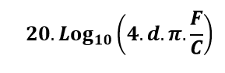

– where F=frequency, d=distance and c=speed of light

It may be noted that the equation is independent of waveform/bandwidth. This equation is plotted in Figure 1 for both 144MHz and some other relevant frequencies in the AI-10 aeronautical proposal.

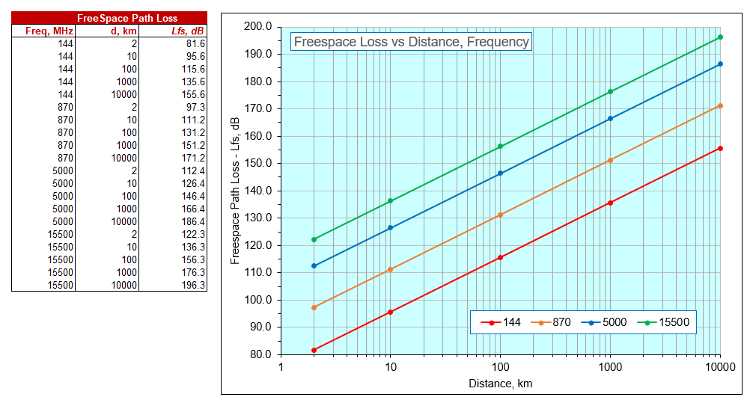

Figure Freespace path loss vs distance and frequency

* 1. AIRBORNE VHF ANTENNAS

The 144-146 MHz band has an approximate wavelength of 2 metres. Directive antennas such as Yagis would involve substantial size booms or elements that in general would not be practical on most airborne platforms.

In practice the most common form of airborne VHF antenna are relatively short loaded or quarterwave ‘blades’ that are typically vertically polarised, with an omnidirectional pattern in azimuth.

* 1. BASIC ANALYSIS

The characteristics of systems operating in the amateur and amateur-satellite services for use in sharing studies can be found in ITU-R recommendation M.1732-2.

For the purposes of this basic study the most common amateur receivers in the 144-146 MHz band can be considered to be in two categories for which we have used the following parameters:-

|  |  |  |  |  |  |
| --- | --- | --- | --- | --- | --- |
| Amateur Station Category | Rx BW | NF | SINR/SINAD | Rx Sensitivity | Antenna gain, dBi |
| CW/SSB | 2.7 kHz | 2dB | 10dB | -127.7dBm / 0.1 uV | 12 |
| FM/Digital Voice | 9 kHz | 2dB | 12dB | -120.4dBm / 0.2uV | 3 |

An aeronautical mobile source is assumed to have 1 Watt transmitter power and 3dBi antenna gain, which gives a radiated emission level of +33dBm EIRP.

From the free space path loss curves for 144 MHz we consider some example separation distances:-

10 km Freespace Loss, Lfs = 95.6 dB

100 km Freespace Loss, Lfs = 115.6 dB

1000 km Freespace Loss, Lfs = 135.6 dB

Given the data above, the incident signal strength present at an amateur station can be readily determined from the transmitter ERP minus the path loss. Taking into account the antenna gains above and the commonly used I/N protection requirement of -6dB we can determine the excess interference level in the amateur station receiver from an aeronautical mobile transmitter when co-channel and in line of sight:-

|  |  |  |
| --- | --- | --- |
| Distance | CW/SSB | FM/DV |
| At 10km:  Incident Signal Strength  Interference Level | -62.6 dBm  +83 dB | -62.6dBm  +65.8 dB |
| At 100km:  Incident Signal Strength  Interference Level | -82.6 dBm  +63 dB | -82.6 dBm  +45.8 dB |
| At 1000km:  Incident Signal Strength  Interference Level | -102.6 dBm  +43 dB | -102.6dBm  +25.8 dB |

In practice the line of sight will be dependent on the altitude of the aeronautical mobile station and local geography (which is modelled in more detail in the next section). However for orbiting amateur satellite receivers there would be no geographic screening.

In summary it is clear that the interference levels from a modestly powered aeronautical mobile source could be severe and may repeatedly disrupt amateur service traffic. It is also quite probable that these strong levels would also result in adjacent channel interference as well as co-channel interference.

1. FUrther Techncial cOnsiDerAtion

This annex shows that even with a low transmission power of 1 Watt, the transmission from an airborne platform at a height of 1000m covers a range with radius 200km at levels between -65 and -119 dBm. At a height of 10000m, an affected area of almost 500 km radius results, within which there would be numerous amateur systems.

For the reverse direction an example calculation is included for an average amateur radio SSB station producing a level of -66 dBm at the aircraft antenna even at 500 km distance.

For this reason the parallel operation of a new aeronautical mobile application and amateur radio in the 144-146 MHz frequency band without mutual interference resulting is likely not to be feasible.

* 1. Coverage area From an Aeronautical transmitter

For an aeronautical transmitter with 1 W output power and an omnidirectional antenna, the respective coverage area was determined for different heights, using the ‘Radio Mobile’ software. This calculates range maps and field strength values between two or more stations, taking into account topography, frequency and transmission power.

In the following examples, the location of the 1W aeronautical transmitter was set as over Berlin-Mitte. Coverage maps are calculated for airborne altitudes of 100, 1000 and 10000m. The maps have a circular overlays at multiples of 100km radius.

It can be seen that at a height of only 100m, an area within a radius of 100 km is covered by a transmitter at levels of -65 to -119 dBm, in individual cases even 200km distance can be achieved due to topography.

At an altitude of 1000m, this reception area expands from the Baltic Sea to the Czech border, and consequently approximately 200km from Berlin-Mitte. At 10000m, the reception area reaches to Copenhagen and Prague, almost 500km.

It is clear these large areas would have many active amateurs and VHF infrastructure systems within range leading to multiple cases of harmful interference to the amateur service.

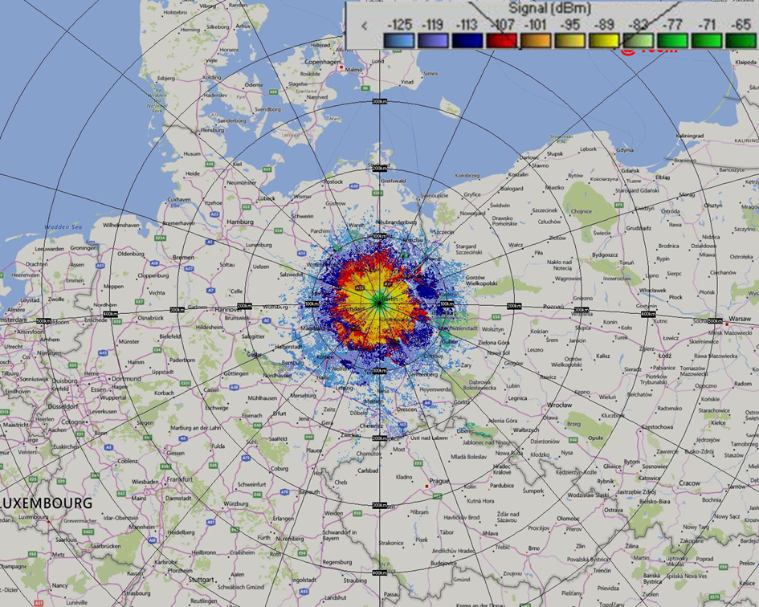

Figure 2: Coverage area from a 1 Watt Aeronautical transmitter at a height of 100m

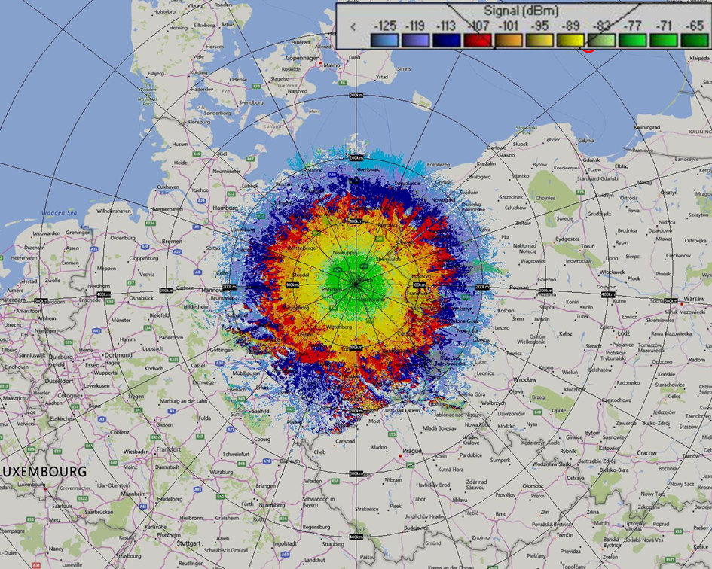

Figure 3: Coverage area from a 1 Watt Aeronautical transmitter at a height of 1000 m

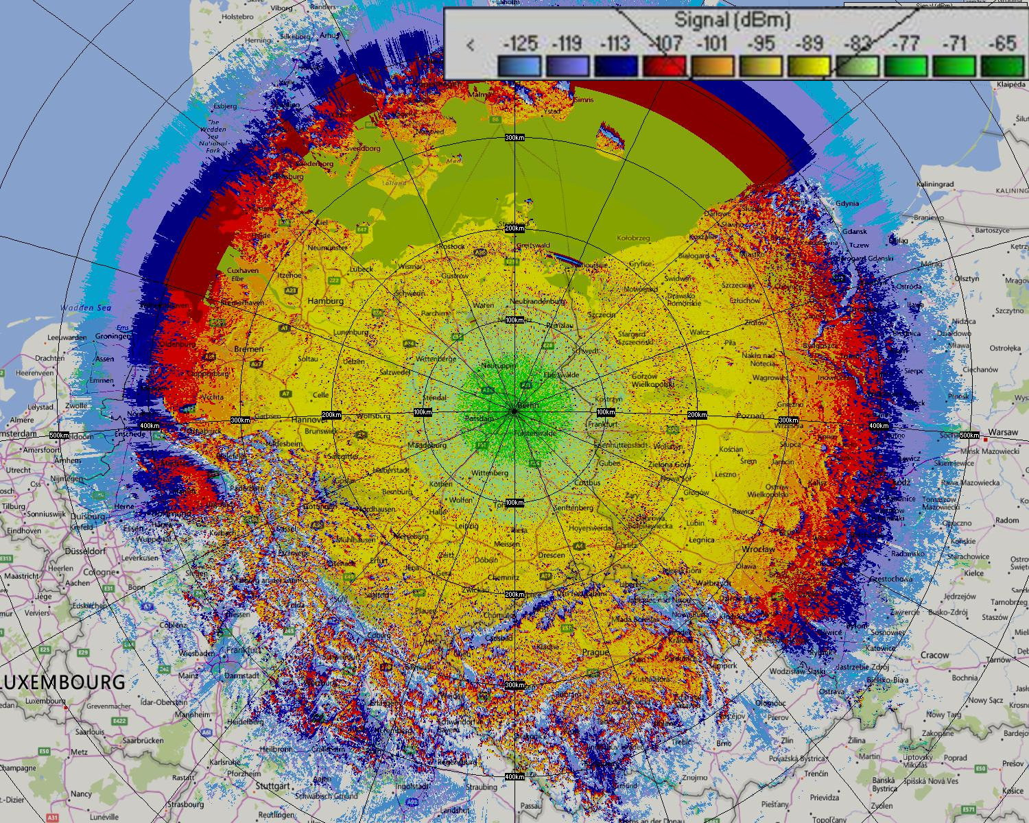

Figure 4: Coverage area from a 1 Watt Aeronautical transmitter at a height of 10000m

* 1. AFFECTED AMATEUR STATIONS

Given the radius of a coverage area from the maps in the previous section, it is feasible to estimate the number of affected amateur stations under the footprint of an aeronautical mobile station.

For WRC-19 Agenda Item 1.1, statistics were gathered on the number and density of amateur licensees across most of the European/CEPT area:-

* Area considered: ~5.1m km2
* Total Licenses: 356488
* Densities: Average - 0.07 amateurs/km2 ; Peak - >0.2 amateurs/km2 (e.g. in Germany, Netherlands, UK)

The geographic modelling in the previous section gave radii of 100, 200 and 500km. These radii involve areas of between 31400 – 785400 km2. This then enables estimates of the potential number of affected amateur stations within a given area.

Assuming a 75% ownership level for VHF equipment, the densities give a range of 1600 – 41000 licensees, within the coverage footprints of aeronautical stations and thus a high probability that significant incidences of harmful interference to numerous amateur stations would occur.

* 1. Reverse Direction – Signal Levels at an aeronautical receiver

The receivers for any new aeronautical application would need to take into account the transmitter powers and antenna gains of incumbent primary amateur stations – again using low free-space path losses.

As the 144-146 MHz frequency band is a global primary amateur allocation, CEPT Administrations typically permit amateur transmitter power levels of 250-750W, whilst other countries permit up to 1.5kW. As indicated in ITU-R M.1732 - this can lead to typical levels of >30dBW EIRP (or 40dBW for EME stations).

The amateur repeater network may typically be 25W EIRP with omnidirectional radiation patterns and operate with high duty cycles used for events or collectively linked (sometimes referred to as reflectors or talk-groups).

Any aeronautical receiver would have to allow for potentially very high received signal strengths and the probability that there may be multiple active amateur systems inside its antenna coverage area.

* 1. SUMMARY

Basic technical studies of the 144-146 MHz frequency range show that sharing of the current amateur service allocation with non-safety-related aeronautical mobile radio systems is not possible at a range of altitudes without a significant likelihood of mutual interference occurring. This is not surprising given the low path losses that inherently occur at VHF and to mitigate this problem would require impractically large separation distances.

Even at low altitudes an aeronautical mobile system, with just 1W EIRP covers a range of several 100 km distance from the transmitter with high field strengths. At 10000m altitude, the affected area exceeds a radius of more than 500km. The affected areas are many 1000s km2 and would contain numerous amateur systems.

In the reverse case, signals from a technically average amateur radio station arriving at the aeronautical receiver are at such high levels that operation of the aircraft datalink may not be guaranteed. In areas with higher densities of amateur radio stations, the mutual interference would be even more pronounced.

Whilst not analysed in detail here, the low free space losses and clear line-of-sight paths would also affect 144-146 MHz amateur satellite receivers, including systems on the International Space Station.

In conclusion, the proposal to include the primary 144-146 MHz amateur and amateur satellite allocation in new aeronautical mobile studies is unsound. There is no need for a lengthy WRC study cycle to determine this. Consequently the 144-146 MHz frequency band should be withdrawn from the WRC-23 non-safety aeronautical proposal.