|  |  |  |  |
| --- | --- | --- | --- |
|  | | | ECC PT1(16)025 |
| ECC PT1 # 51 | |  | |
| Helsinki, Finland, 19-21 January 2016 | |  | |
|  | |  | |
| Date issued: | 13.01.2016 | | |
| Source: | Ericsson , Nokia Networks, Technische Universität Kaiserslautern, Universitat Politècnica de València | | |
| Subject: | Discussions on evaluation methodology for IMT-2020[1] | | |
| N  Group membership required to read? (Y/N) | | | |
|  | | | |
| Summary:  This document discusses the anticipated performance evaluation methodology and framework for IMT-2020. | | | |
|  | | | |
| Proposal:  This input contributions is proposed to be submitted to next WP5D for consideration in the development of the new report ITU-R M. [IMT-2020. EVAL]. | | | |
|  | | | |
| Background: | | | |
| IMT-2020 (5G) is expected to address the wireless connectivity needs for both humans and machine-type devices in 2020 and beyond. In comparison to IMT-advanced, next generation of wireless communications IMT-2020 will push the broadband connectivity to new extremes, by utilizing new solutions such as massive multiple-input multiple-output (MIMO), radio access using higher frequency bands above 6 GHz or ultra-dense networks (UDN). Therefore, IMT-2020 is expected to considerably improve the overall end user experience achievable in contemporary wireless communication systems, and significantly boost the cost-efficiency factor of running the network. At the same time, it is envisioned that IMT-2020 will expand the application areas to new domains, such as Internet of Things (IoT) or road traffic safety and intelligent transport system (ITS), which would require key capabilities and technical performance requirements party different than the ones used for the assessment of broadband access performance in IMT advanced.  From the above mentioned aspects and considering the IMT-2020 usage scenario as defined in Recommendation ITU-R M.2083, there is a need of the creation of appropriate performance evaluation framework that will allow for a fair and comparable evaluation of various technology concepts proposed for the new generation of wireless communication systems. | | | |

Attachment 1

# Introduction

IMT-2020 (5G) is expected to address the wireless connectivity needs for both humans and machine-type devices in 2020 and beyond. In comparison to IMT-Advanced (IMT-A), next generation of wireless communications will push the broadband connectivity to new extremes, by utilizing new solutions such as massive multiple-input multiple-output (MIMO), radio access using higher frequency bands above 6 GHz or ultra-dense networks (UDN). Therefore, IMT 2020 is expected to considerably improve the overall end user experience achievable in contemporary wireless communication systems, and significantly boost the cost-efficiency factor of running the network. At the same time, it is envisioned that IMT 2020 will expand the application areas to new domains, such as Internet of Things (IoT) or road traffic safety and intelligent transport system (ITS), which would require key capabilities and technical performance requirements party different than the ones used for the assessment of broadband access performance in (IMT-A.

From the above mentioned aspects and considering the IMT-2020 usage scenario as defined in Recommendation ITU-R M.2083, there is a need of the creation of appropriate performance evaluation framework that will allow for a fair and comparable evaluation of various technology concepts proposed for the new generation of wireless communication systems.

# General considerations for evaluation methodologies

Following the approach proposed in [ITUR-M.2135], characteristics of IMT-2020 technology solutions could be evaluated using three methods: simulations, analysis and inspection.

* Evaluations through simulations contain both system level simulations and link level simulations.
* In case of analytical procedure, the evaluation is to be based on calculations using the technical information provided by the technology component owner.
* In case of evaluation through inspection the evaluation is based on statements.

For system level simulations the following principles should be considered:

* System simulations shall be based on proposed deployment scenarios and models captured later in the document.
* Cell assignment to a user is based on the cell selection scheme proposed by the technology component owner, which must be described. Some examples are:
  + Connection to the station received with highest power, considering a handover margin of 1 dB.
  + Connection to the station received with highest power, considering a handover margin of 1 dB, but with a limit of users per BS.
  + Connection to the station received with highest wideband SINR, with or without a limit of users per BS.
  + Connection to the station whose estimation of the Quality of Service (QoS) satisfaction is more likely. This could be known based on the SINR estimation, the number of users connected to each station, and their QoS requirements.

It is allowed to have the control plane user plane served by different stations.

* In simulations based on the full-buffer traffic model, packets are not blocked when they arrive into system (i.e. queue depths are assumed to be infinite).
* In bursty traffic simulations, packets that are discarded (e.g. as they can’t be transmitted within given latency requirements) are also included in the overall performance statistics with 0 correctly received bits.
* Packets are scheduled with an appropriate packet scheduler(s) proposed by the proponents for full buffer and bursty traffic models separately. Channel quality feedback delay, feedback errors, PDU (protocol data unit) errors and real channel estimation effects inclusive of channel estimation error are modeled and packets are retransmitted as necessary.
* The overhead channels (i.e., the overhead due to feedback and control channels) should be realistically modeled.
* For a given drop, the simulation is run and then the process is repeated with the users dropped at new random locations. A sufficient number of drops are simulated to ensure convergence in the user and system performance metrics. For mMTC simulations, due to the large number of devices, only one drop is sufficient.
* Performance statistics are collected taking into account the wrap-around configuration in the network layout, noting that wrap-around may not be considered in some test cases

# IMT-2020 usage scenarios mapped to test case and deployment scenarios

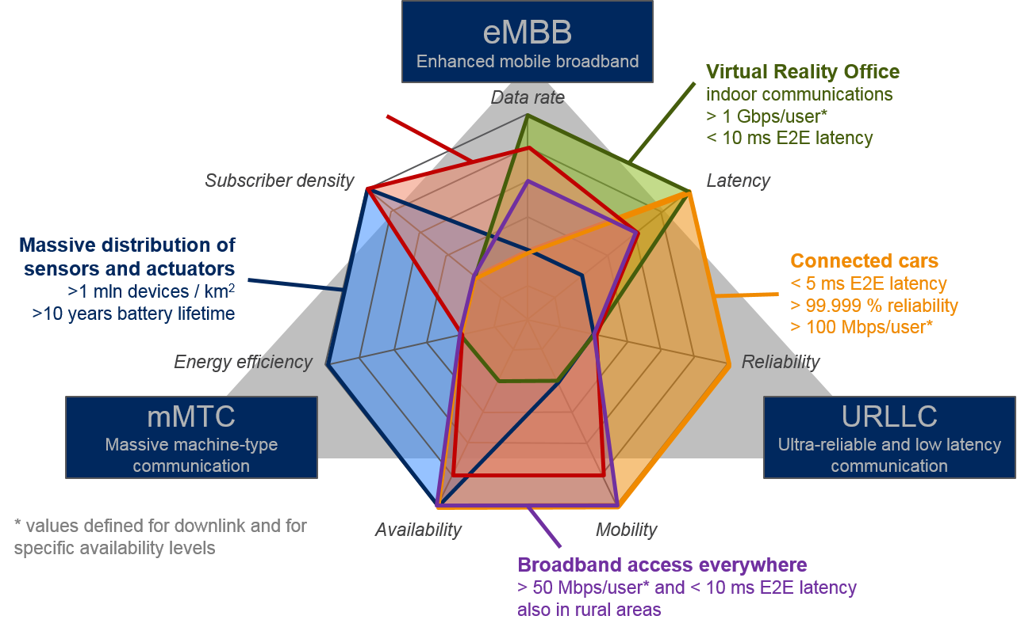

Figure 1 IMT-2020 usage scenarios, mapped to test cases.

As defined in [ITUR-M.2083], IMT-2020 will be based on three usage scenarios. For these three usage scenarios the follwing test case are envisaged:

**Enhanced Mobile Broadband (eMBB)**

* Dense Urban Information Society: the objective of this test case is to provide connectivity for city dwellers at any place and time. Exemplary applications in this test case are immersive multi-media applications (including 4K/8K ultra high definition video, virtual reality and real time mobile gaming). IMT-2020 services should provide in such test case an improved quality of experience (QoE) for users compared to the IMT-A services.
* Virtual Reality Office: This test case is based on a future indoor setting where improved wireless technologies will provide extremely high data rates while fulfilling challenging capacity requirements at a reasonable cost
* Broadband Access Everywhere: this test case emphasizes the need of providing acceptable broadband user experience practically everywhere, even in areas with sparse network infrastructure or at very high user speeds.

**Massive machine type communications (mMTC)**

* Massive Deployment of Sensors and Actuators: this test case is related to to the progressive trend observed in contemporary networks, where machine type devices use radio access to transmit data related to the variety of applications. Key challenge for mMTC is a very large number of low cost devices requiring sporadic access for low payload data exchange. This challenge is different than for eMBB.

**Ultra-reliable and low latency communications (URLLC)**

* Connected Cars: this test case focus on the exchange of safety related data between moving vehicles (or potential vulnerable road users). Such safety related communication is challenging, as reliability of the transmission can be impacted by the availability of radio resources (possible concentration of vehicles in a cell) and high velocity (frequent cell change and challenging transmission conditions caused by the high Doppler effect).

eMBB test cases have similar requirements as of IMT-A (high-speed broadband access), however these requirements are are pushed to the new extremes (e.g. 1Gbps is IMT-A peak data rate , for IMT-2020 this is the expected user throught in test case of virutal reality office), which reflects the effects of growing number of broadband devices and high data rates applications. In contrary to IMT-A evaluation [ITUR M.2135] which focus to a large extend on spectral efficiency, proposed approach in thsi input suggest evaluation of eMBB test cases using absolute data rates to better reflect impact of some key enhancements for IMT-2020, such as utilization of higher frequency bands and exploitation of extreme network densification.

On the other hand specific nature of mMTC and URLLC application test cases impose different set of indicators that should be used for a approporiate evaluation of IMT-2020 performance. mMTC devices should operate with much longer battery life comparing to eMBB and at much higher densities. Similarly, for URLLC applications key performance indicators will rely on extremely high reliability linked with capability to transmit data with very low latency. The test cases can be mapped to deployment scenarios is as follows:

|  |  |  |  |  |  |
| --- | --- | --- | --- | --- | --- |
| **IMT 2020 Usage scenarios Recommendation ITU-R M. 2083** | | | | | |
| eMBB | | mMTC | | URLLC | |
| Test case | Deployment scenario | Test case | Deployment scenario | Test case | descriptions |
| Dense Urban Information Society | HetNet (Urban Macro + Outdoor Small Cells) (FFS) | Massive Deployment of Sensors and Actuators | Urban Macro | Connected cars | HetNet (Urban Macro + Outdoor Small Cells configured as RSUs)  (FFS) |
| Virtual reality office | Indoor Hotspot |  |  |  |  |
| Broadband access everywhere | Rural Macro |  |  |  |  |

The following table gives general information’s on proposed deployments scenarios as examples of parameters to be applied in simulations evaluations based on what is currently under development in METIS II project ( these parameters are subject for further study/ FFS):

|  |  |  |  |  |
| --- | --- | --- | --- | --- |
| Deployment scenario | Indoor hotspot | HetNet (FFS) | | Rural macro |
| Outdoor small cells | Urban macro |
| BS antenna height | 3 m, mounted on ceiling | 10 m on the lamppost / below the rooftop | 25 m, above rooftop | 35 m, above rooftop |
| Carrier frequency for evaluation | 3.5 GHz and 66-86 GHz | 24-27 GHz in Dense Urban Information Society  5.9 GHz for Outdoor Small Cells in Connected Cars | 2 GHz for Massive Deployment of Sensors and Actuators and Connected Cars, 3.5 GHz for Dense Urban Information Society | 800 MHz |
| Duplexing | TDD | TDD | TDD/FDD | FDD |
| Inter-site distance | 20 m | min 20 | 200 for Dense Urban Information Society, 500 m for Massive Deployment of Sensors and Actuators and Connected Cars | 1 732 m |

# Conclusions

IMT-2020 will push the broadband user experience and network available in contemporary networks to the new extremes. It will also span the wireless connectivity to new areas such as IoT or ITS. Although solutions addressing these domains are already available, IMT-2020 will cater for them under the umbrella of one system. The level of integration between different Air Interface Variants (AIVs) supporting different IMT-2020 test cases is still under discussion in many organizations, vendors and research projects. Therefore it is of the uttermost importance to provide a unified evaluation framework that could be used to appropriate assess proposed technical solution with respect to the main IMT-2020 technical performance requirements. This document proposes one example of a framework for evaluation that is currently under study and investigations. Proposed methodology covers all relevant aspect of new generation of wireless systems.

# References

[ITUR-M.2135] ITU-R M.2135-1 “Guidelines for evaluation of radio interface technologies for IMT-Advanced”, December 2009.

[ITUR-M.2083] ITU-R M.2083 “IMT Vision – Framework and overall objectives of the future development of IMT for 2020 and beyond”, September 2015.

1. Example of deployment scenarios

## Synthetic deployment scenarios

### InH

The indoor hotspot scenario consists of one floor of a building. The height of the floor is 3 m. The floor contains 16 rooms of 15 m × 15 m and a long hall of 120 m × 20 m.

Proposed BS network layout consist of small cells placed in the corridor, 6 along one long edge and 6 more along the other long edge. The six stations in one edge have an inter-site distance of 20 m, with the first site placed at 10 m with respect to the left side of the building (see Figure 2).



Figure 2: Sketch of InH deployment.

InH base stations can operate in two configurations:

* Above 6 GHz band – frequencies of 66-86 GHz with the available bandwidth of 1 GHz
* Above 6 GHz and below 6 GHz band – same configuration as above and additional 100 MHz bandwidth in 3.5 GHz band

### HetNet

The HetNet scenario consist of two cell layers: urban macro cellular (UMa) BS and outdoor small cells.

#### UMa

UMa BSs are deployed with fixed ISD of 200 m for Dense Urban Information Society and 500 m for Massive Deployment of Sensors and Actuators and Connected Cars test cases, in a regular, hexagonal grid as depicted in Figure 3. BS are connected to a set of 3 sector antennas, whose characteristics are defined below. Antennas are mounted at the height of 25 m, above the rooftop.

UMa BSs can operate at the frequency of 2 GHz for Massive Deployment of Sensors and Actuators and Connected Cars (10 MHz available for each UC) and in 3.5 GHz in Dense Urban Information Society (100 MHz is available).



Figure 3. Urban and rural macro BS deployment and antenna orientation

#### Outdoor Small Cells

In the HetNet deployment scenario, small cells are deployed as outdoor base stations. Each macro sector is complemented with 8 small cells randomly placed in the coverage area of the macro sector. The constraint for the small cell deployment is that the distance between the small cell and the Macro BS must be greater than 55 m and the distance between the small cell antennas (inter and intra macro sector) shouldn’t be smaller than 20 m (as small cells are deployed as outdoor BSs, most likely by mobile network operators, it is very likely that similar limitations could be enforced by the operator).

Each small cell is equipped with omnidirectional antenna at the height of 10 m and operates in the frequency range of 24-27 GHz with available bandwidth of 1 GHz for Dense Urban Information Society, and at 5.9 GHz and 10 MHz bandwidth (FFS).

### RMa

Rural Macro base stations are deployed with the ISD of 1732 m in a hexagonal cell layout presented in Figure 3 As base stations have to cover large areas, antennas are mounted on a transmission masts at the height of 35 m, above the rooftop. Sector antennas have characteristics as described in the Section below

RMa BSs operate at frequency of 800 GHz where 20 MHz bandwidth is available.

### BS antenna pattern

For UMa and RMa BS sector, the horizontal antenna pattern is specified as:

$$A\left(θ\right)=-min\left[12{\left(\frac{θ}{θ_{3dB}}\right)}^{2},A_{mh}\right]$$

Where $A\left(θ\right)$ is the relative antenna gain in horizontal direction (dB) $, θ$ is the horizontal angle, $θ_{3dB}$ is the 3 dB beamwidth and $A_{mh}$ is the maximum attenuation of the antenna in the horizontal plane. For system level simulations values of =700 and =25 dB shall be used.

For elevation angle antenna pattern is defined as:

$$A_{e}\left(∅\right)=-min\left[12{\left(\frac{∅-∅_{tilt}}{∅_{3dB}}\right)}^{2},A_{mv}\right]$$

Where $A_{e}\left(∅\right)$ is the relative antenna gain in the elevation direction (dB), $∅$ is the elevation angle, $∅_{3dB}$ is the elevation 3 dB beamwidth, $A_{mv}$ is the maximum attenuation of the antenna in the vertical plane and $∅_{tilt}$ is the tilt angle that can be adjusted in each deployment scenario. For system level simulations values of $A_{mv}$ = 20 dB and = 150 shall be used.

The combined antenna pattern is computed as:

* 1. IMT-A evaluation process overview

IMT-A is recognized as the 4th generation (4G) of wireless networks that could provide high data rates to enable various mobile broadband (MBB) applications. In 2007-2008 timeframe, ITU-R Working Party (WP) 5D developed the evaluation guideline for IMT-A for its performance assessment, and defined its performance metrics and technical performance requirements. Summary of these can be found in two ITU-R reports, i.e., the report ITU-R M.2135 “Guidelines for evaluation of radio interface technologies for IMT-Advanced” [ITUR-M2135], and the report ITU-R M.2134 “Requirements related to technical performance for IMT-A radio interface(s)” [ITUR-M2134].

The report ITU-R M.2135 defined a complete framework for IMT-A evaluation. It includes three components:

* Test environments, which consist of:
* Traffic model that is characterized by the service to be evaluated.
* Deployment scenario, which provides the geographical characteristics where the service is deployed (e.g., indoor hotspot, dense urban area).
* Evaluation configuration, i.e., the assumed evaluation parameters applied to the selected traffic (service) and deployment scenario.
* Evaluation methodology and procedure for each of performance metrics:
* High level assessment method for each of the performance metrics, e.g., inspection, analytical, and simulation.
* Detailed evaluation method and procedure.
* Evaluation models, e.g., channel model, etc.

The following subsections give more detailed information on these three IMT-A evaluation components.

* + 1. IMT-A test environments

IMT-A focused on MBB scenarios, where provision of high data rates and voice service were the main UC, and the human communication environments are the typical application environments for MBB. Accordingly, IMT-A defined four test environments, which are listed in the table below. The “indoor” and “microcellular” are representatives for high user density scenarios in indoor (e.g., office) and dense urban area, respectively. The “base coverage urban” and “high speed” represent the wide area coverage scenarios with lower user density, but higher user mobility, in urban and rural area, respectively. The corresponding deployment scenarios are also shown in Table A‑4‑1. One could refer to [ITUR-M2135] for more details.

Table A‑4‑1: Test environments and deployment scenarios of IMT-A.

|  |  |  |  |  |
| --- | --- | --- | --- | --- |
| Test environment | Indoor | Microcellular | Base coverage urban | High speed |
| Deployment scenario | Indoor hotspot scenario (InH) | Urban micro-cell scenario (UMi) | Urban macro-cell scenario (UMa) | Rural macro-cell scenario (RMa) |

Traffic models employed for IMT-A evaluation were full buffer and Voice over Internet Protocol (VoIP) traffic, representing the capacity and the voice service challenge, respectively.

* + 1. Evaluation method and procedure of IMT-A

IMT-A employed three types of high-level assessment method, i.e., inspection (by reviewing the functionality and parameterisation of the proposal), analytical (via a calculation), and simulation. Table A‑4‑2 lists the corresponding method for some of the performance metrics defined in [ITUR-M2134]. The performance metrics that need quantitative evaluation but could not be derived by calculation were evaluated through simulation. In [ITUR-M2135], the procedure of system-level simulation was defined. Figure A‑4‑3 illustrates the abstracted simulation procedure according to the principles defined in [ITUR-M2135].

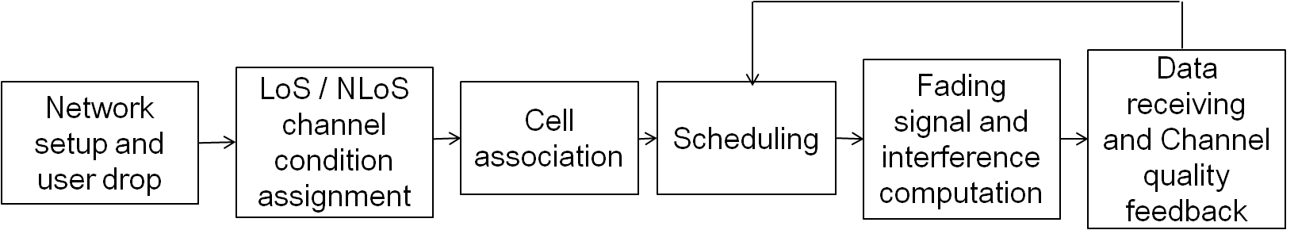

Figure A‑4‑3: Illustration of the system-level simulation procedure of IMT-A [ITUR-M2135].

An important issue is to identify which of the metrics will be evaluated simultaneously. It depends on which of the requirements need to be fulfilled simultaneously. In IMT-A, cell spectral efficiency and cell edge spectral efficiency were evaluated jointly, due to the need for IMT-A systems need to provide good cell capacity along with good fairness among users.

Table A‑4‑2: Evaluation method of IMT-A (for some of performance metrics) .

|  |  |
| --- | --- |
| Performance metric | Method |
| Cell spectral efficiency | Simulation (system level) |
| Peak spectral efficiency | Analytical |
| Bandwidth | Inspection |
| Cell edge user spectral efficiency | Simulation (system level) |
| Control plane latency | Analytical |
| User plane latency | Analytical |
| Mobility | Simulation (system and link level) |
| Inter-system handover | Inspection |
| VoIP capacity | Simulation (system level) |

* + 1. Evaluation configurations and evaluation models of IMT-A

To obtain a fair comparison of results among different proponents, the evaluation configuration and evaluation models for each of the test environment were defined. Table A‑4‑3 summaries the primary evaluation configurations and evaluation models employed in IMT-A. More details can be found in [ITUR-M2135].

Table A‑4‑3: Evaluation configurations and models for system-level simulation of IMT-A [ITUR-M2135]

|  |  |  |  |  |
| --- | --- | --- | --- | --- |
| Parameters/Test environments | Indoor | Microcellular | Urban base coverage | High speed |
| Traffic model | Full buffer (for cell spectral efficiency and cell edge spectral efficiency); VoIP (for VoIP capacity) | | | |
| Network layout |  |  | | |
| User distribution | Randomly and uniformly distributed over area | | | |
| 100% of users indoor | 50% users outdoor and 50% users indoor | 100% of users outdoors in vehicles | 100% of users outdoors in high speed vehicles |
| Inter-site distance | 60 m | 200 m | 500 m | 1 732 m |
| Simulation bandwidth | 20+20 MHz (FDD), or 40 MHz (TDD) | 10+10 MHz (FDD), or 20 MHz (TDD) | 10+10 MHz (FDD), or 20 MHz (TDD) | 10+10 MHz (FDD), or 20 MHz (TDD) |
| Carrier frequency | 3.4 GHz | 2.5 GHz | 2 GHz | 800 MHz |
| Antenna configuration | Up to 8 antennas at base station (BS)  Up to 2 antennas at user terminal (UT) | | | |
| User mobility | 3 km/h | 3 km/h | 30 km/h | 120 km/h |
| BS transmit power | 21 dBm/20 MHz | 41 dBm/10 MHz | 46 dBm/10 MHz | 46 dBm/ 10 MHz |
| UT power class | 21 dBm | 24 dBm | 24 dBm | 24 dBm |

* 1. Updates needed for IMT 2020

Based on the information from Annex A.1 and IMT-2020 test cases described in Section 3, it becomes evident, that in comparison to evaluation method proposed for 4G/IMT-A by ITU-R in [ITUR-M2134], [ITUR-M2135], performance evaluation framework proposed for evaluation of IMT-2020 solutions should bring several key differences and additions.

**Deployment scenarios**. Test environments were adjusted to reflect e.g. higher number of antennas, justified by moving to higher frequency regimes, or TDD configuration that mirrors the expectation of wireless community for this duplexing method to be an important mode in case of small cell deployment.

In addition, new test environments are required to evaluate the mMTC and URLLC usage scenarios which are not considered in evaluation framework for IMT-A proposed in [ITUR-M2135].

* **Technical performance requirements**. IMT-2020 is expected to provide new usage scenarios families (mMTC, URLLCC) that would require defining different technical performance requirements to be used for benchmarking individual solutions. As an example device energy consumption is envisaged to be one of the main performance indicator/KPI for consideration in mMTC, where as for URLLC case reliability would be considered a relevant performance indicator, etc. For eMBB which was a focus area of IMT-A candidates technologies, a new or updated metrics would be needed such as network energy efficiency, ability to exploit heterogeneous environment, etc. Also multiplicity of connectivity options and possible solutions (as well as maturity of cellular ecosystem that manifest in existence of multiple network/service operators) incline the importance of cost and complexity analysis that will allow the choice of economically justified solutions. In addition, the technical performancerequirementsdefinitions need to accommodate new technology trends to keep it technology-agnostic, and some of these requirements defined in IMT-A may need update to achieve this.
* **Higher frequency bands.** New frequency bands (especially in the mmW region) require substantial redefinition of channel models, both for small scale (fast fading) and large scale (slow fading).
* **Traffic**. Although prediction of future applications and related traffic models is always incurred with considerable errors, several trends for future IMT-2020 air interface solutions can be outlined. First of all, full buffer metrics may not be sufficient to capture all the relevant user experience statistics. Full buffer evaluation is a very good mean for quantification of maximum capacity and high load condition. However, when evaluating e.g. experienced user throughput or fulfilment of QoS requirements, finite traffic models are more suitable. They are also needed for mMTC and URLLC services.

1. The content of this contribution originates from the work done in METIS-II but does not necessarily reflect the viewpoints of all partners in the METIS-II project.