**ECC PT1(17)285**

**3GPP TSG-RAN WG4 meeting #85 R4-1714090**

**Reno, Nevada, US, 27 November – 1 December, 2017.**

**Title:** LS on Unwanted emissions of IMT-2020

**Response to:** LS (R4-1707004) on Unwanted emissions of IMT-2020 from ITU-R WP 5D

**Release:** Rel-15

**Work Item:** FS_NR_newRAT

**Source:** 3GPP RAN WG4

**To:** ITU-R WP 5D

**Cc:** CEPT/ECC PT1, TSG RAN

**Contact Person:**

#### Name: Johan Sköld

E-mail Address: 

**Send any reply LS to: 3GPP Liaisons Coordinator,** [**mailto:3GPPLiaison@etsi.org**](mailto:3GPPLiaison@etsi.org)

**Attachments:** -

**1. Overall Description:**

RAN4 thanks ITU-R WP 5D for the opportunity to give feedback to the LS on “Unwanted emission for IMT-2020”, where WP 5D request feedback about the feasibility of meeting more stringent limits and/or potentially using larger measurement bandwidths (e.g. 100 MHz and 200 MHz), to define unwanted emission limits for certain cases (e.g. protection of passive service systems). A first response was sent from 3GPP RAN WG4 to WP5D in September 2017 (3GPP Tdoc R4-1710084). This document provides some information in addition to the previous LS response.

RAN4 has further studied the requests and the following is an overview of the present status of the work:

* -13dBm/MHz is the achievable baseline requirement for mm wave spurious emissions for both UE and BS. The emission limit is expressed as Total Radiated Power (TRP).
* An additional requirement to protect specific sensitive services (e.g. passive services) is under discussion in RAN4 and several observations were already given in the previous LS from 3GPP (R4-1710084). In addition to those preliminary observations made, the following can be said:
  + For BS, further considerations have been made of PA power efficiency, transmitter linearization and filtering in relation to achieving a stricter spurious emission requirement in specific bands. Taking into account the higher output power that needs to be achieved from a BS in comparison with terminals, frequency separation between the considered passive system (23.6-24GHz) and 24.25-27.5GHz NR band, and the fundamental technology limits for reaching the suppression needed, RAN4 is considering the possibility of an additional requirement for protecting the considered frequency range. 3GPP RAN4 is for this purpose considering emission levels in the range ‑27 to ‑32dBW/200MHz.
  + 3GPP RAN4 has studied impacts on NR system performance and coverage for achieving a BS emission level lower than the baseline level in specific bands. While an optimization can be made between the selected implementation, complexity and system performance feasible for mm-wave bands, tighter limits may require power back-off and/or additional guard bands, leading to loss in coverage, capacity and spectrum utilization. It is shown in [1] based on two different filter implementations that a filter giving 20 dB additional suppression (achieving approximately ‑37 dBW/200 MHz) would give 3-4 dB insertion loss (DL Tx power reduction and UL loss of Rx sensitivity) and would also require a 1-1.5 GHz transition region (guard band). Furthermore, it has been shown what is the impact on the performance (cell edge user DL throughput) of NR system for achieving an emission level in the range of ‑27 to ‑37dBW/200MHz to protect EESS (passive) services operating in 23.6-24GHz [2]. As can be observed in Figure 1, the DL Tx power reduction of 7dB would lead to cell edge user DL throughput loss of 36% in reference to baseline power parameters. In case of DL Tx power is even larger, a cell edge user DL throughput loss of up to 80% would be expected.

**Figure 1: Cell edge user throughput loss in reference to DL Tx power reduction**

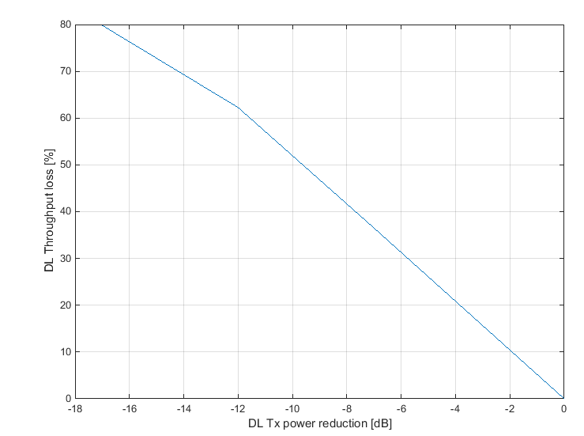

* + For user terminals, RAN4 observed the emissions are possibly not flat within 200 MHz measurement bandwidth and thus a different more stringent emission level in the protected band with larger measurement BW (e.g. 200MHz) is feasible. RAN4 is currently considering the possibility to specify a requirement to be applied for protection of specific frequency ranges in which passive services operate. Depending on the frequency separation to the protected bands, achieving the more stringent level might require mechanisms such as power back off and/or resource scheduling restrictions. RAN4 studied the amount of power reduction needed to achieve an emission level of -37dBW/200MHz. Based on the preliminary analysis carried out in [3], up to 4dB power reduction is needed to meet the target emission level. The required power reduction has direct impact on achievable UL throughput and coverage. In the scenario analyzed in [3], up to 20% median throughput degradation and 50% cell edge throughput degradation were observed. The cell edge throughput loss is directly related to the UL coverage degradation. In particular, it was observed that the coverage loss due to the 4dB power reduction is severe in outdoor scenarios, thus directly affecting mmW NR deployments.

RAN4 will continue to study the possibilities and will update ITU-R WP 5D when further progress is achieved.

**2. Date of Next TSG-RAN4 Meetings:**

TSG-RAN4 NR AH meeting #4 22nd – 26th January 2018 TBD

TSG-RAN4 Meeting #86 26th February – 2nd March 2018 Athens, Greece.

**3. References**

[1] [R4-1712718](ftp://ftp.3gpp.org/tsg_ran/WG4_Radio/TSGR4_85/Docs/R4-1712718.zip), "On mm-wave filters and requirement impact" (Ericsson).

[2] [R4-1713636](ftp://ftp.3gpp.org/tsg_ran/WG4_Radio/TSGR4_85/Docs/R4-1713636.zip), "Evaluation of NR performance degradation in n258 due to protection of EESS (passive) services in 23.6-24GHz" (Nokia, Nokia Shanghai Bell).

[3] [R4-1714048](ftp://ftp.3gpp.org/tsg_ran/WG4_Radio/TSGR4_85/Docs/R4-1714048.zip), “On the additional spurious emission limit to protect passive services”, Qualcomm Incorporated.