Spectrum Planning and International Affairs

Maisons-Alfort, 26th September, 2018

Invitation
ECC PT1 CG – C Band synchronization framework
Maisons-Alfort (2nd -3rd October 2018)

Dear Madam, Sir,

The Agence nationale des fréquences (ANFR) has the pleasure to invite you to the physical meeting for the ECC PT1 correspondence group on C-Band synchronisation in Maisons-Alfort, France.

The meeting will start on Tuesday 2nd of October 2018 at 10.00 a.m. and end around 6 p.m. on Wednesday 3rd of October 2018.

Meeting venue:
AGENCE NATIONALE DES FREQUENCES
78 AVENUE DU GENERAL DE GAULLE
94704 MAISONS ALFORT CEDEX
FRANCE
Phone: +33 1 45 18 72 08
Fax: +33 1 45 18 73 13

For security reasons an I.D or passport will be required to enter ANFR premises.

Registration to the meeting
The delegates are kindly requested to register before 30 September on the CEPT Website.

Meeting arrangement
You will find in Annex information for your accommodation (please contact directly the hotel for booking).

Looking forward to seeing you in Maisons-Alfort,

Yours sincerely,

Eric FOURNIER

Spectrum Planning and International Affairs
Director

ACCESS MAP TO ANFR IN MAISONS ALFORT

"Agence nationale des fréquences"
78 Avenue du Général de Gaulle 94704 Maisons-Alfort
Phone : + 33 1 45 18 72 08 / Fax : + 33 1 45 18 73 13

If you wish a detailed itinerary of your travel consult: http://www.ratp.info/informer/anglais/

By RER (express train):

From Paris "Gare du Nord" or "Chatelet" or “Gare de Lyon” stations, take the RER D2 (Melun) and get off at the "Maisons-Alfort-Alfortville" station (special fare different from subway).
=> Be careful: not all the trains stop at Maisons-Alfort. You must take a slow train and check on the light board that the light corresponding to Maisons-Alfort is on (in the station at the platform).
From the "Maisons-Alfort" station, the ANFR is at 3 mn walking distance (on the left hand side when going out of the station through the garden). Follow red points on the map.

By Metro (subway):

Line n°8 (Balard-Créteil) in direction of "Créteil Préfecture".
Get off at the "Maisons-Alfort Ecole Vétérinaire" station " (15 minutes walk straight on avenue du général de gaulle, south direction) or "Maisons alfort Stade" station (10’ minutes walk, west direction). Follow green points on the map.

By Car:

On the Ring Road, at the exit "Porte de Bercy", take the A4 highway in direction of "Créteil, Metz-Nancy". Maisons-Alfort is the first exit. Turn on the right and cross the Marne river. Go straight ahead on the "avenue du Général de Gaulle" in direction of "Maisons-Alfort Centre".
The ANFR is at about 2 km from the exit.

Note: visitors should present an I.D or passport at the entrance and a “visitor badge” will be given before entering ANFR.

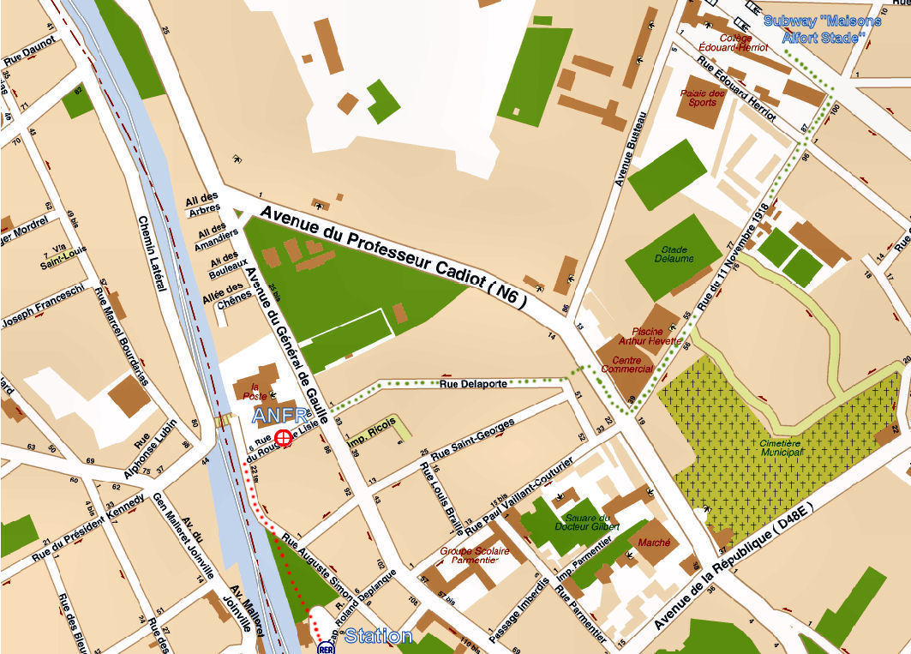

LIST OF HOTELS IN PARIS (around Gare de Lyon), IN MAISONS-ALFORT, and AROUND

How to locate an address : http://www27.mappy.com/?lang=en
(informations are given without guarantee)

HOTELS IN PARIS (Gare de Lyon)
· LES TROIS GARES *** | · BEST WESTERN HOTEL AURORE***
1 rue Jules César | 13 rue Traversière
75012 PARIS | 75012 PARIS
Phone : +33 (0)1 43 43 01 70 | Phone :+33 (0)1 43 43 54 12
Fax : +33 (0)1 43 41 36 58 | Fax : +33 (0)1 43 43 53 20
Mail : h3g@wanadoo.fr | Mail : contact@hotel-aurore.com
http://www.paris-hotel-troisgares.com/en/ | http://www.bestwestern.fr/en/hotel-paris-12eme,Best-Western-Aurore,93546
· PALYM HOTEL** | · HOTEL TRIANON***
4 rue Emile Gilbert | 52 Boulevard Diderot
75012 PARIS | 75012 PARIS
Tel : +33 (0)1 43 43 24 48 | Phone : +33 (0)1 43 43 90 72
Fax : +33 (0)1 43 41 69 47 | Fax : +33 (0)1 46 28 94 96
Mail : infos@hotel-palym.com | Mail : reception@trianongaredelyon.com
http://www.paris-hotel-palym.com/English.phtml | http://www.trianongaredelyon.com/en/
· MARCEAU** | · CORAIL HOTEL***
5 rue Jules César | 23 Rue de Lyon
75012 PARIS | 75012 PARIS
Phone : +33 (0)1 43 43 11 65 | Phone : +33 (0)1 43 43 23 54
Fax : +33 (0)1 43 41 67 70 | Fax : +33 (0)1 43 43 82 55
Mail : bookings@hotelmarceaubastille.com | e-mail : corailhotel@wanadoo.fr
http://www.hotelmarceaubastille.com/en/index.php | http://corailparishotel.com/en/index.html
· LUX HOTEL** | · LUXOR BASTILLE HOTEL**
8, avenue de Corbera | 22 rue Moreau
75012 PARIS | 75012 PARIS
Phone : +33 (0)1 43 43 42 84 | Phone : +33 (0)1 43 43 34 82
Fax : +33 (0)1 43 43 14 45 | Fax : +33 (0)1 44 75 80 73
Mail : hotelux@orange.fr | Mail : contact@luxorbastillehotel.fr
http://www.hotelux-paris.com/ | http://www.luxorbastillehotel.fr/indexGB.php
· LUX HOTEL PICPUS** | · HOTEL PARIS-BERCY
74, boulevard de Picpus | 21, rue de Wattignies
75012 PARIS | 75012 PARIS
Phone : +33 (0)1 43 43 08 46 | Phone : +331 43 43 31 91
Fax : +33 (0)1 43 43 05 22 | Fax : +331 43 44 33 40
Mail : lux.hotel@wanadoo.fr | http://www.cybevasion.com/hotels/france/paris/hotel_index_paris-bercy_384.html
http://www.lux-hotel-picpus.com/?lang=en

· HOTEL LYON BASTILLE***
3 rue Parrot
75012 PARIS
Phone : +33 (0)1 43 43 41 52
Fax : +33 (0)1 43 43 81 16
Mail : reservation@hotellyonbastille.com
http://www.parishotellyonbastille.com/en/index.html

Hotels in MAISONS-ALFORT :
· CITEA hotels et résidences | · HOTEL DES BAINS**
13 Rue Eugène Renault | 132 Rue Jean Jaurès
94700 MAISONS ALFORT | 94700 MAISONS-ALFORT
Phone : +33 (0)1 41 79 70 00 | Phone : +33 (0)1 43 75 78 09
Fax : +33 (0)1 41 79 70 01 | Fax : +33 (0)1 43 96 23 74
Mail : H8413@adagio-city.com | http://www.hoteldesbains-94.fr/
http://www.accorhotels.com/gb/hotel-8413-aparthotel-adagio-access-paris-maisons-alfort/index.shtml | (at a walking distance of the ANFR and RER station, near the city hall, 10 minutes)
At a walking distance of the ANFR 15’
Subway : école vétérinaire – line 8
· AU PETIT CAPORAL*** | · HOTEL MODERNE*
18 Avenue du Général De Gaulle | 19 Bis rue Parmentier
94704 MAISONS-ALFORT | 94700 MAISONS-ALFORT
Phone : +33 (0)1 43 68 10 85 | Phone : +33 (0)1 43 76 76 33
Fax : +33 (0)1 48 93 01 11 | Fax : +33 (0)1 43 78 62 90
Mail : petit.caporal@wanadoo.fr | Mail : hotelmoderne2@wanadoo.fr
http://www.hotelpetitcaporal.com/hotel/ | http://www.hotel-maisonsalfort.fr/
At a walking distance of the ANFR 15’ | (at a walking distance of the ANFR and RER station, near the city hall, 10 minutes)
Subway : école vétérinaire – line 8
· LE GRAND ALBERT 1ER **
5 Avenue du Général De Gaulle
94700 MAISONS-ALFORT
Phone. : +33 (0)1 43 76 71 71
Fax : +33 (0)1 43 76 61 13
http://en.federal-hotel.com/hotel_le-grand-albert-1er-maisons-alfort_3453.htm
Located face to the « petit caporal »)

Hotel in ALFORTVILLE :
· HUATIAN CHINAGORA HOTEL***
1 Place du Confluent France-Chine
94140 ALFORTVILLE
Phone : +33 (0)1 43 53 58 88
Fax : +33 (0)1 49 77 57 17
Mail : resahotel@huatian-chinagora.fr
http://www.huatian-chinagora.fr/index.php?lang=en
(at a walking distance of the ANFR : 25 ‘)
Hotel in CHARENTON-LE-PONT
· NOVOTEL ATRIA ***
3-5 Place de Marseillais
94227 CHARENTON-LE-PONT
Phone : +33 (0)1 46 76 60 60
Fax : +33 (0)1 49 77 68 00
Mail : H1549@accor.com
http://www.accorhotels.com/gb/hotel-1549-novotel-paris-sud-porte-de-charenton/index.shtml
20’ subway+walk line 8 until “maisons alfort stade”
Hotel in SAINT-MAURICE
· HOTEL KYRIAD PARIS EST – BOIS DE VINCENNES (ancien BEST WESTERN SAINT MAURICE) ***
12 rue du Maréchal Leclerc
94410 SAINT-MAURICE
Phone : +33 (0)1 43 75 94 94
Fax : +33 (0)1 43 53 63 82
Mail : paris.est.stmaurice@kyriad.fr
http://www.kyriad.com/en/hotels/kyriad-paris-est-bois-de-vincennes
25’ Walk (cross highway A4 and go south)

GENERAL INFORMATIONS

Registration of the participants

Registration will commence at the venue on Tuesday 2nd of October 2018 at 9:30 hours.
You will be given a badge. The badge should be visible at all times within the ANFR premises. On departure please return the badge to the reception desk.

Visa

Information on foreign citizens requiring or not requiring visas for entry into the Schengen area and on travel documents accepted by France can be found on the web pages of the Ministry for Foreign Affairs. Delegates from the countries whose citizens require visas should start the application process well in advance. Please see information on how to apply for a visa. Individual invitations will be sent upon request.

Electrical Appliances

The electric current in France is 220 V, 50 Hz. Plugs are two-pin continental size.

Emergencies

In case of any Emergency please dial 112 (The pan-European emergency number), this number can be dialed free of charge from most mobile phones, an operator will direct you to the appropriate French department.

Local Time

French local time is UTC +1h. Please note that strating from Saturday 26 March 2017 the Daylight Saving Time (DST) will be applied in France.

Currency

The french currency is the Euro. In Paris, you will find numerous exchange bureau in busy tourist areas and they are usually open on Sundays. Not all banks provide a currency exchange service. Banks and exchange bureau, fix their rates according to the market which fluctuates from day to day. All rates should be displayed outside the agency.

Banking

Banks are open from 9:00 to 17:00 or 18:00, from Monday to Friday, sometimes from Tuesday to Saturday. Cash withdrawal automats (ATM) accept all major bank and credit cards: Eurocard, MasterCard, Visa…

Business Hours

The majority of shops are open all day from 9:00 to 19:00, Monday to Saturday. Sunday and public holidays are the usual closing days, although there are some exceptions.

