Compatibility between MFCN operating in 3400-3800 MHz and Radio Altimeters (RA) operating in 4200-4400 MHz

approved DD Month YYYY (Arial 9)
ECC Report <No>
[last updated: DD Month YYYY] (Arial 9)

Executive summary

TABLE OF CONTENTS

0 Executive summary 2
1 Introduction 6
2 Definitions 7
3 5G MFCN 8
3.1 Harmonised Framework 8
3.1.1 Harmonised technical conditions 8
3.1.2 EC Harmonised timing 8
3.2 ETSI Harmonised Standards 8
3.3 5G Base station parameters 8
3.3.1 3GPP technical specification 11
3.3.2 Antenna characteristics 11
3.3.2.1 Antenna pattern 11
3.3.2.2 Grating lobes 11
3.3.2.3 Antenna gain 11
3.3.3 In-band emission (e.i.r.p., TRP) 11
3.3.4 Unwanted emissions 11
3.4 5G deployement scenario 11
4 Radio altimeters 16
4.1 Role 16
4.2 Interference protection considerations 16
4.3 Operational characteristics 16
4.4 Technical characteristics 16
4.4.1 Antenna 16
4.4.1.1 Antenna pattern 16
4.4.1.2 Antenna gain 16
4.4.2 In-band (4.2-4.4 GHz) protection criteria 16
4.4.2.1 Recommendation ITU-R M.2059 16
4.4.2.2 RTCA report 16
4.4.2.3 Measurement results of interference threshold 16
4.4.3 Blocking characteristics 16
4.4.3.1 Recommendation ITU-R M.2059 16
4.4.3.2 RTCA report 16
4.4.3.3 Measurement results of interference threshold 16
4.5 Standardization (SARPS; EUROCAE) 17
4.5.1 Current standards 17
4.5.2 Update of standards 17
4.5.3 Retrofit, timing 17
4.6 Lessons learnt from others regions / national initiatives 17
5 Description of interference scenarios 18
5.1 In-flights (depending on categories) 18
5.1.1 Commercial Aircraft 18
5.1.2 Regional, Business Aviation, and General Aviation Aircraft 18
5.1.3 Helicopter 18
5.2 Landing (depending on categories) 18
5.2.1 Commercial Aircraft 18
5.2.2 Regional, Business Aviation, and General Aviation Aircraft 18
5.2.3 Helicopter 18
6 Results: 5G unwanted emissions in radio altimeters band 19
6.1 In-flights (depending on categories) 19
6.1.1 Commercial Aircraft 19
6.1.2 Regional, Business Aviation, and General Aviation Aircraft 19
6.1.3 Helicopter 19
6.2 Landing (depending on categories) 19
6.2.1 Commercial Aircraft 19
6.2.2 Regional, Business Aviation, and General Aviation Aircraft 19
6.2.3 Helicopter 19
7 Results: blocking of radio altimeters 20
7.1 In-flights (depending on categories) 20
7.1.1 Commercial Aircraft 20
7.1.2 Regional, Business Aviation, and General Aviation Aircraft 20
7.1.3 Helicopter 20
7.2 Landing (depending on categories) 20
7.2.1 Commercial Aircraft 20
7.2.2 Regional, Business Aviation, and General Aviation Aircraft 20
7.2.3 Helicopter 20
8 Conclusions and follow-up 21
ANNEX 1: Lessons learnt from others regions / national initiatives 22
ANNEX 2: 23
ANNEX 3: 24
ANNEX 4: List of References 25

LIST OF ABBREVIATIONS

Abbreviation | Explanation
CEPT | European Conference of Postal and Telecommunications Administrations
ECC | Electronic Communications Committee

Introduction
Assessment of susceptibility of deployed RA receivers operating in 4200-4400 MHz, while taking into account any civil aviation initiatives on improving RA receivers, in order to study the following compatibility scenarios:
- Unwanted emissions from MFCN operating in 3400-3800 MHz into 4200-4400 MHz radio altimeters band
- Impact of blocking of radio altimeters from 3400-3800 MHz MFCN in-band emissions
- See scope of WI

Definitions

Term | Definition

5G MFCN

Harmonised Framework

Harmonised technical conditions
- ECC Decision (11)06, EC Decision Commission Implementing Decision (EU) 2019/235

EC Harmonised timing
- EECC Art 53

ETSI Harmonised Standards
- Current status, timing

5G Base station parameters
- It is recognised that realistic scenarios and parameters MFCN AAS parameters are needed before compatibility studies can be commenced.
- Relevance of each deployment environment for the radio altimeter study in ECC PT1 should be discussed further.
- Input contributions are invited on real deployment parameters.
Table 1: Beamforming antenna characteristics for IMT in 1 710-4 990 MHz
 |  | Rural macro | Suburban macro | Urban macro | Urban small cell (outdoor)/Micro cell | Indoor (small cell)
1 | Base station antenna characteristics
1.1 | Antenna pattern | Refer to the extended AAS model in Table A of Annex 3 |  |  | Refer to section 5 of Recommendation ITU-R M.2101 | N/A
1.2 | Element gain (dBi) (Note 1) | 6.4 | 6.4 | 6.4 | 6.4 | N/A
1.3 | Horizontal/vertical 3 dB beam width of single element (degree) | 90º for H  65º for V | 90º for H  65º for V | 90º for H  65º for V | 90º for H  65º for V | N/A
1.4 | Horizontal/vertical front-to-back ratio (dB) | 30 for both H/V | 30 for both H/V | 30 for both H/V | 30 for both H/V | N/A
1.5 | Antenna polarization | Linear ±45º | Linear ±45º | Linear ±45º | Linear ±45º | N/A
1.6 | Antenna array configuration (Row × Column) (Note 2) | 4 × 8 elements | 4 × 8 elements | 4 × 8 elements | 8 × 8 elements | N/A
1.7 | Horizontal/Vertical radiating element/sub-array spacing, dh /dv | 0.5 of wavelength for H, 2.1 of wavelength for V | 0.5 of wavelength for H, 2.1 of wavelength for V | 0.5 of wavelength for H, 2.1 of wavelength for V | 0.5 of wavelength for H, 0.7 of wavelength for V | N/A
1.7a | Number of element rows in sub-array, Msub | 3 | 3 | 3 | N/A | N/A
1.7b | Vertical radiating element spacing in sub-array, dv,sub | 0.7 of wavelength of V | 0.7 of wavelength of V | 0.7 of wavelength of V | N/A | N/A
1.7c | Pre-set sub-array down-tilt, θ subtilt (degrees) | 3 | 3 | 3 | N/A | N/A
1.8 | Array Ohmic loss (dB) (Note 1) | 2 | 2 | 2 | 2 | N/A
1.9 | Conducted power (before Ohmic loss) per antenna element/sub-array (dBm) (Note 5, 6) | 28 | 28 | 28 | 16 | N/A
1.10 | Base station horizontal coverage range (degrees) | ±60 | ±60 | ±60 | ±60 | N/A
1.11 | Base station vertical coverage range (degrees) (Notes 3, 4, 7) | 90-100 | 90-100 | 90-100 | 90-120 | N/A
1.12 | Mechanical downtilt (degrees) (Note 4) | 3 | 6 | 6 | 10 | N/A
1.13 | Maximum base station output power/sector (e.i.r.p.) (dBm) | 72.28 | 72.28 | 72.28 | 61.53 | N/A
Note 1: The element gain in row 1.2 includes the loss given in row 1.8 and is per polarization. This means that this parameter in row 1.8 is not needed for the calculation of the BS composite antenna gain and e.i.r.p.
Note 2: For the small/micro cell case, 8 × 8 means there are 8 vertical and 8 horizontal radiating elements. For the extended AAS model case, 4 × 8 means there are 4 vertical and 8 horizontal radiating sub-arrays.
Note 3: The vertical coverage range is given in global coordinate system, i.e. 90° being at the horizon.
Note 4: The vertical coverage range in row 1.11 includes the mechanical downtilt given in row 1.12.
Note 5: The conducted power per element assumes 8 × 8 × 2 elements for the micro/small cell case, and 4 x 8 x 2 sub-arrays for the macro case (i.e. power per H/V polarized element).
Note 6: In sharing studies, the transmit power calculated using row 1.9 is applied to the typical channel bandwidth given in Table 5-1 and 6-1 respectively for the corresponding frequency bands.
Note 7: In sharing studies, the UEs that are below the base station vertical coverage range can be considered to be served by the “lower” bound of the electrical beam, i.e. beam steered towards the max. coverage angle. A minimum BS-UE distance along the ground of 35m should be used for urban/suburban and rural macro environments, 5 m for micro/outdoor small cell, and 2 m for indoor small cell/urban scenarios.
Table 2: Extended AAS model
Description | Equation
Peak normalized element radiation pattern | $$A\left(θ,φ\right)=-min\left[-\left(-min\left[12{\left(\frac{φ}{φ_{3dB}}\right)}^{2},A_{m}\right]-min\left[12{\left(\frac{θ-90}{θ_{3dB}}\right)}^{2},{SLA}_{v}\right] \right),A_{m}\right]$$
Peak gain normalized element radiation pattern | $$A_{E}\left(θ,φ\right)=G_{E,max}+A\left(θ,φ\right)$$
Sub-array excitation | $$w_{m}=\frac{1}{\sqrt{M_{sub}}}exp\left(j2π\left(m-1\right)\frac{d_{v,sub}}{λ}sin\left(θ_{subtilt}\right)\right)$$
Sub-array radiation pattern | $$A_{sub}\left(θ,φ\right)=A_{E}\left(θ,φ\right)+10\log_{10}\left({\left|\sum_{m=1}^{M_{sub}}{w_{m}v_{m}}\right|}^{2}\right)$$  , where  $$v_{m}=exp\left(j2π\left(m-1\right)\frac{d_{v,sub}}{λ}cos\left(θ\right)\right)$$
Array excitation | $$w_{m,n}=\frac{1}{\sqrt{MN}}exp\left(j2π\left(\left(m-1\right)\frac{d_{v}}{λ}sin\left(θ_{etilt}\right)-\left(n-1\right)\frac{d_{h}}{λ}cos\left(θ_{etilt}\right)sin\left(φ_{escan}\right)\right)\right)$$  Where M and N is corresponding to (Row × Column) in Table 1-a, row 1.6.
Composite array radiation pattern | $$A_{A}\left(θ,φ\right)=A_{sub}\left(θ,φ\right)+10\log_{10}\left({\left|\sum_{m=1}^{M}{\sum_{n=1}^{N}{w_{m,n}v_{m,n}}}\right|}^{2}\right)$$  , where  $$v_{m,n}=exp\left(j2π\left(\left(m-1\right)\frac{d_{v}}{λ}cos\left(θ\right)+\left(n-1\right)\frac{d_{h}}{λ}sin\left(θ\right)sin\left(φ\right)\right)\right)$$  Where M and N is corresponding to (Row × Column) in Table 1-a, row 1.6.

3GPP technical specification

Antenna characteristics

Antenna pattern

Grating lobes

Antenna gain

In-band emission (e.i.r.p., TRP)
- There is no BS in-block limit (see EC/ECC Decisions 3.4-3.8 GHz), Member States/CEPT countries wishing to include a limit in their authorisation or to use a limit for coordination purpose may define such limits on a national basis.

Unwanted emissions
- ECC PT1(20)172 (Minutes of 66th ECC PT1 meeting) and ECC PT1(20)172 ANNEX VIII-16 (LS to ETSI on radio altimeters) (09 /20)
3GPP specification, ongoing action in ETSI, transposition 3GPP spec in ETSI HS: 3GPP TS 38.104, Draft EN 301 908-24 for 5G Base Stations
ECC PT1(21)074 ( ETSI - LS on Unwanted emission in 4200-4400 MHz) (01/21)

5G deployement scenario
- Parameters in Tables 1, 2, 3 and 4 have been copied from Chapter 4 Annex 4.4 of 5D/716. Relevance of each deployment environment for the radio altimeter study in ECC PT1 should be discussed further.
Table 3: Deployment-related parameters for bands between 3 and 6 GHz | Rural  (optional, see Note A below) | Urban/suburban macro | Urban small cell (outdoor)/Micro cell | Indoor (small cell)
Base station characteristics/Cell structure
Cell radius / Deployment density (non-AAS) | 1.2 km / isolated BSs or a cluster of four BSs with the density of 0.001-0.006 BSs/km2 (Note 2) | Typical cell radius 0.3 km urban / 0.6 km suburban | 1-3 per urban macro cell  <1 per suburban macro site | Depending on indoor coverage/ capacity demand
Cell radius / Deployment density (AAS) | 1.6 km / isolated BSs or a cluster of four BSs with the density of 0.001-0.006 BSs/km2 (Note 2) | Typical cell radius 0.4 km urban / 0.8 km suburban  (10 BSs/km2 urban / 2.4 BSs/km2 suburban (Note 2)) | 1-3 per urban macro cell  <1 per suburban macro site | Depending on indoor coverage/ capacity demand
Antenna height | 35 m | 20 m urban / 25 m suburban | 6 m | 3 m
Sectorization | 3 sectors | 3 sectors | Single sector | Single sector
Non-AAS BS Downtilt (Note 1) | 3 degrees | 10 degrees urban / 6 degrees suburban | n.a. | n.a.
Frequency reuse | 1 | 1 | 1 | 1
Non-AAS BS antenna pattern (Note 1) | Recommendation ITU-R F.1336 (recommends 3.1)  ka = 0.7  kp = 0.7  kh = 0.7  kv = 0.3  Horizontal 3 dB beamwidth: 65 degrees  Vertical 3 dB beamwidth: determined from the horizontal beamwidth by equations in Recommendation ITU-R F.1336. Vertical beamwidths of actual antennas may also be used when available. | Recommendation ITU-R F.1336 (recommends 3.1)  ka = 0.7  kp = 0.7  kh = 0.7  kv = 0.3  Horizontal 3 dB beamwidth: 65 degrees  Vertical 3 dB beamwidth: determined from the horizontal beamwidth by equations in Recommendation ITU-R F.1336. Vertical beamwidths of actual antennas may also be used when available. | Recommendation ITU-R F.1336 (omni: recommends 2)
Antenna polarization | Linear/±45 degrees | Linear/±45 degrees | Linear | Linear
Indoor base station deployment | n.a. | n.a. | n.a. | 100%
Indoor base station penetration loss | n.a. | n.a. | n.a. | Rec. ITU-R P.2109
Below rooftop base station antenna deployment (Report ITU-R M.2292) (Note 1) | 0% | Urban: 50%  Suburban: 0% | 100% | n.a.
Non-AAS BS Feeder loss (Note 1) | 3 dB | 3 dB | 3 dB | 3 dB
Typical channel bandwidth | 40 or 80 or 100 MHz | 40 or 80 or 100 MHz | 40 or 80 or 100 MHz | 40 or 80 or 100 MHz
Maximum Non-AAS BS output power (Note 1) | 52 dBm in 40 MHz  55 dBm in 80 MHz  56 dBm 100 MHz | 49 dBm in 40 MHz  52 dBm in 80 MHz  53 dBm in 100MHz | 24 dBm in 40 or 80 or 100MHz | 24 dBm in 40 or 80 or 100MHz
Maximum base station non-AAS antenna gain (Note 1) | 18 dBi | 18 dBi | 5 dBi | 0 dBi
Maximum base station output power/sector (e.i.r.p.) (non-AAS BS) (Note 1) | 67 dBm in 40 MHz  70 dBm in 80 MHz  71 dBm in 100 MHz | 64 dBm in 40 MHz  67 dBm in 80 MHz  68 dBm in 100 MHz | 29 dBm in 40 or 80 or 100 MHz | 24 dBm in 40 or 80 or 100 MHz
Network loading factor (base station load probability X%) (see section 3.4 below and Rec. ITU-R M.2101 Annex 1, section 3.4.1 and 6) | 20%, 50% | 20%, 50% | 20%, 50% | 20%, 50%
Average base station power/sector (e.i.r.p.) (non-AAS BS) taking into account activity factor (Note 1) | Use Rec. ITU-R M.2101 (see Section 4.2 below) | Use Rec. ITU-R M.2101 (see Section 4.2 below) | Use Rec. ITU-R M.2101 (see Section 4.2 below) | Use Rec. ITU-R M.2101 (see Section 4.2 below)
TDD / FDD | TDD | TDD | TDD | TDD
BS TDD activity factor | 75% | 75% | 75% | 75%
Note 1: This parameter is only applicable for non-AAS base stations. Antenna characteristics for AAS base stations (for frequency bands above 1710 MHz) are provided in Table 1-a.
Note 2: “1 BS” = 1 sector in 3-sector cell.
Note A to Table 2 above and Table 3 below:
For the 3-6 GHz range, contiguous coverage is not expected in this frequency range in rural areas, and any such base stations that may exist in small numbers will be isolated installations at specific locations, and therefore, the rural deployment environment may or may not be included in the sharing and compatibility studies, depending on the area of study.

- Parameters in Tables 1, 2, 3 and 4 have been copied from Chapter 4 Annex 4.4 of 5D/716.Relevance of each deployment environment for the radio altimeter study in ECC PT1 should be discussed further.
Table 4: UE parameters for bands between 3 and 6 GHz
 | Rural (optional, see Note A above) | Urban/suburban macro | Urban small cell (outdoor)/Micro cell | Indoor (small cell)
 | User terminal characteristics
Indoor user terminal usage (Report ITU-R M.2292) | 50% | 70% | 70% | 100%
Indoor user terminal penetration loss | Rec. ITU-R P.2109 (traditional building) | Rec. ITU-R P.2109 | Rec. ITU-R P.2109 | Rec. ITU-R P.2109
User equipment density for terminals that are transmitting simultaneously  (Note 1) | 3 UEs per BS | 3 UEs per BS | 3 UEs per BS | 3 UEs per BS
UE height (Note 2) | Outdoor: 1.5 m | Outdoor:1.5 m | Outdoor:1.5 m | 1.5 m
Average user terminal output power | Use transmit power control | Use transmit power control | Use transmit power control | Use transmit power control
Typical antenna gain for user terminals | −4 dBi | −4 dBi | −4 dBi | −4 dBi
Body loss | 4 dB | 4 dB | 4 dB | 4 dB
UE TDD activity factor | 25% | 25% | 25% | 25%
 | Transmit power control
Power control model | Refer to Recommendation ITU-R M.2101
Maximum user terminal output power, PCMAX | 23 dBm | 23 dBm | 23 dBm | 23 dBm
Transmit power (dBm) target value per RB, P0_PUSCH (Note 3) | −92.2 | −92.2 | −87.2 | −87.2
Path loss compensation factor, (same as “balancing factor” mentioned in Rec. ITU-R M.2101) | 0.8 | 0.8 | 0.8 | 0.8
Note 1: UEs share equally the channel bandwidth, i.e. each UE is allocated 1/3 of the channel bandwidth (see Rec. ITU-R M.2101, Section 3.4.1, item 1e-f.). In sharing studies, it is assumed that the AAS BS beamforms towards each UE using the entire array.
Note 2: In principle, indoor UEs are distributed over different floors of the building. It should be noted that the number of floors of buildings vary within the environment and among the countries. Moreover, the number of floors of buildings is not related to Macro BS antenna height (parameter given in the Table). In particular in small cities, sub-urban and rural areas, many or most of antennas are installed on masts. Therefore, for outdoor BSs, indoor UEs are assumed to be modelled on the ground floor for the sharing study.
Note 3: The target power is defined per Resource Block (RB), considering 180 kHz RB bandwidth corresponding to 15 kHz subcarrier spacing.

Radio altimeters
- It is recognised that realistic scenarios and parameters for RA parameters are needed before compatibility studies can be commenced.

Role
- operating band – worldwide – European – national usages

Interference protection considerations
- General guidance on Interference Protection Considerations can be found in Chapter 9 of the Handbook on Radio Frequency Spectrum Requirements for Civil Aviation – ICAO spectrum strategy, policy statements and related information (Doc 9718, Volume I)

Operational characteristics
- (flight, landing) and depending on aircraft category

Technical characteristics

Antenna

Antenna pattern

Antenna gain

In-band (4.2-4.4 GHz) protection criteria
- depending on category, altitude, etc… and based on results of measurements of interference threshold

Recommendation ITU-R M.2059

RTCA report

Measurement results of interference threshold

Blocking characteristics
- depending on category, altitude, etc… and based on results of measurement of interference threshold

Recommendation ITU-R M.2059

RTCA report

Measurement results of interference threshold

Standardization (SARPS; EUROCAE)

Current standards

Update of standards

Retrofit, timing

Lessons learnt from others regions / national initiatives

Description of interference scenarios

In-flights (depending on categories)

Commercial Aircraft

Regional, Business Aviation, and General Aviation Aircraft

Helicopter

Landing (depending on categories)

Commercial Aircraft

Regional, Business Aviation, and General Aviation Aircraft

Helicopter

Results: 5G unwanted emissions in radio altimeters band

In-flights (depending on categories)

Commercial Aircraft

Regional, Business Aviation, and General Aviation Aircraft

Helicopter

Landing (depending on categories)

Commercial Aircraft

Regional, Business Aviation, and General Aviation Aircraft

Helicopter

Results: blocking of radio altimeters

In-flights (depending on categories)

Commercial Aircraft

Regional, Business Aviation, and General Aviation Aircraft

Helicopter

Landing (depending on categories)

Commercial Aircraft

Regional, Business Aviation, and General Aviation Aircraft

Helicopter

Conclusions and follow-up
- the results of this study could trigger further actions as appropriate from ECC or other entities
- Lessons learnt from others regions / national initiatives
- Asia:
  - Japan
- national measures to avoid radio altimeters interference
- CEPT countries:
  - France
  - Finland
- Results of the preliminary test of compatibility between MFCN operating in 3400-3800 MHz and Radio Altimeters (RA) operating in 4200-4400 MHz
  - Test setup
    - Test location
The test was performed at Norwegian International Airport Bergen-Flesland (BGO)
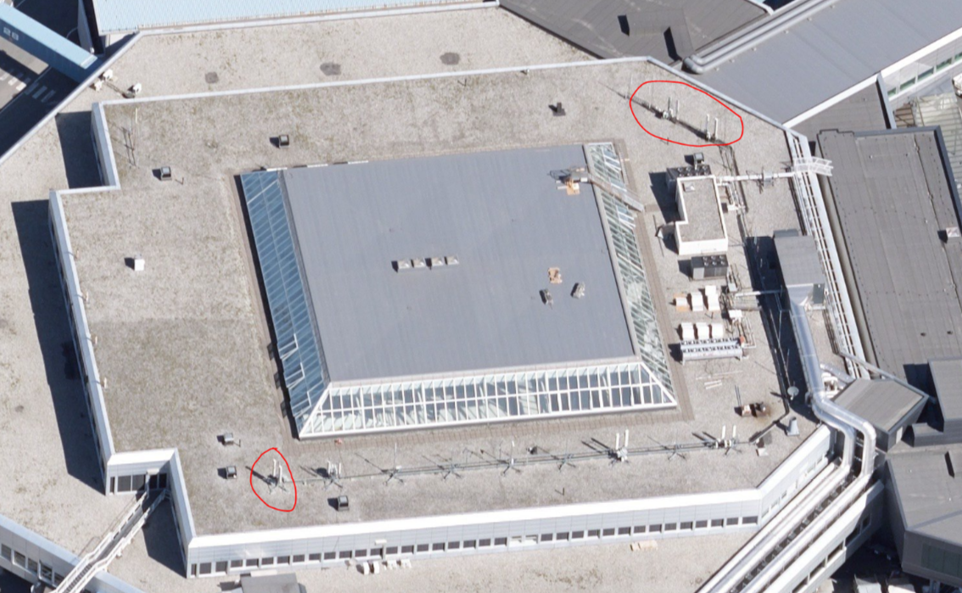
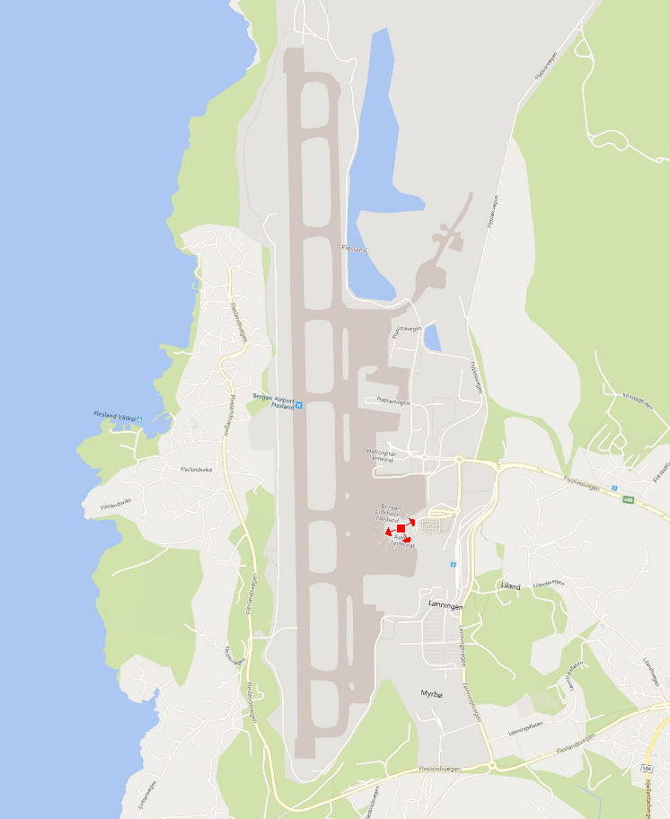
Figure 1: Location of the test base station at BGO
The test was performed using a commercial Ericsson 5G base station operating in the band 3700-3800 MHz. The base station is mounted on top of the roof of the terminal building (Terminal 2), and there were not made any changes in sector directions of the base station for testing purposes. This base station uses active antenna systems (AAS) antennas.
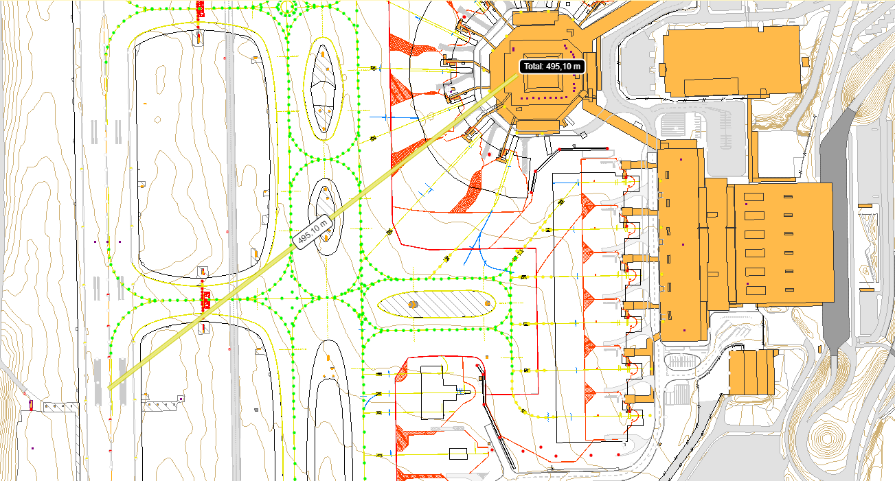
Figure 2: Distance to Touchdown Zone approx. 495m
Antenna with azimuth 250° points directly towards touchdown zone at the runway (RWY 35). The sector 150°, due to AAS, may influence the flight instruments during approach, therefore it has been sheduled to an emergency shutdown too, in case of any abnormalities under the test.
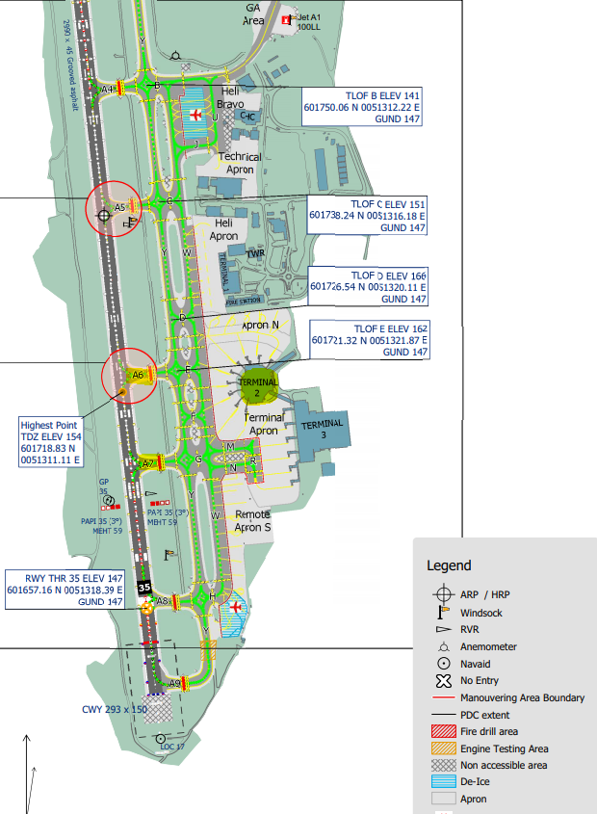
Touchdown zone
Avstand ca. 495m fra antenna
Location of 5G base station
For landing RWY 35 two sectors are active, 150° and 250°
Radiated power from antenna: max 100W pr element.
In real ca. 2 x 95W.
Figure 3: Detailed information about location of runway (RWY) and touchdown zone
    - Test prerequisites and procedure
The test prerequisites and procedure were developed by Avinor and Air Traffic Control.
The following prerequisites was required to perform test:
- All parties participating in the test (Air Traffic Control, Norwegian Communications Authority, Telia) must be in constant contact on-line during the entire test period.
- Air Traffic Control Tower (ATCT) Flesland frequency TWR (VHF/AM): 119,100 MHz
- Weather:
minimum visibility: 10 km
cloud base minimum: 3000 ft
- Flight control should separate aircrafts participating in the test from the other ones if it is needed.
- Do not enable 5G test-signal before touchdown of the previous plane unless it is also a part of the test.
- Flight control (tower frequency) immediately forwards the request to immediate shut down 5G base station in case pilot of the aircraft participating in the test requests it.
Test procedure:
- Nkom monitoring ATCT frequency and “Flightradar24” to clarify when the aircraft participating in the test is entering the test area.
- When the aircraft participating in the test is in position, enable the 5G base station at full power towards the aircraft.
- Turn of the 5G test-signal when the aircraft under test has touched down.
    - Setup of the 5G base station
The commercial 5G base station was set to test mode for emulation of approx. 100% traffic load. The 5G base station was still operational, when 5 handsets onboard the aircraft successfully connected to the base station during the test, after the landing. The use of beam forming during test mode is uncertain since it was not possible to measure it.
Table 1: Antenna parameters
Antenna: Ericsson AIR3239 B78G
Base station longitude | 5° 13' 39.92" E
Base station latitude | 60° 17' 20.8" N
Vertical beamwidth | 9.5° +/- 2°
Horizontal beamwidth | 65° +/- 5°
Front to back ratio | 25 dB
Antenna gain | 15,9 dBi
Antenna sectors azimuth | 60°, 150°, 250°
Antenna tilt | 6°
Antenna altitude AGL | 19 m
Base Station altitude ASL | 50 m

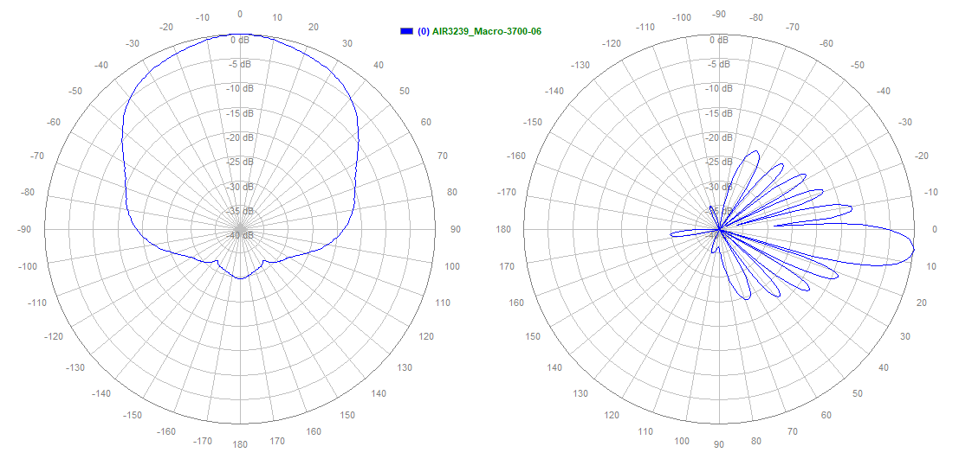
Figure 4: Antenna AIR3239 radiation pattern

Table 2: Test setup of Telia 5G base station
Radio: Ericsson Baseband 6630
Test mode | Air Interface Load Generator
Coverage mode | Macro
Power nominal | 44,77 dBm
Power radiated | 60,67 dBm
Modulation | 256 QAM
Downlink frequency | 3700-3800MHz
    - Aircraft types participating in the test
Aircrafts participating in the test are representative for Norwegian airports. The test consisted of aircrafts which are representative for aircrafts and helicopters landing at Norwegian airports.
      - Helicopters
- Sikorsky S-92A
- Airbus H145 (Eurocopter EC145)
- NH Industries NH90
      - Passenger aircrafts
- De Havilland Canada/Bombardier DHC-8-400
- De Havilland Canada/Bombardier DHC-8-300
- Boeing 737-705
- Airbus A320-232
- Embraer E190-E2
    - Radar types used in the test
Three different radio altimeters were used during the test: Sperry SPER RT 300, Honywell KRA 405 B and Rockwell Collins LRA-900. For two of the aircrafts (NH90 and Airbus A320neo) the type of radar altimeter was not identified.
Table 3: Radar types mounted in the aircrafts participating in the test
Aircraft | Radar type
Sikorsky S-92 | Sperry SPER RT 300
Airbus H145 | Honeywell KRA 405B
NH90 | Unknown
DHC-8-300 | Sperry SPER RT 300
DHC-8-Q400 | 2x Honeywell KRA 405B
B737-700 | 2x Rockwell Collins LRA-900
A320neo | Unknown
Embraer E190-E2 | Honeywell KRA 405B
  - Test results
    - Test time and weather conditions
Test date: 15. April 2021
Test time: 07:00 – 13:00 (05:00-11:00 UTC)
Weather conditions: CAVOK (Clouds and Visibility OK)
Wind: 5 kn, 350°
Visibility: 10+ km
    - Position of Nkom's monitoring point
Table 4: Position of measurement point
Position | Latitude | Longitude
True position of antenna az. 250° of Telia's 5G base station | 60° 17' 19.608" | 5° 13' 37.956"
Nkom position (MP1) | 60° 17' 4.668" | 5° 13' 44.472"
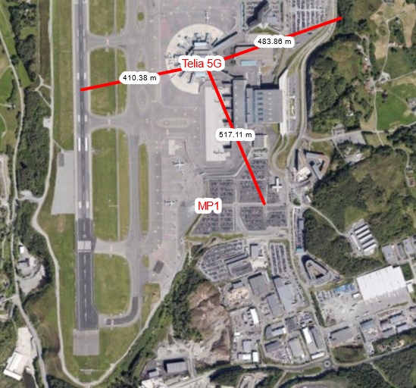
Figure 5: Location of Nkom's measurement point
    - Readout from Nkom's and Telia's monitors
Table 5: Nkom's instrumentation
Instrument | Usage
R&S EB500 (1) | Telia 5G base station test mode logging
R&S EB500 (2) | Visual verification of Telia 5G base station test mode
R&S PR200 | ATCT monitoring channel, verification of flights
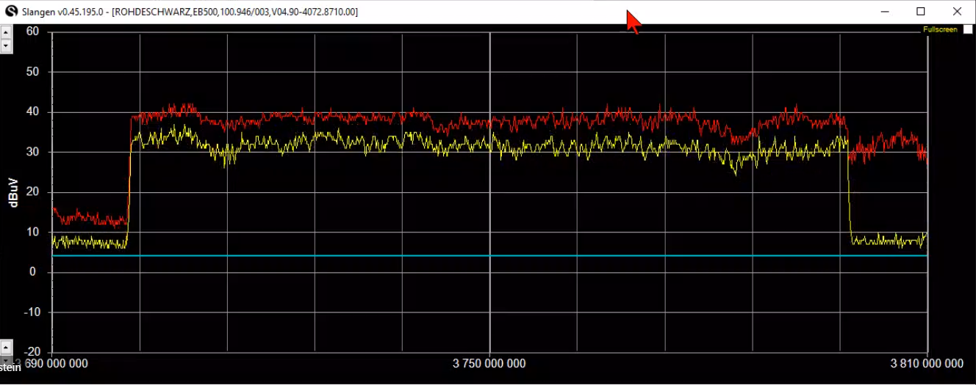
Figure 6: Signal measured in Nkoms position
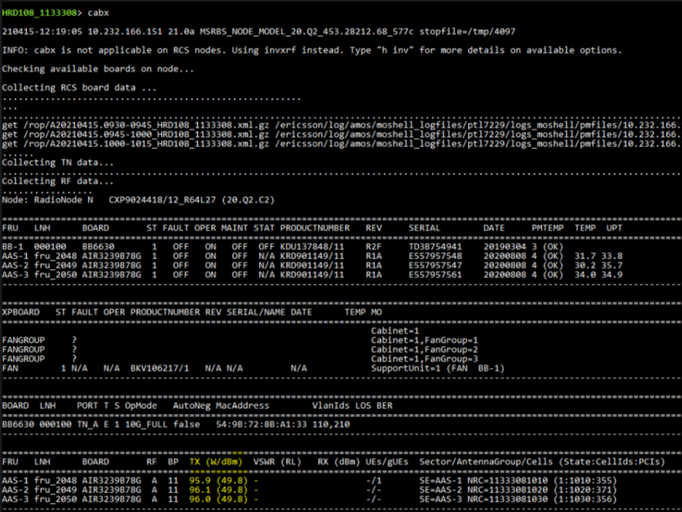
Figure 7: Power rapported by base station software
    - Test log
Table 6: Test log
Aircraft type | Landing | Comment
Sikorsky S-92A | ILS RWY 35 | No abnormalities. Status of Rad-Alt continuously monitored
DHC-8-400 | ILS RWY 35 | No abnormalities. Status of Rad-Alt continuously monitored
Boeing B737-705 | ILS RWY 35  (auto-landing) | No abnormalities.  Auto-landing on RWY 35.
DHC-8-300 | Visual RWY 17 | No abnormalities. Status of Rad-Alt and EGPWS continuously monitored
DHC-8-400 | Visual RWY 17 | No comments from crew all OK.
H145 HEMS | ILS Y RWY 35 | Route shown in Figure 8  Helicopter exposes for 5G signal ca. 10 NM from the airport, it means ca. from establishing of ILS connection. After passing TDZ:  - hover taxi RWY 35  - exit RWY @ A6,  - holding for other departing traffic  - enter RWY @ A7,  - departure (visual) RWY 35  - return to base
Airbus A320-232 | ILS RWY 35 | No comments from crew all OK
Embraer E190-E2 | Visual RWY 35 | No comments from crew all OK  Base station notes 2 connections from the mobile device located onboard aircraft
NH90 | Low approach RWY 35 | No comments from crew all OK
Sikorsky S-92A | Departure RWY 35  enter RWY @ A7 | No abnormalities. Status of Rad-Alt continuously monitored

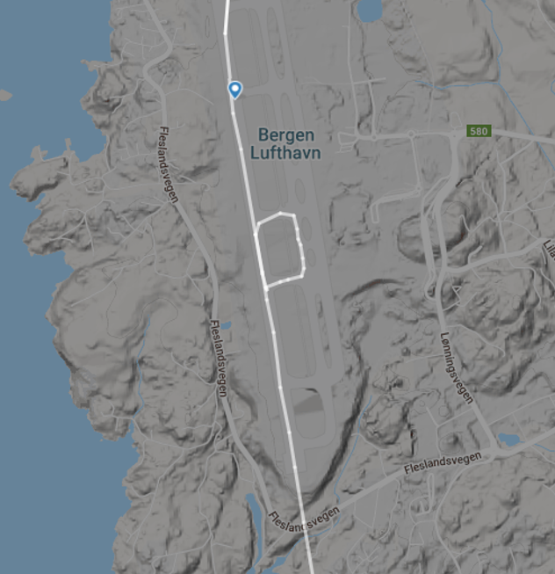
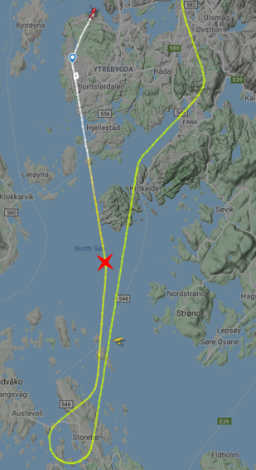
Figure 8: Path of the H145 HEMS - red cross indicates estabilishing of ILS connection (picture from "Flightradar24")
  - Conclusions
The tests were carried out with a wide range of aircrafts representative for aircrafts landing at Norwegian airports
Test results showed no abnormalities on the Radio Altimeters during the test.
During the test the base station transmitted 100% of power with help of the air interface load generator. The aircrafts participating in the test have passed by antennas of the base station at the distance of less than 500 m taxiing along the runway, while helicopters using helipad passed antennas at distances of 200 m.
During the test pilots have been instructed to continuously observe radio altimeters and other systems related to start and landing operations. There were not reported any abnormalities or signs of interference towards radio altimeters and related systems, such as EGPWS (Enhanced Ground Proximity Warning System).
There were no reports related to interference or errors of TCAS/ACAS (Traffic Collision Avoidance System/Airborne Collision Avoidance System), auto-landing functions or "cockpit call-outs".
It is worth to point out, that most of the aircrafts used in the test are relative new ones.

- Description of preliminary trials on one type of helicopter of the French gendarmerie
  - Purpose
The aim of the test is to assess the impact of the 5G NR mobile network on the operational behaviour of altimeter installed onboard the EC135 helicopters of the French gendarmerie.
The helicopter flew at different distances from the 5G NR base station, at multiple altitudes and roll and pitch angles in such a way as to get configurations which would ease the radio altimeter disturbances.
No specific instrumentation or aircraft modifications were performed for this test.
  - Configurations
Prior to the flight and in order to increase the probability of being disturbed, half a day was spent refining the actual position of the main lobe of the 5G NR Base station’s antenna by an ANFR instrumented vehicle. Following these measurements, the direction of the main lobe was marked on the ground by the presence of the ANFR vehicle at point B, visible from the helicopter in flight.
The 5G NR base station was configured to provide the maximum worst-case 78dBm eirp on a 60 MHz channel in the 3640-3710 MHz frequency range.
In the test, a DGPS was used to record the coordinates and altitude of the helicopter. 5G signal level is recorded by the 5G test UE in the helicopter.
  - Flight analysis
All the test points were completed except for the first part of run #2 "fixed beam" where the 5G could not be continuously activated by user equipment on the ground. The three 5G NR user equipment on the ground had in turn overheated (high data rates causing the chips to overheat and an outside temperature of 35°C), so this run was interrupted to continue with run #3 "free beam", leaving time to find the nominal operation of user equipment on the ground and to complete run #2. Below, the GPS tracks of the helicopter and the different test configurations.
Table 7:
Test runs | 5G NR base station | UE on ground | UE on board
1 – Identification | OFF | OFF | OFF
2 – «fixed beam» | ON | ON | OFF
3 – «free beam» | ON | OFF | ON
4 – 1500 ft flight | ON | OFF | ON

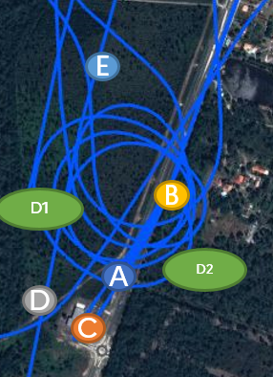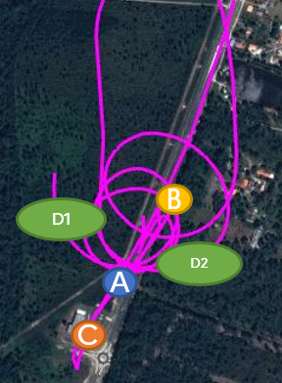
5G NR base station
2
1
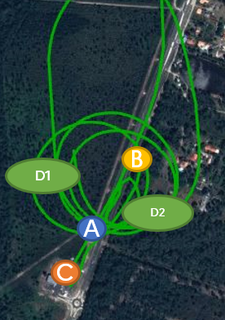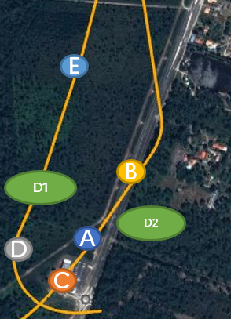
5G NR base station
4
3
Figure 9: GPS trajectories of the helicopter during runs 1 to 4
As an indication and from the barometric measurements (not accurate) taken by the recorder on board the EC135, the altitude indication throughout the flight. The same colour code as the GPS tracks above has been kept to facilitate the understanding of the flight profile.
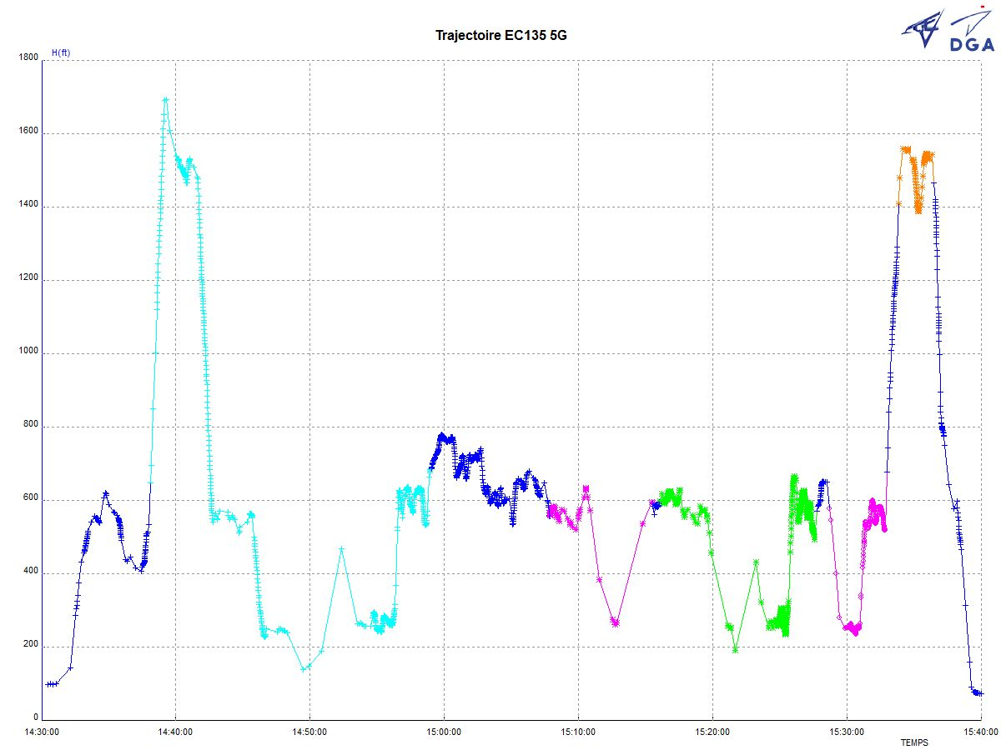
Figure 10:
  - Conclusion of the test
No disturbance to the radio altimeter on board the EC135 of the French gendarmerie was detected during the flight, when using the 5G in the configuration for the test flight. In view of these in-flight observations, the emission of 5G NR base station had no impact on the operational behaviour of the radio altimeter fitted on the French gendarmerie's EC135 helicopters, which gives us a good level of confidence in the resilience of this type of radio altimeter to conduct its missions.

- List of References
- ECC Decision
- EC Decision
- EECC
- ETSI TS
- 3GPP TS
- RTCA report
- SRAS Standard
- etc.

