ECC PT1 |  |  | ECC PT1(23)196r1
ECC PT1 #76
Hybrid: Berlin and web meeting, 6-8 September 2023
Date issued: | 30th August 2023
Source: | LS Telcom, Meta
Subject: | MFCN and RLAN shared use of the band 6425-7125 MHz
Group membership required to read? (Y/N) |  | N
Summary:
Both IMT and RLAN stakeholders claim additional spectrum requirements within the 6425-7125 MHz band. The areas with highest spectrum demands are identical for both IMT and RLANs, namely areas with the highest population density. In a country like Germany, shared use of spectrum is expected to be relevant in limited geographical areas with the highest population density.
Aligning with ITU 5D and SE45 assumptions, an IMT sector and RLANs are positioned in the city centre of Frankfurt, all operating on 80MHz co-channel. Shared use of spectrum is limited with full IMT BS transmit power, as the IMT signal indoor triggers the Channel Access Mechanism of RLAN devices which therefore vacate the channel. Combining reduced IMT BS transmit power with an adjusted RLAN Energy Detection Threshold enables shared spectrum use, with an acceptable impact on the QoS of the IMT DL and the RLAN.
The study assumed that IMT UEs do not operate indoor, an assumption that must be further investigated subsequently. Implementation challenges raised by the lowering of the RLAN Energy Detection Threshold were not assessed by the study.
Shared use of spectrum enables improved connectivity for both RLAN and IMT, in the sense that both RLAN and IMT would get access to additional spectrum. Shared use of spectrum is susceptible to align with environmental considerations, by delivering environmental benefits for both RLAN and IMT, while removing the power wasted in building entry/exit loss.
Proposal:
invites the Group to
Include the material in the draft ECC report on the Feasibility of shared use of the 6425-7125 MHz frequency band by MFCN and WAS/RLAN.
Acknowledge that shared use of the band 6425-7125 MHz by IMT and RLAN is feasible, yet it will lead in a few locally and timely limited cases of interference between IMT and RLAN.
Consider reduction of the IMT BS maximum transmit power to enable RLAN LPI operation within IMT cells.
Consider adjustment of RLAN’s Energy Detection Threshold to minimise interference from RLAN to IMT BSs.
Acknowledge that accidental indoor usage of IMT UE needs to be further investigated.
Acknowledge that implementation challenges and costs linked to the proposals must be further investigated.
Background:
Work Item PT1_50 considers the feasibility of shared use of the 6425-7125 MHz frequency band by MFCN and WAS/RLAN.
ECC PT1(23)122 provided a preliminary analysis of the interference situation by focusing on maximum EIRP for all devices.
A more precise analysis is provided by considering the parameters agreed respectively in ITU WP 5D (MFCN) and SE45 (RLANs) and focusing on a hypothetical cell in the heart of Frankfurt, Germany.

[Attachment (if any): Enter fine name]

Geographical areas of interest for MFCN and RLAN in upper 6GHz Band

Areas of interest for IMT @ 6GHz
IMT stakeholders highlight the potential of the 6425-7125 MHz band as a capacity extension mid-band. IMT stakeholders argue that the propagation characteristics of the upper 6GHz band are close enough to the 3400-3800 MHz band to extend the capacity of 5G networks @ 3.5 GHz by simply reusing the same sites and therefore avoiding network densification.
Coleago Consulting Ltd for GSMA published in July 2021 a report on Estimating the mid-band spectrum needs in the 2025-2030 time frame, while Analysys-Mason published in June 2023 a report on Impact of additional mid-band spectrum on the carbon footprint of 5G mobile networks: the case of the upper 6GHz band. Both reports present the benefits related to opening the upper 6GHz band by focusing on dense urban areas. The Coleago report focuses on areas with population density ranging from 8000 to 31000 hab/km2, with a central focus on 15000 hab/km2, while Analysys-Mason focuses on a population density of 15000 hab/km2. The GSMA Intelligence June 2022 report on the Socioeconomic benefits of the 6GHz band is also focusing on urban areas.
Some opportunities for intermittent IMT uses were also discussed for areas with a potential for very high user density, e.g. football stadium.
While the IMT spectrum requirement claims are disputed, the focus of 6 GHz potential deployments on urban areas seems consensual.

High level analysis of geographical relevant areas in the EU
In the EU context, it is informative to understand which areas would be the focus of 6GHz IMT deployment according to IMT stakeholders. In the European Union, only 9 cities have a population density above 15000 hab/km2 and only 22 cities have a population density above 8000 hab/km² (see Table 1).
Table 1: EU cities with highest population density
City | Habitants | Geographical area (km²) | Population density (hab/km²⁾ | Country
Levallois-Perret | 66,082 | 2.41 | 27,420 | France
Emperador | 692 | 0.03 | 23,067 | Spain
L'Hospitalet de Llobregat | 264,923 | 12.4 | 21,364 | Spain
Paris | 2,203,817 | 105.4 | 20,909 | France
Mislata | 43,278 | 2.1 | 20,608 | Spain
Benetússer | 14,668 | 0.76 | 19,300 | Spain
Athens | 745,514 | 38.96 | 19,135 | Greece
Thessaloniki | 325,182 | 19.31 | 16,840 | Greece
Barcelona | 1,621,537 | 101.9 | 15,991 | Spain
Korydallos | 63,445 | 4.32 | 14,686 | Greece
Senglea | 2,784 | 0.2 | 13,920 | Malta
Nikaia | 89,380 | 6.65 | 13,441 | Greece
Portici | 53,801 | 4.52 | 11,903 | Italy
Odivelas | 59,604 | 5.02 | 11,873 | Portugal
Casavatore | 18,644 | 1.62 | 11,508 | Italy
San Giorgio a Cremano | 47,244 | 4.11 | 11,495 | Italy
Lyon | 500,715 | 47.87 | 10,460 | France
Cádiz | 116,979 | 12.1 | 9,700 | Spain
Piraeus | 448,997 | 50.42 | 8,906 | Greece
Bilbao | 353,187 | 40.65 | 8,688 | Spain
Bucharest | 1,926,334 | 228 | 8,449 | Romania
Naples | 959,574 | 117.27 | 8,183 | Italy
Cities with more than 15000 hab/km2 represent 1% of the EU population and cover 0.007% of the EU geographical area (see Table below). Cities with more than 8000 hab/km² gather 2.2% of the EU population and extend on 0.02% of the EU geographical area.
Table 2: EU cities population density and geographical spread
EU cities classification | Population | Area
With pop density >15000 hab/km² | 5,285,693 hab. | 283 km2
With pop density >15000 hab/km² | 1% of EU pop. | 7.E-03% of EU area
With pop density >8000 hab/km² | 9,926,381 hab. | 806 km2
With pop density >8000 hab/km² | 2.2% of EU pop. | 0.02% of EU area
The data presented above provides a good first order estimate of the extent of the benefits of this band for IMT. However, the population density within cities is not always constant and some neighbourhood of cities may exceed the 8000 hab/km² threshold even though the whole city remains below 8000 hab/km².

Detailed analysis – Germany
A more detailed analysis focusing on Germany is conducted below. The Table 3 below lists the 16 cities with population density higher than 2500 hab/km². None of these cities exceed the 8000 hab/km² threshold, let alone the 15000 hab/km² threshold.
Table 3: German cities with highest population density
City | Geographical area (km²) | Habitants | Population density (hab/km²⁾
München | 310.7 | 1487708 | 4788
Ottobrunn⁠ | 5.23 | 21719 | 4153
Berlin | 891.12 | 3677472 | 4127
Gröbenzell⁠ | 6.36 | 19649 | 3089
Frankfurt am Main | 248.31 | 759224 | 3058
Herne | 51.42 | 156621 | 3046
Stuttgart | 207.33 | 626275 | 3021
Offenbach am Main | 44.88 | 131295 | 2925
Düsseldorf | 217.41 | 619477 | 2849
Essen | 210.34 | 579432 | 2755
Nürnberg | 186.45 | 510632 | 2739
Oberhausen | 77.09 | 208752 | 2708
Eppelheim | 5.7 | 15359 | 2695
Glienicke/Nordbahn⁠ | 4.61 | 12403 | 2690
Köln | 405.01 | 1073096 | 2650
Hannover | 204.3 | 535932 | 2623
An estimation of the geographical areas that would benefit from an IMT deployment at 6GHz can be estimated by identifying the neighbourhood within these 16 cities with a population density exceeding respectively 8000 and 15000 hab/km². Table 4 below provides the summary of these areas, with respectively more than 8000 and 15000 hab/km², while the full detail is provided in the Annex.
Table 4: Areas of German cities with population density above 8000 hab/km².
Areas of cities with population density >8000 hab/km² | Geographical area (km²) | Habitants
München | 34.3 | 415986
Berlin | 59.63 | 688830
Frankfurt | 12.441 | 133155
Düsseldorf | 7.18 | 62340
Essen | 10.06 | 94873
Nürnberg | 16.141 | 214098
Köln | 23.43 | 238997
Hannover | 6.83 | 77060
Total | 170 | 1925339
Total (% of 16 cities) | 5.52 | 18.4
Total (% of Germany) | 0.048 | 2.31
The neighbourhoods of German cities exceeding 8000 hab/km² cover 5% of the geographical area of these cities and 18% of their population. The same areas correspond to 0.05% of the German territory and 2.3% of the population.
Table 5: Areas of German cities with highest population density above 15000 hab/km².
Areas of cities with population density >15000 hab/km² | Geographical area (km²) | Habitants
München | 8.58 | 131986
Nürnberg | 2.44 | 50811
Total | 11.0 | 182797
Total (% of 16 cities) | 0.357 | 1.75
Total (% of Germany) | 0.003 | 0.22
The neighbourhoods of German cities exceeding 15000 hab/km² cover 0.4% of the geographical area of these cities and less than 2% of their population. The same areas correspond to 0.003% of the German territory and 0.2% of the population.

Areas of interest for Wi-Fi @ 6GHz
Wi-Fi interest in the upper 6GHz band is driven by two complementary market demands:
- Gigabit Wi-Fi for indoor connectivity,
- Personal area networks for portable devices (e.g. AR/VR).
Gigabit Wi-Fi is required by consumer to distribute fibre connectivity within buildings. For a single access point, a 160 or 320 MHz channel is required to distribute gigabit connectivity. For large buildings (large house, schools, universities, offices, public buildings), multiple access points are required to provide coverage throughout the venue. 7 channels of 160 MHz are required to provide continuous gigabit coverage in dense areas (e.g. university campuses, large corporate offices, hospitals, shopping malls).
Gigabit Wi-Fi is required everywhere where gigabit connectivity is available. EU 2030 targets include achieving gigabit connectivity to each building, suggesting that gigabit Wi-Fi will be required in each building. For a single isolated house, the 5945-6425 MHz is likely to be sufficient to distribute gigabit connectivity within the house. However, the spectrum requirements increase with the population density. For example, the campuses of both the Technische Universität München (TUM) and the Ludwig-Maximilians-Universität (LMU) are located in Maxvorstadt, one of the densest areas in Munich with more than 12000 hab/km². The areas with the highest Wi-Fi spectrum demand are also the areas with the highest population density. The Digital Economy and Society Index (DESI) reports that Fibre to the Premises coverage/availability reaches 56.5% of EU households as of 2022, with almost ubiquitous coverage in dense urban areas. Fibre to the premises outreach is expected to increase quickly to fulfil the EU 2030 targets. This confirms that fixed connectivity is sufficiently available, especially in dense urban areas. Wi-Fi 6E and 7 can offer a Quality of Service similar to that of an IMT connection, with a much lower energy consumption. Several reports confirmed the demand for more than 3 channels of 160 MHz in 6 GHz frequency range to deliver the requested user experience.
Areas of interest for intermittent IMT use are also areas of interest for high density RLAN use. Stadiums are deploying dense Wi-Fi networks to provide state-of-the-art connectivity to their customers.
Additional Wi-Fi spectrum is also required for personal area networks and AR/VR. Innovative devices such as AR/VR devices leverage VLP Wi-Fi to transmit very large amount of data at very short distance with minimal energy consumption. Such use cases depend on maximising the data rates to reduce the activity factor and therefore reduce the drain on the battery. Availability of channels with low interference will impact the Quality of Experience of such devices. AR/VR are one of the areas expected to drive digital innovation in the coming decade and Wi-Fi connectivity is fundamental to enable AR/VR.

IMT interest for 6GHz and IMT-RLAN sharing in the upper 6GHz
The geographical area where IMT stakeholders expect 5G networks to be deployed in 6425-7125 MHz represent a very small percentage of the geography and population, particularly in Europe. Even within large cities, IMT stakeholders’ studies indicate that 6 GHz IMT networks would only be deployed in denser neighbourhoods, i.e. over a fraction of a city’s geography.
Furthermore, mobile networks’ coverage at 6 GHz will vary between operators. As a result, a subset of the 6 GHz range will not be used for IMT, and thus some frequency channels may be available to WLAN systems on a local basis. This would require WLAN to leverage fragmented spectrum to recreate wide channels.
Such focused deployment on very dense urban areas directly opens a sharing opportunity, as most geographical areas – including in large cities – would not be covered by all national available IMT networks and would therefore be fully or partially available to Wi-Fi. However, the areas of highest interest for IMT are also the areas with the highest spectrum demand for Wi-Fi.
Enabling Gigabit Wi-Fi within buildings and local IMT outdoor in such high population density areas would maximise the use of spectrum. In contrast, such a sharing scenario would mean IMT coverage indoor or Wi-Fi coverage outdoor is not possible in the 6 GHz in dense urban areas where both technologies would be deployed.
ECC PT1(23)122 demonstrated that Wi-Fi would suffer from significant interference should IMT be deployed outdoor at maximum EIRP and that both Wi-Fi and IMT would suffer from interference in a shared use scenario.
The present report investigates how best to enable sharing between IMT outdoor and Wi-Fi indoor, in dense urban areas, under the assumptions that such sharing would occur in limited geographical zones. The report also proposes solution to achieve a shared use of the band.

Assumptions for the study

Concept studied
The study considers:
- IMT is operating outdoor,
- RLANs are operating indoor, under the SE45 assumptions,
- IMT UEs do not connect to IMT networks from indoor, RLAN devices do not connect from outdoor to RLAN Access Points indoor.
- Both IMT and RLAN operate over 80 MHz channel, fully co-channel.
- Interference was considered in terms of SINR, not I/N.

IMT assumptions
The assumptions for IMT UEs and BSs were aligned with document ITU 5D/716.
The study positions an IMT sector (under the ITU WP 5D assumptions) in the centre of Frankfurt, overlapping the Altstadt and Innenstadt districts. The IMT signal level for each 1x1m pixel at 1.5m height is evaluated and the distribution of the IMT signal is determined both indoor and outdoor.
A single sector was simulated over a 800x800m simulation area, but only the sector itself (300m radius circle, 120 degrees) was taken into account to determine the signal distribution.

RLAN Assumptions
The RLAN assumptions were mostly aligned with SE45 assumptions.
The study positions 130 RLANs indoor and determine the interference both for IMT UEs and IMT BSs. The RLAN signal level for each 1x1m pixel at 1.5m height is evaluated and the distribution of the RLAN signal outdoor is evaluated.
For the initial determination of the RLAN signal distribution, 130 RLANs were spread over a 800x800m simulation area and transmit at 23 dBm at 1.5m height. The distribution was then shifted to reflect the SE45 assumptions, depending on the population density considered.
The RLAN e.i.r.p. is aligned with assumption in ECC Report 316, according to Table 6.
Table 6: e.i.r.p. distribution for indoor WAS/RLAN devices
Indoor power (mW)  (Body Loss included) | 200 | 100 | 50 | 13 | 1 | 40 | 20 | 5 | Total
Indoor percentage | 9.81 | 4.39 | 13.76 | 39.63 | 5.62 | 1.85 | 12.25 | 12.69 | 100%
The RLAN deployment parameters considered for this study are directly following the “High” model of ECC Report 316, adjusted to consider the 6415-7125 MHz band (instead of 5945-6425 MHz).
Table 7: Summary of RLAN deployment model, aligned with ECC Report 316
Parameter | Value
Wireless devices operating in licence-exempt spectrum | 90%
Busy Hour Factor | 62.7%
U6GHz factor (U6/(U6+L6+5GHz+2.4GHz) | 41%
Market Adoption Factor (U6 capable devices) | 50%
RF activity factor per person (duty cycle) | 1.97%
Bandwidth overlap factor, i.e. 80/(7125-6425) | 11%
Several population densities were considered:
- Frankfurt’s average population density, 3058 hab/km²,
- Coleago’s low, medium and high guidance for areas of interest to IMT, i.e. 8000/15000/31000 hab/km²)
Frankfurt’s Altstadt and Innerstadt neighbourhood, where the sector is located, have population densities of respectively 8900 and 4200 hab/km², confirming that the range 3000-31000 hab/km² covers the relevant population densities.
The RLAN Energy Detection Threshold is initially set at -66dBm/80MHz (corresponding to -85dBm/MHz, as set by EN 303687). The EDT level is modified when indicated below.
The RLAN receive parameters considered are provided in the Table 8.
Table 8: RLAN Rx parameters
Parameter | Value
RLAN Noise Figure | 9 dB
RLAN minimum SNR (IEEE 802.11 be) | 4 dB
RLAN maximum SNR (IEEE 802.11 be) | 40 dB
RLAN 80 MHz signal RSSI (SE45(23)008R2) | Mean: -49.5 dBm  Std: 9.3 dB

Methodology
The methodology used for the analysis is based on an evolution of a previous analysis (ECC PT1(23)122) that considered a point-to-point investigation modelling cumulative interference from a small number of simplified IMT sites to a sample RLAN installation in a theoretical simplified single room Paris Apartment. ECC PT1(23)122 also considered that all devices transmitted at maximum EIRP, as a first order analysis.
In order to model the scenario more realistically, it was decided to utilise a more sophisticated commercial modelling tool and undertake a more in-depth assessment. The model includes real terrain and clutter data to model a landscape and can output results in a gridded ascii format that could be post-processed in other tools or displayed in a GIS.
All the modelling takes place within a specific ‘moment in time’ scenario over an 850x850m area, where three UEs, one to a beam, giving three beams in use, are each utilising 1/3 of the total capacity of the site.
All calculations, be they ‘coverage’ or path loss and interference, take place in this instant in time and will be different for every potential combination of scenarios possible on an urban macro site.

modelling considerations
The scenario was intended to be realistic, however the terrain is necessarily reduced to a simplified 1m raster of height values, and the clutter/morpho layer is similarly represented, although the layout of buildings and their heights are accurately represented within the limitations of a 1m raster. The results are based on a specific scenario and need to be modelled in such a way as to remain broadly representative without losing the specificity.
Table 9: Modelling considerations
Type | Format | Extent
Height and Value | LS telcom specific | Frankfurt Am Main city centre
The terrain and clutter data created specifically for the tool used (LS telcom’s CHIRplus_TC 2.7.1.0) covers the city centre area of Frankfurt Am Main at 1m intervals.
Buildings were represented in the clutter dataset by their footprint and actual height, rather than being estimated based on clutter classes, although they were also assigned specific clutter classes to satisfy the demands of the propagation model. The software uses clutter height values in the model configuration if actual values are not present in the clutter data.
The tool has a choice of several propagation models, but most are designed around the needs of wide-area network or point-to-point link design. However, it does have P.452, which is suitable for the assessment of interference, and this was used in a previous study in Frankfurt Main for SE45, and therefore we used P.452 for the coverage and path loss calculations.
Table 10: Propagation model parameters
Model | Version | Time
P.452 | 17 | 50%
ITU-R P.452 is a Deterministic model, so the results are reproducible. The model is usually used to predict interference events for very small percentages of time, but this is configurable, so we set the value to 50%, which is representative of a consumer-quality coverage level.
Clutter loss (Recommendation ITU-R P.2108-1) was added through post processing.
Limitations
Known limitations to the simulation are:
- Model complexity increases with every RLAN AP height, so the height of the APs was initially fixed at 1.5m above terrain, and within the building clutter. Each extra height included doubles the amount of simulation required, although it is possible to combine the results in post processing.
- Upper 6 GHz signals do not diffract appreciably, and propagation models such as P.452 do not reflect that particularly well as most are not designed to operate above 3 GHz or have serious limitations in other ways. In the real world of Upper 6 GHz if the receiver is behind an obstruction, it is the signal that travels through the obstruction or is reflected off a surface directly illuminated by the transmitter that tends to be dominant. The effect on the IMT site is that it would not be expected to directly cover much more than rooftops and a small area of street that was line-of-sight. Other areas would be severely affected by multipath propagation.
- This modelling does not take into account the fact that both technologies have alternative bands or in-band channels that the UEs or Clients can use, and they will switch to them automatically based on signal to noise criteria. In general, end users will be unaware of the change.
The modelling software used is LS telcom’s CHIRplus_TC, which is a fast-evolving general-purpose RF and coverage planning tool. It has applicability in most areas of design from fixed links to IMT, GSM-R to PMR, and emerging requirements such as FRMCS. Most of the screenshots in this part of the document are from CHIRplus_TC.
Table 11: Modelling tool details
Name | Version | Suitability | Supplier
CHIRplus_TC | 2.7.1.0 | Mobile | LS telcom

imt transmit configurations
The IMT transmit site is modelled with only three beams (out of eight), with one UE operating in each (as per WP 5D assumptions), taking 1/3 of the capacity of the site, therefore 1/3 of the transmitted power in each beam.
Note: The pattern is more important than the antenna gain in this tool, so any ‘gain’ (within limits as it affects the path loss calculations) can be used so long as it adds up to 1/3 of the maximum EIRP of 68dBm. We show the summary technical parameters and antenna pattern (horizontal and vertical) used in the model.
Table 12: IMT transmit parameters
Power | AAS Gain | EIRP | BW | Location | Numerology
40 dBm | 23 dBi | 63 dBm | 80 MHz | Outdoors | 30kHz.217RB/80MHz
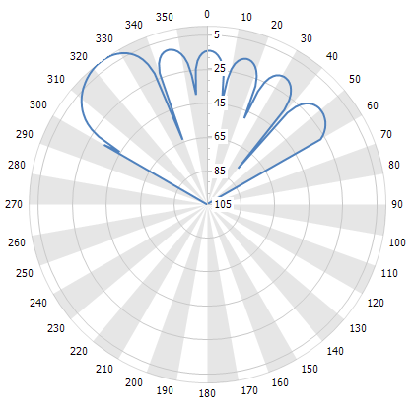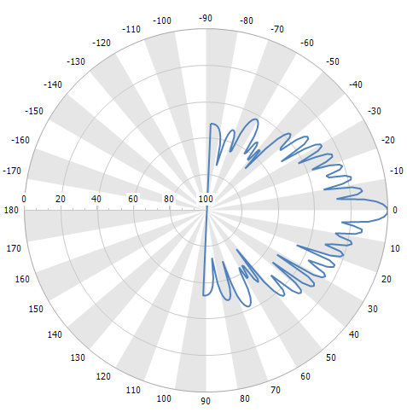
Figure 1: Sample IMT horizontal and vertical antenna pattern (Beam 2)

Figure 1 illustrates Beam 2 (Azimuth and Elevation). Eight beams were defined as individual patterns, which differ mainly in the azimuth of maximum radiation
Note 1: The antenna pattern elevation is 0 degrees. Elevation is set in the tool, with the beam aiming at the edge of the cell (-6 degrees), although it is also possible to assign different patterns for each elevation as they do change to some extent due to the way the pattern is generated in the AAS.
Note 2: The patterns have been truncated at 120 and 180 degrees to ensure that the modelling happens only in the sector of interest and does not affect any other sectors. This kind of pattern would not be used under normal network design circumstances.
The horizontal plane antenna patterns in the software are all normalised to 0 degrees. This allows for beam patterns to share the same sector azimuth as defined in the software, but still radiate in the intended direction. It is not necessary to do this, but it makes management of the sector easier as they all share the same ‘sector azimuth’ and when using truncated patterns, it improves the visual effect and normalises the results.
Note that AAS ‘beams’ at 6GHz are not particularly directional and contain a large number of sidelobes. The sidelobes at higher elevations result in significant levels of RF going over the horizon or hitting the ground at functionally short distances, but at levels likely to cause interference if downtilt is used.

rlan transmit configuration
The RLAN configuration do not differ significantly to the IMT sector, except for the power: 23 dBm EIRP using an omnidirectional antenna of lower gain (end-fed dipole). The building entry loss adds 21.5 dB attenuation whilst in the building, resulting in an equivalent EIRP inside (and outside) the building of 3.65 dBm.
Propagation models will add a building/clutter entry loss, but if the emission originates within a building, then an initial building egress loss needs to be attributed to it.

imt transmit only
This is a coverage plot (only), assuming power in a channel rather than any service parameter as the victim is not interested in the power of, say, a resource block, but in the noise floor degradation that the emission as a whole presents to it.
The coverage is calculated using P.452. All the calculations in this study use the same model, terrain, clutter and prediction area for consistency.
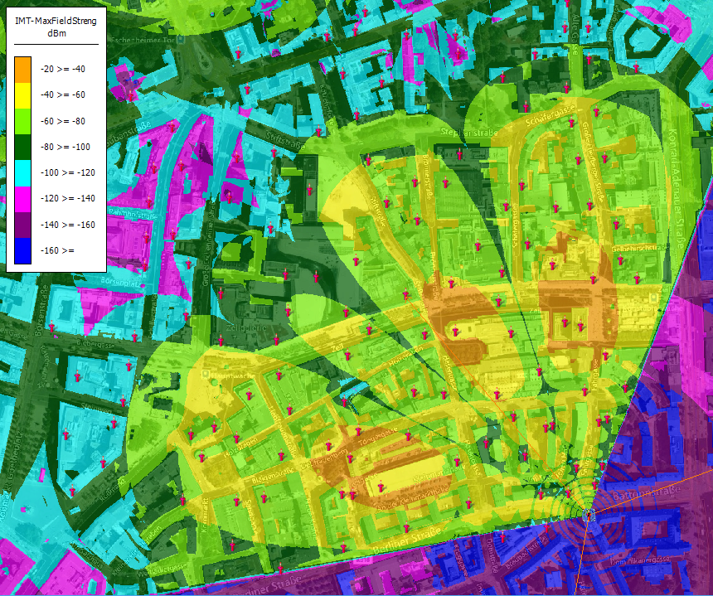
Figure 2: IMT coverage plot of three beams
This 850x850m plot (Figure 2) shows the available power spread across three beams, because there is one user in each beam, and they are sharing the capacity of the site equally.
Note 1: This plot does not show the ‘coverage’ of the sector, but the coverage if the TRP is divided equally between three beams. If the TRP was concentrated in one beam, then the coverage would be 5dB better in the specific direction of the beam. A site coverage plot would use TRP on each beam to show the maximum coverage achievable, which would result in a ‘range’ 2-3x better than shown here.
Note 2: Sidelobes on each beam do not interfere with other beams because the traffic on them is not being carried on resource blocks in the other beams. The effect to a receiver is that it is possible other traffic in other beams could be seen as little as 10dB below the traffic in the wanted beam.
This scenario (3 UEs, one to a beam) is also used for calculating the interference from RLAN into the IMT base station at that point in time.

imt with rlan sharing
IMT is operating outdoors from rooftop macro sites in an urban setting with UEs also outdoors, but liable to be operating close to buildings with RLANs installed.
This can be modelled by taking the power sum service area of the IMT from Part 1 and subtracting the aggregate service plot of the RLAN from it. The result is the Signal to Noise margin of the IMT at that moment in time.
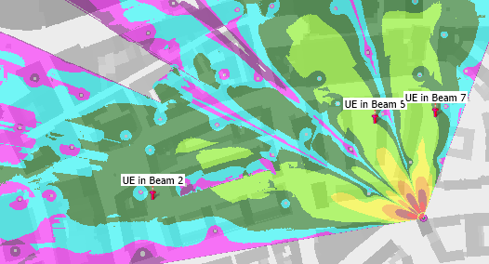
Figure 3: IMT with RLAN sharing
Figure 3 shows the SNIR plot for the IMT sector, showing three sample UEs.
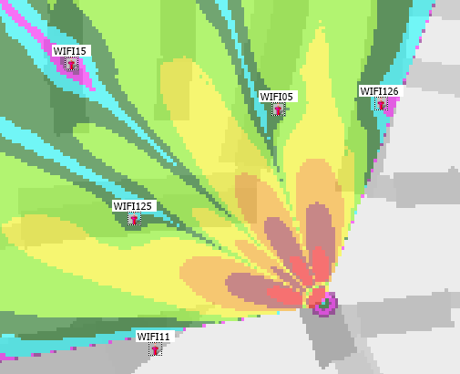
Figure 4: RLAN APs in vicinity of IMT BS sectors (interference margin)
Figure 4 shows the RLAN APs in the vicinity of the Sector.

rlan transmit only
In this scenario, we simulated RLAN APs on their own. The only constraints to the service are physical, such as walls and ceilings, and perhaps from other RLAN installations in neighbouring buildings/apartments but this was not considered in the analysis.
To properly model the effect of objects within clutter represented as buildings, it is necessary to include an ‘egress attenuation’ to them so the signal outside the building starts at the right level. This can be done in two ways: Decrease the initial power by 21.5dB (building entry loss) or including a building loss in the calculation. CHIRplus_TC can do either, but we chose to use a building loss figure because it was more convenient for modelling.
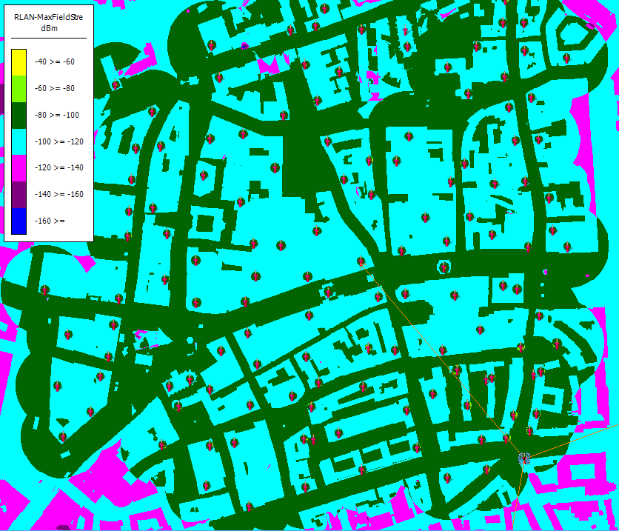
Figure 5: Outdoor signal level of multiple RLAN APs
Total RLAN coverage is shown in Figure 5. It is important to understand that the way the model works, the in-building coverage is not properly represented, but the outdoor coverage is, which is where it would be used to model the rise in noise floor from what is a rather high level of concurrent RLAN use.

rlan with imt sharing
RLAN is operating indoors in the vicinity of a single IMT sector consisting of 8 traffic beams. Only three beams are in use (1/3 power in each beam) with one UE in each beam consuming 1/3 of the site’s capacity.
The job of the software was to calculate the overall coverage of the RLAN installations as shown above, this was compared (using post processing) with the IMT scenario coverage. However, a sample visualisation of the effect is shown below.
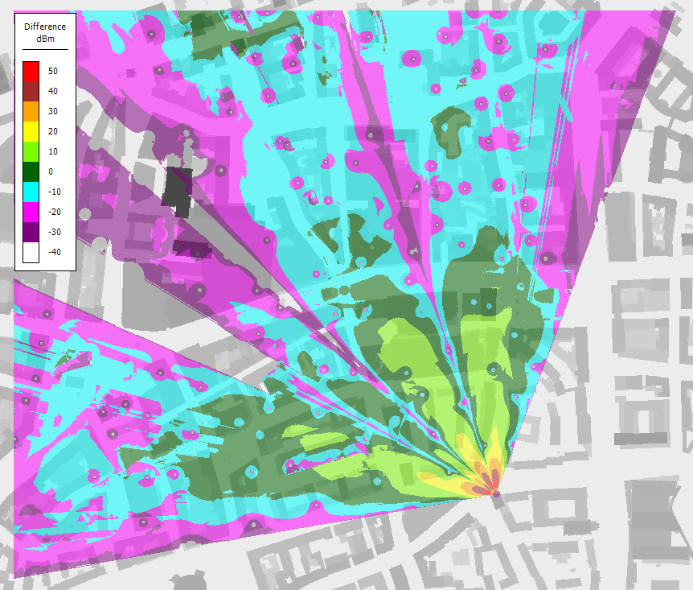
Figure 6: RLAN with IMT sharing
Figure 6 shows the change in SNIR ratio when applying an Upper 6 GHz RLAN population into a IMT site’s service sector.
The margin calculated is effectively the difference between the maximum IMT signal and the background noise caused by the RLAN activity. The RLAN activity outdoors is not of a sufficient strength for service (around -95dBm in most places) but would degrade the noise floor of the IMT base station.
Statistical analysis takes place on the resulting data using a ‘Cookie Cutter’ to mask indoor results from the IMT analysis and conversely, outdoor results from indoor analysis. Statistics of coverage need to be isolated between indoor and outdoor, so a ‘cookie cutter’ is used to mask results in post processing. The black areas here are buildings.

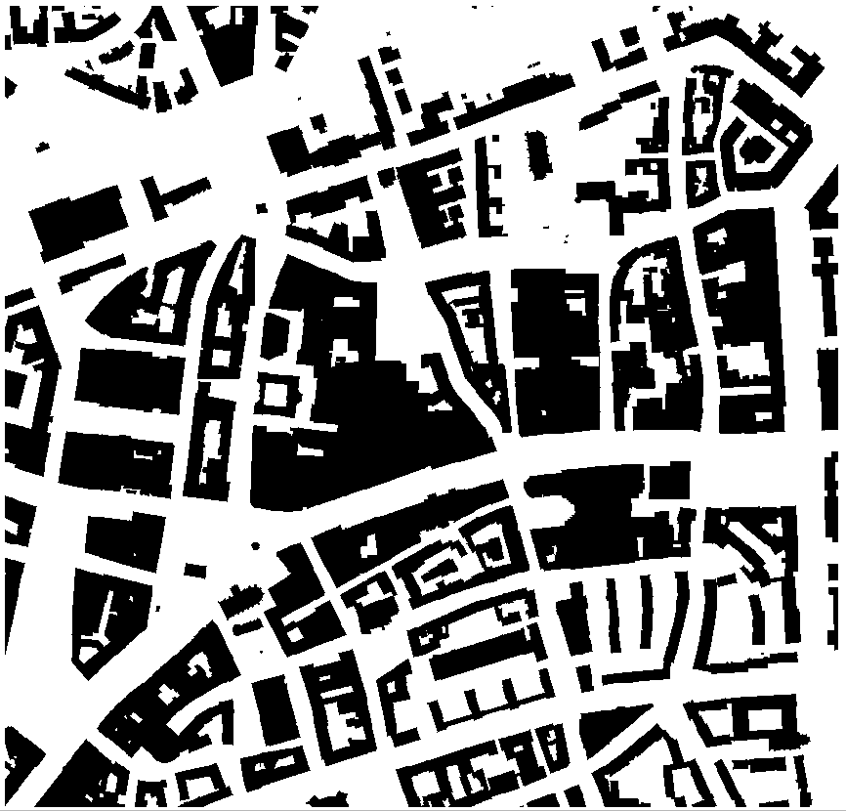
Figure 7: Cookie Cutter used for modelling.

Study initial results

IMT signal level for IMT at full power
The distribution of the IMT signal level outdoor is provided in Figure 8.
Figure 8: CDF of IMT Outdoor Signal Level
Under full IMT power, the simulated base station provides a robust signal outdoor, with 50% of the outdoor location receiving a signal level corresponding to maximum throughput.

The distribution of the IMT signal level indoor is provided in Figure 9.
Figure 9: CDF of IMT Indoor Signal Level
Under full IMT power and leaving the RLAN Energy Detection Threshold (EDT -84dBm/MHz = -65dBm/80MHz for RLAN maximum transmit power of 23dBm) unchanged, the IMT DL signal indoor is strong enough to trigger at least 35% of the RLANs to vacate the channel. By lowering the EDT by 10dB (EDT -94dBm/MHz = -75dBm/80MHz) would vacate the channel in at least 60% of cases.

RLAN Outdoor Signal Level for RLAN at full power
The distribution of the RLAN signal level received outdoor when distributing 130 RLANs over a 800x800m area, with all RLANs transmitting at full power at the same time, is provided in the Figure 10.
Figure 10: CDF of IMT Outdoor Signal Level for 130 RLANs transmitting at full power within a 800x800m area
Despite all RLANs transmitting at full power and the density of RLANs APs being very high, the RLAN received signal outdoor is too low to enable reliable connectivity. It is unlikely that outdoor RLAN devices would connect to indoor RLAN Access Points.
The RLAN signal strength received at the base station can be determined by considering the propagation channel reciprocal and determining the pathloss between the base station transmitter and the indoor pixels. The same pathloss distribution would apply to RLANs distributed over the sector.

Figure 11 shows the interference generated by RLANs at the IMT BS, under different population density assumptions, in the absence of IMT DL signal, i.e. when the RLAN Channel Access Mechanism does not detect the IMT BS.
Figure 11: CDF of RLAN interference received at IMT BS in the absence of IMT DL Signal.
Figure 12 shows the interference generated by RLANs at the IMT BS, under different population density assumptions, when the IMT DL Signal triggers RLAN Channel Access Mechanism of RLANs located close to BS.
Figure 12: CDF of RLAN interference received at IMT BS when the IMT DL Signal triggers RLAN Channel Access Mechanism of RLANs located close to BS
In a compliant use of an RLAN, the channel occupancy is checked before accessing a channel. If the IMT signal is above the EDT, this channel is not utilised. The RLANs located close enough to generate harmful interference to the IMT BS typically detect the IMT DL signal and vacate the channel.

SNR vs SINR for varying population densities
The distributions of the SNR and the SINR for the IMT UE, the IMT BS and the RLAN can be determined for varying population densities.

SNR vs SINR, IMT UE
The SNR and SINR at the IMT UEs are provided in the Figure 13.
Figure 13: SNR/SINR at IMT UE for varying population densities
Figure 13 illustrates that there is no significant difference between the SNR and the SINR of IMT UEs, even at high population density. This does not indicate that interference would not occur. ECC PT1(23)122 determined that a risk of interference exists when an RLAN APs is operating at full power and an IMT UE is receiving with low received signal level in close proximity (on the other side of the wall). However, the Figure above demonstrates that the combination of high received signal strength and limited interference from the RLAN would lead to no significant loss of SINR at the IMT UE even at very high population densities.
Figure 13 also illustrates that the IMT UE SINR is typically very high over the coverage area, indicating that the full IMT power may not be required for outdoor coverage of such cell (300m radius).

SNR vs SINR, IMT BS
The SNR and SINR at the IMT BSs are provided in the Figure 14.
Figure 14: SNR/SINR at IMT BS for varying population densities
Figure 14 illustrates that there is no significant difference between the SNR and the SINR of IMT BSs, even at high population density. While ECC PT1(23)122 concluded on a risk of interference from the RLAN to the IMT BS, it did take into account that an RLAN would vacate the channel when receiving an IMT signal strength above the EDT. When taking this aspect into account, as illustrated in Figure 2, that at least 35% of RLANs with the lowest pathloss to the IMT BS do not transmit. This explains why the SINR of the base station is not degraded by RLANs.
Figure 14 also demonstrates that the SINR at the IMT BS are typically very high for cell with 300m radius.

SNR vs SINR, RLAN
The SNR and SINR at the RLAN are provided in the Figure 15.
Figure 15: SNR/SINR at RLAN
Figure 15 illustrates that the RLAN’s Channel Access Mechanism leads to the SINR curve flattening around 39%, illustrating that in this worst-case scenario (IMT BS at full power) 39% of the RLAN cannot operate on the IMT channel. Even for RLANs that can operate over the IMT channel, the high received IMT signal indoor leads to severe degradation (around 15dB) of the RLAN’s SINR.

Conclusion for IMT Base Station at full power
In line with the conclusions of ECC PT1(23)122, the most critical interference when the IMT BS transmits at full power is the interference from the IMT BS to the indoor RLANs. Under such scenario, at least 35% of the RLANs vacate the channel and the SINR of other RLANs is degraded by 15 dB.
Interference from the RLAN to the IMT BS is not as severe as initially estimated in ECC PT1(23)122, as RLAN channel access mechanism prevents RLANs too close to a base station from transmitting on the channel.
The results are robust to a full range of population density.
Should IMT operate at full power, it would lead to limited use of the band by RLANs in the areas where IMT is deployed. RLANs close to an IMT BS would vacate the channel in line with their Channel Access Mechanism.

Reducing the power of the IMT Base Station
In order to enable the shared use of the upper 6GHz band by IMT and RLAN, a reduction of the IMT transmit power is evaluated in the Section below.

SNR vs SINR, RLAN, Reduced IMT BS Tx power
The SNR and SINR at the RLAN, under 0, 10, 15, 20 and 30dB reduction of the IMT BS power, are provided in Figure 16.
Figure 16: SNR/SINR at RLAN when IMT BS Tx power is reduced by 0/10/15/20/30 dB
As illustrated in Figure 16, a reduction of the IMT signal by 15dB (respectively 20dB) enables RLAN operation with SINR degradation limited to less than 10dB (respectively 5dB). Figure 16 also illustrates that fewer RLANs vacate the channel, which will be studied below.

SNR vs SINR at IMT UE, Reduced IMT BS Tx power
The SNR and SINR at the IMT UE, under 0, 10, 15, 20 and 30dB reduction of the IMT BS power, are provided in the Figure 17.
Figure 17: SNR/SINR at IMT UE when IMT BS Tx power is reduced by 0/10/15/20/30 dB
As illustrated in Figure 17, a reduction of the IMT BS Tx power directly leads to a reduced SINR at the IMT UE. However, as the received IMT signal level was fairly high with the IMT BS at full power, a reduction of the IMT BS Tx power by 20 dB still enables good signal level with good probability and in combination with the 3.5 GHz band, it can fulfil the IMT capacity requirement.
The study of the RLAN interference to the IMT UE did not take into account the RLANs vacating the channel due to channel access mechanism. This is likely to result an even better SINR close to the IMT BS, as the interference from RLAN would be minimal close to the base station. This would provide significant capacity relief around the 6GHz Base Station, while 6GHz downlink connectivity at the cell edge may be degraded. Further studies are required to quantify this effect.

SNR vs SINR, IMT BS, IMT BS Tx power reduced by 15dB
Although the IMT BS transmit power does not play a role for the IMT uplink, the IMT BS transmit power directly determines which RLANs vacate the channel or operate on it, in the immediate vicinity of the base station. The SNR and SINR at the IMT BS, under 15dB reduction of the IMT BS power, are provided in the Figure 18, for varying population densities.
Figure 18: SNR/SINR at IMT BS when IMT BS Tx power is reduced by 15dB, for varying population densities
As illustrated in Figure 18, a reduction of the IMT BS Tx power enables more RLANs to operate on the channel, which in turn leads to increased interference at the IMT BS Rx. The IMT BS SINR is degraded by approximately 5dB for a population density of 31000 hab/km².

Conclusion for IMT Base Station transmitting at reduced power
Reducing the IMT BS Tx power is an effective way to enhance the shared use of the 6425-7125 MHz band by IMT and RLAN.
Considering a 15dB reduction of the IMT BS Tx power:
- Limits the RLAN SINR degradation to less than 10dB,
- Leads to around 15dB degradation of the IMT UE SINR, however the initial IMT UE SINR was very high. Which level of IMT UE SINR degradation is acceptable is expected to be subject to further studies.
Counter-intuitively, a reduction of the IMT BS Tx power is not only affecting the SINR of the IMT UE and RLANs, but also the IMT BS SINR, as more RLANs can operate on the channel. While the degradation is small for a typical German population density, at high population density (31000 hab/km²) the degradation can reach 5dB. In the section below, a lowering of the RLAN EDT combined with a lowering of the IMT BS Tx power is investigated to improve the shared use of 6425-7125 MHz by IMT and RLANs.

Reducing both the Tx power of the IMT Base Station and the RLAN EDT
Reducing the transmit power of the IMT base station enhances the shared use of the band by RLAN and IMT but makes it more challenging for RLANs located close to the IMT BS to detect it and vacate the channel. Lowering the RLAN’s EDT can solve this challenge.

SNR vs SINR at IMT BS, IMT BS Tx power reduced by 15dB, reduced RLAN EDT
The SNR and SINR at the IMT BS, under 15dB reduction of the IMT BS power and a population density of 31 000 hab/km2, are provided in the Figure 19, for an RLAN EDT reduced by 0/5/10 and 15dB.
Figure 19: SNR/SINR at IMT BS when IMT BS Tx power is reduced by 15dB, population density = 31000 hab/km², for RLAN EDT reduced by 0/5/10 and 15dB
As illustrated in the Figure above, a 10dB reduction of the RLAN’s EDT is sufficient to remove most of the interference from the RLAN to the IMT BS.

SNR vs SINR at RLAN, IMT BS Tx -15dB, RLAN EDT -10dB
The SNR and SINR at the RLAN, under 15dB reduction of the IMT BS power are provided in the Figure 20, for an RLAN EDT reduced by 10dB.
Figure 20: SNR/SINR at RLAN when IMT BS Tx power is reduced by 15dB for RLAN EDT reduced by 10dB
Figure 20 illustrates that the SINR of 70% of the RLAN is vastly improved when reducing the power of the IMT BS by 15dB. Approximately 30% of the RLANs vacate the channel, when detecting the IMT signal at EDT-10dB.

Conclusion on the lowering of the RLAN EDT
When the IMT BS transmit power is reduced by 15dB, lowering of the RLAN EDT by 10dB enables:
- minimising the interference from the RLAN to the IMT BS,
- while increasing the number of RLANs vacating the channel in the close proximity of the Base Station, mostly maintaining the benefit of lower IMT BS interference for other RLANs.
The study did not take into account the impact of reduced RLAN EDT on the IMT UE SINR. It is expected that the IMT UE SINR is mostly impacted by the lower IMT signal and not by the RLAN interference. Hence, a reduction of the RLAN EDT may not significantly improve the IMT UE SINR.

Can IMT UE connect from indoor, when IMT Tx power is reduced by 15dB?
One critical assumption in the study is that RLANs operate indoor while IMT operates outdoor. Should IMT UE connect to the IMT BS from indoor, or RLAN terminals operate outdoor, this would result in significantly higher risk of interference for all parties.
Figure 10 indicated that the risk of RLAN terminals to operate outdoor is low, as the RLAN signal level outdoor remains low, even for RLAN APs operating at maximum power, with a very high density of RLAN APs transmitting at the same time, on the same channel, within the IMT cell.
Figure 21 provides the IMT indoor signal level for varying reduction of the IMT BS transmit power.
Figure 21: IMT indoor signal level for varying reduction of the IMT BS transmit power
Figure 21 above illustrates that more than 60% of the IMT UEs located indoor would receive a signal level sufficient to connect to the IMT Base Station, even when the IMT Base Station transmit power is reduced by 20dB. This indicates that the received signal strength alone is not sufficient to indicate to an IMT UE whether it is located indoor or outdoor. An additional mechanism will be required to prevent indoor UEs from connecting to 6GHz IMT networks.

Environmental considerations
Deployment of RLAN and IMT in the upper 6GHz band are expected to contribute to the EU digital transition objectives. However, the EU digital transition is expected to also contribute to the EU green transition. As such, it is important to consider the energy efficiency implications of policy decisions in the upper 6 GHz band.

Previous studies

ARCEP’s 2020 report
ARCEP published in 2020 a report on Achieving Digital Sustainability. The report highlights that 70 to 80% of an electronic communication network’s environmental footprint is related to the access network and that fiber energy consumption per bit is 10 times lower than mobile networks’ energy consumption.
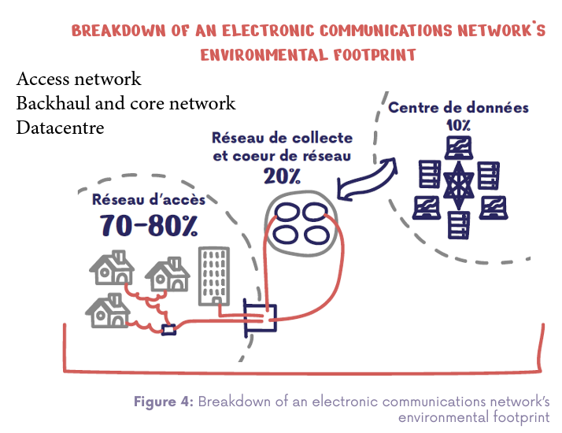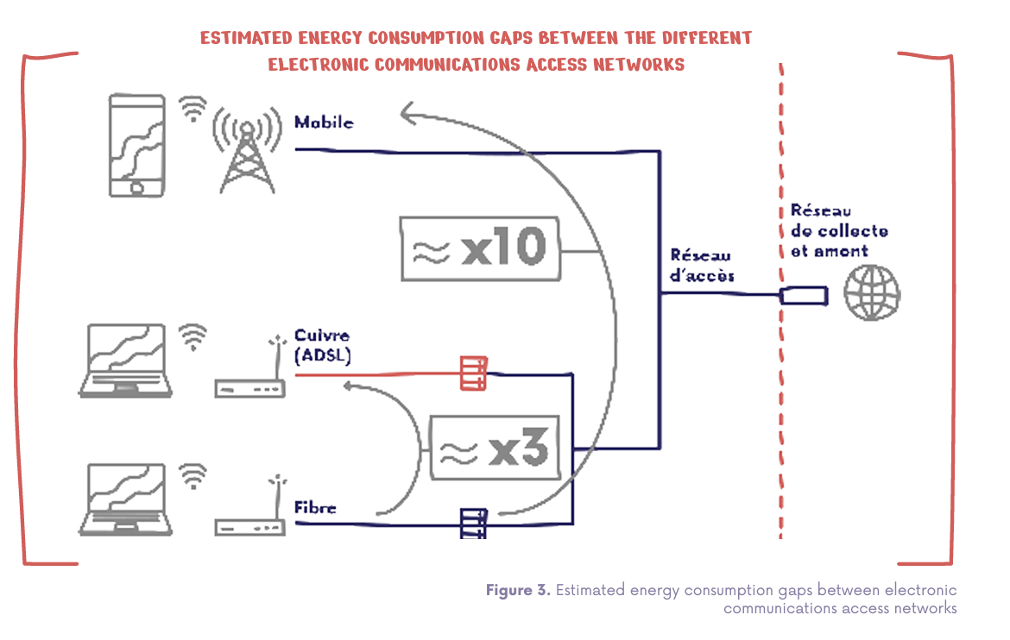
Figure 22: Extracts from ARCEP’s 2020 report on achieving digital sustainability. Source: ARCEP.
ARCEP’s findings suggest that fiber connectivity should be favoured as close as possible to the end user to promote a combined digital and green transition.

WIK’s Green Wi-Fi report
WIK consulting published in 2021 its Green Wi-Fi report on the environmental benefits of Wi-Fi. The report indicates that the power consumption of WiFi still accounts for a very small share of total ICT power consumption and that Wi-Fi 6 and further evolutions enable further significant energy savings. Finally, the reports highlights how Wi-Fi can contribute to the green transition by enabling e.g. home office, remote health and reduced building power consumption.
In the context of the policy decision for the upper 6GHz band, it is clear that opening the upper band would lead to a reduction of the Wi-Fi’s energy consumption, as 6GHz Wi-Fi device can operate on the full band at no additional environmental impact (i.e. no need for new hardware) and would deliver vastly improved performance.

Analysys-Mason’s report on environmental aspects of the upper 6GHz band
Analysys-Mason published in June 2023 a report on the Impact of additional mid-band spectrum on the carbon footprint of 5G mobile networks: the case of the upper 6GHz band. The report highlights that under the assumption that the mobile traffic would grow considerably, the upper 6GHz band could delay the requirement for densification of the mobile network and therefore provide environmental benefits. The report focused on MBB for areas with 15 000 hab/km2 and FWA for rural areas. The report did not consider whether such traffic could be delivered at lower environmental cost by e.g. Wi-Fi in urban area and fiber in rural areas.
The report considered that the upper 6GHz band would not provide environmental benefits if opened to Wi-Fi based on a study by Huawei considering that there is no spectrum need for Wi-Fi in the upper 6GHz band.

WIK for the Wi-Fi alliance
WIK published a study in July 2023 on the Sustainability Benefits of 6GHz policy. The report assesses the environmental impact of opening or not the upper 6GHz band to Wi-Fi and concludes that with sufficient access to spectrum, Wi-Fi outperforms cellular networks in delivering broadband connectivity with significant reductions in energy consumption and environmental footprint.
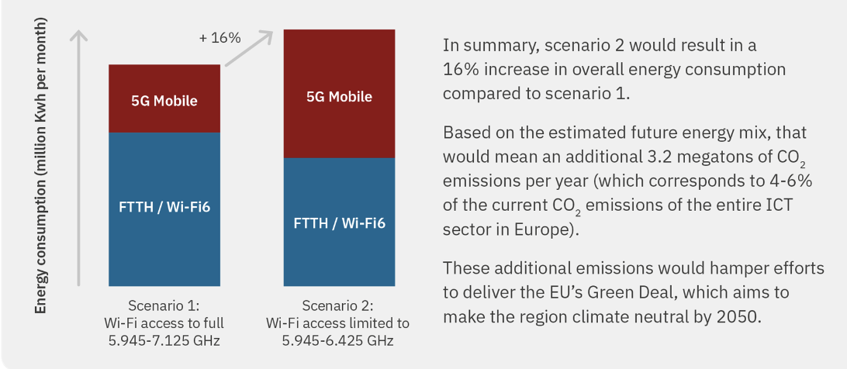
Figure 23: Reduced energy consumption when opening the 6425-7125 MHz band to Wi-Fi. Source: Wi-Fi Alliance/WIK-consult.

Environmental impact of shared use of spectrum – preliminary analysis
A full environmental impact of the proposed shared use of the upper 6GHz band goes beyond the limits of this contribution. However, a few trends can be highlighted based on the literature review above and the contributions’ technical finding.

RLAN vs IMT Tx power requirements
The technical study provides direct insights on the respective transmit energy consumption of IMT vs RLAN:
- RLAN are leveraging 23dBm of transmit power to achieve a 50% SNR above 35dB for a 80MHz signal,
- IMT UEs are leveraging 23dBm of transmit power to achieve a 50% SNR above 18dB for a 80/3 MHz signal,
- IMT BSs are leveraging 43.1dBm of transmit power to achieve a 50% SNR of 25dB for a 80 MHz signal.
These data points indicate, to no surprise, that a lower transmit power is required to transmit over RLANs, as transmissions occur over much shorter distance.

Overall benefits of the shared use solution
While previous studies focused on opening the 6425-7125 MHz band exclusively to RLAN or IMT, the shared use of the band is likely to combine the benefits of opening the band to either technology:
- IMT networks would be in a position to increase their capacity where required, while delaying network densification,
- Wi-Fi devices would get access to additional channels, not only in rural areas, but also partially in dense urban areas.
Shared use of the 6GHz band will also bring additional environmental benefits as the 6GHz band will prioritise outdoor coverage by IMT and indoor coverage by RLAN, reducing the need for IMT (respectively Wi-Fi) to compensate Building Entry Loss (respectively Building Exit Loss) through higher transmit power. In itself, this is likely to increase the energy efficiency of both IMT and Wi-Fi.

Specific benefits of the shared use solution
As discussed above, shared use of the 6425-7125 MHz band by IMT and RLANs would require a significant reduction of the IMT transmit power. Such reduction of the IMT BS transmit power would increase the energy efficiency of the 6GHz IMT network, compared to a scenario where IMT is allowed to transmit at full power.

Solutions and recommendations to enable shared use of 6425-7125 MHz by IMT and RLANs, Benefits of Shared use of spectrum
IMT and RLAN peak spectrum demand are expected to occur precisely in the same areas, i.e. geographical areas with high population density. True shared use of the 6425-7125 MHz by IMT and RLAN must include shared use of such high population density areas.
It is not expected that shared use can be achieved with no interference from one system to another, as ECC PT1(23)122 concluded. Mitigation can enable shared use of the band if SINR degradation is accepted by both parties.

Solutions and recommendations
Under full IMT transmit power (Total IMT BS tx power16x8x22dBm = 43.1dBm), as specified in document ITU 5D/716, shared use is not possible as the high IMT indoor signal triggers the RLAN Channel Access Mechanism, i.e. makes RLANs vacate the channel. The full IMT transmit power is also not required to provide outdoor coverage.
Reducing the IMT BS Tx power enables shared use of the band by both reducing the number of RLANs vacating the channel and improving the SINR of RLANs operating in the channel. However, reduction of the IMT BS Tx power reduces the SINR of IMT UEs and may even lead to reduce SINR for the IMT BS as RLAN close to the BS fail to detect it.
By reducing the RLAN EDT, the impact of RLANs on IMT BS is reduced even at reduced IMT BS Tx power. In such a scenario, IMT UEs face reduced SINR, some RLANs must vacate the channel, while other RLANs suffer from reduced SINR, but there is little to no interference to IMT BS.
Reducing both the IMT BS transmit power and the RLAN EDT seems to offer a solution to enable shared use of the 6425-7125 MHz, accepting some degradation of the performance for both IMT and RLAN, but delivering additional capacity for both.
The following areas require further investigation to optimise this approach:
- the exact reduction of the IMT BS transmit power and of the RLAN Energy Detection Threshold must be further investigated to optimise the solution. 15dB reduction of the IMT BS Tx power and 10dB reduction of the RLAN’s EDT can be taken as initial assumption.
- The costs and implementations challenges associated with a reduction of the RLAN’s EDT by 10dB were not studied and must be further investigated.
- The exact impact of the reduction of the IMT TX power on the IMT downlink performance must be further investigated. In particular, RLANs vacating the channel around the base station implies that perfect IMT QoS will be available close to the Base Station, while 6GHz IMT QoS would be lower at cell edge. Such effect is expected to be acceptable for a spectrum band supporting additional capacity.
- the conclusion of the studies are valid for IMT devices operating outdoor. An additional mechanism is required to prevent indoor UEs from connecting to an IMT BS at 6GHz. Even under a 15dB reduction of the IMT Tx power, the IMT signal level remains strong enough in a significant percentage of indoor locations to enable IMT UEs to connect.

Benefits of shared use of spectrum
Shared use of spectrum seem to enable outdoor IMT connectivity and indoor RLAN connectivity in the areas of very high connectivity demand, at the price of reduced QoS for both systems.
Shared use of spectrum delivers additional capacity for both IMT and RLANs by leveraging the indoor/outdoor separation, i.e. favouring IMT oudoor and RLAN indoor.
Shared use of spectrum provide some flexibility to national regulators, as IMT base station authorisations can be leveraged (area of deployment, power authorised) to control the relative Wi-Fi and IMT spectrum access opportunities on a local basis. While dense urban cells covering outdoor public space may benefit mostly from IMT, universities, stadium and hospitals may be consulted to determine whether they prioritise additional Wi-Fi or IMT capacity on their premises.
Shared use of spectrum seem to deliver and improve on the environmental benefits expected when opening the upper 6GHz band to either RLANs or IMT.

- German neighbourhoods with High population density
Table 13: List of neighbourhoods with population density higher than 8000 hab/km² in the German cities with average population density higher than 2500 hab/km².
City | Neighbourhood | Geographic Area (km²) | Habitants | Population density (hab/km²)
München | Ludwigsvorstadt-Isarvorstadt | 4.4 | 50915 | 11567
München | Maxvorstadt | 4.3 | 52269 | 12161
München | Schwabing-West | 4.36 | 68603 | 15723
München | Au-Haidhausen | 4.22 | 63383 | 15020
München | Sendling | 3.94 | 41011 | 10412
München | Schwanthalerhöhe | 2.07 | 28986 | 14001
München | Obergiesing-Fasangarten | 5.72 | 53964 | 9433
München | Laim | 5.29 | 56855 | 10756
Berlin | Mitte | 39.47 | 395599 | 10023
Berlin | Friedrichshain-Kreuzberg | 20.16 | 293231 | 14545
Frankfurt | Altstadt | 0.51 | 4220 | 8340
Frankfurt | Nordend-West | 3.10 | 31235 | 10076
Frankfurt | Nordend-Ost | 1.53 | 22854 | 14918
Frankfurt | Bornheim | 2.79 | 30799 | 11055
Frankfurt | Gallus | 4.52 | 44047 | 9751
Düsseldorf | Bezirk 2 | 7.18 | 62340 | 8682
Essen | Südostviertel | 0.97 | 12957 | 13358
Essen | Altendorf | 2.49 | 23094 | 9275
Essen | Frohnhausen | 3.62 | 32612 | 9009
Essen | Holsterhausen | 2.98 | 26210 | 8795
Nürnberg | Gostenhof | 0.518 | 9381 | 18110
Nürnberg | Himpfelshof | 0.654 | 5987 | 9154
Nürnberg | Altstadt, St. Sebald | 0.796 | 9168 | 11517
Nürnberg | St. Johannis | 0.594 | 8198 | 13801
Nürnberg | Pirckheimerstraße | 0.512 | 7987 | 15600
Nürnberg | Wöhrd | 0.791 | 10068 | 12728
Nürnberg | Glockenhof | 0.83 | 18195 | 21921
Nürnberg | Guntherstraße | 0.43 | 3654 | 8498
Nürnberg | Galgenhof | 0.848 | 19787 | 23334
Nürnberg | Hummelstein | 0.732 | 11069 | 13756
Nürnberg | Gugelstraße | 0.638 | 8154 | 12780
Nürnberg | Steinbühl | 0.557 | 13656 | 24517
Nürnberg | Gibitzenhof | 0.427 | 5622 | 13166
Nürnberg | St. Leonhard | 1.288 | 14644 | 11370
Nürnberg | Bärenschanze | 1.086 | 9824 | 9046
Nürnberg | Sandberg | 0.709 | 11095 | 15649
Nürnberg | Bielingplatz | 0.642 | 538 | 8380
Nürnberg | Uhlandstraße | 0.707 | 11657 | 16488
Nürnberg | Maxfeld | 0.879 | 10736 | 12214
Nürnberg | Veilhof | 1.088 | 11782 | 10829
Nürnberg | Schleifweg | 0.508 | 4227 | 8321
Nürnberg | Schoppershof | 0.907 | 8669 | 9558
Nürnberg | Gostenhof | 0.518 | 9381 | 18110
Köln | Altstadt-Süd | 2.36 | 27764 | 11760
Köln | Neustadt-Süd | 2.87 | 37803 | 11760
Köln | Neustadt-Nord | 3.49 | 28604 | 8194
Köln | Bayenthal | 1.28 | 11161 | 8732
Köln | Ehrenfeld | 3.71 | 38405 | 10361
Köln | Neuehrenfeld | 2.54 | 23626 | 9285
Köln | Nippes | 2.98 | 36913 | 12386
Köln | Mauenheim | 0.51 | 5596 | 11012
Köln | Finkenberg | 0.64 | 687 | 10772
Köln | Vingst | 1.12 | 12711 | 11302
Köln | Neubrück | 1.1 | 8342 | 8342
Köln | Buchforst | 0.83 | 7385 | 8887
Hannover | Oststadt | 0.85 | 14261 | 16800
Hannover | List | 5.01 | 46198 | 9200
Hannover | Linden-Nord | 0.97 | 16601 | 17100

30/70 split Traditional/Thermal building type (ITU-R P.2109) – ECC Report 302
ETSI EN 303 687 v1.1.0

