|  |  |  |
| --- | --- | --- |
| **Plenary** | | **Doc. ECC(19)033** |
| **50th Meeting** | | |
| **Brighton, 5 – 8 March 2019** | | |
|  | | |
| **Date issued:** | **28 February 2019** | |
| **Source:** | **ECO** | |
| **Subject:** | **ECO Bulletin on on-going/new issues in other regions or organisations** | |
| Group membership required to read? (Y/N)  N | | |
|  | | |
| **Summary:** | | |
| This ECO Bulletin provides a summary update on aspects of progress in spectrum management outside the CEPT. The items in this bulletin include:  1 Asia Pacific Region (APT)  1.1 China plans 6G mobile by 2030  1.2 India 5G auction in 3.3-3.6 GHz  2 Africa (ATU)  2.1 5G Potential in Africa  3 Americas (CITEL)  3.1 USA  3.1.1 3.7-4.2 GHz: C Band Alliance update  3.1.2 Update on NGSO satellite plans  3.1.3 FCC waiver exempting Galileo from licensing  3.1.4 Iridium NEXT full constellation now operational  3.1.5 Update on FCC mmWave auctions  3.1.6 FCC Requests Comment on 5.9 GHz Phase I Testing Data  3.1.7 FCC chairman calls on telecoms industry adopt a robust call authentication system to combat illegal caller ID spoofing  3.2 Conclusion of the ITU Regional Frequency Coordination for Central America and Caribbean  3.3 CITEL/PCC.II approves a new recommendation on PPDR at 380-399.90 MHz  4 Global developments  4.1 2nd ITU Inter-regional workshop on WRC-19 preparation  4.2 5G trials and deployment update  4.3 3GPP Updates: delay of Release 16 until March 2020 and new work item on 5G NR in unlicensed spectrum | | |

|  |
| --- |
| **Proposal:** |
| ECC is invited to note this Bulletin.  Several of the issues covered in this bulletin should be noted or discussed in detail at the respective WG/ PT level, in particular:   * WGFM - 1.1, 1.2, 3.1.1, 3.1.2, 3.1.3, 3.1.4, 3.1.5, 3.1.6, 3.3, 4.3 * WGSE - 3.1.2, 3.1.4 * WGNaN - 3.1.7 * CPG - 3.2, 4.1 * ECC PT1 - 1.1, 1.2, 2.1, 3.1.1, 3.1.5, 4.2, 4.3 * SRD/MG - 3.1.6 * FM44 - 3.1.1, 3.1.2, 3.1.3, 3.1.4 * FM57 - 4.3 * SE40 - 3.1.2, 3.1.4 * SE45 - 4.3   Several items may be of interest in WG FM and WG SE. |
| **Background:** |
| The Office brings to each ECC meeting a bulletin on activities in radio communications in other regions outside CEPT, where a regulatory dimension is raised (e.g. by innovative services or technology).  The primary objective is to identify whether the ECC needs to investigate further or consider possible new actions. A secondary but more frequently addressed objective is to enable comparison to be made with the regulatory approach in other regions for subjects already treated by the ECC (including, where relevant, to the work of the CPG). |

# Asia Pacific Region (APT)

## China plans 6G mobile by 2030

The Ministry of Industry and Computer Science of China has announced the birth of an ad hoc R&D team at work on the 6G standard that will allow a connection speed of 1Tbps.

Su Xin, leader of the 5G work team of the Chinese Ministry, has announced to the China Securities Journal that scientists are preparing to inaugurate the new research programs that will support the launch of the 6G in 12 years, starting to work on mobile networks of the remote future in 2020. The commercial launch is expected by 2030. According to Xin, the sixth generation mobile networks could provide download speeds of up to 1Tbps and almost instantaneous latency levels.

**(For information in ECC PT1 and WGFM)**

## India plans 5G auction in 3.3-3.6 GHz

The Indian government is planning to auction spectrum in the 3.3-3.6 GHz band in June 2019 in order to make 5G services available in 2020. The Telecom Regulatory of India (TRAI) plans to auction 20 MHz blocks at a price of 4920 million Indian Rupees (€53.5 million) per MHz. Operators have reacted negatively to the high price, with only 2 confirmed participants (Reliance Jio and Bharti Airtel).

India has previously been late to deploy mobile technologies, but the government hopes to change this with 5G. Other initiatives include a fund for a 5G test bed in Madras and a high-level committee to develop India-specific 5G services and spur the development of a 5G ecosystem in India. However the use case for 5G in India is not currently clear in the absence of consumer applications which require higher speeds than 4G, and the lack of standards to support enterprise and vertical services.

**(For information in ECC PT1 and WGFM)**

# Africa (ATU)

## 5G Potential in Africa

A [report](https://www.ericsson.com/assets/local/press-releases/africa/2018/5g-africa-report-11-2018.pdf) recently published by The Council for Science and Industrial Research (CSIR – a South African policy organisation) and Ericsson outlines the opportunities 5G could bring to Africa, including the creation of 400,000 jobs and contribution of $8 billion to a country’s GDP. The report includes recommended areas where governments could act to meet these aims. Identified market use cases for 5G include affordable broadband, ITS, PPDR, energy and water, healthcare and agriculture.

On the spectrum side, the importance of harmonisation across Region 1 is highlighted, and on this basis the report recommends governments to support 700 MHz, 800 MHz, 2600 MHz, 3.5 GHz, 26 GHz and 40 GHz as 5G pioneer bands.

**(For information in ECC PT1)**

# Americas (CITEL)

## USA

### 3.7-4.2 GHz: C Band Alliance update

The previous Bulletin reported on the creation of the [C-Band Alliance](https://c-bandalliance.com/) (CBA) consortium of satellite companies set up to facilitate clearance within 3700-4200 MHz in the US through a market-based approach to make 200 MHz of the band available for 5G services. This proposal has met some resistance from other players with interests in the band including T-Mobile and Google.

In a [filing to the FCC](https://ecfsapi.fcc.gov/file/103059257359/T-Mobile%203.7-4.2%20GHz%20Band%20Comments.pdf) on 29 October 2018 responding to the Notice of Proposed Rulemaking (NPRM), T-Mobile criticised the CBA proposal that would only make 180 MHz available (due to a 20 MHz guard band) which is considered insufficient to meet operator requirements for 5G (80-100 MHz per operator). T-Mobile have proposed an alternative multi-phase incentive auction of the entire band on a regional basis, with satellite operators able to retain 200 MHz in most areas, and 300 MHz at certain locations outside of urban areas. US Cellular also [indicated support](https://ecfsapi.fcc.gov/file/1030103249491/U.S.%20Cellular%203.7%20GHz%20NPRM%20Comments%20(Docket%20No.%2018-122)%20(Oct.%2029%2C%202018).pdf) for an auction based approach.

Additional [submissions](https://www.fcc.gov/ecfs/search/filings?limit=100&offset=0&proceedings_name=18-122&sort=date_disseminated,DESC) to the FCC show that not all existing C Band users support the CBA proposal, with 9 in favour, 2 against and 16 not stating a view either way. Comcast raised several [concerns](https://ecfsapi.fcc.gov/file/1030278937503/2018-10-29%20AS-FILED%20Comcast%20C-Band%20NPRM%20Comments%20Dkt%2018-122.pdf) with the CBA approach, noting that the proceeds would all go to the satellite operators without incentive for adequate compensation or technical assistance to the existing end users of the satellite downstream.

In a [response](https://ecfsapi.fcc.gov/file/1207392316779/Reply%20Comments%20of%20the%20C-Band%20Alliance%20(C-Band%20NPRM).pdf) dated December 7 2018, the CBA claimed the T-Mobile proposal would result in delays due to regulatory and legal challenges, and that both T-Mobile and Comcast were using delaying tactics for anti-competitive reasons. The CBA re-iterated that it is committed to ensuring that smaller regional and rural carriers have access to midband spectrum for 5G by creating a block of spectrum solely for the use of smaller regional and rural carriers.’

The dispute continued in January 2019 with T-Mobile [claiming](https://ecfsapi.fcc.gov/file/1214316127579/T-Mobile%20Ex%20Parte%20Letter%2012132018.pdf) that the market-based approach is not consistent with the Communications Act and would not be in the public interest as there would be no revenue for taxpayers, while the CBA claimed that the incentive auction would not be workable as it relies on voluntary participation of all satellite operators with overlapping assignments across the band.

In February the CBA presented more [detailed proposals](https://ecfsapi.fcc.gov/file/102072699030257/CBA%20-%20Ex%20Parte%20re%20Grooming%20Plans.pdf) on migration plans developed by SES and Intelsat, demonstrating how all existing C Band users can be accommodated in 300 MHz of spectrum, and that 200 MHz is the maximum that could be released without detriment to existing users.

Separately, Google and Charter Communications also criticised the market based approach at a [February 5 Open Technology Institute event](https://www.newamerica.org/oti/events/great-airwaves-robbery-ii/), claiming that it would inevitably lead to lawsuits and therefore result in delays to clearing the spectrum. A delay would remove one of the key advantages of the market based approach. Google [supports both mobile and point-to-multi-point use](https://ecfsapi.fcc.gov/file/1211022601440/Google%203.7-4.2%20GHz%20Reply%20Comments.pdf) of the band, and believes that for the latter opportunistic usage should be immediately permitted, based on the under-usage of the band particularly in rural areas. Google have further highlighted problems with inaccurate information in earth station registrations which could lead to an overestimate of usage.

**(For information in ECC PT1, WGFM, FM44)**

### Update on NGSO satellite plans

In November 2018 the FCC granted [approval](https://docs.fcc.gov/public/attachments/DOC-355102A1.pdf) for SpaceX to add 7518 satellites to its Starlink NGSO constellation, in addition to the originally approved 4425 satellites as reported in previous Bulletins.

The additional satellites will operate at a lower orbit of around 340 km (very Low Earth Orbit - VLEO) in the 37.5-42 GHz (space-to-Earth) and 47.2-50.2 GHz (Earth-to-space) frequency bands (‘V Band’), whereas the initially approved satellites will operate at around 1200 km (LEO) in the Ku Band for the user link - 10.7-12-7 GHz (space-to-Earth) and 14-14.5 GHz (Earth-to-space), and Ka Band for the gateway link - 17.8-18.6 GHz and 18.8-19.3 GHz (space-to-Earth) and 27.5-29.1 GHz and 29.5-30 GHz (Earth-to-space).

Due to the low orbits SpaceX claims its network will have latencies as low as 25 ms, and it aims to provide broadband access worldwide at Gigabit speeds. In February 2019 SpaceX Services (a sister company) [applied](https://fcc.report/IBFS/SES-LIC-INTR2019-00217/1616678.pdf) to the FCC for a blanket authorisation of up to 1,000,000 earth stations for end-user terminals with phased array antennas with beamforming capabilities to track the Starlink satellites. SpaceX also estimates hundreds of gateway stations will be required in the US co-located with major internet servers.

The first batch of satellite launches is planned for mid-2019 following the initial launch of 2 demonstration satellites in February 2018 with the aim to have internet service available in 2020. While the initial focus is on the US there are also plans to provide global connectivity.

The FCC did not grant SpaceX a requested waiver of its implementation milestone rules, meaning that SpaceX will have to deploy half of the new 7518 satellites within 6 years, however SpaceX will be permitted to resubmit a waiver request in future.

In response to concerns about the risk of space debris due to the large constellation sizes, the FCC indicated its approval was conditional on SpaceX providing an update to its orbital debris mitigation plan. Additionally the FCC initiated a comprehensive review of its orbital debris mitigation rules, through a [Notice of Proposed Rulemaking](https://docs.fcc.gov/public/attachments/FCC-18-159A1.pdf) (NPRM).

The FCC also issued an [NPRM](https://docs.fcc.gov/public/attachments/FCC-18-160A1.pdf) on a regulatory framework to facilitate the continued deployment of earth stations in motion (ESIM) on ships, aeroplanes and vehicles in Ku and Ka Bands, by expanding the scope of recent changes to existing GSO regulations to also address NGSO constellations.

In addition to the SpaceX approval, the FCC also approved US market entry for smaller constellations from Kepler Communications (140 satellites), Telesat Canada (117 satellites), and LeoSat (78 satellites). These systems would get their primary approvals from foreign governments but require FCC approval for access to the US market.

Meanwhile, the initial launch of the first six of [OneWeb](http://www.oneweb.world/)’s NGSO satellites is planned for 26 February from Kourou, French Guiana, despite some delays due to a problem with the Soyuz launch vehicle announced at the end of January. OneWeb plans a constellation of 900 satellites at an orbit altitude of 1200 km operating in the Ku Band – 10.7-12.75 GHz (space-to-Earth) and 14-14.5 GHz (Earth-to-space), to provide global affordable connectivity by 2027.

**(For information in WGFM, FM44, WGSE, SE40)**

### FCC waiver exempting Galileo from licensing

In response to a request from the European Commission, the FCC has granted a [waiver](https://docs.fcc.gov/public/attachments/DOC-354772A1.pdf) to allow Galileo GNSS receivers to operate without a licence, which was previously required under FCC rules.

The waiver allows for reception of the E1 (1559-1591 MHz) and E5 (1164-1219 MHz) signals, but the request for the E6 (1260-1300 MHz) signal was denied as there is no RNSS allocation in the US in this range and to avoid constraining future usage above 1300 MHz in the US.

The waiver notes the interoperability and compatibility between Galileo and GPS, and the public interest benefit of increased availability and accuracy provided by the additional use of Galileo.

**(For information in WGFM, FM44)**

### Iridium NEXT full constellation now operational

On January 10 the final 10 Iridium NEXT satellites were successfully launched into orbit from a SpaceX Falcon 9 rocket which took off from Vandenburg Air Force Base, California.

The launch completes the NEXT LEO constellation of 75 satellites (66 operational satellites and 9 in-orbit spares), following 7 previous launched over the last 2 years.

The final 2 satellites became operational on February 5, and on the following day Iridium announced full switchover of all its services from the first generation satellites to the NEXT constellation.

The first generation constellation had run out of spare satellites and was 1 operational satellite short since 2015. 52 of the old satellites have now been deorbited, with the remaining 13 to be deorbited over the coming months.’

The NEXT constellation brings new data capabilities whereas the first generation focussed on voice services. The L Band downlink in 1616-1626.5 MHz offers speeds up to 128 kbit/s (handsets) and 1.5 Mbit/s (aero/maritime terminals), while a Ka Band service offers up to 8 Mbit/s for larger terminals.

**(For information in WGFM, FM44, WGSE, SE40)**

### Update on FCC mmWave auctions

The first of the FCC’s millimetre wave spectrum auctions ([Auction 101](https://www.fcc.gov/auction/101)) has completed, with the assignment of the majority the residual licences in the 28 GHz band (27.5-28.35 GHz). 2965 of the 3072 available county level (“partial economic area”) licences in two blocks of 425 MHz were sold. Verizon already held the majority of licences for the band in other counties obtained through secondary trading.

The auction generated a total of $700 million after 176 rounds of bidding over 38 days, finishing on January 24. On a per MHz per population basis this is more than twice the amount raised in the South Korean 28 GHz auction in 2018. The total sum is low compared to other auctions in the US, but the upcoming 24 GHz auction is expected to generate more interest since it covers more major cities.

40 qualified bidders participated. The identities of the winning bidders will remain secret until after the 24 GHz auction.

The 24 GHz auction ([Auction 102](https://www.fcc.gov/auction/102)) is planned to commence on March 14. A total of 2909 county level licences will be auctioned in 100 MHz blocks within 24.25-24.45 GHz and 24.75-25.25 GHz. [58 of 60 prospective bidders](https://docs.fcc.gov/public/attachments/DA-18-1116A1.pdf) have met the [requirements for participation](https://docs.fcc.gov/public/attachments/DA-19-24A1.pdf).

**(For information in ECC PT1 and WGFM)**

### FCC Requests Comment on 5.9 GHz Phase I Testing Data

The FCC’s Office of Engineering and Technology (OET) [has requested comments](https://www.fcc.gov/document/fcc-requests-comment-59-ghz-phase-i-testing-data) on the report for Phase I of tests performed to evaluate potential sharing solutions between the proposed Unlicensed National Information Infrastructure (U-NII) devices and Dedicated Short Range Communications (DSRC) operations in the 5850-5925 MHz (U-NII-4) frequency band.

Since 2016 the FCC has been evaluating the potential for unlicensed national infrastructure (U-NII) devices to share the 5850-5925 MHz frequency band with Dedicated Short Range Communications (DSRC) systems operating under the Intelligent Transportation Service (ITS). The Test-plan describes three phases: Phase I – FCC lab testing, Phase II - basic field tests with a few vehicles at a DoT facility, and Phase III - additional field tests with many more vehicles, more test devices, and real-world scenarios.

Five parties submitted a total of nine devices in response to the U-NII-4 Public Notice for Phase I testing, performing 1450 individual tests with more than one million data points collected.

FCC recognises that there have been a number of developments since the three-phase test plan was announced in 2016—such as the introduction of new technologies for autonomous vehicles, the evolution of the Wi-Fi standards, the development of cellular vehicle-to-everything (C-V2X) technology, and the limited deployment of DSRC in discrete circumstances. Therefore, comments have been invited on how any of these factors or others should impact the evaluation of the test results, the three-phase test plan, or the pending proceeding on unlicensed use in the 5.9 GHz band.

The deadline to submit comments was set on 28 November and until 13 December to submit reply comments. Responses are available [here](https://www.fcc.gov/ecfs/search/filings?proceedings_name=13-49&sort=date_disseminated,DESC).

**(For information in WGFM and SRD/MG)**

### FCC chairman calls on telecoms industry adopt a robust call authentication system to combat illegal caller ID spoofing

The FCC Chairman has called on all telecommunications providers in the U.S. to implement a robust call authentication system to combat illegal calling line identification (CLI) spoofing and robocalling. Nuisance, hoax and fraudulent calls are far and away the biggest consumer complaint to the FCC. Over 200,000 such complaints are received annually which equates to around 60% of all complaints received.

Some private analyses estimate that U.S. consumers received approximately 2.4 billion robocalls per month in 2016. Unfortunately, advancements in technology have made it cheaper and easier to make robocalls and to "spoof" CLI information to hide a caller's true identity.

Protocols have been developed by the IETF and ATIS known as STIR/SHAKEN. These protocols are the bedrock of the proposed call authentication system and the FCC Chairman has called for their implementation by the end of 2019. The ECC, through its Working Group Numbering and Networks (WG NaN), is following these developments closely and the subject was on the agenda of a very successful [public workshop](https://www.cept.org/ecc/groups/ecc/wg-nan/news/public-workshop-on-the-role-of-e164-numbers-in-international-fraud-and-misuse-of-electronic-communications-services-brussels-11-december-2018/) it held in Brussels on 11 December 2018. WG NaN has also held web meetings with ATIS to share information and collaborate on measures to tackle CLI spoofing. More information on the FCC’s activities to tackle CLI spoofing and robocalls is available at:

<https://www.fcc.gov/about-fcc/fcc-initiatives/fccs-push-combat-robocalls-spoofing>

**(For information in WGNaN)**

## Conclusion of the ITU Regional Frequency Coordination for Central America and Caribbean

At the last CITEL meeting in December 2018, Brazil provided information on the Central American and Caribbean Region (CAC) frequency coordination meetings for the use of the VHF and UHF bands within a coordination area delimited between meridians 50W and 122W and parallels 0N and 38N.

This effort was organised by the ITU with the assistance of COMTELCA, CITEL and CTU. The project started in March 2017 and ended in September 2018 with a total of four frequency coordination meetings. The results of this work as well as the resulting new ITU-R Report, with technical criteria for DTT planning, may be useful in other parts of the Region.

44 geographical areas of 30 different administrations were involved. Some administrations or geographical areas informed the ITU about their decision not to submit any Digital Terrestrial Television requirement but nevertheless participated in the coordination meetings to facilitate coordination with neighbouring countries.

The purpose of this exercise was to facilitate the processes of transition from analogue to Digital Terrestrial Television (DTT) and allocation of the Digital Dividend, optimising mutual compatibility among broadcasting and mobile stations in the VHF and UHF bands. The coordination process was not intended to conclude a formal agreement under the ITU auspices, but to build consensus in the Central American and Caribbean regions towards the conclusion of agreements between administrations involved before the formal notification of the relevant frequency assignments to the ITU.

At the end of the process, the participating administrations reached 96% of satisfied requirements in VHF and 94% in UHF. The assignable channels resulting from the final iterations were included in a “DTT frequency reference list” annexed to the Multilateral Agreement that was approved by consensus at the final plenary meeting in Belize on 14 September 2018.

Two tables were included to provide a comparison between the assignments registered in the MIFR (Master International Frequency Register) before and after coordination. The numbers in the tables were obtained from the final iterations files (27th for VHF and 40th for UHF) available at:

* UHF: <https://www.itu.int/en/ITU-R/terrestrial/broadcast/Americas/Pages/results.aspx>
* VHF: <https://www.itu.int/en/ITU-R/terrestrial/broadcast/Americas/Pages/VHF_results.aspx>

Further information about this Regional Frequency Coordination can be found on the website (<http://www.itu.int/en/ITU-R/terrestrial/broadcast/Americas/Pages/default.aspx>).

**(For information in WGFM, CPG)**

## CITEL/PCC.II approves a new recommendation on PPDR at 380-399.90 MHz

The last meeting of PCC:II in December approved a new Recommendation on Public Protection and Disaster Relief (PPDR) in the frequency band 380-399.90 MHz.

It recommends that CITEL administrations that wish to deploy narrowband PPDR networks consider the following frequency arrangement:

|  |  |  |  |  |
| --- | --- | --- | --- | --- |
| **Mobile transmission frequency**  **(MHz)** | **Base transmission frequency**  **(MHz)** | **Duplex type** | **Duplex separation**  **(MHz)** | **Channel bandwidth**  **(kHz)** |
| 380 – 389.90 | 390 – 399.90 | FDD | 10 | 12.5 / 25 |

It also recommends that administrations develop strategies to coordinate with neighbouring countries to ensure compatibility between PPDR applications and stations of other services.

**(For information in WGFM)**

# Global developments

## 2nd ITU Inter-regional workshop on WRC-19 preparation

The [2nd ITU Inter-regional Workshop on WRC-19 Preparation](https://www.itu.int/en/ITU-R/conferences/wrc/2019/irwsp/Pages/2018.aspx) took place at the ITU Headquarters in Geneva from 20 to 22 November 2018.

The results of the ITU-R studies included in the Draft CPM Report to WRC-19 were presented to the Workshop, as well as the status of regional preparations for CPM19-2, RA-19 and WRC-19.

The aim of the Workshop was to provide participants with the opportunity to gain a better understanding of the possible solutions identified to satisfy the WRC-19 agenda items and issues. It also facilitated the exchange of information on the draft common views, positions and/or proposals of the concerned entities.

**(For information in CPG)**

## 5G trials and deployment update

The roll-out of trial and pre-commercial 5G networks continues worldwide. According to data from the [GSA](https://gsacom.com/technology/5g/), by mid-February 2019 there were a total of 201 operators in 83 countries with early 5G networks in the form of tests, trials and launches – covering 562 separate trials in total. The following figure shows countries with ongoing trials or launches.



*Source: GSA*

The majority of trials are being conducted in the 3.3-3.8 GHz range, closely followed by 26.5-29.5 GHz.

At least 94 trials involved the use of massive MIMO (64 or more transmit antennas), and at least 26 reported tests of network slicing.

Headline results for downlink throughput and latency are shown below.

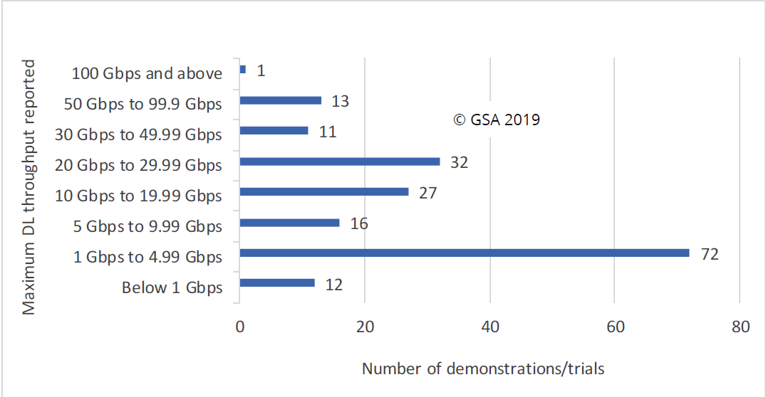 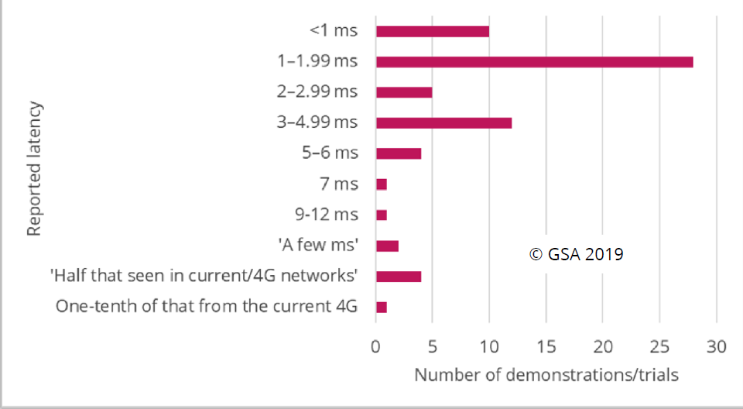

*Source: GSA*

While many trials show peak downlink throughput in excess of 1 Gbps and latencies less than 2 ms, it is important to note these are proof of concept tests that will not necessarily reflect real-world commercial deployments.

23 operators in 13 countries now claim to have launched limited commercial 5G services to users (including 8 via mobile and 11 via FWA). These include:

* **Australia**: Telstra
* **Finland** **and** **Estonia**: Elisa
* **Italy**: Fastweb/TIM
* **Lesotho**: Vodacom
* **Qatar**: Ooredoo
* **South Korea**: LG Uplus, KT, SK Telecom
* **UAE**: Etisalat
* **USA**: AT&T, Verizon*, C-Spire*

*\*non-3GPP compliant networks*

In all cases services are being provided in limited geographic areas to a restricted number of customers with compatible devices.

7 other operators have said they have live 5G networks but have not yet launched commercial services. In total 90 operators in 48 countries have announced intentions of making 5G available to their customers by the end of 2022.

The number of operator announcements is expected to rise in the next year to 18 months as the first 5G-capable devices start to emerge (see more information in 4.4 below).

According to estimates from [Deloitte](https://www2.deloitte.com/content/dam/insights/us/articles/TMT-Predictions_2019/DI_TMT-predictions_2019.pdf), 25 operators are expected to have launched 5G services (at least in major cities) by the end of 2019, with another 26 operators expected to launch in 2020. GSA estimates 40 networks to launch in 2020.

Recent tests of 5G applications include 5G connected drones, stadium applications, holograms and connected vehicles.

50 countries worldwide are reported to have either reserved spectrum for 5G, have announced plans, or are considering options to do so.

Meanwhile, a representative of Japanese operator NTT Docomo has urged caution against over-hyping 5G. Speaking at the European 5G conference in Brussels, 22-23 January 2019, Takehiro Nakamura, senior vice president and general manager for the company’s 5G laboratories, said it was important that the telecoms industry offers a realistic view of early 5G deployments. He noted there were major misconceptions within the industry over coverage and performance, and that it is important to understand that 5G will initially only be available in major urban areas, and cannot meet speed and latency expectations everywhere.

**(For information in ECC PT1)**

## 3GPP Updates: delay of Release 16 until March 2020 and new work item on 5G NR in unlicensed spectrum

As reported in the July edition of the Bulletin, 3GPP Release 15 Standards for standalone (SA) 5G NR mode for enhanced mobile broadband networks were completed in June 2018. 3GPP Release 16, originally due to be completed by December 2019 has now been delayed by 3 months and is now planned to be completed in March 2020. This was announced at the TSG RAN#82 plenary held in Sorrento, Italy ON 10-13 December 2018.

The 3 month shift is due to the need for additional work on components for the ‘late drop’ of Release 15 that address additional architecture options to aid migration from LTE to 5G. TSG RAN has put extreme focus on ensuring the stability and compatibility of these specification that are to be used for the first 5G deployments.

3GPP has indicated that this shift will not in any way impact the first 5G deployments. It is also not expected that this delay would affect the timetable for the final ITU-R IMT-2020 submission which is required by July 2019.

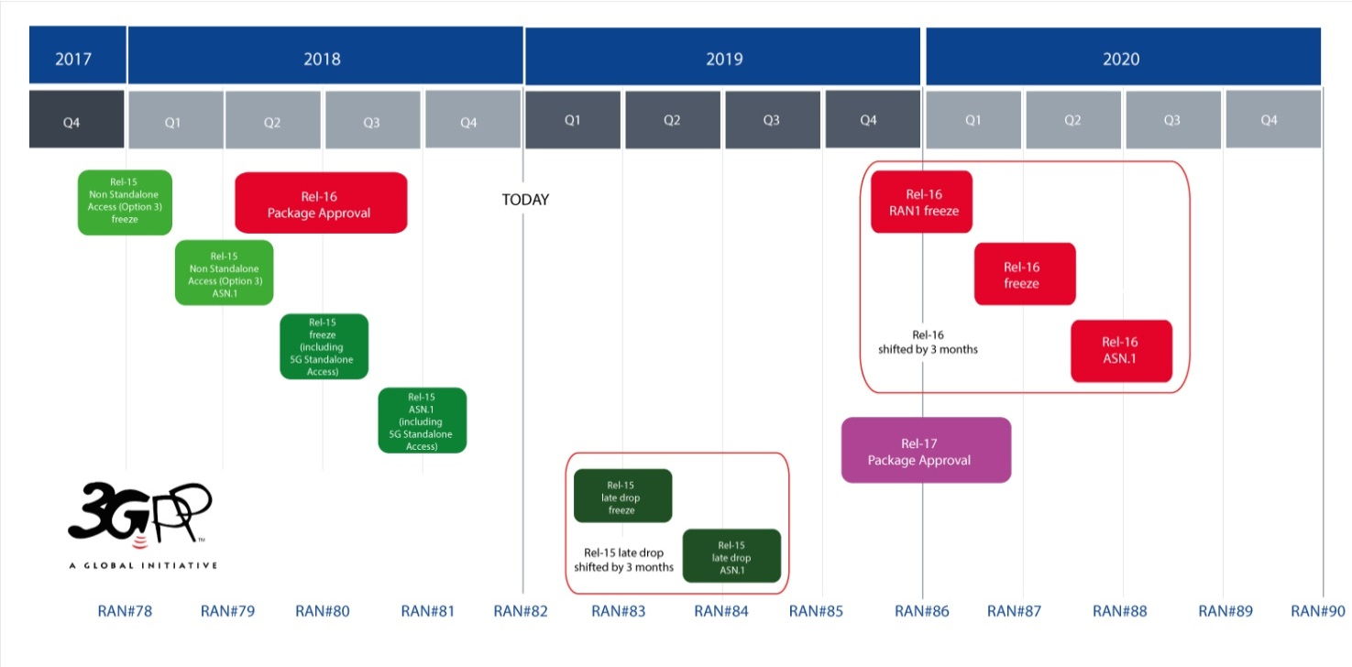

*Source: 3GPP*

Another interesting development from the RAN#82 meeting was the approval of a [work item](https://www.google.com/url?q=http://www.3gpp.org/ftp/meetings_3gpp_sync/ran/Inbox/drafts/RP-182789%2520NR-U%2520WID%2520r1.doc&sa=U&ved=0ahUKEwiwhZyOjr7gAhVb8aYKHUXqAF0QFggEMAA&client=internal-uds-cse&cx=011147748590557393066:btgfoc_873q&usg=AOvVaw04Ql8HaNc-OQ4iZpihDbkC) to study the use of 5G NR in unlicensed spectrum (“NR-U”). The work item covers five scenarios with functionalities such as Carrier Aggregation (within one eNodeB), dual connectivity (across two eNodeBs), LTE anchor in licensed spectrum, 5G NR anchor in licensed spectrum, uplink only in licensed spectrum, downlink only in unlicensed spectrum as well as standalone operation

The work item covers both the 5 GHz and 6 GHz bands (the full 5.925-7.125 GHz range available in the US). The upper limit of Frequency Range 1 (“FR1”) in 3GPP specifications will be extended to 7.125 GHz to accommodate the latter.

**(For information in ECC PT1, WGFM, FM57, SE45)**