EFIS/MG#28 Meeting Prague, 21 – 22 Sep 2011
USEFUL INFORMATION

Meeting venue:  The venue of the meeting is the seat of the  Czech Telecommunication Office,  Sokolovská 219,  190 00 Praha 9 (www.ctu.cz ) | 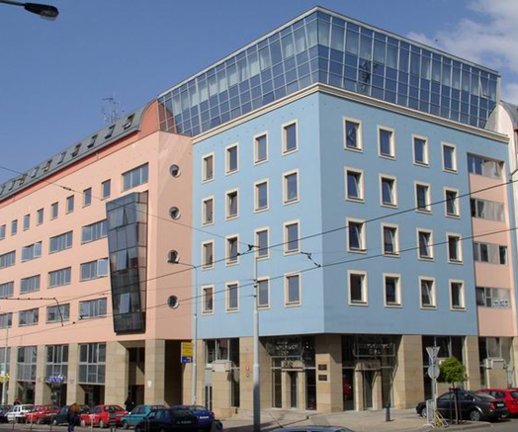
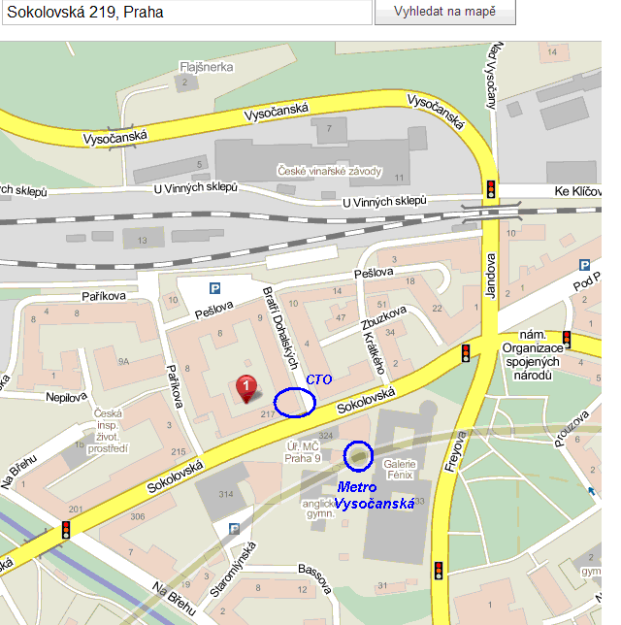 |  | Location: co-ordinates:  50°6'38.565"N,  14°29'56.581"E,  see www.mapy.cz

Arrival by plane:

At Ruzyně -Prague airport, Terminal 1 is for all flights from / to Non-Schengen countries. Terminal 2 is for all flights from / to Schengen countries. Public transport buses stop at both terminals.

a) Public transportation:
Take bus no. 119 from the airport terminal T1/T2 to Dejvická station. Information centres arrival halls sell tickets in arrival halls. The time from airport to Dejvická station takes 24 minutes, bus No. 119 goes since 5:19 h till 0:47 h on weekdays and since 5:27 till 0:47 h during weekend).

Use the Metro line A (green line) from Dejvická station to Můstek station, then change to Metro line B (yellow line) and go to Vysočanská station. Get off and use the exit on your left hand (short stairs and than an excavator), go out form Metro station building and cross the near tram line in the Sokolovská street. You will see the CTO building.

City traffic information: http://www.dpp.cz/en/

b) Taxi: Be careful! The price from airport to the city should usually be CZK 600 (~€ 24), ask for the price before you start!

Arrival by train:

From Praha hlavní nádraží. (Prague main station): Metro C (red line), change on the next station Florenc to Metro B (yellow line) and to the Vysočanská station (exit description see above).

Public transport information is the same as above

City traffic information

- single transfer ticket is 32 CZK since 1st July and is good for 75 minutes of travel, do not forget to imprint it entering a bus,
- tickets can be bought also from bus drivers (price is than slightly higher),
- general ticket sales information please find at www.dpp.cz/en/ticket-sales .

http://www.dpp.cz/en/transport-around%20prague/transit-schematics/

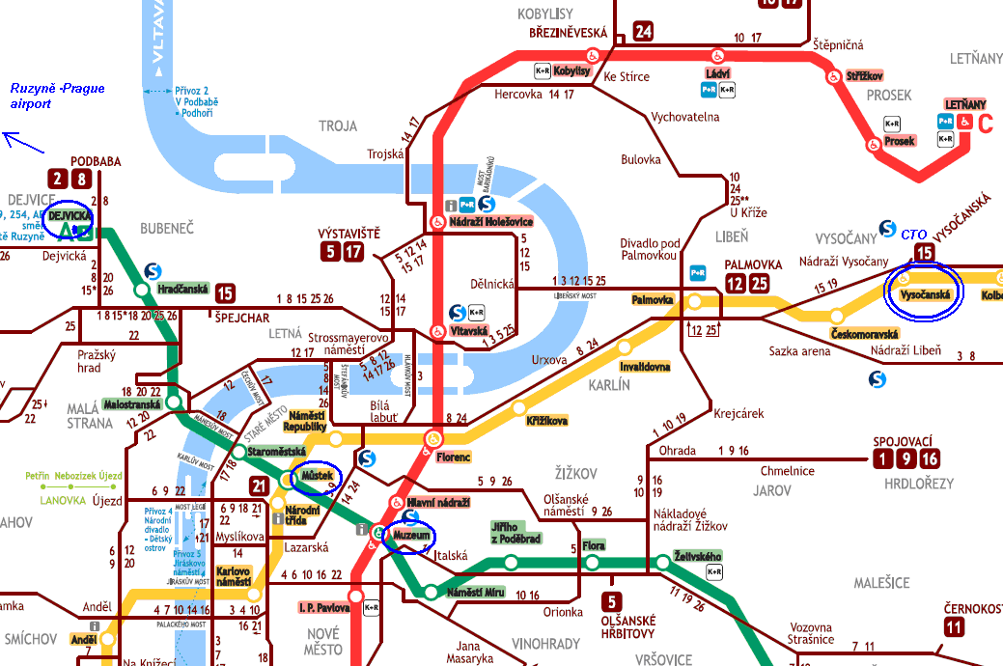

Social event
A social event will take place on Wednesday 21 September 2011 (detail information will be provided at the meeting).

Hotel & accommodation

Participants are required to make their own accommodation arrangements.

Useful web sites are e.g. as follows:
http://prague-stay.com/
http://www.hotel.cz/praha/accommodation/
http://www.onlinehotels.cz/index.php?jazyk=en

The hotels in the vicinity of the CTO building:

Hotel Bohemika ***
Na břehu 3/579, Praha 9 – Vysočany
http://www.penzion-hotel.cz/sk/detail-ubytovani/hotel/hotel-bohemika-praha-9/881.html hotel-bohemika-praha-9@penzion-hotel.cz

Hotel Carol Prague ***
Kurta Konráda 12, Praha 9
tel.: +420 284 019 911, fax: +420 284 019 977
http://www.hotelcarol.com/

Hotel Arlington ***
Kurta Konráda 22, Praha 9 Vysočany
tel.: +420 284 813 005, mobil: +420 602 772 842
info@arlingtonhotel.cz , www.arlingtonhotel.cz

Hotel Čechie Praha
U Sluncové 618, Praha 8
tel.: +420 266 194 101; +420 266 194 131, fax: +420 284 820 076
recepce@hotelcechie.cz , www.hotelcechie.cz

Hotel Ibis Praha Karlín ***
Šaldova 54/13, 186 00 Praha 8
tel.: +420 222 332 800, fax: +420 224 812 681
reservation@hotelibis.cz , http://www.hotelibis.cz

Hotel Olympik ****
Sokolovská 138 , 186 76 Praha 8
tel.: ++420 266 184 509; +420 266 184 510 , fax: +420 266 184 813
reception@olympik.cz, http://en.olympik.cz/olympik

Clarion Congress Hotel Prague ****
Freyova 33, CZ 190 00 Prague 9 - Vysočany
Tel.: +420 211 131 111, Fax: +420 211 131 401
info@cchp.cz , http://www.cchp.cz/en/home-page/

Visiting the city:
Metro lines will take you directly to the city centre historic parts included (Metro stations Staroměstská (A), Malostranská (B), Můstek (A, B), Muzeum (A, C).

Turist informations aviable via web sites:
http://www.about-czechia.com/prazskyhrad/
http://www.praguewelcome.cz/en/
http://cestovniruch.praha-mesto.cz/lang/l2

International telephone service
The access code for international phone calls is “00” followed by the respective country code. The prefix for Czechia is +420.

Currency
The local currency is CZK – Czech crown (česká koruna, Kč) (~ 1 € = 24 Kč).

Electrical appliances
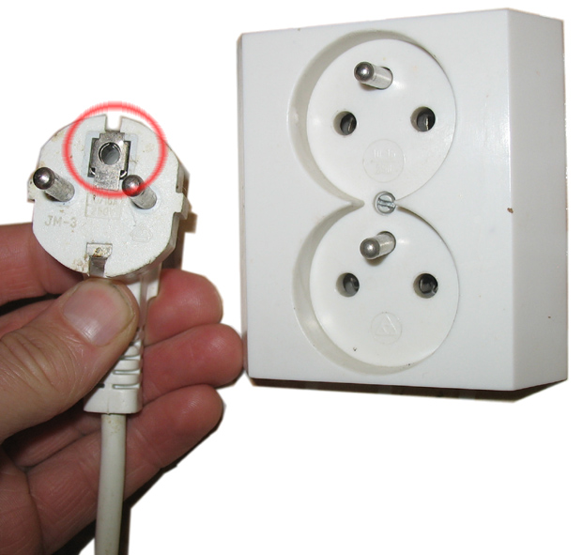
The voltage in Czechia is 230 V AC (50 Hertz). You can use standard continental size two-pin plugs.
In the case of three-pin plugs, your plug should have a hole for the third pin (see picture).

Weather Conditions
The weather in Prague in September can vary from pleasant sunny weather (> 20 ºC) to some periods of rain (< 10 ºC). Please take some warm clothes with you and don’t forget your umbrella.

Contact to the Czech Telecommunication Office:

Czech Telecommunication Office
International Relations Department
Sokolovská 219, Praha 9
Postal Address P. O. Box 02, 225 02 Praha 025
www.ctu.cz

Mrs. Olga Müllerova,
tel. +420 224 004 757, mullerovao@ctu.cz,

secretariat of the International Relations Department:
Mrs. Miluse Bednarikova, tel. +420 224 004 704, bednarikovam@ctu.cz,

fax +420 224 004 817

