API of EFIS
The test API of EFIS is deployed to https://testapi.cept.org/swagger-ui.html, or simply use http://testapi.cept.org/ which will bring you to the https link. This document is meant as an explanation on what an API is for and how it should be used.
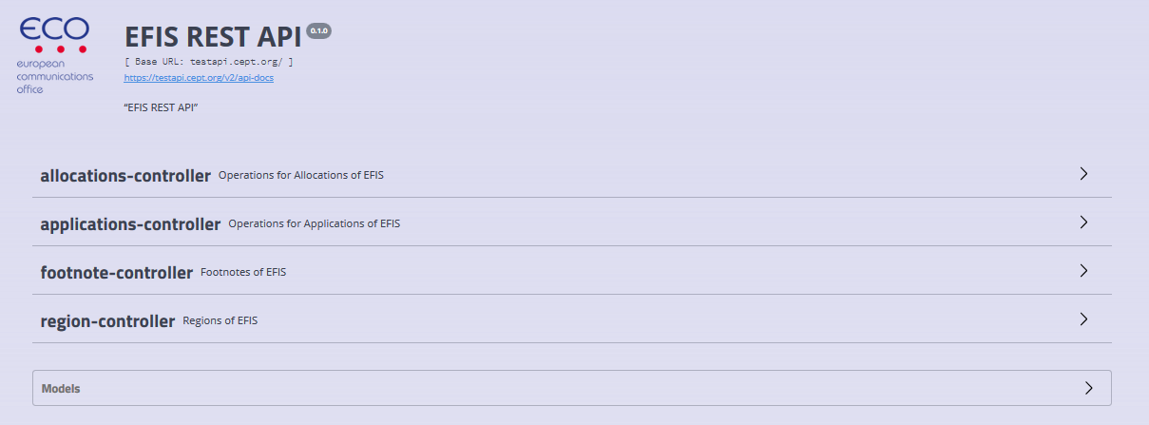
The initial API set up can be used to export information from the EFIS about radio service allocations (incl. frequency band and allocation footnotes) and about radio applications. The used terminology, as defined in ECC Decision (01)03 Annexes 1 and 2, can also be extracted. Users can select the region (i.e. country, ITU-R1 or Europe) and decide whether they want the whole information or only for a specific defined frequency range.
Work will continue to include more information (e.g. documentation, radio interfaces, rights-of-use, dedicated sections on SRD, FS, PMSE, etc) after feedback is received from users of the API.
The EFIS web site is unaffected by this addition of an API and should be seen as merely a new endpoint that exposes the data available in the EFIS database.

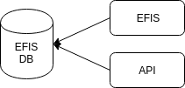

What is an API?
API stands for Application Programming Interface which means that an application programmer will use this API when developing an application. It is a machine-to-machine interface and users could for example use the extracted information to automatically build up a website with the chosen content or use the data in their own database. This gives the users also the possibility to show and process the data according to their wishes.

Documentation of the API
A developer using the EFIS API will have to know how to construct the queries relevant for his application. Therefore documentation of the API is essential.
The EFIS API is developed as a REST interface (a standard approach to designing web APIs today) and luckily there are several tools that can automatically generate documentation for a REST API. We have chosen Swagger UI which enables us to get the following:
- A Swagger UI html page to help developers/users explore the API.
- A Swagger description of the whole API (can be accessed from https://testapi.cept.org/v2/api-docs).
This can be used to auto-generate a client side version of this API.
We will only look at the swagger UI html client in this document.

Swagger UI HTML Client
Going to the main page of the API https://testapi.cept.org/ we are presented with the swagger UI client. This serves as a exploratory human friendly documentation of the API showing its capabilities and how to use it. The Swagger UI is an auto generated client on the API as show in the picture below.
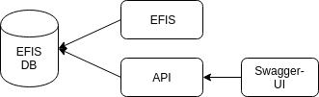

Loading the swagger UI client we see four controllers: allocations-controller, applications-controller, footnote-controller, and region-controller.

The region-controller serves the information about the different regions in EFIS – this is administrations for individual countries and bigger regions as ECA (Europe) and ITU.

Region-Controller
Expanding the region-controller reveals one operation that can show all regions.

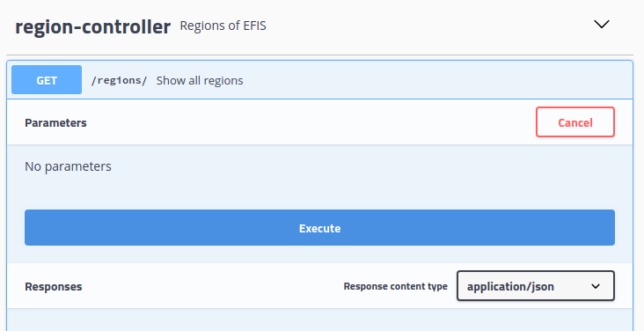
Clicking the Execute button will call this operation of the API and show the result (the result is shown in the box titled “Response body”).
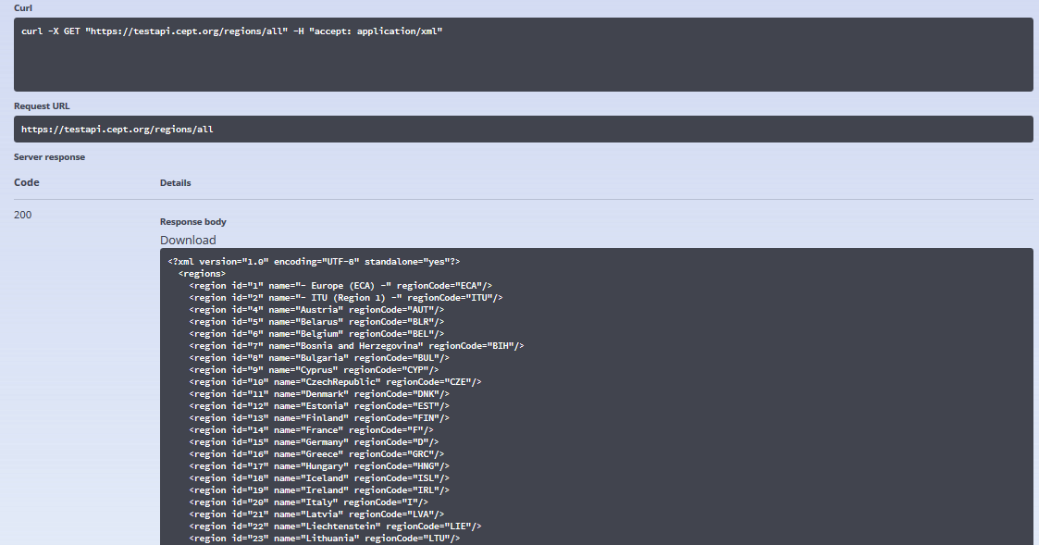

In the output box Swagger UI also shows how to execute the raw API command as an https request: curl -X GET “https://testapi.cept.org/regions/all” -H “accept: application/json”.

Running this command from a terminal will result in the following:

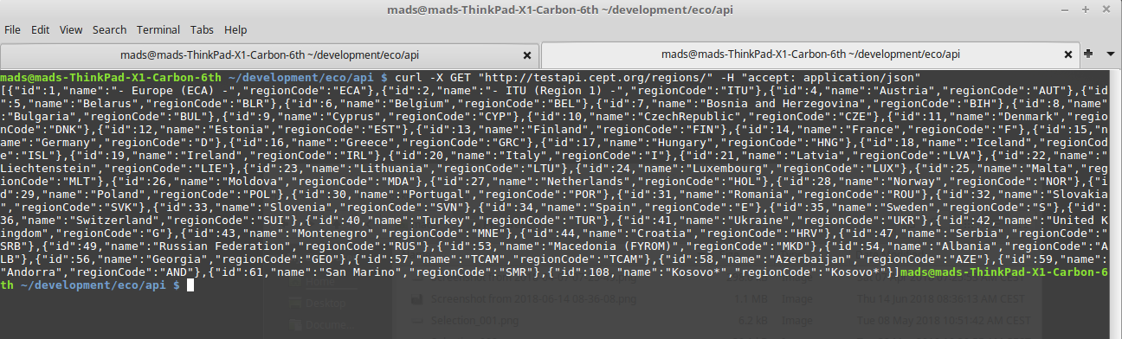
This raw execution of the API is clearly different from the swagger UI version which underlines the different purposes of the two: raw access of an API is for applications and swagger UI access is for humans exploring and understanding how it works.

The id for the ECA Table is for example ‘1’. The query request https://testapi.cept.org/allocations/ranges?regionId=1 would lead to the extraction of all ECA Table Frequency allocations. If a user wants information from all countries too, then the query will need to be repeated with the id of the wanted countries.

Response Format
As shown in the command line example, the formal way to indicate what response type the client accepts, is to set an accept header in the request. That is slightly inconvenient when using a browser – so a shorthand in the URL is also supported. The query url from before can be written “https://testapi.cept.org/regions/all.json” or “https://testapi.cept.org/regions/all.xml” to either get JSON for XML as output format.
Requesting the latter URL in a browser gives the following response:

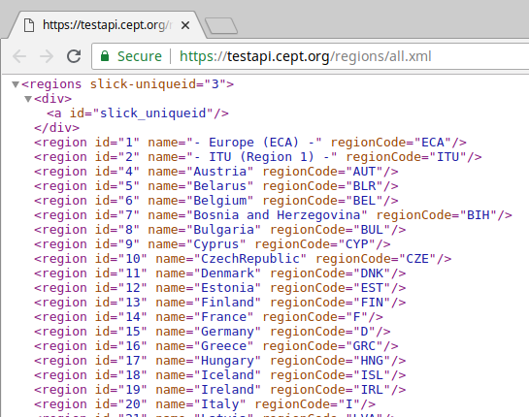

Allocations-Controller & Applications-Controller
The Allocations-controller and Applications-controller are similar in the way that they both support two methods “/ranges” and “/terms”.

Terms
Querying both the allocations/terms and applications/terms will show all the term definitions (either allocation terms or application terms). Terms are merely identified names that describes a particular application that later is assigned in the frequency range for different regions. Below is shown a snippet of exercising the url “https://testapi.cept.org/applications/terms.csv”:
"Term ID", "Name"
1; "Broadcasting"
2; "Aeronautical communications"
3; "Aeronautical satcoms"
4; "AGA communications (civil)"
5; "SAR (communications)"
7; "Aeronautical navigation"
8; "Airborne doppler navigation aids"
9; "Airborne weather radar"
10; "Altimeters"

As a special case for data that is represented as lists, the format text/csv is also supported (XML and JSON is also supported). This format can be requested using the extension “.csv” at the end of the URL.
It is intended that all API controllers can deliver the data in either XML or JSON formats. CSV is less structured but could be included. This will be discussed with CEPT administrations and other users of the EFIS system to find out the need and benefit of including CSV as a format option.

Ranges
Range queries are more complicated than the term lists above. Here we perform a region specific query for frequency range utility of either allocations or applications. From the swagger UI client we can extend the “/allocations/ranges” and press the “try it out” button. This expands the input fields for the query parameters. These are “region ID”, “frequencyMin”, and “frequencyMax”. The Region ID is mandatory but frequencyMin and frequencyMax are optional and when not specified the full frequency range will searched.
As an example we will try to query for region ID 4 (Austria) and limit the frequencyMax to 8500 Hz. Go to the allocations-controller and enter the following:
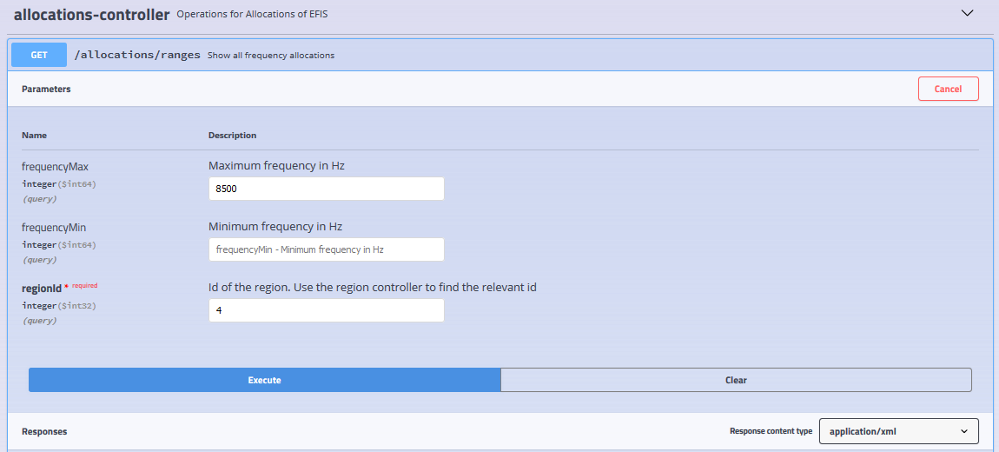
The picture below shows the response when pressing execute. We also see the command line to execute to get the response is: curl -X GET "https://testapi.cept.org/allocations/ranges?regionId=4&frequencyMax=8500" -H "accept: application/json". Knowing the shorthand this is identical to exercising the URL: https://testapi.cept.org/allocations/ranges.json?regionId=4&frequencyMax=8500".
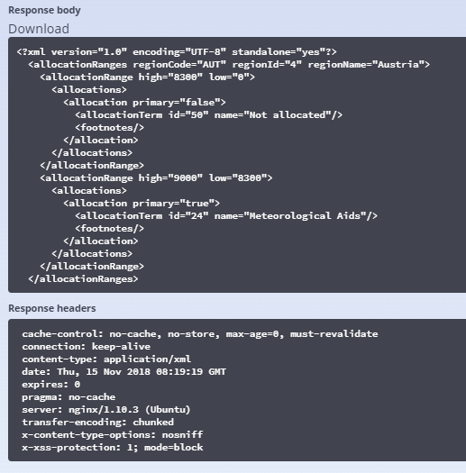

Similarly for “/applications/ranges” we can get the application frequency range also. The difference between allocations and applications are allocations have a “primary” indicator and a list of footnotes and applications have short comments.

Footnote-Controller
Expanding the footnote controller reveals two queries:
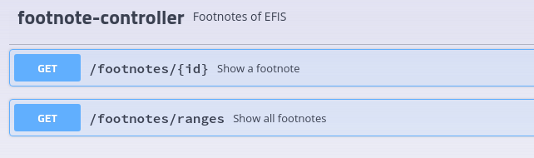
Starting with the “footnotes/ranges” it is similar to the allocations/ranges and application/ranges queries described above. You query for frequency range footnotes for a particular regions and an optional frequency range.

Footnote details
Footnotes are referenced both from “allocations/ranges” and “footnotes/ranges”, i.e. footnotes can be assigned to frequency allocations and frequency ranges. So when performing these range queries a long list of footnotes will be part of the result. Since footnotes can contain a long legal text describing some regional restrictions to the allocation, it is beneficial to avoid returning this long text for every allocation this footnote is referenced. Therefore all footnotes are referenced by id and short name (also called footnote number in EFIS). The only way to read the full text of the footnote is to use the query endpoint: “/footnotes/{id}”. Let’s look at an example:
Performing a range query on the footnotes:

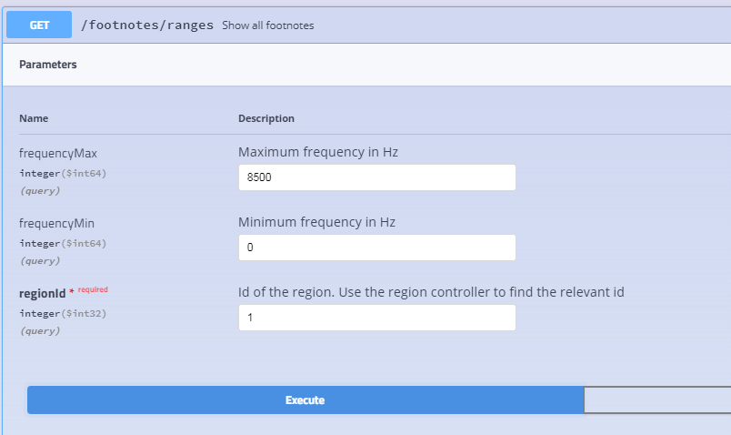
This gives the following response:
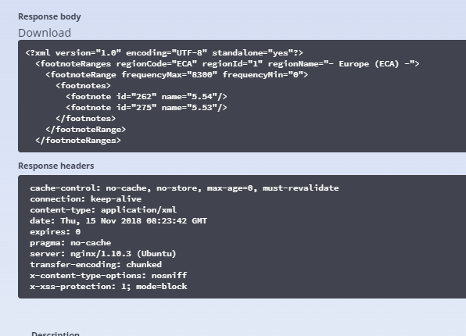

We notice that two footnotes are applied to the range 0-8300 Hz for region ECA. The ID of the last footnote is 275. Details of a footnote can be seen on the URL “/footnotes/{id}” so combining everything we have learned we can now request the details of this footnote in a browser by entering the URL “https://testapi.cept.org/footnotes/275.xml”. The result can be seen in the picture below.

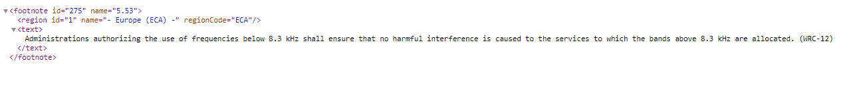

Using the API
The overall idea with an API is to open for general access for 3rd parties to the data. Therefore data access can seem cumbersome: one has to fetch a region ID to perform range queries of applications. But the underlying idea is to have a general purpose API where basic building blocks and queries are exposed for 3rd parties and only their imagination set the limits on what to do with it!

Example
To give a concrete example of one usage of the API a static .html page is also deployed on the test server: https://testapi.cept.org/example.html.
Loading this page will construct the ECA Table wherein it performs three queries against the API (one for allocation ranges and allocation footnotes, one for frequency range footnotes, and one for application ranges) and presents the data in a table. It is possible to take the html content of the web page and place it on another server (or even on the local file system), loading it will again give the same result.

Example:
