|  |  |  |  |  |
| --- | --- | --- | --- | --- |
| WG SE40 | | | Doc. SE40(19)016 | |
| Rome, Italy, 16-17 April 2019 | | | | |  | |
|  | | |  | | | |
| Date issued: | | 8th April 2019 | | | | |
| Source: | | Communications Regulatory Authority of the Republic of Lithuania (RRT) | | | | |
| Subject: | | WI SE40_34: FSS ES to FS interference analysis | | | | |
| Group membership required to read? (Y/N)  N | | | | | | |
|  | | | | | | |
| Summary: | | | | | | |
| This document analyses FSS ES interference to FS point-to-point links in the 27.5-29.5 GHz band based on real case scenario in Vilnius city. | | | | | | |
| Proposal: | | | | | | |
| SE40 is invited to consider the this document on FSS ES interference to FS in 28 GHz band. | | | | | | |
| Background: | | | | | | |
|  | | | | | | |

# Electromagnetic Compatibility Analysis of Satellite and Terrestrial Radio Links in the 27.5-29.5 GHz Band

This Report studies the feasibility of license-exempt (i.e. not individually coordinated and licensed) FSS ESs operation in 27.5-29.5 GHz band. Currently this band is allocated to FS and FSS according to ECC/DEC(05)01 Decision

## Technical FSS ES characteristics and deployment scenario used for electromagnetic compatibility analysis

This analysis studies FSS ES designed for stationary use for the case of Vilnius city area. There are two types of parabolic antenna used in this analysis: 0.75m diameter dedicated to residential usage and 1.8m diameter dedicated to commercial usage. The range from 20W to 45E of satellite orbital positions represents the majority of CEPT countries that can be served. For the purpose of compatibility analysis, a set of {-20, 10, 20, 45} values is considered. From orbital positions, listed above, FSS elevation angles fall into interval of [10, 50] degrees for Continental Europe.

### FSS ES terminal technical characteristics

Table 1 provides FSS ES characteristics used for the FS and FSS compatibility analysis.

Table 1 FSS ES (user terminal) parameters in the band 27.5-29.5 GHz

|  |  |  |
| --- | --- | --- |
| GSO FSS E/S characteristics (user terminal) | | |
|  | Enterprise Terminal | Residential Terminal |
| Antenna height | 2-30 m uniform distribution | 2-30 m uniform distribution |
| Antenna diameter | 1.8 m | 0.75 m |
| Antenna pattern | ITU S. 465-6 | ITU S. 465-6 |
| Frequency considered | 28.35 GHz | 28.35 GHz |
| Higher Range transmit power  (for MCL) | 14.1 dBW | 17.1 dBW |
| Lower Range transmit power | 7.1 dBW | 9.1 dBW |
| Range of elevation angles | 10 - 50 degrees | 10-50 degrees |
| Max Gain | 52.91 dBi | 43.9 dBi |
| Equivalent bandwidth | 320 MHz | 80/160 MHz |
| Lower Range input power spectral density (PSD) | -17.91 dB(W/MHz) | - 12.94 dB(W/MHz) |
| Higher range input power spectral density (PSD) | -10.92 dB(W/MHz) | -1.93 dB(W/MHz) |
| Polarisation | Circular | Circular |

For the purpose of this analysis, Recommendation ITU S.465-6 antenna pattern was considered for FSS ES antenna side-lobes. Such antenna pattern is designated to coordination studies and interference analysis between FSS ES and stations of other services sharing the same frequency band. Gain of such antenna is calculated according to the following formula:

$G\left(φ\right)=32-25log{φ}$ [dBi] for $φ_{min}<φ<48°$

$G\left(φ\right)=-10$ [dBi] for $48°<φ<180°$

where:

$φ_{min}=\max_{}\left(1°,100\frac{λ}{D}\right)$ for $\frac{D}{λ}≥50$

$φ_{min}=\max_{}\left(2°,114{\left(\frac{λ}{D}\right)}^{1.09}\right)$ for $\frac{D}{λ}<50$

$φ_{min}$ is the estimate for the intersection of the main-lobe with the side-lobe gain envelope. In this case:

$\frac{D_{1}}{λ}=\frac{D_{1}f}{c}=\frac{1.80∙28.35∙{10}^{9}}{3∙{10}^{8}}=171$

$\frac{D_{1}}{λ}=\frac{D_{1}f}{c}=\frac{0.75∙28.35∙{10}^{9}}{3∙{10}^{8}}=71$

Thus, $φ_{min}$ for enterprise and residential antennas respectively is:

$φ_{min1}=1°$

$φ_{min2}=1.4°$

According to ITU-R S.2196 report, main-lobe maximum gain could be approximated by the following formula:

$G_{max}=10\log\left(ηπ^{2}{\left(\frac{D}{λ}\right)}^{2}\right)$

Where η is antenna aperture efficiency, which is <1. In this case we used the value of 0.7.

The definition of main-lobe could be found in RR Annex 3, Appendix 8. Using this definition and ITU S.465-6 antenna pattern for side-lobes, main-lobe could be modelled using the following formulas:

$G\left(φ\right)=G_{max}-0.0025{\left(\frac{Dφ}{λ}\right)}^{2}$ for $0°<φ<φ_{m}$

$G\left(φ\right)=G_{1}$ for $φ_{m}≤φ≤φ_{p}$

where:

$G_{1}=2+15\log\left(\frac{D}{λ}\right)$ [dBi]

$φ_{m}=\frac{20λ}{D}\sqrt{G_{max}-G_{1}}$ [deg]

$φ_{r}=15.85{\left(\frac{λ}{D}\right)}^{0.6}$ [deg]

$φ_{p}=\max_{}\left(φ_{r}, 100\frac{λ}{D}\right)$ [deg]

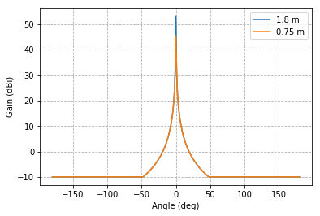Antenna masks for Enterprise and Residential usage are depicted in Figure 2.

Figure 1 FSS antenna pattern for different antenna diameters (enterprise and residential)

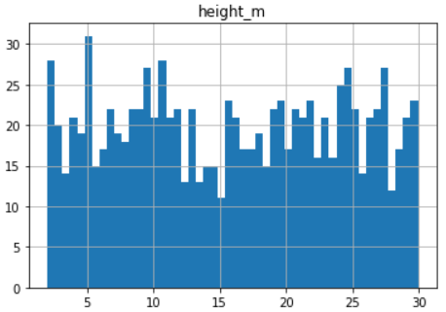FSS ES antenna height is generated randomly in the interval of 2-30 m to satisfy the condition, that FSS ES could be deployed in both urban and suburban areas. Figure 3 illustrates the statistics of random height assignment.

Number of FSS ES

Height (m)

Figure 2 Statistics of random height assignment to FSS ES station

For the purpose of this analysis we used 1 FSS ES for Vilnius city centre area (about 63,25 km2) for 10 000 Monte Carlo iterations. A square of Vilnius urban area, between the listed points, had been taken into consideration (see Figure 3):

Point A – (54.65, 25.21);

Point B – (54.65, 25.32);

Point C – (54.73, 25.32);

Point D – (54.73, 25.21).

### FS characteristics considered in analysis

For the purpose of this analysis, we examined FS Radio Relay Links, operating in band 27.5-29.5 GHz in Vilnius city (see Figure 6). Such area has been selected to investigate FS and FSS compatibility with high FS RRL density taking into account real FS characteristics. Path loss of FS radio link was calculated according to ITU-R P.452-16 recommendation implemented in Python pycraf library.

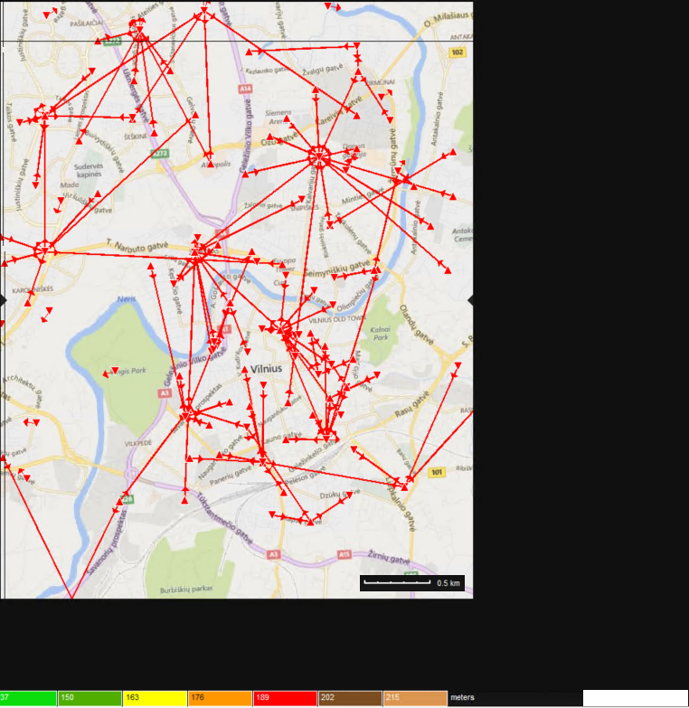

Figure 3 FS P-P links in Vilnius city (band 27.5-29.5 GHz)

For the FS antenna we used ITU-R F.699-8 antenna pattern (see Figure 7), which is also programmatically implemented in Python pycraf library.

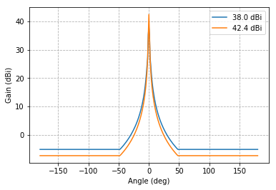

Figure 4 FS RRL antenna pattern (ITU-R F.699-8)

## Methodology for interference analysis

Interference probability evaluation is implemented by performing Monte-Carlo simulation with 10 000 simulation runs for Vilnius city area. For every Monte-Carlo iteration, a new FSS ES is generated with randomly assigned characteristics, defined in Paragraph 1.1. Interference evaluation scheme is illustrated in Figure 5. The interference probability to FS receiver is calculated based on FS protection criteria, which, in this case, is I/N = -10 dB for long term protection criteria. The FSS interference towards FS depends on location of FSS ES, antenna height, elevation angle and transmitted power.

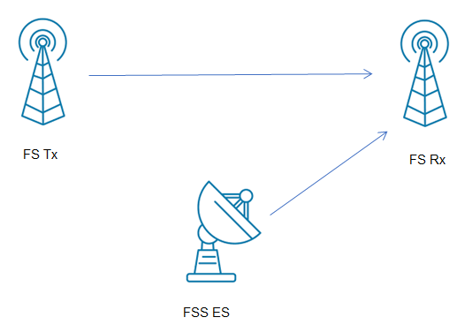

Figure 5 Interference between FSS ES and FS Rx evaluation scheme

### Propagation calculation

Propagation calculations between FSS ES transmitter and the FS victim receiver are based on ITU-R P.452-16 recommendation implemented in Python pycraf library (for programmatic implementation of this recommendation, see ANNEX 1).

#### Line-of-sight propagation

Line-of-sight propagation losses formula also includes short-term effects and is applied both to Line-of-sight and transhorizon profiles. Basic transmission loss is caused by free-space propagation losses and attenuation by atmospheric gases:

$L_{bfsg}=92.5+20\log{f}+20\log{d}+A_{g}$

Where $A_{g}$ is total gaseous absorption (dB).

#### Diffraction loss

The overall diffraction loss is calculated using delta-Bullington diffraction method, which contains three parts. The Bullington part is an expansion of the basic Bullington contstruction for approximate calculation of multiple knife-edge diffraction loss. This part is used twice. Firstly, it is used for actual path profile, and secondly, for a zero-height smooth profile with effective antenna heights. The spherical-Earth diffraction loss is calculated using effective antenna heights. For a perfectly smooth path, total diffraction loss will only contain the part of the spherical-Earth model. The total diffraction loss is calculated by combining three mentioned types of diffraction loss. This method provides an estimate of diffraction loss for all types of paths.

Total diffraction loss for the general path is given by:

$L_{d}=L_{bulla}+\max_{}{\{L_{dsph}-L_{bulls},0\}}$ [dB]

### Clutter loss (ITU-R P.452-16)

Reception of signal by the antennas that are surrounded by local ground clutter, like buildings or vegetation, are affected by additional clutter losses. For clutter loss predictions GlobeCover’09 clutter dataset is selected as it is open source and offers complete and wide coverage. Recommendation ITU-R P.452-16 proposes that the loss due to protection from local clutter is given by the expression:

$A_{h}=10.25F_{fc}e^{{-d}_{k}}\left(1-\tanh\left[6\left(\frac{h}{h_{a}}-0.625\right)\right]\right)-0.33$ [dB]

$F_{fc}=0.25+0.375(1+\tanh{(7.5(f-0.5))})$

Where: $d_{k}$– nominal clutter distance, distance (km) from nominal clutter point to the antenna, $h –$ antenna height (m) above local ground level, $h_{a}$– nominal clutter height (m) above local ground level. Such losses are calculated for both interferer and interfered-with. The maximum additional loss is 20 dB. When this correction is used for urban environments consisting tall buildings separated by open spaces, high clutter losses should not be expected. Nominal clutter heights and distances are listed in Table 2. For this analysis, we use three types of clutter: unknown (i.e. no clutter), urban and suburban.

Table 2 ITU-R 452-16 nominal clutter heights and distances

|  |  |  |
| --- | --- | --- |
| Clutter type | Nominal height, $h_{a}$ [m] | Nominal distance, $d_{k}$ [km] |
| Unknown | 0 | 0 |
| Sparse | 4 | 0.10 |
| Village | 5 | 0.07 |
| Decidious trees | 15 | 0.05 |
| Coniferous trees | 20 | 0.05 |
| Tropical forest | 20 | 0.03 |
| Suburban | 9 | 0.025 |
| Dense suburban | 12 | 0.02 |
| Urban | 20 | 0.02 |
| Dense urban | 25 | 0.02 |
| High urban | 35 | 0.02 |
| Industrial zone | 20 | 0.05 |

### Clutter loss (ITU-R P.2108-0)

Clutter loss result, according to ITU-R P.2108-0 Recommendation, gives a statistical distribution of clutter loss for urban and suburban environments. This clutter loss method should not be applied, if a propagation model used includes clutter losses calculated along entire path. However, model used in this analysis takes into account clutter losses only in the end parts of the path. Minimum path length has to be 0.25 km (for the correction to be applied at only one end of the path), and 1 km (for the correction to be applied at both end of the path). The clutter loss not exceeded for *p*% of locations for the terrestrial path, $L_{ctt}$, is given by:

$L_{ctt}=-5\log\left({10}^{-0.2L_{l}}+{10}^{-0.2L_{s}}\right)-6Q^{-1}(p/100)$ [dB]

Where $Q^{-1}(p/100)$ is the inverse complementary normal distribution function, and

$L_{l}=23.5+9.6\log{(f)}$ [dB]

$L_{s}=32.98+23.9\log{(d)}+3\log{(f)}$ [dB]

Where *d* is the total path length.

## Results of FS and FSS compatibility analysis

Figure 6 illustrates the comparison between interference evaluation calculations with the different clutter loss calculation methods applied. The figure shows overall interference probability of 10 000 Monte Carlo simulation runs.

Method with no clutter losses applied (dark red line) shows the biggest interference probability of more than 10%. Clutter losses implemented in ITU-R P.452-16 model show similar tendencies like calculations without clutter losses (green line for Suburban type of clutter and orange for Urban). For further investigation we used ITU-R P.2108-0 Recommendation for clutter loss prediction along with ITU-R P.452-16 propagation model. This method shows very small interference probability (about 0,15%).

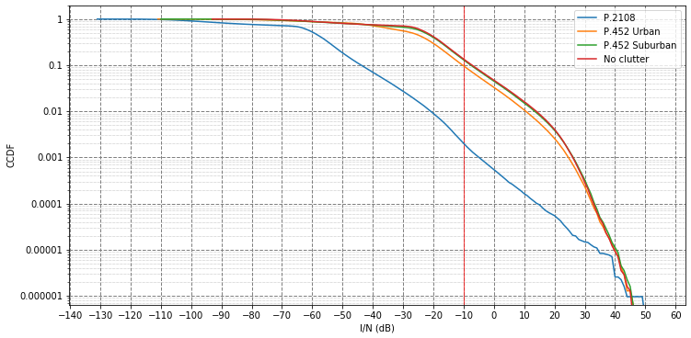

Figure 6 Interference probability CCDF for different clutter types

## Conclusions

FS and FSS ES compatibility analysis were performed for the real case scenario, taking into account existing microwave links operating in 28 GHz band in Vilnius city using propagation model defined in ITU-R Recommendation P.452.

Two different clutter evaluation methods were applied resulting in different interference probability. In the case when clutter losses calculated according to the ITU-R Recommendation P.452 it shows high interference probability from a single FSS ES to FS receiver.

This document presented interference calculations from FSS ES to point-to-point links only. Interference from FSS ES to P-MP was not evaluated in this document due to the lack of time.

## ANNEX 1

Python pycraf library pathprof subpackage offers tools to calculate propagation loss. The important parameters that determine propagation loss are radio wave frequency, distance between transmitter and receiver, antenna gain, boresight angles, and the terrain profile between transmitter and receiver. For short distances, the line-of-sight radio wave propagation mechanism is principal. However, for longer distances, where the profile is trans-horizon, other mechanisms could play a significant role. These mechanisms are diffraction loss, clutter loss, tropospheric scatter loss, ducting and anomalous layer refraction loss.

Height profiles are pictured by querying SRTM data and plotting a height profile:

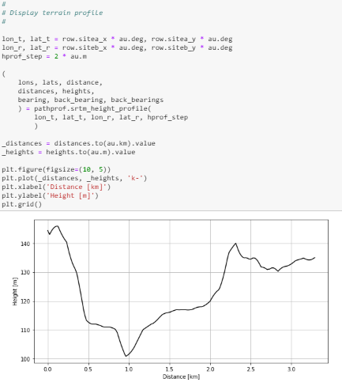

The pathprof package implements ITU-R P.452-16 Recommendation for path propagation loss calculations. atten_path_fast function implements path attenuation calculations along a path using a parallelized method.

